Memorandum of Understanding on
the Conservation of Migratory Sharks

Porbeagle Fact Sheet

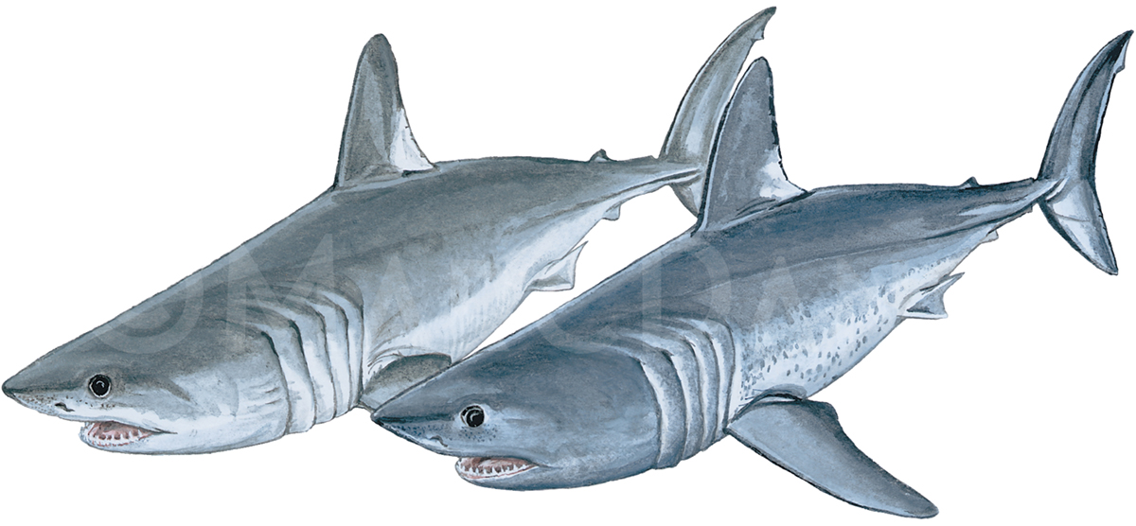
Class: | Chondrichthyes Porbeagle
Order: | Lamniformes Requin taupe
Family: | Lamnidae Marrajo
Species: | Lamna nasus Illustration: © Marc Dando

BIOLOGY
The Porbeagle (Lamna nasus) attains a maximum total length of ca. 300 cm, possibly to 370 cm. Around New Zealand, males and females mature at 140–150 cm and ca. 170–180 cm fork length (FL), respectively (Francis and Duffy, 2005), but Porbeagle mature at a larger size in the NW Atlantic, with 50% maturity at 174 cm (males) and 218 cm FL (females) (Jensen et al., 2002). The reproductive cycle may last about one year, and the (usually) four pups born at 58–75 cm (Compagno, 1984; Francis and Stevens, 2000). The maximum observed age of Porbeagle is over 20 years, and longevity is estimated at 45–65 years (Natanson et al., 2002; Francis et al., 2007).

DISTRIBUTION
In the northern hemisphere, the Porbeagle inhabits oceanic and coastal habitats in the North Atlantic and Mediterranean Sea and in a circumglobal band in the southern hemisphere (Francis et al. 2008), and are absent from tropical waters.

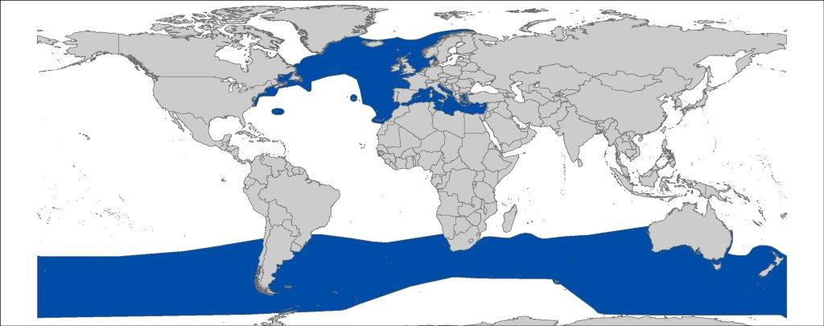
Figure 1: Distribution of Lamna nasus (map adjusted from IUCN Assessment).

CRITICAL SITES
Critical sites are those habitats that may have a key role for the conservation status of a shark population, and may include feeding, mating, pupping, overwintering grounds and other aggregation sites, as well as corridors between these sites such as migration routes. Electronic tagging studies indicated a subtropical pupping ground for Porbeagle in the Sargasso Sea (Campana et al., 2010a). Francis et al. (2015) with the same methodology, found that mature females made seasonal latitudinal migrations from ~46–48°S in summer to ~35–38°S during winter–spring, where they are hypothesized to give birth to pups - a similar period and latitude where Acuña et al. (2001) found females with pups off Chile.

POPULATION STATUS AND TRENDS
There are considered to be separate Northeast and Northwest Atlantic stocks. Recently, Hoyle et al. (2017) assessed the southern hemisphere stock. Whilst recognizing that the stock structure in this area is uncertain (Stevens et al., 2006), it has been suggested to comprise five subpopulations (Southwestern Atlantic; Western Indian Ocean and southeastern Atlantic; Eastern Indian Ocean; Western Pacific; and Eastern Pacific). This assessment concluded that fishing had a low impact on Porbeagle in the southern hemisphere (WCPFC 2017). The current IUCN Red List status for the global population is Vulnerable (Stevens et al., 2006).

Region | Estimated Decline | Time Period | Reference
NORTHERN HEMISPHERE
NE Atlantic | ~94% decline | 1926 – 2008 | (ICCAT SCRS/ICES 2009)
 | 87% decline | 1933/37–2004/08 | (FAO 2010)
Mediterranean | Virtual disappearance | 1800 – 2006 | (Stevens et al. 2006)
NW Atlantic | 73–78% decline | 1961 – 2005 | (Campana & Gibson 2008; Campana et al. 2010b)
SOUTHERN HEMISPHERE
Southern hemisphere | Stable/increasing | 1994 – 2011 | (Semba et al. 2013);
 | Variable | Various | WCPFC, 2017
SW Atlantic | 82% decline | 1961 – 2008 | (ICCAT-SCRS/ICES 2009)

THREATS
- Fisheries: Populations in the Northeast Atlantic and Mediterranean Sea were under high pressure of targeted and incidental catches, which is thought to have depleted populations during the last century. They also represent a valuable bycatch species in various fisheries, including longline, gillnet, driftnet and midwater trawls, as well as recreational fisheries (Stevens et al., 2006).
- International trade: Trade and its underlying demand for Porbeagle products was the driver of the depletion of populations in the North Atlantic. The closure of the major northern fisheries may increase demand from southern hemisphere populations (CITES 2013).
- Pollution: A recent study found high levels of mercury contamination in Porbeagle, but the effects of pollutants on individual (and population) health are unknown (Nicolaus et al. 2016).

KEY KNOWLEDGE GAPS
Some areas of concentration are known, but more information is needed to better define some other critical habitats, migration routes and the connectivity of the different populations. Further, more information on post-release survival is desirable. There are some studies for longline fisheries (e.g. Francis et al., 2001; Francis et al. 2004; Coelho et al. 2012; Campana et al. 2016), but data are more limited for other gear types (e.g. Bendall et al., 2012).

KEY MANAGEMENT AND CONSERVATION GAPS
- There is legal harvesting of Porbeagle in parts of their stock ranges, but some of this may not be regulated. Given the high value of this species, there is the potential for illegal harvesting.
- Recreational fishing for Porbeagle may occur in areas where it is only managed through commercial fishing legislation.
- There is thought to be a degree of misidentification or mislabelling (e.g. with Shortfin Mako), and so landings data may not be accurate.

RECOMMENDATIONS FOR CONSERVATION AND MANAGEMENT ACTION
A multifaceted approach is required to address the management and conservation gaps for porbeagle sharks. Sharks MOU Signatories and other Range States are encouraged:

To incorporate conservation measures for Porbeagle into national legislation of all Parties/Signatories.
- Implement relevant international measures (e.g. CMS, CITES and RFMO recommendations)

To improve the understanding of Porbeagle through strategic research, monitoring and information exchange, including data collection of biological and distributional data and population status.
- Identify critical sites of Porbeagle abundance and seasonality.
- Address data gaps in life-history and determine stock-specific biological parameters.
- Further investigate post-release survivorship of Porbeagle and inform improved handling and release protocols.
- Enhance, or develop where necessary, collection of fishery data (including landings, discards, size frequency, catch and effort where needed).
- Develop more reliable indices of stock abundance.

III. To Improve multilateral cooperation among regions & RFBs
- Communicate your actions to the public and other Range States.
- Support the introduction of appropriate management and conservation measures for Porbeagle at international and regional fora (e.g. Co-sponsor proposals / resolutions within multilateral agreements)
- Promote better regional cooperation between RFMOs and RFBs (e.g. data-sharing or involvement in the Kobe process)
- Support development and implementation of appropriate management plans for the various stocks of Porbeagle
- Identify synergies with other Range States/stakeholders to support coordinated and resource-effective research & conservation programs

LEGAL INSTRUMENTS

Instrument | Description
Barcelona Convention  Barcelona Convention for the Protection of the Marine Environment and the Coastal Region of the Mediterranean | Annex II of the Protocol Concerning Specially Protected Areas and Biological Diversity in the Mediterranean of the Barcelona Convention and are therefore recognised as endangered or threatened. Accordingly, each Party shall take the necessary measures to protect, preserve or manage endangered or threatened species with the aim of maintaining them in a favourable state of conservation.
CCAMLR  Convention on Conservation of Antarctic Marine Living Resources | CCAMLR CM 32-18: Porbeagles occurring within the CCAMLR area should as far as possible, be released alive.
CCSBT  Commission for the Conservation of Southern Bluefin Tuna | CCSBT encourages both Members and Cooperating Non-Members to comply with a variety of binding and non-binding measures in order to protect species ecologically related to Southern bluefin tuna, including sharks.
CITES  Convention on International Trade in Endangered Species of Wild Fauna and Flora | Appendix II: Species not necessarily threatened with extinction, but in which trade must be controlled in order to avoid utilization incompatible with their survival.
CMS  Convention for the Conserbvation of Migratory Species of Wild Animals | Appendix II: Migratory species that have an unfavourable conservation status and need or would significantly benefit from international cooperation; CMS Parties shall endeavour to conclude global or regional agreements to benefit these species.
EU  European Union | Council Regulation (EU) 2017/127: prohibits to fish for, to retain on board, to tranship or to land Porbeagle for Union vessels in all waters and for third parties in Union waters. When accidentally caught, the specimens shall not be harmed and promptly be released.  Council Regulation (EU) 2018/120: prohibits for Union vessels to fish for, to retain on board, to transship or to land Porbeagle in all waters. The regulation also prohibits third-country vessels to fish for, to retain on board, and to tranship Porbeagle in Union waters.
FAO  Food and Agriculture Organization | IPOA Sharks: International Plan of Action for Conservation and Management of Sharks based on which states should adopt and implement a national plan of action for conservation and management of shark stocks (NPO Sharks) if their vessels conduct directed fisheries for sharks or if their vessels regularly catch sharks in non-directed fisheries.
ICCAT  The International Commission for the Conservation of Atlantic Tunas | Recommendation 2015-06 that Contracting Parties shall require their vessels to promptly release Porbeagle unharmed, to the extent practicable.
IOTC  Indian Ocean Tuna Commission | Contracting Parties and Co-operating Non-Contracting Parties (CPCS) are encouraged to comply with the recording and reporting requirements on sharks outlined in Resolution 15/01 and 15/02 and shall require fishermen to fully utilize the entire catches. The removal of shark fins as well as the landing, retention on-board, transshipment and carrying of shark fins which are not naturally attached is prohibited by Resolution 17/05.
NAFO  Northwest Atlantic Fisheries Organization | According to NAFO Conservation and Enforcement Measures 2017 Article 12: NAFO Contracting Parties shall prohibit the removal of shark fins onboard vessels and their retention onboard, transhipment and landing separate to the carcass. Further, vessels shall be encouraged to release sharks alive, which are not intended for use as food or subsistence (especially juveniles). Contracting Parties shall also identify more selective fishing gear and main biological and ecological parameters for key shark species trough research.
NEAFC  The North East Atlantic Fisheries Commission | NEAFC agreed on Recommendation 7:2016 to prohibit, for the period 2016 to 2019, all directed fishing of Porbeagle in the Regulatory Area and prompt release, of incidental catches to the extent possible.
OSPAR  The Convention for the Protection of the Marine Environment of the North-East Atlantic | Recommendation 2014/6: Contracting Parties should inter alia consider the possibility to introduce legislation, to protect all life stages of the Porbeagle, to improve funding and to undertake fishery-independent research to identify critical Porbeagle habitats and/or aggregation sites. Further, Contracting Parties should consider associating themselves with the Sharks MOU.
SEAFO  South-East Atlantic Fisheries Organisation | SEAFO introduced Conservation Measure [CM 04/06] requiring full utilization of catches, a 5% ratio of fin-to-body weight of sharks onboard, up to the first point of landing and reporting of shark catches.
SPRFMO  The South Pacific Regional Fisheries Management Organisation | Porbeagle is listed as a species of concern requiring certain reporting standards for trawl fishing activities.
Sharks MOU  Memorandum of Understanding on the Conservation of Migratory Sharks | Annex 1: Signatories should endeavour to achieve and maintain a favourable conservation status for these species based on the best available scientific information and taking into account their socio-economic value.
WCPFC  Western & Central Pacific Fisheries Commission | CMM 2010-07: Porbeagles (south of 20°S) represent a key shark species and shall therefore be included in the annual reporting to the Commission of annual retained and discarded catches and fishing effort statistics by gear type. As well, fishers shall be required to fully utilize any retained catches of sharks and encouraged to release live sharks that are caught incidentally and are not used for food or other purposes.

REFERENCES
Acuña, E., M. Araya, L. Cid, I. Kong, J. Lamilla, J. Peñailillo y E. Pérez. 2001. Estudio Biológico de Tiburones (Marrajo dentudo, Azulejo y Tiburón sardinero) en la Zona Norte y Central de Chile. Informes Técnicos FIP. FIP/IT N° 2000-23, 128 pp.
Bendall VA, Hetherington SJ, Ellis JR, Smith SF, Ives MJ, Gregson J, Riley AA 2012. Spurdog, porbeagle and common skate bycatch and discard reduction. Fisheries Science Partnership 2012: 1–88.
Campana SE, Gibson J 2008. Catch and stock status of porbeagle shark (Lamna nasus) in the northwest Atlantic to 2007. NAFO SCRS Doc 8: 36.
Campana SE, Joyce W, Fowler M 2010a. Subtropical pupping ground for a cold-water shark. Canadian Journal of Fisheries and Aquatic Sciences 67: 769–773.
Campana SE, Gibson AJF, Fowler M, Dorey A, Joyce W 2010b. Population dynamics of porbeagle in the northwest Atlantic, with an assessment of status to 2009 and projections for recovery. Collective Volume of Scientific Papers ICCAT 65: 2109–2182.
Campana SE, Joyce W, Fowler M, Showell M 2016. Discards, hooking, and post-release mortality of porbeagle (Lamna nasus), shortfin mako (Isurus oxyrinchus), and blue shark (Prionace glauca) in the Canadian pelagic longline fishery. ICES Journal of Marine Science 73: 520–528.
CITES 2013. Proposal: Inclusion of Lamna nasus (Bonnaterre, 1788) in Appendix II in accordance with Article II 2(a). CoP16 Prop. 44.
Coelho R, Fernández-Carvalho J, Lino PG, Santos MN 2012. An overview of the hooking mortality of elasmobranchs caught in a swordfish pelagic longline fishery in the Atlantic Ocean. Aquatic Living Resources 25: 311–319.
Compagno, LJV 1984.. FAO Species Catalogue. Sharks of the World: an annotated and illustrated catalogue of shark species known to date. Part 1: Hexanchiformes to Lamniformes. FAO Fisheries Synopsia No. 125, Vol. 4(1): 1–250.
FAO 2010. Report of the Third FAO Expert Advisory Panel for the assessment of proposals to amend Appendices I and II of CITES concerning commercially-exploited aquatic species. Rome, 7–12 December 2009. FAO Fisheries and Aquaculture Report No.FIRF/R925.
Francis, M. P., and J. D. Stevens. 2000. Reproduction, embryonic development and growth of the porbeagle shark, Lamna nasus, in the south-west Pacific Ocean. Fish. Bull. 98:41−63.
Francis MP & Duffy C 2005. Length at maturity in three pelagic sharks (Lamna nasus, Isurus oxyrinchus, and Prionace glauca) from New Zealand. Fishery Bulletin 103: 489–500.
Francis, M.P., Griggs, L.H. and Baird, S.J., 2001. Pelagic shark bycatch in the New Zealand tuna longline fishery. Marine and Freshwater Research 52: 165–178.
Francis, M.P., Griggs, L.H. and Baird, S.J., 2004. Fish bycatch in New Zealand tuna longline fisheries, 1998-99 to 1999-2000. Ministry of Fisheries: New Zealand Fisheries Assessment Report 2004/22;.62 pp..
Francis MP, Natanson LJ and Campana SE 2008. The biology and ecology of the porbeagle shark, Lamna nasus. p. 105 - 113. In: Sharks of the Open Ocean. Biology, Fisheries and Conservation (eds. M. D. Cambi, B. K. Pikitch and B. A. Babcock). Blackwell Publishing, Oxford UK.
Francis, M.P., Campana, S.E. and Jones, C.M., 2007. Age under-estimation in New Zealand porbeagle sharks (Lamna nasus): is there an upper limit to ages that can be determined from shark vertebrae?. Marine and Freshwater Research 58:10–23.
Francis, M.P., J.C. Holdsworth and B.A. Block. 2015. Life in the open ocean: seasonal migration and diel diving behaviour of Southern Hemisphere porbeagle sharks (Lamna nasus). Marine Biology 162: 2305–2323.
Hoyle SD, Edwards CTT, Roux MJ, Clarke SC and Francis MP 2017. Southern Hemisphere porbeagle shark stock status assessment. WCPFC-SC13-2017/SA-WP-12 (rev. 1), 59 pp.ICCAT-SCRS/ICES 2009. Report of the 2009 Porbeagle stock assessments meeting Copenhagen, Denmark, June 22 to 27, 2009. SCRS/2009/014. 57 pp.
Jensen CF, Natanson LJ, Pratt Jr HL, Kohler N, Campana SE 2002. The reproductive biology of the porbeage shark (Lamna nasus) in the western North Atlantic Ocean. Fishery Bulletin 100: 727–738.
Natanson, L.J., Mello, J.J. and Campana, S.E., 2002. Validated age and growth of the porbeagle shark (Lamna nasus) in the western North Atlantic Ocean. Fishery Bulletin 100: 266–278.
Nicolaus EM, Bendall VA, Bolam TP, Maes T, Ellis JR 2016. Concentrations of mercury and other trace elements in porbeagle shark Lamna nasus. Marine Pollution Bulletin 112: 406–410.
Semba Y, Yokawa K, Matsunaga H, Shono H 2013. Distribution and trend in abundance of the porbeagle (Lamna nasus) in the southern hemisphere. Marine and Freshwater Research 64: 518–529.
Stevens J, Fowler, S.L., Soldo, A., McCord, M., Baum, J., Acuña, E., Domingo, A. & Francis, M. 2006. Lamna nasus. The IUCN Red List of Threatened Species 2006: e.T11200A3261697.
WCPFC 2017. Southern Hemisphere porbeagle shark (Lamna nasus) stock status assessment. Western and Central Pacific Fisheries Commission. WCPFC-SC13-2017/SA-WP-12 (rev 2).

See http://www.iucnredlist.org/ for regional assessments
Various exploratory models were undertaken. An age-structured production model indicated the population had declined to 6% of assumed virgin conditions, whilst a Bayesian surplus production model indicated that biomass was depleted to 78% of the biomass that would sustain the maximum sustainable yield.
http://www.tuna-org.org
https://www.ccamlr.org/en/measure-32-18-2006
South Pacific Regional Fisheries Management Organisation

