Memorandum of Understanding on
the Conservation of Migratory Sharks

Mako Sharks Fact Sheet
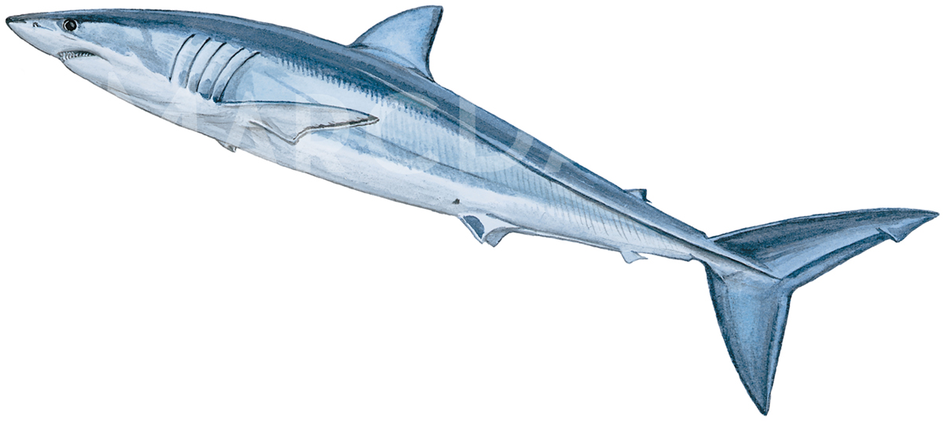
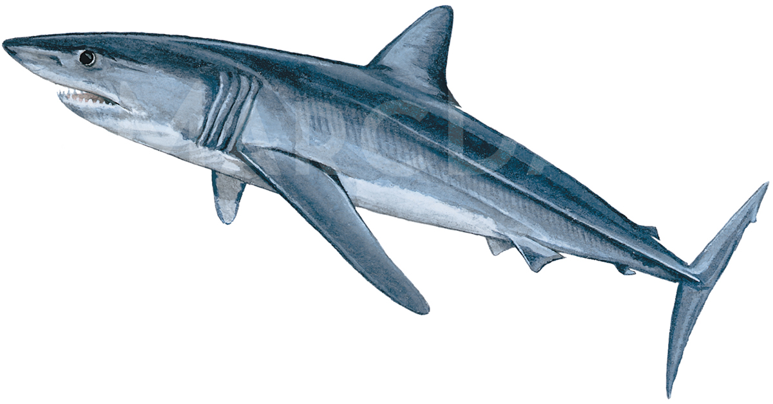

Class: | Chondrichthyes
Order: | Lamniformes
Family: | Lamnidae
Species: | Isurus oxyrinchus – Shortfin Mako  Isurus paucus – Longfin Mako
Mako sharks
Taupe bleu & Taupe petit
Marrajo dientuso & Marrajo carite

Illustration: © Marc Dando

BIOLOGY

The shortfin mako shark (Isurus oxyrinchus) and the longfin mako shark (Isurus paucus) occupy epipelagic habitats in tropical and warm-temperate seas. As a long-lived species with low fecundity (11 young every 3 years) and late age at maturity (18 years for females), population recovery times for shortfin mako are slow. While there is little information on the biology of longfin mako, it is assumed longfin mako would have similar life history traits.

DISTRIBUTION
Shortfin mako prefer temperate to tropical waters with temperatures between 17-22°C. They occur from the surface to 500 m depths and typically in oceanic waters, but have occasionally been observed in shelf seas (Vaudo et al. 2016). Records on longfin mako sharks are sporadic and their complete geographic range is not well known (Reardon et al. 2006).

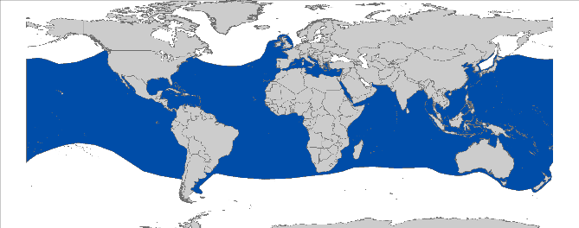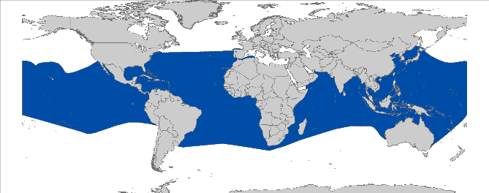
Isurus oxyrinchus Isurus paucus

Figure 1: Distribution of mako shark species courtesy of IUCN.

CRITICAL SITES
Critical sites are those habitats that may have a key role for the conservation status of a shark population, and may include feeding, mating, pupping, overwintering grounds and other aggregation sites, as well as corridors between these sites such as migration routes. Critical sites have not been accurately defined for these species in all areas, but some potentially important grounds have been proposed REFS.

POPULATION STATUS AND TRENDS
Most information available on the population status and trends in this taxon consists of fisheries catch data and is therefore either not species specific or focusses primarily on shortfin mako shark. The subpopulation structure of the longfin mako shark is widely unknown due to scarcity of data. However, it is suspected that two subpopulations in the Atlantic Ocean and an the Indo-Pacific could be isolated from each other (Reardon et al. 2006). RFMOs assessing shortfin mako are examining stocks in the North Atlantic and South Atlantic ICCAT and Indian Ocean IOTC to be undertaken in 2019 tbc. Stock units have not been defined in the Pacific Ocean. The current IUCN Red List status for the global populations for shortfin mako and longfin mako are Vulnerable (Cailliet et al. 2009) and Vulnerable (Reardon et al. 2006), respectively.

Species | Estimated Decline | Region | Time Period | Reference
ATLANTIC
Isurus oxyrinchus | 61% decline | North Atlantic | 1950-2015 | ICCAT (2017)
PACIFIC
Isurus spp. | ≈ 7% decline per year | North Pacific | 1995 to 2010 | (Clarke et al. 2013)

KEY THREATS
- Fisheries: Both species are caught in pelagic longlines, drifting or set gill nets and on hook-and line fisheries (Cailliet et al. 2009). Shortfin mako shark can constitute a considerable proportions of pelagic sharks caught in some long line fleets, but the longfin mako shark is caught in a much lower proportion due to its rarity (Reardon et al. 2006).
- International trade: The shortfin mako shark is a higher value shark species for meat products. Clarke et al. (2006) found that fins of shortfin mako sharks enter the international fin trade, where they account for approximately 2.7% of the fins traded. Longfin mako sharks are mostly sold in the same category with shortfin mako or thresher fins due to a similarity of appearance and market value.

KEY KNOWLEDGE GAPS
- Recent and accurate estimates of population sizes and demographic structure with regard to sustainable levels of fishing pressure are urgently needed;
- Further, the distribution, life-history, and ecological parameters of both species are lacking. Especially, data on Isurus paucus are underrepresented.

KEY MANAGEMENT AND CONSERVATION GAPS
- There are currently no agreed management actions for mako sharks in any RFMO area;
- National fishery or conservation measures are limited;
- Full stock assessments have only been conducted for the two Atlantic stocks, excluding the Mediterranean. The assessment for south Atlantic stock was considered to be highly uncertain.
- Critical habitats have not been identified and delineated;
- Fishery data (landings, discards, size frequency, catch and effort) are lacking in some areas.

RECOMMENDATIONS FOR CONSERVATION AND MANAGEMENT ACTION

- Incorporate conservation measures for mako sharks into national legislation of all Parties/Signatories.

- Implement relevant international measures (e.g. CMS and RFMOs).

- Improve the understanding of mako sharks through strategic research, monitoring and information exchange, including data collection of biological and distributional data and population status.

- Identify critical sites of mako shark abundance and seasonality;
- Address data gaps in biological knowledge (life history parameters) of shortfin mako
- Investigate life history of longfin mako;
- Develop stock assessment in cooperation with RFMOs for all areas;
- Further investigate post-release survivorship of mako sharks to inform improved handling and release protocols;
- Enhance or develop where necessary collection of fishery data (including landings, discards, size frequency, catch and effort where needed).

- Improve multilateral cooperation among regions & RFBs

- Support the introduction of appropriate management and conservation measures for mako sharks at international and regional fora (e.g. Co-sponsor proposals / resolutions within multilateral agreements);
- Promote better regional cooperation between RFMOs and RFBs (e.g. data-sharing or involvement in the Kobe process);
- Support the development and implementation of appropriate management plans for mako sharks;
- Identify synergies with other Range States/stakeholders to support coordinated and resource-effective research & conservation programs.

- Identify the effective approaches to reduce bycatch and improve survivorship of mako sharks, including gear modifications e.g. hook and trace type, and fishing practices e.g. soak time and safe release handling guidelines.

- Raise awareness about the threats to mako sharks

- Inform the public about the need of shark conservation via educational, social media and local outreach campaigns.

- LEGAL INSTRUMENTS

Instrument | Description | Species
Barcelona Convention  Barcelona Convention for the Protection of the Marine Environment and the Coastal Region of the Mediterranean | Annex II: Endangered or threatened species; Parties shall ensure the maximum possible protection and recovery of, while prohibiting the damage to and destruction of, these species. | I. oxyrinchus
CCSBT  Commission for the Conservation of Southern Bluefin Tuna | CCSBT encourages both Members and Cooperating Non-Members to comply with a variety of binding and non-binding measures in order to protect species ecologically related to Southern bluefin tuna, including sharks. | I. oxyrinchus
CMS  Convention on the Conservation of Migratory Species of Wild Animals | Appendix II: Migratory species that have an unfavourable conservation status and need or would significantly benefit from international cooperation; CMS Parties shall endeavour to conclude global or regional agreements to benefit these species. | I. oxyrinchus  I. paucus
FAO  Food and Agriculture Organization | IPOA Sharks: International Plan of Action for Conservation and Management of Sharks based on which states should adopt and implement a national plan of action for conservation and management of shark stocks (NPO Sharks) if their vessels conduct directed fisheries for sharks or if their vessels regularly catch sharks in non-directed fisheries. | I. oxyrinchus  I. paucus
GFCM  General Fisheries Commission for the Mediterranean | Rec. GFCM/36/2012/3: shark species listed under Annex II of the Barcelona Convention cannot be retained on board, transshipped, landed, transferred, stored, sold or displayed or offered for sale and must be released unharmed and alive to the extent possible. | I. oxyrinchus
IATTC  Inter-American Tropical Tuna Commission | Res. C-16-01: Amendment of resolution C-15-03 on the collection and analysis of data on fish-aggregating devices  Res. C-16-04: Amendment to resolution C-05-03 on the conservation of sharks caught in association with fisheries in the eastern Pacific Ocean | I. oxyrinchus
ICCAT  International Commission for the Conservation of Atlantic Tunas | Res. 95-02: Cooperation with FAO to study status of stocks & shark by-catches  Res. 03-10: Resolution by ICCAT on the sharks fishery  Rec. 04-10: Recommendation by ICCAT concerning the conservation of sharks caught in association with fisheries managed by ICCAT  Rec. 07-06: Supplemental recommendation by ICCAT concerning sharks  Rec. 10-06: Recommendation by ICCAT on Atlantic Shortfin mako sharks caught in association with ICCAT fisheries  Rec. 11-10: Recommendation by ICCAT on information collection and harmonization of data on bycatch and discards in ICCAT fisheries  Rec. 13-10: Recommendation on Biological Sampling of Prohibited Sharks Species by Scientific Observers  Rec. 14-06: Recommendation by ICCAT on Shortfin mako caught in association with ICCAT fisheries  Rec. 17-08: Recommendation by ICCAT on the conservation of North Atlantic stock Shortfin mako caught in association with ICCAT fisheries | I. oxyrinchus
IOTC  Indian Ocean Tuna Commission | Res. 13/06: On a scientific and management framework on the conservation of sharks species caught in association with IOTC managed fisheries  Res. 15/09: On a fish aggregating devices (FADs) working group  Res.17/05: On the conservation of sharks caught in association with fisheries managed by IOTC  Res. 17/07: On the prohibition to use large-scale driftnets in the IOTC Area  Res 17/08: Procedures on a FADs Management Plan including limitation on number of FADs, more detailed specifications of catch reporting from FAD sets, & development of improved designs to reduce incidence of entanglement of non-target species | I. oxyrinchus
Sharks MOU  Memorandum of Understanding on the Conservation of Migratory Sharks | Annex 1: Signatories should endeavour to achieve and maintain a favourable conservation status for these species based on the best available scientific information and taking into account their socio-economic value. | I. oxyrinchus  I. paucus
UNCLOS  United Nations Convention on the Law of the Sea | Annex I: States whose nationals fish in the region for the highly migratory species listed in Annex I shall cooperate directly or through appropriate international organizations to ensure the conservation and optimum utilization of such species throughout the region, both within and beyond the exclusive economic zone. | I. oxyrinchus  I. paucus
WCPFC  Western & Central Pacific Fisheries Commission | CMM 2008-04: Conservation and management measures to prohibit the use of large sale driftnets on the high seas in the Convention Area  CMM 2009-02: Conservation and management measures on the application of high seas FAD closure and catch retention  CMM 2010-07: Conservation and management measures for sharks  CMM 2014-05: Conservation and management measures for sharks | I. oxyrinchus

- KNOWN CRITICAL SITES
There are no known critical sites for shortfin or longfin mako. Most information on mako shark is from commercial fishing sources and thus can be biased based on fishing tactics. Increased efforts using pop-off archival satellite tags will aid in enhancing information on critical sites.

REFERENCES
Acuña E, Villarroel J, Grau R 2002. Fauna íctica asociada a la pesquería de pez espada (Xiphias gladius Linnaeus). Gayana 66: 263-267.
Amorim, A.F., Arfelli, C.A. and Fagundes, L., 1998. Pelagic elasmobranchs caught by longliners off southern Brazil during 1974–97: an overview. Marine and Freshwater Research, 49(7), pp.621-632.
Barría P, González A, Devia D, Mora S, Miranda H, Cerna F, Mieres L, Ortega J 2017. Programa de Seguimiento del Etado de Situción de las Principales Pesquerías Nacionales. Investigación Situación Recursos Altamente Migratorios, 2015. Informe Final IFOP-SUBPESCA, 547 pp.
Buencuerpo V, Rios S, Morón J 1998. Pelagic sharks associated with the swordfish, Xiphias gladius, fishery in the eastern North Atlantic Ocean and the Strait of Gibraltar. Fishery Bulletin 96: 667-685.
Bustamante C, Bennett MB 2013. Insights into the reproductive biology and fisheries of two commercially exploited species, shortfin mako (Isurus oxyrinchus) and blue shark (Prionace glauca), in the south-east Pacific Ocean. Fisheries Research 143: 174-183.
Cailliet GM, Cavanagh RD, Kulka DW, Stevens JD, Soldo A, Clo S, Macias D, Baum J, Kohin, S.,, Duarte A, Holtzhausen JA, Acuña E, Amorim A, Domingo A 2009. Isurus oxyrinchus. The IUCN Red List of Threatened Species 2009: e.T39341A10207466.
Clarke SC, Harley SJ, Hoyle SD, Rice JS 2013. Population trends in Pacific Oceanic sharks and the utility of regulations on shark finning. Conservation Biology 27: 197-209.
Clarke SC, Magnussen JE, Abercrombie DL, McAllister MK, Shivji MS 2006. Identification of shark species composition and proportion in the Hong Kong shark fin market based on molecular genetics and trade records. Conservation Biology 20: 201-211.
de Bruyn, P., REPORT OF THE 2017 ICCAT SHORTFIN MAKO ASSESSMENT MEETING.
Foulis A 2013. A retrospective analysis of shark catches made by pelagic longliners off the east coast of South Africa and biology and life history of shortfin mako shark, Isurus oxyrinchus. thesis, University of KwaZulu-Natal, Westville. p.
Groeneveld JC, Cliff G, Dudley S, Foulis A, Santos J, Wintner S 2014. Population structure and biology of shortfin mako, Isurus oxyrinchus, in the south-west Indian Ocean. Marine and Freshwater Research 65: 1045-1058.
Hanan DA, Holts DB, Coan AL 1993. The California drift gill net fishery for sharks and swordfish, 1981-82 through 1990-91, v.175. State of California, Resources Agency, Department of Fish and Game. pp.
Reardon MB, Gerber L, Cavanagh RD 2006. Isurus paucus. The IUCN Red List of Threatened Species 2006: e.T60225A12328101.
Rogers PJ, Huveneers C, Page B, Goldsworthy SD, Coyne M, Lowther AD, Mitchell JG, Seuront L 2015. Living on the continental shelf edge: habitat use of juvenile shortfin makos Isurus oxyrinchus in the Great Australian Bight, southern Australia. Fisheries Oceanography 24: 205-218.
Sepulveda CA, Kohin S, Chan C, Vetter R, Graham JB 2004. Movement patterns, depth preferences, and stomach temperatures of free-swimming juvenile mako sharks, Isurus oxyrinchus, in the Southern California Bight. Marine Biology 145: 191-199.
Tudela S, Kai AK, Maynou F, El Andalossi M, Guglielmi P 2005. Driftnet fishing and biodiversity conservation: the case study of the large-scale Moroccan driftnet fleet operating in the Alboran Sea (SW Mediterranean). Biological Conservation 121: 65-78.
Vaudo JJ, Wetherbee BM, Wood AD, Weng K, Howey-Jordan LA, Harvey GM, Shivji MS 2016. Vertical movements of shortfin mako sharks Isurus oxyrinchus in the western North Atlantic Ocean are strongly influenced by temperature. Marine Ecology Progress Series 547: 163-175.

See IUCN website for further details on the population assessments: http://www.iucnredlist.org/details/39341/0 and http://www.iucnredlist.org/details/60225/0.
http://www.tuna-org.org

