Memorandum of Understanding on the Conservation of Migratory Sharks

Great White Shark Fact Sheet

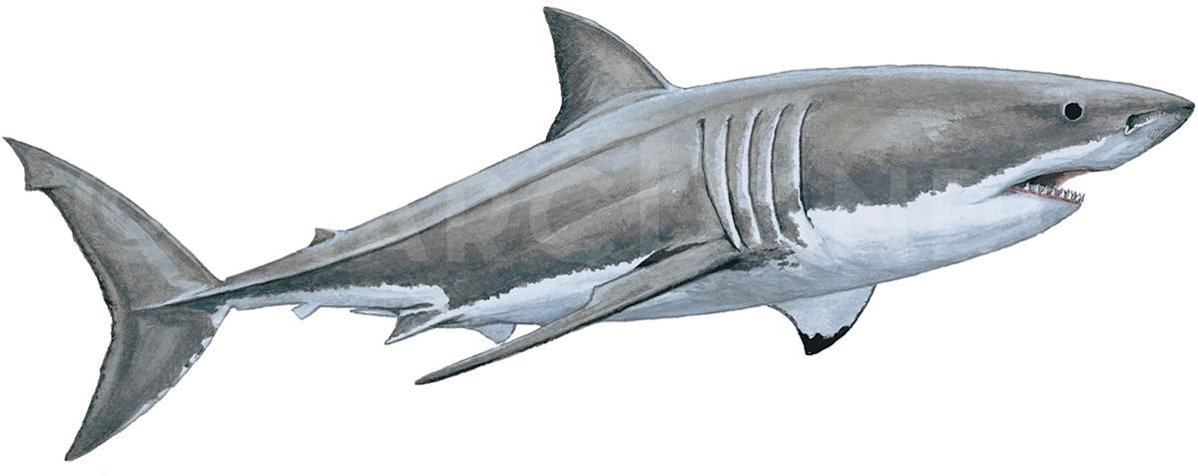

Class: Chondrichthyes Great White shark
Grand requin blanc
Order: Lamniformes Jaquetón blanco
Family: Lamnidae
Species: Carcharodon carcharias Illustration: © Marc Dando

1. BIOLOGY
Carcharodon carcharias (Great white shark) inhabit coastal waters of subtropical and temperate seas. Female age at maturity is uncertain ranging between 9 and 17 years (Smith et al. 1998,
Mollet and Cailliet (2002). Reported litter size ranges between 2- 17 pups per female (Bruce,
2008). Von Bertalanffy growth estimates of white shark range from a k value=0.159 y−1 for female sharks from Japan whereas Cailliet et al. (1985) and Wintner and Cliff (1999) reported k values of 0.058 y−1 and 0.065 y−1 (sexes combined) for individuals collected in California and South Africa, respectively. Based on bomb radio-carbon signatures, the maximum age of white sharks is up to 73 years (Hamady et al., 2014).

2. DISTRIBUTION
The white shark is distributed throughout all oceans, with concentrations in temperate coastal areas (Compagno 2001), including inter alia California, USA to Baja California, Mexico (Ainley et al. 1985, Klimley 1985, Domeier and Nasby-Lucas 2007, Lowe et al. 2012, Onate-Gonzalez et al. 2017), North West Atlantic (Casey and Pratt 1985, Curtis et al. 2014), Australia (Bruce 1992, Bruce and Bradford 2012, McAuley et al. 2017), and South Africa (Ferreira & Ferreira 1996, Dudley 2012). The Mediterranean Sea is thought to host a fairly isolated population with little or no contemporary immigration from the Atlantic (Gubili et al. 2010).

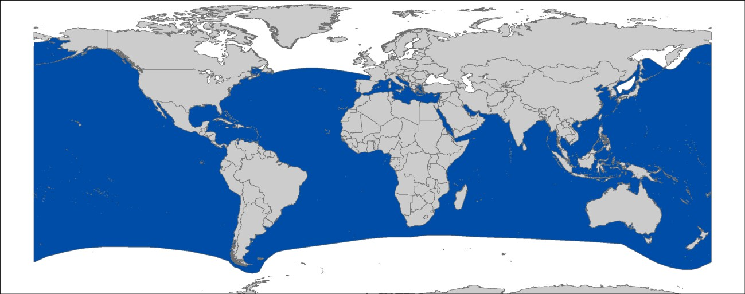
Figure 1: Distribution of Carcharodon carcharias, courtesy of IUCN.

Additionally, there is a seasonal offshore aggregation region in the subtropical northeastern Pacific (Weng et al. 2007, Domeier and Nasby-Lucas 2008, Jorgensen et al. 2009).

3. CRITICAL SITES
Critical sites are those habitats that may have a key role for the conservation status of a shark population, and may include feeding, mating, pupping, overwintering grounds and other aggregation sites, as well as corridors between these sites such as migration routes. Critical sites have not been accurately defined for these species in all areas, but some potentially important grounds have been proposed for Australia.

4. POPULATION STATUS AND TRENDS
There are no stock assessments for white shark. However, population modelling has been undertaken within Australian waters (Bruce et al. 2018; Hillary et al. 2018) and information on population trends are available for some populations and areas. The current IUCN Red List status for the global population of white sharks is Vulnerable (Fergusson et al. 2009).

Region |  | Population trend | Time Period | Reference
ATLANTIC |  | Increase | 1993-2010 | Curtis et al. 2014
INDO-PACIFIC |  | Relatively stable | 1951–2011 | Christiansen et al. 2014
Southeast Australia |  | Declines 1950-1990, Increases since 1990 in shark mesh programs | 1950-2010 | Reid et al. 2011
Eastern Australia and Zealand | New | Total population 2,500-  6,750; juvenile survival rate ~70-75%, adult survival rate ~ 90% | 1984 - 2013 | Hillary et al. 2018
Eastern Australasian population | total | Total population 5,460 (2,909-12,802). Trend in abundance not significantly different to zero (ie stable), evidence of slight decline | 1984 - 2016 | Bruce et al. 2018
 |  | over the 2000s.
Southern-western Australian adult population |  | Adult population 1,460 (760  – 2,250). Trend in abundance not significantly different to zero (ie stable), evidence of slight decline over the 2000s. | 1980 - 2014 | Bruce et al. 2018
Northeast Pacific |  | Increase in fisherydependent CPUE otters | Since 2000 | (Lowe et al. 2012, Dewar et al.  2013, Tinker et al. 2015)
KwaZulu-Natal, South Africa |  | Stable trend in beach net CPUE | 1978-2003 | (Dudley and Simpfendorfer  2006)

5. THREATS
- Fisheries: The majority of annual captures is assumed to occur incidentally in commercial fisheries operating longlines, setlines, gillnets, trawls, fish-traps and other gear. Besides, white sharks are caught in recreational fishing and shark culling (Compagno 2001, Fergusson et al. 2009).
- International trade: Shivji et al. (2005) demonstrated that white shark fins of various sizes are illegally traded, indicating their utilization as both, food and trophies.
- Habitat degradation: The degradation caused by coastal development, pollution, and prey depletion in inshore habitats utilised by white sharks might have negative impacts on the health, range, and abundance of white sharks (Fergusson et al. 2009).
- Shark Meshing (Bather Protection): Bather protection nets or Shark Meshing is used to protect humans on some popular coastal areas from shark attacks. Drum lining (Australia) and protective nets (Australia and South Africa) do result in shark mortality, but whether this is at levels that impact white shark population growth is uncertain (Dudley and Simpfendorfer 2006, Reid et al. 2011). Shark nets or drum lines are primarily not deployed in white shark aggregation sites, likely reducing their population-level impacts (Curtis et al. 2012).

6. KEY KNOWLEDGE GAPS
- Data is needed on population estimates and trends, and the delineation of critical habitats
- Understanding the potential impacts of protective beach meshing and drum line programs

7. KEY MANAGEMENT AND CONSERVATION GAPS
- Critical habitats have not been identified and delineated.
- Population dynamics modelling of the effects of protective beach meshing and drum line programs.

8. RECOMMENDATIONS FOR CONSERVATION AND MANAGEMENT ACTION
A multifaceted approach is required to address the management and conservation gaps for white sharks. Sharks MOU Signatories and other Range States are encouraged:

I. Incorporate conservation measures for white sharks into national legislation of all
Parties/Signatories (in line with CMS Appendix II & the Objective of the Sharks MOU)
− Evaluate & revise the current implementation/compliance with CITES Appendix I and CMS Appendix I obligations.

II. Improve the understanding of white sharks through strategic research, monitoring and information exchange
- Identify new white shark critical sites
- Focus on key habitats & oceanic movements for future research to support development of spatial fisheries management
- Undertake genetic studies to determine population structures
- Undertake research to better quantify the potential impacts of protective beach meshing and drum line programs on white shark populations, and mitigate those impacts if necessary
- Share research results and expertise with other stakeholders/Range States/Sharks MOU Secretariat

III. Improve multilateral cooperation among regions & RFBs
- Identify synergies with other Range States/stakeholders to support coordinated and resource-effective research & conservation programs
- Establish a working group on shark bycatch mitigation techniques with other affected
Range States
- Share methodological and technological advancements between Range States, with a focus on improving baseline population information collection from data-poor regions.

IV. Minimize interactions between fisheries and white sharks
- Relevant organizations concerned with the management of fisheries should improve the collection and reporting of standardized data
- Review fishing gears to evaluate potential modifications for reducing bycatch mortality of white sharks
- Consider gear restrictions in white shark critical sites that would help minimize bycatch mortality

V. Eco-tourism
- Establishment of ecotourism in aggregation sites to support acceptance of white sharks by local communities through generation of economic benefits
- Promote best practice guidelines for white shark tourism (cage diving, boat based breaching tours)

VI. Spatial management
- Include critical sites in marine and coastal spatial planning activities
- Undertake stakeholder consultations to ensure ownership and equitable access to resources
- Involve local communities in the management of coastal fisheries

VII. Raise awareness about the threats to White sharks
- Inform the public about the need of white shark conservation via educational, social media and local outreach campaigns
- Where shark attack mitigation programs are deemed necessary for public safety, encourage the use of non-invasive methods, and training of the public on best behavior to handle threats to humans from entering the marine environment

10. LEGAL INSTRUMENTS

Instrument | Description
Barcelona Convention  Barcelona Convention for the Protection of the Marine  Environment and the Coastal  Region of the Mediterranean | Annex II: Endangered or threatened species; Parties shall ensure the maximum possible protection and recovery of, while prohibiting the damage to and destruction of, these species.
CITES  Convention on International  Trade in Endangered Species of  Wild Fauna and Flora | Appendix I: Species threatened with extinction; trade in specimens of these species is permitted only in exceptional circumstances.
CMS  Convention on the Conservation of Migratory Species of Wild  Animals | Appendix I: Migratory species threatened with extinction; CMS Parties strive towards strictly protecting these species, conserving or restoring the places where they live, mitigating obstacles to migration and controlling other factors that might endanger them.
 | Appendix II: Migratory species that have an unfavourable conservation status and need or would significantly benefit from international cooperation; CMS Parties shall endeavour to conclude global or regional agreements to benefit these species.
EU  European Union | Council Regulation (EC) No 1185/2003: establishes a general prohibition of the practice of ‘shark finning’, whereby a shark’s fins are removed, and the remainder of the shark is discarded at sea.  Council Regulation (EU) 2018/120: prohibits for Union vessels to fish for, to retain on board, to transship or to land Great White Shark in all waters. The regulation also prohibits third-country vessels to fish for, to retain on board, and to tranship Great White Sharks in Union waters.
FAO  Food and Agriculture  Organization | IPOA Sharks: International Plan of Action for Conservation and Management of Sharks based on which states should adopt and implement a national plan of action for conservation and management of shark stocks (NPO Sharks) if their vessels conduct directed fisheries for sharks or if their vessels regularly catch sharks in non-directed fisheries.
GFCM  General Fisheries Commission for the Mediterranean | The GFCM adopted Recommendation GFCM/36/2012/3: under which shark species listed under Annex II of the Barcelona Convention cannot be retained on board, transhipped, landed, transferred, stored, sold or displayed or offered for sale and must be released unharmed and alive to the extent possible.
Sharks MOU  Memorandum of Understanding on the Conservation of Migratory  Sharks | Annex 1: Signatories should endeavour to achieve and maintain a favourable conservation status for these species based on the best available scientific information and taking into account their socio-economic value.
SPRFMO  The South Pacific Regional  Fisheries Management  Organisation | Standards for trawl fishing activities to collect data on species of concern, including white sharks, were introduced in 2017.

11. REFERENCES
Ainley D, Henderson R, Huber H, Boekelheide R, Allen S, McElroy T 1985. Dynamics of white shark/pinniped interactions in the Gulf of the Farallones. Memoirs of the Southern California Academy of Sciences 9: 109122.
Bradai MN, Saidi B 2013. On the occurrence of the Great White shark (Carcharodon carcharias) in tunisian coasts. Rapport Commission International pour l’exploration scientifique de la Mer Mediterranée, Monoco, 40. .
Brodie P, Beck B 1983. Predation by sharks on the grey seal (Halichoerus grypus) in eastern Canada. Canadian Journal of Fisheries and Aquatic Sciences 40: 267-271.
Bruce BD 1992. Preliminary observations on the biology of the white shark, Carcharodon carcharias, in south Australian waters. Marine and Freshwater Research 43: 1-11.
Bruce BD, 2008. The biology and ecology of the white shark, Carcharodon carcharias. Sharks of the open ocean: biology, fisheries and conservation. Oxford, UK: Blackwell Publishing, pp.69-81.
Bruce BD, Bradford RW 2012. Habitat use and spatial dynamics of juvenile white sharks, Carcharodon carcharias, in eastern Australia. Global Perspectives on the Biology and Life History of the White Shark: 225-254.
Bruce BD, Bradford RW 2013. The effects of shark cage-diving operations on the behaviour and movements of white sharks, Carcharodon carcharias, at the Neptune Islands, South Australia. Marine Biology 160: 889-907.
Bruce BD, Bradford RW, Bravington M, Feutry P, Grewe P, Gunasekera R, Harasti D, Hillary R and Patterson T 2018.
A national assessment of the status of White Sharks. National Science Programme, Marine Biodiversity Hub, CSIRO.
Cailliet GM, Natanson LJ, Welden BA, Ebert DA, 1985. Preliminary studies on the age and growth of the white shark, Carcharodon carcharias, using vertebral bands. Memoirs of the Southern California Academy of Sciences, 9(4), pp.49-60.
Casey JG, Pratt Jr HL 1985. Distribution of the white shark, Carcharodon carcharias, in the western North Atlantic. Memoirs of the Southern California Academy of Sciences 9: 2-14.
Chapple TK, Jorgensen SJ, Anderson SD, Kanive PE, Klimley AP, Botsford LW, Block BA 2011. A first estimate of white shark, <em>Carcharodon carcharias</em>, abundance off Central California. Biology Letters.
Christiansen HM, Lin V, Tanaka S, Velikanov A, Mollet HF, Wintner SP, Fordham SV, Fisk AT, Hussey NE 2014. The last frontier: catch records of white sharks (Carcharodon carcharias) in the Northwest Pacific Ocean. PLoS One 9: e94407.
Compagno LJ 2001. Sharks of the world: an annotated and illustrated catalogue of shark species known to date, v.2. Food & Agriculture Org. pp.
Curtis TH, Bruce BD, Cliff G, Dudley SF, Klimley AP, Kock A, Lea RN, Lowe CG, 2012. Responding to the risk of White Shark attack. Global Perspectives on the Biology and Life History of the White Shark. CRC Press, pp.477-510.
Curtis TH, McCandless CT, Carlson JK, Skomal GB, Kohler NE, Natanson LJ, Burgess GH, Hoey JJ, Pratt HL, Jr. 2014. Seasonal Disribution and Historic Trends in Abundance of White Sharks, Carcharodon carcharias, in the Western North Atlantic Ocean. PLoS One 9: e99240.
Dewar H, Eguchi T, Hyde J, Kinzey DH, Kohin S, Moore J, Taylor BL, Vetter R, 2013. Status review of the northeastern Pacific population of white sharks (Carcharodon carcharias) under the Endangered Species Act.
Dicken M, Smale M, Booth A 2013. White sharks Carcharodon carcharias at Bird Island, Algoa Bay, South Africa. African Journal f Marine Science 35: 175-182.
Domeier ML, Nasby-Lucas N 2007. Annual re-sightings of photographically identified white sharks (Carcharodon carcharias) at an eastern Pacific aggregation site (Guadalupe Island, Mexico). Marine Biology 150: 977-984. Domeier ML, Nasby-Lucas N, 2008. Migration patterns of white sharks Carcharodon carcharias tagged at Guadalupe Island, Mexico, and identification of an eastern Pacific shared offshore foraging area. Marine Ecology Progress Series, 370, pp.221-237.
Dudley SF, Simpfendorfer CA 2006. Population status of 14 shark species caught in the protective gillnets off KwaZulu–Natal beches, South Africa, 1978–2003. Marine and Freshwater Research 57: 225-240.
Dudley SFJ, 2012. A review of research on the white shark, Carcharodon carcharias (Linnaeus), in southern Africa. In ‘Global Perspectives on the Biology and Life History of the White Shark’. (Ed. M. L. Domeier.) pp. 511–533. (CRC Press: Boca Raton, FL.)
Duffy CA, Francis MP, Manning MJ, Bonfil R 2012. Regional population connectivity, oceanic habitat, and return migration reveaed by satellite tagging of white sharks, Carcharodon carcharias, at New Zealand aggregation sites. Global Perspectives on the Biology and Life History of the White Shark: 301-318.
Ebert D, Stehmann M 2013. Sharks, batoids, and chimaeras of the North Atlantic. FAO Species Catalogue for Fishery Purposes No. 7. Food and Agricultural Organization of the United Nations (FAO). FAO, Rome.
Fergusson I 1996. Distribution and autecology of the white shark in the eastern North Atlantic Ocean and the Mediterranean Sea. In: Klimley AP,Ainley DG, editors. Great White Sharks: The Biology of Carcharodon carcharias. San Diego: Academic Press. pp. 321–345.
Fergusson I, Compagno LJV, Marks M 2009. Carcharodon carcharias. The IUCN Red List of Threatened Species 2009: e.T3855A10133872.
Ferreira C, Ferreira T 1996. Population dynamics of white sharks in South Africa. Great white sharks: the biology of Carcharodon carcharias. Academic, San Diego: 381-391.
Galván-Magaña F, Hoyos-Padilla EM, Navarro-Serment CJ, Márquez-Farías F 2010. Records of white shark, Carcharodon carcharias, in the Gulf of California, Mexico. Marine Biodiversity Records 3.
Gubili C, Bilgin R, Kalkan E, Karhan SÜ, Jones CS, Sims DW, Kabasakal H, Martin AP, Noble LR 2010. Antipodean white sharks on a Mediterranean walkabout? Historical dispersal leads to genetic discontinuity and an endangered anomalous population. Proceedings of the Royal Society of London B: Biological Sciences:
rspb20101856.
Gubili C, Bilgin R, Kalkan E, Ünsal Karhan S, Jones CS, Sims DW, Kabasakal H, Martin AP, Noble LR 2011. Antipodean white sharks on a Mediterranean walkabout? Historical dispersal leads to genetic discontinuity and an endangered anomalous population. Proc R Soc B 278.
Hamady LL, Natanson LJ, Skomal GB, Thorrold SR, 2014. Vertebral bomb radiocarbon suggests extreme longevity in white sharks. PloS one, 9(1), p.e84006.
Harasti D, Lee K, Bruce B, Gallen C, Bradford R 2017. Juvenile white sharks Carcharodon carcharias use estuarine environments in south-eastern Australia. Marine Biology 164: 58.
Hillary RM, Bravington MV, Patterson TA, Grewe P, Bradford R, Feutry P, Gunasekera R, Peddemors V, Werry J, Francis MP and Duffy CAJ 2018. Genetic relatedness reveals total population size of white sharks in eastern Australia and New Zealand. Scientific reports, 8(1), p.2661.
Hussey N, Christiansen H, Cliff G, Dudley S, P Wintner S, Fisk A 2012. Size-Based Analysis of Diet and Trophic Position of the White Shark, Carcharodon carcharias, in South African Waters. 27-45 pp.
Jorgensen SJ, Reeb CA, Chapple TK, Anderson S, Perle C, Van Sommeran SR, Fritz-Cope C, Brown AC, Klimley AP, Block BA 2009. Philopatry and migration of Pacific white sharks. Proceedings of the Royal Society of London B: Biological Sciences: rspb20091155.
Kelly JT, Klimley AP, 2003. The occurrence of the white shark, Carcharodon carcharias, at the Point Reyes Headlands, California. Bulletin of the California Department of Fish and Game 89:187–196.
Klimley AP, 1985. The areal distribution and autoecology of the white shark, Carcharodon carcharias, off the west coast of orth America. Memoirs of the Southern California Academy of Sciences, 9, pp.15-40.
Klimley AP, Le Boeuf BJ, Cantara KM, Richert JE, Davis SF, Van Sommeran S, Kelly JT 2001. The hunting strategy of white sharks(Carcharodon carcharias) near a seal colony. Marine Biology 138: 617-636.
Kock A, Johnson R 2006. White shark abundance: not a causative factor in numbers of shark bite incidents. Finding a balance: White shark conservation and recreational safety in the inshore waters of Cape Town, South Africa: 1-19.
Kock A, O’Riain MJ, Mauff K, Meÿer M, Kotze D, Griffiths C 2013. Residency, habitat use and sexual segregation of white sharks, Carcharodon carcharias in False Bay, South Africa. PLoS One 8: e55048.
Lowe CG, Blasius ME, Jarvis ET, Mason TJ, Goodmanlowe GD, O’Sullivan JB, 2012. Historic fishery interactions with white sharks in the Southern California Bight. Global Perspectives on the Biology and Life History of the White
Shark’.(Ed. ML Domeier.) pp, pp.169-186
McAuley, RB, Bruce, BD, Keay, IS, Mountford S, Pinnell, T & Whoriskey, FG 2017. Broad-scale coastal movements of white sharks ff Western Australia described by passive acoustic telemetry data. Marine and Freshwater Research 68: 1518-1531.
Mollet HF, Cailliet GM, 2002. Comparative population demography of elasmobranchs using life history tables, Leslie matrices and stage-based matrix models. Marine and Freshwater Research, 53(2), pp.503-515.
Oñate-González EC, Sosa-Nishizaki O, Herzka SZ, Lowe CG, Lyons K, Santana-Morales O, Sepulveda C, GuerreroÁvila C, García-Rodríguez E, O'Sullivan JB, 2017. Importance of Bahia Sebastian Vizcaino as a nursery area for white sharks (Carcharodon carcharias) in the Northeastern Pacific: a fishery dependent analysis. Fisheries research, 188, pp.125-137.
Reid DD, Robbins WD, Peddemors VM, 2011. Decadal trends in shark catches and effort from the New South Wales, Australia, Shark Meshing Program 1950–2010. Marine and Freshwater Research, 62(6), pp.676-693.
Shivji MS, Chapman DD, Pikitch EK, Raymond PW 2005. Genetic profiling reveals illegal international trade infins of the greatwhite shark, Carcharodon carcharias. Conservation Genetics 6: 1035-1039.
Skomal GB, Chisholm J, Correia SJ 2012. Implications of increasing pinniped populations on the diet and abundance of white sharks off the coast of Massachusetts. Global Perspectives on the Biology and Life History of the
White Shark’.(Ed. ML Domeier.) pp: 405-418.
Smith SE, Au DW, Show C, 1998. Intrinsic rebound potentials of 26 species of Pacific sharks. Marine and Freshwater Research, 49(7), pp.663-678.
Tinker MT, Hatfield BB, Harris MD, Ames JA, 2016. Dramatic increase in sea otter mortality from white sharks in California. Marine Mammal Science, 32(1), pp.309-326.
Weng KC, Boustany AM, Pyle P, Anderson SD, Brown A, Block BA, 2007. Migration and habitat of white sharks (Carcharodon carcharias) in the eastern Pacific Ocean. Marine Biology, 152(4), pp.877-894.
Weng K, Honebrink R 2013. Occurrence of white sharks (Carcharodon carcharias) in Hawaiian waters. Journal ofMarine Biology 203.
Wintner SP, 1999. Age and growth determination of the white shark, Carcharodon carcharias, from the east coast of South Africa. Fish. Bull., 97, pp.153-169.

Map requires updating: The species is not present in the Red Sea and Arabian/Persian Gulf.
See the IUCN website for further details on the population assessment: http://www.iucnredlist.org/details/3855/0.

