|  |  |  |
| --- | --- | --- |
|  | **CONVENTION ON**  **MIGRATORY**  **SPECIES** | UNEP/CMS/COP13/Doc.28.2.8  24 September 2019  Original: English |

13th MEETING OF THE CONFERENCE OF THE PARTIES

Gandhinagar, India, 17 - 22 February 2020

Agenda Item 28.2

**PROPOSAL FOR A CONCERTED ACTION FOR**

**THE COMMON GUITARFISH (*Rhinobatos rhinobatos*)**

**LISTED ON APPENDIX II OF THE CONVENTION,**

**THE LARGETOOTH SAWFISH (*Pristis pristis*)**

**LISTED ON APPENDIX I AND II OF THE CONVENTION**

**AND THE SMALLTOOTH SAWFISH (*Pristis pectinata*)**

**LISTED ON APPENDIX I and II OF THE CONVENTION**\*

Summary:

The Government of Gabon has submitted the attached proposal for a Concerted Action for the Common Guitarfish (*Rhinobatos rhinobatos*) the Largetooth Sawfish (*Pristis pristis*), and Smalltooth Sawfish (*Pristis pectinata*) in accordance with the process elaborated in Resolution 12.28.

*The geographical designations employed in this document do not imply the expression of any opinion whatsoever on the part of the CMS Secretariat (or the United Nations Environment Programme) concerning the legal status of any country, territory, or area, or concerning the delimitation of its frontiers or boundaries. The responsibility for the contents of the document rests exclusively with its author

**PROPOSAL FOR A CONCERTED ACTION FOR**

**THE COMMON GUITARFISH (*Rhinobatos rhinobatos*)**

**LISTED ON APPENDIX II OF THE CONVENTION,**

**THE LARGETOOTH SAWFISH (*Pristis pristis*)**

**LISTED ON APPENDIX I AND II OF THE CONVENTION**

**AND THE SMALLTOOTH SAWFISH (*Pristis pectinata*)**

**LISTED ON APPENDIX I and II OF THE CONVENTION**\*

1. **Proponent:**

Government of Gabon

Agence Nationale des Parcs Nationaux du Gabon - ANPN

(National Parks Agency of Gabon)

Contact: Aurelie Flore KOUMBA PAMBO, Conseiller Scientifique

1. **Target species, lower taxon or population, or group of taxa with needs in common:**

Class: Chondrichthyes

Subclass: Elasmobranchii

Order: Rhinopristiformes

Family: Rhinobatidae

Species: ***Rhinobatos rhinobatos*** (CMS Appendix II - global population)

Family: Pristidae

***Pristis pristis*** (CMS App I and II)

***Pristis pectinata*** (CMS App I and II)

The current proposal for Concerted Action focuses on the conservation of the above-mentioned CMS-listed species from the two families Rhinobatidae and Pristidae.

However, the order Rhinopristiformes includes a variety of species, which share similar habitat requirements (shallow and warm waters with sandy bottoms) and which are impacted by similar threats. While prioritizing CMS-listed species in the context of this proposal, other Rhinopristiformes species that are present in the marine areas of Gabon would also benefit from the planned activities.

The order includes five families:

* Glaucostegidae (giant guitarfish),
* Pristidae (sawfish),
* Rhinidae (wedgefish),
* Rhinobatidae (guitarfish) and
* Trygonorrhinidae (banjo rays).

The term “Rhino ray” is a term used collectively for the five family-level groups of the Rhinopristiformes.

The following species of rhino rays are currently present in Gabon (source IUCN),

|  |  |  |
| --- | --- | --- |
| ***Species*** | **Family** | **IUCN status** |
| *Rhinobatos albomaculatus* | RHINOBATIDAE | Vulnerable |
| *Rhinobatos irvinei* | RHINOBATIDAE | Vulnerable |
| *Rhinobatos rhinobatos* | RHINOBATIDAE | Endangered |
| *Rhynchobatus luebberti* | RHINIDAE | Endangered |
| *Glaucostegus cemiculus* | GLAUCOSTEGIDAE | Endangered |
| *Pristis pristis* | PRISTIDAE | Critically Endangered |
| *Pristis pectinata* | PRISTIDAE | Critically Endangered |

1. **Geographical range:**

### **iii.a CMS-listed species proposed for Concerted Action**

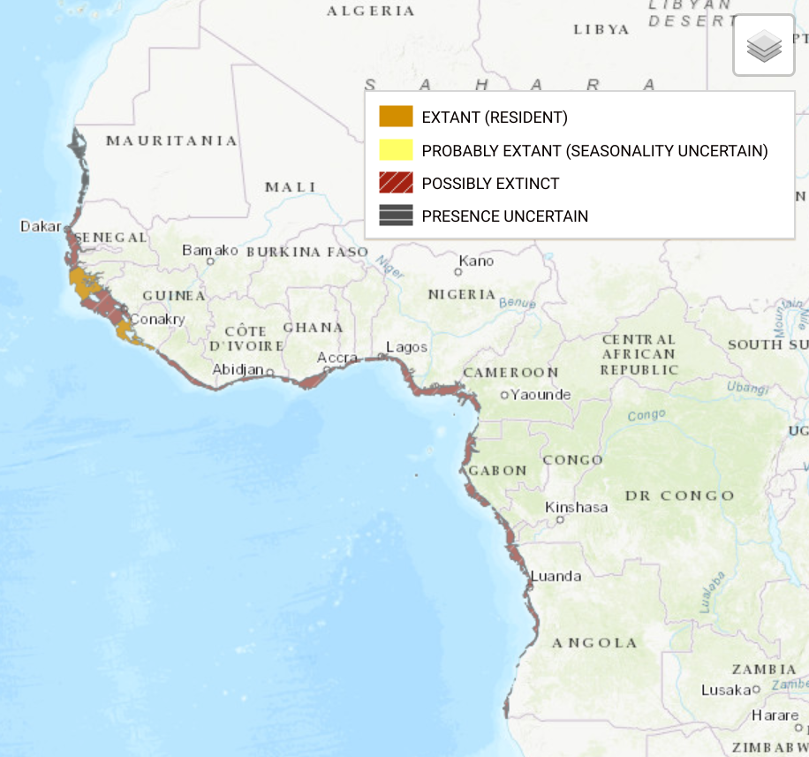

**Largetooth Sawfish** (*Pristis pristis*) geographical range. Source www.iucnredlist.org.

The **Largetooth Sawfish** (*Pristis pristis*) formerly had a widespread tropical distribution, consisting of four sub-populations (Eastern Atlantic, Western Atlantic, Eastern Pacific and Indo-West Pacific). All subpopulations have undergone significant population declines and the species is now apparently extinct in many former Range States. Recent records are rare and there have been very few records in the Eastern Atlantic in the last decade. Current records indicate that Largetooth Sawfish can only be regularly encountered today in the Western Atlantic and in the Indo-West Pacific and northern Australia.

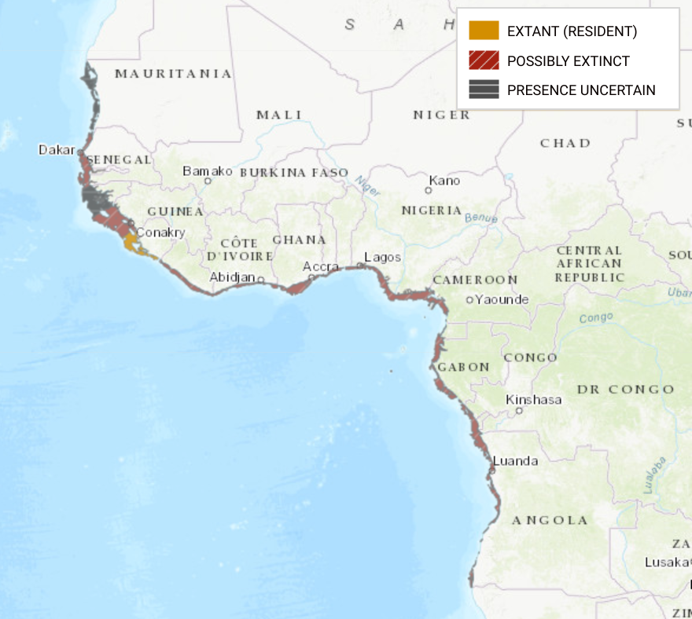

**Smalltooth Sawfish** (*Pristis pectinata*) geographical range. Source [www.iucnredlist.org](http://www.iucnredlist.org).

The **Smalltooth Sawfish** (*Pristis pectinata*) has been wholly or nearly extirpated from large areas of its former range in the Atlantic Ocean by fishing (trawl and inshore netting) and habitat modification. The remaining populations are now small, and fragmented. The species can only be reliably encountered in the Bahamas (where suitable habitat is available) and the United States (Georgia south to Louisiana). It is rare but present in Honduras, Belize, Cuba, Sierra Leone, and possibly Guinea-Bissau and Mauritania. Formerly inhabiting large areas of the west coast of Africa, it is now possibly extinct in most parts of the region.

**Common guitarfish** (*Rhinobatos rhinobatos*) geographical range. Source [www.iucnredlist.org](http://www.iucnredlist.org).

The **Common Guitarfish** (*Rhinobatos rhinobatos*) is a guitarfish known from the southern Bay of Biscay, southwards to Angola, including the Mediterranean Sea. Although the distribution is fairly wide, it is subjected to fishing pressures throughout most of its range. The Common Guitarfish is believed to face similar threats as the Blackchin Guitarfish *Rhinobatos cemiculus*.

### **iii.b Non-CMS-listed species within the order Rhinprisitiformes, which would benefit from the Concerted Action**

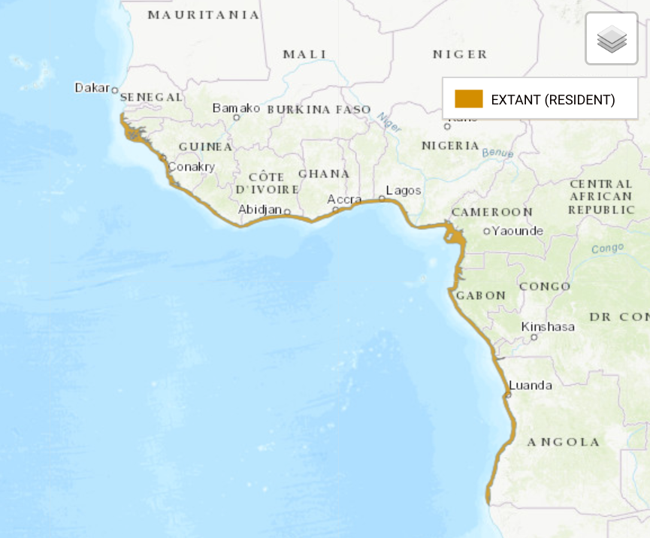

**White-spotted Guitarfish** (*Rhinobatos albomaculatus*) geographical range. Source [www.iucnredlist.org](http://www.iucnredlist.org).

The **White-spotted Guitarfish** (*Rhinobatos albomaculatus*) is an inshore guitarfish known to be present in the Eastern Central Atlantic from southern Senegal to Angola. This species occurs in shallow coastal waters to about 35 m depth.

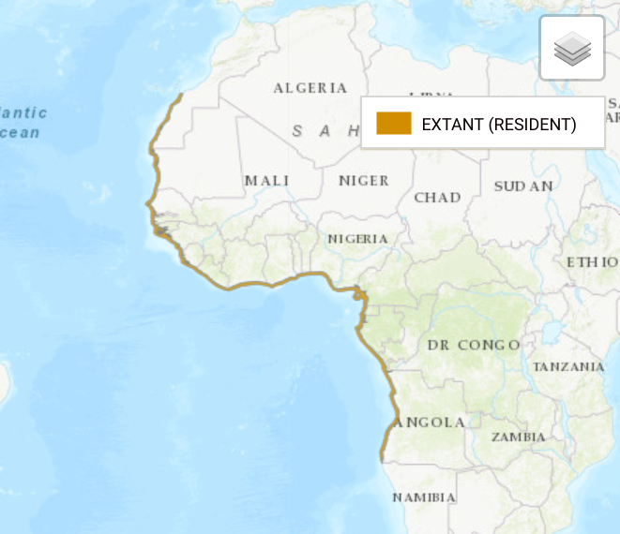

**Spineback Guitarfish** (*Rhinobatos irvinei*) geographical range. Source [www.iucnredlist.org](http://www.iucnredlist.org).

The **Spineback Guitarfish** (*Rhinobatos irvinei*) is known from Morocco to southern Angola, along the western Africa coast, in shallow waters to 30 m depth.

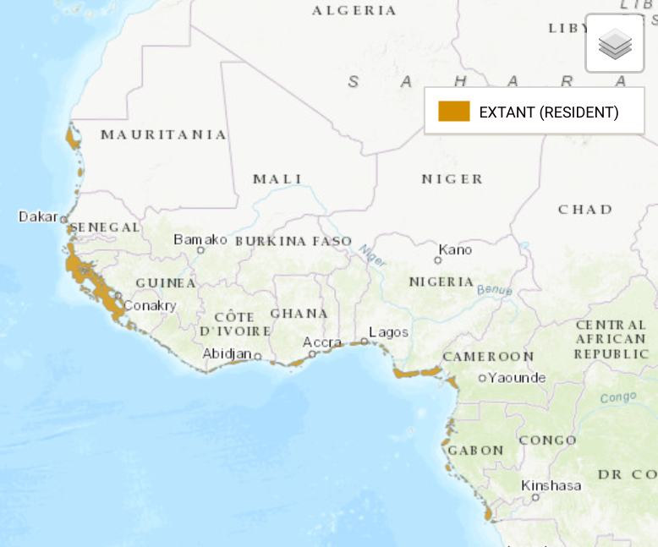

**African wedgefish** (*Rhynchobatus luebberti*) geographical range. Source [www.iucnredlist.org](http://www.iucnredlist.org).

The **African Wedgefish** (*Rhynchobatus luebberti*) is an inshore coastal batoid found from the intertidal zone generally to a depth of 35 m. Occurring off the west coast of Africa from Mauritania through the Gulf of Guinea south to Angola. The African Wedgefish was once moderately abundant in some areas of its distribution but is now taken less frequently.

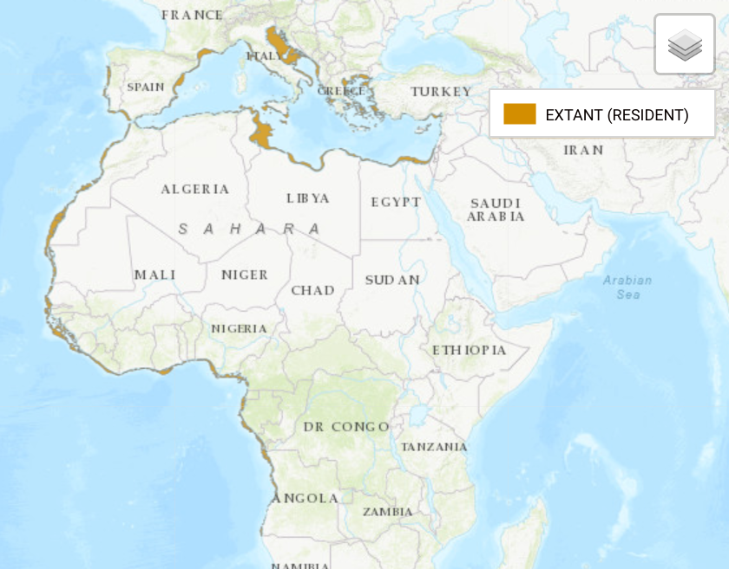

**Blackchin Guitarfish** (*Glaucostegus cemiculus*) geographical range. Source [www.iucnredlist.org](http://www.iucnredlist.org).

The distribution of the **Blackchin Guitarfish** (*Glaucostegus cemiculus*) extends between 42°N to 17°S, 19°W to 36°E. From the Northern coast of Portugal, down the west African coast and including the Mediterranean Sea. *Glaucostegus cemiculus* is targeted throughout its range in West Africa.

1. **Summary of Activities:** Gabon recently established a complex of marine protected areas and aquatic reserves that now protects and regulates more than 20 per cent of its Economic Exclusive Zone. This represents one of the largest conservation efforts along the west coast of Africa. In the context of the newly established protected areas, the ANPN is promoting a baseline biodiversity assessment of its protected areas with the goal of characterizing marine vertebrate biodiversity at large and small scale with a particular focus on the Rhinopristiformes and the characterization of their natural environment and abundance.

The necessity to cover an extensive area (marine protected areas and marine national parks range between 12 km2 to up to 900 km2 in extent) requires a combination of different techniques. Biological sampling will be done at different scales. The large-scale sampling will be done via eDNA analysis of water samples. These will be collected across all major estuaries and will serve as synoptic biological assessment. At an intermediate scale, BRUVS (Baited Remote Underwater Video Stations) and echo-sounders will allow characteristics and biomass of the fish populations to be determined. At a smaller scale, divers will perform transects to identify in more detail individual fish species and potentially benthic populations. Environmental variables will also be collected from in-situ observations in order to complete the ecological picture of the ecosystems as well as catch data from observers on artisanal and industrial vessels to estimate catches of sensitive species and Rhinopristiformes outside the MPAs.

The legal protection of *Pristis pristis*, *Pristis pectinata* and *Rhinobatos rhinobatos* will also be established with the inclusion of these species in a list of marine protected species. This will ensure no commercial exploitation of these species. This will also allow to justify the design of management plans around the protection of these endangered species.

1. **Activities and expected outcomes:** Activities will cover two main areas: a large-scale study of the basal biodiversity in the Marine Protected Areas and the development of the legal framework for the protection of Rhinopristiformes and other marine protected species in Gabon.
   1. **Basal biodiversity assessment in the Marine Protected Areas**

All target sites will be characterized geographically according to environmental parameters such as bathymetry, pluviometric regimes, river outflows, chlorophyll concentration variability, ocean upwelling, and current speed and sea surface temperature. The anthropogenic impact will also be estimated when possible based on the presence of pirogues at nearby landing sites or local villages. Traditional fishery is allowed in the marine parks. Environmental parameters will be collected and analyzed from publicly available repositories and won’t require dedicated field campaigns. Data will be validated when possible in situ during sampling operations. River mouths are expected to be significantly saltier than the estuaries and mostly affected by the interaction of river outflows, ocean currents, and coastal topography. Estuaries on the other side are expected to be mostly affected by tidal currents and river outflows. Sampling is designed to target primarily pelagic species. A variety of sampling methods will be implemented in order to cover the complexity and the extent of the ecological systems.

**Divers and manta tows** Direct observations with divers have been employed successfully in other areas of Gabon. North of Libreville, in the area of the Komo Delta, divers have successfully sampled fish and benthic communities of the marine protected areas of Akanda. Here the ANPN proposes to implement a similar approach at specific sites as this allows to identify both benthic and pelagic species. This methodology can be applied to areas with relatively limited visibility (1-2 m) but will be limited to small scale surveys.

**BRUVS** In an effort to maintain a non-invasive sampling approach, we will implement the use of BRUVS (Baited Remote Underwater Video Stations, Miller et al. [2017], Whitmarsh et al. [2017]) in order to study distribution, abundance and biomass of fish population. This consists in the use of bait to attract fish assemblies to a recording underwater camera. This method has been proven to be an effective tool to sample species from all trophic levels [Murphy and Jenkins, 2010] and has been extensively tested on sharks and rays [White et al.,2013].

**Biomass estimates via echo-sounder** echo-sounders are instruments used to quantitatively measure biomass in the marine domain and can be used to identify fish species, size of groups and of course biomass. Echo-sounders will be used to cover the whole extent of the MPAs producing valuable data for conservation and fishery management.

**eDNA** is a relatively new technology that allows to determine presence-absence of marine species as well as relative abundance from water samples [Baird and Hajibabaei, 2012, Aylagas et al., 2014, Pawlowski et al., 2018, Pikitch, 2018]. Water samples are collected at various sites from which DNA is then extracted, amplified and sequenced. DNA samples are then compared against catalogues of known species for identification. eDNA is well suited for quantification of relative abundance of identified species as well as general taxa identification and will be used to obtain a synoptic scale assessment of the communities inhabiting the MPAs.

**Catch data** data are collected from various sources such as the observer programme on artisanal and industrial fisheries at landing sites and during fishing missions. These data will be integrated in the assessment and will provide information on the presence of rhino rays and sensitive species outside the protected areas.

* 1. **Legal Protection**

Legal protection for *Pristis pristis*, *Pristis pectinata* and *Rhinobatos rhinobatos* will be integrated in the list of marine protected species currently being developed for Gabon. This activity will be supported by the results of the biodiversity assessment which will be presented to the administration together with a text for the protection of endangered marine species. Activities will focus on developing a draft of the legal document, presentation of the document to the administration together with results from the biodiversity assessment. Final integration of the proposed document into law will depend on the availability of the administration.

Please refer to Annex 1 for an overview of activities.

1. **Associated benefits:** The proposed actions fall in the context of the Concerted Action plan proposed by the IUCN Species Survival Commission Shark Specialist Group (SSG) at the global scale. Gabon and the SSG are working together to ensure coordination of future conservation efforts and implementation of global strategies at the national scale.

This work will allow to ultimate the first biodiversity assessment of the fish component of the marine protected areas established in 2017. Gabon is then planning the assessment of the benthic and environmental component via the Arc d’Emeraude programme similarly to what previously done in the province Estuaire in the delta of the River Komo [Menut et al., 2018]. The role of river mouths in productivity of fishing zones is also addressed in which these represent an important fishing zone for local communities and potentially breeding grounds for species targeted in the adjacent fishing zones. Understanding the characteristics of the fish population structure in the MPAs will allow to design better management strategies in the fishing zones.

Data collected in the MPAs can be integrated with the datasets coming from the Rigs-to-Reef project, which is currently under development. Rigs-to-Reef is a study of the role and impact of oil rigs on the ecosystems, which involves a biodiversity assessment and connectivity study of the communities developing in the vicinity of oil platforms. One of the hypotheses is that when rigs are geographically and ecologically connected to marine protected areas, these can serve as islands in a metapopulations network. This hypothesis will be addressed by comparing results about population structure on both oil rigs and river mouths as well as the connectivity study part of the Rigs-to-Reef project.

Ultimately, the proposed actions will be done in collaboration with international experts which will allow local capacity building. This contribution will be valuable for future monitoring programs and sustainability of the proposed actions. In particular, it will be proposed that at least one doctorate student will be Gabonese and that will be trained on the eDNA analysis.

1. **Timeframe:** Activities will span over a period of two years. The first three months will be dedicated to project development and literature review. The following year will be dedicated to field campaigns where we plan to spend one month per site and to cover a total of 10-15 sites. The last nine months will be dedicated to data analysis and report writing.

Please refer to Annex 1 for an overview of activities.

1. **Relationship to other CMS actions:** The proposed actions fall in the context of a Concerted Action Plan by the IUCN Species Survival Commission Shark Specialist Group (SSG) for the coordination of conservation actions at the regional scale. The SSG will focus on the creation of a network of researchers, improve data collection and sharing among partners, promote public awareness raising campaigns and recommendations for better resource management. Gabon will work in direct collaboration with the SSG to support the implementation of the proposed actions from the global scale to the national scale.

*Rhinobatos rhinobatos, Pristis pristis and Pristis pectinata* are also listed in the Sharks MOU, which aims to promote international cooperation and to sustain conservation efforts for migratory sharks and rays included in its Annex 1. The Concerted Actions would support the efforts of the Sharks MOU by providing insights into then population status in Gabonese waters and promoting conservation efforts in the MPAs.

The CMS Scientific Council’s Bycatch Working Group promotes the use of fishing techniques that reduce bycatch of CMS species. The proposed actions will result in national regulations that will protect CMS species such as through the use of Turtle Exclusion Devices on fish trawlers and the definition of fishing seasons in the management plans.

1. **Conservation priority:** Both species of sawfish that have habitat ranges in west Africa (*Pristis pectinata* and *Pristis pristis*) are classified as Critically Endangered by IUCN. Of these two, Smalltooth Sawfish (*Pristis pectinata)* is now possibly extinct in this region. The Common Guitarfish (*Rhinobatos rhinobatos*) as well as the Blackchin Guitarfish (*Glaucostegus cemiculus*) suffered significant declines in reported catch and while they used to extend over large habitat, they have disappeared from most of it and are now classified as Endangered by IUCN. For these reasons, the Glaucostegus family is now listed in Appendix II of CITES. In the northern Mediterranean, both species used to be quite common but are now considered extinct. In the Balearic Islands both species were considered as typical inhabitants of unvegetated sandy bottoms. Old fishermen reported their relative frequency during the first half of the 20th century, but nowadays they seem to be extinct in the area as well. White-spotted Guitarfish (*Rhinobatos albomaculatus*) and the Spineback Guitarfish (*Rhinobatos irvinei*) suffer from similar threats as the other Rhinobatos spp and are classified as Vulnerable by IUCN.
2. **Relevance:** *Pristis pristis* as well as *Pristis pectinata* are currently listed in Appendix I and II of CMS. *Rhinobatos rhinobatos* is listed on Appendix II of CMS globally and in Appendix I and II for its Mediterranean Sea population. Collective action is needed to identify threats, presence and habitats in the subregion. Gabon represents the only country in the Gulf of Guinea with a network of MPAs and can potentially be hosting one of the few remaining healthy populations of rhino rays in the subregion.
3. **Absence of better remedies:** Rhino rays are caught as bycatch by artisanal fisheries and industrial fisheries. Artisanal fisheries are allowed to fish in coastal areas with traditional fishermen, who are permitted to fish in the protected areas. Industrial fisheries are mostly constituted of bottom trawlers, and rhino rays are routinely caught and sold on local markets.

With the establishment of marine protected areas in Gabon, the goal is to create suitable habitats for reproduction of sensitive and threatened species. Although it is currently still unclear what species inhabit the subregion and the protected areas in Gabon. However, marine protected areas in Gabon may represent a potential hotspot for Rhinobatidae in the subregion.

The lack of scientific evidence of the presence and ecology of Rhinobatidae in Gabon makes their inclusion on a list of protected species problematic. As of today the list of protected species does not cover any fish and we hope that results from the proposed actions will allow to extend the list to the species object of this proposal as well as other marine species in Gabon.

1. **Readiness and feasibility:** Similar studies to characterize the biodiversity of the coastal habitats in Gabon have been carried out successfully in the context of Arc Emerald [Menut et al., 2018] and Rigs-to-Reef [Friedlander et al., 2014]. These projects have been coordinated and conducted by the National Parks Agency (ANPN) in Gabon in collaboration with external partners.

For this project, the ANPN proposes a similar model with the bulk of the activities that will be conducted by ANPN and its partners (WCS, CENAREST, IRD). Specific activities will, however, require the support of external partners. The aim of this proposal for Concerted Action under CMS is therefore also to generate international support from CMS Parties and partner organizations for the implementation of the project.

Moreover, the proposed biodiversity assessment will support the activities of the management plans for the AMPs which are already supported in the context of the structural fund from USFWS and will likely drive the interest of other funding and research agencies for example for the assessment of the benthic communities.

1. **Likelihood of success:** The feasibility of the actions is supported by the good management of the ANPN and the momentum coming from the recent establishment of a network of marine protected areas of Gabon. The proposed actions fall in the context of the already scheduled work of the management plans for the MPAs which will require the development of surveillance strategy as well as detailed fishing regulations for artisanal and sport fishermen. Results from the proposed actions will be integrated in the to be developed management plans and will serve to develop future monitoring programs.
2. **Magnitude of likely impact:** Results from the proposed activities will drive conservation strategies in MPAs as well as the aquatic reserves, which in some cases extend into the industrial fishing zones. It is anticipated that these Concerted Actions will increase the understanding of the marine ecosystems not just in Gabon but in the subregion where a general lack of biodiversity studies prevents the development of effective conservation strategies.
3. **Cost-effectiveness:** The proposed activities are considered to be fundamental for the development of a management plan for marine protected areas that takes into account the conservation requirements of CMS-listed species and other species of conservation concern. The proposed survey methods are in line with general scientific standards applied under conditions found in Gabonese waters.
4. **Consultations-Planned/Undertaken:**

* ANPN has already consulted with CMS IUCN and Sea Shepherd Legal.
* WCS has been a long-term partner of ANPN and are currently working in Congo to develop a marine program similar to the one developed in Gabon.

1. **References:**

* Eva Aylagas, Ángel Borja, and Naiara Rodríguez-Ezpeleta. Environmental status assessment using DNA metabarcoding: Towards a genetics-based marine biotic index (gAMBI). PLoS ONE, 9(3), 2014. ISSN 19326203. doi:10.1371/journal.pone.0090529.
* Donald J Baird and Mehrdad Hajibabaei. Environmental barcoding: a next-generation sequencing approach for biomonitoring applications using river benthos. Molecular Ecology, 21: 2039–2044, 2012. ISSN 1932-6203. doi: 10.1371/journal.pone.0017497.
* Alan M. Friedlander, Enric Ballesteros, Michael Fay, and Enric Sala. Marine communities on oil platforms in Gabon, West Africa: High biodiversity oases in a low biodiversity environment. PLoS ONE, 9(8), 2014. ISSN 19326203. doi: 10.1371/journal.pone.0103709.
* Thomas Menut, Lucas Bérenger, Peter Wirtz, Mathias Prat, Catherine Roquefort, Mathieu Ducrocq, and Patrick Louisy. Exploration naturaliste sous-marine des petits fonds rocheux du Cap Santa Clara au Cap Esterias, Province de l’Estuaire, Gabon : les poissons marins. Les Cahiers de la Fondation BIOTOPE, 21, 2018.
* David Miller, Dimitri Colella, Shane Holland, and Danny Brock. Baited Remote Underwater Video Systems (BRUVS): Application and data management for the South Australian marine parks program. 2017. ISBN 9781925510539. URL https://data.environment.sa.gov.au/Content/Publications/DEWNR-TN-2017-20.pdf.
* Hannah M. Murphy and Gregory P. Jenkins. Observational methods used in marine spatial monitoring of fishes and associated habitats: A review. Marine and Freshwater Research, 61(2):236–252, 2010. ISSN 13231650. doi: 10.1071/MF09068.
* Jan Pawlowski, Mary Kelly-Quinn, Florian Altermatt, Laure Apothéloz-Perret-Gentil, Pedro Beja, Angela Boggero, Angel Borja, Agnès Bouchez, Tristan Cordier, Isabelle Domaizon, Maria Joao Feio, Ana Filipa Filipe, Riccardo Fornaroli, Wolfram Graf, Jelger Herder, Berry van der Hoorn, J. Iwan Jones, Marketa Sagova-Mareckova, Christian Moritz, Jose Barquín, Jeremy J. Piggott, Maurizio Pinna, Frederic Rimet, Buki Rinkevich, Carla Sousa-Santos, Valeria Specchia, Rosa Trobajo, Valentin Vasselon, Simon Vitecek, Jonas Zimmerman, Alexander Weigand, Florian Leese, and Maria Kahlert. The future of biotic indices in the ecogenomic era: Integrating (e)DNA metabarcoding in biological assessment of aquatic ecosystems. Science of the Total Environment, 637-638:1295–1310, 2018. ISSN 18791026. doi: 10.1016/j.scitotenv.2018.05.002.
* Ellen K Pikitch. A tool for finding rare marine species. Science, 360(6394):1180–1182, 2018. ISSN 0036-8075. doi: 10.1126/science.aao3787.
* J. White, C. A. Simpfendorfer, A. J. Tobin, and M. R. Heupel. Application of baited remote underwater video surveys to quantify spatial distribution of elasmobranchs at an ecosystem scale. Journal of Experimental Marine Biology and Ecology, 448:281–288, 2013. ISSN 00220981. doi: 10.1016/j.jembe.2013.08.004. URL http://dx.doi.org/10.1016/j.jembe.2013.08.004.
* Sasha K. Whitmarsh, Peter G. Fairweather, and Charlie Huveneers. What is Big BRUVver up to? Methods and uses of baited underwater video. Reviews in Fish Biology and Fisheries, 27(1):53–73, 2017. ISSN 15735184. doi: 10.1007/s11160-016-9450-1.

# Annex 1: Overview of proposed activities

|  |  |  |  |  |
| --- | --- | --- | --- | --- |
| Activities | Expected Outcome | Timeframe | Responsible Entity | Funding requirement |
| 1. Biodiversity assessment | To establish basal biodiversity in the MPAs and define presence and ecology of rhino rays. | Field activities will require 3 months of literature review and planning, 12 months of field activities and 9 months of data analysis. The expected timeframe will be of 2 years. | ANPN | Funding required will cover field activities and data analysis. Field activities will require an estimated 250k USD divided in 100k USD in boat time (fuel and basic maintenance), and 50k USD of material (25 BRUVs and other equipment). An extra 100k USD is allocated for eDNA analysis (3 months’salary for technician and lab equipment) and for echosounder (3 months’ salary, licences and other equipment). |
| 2. Establishing legal protection of *Pristis pristis, Pristis pectinata* and *Rhinobatos rhinobatos* | Inclusion of *Pristis pristis*, *Pristis pectinata* and *Rhinobatos rhinobatos* in the list of protected species of Gabon | 6 months | ANPN and Sea Shepherd Legal | 10k US$ in travel support for the team from Sea Shepherd Legal |