Memorandum of Understanding on
the Conservation of Migratory Sharks

Spiny Dogfish Fact Sheet
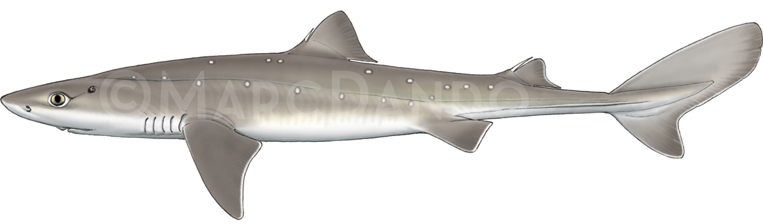

Class: | Chondrichthyes
Order: | Squaliformes
Family: | Squalidae
Species: | Squalus acanthias

Spiny Dogfish
Aiguillat commun
Mielga/Galludo

Illustration: © Marc Dando

BIOLOGY
Spiny Dogfish (Squalus acanthias), also known as Picked Dogfish or Spurdog, is a demersal shark that has a maximum length of 125 cm in the North Atlantic. It occurs mostly in shelf seas, from coastal habitats to the shelf edge, but can occur to depths of 900 m. They aggregate by size and sex, and are migratory in regional seas. Spiny Dogfish are long lived (ca. 50–60 years) and have slow growth rates. Females mature at a length of 75-85 cm, produce up to 21 pups and gestation lasts two years (ICES, 2017). Published studies on S. acanthias from the North Pacific relate to Squalus suckleyi (see Ebert et al., 2010).

DISTRIBUTION
Spiny Dogfish is distributed in both northern and southern temperate and boreal waters, but the Sharks MOU lists northern hemisphere populations only. Northern hemisphere subpopulations occur in the Northeast and Northwest Atlantic, Mediterranean Sea and Black Sea. North Pacific populations of ‘Spiny Dogfish’ are now considered to be a separate species, Squalus suckleyi (see Ebert et al., 2010).
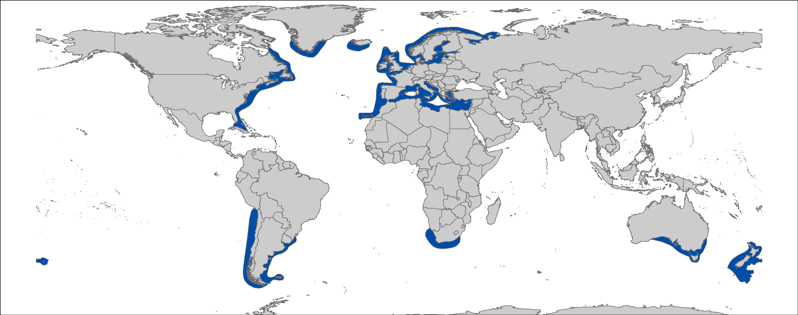
Figure 1: Distribution of Squalus acanthias, courtesy of IUCN.

CRITICAL SITES
While there is extensive monitoring effort in the NE and NW Atlantic, critical sites for this species supporting different life stages or as pupping and nursery grounds are largely undefined (McMillan & Morse 1999; Sulikowski et al. 2013; ICES 2017).

POPULATION STATUS AND TRENDS
Stock assessments for Spiny Dogfish are undertaken by the Northeast Fisheries Science Centre for the NW Atlantic (NEFSC, 2006) and by ICES for the NE Atlantic stock (De Oliveira et al. 2013; ICES, 2017). There is more limited information on Mediterranean Sea and Black Sea, with exploratory assessments undertaken under the auspices of the GFCM. The current IUCN Red List status for the global population is Vulnerable (Fordham et al. 2016) .

Region | Population trend | Time Period | Reference
Northeast Atlantic | -82% | Since 1905 | De Oliveira et al. 2013; (ICES 2017)
Northwest Atlantic | Decline to early 2000s, then period of stability at a low level and recent increase | 1968-2008 | Rago & Sosebee, 2010  NEFSC, 2006
Black Sea | >60% decline | 1981 to 1992 | (Prodanov et al. 1997)
Mediterranean Sea | Depleted |  | (GFCM 2016)

THREATS
- Fisheries: Spiny Dogfish is taken in trawl, gillnet and longline fisheries, and is, or has been, subject to target fisheries as well as a frequent bycatch.

KEY KNOWLEDGE GAPS
- Habitat utilization and critical sites for relevant life-history stages;
- Estimates of discards and post-release survivorship;
- Life-history data are available for the Atlantic stocks, but improved estimates for age and growth, and natural mortality are required;
- Improved knowledge of both the Mediterranean Sea and Black Sea stocks are of high priority, including confirmation of their taxonomic status, population status and demographic structure.

KEY MANAGEMENT AND CONSERVATION GAPS
- Full stock assessments have only been conducted for the two North Atlantic stocks. Improved knowledge of the Mediterranean and Black Sea stocks is required, in order to ascertain the current status of these stocks.
- Identification of the most effective management measures (e.g. size limits, quotas, spatial management) and options for technical measures.

RECOMMENDATIONS FOR CONSERVATION AND MANAGEMENT ACTION
A multifaceted approach is required to address the management and conservation gaps for Spiny Dogfish. Sharks MOU Signatories and other Range States are encouraged to:

- Improve the understanding of Spiny Dogfish through strategic research, monitoring and information exchange, including distributional data and population status

- Identify critical sites for Spiny Dogfish;
- Improved estimation of discards, including post-release survivorship;
- Address data gaps in biological knowledge (life-history parameters), including updated studies of age and growth, and natural mortality;
- Continue the longer-term monitoring of Spiny Dogfish populations, including updated analyses of trawl survey data;
- Further refine stock assessment methods in cooperation with RFMOs in all areas;
- Further investigate post-release survivorship of Spiny Dogfish to inform improved handling and release protocols, and options for technical measures;
- Improve capacity in species identification through training and the dissemination of available ID guidelines for those areas where other members of the genus occur.

- Improve multilateral cooperation among regions & RFBs

- Support the introduction of appropriate management measures for Spiny Dogfish at regional fora;
- Support development and implementation of appropriate management plans for Spiny Dogfish stocks
- Identify synergies with other Range States/stakeholders to support coordinated and resource-effective research programs, with special reference to Mediterranean Sea and Black Sea.

LEGAL INSTRUMENTS

Instrument | Description
Barcelona Convention  Barcelona Convention for the Protection of the Marine Environment and the Coastal Region of the Mediterranean | Annex III: Species whose exploitation is regulated; Parties shall ensure the favourable state of conservation of these species by taking all appropriate measures, in cooperation with competent international organizations.
CMS  Convention on the Conservation of Migratory Species of Wild Animals | Appendix II: Migratory species that have an unfavourable conservation status and need or would significantly benefit from international cooperation; CMS Parties shall endeavour to conclude global or regional agreements to benefit these species.
EU  European Union | Council Regulation (EC) No 1185/2003: establishes a general prohibition of the practice of ‘shark finning’, whereby a shark’s fins are removed and the remainder of the shark is discarded at sea.  Council Regulation (EU) 2018/120 prohibits for Union vessels to fish for, to retain on board, to tranship or to land Spiny (Picked) Dogfish by in all waters, with the exception of avoidance programmes (e.g. limited quota is available for vessels engaged in bycatch avoidance programmes). The regulation also prohibits third-country vessels to fish for, to retain on board, and to tranship Spiny Dogfish in Union waters.
FAO  Food and Agriculture Organization | IPOA Sharks: International Plan of Action for Conservation and Management of Sharks based on which states should adopt and implement a national plan of action for conservation and management of shark stocks (NPO Sharks) if their vessels conduct directed fisheries for sharks or if their vessels regularly catch sharks in non-directed fisheries.
GFCM  General Fisheries Commission for the Mediterranean | Rec. GFCM/36/2012/3: shark species listed under Annex III of the Barcelona Convention cannot be retained on board, transshipped, landed, transferred, stored, sold or displayed or offered for sale and must be released unharmed and alive to the extent possible.
HELCOM  Baltic Marine Environment Protection Commission - Helsinki Commission | Being the environmental governing body of the Helsinki Convention, HELCOM strives to protect the marine environment of the Baltic Sea from all sources of pollution through intergovernmental cooperation.
NAFO  Northwest Atlantic Fisheries Organization | In order to safeguard the marine ecosystems in which the Convention Area’s fisheries resources are found, NAFO develops and adopts conservation and enforcement measures to protect shark species in its region.
NEAFC  North East Atlantic Fisheries Commission | NEAFC considers and designs recommendations and measures to ensure the protection and conservation of shark species related to fisheries in its region.
OSPAR  Convention for the Protection of the Marine Environment of the North-East Atlantic | OSPAR Recommendation 2014/2: Contracting Parties and management authorities responsible for human activities in the region are urged to take the need for protection of these species into account, OSPAR List of Threatened and/or Declining Species and Habitats: Species listed are a priority for protection and conservation;
Sharks MOU  Memorandum of Understanding on the Conservation of Migratory Sharks | Annex 1: Signatories should endeavour to achieve and maintain a favourable conservation status for these species based on the best available scientific information and taking into account their socio-economic value.

REFERENCES
De Oliveira JA, Ellis JR, Dobby H 2013. Incorporating density dependence in pup production in a stock assessment of NE Atlantic spurdog Squalus acanthias. ICES Journal of Marine Science 70: 1341-1353.
Ebert DA, White WT, Goldman KJ, Compagno LJ, Daly-Engel TS, Ward RD 2010. Resurrection and redescription of Squalus suckleyi (Girard, 1854) from the North Pacific, with comments on the Squalus acanthias subgroup (Squaliformes: Squalidae). Zootaxa 2612: 22-40.
Fordham S, Fowler SL, Coelho RP, Goldman K, Francis MP 2016. Squalus acanthias. The IUCN Red List of Threatened Species 2016: e.T91209505A2898271. http://dx.doi.org/10.2305/IUCN.UK.2016-1.RLTS.T91209505A2898271.en.
GFCM 2016. Fourth meeting of the Subregional Group on Stock Assessment in the Black Sea (SGSABS). Burgas, Bulgaria, 15–19 November 2016. Final report, 28 pp. Available at http://www.fao.org/gfcm/reports/technical-meetings/detail/en/c/879801/

ICES 2017. Report of the Working Group on Elasmobranchs (2017), 31 May-7 June 2017, Lisbon, Portugal. ICES CM 2017/ACOM:16. 1018 pp.
McMillan D, Morse W 1999. Essential fish habitat source document: Spiny dogfish, Squalus acanthias, life history and habitat characteristics. In ed., NOAA Tech Memo NMFS NE 150; 19 p. Pp.
NEFSC 2006. Advisory report on Stock Status, The 43rd Northeast Regional Stock Assessment Review
Prodanov K, Mikhailov K, Daskalov G, Maxim C, Chashchin A, Arkhipov A, Shlyakhov V, Ozdamar E 1997. Environmental management of fish resources in the Black Sea and their rational exploitation, v.68. Food & Agriculture Org. pp.
Rago PJ, Sosebee KA 2010. Biological Reference Points for Spiny Dogfish . Northeast Fish Sci Cent Ref Doc. 10-06; 52 p. Available from: National Marine Fisheries Service, 166 Water Street, Woods Hole, MA 02543-1026, or online at: http://www.nefsc.noaa.gov/nefsc/publications/
Sulikowski JA, Prohaska BK, Carlson AE, Cicia AM, Brown CT, Morgan AC 2013. Observations of neonate spiny dogfish, Squalus acanthias, in Southern New England: A first account of a potential pupping ground in the Northwestern Atlantic. Fisheries Research 137: 59-62.

See the IUCN website for further details on the population assessment: http://www.iucnredlist.org/details/91209505/0.

