7th Meeting of the Sessional Committee of the
CMS Scientific Council (ScC-SC7)

Bonn, Germany, 17 – 20 September 2024
UNEP/CMS/ScC-SC7/Doc.6.4.3/Rev.1

TRANSBOUNDARY CONSERVATION HOTSPOTS FOR THE
CENTRAL ASIAN MAMMALS INITIATIVE
(Prepared by the Secretariat)

Summary:

CMS Decision 14.168 requests a Party-appointed Councillor from the region of the Central Asian Mammals Initiative to present the study ‘Transboundary Conservation Hotspots for the Central Asian Mammals Initiative’ and actions taken to implement the study at the next meeting of the Sessional Committee.

CMS Decisions 14.169 (a) and (b), request the Scientific Council to evaluate the methodology and findings of the study and to consider applying them to other regions, as well as to advise on relevant dissemination mechanisms and forums to promote the visibility of the recommendations contained therein.

A revision was prepared to include Decision 14.168 in the document.

TRANSBOUNDARY CONSERVATION HOTSPOTS FOR THE
CENTRAL ASIAN MAMMALS INITIATIVE.

Background

- The Central Asian Mammals Initiative (CAMI) and the associated Programme of Work are described in UNEP/CMS/Resolution 11.24 (Rev.COP13). The Initiative includes 15 CMS-listed species of large mammals and three species of mammals, which are not listed on CMS appendices, but occur in the same habitat. The habitats of these species stretch across 14 Range States, ten of the Range States are CMS Parties. The focus of the Initiative lies in strengthening coordination and cross-border cooperation.

- The report ‘Transboundary Conservation Hotspots for the Central Asian Mammals Initiative’ was prepared with funding from the Government of Switzerland within the frame of CAMI to identify transboundary conservation hotspots and develop recommendations for their conservation.

- The study was discussed during the CAMI Range States Meeting, held in 2019 in Ulaanbaatar, Mongolia, where participants reviewed the pre-identified transboundary areas of importance for the conservation of CAMI species. Their comments are incorporated in this report, which was published as Information Document, UNEP/CMS/COP13/Inf.27 for the 13th Meeting of the Conference of the Parties (COP13). The report was then updated with funding from the Government of Germany and now covers all species included in the CAMI Programme of Work 2021-2026 as well as all CAMI Range States.

- The report identifies 39 transboundary areas of importance for the conservation of CAMI species and provides specific recommendations for each of these areas in order to improve the conservation of the species occurring there.

- In relation to the study, CMS COP14 adopted Decision 14.168 directed to the Scientific Council and, specifically, to the Party-appointed Councillors from the CAMI region, 14.169 directed to the Scientific Council and Decision 14.170 (b) and (c), directed to the Secretariat, which read as follows:

Decision 14.168

Party-appointed Councillors from the CAMI Region are requested to present the study ‘Transboundary Conservation Hotspots for the Central Asian Mammals Initiative’ and actions taken to promote conservation of selected transboundary hotspots to the Scientific Council at the next meeting of the Sessional Committee.

Decision 14.169

The Scientific Council is requested to:
- evaluate the methodology and findings of the study, ‘Transboundary Conservation Hotspots for the Central Asian Mammals Initiative’, and consider applying them to other regions; and
- considering paragraph 11 of Resolution 11.24 (Rev.COP13) and building on Decision 14.167 (e), advise on relevant forums and dissemination mechanisms to promote the visibility of the findings and recommendations of the study ‘Transboundary Conservation Hotspots for the Central Asian Mammals Initiative’.

Decision 14.170

The Secretariat shall:
- subject to the availability of external resources, translate the studies, ‘Transboundary Conservation Hotspots for the Central Asian Mammals Initiative’ and ‘Potential for Community-based Wildlife Management of CAMI Species’, into Russian to facilitate their review and endorsement by the concerned Range State Parties.
- share both studies with the Range State Parties for comment, integrate their feedback and make them publicly available;

- In accordance with Decision 14.170 b) the Secretariat identified a possibility to translate the study into Russian through an in-kind contribution of the Michael Succow Foundation. However, the translation will not be finalized in time to receive input from the Range States prior to the Meeting of the Sessional Committee.

- That said, the Scientific Council is invited to evaluate the methodology and the findings of the draft study, contained in full length in Information Document UNEP/CMS/ScC-SC7/Inf.6.4.3. Annexed to this document is an overview of the methodology used to prepare the study, general recommendations and specific recommendations for two of the identified hotspots: Southwestern Ustyurt and Trans-Altai Gobi, which are both deemed of high priority for action, based on the assessment by the author of the study.

Recommended actions

- The Sessional Committee is recommended to:

  - review and comment on the methodology and findings (recommendations) of the study, advise whether this methodology can be applied to other regions;

  - advise on relevant forums and dissemination mechanisms to promote the visibility of the findings and recommendations of the study with the view of strengthening implementation of such recommendations and the conservation of CMS-listed species.

ANNEX

METHODOLOGY AND SELECTED RECOMMENDATIONS OF THE REPORT ‘MAPPING TRANSBOUNDARY CONSERVATION HOTSPOTS FOR THE CENTRAL ASIAN MAMMALS INITIATIVE’

- Working approach and methods

2.1 General approach and methods

The author, in preparing the first version of the study, followed the approach and steps outlined in the Terms for Reference:

- Key transboundary populations and the associated transboundary areas (TAs) were identified by:
- Using the Central Asian Mammals Migration and Linear Infrastructure Atlas (CAMI Atlas) and other available literature and data on species distribution to identify Range States of the species and transboundary populations of these species;
- Using available literature and data on species distribution to prepare a long-list of potentially relevant TAs and its target species;
- In close consultation with the CMS Secretariat, liaising with the CAMI Species Focal Points and CMS National Focal Points in the region, relevant IUCN Specialist Groups, experts and NGOs to obtain additional information on the potential TAs, species distribution and movements, important transboundary populations and areas, barriers to migration and other threats and past, ongoing, planned and desirable conservation action in the TAs;
- Compiling a list of the transboundary populations of each species and the associated transboundary areas;
- Identifying and analyzing TA-specific threats to these populations and respective conservation needs;
- Analyzing and listing current and existing work and initiatives that are already ongoing and/or planned to enhance the conservation of species in those TAs as well as main decision-making bodies and stakeholders in respective countries.

- An initial prioritization and selection of TAs according to conservation importance and feasibility was undertaken by:
- Assessing the importance of each area for the respective species,
- Assessing the need, urgency and feasibility for implementing conservation action in each TA;
- Considering the requirements for implementation of CMS instruments and mandates (CAMI Programme of Work, Resolutions and Decisions), as well as other existing agreements and trans-boundary projects;
- In cooperation with the CMS Secretariat, liaising with the National Focal Points in the Range States for information on existing efforts to strengthen transboundary conservation and inquire about their interest, and the overall feasibility to enhance cooperation in those areas.

- The feasibility of implementing effective transboundary cooperation to enhance conservation of those transboundary populations and areas was assessed.

- A set of key recommendations for promoting cooperation and transboundary conservation of the most important TAs in the context of CMS and CAMI was developed.
The draft report presented the findings at the Second Range State Meeting of CAMI on 25-28 September in Mongolia. The representatives of the Range States, the Species Focal Points and other experts provided input and guidance with regard to the prioritization of important TAs, the assessment of feasibility of implementing transboundary cooperation in those areas as well as the finalization of key recommendations.

The basis for the maps of the range areas of the species are those of the CAMI Atlas and the IUCN Red List. The areas were further specified and modified based on own expertise and information from various experts, where sufficient information was available.

The spatial information gathered in the process was provided to the CMS Secretariat in form of GIS files in appropriate format for further processing to create accurate maps of the selected TAs.

2.2 Revision and expansion of the study

For the revision and expansion of the study the consultant followed the same approach as for the first version. Specifically, the consultant:

1) Compiled a list of relevant TAs by:
- Researching available literature and data on species distribution and movements;
- Compiling the list of the transboundary populations with the associated TAs and updating the list in the existing study, where necessary;
- Preparing maps of TAs with species distribution in GIS format and updating the maps in the existing study, where necessary;

2) Based on literature, unpublished sources and own expertise, compiled recommendations for conservation actions in the identified TAs and updated the recommendations in the existing study, where needed, by:
- Identifying and analyzing threats to the populations of CAMI species in the TAs and compiling respective conservation needs;
- Analyzing and listing work and initiatives that are already ongoing and/or are planned to enhance the conservation of species in those TAs;
- Listing the main decision-making bodies and stakeholders in the respective countries with respect to managing the species and habitats in question;
- Identifying conservation actions that would be necessary in each TA, including local and transboundary conservation efforts;

3) Prioritized (including revising the prioritization in the existing study), based on literature, unpublished sources and own expertise, the identified TAs in terms of importance for the species, urgency, and feasibility of conservation action, taking into consideration the mandate of CMS in the context of the CAMI POW, by:
- Assessing the urgency and feasibility of implementing identified conservation actions in each TA;
- Assessing the importance of each TA for the conservation of the respective species;
- Considering the requirements for implementation of CMS instruments and mandates (CAMI POW 2021-2026, Resolutions and Decisions), as well as other existing agreements and transboundary projects;
- Liaising with conservation experts in the additional countries for information on existing efforts to strengthen transboundary conservation and inquire about their interest and overall feasibility (expert opinion) to enhance cooperation in those areas;
- Producing a set of recommendations for the most important TAs in terms of species conservation and feasibility of transboundary conservation action.

- Provided the study electronically in Word and PDF formats to the Secretariat. Maps were included in the report as well as provided in the format of ESRI shape files. The final draft was provided to the Secretariat and finalized upon inclusion of the feedback from the Secretariat.

2.3 Determination of priority sites

Determining priority sites is a challenging task, given the multitude of aspects to be considered. Considering too many aspects may lead to an overly sophisticated approach. Not considering sufficiently the complexity of the issue may lead to inadequate priority setting.

For the purpose of this study, an attempt to prioritize the identified TAs was made by combining the following criteria:
- The importance of the area with regard to the number of CAMI species occurring in it and its importance for the population (e.g. regularity of occurrence, population sizes or densities, share of global or regional populations);
- Potential for conservation success, including recovery of small populations and the technical feasibility of rehabilitating populations and migrations;
- The existence of problems, which are to be addressed in a transboundary context;
- The urgency of intervention to prevent continuing declines or even local extinction of target species;
- The feasibility of interventions, which consists of several elements, like the economic feasibility and political willingness of actors of addressing barriers.

For the purpose of priority ranking for every TA, each of the criteria was assigned a score:

Criteria |  | Score
Importance of the area | Number of species | Total number of confirmed target species
Importance of the area | Population status | 1 = occurrence irregularly or previously  2 = regularly  3 = substantial numbers
Potential for conservation success |  | 0 = none  1 = low  2 = medium  3 = high
Existence of problems |  | 0 = none  1 = low  2 = medium  3 = high
Urgency |  | 0 = none  1 = low  2 = medium  3 = high
Feasibility of interventions |  | 0 = none  1 = low  2 = medium  3 = high

The importance of an area can be determined by the number of target species present in the area. However, it is often difficult to determine whether a species is actually present in a particular area or not. The approach taken here is that only those species were counted as present, if they are known to have likely occurred in the area at least during the past 50 years.

Another aspect of importance is the population status of species, i.e., the degree of occurrence of the species: has it occurred in the area only historically or irregularly, in small or large numbers and density or what share of the global or regional population is present. Some species occur only in small numbers in a very fragmented range area, but the survival of each population patch is important despite only small local population numbers. Some sites may represent bottleneck areas of key importance for connectivity within metapopulations. With only one species as the most important in an area, this aspect can be assessed if sufficient information is available. For sites with more than one focus species, it is difficult to determine the total importance of the site, because it can be of different importance for the different species. In these cases, either the score for the species with the most important population was applied or a combined score.

The potential for conservation success can be assessed from various angles. For areas with several species present in viable populations the assigned score would be high. However, the potential for recovery of currently low and even of locally extinct populations also needs to be considered. As an example, until recently the Badghyz area (Afghanistan, Iran, Turkmenistan) had the last autochthonous and for many years the largest population of the Kulan Equus hemionus kulan, a subspecies of Asiatic Wild Ass. The population has decreased to very low numbers and most likely the Kulans have been completely exterminated by poaching. However, the area has still the potential for a recovery of the species if poaching is prevented and other measures are implemented. The potential thus has a technical dimension. Where recolonization or reintroduction of extinct species is very difficult or impossible or where revival of transboundary populations cannot be achieved because of the biological features of the species, the potential would be zero or low.

Existence of problems: areas might become higher priority for conservation action if there are problems or threats, which require transboundary interventions or where transboundary collaboration would help solving the problem. This is especially the case where border fences hinder migration that is vital for the survival of the respective populations in the short or mid-term. Similarly, high priority would be assigned to sites where migrations take place, but threats in one part of the range area threaten the survival of the whole population. For example, limited suitable habitat for a target species on one or either side of a border, may require for conservation of a population that it is managed as transboundary population.

Urgency can be defined by the pace of negative trends in populations caused by barriers to migration as well as by other threats. A high urgency would be assigned where existing problems require urgent attention in order to retain or restore the integrity of the site and/or prevent further population declines.

Feasibility refers to interventions needed to address problems including those of transboundary character, but also threats at the national level and to which extent it is feasible to implement the actions needed. Feasibility has technical and political dimensions, but there might also be economic aspects to be considered, which can be covered within the political dimension of feasibility.

The sum of the scores for each area was used for determining the preliminary priority rank of each sites, from 1 (highest priority) to 12 (lowest).

5.2 (General) Recommendations

Preliminary recommendations for conservation action were listed in section 4.2 for each of the individual areas. These actions were subject for discussion at the CAMI Range States Meeting in Ulaanbaatar, Mongolia 23-28 September 2019 and were revised in consultation with the different stakeholders. In addition to the site-specific recommendations, this chapter attempts to draw some general conclusions and develop recommendations about how to enhance transboundary conservation in the context of CAMI.

The purpose of trying to prioritize the TAs was to help focusing limited resources to areas that are important, need action most, and where interventions are feasible and likely to bear fruit. However, while this prioritizing is a rather political necessity, it is important to note that also those areas with low scores under the numerical assessment above still play important roles for the conservation of the target species and are therefore all worth of implementing specific activities or including them into broader programs.

Across the region transboundary collaboration at various levels in most areas is rather weak. To strengthen it, as a first step, the exchange of information should be developed and institutionalized, starting at the national level. Government authorities in charge of nature conservation, wildlife and protected areas need to communicate across the borders. The communication should involve experts, protected area managers and others involved in the specific sites from the very beginning. Direct local exchange should be set up allowing for immediate communication between organizations and people working on the ground in the transboundary areas. Information about populations and migrations of the target species, about observed barriers to migration and about conservation action considered, needs to be shared across the borders.

There are certainly differences between the preliminarily identified priority sites in terms of knowledge and data availability about the populations of the target species in those areas. However, in all areas, intensified research and continuous monitoring are required for better understanding the status of the migratory mammals, the threats to their survival and the actions needed for their conservation. Research and monitoring activities should at least be coordinated and results be shared in a format, which allows for practical use. Joint transboundary research and monitoring can be particularly useful for understanding population dynamics, spatial and temporal patterns of transboundary migrations and ecological and land-use factors impacting on the target species.

Border-related conservation issues

Information on border area characteristics and in particular on border infrastructure is typically considered highly sensitive and unauthorized exploration of the situation and sharing of information with foreign organizations and individuals is often difficult. Therefore, consultation with and involvement of governmental authorities in charge of border security and customs control is crucial at any stage. The development of cross-border collaboration between these organs with involvement of conservation authorities and practitioners is desirable, but most likely possible only under very favorite circumstances, where neighboring states are joined in a customs union already or other bi- or multilateral agreements facilitate such direct collaboration in potentially sensitive sectors.

Border fences are an important problem for transboundary conservation of the target species in at least 14 out of the 21 sites listed in Section 5.1 with priorities 1-8. In addition, in several of the 17 sites of lower priority, border fences form barriers to the animals’ movements. In critical areas the prevention of new border fence construction and the mitigation or even removal of existing fences is the most important need for maintaining the transboundary character of the populations of the target species, allowing them to migrate to critical habitats, to maintain genetic connectivity and allow for recolonization of areas where a species locally disappeared. A special focus on fences is therefore important in many areas, although also other conservation activities can be meaningful for improving the status of target populations, where border fences currently cannot be addressed.

The purposes of border fences can vary and it is important to understand these purposes to be able to provide justified and targeted solutions, which as much as possible satisfy these purposes. Some border fences may have the purpose of restricting movements of humans (pedestrians as well as motorized transportation). These are hard to modify, but in remote areas gaps in fences, equipped with modern surveillance, can be an option. Fences for preventing only the crossing of motorized transport are easier to modify to become passable for wildlife while still fulfilling its purpose. In some areas, fences have been erected for the prevention of livestock movements in the first place. Here, modifications of the height and type of the lower wires can be useful. Detailed recommendations on the mitigation of border fences are provided by Olson (2013). Any attempts regarding border fences require the development of trust and commitment of the border security and customs control authorities and typically high-level political support. In countries that are Parties to CMS, the Convention can become a vehicle for facilitating such processes.

Poaching

Poaching or illegal hunting is an issue that should be addressed with highest priority and is a key problem in most, if not all, identified areass. Beyond the immediate effect of increased mortality, illegal hunting is a disturbance that can cause target animals to avoid large areas of otherwise suitable habitat. This avoidance can affect their overall condition, survival and recruitment. Prevention or at least reduction of poaching is therefore a precondition for the success of other conservation actions. Which means are suitable for achieving this success depends on specific conditions regarding the target species, their population characteristics, drivers of illegal take, legal and institutional frameworks, enforcement capacities and attitudes of stakeholders. Potential approaches, which often can be and need to be combined, include improved enforcement by government rangers through increase in staff numbers; better equipment and rewards; improved protected areas in terms of area size, staff, financial and technical basis; community-based and other systems of sustainable legal use in assigned areas; training and equipment of customs services to intercept illegal trade; and other approaches. All these approaches can benefit from transboundary collaboration. Moreover, even though border guards particularly in remote areas can sometimes be involved in poaching, their inclusion in approaches is crucial in successful transboundary prevention of poaching.

Livestock grazing

Overgrazing and livestock with its effects of competing with wild species for forage, habitat degradation, displacement and disease transmission are significant threats in nearly all priority areas with very few exceptions. The CAMI PoW 2021-2026 provides a set of activities to address livestock related issues. These activities should be applied as needed and adapted to the site-specific conditions. Of particular importance are the development of approaches facilitating and incentivizing the coexistence of wildlife and other land-uses, including livestock grazing, and the establishment of permanent or temporary grazing-free areas. Traditionally in many transboundary areas, grazing took place across current national borders. Looking into grazing systems from a transboundary perspective may show opportunities for landscape level grazing management in a way that also benefits wildlife. Such approaches can only be implemented where veterinary and other regulations permit for this.

Extractive industries and infrastructure

Industry, mining and infrastructure development are relevant threats in several of the priority areas, e.g., in the context of China’s Belt and Road Initiative, or through the expansion of extractive industries. Transboundary impacts should be considered in the context of the Environmental Impact Assessments. Avoidance, mitigation and compensation of adverse impacts on migratory mammals require the consideration of transboundary aspects.

EXAMPLES OF SITE-SPECIFIC RECOMMENDATIONS

Site ID: 18 Name: Trans-Altai Gobi Countries: China-Mongolia

Location:
Administrative:
- China, Gansu Province, Kumul, Jiayuguan and Jiuquan Prefectures;
- Mongolia, Govi-Altai and Bayanhongor Aimags.

Geographic area:
- Mongolian Trans-Altai Gobi Desert, largely identical with Great Gobi A Specially Protected Area (SPA).

Coordinates: N 42.683870°, E 96.422978°

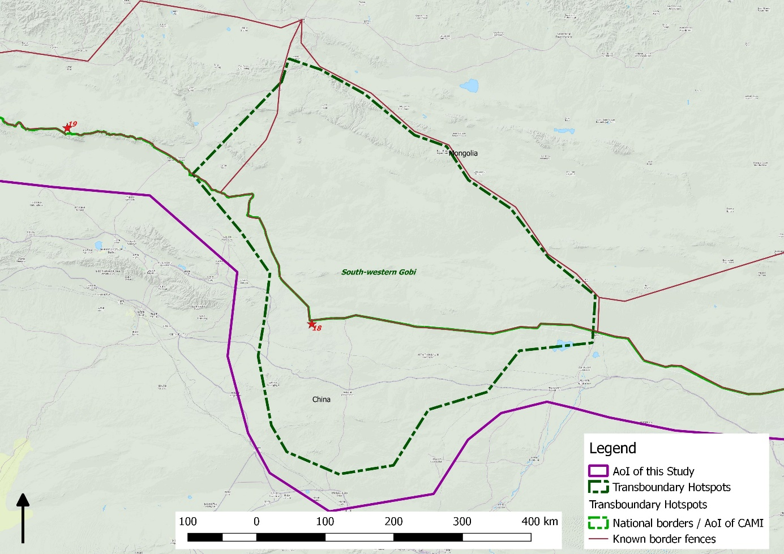
Figure 1: Location map of potential hotspot Trans-Altai Gobi

Biogeographical region; major ecosystems/habitat types:
Biogeographical region by Udvardy (1982): Taklamakan-Gobi Desert;
WWF Ecoregion (Olson et al., 2001): Alashan plateau semi-desert, Jungar Basin semi-desert and Altai montane forest and forest steppe;
Ecosystems/habitat types: Desert and semi-desert, small areas with steppe and woodland.

Species:
The CAMI Atlas (CMS, 2019) shows range area overlaps between species of plain semi-desert (Wild Camel, Asiatic Wild Ass, Goitered Gazelle, Gobi Bear) and species of mountainous areas (Argali and Snow Leopard). This overlap is less real habitat sharing than an issue of the resolution of the range areas layers.

Wild Camel:
Population size: Population estimates for Wild Camels vary widely and were determined using several different methods, thus precluding direct comparisons to assess demographic trends. Estimates for Mongolia, i.e. for this site, vary between 350 and 2,000 (Adiya, 2012). Several hundred Wild Camels may exist in China, but during one survey, Adiya and Dovchindorj (2006) observed only 10 Wild Camels in the Arjinshan Mountain and Gumuago Desert in China (Adiya, 2012).
Movements: Wild Camels are highly mobile and roam within large areas. The border fence is an obstacle to transboundary movements.
Importance of transboundary population: The population of the site hosts one of only three populations of wild camel. This is the only potentially transboundary and probably the largest population of the species.

Asiatic Wild Ass:
Population size: 1,500 in Trans-Altai Gobi of Mongolia (Kaczensky et al., 2015b). Numbers in adjacent China are not known.
Movements: Generally Wild Asses are highly mobile and regularly move long distances in search of water and forage. Kaczensky et al. (2011) found in the area individual home ranges of collared Khulan of 14,695-16,907 km². With the upgrading of the fence along the international border in the 1980s and 1990s, population exchange between Mongolia and China has likely ceased or at least became minimal. Consequently, the Chinese populations should be regarded as separate from Mongolia. (Kaczensky et al., 2015b);
Importance of transboundary population: The population is currently not transboundary. The conservation status in Mongolia is independent of the potential transboundary character. However, survival of the species in the China part of the site will depend on transboundary connectivity.

Goitered Gazelle:
Population size: The site is part of the larger range area of the species in southern Mongolia. No site-specific information is available.
Movements: No documented transboundary movements known. Regular movements are hindered by the border fence.
Importance of transboundary population: There is currently no functionally transboundary population. The conservation status in Mongolia is independent of the potential transboundary character. However, survival of the species in the China part of the site will depend on transboundary connectivity.

Argali:
Population size: The 2009 mountain ungulate survey of Mongolia yielded estimates of approximately 2,000 Argali for the two aimags (Harris et al., 2010). The site covers only a small portion of the Argali habitat of these aimags and so the Argali numbers are much lower. In China Argali range area in the site is not immediately located at the border and numbers are unknown.
Movements: No movement data are known. The border fence and distance of range area in China from the border make transboundary movements unlikely.
Importance of transboundary population: The population is currently not transboundary. The conservation status in both countries is independent of the potential transboundary character. Improved connectivity would positively influence the conservation status and improve the genetic diversity of small Argali groups and increase chances of recolonization of sites where Argali is extinct.

Snow Leopard:
Population size: The Snow Leopard occurs in the site in Mongolia and probably in an area located to the west in China. No population numbers are known.
Movements: No documented transboundary movements known. Border fences and habitat characteristics limit transboundary movements.
Importance of transboundary population: Transboundary character of the population not confirmed.

Gobi Bear:
Population size: The Gobi Bear currently occurs only in the site in Mongolia, but may irregularly occur also in China. The estimated population size is in the range of 20-40 individuals.
Movements: One transboundary movement of a GPS-collared bear was registered, but the regularity of such movements is not known. Border fences and habitat characteristics may limit transboundary movements.
Importance of transboundary population: While the transboundary character of the population is not confirmed, its location close to the border provides the potential of current or future transboundary occurrence. The population is of utmost conservation importance due to its unique ecological features. Given the small population size and its isolation from other Brown Bear populations, any transboundary occurrence would deserve special attention.

Conservation significance:
The site is of global significance, mainly because of Wild Camel and Gobi Bear. The Wild Camel survives only in one population in the Mongolian Trans-Altai Gobi Desert (this site) and in three groups in China, namely a small area of the Taklamakan Desert, the Gashun Gobi in the north of Lop Nur and Arjin Mountain. (Adiya et al., 2012) The occurrence of Gobi Bear contributes to the global significance. The site includes the only known range area of this unique Brown Bear population. The area is further important for the conservation of Wild Ass, Goitered Gazelle and Argali as well as Snow Leopard.

Protected areas status:
Mongolia: Great Gobi A SPA

Barriers for migration:
The border fence from China is the largest and most significant barrier. Highways and railways are among the more common movement barriers and became prominent in the north western China in Gansu and Xinjiang provinces. In particular, the Silk Road and later the Gansu-Xinjiang highway and the Lanzhou-Xinjiang railway have separated the Lop Nur Lake region from the Altai-Gobi Desert. In addition, a green corridor from Weili to Ruoqiang, the Tarim River and Lop Nur Lake has separated Camel populations in the Taklamakan Desert from populations in the Gashun Gobi Desert and the northern piedmont of Arjin Mountain. Accordingly, this highly endangered animal nowadays faces the disadvantaged situation of being dispersed in at least three isolated populations. A mining area in China near the border with Mongolia forms one of the biggest barriers in North-western China. (Adiya et al., 2012; Adiya, pers. comm. 2019)

Other threats:
- Livestock – The Great Gobi A SPA is normally not allowed to be grazed by livestock, but under exceptional circumstances grazing is permitted and causes forage and water competition and disturbance keeping wildlife away from essential resources;
- Hybridizing of wild and domestic camels from the buffer zone and during temporary grazing (Wild Camel bulls taking domestic females in their harems);
- Poaching by local people and border guards (reportedly effectively prevented by Great Gobi A SPA (Adiya et al., 2012));
- Illegal and legal (in China) mining;
- Drying up of water sources.

Recommendations for action:
- Continued collaboration between China and Mongolia. Perhaps the most important tasks are increasing awareness of cross-boundary issues and improving communication between agency personnel, biologists, and conservationists working on Wild Camel conservation in China and Mongolia. Additional joint meetings on camel conservation would facilitate this process, as would joint research projects. Addressing border issues may require involving military border guards and foreign affairs officers.
- Specific measures should include:
  - Mapping and monitoring of the waterbodies in the border area;
  - Joint monitoring and observation of wildlife movement along the border in China and Mongolia, with continuous monitoring by a camera trapping study along the border on the Mongolian side and, if possible, on the Chinese side in the near future;
  - Establishing of a wildlife movement corridor across the border fences based on joint research study between Mongolian and Chinese researchers;
  - Stopping the operation of the mining site near the border in China;
- Regulation of grazing and livestock in critical areas of the buffer zone at the boundaries of Great Gobi A SPA;
- Nomination of a transnational UNESCO World Heritage Site (ongoing);
- Exploring the possibility of transboundary conservation area Great Gobi A SPA and Anxi Extreme Arid Desert Natural Nature Reserve.

Site ID: 28 Name: South-western Ustyurt Countries: Kazakhstan-Turkmenistan-Uzbekistan

Location:
Administrative:
- Kazakhstan, Mangystau Province;
- Turkmenistan, Balkan Province;
- Uzbekistan, Karakalpakstan Autonomous Republic.

Geographic area:
- Ustyurt Specially protected area (SPA) and areas south of it (1);
- Kaplankyr Plateau south east of salt pan (shor) (2);
- Chink at the border, Kazakhly shor (3);
- Kaplankyr SPA s of Sarygamysh lake (4);
- Assake-Audan (5);
- Areas south of the road Barsa Kelmes – Jaslyk and between Kazakhstan-Uzbekistan border and Ustyurt SPA (6).

Coordinates: N 42.382329°, E 54.111493°(1); N 41.194460°, E 55.881960°(2); N 41.338580°, E 55.978608°(3); N 41.235781°, E 57.550095° (4?); N 42.293289°, E 56.077211°(5); N 43.634792°, E 55.961138° (6)

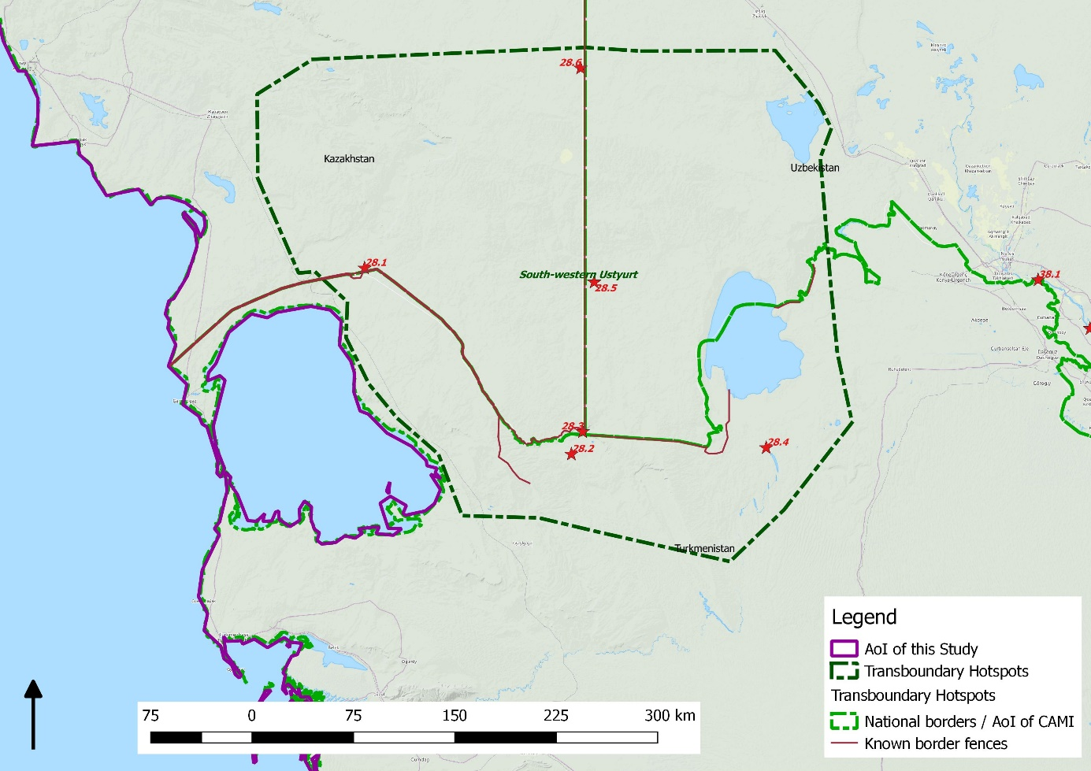
Figure 2: Location map of potential hotspot South-western Ustyurt

Biogeographical region; major ecosystems/habitat types:
Biogeographical region by Udvardy (1982): Turanian;
WWF Ecoregion (Olson et al., 2001): Central Asian northern desert, Central Asian southern desert;
Ecosystems/habitat types: Steppe, semi-desert, arable lands.

Species:

Asiatic Wild Ass:
Population size: Kazakhstan: Kulan is considered extinct in Mangystau since the late 19th/early 20th century (Heptner et al., 1961/1988). There had been attempts of reintroducing the species twice, which both failed, apparently because of poaching. One Kulan was observed by ACBK researchers near the border with Uzbekistan, close to the site Assake-Audan (5) in April 2019 (Pestov et al., 2019). This is the first confirmed Kulan in Mangystau Province for many years. Turkmenistan: The Wild Ass population of the site has been reintroduced in the 1980s and may have reached more than 200 individuals in the early 2000s (Rustamov et al., 2015). But expeditions in 2014-2017 revealed a massive decline and loss of range area with a maximum number of 80 individuals remaining (Rustamov, pers. comm. 2018). In Uzbekistan Kulan has been recorded between Sarykamysh Lake and the borders with Turkmenistan and Kazakhstan, in the Assake Audan depression and at the Kazakhly Shor cliff (chink), as well as in the north and west of Sarykamysh (Marmazinskaya et al., 2013).
Movements: Kulan are highly mobile and move long distances, in particular to access water. At the site, movements are massively hampered by border fences. Areas without border fences mostly are salt swamps or have steep terrain, thuslimiting movements to dry seasons or few locations.
Importance of transboundary population: Despite the massive movement restrictions and the limited range area, the Asiatic Wild Ass population of the site has to be considered entirely transboundary. Given the precarious state of Asiatic Wild Ass outside of Mongolia and of this subspecies in particular, any population is of high conservation significance. Transboundary mobility and connectivity of habitats are essential for the survival of this population.
Goitered Gazelle:
Population size: In the Kazakhstan part of the site Goitered Gazelle is widespread and has a stronghold in Ustyurt SPA and adjacent areas. In Turkmenistan the Red Book previously stated a population of 1,700 gazelles for the area, but expeditions in 2014-2017 confirmed only about 300 animals (Rustamov, pers. comm. 2018). In Uzbekistan expeditions under the CADI project confirmed presence of Goitered Gazelle from the entire area between Sarykamysh Lake and the borders with Turkmenistan and Kazakhstan, as well as further to the north (Wunderlich, pers. comm. 2019, Marmazinskaya et al., 2012). There, Goitered Gazelle occurs in low density, with in total maybe 150 animals only (Marmazinskaya, pers. comm. 2019), although this statement may refer to parts of the site only.
Movements: Goitered Gazelles are very mobile. Their migrations are affected by the border fences, which also are a reason of direct mortality.
Importance of transboundary population: The population is currently only partly transboundary as the border fences have caused an effective fragmentation. Transboundary connectivity is essential for the maintenance of genetic diversity, sufficient effective population size to preserve a viable population and for access to habitats of seasonally varying suitability.

Urial:
Population size: Urial occurs in Kazakhstan in Ustyurt SPA as well as in other areas with suitable relief. Ismailov (pers. comm. 2019) assessed the overall population of the site in Kazakhstan with 700-750 and assumed a 50% decline since the early 2000s. In Turkmenistan Rustamov (pers. comm. 2018) found a decline to 250 animals during expeditions 2014-2017, compared to up to 1,600 animals indicated for the 1990s in editions of the Red Book. In Uzbekistan CADI expeditions (2012-2014, Wunderlich, pers. comm. 2019) recorded Urial observations, tracks and skulls north of Kazakhly Shor (3), northwest of Kaplankyr SPA (near 4), along the western shore of Sarykamysh Lake and northwest of it. There overall numbers are apparently very low (Marmazinskaya et al., 2012).
Movements: Urials move between sites with suitable relief and can cross plain areas of several tens of kilometers. Pestov (pers. comm., 2019) mentioned that Urial in contrast to other ungulates are able to pass the barbed-wire border fences established from Kazakhstan without obvious difficulties or harm. The Turkmenistan border fence of covered chain-link cannot be crossed by Urials, but there might still be areas where Urials can bypass the fence.
Importance of transboundary population: The patchy distribution of suitable habitats, the small size and carrying capacity of many of these habitat patches and low overall numbers make the Urial population’s long-term survival highly dependent on transboundary connectivity.

Persian Leopard:
Population size: The site is so far not considered as permanent range area of the Leopard in any of the countries. During the last two decades three Leopards have been recorded in Mangystau Province, in the Kazakhstan part of the site or close to it. Since fall and winter 2018 a Leopard was repeatedly recorded on camera traps in Ustyurt SPA in Kazakhstan. Its remains were found in June 2021 near Beyneu, about 250 km straight line from the protected area. The closest known occurrence has been in the Great Balkhan in Turkmenistan, where tracks and remains of dead Leopards were found in 2017 (about 370 km). The distance from Ustyurt SPA to the western Kopet Dagh in southern Turkmenistan, where the Leopard lives at present, is at least 600 km. Two more Leopards were killed in Mangystau region in 2007 and 2015. (Pestov et al., 2019) Marmazinskaya (pers. comm. 2018) reported that she had observed possible Leopard tracks in the Uzbekistan part of the site.
Movements: Dispersing Leopards, mainly males, can cover distances of several hundred kilometers in search of new home ranges. Whether these individuals can establish new population nuclei depends on the dispersal of females, which are much less mobile, into such areas.
Importance of transboundary population: So far, the occurrence of single dispersing males does not yet form a transboundary population. These Leopards are nevertheless important as they can indicate the habitat suitability for the species and may in the long run become the colonizers of new areas if reproducing females reach such places naturally or assisted.
Saiga Antelope:
Population size: The site was, in the past, part of the range area of the Ustyurt population and still, in winter 1993-1994, 25,000 Saigas migrated to the Turkmenistan part of the site. With the rapid decline of this population, only single Saiga observations were recorded in the area since that time, in Turkmenistan latest in winter 2008-2009. CADI expeditions in 2012-2014 recorded saiga skulls in the Uzbekistan part of the site, west of Sarykamysh Lake (Marmazinskaya et al, 2012, Murzakhanov, pers. comm. 2019).
Movements: In the past the site has been the winter range for a part of the Ustyurt population and Saigas depending on the weather conditions migrated southwards beyond the border of Turkmenistan.
Importance of transboundary population: Currently the range area of the remaining Ustyurt population is too far away to make Saiga migration to the site likely. If the recovery of this population will also allow for the recolonization of range areas south-west of the Beyneu-Nukus road and railway cannot yet be predicted.

Conservation significance:
The site is of high significance for the conservation of at least three target species – Asiatic Wild Ass (Kulan), Goitered Gazelle and Urial. The latter two species have declining but still substantial population sizes. The status of Kulan appears highly critical, but compared with several other populations in Turkmenistan at the brink of extinction there is still a comparably high chance of survival of the species in the site. For Leopard and Saiga Antelope the area may become important under the most optimistic assumptions.

Protected areas status:
Kazakhstan: Ustyurt SPA; Kenderli Kayasanskaya Protected Zone;
Turkmenistan: Kaplankyr SPA, Sarykamysh Zakaznik, Shasenem Zakaznik;
Uzbekistan: Planned Southern Ustyurt SPA.

Barriers for migration:
Border fences: There is a border fence from Kazakhstan (chain-link) along the entire border of the country. At the section towards Turkmenistan, several openings exist. From the Turkmenistan side, the border fence is made from chain-link and covered by several lines of barbed wire, but there are still areas at Sarykamysh Lake without border fences, where animals can cross at least seasonally. There is no fence from the side of Uzbekistan. The fences cannot be crossed by Goitered Gazelle and Kulan; Urials can reportedly pass the Kazakhstan fence, but not the Turkmenistan fence (Pestov, pers. comm. 2019). Border guards reported that they had observed gazelles, which got injured and died as results of crossing attempts (Pestov, pers. comm. 2019). Furthermore, openings in the border fence from Kazakhstan to facilitate wildlife migration and the open section of the border fence from the Turkmenistan side reportedly allow gazelles and possibly Kulan to move into the area between the fences. In most sections the fences are only few hundred meters or less apart. Wildlife within this strip cannot escape to either side in the case of motorized border patrols and might be chased or jump into the fences, causing death or injuries.

Karashor lake (Altyn asyr): This planned artificial lake (N 40.826509° E 56.705714°) might become another barrier for wildlife movements and may have indirect negative impact. However, currently, not enough water is available to flood the area.

Other threats:
- Poaching: Despite low human population poaching is a serious threat to all target species across the site. Cross-border poaching takes place. Turkmenistan border guards poaching with search lights have been observed in Uzbekistan in the mid 2010-s (anonymous source, pers. comm. 2018). The rapid declines of Kulan, Goitered Gazelles and Urial in Turkmenistan can mainly be explained by poaching (Rustamov et al., 2015).
- Fishery: At Sarykamysh lake fishes are intensively harvested, which causes disturbance.
- Oil and gas industries: Exploration and extraction are a threat to the target species through disturbance, habitat degradation and direct persecution by staff of the companies. Exploration of gas fields adjacent to Ustyurt Zapovednik in 2015/2016 reportedly caused an immediate (temporary?) decline of Goitered Gazelle and Urial numbers due to disturbance (Pestov, SPA staff, pers. comm. 2016). In 2019 the state-owned gas company KazMunayGaz stated that the gas field will not be exploited.
- Climate change impact: The area is naturally already highly arid and Kazakhstan-wide observations and projections both suggest a further increase in aridity (GERICS, 2018). A drought throughout spring and summer 2021 brought almost all vegetation growth on hold and depleted forage and water sources for wild and domestic animals (Dieterich and Kozybakov, pers. comm. 2021).

Recommendations for action:
- Cross-border collaboration at expert and political level: coordinated assessments and monitoring, exchange of information, lobbying of border security authorities and their collaboration;
- Modification of border fence in Kazakhstan: based on the experience from Eastern Ustyurt the responsible border authority shall be lobbied to modify the border fence with sufficiently large openings and underpasses; along the border with Turkmenistan such modifications need to be sufficiently frequent to allow animals to escape from the strip between the fences of the two countries;
- Lobbying with Government of Turkmenistan and border authorities: the government should be further encouraged to implement measures for mitigation of the border fence. Focus should be (Rustamov et al., 2015) on the junction of the borders of the three countries and the Sarykamysh depression as well as Kazakhly Shor, Kara Shor and the area Kulantakyr, located in between.
- Anti-poaching: enforcement of wildlife protection is difficult in this remote area and requires an increase in staff, involvement of local people, and work with border police in the three countries. Approaches of involvement of hunters interested in sustainable hunting opportunities and assignment of hunting grounds should be explored.
- Supporting of the planned Southern Ustyurt cluster protected area in Kazakhstan;
- Supporting of Southern Ustyurt national park in Uzbekistan.

