7th Meeting of the Sessional Committee of the
CMS Scientific Council (ScC-SC7)

Bonn, Germany, 17 – 20 September 2024
UNEP/CMS/ScC-SC7/Doc.6.4.1

JOINT CITES-CMS AFRICAN CARNIVORES INITIATIVE
(Prepared by the Secretariat)

Summary:

This document reports on progress to implement Decisions 14.162 – 14.165 Joint CMS-CITES African Carnivores Initiative related to the conservation status of the Cheetah populations of Botswana, Namibia and Zimbabwe and considerations for listing on CMS appendices.

Background

- The 12th Meeting of the Parties to the Convention on the Conservation of Migratory Species of Wild Animals (CMS COP12, Manila 2017) instructed the CMS Secretariat to establish, jointly with the Convention on International Trade in Endangered Species of Wild Fauna and Flora (CITES), an initiative on African carnivores titled the Joint CITES-CMS African Carnivores Initiative (ACI). CITES Parties at CITES COP18 (Geneva, Switzerland, 2019) and CMS Parties at CMS COP13 (Gandhinagar, India, 2020) directed their respective Secretariats to cooperate closely, and in collaboration with IUCN, to develop a dedicated programme of work (POW) for the initiative.

- In addition, CMS COP13 adopted Resolution 13.4 Joint CITES-CMS African Carnivores Initiative, providing the ACI with a long-term vision and working modalities. Throughout the establishment of the ACI, the Secretariats have cooperated closely with Specialist Groups of IUCN’s Species Survival Commission to underpin their work with sound scientific information and data.

- Furthermore, CMS COP13 requested that the Scientific Council should, after consultation with the respective Range States affected, make recommendations to CMS COP concerning possible amendments to the list of Cheetah populations presently excluded from CMS Appendix I to reflect the current conservation status and inform a Decision by CMS COP14. As such, the CMS Scientific Council, at the 5th meeting of its Sessional Committee (ScC-SC5; June - July 2022, online), established an Intersessional Working Group (IWG) on the Conservation and Management of the Cheetah (Acinonyx jubatus) and African Wild Dog (Lycaon pictus) to conduct these consultations. The IWG was given the mandate to review the conservation status of Cheetah populations of Botswana, Namibia and Zimbabwe and their potential inclusion in Appendix I of CMS and to report to the Sessional Committee at its 6th meeting on its findings and to inform a Decision at COP14.

- The IWG met online in February 2023 and discussed the report Conservation status of the Cheetah populations of Botswana, Namibia and Zimbabwe and considerations for listing on CMS appendices (2023) that was commissioned by the CMS Secretariat and prepared by a group of Cheetah experts. The three concerned Range States felt that the report needed to be updated to include recent survey results and management initiatives; and did not support the listing of the Cheetah populations of Botswana, Namibia and Zimbabwe on CMS Appendices I and II.

- ScC-SC6 (July 2023, Bonn, Germany) recommended CMS COP14 to adopt Decisions on the ACI, inviting Botswana and Namibia and requesting Zimbabwe to supply, data and information on the conservation status of their Cheetah populations.

- Subsequently CMS COP14 (February 2024, Samarkand, Uzbekistan) adopted Decisions 14.162, 14.164 and 14.165 on the Joint CITES-CMS African Carnivores Initiative that read as follows:

14.162 Directed to Botswana, Namibia and Zimbabwe

Botswana and Namibia are invited, and Zimbabwe is requested to supply, by the end of the second quarter of 2024, data and information on the conservation status of their Cheetah populations to the CMS Secretariat for review and consideration by the 7th meeting of its Sessional Committee.

14.164 Directed to the Standing Committee

The Standing Committee is requested to consider the recommendations emanating from the Sessional Committee of the Scientific Council as per Decision 14.165 and approve or reject the recommendations.

14.165 Directed to the Scientific Council

The Scientific Council is requested to:

a) at the 7th meeting of its Sessional Committee and in collaboration with the IUCN Cat Specialist Group, discuss the information provided to the Secretariat in response to Decision 14.162 and the report on the Conservation status of the Cheetah populations of Botswana, Namibia and Zimbabwe and considerations for listing on CMS appendices; and

b) provide recommendations to the Standing Committee at its 56th or 57th meeting.

Implementation of Decision 14.162
- In line with Decision 14.162 Zimbabwe submitted on 30 April 2024 the report Status of the African cheetah (Acinonyx jubatus) in Zimbabwe to the CMS Secretariat that is annexed to this document. the CMS Secretariat shared the report submitted by Zimbabwe with the IUCN Cat Specialist Group on 17 May 2024 to provide its views on the additional information.

- On 10 May 2024, the CMS Secretariat relayed, by email, CMS COP14’s invitation to Botswana and Namibia to supply, by the end of the second quarter of 2024, data and information on the conservation status of their Cheetah populations to the CMS Secretariat, to their respective CITES Management and Scientific Authorities.

Recommended actions

- The Sessional Committee is recommended to:

- Consider the Conservation status of the Cheetah populations of Botswana, Namibia and Zimbabwe and considerations for listing on CMS appendices, the information provided to the Secretariat by Zimbabwe (Annex), any additional information provided by Botswana and Namibia, as well as any analysis provided by the IUCN Cat Specialist Group; and

- provide recommendations to the Standing Committee at its 56th or 57th meeting on the listing of the Cheetah populations of Botswana, Namibia and Zimbabwe on CMS Appendices I and II.
Status of the African cheetah (Acinonyx jubatus) in Zimbabwe

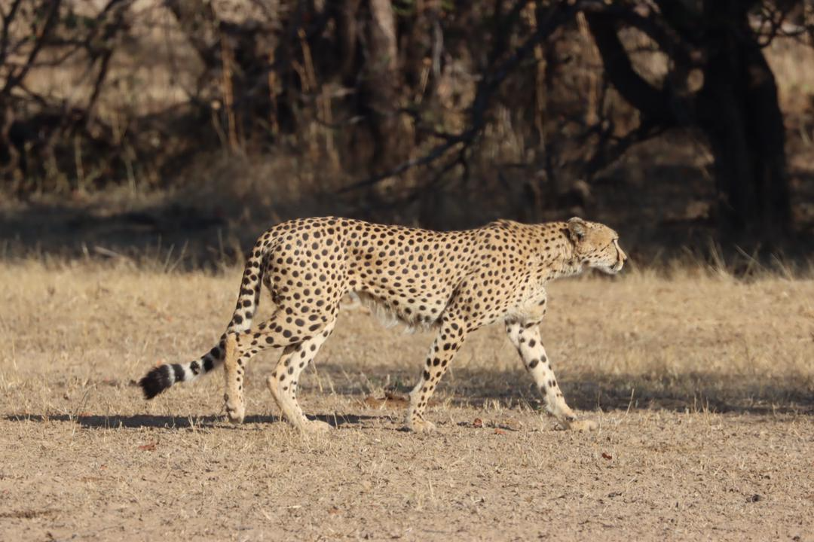
African cheetah (Acinonyx jubatus) in the Zambezi Valley

ZIMBABWE PARKS AND WILDLIFE MANAGEMENT AUTHORITY in collaboration with CHEETAH CONSERVATION PROJECT ZIMBABWE
March 2024

Table of Contents
Executive Summary 6
1.0 INTRODUCTION 7
1.1 The ecology of the cheetah 7
2.0 POLICY AND LEGISLATION 8
3.0 TRENDS IN CHEETAH POPULATION IN ZIMBABWE BETWEEN 1975 AND 2015 11
4.0 Methodology 12
5.0 FINDINGS 13
5.1 Cheetah Population Estimates in Zimbabwe 13
5.2 Mortalities 16
5.3 Conflict with humans? 16
6.0 DISCUSSION AND CONCLUSION 16
REFERENCES 17

Executive Summary
The African cheetah population is declining in the cheetah range areas and is extinct in some areas. A population census conducted in the 1980s and 1990s estimated 1,500 cheetahs in Zimbabwe, a figure which, however, could be on the higher side due to an over estimation of the population. Generally, it’s unlikely that the cheetah population could not have grown above the lion, leopard, hyena populations and further considering that cheetahs were killed as problem animals on the large-scale commercial livestock farms especially in the 1980s and 1990s. The last census of the cheetah population was conducted between 2012 and 2013 and gave an estimate of 150 adult cheetahs, leaving the status largely unknown in recent years. To address this gap, we conducted a population census between 2022 and 2024 to obtain updated estimates. Our findings indicate a population of 134-143 animals in 2024. The largest and most viable cheetah populations are in southern and north-western parts of Zimbabwe. The primary cause of this population decline could be attributed to habitat destruction resulting from changes in land-use on private land where the species was mostly found before 2000. As human activities alter the landscape, cheetahs face the loss and fragmentation of their natural habitats and feed, significantly impacting their ability to thrive and reproduce. Given their sensitivity to environmental threats, slight disturbances can negatively impact cheetah populations. We strongly recommend enhanced conservation efforts of cheetah habitats and further research on the species to understand better their dispersal patterns and the extent of inter and intra-specific competition with other predators such lions and hyenas.

1.0 INTRODUCTION
Globally, many large carnivores in the wild face a severe threat of population decline. Anthropogenic factors, such as changes in land use, incidental snaring, and conflicts with humans, are among the significant threats (Wolf and Ripple 2017). Extensive efforts have been made to conserve wildlife populations worldwide (Karanth and Chellam 2009, Carter and Linnell 2016). Moreover, there has been a shift in the conservation approach, emphasising the importance of considering the needs of wildlife while engaging local communities in culturally appropriate and meaningful ways to achieve better conservation outcomes (Craig, Cardillo et al. 2004, Ripple, Estes et al. 2014).
One species facing a severe population decline throughout their range is the African cheetah (Acinonyx jubatus) (Durant, Mitchell et al. 2017, Durant, Groom et al. 2022). It is estimated that there are currently around 7,100 cheetahs remaining, with populations having been eradicated from 95% of their historical range (Durant, Groom et al. 2022). Cheetahs are currently enlisted as "vulnerable" on the IUCN Red List and require urgent conservation attention.
Specific threats to cheetah populations include habitat loss due to changes in land use, competition with other species and conflict with farmers over livestock (Dickman, Potgieter et al. 2018). While these immediate threats contribute to cheetah decline, they are ultimately driven by various factors such as a lack or poor land-use planning, economic and political instability, and lack of awareness and political will to support ongoing conservation efforts (Durant, Groom et al. 2022). Therefore, addressing these underlying drivers is crucial to combating existing threats and safeguarding the populations in the wild.

1.1 The ecology of the cheetah
Cheetahs are an apex predator in the savanna ecosystem. They are habitat generalists and can be found in many habitats ranging from open plains, woodland, savanna, and thick bush. Habitat preference is often determined by two main factors: (a) the abundance of prey and (b) the presence/absence of sympatric carnivores such as lions, leopards, and hyenas as they are direct competitors. Cheetahs prey on medium-sized antelopes (15-30 kg) and avoid areas with high prey densities to avoid prey-dependent large predators such as lions.
Cheetah males are often social and hold small territories, while cheetah females are solitary and have large home ranges. The sizes of territories and home ranges for males and females can vary greatly across different landscapes, from as little as 37 km² to as high as 3,000 km².
Territorial males’ scent-mark their territory and defend it against intruders, whereas females tolerate other cheetahs in their home range that often overlaps with the home ranges of other cheetahs. On average, cheetahs can survive up to 11 or 12 years in the wild and have their first litter at two years, while males start to breed at three years. Mating in cheetahs occurs throughout the year; the gestation period is 90-95 days, and litter sizes range from 3 to 5 cubs. Cubs are born with their black spots, and a Mohawk-type mane that they shed as they grow older.
Cub mortality in cheetahs can be as high as 95%, and recruitment very low. This is because females rarely defend their cubs against larger predators, and cubs are killed by other larger predators such as lions. On average, cubs stay with their mother for 18-22 months; during this time, the mother teaches them how to hunt and avoid predators. After that, the mother leaves them behind to fend for themselves. Cubs usually stay together in sibling groups for several months before the males and females go their separate ways.

2.0 POLICY AND LEGISLATION
Zimbabwe’s National Legislation is comprehensive to ensure the long-term survival of the cheetah. Zimbabwe has a full range of national legislative and administrative measures needed to manage the cheetahs effectively. No hunting of cheetahs is allowed to protect and conserve the cheetah population. The cheetah is a specially protected species in Zimbabwe whose conservation is regulated through a policy and legal framework and regulations which include:
- Parks and Wildlife Act; Chapter 20:14 (1996)
- Environmental Management Act; Chapter 20:27
- Forest Act; Chapter 19:05
- Statutory Instrument 362 of 1990: Parks and Wildlife (General) Regulations, 1990
- Statutory Instrument 76 of 1998: Import and Export of Wildlife Products
- Statutory Instrument 40 of 1994: Parks and Wildlife Act (General) Amendments
- Statutory Instrument 26 of 1998: Parks & Wildlife Act (General) Amendment
- Statutory Instrument 92 of 2009; Compensation Values for Wildlife
- Statutory Instrument 93 of 2009: Compensation Values for Trapping of Animals
- Trapping of Animals Control Act 20.16
- Licensing and Protection of Wildlife Properties
- Code of Ethics for Hunting in Zimbabwe
- Parks and Wildlife Act Chapter 20:14 of 1996 as amended in 2001.
The principal legislation governs and regulates the purchasing, selling, and exporting of parts and derivates, including live animals. It also protects gazette protected areas which form the major range and habitat for the cheetah.
The Act prohibits the hunting of any animal and the removal of parts of animals from any land without authority. It provides for the protection of animals in the following designated areas: National Parks, Parks and Wildlife Estates, Parks and Wildlife land, Sanctuaries, and Safari Areas.
The Act further provides for the categorization of animals into protected and specially protected animals. Part XII of the Act is particularly interesting to cheetah conservation, which prohibits the hunting, removal and sale of live animals and animal products from designated national parks.
The Act has the following provisions, which address issues related to the Control of live animals, trophies, and trade.
- Section 59 provides for the general protection of all wildlife not covered by the above categories.
- This Act empowers the Minister responsible for Parks and Wildlife to issue regulations governing certain activities, such as:
- Section 60, where the Minister may prohibit or restrict hunting and removal of animals in defined areas.
- Section 66 provides for the licensing of professional hunters who undertake legalised hunting safaris.
- Section 72 provides for selling animals born or hatched and held in captivity.
- Section 73 provides for the sale and manufacture of articles from trophies.
- Environmental Management Act Chapter 20:27 0f 2006
This Act provides for the sustainable management of natural resources and the protection of the environment. The Act also provides for the preparation of National Environmental Plans for managing and protecting the environment in Zimbabwe.
- Forest Act Chapter 19:05
This Act provides for the establishment of a commission to control, manage, and protect State and private forests, thus providing a secure habitat for lions and other wildlife species.
- Statutory Instrument 362 of 1990
This legislation provides in sections 66-75 for the Regulation of Manufacture, Processing and Dealing in trophies.
- Statutory Instrument 76 of 1998
Statutory Instrument number 76 of 1998, Parks and Wildlife (Import and Export) (Wildlife) Regulations specifically deals with Import and Export of wildlife products. This legislation was enacted to ensure compliance with CITES requirements for export and import of wild flora and fauna. These provide for the following-:
- Section 3 deals with the Control of Import and Export of wildlife and trophies.
The above section lays down a general prohibition on the import into or export from Zimbabwe of any “wildlife” or trophy of “wildlife” except in accordance with either a certificate issued in terms of section 5 by the Director or Director of Customs, or an open general permit:
- Section 5 deals with Permits and Certificates and is consistent with CITES legislation.
- Section 15 deals with Offences and Penalties.
Any person who contravenes any of the provisions of subsection 1 shall be guilty of an offence, and liable to a fine or imprisonment.
To effectively ensure compliance, the Zimbabwe Parks and Wildlife Management Authority deployed a permanent team of officers based at all ports of exit and entry to assist border control officials in monitoring and inspection of all wildlife exports.
- Statutory Instrument 26 of 1998
The regulations provide for the monitoring of all hunting activities in the country to ensure compliance by all Safari Operators and international clients and to ensure that the TR2 Form. (Tourism Hunting Return Form) is duly completed.
- Trapping of Animals (Control) Act Chapter 20:21
The Act provides for the control, restriction and regulation of the construction, possession, and use of certain traps for the purpose of trapping animals; to control the sale and disposal of certain animals, to include lions and to provide for matters incidental to or connected with the foregoing.
- Statutory Instrument 92 of 1992
Parks and Wildlife (Payment for Hunting of Animals and Fish) Notice, 2009 This instrument provides for compensation values of various wildlife forms to include animals and fish. It acts as an additional deterrent measure in matters where poaching cases are being dealt with in accordance with the law. The compensation value for illegal hunting of cheetah is USD 1500, 00.
- Statutory Instrument 93 of 2009
Parks and Wildlife (Payment for Trapping of Wild Animals) Notice, 2009
This instrument provides for the payment of compensation to the state or game owners if one is convicted for illegally trapping wild animals on various land categories. The compensation value for illegal hunting of cheetah is USD 1500, 00.
- Statutory Instrument 40 of 1994
Parks and Wildlife (Appropriate Authorities for Communal Land) Notice, 1994, resulted in the according of Appropriate Authority status to various Rural District Councils. This legislation devolved authority to Rural District Councils and gave rights to local communities to sustainable utilize wildlife and other natural resources in their areas of jurisdiction.
- National Conservation Action Plan for Cheetah and African Wild Dog in Zimbabwe (2018-2022)
A Conservation and Action Plan for cheetahs is in place to conserve and manage the cheetah population both on private and state land.
- Code of Hunting Ethics for Zimbabwe
A Code of Ethics for Hunting in Zimbabwe is in place which regulates all forms of hunting including all cheetah hunts.

3.0 TRENDS IN CHEETAH POPULATION IN ZIMBABWE BETWEEN 1975 AND 2015
Estimates of cheetah populations in Zimbabwe have shown significant variation, from 400 in 1975 (Myers, 1975) to more than 1,500 cheetahs in 1999 (Davison, 1999a). The expansion of commercial livestock farming in the 1970s increased conflict between farmers and carnivores such as the cheetah. In response, permits to legally shoot problem cheetahs were issued in the late 1970s (Heath, 1997). Some farmers resorted to illegal methods, leading to the indiscriminate killing of over a hundred cheetahs annually through the "shoot, shovel, and shut up" approach. The 1980 cheetah population survey revealed that cheetahs continued to face persecution and were still perceived as problem animals by farmers, with no perceived commercial benefit, making them unwelcome on farms. In that same year, the cheetah was declared a specially protected species under the Parks and Wildlife Act and listed on Convention in International Trade of Endangered Species flora and fauna (CITES) Appendix I, providing it with high protection.

In the 1990s, the authorities developed several cheetah action plans focussing on reducing human-cheetah conflict, and various steps were taken to try and reduce this conflict, including a proposal to CITES to allow the legal off-take of cheetahs. The reason was to increase the species' commercial value and reduce the livestock farmers from killing the cheetahs as problem animals.
(CITES, 1992). Consequently, Zimbabwe was allowed to legally export 50 cheetah trophies or live cheetahs a year, to enable farmers to get economic returns. When the 50 export tags were exhausted, further provisions were made so that farmers could still apply for problem animal control permits (Davison, 1999b). In 1994, the authorities translocated 21 problem cheetahs from the Southeast Lowveld to Matusadona National Park; seven (7) of these died before or shortly after release (Zank,1995). Although to make it easier for farmers to acquire permits to control problem cheetahs, it was proposed to change the cheetah's status to restricted species (Wilson, 1989), these recommendations were not taken up, and the cheetah remained a specially protected species (Davison, 1999b). While cheetah numbers in National Parks Estates declined in the 1990s, on commercial farmland, the population continued to increase (Heath, 1997). A survey of 37 ranches showed an increase from 220 to 700 cheetahs in just one decade (Heath, 1997).

Towards the late 1990s/ early 20020s, the authorities carried out a country-wide assessment which showed that cheetah densities had continued to increase on commercial farmland, causing unacceptably high levels of stock loss; the status of the cheetah on communal farmlands was uncertain, numbers were probably low, and the species was not commonly reported as a pest; cheetah numbers in national park areas were low and not increasing, probably due to intra-carnivore competition: the cheetah population was estimated at a minimum of 1 200 cheetahs on commercial farmlands and 320 cheetahs in National Parks areas (Davison, 1999a).
Between 2013 and 2015, the Cheetah Conservation Project Zimbabwe carried out its first county-wide cheetah population survey. A survey revealed a staggering 90% decline in Zimbabwe’s cheetah population, reducing from 1,500 individuals in the 1990s to between 150-170 cheetah population (van der Meer 2016). Furthermore, the survey identified three central cheetah populations in Zimbabwe: (a) the Zambezi Valley population, (b) the Hwange-Matetsi-Victoria Falls population, and (c) the Lowveld population. Among these, the Hwange-Matetsi-Victoria Falls population is considered the most viable, as it is connected to other cheetah populations in Botswana, Namibia, Zambia, and Angola through the Okavango Zambezi Transfrontier Conservation Area (KAZA TFCA) (van der Meer 2017).
Between January 2022 and January 2024, we conducted a census to determine Zimbabwe’s current cheetah population estimates. Our specific objective was to assess the decline and potential recovery of cheetah populations in Zimbabwe since 2015, using information and photographs from the public, such as safari guides and national park rangers, and tourists, etc. The results of the survey are indicated in this report. Figure 1 shows a sample of the photographs that were shared by guides, researchers, and general citizens.
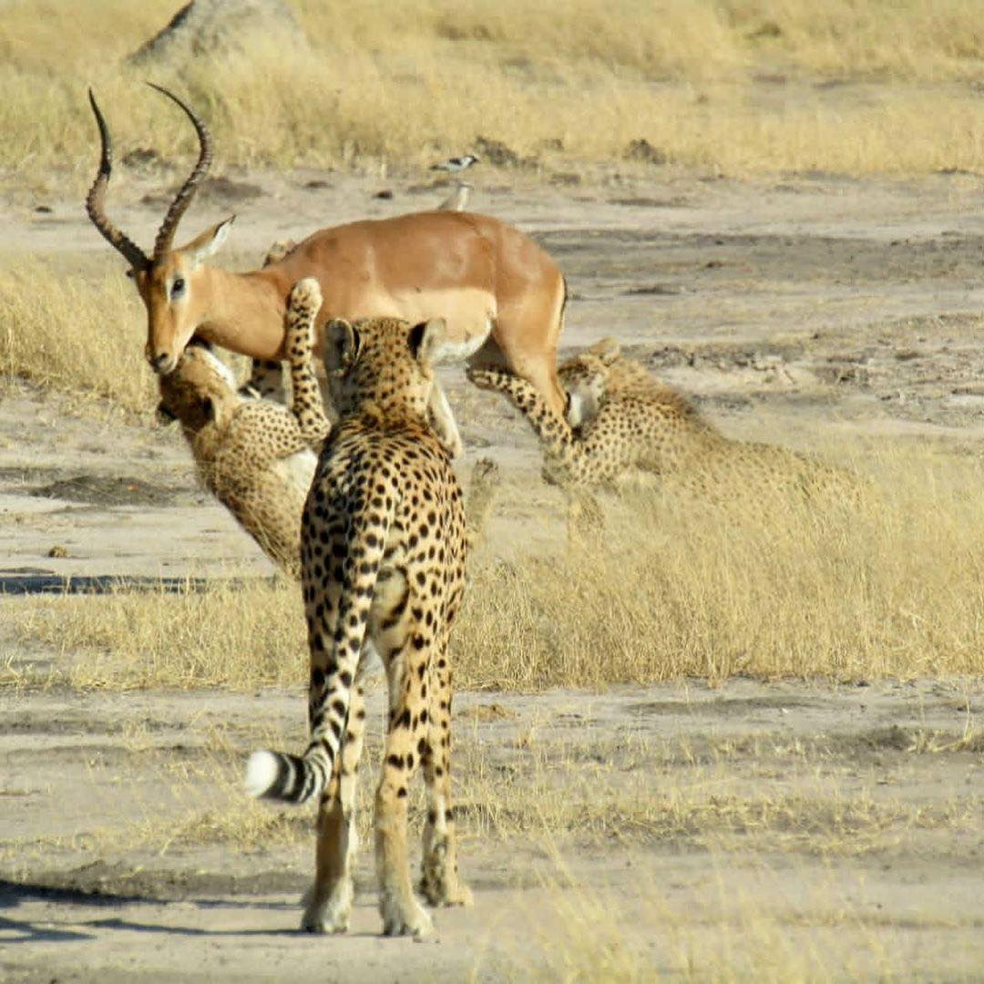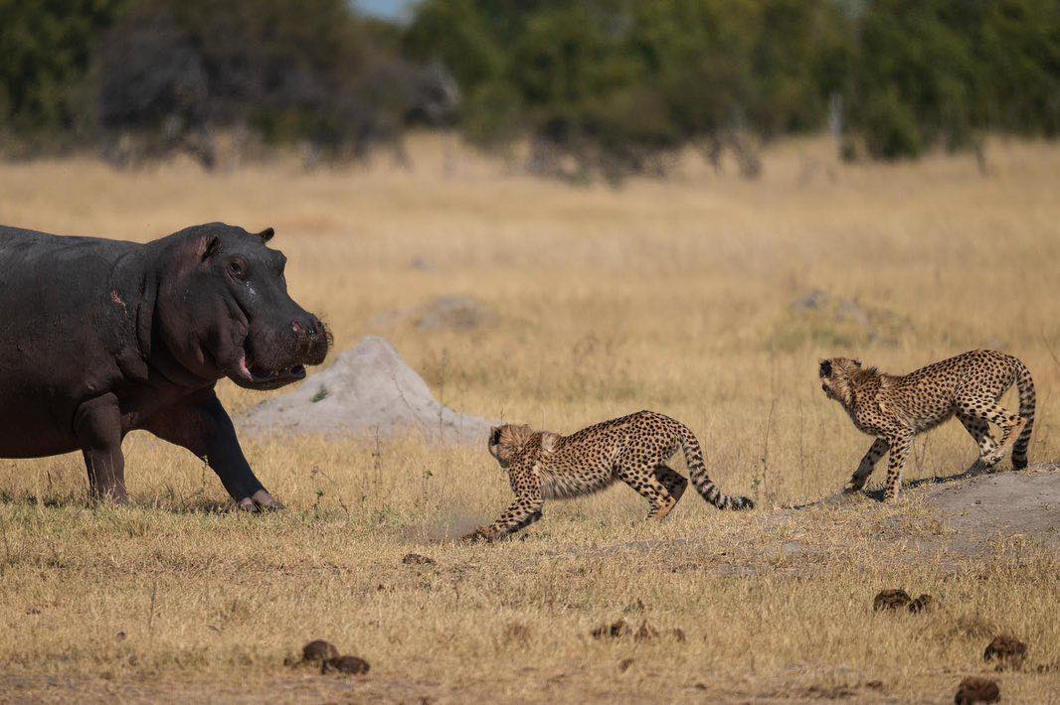
Figure 1: Cheetah ID HNP046 teaching her cubs how to take down prey and a hippo charging towards cheetahs in Hwange NP

4.0 Methodology
In this assessment, we used (i) citizen science data and (ii) secondary data collected using camera traps. Our citizen science programme comprises over 100 participants from different stakeholders, including national park rangers, safari guides, safari operators, tourists, other researchers, and local communities and tourists.
About 567 posters were distributed in local schools, shops, and clinics (key places where people will likely read about our work) around the Hwange National Park-Matetsi and Victoria Falls areas. In return, we received 1,415 photographs in 226 independent sightings (Mean=117.92 per month and 6.26 photographs per sighting). Most (>95%) of the sightings and photographs we received were from safari guides, tourists, and tour operators. Other researchers, local communities, and national park rangers submitted fewer cheetah sightings and photographs (<5%). Most of the sightings and accompanying photographs were from the Hwange National Park- Matetsi- Victoria Falls.

When encountering a cheetah, they record the geographical position system location, date, time, number of animals, activity, number of cubs and photographs of the animal encountered. The information is then sent to us for collation. To encourage citizen scientists to send us information about cheetahs, we engage citizen scientists via several online platforms such as WhatsApp and Facebook. Our WhatsApp group has close to 100 active participants (consisting of guides, safari operators, and other researchers), where we update participants on the latest cheetah sightings in Zimbabwe. Our Facebook has over 8,100 members, and the membership has increased from 6,500 followers in 2021. This page aims to engage with citizen scientists by posting regular updates on cheetahs seen. Further, we also have a dedicated web page where citizen scientists can read about our work, submit cheetah sightings, and find contact information. Finally, we have over 500 posters in key tourist offices, national park rangers’ offices and safari lodges in and around Hwange National Park and the Zambezi Valley. This report also used camera trap data collected by different research projects nationwide.
From 2020 to 2023, different research organisations have shared camera trap images with us and carried out camera trap surveys in different national parks in Zimbabwe. Although these camera traps were explicitly designed for other species, they can help give sightings of cheetahs in an area. To positively identify individuals, we compare each photograph received against a reference file list containing a database of all individual animals in Zimbabwe. Individual animals are distinguished using their front and hind quarters coat markings. Thereafter, the database is updated for each confirmed individual.

5.0 FINDINGS

5.1 Cheetah Population Estimates in Zimbabwe
Our results suggest there could be between 134-143 adult cheetahs in Zimbabwe. The highest populations were found in southern parts of Zimbabwe, i.e., Masvingo and Matabeleland South provinces (n= 77-83 cheetahs), followed by the Hwange-Matetsi-Victoria Falls population (n= 43-45 cheetahs) (Table 1). The lowest populations were found in northern parts of Zimbabwe (n=14-15 cheetahs).

Table 1: Current cheetah population estimates in Zimbabwe based on camera trap and citizen science data
REGION | Description | 2015 Estimates | 2024 Estimates | Population trend | Reason for decline
Matabeleland North | Hwange National Park and buffer zone along Eastern boundary (Gwaai ICA, Sikumi, Ngamo) | ca. 25 | ca. 25-27 | Stable | Competition with other predators
Matabeleland North | Matetsi unit 1-5 and buffer zone along  eastern boundary (Matetsi ICA, Deka) | ca. 10 | ca. 9 | Decreasing | Competition with other predators, poaching of cheetah and their prey
Matabeleland North | Victoria Falls Area (Zambezi National Park, Matetsi unit 6-7, Panda Masuwe, Kazuma, Kazuma Pan, Fuller) | ca. 5-7 | ca. 9 | Stable | Competition with other predators, poaching of cheetah and their prey
Subtotal |  | 40-42 | 43-45 | Stable
Mashonaland West | Chizarira National Park, Chirisa SA, Sengwa | No record | Transient  population  of ca. 2-3 | Unknown | Unknown
Mashonaland West | Matusadona National Park | ca. 3 | ca. 4 | Remained low | Unknown
Mashonaland West | Dande, Omay, Chewore North Hurungwe (Nyakasanga & Rifa) Mana Pools National Park and shoreline along the northern boundary of Hurungwe and Sapi | ca. 12 | ca. 8 | Decreased | Unknown
Subtotal |  | ca. 15 | ca. 14-15
Masvingo | Gonarezhou National Park | ca. 15-17 | ca. 17 | Stable | Competition with other predators
Masvingo | Nuanetsi Ranch cattle and wildlife section | ca. 15-17 | ca. 15 | Stable | No competition with lion
Masvingo | Malilangwe | ca. 12 | ca. 14 | Stable | Influx from surrounding areas as people encroached on the land, less competition with other carnivores (decrease in lion population)
Masvingo | Save Valley Conservancy | ca. 10 | ca.8-11 | Stable | Competition with other predators,  poaching of cheetah and their prey
Masvingo | Bubye Valley | 20-22 | 15-17 | Decreased | Vehicular collusion, competition from other predators
Masvingo | Debshan Ranch/De Beers Cattle Section and neighbouring farms (Magholo Farm, Jabulani Safaris, Phezulu Ranch) | ca. 3-5 | ca. 1 | Decreased | Human encroachment, poaching of  cheetah and their prey, habitat  destruction by people
Masvingo | Farms and communal land southwest of Bubye Valley Conservancy (Den Linian Ranch, Bishopstone Farm, Maramani Communal  Land, River Ranch, Sentinel Ranch) | ca. 5-7 | No sightings received | No sightings received for this location | Human encroachment, poaching of  cheetah and their prey, habitat  destruction by people
Matabeleland South | Bubiana and farms West of Bubiana (Jonsyl Ranch, Chipize Ranch, Reata Farm, Pepeluza Farm, Inhlaba, Lucknow, Mashura Ranch Rooiberg, Li farm, Mkashi, Muko Farm) | ca. 3-5 | ca. 1 | Decreased | Human encroachment, poaching of  cheetah and their prey, habitat  destruction by people
 | Tuli Circle (part of a Botswana's Northern Tuli Game Reserve Population) | ca. 3 | No sighting received | Unknown
 | Additional single cheetah sightings outside resident cheetah range | ca. 6-10 | ca. 7 | NA | Transient population
Subtotal |  |  | ca. 77-83
TOTAL |  |  | 134-143

5.2 Mortalities
Between 2021 and 2023, seven mortalities were recorded of which six were anthropogenic, while one was due to natural causes. Cub mortality is naturally high in cheetah populations.

5.3 Conflict with humans?
Reports of cheetah attacks on livestock were generally low. Between 2021 and 2024, several reports of cheetahs killing livestock in the Northwest Matabeleland were recorded. A total of 11 goats and one calf were reported to have been killed by cheetahs. All incidents occurred in 2022.

6.0 DISCUSSION AND CONCLUSION
Zimbabwe through the Parks and Wildlife Management Authority and its partners is making efforts to conserve and protect the cheetah inside, and outside wildlife protected areas. Research and monitoring are ongoing in key range areas. As seen for the data collected, stakeholders know the cheetah as seen from the photos shared. Since 2015, when it was confirmed that the numbers are declining, all hunting of trophy cheetahs was stopped in Zimbabwe. Efforts are being made to manage the wildlife habitat and there is proposed reintroduction of the cheetah in some areas. However, there is need to collaborate in research and monitoring at national and transboundary level to ensure that cheetahs are protected at landscape level and ensure connectivity across different land use types. Cheetahs are not an easy species to see when doing surveys, there is need for robust methods to be used to ensure that there is no overestimation or underestimating the species numbers for management purposes.

Urgent conservation attention is needed to protect cheetah populations across their range in Zimbabwe and other range states. While conflicts with local farmers in Zimbabwe are minimal, it is essential to gain a comprehensive understanding of cheetah population dynamics, including migration/connectivity patterns and vital population data inside and outside wildlife protected areas. By acquiring this information, we can enhance monitoring and conservation efforts, ultimately safeguarding the future of cheetah population in the wild.

REFERENCES
- Broekhuis, F. (2018). "Natural and anthropogenic drivers of cub recruitment in a large carnivore." Ecol Evol 8(13): 6748-6755.
- Carter, N. H. and J. D. C. Linnell (2016). "Co-Adaptation Is Key to Coexisting with Large Carnivores." Trends Ecol Evol 31(8): 575-578.
- Craig, M., M. Cardillo, A. Purvis, W. Sechrest, J. L. Gittleman, J. Bielby and G. M. Mace (2004). "Human Population Density and Extinction Risk in the World's Carnivores." PLoS Biology 2(7).
- Dickman, A., G. Potgieter, J. Horgan, K. Stoner, R. Klein, J. McManus and L. Marker (2018). Use of Livestock Guarding Dogs to Reduce Human-Cheetah Conflict. Cheetahs: Biology and Conservation: 209-221.
- Durant, S. M., R. Groom, A. Ipavec, N. Mitchell and L. Khalatbari (2022). Acinonyx jubatus (amended version of 2022 assessment). The IUCN Red List of Threatened Species 2023: .
- Durant, S. M., N. Mitchell, R. Groom, N. Pettorelli, A. Ipavec, A. P. Jacobson, R. Woodroffe, M. Bohm, L. T. Hunter, M. S. Becker, F. Broekhuis, S. Bashir, L. Andresen, O. Aschenborn, M. Beddiaf, F. Belbachir, A. Belbachir-Bazi, A. Berbash, I. Brandao de Matos Machado, C. Breitenmoser, M. Chege, D. Cilliers, H. Davies-Mostert, A. J. Dickman, F. Ezekiel, M. S. Farhadinia, P. Funston, P. Henschel, J. Horgan, H. H. de Iongh, H. Jowkar, R. Klein, P. A. Lindsey, L. Marker, K. Marnewick, J. Melzheimer, J. Merkle, J. M'Soka, M. Msuha, H. O'Neill, M. Parker, G. Purchase, S. Sahailou, Y. Saidu, A. Samna, A. Schmidt-Kuntzel, E. Selebatso, E. A. Sogbohossou, A. Soultan, E. Stone, E. van der Meer, R. van Vuuren, M. Wykstra and K. Young-Overton (2017). "The global decline of cheetah Acinonyx jubatus and what it means for conservation." Proc Natl Acad Sci U S A 114(3): 528-533.
- Karanth, K. U. and R. Chellam (2009). "Carnivore conservation at the crossroads." Oryx 43(01).
- Ripple, W. J., J. A. Estes, R. L. Beschta, C. C. Wilmers, E. G. Ritchie, M. Hebblewhite, J. Berger, B. Elmhagen, M. Letnic, M. P. Nelson, O. J. Schmitz, D. W. Smith, A. D. Wallach and A. J. Wirsing (2014). "Status and ecological effects of the world's largest carnivores." Science 343(6167): 151-164.
- van der Meer, E. (2016). The cheetahs of Zimbabwe, distribution and population status 2015. Victoria Falls, Zimbabwe.
- van der Meer, E. (2017). "Carnivore conservation under land use change: the status of Zimbabwe’s cheetah population after land reform." Biodiversity and Conservation 27(3): 647-663.
- Wolf, C. and W. J. Ripple (2017). "Range contractions of the world's large carnivores." Royal Society Open Science 4(7): 1-11.

