7th Meeting of the Sessional Committee of the
CMS Scientific Council (ScC-SC7)

Bonn, Germany, 17 – 20 September 2024
UNEP/CMS/ScC-SC7/Doc.6.1.3

TRANSFRONTIER CONSERVATION AREAS FOR MIGRATORY SPECIES
(Prepared by the Secretariat)

Summary:

CMS Decision 14.198 requests the Scientific Council to review the usefulness of the Tool based on the reports submitted by Parties through the Secretariat and make appropriate recommendations to the Secretariat and Parties on its further use and to help identify improvements that should be incorporated into the Tool and to inform the future expansion of the Tool.

TRANSFRONTIER CONSERVATION AREAS FOR MIGRATORY SPECIES

Background

- In 2021, having been informed by representatives of Southern and Eastern African countries that one of their challenges was the delineation of transboundary protected areas, the CMS Secretariat commissioned the United Nations Environment Programme World Conservation Monitoring Centre (UNEP-WCMC) to develop an online tool for Identifying opportunities for transboundary conservation in Africa. The World Database on Protected Areas and the World Database on Key Biodiversity Areas data used in the Tool can contribute towards informing policy decisions across Africa and provide governments with a basis for evidence-based design of new and updates to existing high-level protocols on the formation of TFCAs by SADC, EAC and IGAD. The Tool provides the data needed to support the protection and extension of ecological connectivity for migratory species. The Tool was officially launched during the IUCN African Protected Areas Congress in Kigali, Rwanda in 2022.

- At CMS COP14 in February 2024, Parties adopted Decisions 14.197 – 14.199 Transfrontier Conservation Areas for Migratory Species, further reflecting on the Tool:

14.197 Parties that are members of the Southern African Development Community (SADC), the Intergovernmental Authority on Development (IGAD) and the East African Community (EAC) are invited to: a) consider testing, as appropriate, the UNEP-WCMC pilot Transboundary tool (the ‘Tool’) to identify potential opportunities for transboundary conservation using data from the World Database on Protected Areas and the World Database on Key Biodiversity Areas; and b) consider reporting through the Secretariat to the Sessional Committee of the Scientific Council at its 7th and/or 8th meeting on the potential opportunities for identifying transboundary conservation areas, as well as the functionality and usefulness of the Tool in supporting Parties to identify these.

14.198 The Scientific Council is requested, subject to the availability of resources, to review the usefulness of the Tool based on the reports submitted by Parties through the Secretariat, in line with Decisions 14.197 (b) and 14.199 (b), and make appropriate recommendations to the Secretariat and Parties on its further use and to help identify improvements that should be incorporated into the Tool and to inform the future expansion of the Tool.

  - The Secretariat shall, subject to the availability of resources: a) in collaboration with UNEP-WCMC and other partners, raise awareness of the Tool among Parties mentioned in Decision 14.197; b) request Parties referred to in Decision 14.197 to consider sharing feedback on the functionality and usefulness of the Tool in identifying potential opportunities for transboundary conservation, and submit a report on the feedback received to the Sessional Committee of the Scientific Council at its 7th and/or 8th meeting; and c) report to the Conference of the Parties at its 15th meeting on the progress in implementing these Decisions.

Activities carried out to implement the decisions

- As instructed, the Secretariat organized a series of webinars on the usefulness and functionality of the Tool. The Tool was presented to members of the Intergovernmental Authority on Development (IGAD) on 6 June 2024; members of the Southern African Development Community (SADC) on 7 June 2024, and members of the East African Community (EAC) on 26 June 2024 during existing events. A standalone event was organized by the CMS Secretariat on 19 June 2024 for all Parties to CMS of the IGAD, EAC and SADC regions.

- To facilitate implementation of decision 12.197, a survey was sent to all CMS Parties as well as participants of the above-mentioned events, a total of 145 persons. Feedback on the tool during the webinars and responses to the survey were compiled by UNEP-WCMC in the document annexed to this document. A total of 2 responses to the survey were received by UNEP-WCMC.

- The recommendations based on the feedback received, and further detailed in the annex, are to:

- Circulate the survey further.
- Consider housing the Transboundary tool contents in a new location, such as the Protected Planet website.
- Consider sharing data layers with UNBL and/or other online platforms. Alternatively, consider adding some data layers listed under the ‘Content improvements’, or providing links to UNBL within the Transboundary tool.
- Consider implementing the ideas listed under ‘Usability improvements’.
- Improve content and visibility of information provided about the data layer methodology.

Recommended actions

- The Sessional Committee of the Scientific Council is requested to:

  - review the usefulness of the Tool based on the reports submitted by Parties;

  - make appropriate recommendations to the Secretariat and Parties on its further use and help identify improvements that should be incorporated into the Tool; and

  - inform the future expansion of the Tool.

ANNEX

UNEP-WCMC REPORT ON USER FEEDBACK ON THE TRANSBOUNDARY TOOL


REPORT ON USER FEEDBACK ON THE TRANSBOUNDARY TOOL

A report for the CMS Secretariat




Prepared for: The Secretariat of the Convention on the Conservation of Migratory Species of Wild Animals (CMS).
Copyright: © 2024 CMS.
Citation: UNEP-WCMC, 2024. Report on User Feedback on the Transboundary tool. UNEP-WCMC, Cambridge, UK.
Authors: Jacinta Jackson, Vignesh Kamath Cannanure, Aude Caromel.
Acknowledgements: The authors would like to thank the following people for their contributions in the implementation of this project: Nina Bhola, Frances Davis and Kelly Malsch (UNEP-WCMC), Clara Nobbe and Amie Figueiredo (CMS Secretariat). UNEP-WCMC would like to express their sincere thanks to colleagues from the CMS Secretariat for organising the workshops showcasing the Transboundary tool to relevant user groups in Africa, and for the workshop participants and respondents to the survey for their useful feedback. This report, and the underlying workshops and user research, was made possible by the generous financial contributions of the EU-funded Programme on “Cross-Regional Wildlife Conservation in Eastern and Southern Africa and the Indian Ocean”.
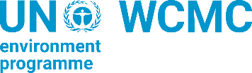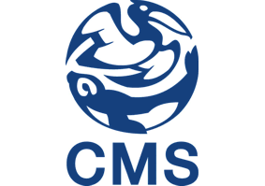
The UN Environment Programme World Conservation Monitoring Centre (UNEP-WCMC) is a global Centre of excellence on biodiversity. The Centre operates as a collaboration between the UN Environment Programme and the UK-registered charity WCMC. Together we are confronting the global crisis facing nature.

This publication may be reproduced for educational or non-profit purposes without special permission, provided acknowledgement to the source is made. Reuse of any figures is subject to permission from the original rights holders. No use of this publication may be made for resale or any other commercial purpose without permission in writing from the UN Environment Programme. Applications for permission, with a statement of purpose and extent of reproduction, should be sent to the Director, UNEP-WCMC, 219 Huntingdon Road, Cambridge, CB3 0DL, UK.

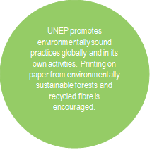
The contents of this report do not necessarily reflect the views or policies of the UN Environment Programme, contributory organisations or editors. The designations employed and the presentations of material in this report do not imply the expression of any opinion whatsoever on the part of the UN Environment Programme or contributory organisations, editors or publishers concerning the legal status of any country, territory, city area or its authorities, or concerning the delimitation of its frontiers or boundaries or the designation of its name, frontiers or boundaries. The mention of a commercial entity or product in this publication does not imply endorsement by the UN Environment Programme.

United Nations Environment Programme World Conservation Monitoring Centre (UNEP-WCMC)
219 Huntingdon Road,
Cambridge CB3 0DL, UK
Tel: +44 1223 277314
www.unep-wcmc.or
UNEP promotes environmentally sound practices globally and in its own activities. Our distribution policy aims to reduce UNEP’s carbon footprint.

Executive summary

This report is a summary of the findings from user research into the utility and usability of the Transboundary tool prototype, as mandated by CMS Decisions 14.197-14.199. The Transboundary tool was developed by UNEP-WCMC to provide Parties to the Convention on the Conservation of Migratory Species of Wild Animals (CMS) and other actors with a scientific basis for establishing bilateral and multilateral Transfrontier Conservation Areas (TFCAs) across Africa.

The user research consisted of two main components. The first was a series of four workshops conducted with the Intergovernmental Authority on Development (IGAD), the Southern African Development Community (SADC), the East African Community (EAC), and CMS focal points from the above regions, to demonstrate the Transboundary tool. The second was a survey circulated via email by the CMS Secretariat to participants of those workshops and invited participants. Workshop participants totalled 67, and the survey was sent to 145 people whilst only two responses to the survey were received.

Key findings

The survey revealed that, when scoping transboundary conservation areas, both respondents report facing challenges such as a lack of incentives, capacity and resources, as well as challenges in coordination within government and with other national governments. Lack of spatial data – the key challenge which this Transboundary tool seeks to solve – was reported as being a challenge by one of the two respondents, with the second not working much on transboundary conservation at present. More data would be needed to assess the overall utility of the tool.

On average, the Transboundary tool was rated as ‘very easy’ to use, and ‘quite’ or ‘very’ useful in survey participants’ own work. With only two survey responses, these average scores are not representative of attitudes from the whole target user population. However, a combination of the survey responses and comments made during the workshops does help to form a picture of how the tool is performing, as well as opportunities for extension in the future.

Recommendations

This report recommends extending the survey period to gather more perspectives and focus on the most common needs that the tool could address, and any changes needed to improve its current usability. Given the information gathered so far, further developments of the tool could involve:
- clarifying visual distinctions within the tool’s existing map feature,
- improving access to the underlying methodology in the tool to aid interpretation of the results, and
- facilitating users’ access to more data layers in the future, either by sharing the tool’s data layers with other platforms or adding more layers to this tool.

Table of Contents
Executive summary i
Background and rationale 1
Methodology 2
Findings 3
About participants 3
Challenges in transboundary conservation 3
Efficacy of the Transboundary tool prototype 4
Improvement ideas (from participants’ comments) 5
Recommendations 8
Annex 1 – Survey 11

Background and rationale

The role of ecological networks and connectivity in the conservation of migratory species has been recognised by Parties to the Convention on the Conservation of Migratory Species of Wild Animals (CMS) as an important aspect that they need to consider when identifying areas of importance for migratory species. The concept of Transfrontier Conservation Areas (TFCAs), described as “meaning an area or component of a large ecological region that straddles the boundaries of two or more countries and is within their national jurisdiction, which may encompass one or more protected areas, as well as multiple resource use areas”, was included in Resolution 12.7 on The Role of Ecological Networks in the Conservation of Migratory Species at the 13th meeting of the Conference of the Parties (COP13, India, 2020). Resolution 12.7 (Rev. COP13) and its replacement Resolution 14.16, encourage Parties to identify transboundary habitats of CMS-listed species that could be considered as TFCAs. This report refers to ”TCFAs” and “transboundary areas” synonymously.
In 2021, the CMS Secretariat commissioned the UN Environment Programme World Conservation Monitoring Centre (UNEP-WCMC) on the basis of feedabck received from members of the South African Development Community and East African Community in a series of webinars about TFCAs, to develop a methodology and a new, publicly available, web-based tool to enable users to identify existing protected areas in Africa that are spatially adjacent and ecologically connected across country boundaries, and that have the potential for harmonized management. The key target users were anticipated to be anyone working for the African Parties to the CMS who might want to identify new opportunities for transboundary conservation. A prototype of the tool, ‘Identifying opportunities for transboundary conservation’ (hereafter Transboundary tool), was developed under the “Cross-Regional Wildlife Conservation in Eastern and Southern Africa and the Indian Ocean” funded by the European Union, and was launched at the African Protected Areas Congress in Rwanda in 2022. In 2023, Kamath et al. published a paper entitled ‘Identifying opportunities for Transboundary Conservation in Africa3‘, demonstrating a possible application of the tool.
At its 14th meeting (Uzbekistan, 2024), the Conference of the Parties adopted a set of decisions on Transfrontier Conservation Areas inviting Parties that are members of the Southern African Development Community (SADC), the Intergovernmental Authority on Development (IGAD) and the East African Community (EAC), as well as the Scientific Council, to review and test the functionality and usefulness of the pilot Transboundary tool in identifying potential opportunities for transboundary conservation (Decisions 14.197-14.199).
To support the implementation of these decisions, the CMS Secretariat requested the support of UNEP-WCMC to present the prototype Transboundary tool to the relevant Parties, gather feedback on the functionality and usefulness of the tool, and provide recommendations, as appropriate, on potential further developments of the tool. A series of four online workshops were delivered to raise awareness of the Transboundary tool’s functionality and benefits to key target users in each of the three regions, and an online survey was circulated to assess the utility and usability of the prototype further.
This report presents the key findings from the feedback received through the survey, as well as unstructured feedback gathered through the discussions at the workshops.

Methodology

Workshops were identified by UNEP-WCMC and CMS as the ideal method to present the Transboundary tool to groups of participants from each of the pilot regions (Eastern and Southern Africa). Four workshops were organised and hosted by the CMS Secretariat in collaboration with UNEP-WCMC with the following groups:
- The Intergovernmental Authority on Development (IGAD) (6 June 2024, 27 participants excluding presenters, CMS, and UNEP-WCMC), as part of a wider workshop on Enhancing cooperation on transboundary conservation among IGAD Member States
- The Southern African Development Community (SADC) (7 June 2024, 15 participants excluding presenters, CMS, and UNEP-WCMC), as part of the SADC Framework on Conservation, Management and Sustainable Use of Natural Resources
- The CMS National Focal Points (open to all regions) (19 June 2024, 7 participants, excluding presenters, CMS, and UNEP-WCMC)
- The East African Community (EAC) (26 June 2024, 18 participants), under the auspice of the Transboundary Wildlife Conservation Areas Technical Working Group.
After a demonstration of the Transboundary tool, general feedback was gathered in an unstructured way, and participants were directed to respond to the online survey.
The online survey was selected as the most appropriate method for the purpose of gathering a mix of quantitative and qualitative feedback from a broad range of target users on the tool’s utility and usability. Microsoft Forms was selected as an appropriate survey software that would be accessible and usable for all participants. The survey was shared broadly to all African Parties to CMS that attended the workshops, initially by UNEP-WCMC after each workshop (in June/July 2024) and again by the CMS Secretariat within the same time period. The survey was open and collecting responses between the 6 June and 11 July 2024.
The survey included questions on demographics (Q1-Q5), current behaviours (Q6) and challenges (Q7) in activities related to transboundary conservation, an assessment of the Tool’s usability (Q8-Q10) and utility (Q11-Q14) through a set task, and ideas for future development (Q13-Q15). The survey is available in full in the Annex to this report. Demographic data was collected for the purpose of identifying any trends across respondents of different regions and roles. Meanwhile, questions to assess the Tool’s usability and utility, and ideas for future improvement, were included to respond directly to the needs of the CMS Secretariat. In the main body of the report, each question number is referred to using the following format: ‘Question 1’ = ‘Q1’, ‘Question 2 = ‘Q2’, etcetera.
In the month that the survey was open, just two responses were received. This is not enough to make any generalisations about overall utility and usability of the Transboundary tool for its target audience. Although demographic data was collected to identify trends across regions and roles, no cross-tabulation took place as trends could not be identified with a sample of this size. However, the findings of the survey, combined with the discussions at the workshops, are useful for gleaning a sense of the reception from some target users, and of possible future directions.

Findings

About participants

Workshops were held with the following groups:

Reference | Details | Total number of participants | Count of Male/Female
W1 - IGAD | Intergovernmental Authority on Development | 27 | Male: 21  Female: 6
W2 - SADC | Southern African Development Community | 15 | Male: 8  Female: 7
W3 – CMS Focal Points | all regions | 7 | Male: 5  Female: 2
W4 - EAC | East African Community | 18 | Male: 12  Female: 0  No data: 6

The survey respondents (each numbered here and labelled throughout this report as ‘R1’, ‘R2’) were as follows:

R | Country | Affiliation | How often are you engaged in activities related to transboundary conservation? | Gender
1 | Ethiopia | IGAD  (Intergovernmental Authority on Development) | A few times a year | Male
2 | Sudan | EAC  (East African Community) | Every few years | Female

Although respondents to the survey belonged to different organisations and regional contexts, both had senior roles. It’s useful to keep in mind their differences whilst reviewing the comments made.

Overall, R1, who works on transboundary conservation a few times a year, seems relatively more engaged in transboundary conservation than R2. They currently work on relevant activities such as: identifying “potential” (presumably, protected/conserved areas), conducting surveys, engagement in (including promotion of) trans-frontier conservation initiatives, and development of management plans for transboundary conservation areas.

Meanwhile, R2, who works on transboundary conservation every few years, is involved with very few activities relevant to transboundary conservation, noting that their country “has no special plan for transboundary conservation. It is only the work of Control patrols to combat wild animal smuggling and combat poaching” (R2, Q6). This may suggest that there is a niche which the tool can help to fill by building engagement, since this and other countries may have “no special plan for transboundary conservation”.

Challenges in transboundary conservation

Both survey respondents reported facing some kind of challenge in the initial scoping to identify (existing or new) areas for transboundary conservation (Figure 1). From the multiple-choice options provided in the question, the challenges most commonly reported by survey participants were: lack of incentives (2), lack of capacity (2), lack of resources (2), coordination within government (2) and coordination with other national governments (2) (see Q7).
Lack of spatial data – the key challenge that this Transboundary tool seeks to solve – was reported as being a challenge by one of the two survey respondents (R1). It is possible that the other respondent (R2) may simply not have given this as an issue because they do not work extensively on transboundary conservation and so have not identified this as a need. The limited number of responses to the survey is not enough data to generalise about the utility of the tool in responding to challenges faced across the target audience. However, webinars conducted by CMS (as part of a 2021 EU funded project) showed that Parties have previously raised that they face challenges in delineating TFCA boundaries. In this way, past feedback has suggested the scientific basis needed to identify TFCAs is lacking – a challenge that this tool helps to fill.
Notably, neither of the survey respondents reported having any challenges in coordinating with non-government stakeholders. It is unknown whether the lack of challenges in coordinating with non-government stakeholders is because non-government stakeholders are not engaged with on transboundary conservation, or if because engaging with those stakeholders is free from challenges.

Figure 1: Challenges faced in initial scoping to identify areas for transboundary conservation, as reported by survey participants
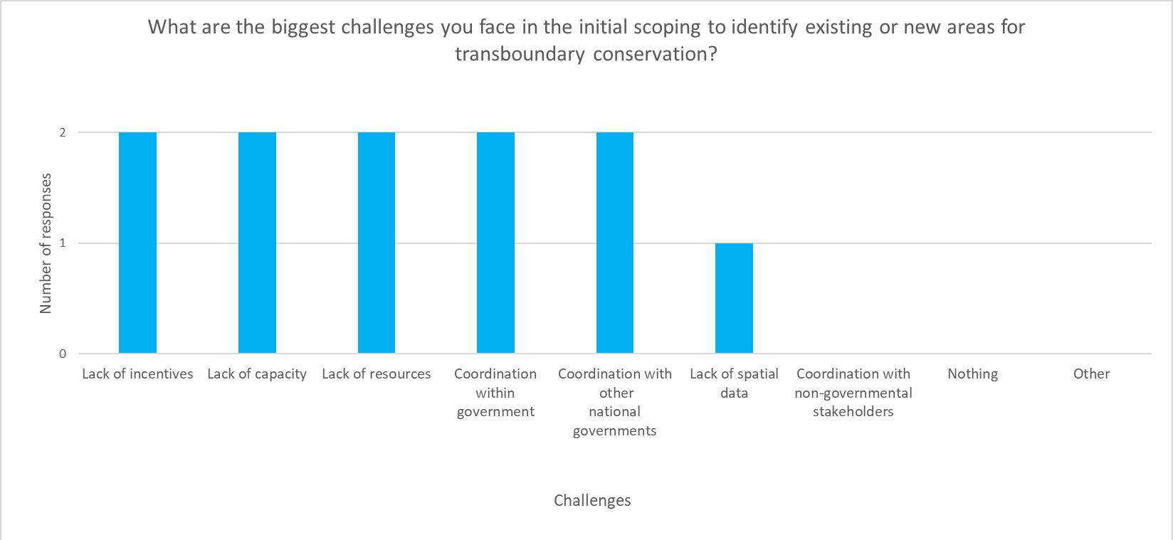

Efficacy of the Transboundary tool prototype

On average, the tool was rated by survey participants as being ‘very easy’ to use, whilst the respondents each rated the tool as ‘very useful’ or ‘quite useful’ in the context of their own work (Figure 2).
Figure 2: Average utility and usability scores for the Transboundary tool, as reported by survey participants
Label | Average score | Question asked (stem and answer options)  (Answers generate average score)
Utility score | 4.5  Quite/Very useful  (Average from 2 responses) | How useful is the tool for your work?  1 - Very limited usefulness  5 - Very useful
Usability score | 5  Very easy  (Average from 2 responses) | How easy/difficult was it to complete the task: ‘Find out how many potential transboundary areas there are within 50 km of your country’s border’ (using the Transboundary tool)?  1 - Very difficult  5 - Very easy

Research participants in the survey and workshops noted the tool’s utility for:
- Identifying each country’s existing protected/conserved areas. (R1, Q12)
- Identifying connectivity. (R1, Q12)
- Understanding the value of the ecosystems already being conserved. (W4 – EAC)
- Educational applications. (W2 – SADC)
- Tourism (especially adventure travel). (W2 – SADC)
- Spatial planning. (W2 – SADC)
Participants in workshop 2 (with SADC Parties) noted the utility of the inclusion of details of length of borders protected. They mentioned this is useful when considering the location of fences, when relocating species, and in other miscellaneous applications.
Few distinct usability issues were reported by survey respondents. The only points mentioned were that the ‘buffer’ (or ‘country border’) on the map made it more difficult to identify areas of connectivity in some cases, and that the map was sometimes difficult to interpret where multiple polygons of different colours overlapped at once.
Of course, with only two survey responses received, the average utility and usability scores can in no way be seen as representative of the actual utility or usability of the tool for the target population. In addition, we lack the behavioural data to confirm whether the lack of difficulties reported is true to users’ actual habits and activities within the tool.

Improvement ideas (from participants’ comments)

The following ideas for improvements to the tool are based on questions, answers, and comments given by survey and workshop participants. Some of these ideas were not suggested explicitly by participants but have been inferred based on the comments made.
This list is not a recommendation that all these ideas should be taken forward; its purpose is to report on suggestions and comments made. For recommendations by UNEP-WCMC, please see the Recommendations section (see p. 9).

Content improvement ideas

Ref. | Improvement idea | Evidence
C1.1 | Add species range data layer(s) (especially for migratory species) | EAC workshop participants suggested that having an understanding of which species occur in potential transboundary areas would support them in understanding the value of the ecosystems they could be conserving through transboundary approaches. (W4 –EAC)  “seasonal movement of wild animals across the border” (R1, Q14).  (presumably, species occurrence data for) “migratory species of wild animals” (R2, Q14)  “Create segments or electronic Sim card for migratory animal species and link them to the satellite and also link them to these borders, as the entry of an animal into these borders is immediately recorded at the border point.” (R2, Q15)  “Habitat suitability analysis based on known migratory species.” (R1, Q13)
C1.2 | Add historic range of species data layer(s)/ Enable tracking of migration patterns over time. | “Historical range of iconic species which may now be restricted to one nation” (R1, Q14)
C2 | Add land cover data layer(s) | “land cover, particularly human use for permanent settlement and farming. Identification of only the land cover may not lead to the accurate potential for Trans-frontier conservation area establishment.” (R1, Q13)  SADC workshop participants also raised the question of how different land tenure systems (e.g. privately owned, community owned, etc.) could be integrated into the tool. (W2 – SADC)
C3 | Add land degradation data layer(s) | EAC workshop participants queried whether land degradation data could be found within the tool. (W4 –EAC)  “Is it possible to measure the deterioration or development of areas, whether in the number of animals or the environment, so that if any deterioration appears, it could become a red warning?” (R2, Q15)
C4 | Add ecosystem data layer(s) | “the type of habitat or ecosystem” (R2, Q14)
C5 | Add topography data layer(s) | SADC workshop participants raised the issue of whether topography could be integrated into the tool map. (W2 – SADC)
C6 | Add data layer(s) showing potential barriers to species movement | SADC workshop participants raised the issue of whether barriers like rivers or roads could be integrated into the tool map. (W2 – SADC)
C7 | Add internal political borders (e.g. municipality) data layer(s) | SADC workshop participants raised the issue of whether internal, sub-national political borders, such as municipality borders, could be integrated into the tool map. (W2 – SADC)
C8 | Include category / status of TFCAs (e.g. to indicate which TFCAs are under MoUs).  (See also U2) | “the transboundary that are made by memorandum of understanding between countries” (R2, Q12)  SADC workshop participants mentioned that, in terms of categorization of TFCAs (conceptual, emerging, etc.) they want to move away from the conceptual term and focus on those that have MoUs/agreements in place. (W2 – SADC)

Usability improvement ideas:

Ref. | Improvement idea | Evidence
U1 | Make it easier to interpret overlapping layers.  (e.g. Consolidate ‘legend’ menu and ‘layers’ menu in map if possible. This would make it easier to increase/decrease layer opacity. Alternatively, simply allow users to click layers ‘on’ or ‘off’, directly through the legend. This suggestion was not explicitly made by the participant, but it is one possible solution to the challenge they faced.) | “may be through the use[] of protected areas indicated in different colors only boundaries then their connectivity through different color of boundary line, not filled/shaded the shapefile for each.” (R1, Q10)  NB This respondent is from Ethiopia. They may be referring to the difficulty in interpreting many overlapping shapes, as in this image of the Tool map for Ethiopia:  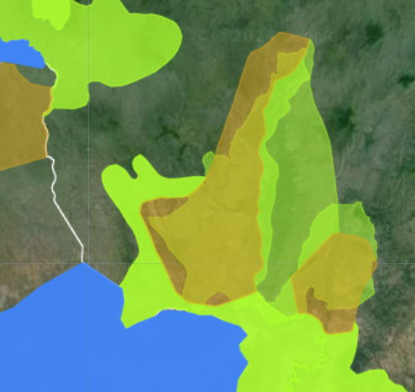  The boundaries and names shown and the designations used on this map do not imply official endorsement or acceptance by the United Nations.
U2 | Distinguish visually between different states of transboundary areas (e.g. MoU/Treaty signed, etc.)  (See also C8) | “the transboundary that are made by memorandum of understanding between countries” (R2, Q13)  SADC workshop participants mentioned that, in terms of categorization of TFCAs (conceptual, emerging and established) they want to move away from the conceptual term and focus on those that have MoUs/agreements in place to advance on implementation. (W2 – SADC)
U3 | Ensure the ‘buffer’ (‘country border’) does not obscure other map data. This could be achieved by some of the ideas below. These ideas were not explicitly suggested by participants, but they are possible solutions to the challenge they faced.:  U3.1 Consider reducing the default opacity of the ‘country border’ layer (the default level applied when the map is generated).  U3.2 Consider having the map legend open by default (to facilitate understanding of differently-coloured polygons).  U3.3 Consider renaming the layer ‘country border’ to ‘Border buffer’ and label the buffer dropdown list (2km, 50km, 100km) with ‘Border buffer’. | “The Buffer masked the boundary of the Country, the overlap or connectivity is not clearly displa[ye]d.” (R1, Q9)  For reference: An example of what the respondent may have been viewing when making this comment (since they work in Ethiopia):  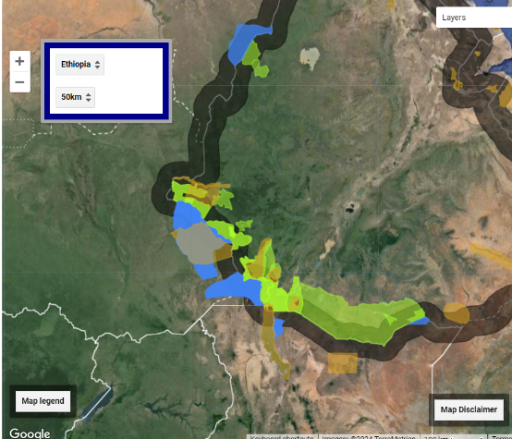  The boundaries and names shown, and the designations used on this map do not imply official endorsement or acceptance by the United Nations. Final boundary between the Republic of Sudan and the Republic of South Sudan has not yet been determined. Final status of the Abyei area is not yet determined.

Other improvement ideas

Ref. | Improvement idea | Evidence
1 | Improve (content and visibility of) information provided about the methodology used to generate the layers visible to users.  This suggestion was not explicitly made by the participant, but it is one possible solution to the challenge they faced. | “I don't get the parameters used by the tool to identify the connectivity of the P[A]s” (R1, Q12)
2 | Facilitate users to upload their own data layers. | SADC workshop participants raised the issue of whether the tool might be able to facilitate users to upload their own data layers in the future. (W2 – SADC)  SADC workshop participants raised an interest in using data from the National Forests Act (W2 – SADC)  However, please see below for further context.
3 | Provide these data layers to online GIS tools where they can be viewed in tandem with other layers (E.g. UN Biodiversity Lab (UNBL))  This solution could also be applied to resolve the desire to see the data alongside data layers on migratory species, land cover, etc.  Alternatively, consider providing links to online GIS tools (such as UNBL) within the Transboundary tool.  These suggestions were not explicitly made by participants, but they are possible solutions to the challenges they faced. | Reviewing all the suggestions made for possible additional data layers within the tool’s map feature (see ‘Content improvement ideas’), and considering the availability of this information elsewhere, one way forward could be to share the existing and potential TFCA data layers currently within this tool with other more powerful mapping platforms, such as UNBL. This would also facilitate some of the other features being requested, such as the ability for users to upload their own data layers.
4 | Provide technical support to enable the tool results to be applied. | “Sharing of the necessary information and provision of the technical support for national experts who will be responsible in applying the tool and the results” (R1, Q15)
5 | Inclusion of Madagascar and other island countries in the Transboundary tool. | CMS focal points raised the question of whether Madagascar is or could be included in the Transboundary tool.
The following additional comments and questions from workshops are also useful to keep in mind:
- SADC workshop participants expressed concerns that the user survey might not reach non-CMS signatories, as not all SADC states are CMS Parties (W2 – SADC).
- SADC workshop participants also queried what support will be provided by CMS/UNEP-WCMC on implementation of transboundary cooperation measures (beyond the tool itself). (W2 – SADC)

Recommendations

The feedback gathered has helped to identify some potential improvements that should be incorporated into the Tool and to inform the future expansion of the Tool. The following are a set of recommendations on opportunities to extend the utility and usability of the tool in the future.

Recommendation | Detail
1. Circulate the survey further. | With the limited number of survey responses received, the utility and usability of the Transboundary tool cannot be assessed comprehensively.  For this reason, it is recommended that the survey is re-opened and further efforts are made to distribute the survey to prospective users of the tool, particularly if any large-scale changes are considered for the future. If soliciting prospective users’ feedback via a survey continues to see a limited response rate, alternative approaches, such as 1-1 usability testing, could be considered. Further time would then be necessary for analysing and summarising the feedback collected.  Encouraging survey recipients to circulate the survey more widely amongst their colleagues, employing a snowball sampling approach, could also help to boost the response rate overall. This could include encouraging recipients to circulate the survey with relevant stakeholders in their country who might find the contents of the Transboundary tool useful.  The risk of continuing without further consultation may be that the content and format of the tool are inappropriate for the audiences targeted, meaning those audiences do not use the tool, or derive limited use from it.

Below are recommendations on opportunities for further expansion of the Tool. However, it would be worthwhile to secure more feedback (by distributing the survey further and/or via more direct engagement with prospective users through interviews or usability testing) before taking any of these actions, as it is difficult to know at this stage whether responses to this effect are anomalous or might be part of a broader trend.

Recommendation | Detail
2. Consider housing the Transboundary tool contents in a new location, such as the Protected Planet website | Exploring opportunities to embed the tool into existing tools or platforms may help to make the tool more visible and accessible. For example, housing the TFCA data within Protected Planet could mean exposing the tool to some of the 122,000 users the Protected Planet website had in 2023, extending its reach and influence.  Furthermore, integrating the (currently static) TFCA data layer into the Protected Planet (which draws on the World Database on Protected Areas) database could enable it to be updated more frequently. The Protected Planet database is regularly updated using data from governments, NGOs, private parties and communities. The TCFA data layer could perhaps be updated through the same means, if it were housed within Protected Planet. Over time, this would improve the quality of data available in the TCFA data layer, ensuring all TFCAs are captured in the dataset. This would also make the tool more useful for existing TFCAs. This is particularly relevant given that one participant at the SADC workshop queried how the Tool might be made more useful for managing existing TCFAs (W2 – SADC).  In addition, some participants in this research noted their interest in knowing the state of TFCAs (i.e. whether the TFCA was established by an MoU/treaty signed, etc.) (see C8/U2). We expect that knowing the state of TFCAs could support target users in effective management (e.g. resource allocation, monitoring, evaluation, etc.). This information should align with the Protected Planet Initiative, the authoritative source of data on protected areas and other effective area-based conservation measures (OECMs), created through government and stakeholder efforts to map, monitor and report data on protected areas and OECMs. Using the Protected Planet’s data collection process for the TFCA tool will better support this goal.  Finally, it is worth noting that one survey respondent specifically mentioned the tool’s utility for them in identifying each country’s existing protected/conserved areas. This suggests significant overlap between the Transboundary tool and Protected Planet – both in the shared capacity to fulfil this function and in their shared target audiences who might need to complete this task.
3. Consider sharing data layers with UNBL and/or other online platforms. Alternatively, consider adding some data layers listed under the ‘Content improvements’, or providing links to UNBL within the Transboundary tool. | Although more evidence is needed, the research completed may suggest that interrogation of other data layers (e.g. migratory species, species range maps, topographic data) alongside TFCA data could be beneficial for target users in scoping opportunities for transboundary conservation. Enabling users to do this could be achieved in a number of different ways including linking the Transboundary tool to websites with these data layers, sharing TFCA data layer with these other GIS-based websites, or including new data layers in the TFCA tool.  When considering which data layers to facilitate users’ access to, attention could be given as to which data layers would support the compilation of the supporting information that is required for the TFCA Initiation and Establishment and Development processes developed by SADC. For example, data layers that assist in carrying out an initial pre-feasibility assessment and a further TFCA feasibility study, or those that may help in identifying key stakeholders and role players of identified potential TFCAs, including affected communities and private landowners, could be considered.  An additional potential outcome of sharing data layers could be being able to draw on the strength of other platforms’ existing audiences (meaning the Transboundary tool could be used by a larger audience and generate more impact). For example, UN Biodiversity Lab was viewed more than 111,000 times in 2022.  It could also allow audiences to draw on the strength of existing features of other platforms (e.g. land cover data layers, ability to upload own layers) which would otherwise be costly to build within the Transboundary tool.
4. Consider implementing the ideas listed under ‘Usability improvements’ | Enhancing users’ ability to use the Transboundary tool may lead to more accurate interpretations of its data, and therefore more effective transboundary cooperation activities. An improved, easy-to-use interface might also encourage users to continue using the tool, possibly increasing the likelihood of them developing transboundary conservation measures as a result.  This research suggests the tool does have some minor usability issues which would be relatively cost-effective to address, such as consolidating the Legend and Layers menus, distinguishing visually between different states of transboundary areas, or reducing the default opacity of the ‘country border‘(buffer) (see suggestions U1-U3).
5. Improve content and visibility of information provided about the data layer methodology. | Providing greater visibility and clarity on the parameters and methodology used by the tool to identify the potential trans-frontier conservation areas could enhance users’ ability to interpret and apply the data, ultimately leading to more effective transboundary cooperation activities.  Ensuring that the geographical extent of a proposed TFCA is defined in an open and transparent manner is a key step in the SADC TFCA Network⁴. Making sure that the Transboundary tool’s methods (as with its results) are easily communicable would complement the existing process, for example in securing buy-in from all stakeholders and communities.

Annex – Survey
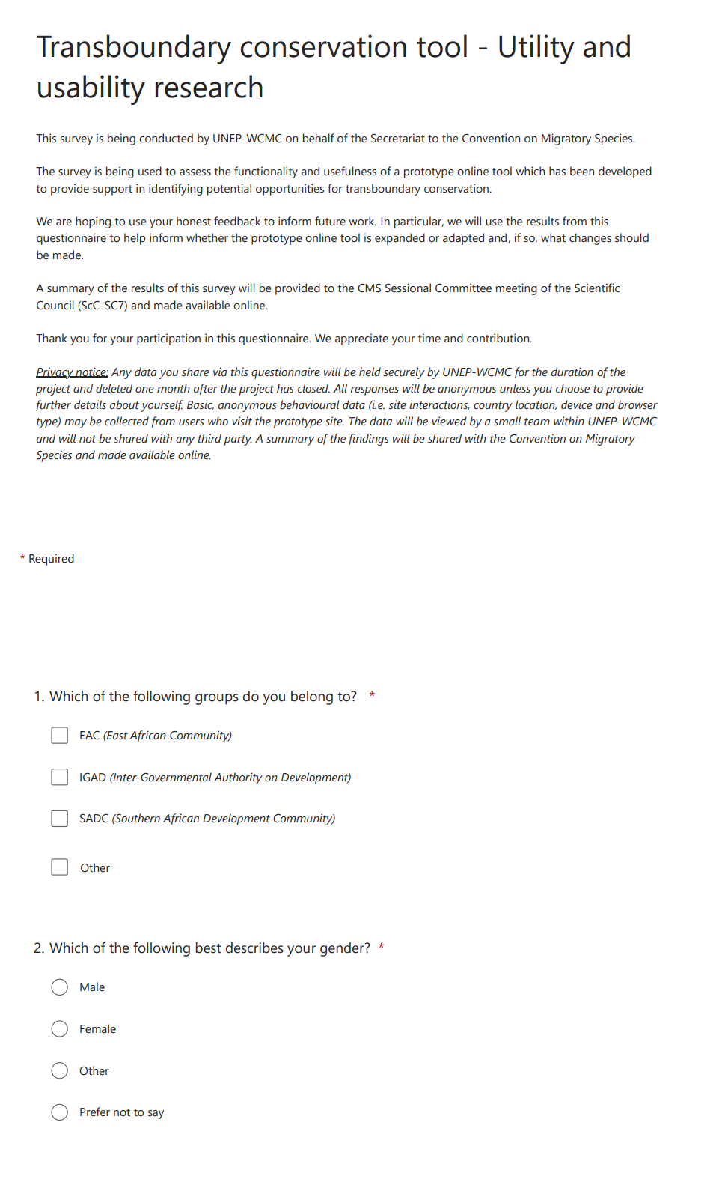
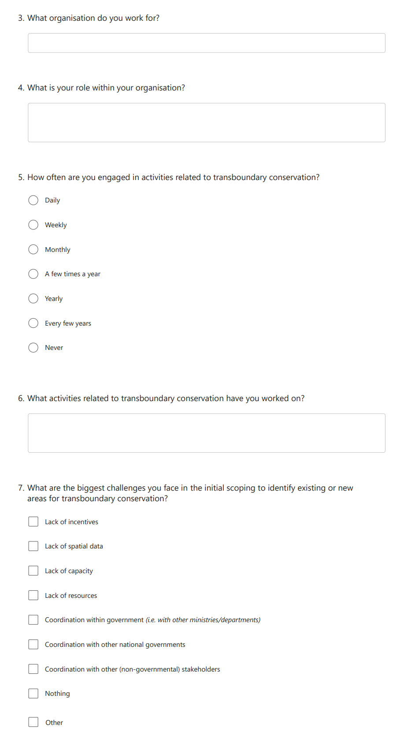

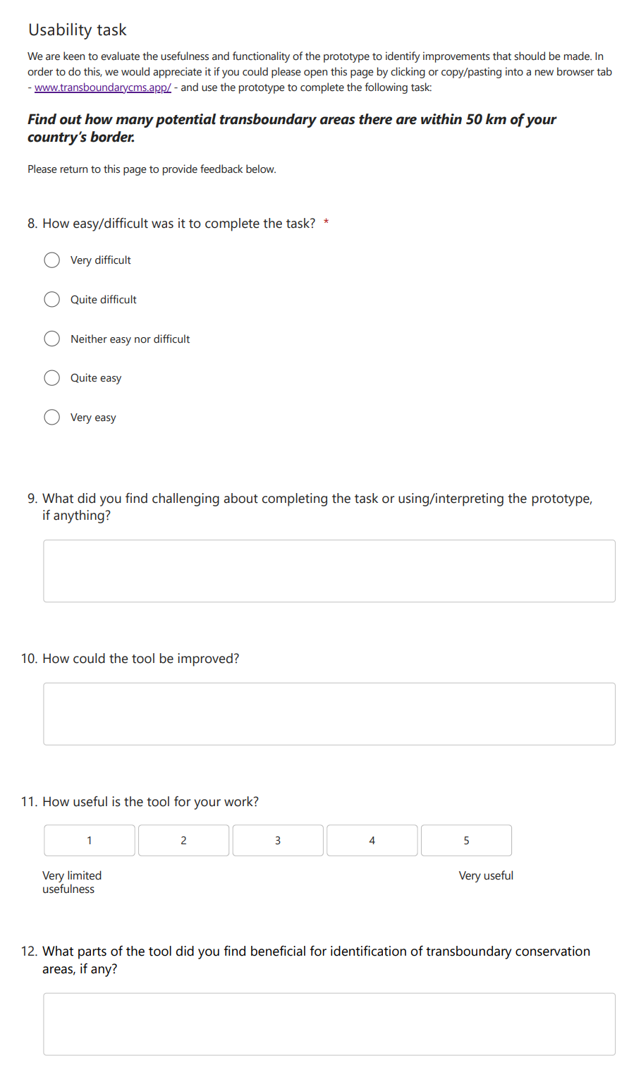

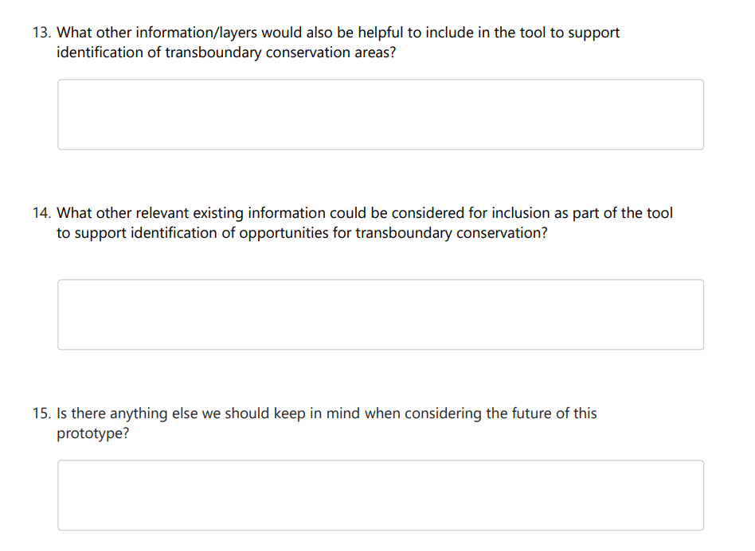

Accessible at https://www.transboundarycms.app/
https://forms.office.com/e/wgwVTNU94p
In this report, the terms Transfrontier Conservation Area (TFCA) and Transboundary Conservation Area (TBCA) are used synonymously.
Resolution 12.7 (Rev. COP13) on The Role of Ecological Networks in the Conservation of Migratory Species has since been repealed and replaced by Resolution 14.16 on Ecological Connectivity.
Kamath V, Brooks H, Naidoo R, Brennan A, Bertzky B, Burgess ND, McDermott Long O, Arnell A and Bhola N (2023) Identifying opportunities for transboundary conservation in Africa. Front. Conserv. Sci. 4:1237849. doi: 10.3389/fcosc.2023.1237849
Accessible at transboundarycms.app
SADC (2015). SADC Transfrontier Conservation Guidelines: the establishment and development of TFCA initiatives between SADC Member States.

