12th MEETING OF THE CONFERENCE OF THE PARTIES

## Manila, Philippines, 23 - 28 October 2017

Agenda Item 16.1

|  |  |  |
| --- | --- | --- |
| **CMS** | | |
|  | CONVENTION ONMIGRATORYSPECIES | Distribution: General  UNEP/CMS/COP12/Doc.16.1  25 July 2017  Original: English |

## REPORT OF RESOLUTION 11.3 ENHANCING SYNERGIES AND SHARING COMMON SERVICES AMONG CMS FAMILY INSTRUMENTS

*(Prepared by the Secretariat)*

Summary:

As requested by Resolution 11.3, this document contains a report of the implementation of the sharing of common services and synergies among the instruments in the CMS Family.

Implementation of the activities outlined in this report contributes towards the Future Structures and Strategies of CMS and the CMS Family Resolution 10.9.

## REPORT OF RESOLUTION 11.3 ENHANCING SYNERGIES AND SHARING COMMON SERVICES AMONG CMS FAMILY INSTRUMENTS

Background

1. Resolution 11.3, adopted by the Conference of the Parties at its 11th meeting (COP11), set forth a mandate to advance the issue of the sharing of common services and synergies among instruments in the CMS Family. In doing so, the COP adopted the following provisions:
2. Requests *the Executive Secretary in consultation with the relevant Secretariats of CMS Family instruments, to submit an independent analysis and report on the legal, financial, operational, and administrative implications of actions to enhance synergies, such as through sharing services in common service areas to the decision-making bodies of the wider CMS Family before the 44th Meeting of the CMS Standing Committee and COP12 in order to establish their benefits and disadvantages;*
3. Invites *the relevant governing bodies of CMS instruments to consider the report and to take a decision on strengthening synergies, such as through sharing services in common service areas;*
4. Invites *the Meeting of the Parties to AEWA at its 6th Session (MOP6) to consider the independent analysis and report and take a decision on the way forward, as regards synergies such as through sharing services in common service areas;*
5. Requests *the CMS Standing Committee to consider the outcome of the 6th Session of the Meeting of Parties to AEWA (MOP6) and to take the appropriate decision in accordance with this outcome with a view to realizing enhanced synergies such as through sharing services in common service areas and report to COP12;*
6. Requests *the CMS Standing Committee to consider the outcomes of the meetings of decision-making bodies of other CMS Family instruments and to take the appropriate decisions in accordance with these outcomes with a view to realizing enhanced synergies such as through sharing services in common service areas and report to COP12;*
7. Instructs *the Executive Secretary of CMS to work in close cooperation with the Executive Secretaries and Coordinators of the CMS Family instruments in implementing the outcomes of the decisions of the Standing Committee;*
8. Furtherrequests *the Executive Secretary to report the outcomes of these decisions to UNEP in view of the ongoing process under UNEP on the effectiveness of administrative arrangements and programmatic cooperation between the United Nations Environment Programme and a number of multilateral environmental agreements in order to ensure the necessary administrative support to promote coherent and effective implementation of the CMS; and*
9. Requests *the Executive Secretary, in close consultation with the Executive Secretary of AEWA, to report the outcomes of the pilot phase and the implementation of this Resolution to COP12.*

This report details the outcomes of the actions provided in Resolution 11.3 for the COP’s consideration.

Independent Analysis

1. An independent analysis was commissioned covering the legal, financial, operational, and administrative implications of actions to enhance synergies, such as through sharing services in common service areas. The report focused on the secretariat services provided among the CMS Family of instruments. The window for completion between COP11 and the 44th Standing Committee was very short considering that necessary funding was only available from January 2015. Nevertheless, the report was completed on time and there were two opportunities for all Parties, members of the governing, advisory and technical committees of the CMS instruments to comment on the first and second drafts of the report. The collection of comments on the report was made available online for the 44th Standing Committee in document UNEP/CMS/StC44/15.1/Annex 2/Rev.1.
2. The independent analysis was based on an examination of several different sources including:

* Desk analysis of experience within the CMS Family as well as among other multilateral environmental agreements (in particular the Basel, Rotterdam and Stockholm Conventions);
* Literature on relevant experience from the private and domestic public sectors;
* Established policy within the CMS Family and global environmental governance more broadly as reflected in relevant documents;
* Interviews with selected key stakeholders.

1. The analysis presented several different options to enhance common services and synergies for the consideration of the 44th CMS Standing Committee. These are summarized as follows:

* Option 1: Non-institutionalized efforts at enhancing synergies. This option would entail no (further) sharing of services among the CMS Family Secretariats, but continued and potentially intensified non-institutionalized efforts.
* Option 2: Stepwise sharing of services. This option would entail the stepwise further implementation and further expansion of common services. In addition to the existing joint CMS/AEWA communications, information management and outreach unit, further joint units for suitable areas such as conference services, capacity-building or implementation support could be created in a stepwise process over time.
* Option 3: Immediate implementation of all relevant shared services in one step. This option would consist of the immediate full sharing of all relevant Secretariat services (among the Bonn-based Secretariats) through the creation of several suitable joint service units at the same time.

1. The consultants presented their findings to the Standing Committee. Upon consideration of the analysis and discussion of different points, it was agreed by the Standing Committee that the best approach to moving forward on the common services and synergies within the CMS Family was through a step-wise approach. Two additional operational parts to the decision were also agreed, namely that the best approach to implementing common services between the CMS and AEWA Instruments is through the Executive Secretaries mutually agreeing on potential services in consultation and with the advice of UNEP; proposing agreed services to the Standing Committees for approval; and regularly reporting on progress, lessons learned and financial cost savings to the Standing Committees; and secondly that any proposed common services should not have any additional financial burdens, should improve efficiency and should enable the Secretariats to preserve their identity.
2. The Standing Committee Members agreed to a draft decision as contained in Box 1. It was also agreed that the Chair of the Standing Committee would transmit the decision on behalf of the Standing Committee to the Meeting of the Parties to AEWA at its 6th Session (MOP6), which was to take place three weeks later, for its consideration.

**BOX 1: Decision of the Standing Committee with regard to Enhancing Synergies and Common Services among the CMS Family Instruments Mindful of the legal autonomy of each of the CMS Family Instruments**

|  |
| --- |
| Recalling Resolution CMS 11.3 “Enhancing Synergies and Common Services among the CMS Family Instruments” and the role of the Standing Committee in moving the issue forward during the intersession of the COP including by establishing the benefits and disadvantages based on the independent analysis, to consider the outcomes of the meetings of decision-making bodies of other CMS Family Instruments, and to take the appropriate decisions in accordance with these outcomes with a view to realizing enhanced synergies such as through sharing services in common service areas and report to COP12;    Recalling also the decision of the 9th Meeting of the AEWA Standing Committee that requests the Executive Secretary of AEWA and the Executive Secretary of CMS to develop further synergies between AEWA and CMS and take actions to merge common services and common areas in an effort to redirect the focus of the Secretariats towards strengthening implementation support;  Welcomes the independent analysis and report on the legal, financial, operational, and administrative implications of actions to enhance synergies, such as through sharing services in common service areas to the decision-making bodies of the wider CMS family;  Notes that the independent analysis contains important information of the potential of common services which can be achieved within the CMS Family. It highlights the general advantages and disadvantages of strengthened cooperation, while also noting that other types of synergies could be important with CMS Instruments based outside of Bonn;  Emphasizing that the goal of the sharing services among CMS instruments is to fill gaps, be mutually reinforcing, produce efficiencies and increase output and that sharing common services should be aimed at strengthening the implementation of the instruments involved and maximizing the effective and efficient use of resources at all levels;  Decides to take a stepwise approach with the Bonn-based instruments and notes that the potential common service areas which the independent analysis suggests could benefit the most from joint approaches include capacity building, cross-cutting implementation issues, conference services and fundraising;  Convinced that the best approach to implementing common services between the CMS and AEWA Instruments, and subject to the decision of the AEWA MOP, is through the Executive Secretaries mutually agreeing on potential services in consultation and with the advice of UNEP and proposing agreed services to the Standing Committees for approval, and regular reporting on progress, lessons learned, and financial cost savings to the Standing Committees.  Agrees that any proposed common services should not have any additional financial requirements on the Secretariats and should preserve their identity and improve efficiency;  Invites the 6th Session of the Meeting of Parties of AEWA to consider the independent analysis and this decision by the CMS Standing Committee and to consider strengthening further common services with CMS;  Invites the Chair of the CMS Standing Committee, who concurrently is also the Chair of the AEWA Standing Committee, to communicate the outcomes of the CMS 44th Standing Committee on enhancing common services to the 6th Session of the Meeting of Parties of AEWA for its Parties consideration;  Invites other CMS Family instruments, starting with the Bonn-based Instruments to consider developing common services and synergies with the CMS Family through appropriate decisions of their respective governing bodies and to report these decisions to the Standing Committee for the development of a way forward on common services proposals. |

Meeting of the Parties to AEWA at its 6th Session

1. MOP6 of AEWA had before it four documents concerning common services arrangements with CMS. These were: 1) the decision of the 44th Standing Committee of CMS inviting the MOP, as requested by CMS COP11, to consider a step-wise approach to sharing common services. 2) the Independent Analysis which was presented as an information document (UNEP/AEWA/MOP/Inf/6.8). 3) a report from the Executive Secretary of AEWA on the CMS/AEWA Common Information Management, Communication and Awareness-Raising Team (UNEP/AEWA/MOP6.10/Rev.1). 4) the decision by the 9th Meeting of the AEWA Standing Committee that requests the Executive Secretary of AEWA and the Executive Secretary of CMS “to develop further synergies between AEWA and CMS and take actions to merge common services and common areas in an effort to redirect the focus of the Secretariats towards strengthening implementation support.”
2. After considering these documents, AEWA MOP6 adopted the following Resolution (UNEP/AEWA/MOP6/Res. 6.22) for moving forward on common services and synergies between the CMS and AEWA Secretariats:
3. Agrees *to continue and refine the pilot Common Information Management, Communication and Awareness-raising Team taking into consideration lessons learned by both the UNEP/CMS and UNEP/AEWA Secretariats;*
4. Requests *the UNEP/AEWA and UNEP/CMS Secretariats to develop a proposal within three months after MOP6 detailing implementation arrangements for the joint unit including staff time and budget sharing ratios, management structure, monitoring and evaluation indicators, among others, to be approved by the Standing Committee;*
5. Further requests *the Standing Committee to review the progress of implementation of the joint unit;*
6. Also requests *the Standing Committee to report in writing to MOP7 about the results and experiences of the arrangement and to make recommendations on the way forward;*
7. Decides *to take a stepwise approach in strengthening synergies in common service areas with the CMS Family and notes that potential common service areas which are mentioned in the analysis include capacity-building, cross-cutting implementation support, conference services and fundraising;*
8. Further decides *that implementing common services between the AEWA and CMS Instruments shall be through the Executive Secretaries, following consultation of staff concerned, mutually agreeing on potential services using expertise in UNEP and proposing those potential services to both Standing Committees for approval, and regularly reporting on progress, lessons learned, and financial cost savings to the Standing Committees;*
9. Requests *the Secretariats, when making their proposals to the Standing Committees, to include reliable scenarios and concrete underpinning of the expected effectiveness and efficiency gains and to set out the measures to ensure transparency on the implementation process and on the use of resources for the CMS and AEWA respectively to be put into place when the proposals are adopted, and in this regard requests the AEWA Standing Committee, after consultation with the Contracting Parties, to take decisions on such proposals for joint approaches to services in common service areas, within the scope of this Resolution, and report to MOP7;*
10. Agrees *that any proposed common services should not have any additional financial requirements on the Secretariats and should preserve the Secretariats’ independence, respect the competences of the Convention and its Agreements and improve effectiveness and efficiency;*
11. Confirms *that a joint Executive Secretary between AEWA and CMS is not a desired option.*
12. Following AEWA MOP6 the Executive Secretaries of CMS and AEWA developed a proposal which detailed the implementation arrangements for the joint unit, including staff time and budget sharing ratios, management structure, monitoring and evaluation indicators. The proposal took more time than the 3-month deadline anticipated by the MOP, but the Standing Committee of AEWA was kept informed and granted the AEWA Executive Secretary more time given the complexity of the task. The proposal for the Joint Information Management Communication and Awareness-raising Unit (IMCA) was circulated on 27 September 2016 and approved by the members of the AEWA Standing Committee on 24 October 2016 as requested by Resolution 6.22. The full document was provided to the AEWA Standing Committee as Document AEWA/StC12.16 for its 12th Session.
13. Key elements of the working arrangements of the Joint Unit include:

* A cost-sharing arrangement of one third AEWA and two thirds CMS based on the financial size of the Secretariats’ budgets;
* IMCA staff will self-monitor their working time daily in order to be able to assess the monetary value of services provided to both instruments taking into account the possible limitations of the monitoring tool. This monitoring will be undertaken through a pertinent time and task tracking software.
* Indicators will be used to monitor the implementation of the arrangements for the Joint Unit and indicators which evaluate the achievement of the objectives of the pilot.
* The primary areas of work for the common unit would cover information management (e.g. website, online Technical/Scientific Committee workspaces, development of the meeting registration tool and technical maintenance), coordination of national reporting processes (e.g. maintenance and management of the Online Reporting System (ORS) tool, news and media service, special events and campaigns, digital design, content production/writing, audio-visual/multi-media products, and communication, education and public awareness activities (CEPA)).
* Two weeks after the AEWA Standing Committee’s approval of the proposal, a new inter-office memo was signed by the two Executive Secretaries and was sent to UNEP/AEWA and UNEP/CMS Secretariat staff to announce the new arrangements and related indicators.

CMS Standing Committee to consider the outcome of the 6th Session of the Meeting of Parties to AEWA (MOP6)

1. According to Resolution 11.3, the Standing Committee was tasked to consider the outcomes of AEWA MOP6 and take appropriate steps to implement the results. The present report on the implementation of Resolution 11.3 outlines the steps that took place.
2. First, this report includes the actions taken by the Standing Committee and therefore serves to fulfil the request by the COP to report back. Secondly, COP11 had envisioned the timing needs of a decision on common services among the different CMS instruments considering the Independent Analysis and on the course of action and then the need to make a proposal on the way forward to the AEWA MOP6. The COP in anticipating this, realized the need to continue moving forward on the issue among the various bodies between COP11 and COP12 and therefore mandated the Standing Committee to take the necessary actions.
3. The direction decided at during the 44th Standing Committee, however, took an approach whereby it proposed broad areas of collaboration for common services and left it to the Executives Secretaries of the instruments to make a proposal to the Standing Committee for its consideration. This approach was also adopted by the Meeting of the Parties to AEWA through Resolution 6.22. In effect, the CMS Standing Committee and the AEWA MOP decided on a broad framework which had no set timetable and allowed the Secretariats the flexibility to agree on common services through a stepwise approach.
4. So far, no proposal for further common services has been made to the Standing Committee by the Executive Secretaries. The stepwise approach envisioned a method of “learning by doing” and ensuring continuity and stability for both the CMS and AEWA Secretariats’ overall work. In taking this approach, the Executive Secretaries of CMS and AEWA have focused since AEWA MOP6 on refining the existing pilot that the two Secretariats have undertaken on Information Management, Communication and Awareness-raising (IMCA).

At the 45th meeting of the CMS Standing Committee, the AEWA and CMS Executive Secretaries reported the progress made since the 44th meeting of the CMS Standing Committee. The CMS Executive Secretary reported that the Joint Communications Team had proved to be effective since its inception in 2014 and was continuing to improve. With the endorsement of the governing bodies of both CMS and AEWA, the Executive Secretaries would elaborate further the structures, management modalities and joint work programmes of the Joint Communications Team. The pilot scheme covering communications, information management and outreach would be further consolidated before moving on to other common services or extending joint services to EUROBATS.

Executive Secretaries cooperation and coordination with UNEP and its work on synergies with MEAs

1. The Executive Secretary reported the outcomes of the decision taken at the 44th meeting of the CMS Standing Committee and AEWA MOP6 to the Executive Director of UNEP in February 2015. A meeting took place in Nairobi on 28 February 2015 with the Executive Director and the Executive Secretaries of CMS, AEWA and EUROBATS. There was a discussion on strategic collaboration with the CMS Family including on the 2030 Agenda and the Sustainable Development Goals, climate change and the Strategic Plan for Biodiversity and Aichi Targets. It was agreed to increase the strategic alignment to these issues by all three Secretariats and that future strategic planning on biodiversity by the daughter agreements of CMS should align their strategic planning with the Aichi Targets and SDGs as the major biodiversity MEAs have already done.
2. It was agreed to work closely together to implement CMS Resolution 11.3 on “Enhancing Synergies and Common Services among the CMS Family Instruments”. It was also agreed that the process of transition towards common services should be understood as part of a broader synergies process that could bring about more effective use of financial resources and provision of high quality services to Parties.
3. The Executive Director and the Executive Secretaries agreed that under the leadership of the CMS Executive Secretary a joint meeting should be held every three months to discuss strategic collaboration including potential common services and fundraising. The meeting should adopt a yearly internal action plan with clear priorities, milestones and timelines and its implementation should be monitored. An internal memo by the Executive Director on these agreed points was issued to the CMS Family Executive Secretaries on 5 April 2016.
4. The first meeting was convened between the Executive Secretaries of CMS, AEWA and EUROBATS on 1 October 2016 when an action plan was discussed and set up. It was further agreed to have a monthly meeting on administrative and financial matters in addition to the regular management meeting already underway for some time among the Secretariats.
5. Further UNEP collaboration on the synergies has continued with the CMS Secretariat’s full involvement in the synergies with MEA work.

Pilot Phase - Information Management Communication and Awareness-Raising

1. The Information Management, Communication and Awareness Raising (IMCA) Unit is jointly managed by the CMS Executive Secretary and the AEWA Executive Secretary, while the IMCA Coordinator (the AEWA Information Officer) has the responsibility for the day-to-day management of the team. Over the course of the past three years since the establishment of the Unit in January 2014, much progress has been made in terms of transforming the Unit into an effective shared team that serves a wide range of communication, information management and outreach needs of both the CMS and AEWA Secretariats. Outputs have increased significantly since the formation of the joint team.
2. The Team carries out content management and development of the CMS website and social media, it provides news alerts, press releases, media liaison, campaigns, messaging, external news, video production and the systems management for online reporting.
3. As of January 2017, the work of the IMCA Unit is guided by an annual Programme of Work (PoW) which is developed by the IMCA Coordinator and approved by both the Executive Secretary of CMS and AEWA. The PoW has improved the overall planning and helps to prioritize the work being done by the IMCA Unit for each Secretariat on a yearly basis.
4. AEWA and CMS have developed strategically aligned communication strategies which form the basis of the work carried out by the two Secretariats.
5. The satisfaction of both Executive Secretaries at the progress and performance of the joint IMCA Team was expressed at the 45th meeting of the CMS Standing Committee and the 12th meeting of the AEWA Standing Committee.

**Organigram of the Joint Information Management, Communications and Awareness-raising (IMCA) Unit of the UNEP/CMS and UNEP/AEWA Secretariats**

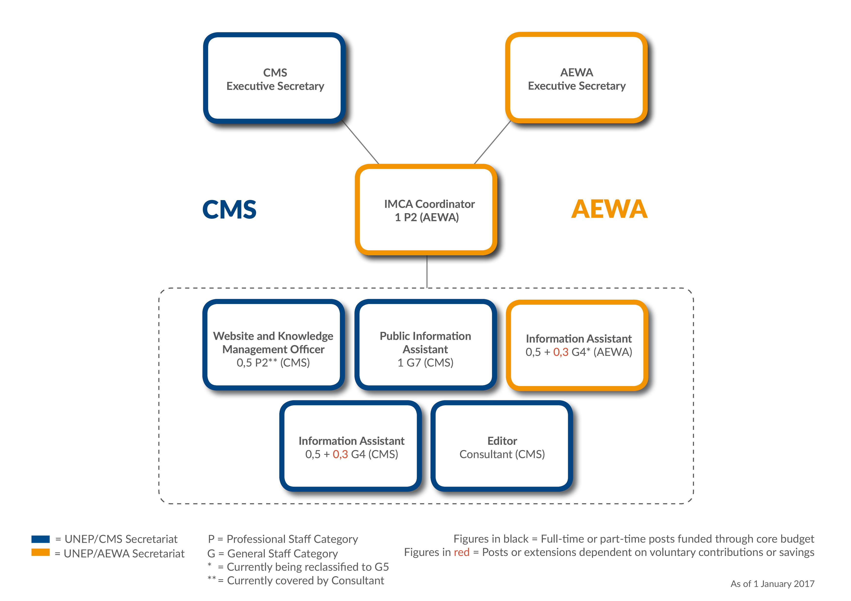

Conclusion

1. Resolution 11.3 has been fully implemented and an agreement reached between CMS and AEWA on the pilot phase. By adopting the stepwise approach, they have also agreed on the process for introducing further common services in the future. The process is working well and further actions, if required, can be introduced by the Executive Secretaries through the Standing Committees or by future meetings of the Conference or Meeting of the Parties.

Recommended actions

The Conference of the Parties is recommended to take note of the Report.