12th MEETING OF THE CONFERENCE OF THE PARTIES

## Manila, Philippines, 23 - 28 October 2017

Agenda Item 14.3

|  |  |  |
| --- | --- | --- |
| **CMS** | | |
|  | CONVENTION ONMIGRATORYSPECIES | Distribution: General  UNEP/CMS/COP12/Doc.14.3  24 July 2017  Original: English |

## RESOURCE MOBILIZATION

*(Prepared by the Secretariat)*

Summary:

The present document provides the state of resources mobilized, as at July 2017, since the Eleventh Meeting of the Conference of the Parties (Quito, Ecuador 2014).

These resources (both financial and in-kind) have contributed to the implementation of the Secretariat Programme of Work for the Triennium 2015 – 2017 (UNEP/CMS/COP12/Doc.18).

These resources (both financial and in-kind) also contribute to the implementation of many Resolutions as well as all targets of the Strategic Plan for Migratory Species 2015-2023.

## RESOURCE MOBILIZATION

Background

1. The Strategic Plan for Migratory Species 2015-2023 and Resolutions adopted by the meetings of the Conference of the Parties guide the work of the Convention setting the goals for its implementation at national, regional and global levels. Although many of these provisions are primarily to be met by Parties, some of them fall under the responsibility of the Secretariat. The 11th Meeting of the Conference of the Parties (COP11), which was held in November 2014, adopted a Programme of Work for 2015-2017 through [Resolution 11.1 on Financial and Administrative matters](http://www.cms.int/sites/default/files/document/Res_11_01_Financial_and_Administrative_matters_E.pdf), detailing a list of activities to be carried out by the Secretariat including the provision of administrative services and coordination to a number of its daughter agreements which have no core budget. The COP-approved triennial budget for 2015-2017, however, was mainly earmarked for staff salaries, operational costs and some activities, while voluntary contributions were to be sought for most of the mandated activities.

Efforts

1. In the triennium 2015-2017, the resource mobilization efforts of the Secretariat have been guided and were based on the elements of the following basic logical framework:

|  |  |
| --- | --- |
| ***GOAL*** | *Secure as many resources as possible for the implementation of the Strategic Plan for Migratory Species* |

|  |  |  |  |
| --- | --- | --- | --- |
| Objective 1 | Ensure predictable, adequate and regular funding and multi-year commitments | | |
| Approach 1.1 | Prioritizing: mapping funding needs against capacity for delivery e.g. overview of funding needs deriving from the Programme of Work (POW) | |
| *Tool 1.1.1* | General appeals - letters to potential donors including CMS Parties and MOU Signatories with funding needs (POW) |
| *Tool 1.1.2* | Tailored contacts - written communications and direct and personal contacts with specific proposals with potential donors |
| Approach 1.2 | Engaging with multi-year funding arrangements e.g. with EC[1] grants, IKI[2] | |
| *Tool 1.2.1* | Consultations and submission of project proposals |
| Approach 1.3 | Migratory Species Champion Programme | |

|  |  |  |
| --- | --- | --- |
| Objective 2 | Broaden the donor base | |
| Approach 2.1 | Migratory Species Champion Programme |

|  |  |  |  |
| --- | --- | --- | --- |
| Objective 3 | Increase synergistic work with the CMS Family and other relevant organizations | | |
| Approach 3.1 | Cooperating to strategize on activities and align priorities | |
| Approach 3.2 | Cooperating to combine available resources | |
| Approach 3.3 | Cooperating to generate financial and in‐kind support for common activities | |
| *Tool 3.3.1-3* | Consultations |
| Approach 3.4 | Contributing to higher level processes to ensure that our work receives recognition and funding e.g. UN Environment MTS and POW[3], EC Strategies for Africa, GEF[4] allocations | |
| *Tool 3.4.1* | Consultations and provision of inputs and proposals |

|  |  |  |  |
| --- | --- | --- | --- |
| Objective 4 | Promote mobilization of resources for action on the ground | | |
| Approach 4.1 | Promoting external grants and funding and encouraging partner organizations to submit proposals relevant to CMS | |
| *Tool 4.1.1* | Notifications about funding opportunities within e.g. Foundations, USFWS[5] grants, SOS[6], etc |
| *Tool 4.1.2* | Letters of endorsement |
| Approach 4.2 | Liaising with external funding programmes to try to match priorities | |
| *Tool 4.2.1* | Consultations |

|  |  |  |
| --- | --- | --- |
| Objective 5 | Develop and apply new and innovative approaches | |
| Approach 5.1 | Organizing outreach and fundraising events and activities: e.g. World Migratory Bird Day Concert |
| Approach 5.2 | Engaging with private sector |
| Approach 5.3 | Migratory Species Champion Programme |

Results

1. The Secretariat has raised considerable resources, which enabled the implementation of a number of priority actions, and is grateful for the support received, especially given the current economic circumstances. The following paragraphs provide an overview of the financial and in-kind contributions received since COP11 as well as their sources.

**Funds received**

1. The total of voluntary contributions received from Governments and organizations to implement the Convention and some of its instruments amounts to €3,915,500 (13 per cent UN Environment Programme Support Cost (PSC) to be deducted).
2. These resources were provided by the Governments of Australia, Finland, Germany, Italy, Monaco, the Netherlands, Norway and Switzerland; the European Commission; and the UN Environment Law Division and Regional Office for Europe. Further details are provided in the document on Implementation of the Programme of Work 2015-2017 (UNEP/CMS/COP12/Doc.18).
3. Funds obtained are grouped by the areas identified in the POW. It has to be highlighted that a significant portion of these resources is allocated to activities to be implemented in the triennium 2018-2020.

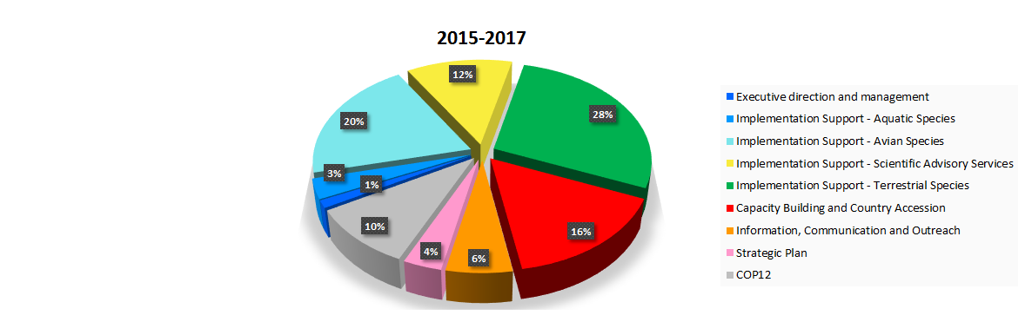

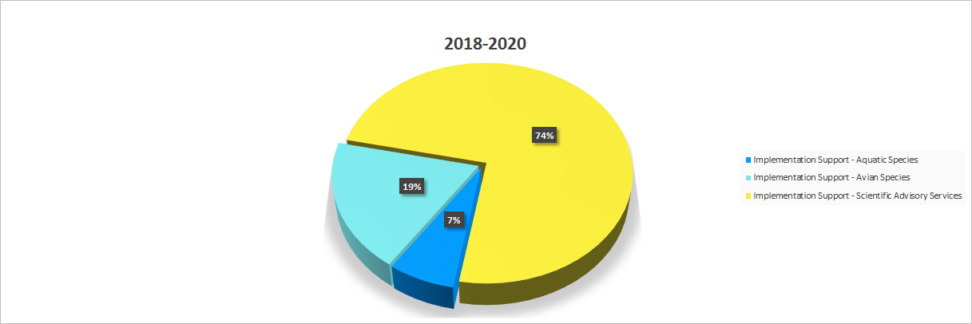

The contributions towards the conservation of “Avian Species” include the provision of a Junior Programme Officer (JPO) generously offered by the Government of Germany to assist with the numerous tasks of the Unit including to further the work on preventing bird poisoning from October 2016 to October 2018.

1. The amount indicated above however does not include the significant pledge for 2016-2019 of approximately US$ 8.1 million from the Environment Agency – Abu Dhabi (EAD) received in September 2015 towards the operation of the CMS Office – Abu Dhabi which coordinates the Memoranda of Understanding (MOUs) for Raptors and Dugongs. This very generous grant is provided by EAD on behalf of the Government of the United Arab Emirates. EAD also accommodates the Office at its headquarters providing world class office space and other practical support.
2. The resources raised by these two instruments and the “assessed voluntary” contributions towards the implementation of the MOUs for Sharks and Marine Turtles and their Habitats of the Indian Ocean and South-East Asia (IOSEA) are also excluded from the total amount indicated above. The contributions obtained in 2015-2017 in support of the Sharks MOU budget and its POW amount to US$584,436 and those received by the IOSEA MOU amount to US$428,345.

**Indirect financial contributions and in-kind contributions**

1. Further contributions were provided either in the form of financial support, which was not channelled through the Secretariat but did directly contribute to activities, or of in-kind support through provision of personnel or services.

*Activities and services*

1. The German Society for International Cooperation (GIZ) operating on behalf of the Federal Ministry for Economic Cooperation and Development (BMZ) covered costs for publishing the Argali Sheep Action Plan and the Guidelines on Mitigating the Impact of Linear Infrastructure and Related Disturbance on Mammals in Central Asia. NABU, the BirdLife Partner in Germany, and the Frankfurt Zoological Society contributed to the organization of the Third Meeting of the Signatories to the Memorandum of Understanding (MOU) concerning Conservation, Restoration and Sustainable Use of Saiga Antelope in October 2015.
2. The Third Meeting of Signatories to the Aquatic Warbler MOU took place in Lithuania in May 2015 and was fully funded by the Baltic Environmental Forum through the LIFE Plus Project “Baltic Aquatic Warbler”.
3. The First Range State Workshop on the European Eel held in October 2016, was mainly sponsored by the Sargasso Sea Commission, while the CMS Secretariat, through funding provided by Monaco, covered limited expenses.
4. The 2nd Meeting of the Preventing Bird Poisoning Working Group held in Toledo, Spain on 19-21 February 2017 was sponsored by the Regional Government of Castilla-La Mancha.
5. BirdLife International has been generously providing the coordination of the CMS African Eurasian Migratory Landbirds Action Plan for two years.
6. Thanks to the initiative of the Chair of the CMS Scientific Council, the Po Delta Interregional Park provided €50,000 for the organization of two workshops bringing together experts to discuss and advance the issue of migratory species connectivity. These discussions resulted in the submission of a resolution contained in UNEP/CMS/COP12/Doc.24.4.11.
7. The First Meeting of Signatories of the High Andean Flamingos MOU took place in Peru in April 2016. The meeting was largely funded by TAIEF (Technical Assistance and Information Exchange Facility). TAIEF is an EU platform which supports the organization of workshops and seminars, and in particular the participation of EU experts.
8. Besides hosting the CMS Secretariat as well as other CMS Family Secretariats based in Bonn, and bearing all costs relating to the premises, the German Government has offered interpretation services for the two intersessional meetings of the Standing Committee in 2015 and 2016 as well as for the two meetings of the Sessional Committee of the CMS Scientific Council which took place in April 2016 and July 2017.
9. Several Parties were able to contribute to the Convention’s work by hosting meetings and workshops and assisting with related logistical arrangements. Further details are provided in the document on Implementation of the POW 2015-2017 (UNEP/CMS/COP12/Doc.18). Special thanks go to the Government of the Philippines which is hosting COP12 and covering several additional related costs including coverage by the Earth Negotiations Bulletin.
10. The Government of Germany[7] sponsored three workshops in support of the Central Asian Mammal Initiative (CAMI). A workshop was held in Ulanbataar, Mongolia in 2015 with the objective of promoting guidelines, mitigating the impact of linear infrastructure and related disturbance on mammals in Central Asia. The other two workshops took place on the Isle of Vilm, Germany in 2016 and 2017 with the aim of stimulating the implementation of the CAMI POW by identifying urgent actions and developing an atlas of range-wide mapping and priority setting of ten CAMI species and linear infrastructure threats across Central Asia respectively.
11. In 2016 regular maintenance of the CMS Family website benefited from support provided in the context of the MEA Information and Knowledge Management Initiative promoted by UN Environment’s Law Division.
12. Three benefit concerts given by the Bologna Opera Choir were organized as part of the celebrations of World Migratory Bird Day (May 2015, 2016 and 2017). The proceeds (€2,210) of the 2015 event supported the implementation of a project on the conservation of the Siberian Crane; those (€1,850) of the 2016 concert contributed to the efforts of the CMS Family against the illegal killing, taking and trade of migratory birds. While the first two concerts were held in Bonn, the 2017 one took place in Bologna and yielded €800.
13. UNEP Headquarters as well as its Regional Offices have been providing support in various forms. Partnerships with the NGO sector have also been critical in providing additional resources for CMS as well as in supporting common conservation objectives (see document UNEP/CMS/COP12/Doc.23.1).
14. Within the CMS Family’s co-located (Bonn) Secretariats, synergies and mutual support have been enhanced. For instance, a number of CMS staff members were deployed to the Sixth Meeting of the Parties to AEWA and assisted the AEWA Secretariat in taking care of logistical aspects of the meeting.
15. For a special publication for CMS COP12, the CMS Secretariat has managed to secure the support of TERRITORY, a Hamburg-based Public Relations Company in the form of a Public-Private-Partnership. The company has committed to work closely with the Joint CMS/AEWA Communications Unit, to produce a professionally designed COP publication in the format and style of a typical In-Flight Magazine.

*Personnel*

1. Through its internship programme, the Secretariat has enjoyed the valuable support of university graduates or students who have assisted CMS staff in their day-to-day work for an average period of three months on a non-remunerative basis. During the current triennium, over 50 interns from various countries have assisted the Secretariat in the accomplishment of tasks or projects in the scientific/technical, administrative and information fields.

**Migratory Species Champion Programme**

1. Following Resolution 10.9 on the Future Structure and Strategies of the CMS Family, the CMS Secretariat has developed, in collaboration with the AEWA Secretariat, the “Migratory Species Champion Programme”, a fundraising scheme to promote the work under the CMS Family and encourage sustainable and predictable support. Since the launch of the programme, numerous Champions were recognized by CMS for their generous support and commitment towards various initiatives:

* The Government of Germany, through the Federal Ministry for the Environment, Nature Conservation, Building and Nuclear Safety (BMUB) was recognized as *Champion Extraordinaire* for supporting the operations of the CMS, AEWA, EUROBATS and ASCOBANS Secretariats;
* The Government of Germany, through BMUB was recognized as *Champion Plus* for supporting African elephant conservation in 2015-2017;
* The Government of Germany, through BMUB was recognized as *Champion Plus* for their support to Reconciling Energy Sector Developments with Migratory Species Conservation in 2015-2017;
* The Government of the Principality of Monaco was recognized as *Champion Extraordinaire* for supporting the operations of the ACCOBAMS Secretariat;
* The Government of the Principality of Monaco was recognized as *Champion* for supporting marine species conservation in 2015 – 2017;
* The Government of Australia were recognized as *Champion* for supporting Pacific Loggerhead turtle conservation in 2015 – 2017;
* The European Commission was recognized as *Champion Plus* for their support to addressing Illegal Killing, Taking and Trade of Migratory Birds in the Mediterranean in 2015-2018 through the Global Public Goods and Challenges (GPGC) Programme Cooperation Agreements with UN Environment;
* The European Commission was recognized as *Champion Plus* for their support to Building Capacity for Migratory Species Conservation in 2015-2018.

1. Five new Champions will be nominated at COP12, these being:

* The Government of the Principality of Monaco will be recognized as *Champion Plus* for supporting marine species conservation in 2018 – 2020;
* The Government of Italy will be recognized as *Champion Plus* for supporting the development of a Global Animal Migration Atlas in 2017-2020;
* The Government of Germany through BMUB will be recognized as Champion Plus for its support to Reconciling Energy Sector Developments with Migratory Species Conservation in 2018-2020;
* The European Commission will be recognized as *Champion Plus* for its support to addressing Illegal Killing, Taking and Trade of Migratory Birds in the Mediterranean in 2018-2020;
* The Environment Agency – Abu Dhabi on behalf of the Government of the United Arab Emirates will be recognized as *Champion Plus* for supporting the conservation of Dugongs and birds of prey in 2015-2019.

**Enhancing engagement with the Global Environment Facility (GEF)**

1. Following CMS Resolution 11.10, the Secretariat made progress in promoting funding of the national priorities for CMS through GEF. Details are contained in document UNEP/CMS/COP12/Doc.23.1.

**Support to conservation work**

1. Web articles and notifications about funding opportunities for conservation actions were produced, as appropriate, to encourage stakeholders to propose projects that contribute to the implementation of the Convention and its instruments. Several CMS partner proposals were supported by the Secretariat with letters of endorsement.

Current developments

1. Final confirmation is expected on the participation of CMS in a EU wildlife conservation programme for the Regional Economic Communities of Eastern Africa (EAC), Southern Africa (SADC) and the Horn of Africa (IGAD (2014-2020). The project implements the 11th EDF Regional Indicative Programme and aligns to both the regional relevant policies and the EU "Larger than Elephants Approach to Wildlife Conservation in Africa” and the EU Action Plan against Wildlife Trafficking. In partnership with CITES and UNODC, CMS will be the lead implementing agency, responsible for the establishment of Transfrontier Conservation Areas in the regions. The budget allocated for CMS activities amounts to US$2.7 million.
2. Two large project proposals supporting CMS species conservation were submitted to the International Climate Initiative of BMUB. In June 2016, the Dugong MOU Secretariat (CMS Office – Abu Dhabi) presented a €4.8 million proposal focusing on promoting the sustainability, productivity and resilience of seagrass ecosystems, including in the context of climate change, that are critical to populations of threatened marine species such as Dugongs and Green Turtles in five countries (Malaysia, the Solomon Islands, Thailand, Timor-Leste and Vanuatu). The CMS Secretariat also contributed to a grant application submitted by the UN Environment Vienna Office to enhance the adaptive capacity of Central Asian migratory flagship species (e.g. Argali Sheep, Snow Leopard, Saiga Antelope, Goitered Gazelle) and associated ecosystems to climate change. Final confirmation of the acceptance of both projects is to be received shortly. The budget allocated for CMS activities under the latter project amounts to €950,000.

Future needs

1. The Secretariat developed a Programme of Work (see document UNEP/CMS/COP12/Doc.14.2) for the consideration of COP12, which estimates the resources, human and financial, needed to implement activities for the period 2018-2020. The POW is based on the allocations proposed in the three scenarios of the budget for 2018-2020 and indicates the level of additional resources needed by the Secretariat to fully implement its future mandate. This document will provide the basis for resource mobilization efforts for the next triennium.

Recommended actions

The Conference of the Parties is recommended to take note of this document.

1. EC: European Commission
2. IKI: International Climate Initiative
3. MTS and POW: - Medium-Term Strategy and Programme of Work
4. GEF: Global Environment Facility
5. USFWS: Unites States Fish and Wildlife Service
6. SOS: Save our Species
7. The German Federal Ministry for the Environment, Nature Conservation, Building and Nuclear Safety (BMUB) and the International Academy for Nature Conservation of the German Federal Agency for Nature Conservation (BfN)