

CONVENTION ON

MIGRATORY

SPECIES

UNEP/CMS/Angelshark WG1/Doc.
5.1
/Rev1

2
8

April

2025

Original: English

1st Meeting of the Working Group on the Implementation of the Single Species Action Plan for the
Angelshark in the Mediterranean Sea (Angelshark WG1)
Bonn, Germany, 29-30 April 2025

ADVICE FOR SPATIAL MANAGEMENT OF ANGEL SHARKS IN THE MEDITERRANEAN
For comments by Range States
(Prepared by the Angel Shark Project and the Secretariat)

Summary

- This document includes an analysis on the overlap of critical areas for angel sharks and Marine Protected Areas and provides guidance on spatial management for angel sharks, in the Mediterranean Sea. The guidance is provided in the Annex.

Background and Mandate

- The Single Species Action Plan for the Angelshark, Squatina squatina in the Mediterranean Sea (SSAP Angelshark Med) was adopted by CMS Parties at COP14 in February 2024, Samarkand,
Uzbekistan (Decision 14.101). Objective 2 of the SSAP Angelshark Med requests the “identification of sites and habitats of Angelshark in the Mediterranean Sea with the result to identify former, current and potential Critical Angel Shark Areas (CASAs) and ascertain the status of Angelshark in these areas”.

- This advice document aims to contribute to the implementation of actions 2.1 on data collection and 2.5 on the role of the current Marine Protected Area network, agreed under Objective 2 of the SSAP Angelshark Med. It shall be used to inform the International Working Group for the SSAP Angelshark Med and to guide decisions and prioritization of the implementation of activities from the SSAP Angelshark Med.

Actions Requested

- The Working Group is requested to:

- Review and discuss the guidance provided and agree on potential spatial management targets; and
- Make recommendations to COP15

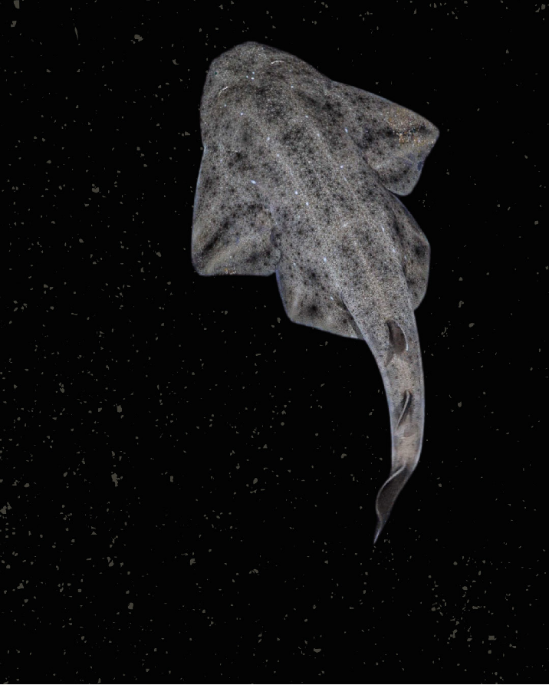
Advice for
Spatial Management of Angel Sharks
in the Mediterranean Sea
April 2025
Kindly funded by : Compiled by :
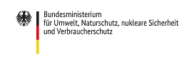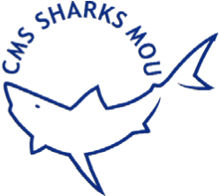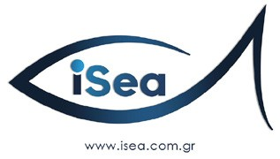
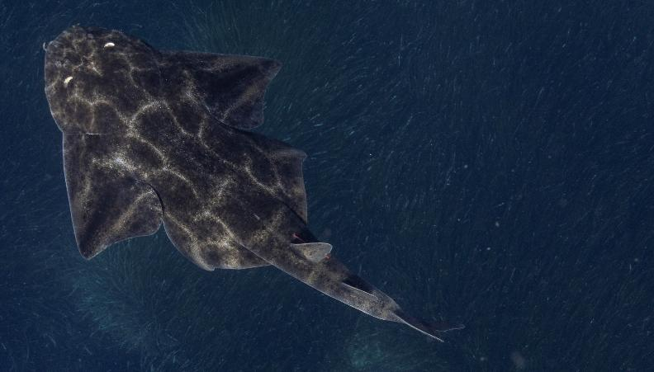
© Dimitris TOSIDIS / iSea
Disclaimer:  Compiled by:  © iSea | This document is a guidance document for the CMS Parties that are Range States to angel sharks in the Mediterranean Sea. The data in this study have not fully been published yet. A scientific publication is underway, involving all co-authors, data providers and reviewers. The data and results cannot be used for any other purpose than the CMS WG meeting of the SSAP Angelshark Med. Any other use require permission from co-authors.  Eva Meyers, Caroline Bousquet, Ioannis Giovos, Roxani Naasan Aga - Spyridopoulou, Martina Ciprian, Runa Schwabe, Dennis Rödder and Simone Niedermüller
With contributions from: | Sara A.A Almabruk, Aylin Ulman, Patrik Krstinic, Samira Enajjar, Michel Marengo, Johann Mourier, Éric Durieux, Marie-Catherine Santoni
Reviewed by: | Andrea Pauly, Rima W. Jabado, Aylin Ulman, Àlex Bartoli, Ali Hood, Sara A.A Almabruk
Citation: | Meyers EKM, Bousquet C, Giovos I, Naasan Aga - Spyridopoulou R, Ciprian M, Schwabe R, Rödder D, Niedermüller S (2025). Advice for spatial management of angel sharks in the Mediterranean Sea. Angel Shark Project.
Funding provided by: | Federal Ministry for the Environment, Nature Conservation, Nuclear Safety and Consumer Protection (BMUV), Convention on the Conservation of Migratory Species of Wild Animals (CMS) and the Shark Conservation Fund.
Contact: | Eva Meyers, e.meyers@leibniz-lib.de
Cover photo credit | Felipe Ravina

Glossary & Acronyms

Angel Shark Conservation Network (ASCN)
The purpose of the ASCN is to facilitate dialogue and information sharing on all matters concerning angel shark conservation.

Angel Shark Project (ASP)
A collaborative project currently working in seven countries to secure the future of
Critically Endangered angel sharks across their range.

Angel Shark Sightings Map (ASSM)
A platform hosted by the Angel Shark Conservation Network to record sightings of angel shark species worldwide.

Area of Interest (AoI)
Regions that have been identified as potentially significant for shark and ray conservation but need further investigation. These areas are flagged for additional research to determine their suitability for ISRA designation.

Barcelona Convention
The Convention for the Protection of the Mediterranean Sea Against Pollution. The Barcelona Convention and its seven Protocols adopted in the framework of the Mediterranean Action Plan (MAP) constitute the principal regional legally binding Multilateral Environmental Agreement (MEA) in the Mediterranean.

Candidate ISRAs (cISRAs)
Areas that have the potential to be designated as Important Shark and Ray Areas (ISRAs) but require more information and research to confirm their importance. These areas are identified based on preliminary data and are considered for future designation as ISRAs once sufficient evidence is gathered.
Convention on the Conservation of

Migratory Species of Wild Animals (CMS)
An environmental treaty of the United Nations. CMS provides a global platform for the conservation and sustainable use of migratory animals and their habitats. CMS brings together the States through which migratory animals pass, the Range States, and lays the legal foundation for internationally coordinated conservation measures throughout a migratory range.

Critical Angel Shark Areas (CASAs)
A specific geographic area that contains essential features necessary for the conservation of Angel Sharks. This may include an area not currently occupied by the species that will be needed for its recovery or conservation e.g., nursery, mating, aggregation, and foraging areas.
Ecologically or Biologically

Significant Areas (EBSAs)
Special areas in the ocean that serve
important purposes, in one way or another, to support the healthy functioning of oceans and the many services that it provides”. (In decision IX/20, the Conference of the Parties to the CBD adopted the scientific criteria for identifying ecologically or biologically significant marine areas in need of protection in open-ocean waters and deep-sea habitats.

Fisheries Restricted Areas (FRAs)
A fisheries restricted area (FRA) is a geographically defined area in which some specific fishing activities are temporarily or permanently banned or restricted in order to improve the exploitation patterns and conservation of specific stocks as well as of habitats and deep-sea ecosystems.

General Fisheries Commission for the Mediterranean (GFCM)
The General Fisheries Commission for the Mediterranean is a regional fisheries management organization. With 22 member countries & the EU, its main objective is to ensure the conservation and the sustainable use of living marine resources as well as the sustainable development of aquaculture in the Mediterranean and in the Black Sea.

Important Shark and Ray Areas (ISRAs)
Discrete three-dimensional portions of habitat that are crucial for the conservation of sharks, rays, and chimaeras. These areas are identified based on scientific criteria that consider the biological and ecological needs of these species.
ISRAs are designed to inform policymakers and decision-makers of the importance of maintaining favorable conservation statuses for these species through appropriate management measures.

Key Biodiversity Areas (KBAs)
Key Biodiversity Areas are “sites that contribute to the global persistence of biodiversity”. According to the CMS State of the World’s Migratory Species report, “currently more than half of the area of KBA sites identified as being important for CMS-listed species is not covered by protected or conserved areas, indicating there are clear gaps and more needs to be done.”

Marine Protected Areas in the Mediterranean (MAPAMED)
MAPAMED (Marine Protected Areas in the Mediterranean) is a cartographic database of key information on Mediterranean Marine Protected Areas (MPAs), potential Other Effective area-based Conservation Measure (OECMs), and more broadly on sites of interest for marine conservation. It is developed and administered jointly by UNEP/ MAP-SPA/RAC and the MedPAN Association.

Marine Protected Areas (MPAs)
Marine Protected Areas (MPAs) are regions of the ocean designated for conservation and management to protect marine ecosystems, habitats, and species. MPAs restrict human activities like fishing, drilling, and tourism to preserve biodiversity and sustain marine resources.

Natura 2000 sites
Natura 2000 is a network of protected areas covering Europe’s most valuable and threatened species and habitats. It is the largest coordinated network of protected areas in the world, extending across all 27 EU Member States, both on land and at sea. The sites within Natura 2000 are designated under the Birds and the Habitats Directives.

National Biodiversity Strategies and Action Plans (NBSAPs)
National Biodiversity Strategies and Action Plans (NBSAPs) are essential tools for countries to develop and implement strategies to protect biodiversity and ecosystem services. These plans outline national priorities, actions, and commitments to address biodiversity loss, aligning with global goals such as the Global Biodiversity Framework (GBF).

Other Effective area-based Conservation Measures (OECMs)
Geographically defined areas distinct from traditional Protected Areas (PAs) but managed in ways that yield positive, sustained, and longterm outcomes for biodiversity conservation, including associated ecosystem functions, services, and, when applicable, cultural, spiritual, socio-economic, and other locally significant values

Particularly Sensitive Sea Areas (PSSAs)
Particularly Sensitive Sea Area (PSSA) is an area that needs special protection through action by the International Maritime Organization because of its significance for recognized ecological or socio-economic or scientific reasons and which may be vulnerable to damage by international maritime activities.

The Convention on Wetlands (RAMSAR)
The Convention’s mission is “the conservation and wise use of all wetlands through local and national actions and international cooperation, as a contribution towards achieving sustainable development throughout the world”.

RAMSAR sites
Ramsar sites are wetlands of international importance designated under the Ramsar Convention, an international treaty for the conservation and sustainable use of wetlands. Ramsar sites are recognized for their ecological significance, particularly as habitats for waterfowl and other wildlife.
Single Species Action Plan for the

Angelshark in the Mediterranean Sea (SSAP Angelshark Med)
Adopted by the CMS Parties with the goal to strengthen coordination, harmonisation, delivery of data collection, conservation, and management efforts for the Angelshark across its range within the Mediterranean Sea.

Species Distribution Model (SDM)
Species distribution modeling (SDM), also referred to as environmental or ecological niche modeling, habitat modeling, predictive habitat distribution modeling, and range mapping, employs ecological models to forecast a species’ distribution across geographic areas and time based on environmental data.
Specially Protected Areas of

Mediterranean Importance (SPAMIs)
Through the Protocol concerning Specially Protected Areas and Biological Diversity in the Mediterranean (SPA/BD Protocol), the Contracting Parties to the Barcelona Convention established the List of Specially Protected Areas of Mediterranean Importance (SPAMI’s List) in order to promote cooperation in the management and conservation of natural areas, as well as in the protection of threatened species and their habitats. The conservation of the natural heritage is then the basic aim that must characterize the SPAMIs.

UNESCO Biosphere Reserves

Biosphere reserves are ‘learning places for sustainable development’. They are sites for testing interdisciplinary approaches to understanding and managing changes and interactions between social and ecological systems, including conflict prevention and management of biodiversity. They are places that provide local solutions to global challenges. Biosphere reserves include terrestrial, marine and coastal ecosystems. Each site promotes solutions reconciling the conservation of biodiversity with its sustainable use. Biosphere Reserves are designated under the intergovernmental MAB Programme by the Director-General of UNESCO following the decisions of the MAB International Coordinating Council (MAB-ICC). Their status is internationally recognized.

World Heritage Sites
The World Heritage List includes 1223 properties forming part of the cultural and natural heritage which the World Heritage Committee considers as having outstanding universal value.

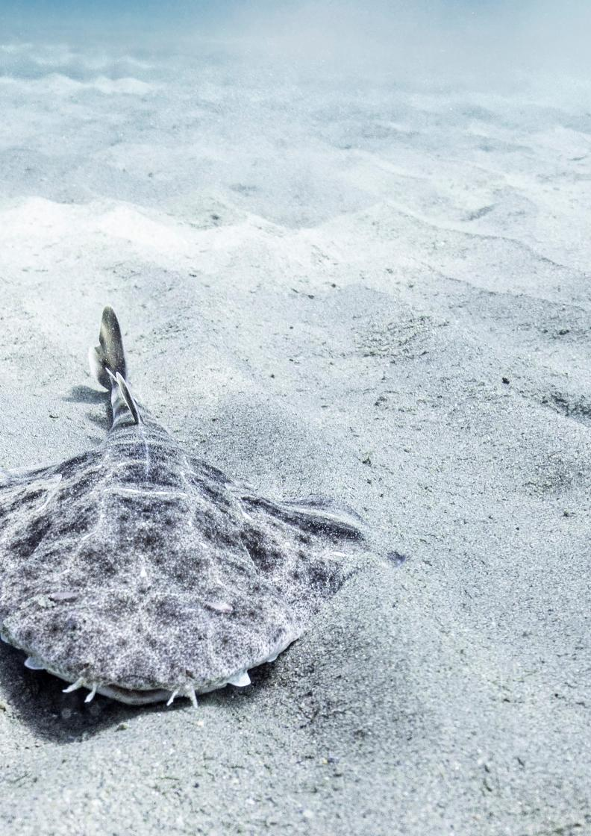
© Ben VERDEILLE

Executive summary
ADVICE SUMMARY
This document is intended to be a dynamic document, updated periodically in collaboration with the Convention on the Conservation of Migratory Species of Wild Animals (CMS) Range States. It offers an overview of current spatial management measures and their overlap with identified critical areas (including Important Shark and Ray Areas for angel sharks and critical areas such as nursery areas, mating areas and aggregation sites) for angel sharks (family Squatinidae) in the Mediterranean Sea. The primary focus is on Angelshark Squatina squatina, which is listed in CMS Appendices I and II. Given the overlapping ranges and challenges in distinguishing between species, two additional angel shark species, Sawback Angelshark S. aculeata and Smoothback Angelshark S. oculata, are also included in this assessment.
REQUEST
The development of this document was kindly funded by The Federal Ministry of the Environment, Nature Conservation, Nuclear Safety and Consumer Protection of Germany, through a CMS Small Scale Funding Agreement (SSFA), to implement priority activities from the CMS Single Species Action Plan for the Angelshark, Squatina squatina (SSAP Angelshark Med).

SUMMARY OF SPATIAL
MANAGEMENT RESULTS
5 ISRAs
1 cISRA
3 AoI
are identified for three angel shark species in the Mediterranean Sea.
8 ISRAs were delineated including angel sharks as a Supporting Species.

2%
of the identified ISRAs for S. squatina and S. aculeata and 1% of the identified ISRAs for S. oculata fall within an Marine Protected Area (MPA) with a fully or partially implemented management plan. However, it remains unclear whether such management plans include specific or effective measures to benefit angel sharks.

3%
of the ISRAs for all three angel shark species fall within an MPA with a management plan in preparation/not implemented/ inexistent/ unreported.

Only 5%
of the suitable habitat for the CMS listed Angelshark (S. squatina), is located within an MPA with a fully or partially implemented management plan. However, it remains unclear whether such management plans include specific or effective measures to benefit angel sharks.

<1%
of the total ISRAs identified for the three species of angel sharks are located within a RAMSAR site.

95%
of the identified ISRAs for all three angel shark species in the Mediterranean Sea fall outside of any MPA regulation.

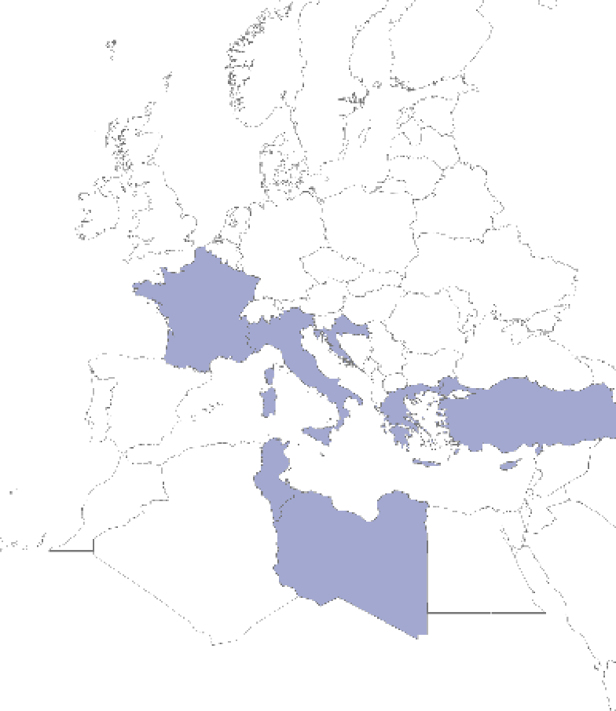
France
Türkiye
Libya
Tunisia
Italy
Cyprus
Malta
Greece
Croatia
M
e
d
i
t
e
r
r
a
n
e
a
n

S
e
a
N
o
r
t
h

A
t
l
a
n
t
i
c

O
c
e
a
n
B
l
a
c
k

S
e
a
RECOMMENDATIONS
Based
on
the
contemporary
presence,
key
habitats, area-based management measures and gaps, the
following countries have been identified as priority areas
(
or Range States) for research, biodiversity management and

conservation for angel sharks in the Mediterranean Sea:
Croatia, Cyprus, France (Corsica), Greece, Italy, Libya, Mal
-
ta, Tunisia, and Türkiye
.

GENERAL RECOMMENDATIONS
We strongly encourage CMS Parties to consider identified ISRAs for angel sharks in priority countries in the Mediterranean Sea in any future spatial management, including in the revision, expansion and designation of MPAs and development of management plans. Specifically, we recommend setting measurable targets to increase the coverage of ISRAs within MPAs.
As more information becomes available and new MPAs are being designated, expanded and improved, a periodic update of this advice document is recommended. This allows an adaptive prioritization of actions and resources, based on the best available science. For example, this advice document can be submitted as a meeting or information document to relevant meetings (i.e. Sharks MOU MOS and Advisory Committee meetings, CMS COP and Scientific Council Meetings, etc.)
SSAP OBJECTIVE 1.
ENSURE APPROPRIATE
SPECIES-LEVEL PROTECTION
- We recommend the development and frequent update of a separate advice document on the legal status of angel sharks in EU and non-EU countries to better understand and evaluate the legal obligations, enforcement mechanisms and gaps.
- Explore the possibilities (through CMS and Ramsar focal points and between the CMS and Ramsar Secretariats) for synergies with the Ramsar Convention on Wetlands ahead of COP15 in 2025, regarding the two ISRAs that fall within a Ramsar site in Türkiye and Tunisia and other overlapping Ramsar sites for angel sharks (Squatinidae), such as those identified in the South American Atlantic.
- We recommend sharing recommendations with the EU Marine Expert group either via the CMS focal points or the government representatives that are part of the International Working Group for the SSAP Angelshark Med.
- We recommend exploring possible synergies and collaboration opportunities with the Barcelona Convention to support the implementation of the UNEP MAP Regional Action Plan for Cartilaginous species.
- Consider existing spatial management tools including the option of joint recommendations under the EU Technical measures regulation (see Art. 21) and the Annex III in which S. squatina is listed as a protected species to extend fisheries restrictions in important areas for Angelsharks. This will also support the implementation of other regional policies including the Regional Plan of Action to monitor and mitigate interactions between fisheries and vulnerable species in the Mediterranean and the Black Sea of the General Fisheries Commission for the Mediterranean and the UNEP MAP Regional Plan of Action for the Conservation of Cartilaginous Fishes and the EU Action plan
- Consider the high priority areas, where ISRAs overlap with suitable habitats, in national waters, and where relevant transboundary Marine Spatial Planning (MSP) processes such as Fisheries Restricted Areas (FRA) to implement CMS decision Decision 14.61 on ISRAs. Such measures should be developed through participatory conservation planning initiatives.
- We recommend that EU Members States that have angel sharks in their waters take this advice document into consideration for their national restoration plans that will have to be submitted by September 2026 to ensure that S. squatina will be considered in the plans as it is listed in the EU regulation for Nature Restoration 2024/1991/EC (Annex III) .

SSAP OBJECTIVE 2. IDENTIFICATION OF SITES AND HABITATS
© Ben VERDEILLE
Action 2.1. Data Collection
- Establish a data sharing agreement between the members of the International Working Group for the SSAP Angelshark Med and the Angel Shark Conservation Network/Angel Shark Sightings Map.
- Fill data gaps in countries with less available information on the presence and management of angel sharks and ascertain the status in these areas. Priority countries: Albania, Cyprus, Malta, Syria and Tunisia.

- Encourage and support data collection on contemporary presence, habitat use and identification of CASAs in countries with data gaps including: Algeria, Egypt, France (mainland), Israel, Lebanon, Monaco, Montenegro, Morocco, Slovenia, Spain (mainland), and Syria.
Action 2.4. None-destructive site sampling • Undertake long-term monitoring programmes and non-destructive surveys (e.g., underwater visual census) in ISRAs, AoI, cISRA in Albania, Croatia, Cyprus, France (Corsica), Greece, Italy, Libya, Malta, Tunisia and Türkiye in order to monitor and evaluate the status of localised angel shark populations. Surveys within ISRAs should focus on monitoring angel shark populations, their habitats and potential threats. Studies within AoI and cISRA should prioritise data collection that provides evidence to meet the ISRA criteria.
Action 2.5. Role of current MPA Network • We recommend a focused follow up study of the five delineated ISRAs (Corsica, Croatia, Greece, Italy, Libya, Malta, Tunisia, Türkiye) for angel sharks. This study should include a fine scale assessment on the effectiveness of MPAs (using the MPA Guide framework), their management plans and other relevant measures for sharks and rays within that area and identify gaps and recommendations for improvement of management measures specifically for angel sharks.
- We further recommend that range states consider setting a target to reach at least 10% of ISRAs covered by an MPA with a fully implemented management plan and if possible, also consider cISRAs and AoI to reach at least a 10% coverage.
Action 2.6. Habitat Modelling
- Based on the results of this study, including the SDM, we recommend following the example from Cyprus and conduct fine scale analyses and habitat modelling in the priority countries that have been identified. This exercise will allow for a more precise identification of critical areas as well as application of specific area-based management and restoration of critical habitats.
- According to the SDM, the distance to seagrass seems to have a strong influence on angel shark presence. Thus, we recommend that range states also prioritize fine scale mapping of seagrass which will allow protecting and restoring seagrass habitats in the Mediterranean Sea.
- In ISRAs, AoIs and cISRAs, particularly those located within an MPA, we recommend the implementation of a long-term monitoring plan that includes at least: a periodical monitoring of presence/absence, population trends, threats and effectiveness of management measures. In addition, studies on the temporal space use patterns and reproductive behaviour should also be conducted in accordance with Objective 3 of the SSAP Angelshark Med.
An overview of delineated ISRAs, cISRA, AoI and specific recommendations per country is provided in table 1 at the end of the document.

Introduction
The Single Species Action Plan for the Angelshark, Squatina squatina in the Mediterranean Sea (SSAP Angelshark Med) was adopted by CMS Parties at COP14 in February 2024, Samarkand, Uzbekistan.
The following decisions on the SSAP Angelshark Med were taken by the Parties and are relevant to this document:
Decision 14.101 a) CMS Range States to the species are requested to undertake to the extent possible, those actions of the Single Species Action Plan for the Angelshark (Squatina squatina) in the Mediterranean Sea (SSAP Angelshark Med) specified for immediate and short-term implementation and for delivery within three years as a matter of priority, continue ongoing and medium-term activities, and start implementation of long-term activities within five years.
Decision 14.104 Non-governmental organisations, the Angel Shark Conservation Network (ASCN) and other experts are encouraged to provide technical support to Range States for the implementation of the Action Plan.
Objective 2 of the SSAP Angelshark Med requests the “identification of sites and habitats of Angelshark in the Mediterranean Sea with the result to identify former, current and potential Critical Angel Shark Areas (CASAs) and ascertain the status of Angelshark in these areas”.
This document aims to contribute to the implementation of two actions agreed under Objective 2 of the SSAP Angelshark Med:
Action 2.1 Data collation (high priority): Collate national data (including both contemporary and historic sources) regarding the presence of Angelshark Squatina squatina (and sister taxa) from relevant sources (including published studies, commercial and recreational fisheries data, fish market data, fisher and diver interviews, citizen science programmes, trawl survey data, discard observer data, museum specimens, Angelshark survey data, and historical resources) to better document the contemporary and historical occurrence of Angelshark in national waters. Such data may also be enhanced through the collection of data on the current presence of Angelshark through the use of social media.
Action 2.5 Role of current MPA network (medium priority): Undertake appropriate sampling (e.g., eDNA sampling, underwater visual census) of existing Marine Protected Areas which may provide suitable habitat for Angelshark, in order to ascertain the likely presence/absence of Angelshark and the effectiveness of conservation measures in place in the current MPA network.
The advice provided in this document shall be used to inform the International Working Group for the SSAP Angelshark Med and to guide decisions and prioritization of the implementation of activities from the SSAP Angelshark Med.

Summary of the
Management
Framework in the
Mediterranean Sea,
relevant to angel sharks
Three species of angel sharks inhabit the Mediterranean Sea, sharing
overlapping ranges: the
Sawback Angelshark
(
Squatina aculeat
a
)
, the
Smoothback Angelshark
(
S. oculat
a
)
, and the
Angelshark
(
S. squatin
a
)
.
According to the IUCN Red List Criteria, all three species are classified
as Critically Endangered.

Barcelona Convention
and the Protocol Concerning Specially Protected Areas and Biological Diversity in the Mediterranean (SPA/BD Protocol)
The Barcelona Convention, formally known as the Convention for the Protection of the Marine Environment and the Coastal Region of the Mediterranean Sea, along with its protocols, is a legally binding agreement that requires the 21 Mediterranean coastal countries to collaborate in protecting and improving the region’s marine and coastal environment while promoting sustainable development. In addition to incorporating a specific Regional Plan of Action for Chondrichthyans, the Barcelona Convention’s Protocol on Specially Protected Areas and Biological Diversity includes two key annexes:
- Annex II: Lists endangered or threatened species that Parties must manage to maintain in a favorable conservation status, ensuring their highest possible protection and recovery.
- Annex III: Includes species whose exploitation is regulated.
Angelshark was listed in Annex III of the SPA/BD Protocol until 2009. In 2009, all three angel shark species were added to Annex II.

General Fisheries Commission for the Mediterranean (GFCM)
All three Mediterranean angel shark species are noted in the legally binding Recommendation GFCM/42/2018/2 (which amends GFCM/36/2012/3), adopted by the then 24 Parties to the General Fisheries Commission for the Mediterranean (GFCM). This recommendation prohibits the retention and sale of 30 elasmobranch (shark and ray) species included in Annex II of the Barcelona Convention.
Article 6 of GFCM/42/2018/2 states that “CPCs shall ensure a high protection from fishing activities for elasmobranch species listed in Annex II of the SPA/BD Protocol of the Barcelona Convention, which must be released unharmed and alive, to the extent possible”.
Article 7 of GFCM/42/2018/2 states that “Specimens of shark species listed in Annex II of the SPA/BD Protocol shall not be retained on board, transhipped, landed, transferred, stored, sold or displayed or offered for sale”.
European Union

Regulation on Nature Restoration
Regulation on Nature Restoration REGULATION (EU) 2024/1991 has the Angelshark (Squatina squatina) listed in the Annex III. This obliges Member States to put in place restoration measures for the marine habitats of species listed in Annex III. It is also specifically mentioned in the COM/2023/102 EU Action Plan: Protecting and restoring marine ecosystems for sustainable and resilient fisheries, which asks countries to adopt national measures or submit joint recommendations to the Commission to minimise by-catch for Angelshark.
Bern

Convention
The Bern Convention (Convention on the Conservation of European Wildlife and Natural Habitats) is a legally binding international treaty adopted in 1979 by the Council of Europe. Its primary goal is to conserve wild flora and fauna and their natural habitats, particularly species and habitats requiring cooperation between multiple countries. It also aims to promote sustainable use of natural resources and prevent habitat destruction.
The Angelshark (Squatina squatina) is listed under Appendix II of the Bern Convention, which includes strictly protected fauna species. This means that member states must take appropriate measures to ensure their conservation, prohibit their killing, and protect their habitats.

Convention on the Conservation of Migratory Species of Wild
The Convention on the Conservation of Migratory Species of Wild Animals (CMS), an environmental treaty of the United Nations provides a global platform for the conservation and sustainable use of migratory animals and their habitats.
Migratory species threatened with extinction are listed on Appendix I of the Convention. CMS Parties strive towards strictly protecting these animals, conserving or restoring the places where they live, mitigating obstacles to migration and controlling other factors that might endanger them. Besides establishing obligations for each State joining the Convention, CMS promotes concerted action among the Range States of many of these species.
Migratory species that need or would significantly benefit from international co-operation are listed in Appendix II of the Convention. For this reason, the Convention encourages the Range States to conclude global or regional agreements.
The inclusion of the Angelshark (Squatina squatina) in the Appendices I and II of CMS was accompanied by a Concerted Action for the species. While the Concerted Action is specifically designed to support the conservation of S. squatina, it also provides benefits to all three angel shark species with overlapping ranges.
In 2018, S. squatina was listed on Annex 1 of the Memorandum of Understanding on the Conservation of Migratory Sharks (CMS Sharks MOU).
At COP14, CMS Parties adopted a Single Species Action Plan for the Conservation of the Angelshark S. squatina in the Mediterranean (SSAP Angelshark Med) with the goal to strengthen coordination, harmonisation, delivery of data collection, conservation, and management efforts for the Angelshark across its range within the Mediterranean Sea.
Türkiye (not party to the CMS), has placed all three species of angel sharks under national protection since 2018, prohibiting their storage, transport, and sale.

Methodology
The advice on the spatial management of angel sharks in the Mediterranean Sea was developed following a thorough compilation of various data sources, including the Angel Shark Sightings Map (citizen science database), research data from regional projects, Local Ecological Knowledge (LEK) studies, fish market surveys, published literature and finally ISRAs, AOI, cISRAs for the three species present in the Mediterranean Sea (Squatina aculeata, Squatina oculata and Squatina squatina). We have assessed the overlap of the current presence and predicted suitable habitats, based on a Species Distribution Model, of the three species, alongside existing area-based conservation tools (ISRAs, AOI, cISRAs) and measures (MPAs, FRAs, Ramsar sites).

MARINE PROTECTED AREA
Marine protected areas (MPAs) are increasingly implemented worldwide to conserve marine ecosystem integrity by managing human activities at sea. Although MPAs are codified in international agreements, their effectiveness is weakened by confusion surrounding the various MPA types, definitions and methodologies to assess their effectiveness, leading to highly inconsistent outcomes.
In the Mediterranean Sea, according to Gomei et al. 2021, considering data up to 2018 in total, 9.68% has been designated as an MPA, 2.48% of the MPAs have a management plan and 1.27% effectively implement their management plan;
0.03% is covered by fully protected areas. This study included the following areas as MPAs: Nationally designated MPAs; Natura 2000 sites; the marine part of Ramsar sites (wetlands of international importance under the Ramsar Convention); The marine part of UNESCO Biosphere reserves; Internationally designated Specially Protected Areas of Mediterranean Importance (SPAMIs).
Another study, using a different definition of MPAs, conducted by Claudet et al. 2020 indicates that only 6.01% of the Mediterranean is covered by protection, in 95% of this area, regulations are not stronger inside than outside MPAs and in fact only 0.23% is fully or highly protected. In this study, legally binding MPAs were collected from MAPAMED. Fishing Restricted Areas, Specially Protected Area of Mediterranean Importance and Particularly Sensitive Sea Area were removed. In the case of non-strictly marine MPAs, only the marine part was kept.
More recently, Aminian-Biquet et al. 2024, provided the first evaluation of protection levels in EU MPAs analysing the legal restrictions on activities using the MPA Guide framework. This Study showed that the Mediterranean Sea has the second largest coverage of MPAs in the EU (14,8%), with only 1,9 % being strictly protected.
Some countries, e.g. Spain or the Republic of Cyprus, have designated new MPAs and developed new management plans since 2018, but few management plans were already officially published as this report is being prepared. For example, Spain recently reviewed the Natura 2000 Network in its territorial waters. In the Spanish Mediterranean, 11.90% is currently covered by Natura 2000 areas and with the new proposed modifications under the LIFE INTEMARES project, it should cover up to 25.06% in the near future.
For the purposes of this advisory document, we have included the following legally binding MPAs, collected from MAPAMED. Please refer to the glossary for detailed information on each site:
- Nationally designated MPAs - Natura 2000 Sites
Other layers provided from the MAPAMED such as Specially Protected Areas of Mediterranean Importance (SPAMIs) and Other Effective area-based Conservation Measures (OECMs) were removed from our analyses. While they are important conservation tools, they do not always meet the strict definition of an MPA or lack a legally binding nature. conservation action with a view to implementing Targets 1 and 3 of the Global Biodiversity Framework, including through National Biodiversity Strategies and Action Plans (NBSAPs)...”.
In the Mediterranean Sea, five ISRAs, one cISRA and three AoI have been identified for angel sharks. Moreover, eight ISRAs were delineated listing angel sharks as a Supporting Species highlighting that they occur in the area but do not meet the ISRA Criteria (Annex 1).
For the purpose of this analysis , we overlapped the identified ISRAs, cISRA and AoI for angel sharks with existing MPAs in the Mediterranean Sea to identify gaps and provide recommendations on area based conservation measures.
In addition, we have overlapped ISRAs, cISRA and AoI for angel sharks in the Mediterranean Sea with Fisheries Restricted Areas (FRAs),

AREAS IMPORTANT FOR CONSERVATION THAT ARE NOT MPAs
In addition to the designation of MPAs, there are other tools that help identify ecologically significant areas, including Ecologically or Biologically Significant Marine Areas (EBSAs), Key Biodiversity Areas (KBAs), and Important Shark and Ray Areas (ISRAs).
ISRAs, specifically designed for sharks and rays, identify habitats essential for their survival. These designations are advisory rather than legally binding, serving as scientific guidance for conservation planning. By integrating EBSAs, KBAs, and ISRAs with which are «geographically defined areas in which some specific fishing activities are temporarily or permanently banned or restricted in order to improve the exploitation patterns and conservation of specific stocks as well as of habitats and deep-sea ecosystem» to look at the coverage and identify gaps and recommendations.
Finally, ISRAs, cISRA and AoI for angel sharks in the Mediterranean Sea were also overlapped with Marine Ramsar sites. So far, most Ramsar sites have been designated for bird species. However, we wanted to explore the presence of angel sharks in these areas and provide recommendations for potential synergies between CMS and Ramsar.

SIGHTINGS DATA

legally established protected areas, marine conservation efforts can be enhanced, ensuring that critical habitats and species receive adequate protection within a coordinated management framework.
As such, at COP14, Parties adopted Resolution 14.61 and committed to «...take into account identified ISRAs for spatial planning and Angel shark sightings data were collected by various stakeholders in the Mediterranean Sea through several research projects and initiatives, including citizen science, Local Ecological Knowledge (LEK) studies, fish market surveys, etc. In this document, only recent data, verified by each project and data owner, incl. citizen science data, (from 2004 and after) are used for the analysis.

ANGEL SHARK SIGHTINGS MAP (ASSM)
The Angel Shark Sightings Map (ASSM) is hosted by the Angel Shark Conservation Network (ASCN) and serves as a tool for citizen scientists, researchers and the public to report angel shark sightings. The sightings are regularly validated by the ASCN. The ASCN kindly provided its entire dataset from the Mediterranean for this analysis.

REGIONAL PROJECT DATA
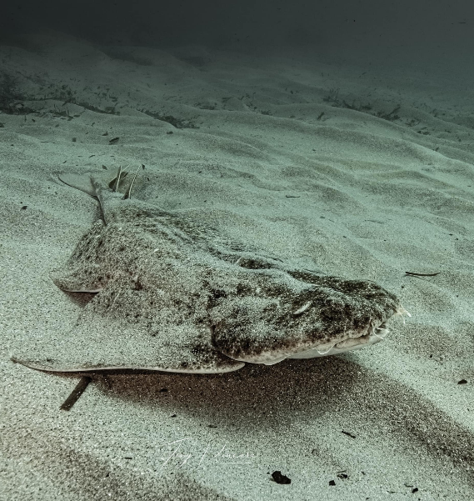
Regional projects monitor angel sharks all over the Mediterranean Sea. Sightings data from the M.E.C.O. project, SPOT/Enalia Physis project, DACOR / Corsican Fisheries Data Collection Framework (CF-DCF), ObsMer, Elasmed, and Regional Angel Shark Project in Croatia, Corsica, Greece and Libya, were compiled for this analysis.
© Tony VIACARA
In addition, a dataset from Mersea Marine Consulting in Turkiye was also included.

PUBLISHED LITERATURE
Sightings from recent published literature were also compiled for this analysis (Akyol et al. 2015, Corsini & Zava 2007, Filiz et al. 2005, Giovos et al. 2019, Giovos et al. 2022, Ismen et al. 2009, Kabasakal 2019, Kara et al. 2018, Karakulak et al. 2006, Lapinksi & Giovos 2019, O’Keefe et al. 2023, Yigin et al. 2019, Zava et al. 2002).

SPECIES DISTRIBUTION MODEL (SDM)
Species distribution modelling (SDM) is an important tool in conservation biology and ecology to analyse the relationship between species distribution data and environmental variables across geographic areas. These models help to assess species abundance, gain insights into biogeography and evolution, evaluate habitat suitability and invasive species distribution, predict future scenarios based on habitat alterations and provide important foundations for targeted conservation strategies (Jiménez-Valverde et al. 2007). SDMs have already been used to predict future habitat alteration due to climate change, establish MPAs, understand fishery interactions, analyse distribution patterns of threatened species (i.e. angelsharks) and implement targeted conservation strategies in marine ecosystems (Meyers et al. 2017). We compiled data from various sources and projects working on elasmobranchs in the Mediterranean Sea to produce a SDM and predict CASAs. Different databases were consulted to collect the environmental layers best suited for this study. The majority of layers were retrieved from the Bio-Oracle database v3.o. at 5.6km pixel-size (Assis et al. 2024). Additionally, to illustrate the current environmental conditions, layers from the time period between 2010 and 2020 were selected. The SDM used a range of environmental variables to predict suitable habitat for angel sharks. Most of these variables have already been used and confirmed to be important in influencing angel shark presence (i.e. temperature, depth). In this SDM, additionally the distance to seagrass appears to play an important role influencing angel shark presence.
To understand and improve area-based conservation measures for angel sharks in the Mediterranean Sea, MPAs were overlapped with the suitable habitat for angel sharks (results of the SDM) and the sightings and estimates of angel shark presence within existing MPAs were calculated.

DATA LIMITATIONS

MARINE PROTECTED AREAS
The MAPAMED version of the Marine Protected Areas data used in this work was last updated in 2019. Although the Natura 2000 sites were updated in 2023, the information regarding the implementation of management plans for each MPA remains from the 2019 data.
Regional FRAs that restrict certain fishing gears permanently or temporarily, were included in this analysis. However, this dataset is also incomplete.
Our analysis does not yet include the evaluation of the effectiveness that the MPAs and their management plans have on angel sharks specifically. The implementation of this exercise is proposed as a next step, see recommendations further down.

SIGHTINGS DATA
Sightings data are collected by various projects across the Mediterranean Sea. Authors acknowledge that the sightings data presented here constitute a non-exhaustive list of the available information. More datasets may be available but could not be included in this analysis at this point, either because they are unpublished, authors could not be reached or are not willing to share data.
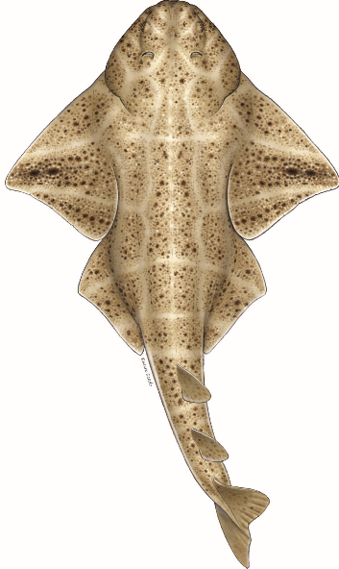
Results
Angelshark
Squatina squatina
For Squatina squatina, four ISRAs were delineated with S. squatina as a qualifying species, five ISRAs with S. squatina as supporting species, one cISRA and two AoI.
2% of these ISRAs fall within an MPA with a fully or partially implemented management plan.
3% of the ISRAs fall within an MPA with a management plan in preparation/not implemented/ inexistent/ unreported, leaving 95% of the ISRAs without any MPA regulation (Figure 1).
The cISRA delineated for S. squatina falls completely out of any MPA regulation and only 1% of the AoI falls within an MPA with a fully or partially implemented management plan (Figure 1).
Nearly half (52%) of the S. squatina sightings recorded fall outside of any MPA regulation (Figure 1). Notably, however, the Natura 2000 site “Grand herbier de la plaine” (FR9402014) in eastern Corsica - accounts for 289 or the 685 recorded sightings of S. squatina.
Based on the SDM, 85% of the predictable suitable habitat for S. squatina falls out of any MPA regulation, 10% has an MPA within preparation/ not implemented/inexistent/unreported/unknown and only 5% falls within an existing MPA (Figure 2).
Finally, 26% of the delineated ISRAs, 57% of the cISRA and 25% of AoI for S. squatina overlap with the predicted suitable habitat in the Mediterranean Sea (Figure 3).

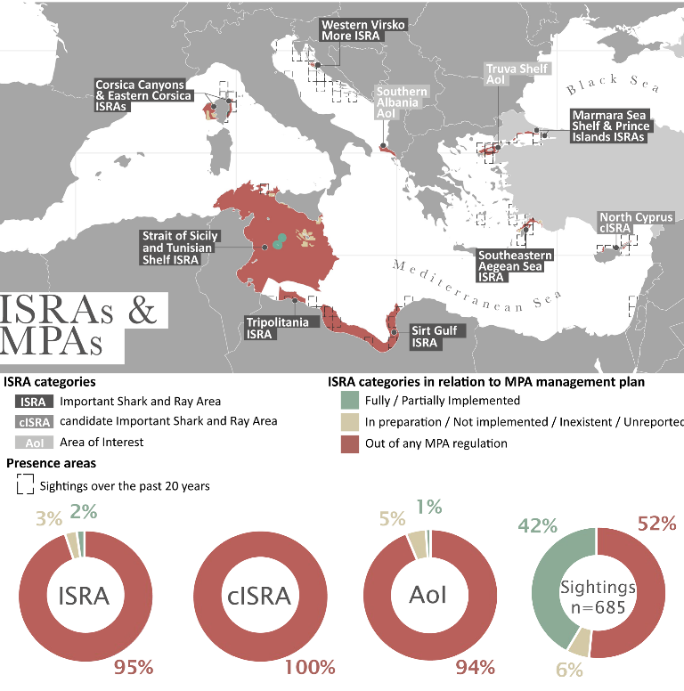
Figure 1. Map showing the delineations of the Angelshark S. squatina Important Shark and Ray Areas (ISRAs), candidate ISRA (cISRA) and Areas of Interest (AoI) in relation to their overlap with Marine Protected Areas (MPAs) and the status of management plans for these MPAs in the Mediterranean Sea. The delineated areas on the map are the actual ISRA/cISRA/AoI polygons and within these ISRA/cISRA/AoI, the coverage of MPAs is shown using the following colour pattern : green: area of an MPA within an ISRA/cISRA/AoI that has a fully or partially implemented management plan; brown: area of an MPA within an ISRA/cISRA/AoI that has a management plan in preparation, not implemented, inexistent or unreported; red: area within an ISRA/cISRA/
AoI that falls out of any MPA regulations. Contemporary sightings (since 2004 onwards) are shown in squares.
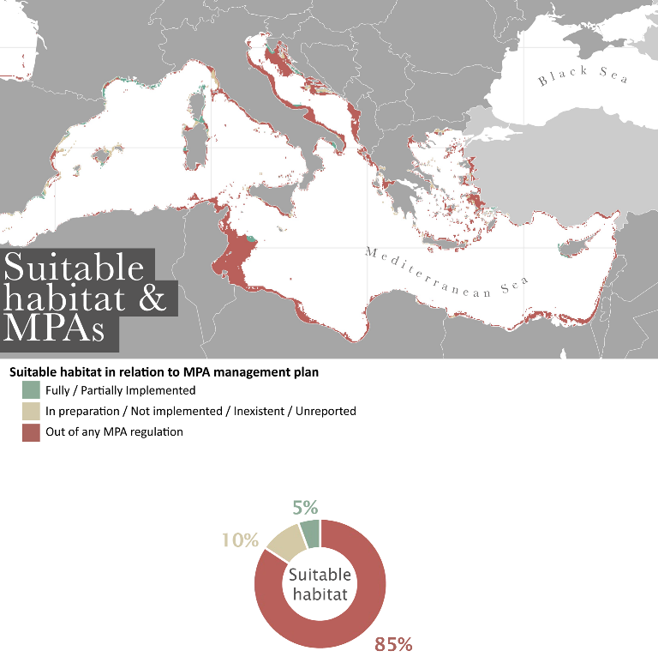
Figure 2. Map showing suitable habitat of the Angelshark S. squatina, based on the Species Distribution Model (SDM) and the area covered by MPAs in relation to a management plan. The areas shown in green are suitable habitats that are covered with an MPA that has a fully or partially implemented management plan. Areas in brown, are suitable habitats with an MPA that has a management plan in preparation, not implemented, inexistent or unreported. Areas shown in red are suitable habitats that are not covered by any MPAs and are out of any MPA regulations.
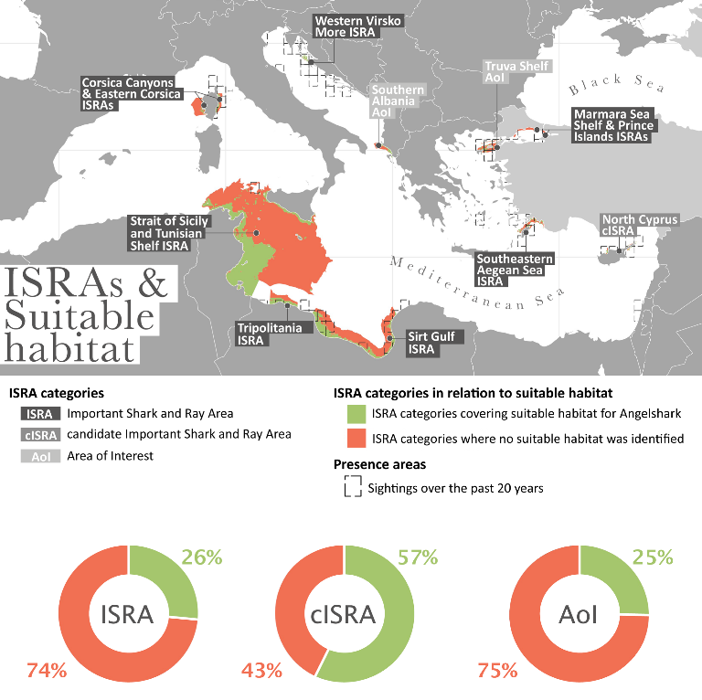
Figure 3. Map showing the delineations of the Angelshark S. squatina Important Shark and Ray Area (ISRA), candidate ISRA (cISRA) and Area of Interest (AoI) in relation to their overlap with suitable habitat, based on the Species Distribution Model (SDM). The delineated areas on the map are the actual ISRA/cISRA/AoI polygons and within these ISRA/cISRA/AoI, the coverage of suitable habitat is shown using the following colour pattern : green: area identified as a suitable habitat within an ISRA/cISRA/AoI; orange: area within an ISRA/ cISRA/AoI that is not identified as a suitable habitat. Contemporary sightings (since 2004 onwards) are shown in squares.

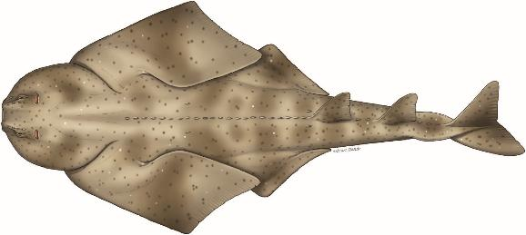
Sawback Angelshark

Squatina aculeata
For Squatina aculeata, five ISRAs were delineated and two AoI.
2% of these ISRAs fall within an MPA with a fully or partially implemented management plan.
3% of the ISRAs fall within an MPA with a management plan in preparation/not implemented/ inexistent/ unreported, leaving 95% of the ISRAs without any MPA regulation (Figure 4).
8% of the AoI falls within an MPA with a fully or partially implemented management plan and 19% within an MPA with a management plan in preparation/ not implemented/ inexistent/ unreported (Figure 4).
7% of S. aculeata sightings recorded fall inside an area with an MPA with a fully or partially implemented management plan (Figure 4).
Based on the SDM, 86% of the predictable suitable habitat for S. aculeata falls out of any MPA regulation, 10% has an MPA within preparation/ not implemented/inexistent/unreported/unknown and only 4% falls within an existing MPA (Figure 5)
Finally, 47% of the delineated ISRAs and 57% of AoI for S. aculeata overlap with the predicted suitable habitat in the Mediterranean Sea (Figure 6).

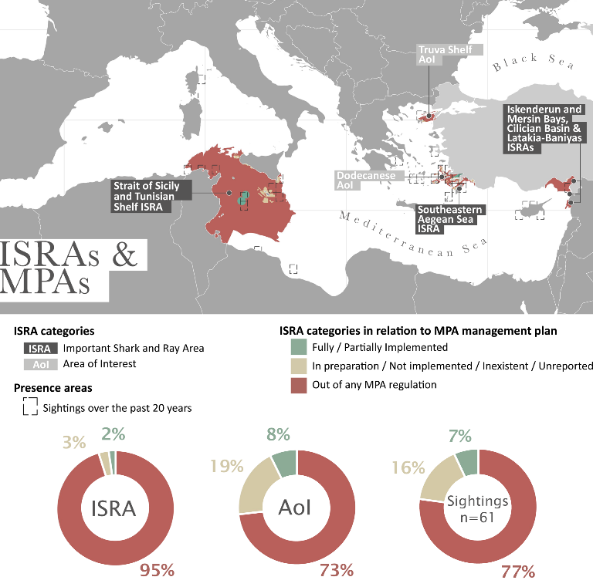
Figure 4. Map showing the delineations of the Sawback Angelshark S. aculeata Important Shark and Ray Area (ISRA) and Area of Interest (AoI) in relation to their overlap with Marine Protected Areas and the status of management plans for these MPAs in the Mediterranean Sea. The delineated areas on the map are the actual ISRA/AoI polygons and within these ISRA/AoI, the coverage of MPAs is shown using the following colour pattern: green: area of an MPA within an ISRA/AoI that has a fully or partially implemented management plan; brown: area of an MPA within an ISRA/AoI that has a management plan in preparation, not implemented, inexistent or unreported; red: area within an ISRA/AoI that falls out of any MPA regulations.
Contemporary sightings (since 2004 onwards) are shown in squares.
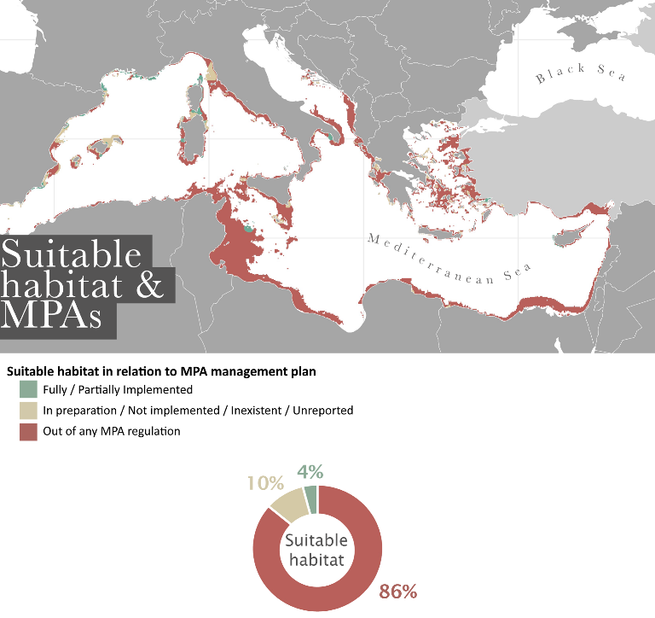
Figure 5. Map showing suitable habitat of the Angelshark S. aculeata, based on the Species Distribution Model (SDM) and the area covered by MPAs in relation to a management plan. The areas shown in green are suitable habitats that are covered with an MPA that has a fully or partially implemented management plan. Areas in brown are suitable habitats with an MPA that has a management plan in preparation, not implemented, inexistent or unreported. Areas shown in red are suitable habitats that are not covered by any MPAs and are out of any MPA regulations.
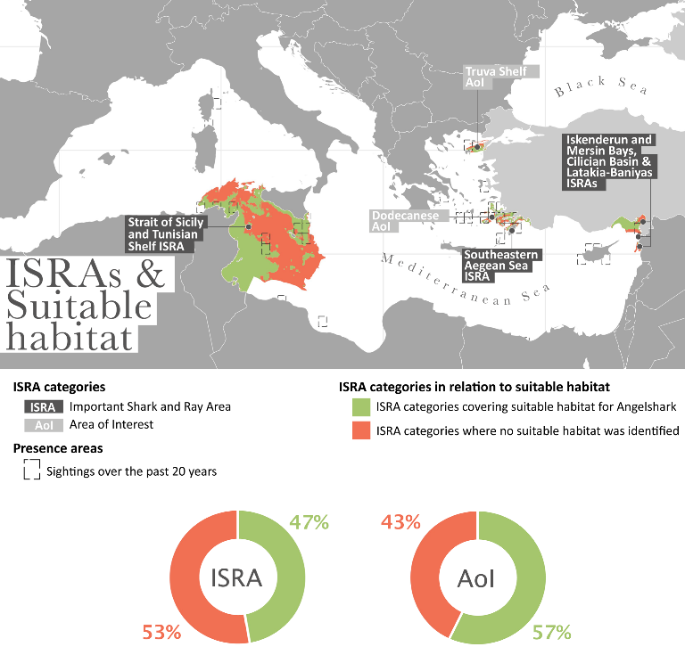
Figure 6. Map showing the delineations of the Angelshark S. aculeata Important Shark and Ray Area (ISRA) and Area of Interest (AoI) in relation to their overlap with suitable habitat, based on the Species Distribution Model (SDM). The delineated areas on the map are the actual ISRA/AoI polygons and within these ISRA/AoI, the coverage of suitable habitat is shown using the following colour pattern : green: area identified as a suitable habitat within an ISRA/AoI; orange: area within an ISRA/AoI that is not identified as a suitable habitat.
Contemporary sightings (since 2004 onwards) are shown in squares.

Smoothback Angelshark

Squatina oculata
For Squatina oculata, five ISRAs were delineated.
1% of these ISRAs fall within an MPA with a fully or partially implemented management plan.
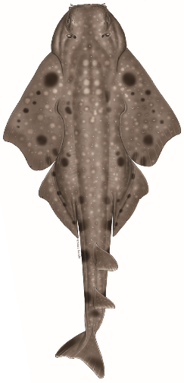
3% of the ISRAs fall within an MPA with a management plan in preparation/not implemented/ inexistent/ unreported, leaving 96% of the ISRAs without any MPA regulation (Figure 7).
0% of S. oculata sightings recorded fall inside an area with an MPA with a fully or partially implemented management plan, while 30% fall within an MPA with a management plan in preparation/ not implemented/inexistent/unreported (Figure 7).
Based on the SDM, 87% of the predictable suitable habitat for S. oculata falls out of any MPA regulation, 10% has an MPA within preparation/not implemented/inexistent/unreported/unknown and only 3% falls within an existing MPA (Figure 8) Finally, only 17% of the delineated ISRAs for
S. oculata overlap with the predicted suitable habitat in the Mediterranean Sea (Figure 9).

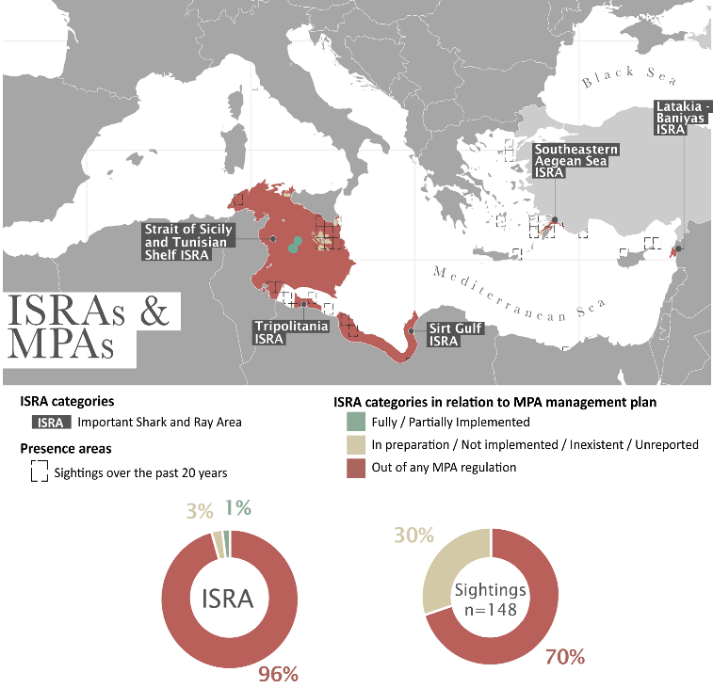
Figure 7. Map showing the delineations of the Angelshark S. oculata Important Shark and Ray Areas (ISRA) in relation to their overlap with Marine Protected Areas and the status of management plans for these MPAs in the Mediterranean Sea. The delineated areas on the map are the actual ISRA polygons and within these ISRAs, the coverage of MPAs is shown using the following colour pattern: green: area of an MPA within an ISRA that has a fully or partially implemented management plan; brown: area of an MPA within an ISRA that has a management plan in preparation, not implemented, inexistent or unreported; red: area within an ISRA that falls out of any MPA regulations. Contemporary sightings (since 2004 onwards) are shown in squares.
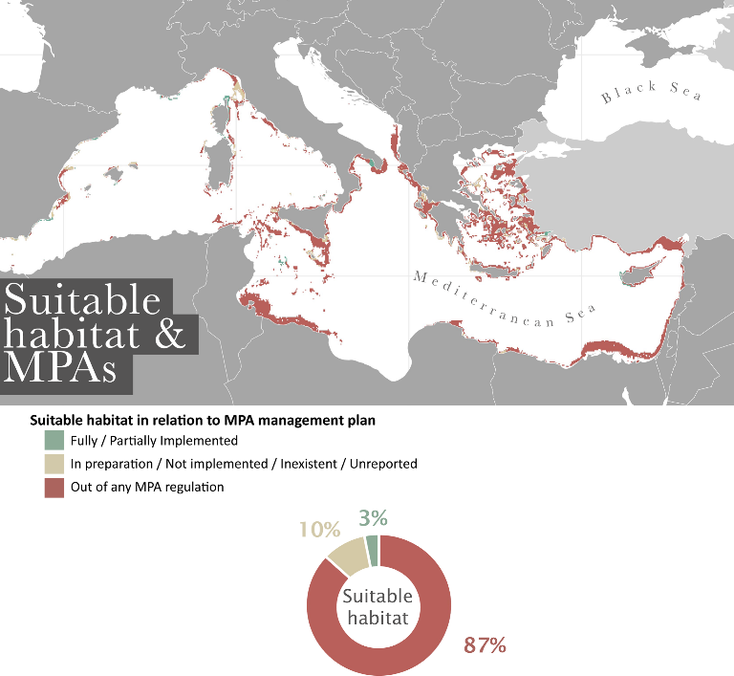
Figure 8. Map showing suitable habitat of the Angelshark S. aculeata, based on the Species Distribution Model (SDM) and the area covered by MPAs in relation to a management plan. The areas shown in green are suitable habitats that are covered with an MPA that has a fully or partially implemented management plan. Areas in brown are suitable habitats with an MPA that has a management plan in preparation, not implemented, inexistent or unreported. Areas shown in red are suitable habitats that are not covered by any MPAs and are out of any MPA regulations.
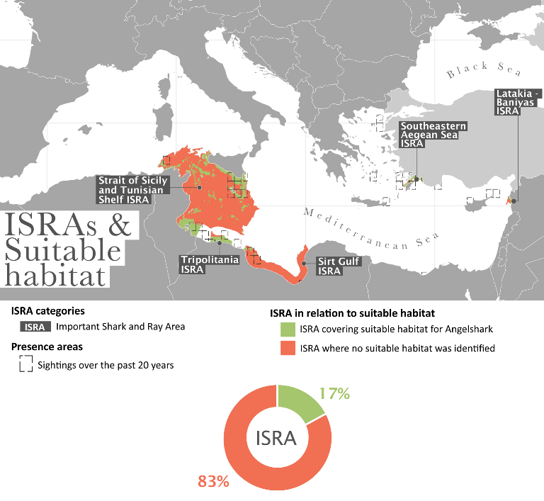
Figure 9. Map showing the delineations of the Angelshark S. oculata Important Shark and Ray Areas (ISRA) in relation to their overlap with suitable habitat, based on the Species Distribution Model (SDM). The delineated areas on the map are the actual ISRA polygons and within these ISRAs, the coverage of suitable habitat is shown using the following colour pattern : green: area identified as a suitable habitat within an ISRA; orange: area within an ISRA that is not identified as a suitable habitat. Contemporary sightings (since 2004 onwards) are shown in squares.

All angel shark species

ISRA categories overlapping with Fisheries Restricted Areas (FRAs)
FRA is a geographically defined area where certain fishing activities are temporarily or permanently restricted or prohibited to enhance exploitation patterns and conserve specific fish stocks, habitats, and deep-sea ecosystems. According to the Food and Agriculture Organisation of the United Nations (FAO), in the Mediterranean and Black Sea, ten FRAs designated by the GFCM protect a total of 1,760,000 km² of marine habitats. However, only 4% of the delineated ISRAs for angel sharks are within FRA, while the cISRA and AoI are almost completely outside any spatial regulation (Figure 10).
ISRA categories overlapping with RAMSAR Sites
Less than 1% of the three ISRA categories delineated for the 3 species of angel shark fall within a Ramsar site (Figure 11). These sites are in Türkiye (3 Ramsar sites), Albania (1 Ramsar site), Sicily (Italy, 2 Ramsar sites), Corsica (France, 2 Ramsar sites) and Tunisia (13 Ramsar sites).

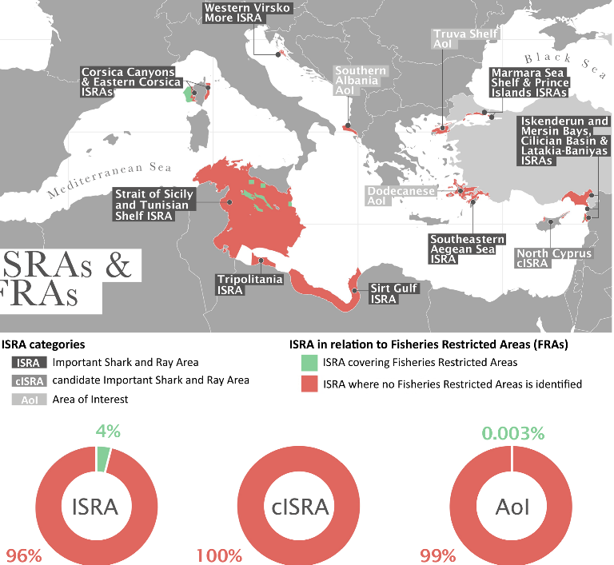
ISRAs &
FRAs
Figure 10. Important Shark and Ray Area (ISRA), candidate ISRA (cISRA) and Area of Interest (AoI in relation to their overlap with Fisheries Restricted Areas (FRAs) under the General Fisheries Commission for the Mediterranean (GFCM) (green) in the Mediterranean Sea.
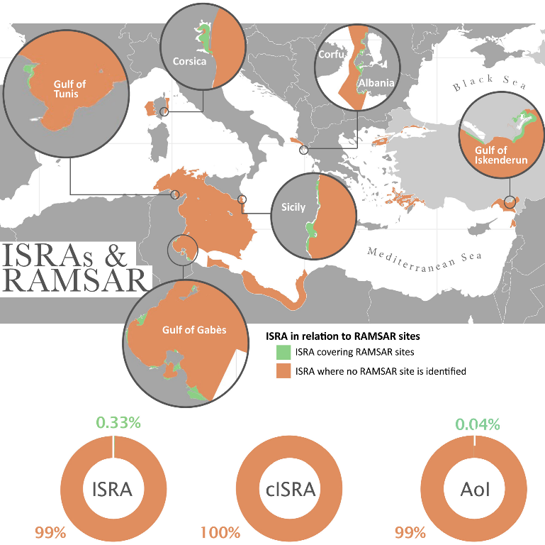
Figure 11. Angel sharks Important Shark and Ray Area (ISRA), candidate ISRA (cISRA) and Area of Interest (AoI), in relation to their overlap with Ramsar sites in the Mediterranean Sea.
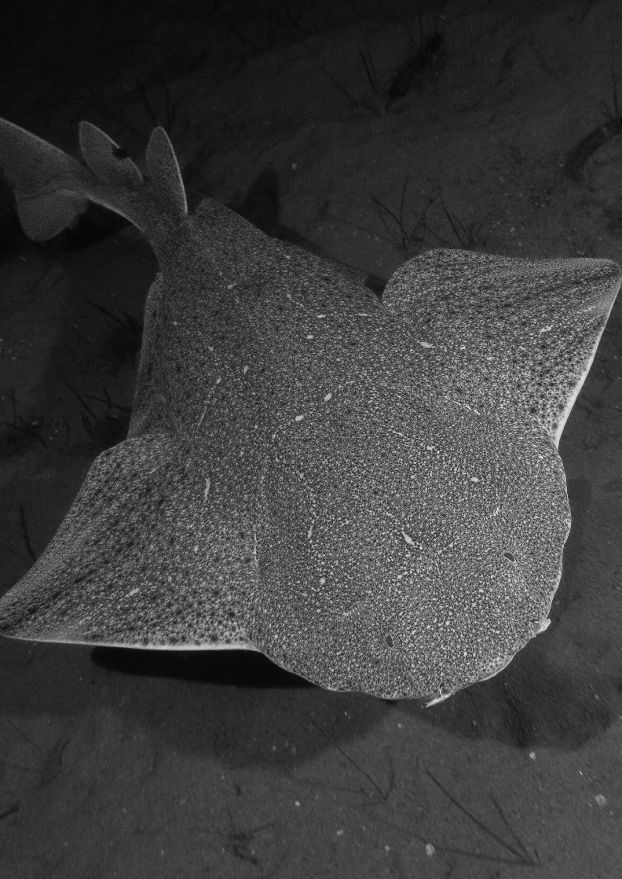
© Laure FINELLI

Summary
ISRA in which
Angel sharks are a
Qualifying Species
cISRA in
which Angel
sharks are a
Qualifying
Species
AoI
ISRA in which
Angel shark are
listed as a
Supporting
Species
Priority for
management/
conservation
Priority to
evaluate
MPA
effectiveness
Priority for
research
Albania
AoI Southern
Albania
Additional research at AoI and
CASAs to determine whether it
can meet ISRA Criteria
Algeria
Confirm areas of presence and
CASAs
Croatia
ISRA Western Virsko
More
*Reproduction area
x
x
Long-term monitoring
(
)
population, threats, habitat
Cyprus
cISRA North
Cyprus
ISRA CIlician Basin
Additional research at cISRA and
CASAs to determine whether it
can meet ISRA Criteria
Egypt
Confirm areas of presence and
CASAs
France
(
mainland
)
Confirm areas of presence and
CASAs
France
(
Corsica
)
ISRA Eastern
Corsica
*Undefined
aggregations
ISRA Corsica
Canyons
x
x
Long-term monitoring
(
population, threats, habitat
)
Investigate undefined aggrega
-
tions
Table 1.
Overview of countries with Important Shark and Ray Areas (ISRAs), candidate Important Shark and Ray Areas (cISRAS), Areas of Interest (AoI) and Important
Shark and Ray Areas (ISRAs) where angel sharks (all three species in the Mediterranean) are listed as supporting species and based on these priorities for management,
evaluation of effectiveness of MPAs and research. Highlighted cells indicate priority countries, areas and priority actions, based on the analysis completed in this study.
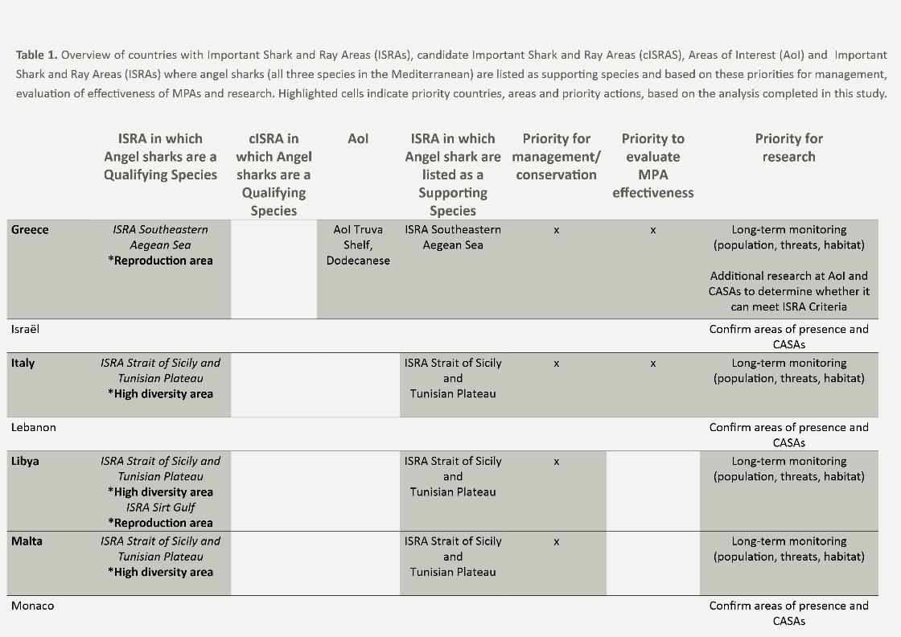
ISRA in which
Angel sharks are a
Qualifying Species
cISRA in
which Angel
sharks are a
Qualifying
Species
AoI
ISRA in which
Angel shark are
listed as a
Supporting
Species
Priority for
management/
conservation
Priority to
evaluate
MPA
effectiveness
Priority for
research
Montenegro
Confirm areas of presence and
CASAs
Morocco
Confirm areas of presence and
CASAs
Slovenia
Confirm areas of presence and
CASAs
Spain
Confirm areas of presence and
CASAs
Syria
ISRA Latakia
Baniyas
Confirm areas of presence and
CASAs
Tunisia
ISRA Strait of Sicily and
Tunisian Plateau
*High diversity area
ISRA Strait of Sicily
and
Tunisian Plateau
x
Long-term monitoring
(
population, threats, habitat
)
Türkiye
ISRA Southeastern
Aegean Sea
*Reproduction area
AoI Truva
Shelf
ISRA Cilician Basin
ISRA Marmara Sea
Shelf
ISRA Iskenderun
and Mersin Bays
ISRA Prince Islands
x
x
Identify CASAs
Table 1.
Overview of countries with Important Shark and Ray Areas (ISRAs), candidate Important Shark and Ray Areas (cISRAS), Areas of Interest (AoI) and Important
Shark and Ray Areas (ISRAs) where angel sharks (all three species in the Mediterranean) are listed as supporting species and based on these priorities for management,
evaluation of effectiveness of MPAs and research. Highlighted cells indicate priority countries, areas and priority actions, based on the analysis completed in this study.

Conclusions
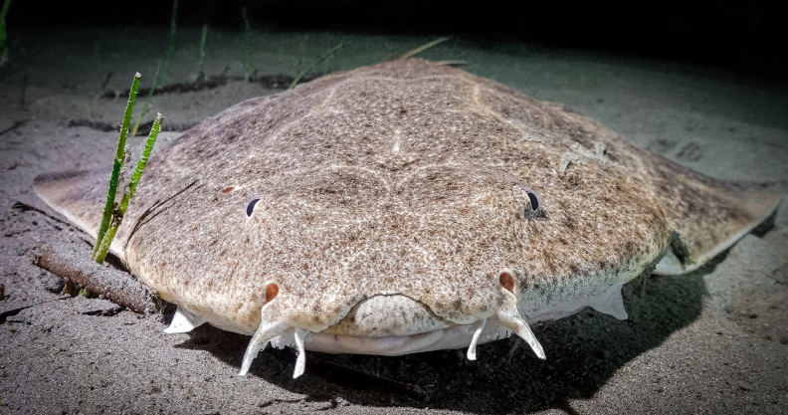
This study is the first Mediterranean-wide analysis on the area-based measures for angel sharks (S. squatina, S. aculeata and S. oculata) that takes into account the most recent and up to date dataset, contemporary presence and recently delineated ISRAs, cISRA and AoI. It should be noted that this advice document is specifically drafted in alignment with the CMS SSAP Angelshark Med. A scientific publication, incorporating all the data and results presented in this document, is underway.
© Pierre-Jean BEAUX
Detailed recommendations directed at Range States (CMS Parties and non-Parties) to the Appendix I and II listed Angelshark S. squatina (and the other two angel shark species with an overlapping range S. aculeata and S. oculata), are provided in the executive summary at the beginning of this document and summarised in Table 1.
As a next step, the effectiveness of current areabased management approaches for the conservation of angel sharks (and other sharks and rays) should be looked at within each ISRA that overlaps with an MPA. Moreover, long-term monitoring programmes will be essential to ensure that the impact and recovery of angel sharks in the Mediterranean can be measured and evaluated.

Data sources & additional information
CMS Single Species Action Plan for the Angelshark in the Mediterranean Sea
WWF Policy Summary on MPA protection
WWF MPA protection Analysis
Important Shark and Ray Areas
Key Biodiversity Areas

Ecologically or Biologically Significant Areas
Natura 2000
Angel Shark Sightings Map
Eastern Atlantic and Mediterranean Angel Shark Strategy
Mediterranean Angel Sharks: Regional Action Plan
X-ray report on spatial protection for angel sharks with a focus on the Adriatic Sea
Conservation and management of chondrichthyans in the Mediterranean
Sea: gaps, overlaps, inconsistencies, and the way forward
State of the World’s Migratory Species

References
Akyol, O., Ünal, V., & Capapé, C. (2015). Occurrence and biological observations on angel shark Squatina squatina (Chondrichthyes: Squatinidae) from the Turkish waters (Eastern Mediterranean). Turkish Journal of Fisheries and Aquatic Sciences, 15(4), 931-935.
Aminian-Biquet, J., Gorjanc, S., Sletten, J., Vincent, T., Laznya, A., Vaidianu, N., ... & e Costa, B. H. (2024). Over 80% of the European Union’s marine protected area only marginally regulates human activities. One Earth, 7(9), 1614-1629.
Assis, J., Fernández Bejarano, S.J., Salazar, V.W., Schepers, L., Gouvêa, L., Fragkopoulou, E., Leclercq, F., Vanhoorne, B., Tyberghein, L., Serrão, E.A., Verbruggen, H., De Clerck, O. (2024) Bio-ORACLE v3.0. Pushing marine data layers to the CMIP6 Earth system models of climate change research. Global Ecology and Biogeography. DOI: 10.1111/geb.13813
Claudet, J., C. Loiseau, M. Sostres, M. Zupan, Underprotected marine protected areas in a global biodiversity hotspot. One Earth.2,380-384 (2020).
Corsini, M., Zava, B. (2007) Recent capture of Squatina oculata and Squatina aculeata from Dodecanese Islands (SE Aegean Sea, East-ern Mediterranean). Biologia Marina Mediterranea 14(2): 352–353.
Filiz, H., Irmak, E., & Mater, S. (2005). Occurence of Squatina aculeata Cuvier, 1829 (Elasmobranchii, Squatinidae) from the Aegean Sea, Turkey. Ege Journal of Fisheries and Aquatic Sciences, 22(3), 451-452.
Giovos, I., Stoilas, V. O., Al-Mabruk, S. A., Doumpas, N., Marakis, P., Maximiadi, M., ... & de Maddalena, A. (2019). Integrating local ecological knowledge, citizen science and long-term historical data for endangered species conservation: Additional records of angel sharks (Chondrichthyes: Squatinidae) in the Mediterranean Sea. Aquatic Conservation: Marine and Freshwater Ecosystems, 29(6), 881-890.
Giovos, I., Katsada, D., Spyridopoulou, R. N. A., Poursanidis, D., Doxa, A., Katsanevakis, S., ... & Hood, A. R. (2022). Strengthening angel shark conservation in the northeastern Mediterranean Sea. Journal of Marine Science and Engineering, 10(2), 269.
Gomei M., Abdulla A., Schröder C., Yadav S., Sánchez A., Rodríguez D., Abdul Malak D. (2021) [original
2019]. Towards 2020: how Mediterranean countries are performing to protect their sea. Rev. ed., 36 pages Ismen, A., Cigdem Yigin, C., Altinagac, U., & Ayaz, A. D. N. A. N. (2009). Length–weight relationships for ten shark species from Saros Bay (North Aegean Sea). Journal of Applied Ichthyology, 25, 109-112.
Jiménez-Valverde, A., & Lobo, J. M. (2007). Threshold criteria for conversion of probability of species presence to either–or presence–absence. Acta oecologica, 31(3), 361-369.
Kabasakal, H. (2019). Finally under protection! Status of the angel shark, Squatina squatina (Linnaeus, 1758) in Turkish Seas, with notes on a recent sighting and incidental captures. In Annales: Series Historia Naturalis (Vol. 29, No. 1, pp. 17-24). Scientific and Research Center of the Republic of Slovenia.
Kara, A., Sağlam, C., Acarli, D., & Cengız, Ö. (2018). Length-weight relationships for 48 fish species of the Gediz estuary, in Izmir Bay (Central Aegean Sea, Turkey). Journal of the Marine Biological Association of the United Kingdom, 98(4), 879-884.
Karakulak, F. S., Erk, H., & Bilgin, B. (2006). Length–weight relationships for 47 coastal fish species from the northern Aegean Sea, Turkey. Journal of Applied Ichthyology, 22(4), 274-278.
Lapinski, M., & Giovos, I. (2019). New records of the critically endangered Squatina squatina (Linnaeus, 1758) from Corsica, France. Acta Adriatica, 60(2), 205-210.
Meyers, E. K., Tuya, F., Barker, J., Jiménez Alvarado, D., Castro-Hernández, J. J., Haroun, R., & Rödder, D. (2017). Population structure, distribution and habitat use of the Critically Endangered Angelshark, Squatina squatina, in the Canary Islands. Aquatic Conservation: Marine and Freshwater Ecosystems, 27(6), 1133-1144.
O’Keefe, M., Bengil, E. G., Palmer, J. L., Beton, D., Çağlar, Ç., Godley, B. J., ... & Broderick, A. C. (2023). Diversity and distribution of elasmobranchs in the coastal waters of Cyprus: using bycatch data to inform management and conservation. Frontiers in Marine Science, 10, 1181437. UNEP-WCMC, 2024. State of the World’s Migratory Species. UNEP-WCMC, Cambridge, United Kingdom.
Yığın, C. Ç., İşmen, A., Daban, B., Cabbar, K., & Önal, U. (2019). Recent findings of rare sharks, Squatina oculata Bonaparte, 1840 and Squatina squatina (Linnaeus, 1758) from Gökçeada Island, Northern Aegean Sea, Turkey. Journal of Black Sea/Mediterranean Environment, 25(3), 305-314.
Zava, B., Insacco, G., Deidun, A., Said, A., Souissi, J. B., Nour, O. M., ... & Corsini-Foka, M. (2022). Records of the critically endangered Squatina aculeata and Squatina oculata (Elasmobranchii: Squatiniformes: Squatinidae) from the Mediterranean Sea.

Annex 1
Table of all Important Shark and Ray Areas (ISRA), candidate Important Shark and Ray Areas (cISRA) and Area of Interest (AoI) identified in the Mediterranean and Black Seas for all three Squatinidae species (Squatina squatina, Squatina aculeata and Squatina oculata).
Name | Country | Type of area | Squatina squatina | Squatina aculeata | Squatina oculata
Strait of Sicily and Tunisian Plateau | Italy - Libya - Malta - Tunisia | ISRA | Qualifying species | Qualifying species | Qualifying species
Sirt Gulf | Libya | ISRA | Qualifying species |  | Qualifying species
Eastern Corsica | France | ISRA | Qualifying species
Western Virsko  More | Croatia | ISRA | Qualifying species
Southeastern Aegean Sea | Greece - Türkiye | ISRA | Supporting species | Supporting species | Qualifying species
Tripolitania | Libya | ISRA | Supporting species |  | Supporting species
Corsica canyons | France | ISRA | Supporting species
Marmara Sea  Shelf | Türkiye | ISRA | Supporting species
Prince Islands | Türkiye | ISRA | Supporting species
Latakia-Baniyas basin | Syria | ISRA |  | Supporting species | Supporting species
Cilician basin | Cyprus - Türkiye | ISRA |  | Supporting species
Iskenderun and Mersin bays | Türkiye | ISRA |  | Supporting species
Dodecanese | Greece | AoI |  | x
Southern Albania | Albania | AoI | x
Truva Shelf | Greece | AoI |  | x
North Cyprus | Cyprus | cISRA | x

Nature Restoration 2024/1991/EC (Annex III) art. 5 par. 5 «Member States shall put in place the restoration measures for the marine habitats of species listed in Annex III and in Annexes II, IV and V to Directive 92/43/EEC and for the marine habitats of wild birds covered under Directive 2009/147/EC, that are necessary in order to improve the quality and quantity of those habitats, including by re-establishing them, and to enhance connectivity, until sufficient quality and quantity of those habitats is achieved.»

