Assessment of the Conservation Status of the Hawksbill Turtle in the Western Pacific Ocean Region

Christine Madden Hof^{1,2}, Kimberly Anne Riskas³, Michael Jensen^{1,4}, Nicolas Pilcher⁵, Alexander Gaos⁶, Mark Hamann⁷

¹ WWF-Coral Triangle Programme, Graha Simatupang Tower 2 Unit C 7th Floor, Jl. Letjen TB Simatupang Kav. 38, 12540 Jakarta Indonesia
² University of the Sunshine Coast, 90 Sippy Downs Dr, Sippy Downs QLD 4556
³ School of Earth and Environmental Sciences, The University of Queensland, St Lucia, Queensland Australia
⁴ Department of Chemistry and Bioscience, Aalborg University, Denmark
⁵ Marine Research Foundation, Sabah, Malaysia
⁶ NOAA Pacific Islands Fisheries Science Center, 1845 Wasp Blvd., Bldg. 176, Honolulu, Hawaii, USA
⁷ College of Science and Engineering, James Cook University

Acknowledgements and contributions
We would like to thank Karen Baird and Unity Roebeck from SPREP for providing TREDS data. The authors acknowledge the vast contributions from thousands of sea turtle biologists and researchers who contributed data to the studies we summarise herein, and the wealth of information in their own original publications and acknowledge that the ownership and intellectual property of that information resides entirely with all of the original data owners and providers. We are also grateful to the numerous research teams, NGOs and government agencies who have funded those efforts.

Suggested citation:
Madden Hof CA, Riskas KA, Jensen M, Pilcher N, Gaos A, Hamann M (2022). Assessment of the conservation status of the hawksbill turtle in the western Pacific Ocean region. Report to the Convention of Migratory Species.

Designations used in figures and text
The depiction and use of boundaries, geographic names and related data shown on maps and included in lists, tables, documents, and databases on this website are not warranted to be error free nor do they necessarily imply official endorsement or acceptance by the United Nations.

Cover image: © Amon/Lissenung Island Report/WWF-Aus
Table of Contents
Preface 5
Introduction 6
Geographic scope 7
Hawksbill turtle synthesis 8
Summary – population identification 8
Summary – nesting 10
Summary – foraging 11
Areas within the western Pacific region of known importance for hawksbill turtles 11
Important Nesting Sites 11
Index nesting beaches 11
Important non-nesting sites 12
Migration 12
Important foraging and refuge sites 12
Gaps in biological information 12
Population structure 12
Life history attributes 13
Nesting populations 13
Non-reproductive populations 13
Oceanic post-hatchling populations 13
Key pressures on hawksbill turtles of the western Pacific region 14
The tortoiseshell trade – a summary 14
Bycatch in legal fisheries 14
Illegal use and Illegal, Unreported and Unregulated (IUU) Fishing 15
Human use of turtles and their products 16
Climate change 17
Marine debris and plastic pollution 17
Management and protection 18
Southwest Pacific Ocean 23
Solomon Island management unit 23
Ecological range 23
Geographic spread of foraging sites and migration 23
Geographic spread of nesting 24
Trends in nesting data 24
Threats to the population 24
Management and protection 25
Biological data 26
Biological data – breeding 26
Biological data – foraging 26
Papua New Guinea 26
Geographic spread of foraging sites 26
Geographic spread of nesting 26
Trends in nesting data 27
Migration and distribution of foraging areas 27
Threats to the population 27
Management and protection 28
Biological data on breeding and foraging 28
West Central Pacific 28
Federated States of Micronesia (FSM) 28
Geographic spread of foraging sites 28
Geographic spread of nesting 28
Trends in nesting data 29
Migration and distribution of foraging areas 29
Threats to the population 29
Management and protection 29
Biological data on breeding and foraging 29
Guam 30
Geographic spread of foraging sites 30
Geographic spread of nesting 30
Trends in nesting data 30
Migration and distribution of foraging areas 30
Threats to the population 31
Management and protection 31
Kiribati 32
Geographic spread of foraging sites 32
Geographic spread of nesting 32
Migration and distribution of foraging areas 32
Threats to the population 32
Management and protection 32
Republic of the Marshall Islands (RMI) 33
Geographic spread of foraging sites 33
Geographic spread of nesting 33
Trends in nesting data 34
Migration and distribution of foraging areas 34
Threats to the population 34
Management and protection 34
Commonwealth of the Northern Mariana Islands (CNMI) 34
Geographic spread of foraging sites 34
Geographic spread of nesting 35
Migration and distribution of foraging areas 35
Threats to the population 35
Management and protection 36
Palau 36
Geographic spread of foraging sites 36
Geographic spread of nesting 36
Trends in nesting data 36
Migration and distribution of foraging areas 37
Threats to the population 37
Management and protection 37
Biological data on breeding and foraging 37
South Central Pacific Ocean 37
American Samoa 37
Geographic spread of foraging sites 37
Geographic spread of nesting 38
Trends in nesting data 38
Migration and distribution of foraging areas 38
Threats to the population 38
Management and protection 39
Biological data on breeding and foraging 39
Fiji 39
Geographic spread of foraging sites 39
Geographic spread of nesting 39
Trends in nesting data 40
Migration and distribution of foraging areas 41
Threats to the population 41
Management and protection 41
French Polynesia 41
Geographic spread of foraging sites 41
Geographic spread of nesting 42
Trends in nesting data 42
Migration and distribution of foraging areas 42
Threats to the population 42
Management and protection 42
Biological data on breeding and foraging 42
Samoa 42
Tonga 42
Vanuatu 43
Geographic spread of foraging sites 43
Geographic spread of nesting 43
Trends in nesting data 43
Migration and distribution of foraging areas 43
Threats to the population 44
Management and protection 44
Biological data on breeding and foraging 44
Wallis and Futuna 45
Other 45
Cook Islands 45
Geographic spread of foraging sites 45
Geographic spread of nesting 45
Migration and distribution of foraging areas 46
Threats to the population 46
Management and protection 46
Biological data on breeding and foraging 46
Nauru 46
New Caledonia (France) 46
New Zealand 46
Geographic spread of foraging sites 46
Geographic spread of nesting 47
Migration and distribution of foraging areas 47
Threats to the population 47
Management and protection 47
Biological data on breeding and foraging 47
Niue 47
Tokelau 47
Geographic spread of foraging sites 47
Geographic spread of nesting 48
Trends in nesting data 48
Migration and distribution of foraging areas 48
Threats to the population 48
Management and protection 48
Biological data on breeding and foraging 48
Tuvalu 48
References 49

Preface
The western Pacific Ocean region is home to six out of seven marine turtle species. There are several regional agreements and action plans relevant to the long-term conservation and management of marine turtles and their habitats in the region, including a newly revised Regional Marine Turtle Action Plan 2021-2025 (that will come into effect in 2022) developed by the Secretariat of the Pacific Regional Environment Programme (SPREP). The SPREP is a regional organisation established and mandated by the governments and administrations of the Pacific to promote cooperation and provide assistance in order to protect and manage the environment and its natural resources. It is non-binding and supported by 21 Pacific Island member countries and territories, but unlike the Memorandum of Understanding on the Conservation and Management of Marine Turtles and their Habitats of the Indian Ocean and South-East Asia (IOSEA Marine Turtle MOU), it is not embedded under the auspices and the frameworks of other legally binding instruments. There is also some overlap in western Pacific Ocean country membership between the SPREP and IOSEA Marine Turtle MOU, and considerable overlap in the geographic distribution and habitat use of the region’s shared marine turtle populations.
Aware of the importance of compiling and making available up-to-date information on the status of marine turtle species, particularly in order to identify and address gaps in basic knowledge and necessary conservation actions, the IOSEA Signatory States commissioned a series of region-wide species assessments. Following assessments for leatherback (Dermochelys coriacea) and loggerhead (Caretta caretta) turtles (Hamann et al. 2006 and Hamann et al. 2013, respectively), the Signatory States Advisory Committee determined the need for a comprehensive assessment of the hawksbill turtle (Eretmochelys imbricata). The assessment was completed in March 2022 and reflects the current state of knowledge on the species, albeit geographically limited to the IOSEA region (Hamann et al., 2022).
Parallel to the development of IOSEA’s hawksbill assessment, the Convention on Migratory Species (CMS) adopted the development of Single Species Action Plan (SSAP) to specifically address the use and trade of hawksbill turtles in South-East Asia and the adjacent western Pacific Ocean region (Decision 13.70c). IOSEA Signatory States agreed to cooperate with CMS to jointly develop the draft SSAP (refer Work Programme 2020-2024, Action 63). However, much of the western Pacific is outside of IOSEA’s geographic scope.
In order to inform the SSAP’s full geographic scope, the CMS Secretariat engaged a team of experts to review the status of hawksbill turtles in the western Pacific Ocean region. This information will also support Pacific countries and territories to implement objectives in the updated Regional Marine Species Action Plans 2022-2026 (SPREP, in press) specifically the Marine Turtle Action Plan.
This document presents a synopsis of the current state of knowledge for hawksbill turtles in the western Pacific Ocean region, including biological and ecological knowledge of nesting and foraging populations, legislative provisions, and detailed recommendations and proposals for addressing identified deficiencies. We collated and synthesised information from scientific and grey literature, reports from the Turtle Research and Monitoring Database System (TREDS) hosted by the SPREP, the new (2021) online marine turtle breeding and migration atlas “TurtleNet” developed by Queensland’s Department of Environment and Science (DES) in collaboration with the CMS, and turtle experts within the western Pacific Ocean region. The format follows the IOSEA hawksbill turtle assessment (Hamann et al., 2022) for consistency and ease of reference. In compiling our assessment of hawksbill turtles in the western Pacific Ocean region, we used the genetic stocks approach as per the loggerhead (Hamann et al. 2013) and hawksbill (Hamann et al., 2022) IOSEA assessments, and as identified by FitzSimmons and Limpus (2014) and Vargas et al. (2016). Where no genetic stock is assigned, we include a summary of published information and reports for countries for which biological data are available.

Introduction
The hawksbill turtle (Eretmochelys imbricata (Linnaeus, 1766)) occurs in all of the world’s tropical and temperate oceans. Hawksbill turtles have significant ecological, economic, and cultural value and play an important role in coral reef health, culture, and tourism (Brander et al. 2021). Hawksbill turtles are listed globally as “Critically Endangered” (IUCN Red List 2008), as some populations around the world are still at very high risk of extinction due to continued pressures resulting from combinations of past and continued human activities. Faced with multiple, cumulative threats, and despite international protection, the major contributing factors likely driving hawksbill turtle populations to lower levels in the western Pacific Ocean region include over-exploitation from unsustainable legal and illegal take including to supply the tortoiseshell trade, fisheries bycatch, ghost nets, and climate change (Mortimer and Donnelly 2008; Wallace et al., 2010; Lam et al., 2012; Humber et al., 2014; SPREP 2022). Many dedicated organisations, individuals, communities, and governments have achieved conservation gains, but there is much more work to be done to prevent further declines.

Given the wide variety of threats and management measures in place across the hawksbill’s ecological range, efforts to determine conservation status at the global level (e.g. IUCN Red List framework) have proven challenging and occasionally provoked debate within the scientific community (Godfrey and Godley 2008; Campbell 2012). The most comprehensive assessment estimated the Pacific Ocean hawksbill populations to be at least 75% lower than historical levels (IUCN Red List 2008), and in the Pacific Ocean basin, an estimated 4,800 nesting females remained in 2008 (Mortimer and Donnelly, 2008). But as with other long-lived, widely-distributed species, it is often difficult to determine the hawksbill’s conservation status at the scales required for management (Meylan and Donnelly 1999; Mortimer and Donnelly 2008; Wallace et al. 2011; FitzSimmons and Limpus 2014). Hawksbill turtle nesting is widespread and, in some areas, abundant within the western Pacific Ocean region. There are numerous hawksbill turtle populations, each of which nest in separate locations to one another and often display distinct life cycle characteristics (FitzSimmons and Limpus 2014). However, different nesting populations may overlap in their use of certain nursery and foraging areas (Vargas et al. 2016; Bell and Jensen, 2018).
Genetic research techniques can be used to identify distinct hawksbill populations, which may then be grouped into stocks, or management units. Delineating these groups below the species level allows for more detailed, location-specific assessment of threats and implementation of conservation strategies. Unfortunately, genetic studies to identify appropriate management units across the western Pacific Ocean region are lacking. In the western Pacific Ocean region only three management units have been identified to date (refer below). In order to address the knowledge gaps in the genetic knowledge of hawksbill turtle rookeries throughout the region, the Indo-Pacific Hawksbill Genetic Working Group (IPHGWG) was established in 2018. The working group aims to identify sampling gaps (and unpublished datasets), coordinate genetic sampling, share unpublished datasets, and collaborate on data analysis and publication. Supported by the World Wide Fund for Nature (WWF), these efforts connect researchers and help fund data collection and analysis to identify the genetic population structure of hawksbills in the Asia-Pacific region.
Similarly, the Asia-Pacific Marine Turtle Genetic Working Group was established in 2020 to connect researchers across the region and to provide capacity building and training in marine turtle genetics.
These knowledge gaps in genetic structure also affect the designation of regional management units (RMUs) across this region (Wallace et al. 2010) (refer below). These RMUs are currently under review at a global scale.
This assessment lists information by RMU and management units (when known). Countries and territories where management units have not yet been assigned are grouped under the respective RMU designations.

Geographic scope
This review complements a previous assessment of hawksbill turtles in the IOSEA region (Hamann et al. 2022). That report included certain IOSEA member countries that fall within the boundaries of the western Pacific Ocean (e.g. Australia, Philippines), and hence their assessments are not repeated here. In this document, we review the remaining countries and territories within the western Pacific Ocean region (including IOSEA non-members), namely: American Samoa, Commonwealth of the Northern Mariana Islands, Cook Islands, Federated States of Micronesia, Fiji, French Polynesia, Guam, Kiribati, Nauru, New Caledonia, New Zealand, Niue, Palau, Papua New Guinea, Republic of the Marshall Islands, Samoa, Solomon Islands, Tokelau, Tonga, Tuvalu, Vanuatu, and Wallis and Futuna (Figure 1).

To date, four RMUs for hawksbill turtles have been described for the western Pacific region: 1. Southwest Pacific, 2. West Central Pacific, 3. West Pacific/Southeast Asia, and 4. South Central Pacific, although the latter requires modification as data become available (Figure 2). Of the four RMUs for hawksbill turtles in the western Pacific Ocean, three appear in this report. The West Pacific/Southeast Asia RMU is included in Hamann et al. (2022) and is not repeated here. For the Southwest Pacific RMU, two management units are included in Hamann et al. (2022) and therefore not included here, while the third–the Solomon Islands management unit–is reviewed in this document.
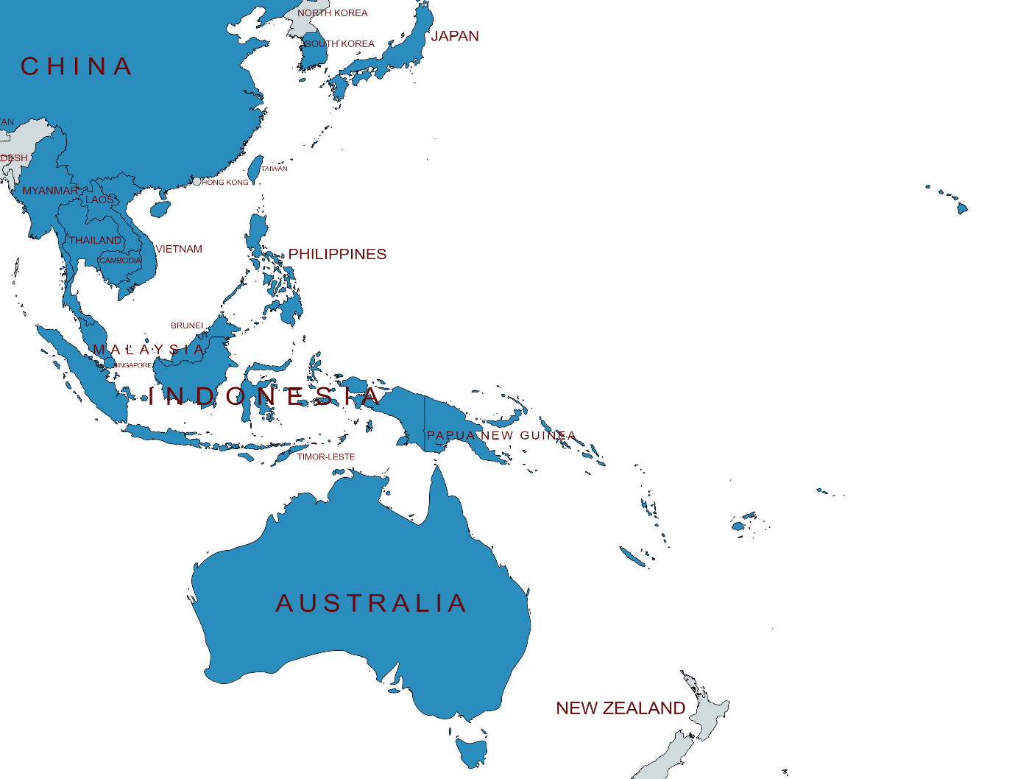
Western Pacific Ocean region
Figure 1. Indicative boundary of western Pacific Ocean region used in this assessment. Refer Table 2 for a list of (highlighted) countries included within this boundary.

Hawksbill turtle synthesis
In 1996 and again in 2008, the species was assessed at the global level as Critically Endangered by the IUCN Species Survival Commission. Meylan and Donnelly (1999) and Mortimer and Donnelly (2008) provide the supporting information for the 1996 and 2008 assessments, respectively.

Summary – population identification
Three out of the four western Pacific Ocean region hawksbill RMUs are in the Pacific Ocean and one encompasses the waters of the eastern Indian Ocean, South-East Asia, and the western tropical Pacific (Wallace et al. 2010) (Figure 2). Three of these are considered putative due to a lack of data demonstrating connectivity through genetics or distribution. Of the four known and putative hawksbill RMUs, only the Southwest Pacific RMU has been assessed for distinct populations/management units, of which it has three: the North Queensland management unit (that is based on sampling at Milman Island in Queensland, Australia), the Northeast Arnhem Land management unit (in Northern Territory, Australia distinguished from the first by a shift in nesting timing), and the Solomon Islands management unit (based on sampling at the Arnavon Islands, Solomon Islands) (FitzSimmons and Limpus 2014; Vargas et al. 2016; LaCasella et al. 2021)). The majority of hawksbill RMUs in the western Pacific have not yet been assessed for genetic population structure, although efforts to collect and analyse samples to do so are underway in several countries. Through the work of the IPHGWG, the genetic sampling of the western Pacific now includes data from several rookeries in Vanuatu, American Samoa, Fiji, and Papua New Guinea (Table 1). While these data are currently unpublished, they are expected to become publicly available in the foreseeable future.
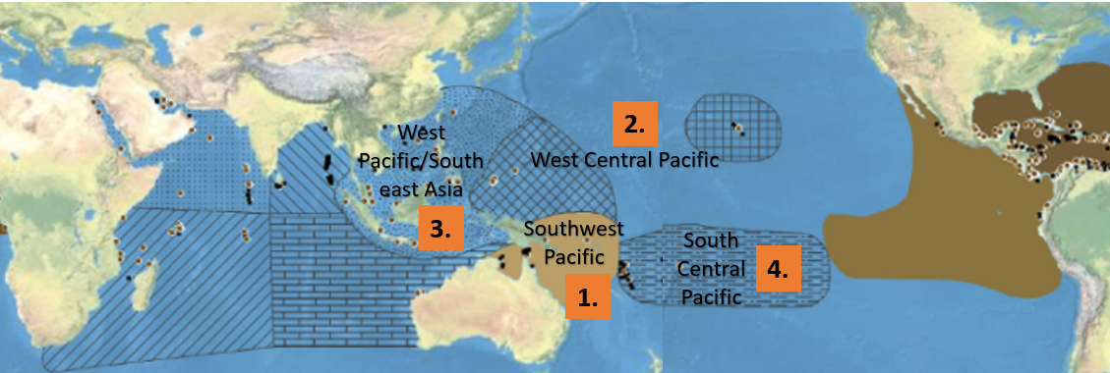

Figure 2. RMUs in the Western Pacific Ocean. (Adapted from Wallace et al 2010a).

Table 1. Outputs from the Wallace et al. (2010a) RMU designations, management units based on genetic stock designations by FitzSimmons and Limpus (2014) and Vargas et al. 2016, and current sampling/analysis status identified under the IPHGWG. *Denotes inclusion in Hamann et al. 2022
Regional Management Unit | Western Pacific countries with documented hawksbill turtle nesting | Management Units based on genetic stocks determined by FitzSimmons and Limpus (2014) and Vargas et al. (2016) | Current sampling/analysis status (based on IPHGWG)
Southwest Pacific Ocean  (including Australia [Northern Territory and Queensland], Papua New Guinea and Solomon Islands) | Australia (Northern Territory and Queensland), Papua New Guinea and Solomon Islands | North Queensland MU*, Northeast Arnhem Land MU*, and Solomon Islands MU have been assessed | Analysis for genetic-population structure is underway for Torres Strait (Australia) and Conflict Islands and New Ireland (Papua New Guinea). Additional genetic sample collection and analysis is underway across Papua New Guinea (nesting, foraging, bycatch) and Australia (confiscated stockpiles).
West Central Pacific Ocean (including waters surrounding Micronesia, FSM, Palau, the Marshall Islands, Guam, Kiribati and Commonwealth of Northern Marianna Islands) | Palau  Marshall Islands  CMMI | Not defined | Efforts to collect samples from countries within this RMU are needed.
South Central Pacific Ocean (including Vanuatu up to the Eastern Solomon Islands, across the Pacific to include Tonga, Samoa, American Samoa, and French Polynesia [equator to 25 South]) | Samoa, Vanuatu, American Samoa, Fiji, French Polynesia, Tonga | Not defined | Genetic sample collection and analysis is underway for Vanuatu (nesting), American Samoa, Tonga (nesting, foraging, bycatch), and Fiji (nesting, foraging, bycatch).
West Pacific/Southeast Asia* | Thailand, Malaysia, Indonesia, Philippines, Viet Nam, plus Singapore (not an IOSEA MOU signatory state) | Sulu Sea (Malaysia) MU, Gulf of Thailand (Kho Kram) (possible MU) and western Peninsular Malaysia MU have been assessed.  Rookeries in Indonesia, Singapore, Viet Nam, and Philippines have not been assessed for genetic population structure. | Genetic sample collection and analysis is underway for Thailand (nesting), Philippines (nesting, stranded, confiscated stockpiles), and Indonesia (nesting).

Summary – nesting
Hawksbill turtles have been recorded nesting in at least 16 countries in the western Pacific Ocean region (including six nations in the West Pacific/Southeast Asia RMU; see Hamann et al. 2022). Many of these are not Signatory States to the IOSEA Marine Turtle MOU as they lie outside the IOSEA region, seven are Parties to the CMS, and all are members of the SPREP. There are no recent records to indicate if hawksbills nest in the Commonwealth of the Northern Mariana Islands (CNMI), Cook Islands, Guam, Kiribati, Nauru, New Caledonia, New Zealand, Niue,Tokelau, Tonga, Tuvalu, or Wallis and Futuna. Hawksbill turtle nesting also occurs in the Solomon Islands—which is outside of the IOSEA region—and nesting turtles from the Solomon Islands are known to migrate into Australian and Papua New Guinean waters (Hamilton et al., 2015).

Summary – foraging
Data from tag recoveries, satellite telemetry, fisheries bycatch, in-water surveys, and anecdotal reports indicate that foraging hawksbill turtles occur and most likely migrate between almost every country in the western Pacific Ocean region. Population and biological studies on foraging hawksbills are limited overall, although some studies have been conducted in American Samoa, Fiji, Guam, Papua New Guinea, Solomon Islands, and Vanuatu.

Areas within the western Pacific region of known importance for hawksbill turtles

Important Nesting Sites
There are a number of identified nesting sites within the western Pacific Ocean region some of which are monitored by local communities, NGOs, and government agencies (Figure 3); however, there are many knowledge gaps regarding distribution (Table 1).

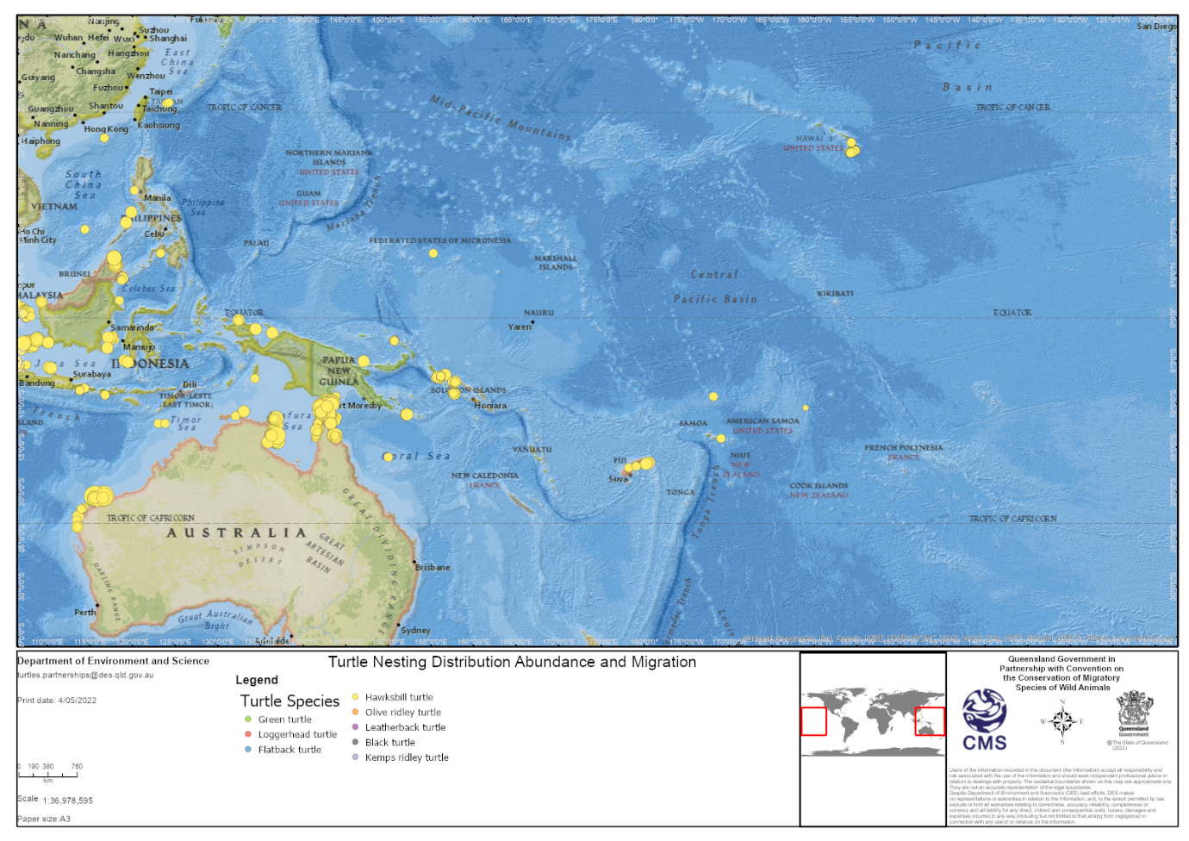

Figure 3: Map of known nesting areas based on TurtleNet [Accessed 4 April, 2022: https://apps.information.qld.gov.au/TurtleDistribution]

Index nesting beaches
There are only two (unofficially) recognised and designated index nesting beaches for hawksbill turtles in the western Pacific Ocean: Namena Lala Island in Fiji and the Arnavon Community Marine Park in the Solomon Islands. While a small number of countries have nesting beach monitoring programmes for hawksbill turtles, these have not been running long enough or with a consistent level of effort needed to gather robust long-term monitoring data and officially establish these areas as index nesting beaches (Pilcher 2021). Monitoring efforts are further hampered by the difficulty of accessing remote islands and atolls and providing staff and essential equipment for the duration of monitoring periods. It is possible that key hawksbill turtle nesting sites have not yet been detected, particularly for the many archipelagic nations in the region, or that nesting reports have not been documented or shared. There are no trends in hawksbill nesting abundance (nests and females) available for most western Pacific countries, except for the Solomon Islands and the Republic of the Marshall Islands (Hamilton et al. 2015).

Important non-nesting sites

Migration
Hawksbill turtles in the western Pacific Ocean have been known to travel ~1,500 km between nesting and foraging sites, and this is potentially a reflection of the vast distances between landmasses. Hawksbill turtles from northeastern Australia have been recorded in Vanuatu, Solomon Islands, Papua New Guinea, and various sites in the Great Barrier Reef (Miller et al. 1998). Linkages of similar distances are demonstrated between American Samoa and the Cook islands (Tagarino et al. 2008), the Conflict Islands (Papua New Guinea) and northern Queensland (CICI 2018; Madden Hof et al. in prep), Arnavons (Solomon Islands) and Queensland (Hamilton et al. 2015; Hamilton et al., 2021), and Tinian (CNMI) and Pohnpei (Federated States of Micronesia; Gaos et al. 2020).

Important foraging and refuge sites
Migratory connectivity for hawksbill turtles in the western Pacific Ocean is poorly understood overall. However, satellite telemetry and tag recoveries have revealed the Coral Sea as a key foraging area for hawksbill turtles in the western Pacific (Limpus 2008; Pilcher 2021). Hawksbills have been reported foraging throughout the Coral Sea after post-nesting migrations from the Conflict Islands in Papua New Guinea (CICI 2018; Madden Hof in prep), the Arnavons in Solomon Islands (Hamilton et al. 2015; Hamilton et al. 2021), and Vanuatu (Miller et al. 1998). There is no known officially designated index foraging site for hawksbill turtles in the western Pacific Ocean.

Gaps in biological information

Population structure
The vast majority of western Pacific Ocean countries lack information on hawksbill population structure (i.e. age class distribution, sex ratios and/or genetic composition). The Solomon Islands is the only country in this assessment where hawksbill populations have been genetically assigned to management units. Genetic research is underway in American Samoa, Guam, CNMI, Fiji, Papua New Guinea, Tonga, and Vanuatu. Many western Pacific Ocean countries are archipelagic nations consisting of numerous islands and atolls separated by vast distances; following genetic research, these countries may be found to host one or more management units, each with different conservation needs. Given the hawksbill’s current global status of Critically Endangered (Mortimer & Donnelly 2008), and future plans likely to evaluate the species at the subpopulation level, such research is vital to provide a foundation for future status assessments and conservation activities.

Life history attributes

Nesting populations
There are substantial gaps in our knowledge of life history attributes for most hawksbill turtle nesting sites in the western Pacific Ocean region. The specific gaps vary among locations, as described in each of the country sections of this report. Data on life history attributes are necessary for the development of accurate population models used in designing and implementing effective management plans. Life history parameters should ideally be collected from at least one rookery for each management unit. Where management units have not yet been defined, efforts to do so through genetic research and consistent nesting beach monitoring should be prioritised. Common gaps in life history attributes are attributable to missing or limited data on the following, as identified by Hamann et al. (2022):
- Sampling for genetic mtDNA profiles
- Annual census figures at representative nesting beaches to quantify the number of females nesting per season, or the number of clutches laid per season, or the number of tracks (nesting attempts) made per season
- Quantified mortality estimates from anthropogenic and non-anthropogenic sources across all life history stages
- Quantified key demographic parameters including:
  - the average number of clutches laid per female per year/nesting season
  - the average number of years between breeding/nesting seasons for individual turtles
  - the rate of female and male recruitment into the breeding population
  - survivorship of adult females
  - incubation success and hatchling recruitment
- Temperature profiles for incubation, hatchling and operational sex ratios
- Information on habitat use during migration and inter-nesting periods

Non-reproductive populations
There are substantial gaps in our knowledge of hawksbill turtle foraging areas, habitat use (oceanic and coastal), diet, growth, age, survivorship, levels of direct harvest, and threats. Although satellite tracking and foraging area studies have been undertaken in a small number of countries (i.e. Australia, American Samoa, Fiji, Guam, Papua New Guinea, Solomon Islands, and Vanuatu), few published data on migration and home range exist for the majority of nations in the western Pacific Ocean.

Oceanic post-hatchling populations
There is no knowledge of the distribution or abundance of hawksbill turtle hatchlings in the western Pacific Ocean. Larger post-hatchling hawksbill turtles are at risk of interacting with pelagic longline and purse seine fisheries operating in EEZs and oceanic areas, as well as ingestion of plastic and entanglement in marine debris.

Key pressures on hawksbill turtles of the western Pacific region

The tortoiseshell trade – a summary
The global trade and its impact on hawksbill turtle populations has been well summarised by Milliken and Tokunaga (1987), Groombridge and Luxmoore (1989), Meylan and Donnelly (1999), NMFS and USFWS (1998) and Mortimer and Donnelly (2008). While it is recognised that the international and domestic commercial trade of hawksbill turtles and/or their eggs dates back to the 9th century, demand for hawksbill turtle shell (scutes) to make tortoiseshell products rapidly expanded in the 17th century. Yet, with international trade globally banned through CITES in 1977, there is still an active and intact illegal trade network (concentrated in Southeast Asia) creating a renewed demand for turtles and turtle products (TRAFFIC, 2019). It has been estimated that trade networks concentrated in Southeast Asia harvested between 1.3 million turtles between 1950 and 1992 (Mortimer and Donnelly 2008) and nine million turtles over a 150-year period (Miller et al., 2019). This later study also noted the trade’s likely overlap and involvement with modern-day IUU fishing and small-scale fisheries (see Riskas et al. 2018; Vuto et al. 2019). Indeed, foreign turtle poachers have been reported encroaching on the national waters of the Coral Triangle and western Pacific countries (IOSEA 2014; Lam et al. 2011; Gomez & Krishnasamy 2019).

The tortoiseshell trade continues to be an issue in multiple western Pacific Ocean countries. Recently in the Solomon Islands, Vuto et al. (2019) reported the local sale of hawksbill shell in three of the 10 communities surveyed, with evidence of sales to overseas buyers in Honiara. In the past, the export of tortoiseshell from the Solomon Islands was among the ten highest globally (Groombridge & Luxmoore 1989). In Papua New Guinea, Kinch and Burgess (2009) noted that the trade in hawksbill turtles was ongoing in coastal towns, mainly in the form of tortoiseshell items for domestic buyers, and potentially targeting international tourists. Also in Papua New Guinea, Opu (2018) found that turtle harvest was concentrated in Manus, Milne Bay, and Western Provinces. Media reports and anecdotal reports from government stakeholders suggest the tortoiseshell trade is still active in Palau despite a 2018 ban (Reklani 2021). While attempts are made to estimate trade and the resultant mortalities of hawksbills, the reports of illegal trade in hawksbill shells occurring in multiple western Pacific Ocean countries warrant further study.

Bycatch in legal fisheries
Incidental capture (bycatch) in legal fisheries is globally recognised as a significant threat to marine turtle populations (Alverson et al. 1994; Lewison et al. 2004; Bourjea et al. 2008; Wallace et al. 2010b). Broadly, the three major gear types shown to have the highest impact on marine turtles are gillnets, bottom trawls, and longlines. In the western Pacific Ocean region, commercial fisheries are dominated by longline and purse seine fisheries for tuna and tuna-like species. Monitoring of these fisheries in high seas areas is the responsibility of the Western and Central Pacific Fisheries Commission (WCPFC), a regional fisheries management organization (RFMO). Peatman et al. (2018a) estimated that hawksbill turtles accounted for 16% of turtle bycatch in purse seine fisheries in the WCPFC area from 2003 to 2017, with a mean of 36 hawksbills per year (range 15-75). Hawksbill bycatch is recorded in longline fisheries, with a mean of 1,126 individuals (range 534-1,598) caught per year in WCPFC longline fleets (Peatman et al. 2018b). Yet because not all bycatch incidences result in mortalities, and observer coverage is not sufficiently uniform nor normally distributed across the fishery (Peatman et al. 2018b), these figures should be used as indicative of the magnitude of the threat, not the precise quantities. Also, given the predominantly nearshore habitats of hawksbill turtles, and the deepwater operations of longline fleets, interaction rates with hawksbills are not high compared to other species. This is supported by data in Peatman et al. (2018a), where hawksbills account for only 4.9% of all interactions.

In 2018, the WCPFC updated the 2008 Conservation and Management Measures (CMM) to reduce the impact of tuna fisheries on marine turtles by requiring fleets to implement additional gear changes, operational controls, mandatory reporting of interactions, and other measures. Other regional bodies, such as the Pacific Islands Fisheries Forum Agency (FFA) and the Secretariat of the Pacific Community (SPC), are leading ongoing efforts to improve the transparency of fisheries activities, including electronic monitoring (EM) to detect and quantify bycatch. In their analysis of EM trials in RMI, FSM, and Palau, Brown et al. (2021) reported that “discards of tuna, billfish and turtles were almost never reported in logbooks, though EM and human observers did observe discards for these taxa”. Observer coverage is very high in purse seine fleets (mandated target is 100% since 2010), but rarely meets the target of 5% in the longline fleets (MRAG Asia Pacific 2021).

Small-scale fisheries largely operate in nearshore or coastal waters using a variety of gears, including set and drift nets, trawls, seines, longlines, traps, and others (Lewison 2013). Recent research has shown that small-scale fisheries can have high levels of turtle bycatch that directly cause population declines (Lewison & Crowder 2007; Peckham et al. 2007; Alfaro-Shigueto et al. 2011). In the western Pacific Ocean region, small-scale fisheries are widespread, often operating in remote areas and at levels that have not been quantified. Because hawksbill turtles inhabit coral reef habitats and shallow coastal waters, they are highly vulnerable to bycatch and mortality in small-scale fisheries in almost every country in the western Pacific Ocean region. There are only two published examples of small-scale fishery assessments, one in Malaysia (Pilcher et al. 2009) which estimated 988 hawksbill turtles were taken in small-scale fisheries in a single year and the other in the Solomon Islands, which estimated small-scale fisheries harvest approximately 10,000 turtles per year (of which almost 1/3 were hawksbill turtles). Although a commissioned study by the CITES Secretariat (2022) surmised that bycatch and active targeting of marine turtles in small-scale fisheries is unlikely to contribute to the international trade of hawksbills, Vuto et al. (2019) provided evidence to the contrary from the Solomon Islands. Vuto et al. (2019) reported that hawksbill turtle products are far more likely to be sold illegally than green turtle products, and that the shells of 87.5% of hawksbill turtles harvested were sold to local buyers, who then on-sold to Asian buyers in Honiara. With growing evidence of the role of small-scale fisheries in facilitating the turtle trade (IOSEA 2014), an understanding of hawksbill interactions with small-scale fisheries across a much larger region is urgently needed.

Illegal use and Illegal, Unreported and Unregulated (IUU) Fishing
Illegal, unreported and unregulated (IUU) fishing is a pervasive issue for fisheries management in every ocean basin (Agnew et al. 2009). Vessels engaged in IUU fishing are less likely to comply with conservation mandates intended to reduce bycatch and mortality of non-target, vulnerable species, including marine turtles (MRAG 2005). Riskas et al. (2018) found that IUU fishing poses a threat to marine turtle populations in the IOSEA region, and that in certain regions IUU fishing is associated with poor fisheries management and wildlife trafficking. Similarly, Lam et al. (2011) note the potential involvement of small-scale fishing vessels in the trafficking of hawksbill turtles and products. In the western Pacific Ocean, commercial IUU fishing incidence is estimated to be lower than in many other seafood-sourcing regions globally and has decreased in the Pacific Islands region relative to a 2016 assessment of data from 2010-2015 (MRAG Asia Pacific 2021). This is attributable to the concerted and ongoing cooperative efforts by Pacific countries and partner organisations (e.g. FFA, SPC, WCPFC) to increase the monitoring, control and surveillance (MCS) of fleets operating in the region.

There is little documented information however, on hawksbill turtle interactions with illegal commercial fisheries in the western Pacific Ocean. Where turtle take is prohibited by law, the take of hawksbills in small-scale fisheries would also be considered illegal and hence be considered IUU fishing. From that perspective, the illegal take of hawksbill turtles by coastal fisheries recorded throughout the western Pacific Ocean (i.e. CNMI, Fiji, Guam, Palau, Solomon Islands, and Vanuatu) constitutes IUU fishing. More information regarding take levels and size classes is needed to inform risk assessments and mitigation measures.

Human use of turtles and their products
Hawksbill turtles have a high level of cultural significance in many countries across the IOSEA and western Pacific Ocean region and are a traditional food with eggs and meat consumed, and shells used in customary practice and in trade.

Hawksbill turtles and their eggs are harvested in every RMU in the western Pacific Ocean, despite laws banning these practices in many countries. Particularly in the central Pacific, data is sparse on legal and illegal turtle and egg harvests, as documentation of these is inconsistent or unrecorded. Further, monitoring turtle harvest over vast distances between atolls and islands is logistically challenging.

Harvest by humans is a serious problem, particularly for green turtles that have historically been used for food (NMFS and USFWS 1998 in Pilcher et al 2021) and hawksbills used for trade (Miller et al 2019), but for several studies that have assessed take there isn’t a clear separation of turtle species. Unless otherwise indicated, the studies mentioned below refer to the take of all marine turtles. Maison et al. (2010) indicate that there have been uncontrolled, long-term harvests of turtle eggs and females in FSM that are likely to have had an impact on current population numbers. In RMI, turtles have historically been a food source and played an important cultural role. Egg collecting and harvest of turtles while they are onshore is prohibited at all times, but current levels of exploitation are unknown (Maison et al. 2010). In Palau, hawksbill turtles are taken to support a tradition of gift exchanges of toluk (Pilcher, pers. obs.), despite traditional closures and a current moratorium banning the take of turtles or eggs. In the Cook Islands, turtles are occasionally killed and eaten at Tongareva, Rakahanga, Manihiki, and Palmerston, and probably at other atolls, but the true level of direct take remains unclear (White 2012). There are no estimates or reports of adult or egg harvests for Kiribati, Nauru, Niue, the Pitcairn Islands, Tokelau, Tuvalu, or Wallis and Futuna.

In Papua New Guinea, Opu (2018) found that the highest catches of turtles occurred in Manus, Milne Bay, and Western Provinces. Although the report estimates 4,760 turtles in 2016 and 5,320 turtles in 2017 were landed in various Papua New Guinea markets over the survey period, these numbers are likely an underestimate of the true degree of turtle harvest in Papua New Guinea, given the limitations of the survey method (37 stakeholders interviewed over 15 maritime provinces) and that many landed turtles were likely used for personal consumption, cash sales or in the barter trade.

Vuto et al. (2019) provide a recent update on turtle harvests in the Solomon Islands. They estimated that 9,473 turtles were harvested each year (95% CI: 5,063 to 22,423), with hawksbill turtles accounting for 25.7% of the total harvest. The majority of these turtles were harvested by free divers and juvenile turtles comprised 76.4% of hawksbill captures. Hawksbill turtles were most commonly used for subsistence purposes (81.6%) and were most likely to be consumed by the family of the fisher that captured the turtles. Hawksbill turtle products were far more likely to be illegally sold (32.3%) than green turtle products (12.1%).

In Vanuatu, there is a strong programme of local turtle monitors that aid in protecting turtles and convincing local communities to participate in turtle conservation efforts (Hickey and Petro 2006). They estimate that turtle harvest in the past may have been in the region of 1,500 turtles per year, although they suggest that much of this harvest has since ceased. However, a recent survey found that people still catch turtles intentionally to eat and sell (Shaw, unpublished data). While Shaw’s study site was not representative of the island chain as a whole, it does indicate that turtle captures continue to this day, and that updated estimates of take and trade are needed.

Collaborative efforts to understand the drivers and annual levels of hawksbill turtle harvest and trade are underway. In collaboration with governments, the World Wide Fund for Nature (WWF) and SPREP are supporting the delivery of a sociocultural survey in Papua New Guinea, Fiji, and Tonga. The project is part of WWF’s broader Cracking the Code for Recovery - Marine Turtle Use and Trade Initiative (MTUTI), which will collect and synthesise data on turtle use, trade, and genetics to advocate for targeted policy action to recover Asia-Pacific hawksbill turtle populations.

Climate change
Countries in the western Pacific are incredibly vulnerable to the effects of global climate change. A recent study (Patrício et al. 2021) reviewed the impacts of climate change to marine turtles globally and highlighted that even if marine turtles survive as a group, species with restricted distribution ranges and depleted populations are likely to be most vulnerable.

Changes in sex ratios due to higher incubation temperatures are likely to affect the reproductive ecology of hawksbill turtles. Rising sand temperatures can negatively impact marine turtle population function by producing clutches that are extremely female (i.e. feminizing the population) and by causing excessive mortality of eggs and/or hatchlings. Feminization of turtle populations is already occurring in the Pacific at Australia’s largest green turtle rookery (Jensen et al. 2018). In the central west Pacific, Summers et al. (2018) reported reduced hatching success and embryonic death above 34 °C for green turtles in CNMI, and that these impacts, combined with egg poaching, could decrease the abundance of nesting females.

There is a high risk of loss of nesting habitat due to sea level rise, which is projected to reach one metre in the Pacific by 2100 (IPCC 2019). Most of the volcanic islands in the western Pacific are barely a few metres above sea level (Oppenheimer et al. 2019). However, recent studies have suggested that some atolls and islands are actually growing (Hollingsworth 2020) and may be less vulnerable than expected to the impacts of sea level rise. Jeh Island, in the Marshall islands, has increased in size by 13% since the 1940s (Ford et al. 2020). Thus estimates of nesting habitat loss due to rising seas should be made at scales that can be supplemented with location-specific data, rather than basin-wide estimates (Pilcher 2021).

Projected increases in the severity of tropical cyclones and hurricanes (IPCC 2007) could cause accelerated erosion of nesting beaches and degradation of foraging habitats (coral reefs and seagrass meadows) (Work et al. 2020). Hawksbills may also be impacted by loss of coral reef habitat through bleaching caused by marine heat waves.

Marine debris and plastic pollution
Marine debris, and plastic pollution in particular, has been increasingly recognised as a serious and widespread threat to marine turtle populations globally (Schuyler et al. 2014, 2016; Wilcox et al. 2013; Duncan et al. 2019; 2021). The main threats that plastics pose to turtles are: ingestion of plastic fragments and plastic bags, entanglement in abandoned, lost or discarded fishing gear (ALDFG) (also called ghost gear), and contamination of nesting and foraging habitat. Ingestion of plastics can be directly life threatening through intestinal blockage (Kühn & Van Franeker 2020), as well as through introduction of toxic substances (either accumulated on the plastic surface (Rochman et al. 2013) or from the plastic itself). The population level impacts of plastic ingestion are still unknown. Entanglement in ALDFG can result in damaged limbs and drowning (Stelfox et al. 2016). The mechanisms enabling accumulation of heavy metals and chemical contaminants in turtles have been studied (Kittle et al. 2018; Leusch et al. 2020), but little is known about the effects of plastic pollution on turtle health.
More research on the impacts of marine debris and plastic pollution is needed for the western Pacific region. Hamann et al. (2022) note six key areas requiring investigation: 1) quantification of health impacts across populations and life stages; 2) toxicological impacts on turtle health; 3) the role of debris particles as vectors for heavy metal and chemical contamination (see Clukey et al. 2018); 4) identification of the oceanographic forces that disperse pollution; 5) understanding the social and economic drivers contributing to the creation of pollution; and 6) the barriers and opportunities for improved management of marine debris and plastic pollution (see Vegter et al. 2014; Nelms et al. 2015; Duncan et al. 2017).

Management and protection
Countries in the western Pacific Ocean have adopted a variety of regional international agreements aimed at protecting hawksbill turtles and their habitats or to mitigate threats that may directly or indirectly affect hawksbills (Table 2). On a national scale, hawksbill management and protection varies from country to country. For example, in Papua New Guinea hawksbill turtles remain unprotected, whereas in Fiji there is currently a total ban on all take, sale, possession and transport. Whilst a marine species legislative review was conducted for Asian countries (Ezekiel 2018), no comprehensive marine turtle policy and legislative review has been undertaken in the western Pacific Ocean region, and is urgently required to understand gaps and inconsistencies.

A coordinated regional effort towards the conservation of hawksbill turtles through collaborative efforts, linkages between countries, and the exchange of information at the national, regional, and global levels is needed if hawksbill populations are to recover. This effort is constrained by limited resources, both financially and in terms of capacity available for implementing many management actions in the western Pacific Ocean region. However, SPREP’s Regional Marine Turtle Action Plan 2021-2025 (that will come into effect in 2022) will help provide direction and support.
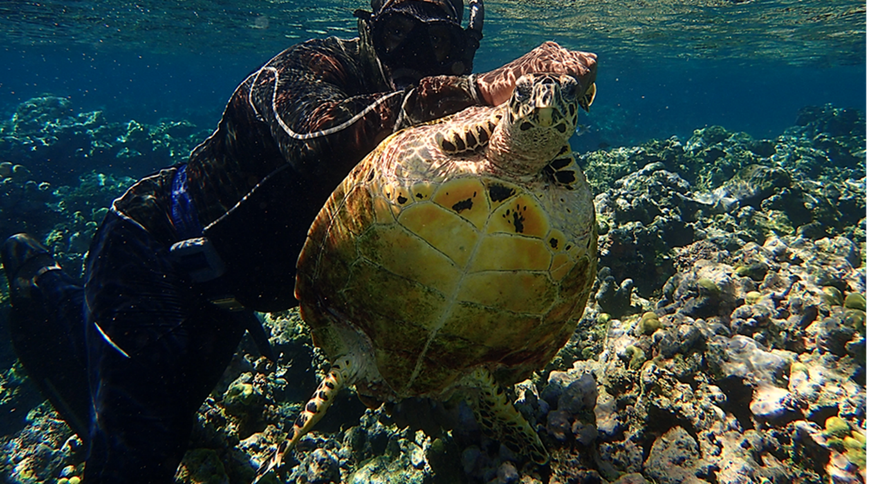
© Christine Madden Hof/WWF-Aus
Table 2: Selection of regional and international Legally and Non-legally Binding Instruments and Relevant Bodies.
Tick mark (✓) indicates adoption, ratification, or membership. For more detail, please refer to CMS/IOSEA/Hawksbill-SSAP/Inf.5.
Asia-Pacific Signatories and Parties | CITES | CBD] | CMS | UNCLOS | RFMOs | PSMA | Ramsar Convention | IOSEA Marine Turtle MOU | MOU ASEAN Sea Turtle Conservation and Protection | CTI-CFF] | London Declaration (IWT) | SSME Regional Action Plan | SPREP]
American Samoa (USA) | ✓ |  |  | ✓ | ✓ | ✓ | ✓ | ✓ |  |  | ✓ |  | ✓
Australia | ✓ | ✓ | ✓ | ✓ | ✓ | ✓ | ✓ | ✓ |  |  | ✓ |  | ✓
Brunei Darussalam | ✓ |  |  | ✓ |  |  |  |  | ✓
Cambodia | ✓ | ✓ |  |  |  | ✓ | ✓ | ✓ |  |  | ✓
China | ✓ | ✓ |  | ✓ | ✓ |  | ✓ |  |  |  | ✓ |  | ✓
Cook Islands |  | ✓ | ✓ | ✓ | ✓ | ✓ | ✓ |  |  |  |  |  | ✓
Federated States of Micronesia |  | ✓ |  | ✓ | ✓ |  |  |  |  |  |  |  | ✓
Fiji | ✓ | ✓ | ✓ | ✓ | ✓ | ✓ | ✓ |  |  |  |  |  | ✓
French Polynesia (France) | ✓ | ✓ | ✓ | ✓ | ✓ | ✓ | ✓ |  |  |  | ✓ |  | ✓
Guam (USA) | ✓ |  |  |  | ✓ | ✓ | ✓ | ✓ |  |  | ✓ |  | ✓
Hawaii (USA) | ✓ |  |  |  | ✓ | ✓ | ✓ | ✓ |  |  | ✓
Hong Kong (China) | ✓ | ✓ | ✓ | ✓ |  |  | ✓
Indonesia | ✓ | ✓ |  | ✓ | ✓ |  | ✓ | ✓ | ✓ | ✓ | ✓ | ✓
Japan | ✓ | ✓ |  | ✓ | ✓ | ✓ | ✓ |  |  |  | ✓
Kiribati |  | ✓ |  | ✓ | ✓ |  | ✓ |  |  |  |  |  | ✓
Lao People’s Democratic Republic | ✓ | ✓ |  | ✓ |  |  | ✓ |  | ✓ |  | ✓
Malaysia | ✓ | ✓ |  | ✓ | ✓ |  | ✓ | ✓ | ✓ | ✓ | ✓ | ✓
Marshall Islands |  | ✓ |  | ✓ | ✓ |  | ✓ |  |  |  |  |  | ✓
Myanmar | ✓ | ✓ |  | ✓ |  | ✓ | ✓ | ✓ | ✓ |  | ✓
Nauru |  | ✓ |  | ✓ | ✓ |  |  |  |  |  |  |  | ✓
New Caledonia (France) | ✓ | ✓ | ✓ | ✓ | ✓ | ✓ | ✓ |  |  |  | ✓ |  | ✓
New Zealand | ✓ | ✓ | ✓ | ✓ | ✓ | ✓ | ✓ |  |  |  | ✓ |  | ✓
Niue |  | ✓ |  | ✓ | ✓ |  | ✓ |  |  |  |  |  | ✓
Northern Marianas (USA) | ✓ |  |  |  |  | ✓ | ✓ | ✓ |  |  | ✓ |  | ✓
Palau | ✓ | ✓ | ✓ | ✓ | ✓ | ✓ | ✓ |  |  |  |  |  | ✓
Papua New Guinea | ✓ | ✓ |  | ✓ | ✓ |  | ✓ | ✓ |  | ✓ |  |  | ✓
Philippines | ✓ | ✓ | ✓ | ✓ | ✓ | ✓ | ✓ | ✓ | ✓ | ✓ | ✓ | ✓
Republic of Korea | ✓ | ✓ |  |  | ✓ | ✓ | ✓
Samoa | ✓ | ✓ | ✓ | ✓ | ✓ |  | ✓ |  |  |  |  |  | ✓
Singapore | ✓ | ✓ |  | ✓ |  |  |  |  | ✓ |  | ✓
Solomon Islands | ✓ | ✓ |  | ✓ | ✓ |  |  |  |  | ✓ |  |  | ✓
Taiwan (China) |  |  |  | ✓ | ✓
Thailand | ✓ | ✓ |  | ✓ |  | ✓ | ✓ | ✓ | ✓ |  | ✓
Timor-Leste |  | ✓ |  | ✓ |  |  |  |  |  | ✓
Tokelau |  |  |  | ✓ |  |  | ✓ |  |  |  |  |  | ✓
Tonga | ✓ | ✓ |  | ✓ | ✓ | ✓ |  |  |  |  |  |  | ✓
Tuvalu |  | ✓ |  | ✓ | ✓ |  |  |  |  |  |  |  | ✓
United States of America | ✓ |  |  |  | ✓ | ✓ | ✓ | ✓ |  |  | ✓ |  | ✓
Vanuatu | ✓ | ✓ |  | ✓ | ✓ | ✓ | ✓ |  |  |  |  |  | ✓
Viet Nam | ✓ | ✓ |  | ✓ |  | ✓ | ✓ | ✓ | ✓ |  | ✓
Wallis and Futuna (France) | ✓ | ✓ | ✓ | ✓ | ✓ | ✓ | ✓ |  |  |  |  |  | ✓
Blue: Countries within the range of the IOSEA Marine Turtle MOU, and adjacent areas
Orange: Western Pacific countries and territories

Southwest Pacific Ocean

Solomon Island management unit

Ecological range
The Arnavon Community Marine Park (ACMP) in the western Solomon Islands, supports the largest rookery for hawksbill turtles in the oceanic South Pacific (Hamilton et al., 2021; Pilcher 2021). Hawksbill turtles' nest throughout the year in the ACMP, with peak nesting activity occurring from approximately May to July, with a second shorter nesting peak occurring from December to January. During the May to July nesting peak approximately 3–4 hawksbill turtle clutches are laid within the ACMP each night (Hamilton et al., 2015). Initial beach surveys that were conducted in the ACMP from the mid-1970s to 1995 revealed that the island of Kerehikapa accounted for 51–65% of all egg clutches laid in the ACMP, however by 2000 greater nesting activity was occurring on Sikopo Island (Mortimer, 2002). The increasing nesting activity on Sikopo has coincided with conservation efforts and the chronic erosion of low-profile nesting beaches on Kerehikapa between 1991 and 2020 (Hamilton et al., 2021). The ACMP is an important hawksbill turtle breeding site, with mating hawksbill turtles observed on numerous occasions over the past 30 years at five locations within the ACMP (Hamilton et al., 2021). The genetic characterisation of this management unit is based solely on samples from the ACMP and the geographical boundaries of the management unit remain unknown, but are likely to extend across the Bismarck-Solomon Sea area, including rookeries in Papua New Guinea (Bell and Jensen 2018).

Geographic spread of foraging sites and migration
Hawksbill turtles from this management unit likely forage across the region. Genetics studies from the Great Barrier Reef (Howick Group) show that the majority of turtles foraging at this nGBR foraging site (83%) originated from the Solomon Island management unit (Bell and Jensen 2018). Flipper and satellite tagging studies show that many hawksbills that nest at the ACMP make long distance migrations to foraging grounds in Australia, Papua New Guinea and New Caledonia (Vaughan and Spring, 1980; Parmenter, 1983; Mortimer, 2002; Limpus et al., 2008; Hamilton et al., 2015; Bell and Jensen, 2018 cited in Hamilton et al., 2021), while a small proportion of ACMP nesters travelled to nearby foraging grounds in Solomon Islands. Hamilton et al. (2021) satellite tracked 30 female hawksbill turtles that were nesting in the ACMP, and these turtles had a mean migration distance between nesting and foraging grounds of 2028 km ± 222 km, much further than the mean migration distance reported for any other nesting hawksbill turtle population (e.g. Parker et al., 2009; Gaos et al., 2012; Hart et al., 2019).

Satellite tracking has revealed that many of the turtles that nest in the ACMP follow a common post nesting migratory corridor before dispersing across the Solomon and Coral Sea (Hamilton et al., 2021). Sixteen of the ACMP nesters that were tracked to their foraging grounds displayed fidelity to specific sites (Mean 50% UD 1.1 km2 ± 0.3 km2), with multiple individuals demonstrating foraging site fidelity over multiple post-nesting migrations. Many of these 16 hawksbills established foraging sites on outer barrier reefs, with several turtles also foraging on inshore reefs close to the Queensland mainland.

Juvenile foraging hawksbill turtles form a small component of catches in multispecies coral reef fisheries throughout Solomon Islands (i.e. Hamilton et al., 2012; Vuto et al., 2019) and juveniles and some adults have been observed foraging on coral reefs in multiple locations in Solomon Islands including Kolombangara (Argument et al. 2009) and Marovo Lagoon in New Georgia (Green et al. 2006).

The TREDS database contains over 140 records of foraging hawksbills, from Wagina Island (Choiseul Province), Santa Isabel (Arnavons, Kia Village, Sire Bay), and Tetepare Island.

Geographic spread of nesting
Index nesting beaches: Nesting is concentrated in the ACMP and is [unofficially] described and designated as the index nesting beach for this management unit.

The CMS Atlas records approximately 25 localities and the TREDS database contains over 1,200 records as ‘nesting’ hawksbills, overwhelmingly from the Isabel Province (Kerehikapa Island in the Arnavons and Haevo Beach on Santa Isabel Island), and the Obeani Group in Western Province.

Trends in nesting data
Nesting numbers are increasing in the ACMP, with the number of nests laid at the ACMP doubling since its establishment in 1995 (Hamilton et al. 2015).

Threats to the population
Hawksbill turtles and eggs are harvested in the Solomon Islands, mainly for subsistence purposes. Vuto et al. (2019) observed that hawksbill turtles comprised 25% of all turtle captures and that hawksbill turtle products are far more likely to be sold illegally than green turtle products. Based on all available data Pilcher (2021) estimated it is likely that between 2,500 and 5,000 hawksbill turtles are taken each year in the Solomon Islands, though these figures require further investigation.

Despite legislation in 1993 banning the trade in turtle products, the tortoiseshell trade remains active in the Solomon Islands. Vuto et al. (2019) reported the sale of hawksbill shell in three of the 10 communities surveyed but was only a common practice in one (Wagina). In the Wagina community, Vuto et al. (2019) found the shells of 87.5% of hawksbill turtles harvested were sold to local buyers, who then on-sold to Asian buyers in Honiara. LaCasella et al. (2021) used mtDNA extracted from tortoiseshell products for sale at local markets in Papua New Guinea and Solomon Islands (Honiara) to show that that nine of the 13 tortoiseshell products were from turtles with haplotypes found primarily at the Solomon Islands management unit. In the past, the export of tortoiseshell from the Solomon Islands was ranked among the ten highest globally (NMFS and USFWS 1998; Miller et al. 2019), peaking at around 4,000 kg of hawksbill shell exported per year in the late 1980s (Limpus & Miller 2008).

Additional threats include nesting beach erosion due to climate change impacts (Foale et al. 2017) and predation of nests by crabs, megapodes, and iguanas (Wilson et al. 2004).

Management and protection

Summary of threats to the Solomon Island management unit of hawksbill turtles.
Type of threat | Known or likely location of impact  1=nesting beach  2=oceanic/high seas  3=coastal foraging areas | Quantified  1=comprehensive documentation across population  2=comprehensive documentation for some of the population  3=non-published evidence only  4=not quantified
Consumption – nesting beach
Egg collection | 1 | 2
Commercial use of turtles | 1,2 | 2
Non-commercial use of turtles | 1,2 | 1
Predation of eggs by non-native fauna | 1 | 3
Predation of eggs by native fauna | 1 | 2
Consumption – foraging turtles
Commercial use of turtles | 3 | 2
Non-commercial use of turtles | 3 | 2
Climate change impacts
Increasing beach temperature | 1 | 4
Beach erosion | 1 | 2,3
Sea level rise | 1 | 4
Coastal development
Habitat modification (urban) | 1 | 4
Habitat modification (industrial) | 1 | 4
Light horizon disorientation | 1 | 4
Fisheries impacts
Bycatch – trawl | 2,3 | 4
Bycatch – longline | 2 | 3
Bycatch – gillnet | 3 | 3
Impact to benthic ecology from fisheries | 3 | 4
IUU fishing | 2,3 | 4
Pollution
Water quality | 3 | 4
Entanglement in discarded fishing gear | 2,3 | 4
Ingestion of marine debris | 2,3 | 4
Noise pollution | 3 | 3
Disease and pathogens | 3 | 4

Biological data

Biological data – breeding
Parameter |  | Value |  | Reference(s)
Pivotal temperature | ? |  | ?
Remigration interval | modal inter-nesting interval of 14 days [range 12–19 days] |  | McKeown 1977; Hamilton et al., 2021 (see SEM data)
Clutches per season | 3-6 |  | Mortimer 2002; Hamilton et al., 2021 (max 6)
Mean size of nesting adult (CCL) | 88 cm (75.5-93) |  | McKeown 1977
 | 84.3 cm (82-90) |  | Leary 1992
Age at maturity

Biological data – foraging
Parameter | Value | Reference(s)
Mean size at recruitment (to inshore foraging) (CCL) | 69.9 cm | Bell & Pike 2012
Growth rates (from Howick Group, nGBR) | 2.5 cm/yr at 60-70 cm  0.5 cm/yr at 70-80 cm  0.6 cm at 80-90 cm | Bell & Pike 2012
Sex ratio – in foraging populations
adults | 97% female (A) | Bell & Jensen et al. 2018
pubescent immature | 85% female (SA) | Bell & Jensen et al. 2018
large pre-pubescent immature
small pre-pubescent immature | 96% female (J) | Bell & Jensen et al. 2018

Papua New Guinea

Geographic spread of foraging sites

There is a lack of data on foraging sites for hawksbill turtles in Papua New Guinea. Tagged hawksbills have been recovered at Fishermen’s Island (Central Province), Tagula Island (Milne Bay Province), and other locations within Milne Bay Province. The TREDS database contains records of foraging by hawksbills at Tureture reef in Western Province, Fishermen’s Island in Central Province, Kavieng in New Ireland Province, and on the northern coast of Papua New Guinea.

Geographic spread of nesting

Hawksbill turtle nesting has been recorded in multiple provinces throughout Papua New Guinea, although population densities are unknown. Surveys in the 1970s found hawksbill nesting in the following locations: East Sepik Province at Laboin Island, Musschu Island, Kairuru Island, Wuvulu Island, and Kaniet Island; Manus Province at Pak Island, Los Reyes Islands, Harengan Island, Paluwak Island, Bipi Island, and the Ninigo Group of Islands; New Ireland Province in the Boloma Group of Islands, Emirau and Mussau Islands, and the Tanga Islands; East New Britain at Nuguria; Madang Province on the north and south coasts and at Long Island; and in Western Province along the whole coast. More recently, hawksbill nesting has been reported at numerous islands in the Jormad Passage and Conflict Islands groups in Milne Bay Province (Wangunu 2004). A detailed review of historical records of hawksbill nesting in Papua New Guinea is provided in Kinch (2020) (in Work et al 2020).

The TREDS database contains 27 records of hawksbill turtle nesting at multiple islands throughout Milne Bay Province (Panarairai, Lunn, Jomard, and Irai), one hawksbill turtle nesting in Wide Bay of East New Britain Province, and one nesting hawksbill turtle on Suau Island on the south coast of Milne Bay Province.

Trends in nesting data
There are no data on long-term trends in nesting hawksbill turtle populations in Papua New Guinea. Mortimer and Donnelly (2008) suggested 500 to 1,000 females may nest annually in Papua New Guinea. In Milne Bay Province, the Conflict Island Conservation Initiative encountered seven turtles in two weeks of nesting beach surveys in the Conflict Islands in 2018−2019. Kinch (2020; in Work et al 2020) reports on several sites where nesting occurs, but surveys have been inconsistent and thus an updated assessment of nesting at a national level is not possible. Based on all available data, Pilcher (2021) suggests that the total nesting population may be less than 500 turtles per year.

Migration and distribution of foraging areas
Nesting and foraging hawksbill turtles from the northern Great Barrier Reef (Australia) are known to migrate to Papua New Guinea and several other nations (Miller et al. 1998; Hamilton et al. 2015). TREDS records indicate that one hawksbill turtle that was flipper tagged in Samoa was later reported as a tag recovery in Papua New Guinea; similarly, three foraging turtles that were tagged in Australia were later reported as tag recoveries in Papua New Guinea (Trevors 2010). Other tagging data shows that an adult female hawksbill turtle that was tagged at Kerehikapa in the Arnavon Group of the Solomon Islands in December 1976 was later killed on its foraging grounds at Fisherman’s Island, Central Province, Papua New Guinea in February 1979 (Vaughan and Spring 1980). Similarly, one nesting hawksbill turtle that was satellite tagged at Kerehikapa in July 2001 retuned to its foraging grounds at Tagula Island in the far south-eastern end of the Milne Bay Province (Hamilton et al., 2015). Many turtles that were satellite tracked in the ACMP made post nesting migrations through Milne Bay on route to Torres Strait Islands and GBR foraging grounds, with several ACMP nesters also returning to foraging grounds in Milne Bay (Hamilton et al., 2021).

Threats to the population

Subsistence harvest of hawksbill turtles for meat, eggs, carapace and other products is widespread throughout Papua New Guinea, which is identified as one of the top three countries in the world for the highest legal harvest of marine turtles (all species combined) (Humber et al., 2014). Coastal communities are documented to use turtles and turtle parts for a variety of reasons, including food, barter, selling for cash, and as part of cultural activities and celebrations (Opu, 2018). Opu (2018) estimated an annual turtle harvest of around 5,000 turtles (all species), with the highest take occurring in Manus Province, Milne Bay Province, and Western Province. It is currently not known what proportion of these are hawksbill. However, given the lack of data and the remoteness of many coastal villages where turtle harvest takes place, accurate figures for annual harvest–and the proportion of hawksbills–may be different across sites, though further research is needed to confirm this.

Hawksbills are widely targeted to produce tortoiseshell items, such as jewellery and other trinkets, mainly for international tourists (Kinch & Burgess 2009). Decorative bekko items (e.g. jewellery, ornaments) have been found for sale in major provincial centres (i.e. Port Moresby) as well as areas popular with tourism (Opu, 2018).

Other threats include bycatch and retention of hawksbills in coastal fisheries, and bycatch in commercial fisheries (Papua New Guinea’s tuna fleet in the WCPFC area recorded 506 hawksbills caught as bycatch in 2017; see Annual Report to WCPFC 2020).

Management and protection

Hawksbill turtles are not protected in Papua New Guinea. The taking of hawksbill turtles by Papua New Guineans within Australia’s EEZ (i.e. the Torres Strait Protected Zone) is allowed under the 1985 Torres Strait Treaty as long as they are traditional inhabitants of ‘Treaty’ Villages (Kinch 2020 in Work et al 2020). International instruments applicable to hawksbill turtles in Papua New Guinea are listed in Table 2.

Biological data on breeding and foraging
The Conflict Islands Conservation Initiative (CICI) initiated a nesting beach monitoring program in 2017, which includes a quantification of nesting, as well as flipper and satellite tagging, and the collection of morphometric data from nesting and foraging hawksbills. Scientific publication of previous seasons’ data (i.e. 2017-2021) is expected by the end of 2022. Prior to this, there have been limited studies (and sample sizes recorded) on the biology of nesting and foraging hawksbill turtles in Papua New Guinea.

West Central Pacific

Federated States of Micronesia (FSM)

Geographic spread of foraging sites

Hawksbill turtles are known to forage on nearshore reefs of FSM, but there is little documented information on the abundance or location of foraging activities (McCoy 2020 in Work et al. 2020). The TREDS database contains 12 records of hawksbill foraging spanning from 1991 to 2018.

Geographic spread of nesting

Nesting by hawksbill turtles in FSM is believed to be rare. Buden and Edward (2001) indicate that nesting was infrequent in Pohnpei, although they were unable to provide a figure for annual nesting females. A single hawksbill was reported nesting on Losiep and Gielop islands in Ulithi from 2005-2008 (Work et al. 2020). No hawksbill nesting has been reported for Yap (Buden 2000). In December 2017, hawksbill turtle hatchlings were photographed emerging from a nest at Ant Atoll. Local Chief William “Willie” Hawley Sr. reported that a handful of hawksbill clutches are deposited each year, but limited funding to support patrols of the lagoon and islets of the atoll has prohibited accurate estimates (PIFSC unpublished data). Based on all available data, Pilcher (2021) estimated it is likely that less than 10 to 20 females nest per year nest at FSM. The TREDS database contains eight records of hawksbill nesting spanning from 1990 to 2009.

Trends in nesting data

There is no information on nesting trends for hawksbill turtles in FSM.

Migration and distribution of foraging areas
No systematic monitoring has been carried out to document the abundance and distribution of hawksbill turtles in FSM waters. A large adult female hawksbill measuring 72.3 cm straight carapace length was captured by staff of the National Oceanic and Atmospheric Administration (NOAA) in the nearshore waters off of Tinian Island, in the Commonwealth of Northern Marianas Islands (CNMI), in July of 2014. In April of the following year (2015) the turtle migrated towards Pohnpei, arriving at Ant Atoll on 01 July 2015, where it continued to transmit locations until April of 2016 (Gaos et al. 2020). Although it is unclear whether the hawksbill nested at either site, the migration demonstrates adult hawksbill connectivity between CNMI and Pohnpei.

Threats to the population

Hawksbill turtles in FMS are threatened by illegal harvest of nests, bycatch, and retention of hawksbills for their carapace (McCoy 2020 in Work et al. 2020). Nest depredation by ghost crabs, monitor lizards, and wild pigs, which has been documented for green turtle nests in FSM (see Pilcher 2021), may potentially affect hawksbill turtle nests where they occur.

Management and protection

The harvest of hawksbill turtles is allowed in FSM, with provisions for minimum size limits for hawksbills and green turtles (27 inches and 34 inches curved carapace length (CCL), respectively) and closed seasons (June 1 to August 31 and December 1 to January 31). Harvest of eggs is not allowed for any species. National jurisdiction covering marine turtles applies only beyond 12 miles in the Exclusive Economic Zone, and thus does not apply in practice to most of the turtle-related activities occurring in FSM. States of Yap, Kosre, and Pohnpei match national regulations concerning minimum size and closed seasons for hawksbill turtle harvest. In 2014, the Yap State Environmental Protection Agency (EPA) banned the shipment of any seafood–including turtles–from the Yap outer islands to Yap mainland. The ban also restricts turtle catch to one turtle per vessel per week and prohibits catch between March and August, inclusive (cited in Balk 2016).The municipality of Sapwuahfik, an atoll about 90 miles southwest of Pohnpei Island, banned the hunting of turtles following two incidents of chelonitoxication that caused the deaths of several people on the island (Buden 1999). Further details on turtle protection in FSM are provided in Hickey 2020 (in Work et al. 2020). International instruments applicable to hawksbill turtles in FSM are listed in Table 2.

Biological data on breeding and foraging

There is no biological information on hawksbill turtle breeding and foraging in FSM.

Guam

Geographic spread of foraging sites

Hawksbill turtles have been recorded foraging and residing in the nearshore waters of Guam during NOAA in-water surveys (Martin et al. 2016,2018; Gaos et al. 2020). The coral reefs along north-western Guam (Double Reef) and near the mouth of Apra Harbor may be particularly important for hawksbill turtles as relatively high densities were observed in these areas during these surveys. The TREDS database has <5 records of encounters with non-nesting hawksbills, including mortality in fishing gear.

Geographic spread of nesting

No hawksbill turtle nesting has been recorded on Guam since 2008 during which four hawksbill nesting attempts were recorded at Dakiki Beach (Grimm & Farley 2008; Kelly 2020 in Work et al. 2020). The TREDS database contains records from 1991 to 1995 of hawksbill nesting at Sumay Marina, Cetti Bay, Sella Bay, and Tarague Beach.

Trends in nesting data

There are no consistent records of nesting hawksbill turtles in Guam that would allow for an evaluation of nesting trends.

Migration and distribution of foraging areas

Aerial sea turtle surveys found that 15% of turtles in marine habitats of Guam are hawksbills, with mean abundance estimates of 101 to 196 hawksbills found between 2008 and 2012 (Martin et al. 2016). Between 2013 and 2019 of the 357 non-capture turtle observations on Guam, 258 (72.3%) were identified as green turtles, 19 (5.3%) as hawksbill turtles, and 80 (22.4%) as “unknown” species (but either green or hawksbill turtles) (Gaos et al. 2020).
Preliminary assessment from 14 satellite tagged and tracked hawksbill turtles in nearshore foraging habitats around Guam, Tinian, and Saipan revealed high foraging site fidelity and limited movements (Martin et al. 2018; Gaos et al. 2020). Gaos et al. (2020) described one sub-adult hawksbill (61.7 cm straight carapace length (SCL)) captured in nearshore waters of Tinian (CNMI) in 2013. It was equipped with a satellite tag and subsequently traveled 233 km south to the Achang Reef, on the southern coast of Guam (Figure 4) where it remained for over 2 years until the tag ceased transmitting. It is possible this turtle underwent some sort of ontogenetic habitat shift as it was getting closer to maturity, or that it reached maturity at a smaller size than expected and moved to breed.

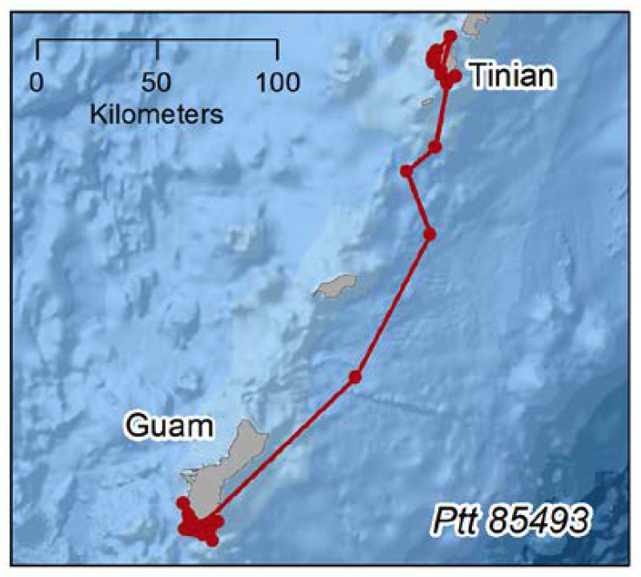
Figure 4: CNMI caught sub-adult hawksbill satellite tracked to Guam

Threats to the population

Hawksbill turtles in Guam are threatened by fisheries bycatch, boat strike, foraging habitat degradation, and coastal development, as well as human activities such as intentional take, harvest for the tortoiseshell trade, and plastic pollution. The limited hawksbills nesting on Guam are impacted by predation by monitor lizards, wild pigs, rats, and crabs (Cummings 2002). The TREDS database contains records of hawksbill turtle strandings at Andersen Air Force Base, Pago Bay, and Jeff’s Pirate Cove (Ipan), and one turtle found at Capras with plastic and metal in its intestine.

Management and protection

Hawksbill turtles are protected on Guam by the Endangered Species Act (USA) and the Endangered Species Act of Guam. As a US territory, Guam must also uphold its responsibilities under all relevant conservation agreements (e.g. CITES, CMS, CBD). International instruments applicable to hawksbill turtles in Guam are listed in Table 2.
Biological data on breeding and foraging
There is no biological data for breeding hawksbill turtles in Guam. Three juvenile foraging hawksbills were tagged and recaptured between 2014 and 2019 on Guam, including two hawksbills that were captured on a total of three occasions (Gaos et al. 2020). The longest period between original capture and most recent capture for one of the hawksbills, was 1,119 days, during which the turtle grew 4.4 cm SCL from 52.9 cm on 12 May 2016, to 60.1 cm on 05 June 2019. The turtle also increased 10.0 kg over that time period. Another hawksbill grew 4.6 cm over a period of 307 days, increasing from 42.3 cm SCL on 17 July 2014, to 46.9 cm on 20 May 2015. It also increased 8.1 kg during that time. The third hawksbill grew 2.9 cm over 729 days, increasing from 68.2 cm SCL on 19 May 2015, to 71.1 cm SCL on 11 May 2017. The turtle also increased 3.9 kg during that time.
The mean core (50% utilization distribution) and overall (95% utilization distribution) home ranges of three juvenile hawksbills equipped with satellite tags on Guam was 0.15 km² (sd = 0.17 km²; range = 0.01−0.34 km²) and 4.41 km², (sd = 7.07 km², range = 0.06−12.57 km²), respectively (Gaos et al. 2020).
Nine hawksbills captured in Guam and CNMI and equipped with satellite tags incorporating dive computers revealed the hawksbills spent 93.1% of their time in waters <25 m in depth and used an average depth of 15.3 m (Gaos et al. 2020).

Kiribati

Geographic spread of foraging sites
Hawksbills are less abundant than green turtles in Kiribati. During SCUBA surveys conducted in the Phoenix Islands, three and five hawksbill turtles were observed over 11 days in May 2000 and over 21 days in June 2002, respectively (Benson et al. 2007). Hawksbill turtles were not observed during a resource assessment conducted at Kanton Island in June 2017. The TREDS database includes three records of foraging by hawksbill turtles at three separate locations: Beru (Gilbert Group) in 2015, Abemama Island in 2010, and Tabiteuea South in 2014.

Geographic spread of nesting
No nesting records of hawksbill turtles in Kiribati are available. The TREDS database does not contain any records of nesting by hawksbills.

Migration and distribution of foraging areas
No tag recapture or genetic data are available to determine the source beaches of the in-water hawksbill population.

Threats to the population

Threats to marine turtles in Kiribati include incidental capture in commercial fisheries, habitat degradation, pollution, marine debris, boat strikes, and climate change (Buden 1999).

Management and protection

Hawksbill turtles are fully protected in the Phoenix Islands Protected Area (PIPA). Kiribati is not a participating party to CITES. International instruments applicable to hawksbill turtles in Kiribati are listed in Table 2.
Biological data on breeding and foraging
There is very limited biological data on breeding and foraging hawksbills in Kiribati. There are only two records of hawksbill turtles available in TREDS. The CCL measurements of the two hawksbill records are 30.0 cm and 69.9 cm.

Republic of the Marshall Islands (RMI)

Geographic spread of foraging sites

Hawksbill turtles have been reported at nearshore foraging grounds of at least 17 atolls in the RMI, including Majuro and Kwajalein (Parker 2020 in Work et al. 2020). However, no information is available on pelagic movements or the migration of adult females or hatchlings from nesting beaches within the RMI. The TREDS database contains three records of foraging by hawksbills, all at Likiep Island with two in 1992 and one in 1993.

Geographic spread of nesting

Infrequent nesting by hawksbill turtles is reported to occur in the RMI, but no current data on abundance are available (Pilcher 2021). Locations of reported nesting are spread across the RMI and not concentrated in a specific location (Figure 5). L. Tobin estimated that hawksbill turtles accounted for approximately 30% of total turtle nesting on Rongerik and Ailinginae Atolls (McCoy 2004). Wotje Atolls has been suggested as possible being the center of activity for hawksbill turtles (Puleloa & Kilma 1992), and both Wotje and Erikub atolls have recorded hawksbills nesting, but in lower numbers than green turtles. The TREDS database contains one record of nesting by hawksbills at Wotje Atoll in 1992.

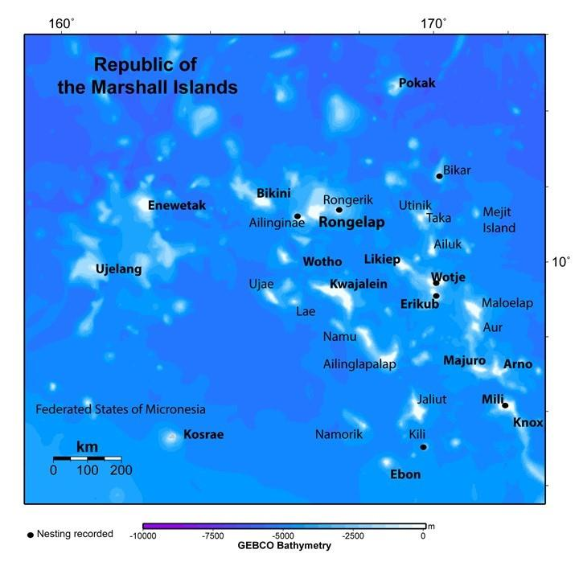
Figure 5. Distribution of reported hawksbill turtle nesting in RMI. From Work et al. (2020)

Trends in nesting data

Hawksbill turtle nesting is believed to be decreasing in the RMI (see Parker 2020 in Work et al. 2020).

Migration and distribution of foraging areas

Hawksbill turtles have been reported foraging on at least 17 atolls throughout the RMI (McCoy 2004; Rudrud 2008) and have been photographed resting at atolls (Parker 2020 in Work et al. 2020). No information is available on pelagic movements or the migration of adult females or hatchlings from nesting beaches within the RMI.

Threats to the population
Nesting hawksbill turtles in the RMI are threatened mainly by the harvest of eggs and nesting females (McCoy 2004; Rudrud 2008). Other anthropogenic threats include sand mining on inhabited islands such as Majuro (Hay and Sablan-Zabedy 2005), coastal development, light pollution, contamination from nuclear testing, and marine debris. Natural threats to nesting hawksbills include sea level rise due to climate change, beach erosion from extreme weather events, and predation by rats, sand crabs, and seabirds. Threats to foraging and breeding hawksbill turtles include direct harvest, fisheries bycatch in pelagic and nearshore artisanal fisheries, and degradation of foraging and resting coral reef habitats (Parker 2020 in Work et al. 2020). Commercial longline fisheries operate in the waters of the RMI, with 190 foreign licensed vessels fishing there in 2020. Mandatory bycatch reporting requirements came into effect on 1 January 2020, but data is not yet available and collection may have been impeded by the COVID-19 pandemic.

Management and protection
The harvest of hawksbill turtles is permitted in the RMI, with provisions for minimum size limits (27 inches CCL) and closed seasons from June 1 to August 31 and December 1 to January 31 (Kabua & Edwards 2010). Egg collecting and harvest of turtles at nesting beaches is prohibited at all times. The RMI is not a participating party to CITES. International instruments applicable to hawksbill turtles in the RMI are listed in Table 2.
Biological data on breeding and foraging
There is very little information regarding distribution and numbers of hawksbill turtles in the RMI. No biological information is available for breeding or foraging hawksbill turtles.

Commonwealth of the Northern Mariana Islands (CNMI)

Geographic spread of foraging sites

Summers et al. (2017) and Gaos et al. (2020) documented predominantly juvenile and sub-adult sized hawksbills in the waters of the islands of Saipan and Tinian in CNMI. Of note is that numerous small hawksbills were observed along the northwest coast of Tinian, indicating this area may be of particular importance for small hawksbills that have recently recruited to neritic habitats after spending their first years of life in open-ocean pelagic habitats.

Geographic spread of nesting

There is no reported nesting of hawksbill turtles at CNMI (NMFS 1998; Mortimer and Donnelly 2008). Summers et al. (2013) and Summers et al. (2017) refer to hawksbill nesting but do not provide further data.

Migration and distribution of foraging areas

NOAA surveyed the nearshore waters of the islands of Saipan and Tinian in CNMI between 2013 and 2019, during which time the captured 11 juvenile and one adult hawksbill and equipped them with satellite tags(Gaos et al. 2020)

One sub-adult hawksbill originally equipped with a satellite tag after being captured in the nearshore waters of Tinian, subsequently migrated to Guam (see Guam section). An adult hawksbill (72.3 cm SCL) equipped with a satellite tag after being captured in the nearshore waters of Tinian in 2014, subsequently migrated 2,118 km in 74 days to Ant Atoll, adjacent to Pohnpei, in the FSM (Figure 6). The turtle remained in the nearshore waters of Ant Atoll for 10 months, at which time the tag ceased transmitting. This individual was likely making a long-distance migration to a known breeding site on Ant Atoll; however, it is also possible that it was concluding a breeding season near Tinian and returning to Ant Atoll to forage.

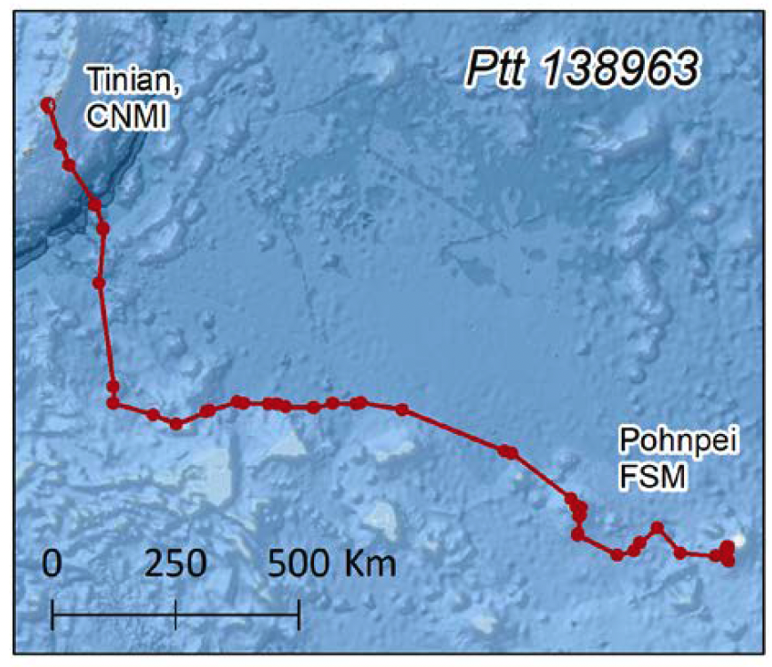
Figure 6: Tinian caught adult hawksbill satellite tracked to FSM

Threats to the population

Hawksbill turtles in CNMI are primarily threatened by illegal harvest, marine debris entanglement, boat strike, and disease (Parker 2020 in Work et al. 2020).

Management and protection
All sea turtle species occurring in U.S. territorial waters of the Western Pacific region are protected under the U.S. Endangered Species Act (ESA). International instruments applicable to hawksbill turtles in CNMI are listed in Table 2.
Biological data on breeding and foraging
There are no biological data for breeding hawksbill turtles in CNMI. Eleven foraging hawksbills were captured and equipped with satellite tags in the nearshore waters of CNMI between 2013 and 2019, including five on Saipan and six on Tinian. The mean core (50% utilization distribution) and overall (95% utilization distribution) home ranges of hawksbills on Saipan was 0.09 km² (sd = 0.13 km²; range = 0.01−0.24 km²) and 0.73 km² (sd = 1.08 km²; range = 0.02−1.97 km²), respectively, while on Tinian was 0.37 km² (sd = 0.13 km²; range = 0.28−0.46 km²) and 2.20 km² (sd = 1.36 km²; range = 1.24−3.16 km²), respectively (Gaos et al. 2020).
Nine hawksbills captured in Guam and CNMI and equipped with satellite tags incorporating dive computers revealed the hawksbills spent 93.1% of their time in waters <25 m in depth and used an average depth of 15.3 m (Gaos et al. 2020).

Palau

Geographic spread of foraging sites
Hawksbill turtles are regularly reported foraging at the seagrass beds, lagoons, and extensive shallow coral reef habitat surrounding the islands of Palau. There has been an apparent steady decline in the population over the years (Rice 2020 in Work et al. 2020). The highest concentrations of foraging hawksbills were reported from the Helen's Reef lagoon and the lagoon of the Rock Islands (Geermans 1992). Sub-adult hawksbill turtles have also been observed foraging in the dive areas of Blue Corner and German Channel (Rice, 2000, personal observation). The TREDS database contains <5 records of foraging by hawksbills, but additional location information is missing.

Geographic spread of nesting
Low level hawksbill turtle nesting is found across Palau, with 5-6 nesting locations reported (Rice 2020 in Work et al. 2020). Mortimer & Donnelly (2008) and NMFS (1998) reported between 20 and 50 female hawksbill turtles nest per year in Palau. In 2018, approximately 70 hawksbill clutches were reported across 13 beaches on the Rock Islands in the Koror State by the Department of Conservation & Law Enforcement (pers comm 25 May 2021). Yalap (2016) also reported that hawksbill turtles nest in small numbers (<10 clutches) on some of the Rock Islands . The TREDS database contains various records of “nesting” hawksbills, but many of these records require clarification and confirmation.

Trends in nesting data

No information is available regarding trends in hawksbill turtle nesting numbers.

Migration and distribution of foraging areas

There are no data on migration and distribution of hawksbills from foraging areas in Palau.

Threats to the population
Hawksbill turtles in Palau are threatened at nesting sites by illegal human harvest (eggs and females), predation by wild pigs and monitor lizards, habitat degradation due to tourism development, and increasing frequency of extreme weather events (Eberdong & Klain 2008; Golbuu et al. 2005). Foraging turtles are threatened by harvest for the tortoiseshell trade (and/or cultural toluk trade), entanglement in marine debris, habitat destruction from sand mining and dredging, water pollution near urbanised areas (Rice 2020 in Work et al. 2020).

Management and protection
In 2018, Palau enacted a ten-year moratorium on the harvest and sale of hawksbill turtles or their products in response to concerns that populations were declining. Previously, the harvest of hawksbill turtles was permitted in Palau under domestic fishing laws (24 PNCA 1201), with provisions for minimum size limits (27 inches CCL) and closed seasons from June 1 to August 31 and December 1 to January 31 (Secretariat of the Pacific Community and Bureau of Marine Resources Palau, 2007). Taking of eggs or female turtles while onshore is prohibited at all times. Nesting females, eggs, and habitats are also protected within the Ngerukewid Islands Wildlife Preserve (Guilbeaux 2002). The Ngeruangel Reserve Management Plan restricts turtle harvest levels and circumstances under which turtles can be harvested from Ngeruangel Atoll in Kayangel State, while the implementation of no-fishing and limited public access areas in Koror State offers some protection to turtles in the water, as well as nesting turtles and eggs. However, enforcement of these regulations is weak (Seminoff et al. 2015).
International instruments applicable to hawksbill turtles in Palau are listed in Table 2.

Biological data on breeding and foraging
There are no biological data on breeding and foraging for hawksbill turtles in Palau. Despite the number of agencies, NGOs, and community groups working on turtle conservation in the country, monitoring of hawksbill turtles to ascertain key nesting sites, abundance, and other biological data is limited throughout Palau (Rice 2020 in Work et al. 2020).

South Central Pacific Ocean

American Samoa

Geographic spread of foraging sites
Hawksbill turtles have been reported foraging at Tutuila Island (63 individuals captured between 1995 and 2002) and in small numbers at Rose Atoll (Grant et al. 1997) and Ofu Island (Tagarino et al. 2008). Becker et al. (2019) recorded a relatively high abundance of hawksbills foraging at Tutuila and Tau.

Geographic spread of nesting

Hawksbill turtles nest at the islands of Tutuila, Ofu, and Olosega. A recent survey of Tutuila identified 15 active nesting beaches for hawksbill turtles, with a further 14 described as having high potential for nesting (Tagarino et al. 2008). The TREDS database contains <10 records of hawksbill nesting at multiple locations around Tutuila (Lauli’i Villa, Maloata Village, and Amalau Beach).

Trends in nesting data
NMFS and USFWS (1998) indicated there may be up to 80 nesting females per year in Tutuila and the Manu’a Islands group. However, Mortimer and Donnelly (2008) indicate only 10 to 30 female hawksbill turtles nest per year in American Samoa and Samoa combined. Surveys with locals in 1991 found that an estimated 50 adult females (green and hawksbills combined) used nesting beaches at Tutuila in 1990-1991 (Tuato’o-Bartley et al. 1991), indicating that present day populations may have declined dramatically (Utzurrum 2002). More recently, based on all available data, Pilcher (2021) suggests that <10-15 female hawksbill turtles nest in American Samoa annually. Rapid assessments of three beaches (Mafafa, Toaga, and Airport Beach) over a period of 5-6 weeks in 2017 and 2018 revealed a total of six and seven nests, respectively (Mark MacDonal, pers comm. 13 December 2018). Approximately 10 known nesting beaches are present on Tutuila, but it is fortunate if each site received one or two nesting females per season and many of these sites may go a season or two with no activity (Mark MacDonal, pers comm. 13 December 2018).

Migration and distribution of foraging areas
Post nesting hawksbill turtles in American Samoa can undertake migrations to other western Pacific countries, including to the neighbouring nation of Samoa, or can remain in local waters. Two hawksbills tracked from American Samoa travelled to the Cook Islands (Tagarino et al. 2008), a straight-line distance of some 1,400 km. Hawksbills tagged at Tutuila and Ofu-Olosega were tracked to the Cook Islands, Samoa, Tonga, and French Polynesia, while others stayed in nearshore waters of Tutuila (Tagarino 2015). The TREDS database contains over 100 records of foraging by hawksbills from numerous locations around Tutuila.

Threats to the population
Turtles have been reported caught in fishing gear, including lines, traps and nets around Tutuila (Utzurrum 2002). An estimated 14 hawksbill turtles may interact with the American Samoa longline fleet annually (McCracken 2019). Hawksbill sea turtles are known to be caught in artisanal fisheries such as gillnets and small numbers have been found stranded with apparent spear holes in the head (Tagarino et al. 2008, 2015).
Impacts on hawksbill turtles due to climate change include sea level rise, increased air temperatures that may change hatchling sex ratio, increased storm severity, and decreased coral reef habitat quality from bleaching and acidification (Score 2017). Toxins from non-point source, land-based sources have been detected in coastal streams in American Samoa at levels known to cause toxicity in aquatic animals (Polidoro et al. 2017). Other threats include entanglement in debris such as fishing gear (MacDonald 2016), erosion of nests from storm surges (Peck 2016), potential predation from feral pigs and rats (Tagarino et al. 2010), and disorientation of hatchlings and adults from light pollution (Tagarino et al. 2008).
The TREDS database contains 6 records of nesting hawksbills, all from Tutuila (Utumea East Village, Lauli’i Village, Maloata Villa, Tula Village, and Amalau Beach) and 69 records of foraging hawksbills, all from multiple locations at Tutuila.

Management and protection
Hawksbill turtles in American Samoa are fully protected under the U.S. Endangered Species Act (ESA) of 1973. A Sea Turtle Hotline was implemented in 2007 for emergency responses to strandings and other wildlife emergencies (Tagarino et al. 2008). International instruments applicable to hawksbill turtles in American Samoa are listed in Table 2.

Biological data on breeding and foraging
There is limited biological data on hawksbill turtle breeding and foraging in American Samoa. Growth rates from mark recapture studies suggest a mean growth rate of 4.5 cm/yr (Grant et al. 1997). Becker et al. (2019) summarize the results of sea turtle observations from towed-diver surveys in the U.S. Pacific Islands. American Samoa had the highest densities of hawksbill turtles within these regions; size class distributions are depicted in Figure 7.
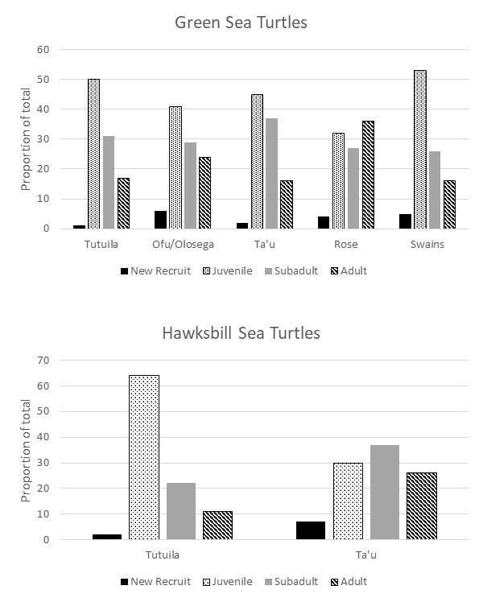
Figure 7. Size distributions of hawksbill turtles in waters around islands and atolls of American Samoa. Adapted from Work et al. (2020).

Fiji

Geographic spread of foraging sites
Hawksbill turtles have been recorded on several Fijian coral reefs, including the Great Sea Reef (Laveti 2010). However, no survey to collect abundance indices has been performed in the last twenty years. Hawksbill turtles reportedly feed on the seagrass beds off the easternmost point of Vanua Levu (Batibasaga et al. 2006). The TREDS database contains records of hawksbills foraging at coral reef habitats throughout Fiji.

Geographic spread of nesting
Hawksbill turtles are known to nest on several beaches of the islands of Fiji (Figure 8). Nesting is diffuse and spread across approximately 27 sites; Namena Lala Island is the only index nesting site for hawksbill turtles in Fiji. Available data recorded in the last 20 years are summarized in Piovano 2020 (in Work et al. 2020). The TREDS database contains records of hawksbill turtle nesting at Treasure Island, Nukuvadra Island, Kavewa Island, Yadua Island, Bounty Island, and Namena Lala Island. The records span from 1997 to 2015.
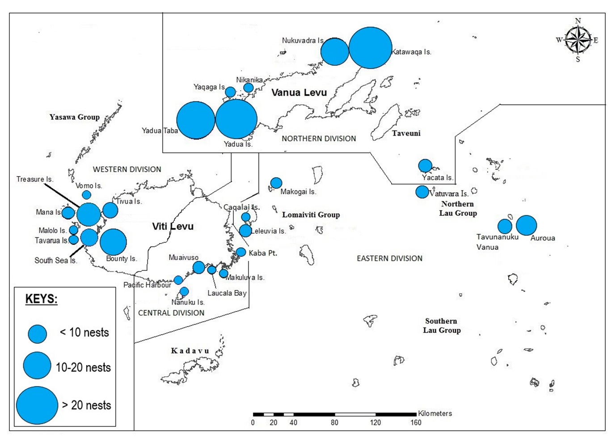
Figure 8. Distribution of hawksbill turtle nesting in Fiji. From Prakash et al. (2020).

Trends in nesting data
Batibasaga et al. (2006) reported a severe decline in the number of nests laid at Namena Lala Island and at Makogai Island. The most recent national estimation of the size of the hawksbill turtle nesting population is 150-200 adult females (Batibasaga et al. 2006). Most recently (during 2015-2019) Prakash et al. (2020) reported Yadu and Yadua Taba recorded 35% of all nesting in Fiji, followed by Katawaqa and Nukuvadra (29%).
There are no long-term data on clutch estimates per female per season for hawksbill turtles in Fiji. However, it is likely that 20 to 30 females nest annually in Fiji (Pilcher 2021). Mortimer and Donnelly (2008) suggested 100 to 200 female hawksbill turtles nest per year in Fiji. However, the most recent nesting assessments are presented from 2015 to 2019; Prakash et al. (2020) report only 147 clutches recorded among 27 nesting sites during the study period. As nesting sites are widely distributed and isolated, the number of nesting turtles at each site is likely to be low, although this is probably underestimated due to the logistics of full-time monitoring.

Migration and distribution of foraging areas

Satellite tracking studies have shown that Fiji is a foraging area for hawksbill turtles nesting in American Samoa (Jayne & Solomona 2007).

Threats to the population

Hawksbill turtles in Fiji are particularly threatened by illegal harvest in coastal waters and flooding and erosion of nesting beaches.

Management and protection

Hawksbill turtles are protected in Fiji under national law. Despite the expiry of the Fisheries Moratorium on 31 December 2018, Regulation 5 of the Offshore Fisheries Management Regulations 2014 (OFMR) remains in force which imposes a ban on the harvest, sale, possession and transportation of sea turtle, their eggs or any part or product of all five species of sea turtles found in Fiji. The provisions of the OFMR apply to “all Fiji Fisheries waters” meaning it applies to all internal, inshore and offshore areas of Fiji. The specific ban under the OFMR applies to the killing, taking, landing, selling or offering or exposing for sale, dealing in, transporting, receiving or possessing any sea turtle species. However, the Ministry of Fisheries is currently working to update and amend this legislation to continue to allow for permits to be issued to authorise limited cultural harvest by local i-Taukei communities. International instruments applicable to hawksbill turtles in Fiji are listed in Table 2.
Biological data on breeding and foraging
A recent literature review (Piovano 2020 in Work et al. 2020) shows missing key information for nesting and foraging hawksbill turtles in Fiji. Upcoming publication of satellite tracking studies will help in the identification of possible migratory routes and benthic foraging areas, and upcoming publication of data collected under the SPREP BIEM project will likely yield a wealth of data on sizes and species of turtles that are captured and traded.
Prior studies recorded minimum CCL of hawksbill turtles nesting in Fiji is 75 cm (Batibasaga et al. 2006). Calculated from available data, average clutch size and average emergence success are 116 eggs and 98.36%, respectively (Piovano 2020 in Work et al. 2020). In more recent assessments between 2015-2019, Prakash et al. (2020) reported an average CCL of 81.5cm (n = 4 nesting females), average clutch size of 121 (eggs/clutch; n = 71 nests), average hatching success of 89% (n = 71 nests), and a mean egg incubation period of 56 days (range 49 to 69 days). Based on these assessments, Prakash et al (2020) recorded peak nesting to occur in January.

French Polynesia

Geographic spread of foraging sites
Hawksbill turtles are commonly seen foraging and resting throughout French Polynesia (Gaspar 2020 in Work et al. 2020). An in-water population assessment in 2010-2011 recorded 243 hawksbill turtles at the barrier reefs of six islands: Tetiaroa, Moorea Maiao, Bora Bora, Maupiti, and Tupai (Petit 2011). The TREDS database contains 46 records of foraging by hawksbills at Taha’a, Mataia, Bora Bora, Tiahura Lagoon, and Moorea. The records span from 1993 to 2013.

Geographic spread of nesting

Hawksbill turtles have only been confirmed to nest at one location in French Polynesia: Reao Atoll in Tuamotu archipelago (M. Tatarata, pers. comm). The TREDS database records 28 “nesting” hawksbill turtles at Taha’a, though these only span from 1995 to 1997.

Trends in nesting data

There are no data on nesting trends for hawksbill turtles in French Polynesia.

Migration and distribution of foraging areas
Tagging data suggest that hawksbill turtles are resident to local islands and do not undertake long migrations, but further studies are necessary to confirm this (Gaspar 2020 in Work et al. 2020).
Prior studies have shown two post-nesting females tagged in American Samoa (in 2019) migrated to French Polynesia. [NOAA to provide further information].

Threats to the population

There is very limited information available on threats to hawksbill turtles in French Polynesia.

Management and protection

Hawksbill turtles are fully protected in French Polynesia, but laws are difficult to enforce given the distances between islands (Gaspar 2020 in Work et al. 2020 2020). International instruments applicable to hawksbill turtles in French Polynesia are listed in Table 2.

Biological data on breeding and foraging
There is very limited biological data on breeding and foraging of hawksbill turtles in French Polynesia. Mean hawksbill CCL is 61.74 ± 13.74 cm, with minimum size of 30 cm and maximum of 95 cm (Petit 2011).

Samoa
Annual nesting for hawksbill turtles is estimated to be between <10 to 30 female hawksbill turtles per year in Samoa and American Samoa combined (Mortimer and Donnelly 2008). It is likely that <5 to 15 female hawksbill turtles nest in Samoa annually. The TREDS database recorded 34 “nesting” hawksbills on Upolu Island (Vini Beach, Nuulua Island, Nuutele Island, and Lalomanu). All but two of these records are from the 1993-1994 season.

Tonga
There is no reported nesting of hawksbill turtles in Tonga (NMFS 1998; Mortimer and Donnelly 2008). The TREDS database contains 11 records of foraging by hawksbills, most caught at Tongatapu Island and two from the Haapai Group (Foa Island and Vavau).

Vanuatu

Geographic spread of foraging sites

Hawksbill turtles have been reported foraging at multiple locations throughout Vanuatu. Hickey (2020) identified foraging habitat (mainly coral reefs) at Southeast Vanua-Lava in the Banks Group, Pakea Island, Reef Island (also known as Rowa), Malekula Island, Uripiv and Uri Islands (Port Stanley and south to Crab Bay), Maskelyne Islands, islands to the north of Efate Island (Lelapa, Kagula, Emao, Nguna, Pele, Emau, and Moso), Aneityum Island, Mystery (Inyueg) Island, and Futuna Island.

Geographic spread of nesting

Hawksbill turtles have been reported nesting at multiple locations throughout Vanuatu, including Banks/Torres, Malekula, Epi, Green, and Aneityum. Rice et al. (2018) report that Malekula Island (Bamboo Bay and Wiawi village area) and Moso Island are the most important documented locations for hawksbills in Vanuatu. The TREDS database lists additional hawksbill turtle nesting sites on the islands of Ambrym, Efate, Espiritu Santo, Moso (off north Efate) and Tegua, Torres. The highest numbers of clutches were reported from Moso and Bamboo Bay during the 2006-2007, 2007-2008, 2009-2010, and 2011-2012 nesting seasons. However, these higher figures may be an artifact of greater surveying intensity (Hickey 2020 in Work et al. 2020). More detailed information on hawksbill nesting throughout Vanuatu is summarised in Hickey (2020) in Work et al. (2020).

Trends in nesting data

Nesting by hawksbill turtles may be declining (Mortimer & Donnelly 2008), but the lack of long-term monitoring in Vanuatu makes detection of a trend not possible (Hickey 2020 in Work et al. 2020). During the 2018/2019 nesting season, 170 hawksbills returned to nest at Bamboo Bay (D. Aromalo, pers. comm). Based on all available data, Pilcher (2021) estimated the annual nesting population to be around 300 female hawksbills.

Migration and distribution of foraging areas
Hawksbills nesting in Vanuatu have been documented migrating to overseas foraging grounds, including areas in New Caledonia, Australia, and Samoa (Hickey 2020 in Work et al. 2020; Rice et al. 2018). For more information on tagged hawksbill turtles recovered outside Vanuatu, see the TREDS 2015 Report (Siota 2015). Figure 9 shows a summary of migratory tracks of the seven post-nesting hawksbills that were satellite tagged on Moso Island, central Vanuatu between 2018 and 2020. The most recent data available from the SPREP TREDS database covers 2017-2018. The 2016 data is currently missing. The 2017-2018 TREDS Report (Ward 2019) indicates that out of the 15,217 tags issued to Vanuatu since 1991, 4,705 tags have been entered into the TREDS database and the hawksbill turtle (n=1,550) is the species with the highest record in TREDS for Vanuatu. Genetic samples have been collected from Malekula and are currently being analyzed.
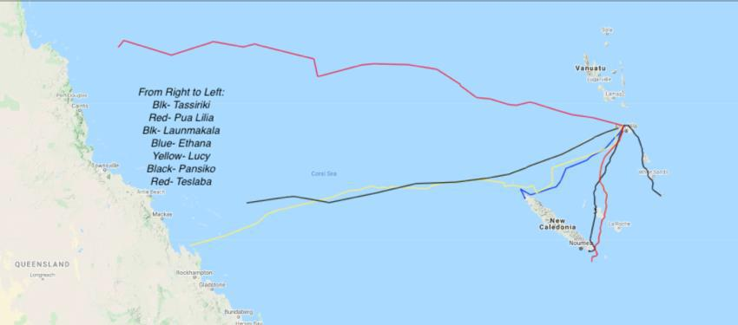
Figure 9. Summary of post-nesting migrations of hawksbill turtles from Moso Island, Vanuatu from 2018 to 2020. Sources from HBA, unpublished data.

Threats to the population

Despite laws prohibiting turtle take in Vanuatu, harvesting of nesting and foraging hawksbill turtles continues (Rice et al. 2018). Other threats include light pollution, construction of seawalls and fences, domestic dogs, development of nesting beaches, and bycatch in longline and purse seine fisheries (Hickey 2020 in Work et al. 2020).
Hawksbill turtle hatchlings are caught and retained for headstarting programs on Efate, and adult hawksbills are occasionally kept in tanks for tourism purposes (Hickey 2020 in Work et al. 2020). Hatchling mortality is reported to be high in these environments due to poor water quality (ibid.).

Management and protection

Take of sea turtles has been prohibited in Vanuatu since 2005 (Fisheries Act No. 55 of 2005). In 2009, an amendment to the 2005 prohibition was passed, which closed earlier loopholes and prohibited the killing of any sea turtle species. Provisions of the law allow for traditional harvests through application to the Department of Fisheries (Rice et al. 2018). The Vanuatu Fisheries Department has recently begun training community members to monitor fisheries violations at the village level, including for turtle related offenses (Hickey 2020 in Work et al. 2020).

International instruments applicable to hawksbill turtles in Vanuatu are listed in Table 2.

Biological data on breeding and foraging
The TREDS database contains CCL measurement records of 1,454 hawksbill turtles in Vanuatu. The size frequency graph shows 1,086 turtles with a CCL under 64.9 cm, 23 turtles within the range of 65.0-79.9 cm, and 345 adult-sized turtles within the range of 80.0-109.9 cm (Figure 10). Siota (2015) reported 870 hawksbill turtles with CCL measurements in 2010, 1,070 621[?] hawksbills with CCL measurements in 2011/2012, and 1,254 reported in 2013-2014.
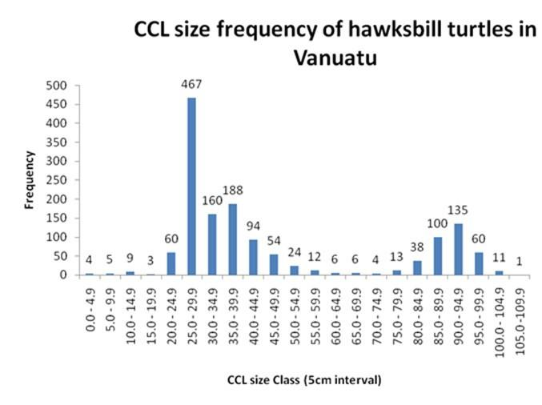
Figure 10. Hawksbill CCL size classes from turtles caught in Vanuatu. From the TREDS database.

Wallis and Futuna
There are no reports of hawksbill turtle nesting for Wallis and Futuna. Some hawksbill turtles have been reported at the reefs of Futuna Island and flipper-tagged as a result of recent monitoring (Work et al. 2020).

Other

Cook Islands

Geographic spread of foraging sites

Hawksbill turtles are known to forage in the waters of the Cook Islands (White 2012; White 2013). Foraging hawksbills can be regularly found on coral reefs at Rarotonga and less frequently in its lagoons. White (2012) recorded three juvenile hawksbills at Palmerston Atoll and one adult female seen at Tongareva Atoll in 2010, although only two juveniles have been seen at Tongareva since 2012. Juvenile hawksbill turtles have also been reported at Suwarrow Atoll (White 2012). The TREDS database contains 29 records of foraging by hawksbill turtles from 2004-2010.

Geographic spread of nesting

There are no reports of nesting by hawksbill turtles in the Cook Islands (White 2012).

Migration and distribution of foraging areas
There are very limited data on migration and distribution of hawksbill turtles from the Cook Islands. Two hawksbills tracked from American Samoa travelled to the Cook Islands (Tagarino et al 2008), a straight-line distance of some 1,400 km.

Threats to the population

Hawksbill turtles in the Cook Islands are threatened by entanglement in marine debris and plastic ingestion, foraging habitat destruction though dredging and sand mining, and water pollution near urbanised areas (e.g. Rarotonga’s Muri Lagoon), and climate change impacts
including degraded foraging habitat (e.g. acidification and bleaching of coral reefs) (White 2020 in Work et al. 2020).

Management and protection

The Marine Resources Act 1989 provides for the protection and management of fishery resources, the definition of which includes marine turtles. It is unknown whether specific regulations exist regarding marine turtle harvest, although Maison et al. (2010) reported that marine turtle eggs were fully protected (Pulea 1992). International instruments applicable to hawksbill turtles in the Cook Islands are listed in Table 2.

Biological data on breeding and foraging
There are no biological data on breeding and foraging hawksbills in the Cook Islands. A new organisation, ‘Te Ara o te Onu’, will work with the tourism industry to collate data on turtle presence, size, and behaviour (White 2020 in Work et al. 2020).

Nauru
There is no reported nesting of hawksbill turtles at Nauru (NMFS 1998; Mortimer and Donnelly 2008). It is not currently possible to determine if nesting occurs. Nauru’s coral reef habitats foraging habitat to hawksbill turtles, but further investigation is needed.

New Caledonia (France)
Meylan and Donnelly (1999) indicated that few hawksbills were reported to nest in New Caledonia. D’Auzon (2007) reported that the main population (about 200 individuals) is located on the northeast coast, but it was unclear if this referred to in-water turtles. Recent surveys suggest there is no nesting in New Caledonia (T. Read, pers. comm.). The TREDS database contains three records of foraging by hawksbill turtles, one at Sainte Marie Bay in 2011 and two at Anse Vata Beach in 2011 and 2012.

New Zealand

Geographic spread of foraging sites
Almost no local population information exists for this species in New Zealand. However, unpublished diet component analysis shows that hawksbill turtles forage in benthic and pelagic habitats in northern New Zealand, especially around the subtropical Kermadec Islands (Godoy unpubl. data).

Geographic spread of nesting

There is no nesting of hawksbill turtles in New Zealand, including the sub-tropical Kermadec Islands.

Migration and distribution of foraging areas
There is very limited information on hawksbill migration in New Zealand. Fifty-three sighting, stranding and incidental capture (commercial and recreational fishing bycatch) records have been documented from 1949 to 2015 (WCPFC 2005; Godoy 2016; Godoy unpubl. data). Hawksbill records extend from the Kermadec islands (c. 30º S) south to Palliser Bay, Wellington (c. 41º S), yet its distribution is mostly concentrated off northeastern North Island, with a significant temporal peak in strandings during winter (July-September) and sightings of free-ranging animals during the warmer summer months (Godoy unpubl. data).

Threats to the population

There are very little data on threats to hawksbill turtles in New Zealand. Hawksbill stranding and incidental capture in commercial and recreational fisheries is collected as part of the New Zealand marine turtle sighting and stranding database (private database curated by D Godoy).

Management and protection
Hawksbill turtles are fully protected under the Wildlife Act 1953 and have been assessed as Migrant - Threatened Overseas according to the New Zealand Threat Classification System (NZTCS). International instruments applicable to hawksbill turtles in New Zealand are listed in Table 2.

Biological data on breeding and foraging
There is no information on ecology, regional connectivity, or genetic origin of hawksbill turtles in New Zealand. Limited data indicates that hawksbills occurring in New Zealand are juvenile to large sub-adults (μ = 53.2 cm CCL, SD 14.5 cm, range 35.0-90.0 cm, n = 23). Data and samples (including tissue for genetic and isotopic analysis) have been collected since 2007, thus warranting further research initiatives into regional connectivity, migratory corridors, threats, and habitat use.

Niue
There is no reported nesting of hawksbill turtles at Niue (NMFS 1998; Mortimer and Donnelly 2008). Hawksbills are reported to frequent marine areas around Niue (Government of Niue 2001).

Tokelau

Geographic spread of foraging sites

Low numbers of hawksbill turtles have been reported to forage in coastal waters around Tokelau (Balazs 1983). No further information regarding location or turtle abundance is available.

Geographic spread of nesting
Hawksbill turtles have been recorded nesting at low numbers on Nukunonu Atoll (Balazs 1983). More recent assessments do not report any hawksbill nesting in Tokelau (Mortimer & Donnelly 2008; NMFS 1998).

Trends in nesting data

There is no data on nesting trends for hawksbill turtles in Tokelau, nor is it possible to determine the number of females nesting annually (Pilcher 2021).

Migration and distribution of foraging areas

There is no data on migration and distribution of hawksbill turtles from foraging areas in Tokelau.

Threats to the population

Hawksbill turtles in Tokelau are threatened by direct harvest of eggs and nesting females, direct take at foraging grounds, fisheries bycatch, predation of nests by crabs and Polynesian rats, and climate change impacts from sea level rise, beach erosion, nest inundation, alteration of sex ratios, and increased frequency of extreme weather events (Ward & Lemalu 2020 in Work et al. 2020).

Management and protection
There are no national protections for hawksbill turtles in Tokelau. Rules and regulations are determined separately for each atoll and village of Tokelau (Balazs 1983; Pierce et al. 2012).
Tokelau is a member of the Forum Fisheries Agency (FFA), the Western and Central Pacific Fisheries Commission (WCPFC), Secretariat of the Pacific Community (SPC) and the South Pacific Regional Environment Programme (SPREP). Tokelau is not a party to CITES, but New Zealand, which administers Tokelau, is a participating party. International instruments applicable to hawksbill turtles in Tokelau are listed in Table 2.

Biological data on breeding and foraging
There are no biological data on breeding and foraging for hawksbill turtles in Tokelau.

Tuvalu
There is no reported nesting of hawksbill turtles at Tuvalu. Low numbers of nesting hawksbills (tens of individuals) are recorded in adjacent countries, namely Solomon Islands and Vanuatu. The TREDS database contains records of two foraging hawksbills at Funafuti Island, one of which was a tag return from Tuvalu, although Vanuatu and Solomon Islands are potentially important foraging areas.
Threats to hawksbill turtles in Tuvalu include illegal harvest, habitat degradation, and pollution.

References
Argument, D., MacKay, K. T., & Krueger, B. H. (2009). Foraging turtles around Tetepare Island, Solomon Islands. Marine Turtle Newsletter, 123, 18-20
Balazs, G.H. 1983. Sea turtles and their traditional usage in Tokelau. Atoll Research Bulletin 279. The Smithsonian Institution, Washington, DC. 38 p.
Becker, S.L., R.E. Brainard, and K.S. Van Houtan. 2019. Densities and drivers of sea turtle populations across Pacific coral reef ecosystems. Plos One 14:e0214972.
Bell, I. & M. P. Jensen (2018). Multinational genetic connectivity identified in western Pacific hawksbill turtles, Eretmochelys imbricata. Wildlife Research 45(4): 307-315.
Bell, I. and Pike, D.A., 2012. Somatic growth rates of hawksbill turtles Eretmochelys imbricata in a northern Great Barrier Reef foraging area. Marine Ecology Progress Series, 446, pp.275-283.
Benson, S.R., K.M. Kisokau, L. Ambio, V. Rei, P. Dutton, D. Parker (2007) Beach use, internesting movement and migration of leatherback turtles, Dermochelys coriacea, nesting on the north coast of Papua New Guinea. Chelonian Conservation and Biology 6(1):7-14. 2007 https://doi.org/10.2744/1071-8443(2007)6[7:BUIMAM]2.0.CO;2
Brander, L., Madden Hof, C., Bishop, J., and Riskas, K.A. (2021). Money talks: the value of conserving marine turtles in Asia-Pacific. Vrije Universiteit Amsterdam and Brander Environmental Economics report to WWF-Australia and WWF-Coral Triangle Programme.
Brown, C., Desbiens, A., Campbell, M., Game, E., Gilman, E., Hamilton, R., Heberer, C., Itano, D. and Pollock, K. (2021). Electronic monitoring for improved accountability in western Pacific tuna longline fisheries. Marine Policy 132 (2021).
Buden, D. 1999 Reptiles, birds, and mammals of Oroluk atoll, Eastern Caroline Islands. Micronesia 31(2): 289-300. 1999.
Buden D.W. and Edward A. 2001. Abundance and Utilization of Sea Turtles on Pohnpei, Federated States of Micronesia: Islanders’ Perceptions. Micronesia 34(1):47–54.
Campbell, L. M. (2012). Seeing red: inside the science and politics of the IUCN Red List. Conservation and Society, 10(4), 367-380.
Conflict Island Conservation Initiative. 2018. PNG Field Research: Conflict Island nesting season 2018-2019. 8pp. Report prepared for the Conflict Island Conservation Initiative, Panasesa Island, Milne Bay Province, Papua New Guinea.
Cummings V. 2002. Sea turtle conservation in Guam. In: Proceedings of the Western Pacific Sea Turtle Cooperative Research and Management Workshop (I Kinan, ed.). February 5– 8, 2002. Honolulu, HI: Western Pacific Regional Fishery Management Council, Honolulu, Hawaii, USA, pp. 37–38.
Eberdong, J., Klain, S., 2008. Palau marine turtle conservation and monitoring program, In: Rees, A.F., Frick, M., Panagopoulou, A., Williams, K. (Eds.), Proceedings of the Twenty- Seventh Annual Symposium on Sea Turtle Biology and Conservation. NOAA Technical Memorandum NMFS-SEFSC-569, pp. 230–231.
Ezekiel, A. (2018). Review of Marine Wildlife Protection Legislation in ASEAN TRAFFIC. Petaling Jaya, Selangor, Malaysia.
FitzSimmons, N. N., & Limpus, C. J. (2014). Marine turtle genetic stocks of the Indo-Pacific: identifying boundaries and knowledge gaps. Indian Ocean Turtle Newsletter, 20(July), 2-18.
Foale, S., Wini, L., Foale, S., & Wini, L. (2017). The Arnavon Community Marine Conservation Area: A review of success, challenges and lessons learned. A report to the MACBIO project. GIZ, IUCN, SPREP.
Gaos, AR, Martin SL, Jones TT. 2020. Sea turtle tagging in the Mariana Islands Training and Testing (MITT) study area. Annual Report prepared for the U.S. Pacific Fleet Environmental Readiness Office, Pearl Harbor, Hawaii by NOAA Fisheries, Marine Turtle Biology and Assessment Group, Protected Species Division, Pacific Islands Fisheries Science Center, Honolulu, Hawaii under Interagency Agreement 47 p.
Geermans, S. 1992. Marine turtles in the Southwest Islands of Palau. Unpublished report prepared for the Palau Bureau of Natural Resources and Development and for The Nature Conservancy, Pacific Region, Honolulu.
Godfrey, M. H., & Godley, B. J. (2008). Seeing past the red: flawed IUCN global listings for sea turtles. Endangered Species Research, 6(2), 155-159.
Godoy, D.A., 2016. Marine reptiles – review of interactions and populations. Report prepared for the New Zealand Department of Conservation. 53 p.
Golbuu Y, Bauman A, Kuartei J, Victor S (2005) The state of coral reef ecosystem of Palau. In: Waddell J (ed) The state of coral reef ecosystems of the United States and Pacific freely associated states: 2005. NOAA Technical Memorandum NOS NCCOS 11, NOAA/NCCOS Center for Coastal Monitoring and Assessment’s Biogeography Team. Silver Spring, MD, pp 488–507
Gomez, L. and Krishnasamy, K. 2019. A Rapid Assessment on the Trade in Marine Turtles in Indonesia, Malaysia and Viet Nam. TRAFFIC. Petaling Jaya, Malaysia.
Government of Niue (2001) Niue National Biodiversity Strategy and Action Plan.
Grant, G., P. Craig, G. Balazs. 1997. Notes on juvenile hawksbill and green turtles in American Samoa. Pacific Science 51: 48–53.
Green, A., Lokani, P., Atu, W., Ramohia, P., Thomas, P. and Almany, J., eds. 2006. Solomon Islands marine assessment: Technical report of survey conducted May 13–June 17, 2004. TNC Pacific Island Countries Report No 1/06. Honiara: TNC.
Grimm, G. and J. Farley. 2008. DRAFT Sea turtle nesting activity on Navy Base Guam 2007-2008. NAVFAC Marianas Report. 7 pp.
Groombridge, B., and Luxmoore, R. A. 1989. The green turtle and hawksbill (Reptilia: Cheloniidae): world status, exploitation and trade. Secretariat of the Convention on International Trade in Endangered Species of Wild Fauna and Flora.
Guilbeaux, M. 2002. New directions for sea turtle conservation in the Republic of Palau, Micronesia. Mosier, A., A. Foley, B. Brost, Compilers, Proceedings of the Twentieth Annual Symposium on Sea Turtle Biology and Conservation. NOAA Technical Memorandum NMFS-SEFSC-477. 369 pp.; 2002, p. 19
Hamann, M., Kamrowski, R. L., & Bodine, T. (2013). Assessment of the conservation status of the loggerhead turtle in the Indian Ocean and South-East Asia. IOSEA Species Assessment, 2, 56.
Hamann, M., Flavell, F., Frazier, J., Limpus, CJ., Miller, JD., Mortimer, JA. (2022). Assessment of the Conservation Status of the Hawksbill Turtle in the Indian Ocean and South-East Asia Region. IOSEA Species Assessment, 3, 113.
Hamilton, R.J. Desbiens, A., Pita, J., Brown, CJ., Vuto, S., Atu, W., James, R., Waldie, P., and Limpus C. 2021. Satellite tracking improves conservation outcomes for nesting hawksbill turtles in Solomon Islands. Biological Conservation: 261 (2021) 109240. https://doi.org/10.1016/j.biocon.2021.109240
Hamilton RJ, Bird T, Gereniu C, Pita J, Ramohia PC, Walter R, et al. (2015) Solomon Islands largest hawksbill turtle rookery shows signs of recovery after 150 years of excessive exploitation. PLOS One 10(4): e0121435. doi:10.1371/journal.pone.0121435
Hay, E., Sablan-Zebedy, E., 2005. USE Republic of the Marshall Islands: country environmental analysis. ADB Technical Assistance Consultant’s Report. 157 pp. Downloadable at https://www.adb.org/sites/default/files/institutional-document/32189/38031-rmi-tacr.pdf
Hickey, F, 2020. Vanuatu: A Review of Sea Turtle Distributions, Threats and Conservation Status. In: Sea Turtles in Oceania MTSG Annual Regional Report 2020 (TM Work, D Parker & GH Balazs, eds). pp. 577-642.
Intergovernmental Panel on Climate Change. 2007. Climate Change 2007: Synthesis Report. Geneva: IPCC. ISBN 2-9169-122-4
Intergovernmental Panel on Climate Change. 2019. Species Report on the Ocean and Cryosphere in a Changing Climate.
Jayne K and Solomona P. Lady Vini’s big Pacific adventure. Apia, Samoa: Western Pacific Regional Fishery Management Council and SPREP; 2007.
Kabua, E.N. & F. Edwards. 2010. Republic of the Marshall Islands (RMI) sea turtle legislation review. SPREP/CMS Report. 9 p. Downloadable at https://rmi-data.sprep.org/dataset/rmi-marine-turtle-legislation-review-2010
Kinch J. and Burgess E. 2009. Assessment of the trade in Hawksbill Turtles in Papua New Guinea. TRAFFIC Bulletin. 22 (2): 62-72.
Kinch J. 2020. In Work, T.M., Parker, D, Balazs, G.H. (eds). 2020. Sea Turtles in Oceania: MTSG Annual Regional Report 2020. Report of the IUCN-SSC Marine Turtle Specialist Group.
Kühn, S. & Van Franeker, J.A. 2020. Quantitative overview of marine debris ingested by marine megafauna. Marine Pollution Bulletin 151, 110858.
Laveti M. Inaugural Meeting Report Turtle Monitors meeting on Kia Island, Macuata. WWF South Pacific Programme; 2010.
Leary, T. (1992). The Arnavon Island Group hawksbill turtle (Eretmochelys imbricata) rookery: Solomon Islands, western Pacific. Unpublished manuscript.
Limpus CJ, Miller JD (2008) Australian hawksbill turtle population dynamics project. Queensland Environmental Protection Agency. 140 p.
MacDonald, M. 2016. Session 7: Protected Species, Sea turtles. In: Oram, R., H. Johnson, H. Ka’aekuahiwi, and G. Talamoa. A summary of the Rose Atoll Marine National Monument and American Samoa Archipelago ecosystem science implementation workshop Utulei, American Samoa May 26-27, 2015. Fish. Sci. Cent., Natl. Mar. Fish. Serv., NOAA Honolulu HI 96818-5007. Pacific Islands Fish. Sci. Cent. Admin. Rep. H-16-01. 68 p.
Madden Hof et al. In prep. First satellite tracking and genetic assignment of critically endangered nesting hawksbill turtles (Eretmochelys imbricata) in Papua New Guinea reveal strong links to Western Pacific
Maison K.A., Kelly I.K. and Frutchey K.P. 2010. Green turtle nesting sites and sea turtle legislation throughout Oceania. NOAA Technical Memorandum NMFS-F/SPO-110. 52pp.
Martin, S.L., VanHoutan, K.S., Jones, T.T., Aguon, C.F., Gutierrez, J.T., Tibbatts, R.B., Wusstig, S.B. and J.D. Bass. 2016. Five Decades of Marine Megafauna Surveys from Micronesia. Front. Mar.Sci.2:116. doi: 10.3389/fmars.2015.00116
Martin, S.L., Gaos, A.R., and T.T. Jones. 2018. Sea Turtle Tagging in the Mariana Islands Training and Testing MITT Study Area. Prepared for the U.S Pacific Fleet Environmental Readiness Office. Under Interagency Agreement NMFS-PIC-16-008. Submitted January 31, 2018.
McCoy, M. A. 2004. Defining Parameters for Sea Turtle Research in the Marshall Islands. U.S. Dept. of Commerce. NOAA Tech. Memo. Administrative Report. AR-PIR-08-04, 92 p.
McCracken, M.L. 2019. American Samoa longline fishery estimated anticipated take levels for Endangered Species Act listed species. NMFS/PIFSC, PIFSC Data Report DR-19-028
McKeown, A., 1977. Marine turtles of the Solomon Islands. Honiara, Solomon Islands: Ministry of Natural Resources, Fisheries Division.
Meylan, A. B., & Donnelly, M. (1999). Status justification for listing the hawksbill turtle (Eretmochelys imbricata) as critically endangered on the 1996 IUCN Red List of Threatened Animals. Chelonian conservation and Biology, 3(2), 200-224.
Miller, J.; Dobbs, K.; Limpus, C.; Mattocks, N. and Landry, A. 1998. Long-distance migrations by the hawksbill turtle, Eretmochelys imbricata, from north-eastern Australia. Wildlife Research. 25 (1): 89-95.
National Marine Fisheries Service and U.S. Fish and Wildlife Service. 1998. Recovery Plan for U.S. Pacific Populations of the Hawksbill Turtle (Eretmochelys imbricata). National Marine Fisheries Service, Silver Spring, MD.
Oppenheimer, M., Glavovic, B., Hinkel, J., van de Wal, R., Magnan, A.K., Abd-Elgawad, A., Cai, R., Cifuentes-Jara, M., Deconto, R.M., Ghosh, T. and Hay, J., 2019. Sea level rise and implications for low lying islands, coasts and communities.
Opu. 2018. An Assessment of Marine Turtle Exploitation In Papua New Guinea. Final Report prepared for the Secretariat of the Pacific Regional Environment Programme, Apia Samoa
Peatman T., Allain V., Caillot S., Park T., Williams P., Tuiloma I., Panizza A., Fukofuka S. and Smith N. 2018a. Summary of purse seine fishery bycatch at a regional scale, 2003-2017. Report to the Scientific Committee Fourteenth Regular Session, 2018. WCPFC-SC14-2018/ST-IP-04 Rev 1. 13pp.
Peatman T., Bell L., Allain V., Caillot S., Williams P., Tuiloma I., Panizza A., Tremblay-Boyer L., Fukofuka S. and Smith N. 2018b. Summary of longline fishery bycatch at a regional scale, 2003-2017. Report to the Scientific Committee Fourteenth Regular Session, 2018. WCPFC-SC14-2018/ST-WP-02.
Peck, B. 2016. Rose Atoll National Wildlife Refuge/Marine National Monument, January 26-28, 2016 Trip Report. Fish and Wildlife Service. Available online at: https://www.fws.gov/uploadedFiles/Region_1/NWRS/Zone_1/Pacific_Reefs_Complex/Rose_Atoll/Sections/What_We_Do/Resouce_Management/January2016Report.pdf
Petit, M., Gaspar, C. 2011. Double programme de recherche sur les tortues marines de l’archipel de la société, Polynésie française. Rapport de l’association Te mana o te moana.
Pierce, R., M. Gruber, J. Atherton, A. Burne, M. Valu and A. Whistler. 2012. A Conservation survey of Tokelau. Eco Oceania Pty Ltd Plan for Tokelau Administration and Critical Ecosystem Partnership Fund. 90 p. Downloaded July 16, 2019. https://www.tokelau.org.nz/site/tokelau/CONSERVATION%20SURVEY%20OF%20TOKELAU.pdf
Pilcher N.J. 2021. Review of the status of sea turtles in the Pacific Ocean 2021. Secretariat of the Pacific Regional Environment Programme, Apia, Samoa. 136 pp.
Pilcher, N.J., T. Ramachandran, T.C. Dah, L.S Ee, J. Beliku, K. Palaniveloo, L.K. Hin, L.S. Ling, L.C. Hui, R. Lewison, J. Moore, 2009. Rapid gillnet bycatch assessment: Sabah, Malaysia 2007. Project GloBAL. 2009. In Workshop Proceedings: Tackling Fisheries Bycatch: Managing and reducing sea turtle bycatch in gillnets. Project GloBAL Technical Memorandum No. 1. pp. 38-41.
Polidoro, B.A., M.T. Comeros-Raynal, T. Cahill, and C. Clement. 2017. Land-based sources of marine pollution: Pesticides, PAHs and phthalates in coastal stream water, and heavy metals in coastal stream sediments in American Samoa. Marine Pollution Bulletin 116:501-507.
Puleloa, W.K. and N. Kilma. 1992. The Sea Turtles of the Northern Marshalls: A Research Expedition to Bikar & Erikup Atolls, and Jemo Island. Unpublished Report to SPREP. 72 pp. Downloadable at http://www.reefbase.org/pacific/pub_A0000005004.aspx
Reklani, L. 2021. Turtle shell jewellery still sold despite ban, can’t tell if real or fake. Island Times Palau. Online January 2021. Available from islandtimes.org [accessed 9 Mar 2022].
Rice M.R., Jim L.M.R., Hickey F.R. and Balazs G.H. 2018. Post Nesting Migrations of Hawksbill Turtles (Eretmochelys imbricata) Nesting at Moso Island, Republic of Vanuatu. Reports to the Fisheries Department, Government of the Republic of Vanuatu. 14pp
Rochman, C.M., Hoh, E., Hentschel, B.T. & Kaye, S . 2013. Long-term field measurement of sorption of organic contaminants to five types of plastic pellets: implications for plastic marine debris. Environmental Science & Technology 47(3), 1646-1654.
Rudrud, R.W. 2008. Sea Turtles of the RMI; Culture, Tradition and Ecological Knowledge. Prepared for the Marshall Islands Marine Resources Authority (MIMRA). Dept. of Anthropology, University of Hawaii. 33 p. Downloadable http://www.reefbase.org/pacific/pub_A0000005000.aspx
Score, A., editor. 2017. Rapid vulnerability assessment and adaptation strategies for the National Marine Sanctuary and Territory of American Samoa. EcoAdapt, Bainbridge Island, WA
Seminoff, J.A., C.D. Allen, G.H. Balazs, P.H. Dutton, T. Eguchi, H.L Haas, S.A Hargrove, M. Jensen, D.L. Klemm, A.M. Lauritsen, S.L. MacPherson, P. Opay, E.E. Possardt, S. Pultz, E. Seney, K.S. Van Houtan, R.S. Waples. 2015. Status Review of the Green Turtle (Chelonia mydas) Under the Endangered Species Act. 2015. NOAA-TM-NMFS-SWFSC-539. U.S. Department of Commerce.
Siota, C. 2015. TREDS report for Vanuatu. Report prepared by the Secretariat of the Pacific Regional Environment Program Apia, Samoa.
Stelfox, M., Hudgins, J., Sweet, M. 2016. A review of ghost gear entanglement amongst marine mammals, reptiles and elasmobranchs. Marine Pollution Bulletin 111(1-2), 6-17.
Summers TM, Jones TT, Martin SL, Hapdei JR, Ruak JK, Lepczyk CA. 2017. Demography of marine turtles in the near-shore environments of the Northern Mariana Islands. Pac Sci, 71(3): 269-286.
Tagarino, A., K.S. Saili, and R. Utzurrum. 2008. Investigations into the status of marine turtles in American Samoa, with remediation of identified threats and impediments to conservation and recovery of species. Final Report: Department of Marine and Wildlife Resources, American Samoa Government to NOAA/NKFS Unallied Management Grant: Award No. NA04NMF4540126.
Tagarino, A., R. Utzurrum, R. Meyer, and S. Sweet. 2010. Investigations into the status of marine turtles in American Samoa: assessment of threat to nesting activities and habitat in Swains Island. Final Report: Department of Marine and Wildlife Resources, American Samoa Government to NOAA/NKFS Unallied Management Grant: Award No. NA08NMF4540506.
Tagarino, A.P. 2015. Spatio-temporal patterns of hawksbill turtle nesting and movements in American Samoa. Masters Thesis submitted in partial fulfillment of the degree of Masters of Science, University of the Philippines Los Baños.
Trevors, A. 2010. Turtle Research and Monitoring Database System (TREDS) Annual Report: 2009. Apia: Secretariat of the Pacific Regional Environment Program.
Tuato’o-Bartley, N. T.E. Morrell, and P. Craig. 1993. Status of sea turtles in American Samoa in 1991. Pacific Science 47(3):215-221.
Utzurrum, R. 2002. Sea Turtle Conservation in American Samoa. In Kinan, I. (ed.), Proceedings of the Western Pacific Sea Turtle Cooperative Research and Management Workshop. Western Pacific Regional Fishery Management Council. p.33-36.
Vargas, S. M., Jensen, M. P., Ho, S. Y., Mobaraki, A., Broderick, D., Mortimer, J. A., ... & Hoenner, X. (2015). Phylogeography, genetic diversity, and management units of hawksbill turtles in the Indo-Pacific. Journal of Heredity, 107(3), 199-213.
Vaughan, P. and Spring, S. 1980. Long distance hawksbill recovery. Marine Turtle Newsletter. 16: 6-7.
Vuto, S., Hamilton, R., Brown, C., Waldie, P., Pita, J., Peterson, N., Hof, C., Limpus, C. 2019. A report on turtle harvest and trade in Solomon Islands. The Nature Conservancy, Solomon Islands. 34 p.
Wallace, B. P., DiMatteo, A. D., Hurley, B. J., Finkbeiner, E. M., Bolten, A. B., Chaloupka, M. Y., ... & Bourjea, J. (2010). Regional management units for marine turtles: a novel framework for prioritizing conservation and research across multiple scales. Plos one, 5(12), e15465.
Wallace, B. P., DiMatteo, A. D., Bolten, A. B., Chaloupka, M. Y., Hutchinson, B. J., Abreu-Grobois, F. A., ... & Bourjea, J. (2011). Global conservation priorities for marine turtles. PloS one, 6(9), e24510.
Wangunu, N.; Kwan. D.; Bell, I. and Pita. J. 2004. Turtle Tagging and Monitoring in Milne Bay Province, December 2003. Report prepared for the South Pacific Regional Environment Program, Apia, Samoa; the Department of Environment and Conservation, Port Moresby, Papua New Guinea; and Conservation International, Alotau, Milne Bay Province, Papua New Guinea.
Western and Central Pacific Fisheries Commission. 2005. Resolution 2005-04: Resolution to Mitigate the Impact of Fishing for Highly Migratory Fish Species on Sea Turtles. In WCPFC Second Regular Session. pp. 1–3.
White M. 2012. Sea Turtles in the Cook Islands: Volume One (2009-2012).
White M. 2013. The first study of sea turtles at Rarotonga, Southern Cook Islands. Testudo, 7(5): 12-29
Work, T.M., Parker, D, Balazs, G.H. (eds). 2020. Sea Turtles in Oceania: MTSG Annual Regional Report 2020. Report of the IUCN-SSC Marine Turtle Specialist Group.
Yalap, Yalap P. 2016. 4th & Final Report. Hawksbill Nest Monitoring Program. Science for Legislation, U.S. Dept. of State, Suva, Fiji. Standardized Assistance Instrument Identification Number S-FJ600-14-GR-014

The IOSEA Marine Turtle MOU, with its associated Conservation and Management Plan (CMP), is a non-binding framework under the Convention on the Conservation of Migratory Species of Wild Animals (Convention on Migratory Species, CMS). Through the MOU, States of the Indian Ocean and South-East Asia (IOSEA) region work together to conserve and replenish depleted marine turtle populations for which they share responsibility. The IOSEA Marine Turtle MOU took effect in September 2001 and as of March 2022 has 35 Signatory States. Supported by an Advisory Committee (AC) of eminent scientists and complemented by the efforts of numerous citizens’ groups, nongovernmental, and intergovernmental organisations, Signatory States are working towards the implementation of a comprehensive Conservation and Management Plan (CMP). The CMP is an integral part of the MOU.
https://www.sprep.org/thetreds
https://apps.information.qld.gov.au/TurtleDistribution/
RMUs group populations into regional constructs, largely based upon the sharing of foraging areas and were assessed in terms of population risk level (population size, recent trend, long-term trend, rookery vulnerability and genetic diversity) and existing threats (fisheries bycatch, take, coastal development, pollution and pathogens, and climate change).

