 | WORKING GROUP ON THE IMPLEMENTATION OF  THE SINGLE SPECIES ACTION PLAN FOR  THE ANGELSHARK IN THE MEDITERRANEAN SEA | UNEP/CMS/AngelsharkWG2/Doc.6.1  3 November 2026
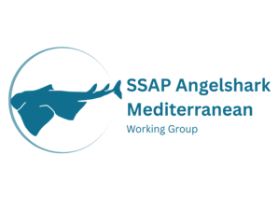

2ND MEETING OF THE WORKING GROUP ON THE IMPLEMENTATION OF THE SINGLE SPECIES ACTION PLAN FOR THE ANGELSHARK IN THE MEDITERRANEAN SEA (ANGELSHARK MED WG2)

Bonn, Germany, 3 December 2026
Agenda Item 6

DATA SHARING PROTOCOL
(Prepared by the Secretariat)

Summary

- This document provides a proposed process for the development of a data sharing protocol in the context of the Single Species Action Plan for the Angelshark, Squatina squatina in the Mediterranean Sea (SSAP Angelshark Med).

Background and Mandate

- The SSAP Angelshark Med outlines the following high priority action under Objective 2:

Action 2.1 Data collation: Collate national data (including both contemporary and historic sources) regarding the presence of Angelsharks Squatina squatina (and sister taxa) from relevant sources (including published studies, commercial and recreational fisheries data, fish market data, fisher and diver interviews, citizen science programmes, trawl survey data,
discard observer data, museum specimens, Angelshark survey data and historical resources) to better document the contemporary and historical occurrence of Angelsharks in national waters. Such data may also be enhanced through the collection of data on the current presence of Angelshark through the use of social media.

Such data could be usefully collated in a common format (see Annex II), with institutes collating national data collaborating with other national institutes in order that more robust regional data are available. The collation of comparable data for other species of Angel Shark should also be undertaken, in order to aid in the interpretation of data for Squatina squatina. The Angel Shark Sightings Map, hosted by the Angel Shark Conservation Network, is already established, open access and widely used and could be utilised for this purpose.

- At the first meeting of the Angelshark Med WG in 2025 (Angelshark WG1), the ASCN presented data sharing tools and proposed to manage data for the Angelshark Med WG. The need for a protocol balancing data confidentiality and utility was agreed and the Secretariat was given the task to develop a Decision for consideration at COP15

- Following the mandate from Angelshark WG1, the Secretariat considered the most appropriate pathway for taking this work forward. As the Coordinator was only recruited in December 2025, the timeline did not align with the deadlines for submitting COP documents, and no draft Decision was brought forward to COP15. Rather than rushing a proposal, it was considered more effective to first reach agreement within the Angelshark Med WG on the data needs and on the protocol itself, so that any subsequent proposal to the COP would rest on a shared understanding among Range States. The Secretariat therefore suggests that the Angelshark Med WG develop the protocol first, and that a proposed Decision be brought forward to a future CMS Scientific Council and COP once the Angelshark Med WG has agreed on it.

- Many datasets have already been provided by scientists for example for the development of the spatial advice document and the global Angel Shark Sightings Map is publicly available and hosted by the Angel Shark Conservation Network. However, much more data exists, including unpublished data and grey literature, that would help complement the full picture. Such data can be handled and traced with appropriate confidentiality safeguards, which is the purpose of the protocol proposed.

Proposed process for the development of data collection priorities and a data sharing protocol

- It is proposed to create an interim working group composed of members of the Angelshark Med WG to implement the following stepwise approach:

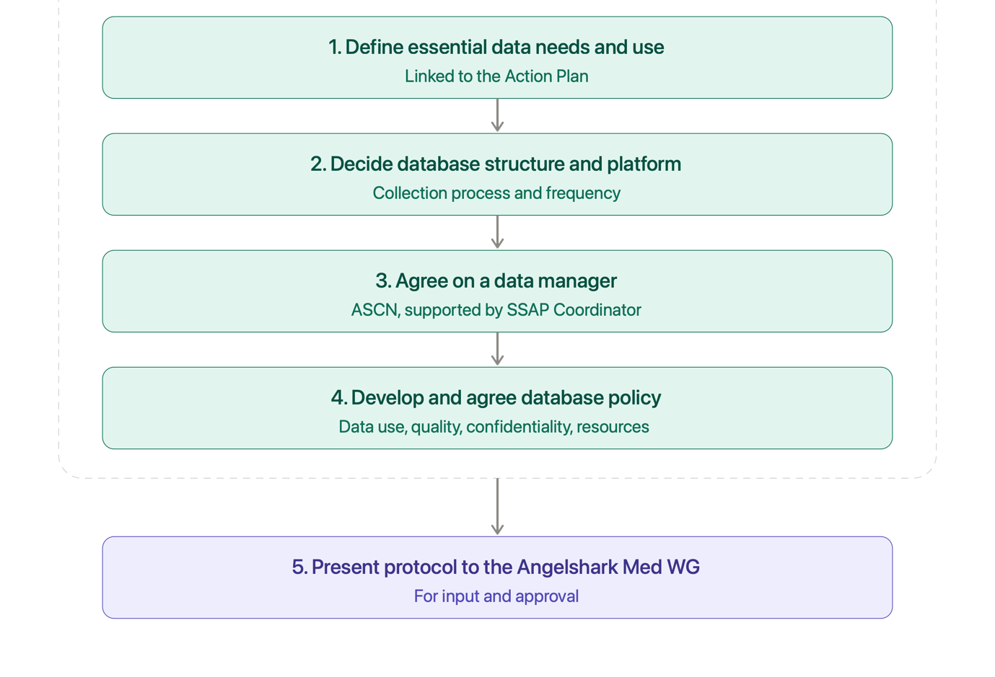
The Angelshark Med WG is requested to:

- Review the proposal; and

- Agree on next steps for its adoption and implementation.

