 | CONVENTION ON  MIGRATORY  SPECIES | UNEP/CMS/COP15/Doc.31.3.16/Rev.1  8 January 2026  Original: English

15th MEETING OF THE CONFERENCE OF THE PARTIES

Campo Grande, Brazil, 23 – 29 March 2026
Agenda Item 31.3.16

PROPOSAL FOR A CONCERTED ACTION FOR

THE MANTA AND DEVIL RAYS (MOBULIDAE) ALREADY LISTED ON APPENDIX I AND II OF THE CONVENTION*

Summary:

The government of Ecuador, the Manta Trust and Wildlife Conservation Society have submitted the attached proposal* for a Concerted Action for the manta and devil rays (Mobulidae) in accordance with the process elaborated in Resolution 12.28 (Rev. COP14).

Revision 1 reflects the inclusion of the Government of Ecuador among the list of proponents.

*The geographical designations employed in this document do not imply the expression of any opinion whatsoever on the part of the CMS Secretariat (or the United Nations Environment Programme) concerning the legal status of any country, territory, or area, or concerning the delimitation of its frontiers or boundaries. The responsibility for the contents of the document rests exclusively with its author.

PROPOSAL FOR A CONCERTED ACTION FOR
THE MANTA AND DEVIL RAYS (MOBULIDAE) ALREADY LISTED ON APPENDIX I AND II OF THE CONVENTION

Proponent(s)

- Government of Ecuador

- The Manta Trust

The Manta Trust is an international not-for-profit conservation organisation. Its mission is to collaborate with affiliates around the world through research and education activities, and by providing expert advice to drive the policies and practices necessary to conserve manta rays, their relatives, and habitats. The Manta Trust’s global network of affiliated projects are based in over thirty manta and devil ray (mobulid) range states. The Manta Trust is a Cooperating Partner to the CMS Sharks MOU.

- Wildlife Conservation Society (WCS)

The Wildlife Conservation Society is an international conservation organization working to save wildlife and wild places worldwide through science, conservation action, education, and inspiring people to value nature. WCS works across the globe in more than 60 countries, and the WCS Marine Conservation Program works in more than 20 countries to protect key marine habitats and wildlife, end overfishing, and protect key species, including sharks and rays. WCS teams conducts research on population trends, movement ecology, and fisheries interactions of sharks and rays; One of the organization’s main goals is to promote the implementation of science-based management measures through CITES and CMS and to build national capacity to conserve threatened species and reduce bycatch. WCS is a Cooperating Partner to the CMS Sharks MOU.

Target species, lower taxon or population, or group of taxa with needs in common

Class: Chondrichthyes
Order: Rajiformes
Family: Mobulidae
Species:
Scientific name | English name | Spanish name | French name
Mobula birostris | Oceanic Manta Ray | Manta oceánica | Raie manta océanique
Mobula yarae | Atlantic Manta Ray | Manta del Atlántico | Raie manta de l’Atlantique
Mobula alfredi | Reef Manta Ray | Manta de arrecife | Raie manta de récif
Mobula tarapacana | Sicklefin Devil Ray | Móbula cornuda | Mante diable faucille
Mobula mobular | Spinetail Devil Ray | Móbula de espina | Diable de mer
Mobula thurstoni | Bentfin Devil Ray | Móbula de aleta doblada | Mante diable à nageoires courbées
Mobula kuhlii | Shorthorned Pygmy Devil Ray | Móbula pigmea de aleta corta | Mante diable pygmée à petites cornes
Mobula eregoodoo | Longhorned Pygmy Devil Ray | Móbula pigmea de aleta longa | Mante diable pygmée à longues cornes
Mobula hypostoma | Atlantic Pygmy Devil Ray | Móbula pigmea del Atlántico | Mante diable pygmée de l’Atlantique
Mobula munkiana | Munk's Pygmy Devil Ray | Móbula pigmea de Munk | Mante diable pygmée de Munk
Table 1: Common names according to Stevens et al. 2025, Field Guide to the Manta and Devil Rays of the World.

Geographical range

Manta and devil rays (collectively known as mobulids) are distributed globally, primarily in tropical and subtropical waters. Mobula birostris, M. tarapacana, M. mobular, and M. thurstoni are distributed circumglobally in the Atlantic, Pacific, and Indian Oceans; seasonally venturing into the temperate regions of these oceans (Stevens et al. 2025). Mobula alfredi, M. eregoodoo, and M. kuhlii are restricted to the Indo-West Pacific (Notarbartolo di Sciara et al. 2020; Stevens et al. 2025). Mobula yarae and M. hypostoma are restricted to the Atlantic Ocean, and M. munkiana is restricted to the Eastern Pacific Ocean (Bucair et al. 2025; Stevens et al. 2025; Boggio-Pasqua et al. [In Review]). Within these broad ranges, populations are often sparsely distributed and highly fragmented, likely due to their resource and habitat needs, in addition to over-exploitation (Stewart et al. 2018).
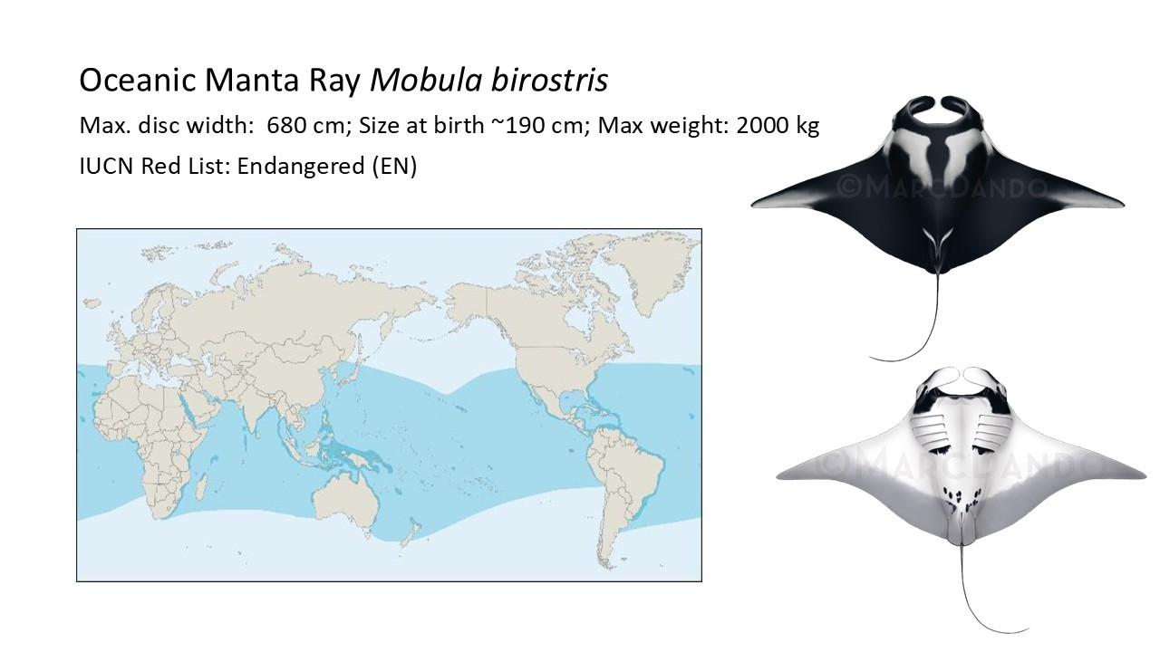

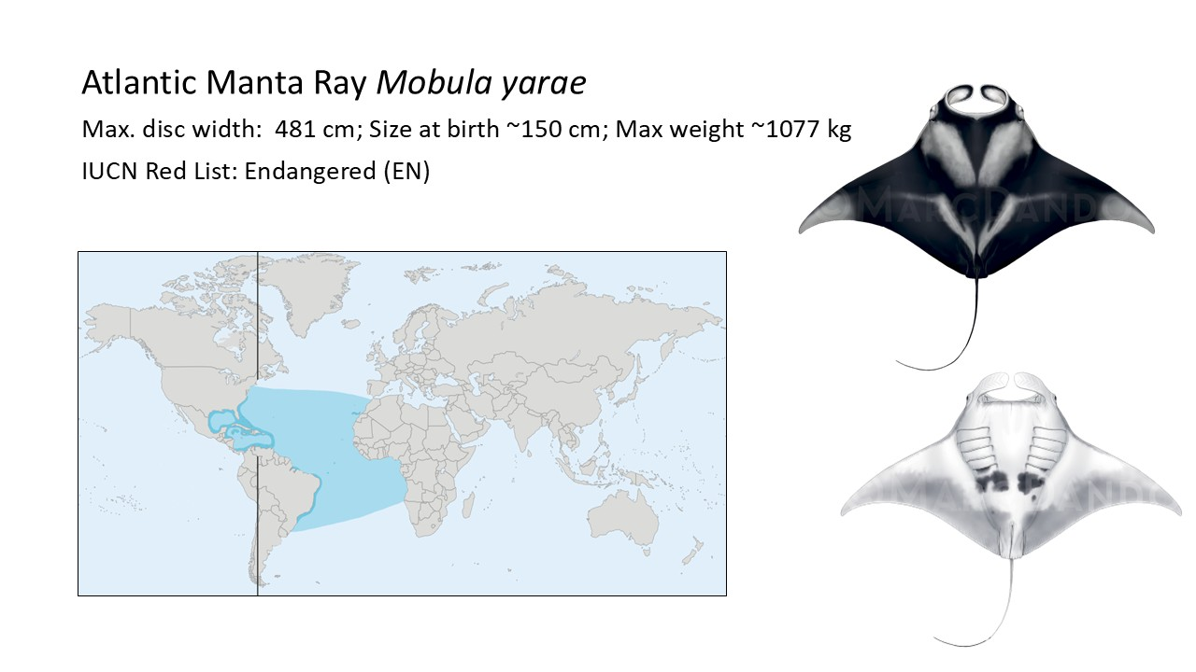

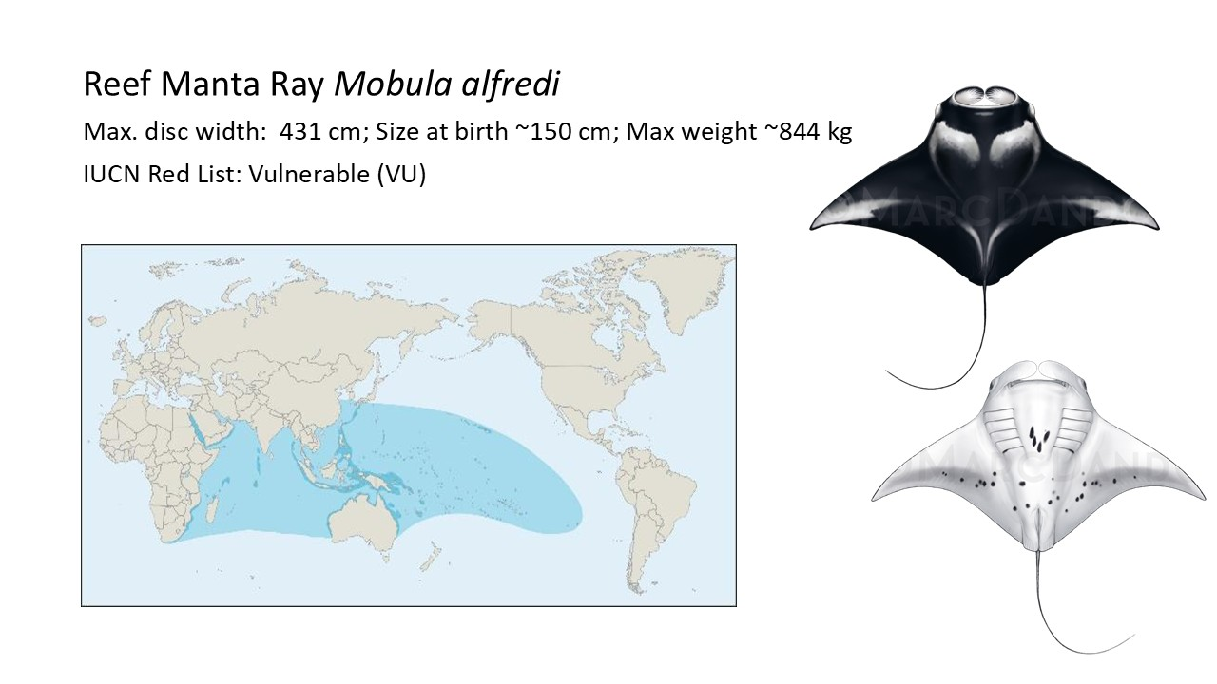

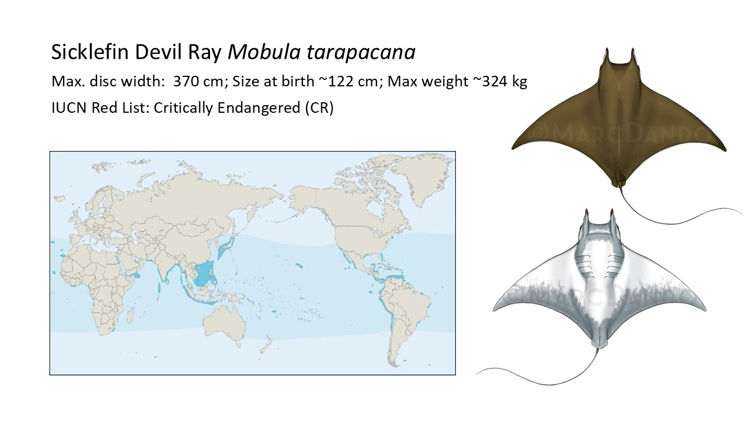

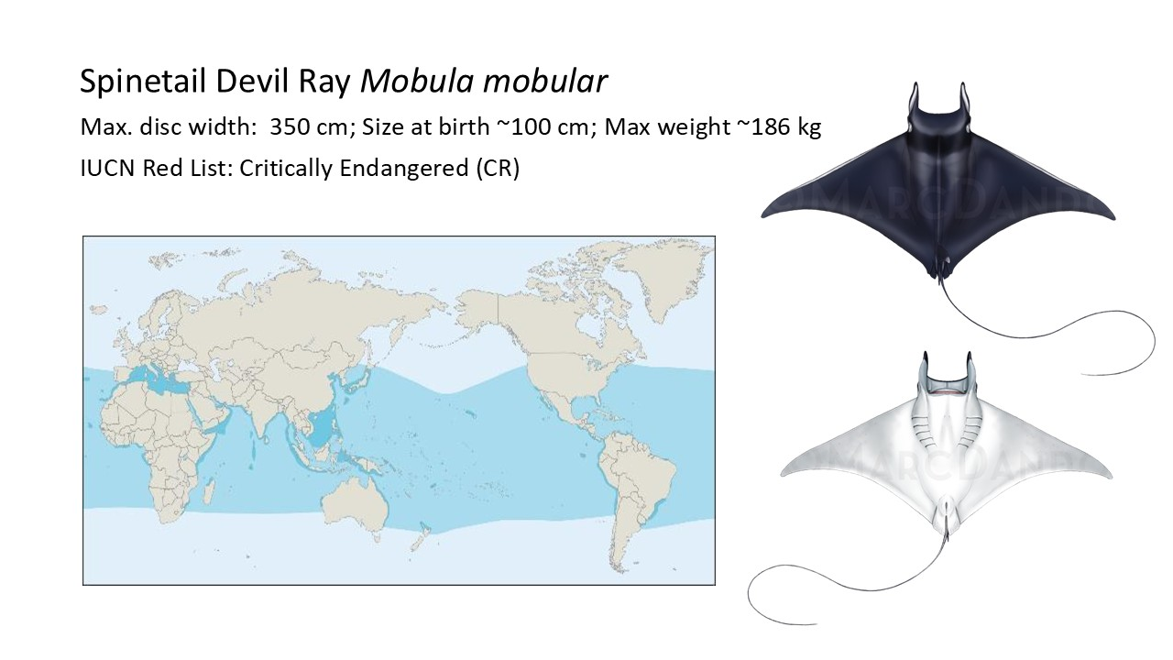

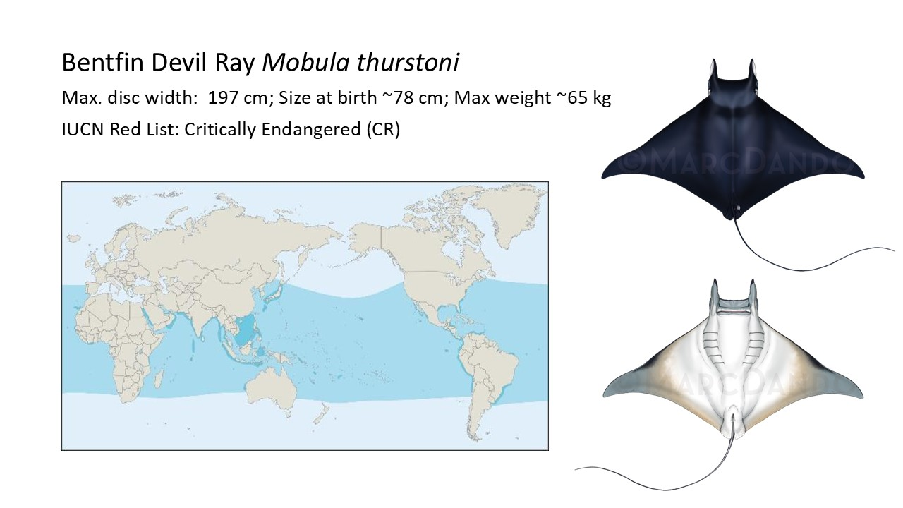

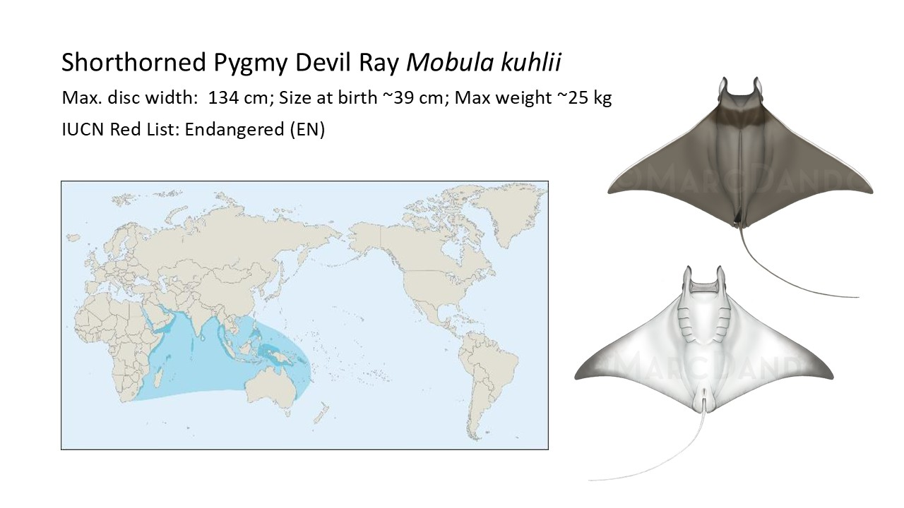

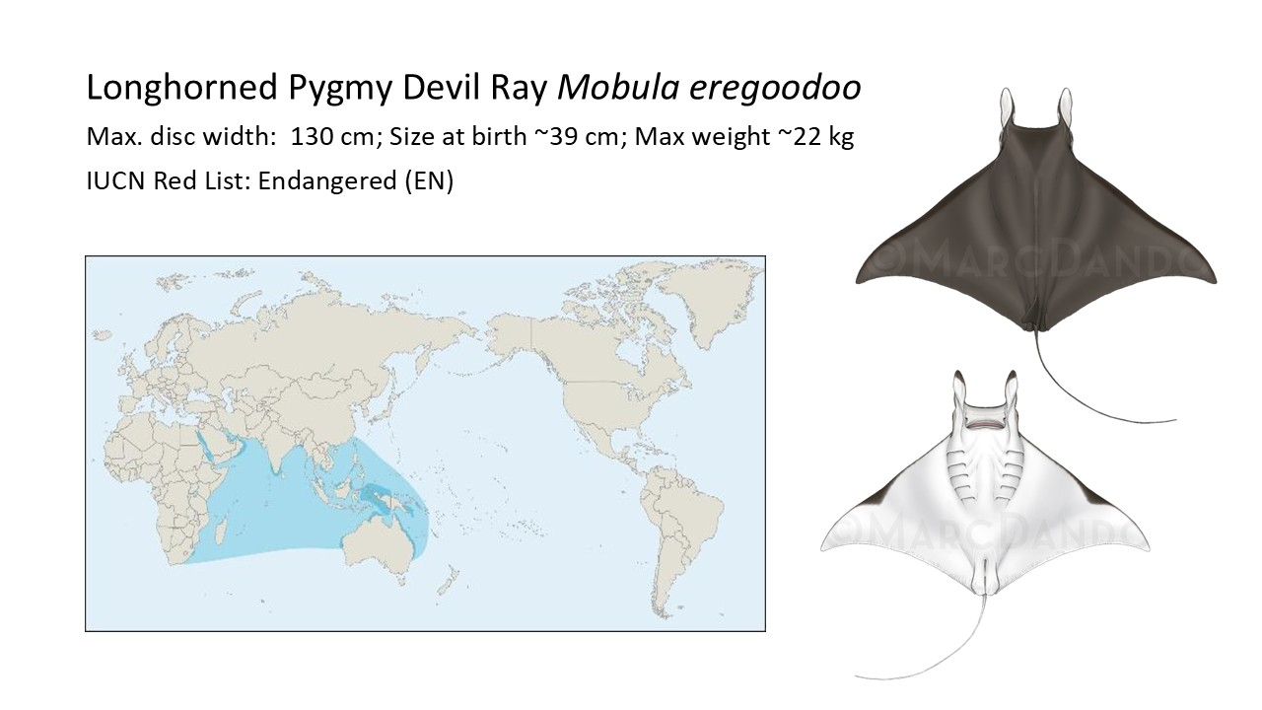

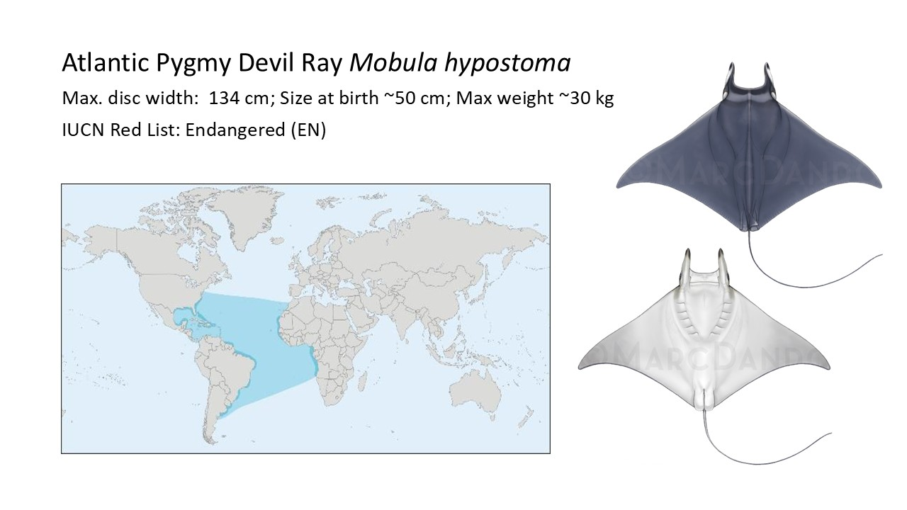

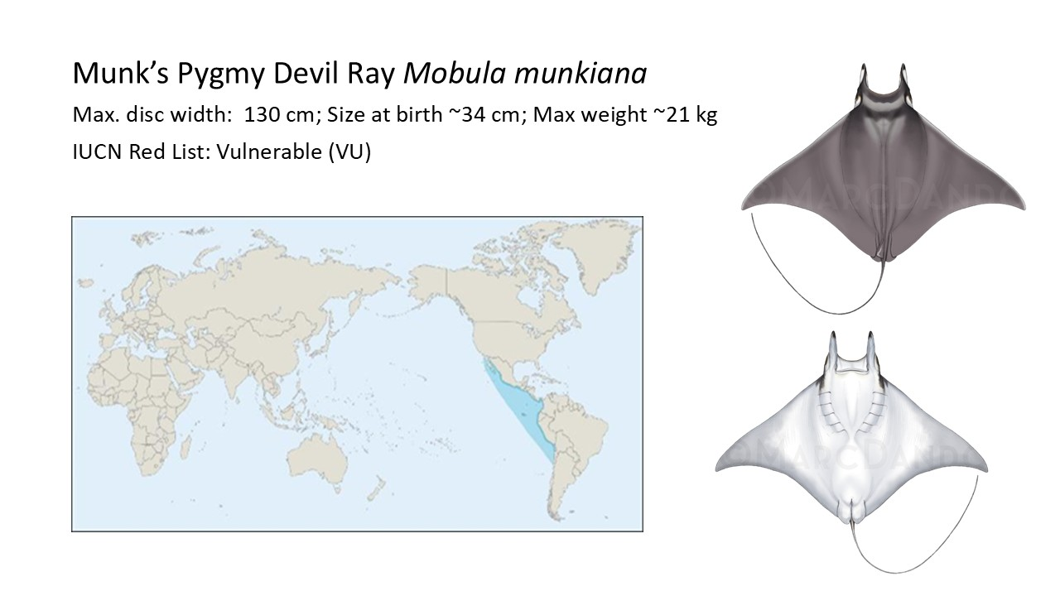

Summary of activities

- Implement national and regional legislation that prioritises manta and devil ray conservation.
- Develop capacity and technological tools to improve enforcement and traceability of manta and devil ray fisheries and trade.
- Transition from destructive fishing gear to affordable selective gear in high mortality-risk areas.
- Adopt safe fisheries handling and release methods.
- Establish area-based management to tackle manta and devil ray fishing in critical habitats
- Support research that improves knowledge on target and incidental manta and devil ray catch.
- Undertake global population distribution, estimates, and stock assessments for all manta and devil ray species.
- Establish long term data collection programmes in manat and devil ray fisheries management organisations.
- Reduce the demand on manta and devil ray products though outreach.
- Involve communities in regulatory or legislative changes, such as area-based management.
- Support the development of alternative livelihood programs with communities through collaborative planning and capacity building.
- Promoting best practices for manta and devil ray interactions and safeguarding in countries with established dedicated tourism.
- Monitor and assess the ecological impact of protective measures on manta and devil rays and re-assess approach dependent on effectiveness.

Activities and expected outcomes

All manta and devil ray range-state parties must implement protections nationally to prohibit catch and take of manta and devil rays to halt the ongoing steep population declines for these species. These protections should include implementation steps (see Annex I: Detailed Activities and Expected Outcomes Table):
- Transitioning from destructive fishing gear.
- Improving enforcement capacity and fisheries and trade traceability.
- Implementing inclusive area-based management in key areas.
- Implementing safe manta and devil ray handling and release guidelines.
- Campaigning to reduce demand on manta and devil ray products.
- Promoting best practices in manta and devil ray interactions and sustainable tourism.
- Developing research to support science-based management and the reduction of fisheries-related mortality in manta and devil rays.

This document should provide clear guidance to Parties on strategic objectives and actions to take to achieve the implementation of their conservation obligations under CMS. The outcomes expected include:
- Decreased manta and devil ray mortality, especially in high mortality-risk locations.
- Enhanced enforcement of existing fisheries and trade regulations.
- Improved science-based decision making on species management.
- Closing the gaps on manta and devil ray population data.

Such obligations will also align with the Pelagic Shark and Ray Conservation Strategy, which is currently being developed by the Shark Specialist Group of the International Union for the Conservation of Nature Species Survival Commission (IUCN SSC SSG). Signatories to the Memorandum of Understanding on the Conservation of Migratory Sharks (Sharks MOU) welcomed this initiative and progress made and agreed to support the approach outlined in CMS/Sharks/MOS4/Doc 10.2/Rev.1.

Associated benefits

It is the intention that the activities proposed in this document serve as a catalyst to deliver effective conservation for manta and devil rays and assist Parties in the implementation of their obligations under international treaties (e.g., CITES and CMS). It is also intended that these activities serve as an opportunity for Parties to collaborate, share, and propagate conservation knowledge, generate coordinating actions, and monitor progress that will be applicable to other marine species.

As trade in meat and gill plates is one of the main drivers of manta and devil ray fisheries worldwide, the efforts to regulate and enforce trade regulations are tightly connected with other conservation actions tackling fisheries-related mortality. Hence, CMS concerted actions need to be harmonized with CITES regulations, helping to stop illegal trade in manta and devil ray products. National legislation protecting all or some species of manta and devil rays exist in at least 44 countries (See Annex III) and implemented CMS actions are also a contribution to their enforcement.

Many coastal communities that catch manta and devil rays often also land other at-risk shark and ray species listed under CMS that will require protection. Recommendations to enhance manta and devil ray conservation outlook will likely have positive implications for other threatened and CMS-listed species in range-states.

Understanding and documenting manta and devil ray fisheries and livelihood options in key fishing communities will also support coordinated, effective, and socially just management and conservation of marine resources. Support for diversified income opportunities will help alleviate pressure on marine resource and ensure long term economic sustainability.

Timeframe

Please refer to Activities and expected outcomes section for an overview.

Relationship to other CMS actions

All Mobula spp. are listed on Appendix I and II of CMS (Mobula birostris in 2011 and the remaining manta and devil rays in 2014). Parties that are a Range State to a migratory species listed in Appendix I shall endeavour to strictly protect them by: prohibiting the taking of such species, with very restricted scope for exceptions; conserving and where appropriate restoring their habitats; preventing, removing or mitigating obstacles to their migration and controlling other factors that might endanger them.

According to Laglbauer et al. (In Review), although manta and devil rays have been listed in App. I and II of CMS for more than a decade, 55 of the countries where manta and devil catches occur have no domestic protective legislation. Of these, 44 are Parties of international conventions with rules or resolutions to fully protect manta and devil rays (CMS; Barcelona and/or Bern Conventions; Cartagena Convention). Additionally, eight countries with are not Parties to the above conventions are members of t-RFMOs with active retention bans, meaning only three range-states with manta and devil ray catches i) don´t have national protective legislation, ii) are not Parties to international conventions and iii) are not members of t-RFMOs (Myanmar; Palestine; Qatar). Therefore, these Concerted Actions would benefit the implementation of national and international regulations that protect manta and devil rays.

The Sharks MOU is the specialized agreement for chondrichthyan species in accordance with Article IV 1 of the Convention. It aims to guide international cooperation to maintain and achieve a sustainable conservation status for migratory sharks and rays included in its Annex 1.

Manta and devil rays have been included in Annex 1 of the Sharks MOU, which means they benefit from the agreed measures and actions under the MOU and its Conservation Plan as well as from technical guidance for its conservation.

The proposed concerted actions support the implementation of the Sharks MOU and the aim of species listed under CMS Appendices I and II. In particular, with regards to encouraging Sharks MOU Signatories that are also CMS Parties to ensure that national, legally binding regulations are in place to prohibit targeting, retaining, landing, transhipping, selling, etc. of manta and devil rays, in line with CMS Appendix I obligations, whilst safeguarding the livelihoods of Parties’ coastal communities that are dependent on manta and devil ray fishery.

The proposed actions will largely contribute to achieving the objectives the Conservation Plan (Sharks MOU Annex 3) for manta and devil rays.

The proposed actions also contribute to the accomplishment of other CMS resolutions. Parties have agreed to a comprehensive set of measures to avoid incidental capture and minimize mortality of CMS-listed sharks (Resolution 12.22 and Decisions 13.62 to 13.63 on Bycatch). And parties are requested to implement a comprehensive list of measures to minimize threats to migratory shark species, improve knowledge, monitoring, data sharing, legislation and international cooperation (Resolution 13.3 and Decisions 13.71 to 13.73 on Chondrichthyan Species).
A previous version of Concerted Actions for manta and devil rays was proposed and adopted in CMS CoP12 in 2017. Since then, recent research has uncovered that manta and devil ray fisheries are more intense and widespread than previously known, causing major declines across all species (Laglbauer et al. [In Review]; See Annex I), that trade in manta and devil ray products is has intensified and the markets have adapted, causing concerning transparency issues (Palacios et al. 2024). New updated and comprehensive safe handling and release guidelines for manta and devil rays have been published (Stevens et al. 2025), and post-release survival studies perfected (Stewart et al. 2024).

To halt declines in manta and devil species, action must be taken to drastically and urgently reduce fisheries-related mortality and trade in manta and devil ray products in an effective and inclusive way. The adoption and implementation of a revised and updated Concerted Actions for manta and devil rays is therefore a priority for this App I species-group conservation under CMS.

Conservation priority

Manta and devil rays are extremely biologically vulnerable due to their conservative life history traits, such as slow growth and late maturation, and are among the least fecund of all elasmobranchs (Dulvy et al. 2014). After reaching maturity at an average of 10 years, they typically give birth to only one pup every two to three years (up to eight years in some subpopulations) (Marshall et al. 2009; Stewart et al. 2018).

A comprehensive review of manta and devil ray catch and landings (Laglbauer et al. [In Review]) conducted a detailed analysis of peer-reviewed journal articles and grey literature, official databases, elasmobranch fishery and trade reports, and expert elicitation through country-focused online surveys and interviews. The results showed that manat and devil rays are targeted and caught as bycatch, and either retained or discarded when caught in non-selective gear, in at least 84 countries globally. This study estimated the global manta and devil ray catch to be ~265,000 individuals per year, being either targeted or retained through bycatch – a number which is incompatible with a sustainable future for these slow-growing, late-maturing species, with such low fecundity.

Laglbauer et al. also found that small-vessel fisheries (<15 m in length) are responsible for 85% of the global catch and 87% of the global mortality. At least 75 countries catch manta and devil rays in coastal/small-vessel fisheries globally (66 with landings), with drift gillnets being the most utilised gear. Annual catch by these fisheries is estimated at 225,047 mobulid rays, across all species. This highlights the importance and impact of actions being taken in “small-scale” fishing communities.

Manta and devil ray bycatch from the global tuna purse seine fleet was previously estimated at 13,000 individuals annually (Hall & Roman 2013; Croll et al. 2016). However, considering all large-vessel (>15 m) fleets, Laglbauer et al. found that 37 flag states and two RFMOs for which publicly available data could not be attributed to specific flag states (i.e., IATTC and WCPFC) catch an estimated 39,470 rays per year, which results in mortality (at-haul back) of 34,387 mobulid rays per year.

A recent study assessed post-release mortality in manta and devil rays using satellite tags to estimate survival rates of four species (M. birostris, M. mobular, M. tarapacana, and M. thurstoni) released from tuna purse seine vessels in three global regions (Stewart et al. 2024). This study found a significant negative effect of time spent on deck and that improved handling practices can increase survival rates, which stresses the importance of implementing optimal safe handling and release guidelines and informing conservation strategies for the future.

All commercial utilisation and trade in manta and devil ray products is derived from wild-caught animals. Manta and devil rays are utilised for their meat and dried pre-branchial appendages (gill plates) and are currently included in Appendix II of CITES; manta rays in 2013 and devil rays in 2016. However, recent literature has uncovered that trade in manta and devil ray products has not been effectively regulated or limited to sustainable levels, and instead has increased and adapted in the last decade, driving fisheries worldwide (Palacios et al. 2024). The same publication states that there is significant ongoing illegal and unreported meat and gill plate trade from 22 range States into eight import hubs, in a clear mismatch to what is reported to the CITES database (2017 – 2023), and threatening these species’ survival. Therefore, working to enforce trade regulations and reduce demand for manat and devil ray products is working towards eliminating market-driven fisheries.

Unsurprisingly, fisheries-related mortality has led to significant declines in manta and devil ray populations worldwide, which have been documented or inferred from sightings, landings, and catch data covering all species (See Annex II). To assess the order of magnitude of these declines, Laglbauer et al. performed a detailed analysis, involving in-depth literature review, calculating average landings per survey day/vessel, breaking down decline rates by species and correcting for fishing effort and seasonality where possible. This new data compilation shows declines of more than 80% in all manta and devil ray species, across all ocean basins, and of up to 99% in some cases (White et al., 2015; Moazzam, 2018; Lezama-Ochoa et al. 2019; Broadhurst et al. 2019; Fernando & Stewart 2021; Venables et al. 2024; Rojas-Perea et al. 2025; Laglbauer et al. 2025; Chopra et al. [In Review]; Boggio-Pascua et al. [In Review]; FAO 2024; FAO 2025; IOTC 2025 a, b).

Changes in population structure include local commercial extinction and local extirpation in certain areas (Venables et al. 2024; Rojas-Perea et al. 2025) and proved mean disc-width reduction in some populations, confirming overfishing (Fernando and Stewart 2021; Laglbauer et al. 2025). Moreover, these declines all happened in the last 30 years – which is equivalent to one to two generations of these slow growing species – and are getting stepper in the last decade, despite national, regional and international protections.

In the last decade, all manta and devil ray species have been included in the threatened categories of the IUCN Red List, and keep moving up the threat assessment status. The three oceanic devil rays (M. tarapacana, M. mobular, and M. thurstoni) were reassessed in 2025, and have all been updated to “Critically Endangered”, the last category before “Extinct in the Wild”.

Despite these overfishing-driven declines, the problem of halting fisheries-related mortality is a complex one that involves working alongside local communities. For fishing communities, especially small-scale fishers, manta and devil rays may represent a significant portion of their income. These rays are often caught with non-selective gear as part of multispecies fisheries. Small scale fishing communities are often in the poorest sector of their countries and have little capacity to absorb sudden income loss. Without working with affected communities as partners and ensuring support is in place before conservation strategies are implemented, strategies are often not effective.

Relevance

Parties that are Range States of manta and devil rays, which are listed on CMS Appendix I and II, agree, under CMS, to endeavour to strictly protect this family of rays by prohibiting the taking of such species, with very restricted scope for exceptions. However, public and fisher awareness of mobulid rays’ threatened status is generally poor.

From 99 range-states for manta and devil rays, 76 are CMS Parties. Of these, only 36 have national protective legislation. This means more than half of the Party range-sates don’t have any domestic legislation to protect manta and devil rays.

Enforcement needs improvement in countries that do have protective legislation and where fishing still occurs. Moreover, support for assisting communities in developing alternative livelihoods is lacking, even in locations where protective measures have been established, which therefore questions the effectiveness of, and compliance with, those measures.

Baseline data to assess population structure is lacking for most manta and devil ray species throughout their range. Some genetic and photo-ID studies indicate certain species (e.g., M. alfredi) have small and highly fragmented populations (Kashiwagi et al. 2014; Humble et al. 2023). As a result, fishing can rapidly deplete sub-populations, with recovery hindered significantly by their conservative life history traits.

Manta and devil rays undertake significant migrations (>1,000s km) across broad geographic ranges and between oceanic and coastal waters (Jaine et al. 2014; Francis & Jones 2016; Aruaz et al. 2019). For example, satellite tagging data from M. tarapacana showed straight-line travel distances up to 3,800 km in several months (Thorrold et al. 2014), while tagged M. mobular travelled 1,400 – 1,800 km, crossing through oligotrophic tropical and subtropical waters (Francis & Jones 2016). Mobula alfredi in the Maldives regularly travel hundreds of kilometres between aggregation sites seasonally (Harris & Stevens 2021), and transnationally over 500 kilometres between sites in Mozambique and South Africa (Marshall et al. 2023).

Manta and devil rays have been documented forming seasonal aggregations in small and extremely large groups around the world, with numbers ranging from a few individuals to tens of thousands (Palacios et al. 2023; Stevens et al. 2025). This migratory behaviour, combined with predictable aggregations in easily accessible areas, makes them vulnerable to coastal and high seas fisheries (Couturier et al. 2012; Croll et al. 2012). In some cases, hundreds of aggregating manta and devil rays have been incidentally captured in the same fishing event (Lezama-Ochoa et al. 2019). This risk is heightened for the lesser-studied and lesser-protected devil rays, which are more likely to aggregate in large numbers (Palacios et al. 2023).

Any national conservation initiatives intended to prevent manta and devil rays from being driven further towards extinction is unlikely to be successful if the animals are not protected during their seasonal migrations into, and through, other Range States’ waters as well as areas beyond national jurisdiction. By agreeing to a listing on CMS, Range States also agree to endeavour conserving and where appropriate restoring their habitats; preventing, removing or mitigating obstacles to their migration and controlling other factors that might endanger them.

Absence of better remedies

A strategic and collaborative approach is needed to take the next steps for conserving migratory species such as manta and devil rays (Lawson et al. 2017, Stewart et al. 2018, Palacios et al. 2024, Laglbauer et al. [In review]), and for this purpose it is essential that Parties work together on developing and implementing activities, such as reducing bycatch mortality and improving the enforcement of protective legislation. Additionally, family Mobulidae is being proposed to de uplisted to CITES Appendix I, which, if successful, will halt all legal commercial international trade. Cooperation through CMS will greatly enhance the ability of CMS Parties to implement their CITES obligations.

Better compliance monitoring of manta and devil ray fisheries and landings could also improve the capacity of priority countries to enforce existing tRFMO retention bans.

Globally, at least 44 countries have enacted domestic legal protections for manta and devil rays (See Annex III). Thirty-five protect all manta and devil rays found in their EEZ, either through domestic legislation pertaining to manta and devil rays (28) or through shark and ray sanctuaries (7), and nine protect some species (Laglbauer et al. [In Review]), so actions proposed should complement or enhance the effectiveness of these protections.

Despite all these protective measures at the national, regional and international level, manta and devil ray populations continue to decline. The CMS network is the ideal platform for improving awareness and driving implementation of the conservation strategies proposed by the recent global reviews of manta and devil ray fisheries (Laglbauer et al [In Review]) and trade (Palacios et al. 2024).

The partners to CMS, such as engaged NGOs and researchers, can support these actions once governments decide to go forward and adopt them, through the existing linkages that CMS has created.

Readiness and feasibility

A Global Strategy and Action Plan for conserving manta and devil rays has been published in 2017 (Lawson et al. 2017). In 2023, the Manta Trust updated this Global Strategy and Action Plan (Manta Trust, 2023a) and released its 5-year Plan (The Manta Trust 2023b) to orientate the work needed to achieve it. More recently, two major publications (Palacios et al. 2024; Laglbauer et al. [In Review]) paved the way for future conservation priorities in manta and devil rays, by performing the most in-depth analysis to date of manta and devil ray fisheries and trade, identifying key conservation actions to halt population declines, and priority countries were these should be implemented.

There is a network of engaged NGOs, researchers, and community organizations working on manta and devil ray conservation, ready to support range states to develop, fund and implement collaborative work, creating is a strong foundation from which Range States can implement the activities proposed. Furthermore, support will be requested from the Sharks MOU and Cooperating Partners to support the development and implementation of the actions planned.

Globally, at least 44 countries have domestic legal protections for manta and devil rays in place, meaning policy framework exist to support the action proposed (See Annex III). In most of these, there is already collaborative work with NGOs and scientists on the ground to support affected communities and implementation. The groundwork exists, but further understanding, planning, and support from these Range States is needed to assist communities to transition away from manta and devil ray fisheries.

In addition, all four relevant tRFMOs have adopted resolutions that prohibit retention on board, trans-shipping, landing, storing, selling, or offering for sale any part or whole carcass of manta and devil rays caught in their areas (Stevens et al 2025). This can provide a for research, namely for stock assessments, and for the dissemination of effective bycatch mitigation measures.

A new Field Guide to the Manta and Devil Rays of the World was published in 2025 (Stevens et al. 2025). This guide features updated species accounts, gill plates and species ID keys, key species features, data collection protocols, safe handling and release guidelines, and post-mortem colour change illustrations, as well as revised ecology, plates, threats assessment, and protective legislation. The guide is available in four languages (English, Spanish, French, and Portuguese) and will be a valuable tool to contribute to better species-specific data gathering and enforcement of protective legislation.

Finally, organizations such as the Manta Trust have an established network of 31 affiliate projects around the world working, brings together new and established initiatives that drive the research and conservation of manta and devil rays as a collective. Other organizations such as Wildlife Conservation Society and Marine Megafauna Foundation have a network of dedicated professionals working worldwide in manta and devil ray to research and conservation.

Likelihood of success

Unsustainable fishing is the main threat to manta and devil rays (Stewart et al. 2018, Stevens et al. 2025). Therefore, reducing fisheries-related mortality, eliminating drivers for targeted catches and retained bycatch and using research to inform management decisions, are the key lines of action that can halt populations declines in manta and devil rays. The proposed activities are supported by engaged NGOs, researchers and community organisations.

There are risk factors associated with this concerted action, namely a lack of capacity in species identification, catch and abundance information, and capacity from national agencies. However, with support from NGOs, scientific experts and organisations, these concerted actions will provide tools to overcome these constrains.

Identification skills will be tackled by the dissemination of the new Field Guide to the Manta and Devil Rays of the World (Stevens et al. 2025) and through the implementation of Activity 2 - Develop capacity and technological tools to improve enforcement and traceability of fisheries and trade.

Existing gata gathering constrains exist, with manta and devil ray landings data often only recorded at the family level. Effort must be directed into standardizing data collection protocols to gather species-specific population trends for each species, across several locations, covering all ocean-basins. Other constraints result from highly fragmented and sparsely distributed populations in some species, many of which are already heavily depleted, making fisheries and trade data scarce (Laglbauer et al. [In Review]). Moreover, working conditions can be challenging as most manta and devil ray fisheries are made by small vessels, in developing countries, making data gathering logistics often difficult (Rojas-Perea, 2025, Laglbauer et al. 2025).

Despite all the risk factors identified above, recent studies have been able to provide solid biological data on species trends, identify policy gaps, priority countries, and pave the way for impactful future conservation actions (Fernado & Stewart 2021; Venables et al. 2024; Rojas-Perea et al. 2025; Laglabuer et al. 2025). Moreover, the actions proposed in these concerted actions, will also increase understanding and scientific data from the community level about catch and species information.

The engagement of communities in co-management and planning activities for implementation helps to ensure that protection strategies will be effective and realistic. This is of benefit to all Range States where coastal communities depend on manta and devil ray fisheries.

Activities involving swimming with manta rays are a fast-growing industry. Tourists spend hundreds of millions of dollars every year to see manta and devil rays in the wild. For example, in the Maldives this industry has grown remarkably in the last decade, generating revenue of US $39 million through diving and snorkelling trips to see manta rays in 2021 alone. Other popular destinations have become increasingly popular in recent years (e.g., Azores, Mexico, Indonesia). However, unmanaged human interactions with manta and devil rays can lead to negative impacts on local populations in tourist hotspots as the number of interactions increase. For example, by entanglement in mooring lines or through collisions with motor boats. There are already developed protocols in place to mitigate these threats, ready to be implemented at a wide scale (Code of conduct for swimming with manta and devil rays; Mooring line entanglement protocol; Mooring line entanglement mitigation), as well as speed restrictions in collision hotspots, to facilitate the sustainable tourism activities and other human interactions.

There are strong foundations and organizational experience to build upon to successfully implement these concerted actions and the Sharks MOU Signatories and Cooperating Partners will be invited to support the development and implementation of the action plans to further increase the likelihood of success.

Magnitude of likely impact

Declines in an order of magnitude of more than 80% have been uncovered for all species across many studied sites worldwide. Manta and devil ray gill plates, once extracted and dried for trade, can only be grouped into four species groups, encompassing all species of the in family Mobulidae. All four categories were found in the global trade assessments made to date (Zeng et al. 2016, O´Malley et al. 2017, Palacios et al. 2024). The impact of the proposed actions would therefore ripple out across all species of manta and devil rays.

Manta and devil ray catch has been documented in at least 84 countries, 62 of which are CMS parties (Laglbauer et al. [In Review]). Therefore, there is potential for these actions to create impact across most of the area where fisheries are driving population declines. To magnify conservation effect, it is encouraged that an increased number of Range States become Signatories to the Sharks MOU to agree to endeavour to pursue MOU objectives.
Successful implementation could result in:
- Increased species-species population and fisheries data to inform further conservation decisions.
- Better compliance of national and international protective legislations.
- Increased local and regional capacity to address fisheries-related mortality.

There is a network of engaged NGOs, researchers, and community organizations working on manta and devil ray conservation, ready to support Range States to develop, fund and implement collaborative work, creating is a strong foundation from which Range States can implement the activities proposed. Furthermore, support will be requested from the Sharks MOU and Cooperating Partners, to support the development and implementation of the actions planned.
Cost-effectiveness

An essential aspect of the Concerted Actions is fostering collaboration among Parties through information sharing, knowledge exchange, and joint strategy development. By replicating successful conservation efforts and promoting best practices, this collective approach becomes far more cost-effective than countries acting independently.

Actions 3, 10 and 11 will need to be implement as pilot or community-specific projects, with funding made available on a project-base case, varying depending on location. Please refer to Annex I (Detailed Activities and Expected Outcomes Table) for an overview.

Consultations planned / undertaken

It is envisaged to engage with Parties and stakeholders to advance the implementation of the concerted actions in one of the Scientific Council Meetings.

References

Arauz, R., Chávez, E. J., Hoyos-Padilla, E. M., & Marshall, A. D. (2019). First record of the reef manta ray, Mobula alfredi, from the eastern Pacific. Marine Biodiversity Records, 12(1), 3.
Boggio-Pasqua, A., Bassos-Hull, K., Stevens, G., …, Notarbartolo-di-Sciara, G. (under review) Closing the gaps: Integrating biological, ecological and taxonomic data to support the conservation of the Atlantic pygmy devil ray (Mobula hypostoma). [In review]
Broadhurst, M. K., Laglbauer, B. J. L., Burgess, K. B., and Coleman, M. A. (2018). Reproductive biology and range extension for Mobula kuhlii cf. eregoodootenkee. Endanger Species Res. 35, 71–80. doi: 10.3354/esr00876
Bucair, N. et al (2025) An integrative taxonomy investigation unravels a cryptic species of Mobula Rafinesque, 1810 (Mobulidae, Myliobatiformes), from the Atlantic Ocean. Enviromental Biology of Fishes. https://doi.org/10.1007/s10641-025-01727-2
Chopra, M., Rowlands, M. G., Stevens, G. M. W., Fernando, D., Mohanraj, T., Laglbauer, B. J., Karnad, D., & Katrina, D. (2025). Fewer devil rays in the sea: Evidence of declining mobulid populations off India’s southeastern coast. [In review]
Couturier, L. I. E., Marshall, A. D., Jaine, F. R. A., Kashiwagi, T., Pierce, S. J., Townsend, K. A., Weeks, S. J., Bennett, M. B. and Richardson, A. J. (2012) Biology, ecology and conservation of the Mobulidae. J. Fish. Biol., 80, 1075-1119.
Croll, D. A., Newton, K. M., Weng, K., Galván-Magaña, F., O’Sullivan, J., and Dewar, H. (2012). Movement and habitat use by the spine-tail devil ray in the Eastern Pacific Ocean. Mar. Ecol. Prog. Series 465, 193–200. doi: 10.3354/meps09900
Croll, D. A., Dewar, H., Dulvy, N. K., Fernando, D., Francis, M. P., Galván-Magaña, F., Hall, M., Heinrichs, S., Marshall, A., McCauley, D., Newton, K. M., Notarbartolo di Sciara, G., O’Malley, M., O’Sullivan, J., Poortvliet, M., Roman, M., Stevens, G., Tershy, B. R. and White, W. T. (2016) Vulnerabilities and fisheries impacts: the uncertain future of manta and devil rays. Aquatic Conserv: Mar. Freshw. Ecosyst., 26: 562-575.
Dulvy, N. K., Pardo, S. A., Simpfendorfer, C. A. and Carlson, J. K. (2014) Diagnosing the dangerous demography of manta rays using life history theory, PeerJ, 2:e400.
Fernando D., Stewart J.D. (2021) High bycatch rates of manta and devil rays in the "small-scale" artisanal fisheries of Sri Lanka. PeerJ 9. https://doi.org/10.7717/PEERJ.11994
Francis, M.P., Jones, E.G. (2016). Movement, depth distribution and survival of spinetail devilrays (Mobula japanica) tagged and released from purse-seine catches in New Zealand. Aquat. Conserv. Mar. Freshw. Ecosyst. 27, 219–236. doi: 10.1002/aqc.2641
Food and Agriculture Organization of the United Nations. (FAO) (2024). FishStatJ: Global capture production dataset (2016–2023 catches of mobulid species in Indonesia). Acceced September 13, 2024, from. https://www.fao.org/fishery/statistics/software/fishstatj/
Food and Agriculture Organization of the United Nations (FAO). (2025a). FishStatJ: Software for Fishery Statistical Time Series: “Reported catches of marine fishes in Mexico (2019–2022)”. Fisheries and Aquaculture Division. Food and Agriculture Organization of the United Nations. Accessed May 22, 2025, from http://www.fao.org/fishery/statistics/software/fishstatj/
Harris, J. L., & Stevens, G. M. (2021). Environmental drivers of reef manta ray (Mobula alfredi) visitation patterns to key aggregation habitats in the Maldives. PLoS One, 16(6), e0252470.
Indian Ocean Tuna Commission (IOTC). (2025a). Public domain dataset: Reported catches of mobulid species in Kenya (2018–2022). IOTC Public Domain Data. https://iotc.org/data/datasets/public-domain-catch-and-effort. Accessed 8 Mar 2025
Indian Ocean Tuna Commission (IOTC). (2025b). Public domain dataset: Reported catches of mobulid species in Pakistan (2006–2023). IOTC Public Domain Data. https://iotc.org/data/datasets/public-domain-catch-and-effort. Accessed 8 Mar 2025
Hall, M. & Roman, M. (2013) Bycatches and non-tuna catches in the tropical tuna purse seine fisheries of the world. FAO Fisheries and Aquaculture Technical Paper No. 568. Food and Agricultural Organization of the United Nations, Rome, Italy.
Humble, E., Hosegood, J., Carvalho, G., De Bruyn, M., Creer, S., Stevens, G. M., ... & Ogden, R. (2023). Comparative population genomics of manta rays has global implications for management. Molecular Ecology.
Jaine, F. R. A., Rohner, C. A., Weeks, S. J., Couturier, L. I. E., Bennett, M. B., Townsend, K. A., et al. (2014). Movements and habitat use of reef manta rays off eastern Australia: offshore excursions, deep diving and eddy affinity revealed by satellite telemetry. Mar. Ecol. Prog. Series 510, 73–86. doi: 10.3354/meps 10910
Kashiwagi, T., Marshall, A. D., Bennett, M. B., and Ovenden, J. R. (2011). Habitat segregation and mosaic sympatry of the two species of manta ray in the Indian and Pacific Oceans: Manta alfredi and M. birostris. Mar. Biodivers. Rec. 4, 1–8. doi: 10.1017/S1755267211000479
Laglbauer, B., D’Costa, N. G., Stewart, J. D., Palacios, M. D., Cronin, M., Fernando, D., ... & Stevens, G. M. W. (In Review). Global manta and devil ray population declines: Closing policy and management gaps to reduce fisheries mortality. Biological Conservation.
Laglbauer, B.J., Salim, M.G., Fahmi, F., Oktaviyani. S., Gozali, I.C., Tawang, F., Rizal, H.S., Rosady, V.P, Rudianto, D., Ender, I., Fontes, J.M., Afonso, P., Bennet, M.B., Stevens, G.M.W. (2025) High take of mobulid rays amongst other threatened elasmobranchs in East Java, Indonesia: landing trends and socio-economic context. Environmental Biology of Fishes, https://doi.org/10.1007/s10641-025-01749-w
Lawson, J.M., Fordham, S.V., O’Malley, M.P., Davidson, L.N., Walls, R.H., Heupel, M.R., Stevens, G., Fernando, D., Budziak, A., Simpfendorfer, C.A., Ender, I. (2017) Sympathy for the devil: a conservation strategy for devil and manta rays. PeerJ. 2017 Mar 14;5:e3027.
Lezama-Ochoa, N., Hall, M. A., Roman-Verdesoto, M. H. &Vogel, N. (2019b) Spatial and temporal distribution of mobulid ray species in the eastern Pacific Ocean ascertained from observer data from the tropical tuna purse-seine fishery, Environmental Biology of Fishes, https://doi.org/10.1007/s10641-018-0832-1
Marshall, A. D., Compagno, L. J. V., and Bennett, M. B. (2009). Redescription of the genus Manta with resurrection of Manta alfredi. Zootaxa 28, 1–28.
Marshall, A. D., Flam, A. L., Cullain, N., Carpenter, M., Conradie, J., & Venables, S. K. (2023). Southward range extension and transboundary movements of reef manta rays Mobula alfredi along the east African coastline. Journal of Fish Biology, 102(3), 628-634.
Moazzam, M. (2018) Unprecedented decline in the catches of mobulids: an important component of tuna gillnet fisheries of the Northern Arabian Sea. IOTC-2018-WPEB14-30. Cape Town, South Africa.
Notarbartolo di Sciara, G., Stevens, G. and Fernando, D. (2020) The giant devil ray Mobula mobular (Bonnaterre, 1788) is not giant, but it is the only spinetail devil ray, Marine Biodiversity Records, 13:4.
O’Malley, M. P., Townsend, K. A., Hilton, P., Heinrichs, S. and Stewart, J. D. (2016) Characterization of the trade in manta and devil ray gill plates in China and South-East Asia through trader surveys, Aquatic Cons.: Mar. and Freshw. Eco., 27:2.
Palacios, M. D., Stewart, J. D., Croll, D. A., Cronin, M. R., Trejo-Ramírez, A., Stevens, G. M., ... & Galván− Magaña, F. (2023). Manta and devil ray aggregations: conservation challenges and developments in the field. Frontiers in Marine Science, 10, 1148234.
Palacios, M.D., Wieand L., Laglbauer B.J., Cronin M.R., Fowler S., Jabado R.W., Ko Gyi T., Fernando D., De Bruyne G., Shea, S.K.H., Hilton, P., Gao Y., Stevens. G.M. W. (2024) Global assessment of manta and devil ray gill plate and meat trade: conservation implications and opportunities. Environmental Biology of Fishes
Rojas-Perea, S., D’Costa, N.G., Kanagusuku, K. et al. (2025) Fisheries, trade, and conservation of manta and devil rays in Peru. Environ Biol Fish 108, 725–748. https://doi.org/10.1007/s10641-024-01647-7
Stevens, G. M. W, Barros, N., Laglbauer B.J., Dando M., Fernando, D & Norbartolo di Sciara G. (2025) Field Guide to the Manta and Devil Rays of the World. Wild Nature Press (pp. 1-100)
Stewart, J. D., Jaine, F. R. A., Armstrong, A. J., Armstrong, A. O., Bennett, M. B., Burgess, K. B., Couturier, L. I. E., Croll, D. A., Cronin, M. R., Deakos, M. H., Dudgeon, C. L., Fernando, D., Froman, N., Germanov, E. S., Hall, M. A., Hinojosa-Alvarez, S., Hosegood, J. E., Kashiwagi, T., Laglbauer, B. J. L., Lazama-Ochoa, N., Marshall, A. D., McGregor, F., Notarbartolo di Sciara, G., Palacios, M. D., Peel, L. R., Richardson, A. J., Rubin, R. D., Townsend, K. A., Venables, S. K. and Stevens, G. (2018) Research Priorities to Support Effective Manta and Devil Ray Conservation, Front. Mar. Sci., 5: 314.
Stewart, J. D., Cronin, M., R., Largacha, E., Lezama-Ochoa, N., Lopez J., Hall, M., Hutchinson, M., Jones, E.G., Francis, M., Grande, M., Murua, J., Vanessa Rojo, V., and Jorgensen, J. M. (2024). Get them off the deck: Straightforward interventions increase post-release survival rates of manta and devil rays in tuna purse seine fisheries. Biological Conservation, volume 299, 110794.
The Manta Trust (2023a). Conserving Manta & Devil Rays: A Global Strategy & Action Plan. https://www.mantatrust.org/our-approach. Accessed October 18, 2025.
The Manta Trust (2023b). The Manta Trust Five-Year Plan. https://www.mantatrust.org/our-approach Accessed October 18, 2025.
Thorrold, S. R., Afonso, P., Fontes, J., Braun, C. D., Santos, R. S., Skomal, G. B., et al. (2014). Extreme diving behaviour in devil rays links surface waters and the deep ocean. Nat. Commun. 5:4274. doi: 10.1038/ncomms5274
Venables, S. K., Rohner, C. A., Flam, A. L., Pierce, S. J., & Marshall, A. D. (2024). Persistent declines in sightings of manta and devil rays (Mobulidae) at a global hotspot in southern Mozambique. Environmental Biology of Fishes, 1-17.
White, E. R., Myers, M. C., Flemming, J. M., & Baum, J. K. (2015). Shifting elasmobranch community assemblage at Cocos Island-an isolated marine protected area. Conservation Biology, 00(0), 1–12. doi:10.1111/cobi.12478
Zeng, Y., Wu, Z., Zhang, C. et al. (2016) DNA barcoding of Mobulid Ray Gill Rakers for Implementing CITES on Elasmobranch in China. Sci Rep 6, 37567. https://doi.org/10.1038/srep37567

Annex I: Detailed Activities and Expected Outcomes Table

Activity | Output/Outcome | Timeframe | Responsibility | Funding | Indicators
Reduce target and incidental catch of manta and devil rays though management measures
- Implement legislation that supports manta and devil ray conservation | - Protective policies exist on local, national or regional scale that decrease or eliminate mobulid mortality, especially in high mortality-risk locations.  - Enhance cooperation by expanding signatories to the Shark MOU. | 2026 – open ended | Range State Parties with identified catches of manta and devil rays, supported by NGOs and experts | As and if requested by Parties. | - Number of national legislations in place, that provide policy framework to enforce retention bans and zero incidental catch retention quotas.  - Increased number. of Range States as Signatories to the Sharks MOU to agree to endeavour to pursue MOU objectives.
- Develop capacity and technological tools to improve enforcement and traceability of fisheries and trade | - Enforcement staff and onboard observers trained to improve reporting and reducing misidentifications and/or coding errors.  - Technology exists allowing anyone to submit info on mobulids being traded and landed or observed at fish markets landing sites.  - Rapid genetic and visual identification tools exist to determine species and population location of specimens (or parts) found in trade. | 2026 - 2029 | Party Range States, NGOs, Research Bodies  Parties may invite the following to support with implementation:  Sharks MOU Signatories, CMS Sharks MOU Cooperating Partners. | Funding needed for development of technology and organising workshops. | - Higher record of species-specific info on FAO, tRFMOs, CITES and national databases.  - Improvement on fisheries and landings data.  - Illegal trade routes finely reassessed.  - Traded specimens identified at a species and population-levels.
- Transition from destructive fishing gear to affordable selective gear in high mortality-risk areas | Fisheries use selective gear that reduces incidental catch and mortality of manta and devil rays, including SSF. | 2026 – open ended | Range State Parties with identified catches of manta and devil rays, supported by NGOs and experts | As required by Parties and/or project/initiative leads in a case-by-case basis. | Improved long-term population outlook for the manta and devil rays in affected areas
- Adopt safe handling and release methods | Updated safe handling and release guidelines adopted by relevant fisheries management entities and disseminated and implemented through fishers, including SSF; | 2026 – open ended | Party Range States, NGOs, Research Bodies, RFBs, RFMOs. | As required on a case-by-case basis. Funding necessary for workshops and in case of gear and/or supporting material needed (i.e mobulid grid) | At-vessel and post-release mortality reduced.
- Establish area-based management to tackle manta and devil ray fishing in critical habitats | - Effective permanent measures to avoid catching manta and devil rays where year-round catch occurs.  - Effective temporal or spatial fishing restrictions exist when suitable, based on knowledge about mobulid movement and habitat use. | 2026 – open ended | Party Range States, NGOs, Research Bodies, RFBs, RFMOs. | As required on a case-by-case basis. Long term funding necessary for community proximity consultation and implementation work. | Improved long-term population outlook for the manta and devil rays in affected areas
Closing knowledge gaps regarding population estimates and trends, fisheries data and bycatch mitigation
- Support research that improves knowledge on target and incidental manta and devil ray catch | - Comprehensive and standardized data recording, and prioritization exist under fisheries management observation programs, including SSF.  - Bycatch mitigation measured trialed and results published.  - Latest scientific knowledge informs Parties on appropriate protective measures and management. | 2026-open ended | Party Range States, NGOs, Research Bodies, RFBs, RFMOs. | As required by research projects. | - Improvement in availability of species-specific information.  - Increased post-release survival rates.  - Literature published on bycatch mitigation.
- Undertake global population distribution, estimates and stock assessments for all manta and devil ray species | - Distribution of all species of manta and devil rays accurately defined.  - Potential range restrictions as a result of historical fishing pressure defined.  - Stock assessments determined in order to inform fisheries management and monitoring. | 2026 – 2029 | Party Range States, NGOs, Research Bodies, RFBs, RFMOs. | As required on a project basis. Funding necessary for desktop research and field work. | - Published research on historical distribution for all species.  - Stock assessments published for all species.
- Establishing long term data collection programmes in manta and devil ray fisheries data | - Regular population (sightings, catches, landings) monitoring programs exist to access population trends, especially in high-mortality risk areas. | 2026 – open ended | Party Range States, NGOs, Research Bodies. | As requested by parties or research projects. | - Number of countries and programmes running.  - Number of mobulids caught by target-area, identified at species-level.
Reduce demand in manta and devil ray products though outreach
- Reduce the demand on manta and devil ray products | - Drivers of manta and devil products consumption known for key regions.  - Demand for manta and devil ray products reduced through Tailored campaigns targeting consumers of meat and gill plates to reduce demand and inform on legality of fisheries and trade. | 2026 - 2029 | NGOs, Research Bodies, Party Range States. | Funding necessary for research on drivers and consumption and for developing and implementing comms campaigns. | - Reduction in availability of manta and devil ray gill plates through market reassessments.  - Number of consumers reached though the campaigns.
Drive collaborative community-based management
- Involve communities in regulatory or legislative changes, such as area-based management | - Informed and inclusive management drives appropriate and effective decision making and implementation of legislation;  - Socio-economic information on manta and devil ray catch from fishing communities gathered. | 2026 – open ended | Party Range States, Sharks MOU Signatories, CMS Sharks MoU Cooperating Partners, NGOs. | As required on a case-by-case basis. Long term funding needed for community involvement | - Number of community members involved in project actions.
- Support the development of alternative livelihood programs with communities through collaborative planning and capacity building. | - Engaged and informed communities are willing and have the capacity to move away from mobulid fishing, and prepared for transition. | 2026 – open ended | Party Range States, Sharks MOU Signatories, CMS Sharks MoU Cooperating Partners, NGOs. | As required on a case-by-case basis. Long term funding needed for community involvement, capacity building and technical support | - Number of alternative livelihood programmes and community members engaged.  - Improved long-term population outlook for the mobulid rays in affected areas.
Promoting best practices in manta and devil ray interactions and sustainable tourism
- Promoting best practices for manta and devil ray interactions and safeguarding in countries with established dedicated tourism | - Disseminating and implementing code of conduct for swimming with manta and devil rays.  - Disseminating mooring line entanglement mitigation and entanglement protocol  - Implementing mitigation measures for boat/propeller injuries | 2026-2028 | NGOs, Research Bodies, Party Range States with established manta and devil ray observation tourism. | As requires in a case-by-case approach. Cost should be minimal. | - Number of companies and stakeholders reached
Monitor impact and adapt management strategies
- Monitor and assess the ecological impact of protective measures on manta and devil rays, and re-assess approach dependent on effectiveness. | Management is informed of the effectiveness of protective measures and adapts its direction if needed. | 2028-2029 | Party Range States, NGOs, research bodies. | No funding needed | - Progress and effectiveness analysis informs strategy for COP16

Annex II: Significant species-specific declines in manta and devil ray populations across countries, ocean regions, and specific regions within a country’s EEZ.
Species | Estimated length of 3 generations | Declines (study period) | Country | References | Notes
Mobula birostris (Walbaum 1792)  IUCN Red List Status: EN | 87 years | 89 % (1993–2013) | Cocos Island, Costa Rica | White et al., 2015 | From sightings data in 27527 dives conducted in 21 years at 17 sites.
Mobula birostris (Walbaum 1792)  IUCN Red List Status: EN | 87 years | 99 % (2010–2014) | IATTC area | Lezama-Ochoa et al., 2019b | Declines calculated from data presented in Table 1 of the paper.
Mobula birostris (Walbaum 1792)  IUCN Red List Status: EN | 87 years | 93 % (2003–2023) | Tofo, Mozambique | Venables et al., 2024 | Modelled sightings data using a hierarchical generalised linear mixed model framework.
Mobula birostris (Walbaum 1792)  IUCN Red List Status: EN | 87 years | 83 % (2013 and 2023) | Threspuram, India | Chopra et al., 2025 (In Review) | Changes in Landings Per Registered Vessel (LPRV) between 2013 and 2023, corrected for fishing effort and season.
Mobula alfredi (Kreft 1868)  IUCN Red List Status: VU | 87 years | 99 % (2003–2023) | Tofo, Mozambique | Venables et al., 2024 | Modelled sightings data using a hierarchical generalised linear mixed model framework.
Mobula alfredi (Kreft 1868)  IUCN Red List Status: VU | 87 years | Significant population declines (1981-2021) | KwaZulu-Natal Province, South Africa | Carpenter et al. 2021 | Assessed annual and seasonal trends on catch rates using GAM and the probability of encounter.
Mobula tarapacana (Philippi, 1892)  IUCN Red List Status: EN | 38 years | 99 % (2001–2014) | Tanjung Luar, Indonesia | Lewis et al., 2015 | Landings/catch data. Other locations surveyed also showed steep declines: Lakamera (75%); Cilacap (77%).
Mobula tarapacana (Philippi, 1892)  IUCN Red List Status: EN | 38 years | 87 % (2013–2015 and 2016–2018) | Pakistan | Moazzam, 2018 | Declines calculated based on two survey intervals during the study period from the data presented in fig. 5 of the IOTC report.
Mobula tarapacana (Philippi, 1892)  IUCN Red List Status: EN | 38 years | 90 % (2008–2014) | IATTC area | Lezama-Ochoa et al., 2019b | Declines calculated from the data presented in Table 1 of the paper.
Mobula tarapacana (Philippi, 1892)  IUCN Red List Status: EN | 38 years | 92 % (2013 and 2023) | Threspuram, India | Chopra et al., 2025 (In Review) | Changes in Landings Per Registered Vessel (LPRV) between 2012 and 2023, corrected for fishing effort and season.
Mobula mobular (Bonnaterre, 1788)  IUCN Red List Status: EN | 38 years | 98 % (2013-2015 and 2016–2018) | Pakistan | Moazzam, 2018 | Declines calculated from the data presented in figure 3 of the report.
Mobula mobular (Bonnaterre, 1788)  IUCN Red List Status: EN | 38 years | 93 % (2015–2023) | East Java, Indonesia | Laglbauer et al., 2025 (In Press.) | Decline calculated from landings data. This decline estimate is maintained when standardising landings by the number of registered vessels per year.
Mobula mobular (Bonnaterre, 1788)  IUCN Red List Status: EN | 38 years | 89 % (2015–2022) | Sri Lanka | Blue Resources Trust (unpublish data) | Landings data from frequent or regular surveys. Decline percentage based on a 7-year trend (linear regression, interpolated).
Mobula mobular (Bonnaterre, 1788)  IUCN Red List Status: EN | 38 years | 81 % (2015–2023) | Tumbes, Peru | Rojas-Perea et al., 2024 | Data from Peru IMARPE data (government data).
Mobula mobular (Bonnaterre, 1788)  IUCN Red List Status: EN | 38 years | 87% (2013 and 2023) | Threspuram, India | Chopra et al., 2025 (In Review) | Changes in Landings Per Registered Vessel (LPRV) between 2012 and 2023, corrected for fishing effort and season.
Mobula thurstoni (Lloyd, 1908)  IUCN Red List Status: EN | 38 years | 98 % (2013–2023) | Tumbes, Peru | Rojas-Perea et al., 2024 | Data from Peru IMARPE data (government data).
Mobula thurstoni (Lloyd, 1908)  IUCN Red List Status: EN | 38 years | 94 % (2002–2014) | IATTC area | Lezama-Ochoa et al., 2019b | Declines calculated from the data presented in Table 1 of the paper.
Mobula thurstoni (Lloyd, 1908)  IUCN Red List Status: EN | 38 years | 85% (2013 and 2023) | Tharuvaikulam, India | Chopra et al., 2025 (In Review) | Changes in Landings Per Registered Vessel (LPRV) between 2012 and 2023, corrected for fishing effort and season.
Mobula eregoodoo (Cantor, 1849)  IUCN Red List Status: EN | 38 years | 78 % (2016–2018) | New South Wales, Australia | Broadhurst et al., 2018; Broadhurst et al., 2019 | Declines in numbers of M. eregoodoo caught in trial gillnets from 2016–2018.
Mobula eregoodoo (Cantor, 1849)  IUCN Red List Status: EN | 38 years | Inferred depleted populations | Sri Lanka | Blue Resources Trust (unpublished data) | Present in landings in SE Sri Lanka (2021–2024).
Mobula kuhlii (Müller & Henle, 1841)  IUCN Red List Status: EN | 38 years | 98 % (2013–2015 and 2016–2018) | Pakistan | Moazzam, 2018 | The monthly number of catches was extracted from fig. 4 of the report.
 | 38 years | 81 % (2003–2023) | Tofo, Mozambique | Venables et al., 2024 | Modelled sightings data using a hierarchical generalised linear mixed model framework.
 | 38 years | Inferred depleted populations | Sri Lanka | Blue Resources Trust (unpublished data) | Present in landings in SE Sri Lanka (2021–2024).
Mobula munkiana Notarbartolo-di-Sciara, 1987  IUCN Red List Status: VU | 38 years | 85 % (2008–2014) | IATTC area | Lezama-Ochoa et al., 2019 | Increase from 2001 to 2008 from which there is a steady decrease in total captures.
 | 38 years | 98 % (2016–2023) | Tumbes, Peru | Rojas-Perea et al., 2024 | Data from Peru IMARPE data (government data).
Mobula hypostoma (Bancroft, 1831)  IUCN Red List Status: EN | 38 years | 83 % (2002–2022) | Southeastern USA | Boggio-Pascua et al. 2025 (In Review) | Declines in long-term SEAMAP trawl database. Calculations considered catches per trawl.
Mobula hypostoma (Bancroft, 1831)  IUCN Red List Status: EN | 38 years | Inferred population declines | Senegal | De Boer et al., 2024 | The species is now apparently extremely rare or altogether absent from a large portion of its northernmost range, from Western Sahara to Nigeria (R. Jabado pers. comm.), whereas it was considered common in Senegal in the 1960s (Cadenat 1960).
Mobula hypostoma (Bancroft, 1831)  IUCN Red List Status: EN | 38 years | Inferred population declines | Cameroon | Humble et al., 2025 | Genetically isolated populations subject to high levels of fishing activity.
Mobula spp. |  | 78 % (1993–2013) | Cocos Island, Costa Rica | White et al., 2015 | From sightings data in 27527 dives conducted in 21 years at 17 sites.
 |  | 99 % (2016–2023) | Indonesia | FAO Data | Calculated from FAO public domain data.
 |  | 84 % (2018–2022) | Kenya | IOTC Data | Calculated from IOTC public domain data.
 |  | 84 % (2015–2023) | Tumbes, Peru | Rojas-Perea et al., 2024b | Declines for all mobulids in the study area. Data from Peru IMARPE data (government data).
 |  | 96 % (2016–2023) | Pakistan | IOTC Data | Calculated from IOTC public domain data.
 |  | 99 %  (2019-2022) | Mexico | FAO Data | Calculated from FAO public domain data.

Annex III - Mapping manta and devil ray national and international protective legislation worldwide. From Laglbauer et al. [In Review]).

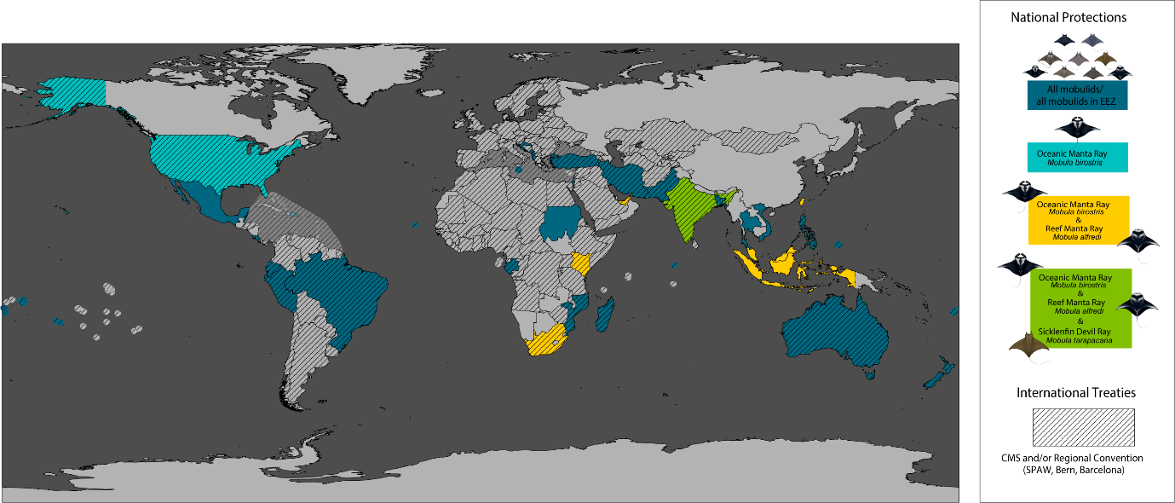

The Secretariat notes that Mobula yarie was only recently described. While the standard reference for fishes, Eschmeyer, recognizes this species, it has not yet been reflected as a separate species within the family Mobulidae in the CMS Appendices. For further details on taxonomic updates to CMS-listed species, please refer to document UNEP/CMS/COP15/Doc.29.3 Taxonomy and Nomenclature.

