 | CONVENTION ON  MIGRATORY  SPECIES | UNEP/CMS/COP15/Doc.31.3.15/Rev.1  22 January 2026  Original: English

15th MEETING OF THE CONFERENCE OF THE PARTIES

Campo Grande, Brazil, 23 – 29 March 2026
Agenda Item 31.3.15

PROPOSAL FOR A CONCERTED ACTION FOR

THE BLUE SHARK (Prionace glauca) ALREADY LISTED

ON APPENDIX II OF THE CONVENTION*

Summary:

Marine Research and Conservation Foundation (MARECO) has submitted the attached proposal* for a continuation of the Concerted Action for the blue shark (Prionace glauca) in accordance with the process elaborated in Resolution 12.28 (Rev. COP14).

Revision 1 implements recommendations made by the Scientific Council at its 8th Meeting of the Sessional Committee in December 2025.

*The geographical designations employed in this document do not imply the expression of any opinion whatsoever on the part of the CMS Secretariat (or the United Nations Environment Programme) concerning the legal status of any country, territory, or area, or concerning the delimitation of its frontiers or boundaries. The responsibility for the contents of the document rests exclusively with its author.
PROPOSAL FOR A CONCERTED ACTION FOR
THE BLUE SHARK (Prionace glauca) ALREADY LISTED
ON APPENDIX II OF THE CONVENTION

Proponent(s)

Marine Research and Conservation Foundation (MARECO)

Target species, lower taxon or population, or group of taxa with needs in common

Class: Chondrichthyes
Subclass: Elasmobranchii
Order: Carcharhiniformes
Family: Carcharhinidae
Genus: Prionace
Species: Prionace glauca

Listed on CMS Appendix II.

Geographical range

Blue sharks are among the most widely distributed of all pelagic shark species, occurring in tropical and temperate waters across all major ocean basins. Typically, blue sharks inhabit water temperatures of 12-18 °C but can tolerate a temperature range of 10-30 °C, from the surface to depths exceeding 1,100 m (Ebert et al. 2021).

Their widespread range, alongside extensive seasonal and vertical migrations are driven by prey availability, thermal fronts and reproductive cycles (Howey et al. 2017). On a global scale, the population shows little to no genetic variation due to extensive migratory connectivity (Bailleul et al. 2018; Verissimo et al. 2017), however two genetic clusters have been identified in the northern Atlantic/Mediterranean and the Indo-Pacific (Nikolic et al. 2023).

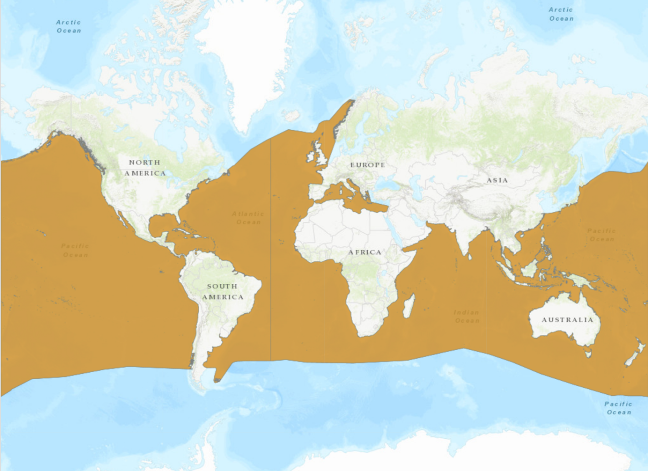
Figure 1: Geographic range of the blue shark (© IUCN Red List).

Summary of activities

This CA proposes to continue working on activities adopted for the blue shark at COP14:

- Encourage Parties to continue engaging with other MEAs, RFBs, and other relevant entities to enhance blue shark management including the development of the IUCN SSC SSG Conservation Strategy and Action Plan for Pelagic Sharks and Rays, in cooperation with the Sharks MOU;

- Support assessments into the impacts of fisheries on blue shark interactions:
  - Fisheries-induced mortality,
  - Discards from fisheries to design mitigation strategies where there is no retention,
  - Support the assessment of post-release mortality of blue sharks across regions (from recreational angling and industry), and
  - Differences, if any, demographics and fishing gears);

- Support the identification of population and genetic differences (in support of regional TACs);

- Identify inconsistencies in the level of management ensured by different Party Range States;

- Identify critical habitats and understand the connectivity and migrations;
- Support assessments into the impacts of climate change on blue sharks by population or region: and

- Develop international guidelines from countries with established blue shark tourism (e.g. Azores, UK, South Africa), using input from the CMS tourism.

Associated benefits

The continued implementation of this Concerted Action will deliver wide-ranging benefits, not only for blue sharks, but other CMS-listed migratory species that occupy the same range. Enhanced coordination under CMS promotes the dissemination of data on shark distribution, fisheries interactions and post-release mortality, improving evidence-based management decisions across Party Range States.

By aligning with the Conservation Strategy and Action Plan for Pelagic Sharks and Rays in development by the Shark Specialist Group of the International Union for the Conservation of Nature Species Survival Commission (IUCN SSC SSG) and drawing insights from the IUCN Green Status assessment for the blue shark, this initiative will strengthen global recovery planning and allow future tracking of conservation progress (Polo-Silva et al. 2025). It is also critical to acknowledge the importance of managing the species sustainably for future food security (Simpfendorfer & Dulvy, 2017). Signatories to the Memorandum of Understanding on the Conservation of Migratory Sharks (Sharks MOU) welcomed this initiative and agreed to support the approach outlined in CMS/Sharks/MOS4/Doc 10.2/Rev.1.

As one of the most broadly distributed species of shark, any recommendations to enhance the conservation outlook for blue sharks, will likely have positive implications for other threatened and CMS-listed species that have the same range and are caught by the same fisheries and fishing gears e.g. mako, thresher and hammerhead sharks. The Concerted Action will further contribute to capacity building and raising awareness among CMS Parties and non-Party Range States, fostering best practices in fisheries management and sustainable tourism in line with the CMS Tourism Guidelines (UNEP/CMS/COP14/Doc.27.3.1/Annex 2). Continued engagement through the Sharks MOU and collaboration with RFMOs will ensure that advances made under this initiative contribute to long-term, ecosystem-based management of migratory species.

Collectively, these outcomes will provide a replicable model for other migratory shark species and help CMS Parties meet their obligations under the Convention through effective, science-driven cooperation. The Annex provides a source of actions that Parties could, where relevant, follow and adopt for the successful management of the blue shark (see NDF Step 6 in Mundy-Taylor et al. 2014). The Annex is not exhaustive and could be used as a mould for shaping a species conservation action plan if necessary.

Timeframe

Please refer to the Annex for an overview.

Relationship to other CMS actions

This CA would significantly contribute to the implementation of the following mandates
established under CMS and the Sharks MOU:
- Resolution 12.22 and Decisions 13.62 to 13.63 on Bycatch
- Resolution 13.3 and Decisions 13.71 to 13.73 on Chondrichthyan Species
- Decisions 13.66 to 13.68 on Marine Wildlife Watching
- Sharks MOU Programme of Work 2023-2025: Development of a global strategy and regional action plans for pelagic sharks

Conservation priority

Blue shark remains one of the most heavily exploited shark species worldwide and continues to face significant conservation and management challenges across its global range. It is estimated that around 10 million blue sharks are caught annually, often within multi-species and target fisheries (Poseidon, 2022). These intensive fisheries also take a bycatch of other, seriously depleted pelagic sharks listed in the CMS Appendices (Pacoreau et al. 2021), whose recovery is also dependent upon conservation action for blue shark (IUCN Green Status, Polo-Silva et al. 2025).

In the Mediterranean, blue shark populations are assessed as Critically Endangered, with declines of ~78-90% over three generations (Sims et al. 2016). Atlantic blue shark stocks are also believed to be at risk , with spatial overlaps of close to 80% with longline fisheries - many of which target blue sharks (Queiroz et al. 2019) and a median population change for the blue sharks in the North Atlantic over three generations of -53.9% in 2018 (Rigby et al. 2019). Although a total allowable catch (TAC) has been adopted in ICCAT for North and South Atlantic blue sharks, similar management frameworks remain limited or inconsistent across other ocean basins. The Indian Ocean population continues to decline (Rigby et al. 2019) albeit a recent IOTC stock assessment indicated that the stock is not overfished (IOTC, 2025), while trends in the Pacific Ocean are comparatively stable but uncertain (Li et al. 2020; WCPFC stock assessments, 2022).

The recent IUCN Green Status Assessment for the blue shark (Polo-Silva et al. 2025) identified a recovery score of 43% (Largely Depleted) due to its Threatened or Near Threatened Status in four of the six spatial units within its global range. This underscores the urgent need for coordinated recovery actions to strengthen management at regional and global scales.

Relevance

CMS provides a global platform for the conservation of migratory animals and their habitats, aiming to ensure that their use does not exceed sustainable levels. The blue shark is one of the most (if not the most) migratory species of shark, which necessitates enhanced conservation action. This CA will contribute significantly by: (i) strengthening the political will to implement conservation management measures in a coordinated and timely fashion; (ii) bridging migratory shark fisheries and conservation interests; and (iii) contributing to the implementation of the FAO’s IPOA-Sharks for the world’s most heavily fished shark.

Absence of better remedies

Only a few t-RFMOs have adopted management measures for this species. The mandate of the Convention on the International Trade in Endangered Species of Fauna and Flora (CITES) is narrowly focused on ensuring that international trade does not endanger the species further. Therefore, the Concerted Action proposed here provides an important avenue for addressing the threats to and lack of cooperative management for this species and for promoting further research and conservation.

Readiness and feasibility

There are engaged NGOs, experts, and community organizations ready to support Range States to develop, fund and implement collaborative work. Recent initiatives at other international fora, shows that expert networks exist that could support Range States with the implementation of the proposed activities. Furthermore, support will be appreciated from the Sharks MOU and Cooperating Partners, to support the development and implementation of the action plans.

Likelihood of success

Supported by engaged NGOs, experts and organisations, and these Concerted Actions, it is bound for success. Moreover, the alignment of some of the Concerted Actions herein with the Conservation Strategy and Action Plans for Pelagic Sharks and Rays under the Sharks MOU, means that there is already active engagement of stakeholders. There may be some risks associated with the commercial interest in blue sharks, although this is offset by increasing adoption of science-based management through the RFMOs. Development of CITES Non Detriment Findings would further reinforce the opportunity of trade only from sustainably managed fisheries.

Magnitude of likely impact

It is anticipated that these Concerted Actions can improve the management of blue shark fishing practices across its geographic range by ensuring all CMS Parties are engaged in these activities. Simultaneously, it can pave the way for greater consideration of science-based management in the high seas by working together with RMFOs. Tourism is a fast-growing industry (e.g. UK, Mexico) and blue sharks are becoming increasingly popular. It is expected that the demand for blue shark tourism will rise globally, becoming both a threat and an opportunity. If well managed, this economic activity can assist in the management of the species, help raise awareness and facilitate research. CMS can provide effective guidelines to ensure this practice is sustainable and equitable for communities involved, with a model replicable to other species.

Cost-effectiveness

This CA is of particular importance given that the Sharks MOU Signatories have not yet listed the blue shark in Annex 1 of the MOU. One of the key components of the Concerted Actions is to encourage cooperation between Parties, information and knowledge exchange, and the development of effective strategies. If conservation successes can be replicated and best practices (such as tourism guidelines) established, this collaboration will prove vastly more cost-effective than individual countries forging their own path separately.

References

Bailleul, D., Mackenzie, A., Sacchi, O., Poisson, F., Bierne, N., & Arnaud‐Haond, S. (2018). Large‐scale genetic panmixia in the blue shark (Prionace glauca): a single worldwide population, or a genetic lag‐time effect of the “grey zone” of differentiation?. Evolutionary Applications, 11(5), 614-630.
Ebert, D. A., Dando, M., & Fowler, S. (2021). Sharks of the world: a complete guide (Vol. 19). Princeton University Press.
Howey, L. A., Wetherbee, B. M., Tolentino, E. R., & Shivji, M. S. (2017). Biogeophysical and physiological processes drive movement patterns in a marine predator. Movement Ecology, 5(1), 16.
Queiroz, N., Humphries, N. E., Couto, A., Vedor, M., Da Costa, I., Sequeira, A. M., ... & Sousa, L. L. (2019). Global spatial risk assessment of sharks under the footprint of fisheries. Nature, 572(7770), 461-466.
Li, W. W., Kindong, R., Wu, F., Tian, S. Q., & Dai, X. J. (2020). Catch rate and stock status of blue shark in the Pacific Ocean inferred from fishery-independent data.
Mundy-Taylor, V., Crook, V., Foster, S., Fowler, S., Sant, G., & Rice, J. (2014). CITES
Non-detriment findings guidance for shark species. A Framework to assist Authorities in making Non-detriment Findings (NDFs) for species listed in CITES Appendix II. Report prepared for the Germany Federal Agency for Nature Conservation (Bundesamt für Naturschutz, BfN).
Nikolic, N., Devloo‐Delva, F., Bailleul, D., Noskova, E., Rougeux, C., Delord, C., & Arnaud‐Haond, S. (2023). Stepping up to genome scan allows stock differentiation in the worldwide distributed blue shark Prionace glauca. Molecular Ecology, 32(5), 1000-1019.
Polo-Silva, C.J., Blanco-Parra, M.P., Barrera-Garcia, A., Araujo, G. & Scotts, G. 2025. Prionace glauca (Green Status assessment). The IUCN Red List of Threatened Species 2025: e.T39381A3938120252. Accessed on 20 October 2025.
Rigby, C. L., Barreto, R., Carlson, J., Fernando, D., Fordham, S., Francis, M. P., ... & Winker, H. (2019). Prionace glauca. The IUCN Red List of Threatened Species, 2019-3.
Simpfendorfer, C. A., & Dulvy, N. K. (2017). Bright spots of sustainable shark fishing. Current Biology, 27(3), R97-R98.
Veríssimo, A., Sampaio, Í., McDowell, J. R., Alexandrino, P., Mucientes, G., Queiroz, N., ... & Noble, L. R. (2017). World without borders—genetic population structure of a highly migratory marine predator, the blue shark (Prionace glauca). Ecology and Evolution, 7(13), 4768-4781.

Consultations planned / undertaken

Following the initial Concerted Action, adopted during COP14 (UNEP/CMS/Concerted Action 14.6), activities got under way. Consultations with experts are still ongoing to inform on the specific activities and outcomes described below. The timeframe for implementation of CA is short, and as such, all activities are proposed for extension/renewal under this new CA proposal.

Annex: Activities and expected outcomes

Activity |  | Outputs/Outcomes | Timeframe | Responsibility | Funding
Management
1. | Encourage Parties to continue engaging with other MEAs, RFBs, and other relevant entities to enhance blue shark management including the development of the IUCN SSC SSG Conservation Strategy and Action Plan for Pelagic Sharks and Rays, in cooperation with the Sharks MOU. | Heightened attention to blue shark conservation needs. | 2026-2029 | NGOs, experts | NA
Sustainable Tourism
2. | Develop international guidelines from countries with established blue shark tourism (e.g. Azores, UK, South Africa) in line with CMS tourism guidelines. | Protocols for responsible blue shark tourism interaction established, in line with CMS tourism guidelines. | 2026-2029 | NGOs, experts | Garfield Weston Foundation/  MARECO
Research
3. | Support the assessment into the impacts of fisheries on blue shark interactions (fisheries-induced mortality, discards from non-target fisheries to design mitigation strategies and support the assessment of post-release mortality of blue sharks across regions, demographics and fishing gears) | - Interactions incidence and mortality rates determined;  - Proposals to reduce risk of interactions with blue sharks produced for non-target fisheries;  - Effects of fisheries interaction on blue shark populations assessed;  - Post-release survival for blue sharks determined. | 2026-2029 | CMS Parties  (and non-Party Range States),  t-RFMO scientific bodies and shark working groups | NA
4. | Support the identification of sub-population and genetic differences (to support regional TACs through fisheries-independent data) | Sub-populations identified. | 2027 | CMS Parties (and non-Party Range States) | Shark Foundation/  MARECO
5. | Identify inconsistencies in the level of protection ensured by different Party Range States. | Protection gap analysis undertaken. | 2027 | NGOs | Law of the Wild/MARECO
6. | Identify critical habitats and understand the connectivity and migrations. | - Critical areas identified;  - Migratory routes identified;  - Priority areas for conservation (PAC) identified;  - ISRAS E-Atlas/other GIS output of critical habitats. | 2026-2029 | NGOs/Research groups/IUCN SSG  ISRA | NA
7. | Support assessments into the impacts of climate change on blue sharks by stock or region. | Vulnerability and impacts of climate change on blue shark populations better understood. | 2029 | NGOs/Research groups | NA

