 | CONVENTION ON  MIGRATORY  SPECIES | UNEP/CMS/COP15/Doc.31.3.5  24 October 2025  Original: English

15th MEETING OF THE CONFERENCE OF THE PARTIES

Campo Grande, Brazil, 23 – 29 March 2026
Agenda Item 31.3.5

PROPOSAL FOR A CONCERTED ACTION FOR THE MASAI GIRAFFE (Giraffa tippelskirchi), NORTHERN GIRAFFE (Giraffa camelopardalis), RETICULATED GIRAFFE (Giraffa reticulata) AND SOUTHERN GIRAFFE (Giraffa giraffa)*

Summary:

The Concerted Action for the Giraffe was first adopted at the 13th Meeting of the Conference of the Parties (COP13), and later revised and extended at COP14 (Concerted Action 13.3 (Rev.COP14).

A report on implementation was submitted to COP15, proposing to extend and update the Concerted Action in line with the introduced updated giraffe taxonomy, which recognizes four distinct species and seven subspecies.

Ethiopia has submitted the attached proposal for a continuation of the Concerted Action, now addressing the Masai giraffe (Giraffa tippelskirchi), Northern giraffe (Giraffa camelopardalis), Reticulated giraffe (Giraffa reticulata) and Southern giraffe (Giraffa giraffa) in accordance with the process elaborated in Resolution 12.28 (Rev. COP14)

*The geographical designations employed in this document do not imply the expression of any opinion whatsoever on the part of the CMS Secretariat (or the United Nations Environment Programme) concerning the legal status of any country, territory, or area, or concerning the delimitation of its frontiers or boundaries. The responsibility for the contents of the document rests exclusively with its author.

CONCERTED ACTION FOR THE MASAI GIRAFFE (Giraffa tippelskirchi), NORTHERN GIRAFFE (Giraffa camelopardalis), RETICULATED GIRAFFE (Giraffa reticulata) AND SOUTHERN GIRAFFE (Giraffa giraffa)

Proponent

Ethiopia

Target species, lower taxon or population, or group of taxa with needs in common

Class: Mammalia
Order: Artiodactyla
Family: Giraffidae
Genus, Species:

IUCN SSC Giraffe & Okapi Specialist Group  (IUCN SSC Giraffe and Okapi Specialist Group Taxonomic Task Force 2025) | IUCN Red List Taxonomy 2018  (Muller et al. 2018) | IUCN Red List Category 2018  (as a single species)
Giraffa camelopardalis (Northern giraffe) | G. c. rothschildi  (Rothschild’s giraffe)* | Near Threatened (Fennessy et al. 2018)
Giraffa camelopardalis antiquorum  (Kordofan giraffe)  Girafe du Kordofan  Jirafa de Kordofán | G. c. antiquorum  (Kordofan giraffe) | Critically Endangered (Fennessy & Marais 2018)
Giraffa camelopardalis camelopardalis  (Nubian giraffe)  Girafe de Nubie  Jirafa nubiana | G. c. camelopardalis  (Nubian giraffe) | Critically Endangered (Wube et al. 2018)
Giraffa camelopardalis peralta  (West African giraffe)  Girafe d’Afrique de l’Ouest  Jirafa nigeriana | G. c. peralta  (West African giraffe) | Vulnerable  (Fennessy et al. 2018a)
Giraffa giraffa  (Southern giraffe) | G. c. giraffa  (Southern giraffe)
Giraffa giraffa angolensis  (Angolan giraffe)  Girafe d’Angola  Jirafa de Angola | Giraffa giraffa angolensis  (Angolan giraffe) | Least Concern  (Marais et al. 2018)
Giraffa giraffa giraffa  (South African giraffe)  Girafe d’Afrique du Sud  Jirafa de Sudáfrica | G. c. giraffa  (South African giraffe) | Not Assessed
Giraffa reticulata  (Reticulated giraffe)  Girafe réticulée  Jirafa somalí | G. c. reticulata  (Reticulated giraffe) | Endangered  (Muneza et al. 2018)
Giraffa tippelskirchi
(Masai giraffe)
Girafe Massaï
Jirafa masai
Giraffa tippelskirchi thornicrofti  (Luangwa giraffe) | G. c. thornicrofti  (Luangwa giraffe) | Vulnerable  (Bercovitch et al. 2018)
Giraffa tippelskirchi tippelskirchi  (Masai giraffe) sensu strictu  Girafe Massaï  Jirafa masai | G. c. tippelskirchi  (Masai giraffe) | Endangered  (Bolger et al. 2019)
*Taxonomic review subsumed Rothschild’s giraffe into Nubian giraffe (G. c. camelopardalis)

Geographical range

Giraffes are the world's tallest land mammals and remain widespread across southern and eastern Africa, with smaller isolated populations in west and central Africa. Giraffes inhabit eighteen African countries and have been reintroduced to three others (Eswatini, Malawi and Rwanda). Giraffes have been introduced into historical and extralimital ranges across the continent (see Appendix 1). Giraffes have gone extinct in at least seven countries (Burkina Faso, Eritrea, Guinea, Mali, Mauritania, Nigeria and Senegal). Giraffes have adapted to a variety of habitats, ranging from desert landscapes to woodland/savanna environments, but many live in non-continuous, fragmented populations across sub-Saharan Africa (Muller et al. 2018).


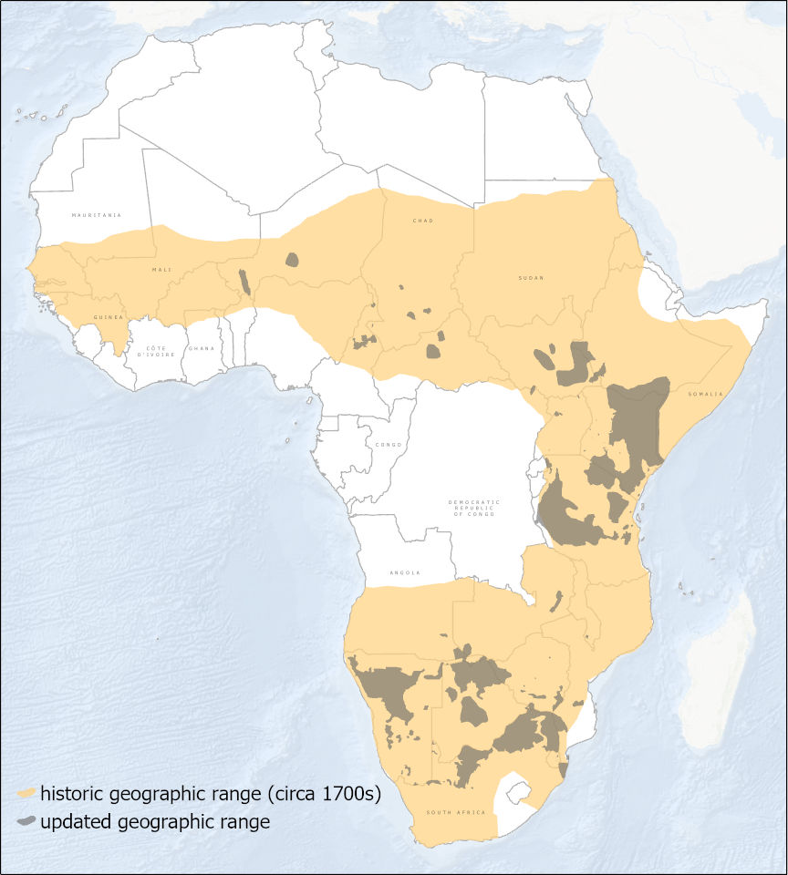

Figure 1: Historical range and recent known distribution of Giraffes (O’Connor et al. 2019).
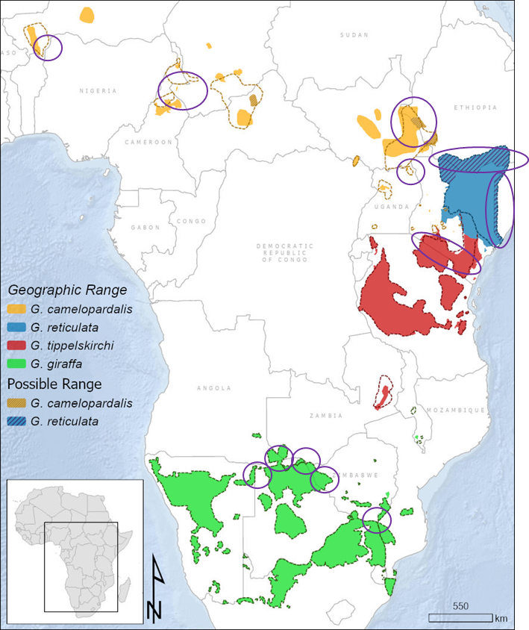

Figure 2: The current known distribution of Giraffes across Africa, highlighting potential transboundary movements (O’Connor et al. 2019).

Summary of activities

International organizational and management structures for the mitigation of threats are vital to improve the conservation status of giraffes. The potential threats faced by giraffes vary according to the geographical range highlighting the need for Africa-wide, national, and regional actions. To this end the following targets are proposed for consideration by the Parties, subject to the availability of sustainable funds:
- Review of taxonomy to guide giraffe conservation and feed into development of an Africa-wide giraffe conservation strategy in consultation with Range States through hosting a workshop between Range State representatives and relevant stakeholders.
- Develop regional/taxon strategies in consultation with Range States through collaborative workshops among Range States and relevant stakeholders.
- Range States develop new national strategies in consultation with relevant stakeholders through workshops that will serve as a platform to develop national working groups.
- Range States implement and review current/existing national strategies in consultation with stakeholders through supporting established working groups/task forces.
- Development of Africa-wide Giraffe translocation guidelines to provide a framework for individual Range States to adapt into tailored translocation manuals.
- Africa-wide annual update of Giraffe conservation science and management to share knowledge, facilitate data sharing and generating reports to use in policy making and enhance conservation decisions. This could also facilitate addressing knowledge gaps across all Range States.
- Engage with the International Union for Conservation of Nature Species Survival Commission Giraffe and Okapi Specialist Group (IUCN SSC GOSG) and contribute to Global Red List reassessments to ensure Africa-wide collaboration among Range States.
- Assess feasibility of establishing a Giraffe conservation fund for sustainable financing to secure reliable support of Giraffe conservation initiatives.
- Increase profile and awareness of Giraffe conservation across different levels of management and within the public sphere.

Vision: Encourage sustainable investment in Giraffe conservation across their range through collaborations among governments, stakeholders, and communities to address threats to existing populations, harmonize policies, research, knowledge dissemination, and increase education and awareness locally and globally.

Recognizing and addressing threats to giraffe populations across all Range States is essential to the success of any conservation initiative. To this extent, the following threats have been identified to occur in some and/or all Range States: infrastructure development (roads/ railways/ powerlines/ pipelines, etc.), habitat loss/fragmentation/degradation (such as wild fire, livestock incursions, illegal encroachment by humans and livestock, change of livestock dynamics e.g. change from cattle to camels/goats), illegal harvesting and trade (e.g. bushmeat, skins, tails), diseases (skin diseases, viruses, etc.), civil unrest, climate change, human population growth, socio-cultural factors/traditional medicine, lack of sustainable financing, insufficient political will, inadequate law enforcement, human/giraffe conflict, and lack of awareness on Giraffe conservation and their status.

Associated benefits

It is the intention of the activities proposed in this document to serve as a catalyst to deliver effective conservation for Giraffes, but also to serve as an opportunity for Parties to collaborate for the protection of other species found within the same Range States.

The Africa-wide, regional, and national workshops will involve collaboration across Range States as well as relevant non-Party stakeholders to invest in effective giraffe conservation which will result in overall benefit for all vulnerable or threatened species located within the range of Giraffes. Furthermore, these workshops will also establish a network of engaged individuals across different regions which will be invaluable for any future activities concerning migratory species within the same range, with great potential for future synergies.

Liaise with the IUCN SSC GOSG to ensure Africa-wide, regional, and national workshops contribute to the Global Red List assessments for Giraffes, and similarly that all workshops and subsequent reports coordinate effectively with global activities.

The following table depicts CMS listed species and the potential benefit that could be gained from association with Giraffe conservation efforts.

CMS Listed Species | Location
African Wild Dog | Angola, Botswana, Chad, Ethiopia, Kenya, Malawi, Mozambique, Namibia, Niger, South Africa, South Sudan, United Republic of Tanzania, Zambia, Zimbabwe
Cheetah | Angola, Botswana, Ethiopia, Kenya, Mozambique, Namibia, Niger, South Africa, Uganda, United Republic of Tanzania, Zambia, Zimbabwe
Dama gazelle | Niger, Chad
Dorcas gazelle | Niger, Chad
Elephant | Angola, Botswana, Cameroon, Central African Republic, Chad, the Democratic Republic of the Congo, Ethiopia, Kenya, Malawi, Mozambique, Namibia, Niger, Rwanda, Somalia, South Africa, South Sudan, Uganda, United Republic of Tanzania, Zambia, Zimbabwe
Grevy’s Zebra | Kenya, Ethiopia
Leopard | Angola, Botswana, Cameroon, Central African Republic, Chad, the Democratic Republic of the Congo, Eswatini, Ethiopia, Kenya, Malawi, Mozambique, Namibia, Niger, Rwanda, Somalia, South Africa, Uganda, United Republic of Tanzania, Zambia, Zimbabwe
Lion | Angola, Botswana, Cameroon, CAR, Chad, DRC, Eswatini, Ethiopia, Kenya, Malawi, Mozambique, Namibia, Niger, Rwanda, Somalia, South Africa, Uganda, United Republic of Tanzania, Zambia, Zimbabwe
Red fronted gazelle | Ethiopia, Niger, South Sudan, Chad
White-eared kob | Ethiopia, South Sudan, Uganda

Timeframe

This Concerted Action identifies individual timeframes for each activity, scheduled for implementation in the pre-sessional period until COP15 and throughout the following inter-sessional period of approximately three years.

Relationship to other CMS actions

This Concerted Action is complementary to a number of other CMS initiatives. The conservation of Giraffes being a prey species of large carnivores, complements the implementation of the Joint CITES-CMS African Carnivores Initiative. Due to overlapping habitats with Savannah Elephants, the conservation of Giraffe habitat also ties in with the objectives of the African Elephant Action Plan and the Sahelo-Saharan Megafauna Initiative.

Conservation priority

A taxonomic review by the IUCN SSC Giraffe & Okapi Specialist Group Taxonomy Taskforce was published in August 2025 and highlights the change to four species and seven subspecies. This is significant progress and supports the detailed research undertaken in the past decade. The next step will be for the IUCN SSC Giraffe & Okapi Specialist Group to undertake Red List Assessments for each giraffe species, which is planned for 2025/26.

The following paragraphs are based on the previous taxonomy and must be updated to incorporate the updated giraffe taxonomy:

Under the previous taxonomy, the giraffe (Giraffa camelopardalis) as one species was assessed as Vulnerable under criterion A2 due to an observed, past (and ongoing) population decline of 36-40 percent over three generations (30 years, 1985-2015). The factors causing this decline (levels of exploitation and decline in area of occupancy and habitat quality) have not ceased and may not be reversible throughout the species’ range. The best available estimates indicate a total population in 1985 of 151,702-163,452 (106,191-114,416 mature individuals), and in 2019, a total population of 111,000 giraffes (GCF 2019). Historically, the species has been overlooked in terms of research and conservation, but in the past five years, considerable progress has been made in compiling and producing a species-wide assessment of population size and distribution by the members of the IUCN SSC Giraffe and Okapi Specialist Group, Range States, and NGOs. Some giraffe populations are stable or increasing, while others are declining, and each population is subject to pressure by threats specific to their local country or region. Many populations of Giraffes are scattered and fragmented with different growth trajectories and threats, but the species trend reveals an overall large decline in numbers across their range in Africa (Muller et al. 2018).

The Reticulated Giraffe is listed as Endangered under criterion A because of an estimated continuing of ~56 percent over the last 30 years (three generations). The decline is most probably attributed to habitat loss, deterioration in habitat quality and illegal killing/poaching. Reticulated Giraffes are found only in the north and east of Kenya and likely persist in southern Ethiopia and in south-western Somalia. The numbers remaining in Ethiopia are estimated to be 100 and Somalia are unknown but suspected to be small: most of the current population is believed to occur in Kenya. Based on available aerial survey data the population of reticulated giraffe in Kenya in 1983-1987, was estimated at 36,000. Most recent estimates (2011-2017) based on aerial survey data estimate the population at 15,784 individuals (11,048 mature individuals) (Muneza et al. 2018).

The Masai Giraffe is listed as Endangered under criterion A2abd due to an estimated decline of 49-51 percent over three generations (30 years). These estimates are based on a time-series of systematic reconnaissance flight (SRF) data that commenced in the late 1970s (ca 38 years) in Kenya and the mid-1980s in the United Republic of Tanzania (ca 30 years). Combined estimates for Kenya and the United Republic of Tanzania at the beginning of these time series are 69,000-71,000 and for the most recent estimates in 2017 were 35,000. Probable causes of the decline are habitat loss and illegal hunting (Bolger et al. 2019).

The Nubian Giraffe is listed as Critically Endangered because of a locally observed and globally inferred 95 percent population decline over 30 years (three generations). It is reported to be limited to three subpopulations, one in western Ethiopia and two in South Sudan. In the late 1970s, its numbers were estimated at 9,038 individuals in Boma National Park, South Sudan, but few contemporaneous data are available for other areas. Current estimates across its limited range indicate a total population of approximately 650, of which 455 are assumed to be mature individuals (Wube et al. 2018).

The West African Giraffe is assessed as Vulnerable under criterion D1, as the number of mature individuals is <1,000. The West African giraffe is predominately limited to one expanding population in south-eastern Niger, as a new population was established in Gadabedji Biosphere Game Reserve. Current estimates across their limited range vary but the latest census estimated 638 Giraffe (DFC/PR 2018). The number of mature individuals is estimated at approximately 446 (70 percent of the population). Numbers have shown an increasing trend since the mid-1990s when the population was at a low of 49 individuals. This is a critical population of Africa’s megaherbivore which requires conservation and management support (Fennessy et al. 2018).

The Rothschild’s Giraffe is listed as Near Threatened under criterion D1 because the number of mature individuals is estimated at less than 1,468 (total population c. 2,098 individuals). Rothschild’s Giraffe exists in eighteen populations; four in Uganda and fourteen in Kenya. Of these, two populations are naturally occurring (Murchison Falls National Park and Kidepo Valley National Park in Uganda), one has been re-introduced to its previous natural range (Ruko Conservancy) and the remaining populations are extralimital conservation introductions e.g. Ruma and Lake Nakuru National Parks, Soysambu Wildlife Conservancy and Mwea National Reserve. The population size is increasing overall, but there is little or no potential for dispersal between sites, some of which are fenced, and limited capacity for expansion (Fennessy et al. 2018). Recent genetic analysis revealed the Rothschild’s Giraffe is genetically identical to the Nubian Giraffe (Fennessy et al. 2016; Winter et al. 2018).

The Kordofan giraffe is listed as Critically Endangered under criterion A due to a population decline of >80 percent over the last 30 years (three generations). In the 1980s and 1990s, their numbers were estimated at more than 13,704 (1,757 in Central African Republic; ca. 1,600 in Cameroon; 890 in Chad; 419 in the Democratic Republic of the Congo and 9,038 in South Sudan), although limited data are available for some areas within these countries. Current estimates across their limited range place their numbers at ca. 2,000 individuals, of which ca. 1,400 are probably mature individuals. The current population is declining, and the subspecies is threatened across its remaining range by illegal hunting, habitat destruction and overgrazing and the factors of insecurity and civil conflicts affect some subpopulations (Fennessy and Marais 2018).

Thornicroft’s Giraffe is an isolated population that survives only in the Luangwa Valley, eastern Zambia. Their restricted distribution coincides with a limited population size. In the 1960s, their numbers were estimated at around 300 to 500 individuals and current estimates place their numbers at approximately 600 Giraffe, of which an estimated 420 are mature individuals. The current population seems to be stable. Given their restricted distribution to a single location, the limited number of mature individuals, their relatively slow reproductive rate combined with high neonatal mortality rate, and their small population size, this subspecies of giraffe is listed as Vulnerable under criterion D1 (Bercovitch et al. 2018). Recent genetic analysis has revealed the Thornicroft’s giraffe are genetically Masai giraffe and may be subsumed into Masai giraffe or become a subspecies (Fennessy et al. 2016; Winter et al. 2018).

The Angolan Giraffe is assessed as Least Concern, as the total population in Angola, Botswana, Namibia and Zimbabwe is estimated to be 17,750 and numbers have increased markedly over the last 30 years (three generations). This overall population estimate across the subspecies range may be conservative as gaps in the data might still exist (Marais et al. 2018; GCF 2019).

The South African Giraffe is the only subspecies yet to be officially assessed by the IUCN Red List, however they are estimated at 37,000 individuals (GCF 2019).

Any conservation initiatives will likely be successful with cooperation on Africa-wide, regional and national levels as well as development and implementation of specific Strategies and Action Plans at each level to prevent further decline of giraffe populations.

As giraffe were included on Appendix II of CMS following the proposal by the Government of Angola at the 12th meeting of the COP (COP12), implementation of existing Strategies and Action Plans and development of further at Africa-wide, regional and national levels will comply with Resolution 12.28.

Relevance

Below is an overview of national protection status of Giraffe in each Range State:

Angola: Giraffe are awarded full protection by the Combined Executive Decree No. 37/99 of 27 January 1999 (Governo de Angola 1999) issued by the Ministry of Agriculture and Rural Development and the Ministry of Finances. This decree was approved to provide an updated list of species (including giraffe) whose hunting is prohibited.

Botswana: Giraffes have been classified as a protected animal under section 17 of The Wildlife Conservation and National Parks Act 1992. This legislation allowed the hunting and capturing of Giraffe under special circumstances and via a permit granted by the director of the Department of Wildlife and National Parks (DWNP), within wildlife management areas. As of January 2014, new legislation made hunting laws more stringent and banned the hunting of protected animals including Giraffes.

Cameroon: Giraffe are classified as a Class A species under Wildlife Law No. 94/01 of 1994 to lay down Forestry, Wildlife and Fisheries Regulations. Class A species includes rare or endangered species that benefit from full protection and may consequently not be hunted.

Central African Republic: Under Section 27 of Ordinance No. 84/045 on the protection of wildlife and the regulating of hunting in the Central African Republic (l’Ordonnance no. 84 /045 portant protection de la Faune Sauvage et règlementant l’exercice de la chasse en République Centrafricaine), hunting, capturing and/or collecting of any individual listed in List A of the Ordinance, which includes giraffe, is strictly prohibited.

Chad: Under Article 25 of Ordinance No. 002/PR/88 on the Conservation of Wildlife, Giraffes are classified as a Category A species. Category A species benefit from full protection and may consequently not be hunted.

Democratic Republic of the Congo: Giraffes are classified by the Congolese Wildlife Authority, the Institut Congolais pour la Conservation de la Nature (ICCN), as a rare or endangered species that is fully protected and may not be killed.

Eswatini: Giraffes are classified as royal game under the Second Schedule of the Game (Amendment) Act of 1991, an Act to amend the Game Act of 1953 and to provide for matters incidental thereto. A valid permit issued under the provisions of section 16 of the Game Act is required to hunt or attempt to hunt or be in possession of a trophy of any royal game.

Ethiopia: Under Article 24 of the Council Ministers Regulations No. 163/2008, a regulation provisioned for wildlife development, conservation and utilization, no person is allowed to hunt species listed in Table 10 of the regulations, which includes giraffe, except with a special hunting license acquired in accordance with Article 22 of the regulations.

Kenya: Nubian/Rothschild’s giraffe are accorded full protection under the Wildlife Conservation and Management Act, 2013. Although Masai and reticulated giraffe are not awarded any special protection in Kenya, big-game hunting has been banned in the country since 1977.

Malawi: The Game Act (No. 26 of 1953) is the main act for the preservation, control and trade of game animals. Giraffe are not specially protected under this act, but no legal hunting is allowed.

Mozambique: Giraffe are protected under the Forestry and Wildlife Law (Law No. 10/99) and Regulations of the Forestry and Wildlife Law (Decree No. 12/2002). Giraffe are listed in Annexure 2 of the Regulations as a protected species that may not be hunted. They are listed as one of the eight mammals on Mozambique’s National Red List that are either extinct or in danger of extinction (MICOA 2009).

Namibia: Giraffe is one of ten species that are classified by the Ministry of Environment & Tourism (MET) as specially protected under Schedule 3 of No.4 of 1975 Nature Conservation Ordinance (Government of Namibia 1975). This classification does not limit hunting of giraffe, but rather requires one to obtain specific hunting permits from the Namibian Government before a license is granted.

Niger: West African giraffes are fully protected under Niger’s ‘Loi N° 98-07 du 29 avril 1998 fixant le regime de la chasse et de la protection de la faune’ and may not be hunted.

Rwanda: The Giraffe is listed by the Rwanda Environment Management Authority as a protected species that may consequently not be hunted under the Rwanda Wildlife Policy (2013).

Somalia: Giraffes are not specially protected in the Federal Republic of Somalia but legal hunting is approved.

South Africa: Giraffes are not specially protected in South Africa and legal hunting is approved.

South Sudan: Under Chapter 5, Section 25 of the Wildlife Conservation and National Parks Act of 2003, no person shall hunt or capture any animal listed in Schedule 1 of the Act, which includes Giraffe.

Uganda: Giraffes are protected under the Game (Preservation and Control) Act of 1959 (Chapter 198). Giraffe are listed under Part A of the First Schedule of the Act as animals that may not be hunted or captured in Uganda.

The United Republic of Tanzania: Giraffe are protected under the Wildlife Conservation Act No.5 of 2009. The act prohibits hunting, killing, capturing and wounding giraffe with punishment including fines and imprisonment.

Zambia: The Zambia Wildlife Authority (ZAWA) is mandated under the Zambia Wildlife Act No.12 of 1998 to manage and conserve Zambia’s wildlife and under this same act, the hunting of giraffe in Zambia is illegal.

Zimbabwe: The Giraffe is a specially protected species whose conservation is regulated through a policy and legal framework and regulations which include: Parks and Wildlife Act Chapter 20:14 (1996) as amended in 2001; Environmental Management Act Chapter 20:27; Forest Act, Chapter 19:05; Statutory Instrument 362 of 1990 : Parks and Wildlife (General) Regulations, 1990; Statutory Instrument 76 of 1998 :Import and Export of Wildlife Products; Statutory Instrument 40 of 1994 : Parks and Wildlife Act (General) Amendments; Statutory Instrument 26 of 1998: Parks & Wildlife Act (General) Amendment; Statutory Instrument 92 of 2009; Compensation Values for Wildlife; Statutory Instrument 93 of 2009, Compensation Values for Trapping of Animals; Trapping of Animals Control Act 20.16; and Code of Ethics for Hunting in Zimbabwe.

Public awareness of giraffes’ vulnerable status is generally poor. Any conservation initiatives will likely to be more successful with cooperation on Africa-wide, regional and national levels across the Range States. Moreover, there are significant knowledge gaps on population and distribution of Giraffe as well as habitat utilization and behavioural ecology through the Range States. Hence, Giraffes would benefit significantly from coordinated Africa-wide, regional, and national management structures to obtain a better understanding on giraffe population and distribution and stimulate full protection from all Range States.

Absence of better remedies

The organization of the 1st Giraffe Experts Meeting has allowed for effective collaboration between many Range State representatives and invested stakeholders. As a result of these discussions the importance of collaborative management of transboundary populations has been identified as key to the overall success of giraffe conservation initiatives. This meeting has highlighted the importance of collaboration and commitment from national to Africa-wide levels. GCF has developed an Africa-wide strategic framework that could be valuable as a tool in the development of an Africa-wide Strategy and Action Plan (Appendix 2). In addition, existing National Strategies not only enhance interest in increasing development of Africa-wide, regional and national strategies but also provide effective examples for creation of additional Strategies.

In addition, this meeting has identified the need for increased data gathering and sharing, and the development of a means for sustainable financing. Through the development of an Africa-wide giraffe database similar to the African Elephant Database, an effective network would provide each Range State and stakeholder access to valuable information to inform and guide effective giraffe conservation measures. In addition, the formulation of a sustainable Giraffe Fund could provide a means to overcoming one of the largest hurdles in all conservation initiatives, that being inadequate and unpredictable funding.

Readiness and feasibility

The Government of Angola, with the support of GCF, has already taken the lead on the listing proposal of Giraffe on Appendix II of CMS. Through the CMS Concerted Action process, many Range States have committed to supporting implementation of giraffe conservation initiatives identified within this document.

At this time, almost all Range States have some form of monitoring program in place for giraffe populations. The CMS Concerted Action for Giraffe document identifies the need to increase transboundary coordination and collaboration across Range States allowing for complementary data collection, data sharing, and monitoring trends of giraffe populations on Africa-wide, regional, and national scales. Some countries have National Strategies in place (DRC, Kenya, Niger) while others are in the process of drafting National Strategies (Uganda and the United Republic of Tanzania). These countries can provide guidance and motivation for the development not only of other National Strategies among Range States, but also allow room for larger Africa-wide and regional strategies to be drafted and implemented.

This 1st Giraffe Experts Meeting has also identified the need to nominate Range State representatives to take the lead on Giraffe conservation initiatives and collaborate with other key stakeholders such as the IUCN SSG GOSG, SDZG, and GCF to ensure implementation of the targets and activities defined within this document.

Likelihood of success

This 1st Giraffe Experts Meeting developed the Concerted Action Plan for giraffe and has facilitated the development of a network of Range States and stakeholders committed to supporting and implementing the targets and activities outlined in this document. The implementation of already existing national strategies will encourage other countries already expressing interest in developing of national, regional, and Africa-wide strategies. The key to success is to formulate a means of sustainable financing. It is also vital to invest in increasing interest in and awareness of conservation of giraffe from the governments, media, and general public forums. With the cooperation of the Range States and stakeholders there is a very strong foundation from which Range States can work on to implement the activities identified during this meeting.

There are many gaps in our current knowledge of giraffe conservation status and science. Increased collaboration across Range States and facilitation of data collection and sharing through development of a giraffe database will enhance the effective implementation of strategies for giraffe conservation across all levels.

Magnitude of likely impact

The new taxonomy for giraffes lists the Northern giraffe as ‘Near Threatened, with two of its subspecies (Kordofan and Nubian giraffes) as ‘Critically Endangered’ and its third, the West African giraffe as ‘Vulnerable’. The Southern giraffe is only partially assessed, with the Angolan giraffe subspecies listed as ‘Least Concern’ while the South African giraffe has not yet been assessed. The Reticulated giraffe is listed as ‘Endangered’ and the Masai giraffe’s two subspecies, the Luangwa giraffe and the Maisai giraffe respectively listed as Vulnerable and Endangered. A number of CMS-listed threatened species would directly benefit from initiatives set in place for Giraffe conservation.

Successful implementation could result in:

- Improvements in: legal protection status; data quality and monitoring; Africa-wide, regional, and national strategies to address giraffe conservation and general awareness.
- Benefits to science through increased data and information dissemination: improved communication, expanded research network, increased sharing of knowledge and techniques, in addition to providing substantial opportunity for complementary action for CMS listed threatened species which share ranges with the Giraffe.
- An increase in political will and resourcing with greater profile and commitment from Range States and facilitated access to sustainable funding as species is higher on government’s agendas.
- A more certain future, as concerted effort across the species range could result in a halt of decline and in the long-term foster species recovery.

Cost-effectiveness

The expected costs are outlined under the timeframe table above. The Range States and stakeholders have also identified the goal of developing a sustainable finance mechanism that will be critical to the implementation of giraffe conservation initiatives moving forward.

Consultations planned / undertaken

This Concerted Action constitutes a renewal of the existing Concerted Action for the Giraffe, originally proposed by the following Parties: Cameroon, Chad, Ethiopia, Kenya, Niger, the United Republic of Tanzania, and Zimbabwe. Further consultations are planned in the lead-up to COP15. A key objective of this renewed Action is to align it with the updated Giraffe taxonomy, with a view to its potential adoption at COP15.

Activities and expected outcomes

Activity | Outputs/Outcomes | Timeframe | Responsibility | Funding
- Review and consensus on taxonomy to guide giraffe conservation and feed into Africa-wide strategy  - Host a consultative workshop including all Range State representatives and relevant stakeholders (refer to Appendix 2 the Africa-wide giraffe conservation framework, which was reviewed and approved by the proponents of this Concerted Action | An Africa-wide giraffe conservation strategy developed collaboratively with Range States, based on the 2016 Strategic Framework. | 2026-2029 | Range States  CMS Secretariat | CMS  International Donors  Range States  NGOs
- Host consultative workshops including all Range State representatives and relevant stakeholders | Regional and taxon-specific giraffe conservation strategies formulated in partnership with Range States. | 2026-2029 | Range States  CMS Secretariat | CMS  International Donors  Range States  NGOs
- Host consultative workshops including national representatives and stakeholders | New national giraffe conservation strategies established through consultation with Range States. | 2026-2029 | Range States  CMS | International Donors  Range States  NGOs
- Host annual national working group meetings to review and evaluate strategies  - Review National Strategy and update every 5 years  - Develop online international giraffe database (G.I.D.)  - Designate giraffe specific representative for each country  - Perform range wide surveys to prioritize areas where knowledge gaps are identified, standardize methodologies, address data gaps and establish consistency  - Greater understanding of movements/corridors and habitat use to guide land use/corridor protection/infrastructure development  - Inclusion of community livelihoods and education/ awareness for coexistence/ conflict management | Existing national giraffe conservation strategies actively implemented in coordination with Range States. | 2026-2029 | Range States/NGOs | International Donors  Range States  NGOs
- Collate and harmonize existing giraffe translocation protocols  - Share and review by Range States and partners for input | Standardized Africa-wide giraffe translocation guidelines produced and disseminated. | 2026-2029 | Range States  GCF/IUCN SSC GOSG  CMS Secretariat | Range States  GCF
- Collate annual reports on giraffe conservation science and management  - Synthesize reports for policy decisions  - Host invitation only giraffe conservation science and management forum | Bi-annual continental updates on giraffe conservation science and management practices published and shared. | 2026-2029 | Range States  SDZG/Smithsonian/Senckenberg/GCF  CMS | International Donors  Range States  NGOs
- Engagement with IUCN SSC GOSG established, and scientific information provided to support reassessment of giraffe | Contributions made to IUCN SSC GOSG and global giraffe Red List reassessments. | 2026-2029 | Range States  CMS  IUCN SSC GOSG | In Kind
- Conduct feasibility study and identify possible partners  - Contact with African Elephant Fund for guidance | Feasibility of a sustainable giraffe conservation fund assessed and documented. | 2026-2029 - | CMS Secretariat  Range States  NGOs | International Donors
- Facilitate incorporation of giraffe conservation into education curriculum at all levels  - Assess policy/legislation in each Range State for giraffe; promote listing of giraffe in relevant Range States  - Promote giraffe on relevant international days e.g. World Giraffe Day/World Wildlife Day | Enhanced visibility and awareness of giraffe conservation across management levels and the general public. | 2026-2029 | Range States  NGOs | Range States  International Donors  NGOs
*Eastern Africa (Kenya, Tanzania, Ethiopia, Somalia, Uganda, Rwanda, South Sudan) - Central Africa (Central African Republic, Chad, Cameroon, Democratic Republic of the Congo) - Western Africa (Niger, *Senegal, *Nigeria) - Southern Africa (South Africa, Namibia, Eswatini, Zimbabwe, Zambia, Malawi, Mozambique, Botswana, Angola)

ANNEX 1

Table of countries with extant and extinct giraffe populations over the past 100 years.

Country | Natural Range State | CMS Party | Notes
Angola | Yes | Yes | Natural – Angolan, South African
Botswana | Yes* | No | Natural – South African, Angolan  Introduced – South African, Angolan
Burkina Faso | Extinct | Yes | Natural – West African
Cameroon | Yes | Yes | Natural -- Kordofan
Central Africa Republic | Yes | No | Natural -- Kordofan
Chad | Yes | Yes | Natural – Kordofan
Democratic Republic of the Congo | Yes* | Yes | Natural – Kordofan  Introduced – Angolan, South African
Eswatini | No* | Yes | Introduced – South African, Angolan
Eritrea | Extinct | Yes | Natural -- Nubian
Ethiopia | Yes | Yes | Natural – Nubian, Reticulated
Guinea | Extinct |  | Natural – West African
Kenya | Yes* | Yes | Natural – Nubian/ Rothschild’s, Reticulated, Masai  Introduced – Nubian/Rothschild’s
Malawi | Yes* | Yes | Natural – South African (extinct); Thornicroft’s (vagrant)  Introduced – South African
Mali | Extinct | Yes | Natural – West African
Mauritania | Extinct | Yes | Natural – West African
Mozambique | Yes* | Yes | Natural – South African  Introduced – South African
Namibia | Yes | No | Natural – South African, Angolan
Niger | Yes | Yes | Natural – West African
Nigeria | Extinct* | Yes | Natural – West African (extinct)  Introduced – Angolan
Rwanda | No* | Yes | Introduced -- Masai
Senegal | Extinct* | Yes | Natural – West African (extinct)  Introduced – South African
Somalia | Yes | Yes | Natural – Reticulated
South Africa | Yes* | Yes | Natural – South African  Introduced -- Angolan
South Sudan | Yes | No | Natural – Nubian, Kordofan
Uganda | Yes | Yes | Natural – Nubian/Rothschild’s
United Republic of Tanzania | Yes | Yes | Natural – Masai
Zambia | Yes* | No | Natural – Thornicroft’s, Angolan  Introduced – South African
Zimbabwe | Yes | Yes | Natural – Angolan, South African
*Denotes countries where Giraffe populations have been introduced.

ANNEX 2

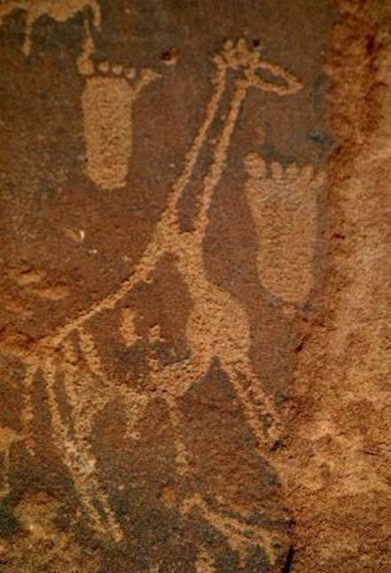

Africa-wide Giraffe Conservation Strategic Framework: Road Map
August 2016

Background
The first three conferences dedicated to the ‘wild’ giraffe, Giraffe Indaba I, II and III, were co-hosted by Giraffe Conservation Foundation (GCF) and the IUCN Giraffe & Okapi Specialist Group (GOSG) in Namibia (2011), Kenya (2013), and South Africa (2015), respectively. The concept of developing an Africa‐wide Giraffe Conservation Strategic Framework evolved out of the discussions at Giraffe Indaba I, and subsequent discussions with giraffe conservation partners across the globe.

This Strategic Framework was developed as a ‘road map’ to guide giraffe conservation activities across Africa, and where appropriate, to inform the creation of new country or (sub)species plans and/or an Africa-­‐wide Giraffe Conservation Strategy. This Strategic Framework summarises shared experience and collective thoughts, the perceived gaps in current giraffe conservation and management, both geographically and in terms of current knowledge in giraffe status, distribution, taxonomy, ecology and other aspects of giraffe science and management. Lastly, this Strategic Framework outlines conservation priority areas and suggested activities to address these. These suggested activities could be used as a guiding ‘Road Map’ for giraffe conservation by the IUCN SSC GOSG, GCF, conservation partners, zoo community, private sector and most importantly, the governments and people of Africa, who live with and collectively manage giraffe in the wild.

Vision
A Strategic Framework for giraffe conservation and management in Africa guiding (sub)species and national strategies or action plans, and their subsequent implementation.

Current Status of Giraffe – an Overview
Taxonomic Status
A number of taxonomic classifications for giraffe have been proposed over the last half a century (Ciofolo & Pendu 2014, Groves & Grubb 2011, Grubb 2005, East 1999, Kingdon 1997, Dagg & Foster 1982, Ansell 1972). However, there remains uncertainty surrounding the geographic and taxonomic limits of the (sub)species described. Furthermore, recent genetic research suggests that several (sub)species may even represent distinct species (Brown et al. 2007; Hassanin et al. 2007). Most recently, comprehensive DNA sampling from all major populations has been undertaken across the current giraffe range and analysis reveals that there are four distinct species of giraffe and five subspecies (Fennessy et al. 2016). It was additionally observed that, Thornicroft’s giraffe is genetically indistinguishable from Masai giraffe, Rothschild’s giraffe is genetically identical to Nubian giraffe, and Angolan giraffe are similar to South African giraffe (Fennessy et al. 2016; Bock et al. 2014; Fennessy et al. 2013).
- Masai giraffe Giraffa tippelskirchi (includes former Thornicroft’s giraffe).
- northern giraffe Giraffa camelopardalis with subspecies Kordofan giraffe G. c. antiquorum; Nubian giraffe G. c. camelopardalis (includes former Rothschild’s giraffe); and West African giraffe G. c. peralta.
- reticulated giraffe Giraffa reticulata.
- southern giraffe Giraffa giraffa with subspecies Angolan giraffe G. g. angolensis; and South African giraffe G. g. giraffe.

Conservation Status
Currently listed as Least Concern on the IUCN Red List, giraffe (Giraffa spp.) were reportedly widespread across Africa, with a population estimate of more than one million individuals a century ago. In the mid 1980s, giraffe numbers were estimated at approximately 153,000 individuals (East 1999; Fennessy & Brown 2010; GCF 2016). Current estimates on giraffe in the wild indicate ~100,000 individuals, and importantly the IUCN SSC GOSG is currently finalising the first‐ever detailed conservation assessment of giraffe numbers, range and threats scheduled to be released in late 2016. Based on the overall decline of giraffe in the last three decades, especially of some (sub)species, it is likely the taxon will warrant listing in a higher category of threat on the IUCN Red List than its current status. Future assessments of the (sub)species will be undertaken in time and the majority will also likely warrant listing in a high category of threat on the IUCN Red List.

Although a few (sub)species and populations remain stable or are increasing, in particular southern giraffe with both subspecies Angolan and South African giraffe, others are clearly in a more precarious situation. The population in Niger was estimated at 49 individuals in the mid-­‐1990s (Ciofolo et al. 2000) and has since increased to more than 400 individuals in 2015 (Niger Ministry of Environment pers. comm.). In 1998, East (1999) estimated that a little more than 500 Nubian (including Rothschild’s) giraffe remained, with the populations in (South) Sudan unknown. In the early 1970s, the population in the Murchison Falls Conservation Area (MFCA), consisting of Murchison Falls National Park (MFNP) and the adjacent wildlife reserves of Bugungu and Karuma, in the north-western parts of Uganda, was estimated at 150-200 individuals (Rwetsiba 2006; NEMA 2009; Rwetsiba et al. 2012). Several aerial sample counts of wildlife in the MFCA were conducted in the 1990s and the population had decreased to an estimated 78 giraffe in 1991 (Olivier 1991). The current Nubian giraffe population in MFNP has and continues to increase since civil unrest in this part of Uganda ceased, and MFNP is now home to the largest (and growing) remaining natural population, estimated at over 1,250 individuals (M. Brown unpublished data). Unfortunately, the Kordofan, Masai and reticulated giraffe numbers are not as promising with large declines recorded over the last three decades, and their conservation status requires urgent updating. Ongoing efforts to better estimate the continent's giraffe populations will allow a more accurate assessment of all (sub)species' conservation status, which are currently limited by lack of resources and capacity, as well as a general lack of understanding of the plight of giraffe.

IUCN Red List - Species
- 2016 – TBA (late 2016 – likely higher threatened category)
- 2010 – Least Concern
- 1996 – Lower Risk/conservation dependent

IUCN Red List – (sub)species (others not assessed)
- 2016/17 – TBA (likely many (sub)species in higher threatened categories)
- 2010 – Endangered (G. c. rothschildi)¹
- 2008 – Endangered (G. c. peralta) CITES
- Not listed

Source: Fennessy & Brown 2008; Fennessy & Brenneman 2010

1 subsumed in G. c. camelopardalis

Current Range
Giraffe formerly occurred widely in arid and dry-savanna zones of sub‐Saharan Africa wherever there were trees. Today, the geographic extent of giraffe has contracted markedly with the expansion of human populations and the conversion of land use.

The West African giraffe formerly ranged from Senegal to Lake Chad, but the only surviving population within this entire area now lives in a small part of south-­‐western Niger. Throughout Central Africa, Kordofan giraffe remain patchily distributed with an estimated 2,000 individuals spread across northern Cameroon, southern Chad, Central African Republic, north-­‐eastern Democratic Republic of Congo and south-­‐western South Sudan. In East and North-­‐East Africa, reticulated giraffe still occurs in relatively large but significantly decimated numbers throughout northern Kenya, and in low numbers in southern and south-­‐western Ethiopia, and there are no clear estimates for south-­‐eastern Somalia. Nubian giraffe occurs in western Ethiopia and south-­‐eastern South Sudan, whilst northern Uganda is the major stronghold (formerly Rothschild’s giraffe), and smaller introduced, reintroductions and augmented populations scattered across national parks and conservancies in Kenya and Uganda. Masai giraffe remain relatively widely distributed throughout southern Kenya and Tanzania, and smaller but stable numbers in eastern Zambia (formerly Thornicroft’s giraffe), however, their numbers have halved in recent decades. A small introduced population occurs in Rwanda.

Throughout southern Africa, giraffe is relatively plentiful and currently account for greater than 50% of the total wild population of giraffe in Africa. One driving force behind this has been their re‐introduction to many parts of the species former range from which they were eliminated or introduced to areas outside of their assumed natural range for conservation, tourism or business purposes. Angolan and South African giraffe are currently ‘common’ both inside and outside of protected areas in Namibia, Botswana, Zimbabwe and South Africa. In Angola, Angolan giraffe were locally extinct but have been re-­‐introduced from Namibia while other natural and extra-limital introductions of South African giraffe have also occurred. Small South African giraffe populations naturally occur in south-­‐western Zambia whilst introductions have occurred onto public and private land throughout southern and central Zambia, as well as Botswana, Senegal, South Africa, Swaziland and Zimbabwe. In Mozambique, a few South African giraffe still occur in areas bordering Kruger National Park and (re-­‐) introductions have been undertaken into a small number parks and reserves.

Native Range
  - Angola, Botswana, Cameroon, Central African Republic, Chad, Democratic Republic of the Congo, Ethiopia, Kenya, Mozambique, Namibia, Niger, Somalia, South Africa, South Sudan, Tanzania, Uganda, Zambia and Zimbabwe.

Extra-limital introduction
  - Angola, Botswana, Kenya, Rwanda, Senegal, South Africa, Swaziland, Zambia and Zimbabwe.

Regionally Extinct.
Burkina Faso, Eritrea, Guinea, Malawi, Mali, Mauritania, Nigeria and Senegal.

Africa-wide Giraffe Range Map

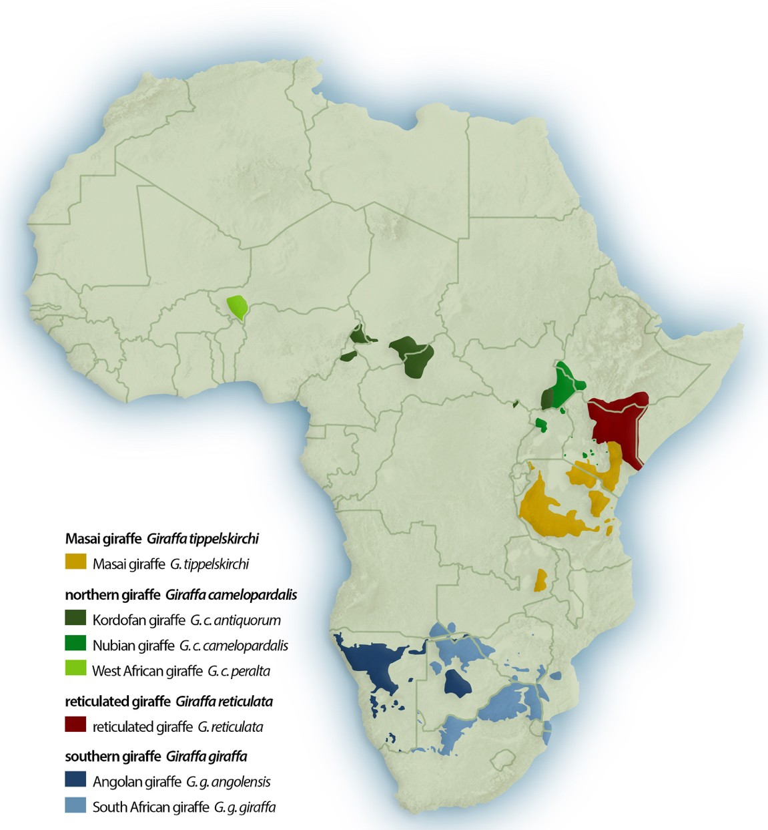
Source: GCF 2016

Guiding Principles
Given the complexity of the threats facing Africa’s giraffe and the diverse suite of conservation measures required to protect and manage them, it is essential to outline the following “Guiding Principles for this Africa-­‐ wide Giraffe Conservation Strategic Framework”. As a ‘Road Map’, the document intends to:

- Develop and prioritise mechanisms by which all giraffe populations in Africa would be offered the recognition, protection and support needed to ensure their future survival;
- Recognise the serious and increasing levels of threat currently facing giraffe, including habitat loss and fragmentation, climate change, illegal killing for meat and other products, illegal domestic and potential international trade, lack of conservation knowledge and attention, and lack of institutional and enforcement capacity;
- Implement measures to prevent any further localised extinction of giraffe in any part of their range;
- Identify and address the needs of those individuals mandated with protecting giraffe, and of those co-existing and interacting with giraffe;
- Demonstrate value to conservation partners and supporters through a commitment to transparency, accountability, coordination, and common purpose by African giraffe range States, NGOs and other stakeholders; and,
- Identify for the local, regional and international donor community mechanisms for channelling support to giraffe conservation programmes through a process which has been developed, owned, approved and managed in the future by the African giraffe range States and in collaboration with key partners.

Conservation and Management Strategies
Objective 1: Improve knowledge of giraffe and their habitats
  - Result: The abundance and distribution of giraffe are known and monitored
  - Rationale
Our knowledge of the abundance and distribution of giraffe and their (sub)species in Africa is limited and incomplete. Without enhanced knowledge on giraffe abundance and distribution, it will be impossible to develop a coherent strategy or action plan, let alone implement effective measures for successful giraffe conservation and management.
  - Activities
- Consolidate data from previously conducted studies and surveys for integration into the Africa-wide Giraffe Database (GiD).
- Define, adapt and/or establish survey protocols and tools across the giraffe range; existing protocols used should be continued and/or adapted as appropriate for comparative analysis.
- Conduct targeted giraffe surveys across their range – it will be particularly important to coordinate the censuses of (sub)species and transboundary populations, and to maximise the opportunity to include giraffe into other large mammal surveys for economies of scale.
- Assess, trial and/or support capture-mark-recapture methods to assist with quantifying giraffe abundance and distribution across their range.
- Encourage research on the historical abundance, distribution and evolution of giraffe through focused bio-geography studies incorporating geology, soils and climate change.
- Gather and integrate traditional knowledge, including attitudes towards, interaction with and usage of giraffe by local communities across the continent to better understand local historical and current giraffe range, seasonal use and threats.
- Further develop the GiD as the key database of abundance and distribution data of giraffe collected from across the continent (private, public and communal land; natural, re-introduced and extra-limital introductions), and with the analytical capacity to process the data.
- Finalise and regularly update GCF’s national giraffe Country Profiles for each giraffe range State.
- Collate, support and publish the first-ever comprehensive conservation status of giraffe – Africa-wide Giraffe Conservation Status.
- Support sharing of data and inclusion in, and appropriate assessment of, giraffe numbers and range for future detailed assessments of giraffe on the IUCN Red List.
- Build on existing capacities and resources among and across giraffe conservation partners.
  - Result: Giraffe population dynamics are known and monitored
  - Rationale
Our knowledge of the population dynamics of giraffe is insufficient to understand their ecology across their range. There is an urgent need to investigate the ecological basis of giraffe population dynamics, threats and the impact giraffe have on their habitats. The latter is particularly relevant in some small protected or communal areas where giraffe are being 'compressed' into restricted ranges, and may provide key insights into ecosystem function including pollination and seed dispersal.
  - Activities
- Identify conservation research activities and priorities, including but not limited to:
  - Establish contemporary, and if possible, historical baselines of population dynamics and ecological relationships in restricted range areas including source and sink dynamics, effects on environment (vegetation, herbivory, ecosystem function).
  - Evaluate ecological roles of bottom-up and top-down regulation of population dynamics.
  - Evaluate the effects food limitation on giraffe demography.
  - Evaluate the effects of poaching and predation on giraffe demography.
- Establish and encourage comparative (sub)species research opportunities for range-wide population studies to compare behaviour and ecology (short- to long-term), with a special emphasis on comparing natural populations, restricted range populations and introduced or extra-limital populations.
- Determine geographical and (sub)specific variation in the social organisation of giraffe and their implications for management across their range.
- Assess if any (sub)species and geographical variation of a seasonal or asynchronous reproduction.
- Understand giraffe dispersal and corridor linkages and opportunities, including how they relate to land use.
- Assess and document drivers of population decline throughout giraffe range in Africa.
- Evaluate genetic structure among populations and genetic diversity both among and within populations.
- Examine potential effects of population bottleneck events and inbreeding depression on population dynamics.
- Define concepts such as ‘herd’ in the context of giraffe population dynamics studies and comparability across their range.

  - Result: Giraffe movements are known
  - Rationale
Giraffe can roam over large areas, but under specific circumstances they can also decide to remain in small restricted and core areas. Factors that determine giraffe range are complex and little is known or understood regarding intraspecific variation in ranging patterns. A range of social and dietary factors are important alongside the degree of human activity, and its impact. The use of technology such as GPS, GSM and satellite tracking allows us to broaden our knowledge of giraffe movements and habitat use considerably, especially when combined with field observations.
  - Activities
- Carry out studies of different giraffe (sub)species and populations ranging patterns, both within their natural range and of (re‐) introduced populations. An effort should also be made to understand transboundary giraffe movements of particular importance and comparability within and between sites and populations.
- Further develop and trial appropriate GPS, GSM and satellite tracking tools to assist a better understanding of giraffe ecology, their conservation and management.
- Track giraffe using geo‐located photo identification of giraffe, including through citizen science opportunities.

  - Result: Giraffe habitat use is better understood
  - Rationale
Historical data suggests that giraffe persist predominantly in Acacia woodlands and the current range of giraffe (sub)species is distributed across 21 countries in sub-Saharan Africa. Invariably, there are differences in the vegetation types, climate, management policies and other abiotic factors across the (sub)species’ range. Research efforts focusing on these issues would further increase our understanding of giraffe ecology.
  - Activities
- Develop a predicted habitat suitability map for giraffe throughout Sub-Saharan Africa to guide future (re-) introductions and the allocation of conservation resources.
- Assess habitat use, preferences and core areas of giraffe (sub)species within targeted populations and across their range.
- Assess seasonal habitat use of giraffe (sub)species within populations and across their range.
- Carry out vegetation and habitat assessment mapping and monitoring of current and potential giraffe ranges to guide current management and future translocation opportunities.
- Evaluate the roles of habitat structure, community composition and browse nutrition on habitat selection.
- Examine the potential roles of competition and predation on habitat preference.

  - Result: Giraffe taxonomy is re-evaluated and better understood
  - Rationale
Until recently, it was widely accepted that there is one species of giraffe and nine subspecies. However, recent evidence has indicated that there are four species and five subspecies of giraffe. Several methods of classifying giraffe have been proposed but developments in genetic analyses and molecular biology techniques are being employed to resolve the question of giraffe taxonomy.
  - Activities
- Identify and complete genetic sampling of any additional or under samples key giraffe populations across Africa.
- Improve existing genetic samples from sampled populations where necessary.
- Carry out additional genetic sampling of key museum populations internationally, as appropriate.
- Facilitate ongoing development and sharing of giraffe specific genetic markers for various aspects of ecological research including, but not restricted to:
  - Taxonomy.
  - Paternity.
  - Social analysis.
  - Comparative demography.
- Explore the viability of and/or improvement in new DNA extraction and analysis tools.
- Carry out further taxonomic assessments of giraffe using best available genetic analysis, morphology, phylogeography and other appropriate tools that arise.
- Monitor genetic diversity, hybridisation and inbreeding of targeted populations, in particular of small and restricted populations.

  - Result: Translocations of giraffe are based on best practice with all the relevant background information available
  - Rationale
Even though giraffe have been successfully (re-)introduced into numerous locations within their former range or introduced into new landscapes for conservation purposes or other reasons, there remains a need to undertake regular monitoring as well as to collate the information on the translocation histories in order to inform the best practice and management policies in order to secure the future of giraffe across their natural range. Such information will be useful in developing an extensive database and best practices to increase the number of viable giraffe populations.
  - Activities
- Develop a database of giraffe (sub)species translocation history across their range (within and between countries).
- Establish taxon and/or (sub)specific re-introduction guidelines for giraffe in line with the IUCN Translocation Guidelines including, but not limited to:
    - Identify of appropriate individual giraffes for translocation.
    - Establishing pre- and post-monitoring protocols.
    - Evaluating stress related impacts.
    - Transboundary translocations.
    - Documenting lessons learned and best practices from translocation experiences.
- Advise and provide technical support and assistance to governments, NGOs, private sector and other stakeholders on best practice for giraffe translocations and post-translocation monitoring.
- Recommend, support and document pre- and post-monitoring of re‐introductions and translocations to better understand the actions of giraffe translocations for their conservation and management.

  - Result: Giraffe physiology, foraging ecology, diet and diseases are better understood
  - Rationale
Morphological variations between (sub)species and geography suggests that biotic and abiotic factors across the range of giraffe might also vary. However, very few studies have explored these factors because of the limited long‐term monitoring surveys of giraffe populations. Increasing and improving studies on the aforementioned factors would increase our understanding of giraffe ecology across their range.
  - Activities
- Encourage ongoing research and dissemination on giraffe physiology and morphological variances.
- Encourage greater research on giraffe rumination biology including, but not limited to:
    - Investigating rumination rates.
    - Stomach content triggers.
    - Understanding the prevalence and potential role of osteo/geophagy.
    - Evaluating environmental and dietary influences on rumen microbiota.
- Encourage research on giraffe forage use and quality, including, but not limited to:
    - Understanding the role of browse nutrition in diet selection.
    - Evaluating nutritional deficiencies in the context of population dynamics.
    - Examining the role of plant secondary metabolites in diet selection.
    - Evaluating nutritional needs.
    - Understanding geographic variation of giraffe forage ecology.
    - Understanding the effects of seasonal variation of nutritional profiles of common browse species on giraffe habitat selection and space use.
- Synthesise published diet and forage studies into a comprehensive review paper(s).
- Establish comparative (sub)species research opportunities for range‐wide population studies to compare forage and diet.
- Develop a database of and encourage research into giraffe epidemiology, diseases and their transmission across their range.
- Undertake an assessment of the abundance and distribution of giraffe skin disease(s) across their range, and importantly detailed epidemiology of known populations.
- Assess the need for giraffe water dependency and use across their range.

  - Result: Giraffe communication observed and understood
  - Rationale:
Studies have shown that giraffe have a fission‐fusion social structure, but there is still very limited understanding of giraffe communication. Communication is an integral component of maintaining social networks and there is a need to better understand this mechanism, especially in wild giraffe populations. Importantly, studies on communication can provide additional information on giraffe ecology and social associations.
  - Activities
- Assess communication capabilities of giraffe including, but not limited to:
  - Sound – in particular Infrasound.
  - Visual.
  - Olfactory.

  - Result: New research tools and technologies are trialled and tested
  - Rationale
In recent years, safer and more efficient technologies have been developed to perform non-invasive surveys on wildlife. Non-invasive techniques can be used in an array of studies and thus greatly enhance the knowledge and understanding of population dynamics of giraffe (sub)species.
  - Activities
- Encourage the research into understanding heritability of pelage patterns within populations.
- Explore the viability of and/or improvement in new DNA extraction and analysis tools.
- Assess the use of hormonal analysis to better understand giraffe reproductive and stress physiology.
- Assess efficacy and best practices for community-based, community involved and/or citizen science based giraffe conservation and research.
- Collate, assess, trial and report on the value of various population survey and monitoring methods including, but not limited to:
  - aerial counts and monitoring (full, sample and infrared, UAV).
  - road counts (strip, transect).
  - DNA.
  - Camera traps.
  - Questionnaires.
  - Water points.
  - Tourist photos: photo-ID citizen scientist e.g. GiraffeSpotter.
- Refine the user‐interface, database and function of photo identification tools.
- Develop appropriate GPS, GSM and satellite tracking tools for giraffe.

Objective 2: Understand human dimensions and giraffe conservation, including reducing human-­‐ giraffe conflict, their illegal killing and domestic trade in giraffe products
  - Result: Improved understanding of the human dimensions of giraffe conservation
  - Rationale
The human dimension in conservation and management is increasingly recognised by stakeholders as an important component to understand and integrate into daily decision-making. The nature of human dimensions and human dimension conservation has changed from a traditional emphasis to economic and social issues. To aid giraffe conservation, increased public understanding, awareness and involvement is key. As human dimensions of giraffe conservation remain relatively unknown, stakeholders and managers can benefit. As giraffe often elicits strong public emotions, management becomes as much a socio‐political issue as a biological one.
  - Activities
- Develop and implement baseline attitudinal, perception and knowledge surveys to assess the importance, understanding and value of giraffe across their range.
- Assess the historical and current cultural significance of giraffe to people across their range.
- Engage more social science research in giraffe conservation to assess current needs and requirements to assist in further conservation and management of giraffe across Africa.

  - Result: Illegal trade and killing of giraffe assessed, and actions taken to reduce these and human-­‐giraffe conflict
  - Rationale
Human activities have led to drastic declines in giraffe numbers over the past three decades. Instances of illegal killing (poaching) and snaring of giraffe have been recorded across the giraffe range, yet there are limited studies that quantify the effect of these and other anthropogenic activities. More research is required to guide and inform targeted giraffe conservation and management.
  - Activities
- Assess and monitor the level of illegal exploitation, harvesting and trade of giraffe across their range.
- Develop and report on illegal hunting (poaching) incidents and surveys of giraffe.
- Assess the impact of habitat loss and destruction impacts on their abundance and distribution.
- Assess the impacts of giraffe on agriculture across their range.
- Document and understand the myths behind illegal hunting (poaching) of giraffe for medicinal use.
- Document and better understand human perceptions towards giraffe including use of products, reasons for poaching, tourist attraction, people/captive giraffe interaction and attitudes, human/giraffe interactions and conflict (avoidance).
- Review human-giraffe conflict and co-existent management issues within and across their range.
- Assess any other threats which will impact giraffe conservation and management.
- Develop a database of giraffe hunting policies and legislation in Africa, as well as numbers hunted and across what countries.
- Undertake a trade assessment of giraffe products in line with CITES methodology.

Objective 3: Garner support for education, awareness, conservation and management of giraffe from the wider community
  - Result: The general public is aware, has a sound understanding of and is supportive of the importance of conserving giraffe.
  - Rationale
Educating and engaging the general public in giraffe conservation and management principles is critical for the long-term success of giraffe conservation in the wild. Often, information available to the wider public about giraffe is limited and at times inaccurate. Ongoing awareness-­‐raising campaigns aimed at all parts of society need to be developed and implemented (e.g. World Giraffe Day – 21 June). Such campaigns must be both broad and targeted, as appropriate, from dissemination of information regarding giraffe abundance and distribution, conservation, threats and impacts, economic importance, etc., and how best the general public can help.
  - Activities
- Work with all sectors (government, NGOs, institutions, etc.), from community to international, to launch and deliver accurate awareness-raising campaigns. As an example, internationally zoos and aquaria have more than 100 million visitors per annum and are best placed for awareness-raising and support.
- Establish information and awareness-raising campaigns using a range of media, including presentations, and social, print and television/radio media.
- Encourage media interest in giraffe conservation and management to produce relevant features on giraffe the mainstream, including documentaries, popular press, etc. and not limited to English speaking countries.
- Mobilise dedicated funds, logistics and equipment for giraffe conservation and management, such as, but not limited to zoo-wild partnerships and social media.
- Develop targeted education and awareness materials for various audiences, not limited to but including zoos, schools, general public and media.
- Establish and make accessible a (sub)species photographic and media library to aid in giraffe conservation and awareness – ‘Giraffe Resource Centre’.
- Continue the development and dissemination of the Giraffid newsletter, a newsletter of the IUCN SSC GOSG and supported by partners.
- Develop funding collaborations with zoos and zoo consortiums to support giraffe conservation and management in the wild.
- Assess and identify new funding mechanisms to support giraffe conservation and management including, but not limited to:
  - Adoption of wild giraffe.
  - Sponsorship of giraffe collars.
  - Green hunting.
  - Commission marketing.
  - Corporate sponsorship.
  - Targeted events and activities.
  - Giraffe ambassador programme – both VIP and scientific/conservationist community.
- Establish a ‘living’ portfolio of media contacts (in as many countries as possible) to share news items and press releases for additional international attention.
- Develop conservation volunteer giraffe supporter programmes to support conservation and management across their range.
- Mobilise and nurture giraffe ‘Ambassadors’ for each taxon.
- Organise and convene meetings targeting giraffe conservation and management to identify and deliberate on priority issues and share up to date information for giraffe conservation and management.
- Develop an appropriate Communication and Marketing Strategy to facilitate the implementation of any future giraffe conservation strategies/plans.
- Make accessible relevant information on legislation associated with giraffe to the wider public for increased transparency.

Objective 4: Facilitate the collation and distribution of giraffe literature to the wider community
  - Result: Increased accessibility of giraffe literature to the scientific and wider community
  - Rationale
As giraffe populations are understudied, scientific and grey literature remain sparse with limited accessibility by the wider community, leading to reduced research, conservation and management efforts/concern. A centralised database of giraffe literature and data would be valuable to help inform priorities for research, management policies, produce educational materials and raise awareness on issues relevant to giraffe conservation, ensuring that accurate and up-to-date information is available to the wider community.
  - Activities
- Establish a dedicated (and living) database of giraffe scientific and grey literature, the ‘Giraffe Resource Centre’.
- Advise and/or update relevant giraffe websites at regular intervals with relevant and accurate information including but not limited to updated (sub)species numbers, taxonomy and projects.
- Collect and authenticate individual giraffe stories and relate them to specific (sub)species campaigns.
- Assess and share education materials and appropriate awareness across Africa, including e.g. economic benefits of conservation versus illegal hunting (poaching).
- Develop and distribute educational materials on giraffe and presentations in local languages to schools and communities across Africa.
- Inform and educate public, private and civil society conservation officials on value of giraffe.
- Inform and educate tour guides through development of targeted giraffe course and/or material, as appropriate.
- Develop ‘Giraffe’ as a brand: zoos have important role and seek support with fundraising and awareness raising about conservation status; including cultivating interest with school children, and the general public.
- Develop, identify and sell materials to support giraffe conservation activities in the wild.
- Assess the viability of bringing wild giraffe conservation projects directly to zoo visitors by integrating webcams, live chats with field teams, blogs, into zoo giraffe exhibits and websites.

Objective 5: Support the development of national or (sub)species strategies/action plans across the giraffe range
  - Result: Development of new giraffe (sub)species and national giraffe strategies and action plans
  - Rationale
In order to stop the decline of giraffe (sub)species across their range, strategies and action plans are needed to identify giraffe conservation, management and research priorities, stakeholders, and develop broader as well as specific initiatives to support their long-term sustainability. As an example, research should focus on the conservation needs of (sub)species in different countries to maximise their success.
  - Activities
- Develop and introduce processes to help governments implement and assess effectiveness of national and/or (sub)species strategies or action plans i.e. encourage governments to develop strategies and action plans as well as provide technical and financial support for the implementation of these plans.
- Establish a network of regional representatives/coordinators for each giraffe (sub)species to liaise with governments, NGOs, local stakeholders etc., and in doing so develop and maintain key working relationships with all relevant collaborators and partners.
- Undertake a trade assessment for giraffe to assess any potential CITES listing.
- Initiate a continent-wide illegal hunting (poaching) assessment of giraffe and its current and potential future impacts on their conservation status and ecological role.

Objective 6: Build and support development of human capacity in giraffe conservation and management across Africa
  - Result: Competent and engaged conservationists across the African continent
  - Rationale
Developing a cadre of African and international giraffe conservation students, researchers, managers and conservationists to guide long-­‐term giraffe conservation is critical for the (sub)species survival. Support in the education and skills development of young Africans should be prioritised while at the same time encouraging international conservationists and stakeholders to engage, share skills and provide capacity development opportunities.
  - Activities
- Offer targeted programmes and opportunities for young African conservationists in giraffe conservation and management.
- Enable access for young African conservationists to education, work and internship programmes, while also providing opportunities to international conservationists.
- Support building in-country capacity around giraffe conservation and management, as well as supporting/incubating early‐career giraffe conservationists and managers.

Conclusion
Giraffe numbers have declined significantly over the past three decades and as such their conservation would benefit greatly from a more coordinated and guided approach. There is a clear need for more local, regional and international stakeholder support and collaboration, from governments to communities, to play an increasing role in the development, implementation and coordination of giraffe conservation in Africa. However, this need should be seen in light of currently limited resources and activities, hence prioritisation is key. The long-term aim is an increased number of giraffe conservation activities with increased support and international awareness to secure a sustainable future for all giraffe populations across Africa in their natural habitat.

The role the giraffe conservation stakeholders is key in developing, financing and facilitating giraffe conservation and research projects, providing technical support, and collaboration internationally and across African giraffe range States. The implementation of this Framework Strategy should be guided by the conservation and management needs of each respective (sub)species and their range countries. This Framework Strategy should be seen as a first step to provide a ‘Road Map’ that guides stakeholders in their giraffe conservation efforts and supports collaboration in a complimentary and effective fashion, to fill knowledge gaps, to be efficient to minimise overlap and repetition to best help conserve giraffe before it is too late.

Acknowledgements
We are grateful to the participants of Giraffe Indaba I, Giraffe Conservation Foundation and Michael Butler Brown, Thomas Leiden, Robert Montgomery and David O’Connor for taking the time to review and provide input into the document.

