 | CONVENTION ON  MIGRATORY  SPECIES | UNEP/CMS/COP15/Doc.31.2.7  24 October 2025  Original: English

15th MEETING OF THE CONFERENCE OF THE PARTIES
Campo Grande, Brazil, 23 to 29 March 2026
Agenda Item Doc.31.2.7

REPORT ON THE IMPLEMENTATION OF THE CONCERTED ACTION
FOR THE SPERM WHALES (Physeter macrocephalus)
OF THE EASTERN TROPICAL PACIFIC*

Summary:

The Red Cachalotes del Pacífico has submitted the attached report for the Concerted Action for Eastern Tropical Pacific* sperm whales (Physeter macrocephalus) in accordance with the process elaborated in Resolution 12.28 (Rev. COP14).

*The geographical designations employed in this document do not imply the expression of any opinion whatsoever on the part of the CMS Secretariat (or the United Nations Environment Programme) concerning the legal status of any country, territory, or area, or concerning the delimitation of its frontiers or boundaries. The responsibility for the contents of the document rests exclusively with its authors.

REPORT ON THE IMPLEMENTATION OF THE CONCERTED ACTION
FOR THE SPERM WHALES (Physeter macrocephalus)
OF THE EASTERN TROPICAL PACIFIC
UNEP/CMS/ CONCERTED ACTION 12.2 (Rev.COP14)

CONCERTED ACTION

Title: Concerted Action for Sperm Whales (Physeter macrocephalus) of the Eastern Tropical Pacific

Document number: UNEP/CMS/Concerted Action 12.2 (Rev.COP14)

REPORTING GOVERNMENT or ORGANIZATION

Red Cachalotes del Pacífico:

Eguiguren A*, Avila IC, Oliver M, Rosero P, Pérez-Puig H, Toro F, Hersh TA, Rojas-Cerda C, Mesnick S, Clarke CMK¹, Whitehead H, Cantor M, Alava JJ

TARGET SPECIES/POPULATION

Class: Mammalia
Order: Artiodactyla
Family: Physeteridae
Genus: Physeter
Species: Physeter macrocephalus
Population: Eastern Tropical Pacific (etP) sperm whale clans

PROGRESS IN ACTIVITIES

Since the adoption of the Concerted Action in 2017 at COP12 (UNEP/CMS/Concerted Action 12.2), and the subsequent renewal in 2024 at COP 14 (UNEP/CMS/Concerted Action 12.2 (Rev.COP14)), we have continued to advance in the establishment of a Research Network—Red Cachalotes del Pacífico—aimed at promoting collaborative research and conservation of sperm whales throughout the etP and the broader southeastern Pacific (including the Gulf of California where re-sightings of etP sperm whales have been confirmed) through a transversal cultural lens. Through this collaboration, we have achieved the following milestones:

1. Publication of a review on the interplay between culture and the conservation of the sperm whale clans

In May 2025, members of the Red Cachalotes del Pacífico published the review article ‘Integrating cultural dimensions in sperm whale (Physeter macrocephalus) conservation: threats, challenges and solutions’ (Eguiguren et al. 2025). In this review, we identified the geographic distribution of existing and emerging threats to sperm whales in the region, which include global (i.e., human-induced climate change and its effects on sperm whale prey distribution) and localized threats (i.e., fisheries interactions, vessel collisions, oceanic contamination, acoustic pollution, and deep-sea mining; Alava et al. 2014, 2022, Avila et al. 2018; Figure 1). We also compiled the existing evidence for the interaction between social learning and culture in sperm whales, their population structure, and their vulnerability to human threats in the region. We highlighted the current knowledge gaps and challenges to the effective conservation of sperm whales through a cultural lens in the etP, which include:
- A lack of fundamental knowledge on the distribution, movement patterns, and ecology of sperm whales in general, and clans specifically, throughout their home ranges.
- Virtually no understanding of the movements, ecology and distribution of mature male sperm whales, which are key to the reproductive potential of sperm whale populations.
- A knowledge gap on the degree to which specific anthropogenic threats impact sperm whale populations and specific clans throughout the region.
- Insufficient frameworks in local and international conservation instruments to protect culturally distinct groups of individuals.
- Inadequate conservation policy and enforcement capabilities for the protection of sperm whales (and other species) whose home ranges span the waters of multiple nations and also into the open seas.

Finally, we proposed concrete actions that can contribute to overcoming some of these challenges, which align with the goals of the Concerted Action for etP Sperm Whales (UNEP/CMS/Concerted Action 12.2 Rev.COP14). These include:
- Strengthening transnational collaboration across member and non-member states throughout the region, with special attention towards securing institutional support and resource mobilization towards local efforts in nations with emerging economies.
- Incorporating new technologies (i.e., machine-learning-assisted photo-ID and acoustic detector software) to streamline data processing and sharing.

2. Update on the status of sperm whale clans off the Galápagos Islands

The latest evaluation of sperm whale clans off the Galápagos Islands was conducted on whales recorded in 2013 & 2014 (Cantor et al. 2016). This analysis showed that the clans that were commonly sighted in the 1980s and 1990s (Regular and Plus-One) were entirely replaced by the Short and Four-Plus clans in the 2010s. This likely reflects the movement of clans from the Galápagos to other areas of the etP, and vice versa, over multiple decades.

Since then, we have completed analyses of sperm whale recordings collected off the Galápagos Islands nearly one decade later (2022–2023) to identify the cultural identity of whales in the region. We were able to confirm the presence of four of the previously identified clans (Table 1). The Short clan was recorded in both years, while the Four-Plus, Slow Increasing, and Palindrome clans were present in 2023 (Oliver 2025). These findings support the delineation of the recently identified Palindrome and Slow Increasing clans as distinct repertoires. They also indicate continuity with clan distributions during the 2000s–2010s, but a marked shift from those of the 1980s–1990s. An exception to this is the Slow Increasing clan, which was present at times in the 1980s–1990s as well as in 2023.
3. Steps towards transnational Photo-ID monitoring

Since 2022, researchers from the Red Cachalotes del Pacífico have begun using web-based, AI-assisted photo-ID platforms (i.e., Flukebook and Happywhale). These platforms allow researchers to streamline the photo-ID matching process and to collaborate with researchers from across the globe, which facilitates monitoring the large-scale movements of sperm whales throughout the Pacific Ocean Basin. The Whitehead Lab catalogue, which consists of over 9000 individuals from the Galápagos Islands, mainland Ecuador, central Chile, and the Eastern Pacific, has been uploaded to Flukebook.

Likewise, an updated regional photo-identification catalogue for the Gulf of California, encompassing approximately 200 sperm whales (including archival photographs dating back to 1997), was recently integrated into Flukebook. A preliminary match with a sperm whale photographed in the Galápagos Islands underscores the importance of collaborative research initiatives to understand movement patterns, home range, and connectivity among populations.

However, there is currently no connectivity between catalogues uploaded in Flukebook and Happywhale. This severely limits our ability to consolidate traditional research efforts (often uploaded to Flukebook) with citizen science uploads (most often uploaded to Happywhale).

4. Documented shift in distribution of sperm whales from the Sea of Cortez

Between 2009 and 2018, a study was conducted in the Eastern Midriff Island Region of the Gulf of California to evaluate the population dynamics of sperm whales (Physeter macrocephalus; Pérez-Puig, et al., 2024). A total of 648 individuals were recorded across 67 sightings, with 207 sperm whales identified through photo-identification; of these, 167 were confirmed as unique individuals. Abundance estimates derived from a Jolly-Seber POPAN open population model indicated that approximately 354 sperm whales transited through the study area between 2009 and 2015. Annual estimates exhibited substantial variability, ranging from a maximum of 167 individuals in 2010–2011 to a minimum of 20 individuals in 2014–2015, followed by a complete absence of sightings between 2016 and 2018, despite sustained survey efforts. This abrupt departure coincides with the documented collapse of the Humboldt squid (Dosidicus gigas) fishery and a phenotypic shift toward smaller body sizes, potentially associated with rising sea surface temperatures and prolonged warming trends in the region. While this association is correlative, additional analyses are required to test causal mechanisms (e.g., prey dynamics vs. thermal anomalies).

5. Emerging passive acoustic monitoring of sperm whales and citizen science network in Chile

Since 2023, collaborative research initiatives have provided the opportunity to conduct the first passive acoustic monitoring of sperm whales in Chilean waters. While these deployments were originally designed for broader oceanographic and cetacean studies, the coordination among national and international institutions has enabled the detection and analysis of sperm whale acoustic activity across both continental and oceanic regions.

In October 2023, the Millennial Institute of Oceanography of Chile (IMO, https://www.imo-chile.cl/) and the COPAS Coastal Center deployed a deep mooring line off Antofagasta for oceanographic and geological research in the continental shelf. Through a collaborative effort with the NGO Centro Ballena Azul, a hydrophone was attached to the mooring and programmed to record for over a year. Preliminary results confirm the acoustic presence of sperm whales through regular clicks, codas, and clangs, suggesting the presence of both female social units and solitary males during that time. These recordings are being analyzed to determine individual size composition and vocal clan identity, and future deployments of the mooring line are pending, depending on funding.

In parallel, Cornell University in collaboration with the Center of Advanced Studies in Arid Zones (CEAZA) initiated in April 2024 a passive acoustic monitoring project within the Motu Motiro Hiva Marine National Park, in the Salas y Gómez Islands of the Easter Island ecoregion. The acoustic data are being analysed for the monitoring of several cetacean species, including sperm whales, for which analyses aim to determine seasonal occurrence, demographic composition, and vocal clan identity in this remote oceanic habitat.

Complementing these research-driven efforts, local initiatives in citizen science are emerging as a source of information on sperm whale occurrence along the Chilean coast. In Caleta Chañaral de Aceituno, adjacent to the Isla Chañaral Marine Reserve, ecotourism operators have opportunistically documented sperm whales behind the island, reporting their return for a third consecutive September (CR, pers. comm.). Males observed during these events have remained in the area for extended foraging periods, ranging from ten days to over twenty days in 2025. Opportunistic photo-identification efforts have yielded interannual matches of individual whales. Additionally, in two different years, groups of sperm whales—likely female social units—have been observed travelling north to south during January and February, with opportunistic acoustic recordings capturing codas characteristic of vocal clans. Future collaboration with the local community aims to consolidate these records and continue monitoring in the long term to uncover potential seasonal patterns and assess the site fidelity of some males in this marine protected area. This site is one of the priorities for future passive acoustic monitoring efforts in the region.

6. Global coda project progress

The most recent updates to our understanding of sperm whale clan presence in the etP stem from analyses by Hersh et al. (2022) and Oliver (2025). Collectively, ~20,000 codas have been extracted from sperm whale recordings in etP waters. Over the next six months, those codas will be analysed as part of larger regional (~26,000 Pacific Ocean codas) and global (~81,000 Pacific Ocean, Atlantic Ocean, and Indian Ocean codas) datasets. These analyses, undertaken as part of the Global Sperm Whale Dialect Project (to which multiple Red Cachalotes del Pacífico members have contributed), will help us further contextualise sperm whale dialect diversity in the etP with the rest of the Pacific Ocean and will also allow us to understand how etP sperm whale communication differs from and aligns with sperm whale communication in the Atlantic and Indian Oceans.

7. Establishment of a network of researchers to progress the understanding of male sperm whales

Starting at the November 2024 Cachalote Consortium meeting (associated with the Society for Marine Mammalogy bi-annual conference), which brings together the global research community interested in sperm whales, a new Red Cachalotes del Pacífico member has been working to establish a network of collaborating researchers to progress understanding of male sperm whales. This effort aims to improve knowledge of their movement, vocal culture, and factors influencing reproductive success across the Pacific Basin and globally.

8. Outstanding questions and activities

While we have made progress in establishing cross-national collaboration to develop monitoring programs in the region, much remains to be done to fully understand how culture influences the vulnerability of sperm whale clans and to apply this knowledge towards informed conservation actions. This shortcoming results in part from the vast distribution of sperm whales in the etP, which makes effective monitoring and conservation expensive and logistically challenging. We believe that identifying the impact of emerging threats—such as the expansion of whale watching tourism in certain areas, the encroaching overlap between the Great Pacific Garbage Patch and sperm whale distribution and increased seismic exploration for resource extraction throughout the region—should be prioritized. However, we continue to experience a lack of financial support among Range States to sustain the fieldwork and subsequent analytical labour that is required for studying sperm whales at a clan level.

Thus, as we outline in our Proposal for Renewal, key next steps for ensuring success are identifying and securing funding sources that can support effective monitoring. Support for local scientists and communities in collecting data and responding to sperm whale (and other marine megafauna) strandings is particularly required. Strandings provide key opportunities for monitoring the human contribution to cetacean mortality, but there is virtually no institutional support for consolidating efforts within and across nations in the etP (Rosero 2019).

CHANGES TO THE CONCERTED ACTION (IF ANY)

We considered that a renewed Concerted Action should incorporate:
- Increased attention to the behaviour, movements, and distribution of and threats faced by males that contribute to the reproductive potential of sperm whales in the etP.
- Dedicated efforts towards engaging citizen & community science. Currently, there is an untapped opportunity in areas where sperm whales can be sighted ( e.g., Mexico, Costa Rica, Perú, and Chile) to engage whale watching tourists in photo-identification platforms (like iNaturalist (Figure 2), Happywhale (https://happywhale.com/home), and Flukebook (https://www.flukebook.org/)). For these efforts to be fruitful in informing movements of sperm whales across the region, there is a need to compile a unified Pacific Ocean photo-ID catalogue on platforms that are accessible to citizen-scientists. This will also require outreach activities to motivate public participation.

REFERENCES

Alava JJ, McMullen K, Jones J, Barragán‐Paladines MJ, Hobbs C, Tirapé A, Calle P, Alarcón D, Muñoz‐Pérez JP, Muñoz‐Abril L, Townsend KA, Denkinger J, Uyaguari M, Domínguez GA, Espinoza E, Reyes H, Piedrahita P, Fair P, Galloway T, Grove JS, Lewis C, Schofield J (2022) Multiple anthropogenic stressors in the Galápagos Islands’ complex social–ecological system: Interactions of marine pollution, fishing pressure, and climate change with management recommendations. Integr Environ Assess Manag 19:870–895. https://doi.org/10.1002/ieam.4661
Alava JJ, Palomera C, Bendell L, Ross PS (2014) Pollution as an emerging threat for the conservation of the Galapagos Marine Reserve: Environmental impacts and Management Perspectives. In: The Galapagos Marine Reserve. Social and ecological interactions in the Galapagos Islands, Denkinger J, Vinueza L (eds) Springer International Publishing, Cham, p 247–283. https://doi.org/10.1007/978-3-319-02769-2_12
Avila IC, Kaschner K, Dormann CF (2018) Current global risks to marine mammals: taking stock of the threats. Biol Conserv 221:44–58. https://doi.org/10.1016/j.biocon.2018.02.021
Cantor M, Whitehead H, Gero S, Rendell L (2016) Cultural turnover among Galápagos sperm whales. R Soc Open Sci 3:160615. https://doi.org/10.1098/rsos.160615
Hersh TA, Gero S, Rendell L, Cantor M, Weilgart L, et al. (2022). Evidence from sperm whale clans of symbolic marking in non-human cultures. Proc Natl Acad Sci USA 119: e2201692119. https://doi.org/10.1073/pnas.2201692119
Eguiguren A, Avila I, Mesnick S, Cantor M, Hersh T, Pérez-Puig H, Rosero P, Rendell L, Whitehead H, Rojas C, Alava JJ (2025) Integrating cultural dimensions in sperm whale ( Physeter macrocephalus ) conservation: threats, challenges and solutions. Philos Trans R Soc B Biol Sci 380:20240142. https://doi.org/10.1098/rstb.2024.0142
Oliver M (2025) Identification of Galápagos sperm whale (Physeter macrocephalus) vocal clans in 2022-2023 using a novel automated coda detection software. Honours Thesis, Dalhousie University, Halifax, NS, Canada
Pérez-Puig H, Arias Del Razo A, Ahuatzin Gallardo D, Bolaños J. (2024). The departure of sperm whales (Physeter macrocephalus) in response to the declining jumbo squid (Dosidicus gigas) population in the central portion of the Gulf of California. PeerJ 12:e18117 https://doi.org/10.7717/peerj.18117
Rosero P (2019) Guía Metodológica: Conformación de la Red Ecuatoriana de Respuesta a Varamientos y Rescate de Especies Marinas en Áreas Marinas y Costeras Protegidas del Ecuador. Subsecretaría de Gestión Marina y Costera, Ministerio del Ambiente de Ecuador, Quito, Ecuador.

ACTION

In light of outstanding issues, we propose the continuation of this Concerted Action (see CMS/COP15/Doc.31.3.6).

Tables and Figures

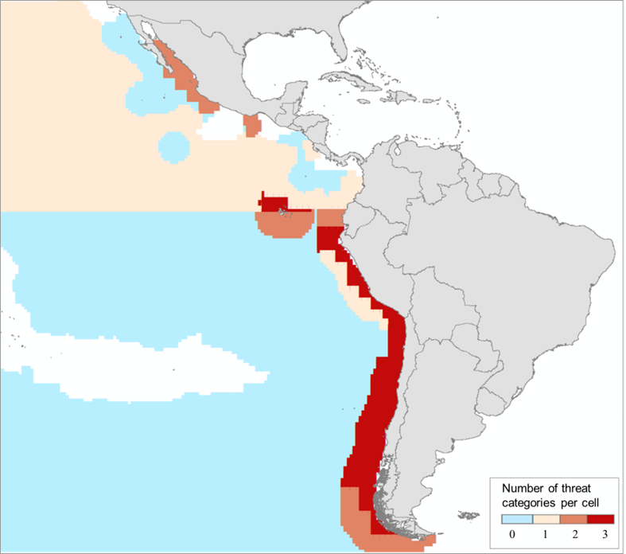

Figure 1. Risk maps for sperm whales in the etP. Cumulative risk estimated as the intersection between threats documented between 1991 and 2024 and the modelled core habitat of the species. Red cells show areas of high risk where at least three threats were detected per cell (N threats = 5 and sperm whale presence probability threshold ≥ 0.6 based on AquaMaps habitat model). The blue region represents the core sperm whale habitat where no threats have been documented. (Extracted from Eguiguren et al. 2025).
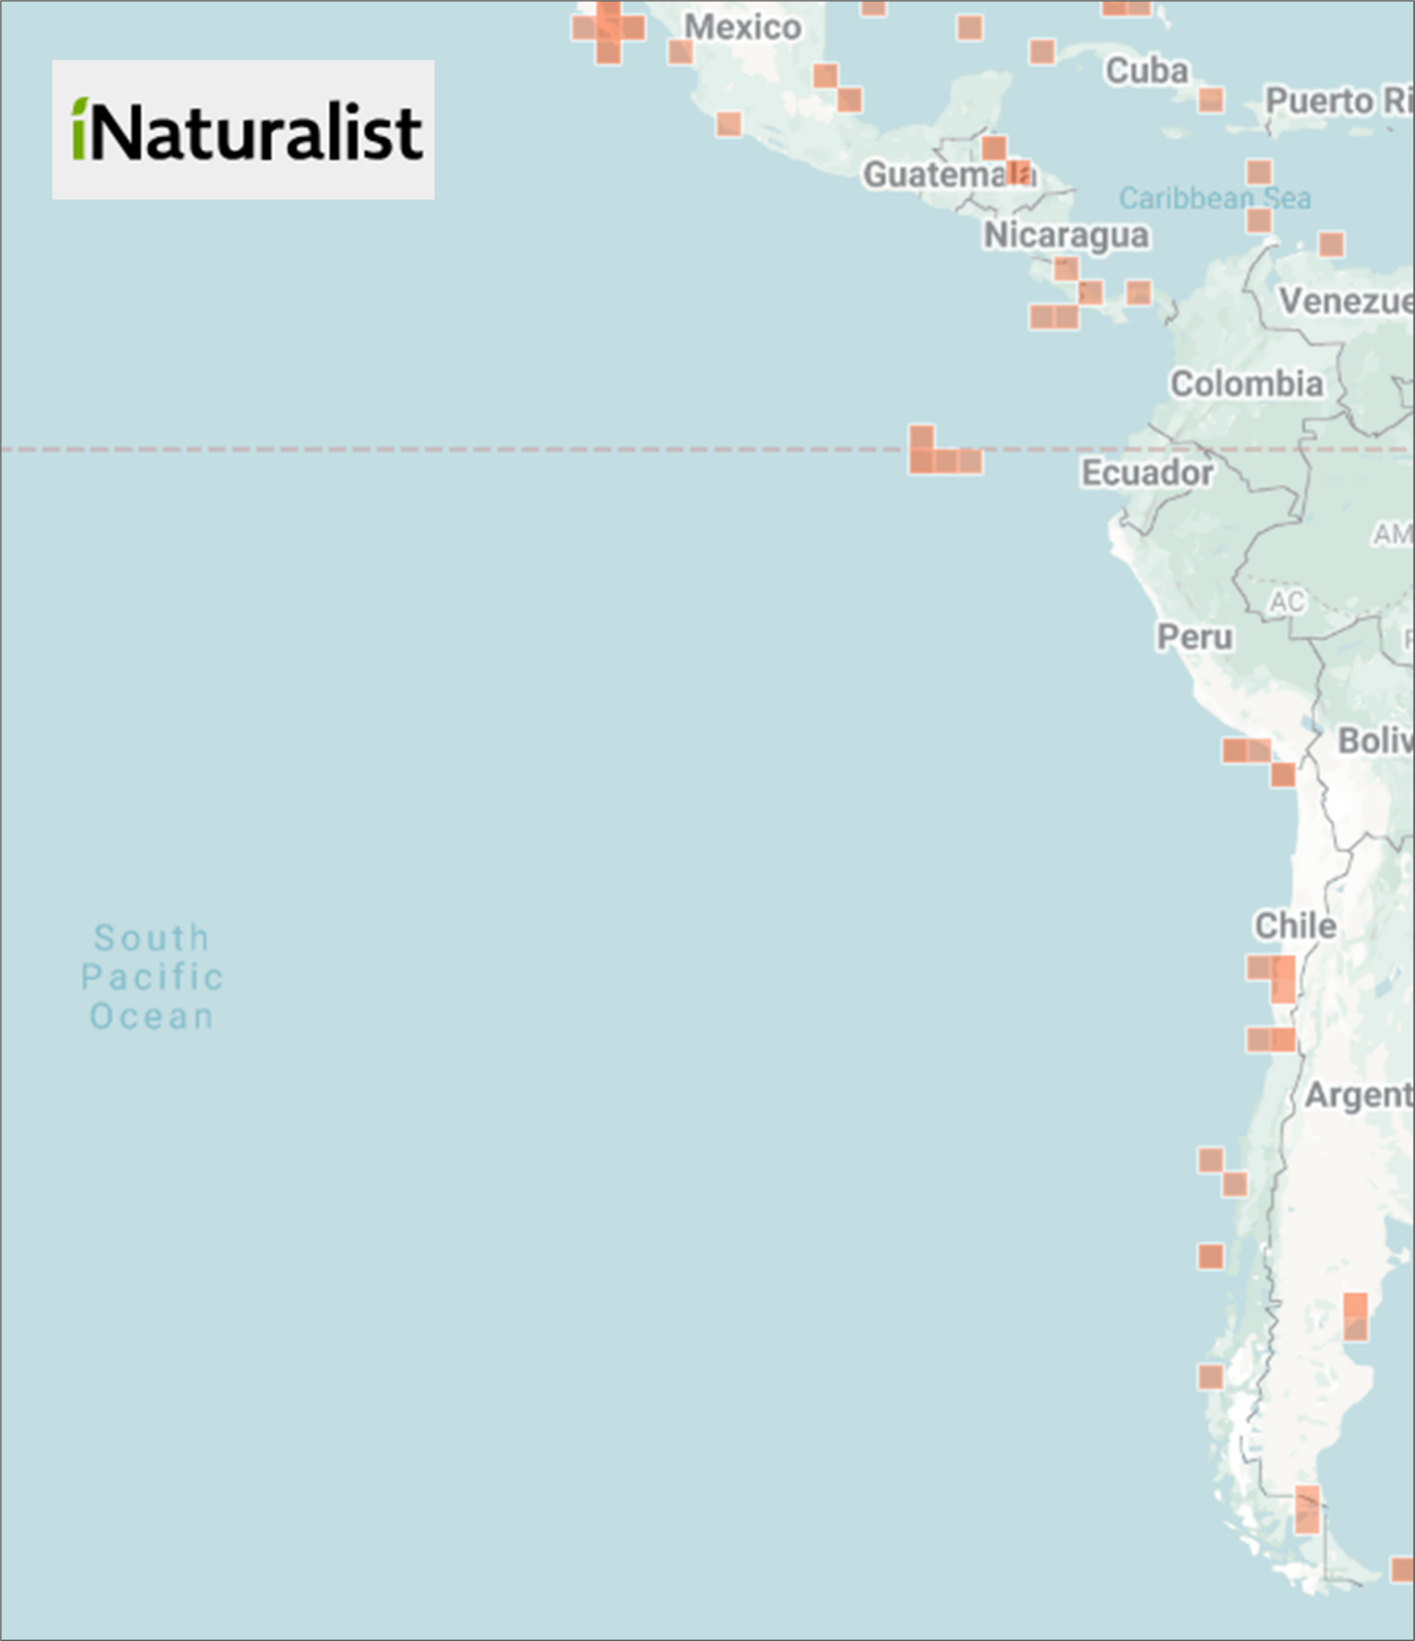

Figure 2. Sightings of sperm whales in the ETP and surroundings registered in iNaturalist (in red). https://www.inaturalist.org/observations?preferred_place_id=7196&subview=map&taxon_id=74890 (Accessed 27 September 2025)

Table 1. Clan presence per year in the ETP based on Hersh et al. (2022) with preliminary results from Oliver (2025) for 2022 and 2023. Location abbreviations are C = Northern Chile, E = Ecuador, G = Galápagos Islands, and P = Peru.

Clan/year | 1978 | 1985 | 1987 | 1989 | 1991 | 1993 | 1995 | 1999 | 2000 | 2013 | 2014 | 2022 | 2023
Four-Plus |  | E |  | G | G | C, P |  |  | C | G | G |  | G
Palindrome |  |  |  |  |  | P |  |  |  | G | G |  | G
Plus-One | G | G | G | G |  | E
Regular |  | G | G | G | G |  | G |  | C
Rapid Increasing |  | G | G |  | E |  | G |  |  | G
Short |  | G | G |  | E | E, P |  |  | G | C, G | G | G | G
Slow Increasing |  |  | G |  | E | P |  | G |  |  |  |  | G

Department of Biology, Dalhousie University, Halifax, NS, Canada/*Corresponding author: ana.eguiguren@dal.ca
Ecología Animal, Universidad del Valle, Cali, Colombia
Institute for Terrestrial and Aquatic Wildlife Research (ITAW), University of Veterinary Medicine of Hannover, Germany
Escuela de Ciencias Ambientales, Universidad Espíritu Santo, km 2.5 vía Samborondón, Ecuador
Marine Mammal Program, Prescott College Kino Bay Center for Cultural and Ecological Studies, Sonora, Mexico
Escuela de Medicina, Facultad de Medicina Veterinaria y Recursos Naturales. Universidad Santo Tomas, Viña del Mar, Chile
ONG Panthalassa, Red de Estudios de Vertebrados Marinos en Chile, Santiago
Department of Fisheries, Wildlife and Conservation Sciences, Marine Mammal Institute, Oregon State University, Newport, Oregon, United States
School of Biological Sciences, University of Bristol, Bristol, United Kingdom
Pontificia Universidad Católica de Chile, Facultad de Ciencias Biológicas, Santiago, Chile
Centro de Estudios Avanzados en Zonas Áridas (CEAZA), Coquimbo, Chile
Southwest Fisheries Science Center, NOAA Fisheries, U.S. Department of Commerce, La Jolla, California, United States
School of Resource and Environmental Management, Simon Fraser University, Burnaby, BC, Canada
Fundación Ecuatoriana para el Estudio de Mamíferos Marinos (FEMM), Salinas, Ecuador

