 | CONVENTION ON  MIGRATORY  SPECIES | UNEP/CMS/COP15/Doc.30.2.9  27 October 2025  English  Original: Spanish

15th MEETING OF THE CONFERENCE OF THE PARTIES

Campo Grande, Brazil, 23 to 29 March 2026
Agenda Item 30.2

PROPOSAL FOR INCLUSION OF THE

LESSER YELLOWLEGS (Tringa flavipes)

IN APPENDIX I OF THE CONVENTION*

Summary:

The Government of Uruguay has submitted the attached proposal* for the inclusion of the lesser yellowlegs (Tringa flavipes) in Appendix I of the CMS.

*The geographical designations employed in this document do not imply the expression of any opinion whatsoever on the part of the CMS Secretariat (or the United Nations Environment Programme) concerning the legal status of any country, territory, or area, or concerning the delimitation of its frontiers or boundaries. The responsibility for the contents of the document rests exclusively with its author

PROPOSAL TO INCLUDE THE LESSER YELLOWLEGS (Tringa flavipes)

IN APPENDIX I OF THE CONVENTION

A. PROPOSAL

This document, which is to be submitted to the Convention on the Conservation of Migratory Species of Wild Animals (CMS), compiles evidence and proposes to include Tringa flavipes in Appendix I of the Convention. This migratory species has recently been reassessed by the IUCN Red List of Threatened Species and is currently classified as Vulnerable (BirdLife International 2024a).

The populations of Tringa flavipes range from North America to South America, spanning over 50 territories, 32 of which are contracting parties to the Convention. If included in Appendix I, all populations of this species could benefit from the international coordination provided by the CMS. The Convention can provide a legal basis for the international protection of the species, as well as establish collective objectives and obligations for the contracting parties to unite their efforts in the protection of this species.

B. PROPONENT

Oriental Republic of Uruguay

C. SUPPORTING STATEMENT

1. Taxonomy
1.1 Class: Aves.
1.2 Order: Charadriiformes.
1.3 Family: Scolopacidae.
1.4 Genus, species or subspecies: Tringa flavipes (Gmelin, 1789).
1.5 Scientific synonyms: There are no current scientific synonyms, only two obsolete ones: Totanus fuscocapillus and Scolopax flavipes.
1.6 Common names:
English: Lesser Yellowlegs, Long Leg.
French: Petit Chevalier, Pattes jaunes.
Spanish: Pata Amarilla Menor.
Portuguese: Maçarico-de-perna-amarela.

2. Overview

The Lesser Yellowlegs (Tringa flavipes Gmelin, 1789) is a long-distance migratory shorebird of the Scolopacidae family. This species breeds in open and semi-open boreal forests of Alaska and Canada and spends the non-breeding season in the southern United States, Mexico, Central America and South America. The highest concentration observed outside the breeding season is found in the Argentine Pampas. During migration, the species relies on various wetland habitats along the mid-continental and Atlantic flyways and is therefore present across more than 50 different territories. Populations of this species have decreased by approximately 60% over the last three generations and are classified as Vulnerable on the 2024 IUCN Red List of Threatened Species. The primary threats identified for this species include habitat loss caused by agriculture and climate change, along with pollution and hunting, particularly during migration and the non-breeding season in the Caribbean.

3. Migration

3.1 Types of movement, distance, cyclical and predictable nature of migration

The Lesser Yellowlegs (Tringa flavipes) is a long-distance migratory shorebird that undertakes an annual cyclical migration between its breeding and non-breeding areas. From February to May, the birds leave non-breeding areas in South America, Central America and the southern regions of North America, to migrate to their breeding grounds in Canada and Alaska. Southward migration, returning to non-breeding areas, typically occurs from late June to October (McDuffie et al. 2022b). During migration, they rely on coastal and inland wetlands throughout the Americas, using the mid-continental and Atlantic flyways (McDuffie et al. 2022b; Linscott et al. 2024). As a result, they are present in more than 50 different territories.

3.2 Proportion of the population that migrates and why it constitutes a significant proportion

All individuals of Tringa flavipes are long-distance migrants (Tibbitts and Moskoff 2020; McDuffie et al. 2022b).

4. Biological data (other than migration)

4.1 Distribution

The Lesser Yellowlegs (Tringa flavipes) breeds throughout Canada (80% of the breeding range) and Alaska (Figure 1). The current non-breeding range of this species encompasses the southern Atlantic, Gulf, and Pacific coasts of the United States, Mexico, Central America and South America. The Argentine Pampas region (Argentina, Uruguay and southern Brazil) is the primary non-breeding site for this species, where 44% of the individuals studied by McDuffie et al. (2022) spent the non-breeding season. Other significant locations include the coast of Venezuela, the north-west coast of Brazil, and Ecuador (McDuffie et al. 2022b). A small portion of the population spends the non-breeding season in the southern United States, Mexico and the Caribbean (Tibbitts and Moskoff, 2020). Breeding populations in eastern Canada typically undertake an uninterrupted migration southward, starting from the Canadian coast and heading to northern South America, from where they may continue further south. Alaskan breeding populations typically migrate southward via the mid-continental route, using the Prairie Pothole region as an important stopover site (McDuffie et al. 2022b). During the northward migration, the Mississippi Alluvial Plain is the recognised stopover area that hosts the largest number of Tringa flavipes (McDuffie et al. 2022). However, there is evidence of a historical decline in the breeding range of this species, as during the 19th century, the species used to breed further south than its current range (Tibbitts and Moskoff, 2020).

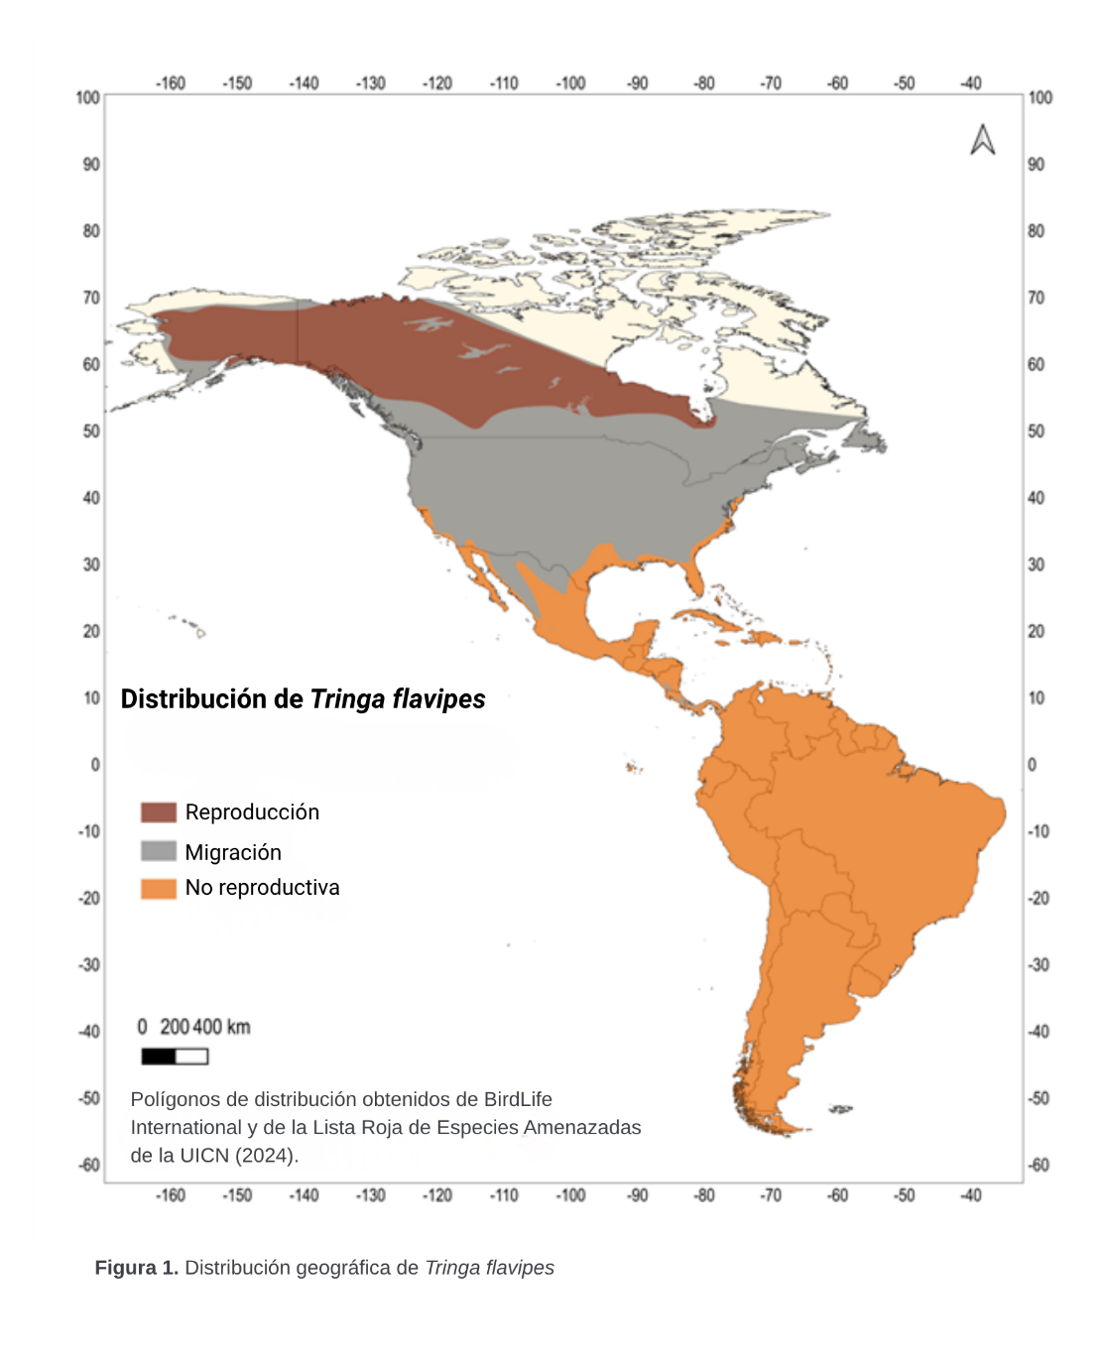
4.2 Population

There are currently two conflicting estimates regarding the total number of individuals of Tringa flavipes. The first estimate, which considers all populations of this species, suggests there are 650,000 mature individuals (Andres et al. 2012). However, a more recent estimate that considers birds breeding in Canada suggests that there are 7.6 million mature individuals in Canada alone, which is probably an overestimate (BirdLife International 2024b).

However, the population of this species has decreased by approximately 60% over the last three generations (Smith et al. 2023). The rate of decline has become more pronounced in recent years, with populations estimated to have decreased by 77% since 1980. Smith et al. (2023) estimated the population decline by considering the generation time as the mean age of the parents in the current cohort, which is 4.06 years (Bird et al. 2020). The authors used population count data from the International Shorebird Survey, the Atlantic Canada Shorebird Survey and the Ontario Shorebird Survey. These monitoring programmes were initiated in the eastern United States and Canada, meaning the study effort is concentrated in these regions, although data are also available for the breeding populations of both Alaska and Canada. However, other sources have confirmed the decline in populations of the species (BirdLife International 2024b), which collectively resulted in the species being listed as Vulnerable (BirdLife International 2024a).

4.3 Habitat

The species breeds in open and semi-open boreal forests, as well as in the transitional zones between forested and tundra habitats (Tibbitts and Moskoff 2020). This species also depends on coastal-marine and inland freshwater habitats during migration, probably to access various critical resources (Danyk et al. 2025). During the non-breeding season, it inhabits a wide variety of wetland habitats, including riverbanks, saltwater and freshwater marshes, mangroves, mudflats, prairie wetlands, and salt flats (Tibbitts and Moskoff 2020).

Considering that individuals of Tringa flavipes rely on a variety of wetland habitats, most of which have been severely affected in recent decades (Ballut-Dajud et al. 2022), it is believed that habitat loss and degradation are among the key factors driving population declines in this species (Clay et al. 2012). In non-breeding areas, one of the most significant factors contributing to habitat loss is the expansion of soybean cultivation, particularly in the Argentine Pampas region, where wetlands and flooded fields have been consistently replaced (Urcola et al. 2015).

4.4 Biological characteristics

Individuals typically migrate in small flocks, although they may gather in large numbers at non-breeding sites. This species is very loyal to its breeding sites (Christie et al. 2023); they form pairs within days of arriving at the breeding grounds, laying eggs about two weeks later. They nest on the ground and typically lay four eggs. Incubation is shared by both sexes. The chicks are precocial and leave the nest within a few hours of all the eggs hatching. They feed themselves after leaving the nest, although both parents guide them to the feeding areas. Juvenile individuals disperse widely (Christie et al. 2023). The species feeds on aquatic and terrestrial invertebrates, such as flies and beetles (Tibbitts and Moskoff 2020).

4.5 Role of the taxon in its ecosystem

The species feeds on invertebrates, such as insects, and primarily serves the function of regulating the abundance of these taxa (Sekercioglu 2006). As long-distance migratory shorebirds, they also play an important role in nutrient cycling and connect the various ecosystems on which they depend (Buelow and Sheaves 2015).

5. Conservation status and threats

5.1 IUCN Red List assessment

Tringa flavipes is classified as Vulnerable in the latest IUCN Red List assessment (BirdLife International 2024a). In previous assessments, the species was classified as Least Concern; the recent change in category is due to the growing body of evidence indicating a decline in its population.

5.2 Equivalent information relevant to the assessment of conservation status

In the last three generations, the species has declined by approximately 60% (see more details in section 4.2 of the Supporting Statement; Smith et al. 2023). This species is also considered to be of high conservation concern in the United States (U.S. Shorebird Conservation Plan Partnership 2016) and a threatened species in Canada (COSEWIC 2020).

5.3 Threats to the population

The species faces several widespread threats throughout its annual cycle, including habitat loss and degradation in both breeding and non-breeding areas, pollution, and climate change (Clay et al. 2012). However, one of the specific threats to this species, particularly to the breeding populations in eastern Canada during migration, is hunting (Rivera-Milan 2023; McDuffie et al. 2022a). Between 7,000 and 15,000 individuals may be hunted each year in Barbados, and until recently this species was also the most hunted shorebird in both Guadeloupe and Martinique (Clay et al. 2012; Cox et al. in preparation). Hunting of this species is also carried out legally in French Guiana and Guyana, and illegally in Suriname.

5.4 Threats specifically related to migrations

Threats to the species may directly increase mortality during migration (e.g. hunting, extreme weather conditions resulting from climate change, pollution from oil spills or agricultural pesticides) or may generate sublethal effects that compromise individual survival and future reproductive success, such as the loss and degradation of habitat along the migration route, which reduces the availability of high-quality stopover sites.

5.5 National and international utilisation

Individuals of Tringa flavipes are hunted for consumption or sport in some countries (e.g., Barbados, Guadeloupe, Martinique and French Guiana), although in Guadeloupe and Martinique, a moratorium on their hunting has been implemented for the 2024-2025 hunting season. Birdwatching tourism also entails an international use of this species.

6. Status of protection and management of the species

6.1 National protection status

In the breeding areas, the species is protected in Canada under the Migratory Birds Convention Act and in the United States under the Migratory Bird Treaty Act. Therefore, the hunting of this species is illegal in these two countries. In both Argentina and Brazil, two countries that host non-breeding populations of Tringa flavipes, all wildlife species are protected by law (Law 22.421 in Argentina and Law 5.197 in Brazil). Additionally, Tringa flavipes is a focal species in the national shorebird conservation plans of both countries. However, the hunting of this species is permitted in several countries within its range (for example, Barbados, Guyana and French Guiana), with a moratorium in place for the 2024-2025 hunting season in Martinique and Guadeloupe.

6.2 International protection status

Currently, the species is only protected internationally under the Migratory Bird Treaty Act (MBTA). This treaty was enacted in 1918 as a federal law in the United States to protect migratory birds, in international cooperation with Canada, and was later expanded to include Mexico, Japan and Russia. Therefore, Tringa flavipes is protected in all three MBTA countries within its range (Canada, the United States and Mexico).

6.3 Management measures

Due to the various urgent threats and the consequent population decline of Tringa flavipes, a Conservation Plan has been developed for this species (Clay et al. 2012), and a new Action Plan is currently being developed by the International Group established under the Road to Recovery initiative (2022). The aim of these plans is to identify knowledge gaps and guide the management activities for this species through partnerships and multisectoral initiatives.

6.4 Habitat conservation

The Western Hemisphere Shorebird Reserve Network (WHSRN) is identifying and working to protect important habitats for Tringa flavipes, such as Laguna Mar Chiquita, a site of hemispheric significance that hosts 15,000 individuals of this species. Other wetlands of international significance, which are also utilised by this species, are protected under the Ramsar Convention on Wetlands. In addition, conserving habitats through conservation easements and other incentives on small properties, both private and public, in Canada and the United States, may help to ensure suitable habitats at key stages in the species' life cycle.

6.5 Population monitoring

Populations of Tringa flavipes are currently being monitored as part of various National Action Plans, and internationally through the International Shorebird Survey coordinated by Manomet Conservation Sciences (https://www.manomet.org/project/international-shorebird-survey/). This Census provides a standardised approach to monitoring shorebird populations across the Western Hemisphere.

7. Effects of the proposed amendment

7.1 Expected benefits of the amendment

The proposed amendment will benefit existing initiatives dedicated to promoting concerted action for the conservation of Tringa flavipes and its habitat, such as the Atlantic Flyway Shorebird Initiative (AFSI; https://atlanticflywayshorebirds.org/), the Midcontinent Shorebird Conservation Initiative (MSCI; https://midamericasshorebirds.org/) and Road to Recovery (R2R; https://r2rbirds.org/). Both the AFSI and MSCI have identified priority actions to reverse the decline of focal shorebird species in the Americas, one of which is Tringa flavipes. These actions have been developed in collaboration by specialists, conservationists and government agencies from countries across the Americas. The R2R initiative was established in response to the loss of three billion birds in the United States and Canada (Rosenberg et al. 2019). The R2R strategy focuses on working groups dedicated to species conservation, grounded in international and interdisciplinary collaboration. The species covered by this proposal has been identified as one of the key species and is included among the species of the R2R working group.

7.2 Potential risks of the amendment

None foreseen.

7.3 Proponent's intention concerning the development of an agreement or concerted action

It is proposed to include Tringa flavipes under the Memorandum of Understanding on the Southern South American Grassland Birds, given the importance of wetlands in the Pampas region as a wintering area for the species.

8. Range states

- Anguilla: non-breeding.
- Antigua and Barbuda: non-breeding.
- Argentina: non-breeding.
- Aruba: non-breeding.
- The Bahamas: non-breeding.
- Barbados: non-breeding.
- Belize: non-breeding.
- Bermuda: non-breeding.
- Bolivia: non-breeding.
- Bonaire: non-breeding.
- Brazil: non-breeding.
- British Virgin Islands: non-breeding.
- Canada: breeding and migratory.
- Cayman Islands: non-breeding.
- Chile: non-breeding.
- Colombia: non-breeding.
- Costa Rica: non-breeding.
- Cuba: non-breeding.
- Curaçao: non-breeding.
- Dominica: non-breeding.
- Dominican Republic: non-breeding.
- Ecuador: non-breeding.
- El Salvador: non-breeding.
- French Guiana: non-breeding.
- Grenada: non-breeding.
- Guadeloupe: non-breeding.
- Guatemala: non-breeding.
- Guyana: non-breeding.
- Haiti: non-breeding.
- Honduras: non-breeding.
- Jamaica: non-breeding.
  - Martinique: non-breeding.
- Mexico: migratory and non-breeding.
- Montserrat: non-breeding.
- Nicaragua: non-breeding.
- Panama: non-breeding.
- Paraguay: non-breeding.
- Peru: non-breeding.
- Puerto Rico: non-breeding.
- Saba: non-breeding.
- Saint Kitts and Nevis: non-breeding.
- Saint Lucia: non-breeding.
- Sint Marteen (Dutch): : non-breeding.
- Saint Pierre and Miquelon: migratory.
- Saint Vincent and the Grenadines: non-breeding.
- St. Eustatius: non-breeding.
- Sint Marteen (Dutch): : non-breeding.
- Suriname: non-breeding.
- Trinidad and Tobago: non-breeding.
- Turks and Caicos Islands: non-breeding.
- United States of America: breeding, migratory and non-breeding.
- Uruguay: non-breeding.
- United States Virgin Islands: non-breeding.
- Venezuela: non-breeding.

9. Consultations

10. Additional observations

11. References

Andres B, Smith PA, Morrison RIG, et al (2012) Population estimates of North American shorebirds, 2012. Wader Study Group Bull 119:178–194
Andres, B. A., Moore, L., Cox, A. R., Roy, C., & Brown, S. C. (2022). A preliminary assessment of shorebird harvest in coastal Guyana. Wader Study, 129(1), 39–47. https://doi.org/10.18194/ws.00263
Ballut-Dajud GA, Sandoval Herazo LC, Fernández-Lambert G, et al (2022) Factors Affecting Wetland Loss: A Review. Land 11:434. https://doi.org/10.3390/land11030434
Bird, J. P., R. Martin, H. R. Akçakaya, J. Gilroy, I. J. Burfield, S. T. Garnett, A. Symes, J. Taylor, Ç. H. Şekercioğlu, and S. H. M. Butchart (2020). Generation lengths of the world’s birds and their implications for extinction risk. Conservation Biology 34:12521261. https://doi.org/10.1111/cobi.13486
BirdLife International (2024a) Tringa flavipes
BirdLife International (2024b) Species factsheet: Lesser Yellowlegs Tringa flavipes
Buelow C, Sheaves M (2015) A birds-eye view of biological connectivity in mangrove systems. Estuar Coast Shelf Sci 152:33–43. https://doi.org/10.1016/j.ecss.2014.10.014
Christie, K., Wilson, R. E., Johnson, J. A., Friis, C., Harwood, C. M., McDuffie, L. A., Nol, E., & Sonsthagen, S. A. (2023). Movement and genomic methods reveal mechanisms promoting connectivity in a declining shorebird: The lesser yellowlegs. Diversity, 15(5), 595. https://doi.org/10.3390/d15050595
Clay RP, Lesterhuis A, Centrón S (2012) Conservation Plan for the Lesser Yellowlegs (Tringa flavipes). Manomet Center for Conservation Sciences, Manomet, Massachusetts
COSEWIC (2020) COSEWIC assessment and status report on the Lesser Yellowlegs Tringa flavipes in Canada. Committee on the Status of Endangered Wildlife in Canada, Ottawa
Cox, A. R., Gallo-Cajiao, E., Tremblay, F., Rateau, F., Urvoy, K., Laliberté, B., Boniface, P., Euphrosine, D., Lavanne, T., & Roy, C. (In prep.). Legal harvest of shorebirds and resident game birds on a Caribbean island: A Martinique case study. bioRxiv. https://doi.org/10.1101/2025.06.17.660260
Danyk KAR, Zwaan DR de, Paquet J, Hamilton DJ (2025) Habitat use and local movement of staging Lesser Yellowlegs (<em>Tringa flavipes</em>) differ between coastal and inland habitat in Atlantic Canada. J Field Ornithol 96:. https://doi.org/10.5751/JFO-00659-960305
Linscott JA, Basso E, Bathrick R, et al (2024) The Amazon Basin’s rivers and lakes support Nearctic-breeding shorebirds during southward migration. Ornithol Appl duae034. https://doi.org/10.1093/ornithapp/duae034
McDuffie LA, Christie KS, Harrison A-L, et al (2022a) Eastern-breeding Lesser Yellowlegs are more likely than western-breeding birds to visit areas with high shorebird hunting during southward migration. Ornithol Appl 124:duab061. https://doi.org/10.1093/ornithapp/duab061
McDuffie LA, Christie KS, Taylor AR, et al (2022b) Flyway-scale GPS tracking reveals migratory routes and key stopover and non-breeding locations of lesser yellowlegs. Ecol Evol 12:e9495. https://doi.org/10.1002/ece3.9495
Rivera-Milán, F. F., Andres, B. A., & Johnson, J. A. (2023). Sustainability assessment of Lesser Yellowlegs Tringa flavipes harvested in the Americas. Wader Study, 130(2), 138–144. https://doi.org/10.18194/ws.00307
Road to Recovery (2022). Lesser Yellowlegs: A Tipping Point Species. https://r2rbirds.org/tipping-point-species/lesser-yellowlegs/
Rosenberg, K. V., Dokter, A. M., Blancher, P. J., Sauer, J. R., Smith, A. C., Smith, P. A., Stanton, J. C., Panjabi, A., Helft, L., Parr, M., and P.P. Marra (2019). Decline of the North American avifauna. Science, 366(6461), 120-124. https://doi.org/10.1126/science.aaw1313
Sekercioglu CH (2006) Increasing awareness of avian ecological function. Trends Ecol Evol 21:464–471. https://doi.org/10.1016/j.tree.2006.05.007
Smith PA, Smith AC, Andres B, et al (2023) Accelerating declines of North America’s shorebirds signal the need for urgent conservation action. Ornithol Appl 125:duad003. https://doi.org/10.1093/ornithapp/duad003
Tibbitts TL, Moskoff W (2020) Lesser Yellowlegs (Tringa flavipes), version 1.0. Birds World. https://doi.org/10.2173/bow.lesyel.01
U.S. Shorebird Conservation Plan Partnership (2016) Shorebirds of Conservation Concern in the United States of America ─ 2016
Urcola HA, de Sartre XA, Veiga I, et al (2015) Land tenancy, soybean, actors and transformations in the pampas: A district balance. J Rural Stud 39:32–40. https://doi.org/10.1016/j.jrurstud.2015.03.001

