 | CONVENTION ON  MIGRATORY  SPECIES | UNEP/CMS/COP15/Doc.30.2.3  24 October 2025  English  Original: French

15th MEETING OF THE CONFERENCE OF THE PARTIES

Campo Grande, Brazil, 23 to 29 March 2026
Agenda Item 30.2

PROPOSAL FOR THE INCLUSION OF
the giant otter (Pteronura brasiliensis)
In Appendices I and II OF THE CONVENTION*

Summary:

The Government of France has submitted the attached proposal* for the inclusion of the giant otter (Pteronura brasiliensis) in Appendices I and II of the CMS.

*The geographical designations employed in this document do not imply the expression of any opinion whatsoever on the part of the CMS Secretariat (or the United Nations Environment Programme) concerning the legal status of any country, territory, or area, or concerning the delimitation of its frontiers or boundaries. The responsibility for the contents of the document rests exclusively with its autho
PROPOSAL FOR THE INCLUSION OF
the giant otter (Pteronura brasiliensis)
In Appendices I and II OF THE CONVENTION

- PROPOSAL

Registration of the Giant Otter (Pteronura brasiliensis) in Appendices I and II of the CMS

- PROPONENT

France

- SUPPORTING STATEMENT

  - Taxonomy
    - Class: Mammalia
    - Order: Carnivora
    - Family: Mustelidae
    - Genus, species or subspecies, including author and year: Pteronura brasiliensis (Gmelin, 1788)
    - Scientific synonyms: Pteronura sambachii (Gray, 1837); Mustela brasiliensis (Gmelin, 1788)
    - Common name(s), in all applicable languages used by the Convention: French: Loutre géante, Loutre géante du Brésil, Loutre géante sud-américaine;
English: Giant Otter, Giant Brazilian Otter;
Spanish: Arirai, Lobito de Cola Ancha, Lobo Gargantilla, Lobo de Rio, Lobo de Río Grande, Lobo del Río, Perro de Agua

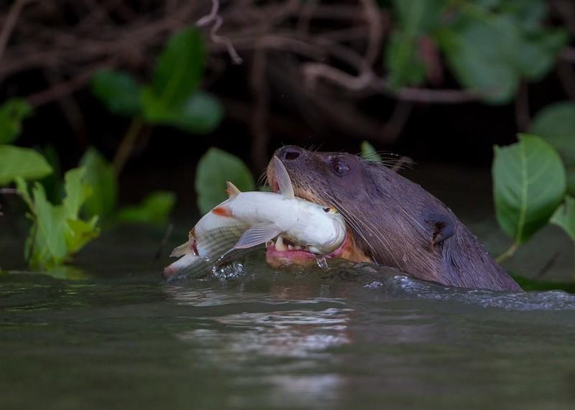
  - Overview

Giant river otter with fish, Pantanal, Brazil © Grégoire Dubois

The giant otter (Pteronura brasiliensis) is a species of semi-aquatic mammal endemic to South America. A member of the mustelid family, it is known for being the largest otter and one of the most significant predators in aquatic ecosystems in South America. It is more specifically found in the Amazon, Orinoco and Pantanal basins, and is present in several South American countries, including Brazil, Peru, Colombia, Venezuela, Bolivia and French Guiana.

Although the geographical distribution of the giant otter appears to be vast, its presence is irregular, making overall estimates of the population difficult, especially since the number of groups is not available for all areas surveyed.

Numerous emerging and/or growing threats pose serious problems for the giant otter, including contamination, overfishing and conflicts with fishermen, as well as infrastructure such as roads and hydroelectric dams. Their preference for lowland wetlands, rivers and lakes means that their primary habitat fully overlaps with human demands (such as gold mining, fishing, deforestation, mega infrastructure and energy developments, human settlements, transport, tourism, etc.). The effects of climate change are already being felt, with Brazil recently experiencing severe droughts. By 2050, large-scale deforestation in the Amazon could reduce precipitation within the basin by 12% during the wet season and by 21% during the dry season (Spracklen et al. 2012), with unknown impacts on aquatic and semi-aquatic species.

The accelerating habitat destruction, degradation and exploitation throughout the distribution range of the giant otter is the greatest threat to the species, and is believed to have caused a population decline of more than 50% over the past 25 years (three generations, according to Groenendijk et al. 2014) and, based on current trends, is expected to result in a further reduction in population size of more than 50% over the next 25 years.

The giant otter is classified as“Endangered” by the International Union for Conservation of Nature (IUCN).

  - Migrations

3.1 Kinds of movement, distance, the cyclical and predictable nature of the migration

Although the species is threatened, knowledge about its ecological needs and its movement patterns remains limited, with its home range being one of the missing pieces of information (Utreras et al., 2005).

The movements of the giant otter are influenced by its aquatic habitat, dietary needs and social interactions.

Giant otters travel long distances either as part of their daily movements (territory sizes vary depending on the availability of resources, but a family group can control a territory of several kilometres along rivers or lakes) or during aquatic hunting.

In some regions, the giant otter may be forced to move according to the seasons, particularly to avoid floods during the rainy season or to find permanent areas of water during the dry season. This seasonal movement is crucial for its survival, as water is essential for its diet and protection.

Giant otters can also be observed alone. Generally, lone giant otters are young adults who have just left their group and are seeking a new territory and a partner to start a new family. They may also be adult individuals who for various reasons might have lost their partner.

Giant otters use large territories based on the resources available (Evangelista & Rosas, 2011). Otter movements and home ranges can therefore be located in cross-border zones (see map below). Giant otters move along the rivers and watercourses that cross multiple South American countries. Their habitat includes ecosystems such as the Amazon, Pantanal and Orinoco basins, which span several countries, including Brazil, Bolivia, Peru, Venezuela, Colombia, Ecuador and French Guiana.

River basins such as the Amazon, Madeira and Paraguay serve as natural ecological corridors, allowing giant otters to move between different countries in search of food or new territories, or to avoid competition with other groups.
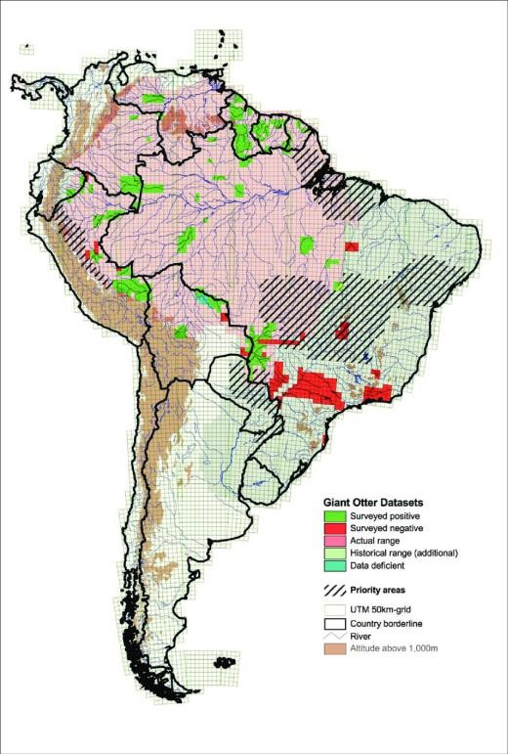
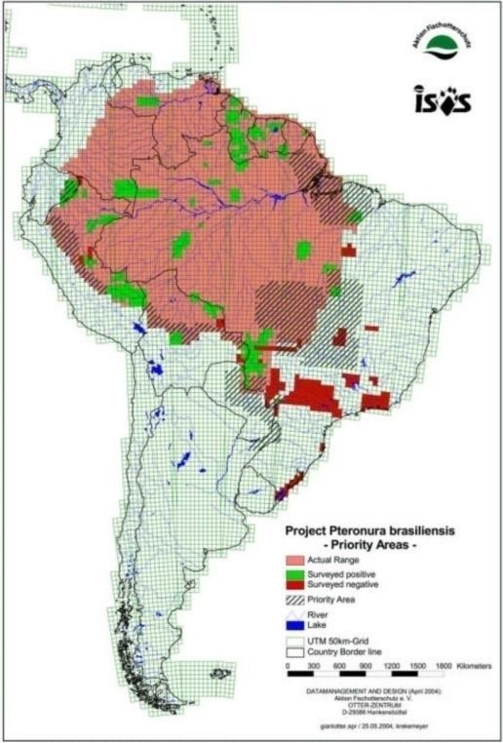
Grid of priority border areas for the study of the current estimated distribution range of the species (Fig. 1, ISOS; 2005) and the zones updated to include the border areas of the estimated distribution of the species, potential corridors between isolated populations and areas of threat (Fig. 2, Giant Otter Species Report, 2008).

3.2 Proportion of the population migrating, and why that is a significant proportion

The species naturally moves over a relatively wide range along streams and rivers, and may be compelled to relocate due to local environmental pressures, such as fluctuating water levels, prey availability and deforestation.

The vast distribution range of the giant otter and the diversity of its habitats (along with the extreme isolation and inaccessibility of certain areas) pose significant challenges to monitoring the species and implementing standard study methodologies for the species. The distribution and conservation status of the giant otter are relatively unknown in many regions and even countries within its distribution range. However, considering its vast distribution range and the number of States within that range, its significant presence in areas near the borders of these States and the cross-border nature of its habitat (rivers), as well as the movement giant otters are capable of, particularly roaming individuals seeking a new territory, it is almost certain that these otters regularly cross borders. Moreover, in tropical forests, aside from one or two boundary markers, these borders are generally not well defined.
In addition, certain regular movements of giant otters between river systems may correspond to the definition of "biological or climate" cycles, particularly when foraging for food during the rainy season. During this time, groups venture much more easily along the numerous fish-rich forest streams, recently replenished by torrential rain.

In any case, its status as an endangered species appears certain, as confirmed by the IUCN Red List assessment. This assessment indicates that the giant otter population is expected to decline by half over the next 25 years, reinforcing the hypothesis of a very high risk of extinction in the wild in the near future. As such, its status meets the definition of "unfavourable conservation status" given in the Convention, and certain studies emphasise that migration corridors must be available to maintain a long-term population of giant otters. The IUCN Otter Specialist Group has identified a number of measures to mitigate threats to the giant otter, including promoting multinational cooperation (for example: Amapá-Brazil and French Guiana, Suriname and Guyana, Southern Amazon and Pantanal) to coordinate the management of cross-border or connected protected areas, the monitoring of illegal mining activities and ensuring the integrity of the giant otter's continuous habitat (Duplaix, N. and M. Savage (2018), The Global Otter Conservation Strategy).

  - Biological data (other than migration)

    - Distribution (current and historical)

Historically, the distribution range of the giant otter extended across much of South America, notably through lowland tropical forests and wetlands. This distribution is gradually decreasing: the species is becoming extremely rare in many areas of Brazil and Ecuador. It is becoming scarce in Bolivia, in Colombia, in Venezuela, in the western part of the Brazilian Amazon and in Peru. According to the IUCN, the species is believed to have already disappeared from Argentina and Uruguay.

The species is distributed in South America to the east of the cordillera of the Andes, across the entire Amazonian plain and in the peripheral areas, including the Guiana Shield. The Guiana Shield is considered to be one of the best areas of preservation for the otter (Groenendijk 1998).

Today, the largest populations are found in the Amazon regions of Peru and Brazil and on the Guiana Shield (WWF).

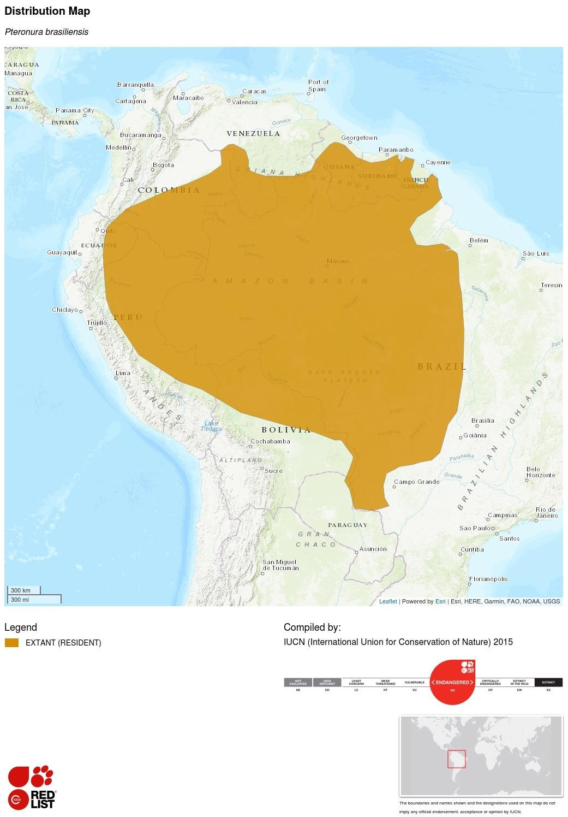

    - Population (estimates and trends)

The total size of the global giant otter population is small, but even more concerning is the fact that the individual subpopulations are fragmented and most of them are small in size. Due to its conspicuous behaviour and social nature, this species is easy to eradicate and is therefore extremely vulnerable. It remains highly vulnerable to hunting (although hunting giant otters is not currently a common practice). The slaughter of individuals and entire groups continues in certain areas where fishermen are active, including in protected areas. Moreover, the giant otter is inherently vulnerable to extinction: combined with the low resilience of its habitat and the fact that only a quarter or a third of the total population reproduces, the species also exhibits late maturity, a late reproductive age, a suspected low transient survival rate and a low pup survival rate - all traits that limit the recovery and recolonisation of the giant otter.

Population estimates based on surveys exist for certain areas:
- Brazil: In the Pantanal, 1,100 breeding individuals or 3,950 individuals across 7,350 km of rivers (Tomas et al. 2015); Xixuaú River in Amazonia, 15 groups (30 breeding individuals, 80 individuals) across 40 km of river (Evangelista and Rosas 2011); Lake Balbina in Amazonia, 67 groups (134 breeding individuals, 280 individuals) (Palmeirim et al. 2014); Amanã Reserve in Amazonia: 12 groups (24 breeding individuals, 75 individuals) (Lima et al. 2014); Araguaia, above Bananal Island, Brazil: upper basin of the Araguaia in the Cerrado: 200 individuals (G. Georgiadis, personal communication, 2018); Cantão State Park: 4 groups (8 breeding individuals, 20 individuals), (Georgiadis et al. 2015). These surveys suggest a population of at least 1,296 breeding individuals and a total population of 4,659 individuals in Brazil.
- Bolivia: in the northwest, sub-basin of Madre de Dios-Beni: 271 individuals across 1,318.6 km of rivers and streams and 42.14 km² of lakes (Ayala et al. 2015); in the Pantanal (sub-basin of the Paraguay River), 50 individuals across 118,031 km²; and in the northeast (sub-basin of the Itenez), 600 individuals across 186,460 km², totalling an estimated 1,021 individuals in Bolivia.
- Peru: southeastern Peru, Madre de Dios: 180 to 400 individuals (R. Williams, personal communication, 2012); Manu National Park: 81 individuals and 11 groups recorded in 2006 (Groenendijk et al. 2014).
- Ecuador: Cuyabeno Wildlife Reserve, nine groups (18 breeding individuals, 45 individuals), but Utreras and Tirica (2011) suggest that the Ecuadorian population is fewer than 250 individuals.
- French Guiana: at least 200 individuals (Benoit de Thoisy, personal communication, 2012).
- Paraguay: 24 to 32 individuals (Cartes and R. Pickles, personal communication, 2011).
- Guyana: Rewa Head: at least 35 individuals (Pickles et al. 2011).

    - Habitat (short description and trends)

The giant otter inhabits large rivers, streams, lakes and swamps (Duplaix 1980, Carter and Rosas 1997). In Suriname, the species appears to prefer blackwater creeks and rivers with sandy or rocky bottoms (Duplaix 1980). In Peru, the species prefers large lowland rivers with a low flow and oxbow lakes with high densities of fish (Schenck 1999). In Bolivia, floodplains of clear water and white water are used (Zambrana Rojas et al. 2012).

As giant otters use dens and marking sites along the banks of water bodies, certain habitat characteristics are key determinants of their presence, such as gentle slopes, vegetation cover and proximity to the water's edge (Lima et al. 2012). In seasonally flooded habitats, the availability of banks and other habitat features can change and cause changes in habitat selection (Leuchtenberger et al. 2013). During peak flooding in the southern Pantanal, when no banks were available, groups of giant otters used shrubs protruding above the water as refuges and latrines (Leuchtenberger et al. 2015). During such periods, when their prey are more scattered, giant otters have been observed in flooded forests, swamps and meadows adjacent to the river (Leuchtenberger et al. 2013). Territoriality and population density can lead some groups to use unusual sites, such as artificial lakes beside roads in the south of the Pantanal (Leuchtenberger et al. 2013), and even to adapt their diet (Ribas et al. 2012). The species also uses agricultural canals (Laidler 1984) and dam reservoirs (Palmeirim et al. 2014).

The preferred habitat of giant otters seems to be undisturbed bodies of water, featuring high-quality vegetation cover and an abundant density of prey.

The most well-known example of the species' use of marshland is the Pantanal. The marshy twists and turns of this immense wetland stretch across three countries (Brazil, Bolivia and Paraguay), and it is home to one of the largest giant otter populations.

In the Amazon, small forest streams (or "creeks") are definitely the preferred habitat of giant otters. These small rivers often have a slow flow and shallow beds, particularly during the dry season. Giant otters find an abundance of food there, and the shallow depth makes it easy to catch prey.

    - Biological characteristics

The giant otter is the largest river otter in the world, with a total length of 145 to 180 cm, a body measuring between 95 and 125 cm and a tail measuring between 45 and 65 cm. The head and neck of the adult male are significantly larger than those of the female. Adults typically weigh between 25 and 35 kg. At birth, otter pups weigh approximately 200 grams and measure about 33 centimetres in length. The paws are very broad with thick and very well-developed webbing; the tail is thick at the base, subcylindrical, and strongly flattened dorso-ventrally on the distal half. The throat and lips are marked with white or yellowish spots. The skin is thick with very short, smooth, very dark brown hairs, and intraspecific variations in colouration are negligible. The coats of juveniles are lighter in colour than those of adults, but the white spots are visible from birth.

Gregarious and territorial, giant otters form stable family groups that defend certain portions of their home range against incursions by other otters. The well-coordinated and closely united groups consist of 2 to 20 individuals (a pair of adults, one or more subadults and one or more juveniles), with groups of 3 or 4 individuals being the most common. Every year, the females bear a litter of 1 to 4 pups. At around three years old, the juveniles leave the group in search of a new territory and a partner (WWF). The groups live in well-established territories which are constantly defended by olfactory markings in latrines, campsites and dens along the banks of lakes and rivers (Leuchtenberger and Mourão 2009), and by warning calls (Leuchtenberger et al. 2014, Mumm Knörnschild 2017). Conflicts are frequent when an intruder is detected and can result in serious injury or even death (Schweizer 1992, Rosas and Mattos 2003, Ribas and Mourão 2004).

The size of territories varies from 0.5 to 18 km during the dry season and from 8 to 24 km during the wet season (Utreras et al. 2005, Leuchtenberger et al. 2015). This variation appears to be linked to the size of the group (Groenendijk et al. 2015, Leuchtenberger et al. 2015). The size of neighbouring groups can limit territorial expansion (Leuchtenberger et al. 2015).

Single, roaming animals are either subadults who leave the family group upon reaching the age of two, or one of the members of a pair who has lost their mate.

The diet of the giant otter consists almost exclusively of fish, but may also include caimans and other vertebrates (Ribas et al. 2012, Rosas-Ribeiro et al. 2012). The species is opportunistic in its feeding habits, adjusting them based on the availability of prey.

The average reproductive lifespan is approximately five years for both females and males (Groenendijk et al. 2014). This, in tandem with a mortality rate of approximately 50% (Groenendijk et al. 2014), a suspected high transient mortality rate and the difficulty of establishing new groups (Schenck and Staib 1998), indicates that the recovery of the population and the colonisation of new areas may be slow.

    - Role of the taxon in its ecosystem

The giant otter is a predator positioned at the top of the food chain, and the abundance of its population is an indicator of the overall health of the river ecosystem.

  - Conservation status and threats

    - IUCN Red List Assessment (if available)

The giant otter was classified as endangered on the IUCN Red List in 1999. The status of the giant otter is regularly monitored by the countries within its distribution range. Of the 12 national assessments of the distribution and conservation status of the giant otter that have been prepared, the species has been classified in national red lists as critically endangered in two countries (Paraguay and Ecuador), as endangered in four countries (Peru, Colombia, Venezuela, Bolivia) and as vulnerable in Brazil. It is considered extinct in Uruguay and probably extinct in Argentina. In the Guianas, the giant otter is also legally protected, although this protection is rarely enforced. Giant otter specialists agree that it should be classified as an endangered species at the continental level.

    - Equivalent information relevant to conservation status assessment

The giant otter is listed in Appendix I of the Convention on International Trade in Endangered Species of Wild Fauna and Flora (CITES) and classified as endangered under the United States Endangered Species Act 1973.

    - Threats to the population (factors, intensity)

The species is facing numerous critical threats. Not particularly timid, they have a natural tendency to approach humans. This has greatly contributed to exacerbating poaching of the species, which is coveted for its fur. Statistics show that between 1959 and 1969, the Brazilian Amazon alone produced between 1,000 and 3,000 furs per year. The species was so thoroughly decimated that its population dropped to just 12 by 1971. The implementation of CITES in 1973 ultimately resulted in a significant reduction in hunting, although the demand has not completely disappeared. They are extremely easy to hunt, as they are active throughout the day and very curious. The animal's relatively late sexual maturity, combined with its complex social life, makes hunting especially devastating.

Although the species is widespread at the continental scale, it can occupy less than 5%, and often less than 1%, of a given catchment basin. This means that changes to or impacts on this specific habitat will have serious consequences, even if only a fraction of the overall area is affected. The rivers are access routes to the forest; this is where people settle, where gold mines are exploited, where there is competition for fish or overfishing, where "green" energy can be harvested, where climate change will have significant impacts, where contamination can spread rapidly, and so on. This vital connection to rivers and wetlands makes the giant otter significantly more vulnerable than most other comparable large predators in the Amazon, such as the jaguar.

    - Threats connected especially with migrations

Numerous emerging and/or growing threats pose serious problems to the giant otter, including contamination, overfishing and conflicts with fishermen, as well as infrastructure such as roads and hydroelectric dams. Their preference for lowland wetlands, rivers and lakes means that their primary habitat fully overlaps with human demands (such as gold mining, fishing, deforestation, mega infrastructure and energy developments, human settlements, transport, tourism, etc.). The effects of climate change are already being felt, with Brazil recently experiencing severe droughts. By 2050, large-scale deforestation in the Amazon could reduce precipitation within the basin by 12% during the wet season and by 21% during the dry season (Spracklen et al. 2012), with unknown impacts on aquatic and semi-aquatic species.

The migration of contaminated fish and the long-distance atmospheric transport of mercury probably increase the area of influence of these contaminants. The contamination of otters by other heavy metals through pesticides and other agrochemicals is still poorly understood. Over the past two decades, the regions of Guyana, French Guiana and Peru have experienced significant expansion in gold-mining areas. Consequently, in French Guiana, populations are still considered to be in decline due to threats to their habitat (Allard et al. 2017).

    - National and international utilisation

  - Protection status and species management

    - National protection status

The giant otter is protected in several countries in South America due to its "endangered" conservation status. It is legally protected in Argentina, Brazil, Colombia, Ecuador, French Guiana, Peru, Suriname, Uruguay and Venezuela (Duplaix, N., Savage, M., 2018). The giant otter is also considered an endangered species under the United States Endangered Species Act of 1973.

Although they have national protections and hunting is now no longer a threat, giant otters face significant new pressures: the destruction of their habitats, intensive fishing and watercourse pollution, caused among other things by panning for gold.
    - International protection status

The giant otter is listed in Appendix I of the Convention on International Trade in Endangered Species of Wild Fauna and Flora (CITES).

    - Management measures

Specific conservation action plans have been developed in Brazil (ICMBio 2016), Colombia (Colombia 2016), Ecuador (Utreras et al. 2013) and Venezuela (Ferrer et al. 2017) to restore and maintain the remaining populations. Ongoing and effective conservation strategies are needed in these countries.

Management measures are also being implemented at more local levels. For example, in 2010, the Instituto Araguaia, a local NGO, launched a programme for the protection and monitoring of giant otters, in order to use them as an umbrella and flagship species for the conservation of the Cantão ecosystem. As part of this programme, a census was conducted to determine the population of giant otters in a group of 16 lakes within the park, and this population was monitored over a period of 28 months covering three breeding seasons, between September 2010 and December 2012.

The giant otter was thought to be extinct in Argentina and Uruguay. For several years now, a significant restoration project has been underway in Argentina's Ibera Reserve (1.3 million hectares). Between 2019 and 2022, two pairs of giant otters from breeding programmes in European and American zoos were reintroduced.

    - Habitat conservation

The giant otter is currently threatened by the disappearance and pollution of its habitat.
The Global Otter Conservation Strategy (Leuchtenberger et al., 2018) recommends priority actions for this species, including:
- Establishing protected areas in all countries within the distribution range, including fish corridors to connect fragmented areas.
- Encouraging multinational cooperation (i.e. Amapá-Brazil and French Guiana, Suriname and Guyana, the southern Amazon and the Pantanal) to coordinate the management of cross-border or connected protected areas, control illegal mining and maintain the integrity of continuous otter habitats.

In a study conducted in Bolivia in 2008, researchers concluded that migration corridors are essential for maintaining a long-term population of giant otters. These corridors would help prevent inbreeding and reduce the vulnerability of isolated "island" populations to environmental disasters. (R. Pickles, R. Cornwallis, P.A. Van Damme, 2009)

    - Population monitoring

Long-term population monitoring programmes have documented the recovery of the giant otter since the beginning of the year 2000 in: Manu National Park, Peru, on the Vermelho-Miranda rivers, the Brazilian Pantanal, in Lake Balbina and the Amanã Sustainable Development Reserve in Amazonia, in Brazil, in the Cantão State Park in the Brazilian Cerrado, on the Upper Rupununi River in Guyana - showing increasing numbers and an expanded area of occupation (Georgiadis et al. 2015, Groenendijk et al. 2014, Leuchtenberger et al. 2015, Lima et al. 2014, Marmontel et al. 2015).

A programme was launched in Peru in 2017 to examine the impact of mining and other human activities on giant otter populations. The programme monitors giant otter territories in the protected Manu National Park and compares them with adjacent mining areas in the lower Madre de Dios river.

The Pantanal otter population warrants particular attention due to its low genetic diversity (Pickles et al. 2011), its southern distribution limit and the impact of human disturbance (Harris et al. 2005, Alho and Sabino 2011).

  - Effects of the proposed amendment

    - Anticipated benefits of the amendment

In summary, three generations of giant otters represent an approximate period of 25 years. The acceleration of habitat destruction, degradation and exploitation across the giant otter's distribution range represents the greatest threat to the species and is suspected to have caused a decline in the population of more than 50% over the past 25 years (three generations), which could also lead to a future reduction in population size of 50% or more over the next 25 years (criterion A3), suspected to be due to a decline in the area of occupation, extent of occurrence and habitat quality, with exploitation, pollutants (particularly mercury and fossil fuels), pathogens (domestic animal diseases) and competitors (fishermen) potentially playing a significant role.

The amendment would make it possible to enhance collaboration among the States within the giant otter's distribution range and implement measures to ensure ecological connectivity, as well as enabling management and protection of freshwater ecosystem habitats and species.

The inclusion of the giant otter in the CMS Appendices could yield multiple benefits and support the recommendations outlined in the Global Otter Conservation Strategy:
- Design of a regional action plan for the preservation and conservation of the giant otter;
- Improvement of understanding of the status of the giant otter population and its cross-border movements;
- Identification, mitigation, and elimination of the primary threats faced by giant otters;
- Establishment of protected areas in all countries within the distribution range, including fish corridors to connect fragmented areas;
- Encouragement of multinational cooperation (i.e. Amapá-Brazil and French Guiana, Suriname and Guyana, the southern Amazon and the Pantanal) to coordinate the management of cross-border or connected protected areas, control illegal mining and maintain the integrity of continuous otter habitats;
- Implementation of reintroduction programmes to restore lost historical populations in Argentina (Corrientes) and Brazil (Paraná basin);
- Establishment of protocols in all range States to regulate mitigation and compensation measures for projects such as hydroelectric dams, gold mines, agriculture, deforestation and overfishing in the giant otter's habitat;
- Work on reducing conflict with local populations. Protecting the species could help to reverse its decline.

    - Potential risks of the amendment

    - Intention of the proponent concerning development of an Agreement or Concerted Action

Encourage cross-border cooperation and better protection of the species through the establishment of ecological corridors.

  - Range States

Existing (resident):
Bolivia, Plurinational State of; Brazil; Colombia; Ecuador; French Guiana; Guyana; Paraguay; Peru; Suriname; Venezuela, Bolivarian Republic of.

Presence uncertain:
Argentina; Uruguay

  - Consultations

All range States were consulted on 11 July 2025 (Bolivia, Plurinational State of; Brazil; Colombia; Ecuador; French Guiana; Guyana; Paraguay; Peru; Suriname; Venezuela, Bolivarian Republic of; Argentina; Uruguay).

  - Additional Remarks

  - References

A., Shapley, R., Lehman, S., Henry, E. & Benjamin, P. .(2000) Records of the Giant Otter, Pteronura brasiliensis, from Guyana IUCN Otter Spec. Group Bull. 17(2): 65 - 74
Association Kwata, suivi des populations chez la loutre géante : aide à la conservation d'une espèce emblématique des cours d'eau amazoniens, juin 2006
Duplaix, N. and M. Savage (2018), The Global Otter Conservation Strategy
Evangelista, E. et Rosas, FCW, B. (2011) Comportement reproducteur de la loutre géante ( Pteronura brasiliensis ) dans la réserve de Xixuan, Roraima, Brésil. Actes du Xe Colloque international sur la loutre, UICN Otter Spec. GroupeBull . 28A:5-10
Feuillet, G., De Thoisy, B., La loutre géante, biologie, écologie, menaces, conservation, assocaition Kwata, 2009
Georgiadis, G., Campello, S., & Leles, B. N. (2015). Protection and monitoring of the giant otter (Pteronura brasiliensis) in Cantão State Park, Tocantins, Brazil. Latin American Journal of Aquatic Mammals, 10(2), 152-155.
Groenendijk, J., Leuchtenberger, C., Marmontel, M., Van Damme, P.A., Wallace, R. & Schenck,
C. 2023. Pteronura brasiliensis (amended version of 2022 assessment). The IUCN Red List of Threatened Species 2023: e.T18711A244867206. https://dx.doi.org/10.2305/IUCN.UK.2023- 1.RLTS.T18711A244867206.en.
The IUCN Red List of Threatened Species: Pteronura brasiliensis – published in 2021.
R.S.A. Pickles,J.J. Groombridge,V.D. Zambrana Rojas,P. Van Damme,D. Gottelli,S. Kundu,R. Bodmer,C.V. Ariani,A. Iyengar,W.C. Jordan, Evolutionary history and identification of conservation units in the giant otter, Pteronura brasiliensis, 2011
R. Pickles, R. Cornwallis, P.A. Van Damme, V. Zambrana, P. Beccera, H. Muñoz, F. Carvajal, J. Franckx, D. Schaerlaekens, An integrated approach towards giant otter (Pteronura brasiliensis) conservation in Bolivia, 2009
Waldemarin, H., Walfrido Moraes, T., Jacques, H. et all, Giant Otter Species Report, 2008, https://www.otterspecialistgroup.org/Library/Colloquium_10/Presentations/10-10-15- 08_Giant_otter_species_report_IOC.pdf.

