 | CONVENTION ON  MIGRATORY  SPECIES | UNEP/CMS/COP15/Doc.30.2.14  4 November 2025  Original: English

15th MEETING OF THE CONFERENCE OF THE PARTIES
Campo Grande, Brazil, 23 to 29 March 2026
Agenda Item 30.2

PROPOSAL FOR THE INCLUSION OF
THE SCALLOPED HAMMERHEAD SHARK (Sphyrna lewini)
ON APPENDIX I OF THE CONVENTION*

Summary:

The Government of Ecuador has submitted the attached proposal for the inclusion of the scalloped hammerhead shark
(Sphyrna lewini) on Appendix I of CMS.

*The geographical designations employed in this document do not imply the expression of any opinion whatsoever on the part of the CMS Secretariat (or the United Nations Environment Programme) concerning the legal status of any country, territory, or area, or concerning the delimitation of its frontiers or boundaries. The responsibility for the contents of the document rests exclusively with its author.
PROPOSAL FOR THE INCLUSION OF THE SCALLOPED HAMMERHEAD SHARK (Sphyrna lewini) ON APPENDIX I OF THE CONVENTION

A. PROPOSAL

Inclusion of all populations of scalloped hammerhead shark (Sphyrna lewini) on Appendix I.

B. PROPONENT

Ecuador

C. SUPPORTING STATEMENT

1. Taxonomy
1.1 Class Chondrichthyes (Subclass: Elasmobranchii)
1.2 Order Carcharhiniformes
1.3 Family Sphyrnidae
1.4 Genus, species Sphyrna lewini (Griffith and Smith, 1834)
1.5 Scientific synonyms Zygaena lewini (Griffith & Smith, 1834)
Zygaena erythraea (Klunzinger, 1871),
Sphyrna diplana (Springer, 1941)
1.6 Common name(s), in all applicable , languages used by the Convention
English: Scalloped hammerhead shark
French: Requin-marteau halicorne.
Spanish: tiburón martillo común.
German: Bogenstirn-Hammerhai
Italian: Squalo martello smerlato
Portuguese: Tubarão-martelo-recortado
Arabic: القرش أبو مطرقة الصدفي
Russian: Бронзовая молот-рыба
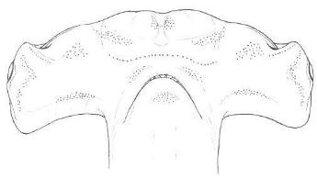
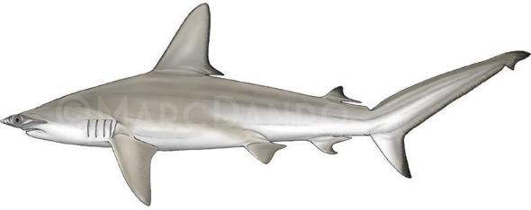

Figure 1. Scalloped hammerhead shark (Sphyrna lewini), full body and cephalofoil. Illustrations: © Marc Dando (Wild Nature Press).

2. Overview

The scalloped hammerhead shark (Sphyrna lewini) is assessed globally as Critically Endangered in the IUCN Red List, due to population reductions greater than 80% over the past three generations (Rigby et al. 2019). The principal driver of these population declines is over-exploitation by fisheries, both as a target and as bycatch species. Scalloped hammerheads are highly sought for the size and quality of their fins (Abercrombie et al. 2005), and recent genetic evidence suggests that scalloped hammerheads from the Tropical Eastern Pacific (TEP) represent over 60% of the international supply at one of the largest global shark fin trade hubs (Fields et al. 2020). These population reductions have occurred in all coastal warm-temperate and tropical seas across the species’ circumglobal range. Scalloped hammerheads are highly migratory: some males move across ocean basins, while mature females undertake regular transboundary migrations between breeding and feeding grounds for parturition, within their home region, including through areas beyond national jurisdiction (ABNJ); (Ketchum et al. 2014; Salinas-de-León et al. 2025). Despite their long-distance migrations, there is evidence that some females might be philopatric to their natal shallow coastal nursery grounds, where they return to give birth (Rangel-Morales et al. 2022).

Fishing pressure is driven by increased demand and incentivized by the high economic value of its fins and the consumption of its meat, which has led to the species being overfished during all stages of its lifecycle, in nearshore coastal and offshore environments. Its highly migratory nature, slow growth, and long gestation periods place this common bycatch species at risk from fishing activities on the high seas, at oceanic congregation sites, and throughout coastal pupping grounds (Gallagher and Klimley, 2018). Coastal nursery areas are also increasingly threatened by climate change, intensive fisheries, and habitat damage and loss from (inter alia) pollution and development (Cerutti-Pereyra et al. 2024). Given these current pressures, in addition to inadequate management by Regional Fisheries Management Organizations (RFMOs), current high rates of Sphyrna lewini capture pose a serious threat to the species’ survival. Because of difficulties in differentiating between species in this genus, estimates of population trends for all three large-bodied hammerheads are often grouped. Abundance trend analyses of catch-rate data for the large hammerhead complex containing Sphyrna lewini, (including S. mokarran and S. zygaena), have reported large declines, ranging from 60-99% over recent years.

In 2014, in recognition that international trade in its products (particularly fins) was a major driver of population declines, the species was listed on Appendix II of the Convention on International Trade in Endangered Species of Wild Fauna and Flora (CITES). Since then, the species has been identified via the CITES compliance processes as being subject to both continued unsustainable trade and illegal trade in large volumes. The IUCN Red List uplisting from Endangered to Critically Endangered was made after this species’ inclusion in CMS Appendix II at CoP 11 (2014) and in the Annex I to the Migratory Sharks MOU (2016). Despite improved international collaboration between range States under CMS, population declines are continuing in all regions except for the Northwest Atlantic and Gulf of Mexico.

Given this species’ current status, one that includes its overutilization, inadequacy of existing regulatory mechanisms, and other anthropogenic threats, the inclusion of Sphyrna lewini in CMS Appendix I is urgently needed and necessary to begin to arrest population declines and initiate their recovery. This proposal to include the scalloped hammerhead in Appendix I of the Convention aims to encourage Parties to introduce or improve the implementation of strictly protected status for this species, the conservation or restoration of critical habitats such as feeding and breeding aggregations, pupping grounds and nursery areas, and the protection of movement corridors.

3. Migrations

3.1 Kinds of movement, distance, the cyclical and predictable nature of the migration

Sphyrna lewini is an aggregating, seasonally-migratory species, in at least parts of its range, frequently crossing national boundaries and often entering the high seas as it moves between coastal and oceanic waters, searching for breeding and feeding grounds. The species segregates by age and sex: juveniles tend to be found in coastal waters (Holland et al., 1992), while adults are often found offshore either as solitary individuals or forming large aggregations around oceanic islands and seamounts (Klimley, 1983). Juveniles spend the first years of their lives in nurseries located in coastal environments, and sub-adults undertake ontogenetic migrations between coastal nurseries and open ocean environments (Figure 2).

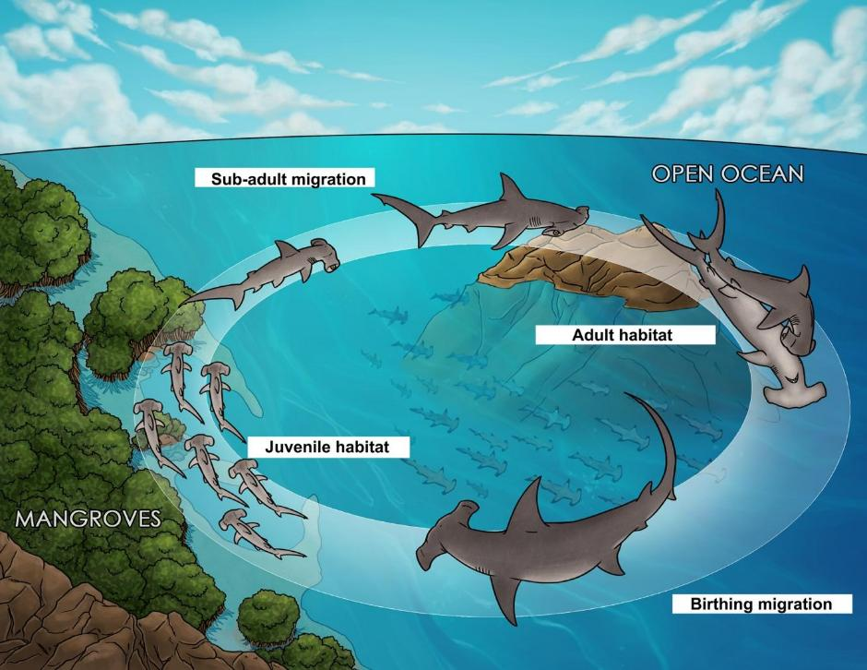
Figure 2. Proposed ontogeny for the scalloped hammerhead shark (Sphyrna lewini) in the Tropical Eastern Pacific. Modified from Salinas-de-León et al. (2017).
Population genetics suggest that the highly migratory adult females could be philopatric to their birth and nursery grounds, at least through part of their distribution (Rangel-Morales et al. 2022). Satellite tracking data has revealed that scalloped hammerheads can travel 1000s of kilometers in short timeframes (Hoyos-Padilla et al. 2014, Bessudo et al. 2016, Spaet et al. 2017; Salinas-de-León et al. 2025).

Adult S. lewini often form seasonal aggregations around oceanic islands and seamounts (Klimley 1983). S. lewini is the only large hammerhead species known to school, a behavior that makes it highly vulnerable to target fishing. In the Eastern Tropical Pacific (ETP), waters around the oceanic islands of Malpelo (Colombia), Coco (Costa Rica), and the Galapagos (Ecuador) support some of the world’s largest remaining concentrations of S. lewini (Bessudo et al. 2011; Friedlander et al. 2012; Salinas-de-León et al. 2016). Sharks tagged at these islands make diel vertical movements and horizontal transboundary migratory movements between them (Bessudo et al., 2016; Ketchum et al., 2014; Nalesso et al., 2019). Parent-offspring genetic analysis have also proven the connectivity between adult sharks sampled at Malpelo Island and juveniles sampled within nurseries located in coastal areas of continental Colombia (Quintanilla et al. 2015).

Satellite tracking of a likely pregnant S. lewini has provided the first satellite track of a return birthing migration between the Galapagos (Ecuador), the Pacific coast of Panama, and international waters located to the west of the Galapagos Islands (Salinas-de-León et al. 2025); (Figure 3). Movements were seasonal, with the female traveling from the Galapagos to continental areas during the warm season (January to June) and to international waters to the west of Ecuador’s Exclusive Economic Zone (EEZ) around the Galapagos during the cold season (June-December); (Figure 3). This female spent one third of the time she was tracked in international waters to the west of Ecuador’s EEZ.

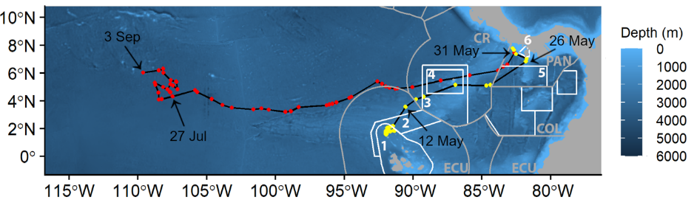
Figure 3. Satellite track of a likely birthing migration for a scalloped hammerhead shark connecting the Galapagos Islands, with coastal nurseries in Panama and international waters to the west of the Exclusive Economic Zone (EEZ) of Ecuador around the Galapagos Islands. White boundaries and numbers represent the Marine Protected Areas within the Tropical Eastern Pacific that the shark visited (1- Galapagos Marine Reserve, Ecuador; 2- Hermandad Marine Reserve, Ecuador; 3- Area de Manejo del Bicentenario, Costa Rica; 4- Isla del Coco National Park, Costa Rica; 5-Corsillera de Coiba Managed Resources Area, Panama; 6- Coiba National Park, Panama). Gray lines represent Exclusive Economic Zone boundaries for countries within the region (ECU: Ecuador; CR: Costa Rica: COL: Colombia; PAN: Panama). Seasons are differentiated by color (cold season: June–November in red; warm season: December–May in yellow). Obtained from Salinas-de-León et al. (2025).

Recent satellite tracking data has also revealed predictable, multi-annual, seasonal birthing migrations between the Galapagos (Ecuador) and Cocos (Costa Rica) Islands, and coastal nurseries located in the Pacific coasts of Panama, Costa Rica and Mexico (Salinas-de-León et al., unpublished data); (Figure 4). The Submerged Cocos Ridge (SCR), a chain of seamounts that connects the Galapagos with Cocos Island (Costa Rica) has also been described as an important aggregation site and migratory corridor, particularly West Cocos seamount in Costa Rica’s EEZ and Paramount seamount within Ecuador’s EEZ (Cambra et al., 2021).

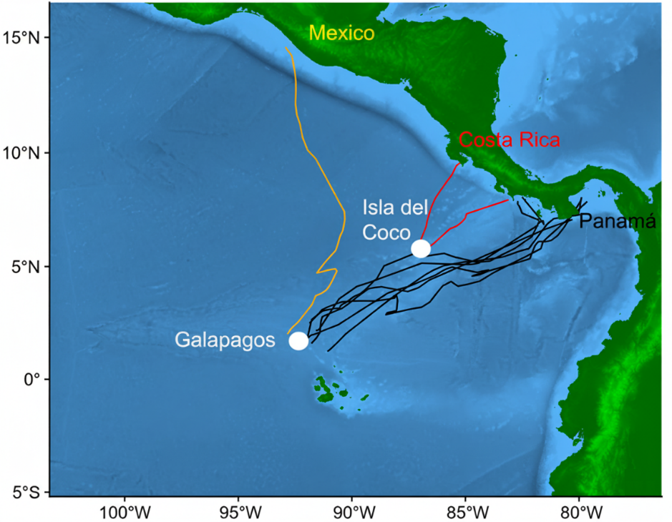
Figure 4. Satellite tracks of birthing migrations by scalloped hammerhead sharks tagged at the Galapagos Islands (Ecuador) and Isla del Coco (Costa Rica), and migrating to coastal nurseries located in Panama (black lines), Costa Rica (red lines), and Mexico (orange line). Source: Salinas de León et al. (unpublished data).

Birthing migrations also take place within and beyond the Eastern Tropical Pacific Marine Corridor important shark and ray area (ETPMC ISRA); (Figure 5). This ISRA was designated inter alia as an important reproductive area for scalloped hammerhead neonates and young-of-the-year in shallow inshore waters, given their presence on fishery-dependent surveys, and oceanic feeding areas for adults (Estupiñán-Montaño 2021a, 2021b). The Malpelo Ridge ISRA, nested within the ETPMC ISRA, is designated in part as a mating ground for scalloped hammerheads. Reproductive areas and potential nursery grounds have been confirmed in Colombia (Quintanilla et al. 2015), Costa Rica (Zanella et al. 2019), Ecuador (Chiriboga et al. 2022), and Panama (Robles et al. 2015).
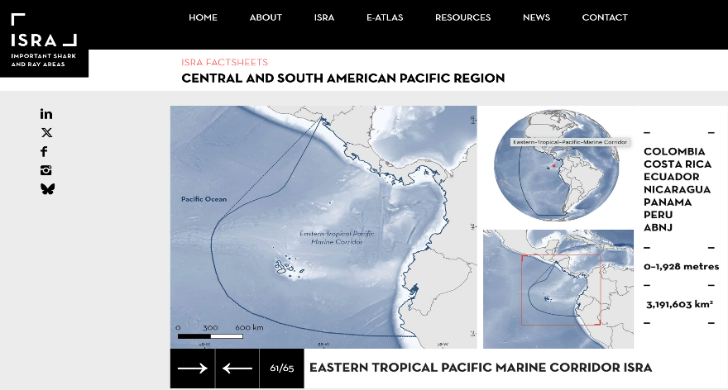
Figure 5. Eastern Tropical Pacific Marine Corridor Important Shark and Ray Area (ISRA) between Perú in the south to Mexico in the north. Source: https://sharkrayareas.org/.

Post-birthing, seasonal migrations to a likely offshore focal area (OFA), located in international waters of the Eastern Tropical Pacific, have also been recently documented, by tracking the movements of female scalloped hammerheads after birthing in coastal nurseries located in the Pacific coast of Panama and Costa Rica. Several females tagged with satellite transmitters undertook highly directional movements to international waters to the west of the Ecuadorian Exclusive Economic Zone around the Galapagos during the cold season (June-December); (Figure 6 & 7).
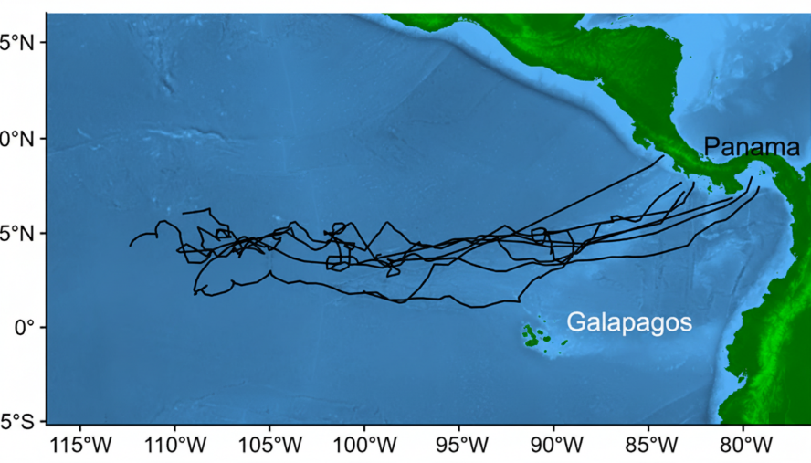
Figure 6. Satellite tracks of post-birthing migrations by scalloped hammerhead sharks departing from coastal nurseries located in the Pacific coast of Costa Rica and Panama. Post-birthing movements were conducted to an area in international waters to the west of the Ecuadorian Exclusive Economic Zone around the Galapagos during the cold season (June-December); (Salinas-de-León et al., unpublished data).

This oceanic area north of the equator has recently been identified as the Pacific Equatorial Front ISRA (Figure 8) due to its importance as a movement area for the whale shark (Rhincodon typus). Adult female whale sharks have been tracked moving along this oceanic front from July through October over multiple years (Hearn et al. 2016), tracking the tropical instability waves (Ryan et al. 2017). Recent evidence suggests that this is also an important movement area for adult female scalloped hammerhead sharks.

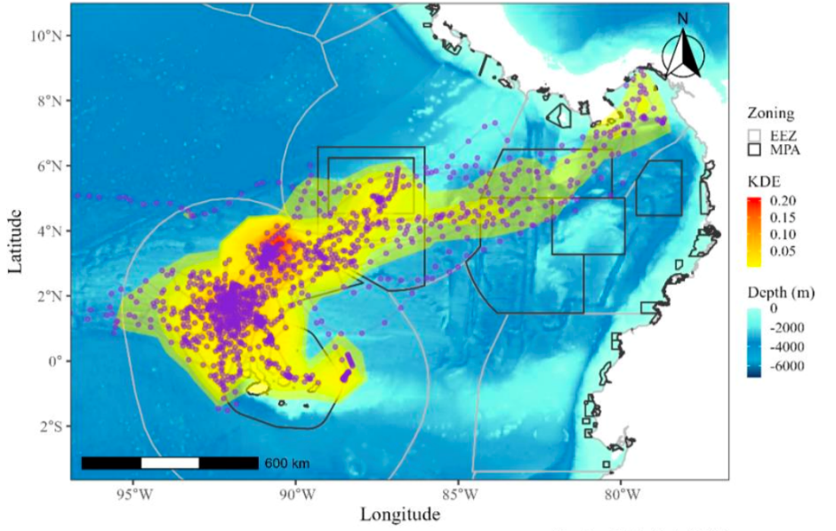
Figure 7. Tracks of scalloped hammerhead sharks tagged at Paramount Seamount and the Galapagos Marine Reserve in January 2025, showing migratory movements to coastal waters of Panama (from Velasco & Hearn 2025).

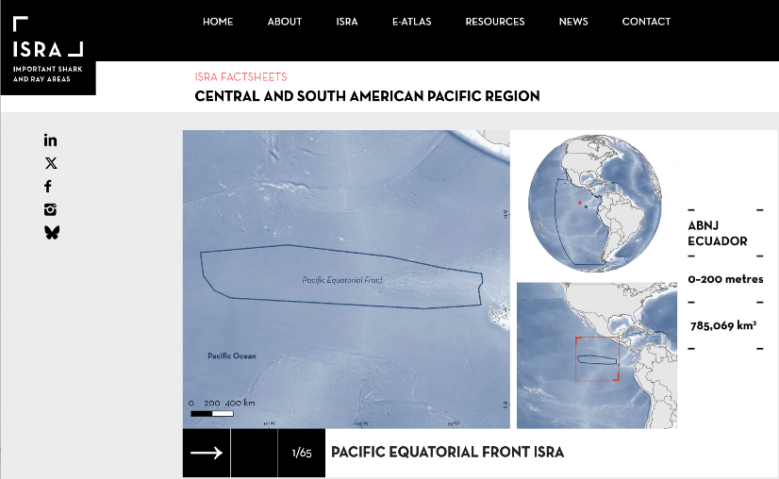
Figure 8. Pacific Equatorial Front Important Shark and Ray Area (ISRA) located in international waters to the northwest of the Galapagos Marine Reserve (GMR). Source: https://sharkrayareas.org/.
In Australia, observed population demographic structuring from fisheries landings, revealed sex and size segregations, with Australian populations dominated by juveniles and small adult males, while Indonesian and PNG populations included large adult females. This suggests that a proportion of adult females may migrate from Australian to Indonesia and Papua New Guinea waters and return to give birth to their young in nursery areas in coastal areas of northern Australia (Chin et al. 2017). There is also genetic evidence of mixing between Australian and Indonesian populations. In addition to cross-shelf migration, along-shelf migration including transboundary migrations, at scales of 100s to 1000s of kilometers have been recorded in South Africa (Diemer et al. 2011), the Pacific coast of Mexico (Hoyos-Padilla et al. 2014), the Red Sea (Spaet et al. 2017), and the Gulf of Mexico (Wells et al. 2018).

Age-related (ontogenetic) movements of S. lewini in the Mexican Pacific, suggest that females use highly variable habitat over their lifetime. In contrast, males alternate between two migratory patterns, coastal or pelagic, either remaining in nearshore waters for their entire life, or migrating regularly between offshore and coastal habitats (Coiraton et al., 2020).

In the Indo-Pacific, an assessment of S. lewini population structure and connectivity across northern Australia, Indonesia and Papua New Guinea (PNG) revealed sex and size segregations, with Australian populations dominated by juveniles and small adult males, while Indonesian and PNG populations included large adult females. The assessment incorporated genetic and tagging data to produce conceptual models of stock structure and movement. This population structure suggests that a proportion of adult females may migrate from Australia to Indonesia and PNG, then return to give birth to their young in nursery areas in coastal areas of northern Australia (Yates et al. 2015a, 2015b). There is genetic evidence of mixing between Australian and Indonesian populations. Chin et al. (2017) also suggest that adult female scalloped hammerheads regularly migrate from Australia into Indonesia and PNG, and back.

Genetic analyses using both biparentally inherited nuclear microsatellite and maternally inherited mitochondrial control region sequence data from adult S. lewini are concordant in showing the existence of at least three distinct S. lewini evolutionary lineages corresponding to the three major world ocean basins. This highlights the need for targeted conservation of the unique and irreplaceable evolutionary lineage in each ocean (Harned et al. 2022). Furthermore, multi-marker-based population-level assessments (using nuclear microsatellites, SNPs and mitochondrial sequences) of S. lewini sampled from across the Indo-Pacific also show clear population-level differentiation between scalloped hammerhead sharks from the Western Indian Ocean (sharks from the Seychelles), the central Indo-Pacific (sharks from Australia, Papua New Guinea, Fiji, Philippines, Taiwan), the Central Pacific (sharks from Hawaii), and Eastern Pacific (sharks from the Gulf of California), (Green et al. 2022). Both studies indicate that male S. lewini do not undertake long-distance migrations across open ocean for breeding. There is also robust evidence of mitochondrial DNA-based population differentiation in some cases across much shorter distances (Daly-Engel et al. 2012; Rangel-Morales, 2022), suggesting that female S. lewini demonstrate reproductive philopatry that has created multiple matrilineal genetic populations in parts of its range. These genetic studies reinforce the need for coordinated conservation efforts across the global range of S. lewini in order to preserve its genetic diversity and evolutionary potential.

These genetic studies have identified multiple distinct genetic populations and at least three evolutionary lineages of S. lewini, indicating this species requires coordinated conservation efforts across its global range to preserve its genetic diversity and evolutionary potential.

3.2 Proportion of the population migrating, and why that is a significant proportion

The life cycle of scalloped hammerhead sharks can be characterized by at least two ontogenetic migrations: 1) Juvenile S. lewini remain in coastal nursery grounds for the first years of life, before migrating to adult habitats in open waters (including ABNJ); 2) Mature females undertake seasonal birthing migrations between feeding, aggregation and mating sites in the open water environment, and coastal nurseries. For example, twenty-six pregnant scalloped hammerheads satellite-tagged in the Galapagos Islands (Ecuador) were all recorded conducting birthing migrations to coastal nurseries located along the coast of Mexico, Costa Rica and Panama (Figure 4, Salinas-de-León et al. unpublished data). To date, it is still unknown whether adult males engage in regular, seasonal migrations.

As with nearly all marine megafauna (excluding mammals), the global population size of S. lewini is unknown, as is the number and the proportion of the population that performs predictable, cyclical migrations. However, considering that juveniles and sub-adults migrate between coastal nurseries and open-water environments, and that pregnant sharks undertake repeated seasonal birthing migrations, a minimum of half of the adult population clearly engages in predictable, cyclical migrations during at least one or more stages of their life cycle.

4. Biological data (other than migration)

4.1 Distribution (current and historical)

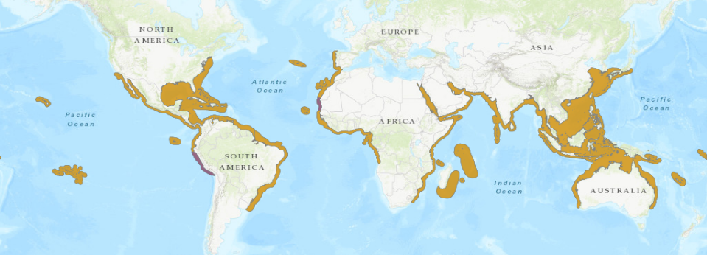
The scalloped hammerhead shark, Sphyrna lewini (Griffith and Smith, 1834), has a circumtropical distribution across coastal, pelagic and semi-oceanic environments, including continental shelves, slopes and offshore waters from the surface to depths of over 1200 m (Anderson et al., 2022; Compagno, 1984); (Figure 7).

Figure 7. Scalloped hammerhead shark (Sphyrna lewini) global distribution map (https://www.iucnredlist.org/species/39385/2918526#geographic-range).

In the western Atlantic Ocean, S. lewini is found from south of New Jersey (United States) to Brazil, including the Gulf of Mexico and the Caribbean Sea. In the eastern Atlantic, it is distributed from the Mediterranean Sea to Namibia. Sperone et al. (2012) documented the range extension of the species to the central Mediterranean off southern Italy. Distribution in the Indo-Pacific Ocean extends from South Africa throughout the Red Sea and Gulf, in the northern Indian Ocean on both coasts of India, east to Australia’s western, northern, and eastern coasts, throughout the coral triangle. and extending into the western Pacific north to southern Japan and westward to Tahiti and Hawaii. S. lewini is also native to the Eastern Pacific Ocean from the coast of southern California (U.S.) to Ecuador and perhaps as far south as Southern Peru (Figure 2). S. lewini is found in the following FAO Fishing Areas: 21, 31, 34, 41, 47, 51, 57, 61, 71, 77, and 87. The Range States for scalloped hammerhead sharks are detailed in Section 8, categorized by whether the Range State is Party to CMS or not.

4.2 Population (estimates and trends)

There are no data available on global population sizes of S. lewini (Rigby et al., 2019a). A recent assessment of the conservation status of the Australian population by the threatened species scientific committee was unable to estimate the number of mature individuals, but noted it is most plausible >10000 mature individuals (DCCEEW, 2024). The global population of S. lewini is estimated to have steeply declined across all oceans by >80% over the past 72 years (three generation lengths) (Rigby et al. 2019) – the pre-exploitation baseline was more than three generations ago, and the decline from this baseline is greater. Four population trend datasets were examined by Rigby et al. (2019): (1) a stock assessment in the Northwest Atlantic and Gulf of Mexico (Jiao et al. 2011); and standardized catch-per-unit-effort (CPUE) data in: (2) the Northwest Atlantic and Gulf of Mexico (J. Carlson and W.B. Driggers, unpubl. data); (3) the South Pacific (Simpfendorfer et al. 2010); and (4) the Indian Ocean (Dudley and Simpfendorfer 2006).

The Northwest Atlantic and Gulf of Mexico stock assessment indicated that the stock was overfished (B<Bmsy) from the early 1980s with overfishing (F>Fmsy) occurring periodically from 1983–2005 (Jiao et al. 2011). The steepest declines occurred prior to 1995, thereafter the abundance index remained stable until the end of the time-series in 2005. The trend analysis of the modelled population abundance for 1981–2005 (25 years) yielded annual rates of reduction of 7.5% consistent with an estimated median reduction of 99.6% over three generation lengths (72.3 years), with the highest probability of >80% reduction over three generation lengths (Rigby et al., 2029).

More recent data (1994–2017) from the Northwest Atlantic and from the Gulf of Mexico comprising two of the time-series underlying the Jiao et al. (2011) stock assessment (J. Carlson and W.B. Driggers, unpubl. data). Both time-series indicate this population has begun to increase soon after the implementation of management actions. The annual fisheries-independent bottom longline surveys (Grace and Henwood 1998) were conducted throughout the northern Gulf of Mexico and Northwest Atlantic by the National Marine Fisheries Service (NMFS), Southeast Fisheries Science Center, Mississippi Laboratories; called the NMFS Mississippi bottom longline shark survey (NMFS-LL-SE, in number of sharks per 10,000 hook hours; Ingram et al. 2005). These data exhibit a steep increase in CPUE from 2010 onwards.

Additionally, the commercial shark bottom longline fishery is active in the U.S. Atlantic Ocean from around North Carolina to Florida and throughout the eastern Gulf of Mexico (BLLOP) (Morgan et al. 2009). Both time-series taken together for 1994–2017 (24 years) demonstrated a median increase and the highest probability of an increase over three generation lengths (72.3 years). Recently, the renewed presence and schooling behavior of S. lewini in the deep waters off the Cayman Islands in 2022 have been documented for the first time since 1970's, likely as the result of increased protection (Gore et al., 2024).

Third, the analysis of the Queensland Shark Control Program population abundance for 1964–2004 (41 years) yielded annual rates of reduction of 8.4% consistent with an estimated median reduction of 99.8% over three generation lengths (72.3 years), with the highest probability of >80% reduction over three generation lengths.

Lastly, an analysis of the Indian Ocean Natal Sharks Board bather protection net program population abundance for 1978–2003 (26 years) yielded annual rates of reduction of 4.0% consistent with an estimated median reduction of 93.4% over three generation lengths (72.3 years), with the highest probability of >80% reduction over three generation lengths.
In addition to these four population trend analyses, Rigby et al. (2019) considered a recent analysis of fishery-dependent longline CPUE from the South Atlantic. These time-series are complex, reflecting access by different fleets and nationalities over time, but the best estimates of trends come from 1998 to 2008 during which 20 fleets (100 vessels) fished for tunas, swordfishes, and sharks. During this 10-year period there was a 61.7% decline in CPUE of Sphyrna spp. (Barreto et al. 2016).

In the Tropical Eastern Pacific (TEP) long-term data from Scuba Diver encounters, has suggested a 50% reduction in scalloped hammerhead sightings in the Galapagos Marine Reserve (Ecuador) since the 1980s (Peñaherrera et al. 2018) and a 45% reduction of sightings at Coco Island National Park (Costa Rica) since the early 1990s (White et al. 2015).

Globally, S. lewini was estimated to have undergone steep declines in all oceans, with some signs of stabilization and possible recovery in response to management only in the Northwest Atlantic and Gulf of Mexico. To reach a global population trend, the estimated three generation population trends for each region were weighted according to the relative size of each region; the two sources of Atlantic data were used to generate two global trends. This resulted in a median reduction of 76.9–97.3%, with the highest probability of >80% reduction over three generation lengths (72.3 years; Rigby et al., 2019).

4.3 Habitat (short description and trends)

S. lewini occupies a wide range of habitats during its life cycle, from shallow coastal zones and brackish-water estuaries where pups are born and spend their first few years of life; to pelagic open-water environments, including deep water off continental and insular shelves, oceanic islands and around seamounts (Klimley et al., 2005). When aggregating at seamounts or oceanic islands, scalloped hammerheads prefer habitat on the up-current side, and above the thermocline during the day, where they may carry out essential activities such as resting, cleaning, mating and thermoregulation (Ketchum et al., 2014a; Estupiñán-Montaño et al., 2017). At night, they perform movements to nearby deep waters, making repeated vertical excursions, ranging from 100 to 1,200 m deep to presumably to feed on squid (Aldana et al., 2020; Bessudo et al., 2016; Hearn et al., 2010; Ketchum et al., 2014; Klimley 1993).

Pregnant females migrate from offshore pelagic areas to shallow coastal nursery habitats where they give birth to live young in estuaries and sheltered bays. Newborns and juveniles remain resident in nurseries for the first years of their lives, although nursery populations linked by continuous coastlines are highly connected, with large schools of juveniles undertaking long-distance, seasonal along-shore movements, migrating to higher latitudes during the summer, and back as water temperature falls (Clarke, 1971; Bass et al., 1975; Stevens and Lyle 1989; Duncan and Holland, 2006). As they mature, juveniles move away from their inshore nursery grounds to offshore pelagic habitats. Coastal nursery areas are increasingly threatened by climate change, intensive fisheries, and habitat damage and loss from (inter alia) pollution and development (Cerutti-Pereyra et al. 2024).

4.4 Biological characteristics

The body of S. lewini is fusiform, or spindle-shaped, with a large first dorsal fin and low second dorsal and pelvic fins. The front teeth of the scalloped hammerhead are straight, while the rest have oblique cusps (unlike the great hammerhead, which has serrated teeth). It can be distinguished from other hammerhead species by the presence of a marked indentation in the middle of the front of the head and two additional indents on each side.

S. lewini reaches a maximum size of 370–420 cm TL (Compagno, 1998). Males mature at 140–198 cm TL and females at 200–250 cm TL (Compagno, 1984; Branstetter, 1987; Harry et al. 2011; White et al., 2008). Reproduction is via placental viviparity with litter sizes of 15–31 individuals, with an annual or biennial reproductive cycle, and a size at birth of 43–55 cm TL (Branstetter 1987; Chen et al., 1988; Amorim et al., 1994; Clarke et al., 2015). Female age-at-maturity is 13.2 years, and maximum age is 35 years; generation length is therefore 24.1 years (Drew et al. 2015). S. lewini have low intrinsic rates of population growth and productivity when compared to other sharks. Overall estimates of the intrinsic rate of increase for this species (r~0.08-0.105 yr⁻¹) indicate that populations are vulnerable to depletion and will be slow to recover from over-exploitation based on FAO’s low productivity category (<0.14 yr⁻¹) (FAO 2001; Musick et al. 2000).

4.5 Role of the taxon in its ecosystem

Sphyrna lewini is an upper trophic level predator in coastal and open ocean ecosystems. It has a diverse diet, taking a wide variety of fish, but also invertebrates, especially cephalopods. Stomach contents analysis revealed a high dietary proportion of mesopelagic cephalopods species in both male (42%) and female (63%) adult diets (Klimley 1987). Additional prey includes a high variety of teleost fish and invertebrate species, reflecting the range of habitats inhabited (Compagno, 1984; FAO 2024).

The trophic level for S. lewini was calculated to be 4.1 (maximum=5.0), based on diet information (Cortés, 1999), and later revised to 4.7 suggesting they feed at a higher trophic position and across a broader trophic range (Hussey et al., 2015). Navia et al. (2010) propose that the scalloped hammerhead ranks as the second most important species for maintaining marine community structure in the central fishing zone in the Colombian Pacific. The loss of large sharks can initiate a trophic cascade, which can lead to an increase of mesopredators, and ultimately destabilize the marine food web, jeopardizing the health of that ecosystem (Daskalov et al., 2007; Dedman et al. 2024; Klinard et al., 2025).

5. Conservation status and threats

5.1 IUCN Red List Assessment

The most recent 2019 IUCN Red List assessment uplisted the species to Critically Endangered (A2bd) globally, with a declining population trend, based on estimated weighted global population median reductions of 76.9 - 97.3%, with the highest probability of >80% reduction over three generation lengths (72.3 years) (Rigby et al., 2019).

The IUCN Red List uplisting from Endangered to Critically Endangered was made after this species’ inclusion in CMS Appendix II at CoP 11 (2014) and its addition to the Annex to the Migratory Sharks MOU (2016). Despite improved international collaboration between range States under CMS, population declines are continuing in all regions except for the Northwest Atlantic and Gulf of Mexico, where there are some signs of stabilization and possible recovery in response to management.

5.2 Equivalent information relevant to conservation status assessment

See section 4.2 for a detailed description of fishery stock assessments and other sources of trend data applied to develop the IUCN Red List assessment for scalloped hammerhead.

5.3 Threats to the population (factors, intensity)

The primary threat to S. lewini populations is overexploitation by fisheries of adults and juveniles. S. lewini is caught globally as target and bycatch in an array of fisheries, from small-scale artisanal bottom longline and gillnet fisheries to larger scale industrial pelagic long line and purse seine operations. Although most of the historical reported catch used to be from bycatch of industrial pelagic fleets in offshore and high-seas waters (Camhi et al., 2009), the species has since been shown to be heavily impacted by coastal gillnet and longline fisheries (Alfaro-Shigueto et al., 2010; Cartamil et al., 2011; Martínez-Ortiz et al., 2015; Sosa-Nishizaki et al., 2020) that seasonally catch neonates and juveniles in their coastal nursery habitats throughout Central America (Arriatti et al., 2011; Zanella & López-Garro, 2015; Guzman et al., 2019; Rodriguez-Arana et al., 2023), South America (López-Angarita et al., 2021), and Africa (Rosa et al., 2023). The species is retained for both fins and meat (Clarke et al. 2006a, Clarke et al. 2006b, Fields et al., 2018). Persistent misreporting and underreporting of S. lewini landings to FAO and RFMOs is an additional, albeit indirect threat, as it inhibits the possibility of designing efficient CMMs for the species. Additionally, S. lewini is affected by illegal, unreported and unregulated (IUU) fishing throughout its distribution range, although the extent of this issue is unclear (Miller et al. 2014; UNEP-WCM, 2019; Bonaccorso et al., 2021).

Habitat degradation of pupping and nursery grounds has significantly increased over the past decades, driven by anthropogenic activities. Coastal urban developments have not only led to pollution (e.g., sewage, plastic waste, noise), but to the destruction of coastal habitats (Chávez et al., 2024). The removal of mangrove swamps, coastal run-off and overfishing have been identified as threats to all elasmobranchs, particularly for endangered species that use shallow coastal habitats for reproduction, such as S. lewini (Dulvy et al., 2014).

Climate change is an additional threat to coastal nurseries, developmental grounds on continental shelves, and oceanic island and seamount hotspots, as a primary consequence of the species’ redistribution in the pursuit of physiologically and ecologically favorable conditions. Poleward shifts are projected for S. lewini, along with considerable declines in abundance in the warming tropics. Such regional shifts in habitat suitability have the potential to affect population connectivity, the access to key habitats, and levels of exposure to other anthropogenic pressures such as fishing, along with the effectiveness of conservation and management efforts in place (Cerutti-Pereyra et al. 2024).

5.4 Threats connected with migrations

Scalloped hammerheads are very susceptible to fisheries, both within jurisdictional and international waters, as they undertake their ontogenetic and seasonal cross-boundary migrations. S. lewini is taken as catch and bycatch in domestic fisheries within Exclusive Economic Zones worldwide and in multinational fisheries on the high seas. The species’ migrations between shallow coastal areas and deep-water open ocean zones makes it susceptible to a variety of gear types used by different large scale commercial and small-scale fisheries. Because S. lewini regularly migrate between the EEZs of different range States and into the high seas, no shared stock can benefit fully from any management measures that are introduced within the waters of a single range State. The regional protections afforded by some regional fisheries management organizations (RFMOs – see 6.2) will reduce some of the threat from the longline and purse seine fisheries targeting tuna and swordfish, but these measures do not offer full protection from every fishery within the region.

5.5 National and international utilization

Global demand for shark products, and trade associated with this demand, have expanded at an unprecedented rate over the past few decades. The majority of trade concerns two products: fins and meat, with fins considerably more valuable per weight ratio. Hammerhead shark fins are highly desired in international trade because of their large size and (for all sizes) high fin-needle (ceratotrichia) count (Rose 1996). These qualities make them one of the most valuable fin types on the market, with an average, wholesale, unprocessed S. lewini fin market value reaching $103/kg over 20 years ago (Clarke 2003; Abercrombie et al., 2005).

Contemporary peer-reviewed analysis of international fin markets revealed alarming trends. Systematic fin market surveys conducted between 2014-2021 in Hong Kong SAR and Guangzhou, Mainland China, found the market dominated by a small subset of large cosmopolitan species including S. lewini which represents 5.21% of the retail market, the 3rd most common species (Fields et al., 2018; Cardenosa et al., 2020, 2022). Analysis of the trade in small-sized fins, which is generally comprised of smaller-bodied species (whose fins are lower value due to a lower content of ceratotrichia), determined that S. lewini was the sixth most common species present, overall representing 5.95% of all fins (Cardenosa et al., 2024). This suggests that fins from juvenile S. lewini harvested in coastal nursery areas are entering international trade in high volumes.

In the last decade, the global trade in shark meat has increased significantly (Shea and Slee, 2024), with more than 200 countries and territories importing and exporting shark meat between 2012 and 2019 for a global trade valued at nearly €2.2 billion (Niedermüller et al. 2021). In some countries, the meat of small S. lewini (neonates and juveniles) is consumed domestically or exported to other countries (Miller et al., 2014). Although trade information was not documented to species level, Vannuccini (1999) indicated hammerhead shark meat was a favored import to countries like Spain and Japan. Uruguay reported exports of hammerhead meat to Brazil, Spain, Germany, Netherlands, and Israel (Vannuccini 1999). However, the current volume of traded meat and other products specific to S. lewini is unknown. Meat is usually consumed in local markets. The meat, liver oil, skin, cartilage and jaws may also be used (Almerón-Souza et al. 2018).

Sphyrna lewini was listed on Appendix II of CITES at CoP16 in March 2013. In the most recent CITES compliance cycle, S. lewini was identified as being subject to large volumes of continued trade. This trade was questioned for its sustainability given the species global Critically Endangered status and was included in the Review of Significant Trade (RST) process. In view of the large volumes of confiscated meat in international trade (particularly by Hong Kong SAR enforcement officials), it is apparent that there is ongoing illegal trade, which will be the subject of further investigation under the Article XIII compliance mechanism of CITES.

The scalloped hammerhead shark is the second most popular target species for shark diving worldwide, occurring in more than 30% of countries with established shark-diving industries (Healy et al. 2020). Analyses of global hammerhead shark-diving operations indicate a significant expansion of the industry over the past two decades, with a 65% increase in seven years (Gallagher and Hammerschlag, 2011; Healy et al. 2020).

The Eastern Tropical Pacific is the primary region where shark-diving industries focus on scalloped hammerhead sharks. Several studies have highlighted the species’ socio-economic importance here. For instance, in Cocos Island National Park, hammerhead sharks are a major tourism draw, with 56% of visitors traveling primarily for shark diving (Moreno et al. 2021). In 2019, this activity generated $1.5 million USD, with revenues flowing into the Costa Rican economy (Moreno et al. 2021). In the Galápagos, the scalloped hammerhead shark is the major attraction of the shark-watching industry and generated $11.3 million USD in 2023, with a total economic impact exceeding $17 million (Vianna et al., in prep). The species plays a vital socio-economic role through tourism by creating jobs, supporting local commerce, and contributing tax revenues to both the government and marine park authorities (Lynham et al. 2015; Peñaherrera, Llerena, and Keith 2012; Vianna et al., in prep).

6. Protection status and species management

6.1 National protection status

Multiple territories have opted to implement ‘Shark Sanctuaries’, which prohibit commercial shark fishing and the export of shark products across their entire Exclusive Economic Zones, and should benefit S. lewini. These territories include Palau (2003, 2009), Maldives (2010), Honduras (2011), The Bahamas (2011), Tokelau (2011), the Marshall Islands (2011), French Polynesia (2012), Cook Islands (2012), New Caledonia (2013), British Virgin Islands (2014), Federal States of Micronesia (2015), Caribbean Netherlands (2015), Cayman Islands (2015) and Dominican Republic (2015) (Ward-Paige 2017).

Australia: The scalloped hammerhead (Sphyrna lewini) has been assessed by the Threatened Species Scientific Committee (TSSC) for listing under Part 13 of the Environment Protection and Biodiversity Conservation Act 1999 (EPBC Act). The species was first assessed in 2018 and found to meet the criteria for both Endangered and Conservation Dependent status. The Conservation Dependent category applies to commercially exploited marine species that are otherwise eligible for listing as threatened (Vulnerable, Endangered, or Critically Endangered), provided there is an enforceable management plan in place to halt population decline and promote recovery, ensuring the species’ long-term survival (subsection 179(6), EPBC Act). During the 2024 reassessment, S. lewini was again found to meet the biological criteria for Endangered under IUCN-aligned standards. Despite this, the species retains a listing of Conservation Dependent, allowing regulated commercial use under the condition of active management. At the state and territory level, Sphyrna lewini receives further legal protection. In New South Wales, it is listed as Endangered under the Fisheries Management Act 1994 and is designated as a no-take species, requiring immediate release if captured. In Queensland, the species is also listed as Endangered under the Nature Conservation (Animals) Regulation 2020, and since 1 January 2024, all hammerhead species are classified as no-take, with mandatory release of any individuals caught. In Victoria, S. lewini is listed as Conservation Dependent under the Flora and Fauna Guarantee Act 1988.

Brazil: All six species of Hammerheads that occur in Brazil are listed in Ordinance 445/2014 (updated by Ordinance 148/2022 and 354/2023), which provides protection from capture, transport, handling, and commercialization of products (Cruz et al., 2021).

Colombia: in 2021, the Executive Fisheries Committee of Colombia removed all sharks and rays from the national Fisheries Resources List (Resolution 0380, 5/3/2021); these are now considered hydrobiological resources that should not be subject to extraction for commercial or sporting interests. As a result, the Ministry of Environment and Sustainable Development of Colombia issued the “Environmental Plan for the Protection and Conservation of Sharks, Rays and Chimeras” (Decree 218, December of 2021, adopted through Resolution 0854 of August 5, 2022), banning the exportation, re exportation and importation of all sharks, ray and chimera products, as well as the transportation and possession of any shark product or subproducts, particularly shark fins. Domestic commercialization of meat is still allowed in certain coastal districts. On 23rd April 2024, the National Aquaculture and Fisheries Authority issued new measures to reduce incidental catches of sharks and rays (Resolution 0766, 23/4/2024), such as a national wide steel wire leader ban, and the prohibition of possessing shark fins, or landing sharks without fins, and a mandate to deliver the fins of sharks that have been landed to satisfy domestic demand of meat, to the authorities.

Costa Rica: Decree 43900 dated on 2nd December 2022, bans the take and retention of hammerhead sharks (Sphyrnidae), as well as their domestic and international trade, although it allows bycatch and safe release of live specimens.

Dominican Republic: Through Resolution No. 0023/2017, issued by the Ministry of Environment and Natural Resources, has established an indefinite ban on the capture, retention, commercialization, export, and import of all shark and ray species, as well as their products, parts, and derivatives, throughout the national territory. This measure effectively provides full protection to species such as the scalloped hammerhead shark (Sphyrna lewini), and seeks to prevent further population declines caused by overfishing and illegal trade, while strengthening national compliance with international conservation commitments under the Washington Convention (1940), CITES, and other regional frameworks for marine biodiversity protection.

Ecuador: In August 2013, Ecuador issued the Ministerial Agreement #116 through which the Undersecretariat of Fisheries Resources of the Ministry of Agriculture, Livestock, Aquaculture and Fisheries established management measures for hammerhead sharks in the country. The agreement protects pregnant female sharks and adult hammerhead sharks. It prohibits transportation and commercialization of hammerhead sharks on industrial ships and limits bycatch retention on artisan boats to no more than five individuals under 150 cm. Ecuador later banned the capture, trade and exportation of five species of sharks, including S. lewini, on September 10, 2020 (Registro Oficial No 988, el ACUERDO Nro. MPCEIP-SRP-2020-0084-A.

Spain: The Spanish Ministry of Environment and Rural and Marine Affairs prohibited the capture of scalloped hammerhead sharks by means of a Ministerial Order that entered into force on 1 January 2010. According to the order, Spanish fishing ships will not be able to catch, transfer, land or commercialize these sharks in any of the fishing-grounds they target.

United States: In August 2011, the United States published a final rule to prohibit the retention of S. lewini in association with ICCAT fisheries. Further, the Eastern Pacific Distinct Population Segment (DPS) and Eastern Atlantic DPS of S. lewini are listed as endangered under the Endangered Species Act (16 U.S.C.1538(a)(1), and thus all the take prohibitions of section 9(a)(1) are applied. These include prohibitions against importing, exporting, engaging in foreign or interstate commerce, or “taking” of the species. “Take” is defined under the ESA as “to harass, harm, pursue, hunt, shoot, wound, kill, trap, capture, or collect, or attempt to engage in any such conduct.” These prohibitions apply to all persons, organizations and entities subject to the jurisdiction of the United States, including in the United States and its territorial seas, or on the high seas. In the case of threatened species—in which case two of the DPSs are listed as threatened—ESA section 4(d) requires the Secretary to issue regulations deemed necessary and appropriate for the conservation of the species. In the listing rule (79 FR 38213, July 3, 2014), NMFS evaluated the needs of and threats to the Central and Southwest Atlantic DPS and Indo-West Pacific DPS and determined that protective regulations pursuant to section 4(d) were not necessary or appropriate for the conservation of either DPS (NOAA 2020).

The Northwest Atlantic and Gulf of Mexico is the only region where fisheries management and governance measures have allowed depleted stocks to begin recovery. Otherwise, despite its inclusion in the regional and international biodiversity and fisheries conservation measures described below, national protection status across the range of this species is still patchy. The success of actions agreed through international wildlife and fisheries treaties depends on implementation at the domestic level; for sharks, such follow up actions have to date been seriously lacking (Rigby et al. 2019).

6.2 International protection status

UNCLOS: Sphyrna lewini is listed in Annex I of the United Nations Convention on the Law of the Sea (UNCLOS) and should thus be subject to its provisions concerning fisheries management in international waters. Annex I lists highly migratory marine species needing special conservation and management because they travel long distances across different maritime zones.

FAO IPOA-Sharks: The species is indirectly covered by the FAO International Plan of Action for the Conservation and Management of Sharks (IPOA-Sharks), adopted in 1999. The IPOA-Sharks is a voluntary international framework that encourages all shark-fishing and shark-trading nations to develop and implement National Plans of Action for sustainable shark conservation and management. It promotes the collection of species-specific data to improve knowledge of shark populations, the reduction of bycatch and wasteful practices including shark finning, the identification and protection of critical habitats such as nursery and breeding areas, and the application of precautionary principles in shark fisheries.

SPAW: The Protocol Concerning Specially Protected Areas and Wildlife (the SPAW Protocol), adopted in 2000, is one of three Protocols to the Cartagena Convention and the only binding tool for cross-border wildlife protection in the Wider Caribbean region. It is one of three Protocols to the Cartagena Convention. Annex III of the SPAW Protocol lists marine and coastal species whose sustainable, rational use is permitted, requiring participating countries to implement protective measures such as fishing bans during breeding seasons, limiting fishing methods to prevent local disappearance, and regulating the sale and transport of these species. Sphyrna lewini was listed on Annex III in 2019.

GFCM: In 2012, the General Fisheries Commission for the Mediterranean (GFCM) banned retention and mandated careful release for the Scalloped Hammerhead and 23 other elasmobranch species listed on the Barcelona Convention Annex II. Implementation by GFCM Parties, however, has been very slow.

IATTC: Several proposals to ban hammerhead landings and/or set regional hammerhead fishing limits through the Inter-American Tropical Tuna Commission (IATTC) have been defeated.

ICCAT: In 2010, the International Commission for the Conservation of Atlantic Tunas (ICCAT) tuna RFMO introduced retention prohibitions for the large hammerhead species. ICCAT Recommendation BYC 10‐08 states that Contracting Parties (CPs) shall prohibit retaining onboard, transshipping, landing, storing, selling, or offering for sale any part or whole carcass of hammerhead sharks of the family Sphyrnidae (except for Sphyrna tiburo) taken in the Convention Area in association with ICCAT fisheries, with an exemption for developing coastal countries for local consumption. However, developing coastal CPs should endeavor not to increase their catches of the family Sphyrnidae and take measures to ensure hammerhead species (except S. tiburo) will not enter international trade. Several proposals to ban hammerhead landings and/or set regional hammerhead fishing limits through the Inter-American Tropical Tuna Commission (IATTC) have been defeated.

WCPFC: The Western and Central Pacific Fisheries Commission (WCPFC) designated the Scalloped Hammerhead as a 'key shark species' in 2010, but has yet to adopt hammerhead catch limits.

IOTC: The Indian Ocean Tuna Commission (IOTC) has yet to act on 2018 scientific advice to adopt Scalloped Hammerhead fishery management measures.

CITES: S. lewini was listed on Appendix II of CITES at CoP16 in March 2013. This requires CITES Parties to ensure that exports and imports are accompanied by permits which confirm that the exported parts are sourced from legal and sustainable fisheries, and to report their exports and imports for inclusion in the CITES Trade Database.This listing has been a significant driver of improved management for the species (Bond et al., 2025).

CMS: Sphyrna lewini was included on CMS Appendix II at CoP11 in Quito, Ecuador in 2014 through a joint proposal by Ecuador and Costa Rica (UNEP/CMS/ COP11/Doc.24.1.16.Rev.1). During the meeting of the Committee of the Whole (CoW) it was noted that the scalloped hammerhead species also met the criteria for an Appendix I listing. Further, the Committee invited Parties to consider amending the proposal in this regard (Pew Charitable Trusts Policy Brief, 2014).

CMS Sharks MOU: The species was listed on Annex I of the Memorandum of Understanding on the Conservation of Migratory Sharks (Sharks MOU), in 2016. The Sharks MOU is a legally non-binding international instrument which encourages the Signatory countries to implement shark conservation plans with the objective of improving the understanding of migratory shark populations, ensuring that directed and non-directed fisheries for sharks are sustainable, ensuring to the extent practicable the protection of critical habitats and migratory corridors and critical life stages of sharks, increasing public awareness of threats to sharks and their habitats, and enhance public participation in conservation activities and enhancing national, regional and international cooperation.

The above measures have not been sufficient to enable S. lewini stock recovery in the waters of CMS range States. Rigby et al. (2019) recommended that all scalloped hammerhead retention and landings be prohibited, at least for as long as the global population is classified as Critically Endangered or Endangered. Initiatives to prevent capture, minimize bycatch mortality, promote safe release, and improve catch (including discard) reporting are also urgently needed, as is full implementation of additional commitments agreed through international treaties. The uplisting of scalloped hammerhead to Appendix I of CMS would highlight the need for strict national protection of this species and its habitats.

6.3 Management measures

Australia: The scalloped hammerhead (Sphyrna lewini) is listed as Conservation Dependent under the Environment Protection and Biodiversity Conservation Act 1999 (EPBC Act), with the species also meeting the criteria for Endangered (Criterion 1 A2bd) based on population declines in Australian waters. To satisfy the requirements of Conservation Dependent listing under paragraph 179(6) of the EPBC Act, a management framework must be in place to halt population decline and support recovery. This is achieved through the National Scalloped Hammerhead Shark Management Strategy 2022, which establishes a coordinated approach for the effective management of S. lewini stocks within Australian waters. Following the implementation of the Strategy, additional measures were introduced by the Queensland and Northern Territory governments, including legislative amendments to fisheries regulations. These measures include restrictions on specific net types and prohibitions on the retention of scalloped hammerhead sharks, providing enforceable protections aimed at reducing fishing mortality and supporting population recovery

Panama: Announced on 25 June 2024 that it had established a zero quota for the exportation of all sharks and rays listed under the Appendixes of CITES (Elasmobranchii spp.), including S. lewini (CITES Notification: No. 2024/073). Catch to meet domestic demand is allowed.

United States of America: Sphyrna lewini is managed as part of the Atlantic Large Coastal Shark Complex with a separate stock assessment. The Atlantic population of the scalloped hammerhead (Sphyrna lewini) was declared overfished and undergoing overfishing in 2011, prompting NOAA Fisheries to initiate a rebuilding plan under the Magnuson–Stevens Act (FR Vol. 76 No. 82, Apr 28 2011). The plan was implemented through Amendment 5a to the Consolidated Highly Migratory Species Fishery Management Plan (2013), which introduced quotas, a separate hammerhead management group, and retention limits (NOAA Fisheries 2013). Subsequent measures—including minimum size limits and a 2024 retention ban in U.S. Caribbean waters—aimed to reduce mortality (NOAA Fisheries 2024). The most recent SEDAR 77 stock assessment (2024) found that the species was not overfished and overfishing was not occurring in the terminal assessment year (≈2019), indicating partial recovery but persistent uncertainty due to taxonomic overlap with Sphyrna gilberti (SEDAR 77 Final Report 2024). Despite local improvements, several U.S. Distinct Population Segments remain listed under the Endangered Species Act, showing that full recovery to MSY by 2021, as projected in 2011, was not demonstrably achieved (NOAA SAFE Report 2023; IUCN 2019).

Management approaches include quotas, limited entry, time-area closures, recreational bag limits, and the requirement that all sharks be offloaded from vessels with their fins naturally attached.

European Union: The European Union (EU) and its Member States (MS) have implemented ICCAT Recommendation BYC 10‐08 by prohibiting the catch of hammerhead sharks throughout the ICCAT Convention Area. Some EU countries such as Spain have stronger domestic measures, prohibiting the target catch and trade of all sharks in their waters. EU MS that are Party to the Barcelona Convention for the Protection of the Mediterranean Sea and Member of the General Fisheries Commission for the Mediterranean (GFCM) protect the scalloped hammerhead and other elasmobranch species listed in Annex II to the Barcelona Convention Protocol concerning Specially Protected Areas and Biological Diversity in the Mediterranean.

6.4 Habitat conservation

The IUCN SSC Shark Specialist Group’s Important Shark and Ray Areas (ISRA) initiative has already identified several areas of importance for Scalloped Hammerhead sharks, including pupping and nursery grounds, mating and foraging areas, and migratory corridors. Hammerhead ISRAs not yet covered by appropriate regulations, would benefit from the introduction of area-based and species-specific conservation measures.

Adult S. lewini aggregation sites in remote Islands of the Eastern Tropical Pacific, such as Malpelo Island (Colombia), Cocos (Costa Rica), the Galapagos Archipelago (Ecuador) and Revillagigedo (Mexico) currently enjoy strict protection from fisheries as marine protected areas under no-take regimes.

Ecuador banned fishing in the northern area of the Galapagos Marine Reserve (GMR) in March 2016, covering 38,000 km2 of no-take waters surrounding Wolf and Darwin Islands (Acuerdo Ministerial 026-A).

The Malpelo Sanctuary of Fauna and Flora was expanded to currently cover 26,679.08 km2 of no-take waters (Ministerio de Ambiente y Desarrollo Sostenible, Colombia, Resolución N°1907 September 14, 2017.

The expansion of Cocos Island National Park from a 12 nm radius covering covering 2,000 km2, to a 54,000 km2 rectangle, in which Las Gemelas Seamount and West Cocos Seamount, two of the seamounts with the highest diversity of large pelagics along the SCR (Cambra et al 2021), are now fully protected.

A Hammerhead Shark Sanctuary was established in the Golfo Dulce of South Pacific Costa Rica (Decree N° 41056-MINAE, La Gaceta Nº 80, 9/5/2018, covering an area of 42.1 km2 where all Hammerhead shark catch, retention and commercialization is banned. Bycatch of Hammerhead sharks however, is allowed, with a mandate to safely release live specimens.

Mexico declared Cabo Pulmo National Park, at the tip of the Baja California Peninsula, and the Revillagigedo National Park (RNP) in the Mexican Pacific, as no-take areas. Revillagigedo National Park is considered the largest marine reserve in North America (Aldana-Moreno et al., 2019). It was established in 2017 to protect large aggregations of the pelagic fauna that occur inside its 148,000km2, including S. lewini (DOF, 2017).

South Africa declared the Protea Banks Marine Protected Area in 2019, which covers an area 1200 km² in size and includes habitat depths that range from 40-1000m deep. The MPA is zoned to allow line-fishers to benefit from fish spillover coming from adjacent no-take zones. Sharks are fully protected throughout the MPA, including schooling S. lewini.

6.5 Population monitoring

Population monitoring requires the collection and regular analysis of species-specific catch and trade data. Species’ specific shark landings data have improved but are still broadly lacking; with hammerhead catches are often amalgamated as Sphyrna spp. or Sphyrnidae. Further, S. zygaena (smooth hammerhead) and S. lewini are often misidentified, even at the genus level. (Maguire et al., 2006). Species level international trade data are improving because of the CITES Appendix II listing. With time, this will provide a valuable resource, when coupled with fisheries-dependent and independent data, to monitor S. lewini populations.

7. Effects of the proposed amendment

7.1 Anticipated benefits of the amendment

Listing on international agreements such as CMS are already helping to some extent to drive substantial improvements in national, regional and international management, and to facilitate collaboration between range and fishing States for the conservation of S. lewini. An Appendix I listing is anticipated to lead to increased attention to legal protection in range States and the adoption and implementation of other scalloped hammerhead shark conservation measures.
This proposal to include Scalloped Hammerheads in Appendix I of the Convention will encourage Parties to introduce or improve strictly protected status for this CR species and its habitats. It will focus increased attention to the conservation or restoration of critical habitats such as feeding and breeding aggregations, pupping grounds, nursery areas, and the protection of transboundary movement corridors.

7.2 Potential risks of the amendment

No potential risks to scalloped hammerhead shark conservation are foreseen from an Appendix I listing.

7.3 Intention of the proponent concerning development of an Agreement or Concerted Action

This proposal seeks to enhance the protection of scalloped hammerhead sharks through an Appendix I uplisting. This species is already covered by a CMS daughter agreement, through its inclusion in Annex I to the CMS Sharks MOU, but efforts to strengthen its national-level protection also need to be enhanced.

8. Range States

CMS Parties: Angola; Antigua and Barbuda; Australia; Benin; Brazil; Cameroon; Cabo Verde; Congo; Costa Rica; Côte d'Ivoire; Cuba; Djibouti; Dominican Republic; Ecuador; Egypt; Equatorial Guinea; Eritrea; France (French Guiana, Guadeloupe, New Caledonia); Gabon; Gambia; Ghana; Guinea; Guinea-Bissau; Honduras; India; Iraq; Iran; Italy; Liberia; Maldives, Mauritania; Netherlands (Aruba); Nigeria; Pakistan; Panama; Philippines; Sao Tomé and Principe; Saudi Arabia; Senegal; South Africa; Spain; Togo; United Arab Emirates; United Kingdom (Anguilla, Cayman Islands), Uruguay; Yemen
Non-CMS Parties: Bahamas; Bahrain; Barbados; Belize; China; Colombia; Dominica; El Salvador; Grenada; Guyana; Haiti; Indonesia; Jamaica; Japan; Kuwait; Mexico; Myanmar; Namibia; Nicaragua; Oman; Qatar; Saint Kitts and Nevis; Saint Lucia; Saint Vincent and the Grenadines; Sierra Leone; Suriname; Thailand; Trinidad and Tobago; United States (Alabama, California, Delaware, Florida, Georgia, Hawaiian Is., Louisiana, Maryland, Mississippi, New Jersey, North Carolina, Puerto Rico, South Carolina, Texas, Virginia); Venezuela, Bolivarian Republic of; Viet Nam.

9. Consultations

The following CMS Parties to CMS responded to the consultation request: United Kingdom of Great Britain and Northern Ireland, Australia, Dominican Republic, and Switzerland.

10. Additional remarks

11. References

Abercrombie DL, Clarke SC, Shivji MS (2005) Global-scale genetic identification of hammerhead sharks: application to assessment of the international fin trade and law enforcement. Conserv Genet 6:775–788.
Aldana‐Moreno, A., Hoyos‐Padilla, E.M., González‐Armas, R., Galván‐Magaña, F., Hearn, A., Klimley, A.P., Winram, W., Becerril‐García, E.E. and Ketchum, J.T., 2020. Residency and diel movement patterns of the endangered scalloped hammerhead Sphyrna lewini in the Revillagigedo National Park. Journal of fish biology, 96(2), pp.543-548.
Alfaro-Shigueto, J., Mangel, J.C., Pajuelo, M., Dutton, P.H., Seminoff, J.A. and Godley, B.J., 2010. Where small can have a large impact: structure and characterization of small-scale fisheries in Peru. Fisheries Research, 106(1), pp.8-17.
Almerón-Souza, F., Sperb, C., Castilho, C.L., Figueiredo, P.I., Gonçalves, L.T., Machado, R., Oliveira, L.R., Valiati, V.H. and Fagundes, N.J., 2018. Molecular identification of shark meat from local markets in Southern Brazil based on DNA barcoding: evidence for mislabeling and trade of endangered species. Frontiers in Genetics, 9, p.138.
Amorim, A.D., Arfelli, C.A. and Fagundes, L., 1998. Pelagic elasmobranchs caught by longliners off southern Brazil during 1974–97: an overview. Marine and Freshwater Research, 49(7), pp.621-632.
Anderson JM, Rex PT, Maloney K, et al (2022) Observations of a species‐record deep dive by a central Pacific female scalloped hammerhead shark (Sphyrna lewini). J Fish Biol 101:323–327. https://doi.org/10.1111/jfb.15115
Arriatti, Y.R., Alvarado, S. and Espinosa, C., Caracterización de la Pesca de Tiburones en Panamá Characterization of Shark Fishing in Panama Caractérisation de la Pêche au Requin à Panama.
Anislado-Tolentino, V. and C. Robinson-Mendoza. 2001. Age and growth for the scalloped hammerhead shark, Sphyrna lewini (Griffith and Smith, 1834) along the Central Pacific coast of Mexico. Ciencias Marinas 27:501–520.
Barreto, R., Ferretti, F., Flemming, J.M., Amorim, A., Andrade, H., Worm, B. and Lessa, R., 2016. Trends in the exploitation of South Atlantic shark populations. Conservation biology, 30(4), pp.792-804.
Bass, A.J., D’Aubrey, J.D. and N. Kistnasamy. 1975. Sharks of the east coast of southern Africa. III. The families Carcharinidae (excluding Mustelus and Carcharhinus) and Sphyrnidae. South African Association for Marine Biological Research. Oceanographic Research Institute Investigational Report 38: 1-100.
Baum, J.K., Myers, R.A., Kehler, D.G., Worm, B., Harley, S.J. and Doherty, P.A. 2003. Collapse and Conservation of Shark Populations in the Northwest Atlantic. Science 299: 389-392.
Bessudo, S. & German Andres Soler & A. Peter Klimley & James T. Ketchum & Alex Hearn & Randall Arauz. 2011. Residency of the scalloped hammerhead shark (Sphyrna lewini) at Malpelo Island and evidence of migration to other islands in the Eastern Tropical Pacific Environ Biol Fish 91: 165–176.
Bessudo S, Soler GA, Klimley PA, et al (2016) Vertical and horizontal movements of the scalloped hammerhead shark (Sphyrna lewini) around Malpelo and Cocos Islands (Tropical Eastern Pacific) using satellite telemetry. Bull Mar Coast Res 40:. https://doi.org/10.25268/bimc.invemar.2011.40.0.133
Bonaccorso, E., Ordóñez-Garza, N., Pazmiño, D.A., Hearn, A., Páez-Rosas, D., Cruz, S., Muñoz-Pérez, J.P., Espinoza, E., Suárez, J., Muñoz-Rosado, L.D. and Vizuete, A., 2021. International fisheries threaten globally endangered sharks in the Eastern Tropical Pacific Ocean: the case of the Fu Yuan Yu Leng 999 reefer vessel seized within the Galápagos Marine Reserve. Scientific Reports, 11(1), p.14959.
Bond, M.E., Booth, H., Tanna, A., Fowler, S.L., Polo-Silva, C.J., Shea, K.S., Cardiec, F., Mansur, E.F. and Jabado, R.W., 2025. Trade regulations drive improved global shark and ray management. Marine Policy, p.106733.
Branstetter, S., 1987. Age, growth and reproductive biology of the silky shark, Carcharhinus falciformis, and the scalloped hammerhead, Sphyrna lewini, from the northwestern Gulf of Mexico. Environmental Biology of Fishes, 19(3), pp.161-173.
Cambra, M., Lara-Lizardi, F., Peñaherrera-Palma, C., Hearn, A., Ketchum, J.T., Zarate, P., Chacón, C., Suárez-Moncada, J., Herrera, E. and Espinoza, M., 2021. A first assessment of the distribution and abundance of large pelagic species at Cocos Ridge seamounts (Eastern Tropical Pacific) using drifting pelagic baited remote cameras. PLoS One, 16(11), p.e0244343.
Camhi, M.D., S.V. Valenti, S.V. Fordham, S.L. Fowler and C. Gibson. 2009. The Conservation Status of Pelagic Sharks and Rays: Report of the IUCN Shark Specialist Group Pelagic Shark Red List Workshop. IUCN Species Survival Commission Shark Specialist Group. Newbury, UK. x + 78p.
Cardeñosa, D., Fields, A.T., Babcock, E.A., Shea, S.K., Feldheim, K.A. and Chapman, D.D., 2020. Species composition of the largest shark fin retail-market in mainland China. Scientific reports, 10(1), p.12914.
Cardeñosa, D., Shea, S.K., Zhang, H., Fischer, G.A., Simpfendorfer, C.A. and Chapman, D.D., 2022. Two thirds of species in a global shark fin trade hub are threatened with extinction: Conservation potential of international trade regulations for coastal sharks. Conservation Letters, 15(5), p.e12910
Cardeñosa, D., Babcock, E.A., Shea, S.K., Zhang, H., Feldheim, K.A., Gale, S.W., Mills, D. and Chapman, D.D., 2024. Small sharks, big problems: DNA analysis of small fins reveals trade regulation gaps and burgeoning trade in juvenile sharks. Science advances, 10(42), p.eadq6214.
Carlson, J.K., I.E. Baremore, and D.M. Bethea. 2005. The direct shark gillnet fishery, catch and bycatch 2004. National Marine Fisheries Service, Southeast Fisheries Science Center, PCB-05-01. Panama City, FL.
Cartamil, D., Santana-Morales, O., Escobedo-Olvera, M., Kacev, D., Castillo-Geniz, L., Graham, J.B., Rubin, R.D. and Sosa-Nishizaki, O., 2011. The artisanal elasmobranch fishery of the Pacific coast of Baja California, Mexico. Fisheries Research, 108(2-3), pp.393-403.
Cerutti‐Pereyra, F., Drenkard, E.J., Espinoza, M., Finucci, B., Galván‐Magaña, F., Hacohen‐Domené, A., Hearn, A., Hoyos‐Padilla, M.E., Ketchum, J.T., Mejía‐Falla, P.A. and Moya‐Serrano, A.V., 2024. Vulnerability of Eastern Tropical Pacific chondrichthyan fish to climate change. Global Change Biology, 30(7), p.e17373.
Centeno-Chaves, A., Marrari, M., Arias-Zumbado, F., García-Rojas, A. and Mug-Villanueva, M., 2025. Composition of pelagic fish in commercial landings of the longline fishery in the Costa Rica Pacific during 2015-2021. Frontiers in Marine Science, 11, p.1490883.
Chen, C. T. , T. C. Leu, and S. J. Joung. 1988. Reproduction in the female scalloped hammerhead, Sphyrna lewini, in northeastern Taiwan waters. U.S. Fish Wildl. ServoFish. Bull. 86(2): 389-393.
Chen, C.T., Leu, T.C., Joung, S.J. and Lo, N.C.H., 1990. Age and growth of the scalloped hammerhead, Sphyrna lewini, in northeastern Taiwan waters. PUBLISHED WHERE?

Chin, A., Simpfendorfer, C.A., White, W.T., Johnson, G.J., McAuley, R.B. and Heupel, M.R., 2017. Crossing lines: a multidisciplinary framework for assessing connectivity of hammerhead sharks across jurisdictional boundaries. Scientific Reports, 7(1), p.46061.
Chiriboga-Paredes, Y., Palomino, Á., Goodman, L., Córdova, F., Páez, V., Yépez, M., Jorgensen, S., Armijos, D., Pazmiño, D. and Hearn, A., 2022. Discovery of a putative scalloped hammerhead shark Sphyrna lewini (Carcharhiniformes: Sphyrnidae) nursery site at the Galapagos Islands, Eastern Tropical Pacific. Environmental Biology of Fishes, 105(2), pp.181-192.
Clarke, T.A. 1971. The ecology of the scalloped hammerhead shark, Sphyrna lewini, in Hawaii. Pacific Science 25: 133-144.
Clarke, S. and Rose, D.A. 2003. Regional Fisheries and Trade. In: Fowler, S. L., Cavanagh, R. D., Camhi, M., Burgess, G. H., Cailliet, G. M., Fordham, S. V., Simpfendorfer, C. A. and Musick, J. A. (eds), Sharks, Rays and Chimaeras: The Status of the Chondrichthyan Fishes. Status Survey. , pp. 24-29. IUCN/ SSC Shark Specialist Group, IUCN, Gland, Switzerland and Cambridge, UK.
Clarke, S.C. et al. 2006(a). Global estimates of shark catches using trade records from commercial markets. Ecology Letters 9(10):1115–1126.
Clarke, S.C. et al. 2006(b). Identification of shark species composition and proportion in the Hong Kong shark fin market based on molecular genetics and trade records. Conservation Biology 20(1): 201-211.
Coiraton, C., Amezcua, F. and Ketchum, J.T., 2020. New insights into the migration patterns of the scalloped hammerhead shark Sphyrna lewini based on vertebral microchemistry. Marine Biology, 167(5), p.58.
Compagno, L.J.V., FAO species catalogue. Vol. 4. 1984 Sharks of the world. An annotated and illustrated catalogue of shark species known to date. Part 2. Carcharhiniformes. FAO Fish.Synop. 125 (4): 545-546.
Cortés, E., Arocha, F., Beerkircher, L., Carvalho, F., Domingo, A., Heupel, M., Holtzhausen, H., Santos, M.N., Ribera, M. and Simpfendorfer, C., 2010. Ecological risk assessment of pelagic sharks caught in Atlantic pelagic longline fisheries. Aquatic Living Resources, 23(1), pp.25-34.
Cortés E. 1999. Standardized diet compositions and trophic levels of sharks. ICES Journal of Marine Science 56:707–17.
Cruz, M.M., Szynwelski, B.E. and De Freitas, T.O., 2021. Biodiversity on sale: the shark meat market threatens elasmobranchs in Brazil. Aquatic Conservation: Marine and Freshwater Ecosystems, 31(12), pp.3437-3450.
Convention on International Trade in Endangered Species of Wild Flora and Fauna (CITES). 2013. Proposal to include scalloped hammerhead sharks and lookalike species in Appendix II. CoP16. Bangkok, Thailand.
Daly-Engel TS, Seraphin KD, Holland KN, Coffey JP, Nance HA, Toonen RJ, et al. (2012) Global Phylogeography with Mixed-Marker Analysis Reveals Male-Mediated Dispersal in the Endangered Scalloped Hammerhead Shark (Sphyrna lewini). PLoS ONE 7(1): e29986. https://doi.org/10.1371/journal.pone.0029986
Daskalov, G.M., Grishin, A.N., Rodionov, S. and Mihneva, V., 2007. Trophic cascades triggered by overfishing reveal possible mechanisms of ecosystem regime shifts. Proceedings of the National Academy of Sciences, 104(25), pp.10518-10523.
Department of Climate Change, Energy, the Environment and water (DCCEEW), 2024. Threatened species scientific committee: Listing Advice for Sphyrna lewini (scalloped hammerhead). https://www.environment.gov.au/biodiversity/threatened/species/pubs/85267-listing-advice-27022024.pdf
De Jong, S. and Simpfendorfer, C., 2009, May. The Queensland Shark Control Program: a fisheries-independent assessment of shark stocks in far north Queensland. In 8th Indo Pacific Fish Conference and 2009 Australian Society for Fish Biology Workshop and Conference (Vol. 31).
Dedman, S., Moxley, J.H., Papastamatiou, Y.P., Braccini, M., Caselle, J.E., Chapman, D.D., Cinner, J.E., Dillon, E.M., Dulvy, N.K., Dunn, R.E. and Espinoza, M., 2024. Ecological roles and importance of sharks in the Anthropocene Ocean. Science, 385(6708), p.adl2362.
Dent, F. and Clarke, S., 2015. State of the global market for shark products. FAO Fisheries and Aquaculture technical paper, (590), p.I.
Diemer, K.M., Mann, B.Q. and Hussey, N.E., 2011. Distribution and movement of scalloped hammerhead Sphryna lewini and smooth hammerhead Sphyrna zygaena sharks along the east coast of southern Africa. African Journal of Marine Science, 33(2), pp.229-238.
Drew, M., White, W.T., Dharmadi, Harry, A.V. and Huveneers, C., 2015. Age, growth and maturity of the pelagic thresher Alopias pelagicus and the scalloped hammerhead Sphyrna lewini. Journal of Fish Biology, 86(1), pp.333-354.
Dudley, S. and Simpfendorfer, C. 2006. Population status of 14 shark species caught in the protective gillnets off KwaZulu-Natal beaches, South Africa, 1978-2003. Marine and Freshwater Research 57: 225-240.
Dulvy, N.K., Fowler, S.L., Musick, J.A., Cavanagh, R.D., Kyne, P.M., Harrison, L.R., Carlson, J.K., Davidson, L.N., Fordham, S.V., Francis, M.P. and Pollock, C.M., 2014. Extinction risk and conservation of the world’s sharks and rays. elife, 3, p.e00590.
Duncan KM1, Martin AP, Bowen BW, DE Couet HG. 2006. Global phylogeography of the scalloped hammerhead shark (Sphyrna lewini). Mol Ecol. 15(8): 2239-2251.
Estupinan-Montano, C., Galvan-Magana, F., Tamburin, E., Sanchez-Gonzalez, A., Villalobos-Ramirez, D.J., Murillo-Bohorquez, N., Bessudo-Lion, S. and Estupinan-Ortiz, J.F., 2017. Trophic inference in two sympatric sharks, Sphyrna lewini and Carcharhinus falciformis (Elasmobranchii: Carcharhiniformes), based on stable isotope analysis at Malpelo Island, Colombia. Acta Ichthyologica et Piscatoria, 47, pp.357-364.
Ebert, D.A., M. Dando & S. L. Fowler. 2021. Sharks of the World: a complete guide. Princeton University Press.
Ferretti, F., R.A. Myers, F. Serena and H.K. Lotze. 2008. Loss of large predatory sharks from the Mediterranean Sea. Conservation Biology 22:952-964.
Fields, A.T., Fischer, G.A., Shea, S.K., Zhang, H., Abercrombie, D.L., Feldheim, K.A., Babcock, E.A. and Chapman, D.D., 2018. Species composition of the international shark fin trade assessed through a retail‐market survey in Hong Kong. Conservation biology, 32(2), pp.376-389.
Fields, A.T., Fischer, G.A., Shea, S.K.H., Zhang, H., Feldheim, K.A. and Chapman, D.D., 2020. DNA Zip‐coding: identifying the source populations supplying the international trade of a critically endangered coastal shark. Animal Conservation, 23(6), pp.670-678.
Friedlander, A.M., Zgliczynski, B.J., Ballesteros, E., Aburto-Oropeza, O., Bolaños, A. and Sala, E., 2012. The shallow-water fish assemblage of Isla del Coco National Park, Costa Rica: structure and patterns in an isolated, predator-dominated ecosystem. Revista de Biología Tropical, 60, pp.321-338.
Food and Agriculture Organization of the United Nations (FAO). 2014. Major fishing areas. May 13, 2014. http://www.fao.org/fishery/area/search/en
Gallagher, A. J., & Hammerschlag, N. (2011). Global Shark Currency: The Distribution, Frequency, and Economic Value of Shark Ecotourism. Current Issues in Tourism, 14(8), 797–812.
Gallagher, A.J. and Klimley, A.P., 2018. The biology and conservation status of the large hammerhead shark complex: the great, scalloped, and smooth hammerheads. Reviews in Fish Biology and Fisheries, 28(4), pp.777-794.
Gore M, Kohler J, Ormond R, Gallagher A, Fernandes T, Austin T and Pattengill-Semmens C. Renewed
occurrence of schooling scalloped hammerhead (Sphyrna lewini) and of great hammerhead (S.
mokarran) sharks in the Cayman Islands. 2024. Front. Mar. Sci. 11:1347285. doi:10.3389/fmars.2024.1347285
Grace, M. and Henwood, T., 1997. Assessment of the distribution and abundance of coastal sharks in the US Gulf of Mexico and eastern seaboard, 1995 and 1996. Marine Fisheries Review, 59(4), pp.23-32.
Green, M.E., Appleyard, S.A., White, W.T., Tracey, S.R., Heupel, M.R. and Ovenden, J.R., 2022. Updated connectivity assessment for the scalloped hammerhead (Sphyrna lewini) in Pacific and Indian Oceans using a multi-marker genetic approach. Fisheries Research, 251, p.106305.
Guzman, H.M., Cipriani, R., Vega, A.J. and Morales‐Saldaña, J.M., 2020. Fisheries and conservation assessment of sharks in Pacific Panama. Aquatic Conservation: Marine and Freshwater Ecosystems, 30(2), pp.315-330.
Harned, S.P., Bernard, A.M., Salinas‐de‐León, P., Mehlrose, M.R., Suarez, J., Robles, Y., Bessudo, S., Ladino, F., López Garo, A., Zanella, I. and Feldheim, K.A., 2022. Genetic population dynamics of the critically endangered scalloped hammerhead shark (Sphyrna lewini) in the Eastern Tropical Pacific. Ecology and Evolution, 12(12), p.e9642.
Harry, A.V., Macbeth, W.G., Gutteridge, A.N. and Simpfendorfer, C.A., 2011. The life histories of endangered hammerhead sharks (Carcharhiniformes, Sphyrnidae) from the east coast of Australia. Journal of Fish Biology, 78(7), pp.2026-2051.
Hayes, C.G., Y. Jiao & E. Cortes. 2009. Stock assessment of scalloped hammerhead sharks in the Western North Atlantic Ocean and Gulf of Mexico. North American Journal of Fisheries Management.
Hazin, F., Fischer, A. and Broadhurst, M., 2001. Aspects of reproductive biology of the scalloped hammerhead shark, Sphyrna lewini, off northeastern Brazil. Environmental Biology of Fishes, 61(2), pp.151-159.
Healy, T. J., Hill, N. J., Barnett, A., & Chin. A. (2020). A Global Review of Elasmobranch Tourism Activities, Management and Risk. Marine Policy, 118, 103964.
Hearn, A., J. Ketchum, A.P. Klimley, E. Espinoza & C. Peñaherrera. 2010. Hotspots within hotspots? Hammerhead shark movements around Wolf Island, Galapagos Marine Reserve. Marine Biology. Vol 157(9):1899-1915.
Hearn, A.R., Green, J., Román, M.H., Acuña-Marrero, D., Espinoza, E. and Klimley, A.P., 2016. Adult female whale sharks make long-distance movements past Darwin Island (Galapagos, Ecuador) in the Eastern Tropical Pacific. Marine biology, 163(10), p.214.
Heupel, M. R. and McAuley, R. B. 2007. Sharks and Rays (Chondrichthyans) in the North-west Marine Region. Report to Department of the Environment and Water Resources, National Oceans Office Branch. Hobart, Tasmania.
International Union for the Conservation of Nature (IUCN). 2014. IUCN Red List of Threatened Species. Version 3.1. April 21, 2014. http://www.iucnredlist.org/
Holland, K., Lowe, C., Peterson, J., & Gill, A. (1992). Tracking Coastal Sharks with small boats: Hammerhead Shark Pups as a case study. Marine and Freshwater Research, 43, 61.
Hoyos-Padilla EM, Ketchum JT, Klimley AP, Galván-Magaña F (2014) Ontogenetic migration of a female scalloped hammerhead shark Sphyrna lewini in the Gulf of California. Anim Biotelemetry 2:17. https://doi.org/10.1186/2050-3385-2-17
Hussey, N.E., MacNeil, M.A., Siple, M.C., Popp, B.N., Dudley, S.F. and Fisk, A.T., 2015. Expanded trophic complexity among large sharks. Food webs, 4, pp.1-7.
Ingram, W., Henwood, T., Grace, M., Jones, L., Driggers, W. and Mitchell, K., 2005. Catch rates, distribution and size composition of large coastal sharks collected during NOAA Fisheries Bottom Longline Surveys from the US Gulf of Mexico and US Atlantic Ocean. MS− SEDAR, 11.
Jiao, Y., C. Hayes, and E. Cortés. 2008. Hierarchical Bayesian approach for population dynamics modelling of fish complexes without species-specific data. ICES Journal of Marine Science 66: 367 - 377.
Jiao, Y., Cortés, E., Andrews, K. and Guo, F., 2011. Poor‐data and data‐poor species stock assessment using a Bayesian hierarchical approach. Ecological Applications, 21(7), pp.2691-2708.
Ketchum, J. T., A. Hearn, A. P. Klimley, C. Peñaherrera, E. Espinoza, S. Bessudo, G. Soler, and R. Arauz. 2014. Inter island movements of scalloped hammerhead sharks (Sphyrna lewini) and seasonal connectivity in a marine protected area of the eastern tropical Pacific.Mar Bio. International Journal on Life in Oceans and Coastal Waters. DOI 10.1007/s00227-014-2393-y
Ketchum, J.T., Hearn, A., Klimley, A.P., Espinoza, E., Peñaherrera, C. and Largier, J.L., 2014. Seasonal changes in movements and habitat preferences of the scalloped hammerhead shark (Sphyrna lewini) while refuging near an oceanic island. Marine Biology, 161(4), pp.755-767.
Ketchum, J.T., Hoyos-Padilla, M., Aldana-Moreno, A., Ayres, K., Galván-Magaña, F., Hearn, A., Lara-Lizardi, F., Muntaner-López, G., Grau, M., Trejo-Ramírez, A. and Whitehead, D.A., 2020. Shark movement patterns in the Mexican Pacific: a conservation and management perspective. In Advances in marine biology (Vol. 85, No. 1, pp. 1-37). Academic Press.
Klimley AP (1983) Social organization of schools of the Scalloped Hammerhead shark, Sphyrna lewini (Griffith and Smith, 1834), in the Gulf of California. Sch Publ 357
Klimley, A.P., 1987. The determinants of sexual segregation in the scalloped hammerhead shark, Sphyrna lewini. Environmental Biology of Fishes, 18(1), pp.27-40.
Klimley, A.P., Cabrera-Mancillas, I. and Castillo-Geniz, J.L., 1993. Horizontal and vertical movements of the scalloped hammerhead shark, Sphyrna lewini, in the southern Gulf of California, Mexico. Ciencias Marinas, 19(1), pp.95-115.
Klimley, A.P., Richert, J.E. and Jorgensen, S.J., 2005. The home of blue water fish: Rather than singly inhabiting the trackless ocean, pelagic fish species travel together in groups, which migrate between hidden, productive oases. American Scientist, 93(1), pp.42-49.
Klinard, N.V., Mull, C.G., Heithaus, M.R. and MacNeil, M.A., 2025. Defining ecological roles of sharks on coral reefs. Biological Reviews.
López-Angarita, J., Villate-Moreno, M., Díaz, J.M., Cubillos-M, J.C. and Tilley, A., 2021. Identifying nearshore nursery habitats for sharks and rays in the Eastern Tropical Pacific from fishers’ knowledge and landings. Ocean & Coastal Management, 213, p.105825.
Lynham, J., C. Costello, S. Gaines, and E. Sala. (2015). Economic Valuation of Marine-and Shark-Based Tourism in the Galápagos Islands: Report to the Galápagos National Park. Ecuador.
Maguire, J.J., 2006. The state of world highly migratory, straddling and other high seas fishery resources and associated species (Vol. 495). Food & Agriculture Org.
Martínez-Ortíz J, F Galván-Magaña, M Carrera-Fernández, D Mendoza-Intriago, C Estupiñán-Montaño & L Cedeño-Figueroa. 2007. Abundancia estacional de Tiburones desembarcados en Manta - Ecuador / Seasonal abundance of Sharks landings in Manta - Ecuador. En: Martínez-Ortíz J. & F. Galván-Magaña (eds). Tiburones en el Ecuador: Casos de estudio / Sharks in Ecuador: Case studies. EPESPO - PMRC. Manta - Ecuador. 9 - 27.
Martínez-Ortiz, J., Aires-da-Silva, A.M., Lennert-Cody, C.E. and Maunder, M.N., 2015. The Ecuadorian artisanal fishery for large pelagics: species composition and spatio-temporal dynamics. PloS one, 10(8), p.e0135136.
Miller M.H., J. Carlson, P. Cooper, D. Kobayashi, M. Namack and J. Wilson. 2013. Status Review Report: Scalloped Hammerhead Shark (Sphyrna lewini). National Marine Fisheries Service, National Oceanic and Atmospheric Admnistration, 125p
Moreno, M. L., Jiménez, K., & Villalobos, C. (2021). Approximation of the Benefits of Socioeconomic Activities in Cocos Island National Park and the Effects of Climate Change. RIAT, 17(1), 14–26.
Morgan A. and G.H. Burgess. 2007. At-vessel fishing mortality for six species of sharks caught in the northwest Atlantic and Gulf of Mexico. Gulf and Caribbean Research 19(2):1-7.
Musick, J.A., Burgess, G., Cailliet, G., Camhi, M. and Fordham, S., 2000. Management of sharks and their relatives (Elasmobranchii). Fisheries, 25(3), pp.9-13.
Myers, R.A., J.K. Baum, T.D. Shepherd, S.P. Powers, and C.H. Peterson. 2007. Cascading effects of the loss of apex predatory sharks from a coastal ocean. Science, 30 March 007, 315: 1846-1850.
Nalesso, E., Hearn, A., Sosa-Nishizaki, O., Steiner, T., Antoniou, A., Reid, A., Bessudo, S., Soler, G., Klimley, A.P., Lara, F. and Ketchum, J.T., 2019. Movements of scalloped hammerhead sharks (Sphyrna lewini) at Cocos Island, Costa Rica and between oceanic islands in the Eastern Tropical Pacific. PloS one, 14(3), p.e0213741.
Navia, A.F., Cortés, E. and Mejía-Falla, P.A., 2010. Topological analysis of the ecological importance of elasmobranch fishes: a food web study on the Gulf of Tortugas, Colombia. Ecological modelling, 221(24), pp.2918-2926.
Pacoureau, N., Rigby, C.L., Kyne, P.M., Sherley, R.B., Winker, H., Carlson, J.K., Fordham, S.V., Barreto, R., Fernando, D., Francis, M.P. and Jabado, R.W., 2021. Half a century of global decline in oceanic sharks and rays. Nature, 589(7843), pp.567-571.
Peñaherrera, C., Llerena, Y., & Keith, I. (2012). Perceptions on the Economic Value of Sharks for the Daily Diving Tourism Industry and the Souvenir Commerce in Santa Cruz Island. Report, The Galapagos Island, Ecuador.
Peñaherrera-Palma, C., van Putten, I., Karpievitch, Y.V., Frusher, S., Llerena-Martillo, Y., Hearn, A.R. and Semmens, J.M., 2018. Evaluating abundance trends of iconic species using local ecological knowledge. Biological Conservation, 225, pp.197-207.
Piercy, A.N., Carlson, J.K., Sulikowski, J.A. and Burgess, G. 2007. Age and growth of the scalloped hammerhead shark, Sphyrna lewini, in the north-west Atlantic Ocean and Gulf of Mexico. Marine and Freshwater Research 58: 34-40.
Policy Brief on the 11th Meeting of the Conference of the Parties to the Convention on the Conservation of Migratory Species of Wild Animals Quito, Ecuador, 4–9 November 2014 (Pew Charitable Trusts, 2014)
Quintanilla, S., Gómez, A., Mariño-Ramírez, C., Sorzano, C., Bessudo, S., Soler, G., Bernal, J.E. and Caballero, S., 2015. Conservation genetics of the scalloped hammerhead shark in the Pacific coast of Colombia. Journal of Heredity, 106(S1), pp.448-458.
Rangel-Morales, J.M., Rosales-López, L.P., Díaz-Jaimes, P., Amezcua-Martínez, F., Ketchum, J.T., Hoyos-Padilla, M. and Corgos, A., 2022. Regional philopatry of scalloped hammerhead sharks (Sphyrna lewini) to nursery areas in the Mexican Pacific. Hydrobiologia, 849(14), pp.3083-3099.
Rigby, C.L., Dulvy, N.K., Barreto, R., Carlson, J., Fernando, D., Fordham, S., Francis, M.P., Herman, K., Jabado, R.W., Liu, K.M., Marshall, A., Pacoureau, N., Romanov, E., Sherley, R.B. & Winker, H. 2019. Sphyrna lewini. The IUCN Red List of Threatened Species 2019: e.T39385A2918526. Accessed on 02 September 2025.
Rodriguez‐Arana Favela, J.P., Hernández, S., González‐Armas, R., Galván‐Magaña, F., Tripp‐Valdez, A., Hoyos‐Padilla, M. and Ketchum, J.T., 2022. A priority nursery area for the conservation of the scalloped hammerhead shark Sphyrna lewini in Mexico. Journal of Fish Biology, 101(6), pp.1623-1627.
Rosa, R., Nunes, E., Pissarra, V., Santos, C.P., Varela, J., Baptista, M., Castro, J., Paula, J.R., Repolho, T., Marques, T.A. and Freitas, R., 2023. Evidence for the first multi-species shark nursery area in Atlantic Africa (Boa Vista Island, Cabo Verde). Frontiers in Marine Science, 10, p.1077748.
Rose, D. A. 1996. Shark fisheries and trade in the Americas, Volume 1: North America. Traffic, Cambridge, U.K
Salinas-de-León, P., Acuña-Marrero, D., Rastoin, E., Friedlander, A.M., Donovan, M.K. and Sala, E., 2016. Largest global shark biomass found in the northern Galápagos Islands of Darwin and Wolf. PeerJ, 4, p.e1911.
Salinas-de-León, P., Hoyos-Padilla, E.M. and Pochet, F., 2017. First observation on the mating behaviour of the endangered scalloped hammerhead shark Sphyrna lewini in the Tropical Eastern Pacific. Environmental Biology of Fishes, 100(12), pp.1603-1608.
Salinas-de-León, P., Vaudo, J., Suarez-Moncada, J. and Shivji, M., 2025. Long-distance movements of a scalloped hammerhead shark connect the Galapagos Islands with coastal areas and international waters of the Tropical Eastern Pacific. Environmental Biology of Fishes, pp.1-7.
Shea, S., & Slee, B. (2024) Meat on the menu and fins for export: Latin America’s shark trade with Asia. Stichting IFAW (International Fund for Animal Welfare), The Hague, The Netherlands. 44pp.
Simpfendorfer, C.A., Heupel, M.R., White, W.T. and Dulvy, N.K., 2011. The importance of research and public opinion to conservation management of sharks and rays: a synthesis. Marine and Freshwater Research, 62(6), pp.518-527.
Sosa-Nishizaki, O., García-Rodríguez, E., Morales-Portillo, C.D., Pérez-Jiménez, J.C., del Carmen Rodríguez-Medrano, M., Bizzarro, J.J. and Castillo-Géniz, J.L., 2020. Fisheries interactions and the challenges for target and nontargeted take on shark conservation in the Mexican Pacific. In Advances in marine biology (Vol. 85, No. 1, pp. 39-69). Academic Press.
Spaet JLY, Lam CH, Braun CD, Berumen ML (2017) Extensive use of mesopelagic waters by a Scalloped hammerhead shark (Sphyrna lewini) in the Red Sea. Anim Biotelemetry 5:20. https://doi.org/10.1186/s40317-017-0135-x
Sperone, E. et al. 2012. Spatiotemporal patterns of distribution of large predatory sharks in Calabria (central Mediterranean, southern Italy). Acta Adriatica 53:13-24.
Stevens, J.D. and J.M. Lyle. 1989. The biology of three hammerhead sharks (Eusphyrna blochii, Sphyrna mokarran and S. lewini) from Northern Australia. Australian Journal of Marine and Freshwater Research 40: 129-146.
Tapiero, L. 1997. Contribución al conocimiento de la biología y dinámica poblacional de Sphyrna lewini (Pisces: Chondrichthyes) en el Pacífico colombiano. Tesis Biol., Univ. Valle, Cali. 143 pp.
Ulrich, G.F. 1996 “Fishery independent monitoring of large coastal sharks in South Carolina (1993-1995), final report” U.S. NOAA and Interjurisdictional Fisheries Act NA47FI0347-01.
United States Department of Commerce, National Oceanic and Atmospheric Administration, National Marine Fisheries Service, Office of Sustainable Fisheries, Highly Migratory Species Management Division, “Draft Environmental Assessment, Regulatory Impact Review, and Initial Regulatory Flexibility Analysis for a Proposed Rule to Implement the 2010 International Commission for the Conservation of Atlantic Tunas Recommendations on Sharks,” April 2011.
Vannuccini, S. 1999. Shark utilization, marketing and trade. FAO Fisheries Technical Paper No. 389. FAO. Rome. 470 pp.
Velasco D & A Hearn 2025. Indicadores de uso y conectividad de tiburones en la Reserva Marina Hermandad. USFQ-PBOL. Quito, Ecuador 30 p
Vooren, C.M., Klippel, S. and Galina, A.B. 2005. Biologia e status conservação dos tubarão-martelo S. lewini e S. zygaena, pp: 97-112. In: Vooren. C. M. and Klippel, S. (eds) Ações para a conservação de tubarões e raias no sul do Brasil. Igaré, Porto Alegre.
Ward-Paige, C.A., 2017. A global overview of shark sanctuary regulations and their impact on shark fisheries. Marine Policy, 82, pp.87-97.
Wells, R.D., TinHan, T.C., Dance, M.A., Drymon, J.M., Falterman, B., Ajemian, M.J., Stunz, G.W., Mohan, J.A., Hoffmayer, E.R., Driggers III, W.B. and McKinney, J.A., 2018. Movement, behavior, and habitat use of a marine apex predator, the scalloped hammerhead. Frontiers in Marine Science, 5, p.321.
White, W.T., Bartron, C. and Potter, I.C., 2008. Catch composition and reproductive biology of Sphyrna lewini (Griffith & Smith)(Carcharhiniformes, Sphyrnidae) in Indonesian waters. Journal of fish biology, 72(7), pp.1675-1689.
White, E.R., Myers, M.C., Flemming, J.M. and Baum, J.K., 2015. Shifting elasmobranch community assemblage at Cocos Island—an isolated marine protected area. Conservation Biology, 29(4), pp.1186-1197.
Yates, P.M., Heupel, M.R., Tobin, A.J. and Simpfendorfer, C.A., 2015. Ecological drivers of shark distributions along a tropical coastline. PLoS One, 10(4), p.e0121346.
Yates, P.M., Heupel, M.R., Tobin, A.J. and Simpfendorfer, C.A., 2015. Spatio-temporal occurrence patterns of young sharks in tropical coastal waters. Estuaries and Coasts, 38(6), pp.2019-2030.
Zanella, I. and López-Garro, A., 2015. Abundance, reproduction and length of scalloped hammerhead shark Sphyrna lewini (Carcharhiniformes: Sphyrnidae) in the artisanal fishery in Golfo Dulce, Pacific of Costa Rica. Revista de Biología Tropical, 63, pp.307-317.

Annex I.

Population dynamics of S. lewini

Growth curve  (von Bertalanffy k) | 0.13 year (M, Atlantic NW)  0.09 year ⁻¹ (F, Atlantic NW)  0.13 year ⁻¹ (M, Eastern Pacific)  0.15 year ⁻¹ (F, Eastern Pacific) | Piercy et al, (2007)  Tolentino & Mendoza (2001)  Chen et al (1990)
0.22 year ⁻¹ (M, Western Pacific)
0.25 year ⁻¹ (F, Western Pacific)
Length as first maturity | 131 cm FL (M, Atlantic NW)  180-200 cm FL (F, Atlantic NW)  152 cm FL (M, Western Pacific)  161 cm FL (F, Western Pacific)  108-123 cm FL (M, Australia)  154 cm FL (F, Australia)  138-154 cm FL (M, Atlantic SW)  184 cm FL (F, Atlantic SW)  135 cm FL (M, Indo-Pacific) | Tolentino & Mendoza (2001)  Chen et al (1988) Stevens & Lyle (1989) Hazin et al (2001) White et al (2008)
Age at first maturity | 6 year (M, Atlantic NW)  15-17 year (F, Atlantic NW) | CITES, 2013
Life span | 30.5 year (Atlantic NW)  12.5 year (Eastern Pacific) 14 year (Western Pacific) | Piercy et al (2007) Tolentino & Mendoza (2001)  Chen et al (1990)
Gestation period | 8-12 months (Global) | Chen et al (1988) Hazin et al (2001) White et al (2008)
Reproductive cycle | 2 year | Chen et al (1988) Hazin et al (2001) White et al (2008)
Average clutch | Distribution area normal =12-41 | Chen et al (1988) Hazin
size | 23 (Atlantic NW)  14 (Atlantic SW)  25-26 (Indo-Pacific) | et al (2001) White et al (2008) Tapiero (1997)
Growth rate (r) | 0.09 year | Cortés et al (2009)

Annex II.

Global S. lewini population trends

Year | Site | Data set | Trend | Reference
1972-2003 | Atlantic NW | Independent fisheries study (CPUE) | Reduction of | Myers et al (2007)
1992-2003 | Atlantic NW | Pelagic longline onboard data  (CPUE) | Reduction of 89%* | Baum et al (2003)
1992-2005 | Atlantic NW | Commercial longline observer program (CPUE) | Reduction of 76%* | Baum et al (2003)
1983-1984 &  1991-1995 | Atlantic NW | Independent fisheries study (CPUE) | Reduction of 66% | Ulrich (1996)
1994-2005 | Atlantic NW | Commercial driftnet observer program (CPUE) | Reduction of 25%* | Carlson et al (2005)
1994-2005 | Atlantic NW | Shark longline observer program (CPUE) | Increase of 56%* | Hayes et al (2009)
1995-2005 | Atlantic NW | Independent fisheries study (CPUE) | Reduction of 44%* | Ingram et al (2005)
1981-2005 | Atlantic NW | Stock assessment (CPUE) | Reduction of 72%* | Jiao et al (2008)
1981-2005 | Atlantic NW | Stock assessment (CPUE) | Reduction of 83%* | Hayes et al (2009)
1898-1922  1950-2006  1978-1999  1827-2000 | Mediterranean | Longline sightings (CPUE) | Reduction of 99%* | Ferretti et al (2008)
1993-2001 | Pacific SW | Landings | Reduction of 60-90% | Vooren et al (2005)
1992-2004 | Eastern Pacific | Sightings | Reduction of 71%* | Myers et al (2007)
2004-2006 | Eastern Pacific | Landings | Reduction of 51% | Martínez-Ortiz et al (2007)
1963-2007 | Western Pacific | Beach sein (CPUE) | Reduction of 85% | de Jong & Simpfendorfer (2009)
1978-2003 | Western Indian | Beach sein (CPUE) | Reduction of 64%* | Dudley & Simpfendorfer (2006)
1997-1998 &  2004-2005 | Eastern  Pacific | Catch (CPUE) | Reduction of 50-75% | Heupel & McAuley (2007)

