 | CONVENTION ON  MIGRATORY  SPECIES | UNEP/CMS/COP15/Doc.30.2.12  28 October 2025  Original: English

15th MEETING OF THE CONFERENCE OF THE PARTIES
Campo Grande, Brazil, 23 to 29 March 2026
Agenda Item 30.2

PROPOSAL FOR THE INCLUSION OF THE PELAGIC THRESHER (ALOPIAS PELAGICUS), THE BIGEYE THRESHER (ALOPIAS SUPERCILIOSUS), AND THE COMMON THRESHER (ALOPIAS VULPINUS) ON APPENDIX I OF THE CONVENTION*

Summary:

The Government of Panama has submitted the attached proposal for the inclusion of the three species of thresher shark [pelagic thresher shark, bigeye thresher shark, and common thresher shark (Alopias pelagicus, Alopias superciliosus, Alopias vulpinus)] in Appendix I of the CMS.

*The geographical designations employed in this document do not imply the expression of any opinion whatsoever on the part of the CMS Secretariat (or the United Nations Environment Programme) concerning the legal status of any country, territory, or area, or concerning the delimitation of its frontiers or boundaries. The responsibility for the contents of the document rests exclusively with its author.
PROPOSAL FOR THE INCLUSION OF THE PELAGIC THRESHER (ALOPIAS PELAGICUS), THE BIGEYE THRESHER (ALOPIAS SUPERCILIOSUS), AND THE COMMON THRESHER (ALOPIAS VULPINUS) ON APPENDIX I OF THE CONVENTION

A. PROPOSAL

Inclusion of the bigeye thresher (Alopias superciliosus), the common thresher (Alopias vulpinus), and the pelagic thresher (Alopias pelagicus) on Appendix I while maintaining its existing status under Appendix II.

B. PROPONENT

Panama

C. SUPPORTING STATEMENT

1. Taxonomy
1.1 Class: Chondricthyes, subclass Elasmobranchii
1.2 Order: Lamniformes
1.3 Family: Alopiidae
1.4 Genus: Alopias
Species:
Alopias pelagicus (pelagic thresher) Nakamura, 1935.
Alopias superciliosus (bigeye thresher) Lowe, 1841,
Alopias vulpinus (common thresher) Bonnaterre 1788,
1.5 Scientific synonyms:
Alopias profundus (Nakamura, 1935), Squalus vulpes (Gmelin, 1788), Alopias macrourus (Rafinesque, 1810), Squalus alopecias (Gronow, 1854), Alopecias chilensis (Philippi, 1902)
1.6 Common name(s):
English: Pelagic thresher shark, Bigeye thresher shark, Common thresher shark.
French: Renard pélagique, Requin-renard
Spanish: zorro pelagico, tiburon zorro/rabon ojon, zorro comun, Zorro de mar.

Alopias pelagicus (Pelagic Thresher)  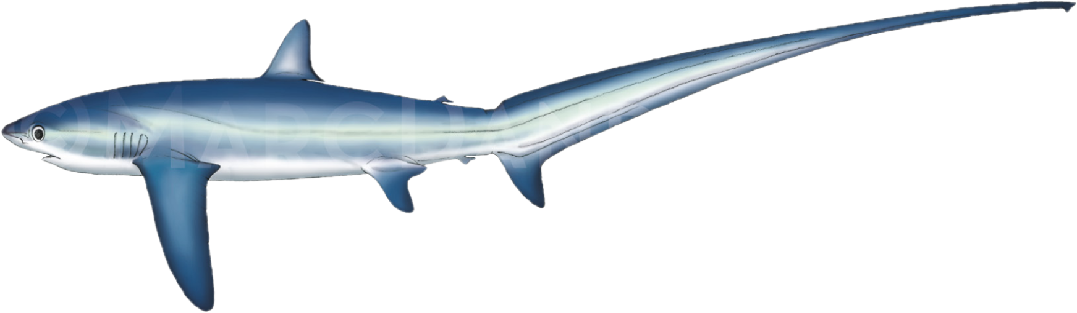 | Alopias superciliosus (Bigeye Thresher)  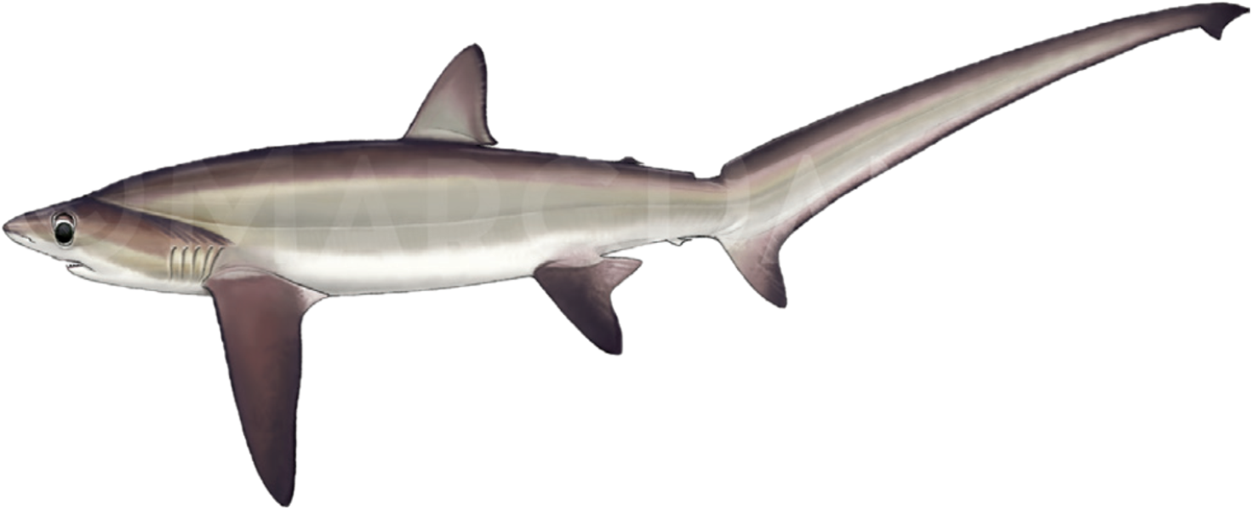
Alopias vulpinus (Common Thresher)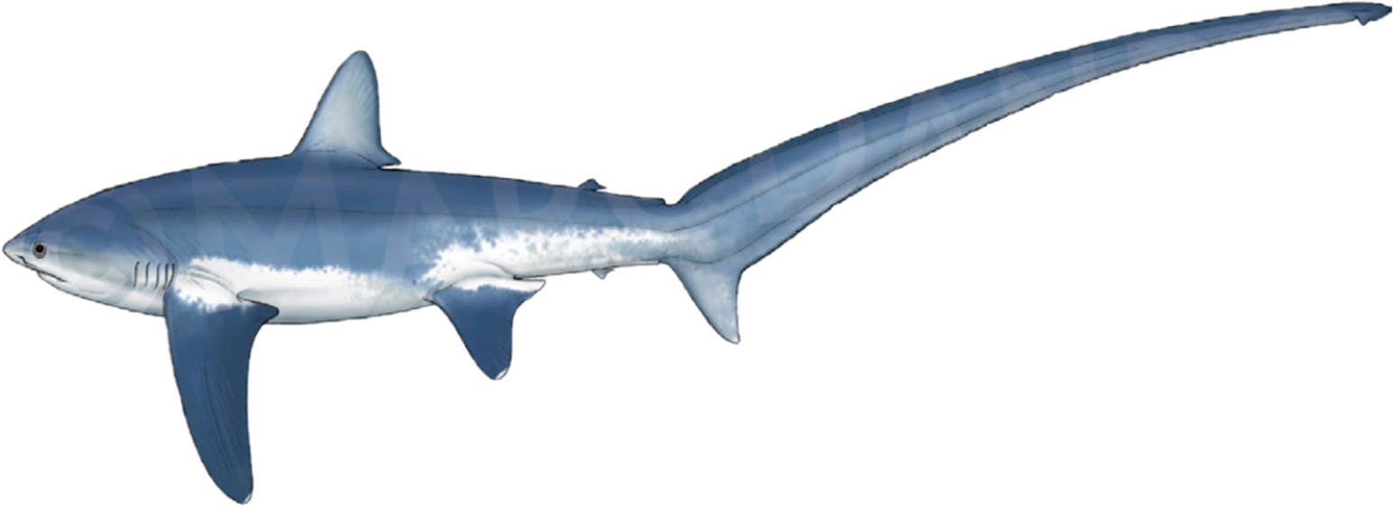 | Illustrations by Marc Dando

2. Overview

The bigeye thresher (Alopias superciliosus), the common thresher (Alopias vulpinus), and the pelagic thresher (Alopias pelagicus) are migratory, transboundary species facing a high risk of extinction globally. Back in 2018, assessments conducted by the IUCN Red List of Threatened Species categorised A. pelagicus as globally Endangered, and A. superciliosus and A. vulpinus as Vulnerable globally. In all 3 cases, they were documented with decreasing population trends.

Alopias species are large, highly migratory oceanic and coastal sharks found worldwide in tropical and temperate seas. Their biological characteristics make them exceptionally vulnerable to overexploitation. They all exhibit particularly low productivity and growth rates, including late sexual maturity and long gestation periods. This means they have a high susceptibility to anthropogenic pressures, whether as target or bycatch species, and are slow to recover. Alopias are the family at the highest risk of extinction of all pelagic sharks.

They are caught and killed in both targeted and bycatch fisheries in domestic waters and the high seas globally. This catch is largely unmanaged, allowing for severe overexploitation. The fins of Alopias species are a highly valued component of the global shark fin trade, which resulted in their listing on CITES Appendix II in 2016. A comprehensive study of the trade in 2018-2019 identified thresher fins as a significant component of the Hong Kong market, accounting for approximately 1% of the sharks traded.

Despite non-retention measures by some RFMO’s and their listing on CITES, their populations continue to decline. A listing on Appendix I of CMS is necessary to afford these species the highest level of protection under the Convention. The current threats have brought these species to a critical state, where unfavourable conservation status and international cooperation alone are no longer sufficient to secure their survival. An Appendix I listing would mandate that all Range States strictly protect these species by prohibiting the taking of individuals and managing all threats, including the international trade in their products. This action is critical to prevent their extinction.

3 Migrations

3.1 Kinds of movement, distance, the cyclical and predicable nature of the migration

Family Alopiidae is listed in Annex 1 (Highly Migratory Species) of the UN Convention on the Law of the Sea (UNCLOS) due to their regular, cyclical and predictable migrations across international boundaries. The CMS Secretariat commissioned report on the Review of Migratory Chondrichthyan Fishes noted that their migrations are not well studied, but that all Alopias spp. are likely migratory within at least parts of their range (CMS Technical Series No. 15, 2007), while the latter CMS report on The Conservation Status of Migratory Sharks notes that thresher sharks are highly migratory species (Fowler, 2014).

Data from tagged A. superciliosus showed them moving from the Northeast coast of the US to the Gulf of Mexico; a straight-line distance of 2,767 km (1,719 miles, Weng and Block 2004), while another crossed international borders in Central America (Kohin et al. 2006). Another study that tagged 12 A. superciliosus demonstrated their ability for significant horizontal movements, with mean displacements being 1,235 ± 235 km (range = 733− 1,523km) over just a 30-day period (Aalbers et al., 2021). Tag and recapture studies have recorded movements from the US EEZ to the high seas and Central American State EEZs (Kohler et al. 1998). A. vulpinus is noted as a highly migratory species, with seasonal migrations taking place annually and studies demonstrating that its range in the northeastern Pacific extends from California (USA), well into Mexican waters (Cartamil et al. 2010). Research on A. pelagicus have indicated that this species migrates between Central America and U.S. waters in the Gulf of California (Cartamil et al., 2010; Cartamil et al., 2016; Kinney et al., 2020), with genetic studies of A. pelagicus indicating that there is gene flow between populations in Mexico and Ecuador, and possible population links as far as China (Taiwan, Province of China) waters (Trejo 2004).

3.2 Proportion of the population migrating, and why that is a significant proportion

There is no information on global populations for Alopias spp., and therefore proportions of the population that migrates cannot be determined. However, A. pelagicus and A. superciliosus are highly oceanic, with most of the population making seasonal or long-distance migrations between offshore and coastal habitats (Coelho et al. 2015; Shidqi et al. 2024), while A. vulpinus (common thresher) exhibits partial migration: some individuals stay resident in productive coastal upwelling zones, while a substantial proportion (estimates range 50–70% depending on stock and season) migrate over hundreds to thousands of kilometers (Cartamil et al 2011).

4.Biological data (other than migration)

4.1 Distribution (current and historical)

These highly migratory oceanic and coastal species are found nearly worldwide in tropical and temperate seas.

A. superciliosus is circumglobal in distribution and occurs in tropical and temperate seas. Ongoing analysis has indicated no structuring of populations of A. superciliosus within the Pacific Ocean, but significant genetic divergence between Atlantic and Indo-Pacific populations (Trejo 2005). The existence of separate Indian Ocean and Pacific Ocean stocks is as yet unconfirmed.

A. vulpinus occurs worldwide in tropical to cold-temperate seas (Last and Stevens 2009, Ebert et al. 2013) but is more common in temperate waters (Compagno 2001) and most abundant in waters up to 40 or 50 miles offshore (Strasburg 1958; Gubanov 1972; Moreno et al. 1989; Bedford 1992). Occurrences of A. vulpinus in the equatorial and northern tropical Indian Ocean could be misidentification with A. pelagicus (Rigby et al., 2022). In the Northeast Atlantic, A. vulpinus has been recorded from Norway to the Mediterranean and Black Seas, and off Madeira and the Azores, with juveniles caught in UK waters in the English Channel and southern North Sea (Ellis 2004).

A. pelagicus is found in tropical to subtropical Indo-Pacific oceanic waters (Rigby et al., 2019a). This truly oceanic species is documented throughout the Indo-Pacific, Australasia region north to Japan, and the Pacific coast of Mexico and northern South America. It has not been recorded in the Atlantic Ocean (Compagno 1984). Few data are available for A. pelagicus throughout its epipelagic range. It is not known whether Indian and Pacific Ocean populations are isolated although it is considered likely that this species migrates between Central America and the Gulf of California.

Figure 2a - Global distribution of Alopias pelagicus:
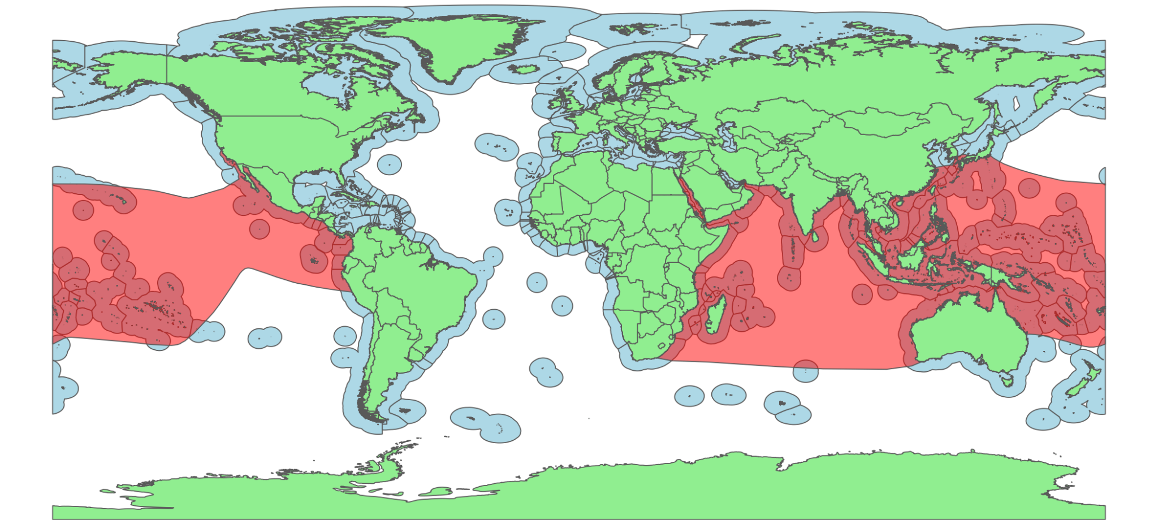

Figure 2b Global distribution of Alopias vulpinus
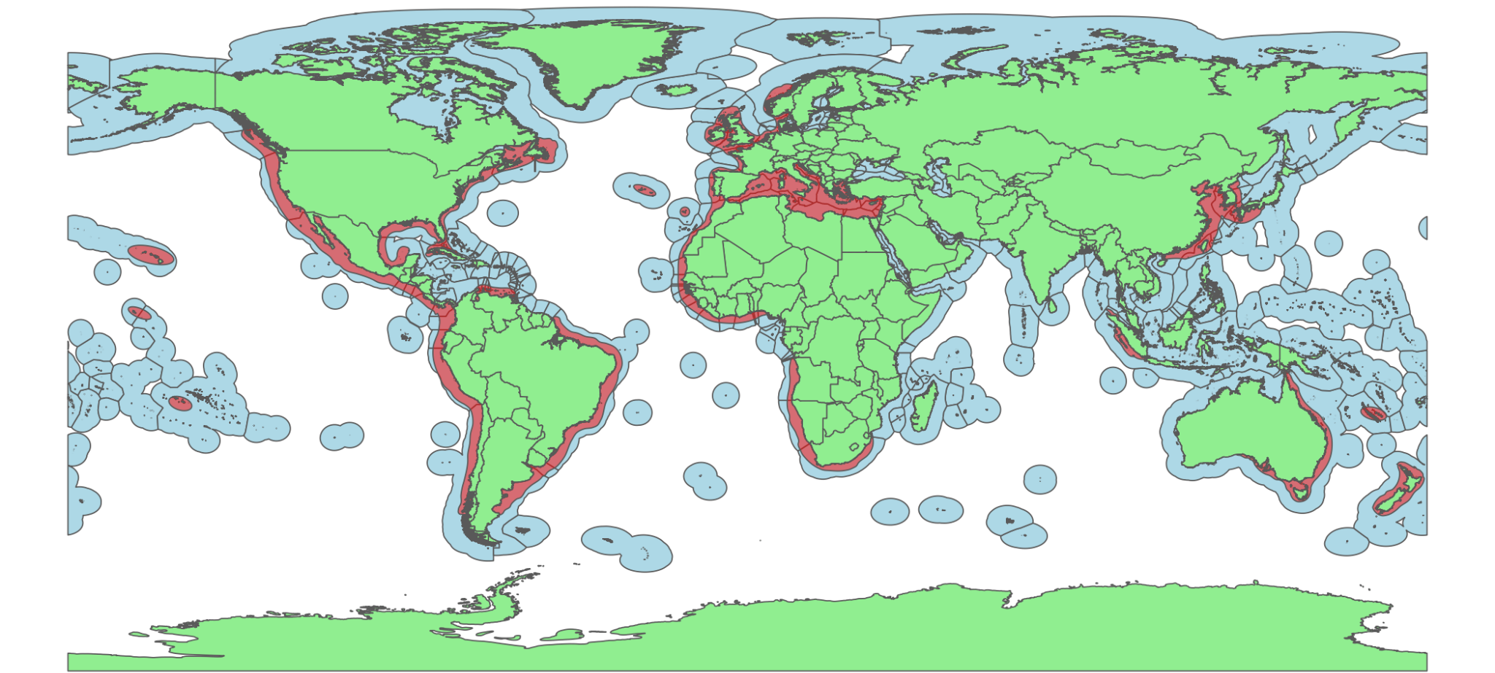
Figure 2c - Global distribution of Alopias superciliosus:
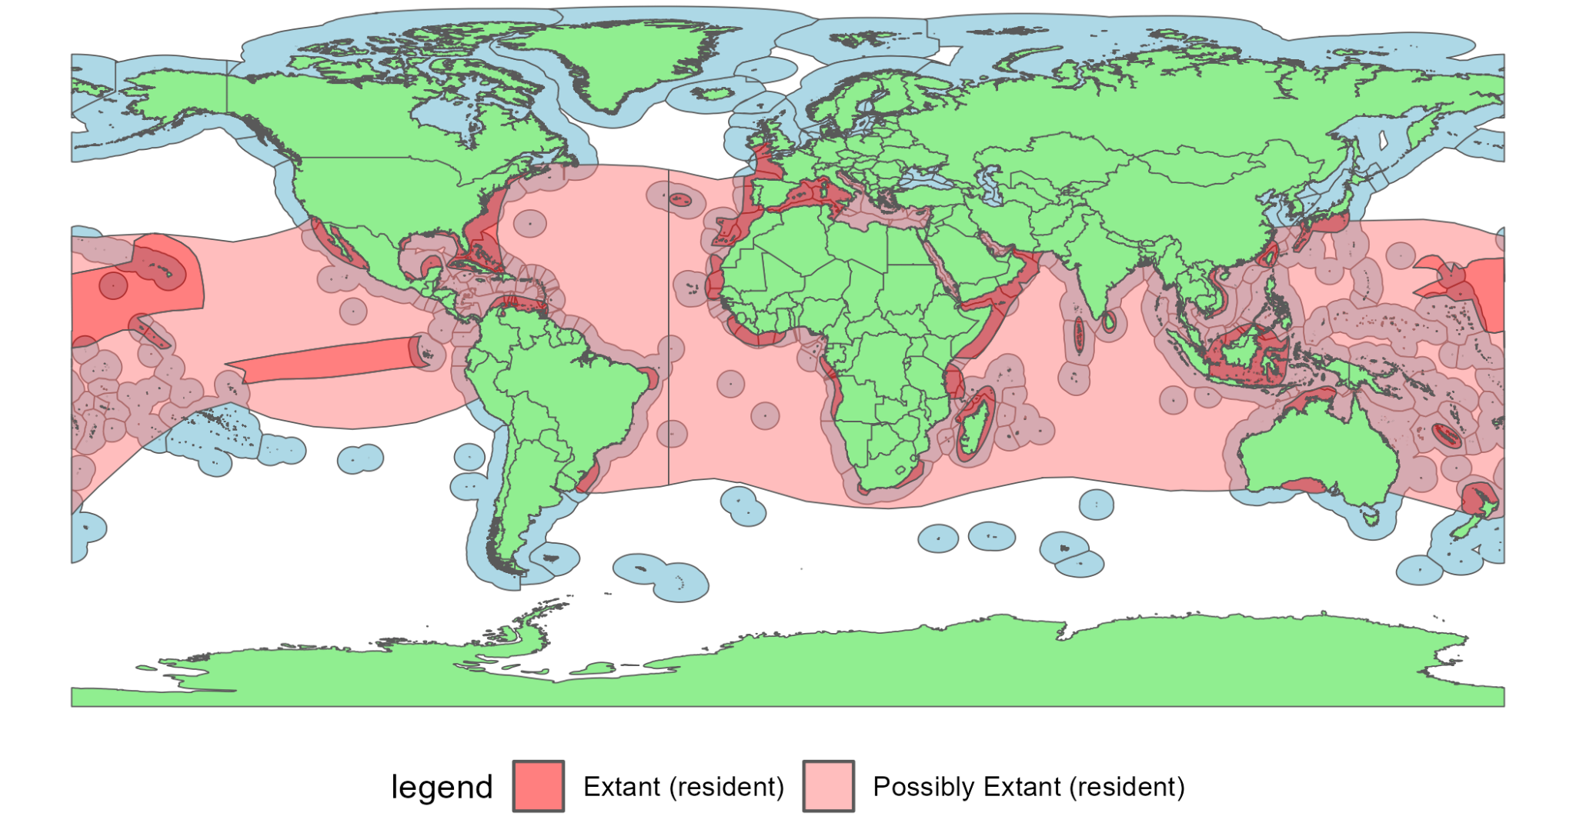

Fig. 2a-c; World distribution maps for thresher sharks (data from IUCN Red List).

4.2 Population (estimates and trends)

The thresher shark family is among the most vulnerable of all pelagic shark species to any level of fisheries mortality, whether as a target or bycatch/incidental capture species. Since threshers are typically identified at family level only, there are no data for population size, however there are some trend data for the family and species, largely compiled by the IUCN Red List global assessments.

Worldwide, the Alopias species complex has declined in almost every area they are found. A recent study estimates that combined catches of the three Alopias species average approximately 33,200 tons per year, with annual totals peaking at over 70,000 tons (MacNeil et al. 2025, in review). The proportion of thresher shark fins in the Hong Kong shark fin market, a more accurately recorded data source, has also declined in a period of three years 2019-2021 (Cardenosa et al. 2024). A. superciliosus, having the highest intrinsic biological vulnerability to overfishing of all the threshers, is likely the most vulnerable of the group.

Genetic results for A. pelagicus indicate some structuring between Eastern and Western Pacific, but it is unknown if there is any genetic structure between Indian and Pacific Oceans (Trejo 2005), while A. superciliosus and A. vulpinus indicate one global population, with some genetic structuring between the Northwest Atlantic and the Pacific Oceans (Trejo 2005, Morales et al. 2018).

Table 1: Population declines for Alopias spp.

Ocean/Sea | Estimated thresher stock decline | Reference
Atlantic | 83.1% over three generation lengths (55.5 years) for A. superciliocus in the Northwest Atlantic.  97% over three generation lengths (76.5 years) for A. vulpinus in the Northwest Atlantic.  97% between 2002 and 2005 for A. vulpinus in the Southwest Atlantic. | Rigby et al., 2019b,  Rigby et al., 2019c
Mediterranean | 99.9% since the early 19th century for A. vulpinus in the Mediterranean Sea. | Rigby et al., 2019c
Indian | 89% over three generation lengths (55.5 years) for A. pelagicus.  91.8% over three generation lengths (55.5 years) for A. superciliosus. | Rigby et al., 2019a,  Rigby et al., 2019b
Pacific | 71.5% over three generation lengths (55.5 years) for A. pelagicus and A. superciliosus in the Western-Central Pacific, as A. vulpinus is rarely recorded in this region. | Rigby et al., 2019a
Global | 77-99% decline in proportion of threshers in the Hong Kong shark fin market over a 10-15 year period  74.5%, with the highest probability of >80% reduction over three generation lengths (55.5 years) for A. pelagicus.  36.5% over three generation lengths (55.5 years) for A. superciliousus, noting that data for the Pacific was only from Hawaii (documenting a population increase), which is unlikely to be representative of the entire Pacific. Therefore, this figure is likely an under-represenation of true trends.  47% overall median population decline for A. vulpinus, noting that the (increasing) trend for the Eastern North Pacific are unlikely to be representative of the entire Pacific. Therefore, this figure is likely an under-represenation of true trends. | Fields et al., 2018  Rigby et al., 2019a,  Rigby et al., 2019b,  Rigby et al., 2019c

Atlantic trends
Assessments by the IUCN (Rigby et al., 2019b) for A. superciliosus from relative abundance observer time-series from the United States pelagic longline fishery for 1992–2013 indicated that the abundance in the Northwest Atlantic had stabilized, while noting that fishing pressure had been present for two decades prior to 1992 and that the abundance had likely stabilized at lower abundance than unexploited biomass (Young et al. 2016). Observed historical declines in the Northwest Atlantic region from 1986 to 2000 suggest an 80% decrease for A. superciliosus and A. vulpinus, validating that the stabilised population is likely a depleted one (Baum et al. 2003; Amorim et al. 2009; Goldman et al. 2013; Reardon et al. 2009). The IUCN trend analysis of the time-series for 1992–2013 (22 years) revealed annual rates of reduction of 3.1%, consistent with an estimated median reduction of 83.1% over three generation lengths (55.5 years), with the highest probability of >80% reduction over three generation lengths. Although reported to have stabilized, there was an annual rate of reduction in the time-series and this has produced a high reduction when extrapolated beyond the length of the data time-series to three generation lengths.

In the South Atlantic, CPUE data from a longline fleet indicated a generally decreasing trend from 1971 to 2001 for A. superciliocus (Mancini 2005), however because the data were not considered robust due to the low catch rates (R. Barreto unpubl. data), they were not analysed over three generations by the IUCN. An Ecological Risk Assessment (ERA) of pelagic sharks in Atlantic pelagic longline fisheries identified A. superciliosus as one of the shark species most at risk from overexploitation in the Atlantic, following six decades of incidental and targeted fishing Cortés et al. (2012). A publication from 2007 highlighted a 63% decline for A. superciliosus and A. vulpinus in the western central Atlantic since 1986, which has likely declined further given continued fishing pressure (Cortes et al., 2007). Subsequent assessments and regional analyses (NOAA SAFE reports, 2020–2024; Kinney et al., 2020) indicate that populations have remained depleted and some indices have stabilised at low levels.
Similar to A. superciliocus in the Northwest Atlantic, the IUCN assessments for A. vulpinus (Rigby et al., 2019c) show declines of 97% in the Northwest Atlantic, despite the population reported to have stabilised. The trend analysis of the 1992–2013 (22 years) time-series revealed annual rates of reduction of 4.6%, consistent with an estimated median reduction of 97.0% over three generation lengths (76.5 years), with the highest probability of >80% reduction over three generation lengths. Although reported to have stabilized, the 4.6% annual rate of reduction in the time-series produced a high reduction when extrapolated beyond the length of the data time-series to three generation lengths.

And in the Southwest Atlantic, CPUE data for A. vulpinus show declines of 97% between 2002 and 2005 (Berrondo et al. 2006).

Mediterranean trends
In the Mediterranean Sea, nine time-series of abundance indices from commercial and recreational fishery landings, scientific surveys, and sighting records were compiled to reconstruct long-term population trends for the northwestern Mediterranean Sea. These showed an average instantaneous rate of decline in abundance of -0.11 (time range 108 years) and biomass of -0.10 (time range 108 years), which equates to an estimated decline of 99.9% in abundance and biomass since the early 19th century (Ferretti et al. 2008).

Indian Ocean trends
The IUCN review (Rigby et al., 2019a) for A. pelagicus in the Indian Ocean for nominal CPUE from 1967-1987 (21 years) suggested an annual rate of decline of approximately 1% per year from 0.35 caught per 1,000 hooks to <0.1 in 1987 (Romanov et al. 2006, E. Romanov unpubl. data). The trend analysis of these data over three generation lengths (55.5 years) revealed annual rates of reduction of 3.8%, consistent with an estimated median reduction of 89% with the highest probability of >80% reduction over three generation lengths.

Data for A. superciliosus (Rigby et al., 2019b) nominal CPUE spanning 1966–1986 (aggregated with A. pelagicus) in the Indian Ocean suggested a decline of approximately 1% per year from 0.35 caught per 1,000 hooks to 0.1 in 1987 (Romanov et al. 2006, E. Romanov unpubl. data). Trend analysis of this data for 1966–1986 (21 years) revealed annual rates of reduction of 4.4%, consistent with a median reduction of 91.8% over three generation lengths (55.5 years), with highest probability of >80% reduction over three generation lengths.

A review of fisheries in the Indian Ocean concluded that thresher sharks in this region are overutilized (NOAA 2016). In Sri Lanka, thresher sharks played an important role historically in both onshore and offshore fisheries, making up nearly 20% of total shark catch by the Sri Lankan fleet in 1994 (Williams, 1995; Dayaratne et al. 1996). The catch comprised of A. pelagicus and A. superciliosus, with the latter being the second most abundant shark caught in Sri Lankan fisheries (Jayathilaka & Maldeniya 2015). However Sri Lankan catches declined by over 70% in subsequent years, leading to concerns over the state of thresher shark populations. Despite national regulations in place, no scientific data is available on current status.

Pacific Ocean trends
Analysis by the IUCN (Rigby et al., 2019a) of observer data from the WCPFC (Western Central Pacific Fisheries Commission) Alopias species-complex standardized CPUE for 1996–2014 (19 years) helps represent catches from the Pacific (Rice et al. 2015). These likely comprise A. pelagicus and A. superciliosus, as A. vulpinus is rarely recorded in the Pacific; but no data is available on the proportions between these two. The CPUE indicated a decline, particularly from 2010 to 2014 and the IUCN trend analysis of the WCFPC standardized CPUE for 1996–2014 (19 years) revealed annual rates of reduction of 2.1%, consistent with an estimated median reduction of 71.5% over three generation lengths (55.5 years), with the highest probability of 50–79% reduction over three generation lengths (Rigby et al., 2019a). From the same region, a demographic analysis off Taiwan reported a projected stock reduction of 34.3% over 20 years (2007–2027), and that the A. pelagicus stock is overexploited (Tsai et al. 2010). This conclusion was consistent with a spawning-per-recruit analyses off Taiwan that also found it to be overexploited (Liu et al. 2006).

A Pacific-wide sustainability risk assessment for A. superciliosus reported low fishing mortality since 2000 in Pacific pelagic longline fisheries, yet fishing mortality exceeded the maximum impact sustainable threshold of the species in some years (Fu et al. 2018). The trend analysis of the United States Hawaii longline observer data CPUE for 1995–2014 (20 years) revealed annual rates of increase of 0.4%, consistent with a median increase of 24.0% over three generation lengths (55.5 years), with the highest probability of an increase over three generation lengths. These CPUE data are from a large area around Hawaii, but they may not be representative of the entire Pacific region.

For A. vulpinus, nominal logbook CPUE data from the California (United States west coast) swordfish/shark drift gillnet fishery for 1981–2013 (33 years) was used as it considered the most important west coast commercial fishery for this species (Teo et al. 2016). It shows that A. vulpinus stock declined steeply in the early 1980s, then stabilized in the mid-1980s after regulations were implemented, and then increased through to ~2000 before stabilizing again, with the current stock considered close to unexploited level and unlikely to be overfished (Teo et al. 2016). The trend analysis of the CPUE for 1981–2013 (33 years) revealed annual rates of increase of 0.6%, consistent with an estimated median increase of 18.7% over three generation lengths (76.5 years), with the highest probability of an increase over three generation lengths. However, the increasing trend in the Eastern North Pacific is from a managed fishery and may not be representative of trends in the wider Pacific.

A 2013 study notes that the stock of A. pelagicus in the western and central Pacific had reduced by 34.3% over the past 20 years (slightly more than one generation) and that the stock is under high fishing pressure and overexploited (Liu S-YV 2013). Furthermore, a significant decrease in the median size of thresher sharks caught in the western and central Pacific has been noted in recent years, as well as a decrease in nominal catch rates in portions of the western and central Pacific (Clarke et al., 2011).

The Western and Central Pacific Fisheries Commission (WCPFC) released a Pacific-wide stock assessment report for the bigeye thresher shark in September 2016, which found that, across various scenarios, some estimated fishing mortality rates exceeded indicative biological reference points. This means that there was a high probability that bigeye thresher sharks were being overfished in parts of the Pacific.

4.3 Habitat (short description and trends)

A. pelagicus is less widely distributed than A. superciliosus and A. vulpinus being found only in the Pacific and Indian Oceans. It is believed to be highly migratory and is epipelagic and mesopelagic from the surface to depths of 300 m (Weigmann 2016). Factors such as temperature and oceanic currents influence greatly its distribution, for example it is found near the Equator in winter, but not in summer (Dingerkus 1987).

Alopias superciliosus is found in all warm and temperate areas of the world’s oceans on the continental shelf, epipelagic and mesopelagic zones, and also in shallow coastal waters (Stillwell and Casey 1976; Compagno 2001; Nakano et al. 2003; Weng and Block 2004, Rigby et al., 2019b). This species is one of the few sharks to exhibit diel vertical migratory behaviour, generally moving to shallow depths at night to feed (<100 m) and inhabiting deeper waters (between 400 to 600m) during the day (Nakano et al. 2003; Weng and Block 2004; Stevens et al. 2010). They occur in surface temperatures of 16–25 °C (61–77 °F), but have been tracked as far down as 723m (2,372 ft), where temperatures are around 5°C (41 °F) (Nakano et al. 2003).

A. vulpinus is also found in all warm and temperate areas of the world’s oceans with a noted tolerance for colder waters (Moreno et al. 1989). Whilst found in both coastal and oceanic waters, it is most abundant 40-50 miles offshore (Moreno et al. 1989: Bedford 1992), ranging between surface waters and 366m depth (Compagno 1984).

Overall, critical habitats and the threats they face are still largely unknown for all Alopias spp.. Alopias spp. nursery grounds have been identified in some inshore temperate regions in the Adriatic Sea, northeastern Atlantic, western Mediterranean (Alboran Sea), southern California, and South Africa waters (Moreno et al. 1989; Compagno 2001; Notabartolo Di Sciara and Bianchi 1998). A nursery area for A. superciliosus is suspected in the waters off the southwestern Iberian Peninsula (Moreno and Moron 1992). Also, the same authors observed aggregations of gravid females of A. vulpinus in the Strait of Gibraltar. None of these possible key habitat areas have any specific protection measures for Alopias spp.

The recent Important Shark and Ray Areas (ISRA) project documented key sites for threshers in the Azores (A. superciliosus); the Northern Humboldt Current and Transition Zone for common and pelagic threshers; the Cocos–Galápagos corridor, Galápagos Platform, and Malpelo Ridge for pelagic thresher movements; and Fuvahmulah Atoll, Monad and Kimud Shoals, Pantar Strait, and Lombok Strait as reproductive or cleaning grounds. Additional threatened habitats were noted in Derawan Islands, Southern Hawaii, and the Pemba Channel, with Solano Bay also recognized as a feeding ground. Collectively, these sites underscore the ecological importance and vulnerability of thresher sharks given threats in many of these critical areas.

4.4 Biological characteristics

Alopias pelagicus is the smallest of the thresher sharks, reaching a maximum size of 365 cm total length (TL). Males and females mature at 250–300 cm TL (Ebert et al. 2013). Reproduction is lecithotrophic viviparous with oophagy, and a litter size of only two, very large (158–190 cm TL) pups and the reproductive cycle is likely annual (Liu et al. 1999). The potential annual rate of population increase under sustainable fishing is thought to be very low and has been estimated at 2–4% (Smith et al. 1998), or 0.033 (i.e. 3.3%) (Dulvy et al. 2008). Female age-at-maturity varies from 9 to 13.2 years and maximum age from 24 to 28 years in Taiwan and Indonesia, respectively (Liu et al. 1999, Chen and Yuan 2006, Drew et al. 2015); generation length is therefore 16.5 years in Taiwan, and 20.6 years in Indonesia (average of 18.5 years).

Alopias superciliosus reaches a maximum size of 484 cm total length (TL) (Compagno 2001). Males mature at 245–300 cm TL and females at 282–355 cm TL (Chen et al. 1997, Liu et al. 1998, Moreno and Moron 1992, Stillwelli and Casey 1976, Varghese et al. 2017). Size at birth is 64–140 cm TL (Golani 1996, Chen et al. 1997, Bauchot 1987). The gestation period is 12 months with average litter sizes 2–4 pups per litter (usually two) and the reproductive cycle is likely annual (Compagno 2001, Varghese et al. 2017). It has the lowest rate of annual increase of the thresher sharks, estimated at 1.6% under sustainable exploitation (Smith et al. 2008), or 0.002–0.009 (Cortés 2008, Dulvy et al. 2008). Observed female age-at-maturity is 12–13 years and maximum age 20 years in Taiwan, Northwest Pacific (Liu et al. 1998). Female age-at-maturity is estimated at 9 years and maximum age at 28 years, with a generation length of 18.5 years (Chen and Yuan 2006).

Alopias vulpinus is the largest of the thresher sharks, reaching a maximum size of 573 cm total length (TL), and possibly 635 cm TL. Males mature at 260–420 cm TL, females at 260–465 cm TL, and size at birth is 120–150 cm TL (Ebert et al. 2013, Young et al. 2016). Reproduction is aplacental viviparous oophagous with litter sizes of 2–6 pups and an annual or biennial reproductive cycle (Gubanov 1978, Cailliet and Bedford 1983, Ebert et al. 2013, Gervelis and Natanson 2013). The potential annual rate of population increase under sustainable fishing is the highest of the thresher sharks, estimated at 0.254 (Dulvy et al. 2008). Female age at maturity is estimated at 13 years and maximum age is 38 years based on bomb-radiocarbon validated ages from the Northwest Atlantic (Natanson et al. 2016). In the Eastern Central Pacific, age-at-maturity estimates are much younger, with female age-at-maturity at 5.3 years and maximum age at 22 years off California (Smith et al. 2008). It is possible these are regional differences in life history parameters, but adopting a precautionary approach, the generation length is 25.5 years.

4.5 Role of the taxon in its ecosystem

The three species of Alopias are mid- to top-level predators that regulate prey populations, connect ecosystems through their migratory and feeding behavior, and serve as important indicators of pelagic ecosystem health. Their decline could disrupt trophic balance, reduce biodiversity resilience, and diminish ecosystem services such as sustainable fisheries and ecotourism.

5. Conservation status and threats

5.1 IUCN Red List Assessment (if available)

Assessments conducted in 2018 categorised A. pelagicus as globally Endangered (Rigby et al., 2019a), and A. superciliosus (Rigby et al., 2019b) and A. vulpinus (Rigby et al., 2022) as globally Vulnerable. In all 3 cases, they were documented with decreasing population trends.
Regional Red List assessments are: Endangered in European and Mediterranean waters, the northwest Atlantic and western central Atlantic; Vulnerable in the Indo-west Pacific, eastern and western central Pacific; and Near Threatened in the southwest Atlantic.

5.2 Equivalent information relevant to conservation status assessment

The Living Planet Index (LPI), which compiles 57 abundance time-series datasets dating back to 1970, reports that thresher shark (Alopias spp.) populations have declined by 71%, driven largely by an 18-fold increase in fishing pressure.

5.3 Threats to the population (factors, intensity)

The biology and very low intrinsic reproductive rate of all thresher sharks, Alopias spp., makes them among the most vulnerable of all shark species to fishing mortality worldwide, whether as a target or bycatch species, and threshers are the family at highest risk of extinction of all pelagic sharks (Oldfield et al 2012, Dulvy et al 2014).

The principal threat to Alopias spp. is unsustainable mortality in target and bycatch fisheries. They are frequently caught by coastal and offshore longlines (sometimes hooked by the tail) and gillnet fisheries, most of which are unregulated and unreported (Dulvy et al. 2008). Ghost fishing, purse seines, trammel nets, and bottom trawls are also likely threats (Camhi et al. 2008, Martinez-Ortiz et al. 2015, Parton et al. 2019, Temple et al. 2019). The species is highly valued by big-game recreational fishers, and although many practice catch and release, recreational fishing could be a threat due to post-release mortality. Data for A. vulpinus show mortality of 78% for tail-hooked and 0% for mouth-hooked animals (i.e. all mouth-hooked animals survived) (Camhi et al. 2008, Sepulveda et al. 2015). For commercial fisheries, at-vessel hooking mortality (i.e., dead on haulback) for A. superciliosus is between 49-68% (Coelho et al. 2011, IOTC 2016). The post release mortality rate of threshers released alive from pelagic fisheries is unknown, but probably high (IOTC 2015). Hutchinson et al. (2021) found that the survival of discarded bigeye threshers in Pacific longline fisheries depends strongly on handling and gear type, with sharks in good condition and free of trailing gear showing higher survival. This indicates that while post-release mortality can be reduced through better practices, it remains high under poor conditions.

Demand for their meat and large valuable fins is a significant driver of mortality in many of these target and bycatch fisheries (Clarke et al. 2006a, Clarke et al. 2006b, Dent and Clarke 2015, Fields et al. 2018). The quantity of thresher shark fins identified in Hong Kong fin markets in the early 2000s equated to between 350,000 and 3.9 million individual thresher sharks, or a biomass of 12,000 - 85,000 tonnes being killed and traded per year (Clarke et al. 2006 b). At that time, global catches of less than 4,000 t of threshers were being reported to FAO, or 5%–40% of animals entering trade. The most recent reported global thresher shark catches were around 25,058 t in 2020 and 24,190 t in 2021 (FishStat 2023), demonstrating the high level of unreporting in earlier years, while the percentage of thresher sharks in trade have actually declined significantly, to account for some 0.03-0.53% of the sharks in the Hong Kong market in 2015 (Fields, submitted). Sampling in 2015-2017 showed that thresher sharks (nearly all A. pelagicus) was the 9th most encountered fin in trade (Cardeñosa et al., 2020). In 2020, Hong Kong authorities seized 26 tons of shark fins, estimated to come from ~31,000 thresher sharks. Estimates by MacNeil et al. in review for Alopias spp indicate that average annual global landings during 2012 to 2023 were around 38,503 t, ranging between 7,610 t and 141,210 tons, and reconfirm that they are among the most underreported species (landings by volume) in pelagic fisheries.

RFMO’s across their range have recognised that overfishing is the primary threat affecting these species. The International Council for the Exploration of the Sea (ICES) (2007) noted that the management of A. vulpinus in the Atlantic was of concern due to the lack of management measures in place. Parallels can be drawn with the USA Pacific targeted fishery which, also lacking in management measures, experienced rapid declines and eventual closure in the 1990’s as a direct result of overfishing (Hanan et al. 1993). Cortés et al. (2010) undertook an Ecological Risk Assessment (ERA) of pelagic sharks in Atlantic pelagic longline fisheries, which identified A. superciliosus as one of the shark species most at risk from overexploitation in the Atlantic. Studies in the Southeastern United States also show severe declines in the species, with decreases in Catch Per Unit Effort (CPUE) indicating that the population of A. superciliosus has declined by 70% from historic levels (Beerkircher et al. 2002). However, action to prevent further mortality has been insufficient. Despite ICCAT prohibiting the retention of thresher sharks, reported catches of thresher sharks have continued to rise in the Atlantic.

Similarly, an Ecological Risk Assessment (ERA) by the IOTC of pelagic longline fishing pressure (IOTC Scientific Committee 2013) concluded that A. pelagicus and A. superciliosus had very high vulnerability rankings (No. 2 and No. 3 respectively) because they are two of the least productive shark species, and highly susceptible to capture in longline fisheries (and have a high hooking mortality as noted in the 2024 IOTC summary for the species). They also noted that the available evidence indicates considerable risk to the status of the Indian Ocean Alopias spp. stocks at current effort levels. As of 2024, the IOTC Working Party on Ecosystems and Bycatch (WPEB) reviewed the status of the bigeye thresher, concluding that its stock status was uncertain. They considered that maintaining or increasing effort, with associated fishing mortality, can result in declines in biomass, productivity and CPUE, and that concentration of longline fishing effort into the southern and eastern Indian Ocean may result in localised depletion. They recommended that the prohibition on retention be maintained.

Like many sharks, catches of Alopias spp. are significantly under-reported globally (Clarke et al. 2006; Worm et al. 2013; MacNeil et al., 2025), and species-specific data on thresher shark population trends are scarce. The FAO has concluded that, due to this lack of data, these species should be considered "fully exploited or overexploited globally" (Maguire et al. 2006). A 2014 assessment by TRAFFIC for UK DEFRA found Alopias spp. to be in the highest risk category with regard to the level of management in place and their intrinsic vulnerability (Lack et al 2014).

All three thresher species were estimated to make up 13% of the total shark and ray bycatch of the tuna longline industry around 2010, of which 98.9% were finned and then discarded (Bromhead et al., 2012). Work by TRAFFIC in 2014 found Alopias spp to be in the highest risk category with regard to the level of management in place and their intrinsic vulnerability (Lack, M. et al 2014).

Noting that the entire Alopias genus has low intrinsic rebound potential from even small levels of exploitation due to their slow life history characteristics, their now heavily depleted populations with continuing threats as a result of their ranges overlapping with many largely unregulated and unreported gillnet and longline fisheries, ghost fishing, and habitat threats, exacerbate their situation.

The demand for shark fins and meat drives this overexploitation of Alopias spp. However, other threats such as climate change impacting the ranges of pelagic sharks like threshers, combined with high levels of ecosystem contaminants (PCBs, organo-chlorines and heavy metals) that bio-accumulate and are bio-magnified at high trophic levels likely also impact these species. Habitat loss, especially in their nursery areas, is also a possible contributing threat.

5.4 Threats connected especially with migrations

There is no specific protection for these species across their critical high seas or nearshore nursery habitats or migratory routes. This is a significant and ongoing threat to all Alopias spp. given their wide ranging, migratory, and largely pelagic nature, and the fact that the major threat to their populations is unregulated catch by high seas and coastal fisheries operating multiple gear types, particularly longlines and gillnets. These fisheries, extracting an unsustainable proportion of threshers will be impacting their migratory potential and impeding transitions between coastal and pelagic waters.

Coastal development, pollution, and tourism can disrupt critical habitats and indirectly affect migration success (e.g., Monad Shaol, Philippines). Climate change, causing shifts in ocean temperatures, acidity, currents, and productivity can force sharks to modify migration routes.

5.5 National and international utilization

Alopias are fished for their meat, fins, liver oil, and skin (Compagno 2001, Jabado et al. 2015). There is also small-scale demand for their cartilage, and teeth and jaws for curios. Catch data for most sharks is incomplete due to unreporting and unregulated fisheries, while under-reporting of catches is also occurring (MacNeil et al., 2025). This makes it challenging to quantify such trends.

Alopias spp. are mostly utilised nationally for their meat, which is preferred over many other species of shark. This is often marketed fresh/chilled or frozen in Europe, North America (including from a target fishery off California), Australia, New Zealand, Japan and Taiwan. In areas where immediate refrigeration or freezing facilities are not available, meat is often salted and dried, smoked, or cooked and processed and either consumed domestically or traded. In East Asia processed forms of shark meat are common. These include production of minced fish products, such as fish balls. In Japan Alopias spp. are marketed frozen, whilst in China the meat is used to produce salted shark meat, canned meat, and shark meatballs (Parry-Jones et al.; 1996). A study from Liu et al., 2013 showed that Alopias spp. are heavily consumed in Taiwan, with 23% of sampled shark products coming from A. pelagicus. The study notes that the stock of A. pelagicus in the region reduced by 34.3% over the past 20 years prior to the study and that the stock is both under high fishing pressure and overexploited. Between 1989 and 2002, pelagic thresher sharks declined from 11.9% of total Taiwanese catch by weight to 3.66% (Liu & Tsai, 2011). In Ecuador, shark meat is an important source of animal protein, especially for communities in the Sierra, Amazon, and coastal areas dependent on artisanal fishing.

Their fins are dried and typically exported (unless there are domestic fin processing facilities). Since data on the international shark product trade are not documented to the species or genus level in the Harmonized Tariff Schedule, there is limited species-specific information on the quantity and/or value of imports or exports. Based on research, the three species collectively accounted for 2–3% in 1991–2001 and 0.5% in 2014, of the fins imported to Hong Kong (Clarke et al. 2006a, Fields et al. 2018). A comprehensive study of the trade in 2018-2019 identified thresher fins as a significant component of the Hong Kong market, accounting for approximately 1% of the sharks traded (Cardeñosa et al., 2024; Dr. Hau Cheuk Yu et al., 2025).

Data reported by CITES Parties (following their Appendix II listing implemented in 2017) is available in Annex 1.

Illegal trade is occuring. The complete extent of illegal trade activities is unknown, because there is very little compliance monitoring and enforcement. However, for example, it is apparent from catch data submitted to FAO that reported Atlantic catches of A. superciloisus increased steeply after the adoption of the ICCAT and GFCM recommendations prohibiting this species, and Indian Ocean catches of all thresher sharks fell only 20% following the IOTC Recommendation. Trade in products from RFMO-managed fisheries in these oceans will have been illegal, and so would trade from other fisheries by CITES Parties without legal acquisition findings (LAFs) or positive non-detriment findings (NDFs). A sudden increase in pre-convention fins reported to CITES trade in 2021 is also suspicious as it is unlikely that fins were stored for 5 years before exporting (see Annex 1). In 2019, a total of 13,054.5 kg of thresher shark fins that had Hong Kong as a final destination were confiscated in Peru, and in the same year, Hong Kong authorities confiscated another 513 kg of thresher shark fins. In May 2020, Hong Kong Customs authorities seized 21,000 kg of pelagic thresher shark fins from two containers coming from Ecuador; the largest shark fin seizure in history (Cardeñosa et al., 2021).

Thresher sharks are also an important recreational sports fishing resource in some countries, including the United States (particularly California), United Kingdom, New Zealand and elsewhere in the Pacific. And A. pelagicus is very valuable for dive tourism in the Philippines.

6. Protection status and species management

6.1 National protection status

Bahamas: Established a shark sanctuary in 2011, outlawing the capture, possession, and sale of sharks and their products throughout its EEZ.

Cook Islands: All commercial shark fishing is prohibited since 2011.

Costa Rica: In May 2021 Costa Rica added thresher sharks to its national list of endangered species (published in La Gaceta N°93, 17/5/2021) and protection under Wildlife Conservation Law restricts extraction and commercialization.

Ecuador: In compliance with its international commitments, the Ecuadorian government is developing specific regulations for the sustainable management of thresher sharks (Alopias pelagicus and A. superciliosus), which are currently being disseminated to the artisanal and industrial fishing sectors. These regulations propose an annual bycatch limit and a minimum catch size to protect juvenile specimens and ensure reproduction. The country recognizes the high biological vulnerability of the Alopias genus and its inclusion in Appendices II of the CMS and CITES, reinforcing its commitment to the conservation and sustainable management of these species, whose capture in Ecuador occurs primarily as incidental catches in artisanal and industrial fisheries.

European Union: Prohibits retaining on board, transhipping or landing any part or whole carcass of bigeye thresher shark (A. superciliosus) caught in any fishery. Also prohibits directed fisheries for any thresher shark species (genus Alopias).

French Polynesia: All commercial shark fishing is prohibited since 2006.

Honduras: Declared its waters a shark sanctuary in 2010, prohibiting the capture and trade of sharks.

Indonesia: While specific protections are limited, a Governor's decree in East Nusa Tenggara province (Dis. Pkl. 188.48/B1. 57/VIII/2022) prohibits the capture and trade of pelagic thresher sharks within that province. Indonesia has also incorporated the IOTC Resolution 10/12 into a Ministerial Regulation to regulate high-seas catches.

Israel: All commercial shark fishing is prohibited since 2005 (enforced since 2008).

Maldives: A complete ban on all shark fishing and the retaining of sharks in any fisheries within its entire Exclusive Economic Zone (EEZ) since 2010.

Marshall Islands: In 2011, the country created the world's largest shark sanctuary, banning all commercial shark fishing within its EEZ.

New Caledonia: All commercial shark fishing is prohibited since 2014.

Palau: A shark sanctuary (2009) that prohibits all commercial shark fishing, finning and possession/trade of sharks/shark parts.

Philippines: Under RA 10654 (2015), the Philippines protects species listed in CITES Appendices (including the thresher sharks), making it unlawful to fish, catch, gather, sell, possess, transport, or export such species unless proper non-detriment findings are in place.

Spain: A Ministerial Order was published on April 22, 2010, and took effect on January 1, 2010. This order prohibits the catch, landing, and commercialization of all thresher sharks.

Sri Lanka: In response to the IOTC resolution, Sri Lanka implemented a national regulation under the Fisheries and Aquatic Resources Act, No. 2 of 1996, published in Gazette 1768/36 on July 27, 2012. This regulation prohibits catching, retaining, transshipping, landing, storing, or selling thresher sharks.

Tokelau: All commercial shark fishing is prohibited since 2011.

6.2 International protection status

All Alopias spp. Were listed on CITES Appendix II in 2016, which came into effect in October 2017 (Japan has a reservation).

In 2014, all thresher shark species were listed on Appendix II of the Convention on Migratory Species (CMS). The species are also covered by the CMS Memorandum of Understanding for Migratory Sharks, which is aimed at facilitating conservation.

The Indian Ocean Tuna Commission (IOTC) acted in response to the reported drops in thresher shark catches throughout the Indian Ocean by prohibiting the retention of thresher sharks (IOTC Resolution 12/09). Similar measures for all thresher sharks are in place by ICCAT (International Commission for the Conservation of Atlantic Tunas) since 2010 (adopted in 2009), which was adopted by GFCM (General Fisheries Commission for the Mediterranean) and extended into the Mediterranean Sea in 2010. WCPFC (Western and Central Pacific Fisheries Commission) have measures in place only for A. superciliosus since 2011 (adopted in 2010).

6.3 Management measures

Austria: Regarding imports to and exports from Austria, all shark species that are included in the CITES Appendices will be treated as if included in Appendix I (2024).

Colombia: Prohibition of all trade in products and derivatives of sharks, marine rays and chimaeras, including export, re-export and import (2023).

Ecuador: Suspended all commercial trade in specimens of sharks and rays listed on CITES Appendix II before CoP19 from Ecuador or with country-of-origin Ecuador (2024).

Several CITES Parties have also suspended all commercial trade of CITES listed species. These include Dominica (2024), Libya (2024), Oman (2024), Guinea (2023), Panama (2023: for all wildlife specimens harvested from the wild (W) for commercial purposes (T)), Sao Tome and Principe (2022), Somalia (2019), India (2018), Djibouti (2018), Liberia (2018), Grenada (2016), Djibouti (2011), and the Philippines (2010).

Quotas under CITES:
A. pelagicus: El Salvador has an export quota of 702 kg for dried fins and 835 kg for dried skin in 2024, while Panama has a 0 quota with an exemption for scientific and law enforcement/judicial/forensic purposes.
A. vulpinus: Congo has an export quota of 200 kg dried fins for 2025, while El Salvador has 26 kg for dried fins and 30 kg for dried skin in 2024, and Panama has a 0 quota.
A. superciliosus: El Salvador has 574 kg for dried fins and 683 kg for dried skin in 2024, and Panama has a 0 quota.

Some countries (Canada, UK, certain states and territories in the US, Bahamas, the Maldives, Marshall Islands, United Arab Emirates, and India) have also prohibited export of all shark fins.

The European Union manages thresher sharks primarily through regulations implementing RFMO (ICCAT and IOTC) measures, and therefore aside from their prohibition of retaining A. superciliosus across all their fisheries, will have limited benefits for the other 2 thresher species outside ICCAT and IOTC areas of competence.

The Atlantic common thresher shark fishery in the US is managed by NOAA Fisheries under the Consolidated Atlantic Highly Migratory Species Fishery Management Plan. This plan requires permits and sets catch limits. The Shark Conservation Act also mandates that all sharks be brought to shore with their fins attached.

6.4 Habitat conservation

Monad Shoal & Gato Island, Malapascua, Philippines: shark and ray sanctuary. It is very small and local and will not cover all habitat use of the species.

Selat Pantar MPA, East Nusa Tenggara (NTT), Indonesia: provincial decree prohibits capture / trade of pelagic threshers in NTT province. A very localised protection that offers limited protection for such migratory species.

The establishment of marine protected areas within EEZs may provide a degree of protection for Alopias and their critical habitats, however, given varying levels of implementation of MPA’s across the world and their migratory nature, it will be insufficient. And there is no protection for critical pelagic high seas habitats, which is highly significant given the highly migratory, pelagic nature of all Alopias spp.

6.5 Population monitoring

Species-specific population monitoring is often lacking as the extremely limited data collected are typically aggregated at higher taxonomic levels.

7. Effects of the proposed amendment

7.1 Anticipated benefits of the amendment

A CMS Appendix I listing would result in national regulations prohibiting the take of these species, which combined with their existing Appendix II listing (encouraging regional collaboration and management), would help reduce mortality of these highly threatened species, enabling species recovery.

All Alopias spp. are in need of urgent conservation action as a result of their conservative life history, vulnerable biology, and significant declines seen in their populations due to anthropogenic fishing pressure. While some national or regional protections are there, they do not extend throughout their entire range, which for migratory species such as these, results in inadequate protection. Existing management is also insufficient to halt ongoing population declines. The Appendix I listing would resolve these problems.

7.2 Potential risks of the amendment

None identified. The CMS Appendix I listing would complement RFMO non-retention measures, strengthen the few national protections aleady in place, and support the CITES Appendix II listing by reducing burden on trade enforcement agencies.

7.3 Intention of the proponent concerning development of an Agreement or
Concerted Action

The proponent intends to support and encourage the development of Concerted Actions to enhance the CMS Appendix I listing.

8. Range States

All three species of thresher shark occur in areas beyond national jurisdiction therefore CMS Article I h) should be considered in determining a Range State:

“A Range State in relation to a particular migratory species means any State […] that exercises jurisdiction over any part of the range of that migratory species, or a State, flag vessels of which are engaged outside national jurisdictional limits in taking that migratory species.”

A range state is therefore considered to be any nation where Alopias spp are present in domestic waters and those fisheries nations operating on the high seas.

a) Pelagic thresher shark (Alopias pelagicus):
American Samoa; Australia; Bangladesh; British Indian Ocean Territory (Chagos Archipelago); Brunei Darussalam; Cambodia; China; Christmas Island; Cocos (Keeling) Islands; Colombia; Comoros; Cook Islands; Costa Rica; Disputed Territory (Spratly Is., Paracel Is.); Djibouti; Ecuador (Ecuador (mainland), Galápagos); Egypt; El Salvador; Eritrea; Fiji; French Polynesia; Guam; Guatemala; Honduras; Hong Kong; India (Andaman Is.); Indonesia; Iran, Islamic Republic of; Japan; Kenya; Kiribati; Korea, Republic of; Macao; Madagascar; Malaysia; Maldives; Marshall Islands; Mauritius; Mayotte; Mexico; Micronesia, Federated States of ; Mozambique; Myanmar; Nauru; New Caledonia; Nicaragua; Niue; Norfolk Island; Northern Mariana Islands; Oman; Pakistan; Palau; Panama; Papua New Guinea; Peru; Philippines; Pitcairn; Réunion; Samoa; Saudi Arabia; Seychelles; Singapore; Solomon Islands; Somalia; South Africa; Sri Lanka; Sudan; Taiwan, Province of China; Tanzania, United Republic of; Thailand; Timor-Leste; Tokelau; Tonga; Tuvalu; United States (Hawaiian Is.); United States Minor Outlying Islands (Johnston I., Howland-Baker Is., Midway Is., US Line Is., Wake Is.); Vanuatu; Viet Nam; Wallis and Futuna; Yemen

b) Bigeye thresher shark (Alopias superciliosus):
Algeria; Angola; Anguilla; Antigua and Barbuda; Aruba; Australia; Bahamas; Barbados; Belize; Bermuda; Bonaire, Sint Eustatius and Saba (Bonaire, Sint Eustatius, Saba); Bosnia and Herzegovina; Brazil; British Indian Ocean Territory (Chagos Archipelago); Brunei Darussalam; Cabo Verde; Cambodia; Canada; Cayman Islands; China; Colombia (Colombia (mainland), Colombian Caribbean Is.); Comoros; Congo; Costa Rica; Cuba; Curaçao; Côte d'Ivoire; Disputed Territory (Paracel Is., Spratly Is.); Dominica; Dominican Republic; Ecuador (Galápagos); El Salvador; Equatorial Guinea (Equatorial Guinea (mainland), Annobón); France (Clipperton I., France (mainland)); French Guiana; Gabon; Gambia; Ghana; Grenada; Guadeloupe; Guatemala; Guinea; Guinea-Bissau; Guyana; Haiti; Honduras; Hong Kong; India (Andaman Is.); Indonesia; Iran, Islamic Republic of; Ireland; Italy; Jamaica; Japan; Kenya; Kiribati; Lebanon; Liberia; Libya; Macao; Madagascar; Maldives; Malta; Martinique; Mauritania; Mauritius; Mayotte; Mexico; Monaco; Montenegro; Montserrat; Morocco; Mozambique; Nauru; New Caledonia; New Zealand; Nicaragua; Nigeria; Oman; Pakistan; Panama; Philippines; Portugal (Azores, Portugal (mainland), Madeira, Selvagens); Puerto Rico (Puerto Rico (main island), Navassa I.); Réunion; Saint Barthélemy; Saint Kitts and Nevis; Saint Lucia; Saint Martin (French part); Saint Pierre and Miquelon; Saint Vincent and the Grenadines; Senegal; Seychelles; Sierra Leone; Singapore; Sint Maarten (Dutch part); Slovenia; Somalia; South Africa; Spain (Canary Is., Spain (mainland), Spanish North African Territories); Sri Lanka; Sudan; Suriname; Taiwan, Province of China; Tanzania, United Republic of; Timor-Leste; Trinidad and Tobago; Turks and Caicos Islands; United Arab Emirates; United Kingdom; United States; United States Minor Outlying Islands (Johnston I., Wake Is., Howland-Baker Is., Midway Is., US Line Is.); Uruguay; Venezuela, Bolivarian Republic of; Viet Nam; Virgin Islands, British; Virgin Islands, U.S.; Western Sahara; Yemen.

Possibly Extant: Albania; American Samoa; Bangladesh; Benin; Cameroon; Chile; Christmas Island; Cocos (Keeling) Islands; Cook Islands; Croatia; Cyprus; Djibouti; Ecuador (Ecuador (mainland)); Egypt; Eritrea; Fiji; French Polynesia; Greece; Guam; Israel; Marshall Islands; Micronesia, Federated States of ; Myanmar; Namibia; Niue; Norfolk Island; Northern Mariana Islands; Palau; Papua New Guinea; Peru; Samoa; Saudi Arabia; Solomon Islands; Syrian Arab Republic; Thailand; Togo; Tokelau; Tonga; Tunisia; Tuvalu; Türkiye; United States (Hawaiian Is.); Vanuatu; Wallis and Futuna

c) Common thresher shark (Alopias vulpinus):
Albania; Algeria; Angola; Argentina; Aruba; Australia; Belgium; Benin; Bonaire, Sint Eustatius and Saba (Bonaire); Bosnia and Herzegovina; Brazil; British Indian Ocean Territory (Chagos Archipelago); Canada; Chile; China; Colombia (Colombia (mainland)); Costa Rica; Croatia; Cuba; Curaçao; Cyprus; Côte d'Ivoire; Denmark; Disputed Territory; Ecuador (Ecuador (mainland)); Egypt; El Salvador; France (France (mainland)); French Polynesia; Gambia; Germany; Ghana; Gibraltar; Greece; Grenada; Guatemala; Guernsey; Guinea; Guinea-Bissau; Hong Kong; Indonesia; Ireland; Isle of Man; Israel; Italy; Japan; Jersey; Korea, Democratic People's Republic of; Korea, Republic of; Lebanon; Liberia; Libya; Macao; Malaysia; Malta; Mauritania; Mexico; Monaco; Montenegro; Morocco; Namibia; Netherlands; New Caledonia; New Zealand; Nicaragua; Nigeria; Norway; Panama; Peru; Portugal (Azores, Portugal (mainland)); Senegal; Sierra Leone; Singapore; Slovenia; South Africa; Spain (Spain (mainland)); Syrian Arab Republic; Taiwan, Province of China; Togo; Trinidad and Tobago; Tunisia; Türkiye; United Kingdom; United States (Hawaiian Is.); Uruguay; Venezuela, Bolivarian Republic of; Western Sahara

Possibly Extant: American Samoa; Anguilla; Antigua and Barbuda; Bahamas; Bangladesh; Barbados; Belize; Bermuda; Bonaire, Sint Eustatius and Saba (Sint Eustatius, Saba); Brunei Darussalam; Cabo Verde; Cambodia; Cameroon; Cayman Islands; Christmas Island; Cocos (Keeling) Islands; Colombia (Colombian Caribbean Is.); Congo; Cook Islands; Disputed Territory (Spratly Is., Paracel Is.); Djibouti; Dominica; Dominican Republic; Ecuador (Galápagos); Equatorial Guinea (Equatorial Guinea (mainland), Annobón); Falkland Islands (Malvinas); Fiji; France (Clipperton I.); French Guiana; Gabon; Guadeloupe; Guam; Guyana; Haiti; Honduras; India; Iran, Islamic Republic of; Jamaica; Kenya; Kiribati; Madagascar; Maldives; Marshall Islands; Martinique; Mauritius; Mayotte; Micronesia, Federated States of ; Montserrat; Mozambique; Myanmar; Nauru; Niue; Norfolk Island; Northern Mariana Islands; Oman; Pakistan; Palau; Papua New Guinea; Philippines; Pitcairn; Portugal (Madeira); Puerto Rico (Puerto Rico (main island), Navassa I.); Réunion; Saint Barthélemy; Saint Helena, Ascension and Tristan da Cunha (Tristan da Cunha, Saint Helena (main island), Ascension); Saint Kitts and Nevis; Saint Lucia; Saint Martin (French part); Saint Pierre and Miquelon; Saint Vincent and the Grenadines; Samoa; Sao Tome and Principe; Seychelles; Sint Maarten (Dutch part); Solomon Islands; Somalia; Spain (Canary Is.); Sri Lanka; Suriname; Tanzania, United Republic of; Thailand; Timor-Leste; Tokelau; Tonga; Turks and Caicos Islands; Tuvalu; United Arab Emirates; United States Minor Outlying Islands (Midway Is., Wake Is., US Line Is., Johnston I., Howland-Baker Is.); Vanuatu; Viet Nam; Virgin Islands, British; Virgin Islands, U.S.; Wallis and Futuna; Yemen

9. Consultations

The proposal was sent to the geographic distribution areas of the three species, receiving responses and information from the Ecuadorian delegation, which have now been incorporated into the proposal.

10. Additional remarks

None.

11. References

Aalbers, S.A., Wang, M., Villafana, C. and Sepulveda, C.A., (2021). Bigeye thresher shark Alopias superciliosus movements and post-release survivorship following capture on linked buoy gear. Fisheries Research, 236, p.105857.
Amorim, A., Baum, J., Cailliet, G.M., Clò, S., Clarke, S.C., Fergusson, I., Gonzalez, M., Macias, D., Mancini, P., Mancusi, C., Myers, R., Reardon, M., Trejo, T., Vacchi, M. & Valenti, S.V. (2009). Alopias superciliosus. IUCN Red List of Threatened Species. Version 2013.2. <www.iucnredlist.org>. Downloaded on 13 March 2014.
Baum, J. K. et al. (2003). Collapse and conservation of shark populations in the northwest Atlantic. Science 299: 389-392.
Bedford, D. (1992). Thresher shark. In California's living marine resources and their utilization, W. S. Leet, C. M. Dewees, and C. W. Haugen, eds. California Sea Grant Publication UCSGEP-92-12, Davis, Calif, pp. 49-51.
Beerkircher, L.R., E. Cortes, and M. Shivji. (2002). Characteristics of shark bycatch observed on pelagic longlines off the Southeastern United States, 1992–2000. Marine Fisheries Review 64(4): 40-49.
Cardeñosa, D., Fields, A.T., Babcock, E.A., Shea, S.K., Feldheim, K.A. and Chapman, D.D., (2020). Species composition of the largest shark fin retail-market in mainland China. Scientific Reports, 10(1), p.12914.
Cardeñosa, D., Fields, A.T., Shea, S.K.H., Feldheim, K.A. and Chapman, D.D., (2021). Relative contribution to the shark fin trade of Indo‐Pacific and Eastern Pacific pelagic thresher sharks. Animal Conservation, 24(3), pp.367-372.
Cardeñosa, D., Babcock, E. A., Shea, S. K., Zhang, H., Feldheim, K. A., Gale, S. W., ... & Chapman, D. D. (2024). Small sharks, big problems: DNA analysis of small fins reveals trade regulation gaps and burgeoning trade in juvenile sharks. Science advances, 10(42), eadq6214.
Cartamil, D. P., Sepulveda, C. A., Wegner, N. C., Aalbers, S. A., Baquero, A., & Graham, J. B. (2011). Archival tagging of subadult and adult common thresher sharks (Alopias vulpinus) off the coast of southern California. Marine Biology, 158(4), 935-944.
Cartamil, D., Wraith, J., Wegner, N.C., Kacev, D., Lam, C.H., Santana-Morales, O., Sosa-Nishizaki, O., Escobedo-Olvera, M., Kohin, S., Graham, J.B. and Hastings, P., (2016). Movements and distribution of juvenile common thresher sharks Alopias vulpinus in Pacific coast waters of the USA and Mexico. Marine Ecology Progress Series, 548, pp.153-163.
Cartamil, D., Wegner, N.C., Kacev, D., Ben-Aderet, N., Kohin, S., and Graham, J.B. (2010). Movement patterns and nursery habitat of the juvenile common thresher shark Alopias vulpinus in the Southern California Bight. Mar. Ecol. Prog. Ser. 404: 249-258.
Clarke, S.C., J.E. Magnussen, , D.L. Abercrombie, M.K. McAllister, and M.S. Shivji. (2006a). Identification of shark species composition and proportion in the Hong Kong shark fin market based on molecular genetics and trade records. Conservation Biology Volume 20, Issue 1, pages 201–211, February 2006
Clarke, S C et al (2006b) - Global estimates of shark catches using trade records from commercial markets Ecology Letters, 9: 1115–1126
Coelho, R., Fernandez-Carvalho, J., & Santos, M. N. (2015). Habitat use and diel vertical migration of bigeye thresher shark: Overlap with pelagic longline fishing gear. Marine environmental research, 112, 91-99.
Compagno, L. J. V. (1984). Sharks of the world: an annotated and illustrated catalogue of shark species known to date. Food and Agriculture Organisation species catalogue, vol. 4, part 2. Carcharhiniformes. F.A.O. Fisheries Synopsis 125, pp. 251-655.
Compagno, L.J.V. (2001). Sharks of the World: An Annotated and Illustrated Catalogue of Shark Species Known to Date, vol. 2. Bullhead, mackerel, and carpet sharks (heterodontiformes, lamniformes and orectolobiformes) FAO species catalogue for ﬁshery purposes, no. 1. FAO, Rome.
Cortes, E., C. A. Brown, and L.R. Beerkircher. (2007). Relative abundance of pelagic sharks in the western North Atlantic Ocean, including the Gulf of Mexico and Caribbean Sea. Gulf Caribb Res 19: 135–145.

Dingerkus, G. - Facts on File publications (ed.) Sharks. New York, 1987.
Dr. Hau Cheuk Yu, Loby, Wong Cheuk Ting, Mandy, Shea Kwok Ho, Stan. (2025). King Fin. Extensive market survey of CITES-listed shark and shark-like batoid ﬁns in Sheung Wan, the Hong Kong SAR major dried seafood market.
Dulvy, N.K., J.K. Baum, S. Clarke, L.J.V. Compagno, E. Cortés, A.Domingo, S. Fordham, S. Fowler, M.P. Francis, C. Gibson, J. Martínez, J.A. Musick, A. Soldo, J.D. Stevens, and S. Valenti. (2008). You can swim but you can’t hide: The global status and conservation of oceanic pelagic sharks and rays. Aquatic Conservation: Marine and Freshwater Ecosystems 18(5): 459–482.
Ebert, D.A., Fowler, S. and Compagno, L. (2013). Sharks of the World. A Fully Illustrated Guide. Wild Nature Press, Plymouth, United Kingdom.
Ellis J.R. (2004). The occurrence of thresher shark off the Suffolk coast. Transactions of the Suffolk Naturalists' Society 40: 73–80.
FAO global landing statistics (2023): http://www.fao.org/fishery/statistics/globalproduction/en
Fields, A.T., Fischer, G.A., Shea, S.K., Zhang, H., Abercrombie, D.L., Feldheim, K.A., Babcock, E.A. and Chapman, D.D., (2018). Species composition of the international shark fin trade assessed through a retail‐market survey in Hong Kong. Conservation biology, 32(2), pp.376-389.
Fowler, S.L. and Valenti, S., (2007). Review of Migratory Chondrichthyan Fishes. CMS Technical Report Series 15. IUCN & CMS.
Fowler, S. (2014). The Conservation Status of Migratory Sharks. UNEP/CMS Secretariat, Bonn, Germany.
Francesco ferretti,∗‡ Ransom a. Myers,∗§ Fabrizio Serena,† and Heike k. Lotze∗ Loss of Large Predatory Sharks from the Mediterranean Sea (2008) Conservation Biology - Wiley Online Library
Goldman, K.J., Baum, J., Cailliet, G.M., Cortés, E., Kohin, S., Macías, D., Megalofonou, P., Perez, M., Soldo, A. & Trejo, T. (2013). Alopias vulpinus. In: IUCN 2013. IUCN Red List of Threatened Species. Version 2013.2. <www.iucnredlist.org>. Downloaded on 13 March 2014.
Gubanov, Y.P. (1972). On the biology of the thresher shark Alopias vulpinus (Bonnaterre) in the northwest Indian Ocean. J. Ich- thyol. 12: 591-600.
Hanan D.A., D.B. Holts and A.L. Coan Jr. (1993). The California drift gillnet fishery for sharks and swordfish, 1981–1982 through 1990–91. California Department of Fish Game, Fishery Bulletin 175: 95 pp.
Hutchinson, M., Siders, Z., Stahl, J., & Bigelow, K. (2021). Quantitative estimates of post-release survival rates of sharks captured in Pacific tuna longline fisheries reveal handling and discard practices that improve survivorship.
ICES WGEF Report (2007). ICES Advisory Committee on Fishery Management ICES CM 2007/ACFM: 27 REF. LRC IOTC Scientific Committee advice on pelagic and bigeye thresher sharks (2013): http://www.iotc.org/sites/default/files/documents/science/species_summaries/Bigeye%20thresher%20shark%20%5BE%5D.pdf
Kinney, M. J., Kacev, D., Sippel, T., Dewar, H., & Eguchi, T. (2020). Common thresher shark Alopias vulpinus movement. Marine Ecology Progress Series, 639, 155-167.
Kohler, N.E., J.G. Casey, and P.A. Turner. (1998). - NMFS Cooperative SharkTagging Program, 1962-93: An Atlas of SharkTag and Recapture Data. Marine Fisheries Review.
Kohin, S., R. Arauz, D. Holts, and R. Vetter (2006). Preliminary Results: Behavior and habitat preferences of silky sharks (Carcharhinus falciformis) and a big eye thresher shark (Alopias superciliosus) tagged in the Eastern Tropical Pacific.
Lack, M., Sant, G., Burgener, M. and Okes, N. (2014). Development of a Rapid Management-Risk Assessment Method for Fish Species through its Application to Sharks: Framework and Results - http://randd.defra.gov.uk/Default.aspx?Menu=Menu&Module=More&Location=None&ProjectID=18800&FromSearch=Y&Publisher=1&SearchText=shark&SortString=ProjectCode&SortOrder=Asc&Paging=10#Description
Last, P.R. and Stevens, J.D. (2009). Sharks and Rays of Australia. Second Edition. CSIRO Publishing, Collingwood.

Liu K-M, Changa Y-T, Ni I-H, Jin C-B. (2006). Spawning per recruit analysis of the pelagic thresher shark, Alopias pelagicus, in the eastern Taiwan waters. Fisheries Research 82: 52–64.
Liu, K.M. and Tsai, W.P., (2011), July. Catch and life history parameters of pelagic sharks in the Northwestern Pacific. In Keelung, Chinese Taipei, ISC Shark Working Group Workshop.
Liu S-YV, Chan C-LC, Lin O, Hu C-S, Chen CA. (2013). DNA Barcoding of Shark Meats Identify Species Composition and CITES-Listed Species from the Markets in Taiwan. PLoS ONE 8(11): e79373. doi:10.1371/journal.pone.0079373
MacNeil, A M., Mull, C.G., Barbosa Martins, A., Babcock, E.A., Tyabji, Z., Andorra, A., Clarke, S., Jabado, R.W., Sant, G., Cinner, J.E. and Gephart, J.A., (2025). Hidden Diversity of Threatened Sharks and Rays in the Global Meat Trade. bioRxiv, pp.2025-04.
Maguire, J.-J., M. Sissenwine, J. Csirke, R. Grainger, and S.M. Garcia. (2006). The State of World Highly Migratory, Straddling and Other High Seas Fishery Resources and Associated Species. FAO Fisheries Technical Paper No. 495, Food and Agriculture Organization of the United Nations, Rome.
Moreno, J.A., J.L. Parajua, and J. Moron. (1989). Breeding biology and phenology of Alopias vulpinus (Bonnaterre, 1788) (Alopiidae) in the north-eastern Atlantic and western Mediterranean. Scientia Marina (Barcelona) 53(1): 37–46.
Notabartolo De Sciara, G. & I. Bianchi. (1998). Guida dcgli Squali e dellc Razze del Mediterráneo (Guide of sharks and rays from the Mediterranean). Franco Muzzio,Padova, 338 pp.
Oldfield, T.E.E., Outhwaite, W., Goodman, G. and Sant, G. Assessing the intrinsic vulnerability of harvested sharks -http://www.cms.int/sites/default/files/document/MOS1_Inf_11_Intrinsic_Vulnerability_of_sharks_UK_Rpt_Eonly_0.pdf
Parton, K. J., Galloway, T. S., & Godley, B. J. (2019). Global review of shark and ray entanglement in anthropogenic marine debris. Endangered Species Research, 39, 173-190
Parry-Jones, R. (1996). Trafﬁc report on shark ﬁsheries and trade in Hong Kong. In: Rose, D. (Ed.), The World Trade in Sharks: A Compendium of Trafﬁc’s Regional Studies, Vol. I. Trafﬁc International, Cambridge, UK, pp. 87–143 (http://www.trafﬁc.wcmc.org.uk)
Reardon, M., F. Márquez, T. Trejo, and S.C. Clarke. (2009). Alopias pelagicus. In: IUCN 2013. IUCN Red List of Threatened Species. Version 2013.2. <www.iucnredlist.org>. Downloaded on 13 March 2014.
Rigby, C.L., Barreto, R., Carlson, J., Fernando, D., Fordham, S., Francis, M.P., Herman, K., Jabado, R.W., Liu, K.M., Marshall, A., Pacoureau, N., Romanov, E., Sherley, R.B. & Winker, H. (2019a). Alopias pelagicus. The IUCN Red List of Threatened Species 2019: e.T161597A68607857. https://dx.doi.org/10.2305/IUCN.UK.2019-3.RLTS.T161597A68607857.en. Accessed on 04 September 2025.
Rigby, C.L., Barreto, R., Carlson, J., Fernando, D., Fordham, S., Francis, M.P., Herman, K., Jabado, R.W., Liu, K.M., Marshall, A., Pacoureau, N., Romanov, E., Sherley, R.B. & Winker, H. (2019b). Alopias superciliosus. The IUCN Red List of Threatened Species 2019: e.T161696A894216. https://dx.doi.org/10.2305/IUCN.UK.2019-3.RLTS.T161696A894216.en. Accessed on 04 September 2025.
Rigby, C.L., Barreto, R., Fernando, D., Carlson, J., Charles, R., Fordham, S., Francis, M.P., Herman, K., Jabado, R.W., Liu, K.M., Marshall, A., Pacoureau, N., Romanov, E., Sherley, R.B. & Winker, H. (2022). Alopias vulpinus (amended version of 2019 assessment). The IUCN Red List of Threatened Species 2022: e.T39339A212641186. https://dx.doi.org/10.2305/IUCN.UK.2022-1.RLTS.T39339A212641186.en. Accessed on 04 September 2025.
Shidqi, R. A., Erdmann, M. V., Setyawan, E., Lezama-Ochoa, N., Sari, D. R., Sianipar, A. B., & Croll, D. A. (2024). Identifying spatial movements and residency of pelagic thresher sharks (Alopias pelagicus) using satellite and passive acoustic telemetry to inform local conservation in central Indonesia. Frontiers in Fish Science, 2, 1391062.
Smith, S.E., R.C. Rasmussen, D.A. Ramon and G.M. Cailliet. (2008). The biology and ecology of thresher sharks (Alopiidae). Pp. 60–68. In: Sharks of the Open Ocean: Biology, Fisheries and Conservation (eds M.D. Camhi, E.K. Pikitch and E.A. Babcock). Blackwell Publishing, Oxford, UK.

Stevens, J.D., R.W. Bradford, G.J. West. (2010). Satellite tagging of blue sharks (Prionace glauca) and other pelagic sharks off eastern Australia: depth behavior, temperature experience and movements. Mar. Biol. 157 (3): 575–591.
Stillwell, C. and J. G. Casey. (1976). Observations on the bigeye thresher shark, Alopias superciliosus, in the western North Atlantic. Fish. Bull. 74: 221-225.
TRAFFIC - WORLD SHARK CATCH, PRODUCTION & TRADE 1990 – 2003 By Mary Lack and Glenn Sant: http://www.traffic.org/fish/
Trejo, T. 2005. Global phylogeography of thresher sharks (Alopias spp.) inferred from mitochondrial DNA control region sequences. M.Sc. thesis. Moss Landing Marine Laboratories, California State University.
Tsai, W.P., K.M. Liu, and A. Joung. (2010). Demographic analysis of the pelagic thresher shark, Alopias pelagicus, in the north-western Pacific using a stochastic stage-based model. Marine and Freshwater Research 61(9): 1056-1066.
Weigmann, S. (2016). Annotated checklist of the living sharks, batoids and chimaeras (Chondrichthyes) of the world, with a focus on biogeographical diversity. Journal of Fish Biology 88(3): 837-1037.
Weng K.C. and B.A. Block. (2004). Diel vertical migration of the bigeye thresher shark (Alopias superciliosus), a species possessing orbital retia mirabilia. Fish Bull 102:221–229.
Worm B., B. Davis, L. Kettemer, C.A. Ward-Paige, D.Chapman, M. R. Heithaus, S. T. Kessel, S. H. Gruber. (2013). Global catches, exploitation rates, and rebuilding options for sharks. Mar. Policy 40, 194–204.

ANNEX

CITES TRADE DATA
