 | CONVENTION ON  MIGRATORY  SPECIES | UNEP/CMS/COP15/Doc.30.2.10  20 October 2025  Original: English

15th MEETING OF THE CONFERENCE OF THE PARTIES

Campo Grande, Brazil, 23 to 29 March 2026
Agenda Item 30.2.10

PROPOSAL FOR THE INCLUSION OF THE SNOWY OWL (Bubo scandiacus)

on Appendix II of the Convention*

Summary:

The Government of Norway has submitted the attached proposal for the inclusion of the snowy owl (Bubo scandiacus) on Appendix II of CMS.

*The geographical designations employed in this document do not imply the expression of any opinion whatsoever on the part of the CMS Secretariat (or the United Nations Environment Programme) concerning the legal status of any country, territory, or area, or concerning the delimitation of its frontiers or boundaries. The responsibility for the contents of the document rests exclusively with its author.

PROPOSAL FOR THE INCLUSION OF THE SNOWY OWL (Bubo scandiacus)
on Appendix II of the Convention

A. PROPOSAL

Inclusion of the Snowy Ool (Bubo scandiacus) in Appendix II of CMS.

B. PROPONENT

Norway.

C. SUPPORTING STATEMENT

1. Taxonomy
1.1 Class: Aves
1.2 Order: Strigiformes
1.3 Family: Strigidae
1.4 Genus: Species or subspecies, including author and year: Bubo scandiacus (Wink & Heidrich 2000, Sangster et al. 2004); Figure 1.
1.5 Scientific synonyms: Nyctea scandiaca (Linnaeus 1758), Strix scandiaca (Linnaeus, 1758), Strix Nyctea (Linnaeus 1758), Bubo lapponicus (Brisson 1760), Strix wapacuthu / Bubo virginianus wapacuthu (Gmelin 1788), Strix arctica (Bartram 1791), Strix nivea (Thunberg 1798), Strix bubo (Daudin 1800), Strix candida (Latham 1801), Strix erminea (Shaw 1809), Haemeria nivea (Zander 1838), Nyctea nivea europea / americana (Brehm 1866), Leuchybris nivea (Sundevall 1872), Bubo scandiaca (Ridgway 1874).
1.6 Common name(s), in all applicable languages used by the Convention:
Snøugle (NO), Fjälluggla (SV), Tunturipöllö (FI), Sneugle (DA), Ukpik/Ugpik (inuitt)
Snowy Owl (EN), Harfang des neiges (FR), Snæugla (ICE), Белая сова/Belaya Sova (RU), Schnee-Eule (D), Búho mival (ES)

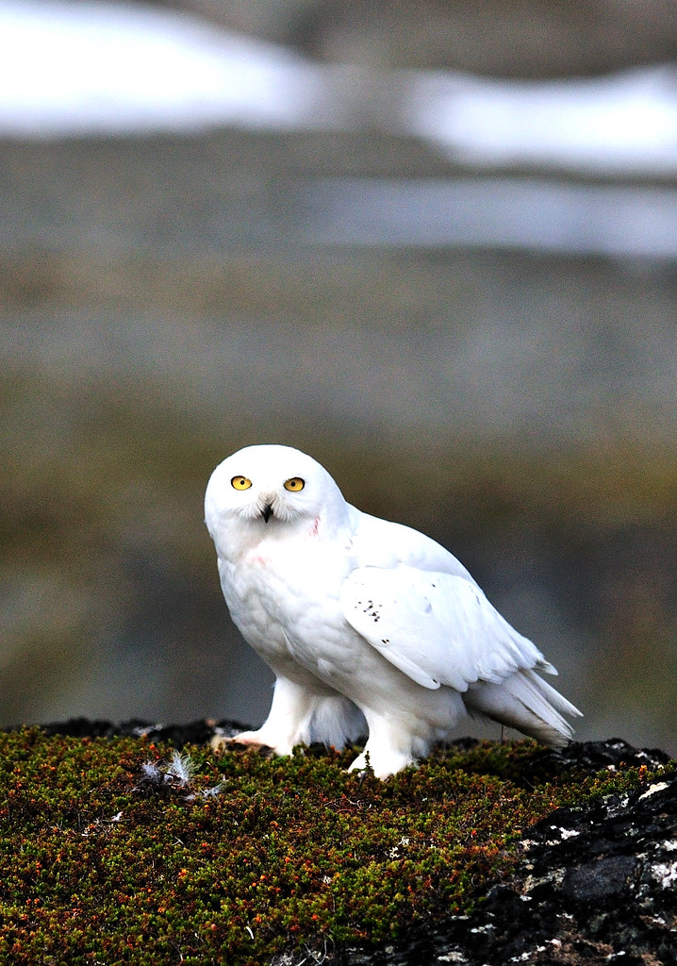
Figure 1. Snowy owl (Bubo scandiacus). Photo: Arild Robert Espelien.

2. Overview

Snowy owl has undergone a population decline across its global range that equates to around a third of the population lost in the last three decades (McCabe et al. 2024). The species was uplisted from ‘Least Concern’ to ‘Vulnerable’ in the 2017 IUCN Red List assessment (BirdLife International 2017). This unfavorable conservation status along with being a migrant would qualify it for CMS Appendix II listing. Listed on Annex 1 (list of species) of the Memorandum of Understanding on the Conservation of Migratory Birds of Prey in Africa and Eurasia (Raptors MOU, which covers migratory species of Accipitriformes, Falconiformes and Strigiformes) and in light of its uplisting to Vulnerable, it was reclassified in Annex 3 (action plan) of the Raptors MOU at the third Meeting of Signatories (MOS3 Dubai, July 2023), moving from Table 1 category 2 to category 1.

CMS Appendix I already lists the globally ‘Vulnerable’ eagles Spanish imperial eagle (Aquila adalberti), greater spotted eagle (Clanga clanga), eastern imperial eagle (Aquila heliaca), Pallas’s fish-eagle (Haliaeetus leucoryphus) and Steller’s sea-eagle (Haliaeetus pelagicus), but no owl species. CMS Appendix II contains a family level listing of Accipitriformes and Falconiformes, but no such family level listing of Strigiformes. As a migratory, globally Vulnerable species on the IUCN Red List, snowy owl meets the criteria for CMS Appendix II listing as outlined in Conservation Status Assessment Report | Raptors.

Today, the snowy owl stands alone as the avian icon of Arctic tundra ecosystems. Indeed, it may be one of the best indicators of the health of Arctic environments and, owing to its many admirable qualities, can play a key role in helping to galvanize Arctic conservation.
- Holt et al. (2020).

3 Migrations

3.1 Kinds of movement, distance, the cyclical and predicable nature of the migration

The snowy owl exhibits complex migratory behaviours characterized by both regular seasonal movements and irregular irruptions. Primarily inhabiting the Arctic tundra during the breeding season, these owls migrate as northern winter approaches, with their movements influenced by prey availability, particularly lemming populations. Individuals and populations have diverse migratory strategies and undertake journeys with different directions, traverse variable distances, and overwinter in different habitat types with different types of prey.

Twenty-two snowy owls were tagged while breeding in northern Norway in 2007, 2011 and 2015. They remained in the Arctic during winter. but most of them migrated to the Russian Federation after the breeding seasons. There they stayed mainly in areas where they were most likely to hunt willow ptarmigan (Lagopus lagopus), while a few stayed around polynyas where they were preying on seabirds (Øien et al. 2018); Figure 2.

Results from four snowy owls tagged in Alaska showed west-east movements of females to the Russian Federation and Arctic Canada in subsequent years (Fuller et al. 2003). Most (74%) of breeding snowy owls tagged in the eastern Canadian Arctic remained in the Arctic during winter, moving along the marine coastlines and around polynyas in the sea ice while preying mainly on seabirds (Robillard et al. 2018). In contrast, four female snowy owls that were tagged in the far western Arctic of the Yukon (Doyle et al. 2017) moved inland during winter to settle in Arctic terrestrial montane boreal biomes. 16 birds tagged in their winter areas on the prairies in Saskatchewan all made annual north-south migration to the breeding grounds in the Arctic tundra of Northern Canada (Wiebe et al. 2023).

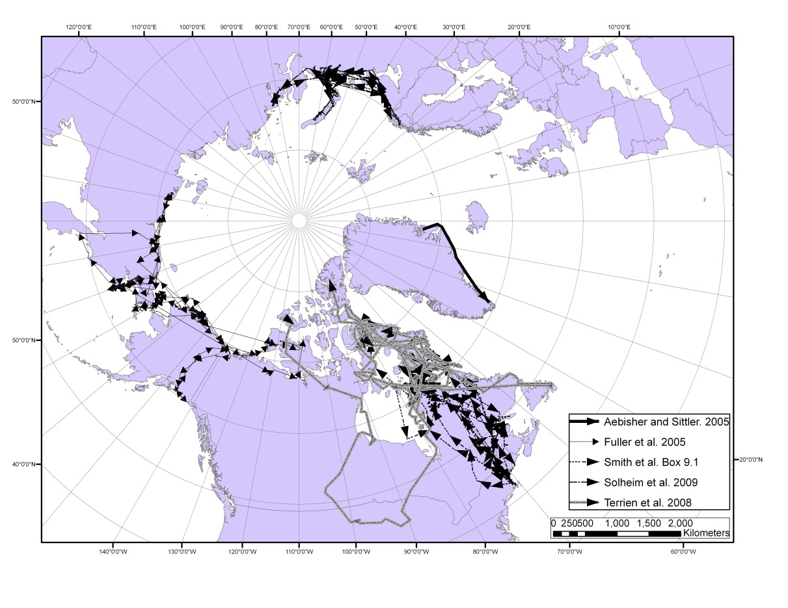
Figure 2. Map of migrations of some snowy owls that have been fitted with satellite transmitters (from Potapov & Sale 2012)

3.2 Proportion of the population migrating, and why that is a significant proportion

It is difficult to estimate the proportion of the population migrating as it varies by population and year. Older literature describes that most snowy owls in northern Russian Federation migrate south in the autumn to open areas to overwinter. This may be to shrub-tundra areas or south to the steppes of Kazakhstan and southwestern Siberia (Dementiev & Gladkov 1951; Portenko 1972; Potapov & Sale 2012), but more up-to-date knowledge is needed here. In some populations it is likely that most individuals migrate. For example, all 16 birds tagged in a study in Saskatchewan made annual north-south migration from their breeding grounds in the Artic tundra of Northern Canada to the prairies of Saskatchewan (Wiebe et al. 2023). The number of individuals moving south in North America, especially moving between Canada and the United States of America increases in some years due to eruptive movements.

4 Biological data (other than migration)

4.1 Distribution (current and historical)

Circumpolar breeding distribution generally found in a latitudinal band between 60⁰ to 82⁰ N, most often associated with the distribution of lemmings (Dicrostonyx and Lemmus): Figure 3. This band covers the northeastern parts of Greenland, northern Fennoscandia, Canada, Alaska and the Russian Federation down to the southern limits of the Tundra in Eurasia and Commander Islands in the Russian Federation. There has been no documented breeding of snowy owls in southern Norway since the 1970s (Jacobsen 2005; Jacobsen et al. 2014). Although snowy owls are regularly observed in Svalbard, they have never been found breeding there, which is related to the lack of lemmings there (Løvenskiold 1964; Mehlum & Gjertz 1998). If food is available, they can spend the non-breeding season across much of its Arctic breeding range. It is also found south of the breeding range throughout southern Canada, United States of America, Iceland, southern Fennoscandia, northern continental Europe, central Russian Federation, northern Kazakhstan and northern China. In some cases, snowy owls have been recorded in southern Europe and have probably arrived by boat from the east coast of North America (Holt et al. 2020; GutIérrez-Expósito et al. 2025). This species is prone to eruptive movement, most well documented within North America. (Holt et al. 2020).

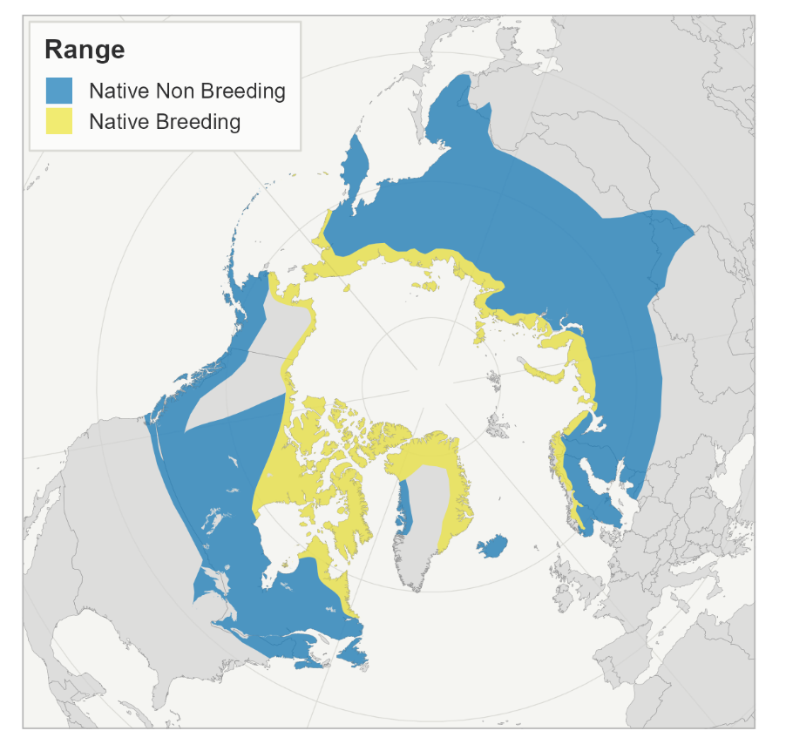
Figure 3. Global distribution of Snowy Owl (BirdLife International 2021b).

4.2 Population (estimates and trends)

Estimate:

Given the nomadic habits of snowy owls, population estimates from the breeding and wintering grounds are difficult to gather with any measure of precision. One needs to be careful with extrapolations of data over large landmasses. Since lemmings are important to snowy owls and asynchronous in distribution, the owls are unlikely to be evenly distributed throughout large geographic areas (Holt et al. 2020). The global snowy owl population was estimated to be as high as 290,000 individuals in the early 2000s (Rich et al. 2004). However, this population is now considered as an overestimate as it relied on the misconception that snowy owls breed regularly and uniformly across their breeding range. Their breeding behaviour is far more heterogenous due to continental-scale annual breeding dispersal and low breeding site fidelity (Gousy-Leblanc et al. 2023). This population estimate was updated when Potapov & Sale (2012) presented a 'Loose Boid’ method of population estimation. This approach created seven loose 'boids', each with very thinly distributed groups which move throughout given areas in line with conditions, especially food availability. The largest of these boids was suggested to be in central northern Canada and could contain 4,000 pairs. In total, they estimated that, on average, each boid may contain 2,000 pairs and so the global population size would be c.14,000 pairs or 28,000 mature individuals. They also suggested a conservative population estimate would be 7,000–8,000 pairs in bad times. However, many assumptions behind this approach (e.g. size and number of individual boids) remain vague and untested. This estimate is backed up by mitochondrial DNA analyses (Marthinsen et al. 2009) which estimated the maximum effective population at 14,000 females worldwide. Gousy-Leblanc et al. (2023) used a genetic method based on nuclear single-nucleotide polymorphism (SNP) and estimated 15,792 individuals (95% CI: 10 850–28 950) in North America (Canada). McCabe et al. (2024) used long-term breeding data, genetic studies, satellite-GPS tracking, and survival estimates to assess current population trends at several monitoring sites in the snowy owl range in the Arctic. An assessment of the available data suggests that current estimates of a worldwide population of 14,000–28,000 breeding adults are plausible.

As part of the European red list assessment, the population of snowy owls in Europe was estimated at 1200-2700 pairs divided between Russian Federation (700-2000), Greenland (500), Norway (0-100), Sweden (0-35), Finland (0-12) and Iceland (2-5) (BirdLife International 2021b). If you only include the Party Range States in CMS (Fennoscandia and Greenland), the population will be 500-647 pairs. It is important to note that Fennoscandia shares a common population with western Russian Federation. Furthermore, the estimate for Greenland is very uncertain. In the two good breeding years of 2011 and 2015, 50 and 54 pairs respectively bred in Fennoscandia (Norway, Sweden & Finland). It is estimated that the total number may have been up to 70 pairs in those years (Jacobsen et al. 2012, Øien et al. 2016). The snowy owl breeds in the northeastern part of Greenland. However, in recent decades there have been few known breedings due to irregular lemming years (Benoît Sittler & Olivier Gilg pers. comm.). The most productive area in the past was said to have been Jameson Land, where it was estimated that around 500 pairs may have been breeding in the late 1930s (Pedersen 1942). The population has recently been estimated to 50-1,000 pairs in Greenland (see Potapov and Sale 2012). However, no one has subsequently reported such high numbers of breeding pairs in Greenland (Benoît Sittler pers. comm. in Jacobsen et al. 2014).

In northern Russian Federation, Morozov et al. (2020) estimated population size based on aerial transect counts in western Siberia in 2019. The authors estimated the current population for the whole Russian Arctic at 14,000-15,000 individuals.

Overall, the global population estimate is uncertain but 28,000 mature individuals is the current best estimate. The majority of the population during the breeding season is located in Canada and the Russian Federation with smaller populations in Greenland and Fennoscandia.

Trends:

Snowy owl populations are reported to be in decline in the Western Palearctic, with a notable vulnerable or endangered status in the Fennoscandian countries (see Voous 1988, Marthinsen et al. 2008; Holt et al. 2020). McCabe et al. (2024) estimated that within the last three generations snowy owl populations have declined 35.6 % (80% HDIs = [-74.9%,-1.2%] for 8-year generations) or 41% (80% HDIs = [-84.2%, 3.5%] for 10.7-year generation). These estimates have wide 80% highest density intervals but represent the most recent and comprehensive estimates of population trends. In a global analysis of North American bird fauna, Rosenberg et al. (2016) reported a 64% decline of snowy owls in North America over the period 1970 to 2014. However, the value is most likely inflated as this analysis may be mixing previous population estimates, which were considered overestimates, with more recent ones. Extrapolating backwards this would equate to a decline of c.43.6% over three generations (c.24 years) in the population in these countries. Reconstructing the population demographic indicated that North American snowy owls have been steadily declining since the Last Glacial Maximum c. 20 000 years ago, and concurrently with global increases in temperature (Gousy-Leblanc et al. 2023).

4.3 Habitat (short description and trends)

Breeding habitat:
Arctic tundra habitat throughout its circumpolar range. Will use any habitat where rodent prey sources are available, including marshes, rivers, and lakes. These include desert Arctic tundra, wet tundra, coastal tundra, and Arctic islands. Less common in low shrub-like inland tundra and slopes nearing tree line. Usually breeds at elevations below 300 m (Holt et al. 2020). In Norway and Sweden, however, the snowy owl can nest in areas between 1,000 – 1,500 meters above sea level (Hagen 1952; Haftorn 1971; Bannermann 1957; Watson 1957; Cramp 1985).

Wintering:
From snow-covered tundra and open water within the ice pack, south to rangelands, farmlands, coastlines, marshes, islands, large forest clearings, and cities and towns bordered by open habitats. Also known to winter on sea-ice at Arctic latitudes (Therrien et al. 2011).
Snowy owls tagged in Norway stayed mainly in mountain areas on Kola Peninsula in Russian Federation during winter where they were most likely to hunt willow ptarmigan, while a few stayed around polynyas in the White Sea where they were preying on seabirds (Øien et al. 2018). A few decades ago, snowy owls regularly wintered along the coast in southern Norway and Sweden (e.g. Jacobsen et al. 2014; Lind 1993).

Migration:
During migration they appear to prefer open habitats, such as coastlines and prairies. However, some individuals must fly over forests and mountains to reach tundra habitats for spring nesting, and open habitats for wintering. No specific habitat described for migration, but coastlines and prairies are probably important (Holt et al. 2020).

4.4 Biological characteristics

Breeding:
Due to nomadic lifestyle and fluctuating food resources, individuals may or may not breed in consecutive years. Clutch sizes are small (3–5) when food is limited, but larger (7–11) when food is plentiful. Incubation period is 32-33 days, and the female start to incubate on the first egg. In most studies, eggs are usually laid in mid-May to early June, depending on weather and food resources. The young leaves the nest after about 3 weeks (Holt et al. 2020). Defining territories is difficult. Territories can change seasonally or annually in relation to prey densities, perhaps topographic features, and result in varying nest densities. If there is plenty of food, they can nest with relatively short distances (~1-3 km) between pairs (e.g. Hagen 1960; Parmelee 1992, Holt et al. 2020). Age at first breeding for males is assumed to occur mainly when adult plumage is achieved after 3-4 years. Females have been documented to breed when 1 year old in Norway (Solheim et al. 2019), although it is probably more common at 2 years of age or older. Polygamy (one male and two females in separate nests) is known from several cases (see Holt et al. 2020).

Diet:
It has been common knowledge for more than 100 years, that snowy owls are dependent on high densities of lemming or voles, with few exceptions for successful breeding (Holt et al. 2020; 2024; 2025). Studies in Greenland have shown that snowy owls do not attempt to breed unless there is a density of about two lemmings per hectare when the snow melts (Gilg et al. 2003). They are capable of killing a wide range of prey species from small to large mammals and birds during any time of year. Fish, frogs and other aquatic animals may also be part of the diet (Potapov & Sale 2012). For snowy owls that winter in arctic areas, there is much evidence that ptarmigans are important prey. This has been described by several authors (Portenko 1972; Mikkola 1983; Mehlum & Gjertz 1998; Rogacheva 2005; Potapov & Sale 2012).
Lifespan:
Some individuals may live 15-20 years in the wild. Longevity record in wild is a female banded in Massachusetts and recaptured and released in Montana when at least 23 years and 10 months old (Holt et al. 2020). A bird in captivity in Switzerland lived to be at least 28 years old (Schenker 1978). The generation length is 7.77 years (BirdLife International 2021a).

4.5 Role of the taxon in its ecosystem

Snowy owls are top predators in Arctic ecosystems and feed on a variety of prey, e.g. lemmings, voles, hares and ptarmigans. This makes them an important indicator species for the health of the Artic environment. By using snowy owl population fluctuations as an indicator of lemming population fluctuations, snowy owls could be the harbinger/indicator of a healthy Arctic environment, both locally and wide-ranging (Holt et al. 2024). Like any species migrating, but especially migrating moving to the Arctic, snowy owls play an important role in the movements of nutrients to the Arctic (see this example of seabird nutrient movement (Zwolicki et al. 2016)).

5. Conservation status and threats

5.1 IUCN Red List Assessment (if available)

The species was uplisted from ‘Least Concern’ to ‘Vulnerable’ during the 2017 IUCN Red List assessment (BirdLife International 2017) and it remained classified as Vulnerable during the last assessment in 2021 (BirdLife International 2021a). The species was listed as ‘Least Concern’ in the European specific IUCN Red List assessment (BirdLife International2021b).

5.2 Equivalent information relevant to conservation status assessment

A paper published by McCabe et al. (2024), since the last IUCN assessment in 2021, analysed a new data set and estimated that the population has declined by more than 30% over that last three generations (relating to IUCN Red List Criterion A2). This further reinforces the current assessment as ‘Vulnerable’.

5.3 Threats to the population (factors, intensity)

The report Jacobsen et al. (2014) was intended as a scientific basis for a possible Action Plan for Snowy Owls in Norway. It addresses, among other things, assumed threats and causes of the decline in the snowy owl population in Fennoscandia over the last 100 years (Figure 4). A population that is also shared with the western part of Russian Federation, where these owls spend most of their time. There are different types of threats that could affect adult survival, breeding success and habitat:
• Food shortage / starvation
• Climate change
• Human persecution and collections (including bycatch)
• Technical installations and disturbance
• Predation and parasitism
• Inclement weather
• Environmental pollutants

Climate change is likely to have a significant impact on the species, as changes in the onset of spring and snowmelt in the breeding areas are likely to affect lemming populations (International Snowy Owl Working Group 2010). Periods of mild weather and heavy rain in winter can lead to problems with icing on the ground. This means that the main prey, the lemming, cannot get to the food, and the population collapses. This happened in northern Fennoscandia in both 2019 and 2023 (Jacobsen et al. 2019, 2023). Snowy owls hunt seabirds over pack ice and polynyas in winter. As sea ice distribution shifts and disappears with a warming climate, dispersing prey, impacts on snowy owls could be significant (Holt et al. 2020). Blackflies (Simuliidae) have been shown to attack incubating snowy owls (Solheim et al. 2013). This is also a concern for the future, given a warming climate, thawing of tundra habitats and extended growth of vegetation within the Arctic biome.

Historically, thousands of owls were shot for taxidermy, and adults and eggs were hunted for food (Holt et al. 2020). Harvesting of the species for food, feathers and claws by native peoples still occurs but has decreased significantly, therefore while it may have a local impact on populations, it is unlikely to have any wider effect on total numbers. The snowy owl is a very attractive species for both nature photographers and bird enthusiasts, but these can cause unwanted disturbance both at nesting sites and wintering areas. And egg collections, which were common in the past, continue to an unknown extent. All three half-grown young owlets in a nest in Finnmark in 2011 died following heavy rainfall and relatively low temperatures lasting over a day (Jacobsen et al. 2014). This is probably not a unique event, and cases where inclement weather may have fatal consequences.

In some areas, nesting habitat may be degraded because of urban development (Holt et al. 2009). There is a recent case study where a wind farm was not approved in northern Norway due to the potential negative impacts on snowy owl (Mohammed 2024). Bycatch in fox traps was probably one of the most important causes of mortality among snowy owls in winter in the Russian part of the Arctic from the late 1940s and up until the early 1990s (Ellis & Smith 1993; Potapov & Sale 2012, cited in Holt et al. 2020). Snowy owls may also be subject to secondary poisoning by Warfarin bait set for rats, e.g. at airports in North America (Campbell & Preston 2009, cited in Holt et al. 2020). Electrocution, airplane strikes, collision with vehicles and entanglement in fishing equipment have all been identified as sources of mortality in Canada (Kerlinger & Lein (1988). See also Holt et al. 2020; Jacobsen et al. 2014). These threats are not known to be a problem in Fennoscandia or Greenland.

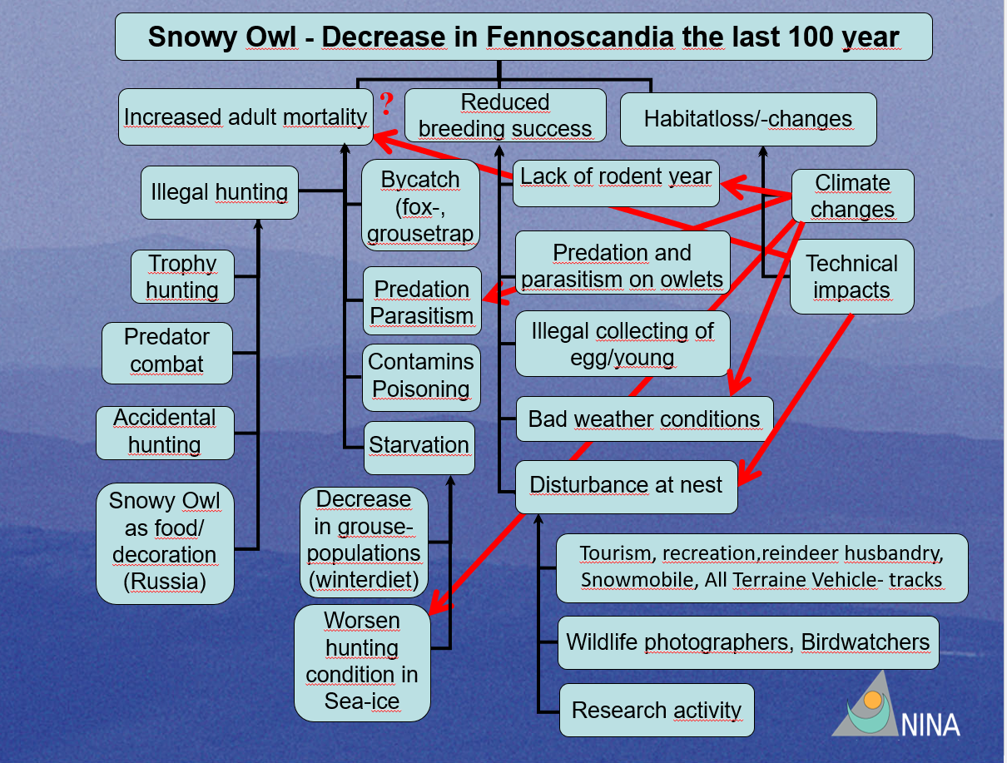
Figure 4. Flowchart of presumed threats and causes of decline in the snowy owl population in Fennoscandia over the past 100 years. Arrows show factors that influence each other (after Jacobsen et al. 2014).

5.4 Threats connected especially with migrations

Degradation of stopover sites due to climate change and residential developments. Collision with energy infrastructure. Repeated from above: Electrocution, airplane strikes, collision with vehicles and entanglement in fishing equipment have all been identified as sources of mortality in Canada (Kerlinger & Lein (1988). See also Holt et al. 2020; Jacobsen et al. 2014).

5.5 National and international utilization

Historically, thousands of owls were shot for taxidermy, and adults and eggs were hunted for food (Holt et al. 2020). Harvesting of the species for food, feathers and claws by native peoples still occurs in North America but has decreased significantly, therefore while it may have a local impact on populations, it is unlikely to have any wider effect on total numbers.

6. Protection status and species management

6.1 National protection status

• Norway: CR-Critically Endangered (Stokke et al. 2021)
• Sweden CR-Critically Endangered (SLU Artdatabanken (2020)
• Finland: CR-Critically Endangered (Hyvärinen et al. 2019)
• Greenland: NT-Near Threatened (Boertmann & Bay 2018)

6.2 International protection status

• CITES Appendix II
• Raptors MOU Annex 3, Table 1, Category 1
• EU Birds Directive Annex I
• IUCN Red List. Bubo scandiacus is listed as Vulnerable under criteria A2bd+3bd+4bd.

6.3 Management measures

Birds wintering at major airports in the United Stated of America are sometimes trapped and released at remote locations to prevent collisions with airplanes (Holt et al. 2020). E.g., at Logan Airport, Boston, USA, where > 900 snowy owls have been captured and released at remote locations since 1981 (The Owl Man of Logan Airport: Norman Smith’s Legend Takes Flight)

6.4 Habitat conservation

There is a recent case study where a wind farm was not approved in northern Norway due to the potential negative impacts on snowy owl (Mohammed 2024). Nomadic breeding strategies and remote Arctic nesting grounds put this species low on the list of North American owls in need of management. Only populations nesting near human settlements (e.g., Utqiagvik/Barrow, Alaska) might show such need, but to date no sustained management efforts have been warranted for any snowy owl nesting population (Holt et al. 2020).

Wintering concentrations, however, especially those at major airports in the United States of America, have received attention. Because snowy owls sometimes collide with airplanes (but rarely - flocking birds like geese are more likely to do so), safety concerns have prompted airport personnel to try to remove some of the owls (Holt et al. 2020; (The Owl Man of Logan Airport: Norman Smith’s Legend Takes Flight)).

6.5 Population monitoring

An International Snowy Owl Working Group (ISOWG) gathers snowy owl researchers from across the range of the species (breeding and non-breeding) from 13 countries. The group is working on a thorough status assessment for the species, including population size, precise distribution, dispersal and survival rates (J. F. Therrien in litt. 2017). The Norwegian Snowy Owl Project took the initiative for this working group, which was established in 2007, and has always had leadership responsibility. They monitor the population in Norway but collaborates with ISOWG members in Sweden and Finland to have a status for all of Fennoscandia. Other projects are monitoring the breeding population in Russian Federation, NE-Greenland, Arctic Canada and Alaska through ISOWG members. Snowy owl is also monitored by the North American Christmas Bird Count, with high reliability score (e.g. North American Bird Conservation Initiative 2022). However, this only covers a portion of the wintering population as the count only covers the United States of America.

7. Effects of the proposed amendment

7.1 Anticipated benefits of the amendment

The amendment addresses a gap in the CMS Appendices regarding Strigiformes so that they better align with the Raptors MOU listing and helps ensure better representation for nocturnal species in the CMS Appendices. It will raise international awareness to strengthen conservation of the species. It will ensure a connection to the Arctic Migratory Birds Initiative (AMBI) under the Biodiversity Working Group of the Arctic Council called Conservation of Arctic Flora and Fauna (CAFF), adding weight to their efforts and connecting the flyways.

7.2 Potential risks of the amendment

There is a potential for duplication of efforts between CAFF, AMBI, ISOWG and CMS. but listing snowy owl on Appendix II of CMS could help unifying efforts for the conservation of the species.

7.3 Intention of the proponent concerning development of an Agreement or Concerted Action

Since 2005, Norway has been involved in strengthening the knowledge base for the Snowy Owl. This building of knowledge has included the entire global population, but with a special focus on Norway and neighbouring countries. This effort has been channelled through the Norwegian Snowy Owl Project and the ISOWG. We believe that a listing of the Snowy Owl in the CMS Appendix II will stimulate further development of cooperation between non-governmental organisations and other stakeholders to conserve the species. It will also make it easier to continue and develop the Norwegian effort in conservation work. Since the occurrence of the species in CMS party countries is unpredictable in time and space, it will be important to monitor the species continuously, so that measures can be taken when conditions are right for the snowy owl to breed. The proposal could therefor strengthen international cooperation on the species.

8. Range States

Party Range States of CMS

Country | Seasonal Occurrence
Finland | Year-round
Norway | Year-round
Sweden | Year-round
Greenland (to Denmark) | Year-round
Svalbard and Jan Mayen Islands (to Norway) | Non-Breeding

Other countries

Country | Seasonal Occurrence
Canada | Year-round
United States of America | Year-round
Russian Federation | Year-round
Iceland | Year-round
United Kingdom of Great Britain and Northern Ireland* | Non-breeding
Ireland** | Non-breeding
Kazakhstan | Non-breeding
St Pierre and Miquelon (to France) | Non-breeding & Passage
Latvia | Non-breeding
Japan | Non-breeding
China | Non-Breeding
Albania | Vagrant
Austria | Vagrant
Belarus | Vagrant
Belgium | Vagrant
Bermuda (to UK) | Vagrant
Croatia | Vagrant
Czechia | Vagrant
Democratic People’s Republic of North Korea | Vagrant
Denmark | Vagrant
Faroe Islands (to Denmark) | Vagrant
France | Vagrant
Germany | Vagrant
Hungary | Vagrant
Iran, Islamic Republic of | Vagrant
Kyrgyzstan | Vagrant
Luxembourg | Vagrant
Mongolia | Vagrant
Montenegro | Vagrant
Netherlands | Vagrant
Pakistan | Vagrant
Poland | Vagrant
Portugal | Vagrant
Serbia | Vagrant
Slovakia | Vagrant
South Republic of Korea | Vagrant
Turkmenistan | Vagrant
Ukraine | Vagrant
*Previous nesting in Shetland (1967-1975), maybe also in the past (1800)
**One nesting attempt (2001)

9. Consultations

Norway invited the other party range states - Finland, Sweden and Denmark - to provide comments and input to the draft listing proposal, through their national focal points to the CMS. In general, positive feedback was received. The party range states may wish to submit more detailed input during the broader consultation process. The authorities of other range states have not been consulted.

Norway also invited the Technical Advisory Group to the Raptor MOU to provide comments to the draft and in return received an official statement supporting the proposal by Norway to include the snowy owl in CMS Appendix II (Addendum I). The Technical Advisory Group states that "The proposal submitted by Norway to include the snowy owl in CMS Appendix II is comprehensive and clearly demonstrates the positive conservation benefits that such a listing would bring to the species."

10. Additional remarks

There are no additional remarks.

11. References

Bannermann, D.A. (1957). The birds of the British Isles. Vol 6. Oliver & Boyd.
Bartram, W. (1791). Travels through North & South Carolina, Georgia, East & West Florida, the Cherokee country, the extensive territories of the Muscogulges, or Creek Confederacy, and the country of the Chactaws; Containing an account of the soil and natural productions of those regions, together with observations on the manners of the Indians. Embellished with copper-plates. Philadelphia. s 289.
BirdLife International (2017). Bubo scandiacus (errata version published in 2018). The IUCN Red List of Threatened Species 2017: e.T22689055A127837214. Available at: https://dx.doi.org/10.2305/IUCN.UK.2017-3.RLTS.T22689055A119342767.en (Accessed: 21 February 2025).
BirdLife International (2021a). Bubo scandiacus. The IUCN Red List of Threatened Species 2021: e.T22689055A205475036. Available at: https://dx.doi.org/10.2305/IUCN.UK.2021-3.RLTS.T22689055A205475036.en (Accessed: 21 February 2025).
BirdLife International (2021b). Bubo scandiacus (Europe assessment). The IUCN Red List of Threatened Species 2021: e.T22689055A166224787. Available at: https://dx.doi.org/10.2305/IUCN.UK.2021-3.RLTS.T22689055A166224787.en (Accessed: 7 April 2025).
Boertmann, D. & Bay, C. (2018). Grønlands Rødliste 2018 – Fortegnelse over grønlandske dyr og planters trusselstatus. – Aarhus Universitet, Nationalt Center for Energi og Miljø (DCE) og Grønlands Naturinstitut.
Brisson, M.J. (1760). Ornithologia sive synopis methodice sistens Avium divisiones in ordine, 1:522.
Brehm, A.E. (1866). Verzeichniss der Sammlung. S. 2 (Nomina nuda).
Campbell, R.W. and Preston, M.L. (2009). Wildlife Data Centre: Snowy Owl. Wildlife Afield, 6, pp. 173–255.
Cramp, S. (ed.) (1985). Handbook of the birds of Europe, the Middle East and North Africa.Vol. 4.- Oxford Univ. Press. Oxford.
Daudin, F.M. (1800). Traité élementaire et complet d’Ornithologie, ou historie naturelle des oiseaux. Tome II. Paris. s.210.
Dementiev, G.P. & Gladkov, N.A. (1951). Birds of the Soviet Union. Vol.1. Moscow.
Doyle, F.I., Therrien, J.-F., Reid, D.G., Gauthier, G. and Krebs, C.J. (2017). Seasonal movements of female Snowy Owls breeding in the western North American Arctic. Journal of Raptor Research, 51, pp. 428–438. https://doi.org/10.3356/JRR-16-51.1
Ellis, D.H. and Smith, D.G. (1993). Preliminary report of extensive Gyrfalcon and Snowy Owl mortality in northern Siberia. Raptor-Link, 1(2), pp. 3–4.
Fuller, M., Holt, D. and Schueck, L. (2003). Snowy Owl movements: variation on the migration theme. in Berthold, P., Gwinner, E. and Sonnenschein, E. (eds) Avian migration. Berlin: Springer-Verlag, pp. 359–366. https://doi.org/10.1007/9783-662-05957-9_25
Gilg, O., Hanski, I. & Sittler, B. (2003). Cyclic dynamics in a simple vertebrate predator-prey community. Science 302: 866-868.
Gmelin, J. F. (1788). Caroli a Linné systema naturae per regna tria naturae, secundum classes, ordines, genera, species, cum characteribus, differentiis, synonymis, locis. Tomus I. Editio decima tertia, aucta, reformata. - pp. [1-12], 1-500. Lipsiae. (Beer). s 291.
Gousy-Leblanc, M., Therrien, J., Broquet, T., Rioux, D., Curt-Grand-Gaudin, N., Tissot, N., Tissot, S., Szabo, I., Wilson, L., Evans, J., Bowes, V., Gauthier, G., Wiebe, K., Yannic, G. and Lecomte, N. (2023). Long‐term population decline of a genetically homogeneous continental‐wide top Arctic predator. Ibis, 165(4), pp. 1251–1266. https://doi.org/10.1111/ibi.13199
Gutiérrez-Expósito, C., De Vega, L., Sangari, F.J., De Ana, J.M.P., Fayos, M., et al. (2025). Stable Isotopes Support a Wild Origin for Snowy Owl Bubo scandiacus Records in Spain in Autumn 2021. Ardeola, 72(2) : 281-287. https://doi.org/10.13157/arla.72.2.2025.sc2
Haftorn, S. (1971). Norges Fugler. Universitetsforlaget, Oslo, 862 pp.
Hagen, Y. (1952). Rovfuglene og viltpleien. Gyldendal, Oslo, 622 pp.
Hagen, Y. (1960). Snøugla på Hardangervidda sommeren 1959. Medd. Statens Viltundersøk.2. serie, nr.7. 25s.
Holt, D.W., Larson, M.D., Smith, N.E., Evans, D.L. and Parmelee, D.F. (2020). Snowy Owl (Bubo scandiacus), version 1.0. In: Billerman, S.M. (ed.) Birds of the World. Ithaca, NY: Cornell Lab of Ornithology. https://doi.org/10.2173/bow.snoowl1.01
Holt, D.W., Larson, M.D., Seidensticker, M.T. & Hiro, S.P. (2024). Worldwide review of Snowy Owl feeding ecology: The importance of lemmings and voles in a changing climate. Birds 2024, 5, 341–351.
Holt, D.W., Larson, M.D., Seidensticker, M.T. & Hiro, S.P. (2025). Breeding Snowy Owls Are Obligate Lemming Predators in Utqiagvik, Alaska: Results from 30 Years of Study. Diversity 2025, 17, 209. https://doi.org/10.3390/d17030209
Hyvärinen, E., Juslén, A., Kemppainen, E., Uddström, A. & Liukko, U.-M. (eds.) (2019). The 2019
Red List of Finnish Species. Ympäristöministeriö & Suomen ympäristökeskus. Helsinki. 704 p.
International Snowy Owl Working Group (2010). Resolution Document. 2nd meeting, Saskatoon, February 2010.
Jacobsen, K.-O. (2005). Snowy Owl (Bubo scandiacus) in Norway. Breeding status in the period 1968-2005. NINA report 84. 35 pp. (In Norwegian with English abstract).
Jacobsen, K.-O., Øien, I.J., Solheim, R., & Aarvak, T. (2011). Population, movements and habitat choice of Snowy Owls Bubo scandiacus. Annual Report 2011. - NINA Report 813. 20 pp. (In Norwegian with English abstract).
Jacobsen, K.-O., Øien, I.J., Solheim, R. & Aarvak, T. (2014). Present knowledge and threats to Snowy Owl Bubo scandiacus in Norway. NINA Report 727. 69 pp. (In Norwegian with English abstract).
Jacobsen, K.-O., Solheim, R., Øien, I.J. & Aarvak, T. (2019). Ecology and occurrence of Snowy Owl in Norway. Annual Report 2019. NINA Report 1753. Norwegian Institute for Nature Research.
Jacobsen, K.-O., Øien, I.J., Aarvak, T., Solheim, R., Baalsrud, H.T. & Enevoldsen, E.L.G. (2023). Ecology and occurrence of Snowy Owl in Norway. Annual Report 2023. NINA Report 2401. Norwegian Institute for Nature Research.
Kerlinger, P. & Lein, M.R. (1988). Causes of mortality, fat condition, and weights of wintering snowy owls. J.Field Ornithol., 59:7-12.
Latham, J. (1801). Supplementum Indicis ornithologici sive Systematis ornithologiae. i-lxxiv. London. p.14
Lind, H. (1993). Different ecology in male and female wintering Snowy Owls Nyctea scandiaca L. in Sweden due to colour and size dimorphism. Ornis Svecica 3: 147-158
Linnaeus, C. (1758). Systema Naturae (Syst. Nat.) ed. 10: p 92.
Løvenskiold, H.L. (1964). Avifauna Svalbardensis. Nor. Polarinst. Skr. 129. 460 pp.
Marthinsen, G., Wennerberg, L., Solheim, R. and Lifjeld, J.T. (2009). No phylogeographic structure in the circumpolar snowy owl (Bubo scandiacus). Conservation Genetics, 10, pp. 923–933. https://doi.org/10.1007/s10592-008-9581-6
McCabe, R.A., Aarvak, T., Aebischer, A., Bates, K., Bety, J., Bollache, L., Brinker, D., Driscoll, C., Elliot, K.H., Fitzgerald, G., Fuller, M., Gauthier, G., Gilg, O., Gousy-Leblanc, M., Holt, D., Jacobsen, K.-O., Johnson, D., Kulikova, O., Lang, J., Lecomte, N., McClure, C., McDonald, T., Menyushina, I., Miller, E., Morozov, V.V., Øien, I.J., Robillard, A., Rolek, B., Sittler, B., Smith, N., Sokolov, A., Sokolova, N., Solheim, R., Soloviev, M., Stoffel, M., Weidensaul, S., Wiebe, K.L., Zazelenchuck, D. and Therrien, J.-F. (2024). Status assessment and conservation priorities for a circumpolar raptor: the Snowy Owl Bubo scandiacus. Bird Conservation International, 34, e41, pp. 1–11. https://doi.org/10.1017/S0959270924000248
Mehlum, F. & Gjertz, I. (1998).The occurrence of the Snowy Owl Nyctea scandiaca in Svalbard. Fauna norv. Ser. C. Cinclus 21:7-16
Mikkola, H. (1983). Owls of Europe. Calton, U.K.: T. and A.D. Poyser. 397 pp.
Mohammed, L.I. (2024) ‘Saved by the snowy owl: An intersectional analysis of Indigenous rights and biodiversity in the Kvalsund wind power project in Norway’, Energy Research & Social Science, 118, 103758. https://doi.org/10.1016/j.erss.2024.103758
Morozov, V.V., Rosenfeld, S.B., Rogova, N.V., Golovnyuk, V.V., Kirtaev, G.V. and Kharitonov, S.P. (2020). What is the number of snowy owls in the Russian Arctic?. Ornithologia, 44, pp. 18–25. (In Russian, with English summary)
North American Bird Conservation Initiative (2022) The State of the Birds: United States of America 2022. Available at: http://stateofthebirds.org (Accessed: 15 July 2025).
Øien, I.J., Aarvak, T., Jacobsen, K.-O. and Solheim, R. (2018). Satellite telemetry uncovers important wintering areas for Snowy Owls on the Kola Peninsula, Northwestern Russia. Ornithologia, 42, pp. 42–48.
Øien, I.J., Jacobsen, K.‐O., Aarvak, T., Solheim, R. & Kleven, O. (2016). Snøuglas økologi og forekomst i Norge i 2015. NOF‐Rapport 4‐2016. 30 s. (In Norwegian with English abstract).
Parmelee, D.F. (1992). Snowy Owl.Pages 1-20 in A. Poole, Stettenheim, P. & Gill, F. editors. The Birds of North America. The American Ornithologists' Union, Washington, DC.
Pedersen, A. (1942). Säugetiere und Vögel. Dansk Nordostgrönlands Expedition. 1938-39. Meddelelser om Grønland 128(2). 119p.
Portenko, L.A. (1972). Die Schnee-eule. Die Neue Brehm-Bücherei, 232 pp.
Potapov, E. & Sale, R. (2012). The Snowy Owl, London: T & AD Poyser
Rich, T.D., Beardmore, C.J., Berlanga, H., Blancher, P.J., Bradstreet, M.S.W., Butcher, G.S., Demarest, D.W., Dunn, E.H., Hunter, W.C., Inigo-Elias, E.E., Martell, A.M. and Panjabi, A.O. (2004). Partners in Flight North American Landbird Conservation Plan. Ithaca, NY: Cornell Lab of Ornithology.
Ridgway, R. (1874). The ornithology of Illinois (Volume 1). Springfield, Ill.
Robillard, A., Gauthier, G., Therrien, J.-F. and Bêty, J. (2018). Wintering space use and site fidelity in a nomadic species, the Snowy Owl. Journal of Avian Biology, 49(5), jav-01707. https://doi.org/10.1111/jav.01707
Rogacheva, E.V. (2005). Owls of the northern part of Central Siberia. Page 369-384 In Volkov, S.V., V.V. Morozov, A.V. Sharikov (eds.). Owls of Northern Eurasia. Vibor Print, Moscow. 471 pp. [In Russian, with English summary].
Rosenberg, K.V., Kennedy, J.A., Dettmers, R., Ford, R.P., Reynolds, D., Alexander, J.D., Beardmore, C.J., Blancher, P.J., Bogart, R.E., Butcher, G.S. and others (2016). Partners in Flight Landbird Conservation Plan: 2016 Revision for Canada and Continental United States. Partners in Flight Science Committee.
Sangster, G., Collinson, J.M., Helbig, A.J., Knox, A. G. & Parkin, D.T. (2004). Taxonomic recommendations for British birds: second report. Ibis, 146:153-157.
Schenker, A. (1978) Höchsalter europaischer Vögel im Zoologischen Garten Basel. Ornithol. Beob. 75: 96-97.
Shaw, G. 1809. Strix erminea. Gen. Zool. VII s. 251
SLU Artdatabanken (2020). Rödlistade arter i Sverige 2020. SLU, Uppsala slu.se/contentassets/06bc62d2c893426181f812a48d94e919/rodlista-2020-1.pdf
Solheim, R., Jacobsen, K.-O., Øien, I.J., Aarvak, T. & Polojärvi, P. (2013). Snowy Owl nest failures caused by blackfly attacks on incubating females. Ornis Norvegica 36:1-5
Solheim, R., Jacobsen, K.-O., Øien, I.J. & Aarvak, T. (2019). Snowy owls may breed when one year old. Poster at Raptor Research Foundation conference in Skukuza, Kruger national park, South Africa, 12.-16.11.2018
Stokke, B.G, Dale, S., Jacobsen, K.-O., Lislevand, T., Solvang, R. & Strøm, H. 2021. Fugler Aves – Norge. I: Artsdatabanken. (2021). Norsk rødliste for arter 2021. Artsdatabanken, Norge. 2021 206 s. https://www.artsdatabanken.no/rodlisteforarter2021/Artsgruppene/Fugler
Sundevall, C.J. (1872). Methodi naturalis avium disponendarum tentamen: försök till fogelklassens naturenliga uppställnung. Oxford University. 199s. (Leuchybris nivea . s.105)
Therrien, J.-F., Gauthier, G. & Bêty, J. (2011). An avian terrestrial predator of the Arctic relies on the marine ecosystem during winter. Journal of Avian Biology, 42(4), pp. 363–369. https://doi.org/10.1111/j.1600-048X.2011.05330.x
Thunberg, C.P. (1798). Strix nivea. Svensk Ac. Förh. S 184.
Voous, K.H. (1988). Owls of the Northern Hemisphere. Williams Collins Sons and Co. Ltd, London.
Watson, A. (1957). The behaviour, breeding and food ecology of the Snowy Owl, Nyctea scandiaca. Ibis 99:419-462.
Wiebe, K., Bidwell, M. and McCabe, R. (2023). Snowy Owls in central North America have regular migration and high philopatry to wintering sites though not always to home ranges. Avian Conservation and Ecology, 18(2). https://doi.org/10.5751/ace-02528-180214.
Wink, M., and P. Heidrich (2000). Molecular systematics of owls (Strigiformes) based on DNA-sequences of the mitochondrial cytochrome b gene. In Raptors at Risk: Proceedings of the V World Conference on Birds of Prey and Owls, Midrand, Johannesburg, South Africa, August 1998 (R. D. Chancellor and B. U. Meyburg, Editors). Hancock House, London, United Kingdom. pp. 819–828.
Zander (1838). Haemeria nivea. Die Naturgeschichte der Vogeln Mecklenbergs,heft 2,p.119.
Zwolicki, A., Zmudczyńska-Skarbek, K., Richard, P. and Stempniewicz, L. (2016). Importance of marine-derived nutrients supplied by planktivorous seabirds to high Arctic tundra plant communities. PLOS ONE, 11(5), e0154950. https://doi.org/10.1371/journal.pone.0154950

