 | CONVENTION ON  MIGRATORY  SPECIES | UNEP/CMS/COP15/Doc.27.4  6 November 2025  Original: English

15th MEETING OF THE CONFERENCE OF THE PARTIES

Campo Grande, Brazil, 23 to 29 March 2026
Agenda Item 27.4

JAGUAR
(Prepared by the Secretariat)

Summary:

This document reports on progress to implement Resolution 14.14 CMS Jaguar Initiative and Decisions 14.173–14.178. It proposes the amendment of Resolution 14.14, the adoption of new draft Decisions and the deletion of Decisions 14.173–14.178.

The attached amended Resolution and draft Decisions would support the achievement of Targets 1.1–1.3, 2.1–2.3, 3.2, 4.1–4.3, 5.3 and 6.3 of the Samarkand Strategic Plan for Migratory Species 2024–2032.

JAGUAR

Background

- Jaguars are among the most iconic mammal species in Latin America, with an historic range that extends from southwestern USA all the way to Argentina. Currently, 18 countries are considered Range States of the jaguar, 10 of which are CMS Parties. The conservation of the jaguar is extremely important to all Range States, as well as former Range States such as Uruguay, which are highly engaged in CMS discussions on the species.

- Jaguars face many threats. According to recent scientific assessments, the greatest threats are habitat destruction, fragmentation and loss of connected habitat and migratory corridors.

- The CMS–CITES Joint Work Programme 2021-2025, which was approved by the Standing Committees of both Conventions in 2021, specifically includes cooperation on the jaguar (B10. “Collaborate on the conservation of jaguar, taking into account existing mandates, and ongoing efforts and initiatives in the region”). The need for cooperation was also agreed by CITES Parties through Decision 19.111 and by CMS Parties through Resolution 14.14 (para. 3.) and Decision 14.178. Close cooperation between the two Secretariats is important to effectively collaborate on the actions and mechanisms needed to address conservation of the jaguar across all of the Range States.

- A significant amount of work has been undertaken in the intersessional period between COP14 and COP15 to advance the conservation of the jaguar, as summarized below. CITES COP20, which is taking place at the end of 2025, will be considering an agenda item on jaguar. As such, this document, along with the proposed outcomes, may need to be updated following this meeting.

14th meeting of the CMS Conference of the Parties

- The 14th meeting of the Conference of the Parties (COP14) considered a proposal submitted by Costa Rica, together with Argentina, Brazil, Ecuador, Panama, Peru and Paraguay, for a CITES–CMS ‘Jaguar Initiative’, The approach was modelled on the African Carnivores Initiative, which is jointly supported by the CITES and CMS Secretariats.

- COP 14 adopted Resolution 14.14, by which it established the CMS Jaguar Initiative as the framework to foster coordination and cooperation between all CMS jaguar Range States, to enable joint action for the conservation of the species and its habitat. Through the Resolution, it agreed that the Initiative shall be implemented through a Programme of Work that outlines concrete actions framed by clear objectives and quantifiable goals. It also invited other non-Party Range States to officially join this Initiative, with the aim of creating a Joint CITES–CMS Jaguar Initiative that allows for greater cooperation in view of the numerous threats faced by the jaguar.

- COP14 also adopted Decisions 14.173–14 .178 CMS Jaguar Initiative:

Decision 14.173 Directed to the Jaguar Range States

Parties are requested, and non-Parties are invited:
- to collaborate with the CMS and CITES Secretariats in preparing a Joint CITES-CMS Programme of Work;
- to participate in a Range State meeting to discuss and agree upon the Joint CITES-CMS Programme of Work; and
- to report to the Standing Committee at its 56th meeting on the progress toward implementing this Decision.

Decision 14.174 Directed to Parties

Parties that are Jaguar Range States are requested to invite non-Party Range States to consider joining the Initiative, using the Joint CITES-CMS Programme of Work as a harmonizing document.

Decision 14.175 Directed to Parties and intergovernmental and non-governmental organizations

Parties, and intergovernmental and non-governmental organizations are encouraged to:
- provide financial/technical support to prepare a Joint CITES-CMS Programme of Work and hold a meeting of the Range States; and
- coordinate and align efforts of this Initiative with those related to Jaguars under frameworks such as the 2030 Jaguar Roadmap, national jaguar action plans and others, conventions such as CITES and CBD, and others.

Decision 14.176 Directed to the Standing Committee

The Standing Committee shall:
- review and approve the Joint CITES-CMS Programme of Work submitted by the Secretariat; and
- report to the Conference of the Parties at its 15th meeting on progress toward implementing this Decision.

Decision 14.177 Directed to the Scientific Council

The Scientific Council is requested to:
- review and advise on the Joint CITES-CMS Programme of Work proposed for the Jaguar;
- provide available information to the Initiative in support of the coordinated approach to improve knowledge; and
- report to the Standing Committee at its 56th meeting on progress towards implementation of this decision.

Decision 14.178 Directed to the Secretariat

The Secretariat shall, subject to funding availability,
- prepare, in close collaboration with the CITES Secretariat and the 2030 Jaguar Roadmap's Coordination Committee, along with the Jaguar Range State Parties, and other relevant actors, a draft Joint CITES-CMS Programme of Work, aligned with the 2030 Jaguar Roadmap and all National Jaguar Action Plans;
- organize a Range State meeting in close collaboration with the CITES Secretariat and with the support of the 2030 Jaguar Roadmap's Coordination Committee to discuss and agree upon the draft Joint CITES-CMS Programme of Work for the conservation of the Jaguar; and
- submit the Programme of Work for approval to the CMS Standing Committee.

Implementation of Decisions

- In May 2024, the CMS Secretariat and CITES Secretariat were in communication regarding activities stemming from their respective mandates. The CITES Secretariat noted that funding was made available by the Government of Switzerland for a consultant to implement the CITES SC77 recommendations, which included:
- preparing terms of reference for the creation of a modular system for monitoring illegal killing of jaguars, illegal trade in their parts and derivatives, and other aspects related to their conservation;
- preparing terms of reference for the creation of an intergovernmental platform, as specified in paragraph 21 of document SC77 Doc. 43, including the option of a Joint CITES–CMS Jaguar Initiative; and
- developing, in close consultation with jaguar Range States, and inviting contributions from the Convention on Biological Diversity and other relevant organizations, a joint working programme establishing specific priorities for jaguar conservation throughout the region, activities to promote coexistence, and necessary actions for preventing and combating illegal killing and illegal trade of jaguars, their parts and derivatives.

The CITES and CMS Secretariats subsequently cooperated in drafting terms of reference for the consultancy, as set out in CITES Document AC33 Doc. 37, which were submitted to the 33rd meeting of the CITES Animals Committee (AC33).

- In the meantime, the Government of Germany provided funds for the development of a Joint CITES–CMS Programme of Work as requested by CMS COP14, in line with the outcomes of the first Range State meeting held in Brazil in 2023 and with the recommendations of both the CITES Standing and Animals Committees. The Secretariats of CMS and CITES agreed that CMS would use the funds from Germany to prepare the Joint Programme of Work; this was therefore removed from the terms of reference for the CITES consultancy.

- Commissioned by the CMS Secretariat, a first draft Joint Programme of Work was developed to be consulted on – in line with Decision 14.178 – by the jaguar Range States, the Jaguar 2030 Roadmap Coordination Committee, the CBD Secretariat and other relevant actors, prior to being submitted to the CMS and CITES Standing Committees for approval and review.

- The CITES Secretariat included the draft Joint CITES–CMS Programme of Work in Annex 3 of CITES SC78 Doc.44.2, inviting the Committee to “advise if the draft ‘Programme of Work for a range-wide Jaguar initiative’ […] could serve as a building block for the development of an Intergovernmental Platform foreseen by the CoP19 Decisions”.

- During CITES SC78, informal meetings with the jaguar Range States that were present and the CITES and CMS Secretariats took place, facilitated by Brazil and Mexico. These resulted in recommendations captured in summary record SC78 SR:

The CITES Standing Committee:

  - noted documents SC78 Doc. 44.1 and SC78 Doc. 44.2 and the recommendations of SC77;
  - requested the Secretariat to issue a notification with the CMS Secretariat as soon as possible to request comments from jaguar Range States and other partners, including the CBD and Coordination Committee for the 2030 Jaguar Conservation Roadmap for the Americas, on:
- the draft situational analysis;
- the draft included in Annex 3 of document SC78. Doc. 44.2; and
- elements for a possible resolution on jaguar, taking into account the Annex to document SC78 Doc. 44.1 of the Intersessional Working Group on Jaguar, which took up the results of the meeting of Range States in Cuiabá, Brazil;
  - invited the CITES Secretariat, in collaboration with the CMS Secretariat, to propose a schedule of activities, identifying next steps on jaguars in preparation for CITES CoP20 in Uzbekistan and CMS CoP15 in Brazil, and to support the organization of a virtual meeting between the jaguar Range States and other partners in the second quarter of 2025 to:
    - review the outcomes of recommendation b);
    - identify elements for a joint work programme between CITES and CMS, taking into consideration Annex 3 of document SC78 Doc. 44.2;
    - review the progress of the implementation of Decisions 19.111 and 19.112 and the outcomes of SC77; and
    - define details for preparing a second in-person meeting of the jaguar Range States, subject to availability of external funding;
- invited the Secretariats of CITES and CMS, and other partners to seek financial resources to organize the second in-person meeting of the jaguar Range States in September or October 2025 to discuss the outcomes of the virtual meeting, together with other developments in the implementation of Decisions 19.111 and 19.112 and the recommendations of SC77;
- requested the Secretariat to incorporate the outcomes of the virtual and in-person meetings in an addendum to its report for consideration at the 20th meeting of the Conference of the Parties (CoP20).

- Both the CMS and CITES Secretariats issued notifications (CMS Notification 2025/011: CMS Jaguar Initiative and CITES Notification to the Parties No. 2025/023) to seek comments on the draft situational analysis, the draft Programme of Work for a range-wide jaguar initiative and elements for a possible draft resolution on jaguar under CITES.

- The two Secretariats, along with the Governments of Mexico and Brazil, and with inputs from the Coordination Committee for the 2030 Jaguar Conservation Roadmap for the Americas (‘Jaguar 2030 Committee’), planned both a virtual and in-person meeting of the Range States and stakeholders to advance the work on these various elements. A virtual Range State meeting was held on 2 June 2025, chaired by Brazil. The meeting focused on the three documents referred to in the CITES and CMS Notifications, and preparations for the second jaguar Range State meeting. The report on the outcomes of the meeting can be found in CITES CoP20 Inf. 11. As noted in the report, the meeting reviewed a draft resolution on management and conservation of jaguars (Panthera onca) prepared by Brazil and Mexico for consideration at CITES COP20. The meeting also considered the terms of reference for a modular system for monitoring illegal killing of jaguars, illegal trade in their parts and derivatives, and other aspects related to their conservation; and for an intergovernmental platform. Following the meeting, Range States and other stakeholders were invited to provide additional comments on the documents, and revised versions of documents to be discussed at the second meeting of the jaguar Range States were prepared.

- The second jaguar Range State meeting took place from 22 to 24 September 2025, hosted by Mexico. The meeting was funded by the United Kingdom of Great Britain and Northern Ireland, Switzerland, the UNEP China Trust Fund and the UNEP Vanishing Treasures programme funded by the Government of Luxembourg, the Global Environment Facility (GEF), the World Bank through the GEF Global Wildlife Program and the Amazon Sustainable Landscape Programme, and the World Wide Fund for Nature (WWF-Mexico).

- Over 80 participants attended the meeting, including government representatives from current and historical jaguar Range States: Argentina, Belize, Bolivia (Plurinational State of), Brazil, Colombia, Costa Rica, Ecuador, France, Guatemala, Guyana, Honduras, Mexico, Nicaragua, Panama, Paraguay, Peru, Suriname, the United States of America and Venezuela (Bolivarian Republic of). The meeting was also attended by the United Nations Development Programme (UNDP), the United Nations Environment Programme (UNEP), the Secretariat of the Convention on Biological Diversity (CBD), the World Bank, the International Union for Conservation of Nature (IUCN), the Inter-American Development Bank (IDB), BioFutura, Center for Biological Diversity, Humane World for Animals, International Fund for Animal Welfare, Panthera, Species Survival Network, TRAFFIC, Webconserva, Wildlife Conservation Society and WWF-Mexico.

Regional Action Plan for Jaguar Conservation

- Mexico and Brazil presented a document, Regional Action Plan for Jaguar Conservation, which was based on the Programme of Work for a range-wide jaguar initiative/Joint CITES–CMS Programme of Work, which had been prepared by the CMS Secretariat and revised following the virtual meeting. The Range States at the meeting revised and adopted the Plan. It includes six objectives covering the following areas: habitat conservation, restoration and land-use planning; recovery of jaguar populations and their prey; coexistence; illegal killing and trade in jaguars; capacity-building and awareness-raising; and knowledge and information. It also sets out three crosscutting enabling mechanisms: cooperation, coordination and effectiveness evaluation; sustainable funding; and policy and legislation. The Plan is intended to serve as an overarching set of actions to guide coordinated actions of jaguar Range States.

- The final Regional Action Plan is contained in Annex 1 to this document. It fulfils the mandate of CMS Decision 14.178 to develop a Joint CITES–CMS Programme of Work. The CMS Secretariat will present the Regional Action Plan to the CMS Standing Committee at their next meeting.

Intergovernmental Platform for Jaguar Conservation and a modular system for monitoring illegal killing and illicit trade of jaguars

- The Range State meeting agenda included a possible governing mechanism to support jaguar conservation across its range, with a view to finalizing any such mechanism at a later date. The CITES consultant presented their document on options for an intergovernmental platform. Mexico proposed an intergovernmental platform along with a steering committee and a secretariat, which could be hosted by the UNEP Regional Office for Latin America and the Caribbean. Draft decisions provided for CITES CoP20 include additional details (see Annex 4, CITES CoP20 Doc.81 Add). An intersessional working group under the CITES Standing Committee, composed of jaguar Range States and other concerned Parties, the Secretariats of the CBD and CMS, UNDP, UNEP and other relevant stakeholders, is requested to:
- develop and agree on the terms of reference of the Steering Committee of the Intergovernmental Platform for Jaguar;
- agree on the modalities for the operationalization of the Intergovernmental Platform; and
- identify and evaluate potential sources of financing for the operationalization of the Intergovernmental Platform.

- A proposal for establishing a long-term system for monitoring the illegal killing and associated illegal trade in jaguars, parts and derivatives was discussed by the meeting, including its connection to the Regional Action Plan and the Intergovernmental Platform. The final proposals are set out in Annex 5 of CITES CoP20 Doc. 81 Add.

CITES Resolution and Decisions on jaguar

- Range States in Mexico also agreed on a CITES Resolution on Jaguar, pertinent to the CITES mandate. The Resolution encourages Parties to implement the Regional Action Plan for Jaguar Conservation and requests that the CITES Secretariat works in close collaboration with the CMS Secretariat, CBD, UNEP and other appropriate entities to facilitate strengthened collaboration among all jaguar Range States, international organizations and partners on measures to address jaguar management and conservation. This includes convening meetings of all jaguar Range States and other such entities to, inter alia, review and update priorities, exchange information, and identify gaps and opportunities. (The same paragraph has been included in the amended CMS Resolution 14.14 Jaguar.)

- Likewise, a set of Decisions on jaguar have been submitted to CITES COP20, requesting the CITES Secretariat, inter alia, to identify relevant activities in the Regional Action Plan that may be carried out in collaboration with the Secretariat of CMS and incorporate them in the CITES–CMS Joint Programme of Work.

- The current Joint Programme of Work expires at the end of 2025. Based on past practice, a new one would be developed following the two Convention’s respective COPs.

- The draft CITES Resolution and Decisions are contained in CITES CoP20 Doc. 81 Add.

Amendments to CMS Resolution 14.14

- Under the lead of Brazil, CMS Range States also reviewed CMS Resolution 14.14 CMS Jaguar Initiative and proposed amendments to reflect the discussions and agreements made at the meeting in Mexico. The amended Resolution is contained in Annex 2 of this document.

Discussion and analysis

- With the above developments, a different approach to the one originally reflected in Resolution 14.14 CMS Jaguar Initiative has evolved, particularly with regards to the governance model for ensuring that priorities agreed by the Range States are supported, monitored and revised as warranted. As described above, the governance model has not yet been fully developed; it is proposed that this will be finalized under an intersessional working group of the CITES Standing Committee.
- The amendments to CMS Resolution 14.14 developed at the Range State meeting focus on areas of work within the CMS mandate, while also calling for close collaboration with the CITES Secretariat and for convening Range State meetings.

- The 56th meeting of the CMS Standing Committee noted the importance of moving forward rapidly with priority actions for jaguar conservation related to the CMS mandate – e.g., habitat conservation and restoration, ecological connectivity, and addressing human–wildlife conflict. In line with this recommendation, the CMS Secretariat proposes a set of draft Decisions contained in Annex 3 to this document.

- As noted, the jaguar is on the agenda for CITES COP20, and any relevant updates will be reflected in a revised document following adoption by CITES COP20.

Recommended actions

- The Conference of the Parties is recommended to:

- take note of the Regional Action Plan for Jaguar Conservation contained in Annex 1 of this document;

- adopt the draft amendments to Resolution 14.14 contained in Annex 2 of this document;

- adopt the draft Decisions contained in Annex 3 of this document; and

- delete Decisions 14.173–14.178.

ANNEX 1

REGIONAL ACTION PLAN FOR JAGUAR CONSERVATION

September 2025

Introduction

The aim of this Regional Action Plan is to streamline Jaguar conservation, including its prey and habitats, under one common concept and to facilitate range-wide cooperation as well as to inform the further development or updating of relevant National Action Plans (NBSAPs, NAPs, RAPs) and strategies.

National strategies and plans are important instruments for the implementation of over-arching and range-wide Strategies (see list in Annex I).

This Regional Action Plan, however, addresses general and range-wide principles in Jaguar conservation, as well as cross-border aspects, as most of the extant and future Jaguar populations (Jaguar Conservation Units) are transboundary (see Annex II).

The Regional Action Plan comes from a clear Vision and Mission and is centered around Objectives, Results and Actions. The objectives are intended to address the specific threats or shortcomings identified in a threat analysis. Such threat analyses for the Jaguar have been performed for the development of several strategic documents considered for this Regional Action Plan and are summarized in Annex III.

A Regional Action Plan will also allow for coordinated efforts from the different multilateral agreements - like CITES, CMS and CBD- and organizations working with jaguar, giving clear guidance on how to support range-countries, within their mandates, to implement the conservation measures avoiding duplication and promoting an efficient use of available resources.

The Jaguar Range States are encouraged to use this Regional Action Plan as a blueprint for the development and implementation of National Action Plans (see Result 1.3), which will also allow to engage with national and local partners and interest groups. Further information on the conceptual and organisational background of this Regional Action Plan are summarised in Annex I.

Glossary

CITES | Convention on International Trade in Endangered Species of Wild Fauna and  Flora
CMS | Convention on the Conservation of Migratory Species of Wild Animals
GBF | Kunming-Montreal Global Biodiversity Framework; see Convention on Biological Diversity
IGO | Intergovernmental Organization
JCU | Jaguar Conservation Unit. Areas with a stable prey community that contain a population of at least 50 breeding Jaguars OR Areas with fewer than 50 breeding Jaguars but with sufficient habitat and prey base such that Jaguar  populations could increase under favourable conditions.
Jaguar Corridor | Least-cost path corridors connecting Jaguar Conservation Units.
NAP | National Regional Action Plan
NBSAPs | National Biodiversity Strategies and Regional Action Plans; see Convention on Biological Diversity CBD
NGO | Non-governmental Organization
OECM | Other Effective Area-Based Conservation Measures; see e.g. IUCN WCPA  OECM Specialist Group
PA | Protected Area

REGIONAL ACTION PLAN FOR JAGUAR CONSERVATION

SEPTEMBER 2025

Vision

By 2050, a network of well-conserved and connected Jaguar populations coexisting sustainably with human communities across native natural Jaguar habitat throughout the species’ historic range is maintained, thus contributing to the achievement of global goals on biodiversity, climate, health and sustainable development.

Mission

Establish the actions necessary for the conservation of the jaguar in its natural and historical range, as well as the timelines for implementing and monitoring them, with the full participation of indigenous peoples and local communities, women, and youth.

Objectives

Objective 1. Habitat conservation, restoration, and land use planning
To conserve and, where needed and possible, restore Jaguar habitats and corridors, and promote land-use practices and infrastructure development compatible with Jaguar conservation.

Objective 2. Recovery of Jaguar populations and their prey
Recover populations and reintroduce jaguars and wild prey species and jaguars in key/priority areas within the historical range.

Objective 3. Coexistence
To understand, prevent and mitigate negative interactions between humans and jaguars and to promote coexistence.

Objective 4. Illegal killing and trade of Jaguars
Prevent, combat and reduce illegal killing of Jaguars and illegal domestic or international trade in live Jaguars, and jaguar specimens, parts and derivatives.

Objective 5. Capacity-building and awareness-raising
To develop and strengthen capacity of Jaguar Range States to protect, conserve, and monitor Jaguars, their prey populations and habitats, and increase local, national and global awareness on their conservation.

Objective 6. Knowledge and information
Generate knowledge and information about key aspects related to decision making for jaguar conservation.

Crosscutting Enabling Mechanisms

Cooperation, coordination and effectiveness evaluation

Strengthen the cooperation and coordination between Jaguar Range States, indigenous people and local communities, women and youth, and the global conservation community (biodiversity-related and other Conventions, IGOs, international and national NGOs, scientific institutions, and the private sector) for the conservation of the Jaguar and evaluation of the effectiveness of the implemented measures.

Sustainable funding

To establish innovative, sustainable and long-lasting mechanisms for Jaguar conservation and research programmes including the preservation of associated ecosystems and securing sustainable livelihoods.

Policy and legislation

To strengthen and apply appropriate international and national policies and legal frameworks for the conservation and protection of Jaguars, their wild prey, habitats and corridors, while also generating incentives for enhanced political commitment and local community support.

REGIONAL ACTION PLAN FOR JAGUAR CONSERVATION

Priority Landscapes for Jaguar Conservation (PLJC) – includes, amongst others, areas of importance for jaguar conservation and connectivity, like Jaguar Conservation Units (JCUs), Jaguar Corridor, other biological corridors, natural protected areas, buffer zones, important habitats, OECMs, including transboundary.

Elements
Objective 1. Habitat conservation, restoration, and land use planning
To conserve and, where needed and possible, restore Jaguar habitats and corridors, and promote land-use practices and infrastructure development compatible with Jaguar conservation.
Result 1.1. Important conservation and connectivity areas (including transboundary) are identified, conserved and, where needed, restored for the jaguar and their wild prey species
Action 1.1.1. Identify and prioritize important conservation areas, habitats and ecological corridors for Jaguar and its wild prey species (including transboundary), and define respective conservation measures (see also Result C.2).
Action 1.1.2. When feasible, design and implement restoration projects for important conservation areas, habitats and ecological corridors for the Jaguar and its wild prey species.
Action 1.1.3. Develop and implement management plans for new and, when needed, existing protected areas and OECMs including related buffer zones as appropriate (see also Result C.2, and Result 1.2).

Result 1.2. Best practices for land-use, in particular for agriculture and livestock husbandry (incl. sustainable development models), for the conservation of the Jaguar and its wild pray species within and outside protected areas and OECMs are developed and implemented.
Action 1.2.1. Review existing land-use practices and guidelines or regulations at local, national and regional level with regard to their impact on the
conservation of Jaguar, wild prey and their habitats and corridors.
Action 1.2.2. Develop and support the implementation of best practice land-use guidelines or regulations regarding habitat maintenance/restoration.
Action 1.2.3. Promote productive landscapes compatible with jaguar conservation.

Result 1.3. The impact of existing and planned infrastructures within the Priority Landscapes for Jaguar Conservation (PLJC) is mitigated.
Action 1.3.1. Evaluate the impact of infrastructures and develop best practice guidelines based on the review and on experience from other places.
Action 1.3.2. Develop, in cooperation with the responsible national/subnational institutions, projects to mitigate the negative impact of existing infrastructures within the PLJC.
Action 1.3.3. Promote the application of the best practice guidelines in the planning and realization of new infrastructures among responsible
national/subnational institutions.
Objective 2. Recovery of jaguar populations and their prey
Recover populations and reintroduce jaguars and wild prey species and jaguars in key/priority areas within the historical range.
Result 2.1. Populations of wild prey species for the jaguar are recovered, when needed, and sustainably managed across the jaguar’s range (see also Result 1.1, 1.2).
Action 2.1.1. Develop and implement strategies and/or action plans for the recovery of populations of wild prey recovery in PLCJ where improved prey conservation is a prerequisite for the conservation of the Jaguar.
Action 2.1.2. Develop and apply best practice guidelines for the sustainable management of wild prey, including management and governance of wild meat and implement them in PLCJ.
Result 2.2. Potential sites for the recovery / reintroduction of the jaguar across its range have been identified, general guidance for their recovery / reintroduction are available, potential source populations have been identified, and translocations are initiated.
Action 2.2.1. Identify and map areas where habitat, connectivity, wild prey species and potential conflict level with human populations would (in the future) allow the recovery of Jaguar populations within its historical range (see also Result 1.1, 1.2).⁶
Action 2.2.2. Develop, in cooperation with the Range States, general guidelines and protocols for the reinforcement and reintroduction of the jaguar based on international guidelines and considering available national protocols and legislation, including the identification of suitable in
situ source populations.⁷
Action 2.2.3. Promote, when possible, the establishment of rescue and rehabilitation centers in each Range State, implementing husbandry and welfare conditions based on national and international guidance and best practices.
Action 2.2.4. Promote, when possible, the establishment and maintenance, in cooperation with the zoo community and other ex situ conservation centers and Range States, a (genetically) healthy ex situ source population for Jaguars, aligned with CITES Conf. Res. 13.9.
Action 2.2.5. Make efforts to successfully reintroduce or reinforce jaguar populations.

Objective 3. Coexistence
To understand, prevent and mitigate human-Jaguar negative interactions and to promote coexistence.

Result 3.1. Coexistence of indigenous people and local communities with the Jaguar is enabled or facilitated.
Action 3.1.1. Establish cooperation with the IUCN SSC Human-Wildlife Conflict & Coexistence Specialist Group (HWCCSG) and its Latin America HWC Working Group.
Action 3.1.2. Compile, review, analyze and develop best practice guidelines, mainly in agriculture and livestock production and in addressing human–jaguar interactions, with a gender perspective, to mitigate the negative coexistence of Indigenous Peoples and local communities with the jaguar and its wild prey (including, for example, livestock husbandry practices, sustainable livelihood enterprises, community-based ecotourism, increasing tolerance towards the species, behavior change approaches, livestock insurance schemes, and the establishment of trained groups to address human–jaguar interactions).
Action 3.1.3. Identify priority landscapes where human-Jaguar negative interactions are a threat to the species, and where there is a need and / or opportunity for action (see also Result 6.2).
Action 3.1.4. Implement the best practice guidelines (see 3.1.2) for indigenous peoples and local communities in the priority areas identified under Action 3.1.3 and monitor their effect.
Action 3.1.5. Identify and define synergies with other crosscutting topics, such as climate change that is included in the conflict between humans and felines, compiling best practices, like nature-based solutions, for humans and wildlife.
Objective 4. Illegal killing and trade of Jaguars
Prevent, combat and reduce illegal killing of Jaguars and illegal domestic or international trade in live Jaguars, and jaguar specimens, parts and derivatives.
Result 4.1. Recommendations to prevent and combat illegal trade and illegal killing are implemented including those of the CITES Big Cat Task Force, World Customs Organization, INTERPOL, UNODC and the outcomes of the study on The Illegal Trade in Jaguars, commissioned by CITES .

Action 4.1.1. Implement recommendations to reduce illegal offtake and trafficking including those mentioned in the study on The Illegal Trade in Jaguars, commissioned by CITES, and other relevant bodies (e.g. CITES Big Cat Task Force), to the extent that they are relevant to Jaguar
Range States.
Action 4.1.2. Exchange information and conclusions on the illegal trade in Jaguars through the Intergovernmental Platform⁹/Monitoring System for the Illegal Killing of jaguars, when available, between the Jaguar Range States and other relevant bodies and stakeholders (see also Result 6.2 and 6.4) using the Annual Illegal Trade Reports from CITES as a guideline.
Action 4.1.3. Integrate the relevant recommendations into all conservation strategies and action plans relevant for the Jaguar, and into national policies and legislation (see also Result A.3 and C.1).
Result 4.2. Jaguar Range States are empowered to detect and combat illegal killing and trade in live Jaguars, their parts and derivatives, in cooperation with other Range States.
Action 4.2.1. Develop and promote, in consultation with relevant experts (e.g. the CITES Directory of Laboratories that Conduct Wildlife Forensic Testing), the use of appropriate forensic-type techniques to identify and trace specimens of Jaguars in illegal killing and trade.
Action 4.2.2. Promote the development and deployment of new technologies and tools to support the investigation and monitoring (e.g. financial investigations, online research) of illegal activities that threaten Jaguars (see also Action 4.3.3).
Action 4.2.3. Strengthen capacity to enable effective law enforcement and prosecution (e.g. by establishing quick response teams, multi-agency units, training provided by INTERPOL, World Customs Organization, Financial investigation units, UNODC, EUROPOL, and Jaguar Network) for customs and enforcement officers, and improving international inter-agency cooperation), including with transit countries and destination countries (see also Objective 5).
Action 4.2.4. Include the Jaguar as a priority species to be targeted as part of enforcement operations, measures and controls deployed to respond to and address wildlife crime (see also Result A.1).
Action 4.2.5. Train competent authorities in the Monitoring System for the illegal killing and trade of jaguars, when available (see also Result 6.4).
Action 4.2.6. Promote close coordination with law enforcement authorities for the timely handling of reports and complaints related to direct and indirect impacts on jaguars, their wild prey, and their habitat, as well as strengthen the legal framework for Jaguar protection.
Action 4.2.7. Undertaking regular inspections, monitoring and audits of jaguar breeding facilities as well as conducting unannounced spot checks by authorized personnel, based on established procedures/protocols.
Action 4.2.8. conduct financial investigations, to quantify the value of illegal trade in jaguars, and to identify international financial flows related
to the illegal trade in jaguars.
Action 4.2.9. where relevant, make use of the International Consortium on Combating Wildlife Crime (ICCWC) Indicator Framework for Combating Wildlife and Forest Crime (a self-assessment framework for national use) to measure and monitor the effectiveness of law
enforcement responses to illegal killing and trade of jaguars.
Action 4.2.10. Strength regulations on transportation and delivery companies to improve controls against jaguar illegal trade.
Action 4.2.11. Improve the security features on the documentation and permits, both national and international (CITES) positively impacting traceability monitoring
Action 4.2.12. Establish protocols for the disposal of jaguar specimens (live and dead), consistent with Res. Conf. 17.8 (Rev. CoP 19) on Disposal of illegally traded and confiscated specimens of CITES-listed species

Action 4.2.13. Strengthen community surveillance in key jaguar habitat areas by training and equipping them for local monitoring.
Result 4.3. A strategy for the reduction in demand for illegally traded Jaguar products through behaviour change has been developed and implemented.
Action 4.3.1. Develop a strategy for the reduction in demand for illegally traded Jaguar products, addressing the underlying drivers of domestic and international demand with a focus on consumer behavioural change, taking into account, among other things, CITES Resolution Conf. 17.4 on Demand Reduction Strategies to combat illegal trade in CITES-listed species and the CITES guidance on demand-reduction strategies to combat illegal trade in CITES-listed species ¹⁰
Action 4.3.2. Implement awareness raising campaigns on the threat of illegal jaguar trade at local, national and international levels, seeking the support from Parties and international organizations at the highest possible level.
Action 4.3.3 Monitor online platforms (e.g. social media) and develop intervention and prevention strategies (see also Action 4.2.2)
Objective 5. Capacity-building and awareness-raising
To develop and strengthen capacity of Jaguar Range States to protect, conserve, and monitor Jaguars, their wild prey populations, and habitats, and increase local, national and global awareness on their conservation.
Result 5.1. Capacity (human resources and technical means) of Jaguar Range States to protect and monitor Jaguar populations, promote coexistence, and sustainably manage and monitor the wild prey populations, is strengthened.
Action 5.1.1. Review and evaluate capacities (incl. infrastructure and equipment) and training opportunities, identify the gaps and the needs for national and regional training in the Jaguar Range States for the conservation and monitoring of Jaguar populations, its wild prey and its habitat.
Action 5.1.2. Support capacity-building and transfer of skills relevant for conservation (see Action 5.1.1, sustainable management and monitoring of the Jaguar), especially to the local wildlife and enforcement authorities (incl. management of protected areas) in and among the Jaguar Range States, including the cooperation with other Parties and international organizations.
Action 5.1.3. Provide to the trained personnel, the necessary infrastructure, equipment and rescue centers for the implementation of their tasks.
Action 5.1.4. Promote capacity building to local authorities and other stakeholders for the implementation of jaguar coexistence strategies.
Result 5.2. The relevant information on Jaguars (reports and publications) is exchanged among all Ranges States, and relevant bodies of the Conventions.
Action 5.2.1. Use all appropriate available mechanisms for the exchange of information among Range States, relevant bodies of the Conventions, and other stakeholders
Action 5.2.2. Take the necessary measures to ensure the preparation and submission of the CITES annual illegal trade reports, in accordance with Res. Conf.11.17 (Rev. CoP19), including information related to illegal trade in jaguar and its parts (see 4.1.2)
Result 5.3. Landscape-level, national and global awareness for the conservation of the Jaguar across its range is increased, and the conservation of Jaguar and wildlife conservation is integrated into educational curricula at national and subnational levels.
Action 5.3.1. Establish cooperation with appropriate international, national and local media outlets to increase outreach for conservation messages and awareness campaigns (see also Action 4.3.2).

Action 5.3.2. Review and improve available propagation materials and educational tools on conservation of the Jaguar and identify opportunities at national and subnational levels for further integration and intercultural focus adapted to the indigenous and rural context into educational curricula in schools, universities and professional training colleges and other public outreach efforts.
Action 5.3.3. Design and implement multilingual outreach and (public) awareness campaigns (e.g. “All4Jaguars”) targeting people and communities living with Jaguars, and other relevant stakeholders.
Action 5.3.4. Recognize the Jaguar as the flagship species and a positive symbol in all Range States to improve awareness of the need of protection and conservation of the species and its habitat.
Objective 6. Knowledge and information
Generate knowledge and information about key aspects related to decision making for jaguar conservation.
Result 6.1. Standardized surveys (demography, genetics, health) for the study of Jaguar and wild prey species are established in the PLJC.
Action 6.1.1. Integrate standardized protocols and monitoring and evaluation methods for the Jaguar (demography, genetics, health) and its wild prey species, and promote trainings for their implementation.
Action 6.1.2. Promote the creation of appropriate partnerships with relevant institutions for performing in situ monitoring, genetic analysis, and health screening within and between Range States.
Action 6.1.3. Develop and apply a spatial implementation scheme at a regional distribution scale for the protocols (Action 6.1.1), in PLJC (see also Result 4.1) and areas with information gaps.
Result 6.2. Monitoring protocols of the threats to Jaguars incl. e.g. conflict levels, illegal killing and trade, and health hazards, are available.
Action 6.2.1. Develop and implement a protocol for the monitoring of human-Jaguar conflicts.
Action 6.2.2. Develop and implement a protocol for the monitoring of illegal killing and trade in Jaguar parts and derivatives (see also result 4.2).
Action 6.2.3. Develop and implement, in cooperation with veterinarian institutions, screening protocols for jaguar health hazards (live captures and necropsy of dead individuals)
Action 6.2.4. Develop and implement other protocols as needed.
Result 6.3. The impact and effectiveness of conservation projects is evaluated.
Action 6.3.1. Develop a template for a standardized impact monitoring protocols (Monitoring & Evaluation Framework) for in situ projects.
Action 6.3.2. Ensure that each conservation project applies a similar Monitoring & Evaluation Framework.
Result 6.4. A long-term system for the collection and exchange of data from the monitoring of Jaguar populations and data on mortalities (e.g. road mortality, illegal killing) is available and said data is shared on a web portal.
Action 6.4.1. Support the development and establishment of the system, integrating datasets.
Action 6.4.2. Develop, in cooperation with all Range States and other key stakeholders, Terms of Use for the system.
Action 6.4.3. Secure the management, maintenance, and update of the system.

Action 6.4.4. Develop a web portal for the dissemination of relevant information and documents for the conservation of the Jaguar.
Action 6.4.5. Synchronize and harmonize data and information shared in the system with existing national and other repositories.
Result 6.5. Knowledge gaps in human-dimension aspects associated with Jaguar conservation are identified and addressed.
Action 6.5.1. Identify knowledge gaps and open questions relevant to the human-dimension for conservation of the Jaguar.
Action 6.5.2. Support the implementation of projects in cooperation with academia and/or other key stakeholders to address the identified knowledge gaps under Action 6.5.1.

Crosscutting Enabling Mechanisms:

Mechanism A. Cooperation, coordination and effectiveness evaluation
Strengthen the cooperation and coordination between Jaguar Range States, indigenous people and local communities, women and youth, and the global conservation community (biodiversity-related and other Conventions, IGOs, international and local NGOs, scientific institutions, and the private sector) for the conservation of the Jaguar and evaluation of the effectiveness of the implemented measures.
Result A.1. Broad international partnerships and synergistic cooperation between Jaguar Range States and other relevant
institutions and stakeholders engaged in the conservation of Jaguars, are established and maintained.
Action A.1.1. Encourage collaboration between governments, multilateral environmental agreements, intergovernmental organizations, financial institutions, non-governmental organizations and other stakeholders in the conservation of jaguars and to combat poaching and illegal trade in the species.
Action A.1.2. Coordinate existing initiatives and proposed activities, their linkages and complementarities, to promote integration, leverage cooperation and avoid duplication of efforts and information.
Result A.2. The impact and effectiveness of the Regional Action Plan are optimized based on adaptive monitoring and evaluation management.
Action A.2.1 Establishment of a long-term mechanism to ensure regular coordination meetings and to monitor the effectiveness of the Regional Action Plan
Action A.2.2. Define impact indicators that allow for measuring if Objectives of the Regional Action Plan are achieved
Action A.2.3. Define operation indicators that allow for measuring if Actions and Results of the Regional Action Plan are being effectively implemented
Action A.2.4. Periodic measurement of indicators and development of reports on the implementation and results of the Regional Action Plan
Action A 2.5. Regularly review and adapt the Regional Plan of Action as needed

Mechanism B. Sustainable Funding
To establish innovative, sustainable and long-lasting mechanisms for Jaguar conservation and research programmes including the preservation of associated ecosystems and securing sustainable livelihoods.
Result B.1. Financial needs for the implementation of the Regional Action Plan are evaluated.
Action B.1.1. Identify existing and initiated financial mechanisms and funding efforts for range-wide Jaguar conservation and related research.
Action B.1.2. Estimate the financial needs for the implementation of the Regional Action Plan and prepare diversified financial sustainability plans.
Action B.1.3. Evaluate potential sources for the generation of shared funds (e.g. GEF funding, business-based incentives) for the implementation of the Regional Action Plan.
Result B.2. Possibilities for the management of shared funds are evaluated and a suitable structure is established.
Action B.2.1. Identify existing funding mechanisms and financial sustainability efforts to generate and manage funds for Jaguar conservation, to inform the discussion under Action B.2.2.
Action B.2.2. Suggest new possible financial structures for the management of shared funds for the implementation of the Jaguar Regional Action Plan between the Range States, the Conventions, other partners, and with potential donors.
Result B.3. Sustainable funding for the implementation of the Jaguar Regional Action Plan and priority activities is secured.
Action B.3.1. Secure funding for the coordination and management of the Regional Action Plan as defined under Result B.1, including regular Range State Meetings with participation from the finance sector, the private sector and civil society.
Action B.3.2. Secure funding for projects contained in the Jaguar Regional Action Plan commissioned directly through the Jaguar Regional Action Plan governance structures with participation from Range States, the finance sector, the private sector and civil society.
Action B.3.3. Develop partnerships and adequate tendering procedures to implement projects / actions under the Regional Action Plan through public calls.
Mechanism C. Policy and Legislation
To strengthen, harmonize, operationalize, and implement appropriate international and national policies and legal frameworks for the conservation and protection of Jaguars, their wild prey, habitats and corridors, while also generating incentives for enhanced political commitment and local community support.
Result C.1. Effective national and international policies and legislations for the conservation of the Jaguar, their wild prey, and their habitats in the Jaguar Range States, are revised, harmonized, integrated and implemented (e.g. through NBSAPs).
Action C.1.1. Review and update, when possible, and develop, when necessary, national/regional Conservation Strategies, National Biodiversity Strategies and Action Plans (NBSAPs) or Jaguar-specific National Action Plans (NAPs), and landscape-level action plans (e.g. for transboundary Jaguar Conservation Units) and other guidelines and protocols for the conservation of the Jaguar and harmonize them with the Regional Action Plan, if necessary, identifying progress, information gaps and priority needs.

Action C.1.2. Compile and assess, in a review report for the Jaguar Range States and relevant bodies of the Conventions, the effectiveness of relevant existing policies and legislation, and identify appropriate policy reform targets, including intersectoral as well as major barriers that need to be removed for the effective conservation of the Jaguar and the management of their wild prey, and conservation of PLJC and (transboundary) corridors
Action C.1.3. Review and adapt, when necessary, policy and legislation related to jaguars at national level according to support the implementation of the Regional Action Plan, including: (i) establishment of clear administrative and criminal sanctions for hunting, trafficking, and noncompliance with coexistence practices; (i) modify the language of existing laws to strengthen their adoption, implementation, and enforcement; (iii) improvement of policy and administrative sanction harmonization among range States.
Result C.2 PLJC are identified, preserved and managed under regulatory frameworks
Action C.2.1. Review and update Jaguar Conservation Units and the Jaguar Corridor (see definitions in Annex III; see also Result 6.1 and Action 1.1.1).
Action C.2.2. Perform analyses of gaps and needs of protected areas (including the management of already gazetted PAs) or OECMs for Jaguars throughout the distribution range and at national and transboundary level, and a baseline assessment of Jaguar Corridor functionality (see also Objective 6), considering existing spatial units, such as Jaguar Conservation Units and the Jaguar Corridor (see also Result 1.1, 1.2).
Action C.2.3. Utilizing the shared gaps and needs analysis to promote the creation of new protected areas or OECMs and improvement of protected area management, and strengthening. National and transboundary corridors (see also Action 1.1.4).

REGIONAL ACTION PLAN FOR JAGUAR CONSERVATION

Annexes

Annex 0 Background

Annex I Overview National Action Plans (NAP) and other strategic documents

Annex II Jaguar Conservation Units, the Jaguar Corridor and criteria for the selection of landscapes

Annex III Compilation of threats, drivers and shortcomings for Jaguar conservation

Annex IV IUCN Red List and Green Status of Species assessments

Annex 0 – Background

The jaguar (Panthera onca) is the largest cat species and the only representative of the genus Panthera that occurs in the Americas. It has been included in CITES Appendix I since 1975 and is classified as Near Threatened (NT) in the IUCN Red List of Threatened Species. It was listed in CMS Appendices I and II at COP13 in Gandhinagar in 2020, formally recognizing it as a species requiring coordinated, cross-border conservation action. Building on this recognition, the CMS Jaguar Initiative was established at the 14th Conference of the Parties (CMS COP14) in Samarkand in 2024, aiming to eventually create a Joint CITES-CMS Jaguar Initiative. This Regional Action Plan has been developed based on Jaguar-related Resolutions, Decisions and Recommendations of the Convention on International Trade in Endangered Species of Wild Fauna and Flora (CITES), the Convention on the Conservation of Migratory Species of Wild Animals (CMS) and other regional or range-wide plans, in collaboration with experts from the Cat Specialist Group of the International Union for Conservation of Nature (IUCN).

The following documents provide the foundation and mandates for the development of this Regional Action Plan:
- CITES Decisions 19.110 to 19.114 Jaguar (Panthera onca);
- CITES SC77 Doc.43 Jaguars (Panthera onca), which presents the results and recommendations of the 1st meeting of jaguar range States (Cuiabá, 2023);
- CMS Res 14.14 CMS Jaguar Initiative (Panthera onca);
- CMS Decision 14.173-14.178 CMS Jaguar Initiative (Panthera onca);
- the Report of the Joint CITES-CMS Virtual Meeting of the Jaguar Range States, 2 June 2025; and integrates existing Conservation Strategies and related strategic document on the conservation of Jaguars, their prey and habitats, such as
- the Jaguar 2030 Conservation Roadmap for the Americas;
- and the Regional Conservation Strategy for the Jaguar in South America.

Several of the Objectives and related Results and Activities will contribute to achieving the 2030 Targets of the Global Biodiversity Framework (GBF) of the Convention on Biological Diversity (CBD), namely Target 2 (Restore 30% of all Degraded Ecosystems), Target 3 (Conserve 30% of Land, Waters and Seas), Target 4 (Halt Species Extinction, Protect Genetic Diversity, and Manage Human-Wildlife Conflicts), Target 5 (Ensure Sustainable, Safe and Legal Harvesting and Trade of Wild Species), Target 9 (Manage Wild Species Sustainably To Benefit People), Target 11 (Restore, Maintain and Enhance Nature’s Contributions to People), Target 18 (Reduce Harmful Incentives and Scale Up Positive Incentives), Target 19 (Funding), Target 20 (Strengthen Capacity-Building and Cooperation for Biodiversity) and Target 21 (Ensure that Knowledge is Available and Accessible To Guide Biodiversity Action).

Previous versions were made available at the CITES 78th Standing Committee meeting in Annex 3 to document SC78 Doc. 44.2 as a draft Program of Work. The CMS and CITES Secretariats invited Parties and partners to comment on the document (CMS Notification 2025/011 and CITES Notification No. 2025/023, respectively).

CMS and CITES Secretariats held a joint jaguar range State meeting online on 2 June 2025 which inter alia also considered the draft Program of Work. Brazil, Colombia, Costa Rica, Mexico and the United States of America commented on it, and it was agreed that further comments could be provided by 30 June 2025 to produce a draft Regional Action Plan. The document was revised again based on the answers received in response to the Notifications and during and after the Virtual Meeting to become this draft Regional Action Plan for Conservation of Jaguar to be discussed at the Second Range State meeting in Mexico on 22-24 September 2025.

Annex I – Overview National Action Plans (NAPs) and other strategic documents

National or Regional (transboundary) Action Plans, developed in a participatory approach considering national legislation and including all important sectors and national/local stakeholders and communities concerned, are an important tool for the implementation of over-arching, range wide conservation Results and principles. Several Range States already have developed such plans, which should considered being updated, other Range States are invited to develop NAPs.
National Action Plans:
Country | Year | Title | Elements
Argentina | 2016 | Plan Nacional de Conservación del Monumento Natural Yaguareté (Panthera onca) | 8 Objetivos particulares, 74 Acciones
Bolivia | 2020 | Plan de Acción para la Conservación del Jaguar (Panthera onca) 2020-2025 | 7 Objetivos estratégicos; 4 Lineas estrategicas de acción with  109 acciones
Brazil | 2018  2025 | Plano de Ação Nacional para a Conservação dos Grandes Felinos, 2018-2023 Plano de Ação Nacional para a Conservação dos Grandes Felinos – ciclo II, 2025-2030 | 6 specific objectives, 40 actions, 11 goals, estimated cost of R$ 5,073,100.00  6 specific objectives, 56 actions, US$ 4,244,000.00
Ecuador | 2022 | Plan de Acción para la Conservación del Jaguar en el Ecuador 2022-2031 | 14 Objetivos, 5 Lineas de acción, 39 Actividades
Honduras | 2011 | Plan Nacional para la Conservación del Jaguar (Panthera onca), Honduras | 7 Objetivos específicos, 7 Lineas de acción, 52 Acciones
Mexico | 2009 | Programa de acción para la conservación de la especie: Jaguar (Panthera onca) | 17 Componentes, 67 Actividades
Panama | 2011 | Action Plan for Jaguar Conservation in Panama – 2011 | 4 Components, 16 Objectives
Paraguay | 2016 | Plan de Manejo de la Panthera onca Paraguay 2017-2027 | 5 Líneas de Acción, 16 Objetivos específicos, 53 Actividades
Peru | 2021 | Plan Nacional de Conservación del Jaguar (Panthera onca) en el Perú, período 2022-2031 | 4 Objetivos específicos, 8 Lineas de Acción, 21 Actividades
U.S.A. | 2018 | Jaguar Recovery Plan | 3 Recovery Units, 8 Recovery Objectives, 32 Recovery Actions
Range-wide or Regional Plans:
Region | Year | Title | Publisher | Elements
Rangewide | 2019 | Estrategia de conservación Jaguar 2020-2030 | WWF | 5 Objetivos
Rangewide | 2022 | Jaguar 2030 Conservation Roadmap for the Americas | Jaguar 2030 Coordination Committee* | 4 Pathways, 92 Steps
South America | 2023 | Regional Conservation Strategy for the Jaguar in South America | IUCN SSC Cat Specialist  Group | 9 Objectives, 30 Results,  100 Activities
Misiones, Argentina | 2011 | Plan de Acción para la conservación de la población de Yaguareté (Panthera onca) del corredor verde de Misiones | Subcomisión Selva Paranaense | 7 Programas, 38 Acciones
*Jaguar 2030 Coordination Committee. 2022. Jaguar 2030: Conservation Roadmap for the Americas. UNDP, UNEP, UNODC, Panthera, WCS, WWF & Endorsing Jaguar Range Countries: 91 pp. Available from: https://internationaljaguarday.org/

Annex II – Jaguar Conservation Units, the Jaguar Corridor and criteria for the selection of landscapes

The Jaguar 2030 Roadmap uses the concept of „Jaguar Conservation Units” (JCUs) and the „Jaguar Corridor”, terms also used in this Regional Action Plan. JCUs are „areas with stable prey community that contain a population of at least 50 breeding jaguars”, and „areas with fewer than 50 breeding jaguars but with sufficient habitat and prey base such that jaguar populations could increase under favourable conditions”. The Jaguar Corridor includes „least-cost path corridors connecting the JCUs”. Together, JCUs and the Corridor, will ascertain the viability of populations. The maps from the Jaguar 2030 Roadmap depict the Transboundary Priority Areas for Mesoamerica and South America. More detailed maps (e.g. by country) can be found in the Jaguar 2030 Roadmap.

During the 1st Meeting of the Jaguar Range States (Cuiabá, 2023), there was a discussion session on criteria for the selection of landscapes (see SC77 doc. 43). During the session, participants discussed the minimum criteria for the characterization of national and cross-border territories to enable priority setting if the States consider it necessary. The exercise was based on the territories proposed in the 2030 Jaguar Roadmap: close to 80 landscapes. Participants defined the following criteria, which should be used to assess the landscapes in which conservation actions are implemented and to establish future priorities according to various needs:
- conservation status: presence/absence, population size, population density, population trends, habitat quality (land cover, prey, connectivity);
- threats: killing of jaguars due to conflicts with humans, opportunism and livelihoods and illegal trade, habitat loss (i.e., expansion of unsustainable agricultural practices, wildfires, infrastructures, etc.), decrease of prey availability; and
- conservation efforts: effective management of protected areas and corridors, management of negative human-jaguar interactions, landscape restoration, jaguar-friendly productive practices, enforcement, engagement and environmental awareness of indigenous peoples and local communities, and behaviour change.

Other indirect factors to consider in relation with the three criteria mentioned in the previous paragraph include mining, migration, fake news on social media, collisions with vehicles, existence of other effective area-based conservation measures (OECMs) and subnational protected areas, indigenous peoples and local communities, financial mechanisms, climate change, and property regimes.

It should be noted that it is not possible to apply the criteria uniformly to all countries, but an initial consensus was reached on the minimum necessary criteria that apply to all countries, considering that the threats are rather similar.

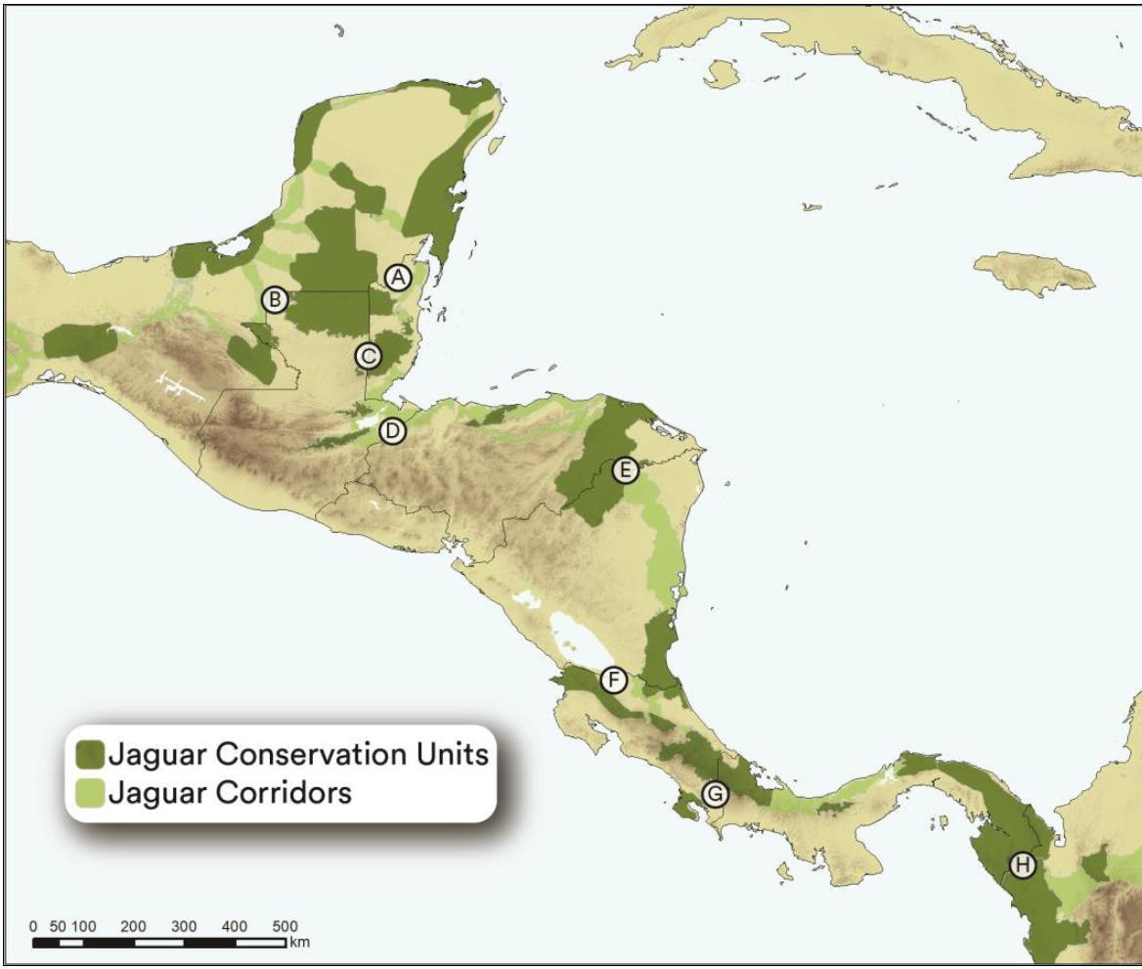
A – Selva Maya (Mexico-Guatemala-Belize) E – Honduras-Nicaragua
B – Montes Azules – Sierra del Lacandón F – The Cerro Silva-Indio Maiz-Tortuguero
C – Maya Mountains, Belize-Guatemala G – Talamanca Cordillera Central
D – Guatemala-Honduras H – Darien, Panama-Colombia border

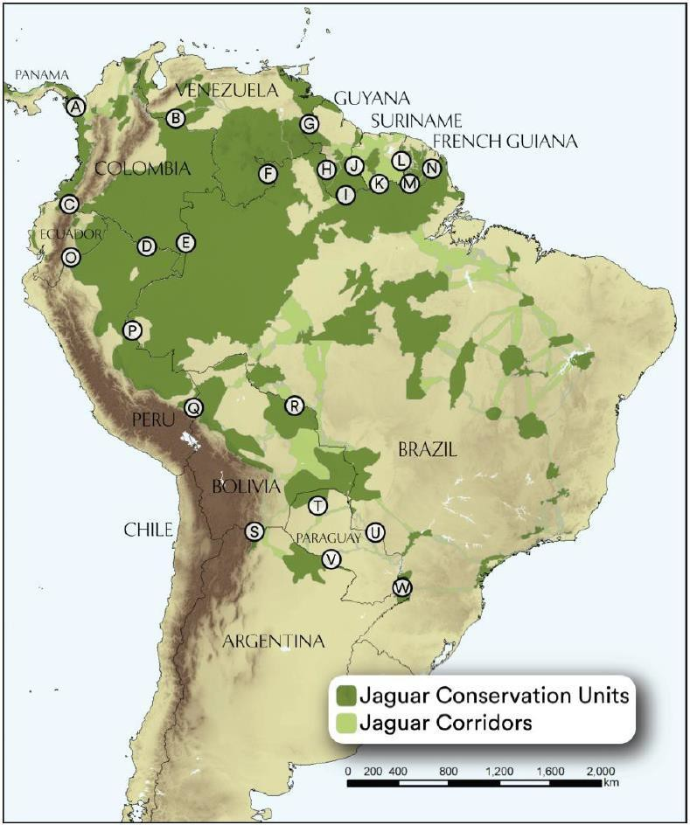
A – Darien, Panama Colombia border P – Peru-Brazil
B – Colombia-Venezuela border Q – Greater Madidi-Tambopata Landscape – Yungas – Amboro National Park
C – The Southwestern Colombia-Ecuador border R – Noel Kempff
D & E – The northern Amazon, Colombia-Peru-Brazil S – Chaco and Yungas
F & G – Eastern Venezuela T – Bolivia-Paraguay-Brazil border H, I, K & M – The northern Guyana shield U – Paraguay-Brazil border
J, L & N – Guyana-Suriname-French Guiana borders V – Paraguay-Argentina border
O – Ecuador-Colombia-Peru W – Paraguay-Brazil-Argentina border

Annex III – Threats to the Jaguar as identified in other over-arching strategic plans (see Appendix II)

The problem analysis, hence the identification of threats, underlaying causes and drivers, and constraints to the conservation of a species is an important exercise to define the Objectives of a Conservation Strategy or Regional Action Plan (see IUCN SSC Guidelines for Species Conservation Planning). Such exercise was not possible for drafting this document, but some documents refer to the threats. Two range-wide strategic documents have been consulted for the definition of the Objectives, the Jaguar 2030 Conservation Roadmap for the Americas and the Regional Conservation Strategy for the Jaguar in South America.

The Jaguar 2030 Roadmap presents a short narrative about general threats range-wide including their drivers, plus the main threats per country in the country profiles. Overall, habitat loss and fragmentation were identified as the main threat, which is driven by unsustainable agriculture and cattle ranching as well as by large-scale infrastructure development. Direct killing is the second most important threat. This is driven by actual or suspected livestock depredation, and by fear of attacks on people. Additionally, sport and trophy hunting still exist and appear to be increasing due to demand for jaguar parts for trade. Jaguars are also threatened by vehicle-jaguar collisions. See compilation in Table 1.

The Regional Conservation Strategy presents threats (but also weaknesses, strengths and opportunities) ranked according to their importance. Habitat loss and direct killing were top ranking. However, the analysis differentiated threats according to their drivers, so that e.g. direct killing simultaneously received the highest possible rating and the lowest possible rating depending on the underlying cause / driver. For direct killing, the highest-ranking drivers were retaliatory killing (livestock, dogs) and trade/trafficking. Meanwhile, direct killing driven by fear / preventative / casual received the second-highest ranking, whilst direct killing for sustenance / trophy received the lowest ranking and was basically not considered a threat. The highest-ranking drivers for habitat loss are related to human expansion into natural habitats, including infrastructure, mining, agriculture and ranching. Habitat loss driven by fire, unsustainable logging and urban development were ranked lower. Prey base depletion was also identified as a threat, where sustenance and commercial hunting were ranked as higher drivers than the same causes as above (habitat loss and direct killing), and invasive and feral species. Climate change, and civil unrest received the second-lowest ranking.

Table 1. Threats compiled from the Jaguar 2030 Roadmap (Range-wide and per country) and from the Regional Conservation Strategy for South America (South America) per region and Range State.
Threat | Range- | South | AR | BO | BR | BZ | CO | CR | EC | GF | GT | GY | HN | MX | NI | PA | PE | PY | SR | VE
 | wide | America
Habitat | x | x | x | x | x | x | x | x | x |  | x | x | x | x | x | x | x |  | x | x
Killing | x | x | x | x |  | x | x | x |  | x |  |  |  | x | x | x |  | x | x | x
Vehicle | x
Prey |  | x | x* |  |  | x |  | x |  |  | x |  | x |  | x | x | x
Climate |  | x
Unrest |  | x
*Indiscriminate hunting, even in protected areas

The Regional Conservation Strategy for South America also identified Weaknesses (sometimes synonymised with Constraints or Shortcomings). These Weaknesses are summarised in Table 2.

Table 2. Weaknesses identified by the Regional Conservation Strategy for South America. Four independent working groups identified the weaknesses. Consequently, they can have a ranking between 4 (identified as important weakness by all working groups) and 0 (not identified as important weakness by any working group).
Weakness | Ranking | Weakness | Ranking
Poor regulation & law enforcement (presence & prosecution) | 4 | Political instability / Slow political traction / poor governance / poor will | 2
Lack of biological / social science knowledge/information | 4 | Lack of education and awareness and misconception of general public | 2
Suboptimal collaboration between institutions/NGOs | 3 | Lack of suited PAs and proper management of Pas, and PADDD | 2
Limitations to reach decision-makers | 3 | Inadequate resources / investments – limited funding | 1
Corruption | 2 | Lack of biodiversity mainstreaming into different sectors | 1
Poverty/Lack of alternative/sutainable livelihoods and opportunities for people | 2 | Lack of political will | 0
Poor land-use planning | 2 | Poor communication / lack of multidisciplinary cooperation | 0
Inadequate capacity (knowledge, patrol, PA management) | 2

Annex IV – Summaries of the Red List and the Green Status of Species for the Jaguar Panthera onca in the IUCN Red List of Threatened SpeciesTM

Tabea Lanz and Elliot Carlton, IUCN/SSC Cat Specialist Group, with thanks to Molly Grace, IUCN Green Status Working Group and Melissa Arias, ZSL

Note: The Red List – estimating the extinction risk – and the new Green Status of Species – evaluating the recovery status – of a species are important assessment to inform the development of large-scale conservation plans. Both assessments are presently in process by a group of Jaguar experts and are expected to be published end of 2025. We summarise here the 2017 Red List Assessment (RLA; Quigley et al. 2017) and a preliminary Green Status of Species assessment (GSS; Carlton 2024).

The IUCN Red List of Threatened SpeciesTM, known as the IUCN Red List, has been established in 1964 and is the world’s most comprehensive inventory of the global conservation status of plant, fungi and animal species (IUCN 2019). The IUCN Red List assesses the extinction risk of a taxon based on a comprehensive, objective and scientifically rigorous approach (IUCN Standards and Petitions Committee 2024). The goal of the IUCN Red List is to inform and catalyse action for biodiversity conservation and policy change. It aims to convey the urgency and scale of conservation problems to the public and policy makers, and to motivate the global community to reduce species extinctions (IUCN 2019). To evaluate the extinction risk of taxa, the IUCN Red List uses five Criteria to classify them into one of nine Red List Categories (Fig. 1; IUCN 2012).

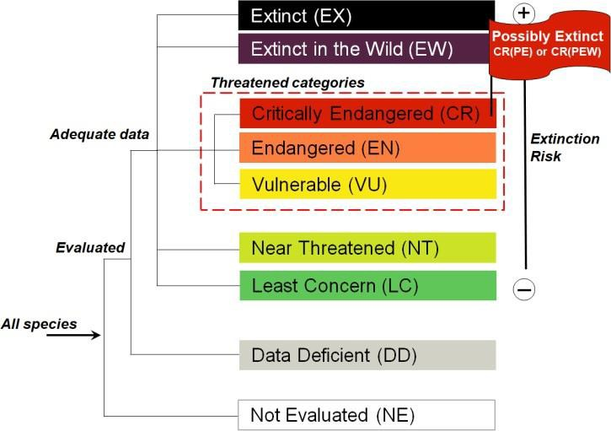

Fig. 1. The nine IUCN Red List Categories. Species which were never evaluated against the IUCN Red List Categories and Criteria are labelled as NE, for species where very limited data is available and where it is not clear if they classify for LC or CR are DD. Species with a low risk of getting extinct in the near future are classified as LC, species that nearly meet the threatened Categories are NT, species with a high risk of getting extinct in the near future are classified as VU, with a very high risk of getting extinct as EN and with an extremely high risk of getting extinct in the near future as CR. When individuals of a species only remain in captivity they are classified as EW, if all individuals have gone and nowhere the species is existing it is EX (IUCN Standards and Petitions Committee 2024).

The IUCN Red List has a strong scientific base. Assessments are done by the world’s leading species experts and go through a thorough review process before publication. The IUCN Red List is not just a list of taxa and does not only evaluate the extinction risk of a taxon but also provides important background information and analyses on the status of the taxon in a global or regional perspective such as on its range, population size and trend, habitats and ecology, use and trade, threats and conservation actions (IUCN Standards and Petitions Committee 2024). It establishes a baseline from which to monitor the future status of a taxon. The periodic assessment process for the IUCN Red List is important to identify improvements and aggravations of a taxon's situation. In this regard, the IUCN Red List helps to define the most urgent conservation measures for a taxon and is widely used to inform and influence biodiversity conservation. Ultimately, the IUCN Red List informs policy and provides information to international agreements such as the Convention on Migratory Species (CMS) and the Convention on International Trade in Endangered Species of Wild Fauna and Flora (CITES; IUCN Standards and Petitions Committee 2024).

The IUCN Red List assessments of the Jaguar (Panthera onca)

The Jaguar (Panthera onca) has already been assessed eight times for the IUCN Red List of Threatened SpeciesTM. In the first four evaluations, the Jaguar was assessed as Vulnerable (1982, 1986, 1988 and 1990). In 1996 it has been down-listed to Near Threatened (NT) and stayed NT in the 2002 and 2008 assessment. In the last Red List assessment of 2016 (Quigley et al. 2017), the Jaguar has been re- classified as Near Threatened under the Criteria A2cd in spite of a suspected population decline of 20– 25% over the past three generations (21 years) based on declines in area of occupancy, extant of occurrence and habitat quality, together with actual or potential levels of exploitation (Fig. 2a, b)

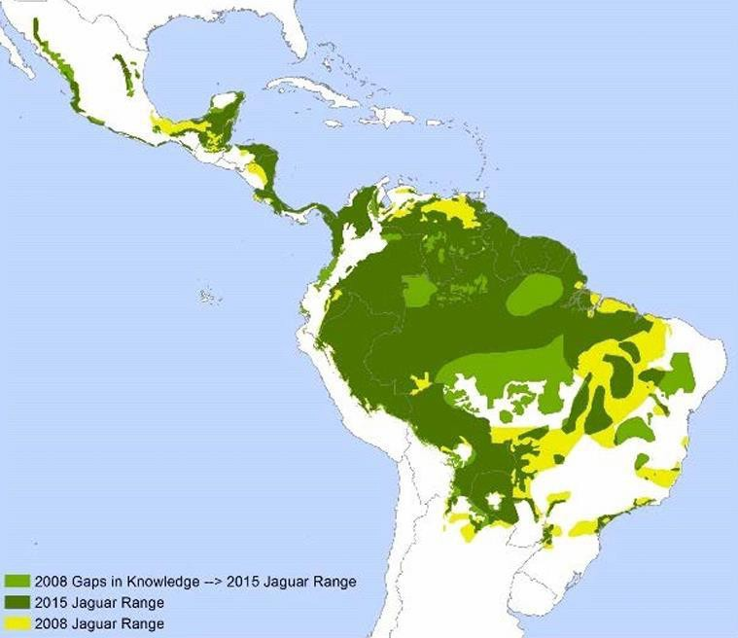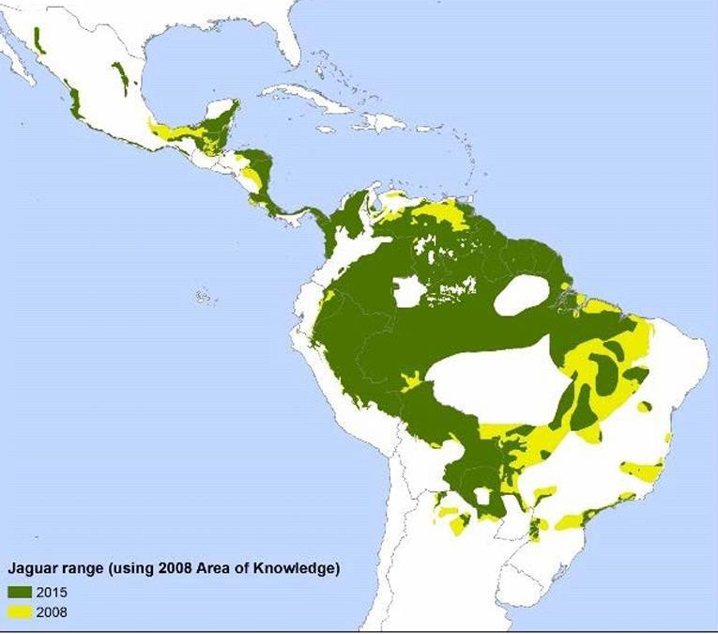

Fig. 2a. Comparison of the range of the Jaguar from 2008 and 2015 and identified gaps in knowledge from 2008 (2,006,502 km2).
Fig. 2b. After eliminating gaps in knowledge from the 2008 assessment, there is a documented 20% decline in Jaguar range from 2008 to 2015. (Figures taken from Quigley et al. 2017.)

In most of the range countries, declines in the Jaguar population and habitat loss have been documented and connectivity among Jaguar populations has been lost at local and regional scales. The population trend of the Jaguar has been assessed as decreasing and its population assumed to be severely fragmented. However, the Jaguar is difficult to assess, has low densities and the effects of small population and habitat degradation is unclear. Thus, according to the 2017 assessment, the suspected population decline could have been a significant underestimate and the species could likely qualify for VU again in the near future.

Since 2008, threats to the Jaguar have continued to intensify and there have been indications of increasing fragmentation of Jaguar populations, particularly in eastern and south-eastern Brazil, northern Venezuela and the Maya Forest of Mexico and Guatemala. Beside habitat loss and fragmentation, Jaguar-livestock conflict has been assessed to be a serious threat to the survival of the species across its range in 2016. Additionally, even in nominally protected areas, Jaguars were stated to often suffer from human impacts such as illegal hunting. The stronghold of the Jaguar is the Amazon basin. In much of the drier northern part of its range, in Arizona and New Mexico in the United States and the extreme northern Sonora state in Mexico as well as northern Brazil, the pampas scrub grasslands of Argentina and throughout Uruguay, the Jaguar is virtually extinct. Overall, Jaguars were estimated to only remain in around 51% of its historic range.

Jaguar viability was assessed by Sanderson et al. (2002). For populations in 70% of the Jaguars range (Amazon Basin rainforest and adjacent areas in the Pantanal and Gran Chaco, tropical moist lowland forest in Mesoamerica and a small strip of the Choco-Darien of Panama and Colombia to northern Honduras) a high probability for survival was estimated. In 18% of the Jaguar range (areas adjoining the areas with high chance of survival and including large part of the northern Cerrado, most of the llanos in Venezuela and Colombia, the northern part of the Colombian Caribbean coast, highlands of Costa Rica and Panama, southern Mexico and Sierre de Taumalipas and Sierra Madre Oriental) populations were estimated to have a medium probability of long-term survival. In 12% of the range (Atlantic Tropical Forest, Cerrado of Brazil, parts of the Chaco in northern Argentina, the Gran Sabana of northern Brazil, Venezuela and Guyana, parts of coastal dry forest in Venezuela and remaining range in Central America and Mexico), Jaguar subpopulations were estimated to have a low chance of survival and to be of high conservation concern.

Jaguar densities were estimated at 0.75 to 6 adults per 100 km² in Mexico. The Jaguar population in the Selva Maya in Yucatan Peninsula (Mexico) was estimated at 2,000 individuals, in the greater Lacadona Ecosystem in southern Mexico, Jaguar population was estimated at 62 to 168 individuals within protected areas. Mexico’s national Jaguar census estimated 4,000-5,000 individuals in 2011. In the northern and central areas of Mexico Jaguars were becoming increasingly isolated and disappearing where they were previously detected.

In Central America Jaguar densities ranged from 0.74 to 11.2 per 100 km² and was found to be declining across the human-influenced landscape. The Talamanca Mountains of Costa Rica and Panama support a Jaguar population but the probability of long-term persistence was assessed as medium to low. Furthermore, Jaguar populations in protected areas in Guatemala, Honduras and Nicaragua were evaluated to be under great pressure from deforestation and hunting.

In South America Jaguar density in the Brazilian Pantanal reached from 6.6 to 11.7 per 100 km². In the Bolivian Amazon 2.8 per 100 km², and in the Colombian Amazon 4.5 and 2.5 per 100 km². In the Savannas of the Brazilian Cerrado density was 2 individuals per 100 km², 3.5 per 100 km² in the semiarid scrub of the Caatinga, 2.2 per 100 km² in the Atlantic Forest and 2.2-5 Jaguars per 100 km² in the Bolivian Gran Chaco. The Atlantic forest subpopulation in Brazil was estimated at 200 +/- 80 adults. Jaguar populations in the Chaco region of northern Argentina and Brazil and the Brazilian Caatinga showed low-density and were assessed to be highly threatened by livestock ranching and related persecution.

Across the Jaguar range, 34 subpopulations were identified by de la Torre et al. (2017). 97% met the criterium for Critically Endangered (25 subpopulations) or Endangered (8 subpopulations). The large Amazonia subpopulation, estimated to hold 89% of the total species population (57,000 out of 64,000), was the only one assessed as Least Concern (Fig. 3).

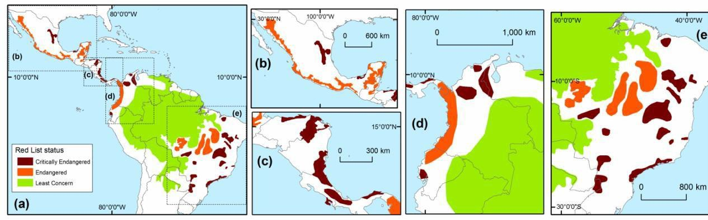
Fig. 3. Red List Categories of Jaguar subpopulations according to de la Torre et al. (2017); (a) throughout the Jaguars range, (b) in Mexico, (c) in Central America, (d) in northern South America and (e) in southern Amazonia (Figure taken from Quigley et al. 2017).

Main threats to Jaguar populations identified in 2016 were habitat loss and fragmentation, killing for trophies and illegal trade in body parts and pro-active or retaliatory killings associated with livestock depredation and due to competition for wild meat with human hunters. Fragmentation and displacement were stated to lead frequently to a reduction in Jaguar and prey densities in leftover forest patches due to easier access by humans and Jaguars feeding on the replaced livestock, enhancing Jaguar-livestock conflict. Generally, the increasing human population is threatening the Jaguar by leading to more habitat loss and fragmentation and making wildlife easier accessible for hunting. Persecution is another big problem and only few areas within the Jaguar range could be considered to be safe. There is still a demand for Jaguar paws, teeth and other products, especially in local markets. Jaguars are also considered a replacement for tiger bone for traditional medicine purposes by the increasing Asian community in Latin America.

Although the Jaguar is fully protected at the national level across most of its range, is included in CITES Appendix I and specific conservation plans have been developed in several Range States (Appendix II), there is a need for further conservation actions. Jaguars have lost about 49% of their historical geographic range and are considered extinct in El Salvador, Uruguay and the United States. Jaguar population declines and habitat loss were documented for most of its range countries and connectivity among Jaguar populations has been lost at local and regional scales. Connectivity of Jaguar habitat, for example, has almost gone between Honduras and Guatemala, similar gaps have been documented across the Chaco Iguazu and Atlantic Forest, and between Tamaulipas and Veracruz. Additionally, corridors connecting Jaguar subpopulations lie mostly outside of protected areas making them even more vulnerable to human impacts. Many Jaguar populations require improved connectivity between core sites to survive in the long term. Evidence of little genetic differences among Jaguar populations further suggests that maintaining connectivity across the range is important. There is also a need for improved habitat protection, enhanced area and trade management, awareness raising, improvement of legislation at national and sub-national level and improved livestock management and compensation schemes. Better surveillance is needed regarding Jaguar population size and trend as well as the distribution and habitat trends, threats and trends in trade. More research is recommended regarding Jaguar life history and general ecology.

Important conservation actions conducted so far include reduction of Jaguar-livestock conflicts by improving livestock management practices and responding to reports of livestock depredation, further research to understand and address the hunting of Jaguar prey, awareness raising regarding the laws governing the hunting of wildlife and the necessity to adopt sustainable hunting practices, monitoring and safe-guarding Jaguar core populations (Jaguar Conservation Units (JCU); see Appendix III), maintaining of national and regional connectivity between populations by identifying Jaguar corridors between the JCUs and conserving them, as well as the development of national, regional and local monitoring programmes for Jaguars and their prey.

The IUCN Green Status of Species assessment of the Jaguar (Panthera onca)

The IUCN Green Status of Species (GSS) provides a standardised assessment of recovery status, complementing the Red List to provide a more complete picture of a taxon’s status and incentivise more ambitious conservation goals (IUCN GSSWG 2024).

The GSS has two main goals: (1) to assess recovery status and (2) to assess conservation impact. To assess current recovery status, the GSS considers viability, spatial representation, and ecological functionality to calculate a Species Recovery Score and Category including the following steps (IUCN GSSWG 2024):
  - Determination of the indigenous range (distribution of taxon in the absence of human impacts, informed by historical and current distribution).
  - Division of the indigenous range into spatial units (subdivisions of the entire indigenous range, e.g., based on genetic or ecological divisions).
  - Assessment of the recovery status at the level of spatial units. Spatial units can be assigned one of four states: Absent (extinct or extirpated from the spatial unit), Present (the taxon is assessed as either threatened or Near Threatened with continuing decline under the regional Red List criteria in the spatial unit; IUCN 2012), Viable (the taxon is assessed as either Least Concern or Near Threatened with no continuing decline under the regional Red List criteria in the spatial unit; IUCN 2012), and Functional (the taxon is Viable and the taxon is fulfilling ecological functions at baseline levels across a majority of the spatial unit).
  - The states are weighted and based on this the Species Recovery Score (SRS) is calculated, and Species Recovery Category defined (ranging from 0% = Extinct in the Wild, to 100% = Fully Recovered or Non-Depleted; Fig. 4).

Under the GSS, a taxon is described as “Fully Recovered” if it is both Viable and Functional at baseline levels across its indigenous range. Within the GSS framework we can also assess the past and expected future impact of conservation by assessing the recovery status under several hypothetical scenarios;

(1) counterfactual: hypothetical present status of the taxon if there had been no past conservation actions, (2) future-without-conservation: status in 10 years’ time if all conservation actions were halted today, (3) future-with-conservation: expected status in 10 years’ time given all planned conservation actions, and (4) long-term aspirational: potential status of the taxon in 100 years’ time if all possible conservation actions are implemented. The scores calculated under these scenarios are compared to the current SRS to calculate the four Conservation Impact Metrics: Conservation Legacy (the past impact of conservation), Conservation Dependence (the expected short-term impact of halting conservation), Conservation Gain (the expected short-term impact of planned conservation actions), and Recovery Potential (an aspirational recovery target for the next 100 years; Fig.4). The outputs of the GSS are published alongside the Red List of the corresponding taxa and together these provide important inputs regarding conservation planning and definition of priority conservation actions to enhance the recovery of taxa.

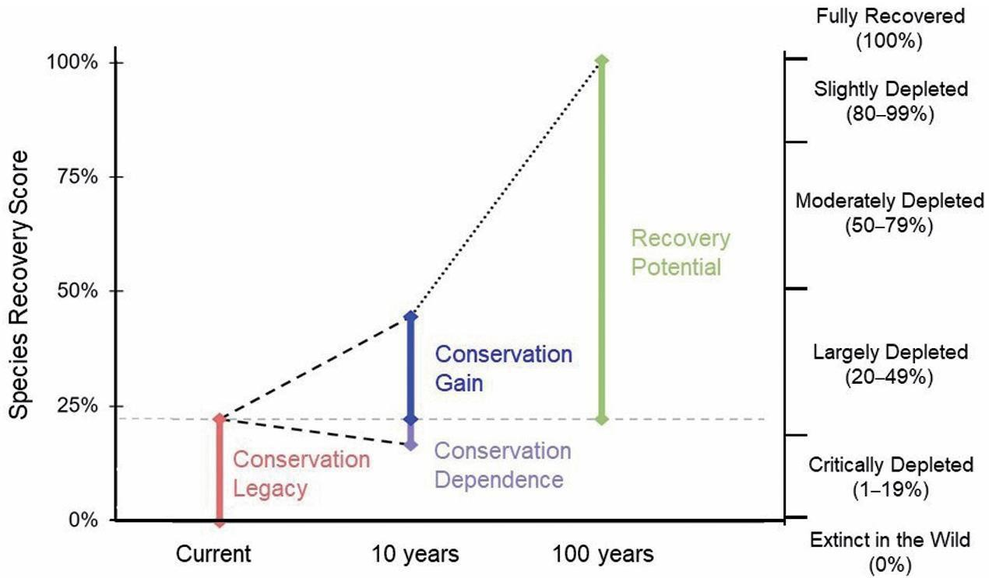
Conservation Impact Metrics for the Iberian Lynx, Lynx
Fig. 4. The four conservation impact metrics as calculated for the Iberian lynx (Lynx pardinus). Please note that these are not yet calculated for the jaguar and may take on very different values. The Green Score (left y-axis) and Category (right y-axis) are calculated under four hypothetical scenarios. The difference between these Green Scores and the current SRS (represented by the horizontal grey dashed line) gives the Conservation Legacy (pink), Conservation Gain (blue), Conservation Dependence (purple), and Recovery Potential (green; Salcedo et al. 2023).

A preliminary Green Status of Species assessment for the Jaguar (Panthera onca):

A Green Status of Species assessment for the Jaguar has not yet been published. However, a preliminary Green Status of Species assessment of the current recovery status of the Jaguar found the species to be Largely Depleted (Carlton, E. 2024). This preliminary result highlights that whilst the Jaguar is faring well in the Amazon (hence the latest Red List assessment of Near Threatened; Quigley et al. 2017), the species faces regional declines and extirpation across much of its indigenous range. The preliminary GSS assessment (i.e., estimation of the current state in each spatial unit) was conducted as part of master’s research on the GSS using the assessment materials made available by the IUCN Species Survival Commission and mainly based on the last Red List assessment of the species (Quigley et al. 2017). It should be noted that the GSS assessment of the species is not final until it has been reviewed and published on the Red List website.

Historically, the Jaguar ranged from southwestern US, through central America, to as far south as central Argentina (Fig. 5; Panthera 2024). For the preliminary assessment, this historical range was delineated into 10 spatial units primarily based on the 8 Jaguar eco-regions of South America identified by Jędrzejewski et al. (2023b) - with two further spatial units based on the biogeographic regions of the Jaguar 2030 Roadmap (Forum for Jaguar Conservation 2018) representing the Jaguar’s indigenous range in Central and North America (Fig. 5). The Jaguar was assessed as Functional in one spatial unit (Amazon) and Present in all other spatial units given the threatened status of these subpopulations (de la Torre et al. 2018, Jędrzejewski et al. 2023a, Thompson et al. 2023). This resulted in the recovery status being assessed as Largely Depleted. By highlighting regional threats and extirpations the GSS can emphasise the need for continued and intensified conservation action for the recovery of the species. This is particularly important as regional declines and extirpations of Jaguar also means the loss of critical ecosystem functions. Alongside an updated Red List assessment, species experts will do a GSS assessment for the Jaguar. The completed assessment will provide important information on the species’ current recovery status. The Conservation Impact Metrics (which are not yet assessed within the preliminary assessment) will also provide information on the past, expected, and potential future impact of conservation on the status of the species.
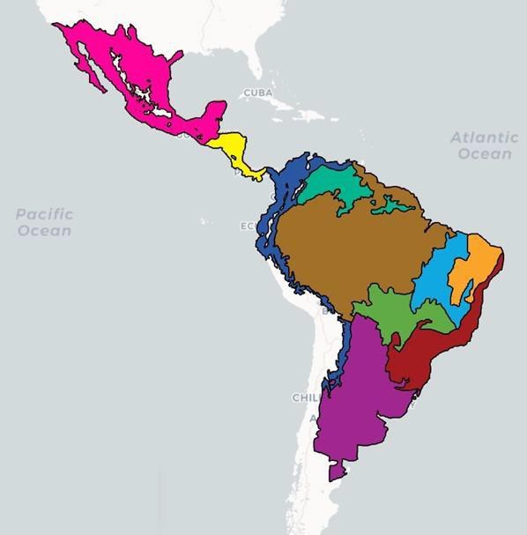

Fig 5. Rough sketch of preliminary spatial units – adapted from historical range map taken from Panthera website (Panthera 2024), with spatial units primarily based on the Jaguar eco-regions identified by Jędrzejewski et al. (2023b); Pink: North America, Yellow: Central America, Dark Blue: Andes, Dark Green: Los Llanos and Guiana Highlands, Brown: Amazon, Light Blue: Cerrado East, Orange: Caatinga, Light Green: Cerrado West and Pantanal, Red: Atlantic Forest, Purple: Gran Chaco, Patagonia, and Pampas.

References

Carlton, E. (2024). Drivers of Recovery Status in Wild Canids and Felids [Unpublished master’s dissertation]. University of Oxford.
de la Torre, J. A., González-Maya, J. F., Zarza, H., Ceballos, G., & Medellín, R. A. (2018). The jaguar’s spots are darker than they appear: Assessing the global conservation status of the jaguar Panthera onca. Oryx, 52(2), 300–315. https://doi.org/10.1017/S0030605316001046
Forum for Jaguar Conservation. 2018. Jaguar 2030 – Conservation Roadmap for the Americas. Report, 91 pp.
IUCN GSSWG (Green Status of Species Working Group). (2024). Background and Guidelines for the IUCN Green Status of Species. Version 2.0. Prepared by the Green Status of Species Working Group. Downloadable from https://www.iucnredlist.org/resources/green-status-assessment-materials
IUCN Standards and Petitions Committee. 2024. Guidelines for Using the IUCN Red List Categories and Criteria. Version 16. Prepared by the Standards and Petitions Committee. Downloadable from https://www.iucnredlist.org/documents/RedListGuidelines.pdf.
IUCN. 2012. IUCN Red List Categories and Criteria: Version 3.1. Second edition. Gland, Switzerland and Cambridge, UK: IUCN. iv + 32pp
IUCN. 2019. Preventing extinction and advancing the recovery of species using The IUCN Red List of Threatened Species. The IUCN Red List 2021-2030 Strategic Plan. 11 pp. Available at: https://nc.iucnredlist.org/redlist/resources/files/1630480299- IUCN_Red_List_Strategic_Plan_2021-2030.pdf
Jedrzejewski, W., Maffei, L., Espinosa, S., Wallace, R., Negrões Soares, N., Morato, R., Tobler, M., Ayala, G., Ramalho, E., Payan, E., Hoogesteijn, R., González-Maya, J., Viscarra, M., Ferraz, K., Portugal, M.,
Parra, A., Polisar, J., Breitenmoser, C., & Breitenmoser, U. (2023a). Jaguar conservation status in north-western South America. Cat News Special Issue 16, pp.23-34.
Jedrzejewski, W., Morato, R., Negrões Soares, N., Wallace, R., Paviolo, A., Angelo, C., Thompson, J., Paemelaere, E., Hallett, M., Berzins, R., Tortato, F., Espinosa, S., Payan, E., Parra, A., Ouboter, P., Kadosoe, V., Quiroga, V., Tobler, M., Ferraz, K., & Abarca, M. (2023b). Estimating species distribution changes due to human impacts: The 2020’s status of the jaguar in South America. Cat News Special Issue 16, pp.44-55.
Panthera. (2024). Jaguar. https://panthera.org/cat/jaguar Accessed on 13 November 2024.
Quigley, H., Foster, R., Petracca, L., Payan, E., Salom, R. & Harmsen, B. 2017. Panthera onca (errata version published in 2018). The IUCN Red List of Threatened Species 2017: e.T15953A123791436. https://dx.doi.org/10.2305/IUCN.UK.2017-3.RLTS.T15953A50658693.en. Accessed on 28 October 2024.
Salcedo, J., Garrote, G., López, G., Rodríguez, A., López, M., Carlton, E., Lanz, T. & Breitenmoser,
U. (2023). Lynx pardinus (Green Status assessment). The IUCN Red List of Threatened Species 2023: e.T12520A1252020242. Accessed on 14 November 2024.
Sanderson E.W., Redford K.H., Chetkiewicz C.B., Medellin R.A., Rabinowitz A.R., Robinson J.G. & Taber
A.B. 2002. Planning to save a species: the jaguar as a model. Conservation Biology 16(1), 58.
Thompson, J., Paviolo, A., Jedrzejewski, W., Tortato, F., de Bustos, S., Reppucci, J., Perovic, P., Negrões Soares, N., Romero-Muñoz, A., Cruz, P., Foster, V., Velilla, M., Srbek-Araujo, A. C., Campos, C., Breitenmoser, U., Breitenmoser, C., & Angelo, C. (2023). Jaguar status, distribution and conservation in south-eastern South America. Cat News Special Issue 16, pp.35-43.

Annex 2

PROPOSED AMENDMENTS TO RESOLUTION 14.14

NB. Proposed new text is underlined. Text to be deleted is crossed out.

CMS JAGUAR INITIATIVE (Panthera onca)

Recognizing Acknowledging that the Jaguar (Panthera onca) has been declared an emblematic species in the Americas given due to its importance for conservation the maintenance of natural landscapes and ecosystem functionality, as well as for representing a spiritual and cultural icon of for many people throughout its distribution range, and as a symbol of the fight against the illegal wildlife trade of wildlife (Lima Declaration, 2019),

Recognizing document UNEP/CMS/COP13/Doc.27.1.2, which attests to proposes the inclusion of the jaguar in Appendices I and II of the Convention on the Conservation of Migratory Species of Wild Animals (CMS), and Article IV, paragraph 4 of the Convention,
Recognizing all decisions taken in under the Future Structure process framework (including all activities listed in Resolution 10.9 (UNEP/CMS/COP11/Doc.16.1)), wherein the which urges Parties are urged to "identify any opportunities for cooperation and coordination at the local and regional /national-levels cooperation/coordination through the by creating synergies on of based on geography-based synergies", and to "seeking opportunities to develop build synergistic or geography-based relationships or species groupings (either geography or species grouping-based)", such as is the case with the development of a common conservation programme,

Concerned by the studies concluding that, in despite of the persistence tly of a large jaguar sub-population in the Amazon, 33 of the 34 jaguar sub-populations meet the criteria for the categories Endangered or Critically Endangered categories, due to their small size, isolation, deficient poor protection, and high density of human population density in the surrounding areas,

Recognizing Acknowledging the significance importance of collaboration among between the jaguar Range States in order to implement carry out actions favoring that promote the connectivity and feasibility viability of jaguar populations and the obligation to endeavour to reach conclude cooperation agreements for the transboundary rder conservation of migratory species (Appendix II, CMS), and

Considering the 2030 Jaguar 2030 Roadmap as a broad effort that seeks to unite 16 governments of countries in the jaguar’s range, non-governmental and /inter-governmental organizations, local communities, and the private sector with the aim purpose of establishing a jaguar corridor in the countries of the species' range distribution area, securing ensuring that there are 30 priority landscapes by 2030,

Taking note of the results of the XXIV Forum of Ministers of Environment of Latin America and the Caribbean, which recognize that working at a regional level with keystone emblematic species, such as the jaguar, is an opportunity for the convergence of multiple environmental agendas and commitments related to biodiversity conservation, ecosystem and landscape restoration, and climate action, and

Welcoming the agreement on the Regional Action Plan for Jaguar Conservation at the second meeting of jaguar Range States, held in Mexico City in September 2025, as a strategic framework for guiding coordinated action, and underlining the importance of an intergovernmental platform as a regional support mechanism for its implementation and follow-up, as well as for the operation of the modular system for monitoring the illegal killing and trade of jaguars and their parts through information sharing, technical cooperation and the coordination of joint actions,

The Conference of the Parties of the
Convention on the Conservation of Migratory Species of Wild Animals

- Recognizes Acknowledges that the Jaguar (Panthera onca) needs requires concerted conservation efforts of regional conservation, including community knowledge and community awareness, due to habitat loss and growing increasing fragmentation of its range and habitat, and increased poaching and trafficking in of jaguars and their parts, which. This more most severely affects endangered, and isolated sub-populations;

- Encourages jaguar Range States that are Parties to CMS Establishes the CMS Jaguar Initiative (Initiative) as the framework to strengthen foster coordination and cooperation between all CMS Jaguar with other Range States, in order to enable joint action for conservation of the species and its habitat;

- Recommends all CMS Party Range States and invites non-Party Range States (including all CITES Parties in the Jaguar range) to officially join this Initiative, with the aim of creating a Joint CITES-CMS Jaguar Initiative, allowing greater to strengthen their cooperation in view of the threats faced by the jaguar, and the deterioration of the such as habitat degradation and illegal trade;

- Agrees to implement actions that the objective of the Initiative consists of to maintaining the integrity of large, medium and /mid-sized/ small jaguar populations throughout their range along its distribution and connectivity between them each other and between transboundary populations, taking into account considering the needs of and livelihoods means of support to of local communities that coexisting with the jaguar;

- Acknowledges that cooperation among jaguar Range States is important the Initiative is a tool for, inter alia:
- coordinating regional efforts and plans for the jaguar conservation of the Jaguar in order with a view to leveraging e synergies and avoiding duplication of activities and related costs associated expenses;
- strengthening a coordinated approach to improve knowledge regarding the jaguar, particularly to better understand movement patterns of individuals;
- leveraging funding financing opportunities and generating resources for the jaguar conservation of the Jaguar;
- supporting and expanding sub-national, /national, and regional jaguar conservation programmes, prioritizing those with a holistic and inclusive approach; and
- creating spaces and systems to exchange experiences and standardized information related to regarding the Jaguar and the any threats it faces thereto;
- increasing the interest of non-Party countries to work with CMS Parties in Jaguar conservation efforts, laying the foundations to unify said efforts through the Joint CITES – CMS Jaguar Initiative;
5bis. Encourages Parties to implement the Regional Action Plan for Jaguar Conservation, particularly the aspects that strengthen the implementation of the present Resolution;

5ter. Notes the importance of moving forward quickly with priority actions for jaguar conservation related to the CMS mandate, such as habitat conservation and restoration, ecological connectivity, addressing interactions and promoting coexistence between humans and wildlife, given that the greatest threats to jaguar conservation are the destruction and fragmentation of its habitat;

- Calls on CMS jaguar Range States to undertake efforts to: Agrees that the Initiative shall focus on:
- create ing and strengthening strategic alliances and bilateral or /regional agreements for jaguar conservation (including transformation of this Initiative into a Joint CITES-CMS Jaguar Initiative), in line with the 2030 Jaguar Roadmap with its respective Work Programme;
- prepare ing proposals and materials that facilitate fundraising enabling funding for the conservation of the species, and analyzing potential mechanisms for the optimal use of funds and capacities of the Initiative, and through the creation of a Jaguar fund;
- defining the current distribution, based on per the available knowledge about on the species according to per state of its geographical range, with prioritizing ation of significant important transboundary transborder areas, connectivity corridors, and a core area for the preservation of the species in order to promote all other management measures to be developed species preservation hub to feed all other handling steps to be developed;
- preparing develop and implementing jaguar conservation strategies with a view in order to addressing threats to its their survival—especially in view of particularly illegal trade in jaguars and their illegal parts, poaching, and or retaliation for due to human conflicts with humans, and loss of habitats, prey dams, and connectivity;
- adopting implement measures actions that enable allow and ensure connectivity between jaguar populations (including the creation and official designation of biological corridors), as well as effective management handling of protected areas, indigenous territories, and other effective area-based conservation measures action;
- promote ing coexistence between jaguars, indigenous peoples and local communities through efforts for changing behaviors, and the adoption of productive practices and livelihoods that respect the jaguar-friendly means of support — especially in priority areas zones for connectivity and for the reducing tion of hunting and /trafficking;
- developing strengthen the capacities y of Range States to handle the for conservation, management, monitoring, assessment and enforcement of species-related legislation law, creating, reviewing and updating national conservation plans, and other strategies and legal frameworks, as necessary required;
- improve ing education and awareness of indigenous people, local communities and the general public about overall population on the state of conservation status and any threats to the jaguar;
- widening all expand efforts to assess evaluate the state of local/regional conservation status of jaguar populations and any trends thereof over time - especially of shared/transboundary border populations, and to monitoring any threats thereto;
- fostering promote and enabling communication and information exchange of information between Range States, and other stakeholders for the species conservation of the species, (including generation the development of standardized systems for data the collection and analysis of data on jaguars and the threats they face thereof);
- adopt or amend existing legislation and regulations necessary to conserve and restore the jaguar's habitat and ecological corridors;
- adopt legislation that provides for custodial sentences, and not just civil penalties, for crimes related to jaguars;
- strengthen judicial capacity to support the effective prosecution of jaguar killing and trafficking;
- develop and improve regular monitoring programmes to assess the presence/absence of jaguars, population size, population density, population trends, habitat quality (e.g. land cover, prey availability, habitat connectivity) and threats at all levels (local, regional, national, range area), with the aim of developing direct conservation actions, incorporating the participation of Indigenous Peoples and local communities in data collection, data sharing agreements and analysis;
- take into consideration the cultural and land-use perspectives of Indigenous Peoples and local communities that are compatible with species and habitat conservation actions, and proactively engage with them in jaguar conservation initiatives (at local, national and regional levels);
- implement strategies to restore degraded areas in jaguar habitats and promote sustainable production practices compatible with jaguar conservation;
- promote population management that results in the reintroduction of jaguars into suitable areas of their original range where the species no longer occurs and the repopulation of areas with critical population status, ensuring that animal welfare considerations are taken into account;
- collaborate with civil society and academic institutions to support research, training, education, habitat conservation and community monitoring, and promote coexistence and address interactions with jaguars;
- work with productive and economic sectors to include specific actions aimed at jaguar conservation in their policies, promoting coexistence, ecosystem connectivity and sustainable development;
- create and utilize incentives for jaguar conservation, such as jaguar-based ecotourism or photographic safaris, with ethical and safe practices that respect the natural behaviour of the species and the ecological integrity of its habitats;
- analyze interactions between humans and jaguars to support Indigenous Peoples and local communities in implementing mitigation and economic compensation measures to promote coexistence;
- establish and train response teams designed to promote the prevention and reduction of negative interactions in situ;
- prohibit non-essential interactions between humans and captive jaguars, domestic (or private) cohabitation with jaguars, or their interaction with tourists in ex situ conservation programmes;
- curb the dissemination on social media of digital content that promotes or advertises human interaction with jaguars in a manner inconsistent with the animal's natural behaviour, and promote a positive attitude towards in situ conservation.

- Agrees that the Initiative shall be implemented through a Programme of Work considering concrete actions framed by clear objectives and quantifiable goals;

- Requests the Secretariat to hold regular meetings of the Range States with the objective of evaluating the implementation of the Programme of Work, as required, and supervise the Initiative's functionality;

8bis. Requests that the CMS Secretariat work closely with the CITES Secretariat, CBD, UNEP and other appropriate entities to facilitate enhanced collaboration among all jaguar Range States, international organizations and partners on measures to address jaguar management and conservation, including convening meetings of all jaguar Range States and other entities to, inter alia, review and update priorities, exchange information, and identify gaps and opportunities;

- Encourages Parties, all 2030 Jaguar Roadmap partners, intergovernmental, non-governmental organizations, and other institutions, communities, donors and individuals involved in linked to the conservation of the Jaguar to contribute to the Initiative's objectives, and to support the Initiative the implementation of this Resolution by providing human/financial/technical resources; and

- Requests the CMS Secretariat to report on the implementation of this Resolution to each meeting of the Conference of the Parties, as appropriate.

ANNEX 3

DRAFT DECISIONS

JAGUAR

Directed to Parties

15.AA Parties, especially jaguar Range States, are encouraged to:

  - implement the Regional Action Plan for Jaguar Conservation agreed at the second jaguar Range States meeting (Mexico, September 2025), with a focus on the following areas:

    - identify and prioritize important conservation areas, habitats and ecological corridors for jaguar (Priority Landscapes for Jaguar Conservation) and its wild prey species (including transboundary), and define respective conservation measures, including infrastructure mitigation;

    - recover populations and reintroduce jaguars and wild prey species in key/priority areas within the historical range;

    - understand, prevent and mitigate negative human–jaguar interactions and promote coexistence, and prevent, combat and reduce illegal killing of jaguars and illegal domestic and international trade;

    - strengthen national legal frameworks for jaguar conservation, its habitats and migration routes, including by participating in the CMS National Legislation Programme; and

    - establish innovative, sustainable and long-lasting finance mechanisms, including by mobilizing funding from relevant international financial institutions, public and private funding sources;

- participate in and support the work of the intersessional working group under the CITES Standing Committee, if established under CITES Decision 20.CC;

- finalize and operationalize a governing mechanism for range-wide jaguar conservation, as well as a monitoring system for the illegal killing and illicit trade of jaguars; and

- identify areas for support from the Secretariat in the implementation of the Regional Action Plan for Jaguar Conservation.

Directed to the Secretariat

15.CC The Secretariat shall, subject to the availability of resources,

- identify relevant activities in the Regional Action Plan for Jaguar Conservation that may be carried out in collaboration with the Secretariat of CITES and incorporate them in their next CMS–CITES Joint Programme of Work,

- provide support to Range States in implementing the Regional Action Plan for Jaguar Conservation in collaboration with relevant partners, such as the members of the 2030 Jaguar Roadmap Committee and the IUCN Human-Wildlife Conflict and Coexistence Specialist Group;

- convene meetings among Range States to support the identification of transboundary Priority Landscapes for Jaguar Conservation, associated conservation measures and mechanisms that ensure long-term and sustainable cooperation;

- work with Range States and partners towards the establishment of a range-wide network of jaguar habitat, connected through corridors; and

- participate in the intersessional working group under the CITES Standing Committee, if established, and contribute to the finalization of a governing mechanism for range-wide jaguar conservation, as well as a monitoring system for the illegal killing and illicit trade of jaguars.

IUCN’s Guidelines for Species Conservation Planning: “An overarching Vision outlines, in an inspirational and relatively short statement, the desired future state for the species.” The timeline for a large mammal may be 30-50 years.
IUCN’s Guidelines for Species Conservation Planning: The Goal is a practical, concrete step that contributes directly to achieving the Vision. The timeline is 5-10 years.
Consider the Outcomes of the Meeting of Jaguar Ranges States in Cuiabá, Brazil, and the initiated work by the Jaguar 2030 Roadmap Coordination Committee.
E.g. working through the Conventions (Multilateral Environmental Agreements MEAs), through regional agreements (e.g. Amazon Cooperation Treaty), and data sharing agreements.
See CITES SC74 Doc. 75, Annex 2
See Jaguar 2030 Roadmap Chapter 4: Transboundary profiles
See also Kretser, H. E., Nuñez-Salas, M., Polisar, J., & Maffei, L. (2022). A Range-Wide Analysis of Legal Instruments Applicable to Jaguar Conservation. Journal of International Wildlife Law & Policy, 25(1), 1–61. https://doi.org/10.1080/13880292.2022.2077406
The Jaguar is also specifically listed in the CMS-CITES Joint Work Programme 2021-2025 (Action B10: “Collaborate on the conservation of Jaguar, taking into account existing mandates, and ongoing efforts and initiatives in the region” (See CITES SC73 Doc 13, Annex 2
Note: in some national assessments, the Jaguar is listed in a higher threat category

