 | CONVENTION ON  MIGRATORY  SPECIES | UNEP/CMS/COP15/Doc.27.3  14 October 2025  Original: English

15th MEETING OF THE CONFERENCE OF THE PARTIES

Campo Grande, Brazil, 23 to 29 March 2026
Agenda Item 27.3

CENTRAL ASIAN MAMMALS INITIATIVE*
(Prepared by the Secretariat)

Summary:

This document reports on progress to implement Decisions 14.167–14.170 and Resolution 11.24 (Rev.COP13) Central Asian Mammals Initiative. It proposes amendments to Resolution 11.24 (Rev. COP13) as well as draft Decisions for adoption.

The revised Resolution 11.24 (Rev. COP13) and draft Decisions would support the achievement of Targets 1.2, 1.3 and 3.1–3.4 and all Targets of Goals 2, 4, 5 and 6 of the Samarkand Strategic Plan for Migratory Species 2024–2032.

*The geographical designations employed in this document do not imply the expression of any opinion whatsoever on the part of the CMS Secretariat (or the United Nations Environment Programme) concerning the legal status of any country, territory or area, or concerning the delimitation of its frontiers or boundaries.

CENTRAL ASIAN MAMMALS INITATIVE

Background

- The Central Asian Mammals Initiative (CAMI) was established at the 11th meeting of the Conference of the Parties (COP11) in 2014 (Resolution 11.24). The overall goal of the initiative is to improve the conservation status of large migratory mammals and their habitats in the wider Central Asian region by strengthening coordination and cross-border cooperation, while addressing major threats. CAMI follows a comprehensive Programme of Work consisting of activities developed to achieve this goal for 17 CMS-listed species across 14 Range States, which is updated at each meeting of the Range States held every six years. CAMI is considered a form of agreement as described under Article V of the Convention and is open to all Range States of CAMI species, whether they are Parties to the Convention or not. Since its establishment, CAMI’s Programme of Work has been updated twice. Activity 29.7 of the Programme of Work 2021–2026 calls for it to be updated in preparation for approval by CMS COP15.

- COP14 also adopted the following Decisions on CAMI:

Decision 14.167 Directed to the Parties

Parties that are CAMI Range States are requested to:

- review the reports, ‘Transboundary Conservation Hotspots for the Central Asian Mammals Initiative’ and ‘Potential for Community-based Wildlife Management of CAMI Species’, to be shared by the Secretariat;
- enhance transboundary cooperation in hotspot areas, as identified by the study, ‘Transboundary Conservation Hotspots for the Central Asian Mammals Initiative’;
- consider adding species newly listed on CMS to CAMI, if they share similar threats and habitats with existing CAMI species and, if needed, propose respective modifications to the current CAMI POW for consideration by the 3rd Meeting of CAMI Range States;
- revise, for adoption by COP15, the CAMI POW for the period 2027-2032, with the aim of streamlining its actions to focus on cross-cutting activities that benefit multiple species and to reflect updated CMS mandates relevant to the region, in alignment with Parties’ commitments to the Global Biodiversity Framework, ensuring that emerging threats such as climate change are understood and included; and
- develop, in cooperation with the CMS Secretariat, and implement a strategy or other actions to promote the use of the various reports and other guidance materials developed under CAMI in relevant organizations, entities and processes.

Decision 14.168 Directed to the Scientific Council

Party-appointed Councillors from the CAMI Region are requested to present the study ‘Transboundary Conservation Hotspots for the Central Asian Mammals Initiative’ and actions taken to promote conservation of selected transboundary hotspots to the Scientific Council at the next meeting of the Sessional Committee.

Decision 14.169 Directed to the Scientific Council

The Scientific Council is requested to:

- evaluate the methodology and findings of the study, ‘Transboundary Conservation Hotspots for the Central Asian Mammals Initiative’, and consider applying them to other regions; and
- considering paragraph 11 of Resolution 11.24 (Rev.COP13) and building on Decision 14.167 (e), advise on relevant forums and dissemination mechanisms to promote the visibility of the findings and recommendations of the study ‘Transboundary Conservation Hotspots for the Central Asian Mammals Initiative’.

Decision 14.170 directed to the Secretariat

The Secretariat shall:

- support Parties in implementing Decision 14.167;
- subject to the availability of external resources, translate the studies, ‘Transboundary Conservation Hotspots for the Central Asian Mammals Initiative’ and ‘Potential for Community-based Wildlife Management of CAMI Species’, into Russian to facilitate their review and endorsement by the concerned Range State Parties;
- share both studies with the Range State Parties for comment, integrate their feedback and make them publicly available;
- subject to availability of external resources, support the effort of the Government of Uzbekistan to conduct a comprehensive feasibility study, including restoration of the prey base, habitat suitability and extension of space available for cheetahs by providing capacity-building and support to fundraising efforts on the reintroduction of cheetah in Uzbekistan using cheetahs and prey base from appropriate sources;
- and report to the Conference of the Parties at its 15th meeting on the progress in implementing this Decision;

Activities of the Secretariat (Decision 14.170)

Review, publish and disseminate the results of the studies, ‘Transboundary Conservation Hotspots for the Central Asian Mammals Initiative’ and ‘Potential for Community-based Wildlife Management in Central Asia’.

- In accordance with Decisions 14.167 (a) and 14.170 (a–c), the Secretariat translated the studies into Russian with in-kind support provided by the Michael Succow Foundation (MSF) and funding from the International Climate Initiative (IKI) of the German Government within the framework of the Central Asian Mammals and Climate Adaptation (CAMCA) project. Drafts were circulated to the National Focal Points of CAMI Range States for feedback, after which both studies were made available on the CMS website under the following titles and links: Transboundary Conservation Hotspots for the Central Asian Mammals Initiative, Potential for Community-based Wildlife Management in Central Asia. In accordance with Decisions 14.170 (a) and 14.167 (e), the Secretariat launched the latter study in a CMS webinar (see also UNEP/CMS/COP15/Doc.28.4).

- Additionally, the CMS Secretariat presented the recommendations of both studies at meetings of Signatories (MOS) to the Memorandum of Understanding (MoU) Concerning Conservation, Restoration and Sustainable Use of the Saiga Antelope (Saiga spp.) (Saiga MOU) and the MOU concerning Conservation and Restoration of the Bukhara Deer (Bukhara Deer MOU), as well as at the 1st Range State meeting on the Implementation and Revision of the International Single Species Action Plan for the Conservation of the Argali (Ovis ammon) and the Technical Workshop for CAMI. Parties also incorporated selected recommendations from the studies into the regional policy instruments developed at these meetings: Work Programme for the Bukhara Deer (2025-2032), Action Plan for the Conservation of the Argali (2024-2032), Medium-Term International Work Programme for the Saiga Antelope (2025-2030) and the draft Work Programme for CAMI 2026-2032 (CAMI WP) found in the Annex of the draft revised Resolution 11.24 (Rev.COP13), which is contained in Annex 1 of this document.

Revision of the CAMI Work Programme

- To support Parties in implementing Decisions 14.167 (b)–(d), the Secretariat organized two meetings to facilitate the revision of the CAMI WP: a technical workshop and the 3rd meeting of Range States to CAMI. The technical workshop was organized jointly with the International Nature Academy (INA) of the German Federal Agency for Nature Conservation (BfN), and with funding from the German Federal Ministry for the Environment, Nature Conservation, Nuclear Safety and Consumer Protection (BMUKN) in May 2025 on the Isle of Vilm, Germany. The workshop brought together CAMI Species Focal Points, representatives of other conventions, NGOs, and some Range State governments representing sub-regions within CAMI. The participants mapped out priority transboundary conservation regions, based on the Hotspots Study, to be included in the CAMI WP, with the aim of focusing transboundary conservation efforts on priority sites. They also finalized a draft WP for consideration at the 3rd Range State meeting to CAMI.

- The 3rd meeting of Range States to CAMI was hosted by the Government of Uzbekistan in June 2025 in Tashkent with funding from the CAMCA project. At the meeting, two new species – the Pallas’ cat (Felis manul) and the Eurasian lynx (Lynx lynx) – were added to CAMI. Participants also reviewed, amended and endorsed the draft CAMI WP 2026–2032, ensuring linkages to the Kunming-Montreal Global Biodiversity Framework. The WP revisions incorporate climate change considerations and include area-specific activities for priority transboundary conservation regions, in line with Decisions 14.167 (c) and (d), and building on the recommendations of the Technical Workshop. The WP timeframe was adjusted from 2027–2032 to 2026–2032, as CMS COP15 will take place in 2026 and not in 2027 as was anticipated when Decision 14.167 (d) was adopted.

- The Secretariat could not identify any external resources to implement Decision 14.170 (d). However, the activity was included in a project proposal to the Kunming Biodiversity Fund, which has reached the second phase of consideration.

Other activities of the Secretariat to implement Resolution 11.24 (Rev. COP13)

Meetings

- The 3rd MOS of the Bukhara Deer MOU was organized by the Secretariat and hosted by the Government of Kazakhstan in Almaty in September 2024, with funding from the CAMCA project. The Signatory States adopted the Work Programme for the Bukhara Deer 2025–2032.

- The Range State meeting on the Implementation and Revision of the International Single Species Action Plan for the Conservation of the Argali (Ovis ammon) was organized by the Secretariat and hosted by the Government of Kazakhstan in Almaty in September 2024, with funding from the CAMCA project. Range States adopted the Action Plan for the Conservation of the Argali 2024–2032.

- Kazakhstan, Turkmenistan and Uzbekistan signed a Memorandum of Cooperation for Wildlife Conservation on the Ustyurt Plateau (Ustyurt MOC), which was developed based on CMS mandates, including those addressing conservation of CAMI and avian CMS-listed species. The process was facilitated by the CMS Secretariat together with Deutsche Gesellschaft für Internationale Zusammenarbeit (GIZ) and MSF. The 1st meeting of Parties to the Ustyurt MOC took place in Astana Kazakhstan, in March 2025, co-organized by GIZ, MSF, the Association for the Conservation of Biodiversity of Kazakhstan (ACBK) and the CMS Secretariat. The meeting developed and endorsed the Roadmap to Ustyurt MOC (2025-2030).

- The 5th meeting of Signatories to the Saiga MOU was organized by the CMS Secretariat and hosted by the Government of Kazakhstan in Astana, in March 2025, with funding from the International Bustard Conservation Foundation (IBCF), the United Nations Development Programme in Kazakhstan (UNDP), ACBK and GIZ as well as in-kind support from the Frankfurt Zoological Society (FZS). The meeting developed and endorsed the Overview Report on Saiga Conservation Status and the MOU Implementation and the Medium-Term International Work Programme for the Saiga Antelope 2025–2030.

Studies

- BfN INA commissioned the Report on the Identification of Funding Options for the Implementation of the Central Asian Mammals Initiative for the CMS Secretariat, which was presented at the Technical Workshop and the 3rd meeting of Range States to CAMI, both of which took place in 2025 (see paragraphs 5 and 6). Its recommendations were included in CAMI WP 2026-2032.

Projects

- To support the implementation of CAMI, the CMS Secretariat is participating in two projects funded by IKI: CAMCA (see paragraph 3) and the One Health in Nature Conservation in Central Asia.

Activities of the Scientific Council (Decisions 14.168 and 14.169)

- In accordance with Decisions 14.168 and 14.169, Mr. Sathyakumar Sambandam (Party-appointed councillor for Asia) presented the Hotspots Study and actions taken by two CAMI Range States to the Terrestrial Working Group at the 7th meeting of the Sessional Committee of the Scientific Council, which discussed the methodology used. The Working Group considered it worthwhile to promote the study, and proposed that the Secretariat organize a webinar to promote it globally, during which the applicability of the methodology (and the need for similar studies) for other regions could be discussed.

Discussion and analysis

- The implementation of the CAMI Programme of Work 2020-2026 was enabled thanks to the efforts of Range States and the support of several partners. Of particular note is the close cooperation with BfN INA, the financial support from the IKI CAMCA project, and the cooperation with national and international NGOs. As the Secretariat was unable to identify funding to support the Government of Uzbekistan, as foreseen under Decision 14.170 (d), it suggests extending this Decision. In view of the increasing number of CAMI species and the expanding scope of activities under the initiative, the Secretariat proposes draft Decisions prioritizing key activities necessary to enable implementation of the CAMI WP, including strengthening communication, outreach and synergies with other regional and global political frameworks.
- The Scientific Council’s recommendation to promote the Hotspots Study in a webinar is no longer considered necessary, as the study has already been presented at four in-person CMS meetings.

Recommended actions

- The Conference of the Parties is recommended to:

- adopt the draft amendments to Resolution 11.24 (Rev.COP13) contained in Annex 1 of this document;

- adopt the draft Decisions contained in Annex 2 of this document; and

- delete Decisions 14.167–14.170.

Annex 1

PROPOSED AMENDMENTS TO RESOLUTION 11.24 (Rev.COP13)

NB. Proposed new text is underlined. Text to be deleted is crossed out.

Text from Existing Resolution | Commentary | Clean New Text Proposed
CENTRAL ASIAN MAMMALS INITIATIVE (CAMI) | Retain | CENTRAL ASIAN MAMMALS INITIATIVE (CAMI)
Recognizing that the Central Asian plains and mountains constitute one of the last remaining regions in the world that support long-distance movements of terrestrial species, | Inserted to start the Resolution on a more positive note. | Recognizing that the Central Asian plains and mountains constitute one of the last remaining regions in the world that support long-distance movements of terrestrial species,
Noting with appreciation the ongoing conservation efforts of CMS Parties as well as the contribution of non-Party Range States and other stakeholders in the region to these efforts, | Inserted to acknowledge the conservation efforts led by Range States on the ground. | Noting with appreciation the ongoing conservation efforts of CMS Parties as well as the contribution of non-Party Range States and other stakeholders in the region to these efforts,
Deeply concerned that large mammal migrations in one of the last remaining regions supporting long-distance movements, the Central Asian plains and mountains, are severely threatened by overexploitation of wildlife as well as exploitation of minerals and other natural resources and that the habitats upon which large mammals depend are becoming lost, degraded and fragmented at an unprecedented rate | Removed, not all threats mentioned, information included in new sentences below.
Recognizing that extractive industries and linear infrastructure can have a particularly detrimental impact on the conservation status of migratory mammals and may cause direct mortality and fragmentation of habitats, disrupting essential movement from one place to another and further recognizing the urgent need to mitigate the direct and indirect impacts on migratory mammals from linear infrastructure, including from increased human habitation and associated poaching along infrastructure routes, | Removed, too focused on extractive industries alone.
Deeply concerned that most CMS-listed mammals of the region remain threatened by illegal hunting as well as barriers to migration and that the habitats upon which they depend are becoming degraded at an unprecedented rate, | New text covering all major threats, based on more recent evidence. | Deeply concerned that most CMS-listed mammals of the region remain threatened by illegal hunting as well as barriers to migration and that the habitats upon which they depend are becoming degraded at an unprecedented rate,
Underscoring the need for enhanced efforts to introduce and ensure implementation of mitigation measures at the planning and implementation stages of industrial, energy and linear infrastructure developments and to ensure that effective anti-poaching measures are applied and rangelands are managed sustainably, | New text to highlight the need for solutions. | Underscoring the need for enhanced efforts to introduce and ensure implementation of mitigation measures at the planning and implementation stages of industrial, energy and linear infrastructure developments and to ensure that effective anti-poaching measures are applied and rangelands are managed sustainably,
Noting that lasting conservation success is dependent on fostering peaceful human-wildlife coexistence through the prevention and mitigation of human-wildlife conflict, | New text, introducing the concept of human-wildlife conflict to reflect updated information on conflicts with respect to carnivore species, saiga and Bukhara deer. | Noting that lasting conservation success is dependent on fostering peaceful human-wildlife coexistence through the prevention and mitigation of human-wildlife conflict,
Aware that the wide-ranging movements of many species increase the need to maintain the permeability of large landscapes, | Retain | Aware that the wide-ranging movements of many species increase the need to maintain the permeability of large landscapes,
Acknowledging Aware that migratory species and their habitats provide essential ecosystem services as well as cultural heritage value and economic benefits, for instance, through sustainable use and tourism, and that many human communities directly and indirectly rely on the availability of large mammal species and on intact ecosystems for their livelihoods, | Replacement of the word ‘aware’ to avoid repetition and removal of the word ‘large’ to reflect inclusion of Palas’s cat in CAMI. | Acknowledging that migratory species and their habitats provide essential ecosystem services as well as cultural heritage value and economic benefits, for instance, through sustainable use and tourism, and that many human communities directly and indirectly rely on the availability of mammal species and on intact ecosystems for their livelihoods,
Emphasizing Acknowledging the exceptional importance of Eurasian ecosystems for migratory species and the crucial role of CMS in conserving them, | Replacement of the word ‘acknowledging’ to avoid repetition. | Emphasizing the exceptional importance of Eurasian ecosystems for migratory species and the crucial role of CMS in conserving them,
Further acknowledging the multiple mandates of CMS to work in the region, including the Memoranda of Understanding covering the Saiga Antelope and Bukhara Deer, | Outdated, as there are many more CMS mandates for work in the region that are now mentioned in the operative paragraphs.
Noting that most of the species in the Central Asian region listed in on the Appendices of CMS are also included in on the Appendices of the Convention on the International Trade in Endangered Species of Wild Fauna and Flora (CITES), thus offering opportunities for synergy as envisaged in the Memorandum of Understanding and Joint Work Programme between the Secretariats of the two Conventions, | Replacement of ‘in’ by ‘on’ in accordance with updated CMS writing style. | Noting that most of the species in the Central Asian region listed on the Appendices of CMS are also included on the Appendices of the Convention on the International Trade in Endangered Species of Wild Fauna and Flora (CITES), thus offering opportunities for synergy as envisaged in the Memorandum of Understanding and Joint Work Programme between the Secretariats of the two Conventions,
Noting with satisfaction the progress made since COP11 in implementing the Central Asian Mammals Initiative and its Programme of Work, | Retain | Noting with satisfaction the progress made since COP11 in implementing the Central Asian Mammals Initiative and its Programme of Work,
Recalling the decisions under the Future Shape process, including activities 8 and 15 under Resolution 10.9 urging Parties to “identify opportunities for cooperation and coordination at the local and regional level through the creation of synergies based on geography”, and “to seek opportunities to develop synergistic relationships either based on geography or species clustering“, such as with the development of a common conservation programme, | Retain | Recalling the decisions under the Future Shape process, including activities 8 and 15 under Resolution 10.9 urging Parties to “identify opportunities for cooperation and coordination at the local and regional level through the creation of synergies based on geography”, and “to seek opportunities to develop synergistic relationships either based on geography or species clustering“, such as with the development of a common conservation programme,
Taking into account the Bishkek Declaration on the Conservation of Snow Leopards and the comprehensive, long-term Global Snow Leopard and Ecosystem Protection Programme adopted by Range States at the Global Snow Leopard Forum in Bishkek, Kyrgyzstan in October 2013, which called upon all Range States to declare the year of 2015 as the International Year of the Snow Leopard, and 23 October as an annually celebrated Snow Leopard Day, | Remove outdated information. | Taking into account the Bishkek Declaration on the Conservation of Snow Leopards and the comprehensive, long-term Global Snow Leopard and Ecosystem Protection Programme adopted by Range States at the Global Snow Leopard Forum in Bishkek, Kyrgyzstan in October 2013, which called upon all Range States to declare 23 October as an annually celebrated Snow Leopard Day,
The Conference of the Parties to the
Convention on the Conservation of Migratory Species of Wild Animals
0. Endorses the Central Asian Mammals Initiative (CAMI) as an integrative approach that identifies shared conservation needs for CAMI species based on their ecological characteristics and distribution, as well as synergies in legislative and political frameworks to secure conservation of the regions’ mammals and their habitats through enhanced CMS implementation, | New paragraph to define CAMI based on updated mandates | - Endorses the Central Asian Mammals Initiative (CAMI) as an integrative approach that identifies shared conservation needs for CAMI species based on their ecological characteristics and distribution, as well as synergies in legislative and political frameworks to secure conservation of the regions’ mammals and their habitats through enhanced CMS implementation,
1. Adopts and urges Range States to fully implement the Work Programme of Work 20216–202632 for the Central Asian Mammals Initiative (CAMI) contained in the Annex to this Resolution; and endorses CAMI as an innovative and integrative approach building on a regional programme, that identifies synergies based on common or shared work programmes, geography, species and interests, to enhance cooperation and coordination at the local, regional and international level, to minimize institutional overlap and to improve efficient implementation of CMS and its instruments on large mammals in the region; | Updated Work Programme in line with Decisions of the 3rd meeting of Range States to CAMI, second part of paragraph removed, as information is already reflected in 0 above. | - Adopts and urges Range States to fully implement the Work Programme for CAMI 2026–2032 contained in the Annex to this Resolution;
2. Recalls the adoption of the Guidelines for Addressing the Impact of Linear Infrastructure on Large Migratory Mammals in Central Asia contained in UNEP/CMS/COP11/Doc.23.3.2 and the International Single Species Action Plan for the Conservation of the Argali Ovis ammon contained in UNEP/CMS/COP11/Doc.23.3.3 at COP11; | Outdated, many guidance documents and instruments within CAMI were developed since COP11, now all of them are referenced in the CAMI Work Programme 2026-2032.
3. Agrees to include the Eurasian lynx (Lynx lynx) and Pallas’ cat (Felis manul) Gobi Bear (Ursus arctos isabellinus), the Urial (Ovis vignei) and the Persian Leopard (Panthera pardus saxicolor) in CAMI | Gobi bear, Persian leopard and urial have been part of CAMI since 2020. Species newly added to CAMI by the 3rd meeting of Range States in 2025, as recommended by CMS COP14, are now mentioned here. | - Agrees to include the Eurasian lynx (Lynx lynx) and Pallas’ cat (Felis manul) in CAMI;
4.Takes note of the Central Asian Mammals Migration and Linear Infrastructure Atlas (Second Edition), which provides information about the distribution and movements of migratory species and data on linear infrastructure such as fences, roads and railways and therefore offers a much-needed resource for decision makers as they plan and implement infrastructure projects; | Updated the title to refer to the current edition of the Atlas. | - Takes note of the Central Asian Mammals Migration and Linear Infrastructure Atlas (Second Edition), which provides information about the distribution and movements of migratory species and data on linear infrastructure such as fences, roads and railways and therefore offers a much-needed resource for decision makers as they plan and implement infrastructure projects;
5.Instructs the Secretariat to regularly update, expand and further develop the CAMI Atlas to cover the whole region and include the most accurate and recent information available, subject to available funding; | This activity is already included in the CAMI WP.
6. Also takes note of the report on Transboundary Conservation Hotspots for the Central Asian Mammals Initiative as contained in UNEP/CMS/COP13/Inf.27, which identifies and analyses transboundary conservation hotspots of major importance to CAMI species in the region and outlines recommendations for their conservation, | Recommendations of the study were discussed and directly integrated into the CAMI WP. This report is referenced in CAMI WP along with other guidance materials.
7.Urges Parties to implement conservation actions for the identified transboundary conservation hotspots also taking into account, where appropriate, the Guidelines for Management Planning of Snow Leopard Landscapes under the Global Snow Leopard and Ecosystem Protection Programme (GSLEP) which provide a framework for transboundary conservation of relevant landscapes; | Removed because the 3rd meeting of CAMI Range States already identified priority transboundary conservation regions, which are included in CAMI WP, using the hotspots as a starting point. GLSEP is referenced in CAMI WP, where needed.
8. Instructs the Secretariat, subject to funding, to continue coordinating the implementation of CAMI and its Programme of Work Work Programme and the implementation of the Memoranda of Understanding on the Saiga Antelope and Bukhara Deer, as well as the Range-wide Strategy for the Conservation of the Persian Leopard (2023–2032), the Action Plan for the Conservation of the Argali (2024–2032) and the Range-wide Action Plan for the Asiatic Wild Ass (2024–2033) the Single Species Action Plan for Argali and other CMS mandates with relevance to CAMI; | ‘Subject to funding’ removed in accordance with COP15 document guidance and titles of relevant instruments updated. | - Instructs the Secretariat to continue coordinating the implementation of CAMI and its Work Programme and the implementation of the Memoranda of Understanding on the Saiga Antelope and Bukhara Deer, as well as the Range-wide Strategy for the Conservation of the Persian Leopard (2023–2032), the Action Plan for the Conservation of the Argali (2024–2032) and the Range-wide Action Plan for the Asiatic Wild Ass (2024–2033);
9.Requests Parties and invites all Range States, partner organizations, donors and the private sector to engage in CAMI and to provide financial or in-kind resources to support its coordination and to fully and timely implementation its Work Programme; | Clarified that CAMI WP is to be implemented, including all instruments referenced therein, which are also mentioned in new operational paragraph 5 above. | - Requests Parties and invites all Range States, partner organizations, donors and the private sector to engage in CAMI and to provide financial or in-kind resources to support its coordination and to fully and timely implement its Work Programme;
10.Calls upon Range States to strengthen their transboundary cooperation to implement the Work Programme 2026–2032, inter alia, by utilizing international and regional fora, such as the Working Group on the Environment of the Shanghai Cooperation Organization, the United Nations Regional Centre for the Sustainable Development Goals for Central Asia and Afghanistan, the Central Asian Regional Environmental Center, the United Nations Development Programme, the United Nations Convention to Combat Desertification (UNCCD) (including Meetings of the Regional Liaison for Asia, the Central Asia–Russia Interregional Group and the Regional Strategy for Drought Risk Management and Mitigation in Central Asia), the Regional Strategy for Adaptation to Climate Change in Central Asia supporting the implementation of United Nations Framework Convention on Climate Change (UNFCCC), the Climate Action Network South Asia, the International Centre for Integrated Mountain Development, the Global Snow Leopard and Ecosystem Protection Programme, the International Big Cat Alliance and others; | Specific international and regional fora are explicitly listed for more clarity. | - Calls upon Range States to strengthen their transboundary cooperation to implement the Work Programme 2026–2032, inter alia, by utilizing international and regional fora, such as the Working Group on the Environment of the Shanghai Cooperation Organization, the United Nations Regional Centre for the Sustainable Development Goals for Central Asia and Afghanistan, the Central Asian Regional Environmental Center, the United Nations Development Programme, the United Nations Convention to Combat Desertification (UNCCD) (including Meetings of the Regional Liaison for Asia, the Central Asia–Russia Interregional Group and the Regional Strategy for Drought Risk Management and Mitigation in Central Asia), the Regional Strategy for Adaptation to Climate Change in Central Asia supporting the implementation of United Nations Framework Convention on Climate Change (UNFCCC), the Climate Action Network South Asia, the International Centre for Integrated Mountain Development, the Global Snow Leopard and Ecosystem Protection Programme, the International Big Cat Alliance and others;
10 bis. Calls upon Range States to strengthen their national efforts to mainstream migratory species’ needs into relevant laws and policies, such as on hunting, protected areas, eco-corridors, sustainable land use and pasture management, environmental impact assessment, and climate change adaptation and mitigation measures, inter alia, by including conservation of migratory species and other wildlife in Nationally Determined Contributions, National Adaptation Plans, and Land Degradation Neutrality Targets; | Recommendation arising from the Central Asian Mammals and Climate Adaptation Project funded by the International Climate Initiative of the German Government, which is currently being wrapped up. | - Calls upon Range States to strengthen their national efforts to mainstream migratory species’ needs into relevant laws and policies, such as on hunting, protected areas, eco-corridors, sustainable land use and pasture management, environmental impact assessment, and climate change adaptation and mitigation measures, inter alia, by including conservation of migratory species and other wildlife in Nationally Determined Contributions, National Adaptation Plans, and Land Degradation Neutrality Targets;
11.Requests the Scientific Council and the Secretariat subject to availability of funding, to continue and strengthen efforts to collaborate with other relevant international fora, such as those mentioned above, with a view to strengthening synergies and implementation of CMS and CAMI, and to report to each ordinary meeting of the Conference of the Parties on the progress in implementing this Resolution. | It does not fall within the mandate of the Scientific Council. ‘Subject to availability of funding’ removed according to COP15 document guidance. | - Requests the Secretariat to continue and strengthen efforts to collaborate with other relevant international fora, such as those mentioned above, with a view to strengthening synergies and implementation of CMS and CAMI, and to report to each ordinary meeting of the Conference of the Parties on the progress in implementing this Resolution.

Annex to Resolution 11.24 (Rev.COP13)

[Please note that this entire Annex is new]

WORK PROGRAMME FOR THE CENTRAL ASIAN MAMMALS INITIATIVE
2026–2032

Background

1. Given the vast and overlapping ranges of many Central Asian mammals, as well as the similar threats to these species, the Work Programme incorporates a set of cross-cutting activities aimed at improving the conservation of multiple species. These include measures related to habitat connectivity, human-wildlife conflict and coexistence, sustainable use and trade, sustainable land-use practices, population (including health and disease) monitoring, anti-poaching, and community engagement. They are also aligned with current obligations of Range States under CITES, CMS, CBD and other relevant international treaties. The Work Programme aims to foster long-term conservation success by guiding the creation of up-to-date national policies coordinated between Range States to safeguard transboundary populations of CMS-listed species.

2. This Work Programme also makes reference to the following species-specific instruments, which have already been adopted by Range States and are part of CAMI:
- Range-wide Strategy for the Conservation of the Persian Leopard (2023–2032);
- Action Plan for the Conservation of the Argali (2024–2032);
- Range-wide Action Plan for the Asiatic Wild Ass (2024–2033);
- Work Programme for the Bukhara Deer (2025–2032); and
- Medium-term International Work Programme for the Saiga Antelope (2025–2030).

3. The area-based activities of this Work Programme are grounded in geographical areas of high importance for the conservation of CAMI species, referred to as Priority Transboundary Conservation Regions (PTCR). For a map of these regions please see Figure 1 and Annex to the CAMI WP. PTCRs were defined based on the transboundary conservation hotspots identified in the CMS report, Transboundary Conservation Hotspots for the Central Asian Mammals Initiative. As a result, PTCRs for the period 2026–2032 were selected based on the following criteria:
- their transboundary nature;
- the importance of each PTCR for the conservation of the respective species and the total number of CAMI species occurring there;
- alignment with Range State obligations under CMS and other Conventions;
- existing priority areas for biodiversity conservation;
- the need and urgency for implementing conservation action in each PTCR;
- the requirements for implementation of CMS instruments and mandates, as well as other existing agreements and transboundary projects; and
- the political feasibility of implementing transboundary cooperation to enhance conservation of the PTCR.

4. The PTCRs are organized by the number of CMS Parties and geographic clusters in the following order:
- Western and Southern Ustyurt
- Northern and Eastern Ustyurt
- Aralkum/North-Western Kyzylkum Desert
- Kopetdag
- Koytendag/Kugitang
- Western Tian Shan
- Northern and Inner Tian Shan
- Pamirs-Hindukush-Karakoram
- Altai
- Daurian Steppe
- Gobi
- Western Himalaya
- Eastern Himalaya
.

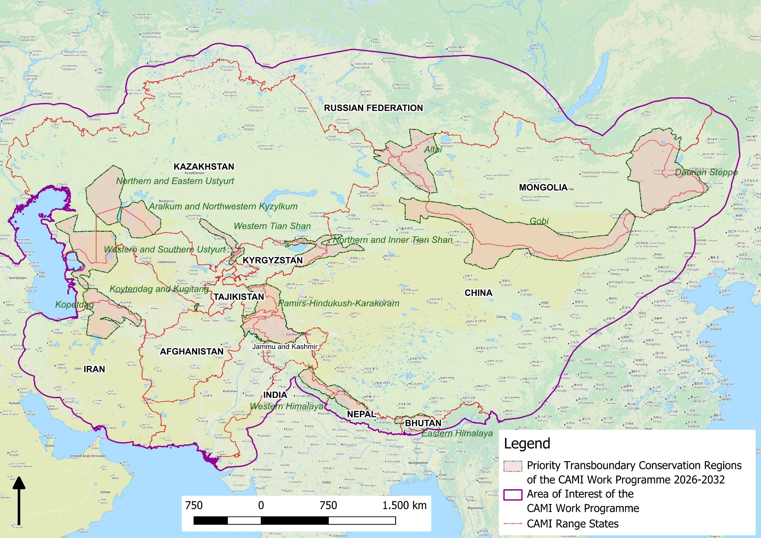
Figure 1. Priority Transboundary Conservation Regions (PTCRs)

Taxonomic and geographical scope:

Table 1. Species covered

 | Species (common name) | Species (scientific name) | CMS Appendix
1 | Argali | Ovis ammon | App. II
2 | Asiatic cheetah | Acinonyx jubatus | App. I
3 | Asiatic wild ass | Equus hemionus | App. II
4 | Bukhara deer | Cervus elaphus yarkandensis | App. I & II
5 | Eurasian lynx | Lynx lynx | App. II
6 | Gobi bear | Ursus arctos isabellinus | App. II
7 | Goitered gazelle | Gazella subgutturosa | App. II
8 | Kiang | Equus kiang | App. II
9 | Mongolian gazelle | Procapra gutturosa | App. II
10 | Pallas’ cat | Felis manul | App. II
11 | Persian leopard | Panthera pardus tulliana | App. II
12 | Przewalski’s horse | Equus ferus przewalskii | App. I
13 | Saiga antelope | Saiga spp. | App. II
14 | Snow leopard | Uncia uncia | App. I
15 | Urial | Ovis vignei | App. II
16 | Wild camel | Camelus bactrianus | App. I
17 | Wild yak | Bos grunniens | App. I

The scientific names follow Mammal Species of the World, 3rd edition (Wilson & Reeder 2005), the standard taxonomic reference for mammals used by CMS. The names used do not consider nomenclatural changes made since 2005 and in several cases the species names differ from those currently used by the IUCN Red List of Threatened Species and other authorities. The species concerned are the snow leopard (Panthera uncia), wild camel (Camelus ferus), Przewalski’s horse (Equus ferus), Pallas’ cat (Otocolobus manul), saiga antelope (Saiga tatarica tatarica and Saiga tatarica mongolica) and Bukhara deer (Cervus hanglu bactrianus).

The following are considered Range States to CAMI: AFGHANISTAN, Bhutan, China, INDIA, the Islamic Republic of IRAN, KAZAKHSTAN, KYRGYZSTAN, MONGOLIA, Nepal, PAKISTAN, the Russian Federation, TAJIKISTAN, TURKMENISTAN and UZBEKISTAN (the names of CMS Parties are capitalized).

CAMI WORK PROGRAMME 2026–2032

Vision: Secured and functional populations of migratory mammals that range across the landscapes of the wider Central Asian region in healthy ecosystems, are valued by, and bring benefits to, all stakeholders and particularly the local communities that share their range.

Goal: To facilitate coordinated actions for the conservation of CMS-listed mammals and their habitats in the wider Central Asian region by strengthening cross-border cooperation to address illegal taking and trade, enhancing habitat connectivity, ensuring sustainable use of natural resources, and promoting the coexistence of wildlife and local communities.

Activities to be implemented by 2032 |  | Responsible | Indicator | Priority | Related programmes
Cross-cutting activities applicable to the conservation of all CAMI Species across the identified Priority Transboundary Conservation Regions and to the species-specific instruments listed below
Complementary CAMI instruments:
Range-wide Strategy for the Conservation of the Persian Leopard (2023–2032)
Action Plan for the Conservation of the Argali (2024–2032)
Range-wide Action Plan for the Asiatic Wild Ass (2024–2033)
Work Programme for the Bukhara Deer (2025–2032)
Medium-term International Work Programme for the Saiga Antelope (2025–2030)
- CAMI WP Implementation and Coordination
1.1 | CMS Secretariat to organize:  - a mid-term meeting in 2028/29 to assess the status of implementation of this WP, discuss successes and address challenges, and report to CMS COP16;  - the 4th meeting of CAMI Range States in 2031/32 to assess implementation, discuss successes and address challenges, revise and submit a new WP to CMS COP17. | CMS Secretariat, GOs, scientific institutions, NGOs | Meetings held back-to-back with other appropriate meetings, where possible, in coordination with Global Snow Leopard and Ecosystem Program (GSLEP), Central Asian Flyway Initiative, Persian Leopard Working Group, Pallas’s Cat International Conservation Alliance (PICA), Manul Working Group and others, as appropriate, to utilize possible synergies to enhance the implementation of the WP. | High | Kunming-Montreal Global Biodiversity Framework (GBF) Target 20, Samarkand Strategic Plan for Migratory Species (2024-2032) (SPMS)  Goals 1 & 6
1.2 | Keep a record of implemented activities and submit National Reports on the implementation of the WP every 3 years, using the reporting forms provided by the CMS Secretariat. | GOs, scientific institutions, NGOs | Reports prepared utilizing the reporting forms distributed by the CMS Secretariat. | High | GBF Target 20, SPMS Goals 1 & 6
1.3 | Establish Terms of Reference (ToRs) for cooperating organizations providing technical support to the implementation of the CAMI WP, as well as related Strategies and Action Plans, and publish them on the CAMI website. | CMS Secretariat | ToRs developed and published. | High | GBF Target 20, SPMS Goals 1 & 6
1.4 | Nominate governmental Focal Points for each PTCR of this WP and technical support organization(s) covering all PTCRs. | GOs, scientific institutions, NGOs | Governmental Focal Points nominated, and technical support organizations identified. | High | GBF Target 20, SPMS Goals 1 & 6
1.5 | Convene at least one meeting annually for CAMI Focal Points and CITES Management Authorities (MA) responsible for liaising with counterparts in other Range States and cooperating organizations to exchange information on the implementation of the WP, relevant CITES Decisions, and technical expertise on CAMI species conservation actions. | CAMI Focal Points, CITES MAs | Meeting participant list, summary of the type of information and relevant CITES Decisions exchanged, and nature of technical expertise provided. | High | GBF Target 20, SPMS Goals 1 & 6
1.6 | Integrate relevant aspects of this WP into the joint work programme of the CITES-CMS Secretariats, at its renewal, to further align and strengthen joint activities on CAMI species and pursue collaborative funding opportunities. | CMS and CITES Secretariats | New CITES-CMS joint work programme 2026-2032 considering relevant activities from this WP. | High | GBF Target 20, SPMS Goals 1 & 6
1.7 | Propose to CMS and CITES COPs, turning CAMI into a joint CMS-CITES Central Asian Mammals Initiative, following the example of the African Carnivores Initiative. | CMS and CITES Parties | Relevant proposal made to CITES and CMS COPs | Medium | GBF Target 20, SPMS Goals 1 & 6
1.8 | Request non-Party Range States to nominate a Focal Point for CAMI, in cases where no CMS Focal Point is identified. | CMS Secretariat | Focal Points nominated | High | GBF Target 14, SPMS Goal 5
1.9 | Conduct technical ecoregional workshops on components of the Work Programme (e.g. on community-based wildlife management) to produce guidance, as needed. | CMS Secretariat, GOs, NGOs | Three or more workshops held by 2032 | Medium | GBF Targets 20 & 22  SPMS Goals 1 & 6
1.10 | Establish cross-sectoral working groups at the national level, consisting of relevant government authorities and other stakeholders, meeting at least biennially, to coordinate the implementation of this Work Programme, building on existing mechanisms, where available. | GOs, scientific institutions, NGOs, CMS Secretariat (if needed) | Two or more annual meetings held, TOR agreed, and minutes published. | High | GBF Target 14, SPMS Goal 5, Recommendations of NBSAP Technical Guidance
1.11 | Submit, in 2026, to the CBD Secretariat proposals on how to integrate relevant components from this Work Programme into the review of the CBD Protected Area Work Programme. | GOs, scientific institutions, NGOs, CMS Secretariat | Proposals submitted. | High | GBF Target 14, SPMS Goal 5, CBD Protected Area Work Programme
1.12 | Contribute to the UNCCD Central Asia – Russia Interregional Group and its thematic commissions to facilitate cooperation between the UNCCD and CMS activities in the region. | GOs, CMS Secretariat | Information submitted. | High | GBF Target 14, SPMS Goal 5, UNCCD Central Asia – Russia Interregional Group
1.13 | Contact the IUCN Regional Office for Eastern Europe and Central Asia with a request to consider receiving support under the CBD Technical and Scientific Cooperation Mechanism. | Kazakhstan, Kyrgyzstan, Tajikistan, Turkmenistan, Uzbekistan | Range States requested support. | High | GBF Target 20, SPMS Goal 6
1.14 | Nominate Species Focal Points (SPFs) for all CAMI species in accordance with the agreed TOR. | CMS Secretariat, GOs | SPFs nominated. | High | GBF Target 14, SPMS Goal 5
2. Funding and Finance
2.1 | Conduct natural capital valuations for each of the Priority Transboundary Conservation Regions (PTCRs) to demonstrate the value that they provide to a multitude of beneficiaries, by utilizing an ecosystem service assessment (ESA) framework to identify the linkages between the ecological asset (including CAMI species populations and habitats), the subsequent delivery of ecosystem services and the benefits provided to society, building on existing valuations, where available. | GOs, scientific institutions, NGOs, CMS Secretariat | Valuations produced. | High | GBF Target 14, SPMS Goal 5
2.2 | Based on results of 2.1, use a systematic methodology to develop national financing strategies to identify suitable financial mechanisms to implement this Work Programme, including sustainable land use and relief, taking into consideration the CMS/BfN Report on the Identification of Funding Options for the Implementation of the CAMI. | GOs, NGOs, CMS Secretariat (if needed) | Financial strategies and solutions approved by stakeholders. Resources mobilized. | High | GBF Target 19, SPMS Goal 4
2.3 | Conduct an online workshop for CAMI Range States, concerned stakeholders and NGOs to present the findings of the Report on the Identification of Funding Options for the Implementation of the CAMI | CMS Secretariat, GOs, NGOs | Online workshop | High | GBF Target 19, SPMS Goal 4
2.4 | Provide in-depth training on conservation economics and finance, highlighting the financial solutions identified in the financing strategies (see Activity 2.2) to support conservation in the PTCRs. | NGOs, GOs | Training held, report prepared | High | GBF Target 20, SPMS Goal 4
2.5 | Develop joint funding proposals and innovative financial mechanisms involving relevant Range States for the conservation of PTCRs identified in this WP and submit to relevant donors. | GOs, NGOs, in consultation with SFPs, CMS Secretariat (if needed) | New projects funded | High | GBF Target 19, SPMS Goal 4
3. Legislation
3.1 | Integrate relevant activities of the CAMI WP into appropriate national legislation/policies and National Biodiversity Strategies and Action Plans (NBSAPs), and report to the CMS Secretariat on this activity within one year of the WP’s adoption. | GOs | CAMI WP integrated in relevant national legislation and NBSAPs and the report on this submitted to the CMS Secretariat. | High | GBF Target 23, SPMS Goal 5
3.2 | Join the CMS National Legislation Programme (NLP), if not already done so. | CMS Parties | At least three Parties submit NLP questionnaires to CMS Secretariat | High | GBF Target 14, SPMS Goal 5
3.3 | Prepare an evaluation of potential benefits of listing CAMI species that are already listed on CMS Appendix II, also on Appendix I, and submit relevant proposals to CMS COP, where necessary. | GOs, NGOs, scientific institutions | Evaluation conducted, proposal submitted to COP16/COP17, where necessary | Medium | GBF Target 14, SPMS Goal 5
3.4 | Submit cases of possible implementation matters affecting CAMI species listed on Appendix I to the CMS Secretariat through the CMS Review Mechanism, and include information about impacts of these activities on Appendix II species. | GOs, scientific institutes, NGOs | Cases submitted through Review Mechanism, if implementation issues arise. | High | GBF Target 14, SPMS Goal 5
3.5 | Use the IUCN Guidelines for Conserving Connectivity through Ecological Networks and Corridors and examples from the region (e.g. developed within CAMCA project in Kyrgyzstan) to define ecological corridors and integrate such corridors into national legislation to implement appropriate measures to conserve CAMI species, building on experience in the region and beyond. | GOs, scientific institutes, NGOs | IUCN Guidelines used, methodology for defining eco-corridors established and legislation on eco-corridors developed in all CAMI Range States | High | GBF Targets 2 & 14, SPMS Goal 5
3.6 | Prevent barriers to migration, where possible, through:  - integrating the Guidelines on Mitigating the Impact of Linear Infrastructure and Related Disturbance on Mammals in Central Asia into national legislation, if needed, in particular by requiring a rigorous EIA process before the granting of construction permission and the use of the Mitigation Hierarchy in line with internationally recognized standards IFC1 and IFC6;  - requiring impact assessment procedures for projects affecting CAMI species to include consultations with the CMS Secretariat and CAMI Species Focal Points, and to take into account recommendations of the Central Asian Mammals Migration and Linear Infrastructure Atlas, if needed;  - requiring impact assessments for planned fences, e.g. along roads and railroads. | GO, NGOs, scientific institutions | Legislation with clear instructions for impact assessment of planned projects falling within CAMI species range to use the tools mentioned and consult with CMS Secretariat. | High | GBF Target 14, SPMS Goal 5
3.7 | Adopt and implement national legislation in accordance with Articles III.5 and V.1 of CMS, to enhance measures to address illegal take of CAMI species, in particular:  - strengthen enforcement measures and penalties proportional to the incident and type of actors involved to deter illegal hunting, possession, use and trade of CAMI species;  - introduce incentives (financial and non-) for rangers, border guards and civil society for reporting incidents of illegal take, possession and trade;  - invest proceeds from fines in conservation;  - grant enforcement powers to community rangers; and  - strictly monitor and control online platforms promoting illegal wildlife trade. | GOs, NGOs, IGOs | Updated legislation, guidelines, roadmap | High | GBF Target 5, SPMS Goal 5
3.8 | In cases of abundant populations of CMS Appendix II-listed species and in accordance with CMS Article V.1, consider preparing national management plans for the species in a transparent way, involving all relevant stakeholders and ensuring benefits to local communities from any sustainable use of the species. | GOs, scientific institutions, NGOs | Conservation and management plans developed for abundant populations of Appendix II species, in accordance with Resolution 14.17 Community Participation and Livelihoods and using recommendations of the study Potential for Community-based Wildlife Management in Central Asia, where relevant. | High | GBF Target 5, 9, SPMS Goals 1 and 3
3.9 | To support implementation of CMS Article V.1, establish robust and clear procedures for scientifically set quotas for sustainable taking of migratory species, as per national legislation, that address risks of compounded harvesting pressure, ensuring that transboundary populations of CAMI species are not overexploited by different countries due to lack of coordinated assessment/decision-making. | GOs, scientific institutions | Sustainable quota setting decrees for CAMI species that can be sustainably used’. | High | GBF Target 9, SPMS Goal 1
3.10 | In countries where national Red Books are being used, bring species assessment procedures for national Red Books in line with the Guidelines for Using the IUCN Red List Categories and Criteria at the national level. | GOs, scientific institutions, NGOs | Manual/guide | Medium | GBF Target 4, SPMS Goal 1
3.11 | In cases of Appendix II-listed species, as per national legislation, allow limited (in time and quantities) extractive use of selected National Red Book-listed species if it can be shown in a scientifically robust way that this will contribute to the conservation of the species, as well as towards GBF Targets 4, 5 and 9. | GOs, scientific institutions, NGOs | Legislation/quota decree | Medium | GBF Target 4,5,9, SPMS Goal 3
3.12 | Develop and promote policies, regulations and tools, and build capacity of decision makers and planners for sustainable rangeland management that enables the coexistence of people, livestock and wildlife. | GOs, scientific institutions, NGOs | Number of national policies, regulations and tools. | High | GBF Target 4,20, SPMS Goal 4
3.13 | Develop and enact legislation to allow for the management of protected and conserved areas (including hunting areas) by private and/or community-based organizations, as per national priorities, where it does not exist. | GOs, scientific institutions, NGOs | Legislation proposed | Medium | GBF Target 22, SPMS Goal 3
4. Transboundary Cooperation
4.1 | Support CAMI Range States in their efforts to enter into bilateral/multilateral agreements to strengthen conservation of specific PTCR. | CMS Secretariat, GOs, NGOs, IGOs, GSLEP | Agreements, Memoranda of Understanding Work Programmes to support MOU implementation developed and implementation initiated. | High | GBF Target 12, SPMS Goal 5
4.2 | Establish inter-agency working groups involving both border security and nature protection agencies and other stakeholders for regular inter-agency cooperation and information exchange on conservation issues at the national and transboundary levels to enhance transboundary conservation of natural ecosystems and migratory species. | GOs, NGOs, IGOs, local authorities | Working groups established and operational for conservation of PTCRs. | Medium | GBF Target 12, 20, SPMS Goal 5, Ashgabat communique; Recommendations of technical guidance for NBSAPs
4.3 | Leverage existing awareness-raising programmes to develop and deliver wildlife conservation training for border and customs officials in national languages, clarifying their role and authority with regard to wildlife conservation, and, where possible, collaborate with national and international organizations and development partners. | CMS Secretariat, GOs, NGOs, IGOs, CITES Parties | Training materials produced and used in trainings conducted for at least three PTCRs. | High | GBF Target 20, SPMS Goal 4, Ashgabat Communique,
4.4 | Support recognition of selected border areas as Other Effective area-based Conservation Measures (OECMs). | GOs, NGOs, IGOs | At least two border areas in PTCRs recognized as OECM by national governments and monitoring programmes are set up; Task forces established for at least 2 PTCRs; Inter-agency information exchange takes place through calls and meetings. | High | GBF Target 3, SPMS Goal 2,  Ashgabat Communique
4.5 | Update the report Transboundary conservation hotspots for the Central Asian Mammals Initiative by 2028 by including species listed by CMS COP14 and, if relevant, by CMS COP15, and add spatially explicit mapping of challenges and opportunities, submit it to CAMI Range States and the CMS Standing Committee for their endorsement. Once endorsed, reflect relevant changes in the activities for specific PTCRs in this WP. | CMS Secretariat, GOs, NGOs | Updated report published in 2028.  If necessary, updated CAMI WP which includes new species and activities for them. | Medium | GBF Target 20, SPMS Goal 4
5. Ecological Connectivity
5.1 | Monitor plans for infrastructure development that are likely to impact CMS-listed species on a frequent basis (every 6 months) and consider seeking guidance from the CMS Secretariat prior to the approval process, if needed. | CMS Parties and CAMI Range State Focal Points, NGOs | Information submitted to CMS Secretariat before the project is approved | High | GBF Target 20, 23 SPMS Goals 2 & 4
5.2 | Conduct online meetings to facilitate discussion of the issues reported in 5.1 and identify solutions involving infrastructure developers and planners, the CMS Global Partnership on Ecological Connectivity, CAMI Species Focal Points (SPFs) and National Focal Points (NFPs) of CAMI Range States. | CMS Secretariat, SFPs, NFPs, other relevant GOs, NGOs, scientific institutions | At least one online meeting conducted, protocols produced. | High | GBF Target 20, 23 SPMS Goals 2 & 4
5.3 | Compile available information, in cooperation with partners, on mitigation solutions to address impacts of infrastructure on CMS-listed species, taking into account species-specific requirements, landscapes and types of barriers in the CAMI region, and lessons learned; and identify those species that need further analysis/research. | CMS Secretariat, GOs, NGOs, scientific institutions | Report outlining available mitigation measures for various types of linear infrastructure and species, their effectiveness and lessons learned, and species and solutions requiring further research. | High | GBF Targets 2, 20 & 23, SPMS Goals 2 & 4
5.4 | Explore options to integrate the CAMI Atlas into the Integrated Biodiversity Assessment Tool (IBAT) and national mapping systems and portals (e.g. Tabigat in Kazakhstan) | CMS Secretariat, NGOs, GOs | CAMI Atlas integrated into IBAT and other systems | Medium | GBF Target 20, SPMS Goal 4
5.5 | Conduct capacity-building workshops on mitigation of impacts of infrastructure, incorporating available CMS and other tools, such as atlases and guidelines. | CMS Secretariat, GO, NGOs, scientific institutions | At least one workshop is conducted for the region bringing together relevant actors, including infrastructure planners and funders. | High | GBF Target 20 & 23, SPMS Goals 2 & 4
5.6 | Plan and create Protected Areas, OECMs and eco-corridors to ensure ecological connectivity for CAMI species and to facilitate conservation of larger areas and networks of their habitat (see Activity 6.2). | GOs, NGOs, scientific institutions | Number of protected areas enlarged, OECMs and ecological corridors between protected areas established. | High | GBF Target 2, 3, SPMS Goal 2
5.7 | Identify and implement suitable measures to mitigate the negative effects of border structures on the movement of CAMI species, where feasible. | GOs, NGOs, scientific institutions | Report on such measures in the frame of national reporting on CAMI and CMS implementation. | High | GBF Target 2, 3, SPMS Goal 2
5.8 | Update the Central Asian Mammals Migration and Linear Infrastructure Atlas by 2032 including new information on changes in infrastructure and on species distribution, if possible, aligning with IUCN Red List mapping standards and processes in cooperation with the Global Initiative on Ungulate Migration (GIUM) and utilizing data obtained by international and national researchers. (Include outcome of Activity 10.8.) | CMS Secretariat, GOs, scientific institutions, NGOs | Atlas updated by 2032 | Medium | GBF Target 1, 2, SPMS Goal 2
6. Protected and Conserved Areas
6.1 | Apply IUCN’s various guidelines to promote good practices relating to identifying, reporting, monitoring and strengthening OECMs in support of GBF Target 3. | CMS Secretariat, NGOs, GOs, IUCN World Commission on Protected Areas (WCPA) | Workshop on OECMs | High | GBF Target 3, SPMS Goal 2
6.2 | Support CAMI Range States in efforts to achieve the GBF Target 3 30 x 30 goal and ensure that the protected and conserved area network is relevant for the current range and movements of CAMI species, and align the conservation systems in these territories with the conservation needs of CAMI species. | GOs, NGOs, IUCN WCPA | Meetings/communication, progress reported to CBD and CMS Secretariats. IUCN Green List | High | GBF Target 3; SPMS Goal 2, Decision No. 11, Council of Heads of State of the Shanghai Cooperation Organization (4 July 2024)
6.3 | Assess the extent to which the management plans of protected and conserved areas integrate climate change considerations, including adaptation measures (e.g. protecting water sources for wildlife, expanding protected and conserved areas) and the extent to which they are implemented | GOs, NGOs, scientific institutions | Report on identified climate change-related challenges and measures implemented produced. | Medium | GBF Target 3, SPMS Goal 2
7. Illegal Hunting, Possession and Trade
7.1 | In collaboration with CMS’ Global Initiative on Illegal and Unsustainable Take of Species, identify priorities for increasing capacity of Parties for monitoring and enforcement of national legislation and regulations and other measures pertaining to the illegal taking of CAMI species. | CMS Secretariat, CITES Secretariat, GOs, scientific institutions, NGOs | Report and recommendations by 2027. | High | GBF Targets 4, 5, 9, 20, SPMS Goal 3, 4
7.2 | Improve working conditions, including occupational safety and health (OSH), and social security of inspectors and other relevant officers of nature protection agencies. | GOs, scientific institutions, NGOs, IGOs | Increased satisfaction with wages, prestige, social security indicated through the results of an anonymous survey. | High | GBF Targets 4, 5, 9, 20, SPMS Goals 3, 4
7.3 | Provide training and equipment to inspectors and other relevant officers of nature protection agencies to increase their capacity for combatting illegal hunting, possession, use and trade (including online) of CAMI species, and scale up the use of Spatial Monitoring and Reporting Tool (SMART). | GOs, scientific institutions, NGOs, IGOs | Improved equipment of rangers, including computers, mobile phones and SMART. | High | GBF Targets 4, 5, 9, 20, SPMS Goals 3, 4
7.4 | Monitor and measure anti-poaching efforts and impacts through SMART and use these analyses to inform improved anti-poaching strategies. | GOs, scientific institutions, NGOs | SMART reports. | High | GBF Targets 4, 5, 9, SPMS Goal 3
7.5 | Conduct regular surveys to understand the level and drivers of wildlife poaching, using scientifically sound methods to develop effective anti-poaching strategies. Standardize and share survey formats whenever possible. | GOs, scientific institutions, NGOs | Availability of survey reports and anti-poaching strategies for each Range State. | Medium | GBF Targets 4, 5, 9, SPMS Goal 3
7.6 | Establish centralized national databases and related procedures on poaching cases and illegal trade to allow for an estimation of the impact on populations of CAMI species. | GOs, scientific institutions, NGOs | Databases and procedures established. | Medium | GBF Target 4, 5, 9,  SPMS Goal 3
7.7 | Develop and distribute information materials about wildlife products and provide training to border guards, customs officers and police to strengthen their capacity in detecting illegal wildlife trade. | NGOs, GOs, UNODC, scientific institutions | Number of trainings; materials available in all Range States. | High | GBF Targets 4, 5, 9, 20, SPMS Goal 3, 4
7.8 | Encourage the deployment of sufficient numbers of wildlife detection dogs and DNA toolkits, enabling customs officers, border guards, and police to effectively identify and intercept trade in wildlife products and derivatives. | GOs, scientific institutions, NGOs | Number of dogs deployed, and DNA toolkits used at border / customs posts across Range States. | High | GBF Targets 4, 5 9, SPMS Goal 3
7.9 | Develop and implement whistle blower policies / mechanisms to ensure the safety of informants who provide information about violations of wildlife legislation (e.g., poaching incidents, illegal trade). | GOs | Policies and mechanisms implemented. | Medium | GBF Targets 4, 5, 9, SPMS Goal 3
7.10 | Create a collection of reference samples from derivatives of CAMI and other wildlife species for the purpose of training and capacity-building. | GOs, scientific institutions, CITES Secretariat | Collection established and used. | High | GBF Target 4, SPMS Goal 3
7.11 | Exchange collections of derivatives of CAMI species between the Range States, as per CITES regulations to improve capacity for correct identification. | GOs, scientific institutions, CITES Secretariat | Collections exchanged between scientific institutions | High | GBF Target 4, SPMS Goal 3
7.12 | Inform artisans and businesses so that they can recognize illegally harvested derivatives of wildlife and refrain from producing traditional crafts using them. | GOs, scientific institutions, NGOs | Reduction in use of illegal items. | High | GBF Target 4, SPMS Goal 3
7.13 | Develop a coordinated response plan to tackle online wildlife trade, including training of enforcement units, improved detection mechanisms, strengthened legal enforcement, and inter-agency data sharing. | GOs, scientific institutions, Interpol, UNODC, NGOs | Plan developed and implemented. | High | GBF Target 4, SPMS Goal 3
8. Land use and Human-wildlife Conflict and Coexistence
8.1 | Build the capacity and increase the awareness of decision-makers and local communities in applying the IUCN SSC Guidelines on Human-wildlife Conflict and Coexistence, and the recommendations of the CMS report, Potential for Community-based Wildlife Management in Central Asia. | CMS, NGOs, GOs, IUCN SSC Human-Wildlife Conflict and Coexistence (HWCC) SG, Sustainable Use and Livelihoods (SuLi) SG | At least one workshop organized by 2027. | High | GBF Targets 4, 20 & 22  SPMS Goal 4
8.2 | Strengthen the involvement of different stakeholders, including local communities, in the conservation and management of CAMI species through behaviour change awareness campaigns. | GOs, scientific institutions, NGOs | Increased number of stakeholders involved in conservation. | High | GBF Target 4, SPMS Goal 3
8.3 | Conduct workshops for biodiversity-inclusive, landscape-scale land-use planning, involving relevant stakeholders across agencies and sectors and including local communities, to take into consideration priority habitats for CAMI species supporting sustainable pasture use. | GOs, NGOs, scientific institutions | At least one planning workshop conducted in each country. | High | GBF Target 1, SPMS Goal 1, Regional Strategy for Drought Management and Mitigation in Central Asia for 2021-2030;  Regional Environmental Programme for Sustainable Development of Central Asia (REP4SD CA) for 2020-2030
8.4 | Share experiences between specialists and practitioners from the CAMI region and other countries on managing wildlife and human-wildlife conflict between local communities and migratory species. | CMS, GOs, NGOs, IUCN SSC | Exchange visits organized for decision-makers and practitioners. | High | GBF Targets 5, 22, SPMS Goal 3
8.5 | Conduct pilot studies through participatory processes with the land users concerned to investigate the potential effectiveness and sustainability of financial and non-financial incentives to coexist with wildlife and reduce retaliatory / preventive wildlife destruction. | NGOs, GOs, scientific institutions, IUCN SSC | Report published, scientific publications | High | GBF Targets 4, 5, SPMS Goals 1 & 3
8.6 | Conduct assessments of the level of impacts caused by CAMI species on land users and clearly indicate the levels of uncertainty and variability surrounding these estimates. | Scientific institutions, NGOs, IUCN SSC | Report published, scientific publications | High | GBF Targets 5, 21, SPMS Goal 3
8.7 | Investigate potential mechanisms to avoid or reduce negative impact on domestic animals, crops, beehives, hayfields, pastures and other properties caused by CAMI species. | GOs, NGOs, scientific institutions, IUCN SSC | Report published, scientific publications | High | GBF Targets 4, 21, SPMS Goal 3
8.8 | Assess the impact of livestock farming on CAMI species and, if necessary, implement measures to conserve and support expanding CAMI species within their habitat. | GOs, NGOs, scientific institutions | Assessment completed. Guidelines on minimizing negative impacts on CAMI species developed. | High | GBF Target 4, SPMS Goal 3
8.9 | Monitor attitudes of local people towards conservation activities and their willingness to coexist with CAMI species using local-level social research, including participatory community monitoring, and adjust management plans accordingly. | NGOs, scientific institutions, IUCN SSC | Social research reports and publications | Medium | GBF Target 22, SPMS Goal 3
8.10 | Where water is a main source of conflict, assess the availability of water and grazing grounds for CAMI species and develop, as necessary and scientifically justified, measures to improve their conservation, including safeguarding of water points, artificial and natural, and livestock exclusion zones. | GOs, NGOs, scientific institutions | Assessment reports and recommendations, review of scientific publications. | High | GBF Target 4, SPMS Goal 1
8.11 | Support and expand incentive-based and conservation-linked livelihood-improvement projects and develop new programmes in all appropriate parts of the CAMI range. | NGOs, GOs | Livelihood improvement projects (e.g. improving local schools, infrastructure) linked to conservation of CAMI species in place. | High | GBF Targets 21, 22, SPMS Goal 3
8.12 | Conduct feasibility assessments for developing community-based wildlife-related tourism offers taking into account Resolution 14.17 Community Participation and Livelihoods, the recommendations of the study Potential for Community-based Wildlife Management in Central Asia, national financing strategies (Activity 2.2), where relevant, and other guidance. | NGOs, scientific institutions, GOs | Assessments available | Medium | GBF Target 22, SPMS Goal 3 Decision No. 11, Council of Heads of State of the Shanghai Cooperation Organization (4 July 2024),
8.13 | Pending the outcome of Activity 8.12, develop and implement funding programmes to support the creation of community-based wildlife tourism offers in the CAMI Range States through initial investment portfolios, promotion, capacity-building and pledged returns of tourism revenues as conservation investments. | GOs, NGOs | Funding programmes in place in at least three countries. | Medium | GBF Targets 22 & 20, SPMS Goal 4
8.14 | Establish or improve control regimes for feral, free-ranging and shepherd dogs. | GO, NGOs, scientific institutions, local communities | Reduction of population of free-ranging dogs. | Medium | GBF Target 4, SPMS Goal 3
9. One Health
9.1 | Integrate the One Health approach into national and regional legislation and policy frameworks. | GOs, NGOs, health organizations | Number of legislation and policy frameworks with integrated One Health approach. | High | GBF Targets 5, 23, SPMS Goal 3
9.2 | Adopt or update standard operating procedures for rapid responses to disease outbreaks in wildlife and establish and/or support rapid response teams and build their capacity to document, examine and sample carcasses of wildlife. | GOs, NGOs, scientific institutions | Rapid response teams established, and their capacity built. | High | GBF Targets 4, 5 and 20; SPMS Goals 1 & 3
9.3 | Use existing platforms, such as the World Animal Health Information System (WAHIS), WHO’s One Health Initiative, and UNEP/CMS Working Group on Migratory Species and Health, and establish transboundary contact groups on wildlife disease to enable timely cross-border information exchange on disease outbreaks and coordinated actions. | GOs, NGOs, scientific institutions | Existing platforms used, relevant contact groups established by the end of 2029. | High | GBF Targets 4, 5, 20; SPMS Goals 1 & 3
9.4 | Develop and enforce national vaccination regulations and support relevant local institutions for targeted vaccination of livestock and herder dogs against infectious diseases/hybridization where they are sharing the same landscape with CAMI species. | GOs, NGOs, scientific institutions, private sector | Vaccination regulations developed and enforced.  Percentage of vaccinated livestock by the end of 2032. | High | GBF Target 4, 5, SPMS Goal 1
9.5 | Identify and map important wildlife water points and explore solutions to separate their use between wildlife and livestock, taking into account projected changes in water availability due to climate change. | GOs, scientific institutions, NGOs, local communities | Maps of important wildlife water points.  Analysis of solutions to separate water points between wildlife and livestock available.  A workshop on the solutions to separate wildlife and livestock at water points. | High | GBF Target 4, SPMS Goal 1
9.6 | Strengthen surveillance for emergence or re-emergence of diseases and potential impacts of drugs used for veterinary purposes, and chemicals (e.g. at water points) through harmonized monitoring and sampling of livestock and wildlife populations (Resolution 11.15, Preventing Poisoning of Migratory Birds) with particular focus on disease risk associated with cross-border movements of livestock, their products and derivatives. | GOs, NGOs, scientific institutions | Surveillance reports and harmonized protocols | High | GBF Target 4, SPMS Goal 1
10. Species Monitoring and Research
10.1 | Collect data on movements and migrations of CAMI species using appropriate technology (including genetic analysis, camera trapping, satellite tracking, remote sensing, and modelling of species distribution and connectivity), with a particular focus on improving the understanding of impacts of infrastructure developments, climate change, and environmental and land use change. | GOs, NGOs, scientific institutions | Data collected | High | GBF Target 19, SPMS Goal 4
10.2 | Store data obtained from Activity 10.1 in appropriate databases and use them to inform decision-making, aiming to maintain connectivity of wildlife habitat and their migratory behaviour and to update the Central Asian Mammals Migration and Linear Infrastructure Atlas. | GOs, NGOs, scientific institutions | Relevant databases established and used by implementers of Activity 5.8. | High | GBF Target 19, SPMS Goal 4
10.3 | Conduct meetings between specialists and conservation authorities from Range States to standardize methodologies and reporting formats; coordinate survey designs, timing and locations, to be applied for monitoring species and ecosystems, using specific tools such as SMART, and establish the necessary systems to apply these methodologies at local, national and transboundary levels. | GOs, NGOs, scientific organizations | Systems established, standards harmonized, data shared and applied. | High | GBF Target 17 and 20, SPMS Goal 4
10.4 | Regularly assess the population sizes, distribution and, where feasible, reproduction and sex ratios of CAMI species, using the methodologies and guidelines outlined in Activity 10.3 or other best available scientific approaches. | GOs, NGOs, scientific institutions | Population data reports and publications (e.g., scientific publications) available | High | GBF Target 4, SPMS Goal 5
10.5 | Using results of 10.4, obtain reliable and comparable estimates to track population trends and inform conservation efforts and, where applicable, management policies. | GOs, NGOs, scientific institutions | Assessments used to inform conservation and management policies | High | GBF Target 4, SPMS Goal 5
10.6 | Train relevant agencies, rangers, border guards (where applicable), and staff of scientific institutions in the use of standardized guidelines / manuals for monitoring transboundary populations, as necessary. | GOs, NGOs, IUCN SSC, scientific institutions | Guidelines / manuals available and training reports | High | GBF Target 20, SPMS Goals 4 & 5
10.7 | Identify and use suitable existing data-sharing platforms and potential partners to store and exchange data on CAMI species. | GOs, NGOs, IUCN SSC, scientific institutions | Data-sharing agreements and databases in place. | High | GBF Target 20, SPMS Goal 4
10.8 | Establish groups of experts to implement 10.6 and 10.7 and other relevant activities from section 10, and secure resources for their implementation. | GOs, NGOs, scientific institutions, CMS Secretariat | Groups of experts established | High | GBF Target 20, SPMS Goal 4
10.9 | Facilitate exchange of information, data, reports and experience between actors at different levels across the Range States and encourage joint data analysis. | GOs, NGOs, scientific institutions, group of еxperts from 10.8 | Meetings, webinars held to support information exchange within PTCR, establish information exchange mechanisms and produce joint publications | High | GBF Targets 17, 19, 20, SPMS Goal 4
10.10 | Update outdated IUCN Red List assessments for CAMI species, e.g., wild camel, goitered gazelle. | NGOs, scientific institutions | Updated IUCN Red List assessments for CAMI species | High | GBF Target 4, SPMS Goal 1, IUCN Red List Assessments
10.11 | Conduct range-wide species climate vulnerability assessments based on climate change predictions and the collected habitat and species occurrence information, and consider the outcomes in conservation planning. | GOs, NGOs, scientific institutions, group of experts from 10.8 | Species vulnerability assessments conducted, published and posted on CMS website and used in conservation planning by relevant stakeholders | Medium | GBF Targets 1, 2 and 4, SPMS Goals 1, 2 & 3
11. Education, Community and Communication
11.1 | Raise awareness on threats affecting CAMI species and necessary behavioural change as well as planned or existing conservation measures among relevant sectors, including decision makers, local communities and the general public, in a coordinated manner between Range States of PTCRs. | GOs, NGOs, scientific institutions. | Number of awareness-raising activities at national and international levels. | High | GBF Target 1, SPMS Goal 3
11.2 | Continue to develop, update and widely implement a range of educational activities and materials on wildlife ecology and conservation for children in CAMI Range States. | GOs, NGOs, scientific institutions, local communities | Educational activities and materials available and distributed. | Medium | GBF Target 1, SPMS Goal 3
11.3 | Develop and implement awareness-raising campaigns for investors, companies and governmental organizations whose activities (or whose employees’ activities) could negatively impact CAMI species. | GOs, NGOs, scientific institutions | Materials available and distributed. | Medium | GBF Target 1, SPMS Goal 3
11.4 | Develop and widely implement awareness-raising campaigns, through all relevant media, to raise the profile of CAMI species and highlight the benefits that accrue to people through their conservation at local, national and international levels. | CMS Secretariat, NGOs, scientific institutions, GOs | Campaign developed and launched by end of 2026 | High | GBF Target 1, SPMS Goal 3
11.5 | Produce and disseminate a brochure and a promotional video to raise awareness and understanding of the importance of the Central Asian region for CAMI species (and potentially also for migratory birds) for different audiences. | CMS Secretariat, NGOs, scientific institutions, GOs | Video and brochure featuring CAMI and other CMS-listed species of the region produced and promoted online. | High | GBF Target 1, SPMS Goal 3
11.6 | Conduct side events at the meetings of COPs of CMS, CBD, UNCCD, UNFCCC, CITES and other relevant meetings to raise awareness of the CAMI WP and its implementation. | CMS Secretariat, scientific institutions, NGOs, GOs | Side events at CBD / CITES / UNCCD / UNFCCC COPs | Medium | GBF Target 1, SPMS Goal 3
11.7 | Publish an annual CAMI newsletter in two languages (and, if possible, other languages) in cooperation with the CMS Secretariat. | CMS Secretariat, GOs, NGOs, scientific institutions | Newsletter published once a year. | Low | GBF Target 1, SPMS Goal 3
Priority Transboundary Conservation Regions (PTCRs)
12. Western and Southern Ustyurt (Kazakhstan, Turkmenistan, Uzbekistan) - 1
Species: Asiatic wild ass, goitered gazelle, Persian leopard, urial, saiga
Range-Wide Strategy for the Conservation of the Persian Leopard 2023–2032
Range-wide Action Plan for the Asiatic Wild Ass 2024–2033
Medium-Term International Work Programme for the Saiga Antelope 2025–2030
12.1 | Fully implement the Memorandum of Cooperation for Wildlife Conservation on the Ustyurt Plateau (Ustyurt MOC) and its Roadmap. | GOs, NGOs, scientific institutions | Implementation reports submitted to Ustyurt MOC coordinator | High | GBF Target 4, SPMS Goal 3
12.2 | Conduct a meeting to facilitate development of avoidance, compensation or mitigation measures for impact of industrial infrastructure, in particular related to wind and solar power development, on CMS-listed species, including CAMI and avian species, and on the basis of the discussions establish a working group, including if possible, representatives of the private sector. | GOs, NGOs, scientific institutions, private sector, CMS Secretariat | Meeting either in person or online conducted, identified and agreed measures at the latest by 2026. | High | GBF Targets 1, 3, 4 ,14, 15, SPMS Goals 1, 3 & 5
12.3 | Implement the measures agreed in 12.2 | GOs, NGOs, scientific institutions, CMS Secretariat | Measures implemented before infrastructure is built. | High | GBF Targets 1, 3, 4 ,14, 15, SPMS Goals 1, 3 & 5
12.4 | Ensure that biodiversity action plans for each infrastructure project are in line with the conservation goals of CAMI. | GOs, NGOs, scientific institutions, private sector | Biodiversity action plans have measures for conservation of CAMI species | Medium | GBF Targets 1, 3, 4 ,14, 15, SPMS Goals 1, 3 & 5
12.5 | In cooperation with the Coordinator of the Ustyurt MOC, support organization of the 2nd meeting of the Parties to the Ustyurt MOC in 2030. | CMS Secretariat, GOs, NGOs, scientific institutions | Support to meeting organization provided. | Medium | GBF Targets 1, 3, 4, 14, SPMS Goals 1, 3 & 5
12.6 | Conduct a feasibility study for the possible reintroduction of saiga and Asiatic wild ass in northern Turkmenistan and in northern Uzbekistan and in case of positive outcome develop a reintroduction plan. | GOs, NGOs, scientific institutions, IUCN SSC SGs | Feasibility study conducted and draft of reintroduction plan, if needed | Medium | GBF Target 4, SPMS Goal 1
12.7 | Conduct a feasibility study for the possibility of reintroduction of Persian Leopard in Ustyurt State Nature Reserve (Kazakhstan) and if recommended develop a reintroduction plan. | GOs, NGOs, scientific institutions, IUCN SSC SGs | Feasibility study conducted and draft of reintroduction plan, if needed | Medium | GBF Target 4, SPMS Goal 1
13. Northern and Eastern Ustyurt (Kazakhstan, Uzbekistan) - 2
Species: goitered gazelle, Asiatic wild ass (re-introduced), saiga, urial
Range-wide Action Plan for the Asiatic Wild Ass 2024–2033
Medium-Term International Work Programme (MTIWP) for the Saiga Antelope 2025–2030
13.1 | Strengthen bilateral cooperation between Kazakhstan and Uzbekistan within the Medium-Term International Work Programme for the Saiga Antelope 2025–2030 (Activities 9.1–9.8), the Range-wide Asiatic Wild Ass Action Plan and the Memorandum of Cooperation for Wildlife Conservation on the Ustyurt Plateau and its Roadmap (see 12.1-12.6 above). | GOs, NGOs, scientific institutions | Official national documents prepared and ratified, National Reports on the implementation of the Memorandum available online | High | GBF Target 1, SPMS Goal 3
13.2 | Continue re-introduction of the Asiatic wild ass (kulan) in Uzbekistan by applying improved methodologies, such as the use of adaptation pre-release enclosures and improved post-release monitoring by satellite tracking. | GOs, NGOs, scientific institutions | Reintroduction report, scientific publications | Medium | GBF Target 4, SPMS Goal 1
13.3 | Develop a programme of re-stocking of goitered gazelle population using animals from the Bukhara Special Center ‘Jeyran’. | GOs, NGOs, scientific institutions | Programme approved and implementation of the re-stocking. | Medium | GBF Target 4, SPMS Goal 1
13.4 | Conduct an analysis of the existence of watering points and create a network of watering points for goitered gazelles, saiga and Asiatic wild ass and other wildlife in core habitat and on migration routes. | GOs, NGOs, scientific institutions | Network in place in core habitats and on migration routes and use by wildlife proven through camera traps. | High | GBF Target 4, SPMS Goal 1
13.5 | Conduct a feasibility study for the possible reintroduction of urial in the area of the western cliffs of the Aral in Uzbekistan and Kazakhstan. | GOs, NGOs, scientific institutions | Feasibility study conducted and results available. | Medium | GBF Target 4, SPMS Goal 1
13.6 | Assess the feasibility of establishing transboundary ecotourism tours. | GOs, NGOs, scientific institutions, private sector | Feasibility study conducted | Medium | GBF Target 4, SPMS Goal 3
13.7 | Engage local communities in the conservation of Saiga to reduce the level of poaching (see also MOC Roadmap goals 5.1 and 5.2) | GOs, NGOs, scientific institutions, private sector | Poaching levels decreased at the local level | High | GBF Target 4, SPMS Goal 3
13.8 | Prepare documents for creation of protected areas in Northern Ustyurt in Kazakhstan (see 9.4 of MTIWP for the Saiga Antelope, and Ustyurt MOC Roadmap measure 1.1.2) | GOs, NGOs, scientific institutions | Documents prepared | High | GBF Target 3, SPMS Goal 2
14. Aralkum / North-Western Kyzylkum Desert (Kazakhstan, Uzbekistan) - 3
Species: Asiatic wild ass, goitered gazelle, saiga
Range-wide Action Plan for the Asiatic Wild Ass 2024–2033
Medium-Term International Work Programme for the Saiga Antelope 2025–2030
14.1 | Continue monitoring of Asiatic wild ass population in and around Barsa-Kelmes State Strict Nature Reserve (SSNR) in Kazakhstan. | GOs, NGOs, scientific institutions | Survey reports, scientific publications | High | GBF Target 4, SPMS Goal 1
14.2 | Continue monitoring of goitered gazelle and saiga populations in the Aralkum National Park, Barsa-Kelmes SSNR and Northwest Kyzylkum, and assess the impacts of current afforestation, and oil and gas development on these. | GOs, NGOs, scientific institutions | Survey reports, scientific publications | High | GBF Target 4, SPMS Goal 1
14.3 | Implement SMART patrolling in Aralkum National Park and Barsa-Kelmes SSNR. | GOs, NGOs, scientific institutions | SMART used in these areas. | Medium | GBF Target 4, SPMS Goal 1
14.4 | Conduct a feasibility study for creation of a protected area in Kazakhstan next to Akpetki part of Sudochie-Akpetki zakaznik in Uzbekistan. | GOs, NGOs, scientific institutions | Feasibility study conducted. | High | GBF Target 3, SPMS Goal 2
14.5 | Evaluate the possibility of creating new protected areas in the Aralkum desert in Kazakhstan and for supporting conservation measures in Barsa- Kelmes SSNR and Aralkum National Park including the potential for a transboundary protected area. | GOs, NGOs, scientific institutions | Report containing a new evaluation including zoning/maps | Medium | GBF Target 3, SPMS Goal 2
14.6 | To enable transboundary movement of target species of wildlife, identify suitable locations for border fence crossings, facilitate opening of these crossings and monitor the use of border fence crossings by wildlife with camera traps from the Kazakh and Uzbek sides. | GOs, scientific institutions | Border crossings actively used by CAMI species proven by camera trap data | High | GBF Target 2, SPMS Goal 2
14.7 | Consider the possibility of creating passages in border fences to enable the migration of kulan, saiga and goitered gazelle within the Aralkum region. | GOs, scientific institutions | Feasibility assessment conducted | Medium | GBF Target 2, SPMS Goal 2
14.8 | Work with oil and gas industry representatives to develop strategies to mitigate the impacts of the industrial activities in the region in accordance with international standards IFC6, Guidelines for Addressing the Impact of Linear Infrastructure on Large Migratory Mammals in Central Asia and other guidance. | GOs, NGOs, scientific institutions | Recommendations developed by 2027 and interventions implemented by 2028 | High | GBF Target 14, SPMS Goal 5
14.9 | Assess the feasibility of community-based eco-tourism including CAMI species observation tours, and provide support for business development in most promising locations. | GOs, NGOs | Feasibility study carried out by 2027, support provided | Medium | GBF Target 21, SPMS Goal 3
14.10 | Assess the need for and feasibility of the reintroduction of the Asiatic wild ass in Aralkum. | GOs, NGOs, scientific institutions | Feasibility study completed by 2027. | Medium | GBF Target 4, SPMS Goal 1
14.11 | Study the possibility of reintroducing Bukhara Deer and Asiatic wild ass in Sudochie-Akpetki zakaznik in Uzbekistan. | GOs, scientific institutions | Report prepared | Medium | GBF Target 4, SPMS Goal 1
15. Kopetdag (Iran, Turkmenistan) - 4
Species: Asiatic cheetah, Asiatic wild ass, goitered gazelle, lynx, Pallas’s cat, Persian leopard, urial
Range-Wide Strategy for the Conservation of the Persian Leopard 2023–2032
Range-wide Action Plan for the Asiatic Wild Ass 2024–2033
15.1 | Organize a workshop for relevant government authorities initiated by the Department of Environment of Iran and the Ministry of Environmental Protection of Turkmenistan with a view to strengthening transboundary collaboration between neighbouring protected areas on CAMI species monitoring and conservation. | GOs, NGOs, scientific institutions | Workshop conducted and report prepared by the end of 2026. | High | GBF Target 1, SPMS Goal 2
15.2 | Identify corridors for transboundary wildlife movements, especially for Persian leopard, Asiatic cheetah, urial, goitered gazelle and Asiatic wild ass, in collaboration with the border security services. | GOs, NGOs, scientific institutions | Scientific surveys conducted bi-annually starting in 2027 and reports published | High | GBF Target 3; SPMS Goal 2
15.3 | Convene a meeting with environmental, border and security authorities to discuss the feasibility of creating wildlife passages in the parts of the border fence that are most intensively used by animals (as identified by 15.2) to enable ecological connectivity for the affected CAMI species. | GOs, NGOs, scientific institutions | Monitoring report published and one workshop held by the end of 2027. | High | GBF Target 2, SPMS Goal 2
15.4 | Strengthen anti-poaching patrols and measures using SMART and other innovative technologies such as satellite- and LORA-powered camera traps or other national tools and systems. | GOs, NGOs | Quarterly reports published for at least one site. | High | GBF Target 4, SPMS Goal 1
15.5 | Enforce evidence-based grazing bans and restrictions in borderline protected areas. | GOs, NGOs, scientific institutions | Reports and official enforcement documents on no-grazing zones; absence of livestock in these PAs. | High | GBF Target 4, SPMS Goal 1
15.6 | Organize a series of practical workshops for herders on applying the IUCN SSC Guidelines on Human-Wildlife Conflict and Coexistence (HWCC) and facilitate implementation of conflict reduction tools and practices. | GOs, NGOs, IUCN SSC, scientific institutions | First 2 workshops in Iran and Turkmenistan held by 2027. | High | GBF Target 20, SPMS Goal 3
15.7 | Map existing water points for CAMI species and assess the need for building additional artificial water points for livestock to separate wildlife and livestock. | GOs, NGOs, scientific institutions | Water points mapped and monitored using camera traps in sections of the PTCR by the end of 2026. | High | GBF Target 4, SPMS Goal 1
15.8 | Implement broad educational and outreach campaigns to raise awareness among local communities about the value of CAMI species, the importance of wildlife corridors, and the role of human communities in their conservation. | GOs, NGOs, scientific institutions | At least 2 educational and outreach campaigns conducted on CAMI species, wildlife corridors and community involvement. | Medium | GBF Target 4, SPMS Goal 1
15.9 | In Iran, strengthen the participation of the private sector and local communities in participatory management of wildlife corridors for CAMI species, especially outside the boundaries of officially protected areas, by creating incentive mechanisms and capacity-building programmes, and reinforcing appropriate legal and financial frameworks. | GOs, NGOs, scientific institutions | Five important areas in Iran for the conservation of CAMI species identified and established within corridors outside of official protected areas, using a participatory conservation approach involving the government, NGOs, the private sector and local communities. | High | GBF Target 4, SPMS Goal 1
15.10 | Consider the possibility of establishing a Transboundary Protected Area or Friendship Park between Iran and Turkmenistan for conservation of the Persian leopard and its prey. | GOs | Possibility of establishing a Transboundary Protected Area or Friendship Park between Iran and Turkmenistan for conservation of the Persian Leopard and its prey evaluated. | High | GBF Target 4, SPMS Goal 1
15.11 | Develop joint action plans between Iran and CAMI countries for the conservation of the Pallas’s cat and Eurasian lynx. | GOs, NGOs, scientific institutions | Action plans between Iran and CAMI countries for the conservation of the Pallas’s cat and Eurasian lynx have been developed. | Medium | GBF Target 4, SPMS Goal 1
15.12 | Initiatе an international campaign supporting cheetah conservation activities in Iran. | DoE of Iran, NGOs, scientific institutions (CMS Secretariat if needed) | Technical and financial support from the international community for cheetah conservation activities in Iran provided. | Нigh | GBF Target 4, SPMS Goal 1
16. Koytendag/Kugitang (Turkmenistan, Uzbekistan) - 5
Species: goitered gazelle, lynx, urial
16.1 | Coordinate CAMI species monitoring and data sharing between Surkhan SSNR and Koytendag SSNR. | GOs, scientific institutions, hunting grounds | Coordinated surveys and sharing of data protocols implemented by the end of 2027. | High | GBF Target 4, SPMS Goal 1
16.2 | Continue using SMART in Surkhan SSNR and Koytendag SSNR and strengthen patrols with the use of SMART. | GOs, NGOs, scientific institutions | SMART reports published quarterly. | High | GBF Target 4, SPMS Goal 1
16.3 | Submit a request to the UNESCO World Heritage Commission for a preliminary feasibility assessment for the nomination of the ‘Karsts, Caves and Canyons of Kugitang’ for the UNESCO World Heritage List. | GOs, NGOs, scientific institutions | Request submitted by 15 September 2026. | High | GBF Target 1, SPMS Goal 2
16.4 | If the response from UNESCO is positive, submit a full nomination dossier to the UNESCO World Heritage Commission. | GOs, NGOs, scientific institutions | Nomination dossier submitted at the latest by February 2028. | High | GBF Target 1, SPMS Goal 2
16.5 | Enforce and monitor the full ban on livestock (cows, horses, donkeys and sheep) inside Koytendag SSNR through SMART application, Google Maps and camera traps. | GOs | Full ban in place by the end of 2026; SMART reports and camera trap pictures | High | GBF Target 4, SPMS Goal 1
16.6 | Set up and enforce strictly controlled grazing in the Hojeypil and Hojagaraul Wildlife Sanctuaries (Turkmenistan). | GOs, local communities | Legislation adopted regulating grazing in wildlife sanctuaries by the end of 2027 | High | GBF Target 4, SPMS Goal 1
16.7 | Improve the rangelands adjacent to the Hojeypil and Hojagaraul Wildlife Sanctuaries by promoting more sustainable and rotational use of rangelands with local shepherds, and drilling at least 2 wells for livestock in territories adjacent to the protected areas (Turkmenistan). | GOs, local communities | At least 2 wells drilled, and rotational use of rangelands implemented by the end of 2027. | High | GBF Target 4, SPMS Goal 1
16.8 | Develop recommendations for alternative livelihood sources based on a socioeconomic assessment in the local communities adjacent to the protected areas. | NGOs, local communities | Report with the recommendations by the end of 2027. | High | GBF Target 22, SPMS Goal 3
16.9 | To preserve the overall integrity and connectivity of the Koytendag SSNR, identify scientifically justified locations for crossings and open wildlife passages to ensure the genetic diversity of wild animals, including genetic exchange between populations of urial and other ungulates. | GOs, scientific institutions | Passages created by the end of 2026 | High | GBF Target 4, SPMS Goal 1
16.10 | Develop and implement recommendations on the revision of the zoning of Surkhan SSNR to exclude the existing children’s camp from the reserve for purposes of inclusion of the reserve in the UNESCO World Heritage list. | GOs, scientific institutions | New zoning completed | High | GBF Target 3, SPMS Goal 2
17. Western Tian Shan (Kazakhstan, Kyrgyzstan, Uzbekistan) – 6
Species: argali, lynx, snow leopard
Action Plan for the Conservation of the Argali (2024–2032)
17.1 | Exchange information on target species, plan and conduct coordinated surveys (see activity 10.3). | GOs, NGOs, scientific institutions, hunting grounds | Workshop conducted, methodology guidelines agreed; survey reports, including of coordinated transboundary surveys. | High | GSLEP, GBF Target 4, SPMS Goal 1
17.2 | Monitor the impact of climate change on the target species, specifically where glacier reduction and related hydrological regime changes occur. | NGOs, GOs, scientific institutions | Report on climate change impact | High | GBF Target 8, SPMS Goal 3
17.3 | Evaluate the Protected Area Management Effectiveness (PAME) in the Western Tian Shan World Natural Heritage Site. | GOs, NGOs, scientific institutions | PAME report, e.g., IUCN Green List Assessment Report | High | GBF Target 4, SPMS Goal 1
17.4 | Integrate recommendations from the transboundary management framework for the Western Tian Shan World Natural Heritage Site into protected area management plans. | GOs, IUCN, GIZ, scientific institutions | Updated and coordinated management plans | Medium | GBF Target 1; SPMS Goal 2, UNESCO
17.5 | Apply Activities 3.6, 5.1 and 5.2 to this PTCR, ensuring that requirements for the conservation of all target species and other biodiversity are adequately addressed during planning, construction and operation of energy, industrial, linear and tourism infrastructure. | GOs, NGOs, CMS Secretariat, scientific institutions | EIA processes include CMS requirements for CAMI species conservation. | High | GBF Target 14, SPMS Goal 5, Agreement between the Government of the Republic of Kazakhstan, the Government of the Kyrgyz Republic, and the Government of the Republic of Uzbekistan on Cooperation in the Field of Environmental Protection and Rational Use of Natural Resources dated 17 March 1998 (hereinafter – the Agreement).
17.6 | Explore an opportunity to expand Karatau SSNR by annexing the adjacent north-east-facing slopes of the Karatau Range. | GOs, scientific institutions | New zoning/maps, expanded Karatau SPA | Medium | GBF Target 3, SPMS Goal 2, GSLEP
17.7 | Prepare and adopt a justification for the creation of the Pskem SSNR in the upper reaches of the Oygaing and Shabyrsai Rivers (Uzbekistan). | GOs, NGOs, scientific institutions | Pskem SSNR is legally established | High | GBF Target 3, SPMS Goal 2
17.8 | Complete the creation of a buffer zone around the Chatkal State Biosphere Reserve. | GOs, NGOs, scientific institutions | Buffer zone identified and approved | High | GBF Target 3, SPMS Goal 2
17.9 | Explore possibility of expanding the Besh Aral SSNR by adding the Pskem River basin and the eastern part of the Chatkal River, including the riverine floodplains (Kyrgyzstan). | GOs, NGOs, scientific institutions | Expansion of the Besh Aral SSNR is legally approved | High | GBF Target 3, SPMS Goal 2
17.10 | Expand the territory of the Pap NP by adding Angren Plateau cluster (Uzbekistan). | GOs, NGOs, scientific institutions | Expansion of the Pap NP is legally approved | High | GBF Target 3, SPMS Goal 2
18. Northern and Inner Tian Shan (China, Kazakhstan, Kyrgyzstan) – 7
Species: argali, lynx, Pallas’s cat, snow leopard
Action Plan for the Conservation of the Argali (2024–2032)
18.1 | Conduct transboundary assessment and systematic monitoring of the target species and habitats (activities 10.1, 10.2, 10.3). | GOs, NGOs, scientific institutions | Assessment and monitoring carried out by 2028, report prepared. | High | GBF Target 4, SPMS Goal 1, GSLEP
18.2 | Monitor the impact of climate change on the target species, specifically where glacier reduction and related hydrological regime changes occur. | NGOs, GOs, scientific institutions | Report on climate change impact | High | GBF Target 8, SPMS Goal 3
18.3 | Prepare a plan for establishing a network of protected areas and OECMs to conserve target species and their habitats in the transboundary landscape between Kazakhstan, China and Kyrgyzstan (Mountains of Kungey Alatau, Terskey Alatau and Uzynkara). | GOs, NGOs, scientific institutions, CMS Secretariat | Plan for creating a network is published and agreed between the three countries. | High | GBF Target 3, SPMS Goal 2, GSLEP
18.4 | Map existing and planned border fences, as appropriate per national context, and other linear infrastructure, prepare an analysis of their impacts, and develop mitigation measures. | GOs, NGOs, scientific institutions, GSLEP, CMS Secretariat | Workshop held by 2027, report prepared including maps and site-specific mitigation measures developed and agreed. | High | GBF Targets 1, 2, SPMS Goal 2, GSLEP
18.5 | Implement the measures to enhance connectivity as determined under 18.3 and 18.4. | GOs, IFIs | Measures implemented. | High | GBF Targets 1, 2, SPMS Goal 2, GSLEP
18.6 | Conduct training of border guards and customs officers as per Activities 4.3, 7.7 and 10.6. | GOs, NGOs, scientific institutions | One training held by 2027 in each country and one regional one. | High | GBF Target 20, SPMS Goal 3, GSLEP
18.7 | Improve policy and regulation to avoid negative impacts of tourism on target species, their habitats and on eco-tourism potential of the area, ensuring that tourism benefits local communities and incentivizes biodiversity conservation. | GOs, NGOs | Policy and regulations to avoid negative impact on target species and habitats are in place and enforced | High | GBF Target 1, SPMS Goal 2, GSLEP
18.8 | Support the development of community- and nature-based solutions, namely:  - provide initial investment and assistance to wildlife tourism product development and marketing;  - ensure link between benefits to communities and conservation efforts;  - assign the management of argali and other species’ habitats to community-based organizations, including for the sustainable use of argali once its population reaches the established thresholds; and  - support other sustainable and wildlife-friendly alternatives to livestock rearing. | GOs, NGOs | At least one community- and nature-based solution developed by 2028 | High | GBF Target 22, SPMS Goal 3, GSLEP
18.9 | Outside protected areas, engage with and provide training to local communities to ensure sustainability of grazing practices. | NGOs, GOs, scientific institutions, UNEP | At least 1 training provided to local communities in each country. | Medium | GBF Target 20, SPMS Goal 4, GSLEP
18.10 | Apply grazing management including necessary seasonal and temporary restrictions on grazing in OECMs (including eco-corridors) and/or in Protected Areas (where applicable) to improve habitat conditions for target species using relevant tools (wildlife-inclusive pasture management guidelines used in Kyrgyzstan). | GOs, NGOs, scientific institutions | Grazing management improved in at least one PA and/or OECM per country | High | GBF Targets 3, 4, SPMS Goals 1 & 2, GSLEP
19. Pamirs-Hindukush-Karakoram (Afghanistan, China, Kyrgyzstan, Pakistan, Tajikistan) - 8
Species: argali, lynx, Pallas’s cat, snow leopard, urial
Action Plan for the Conservation of the Argali (2024–2032)
19.1 | Coordinate monitoring and research of population status and threats to target species, exchanging analysis of data / information on target species, particularly collected through camera traps and non-invasive DNA sampling. | GOs, NGOs, GSLEP, scientific institutions, IUCN SSC SGs | Survey reports, scientific publications. Coordinated monitoring carried out by 2028. | High | GBF Targets 4, 20, 21, SPMS Goals 1 & 4, GSLEP
19.2 | Map border structures and remnants of old fences, where applicable in accordance with national legislation, as well as existing and planned fences and roads; assess their impacts and identify mitigation measures by involving all relevant national and international stakeholders, CAMI SFPs and national experts, with the facilitation from the CMS Secretariat and other organizations, taking into account relevant guidelines. | CMS Secretariat, GOs, NGOs, scientific institutions, GSLEP | Meeting took place (in person or online), outcomes of the meeting published by 2028, results added to updated CAMI Atlas, identified mitigation, measures ready for implementation. | High | GBF Targets 1, 14, SPMS Goals 2 & 5, GSLEP
19.3 | Implement measures agreed at the meeting above (19.2) to increase connectivity, transboundary migrations and support range expansion of target CAMI species. | GOs, NGOs, scientific institutions | Report on implemented mitigation measures by 2032. | High | GBF Targets 1, 14, SPMS Goals 2 & 5, GSLEP
19.4 | Support the implementation of community-based wildlife management approaches, where possible, including sustainable use of wildlife (particularly in Kyrgyzstan and Pakistan and potentially in Afghanistan and Tajikistan). | NGOs, GOs, scientific institutions | Number of community-based wildlife management initiatives active in the PTCR. | Medium | GBF Target 22, SPMS Goal 3, GSLEP
19.5 | Conduct a feasibility study for the reintroduction of local subspecies of urial in the Tajik part of the Wakhan using animals from Afghanistan, including the feasibility of reintroducing urial in its former range within Pakistan. | NGOs, GOs, IUCN SSC SGs, scientific institutions | Feasibility studies by 2032 | Medium | GBF Target 4, SPMS Goal 1
20. Altai (China, Mongolia, Kazakhstan, Russian Federation) – 9
Species: argali, snow leopard, Pallas’s cat, lynx
Action Plan for the Conservation of the Argali (2024–2032)
20.1 | Compile CAMI species data from different institutions within this PTCR to update the range and population estimates. | GOs, NGOs, GSLEP, scientific institutions | Data compilation started by 2026. Results reported annually. | Medium | GBF Target 20, SPMS Goal 4, GSLEP
20.2 | Conduct transboundary and coordinated monitoring of target species. | GOs, NGOs, scientific institutions, Protected Areas, GSLEP, IUCN SSC, Manul Working Group | Coordinated monitoring carried out by 2026 | High | GBF Target 4, SPMS Goal 1, GSLEP
20.3 | Update the linear infrastructure map of this PTCR in the CAMI Atlas, including border fences between the Range States, assess their impact on target species, and mitigate their effects. | GOs, NGOs, PAs, scientific institutions | Report on impact assessment by 2028 and on reduction of negative effects by 2032 | High | GBF Targets 1, 14, SPMS Goal 2
21. Daurian Steppe (China, Mongolia, Russian Federation) - 10
Species: Mongolian gazelle, Pallas’s cat, Przewalski’s horse (re-introduction ongoing), goitered gazelle (reported in the Russian Federation)
21.1 | Compile CAMI species data from different institutions within this PTCR to update the range and population estimates and to prepare recommendations on coordinated monitoring. | GOs, NGOs, scientific institutions | Report and recommendations prepared by 2026 | High | GBF Target 4, 17, SPMS Goals 1 & 5
21.2 | Conduct transboundary and coordinated monitoring of target species. | GOs, NGOs, scientific institutions, PAs, IUCN SSC, PICA, Manul Working Group | Coordinated monitoring conducted, report and recommendations prepared by the end of 2026 | High | GBF Target 4, SPMS Goal 1, PICA
21.3 | Conduct joint surveys to understand and agree on how to maintain and improve transboundary migration of Mongolian gazelles between China, Mongolia and Russia. | GOs, NGOs, scientific institutions | Surveys conducted and the assessment report prepared by the end of 2028, passages are re-designed at least in one identified hotspot | High | GBF Target 4, SPMS Goal 1
21.4 | Maintain and improve connectivity along existing railways through the modification and re-design of barbed wire fences:  - replace the barbed wire fences along the trans-Mongolian railway with smooth wire and adjust fence height to allow Mongolian gazelles and goitered gazelles to cross;  - remove fences where no human settlements are located in accordance with the Mongolian fence standards from 2024. | GOs, NGOs, scientific institutions | Fences re-designed along identified hotspots derived from GPS tracking data by 2028 | High | GBF Targets 1, 2, 14, SPMS Goals 2 & 5
21.5 | CMS Secretariat to address planned railway including fencing of the railway in a letter to the Mongolian Government, sharing the GIUM and CAMI Atlases and as a follow up organize an online meeting between relevant sector representatives in Mongolia. | CMS Secretariat, GOs, NGOs, scientific institutions | Letter sent, online meeting protocol available by 2026 | High | GBF Targets 1, 2, SPMS Goal 2
21.6 | Map the distribution of mining activities and conduct workshops with relevant stakeholders to explore their impact on CAMI species and further mitigation measures. | GOs, NGOs, scientific institutions | Impact assessment report prepared by 2028 | High | GBF Targets 1, 2, SPMS Goal 2
21.7 | Conduct a workshop to train border guards in monitoring transboundary movements of wildlife and control and prevention of wildlife crime. | GOs, NGOs | Workshop conducted by the end of 2027 | Low | GBF Target 20, SPMS Goal 4
21.8 | Organize a workshop with stakeholders at the national and local levels to explore the magnitude, distribution and decision-making process of haymaking and its impacts on the target species of wildlife. | GOs, NGOs, scientific institutions, local communities | A workshop organized by the end of 2027 | High | GBF Targets 1, 2, SPMS Goal 2
22. Gobi (China, Mongolia) – 1
Species: argali, Asiatic wild ass, Gobi bear, goitered gazelle, lynx, Pallas’s cat, Przewalski’s horse, snow leopard, wild camel
Action Plan for the Conservation of the Argali (2024–2032)
Range-wide Action Plan for the Asiatic Wild Ass (2024–2033)
22.1 | CMS Secretariat to organize a Range State meeting between Mongolia and China, including the relevant national and provincial authorities, to discuss possible areas and means of cooperation to improve the conservation of CAMI species | GOs, NGOs, CMS Secretariat, scientific institutions | In person meeting conducted by 2027 | High | GBF Targets 3, 4, 20, SPMS Goals 1, 2 & 4, GSLEP
22.2 | Continue collaboration between China and Mongolia through increasing awareness on transboundary issues and where needed establishing communication channels between agency personnel, biologists and conservationists working on CAMI species conservation in China and Mongolia. | GOs, NGOs, scientific institutions | One online meeting by the end of 2026 followed by annual in-person/online meetings, sharing of information and data on wildlife | High | GBF Targets 3, 20; SPMS Goals 2 & 4
22.3 | Building on the results of the Activity 22.2, harmonize monitoring protocols of wildlife movements and distributions, and coordinate field surveys along the border between China and Mongolia | GOs, NGOs, scientific institutions | At least one survey conducted following 2028, report with survey results prepared | High | GBF Targets 3, 4, 20, SPMS Goals 1, 2 & 4, GSLEP
22.4 | Identify, describe and map potential transboundary wildlife movement corridors based on existing movement data from the Mongolian and Chinese teams, focusing on the Great Gobi A and Great Gobi B SPAs in Mongolia and Kalamaili NP in China. | GOs, NGOs, scientific institutions | Wildlife movement corridors identified, described and mapped by the end of 2028 | High | GBF Targets 1,2, 3, SPMS Goal 2, GSLEP
22.5 | Identify, describe and map human footprint (e.g., mining sites) and water points on both sides of the border between China and Mongolia, based on most recent satellite images | NGOs, scientific institutions | Maps produced by the end of 2026 | High | GBF Target 2, SPMS Goal 2, GSLEP
22.6 | Continue monitoring the impacts of mining and related infrastructures on CAMI species and feed back into companies’ management to mitigate impacts. | GOs, NGOs, scientific institutions, private business | Regular monitoring reports on the long-term mining-related impacts on CAMI species are available | High | GBF Target 14, SPMS Goal 2
22.7 | Support community-based projects, ensuring link between benefits to communities and conservation efforts to:  - increase income per domestic animal unit through improved animal husbandry; and  - provide initial investments and assistance to livestock and ecotourism product development and marketing. | Local communities, GOs, NGOs | Projects in place | High | GBF Target 8, SPMS Goal 3
22.8 | Explore possibility of expanding the protected area network in the region of Great Gobi A SPA in Mongolia and MaJu Shan LPA, and Anxi Extreme Arid Desert ANR in China, as well as along the Bulgan River ecosystem | GOs, NGOs, scientific institutions | Online meeting held by the end of 2026 | High | GBF Target 3, SPMS Goal 1 & 5, GSLEP
22.9 | Ensure the implementation of the national standards for wildlife passages in the fences along the Trans-Mongolian, Tavan Tolgoi, Zuun Bayan, and Khangi railroads as well as high-traffic mining roads. | GOs, private business | Number of wildlife-friendly crossing structures built by the end of 2030 | High | GBF Targets 1, 3, 14, SPMS Goals 1, 2 & 5 and GSLEP
22.10 | Evaluate and improve pasture management plans to regulate livestock grazing in the buffer zones of Great Gobi A & B SPA and Small Gobi A & B SPA in close cooperation with local communities, soum and aimag administrations. | GOs, NGOs, local communities | Revised pasture management plans by the end of 2027 | High | GBF Target 10, SPMS Goal 2
22.11 | Reduce the livestock numbers within the Great Gobi B SPA, the Small Gobi A SPA, and the Small Gobi B SPA and restrict livestock grazing to limited-use zones in close cooperation with local communities, soum and aimag administrations. | GOs, NGOs, local communities | Revised herder contracts with the Great Gobi B SPA by the end of 2028 | High | GBF Targets 1, 4, SPMS Goal 1, GSLEP
22.12 | Establish water management plans to secure sufficient water flow into the Great Gobi B SPA in cooperation with watershed councils. | GOs, NGOs | Water management plans established by the end of 2028 | High | GBF Target 4, SPMS Goal 1
22.13 | Maintain and re-establish, where needed, functional connectivity between all PAs of the Great and Small Gobis based on socio-ecological surveys as well as through mapping and defining wildlife movement corridors. | GOs, NGOs, scientific institutions | Socio-ecological surveys and mapping of wildlife movement corridors conducted by the end 2028 | High | GBF Target 3, SPMS Goal 2
22.14 | Revise the boundaries of the Small Gobi B SPA excluding mining-related infrastructure. | GOs | Officially approved decree on the boundaries of the Small Gobi B SPA by the end of 2026 | High | GBF Target 3, SPMS Goal 2
22.15 | Establish an appropriate national legal framework to prevent hybridization of Przewalski’s horses with domestic horses, and wild camels with domestic camels, and to allow removal of hybrids from the wild. | GOs, NGOs, scientific institutions | Revised national legal framework by the end of 2029 | High | GBF Target 4, SPMS Goal 2
22.16 | Reduce the number of domestic horses grazing in the limited use zone in the Great Gobi B SPA and limit their presence to the non-breeding period of Przewalski’s horses from fall to early spring. | GOs, NGOs, local communities | Revised pasture management plans by the end of 2027 | High | GBF Target 4, SPMS Goal 1
23. Western Himalaya (China, India, Nepal) – 12
Species: argali, lynx, kiang, snow leopard, Pallas’s cat, wild yak
Action Plan for the Conservation of the Argali (2024–2032)
23.1 | Assess distribution areas of the target species (at least for argali, kiang, snow leopard, wild yak), habitat use, population sizes and trends. For other target species, define distribution areas. | GOs, NGOs, scientific institutions | Range maps, first surveys, reports, scientific publications prepared | High | GBF Target 4, SPMS Goal 1, GSLEP
23.2 | Conduct meetings to share best practices/experience for target species conservation in the PTCR to enhance transboundary cooperation. | GOs, NGOs, scientific institutions, CMS Secretariat | One meeting conducted, coordinated activities determined, report on implementation within CAMI. | Medium | GBF Targets 4, 20, SPMS Goals 1 & 5, GSLEP
23.3 | Monitor climate change impacts on water and pasture availability for wildlife, and land use change, and define and implement adaptation measures, if needed. | GOs, NGOs and scientific institution | Collaboration between relevant authorities. Adaptation measures identified. | Medium | GBF Target 8, SPMS Goal 3, GSLEP
24. Eastern Himalaya (Bhutan, China, India, Nepal) – 13
Species: argali, kiang, snow leopard, Pallas’s cat
Action Plan for the Conservation of the Argali (2024–2032)
24.1 | Assess distribution areas of the target species (at least for argali, kiang, snow leopard), habitat use, population sizes and trends. For Pallas’ cat, define distribution areas. | GOs, NGOs, scientific institutions | Range maps, first surveys, reports, scientific publications prepared | High | GBF Target 4, SPMS Goal 1, GSLEP
24.2 | Conduct meetings to share best practices/experience for target species conservation in the PTCR to enhance transboundary cooperation. | GOs, NGOs, scientific institutions, CMS Secretariat | One meeting conducted, coordinated activities determined, report on implementation within CAMI. | Medium | GBF Targets 4, 20, SPMS Goals 1 & 5, GSLEP
24.3 | Monitor climate change impact on water and pasture availability for wildlife, and land use change, define and implement adaptation measures, if needed. | GOs, NGOs and scientific institutions | Collaboration between relevant authorities. Adaptation measures identified. | Medium | GBF Target 8, SPMS Goal 3, GSLEP

Annex to CAMI WP

The priority transboundary conservation regions (PTCRs) listed in the Central Asian Mammals Initiative Work Programme 2026–2032 were identified by the 3rd meeting of CAMI Range States, using the study Transboundary conservation hotspots for the Central Asian Mammals Initiative as a starting point. Several areas in the study were re-named and/or their boundaries expanded during consultations with experts and Range States, to reflect current data and conservation priorities.

- Renaming for geographic precision and clarity:

- Aral Sea / Western Kyzylkum Desert was renamed Aralkum / North-Western Kyzylkum Desert;
- Eastern Ustyurt was renamed Northern and Eastern Ustyurt;
- Southwestern Ustyurt was renamed Western and Southern Ustyurt;
- The Khan Tengri region was renamed Northern and Inner Tian Shan, reflecting the inclusion of two hotspots identified in the study;
- High Pamirs was expanded to include Pamiro-Alai in Kyrgyzstan and Wakhan in Afghanistan, and extended in Pakistan to reflect Range State priorities, and was thus renamed Pamirs-Hindukush-Karakoram;
- Trans-altai Gobi, South Gobi and Jungarian Gobi were merged into one PTCR named Gobi;
- Western Trans-Himalya was renamed Western Himalaya to reflect the expansion of the region.

- Expansion of areas of conservation significance for CAMI (which is not reflected in the name of the PTCR):

Several existing areas have been expanded based on updated data on species distribution, habitat connectivity, other identified important areas for biodiversity conservation and emerging threats:

- Western and Southern Ustyurt to include the Kyzylsai Regional Natural Park in Kazakhstan and the corridor used by Persian leopards; and in Turkmenistan, the proposed Balkan protected area cluster;
- Kopetdag to include the foothills of the Kopetdag in Turkmenistan; and in Iran, Golestan National Park (key Persian leopard and urial habitat), and Turan National Park and Miandasht Wildllife Refuge (critical Asiatic cheetah habitat); and
- Western Tian Shan boundaries were extended to closely reflect those of the UNESCO World heritage site.

- Addition of new PTCRs:

Two transboundary conservation areas – Altai and South Gobi – were added to the list of PTCRs. They were identified as priority areas during the Technical Workshop for CAMI that took place on the Isle of Vilm, Germany, from 6 to 8 May 2025, based on the habitats of additional species proposed for inclusion in CAMI:

- Altai covers critical habitat across the Altai Mountains for CAMI species;
- South Gobi is a unique desert-steppe and mountain ecosystem in southern Mongolia (now part of Gobi PTCR).
- Eastern Himalaya was added following a joint request by the respective Range States (Bhutan, China, India and Nepal).

These adjustments aim to provide an operational conservation framework that aligns with current ecological knowledge, supports targeted conservation action, and facilitates cross-border collaboration in Central Asia.

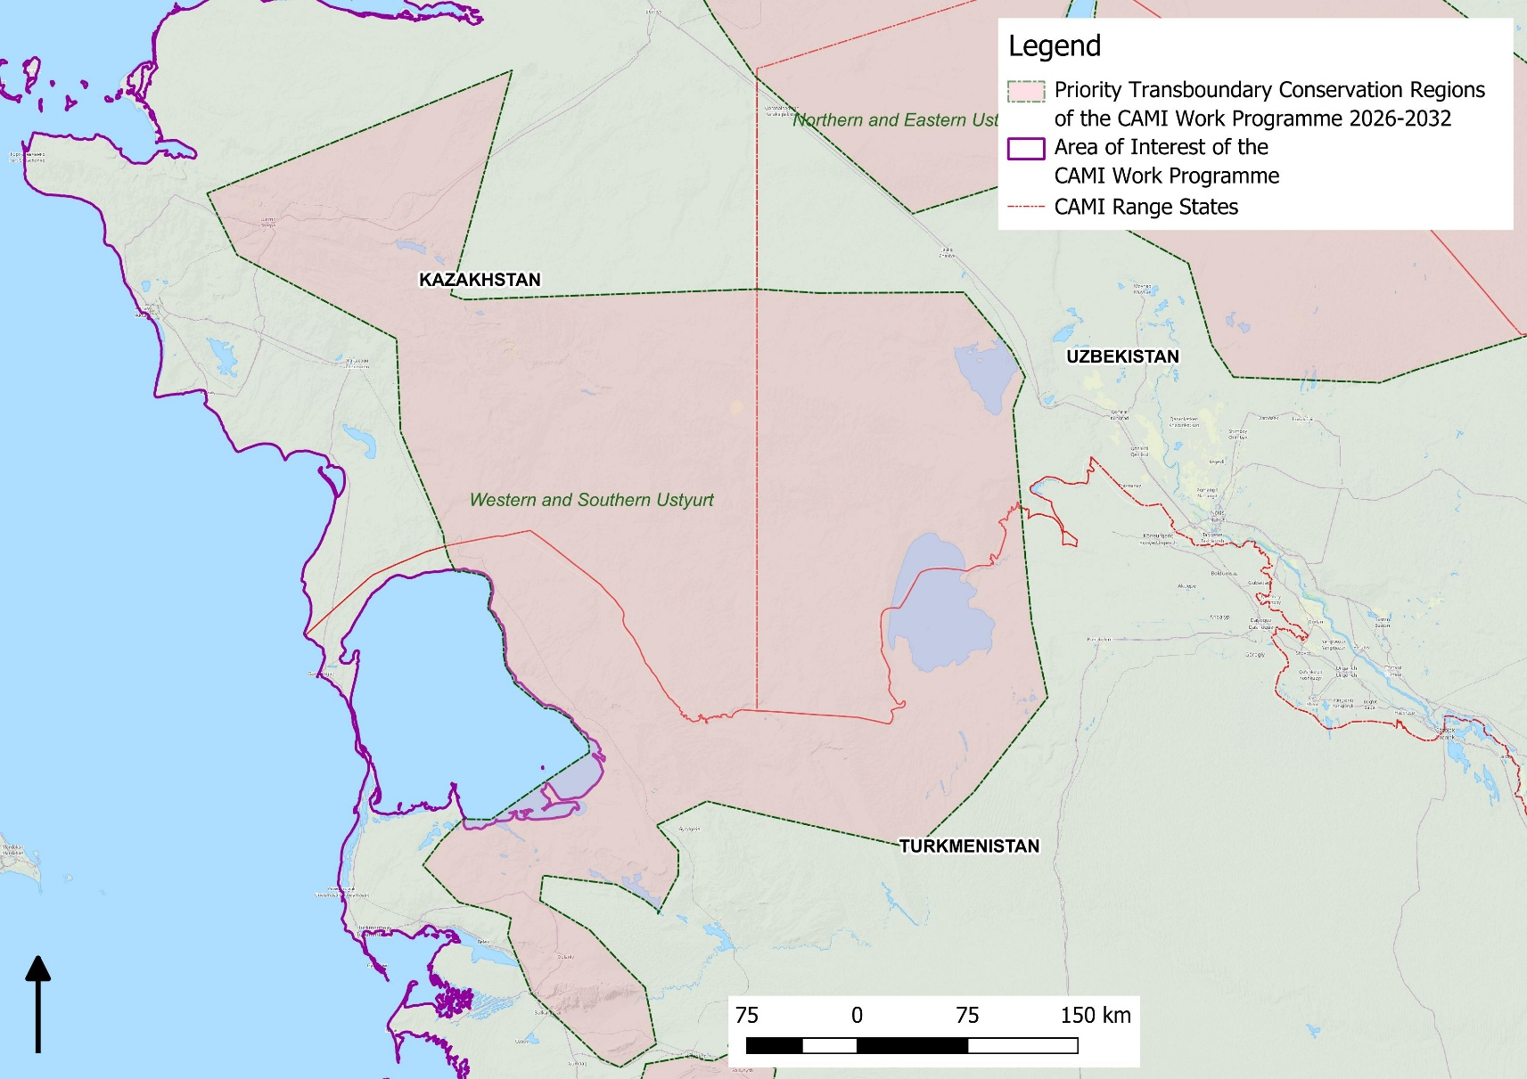
Figure 2. Priority Transboundary Conservation Region 1: Western and Southern Ustyurt

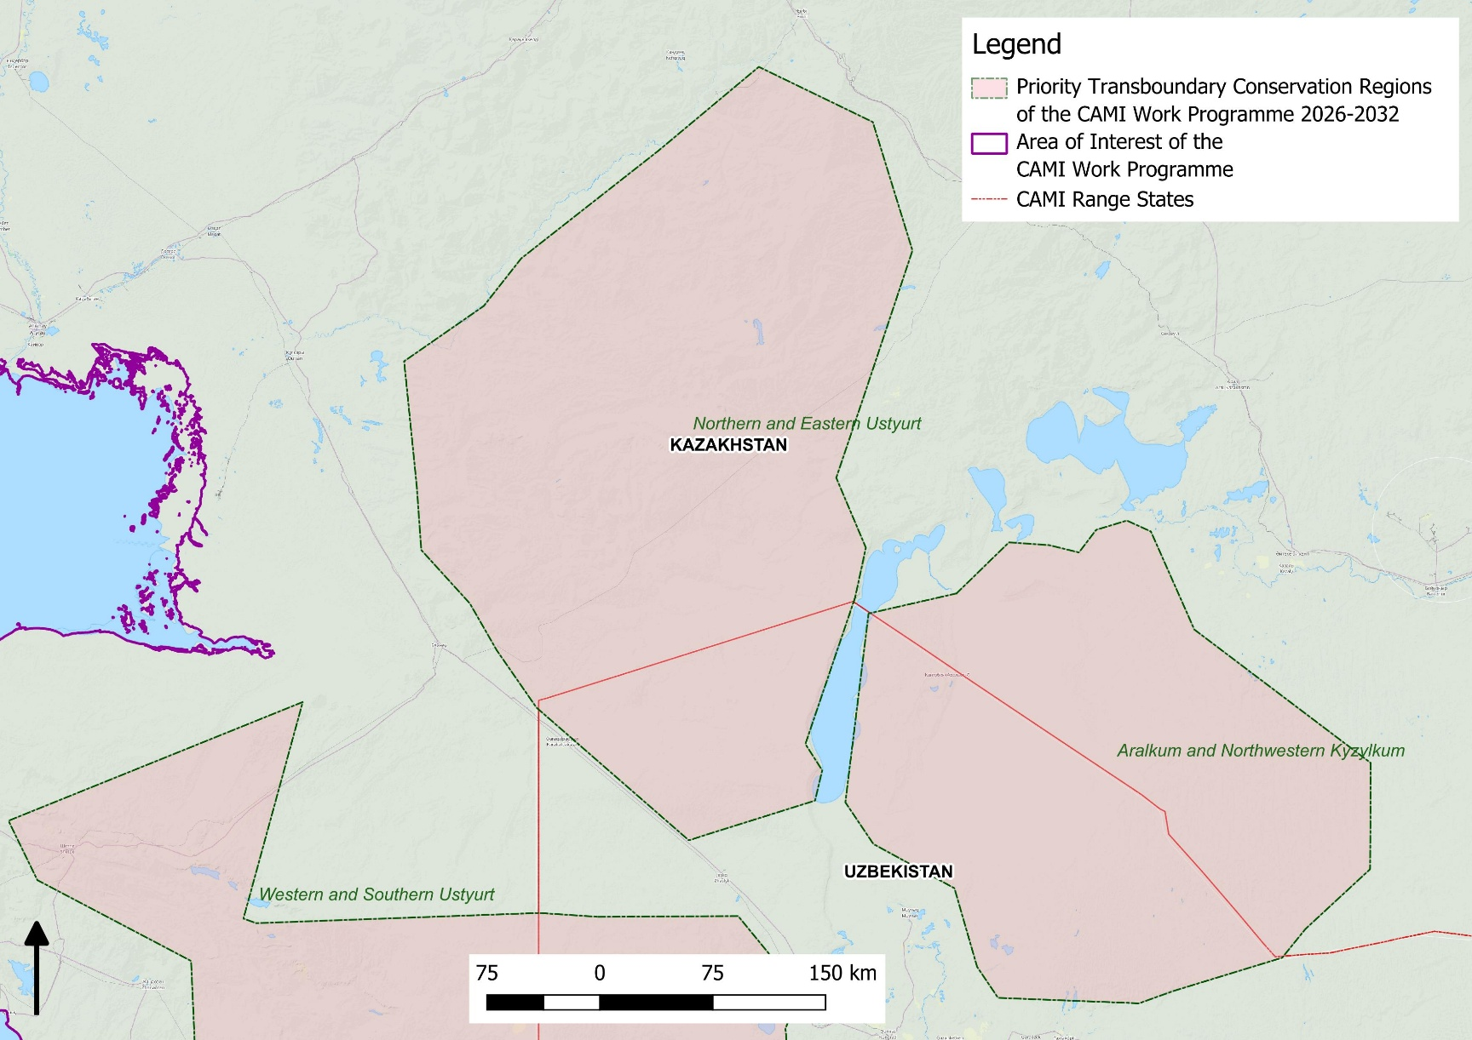

Figure 3. Priority Transboundary Conservation Region 2: Northern and Eastern Ustyurt and 3: Aralkum and Northwestern Kyzylkum
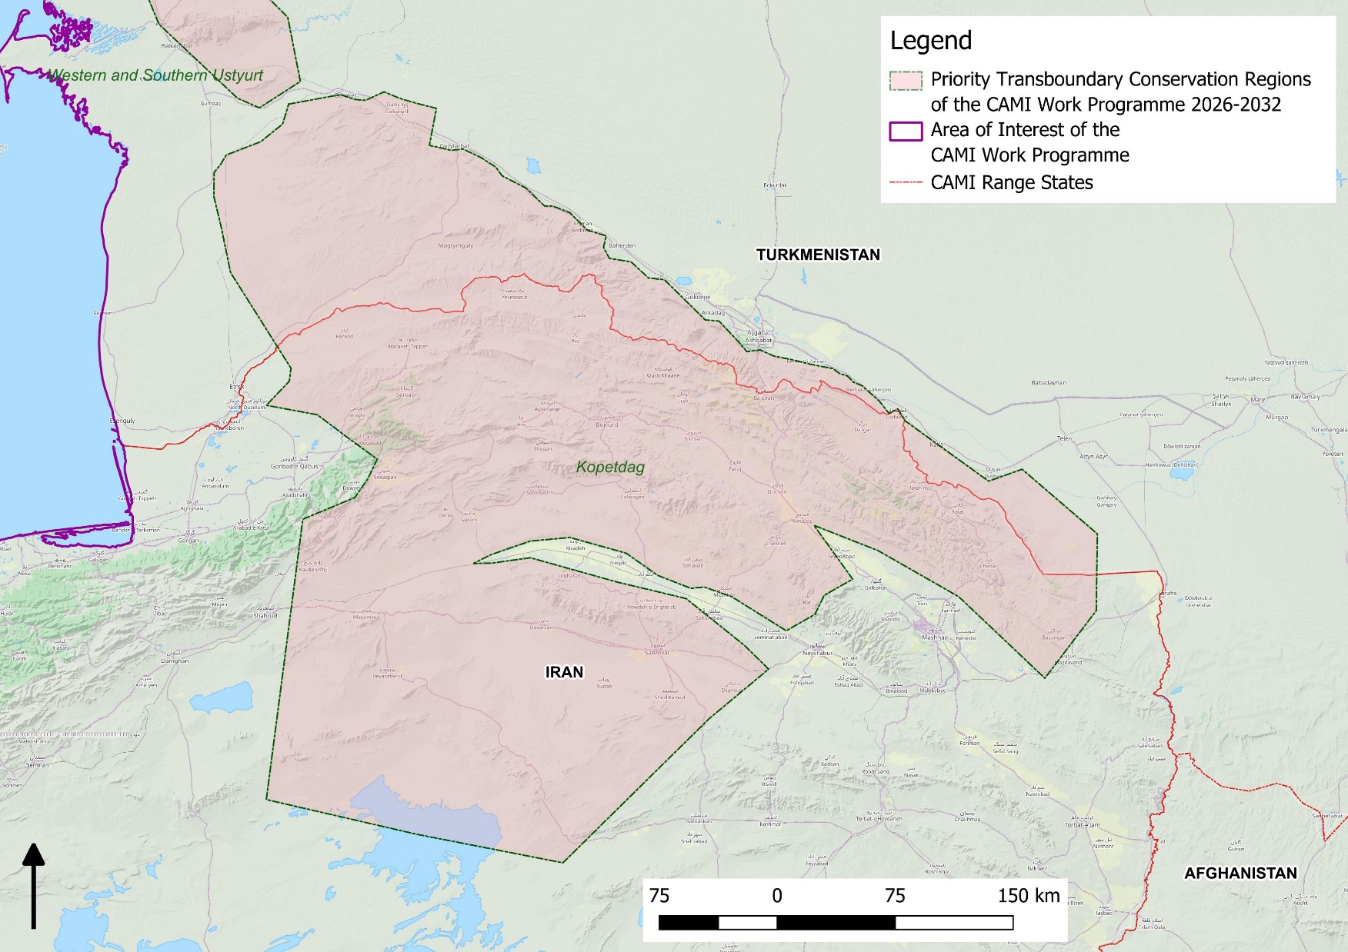
Figure 4. Priority Transboundary Conservation Region 4: Kopetdag
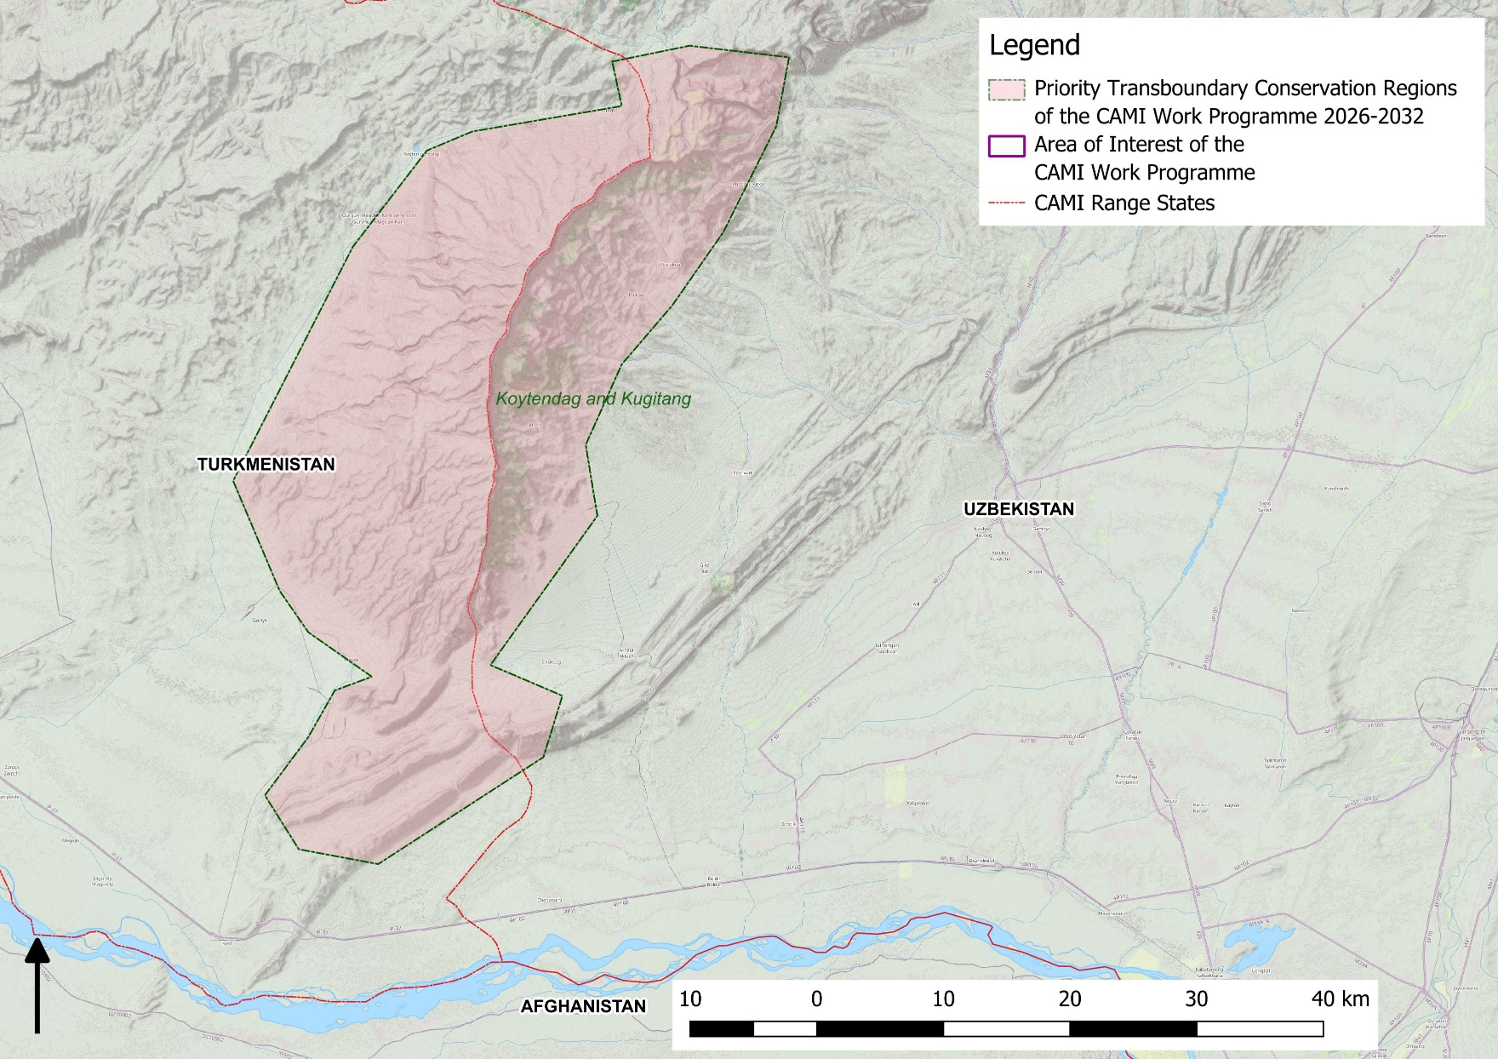
Figure 5. Priority Transboundary Conservation Region 5: Koytendag and Kugitang
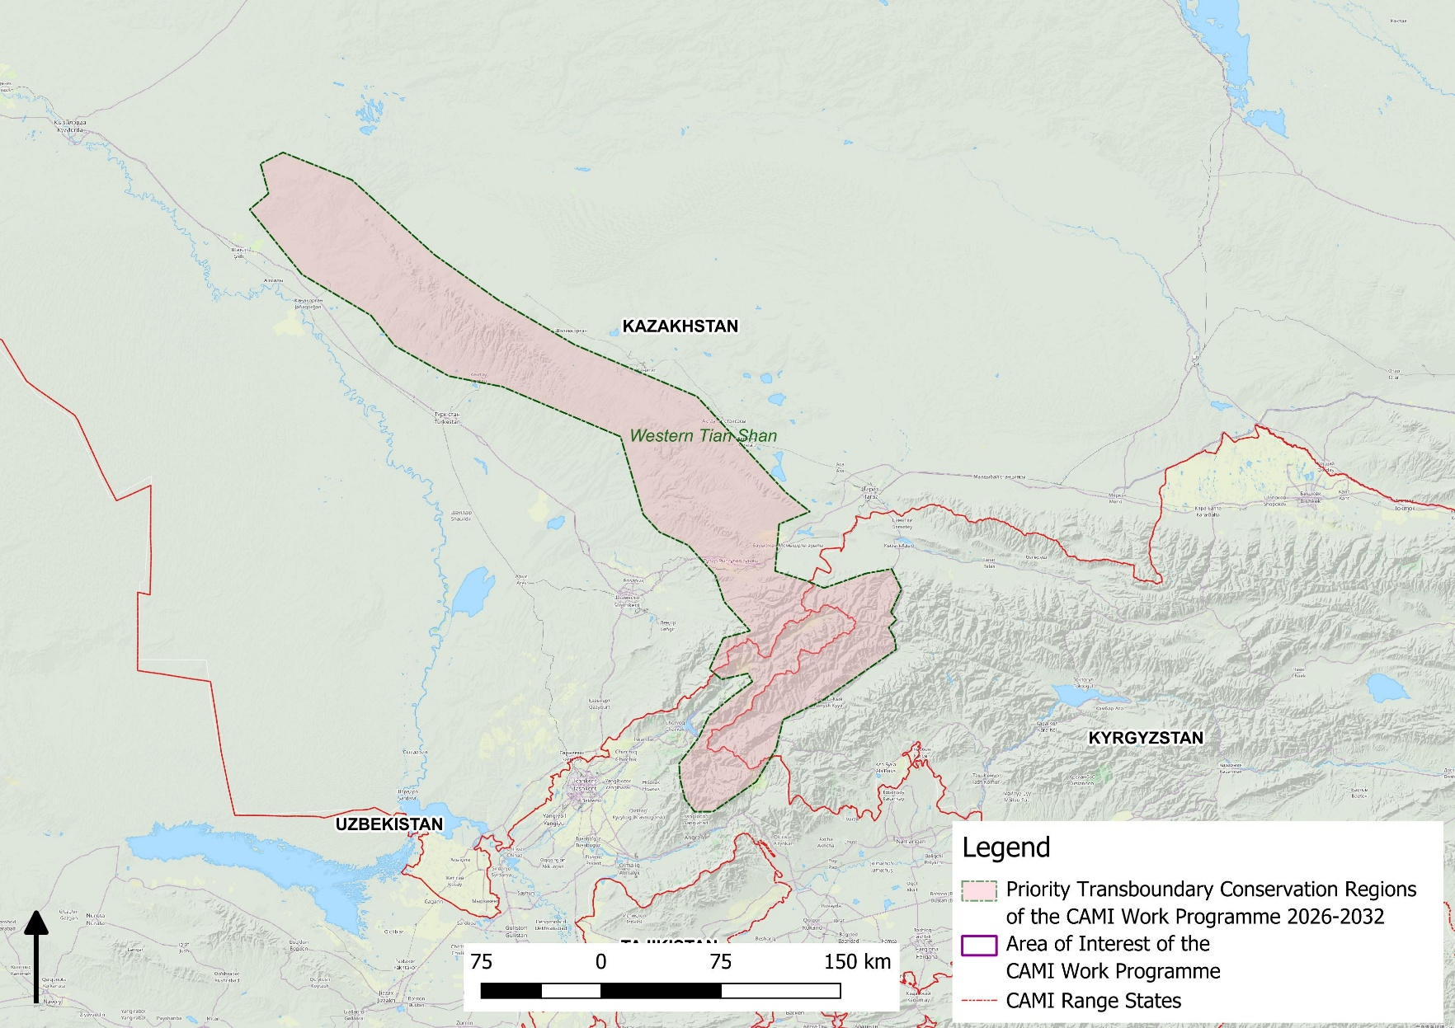
Figure 6. Priority Transboundary Conservation Region 6: Western Tian Shan
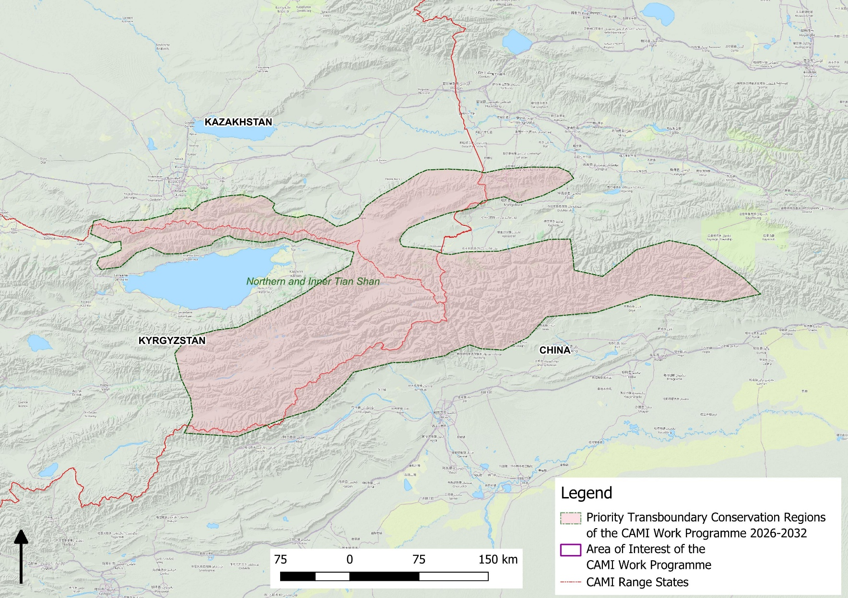
Figure 7. Priority Transboundary Conservation Region 7: Northern and Inner Tian Shan
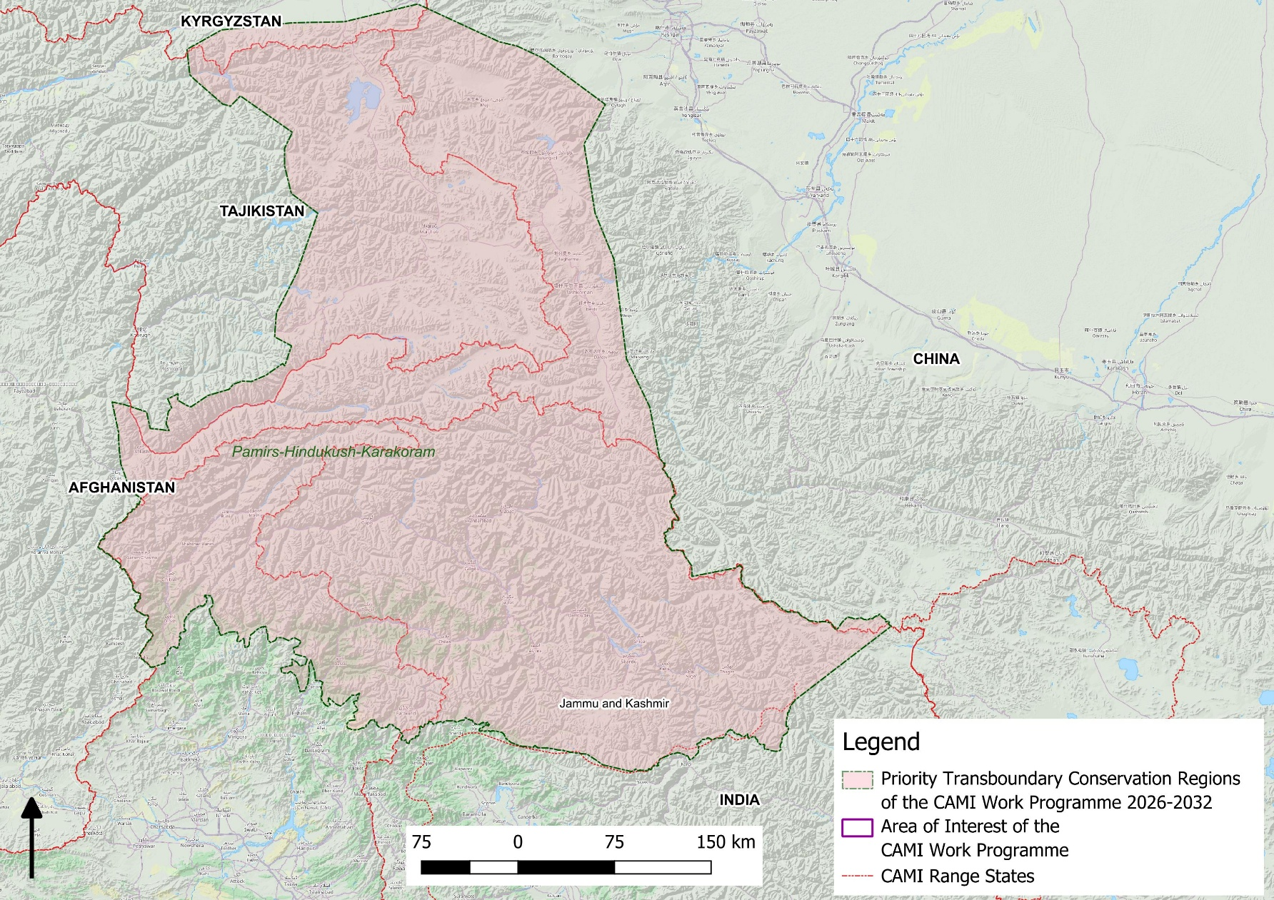
Figure 8. Priority Transboundary Conservation Region 8: Pamirs-Hindukush-Karakoram
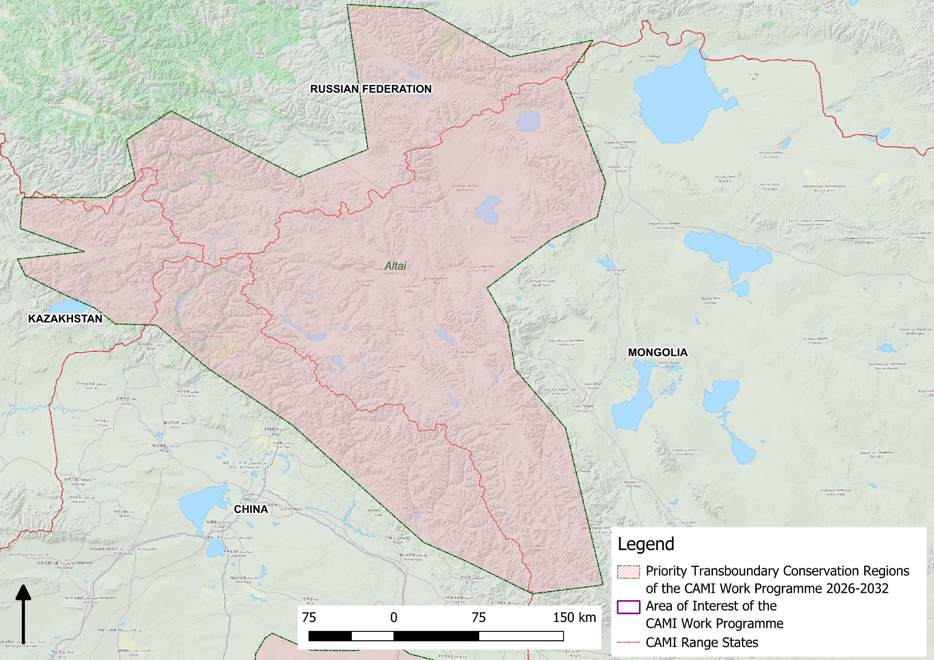
Figure 9. Priority Transboundary Conservation Region 9: Altai
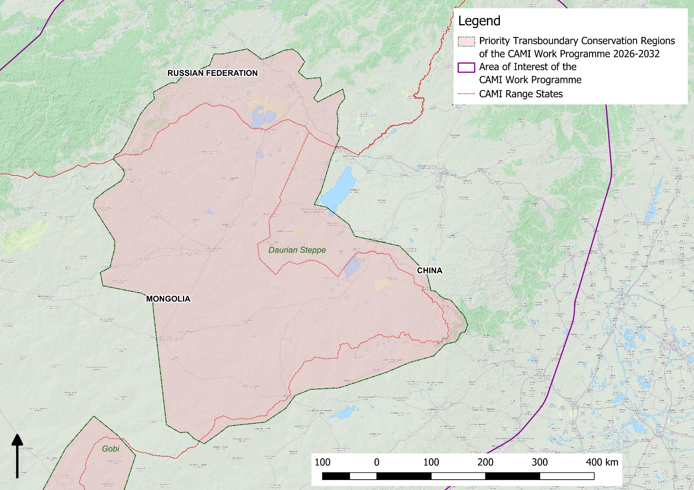
Figure 10. Priority Transboundary Conservation Region 10: Daurian Steppe
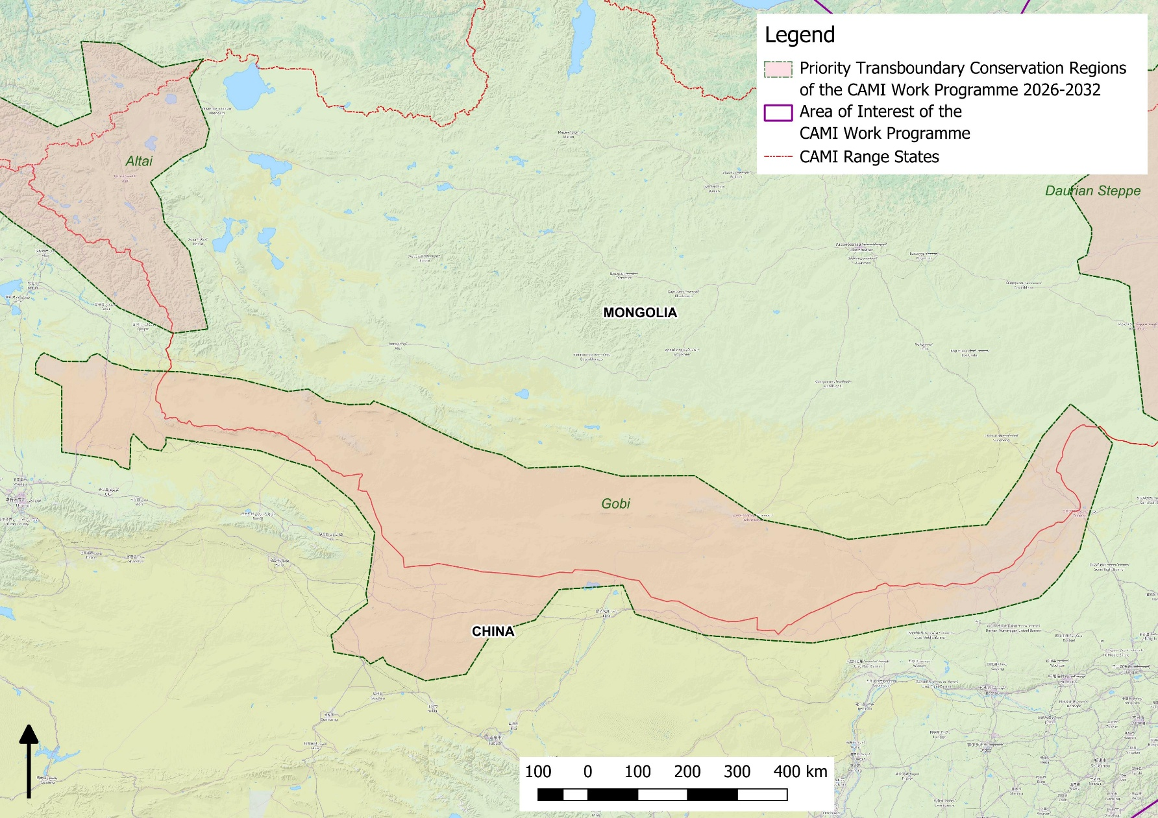
Figure 11. Priority Transboundary Conservation Region 11: Gobi
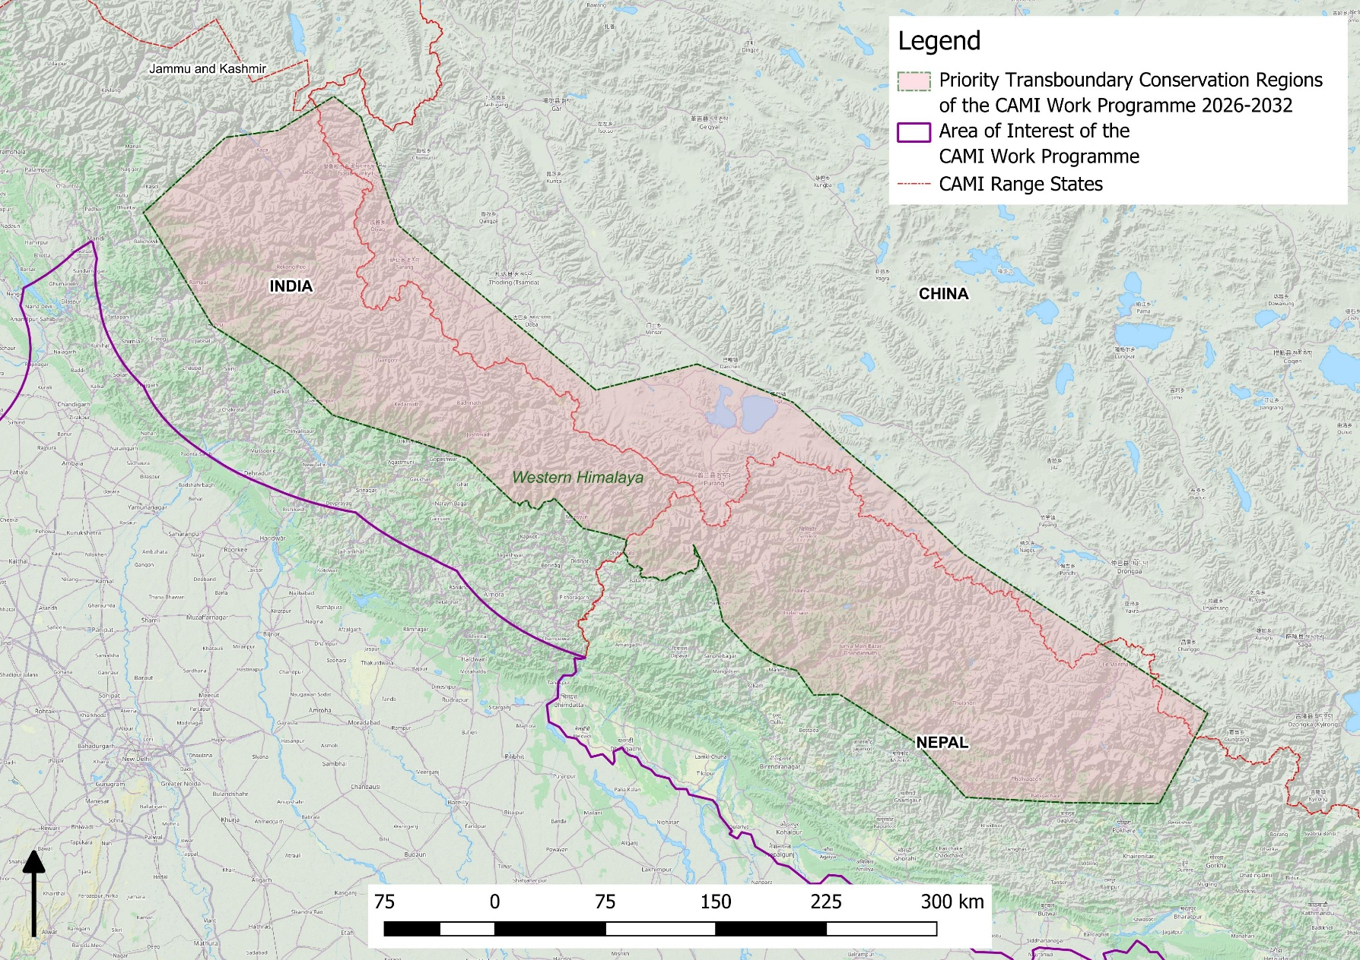
Figure 12. Priority Transboundary Conservation Region 12: Western Himalaya
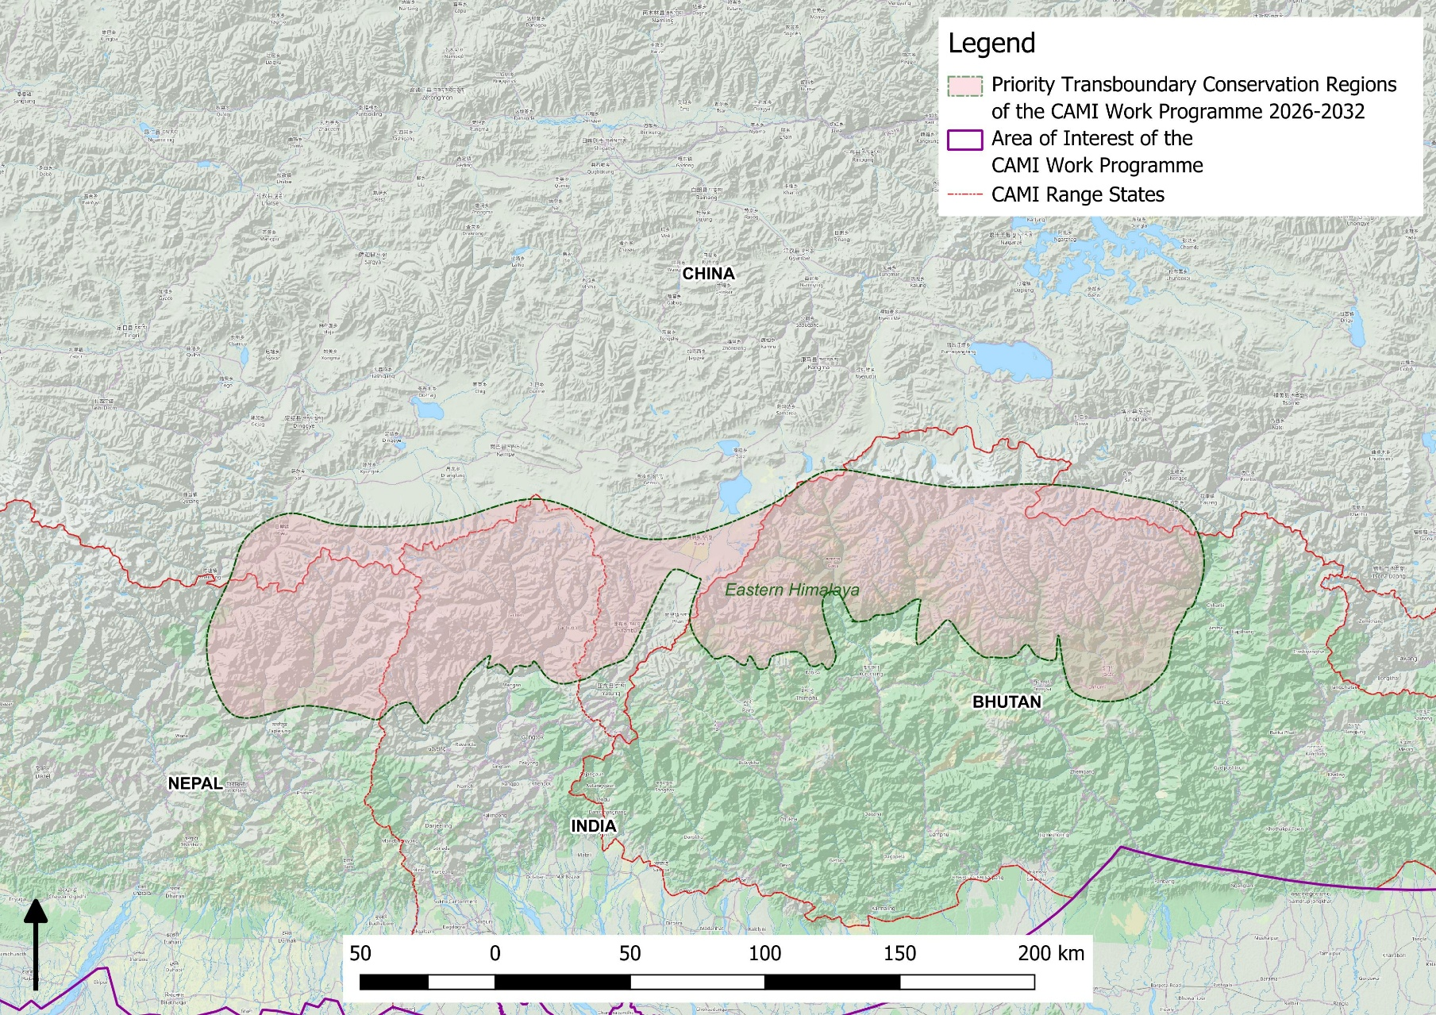
Figure 13. Priority Transboundary Conservation Region 13: Eastern Himalaya
Annex 2

Central asian mammal initative

Directed to Parties

15.AA Parties are requested to:

- conclude, where needed, transboundary agreements to strengthen the conservation of specific priority transboundary conservation regions (PTCRs) as identified in the CAMI Work Programme 2026–2032;

- nominate Government Focal Points for specific PTCRs; and

- develop joint funding proposals and innovative financial mechanisms to advance transboundary cooperation on PTCRs and other activities for the implementation of the CAMI Work Programme 2026–2032, with support and facilitation from the CMS Secretariat, where needed.

Directed to Parties, intergovernmental and non-governmental organizations

15.BB Parties, intergovernmental and non-governmental organizations are encouraged to provide political, financial and technical support in the implementation of the CAMI Work Programme 2026–2032 and the activities foreseen in Decision 15.AA a) and c), 15 DD and 15 EE.

Directed to the Standing Committee

15.CC The Standing Committee is requested to review and endorse, if needed, changes proposed by Parties during the intersessional period to the CAMI Work Programme 2026–2032 to reflect listing of new species by CMS COP15.

Directed to the Secretariat

15.DD The Secretariat shall:

- in accordance with agreed procedures and terms of reference, facilitate the nomination of Government Focal Points for each PTCR of the CAMI Work Programme 2026–2032, technical support organization(s) covering all PTCRs and CAMI Species Focal Points (SFPs);

- identify synergies between CAMI and the Central Asian Flyway Initiative, the Ramsar Regional Initiative for Central Asia, the Global Snow Leopard and Ecosystem Protection Program, the International Big Cat Alliance, and other relevant regional platforms to enhance joint conservation goals, save costs and reduce carbon footprints when organizing meetings;

- organize an online meeting between relevant sector representatives in Mongolia to discuss mitigation of the impact of planned/existing railways on migratory species;

- in cooperation with the CMS Energy Task Force, organize an online meeting to facilitate discussion of mitigation measures for wind and solar energy infrastructure on the Ustyurt Plateau;

- if requested by Parties, conduct other online meetings to facilitate discussion of the issues related to barriers to migration and identifying solutions involving infrastructure developers and planners, the CMS Global Partnership on Ecological Connectivity, CAMI SFPs and NFPs of CAMI Range States; and

- report to the Conference of Parties at its 16th meeting on the progress in implementing this Decision.

Directed to the Secretariat

15.EE The Secretariat shall, subject to the availability of external resources:

- produce and disseminate a brochure and a promotional video (for different audiences) to raise awareness and understanding of the importance of the region for the conservation of migratory species and the role of CAMI and the Central Asian Flyway Initiative;

- conduct a workshop to build the capacity and increase the awareness of decision makers and local communities in applying the IUCN SSC Guidelines on Human-wildlife Conflict and Coexistence, and the recommendations of the CMS report, Potential for Community-based Wildlife Management in Central Asia, as well as the recommendations of the CMS Scientific Council Working Group on Pastoralism and CMS-listed species;

- in cooperation with the CMS Energy Task Force, conduct a workshop to build the capacity of relevant decision makers and stakeholders and to develop guidance with a view to reducing the impacts of linear infrastructure on CAMI species and CMS-listed avian species;

- conduct workshops to strengthen transboundary cooperation in specific PTCRs;

- support the efforts of the Government of Uzbekistan to conduct a comprehensive feasibility study on re-introduction of the cheetah using cheetahs and prey base from appropriate sources that assesses, inter alia, the restoration of the prey base, habitat suitability and extension of available space for cheetahs, by providing capacity-building and support to fundraising efforts;

- organize a mid-term meeting in 2028 or 2029 to assess the implementation of the CAMI Work Programme 2026-2032, identify successes and address challenges; and

- report to the Conference of Parties at its 16th meeting on the progress in implementing this Decision.

The title has changed from Potential for Community-based Wildlife Management of CAMI Species to make it more accessible to a broader audience.
The 3rd meeting of CAMI Range States changed the title of the CAMI Programme of Work to CAMI Work Programme (CAMI WP).
Priority for implementing within 6 years: High (high importance and urgency for solving conservation issues affecting the animals and their habitat within 1-2 years); Medium (necessary for stabilization of population numbers within 3-5 years); Low (will contribute to conservation success, but is not urgently needed).
Where CITES’ responsibility is indicated, it only relates to CITES-listed species.
Instruments listed at the beginning of each section have been developed within CAMI and complement the CAMI Work Programme.

