 | CONVENTION ON  MIGRATORY  SPECIES | UNEP/CMS/COP15/Doc.26.4.3  30 September 2025  Original: English

15th MEETING OF THE CONFERENCE OF THE PARTIES

Campo Grande, Brazil, 23 to 29 March 2026
Agenda Item 26.4.3

GLOBAL ACTION PLAN FOR THE CONSERVATION OF STEPPE EAGLE
(Aquila nipalensis) (2025 – 2035)
(Prepared by the Secretariat)

Summary:

This document presents the Global Action Plan for the Conservation of Steppe Eagle (Steppe Eagle GAP) for adoption. A selection of key sections of the final draft Steppe Eagle GAP is contained in the Annex to this document and the full draft Plan is made available as an Information Document.

The Steppe Eagle GAP would support the achievement of Targets 1.1-1.3, 2.1-2.2, 3.1-3.2 and 5.5 of the Samarkand Strategic Plan for Migratory Species 2024–2032.

GLOBAL ACTION PLAN FOR THE CONSERVATION OF STEPPE EAGLE
(Aquila nipalensis) (2025 – 2035)

Background

- The steppe eagle (Aquila nipalensis) is a species listed on CMS Appendix I and II, and classified as a Category 1 species under the Memorandum of Understanding on the conservation of migratory birds of prey in Africa and Eurasia (Raptors MOU). Its populations are undergoing severe declines across much of its range, and for this reason the species is classified as Endangered on the IUCN Red List.

- The Technical Advisory Group to the Raptors MOU has identified the development of a Global Action Plan for the steppe eagle as a priority for reversing its current ‘Endangered’ IUCN Red List status.

- At the 14th meeting of the Conference of the Parties to CMS (COP14) in February 2024, the urgent need for international cooperation and for the development of a Global Action Plan for the species was noted in Resolution 12.12 (Rev.COP14) Action Plan for Birds. In addition, Decision 14.145 encouraged Parties and non-Parties, intergovernmental and nongovernmental organizations, and other relevant stakeholders to make rapid progress in the development of a Single Species Action Plan be endorsed at CMS COP15.

- In response, the Secretariat, in collaboration with the Royal Society for the Protection of Birds (RSPB, UK), which provided support in the form of resources and technical expertise, developed the Global Action Plan for the steppe eagle. The Secretariat, through the Coordinating Unit of the Raptors MOU, has established a core working group of leading experts across the geographical range of the species. A call for members of the working group was circulated to all Range States including CMS Parties and Raptors MOU Signatories on 8 April 2025, alongside a questionnaire on the species.

- An expert group further contributed to the drafting of the Action Plan at a workshop held in Astana, Kazakhstan in May 2025. During this workshop, a problem tree, threat ranking and conservation action framework were developed. These have since been refined by the coordinator and core working group, in close consultation with the workshop participants.

- The steppe eagle is also a flagship species of the Central Asian Flyway (CAF) established through Resolution 14.13 Initiative for Central Asian Flyway. The CAF acts “as a platform for international cooperation under the umbrella of CMS to further strengthen regional cooperation in the implementation of the Convention, and the existing CMS Family flyway instruments”.

Discussion and analysis

- A summary of the Steppe Eagle Global Action Plan (GAP) is provided in the Annex to this document. The full plan is provided as an information document (UNEP/CMS/COP15/inf.26.4.3, in English only). The GAP is the result of an extensive research and consultation process which included:
- a review of recently published literature to gather the best available scientific information on steppe eagle biology, ecology, conservation status and threats across the distribution range of the species;
- an analysis of distribution data available in avian databases;
- an analysis of responses to a circulated questionnaire aimed at collecting information at national level on the sizes and trends of breeding, migrating and wintering populations, sites of importance for the species, threats, and conservation actions implemented;
- a consultation with the steppe eagle Working Group for technical advice, a review of drafts of the Steppe Eagle GAP, and sharing data.

- The Steppe Eagle GAP sets out the following six goals:
- Reduce the impact of energy infrastructure on steppe eagles along the flyway;
- Reduce significantly mortality due to impact of legal and illegal take and trade;
- Understand and reduce the impact of unintentional poisoning on steppe eagle populations;
- Attain good quality habitats that support populations of steppe eagle across the species range;
- Address key knowledge gaps on Steppe Eagle distribution, movement and threats through increased collaboration and coordinated research, to inform conservation action across their global range; and
- Ensure endorsement and effective implementation of the Steppe Eagle GAP across all Range States through outreach with key communities and all major stakeholders.

- Each action of the Plan is accompanied by a list of stakeholders, implementation priorities, target countries and timescales. All Range States of the steppe eagle are requested to implement the Plan.

- It is recommended that a mid-term review of the Plan’s implementation is undertaken after five years, with an end-of-term review and update in 2036. To coordinate, oversee and report on implementation progress, the Plan also recommends establishing a dedicated coordinating entity.

Recommended actions

- The Conference of the Parties is recommended to review and consider adopting, as part of the draft amendments to Resolution 12.12 (Rev.COP14), the Global Action Plan for the Conservation of Steppe Eagle (Aquila nipalensis) (2025–2035).

ANNEX

Global Action Plan for the Conservation of the Steppe Eagle (Aquila nipalensis)
(2026-2035)

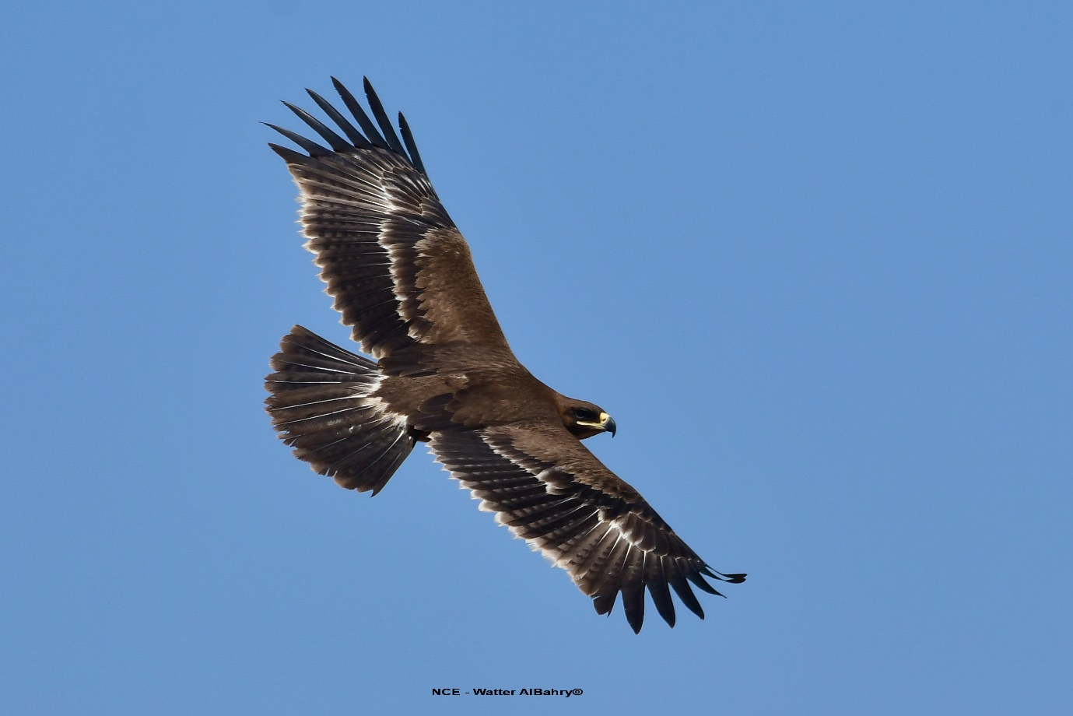
Halt and reverse the decline of Steppe Eagles by delivering innovative actions in science-based conservation and community engagement across its whole range.
This document reproduces key sections of the Global Action Plan for the Conservation of the Steppe Eagle (Aquila nipalensis)

Jenny Weston, Márton Horvárth, Igor Karyakin, Suresh Kumar, Elvira Nikolenko, Martin Odino, Mohammed Shobrak and Umberto Gallo-Orsi

September 2025








Introduction

The Steppe Eagle (Aquila nipalensis) is a large migratory raptor of Western Palearctic steppe and grasslands and a flagship of the Central Asian and East African-Eurasian Flyways. Once considered the most common large raptor (McGrady et al. 2021), declines have been seen across almost all of its range, and this has become a focus of international collaboration and conservation effort as is presented here in this Global Action Plan. Considered Endangered since 2015 (last assessed in 2021) (IUCN, 2021), Steppe Eagle is listed in Convention on Migratory Species (CMS) Appendix I and II and classified as Category 1 under the Memorandum of Understanding on the Conservation of Migratory Birds of Prey in Africa and Eurasia (Raptors MOU).

A call for international cooperation came at the III Eagles of the Palearctic Conference in Kazakhstan and, the Almaty Declaration (BRCC, 2023), highlighted the urgent need to a Global Action Plan for the Species. At the 14th meeting of the Conference of the Parties to CMS (CMS COP14) in February 2024, this urgent need for international cooperation and for the development of a Global Action Plan for the species was noted. Resolution 12.12 (Rev.COP14) and Decision 14.145 on Action Plan for Birds encouraged Parties and non-Parties, intergovernmental organizations and nongovernmental organizations, and other relevant stakeholders to make rapid progress in the development of a Single Species Action Plan, to be endorsed by CMS COP15 in early 2026. For migratory raptors, such as Steppe Eagle, international cooperation is of particular importance. Collaboratively designed and adopted international action plans provide a framework for state and non-state actors across range states to work together to improve a species’ conservation status (Lees et al. 2021; McClure et al. 2018).

Species Overview

Previously considered a single species, Steppe Eagle was split from Tawny Eagle (Aquila rapax) at the turn of the century (Clark 1992; Sangster et al. 2002). Two subspecies are recognised: A. n. nipalensis, found in the eastern part of the breeding range and generally wintering in South and South-east Asia; and A. n. orientalis, which breeds in the western part of the breeding range and generally winters in the Middle East, Arabia and East and Southern Africa.

The most recent published world population estimate is 50,000 – 75,000 mature individuals, which equates to 31,372 (26,014 – 36,731) pairs (IUCN, 2021). However, this figure is from 2015, and at this time the population was considered to have declined by at least 50% over three-generations (i.e. 42 years (Bird et al. 2020)), so it is reasonable to assume that the current world population is likely now 30,000 pairs or less, with observations from the field confirming further declines (Pulikova et al. 2023).

Breeding range

Steppe Eagles are birds of open habitats from Eastern Europe through Central Asia to East Asia (Figure 1). Kazakhstan is the stronghold of breeding Steppe Eagles, with 68-82% of the global population (Karyakin et al. 2018). Pulikova et al. (2023) provided the most recent national estimate as 16,750 – 28,070 pairs, which indicates a >10% decline in five years. Other key range states are Russia [2,500 – 3,700 pairs, estimated by Karyakin et al. (2016)], Mongolia [1500-2000 pairs, (Bold & Boldbaatar 1999)] and China [400-600 pairs, Karyakin et al. (2016)].
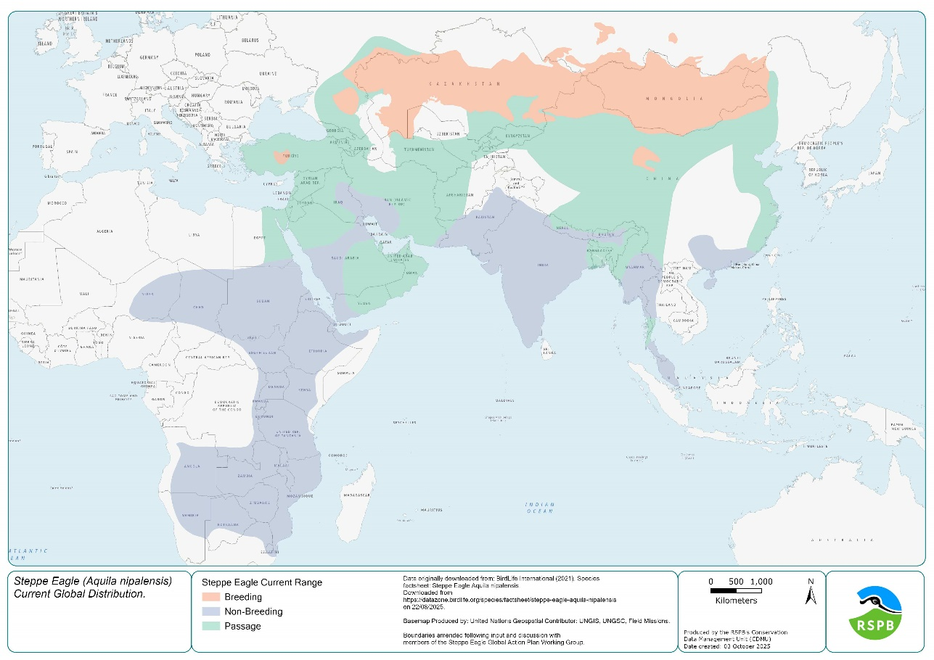
Figure 1 - Map of breeding (red), passage (green) and non-breeding (blue) range of Steppe Eagle
Previously the breeding range extended into SE Europe and Ukraine and into western China (Dementiev 1951) but the previously wide range has contracted significantly. Breeding in Europe has declined over the past four decades, with the exception of a newly discovered satellite breeding population in Türkiye confirmed in the mid-2010s (Horváth et al. 2018; Horváth et al. 2023; Horváth et al. 2022), although this population has potentially been present yet undetected for some time. Breeding has ceased in Romania, Moldova, Bulgaria (last recorded breeding in the 1940s) and Ukraine (last recorded breeding in the 1980s, although dispersing immature birds regularly recorded (Angelov 2015; Cramp & Simmons 1980).

Non-breeding range

Some individuals remain within the borders of the breeding range year-round, associated with good resources such as a rubbish dump in south-east Kazakhstan (McGrady et al. 2021) and areas of Mongolia with high rodent densities (Bold & Boldbaatar 1999), but the vast majority of birds migrate annually. Migration follows a number of corridors from the breeding range into wintering areas (Batbayar & Lee 2017; McGrady et al. 2021; Pande et al. 2013) (Figure 1).
Steppe Eagles winter in four areas: sub-Saharan Africa, the Arabian Peninsula, South Asia, and South-east Asia (Figure 1). Wintering birds can range wider than in the breeding grounds, but where food is concentrated their wintering range will contract (McGrady et al. 2021). In Africa, the wintering areas extend southwards from Sudan, with some individuals reaching South Africa and Namibia (Meyburg et al. 2003). Data from nestlings fitted with GPS transmitters in Türkiye have shown their wintering further west into Chad and Cameroon, suggesting that the wintering areas move westward in parallel with westward movement of breeding areas (B. Tatar & M. Horvath et al. unpublished data). Declines ranging from 56% to 96% decline over three generations (median 91%) have been seen across the continent (Shaw et al. 2024); Kenya alone has lost 76% of Steppe Eagles in 30-40 years (Ogada et al. 2022).

CONSERVATION ACTION FRAMEWORK
Action | Description | Stakeholders | Dependencies | Priority | Where | Timescale
Goal 1 - Reduce the impact of energy infrastructure on Steppe Eagles along the flyway
Objective 1.1 Improve detection methods and data sharing on the impact of energy infrastructure
1.1.1 | Review, agree and adopt standard survey methods and protocols for monitoring electrocution and collision with energy transmission and generation infrastructure across the whole range. | Academic Institutions, Research Agencies, Conservation NGOs, Energy Utilities, National Authorities |  | HIGH | All | Immediate
1.1.2 | Undertake standardised surveys in key areas to fully understand the impact of energy infrastructure on Steppe Eagle mortality to inform appropriate mitigation measures. | National Authorities (wildlife management & energy), Academic Institutions, Research Agencies, Energy Utilities, Conservation NGOs | 1.1.1 | HIGH | All | Short
1.1.3 | Promote transparency and regular exchange (or publication) of collected data on presence and mortality of Steppe Eagles from developers, infrastructure owners and other key stakeholders including energy funding agencies. | CMS Energy Taskforce, National Authorities, Conservation NGOs, Energy Utilities. |  | MEDIUM | All | Short
Objective 1.2 – Promote bird (eagle) safe infrastructure and solutions
1.2.1 | Facilitate that national guidelines and legislation reflect international standards and the implementation of CMS Resolution 10.11 by all range states and promote implementation of bird friendly infrastructure and mitigation actions, working in partnership in part with the CMS Energy Task Force. | National Authorities, CMS Energy Taskforce |  | MEDIUM | All | Short
1.2.2 | Ensure there are effective national legal frameworks to minimise the impacts of dangerous infrastructure in all range states. | National Authorities, CMS Energy Taskforce, Energy Utilities, CMS Energy Taskforce |  | MEDIUM | All | Long
1.2.3 | Promote awareness of the risks and implications associated with unsafe energy infrastructure to the communities and economies which may be impacted by it. | Energy Utilities, CMS Energy Taskforce, National Authorities |  | MEDIUM | All | Short
Objective 1.3 – Prevent and mitigate hazardous energy infrastructure in high-risk areas
1.3.1 | Identify the highest risk areas through promoting wider coverage of sensitivity mapping tools (such as Avistep, etc), and by paying particular attention to bottleneck and congregation sites, prioritising assessments of the powerlines and windfarms for electrocution and collision risks in these key areas. | Energy Utilities | 1.1.2  1.1.3  List of important sites (see 2025 list in Annexe) | CRITICAL | All | Short
1.3.2 | Ensure all key breeding areas, bottleneck and congregation (such as dumpsites and landfills) have safe electricity transmission infrastructure through the replacement and retrofitting of dangerous infrastructure (burying underground, insulation, diverters etc) and that new infrastructure also meets these standards. | National Authorities (wildlife management & energy), Energy Utilities, Conservation NGOs | 1.1.3  1.3.1 | CRITICAL | All | Short
1.3.3 | Improve EIA procedures to ensure appropriate consideration within EIAs for development in key areas for Steppe Eagle. | National Authorities | 1.1.3  1.3.1 | HIGH | All | Short
Goal 2 - Reduce significantly mortality due to impact of legal and illegal take and trade
Objective 2.1 - Understand the magnitude and socioeconomic drivers of illegal and unsustainable legal take, sharing information across the range
2.1.1 | Adopt common methodology across the range, based on existing good practice, on the gathering and management of data on illegal and legal take and in-person trade (including questionnaires and standard database structure etc.), to identify hot spots and methods. | Academic Institutions, CITES Authorities, Research Agencies, Conservation NGOs, MIKT, SWAITB TF, ITTEA |  | MEDIUM | All | Immediate
2.1.2 | Adopt common methods of monitoring online trade and sales of Steppe Eagle, including via social media and content platforms, based on existing good practice. | Academic Institutions, CITES Authorities, Research Agencies, Conservation NGOs, MIKT, SWAITB TF, ITTEA | 2.1.1 | MEDIUM | All | Immediate
2.1.3 | Provide support and data for an international review on the magnitude of illegal and legal take and trade of Steppe Eagles (and other raptors where appropriate) throughout the species’ range. | Academic Institutions, Research Agencies, Conservation NGOs, MIKT, SWAITB TF, ITTEA, CITES, CMS | 2.1.1  2.1.2 | MEDIUM | All | Medium
2.1.4 | Undertake socioeconomic research to identify drivers of illegal take and trade (e.g. trophy hunting through recreational shooting, livestock protection or captive bird keeping) among key stakeholder groups utilising different techniques. | Academic Institutions, CITES Authorities, Research Agencies, specifically social scientists, | 2.1.2 | MEDIUM | All | Short
2.1.5 | Identify key stakeholder groups and primary communication channels in relation to illegal and legal take and trade of Steppe Eagles including law enforcement groups at the national level. | Academic Institutions, Research Agencies, MIKT, SWAITB TF, ITTEA, CITES | 2.1.2  2.1.3  2.1.4 | MEDIUM | All | Short
Objective 2.2 - Strengthen legislation and law enforcement to minimise illegal and unsustainable legal take and trade
2.2.1 | Gain full protection status, with appropriate penalties where breached, for the Steppe Eagle in all range states following review of current levels, including international responsibilities through CMS and CITES. | National Authorities (wildlife management) |  | CRITICAL | All | Immediate
Objective 2.3 - Increase awareness and capacity amongst key stakeholders to decrease illegal and legal take of Steppe Eagles
2.3.1 | Enhance enforcement of illegal take and trade laws in hot-spot areas by building cooperation and capacity between conservation organizations (i.e. both governmental and non-governmental) and law enforcement agencies. | National Authorities, Conservation NGOs, MIKT, SWAITB TF | 2.1.3 | HIGH | All | Short
2.3.2 | Prepare, disseminate and adopt best practice guidance on effective voluntary and state mechanisms for enforcing hunting and take regulations to increase awareness of key stakeholders including the full judiciary system (i.e. law enforcement agencies, prosecutors, judges etc). In addition, undertake extensive targeted outreach activities in key impact areas, such as patrols in specific markets, e-commerce enforcement units, targeting known criminal organisations and engaging decision makers. | National Authorities (law enforcement), Conservation NGOs, MIKT, SWAITB TF, CITES Authorities, | 2.3.1 | HIGH | All | Short
2.3.3 | Develop and deliver a programme of work in key areas to reduce ownership of Steppe Eagles as ‘status symbols’ either by educating on its illegality or by promoting legal alternatives, to target consumer demand. Share national and international resource opportunities to undertake campaigns to include community engagement and media dissemination. | National Authorities (law enforcement), Conservation NGOs |  | MEDIUM | Middle East, S & SE Asia | Medium
Goal 3 - Understand and reduce the impact of unintentional poisoning on Steppe Eagle populations
Objective 3.1 - Identify critical chemicals affecting Steppe Eagle survival and/or fitness
3.1.1 | Conduct research and disseminate literature on critical chemicals likely to affect the fitness (health and population productivity) and/or survival of Steppe Eagle throughout its range. | National Authorities, Academic Institutions, Research Agencies, Conservation NGOs |  | HIGH | All | Short
3.1.2 | Understand the extent of use, impact and contamination pathway of NSAIDs, pest control chemicals and other environmental contaminants (such as heavy metals) at or near breeding and congregation sites including systematic sampling and analysis of primary food resources. | National Authorities, Academic Institutions, Research Agencies, Conservation NGOs, Waste management authorities | 3.1.1  5.2.1 | HIGH | All | Immediate
3.1.3 | Sample live Steppe Eagles and fresh eagle carcasses, in a timely effective manner to determine cause of death and presence of critical chemicals and disease, recorded in a centralised database to enable data sharing. | National Authorities (state testing laboratories, wildlife management), Research Agencies, Conservation NGOs, CITES Authorities | 3.1.1  3.1.2 | HIGH | All | Short
Objective 3.2 - Minimize exposure to critical chemicals
3.2.1 | Ratify the legislation on critical chemicals use and disposal to ensure the implementation of CMS Resolution 11.15 (RevCOP14) and related CMS Preventing Poisoning Guideline use and the Bern Convention to ensure the use of critical chemicals is banned or appropriately restricted across range states. | National Authorities |  | HIGH | All | Immediate
3.2.2 | Identify the socio-economic drivers of the use of critical chemicals and employ methods to reduce these drivers measurably. | Academic Institutions, Research Agencies, Conservation NGOs |  | LOW | All | Medium
3.2.3 | Develop, adopt safe farmed-animal carcass management and disposal and promote with key stakeholders, ensuring that eagles still have access to safe carcasses as a food resource. | National Authorities (agriculture, drug regulation), Conservation NGOs, Waste management authorities |  | MEDIUM | All | Medium
3.2.4 | Strengthen law enforcement, by building capacity and making resources available, to ensure effective monitoring and enforcement of existing and new legislation of critical chemicals. | National Authorities, Conservation NGOs, CMS |  | HIGH | All | Medium
3.2.5 | Develop communication and awareness mechanism with WOAH to support in banning of dangerous drugs and support using the safe alternatives. | National Authorities (agriculture, drug regulation), Conservation NGOs |  | MEDIUM | All | Long
3.2.6 | Raise awareness on the environmental impact from the use of critical chemicals and promotion of alternatives in key Steppe Eagle areas (safe chemicals or alternative mitigation measures such as fences etc). | National Authorities, Conservation NGOs |  | HIGH | All | Medium
Goal 4 - Attain good quality habitats that support populations of Steppe Eagle across the species range
Objective 4.1 - Identify and map key habitats
4.1.1 | Conduct targeted research, in the breeding, migratory and non-breeding ranges on habitat use, site connectivity and diet, to fill key knowledge gaps. | Academic Institutions, Research Agencies, Conservation NGOs |  | CRITICAL | All | Short
4.1.2 | Develop a habitat suitability map of whole species’ range, integrating sensitivity layers, telemetry data, and observation networks to identify critical habitats. | Academic Institutions, Research Agencies, Conservation NGOs | 5.3.2 | MEDIUM | All | Medium
Objective 4.2 - Improve and maintain habitat quality
4.2.1 | Implement habitat conservation and sustainable land-use management (e.g., restoring traditional pasture management practices) in priority breeding areas across the range, including baseline and follow-up assessments of habitat quality (i.e. nest and foraging sites) and prey availability. Collaborate with protected area authorities to integrate Steppe Eagle habitat requirements into site management plans. | National Authorities (protected areas), Conservation NGOs |  | MEDIUM | Breeding | Medium
4.2.2 | Establish and enforce land management policies in critical habitats along both the African-Eurasian Flyway and the Central Asian Flyway, focusing on reducing disturbance and sustaining prey populations and promote the broader spatial scale of landscape scale restoration to ensure connectivity along global flyways and the longer-term aim of a return to historic population range. | Conservation NGOs, National authorities | 4.1.2 | MEDIUM | All | Long
4.2.3 | Ensure key congregation sites (including dump sites) are managed to ensure they provide safe roosting and feeding opportunities for Steppe Eagles through safe energy infrastructure and no access to poisoned food resources. | National authorities, Waste authorities, Electricity companies |  | CRITICAL | All | Short
Objective 4.3 - Strengthen support for habitat conservation
4.3.1 | Develop targeted communication materials and conduct workshops with decision-makers in all range states using local languages to raise recognition of Steppe Eagle conservation needs. | National Authorities, Conservation NGOs |  | MEDIUM | All | Short
4.3.2 | Disseminate key outreach materials to local stakeholders in critical habitats, using appropriate local languages and media formats | National Authorities, Conservation NGOs | 4.3.1 | MEDIUM | All | Short
4.3.3 | Identify and designate a network of protected sites for Steppe Eagle by strengthening existing protection and the creation of new protected and OECM areas, providing flyway connectivity which are managed effectively (through the production and implementation of appropriate management plans) for the conservation of the species and their key prey species. | National Authorities, Conservation NGOs |  | MEDIUM | All | Short
4.3.4 | Assess Steppe Eagle’s vulnerability and adaptive capacity to climate change to inform scenario-planning and development of adaptation and dynamic management measures. | National Authorities, Academic Institutions, Research Agencies, Conservation NGOs | 4.1.2 | MEDIUM | ALL | Medium
Goal 5- Address key knowledge gaps on Steppe Eagle distribution, movement, and threats through increased collaboration and coordinated research, to inform conservation action across their global range
Objective 5.1. Sharing best practices and standardized data collection, along with the data itself where required
5.1.1 | Develop and share standard protocols for the monitoring of Steppe Eagles at breeding sites, migratory bottlenecks and stopover sites, and wintering areas, prioritizing high-risk regions. | National Authorities, Academic Institutions, Research Agencies, Conservation NGOs |  | HIGH | All | Immediate
5.1.2 | Conduct a baseline assessment of existing Steppe Eagle monitoring, telemetry, and survey data across the range, and identify priority knowledge gaps to guide optimal investment in research. | National Authorities, Academic Institutions, Research Agencies, Conservation NGOs |  | HIGH | All | Immediate
Objective 5.2. Coordinated monitoring across the range
5.2.1 | Carry out species monitoring (at all life stages) using standardised methods to guide sensitivity mapping and conservation action. | National Authorities, Conservation NGOs |  | CRITICAL | All | Immediate
5.2.2 | Develop and maintain a centralized and dynamic data sharing group who advocate for analysis and publication of combined datasets for overall understanding of the species and the primary threats driving their decline. | National Authorities, Academic Institutions, Research Agencies, Conservation NGOs, SE GAP Working Group |  | MEDIUM | All | Short
5.2.3 | Develop and maintain a centralised registry of trained personnel (experts), researchers, and institutions engaged in compatible Steppe Eagle monitoring, telemetry, and conservation across the species’ range. The registry should include contact details, areas of expertise, and geographic focus to support improved coordination, collaboration, and better mobilization and be regularly updated. | National Authorities, Academic Institutions, Research Agencies, SE GAP Working Group |  | MEDIUM | All | Short
5.2.4 | Develop and share opportunities and sources of funding for monitoring, data analysis, research and advocacy. | CMS Secretariat, SE GAP Working Group |  | HIGH | All | Short
Objective 5.3. Improved understanding of changing population dynamics, species range leading to effective conservation programs across all range states
5.3.1 | Implement regular horizon scanning to detect emerging and future threats, including along migratory routes. | Academic Institutions, Research Agencies,  SE GAP Working Group |  | MEDIUM | All | Immediate
5.3.2 | Promote the tracking of birds to further scientific aims which follows best practice and modern technologies, making the data available for wider analyses to identify threats and key habitats. Ensure resources are available for the timely recovery of dead birds to understand causes of mortality. | Academic Institutions, Research Agencies, Conservation NGOs | 4.1.1 | MEDIUM | All | Medium
5.3.3 | Clarify the borders of and connectivity between breeding populations and their flyway (i.e. metapopulation), to identify and highlight the most important and/or vulnerable populations. | Academic Institutions, Research Agencies | 5.1.2  5.3.2 | HIGH | All | Medium
5.3.4 | Monitor and investigate the changing productivity and how these changes impact on population dynamics and their drivers, analysing both historic and new data. | National Authorities, Academic Institutions, Research Agencies |  | HIGH | All | Short
Goal 6 - Ensure endorsement and effective implementation of the Steppe Eagle GAP across all range states through outreach with key communities and all major stakeholders
Objective 6.1 – Awareness of the value of Steppe Eagles and their key threats is raised among the key stakeholder groups
6.1.1 | Communicate key findings on both the problems facing Steppe Eagle populations, and potential solutions to achieve positive responses to key decision-makers and communities to generate support evidence-based conservation actions. | Conservation NGOs, SE GAP working group, National Authorities |  | MEDIUM | All | Immediate
6.1.2 | Highlight and promote the Steppe Eagle as a flagship species of the Central Asian and African-Eurasian Flyways, utilising and supporting existing national and international events to raise awareness of Steppe Eagle global conservation needs and efforts. | Conservation NGOs, CMS, National Authorities, CAFI |  | HIGH | All | Short
6.1.3 | Establish or strengthen civil society organisations in key areas along the flyway by 2030, promoting local stewardship of Steppe Eagle habitats to aid with meeting international targets and sustainability goals. | Conservation NGOs, National Authorities (protected areas, wildlife management, communities), Steppe Eagle Working Group |  | LOW | All | Long

Legend

Priority scale of actions
CRITICAL – action needed to prevent a large decline which could lead to the species extinction
HIGH – action needed to prevent a decline >20% of the population in <20 years
MEDIUM – action needed to prevent a decline of <20% of the population in <20 years
LOW – action needed to prevent local population declines or which is likely to have only a small impact on the whole population

Timescale
Immediate – to commence within the next year
Short – to commence within the next 3 years
Medium – to commence within the next 5 years
Long – to commence within the next 10 years
Ongoing – currently implemented and should continue

Geographic range
Breeding range (includes birds in the breeding range which may not be breeding such as sub-adults)
Middle East and North Africa
South and South-east Asia
Sub-Saharan Africa

THREAT ASSESSMENT

Fully understanding the drivers of population declines of Steppe Eagle is fundamental to halting and reversing their decline. Threat mapping and ranking was carried out as part of an international expert workshop held in May 2025 in Astana, Kazakhstan. This was also informed by the responses to a questionnaire sent to experts across the range states, CMS Focal Points and Raptors MOU Contact Points.

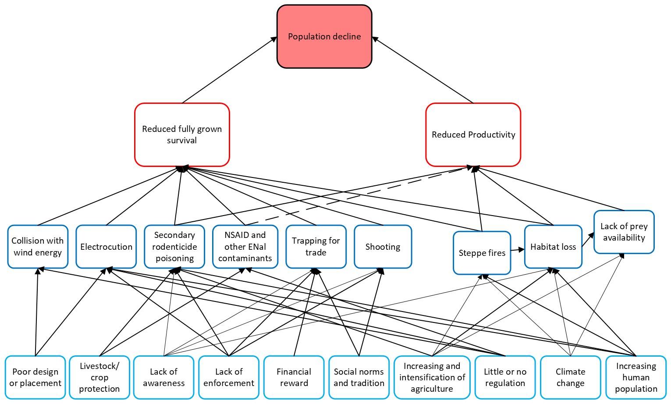 Figure 2 - Problem tree and threat mapping for Steppe Eagle showing drivers, threats, impacts and overall outcome (decline). Dashed line is where the driver or link is less well understood.
The threat mapping which forms the Problem Tree in figure 2 identifies the threats impacting Steppe Eagle and the drivers of these threats, how each threat impacts the species (e.g. reduces fully-grown survival or impacts productivity), and whether these links are proven or hypothesised.

Threat | Whole range |  | Breeding range | Middle East and North Africa | Sub-Saharan Africa | South & Southeast Asia
Energy Infrastructure
Electrocution | High |  | High | High | High | High
Windfarms | Medium |  | Medium | Medium | High | Medium
Collision (powerlines) | Low |  | Unknown | Low | Low | Low
Habitat
Lack of food/prey availability | High |  | High | Medium
Habitat loss | Unknown |  | Low | Unknown | Unknown | Medium
Steppe and bush fires | Medium |  | Medium |  | Medium
Predation | Low |  | Low
Human disturbance | Medium |  | Medium
Nest rubbish | Low |  | Low
Climate change | Medium |  | Medium |  | Medium
Poisoning
Rodenticide poisoning | High |  | High | Medium | Medium | Medium
HWC poisoning, including quelea, insecticide and feral dog poisoning | Medium |  |  | Medium | High | Medium
NSAID poisoning | Unknown |  | Unknown | Unknown | Unknown | Unknown
Unsafe water | Unknown |  |  | Unknown | Medium | Unknown
Illegal and unsustainable take
Hunting (IKB) | Medium |  | Low | High | Medium | Medium
Trapping/trade | Medium |  | Low | High | Low | Medium

Table 1 Global threat ranking of Steppe Eagle by region. Threats were scored by scope, severity and timing and considered at a global scale and by region. HIGH (red) = threats with the highest potential impact; MEDIUM (orange); LOW (yellow); UNKNOWN (blue)= where there the severity of the threat is unknown but believed to be present; GREY = all available evidence suggests the threat is not present in the region.

Energy Infrastructure

Energy infrastructure presents three related risks for Steppe Eagle: electrocution, powerline collisions, and wind-turbine collisions.

Electrocution (Overall High)

Electrocution is a key threat to large raptors globally (Oppel et al. 2021; Serratosa et al. 2024; Slater et al. 2020). In the largely treeless landscapes used by Steppe Eagle, electricity infrastructure offers perching and nesting sites, but birds are at risk when they simultaneously contact two uninsulated components or an uninsulated component and the ground (Slater et al. 2020). Large numbers of Steppe Eagles have been recorded as electrocuted across the species’ range, highlighting the universal nature of this issue (McGrady et al. 2021). True mortality is underestimated due to carcass decay and scavenging; within Kazakhstan alone, detection-bias adjustments suggest 9 to 90 times more deaths than found (see summary in Dwyer et al. (2022). Electrocution also affects people via electricity outages and increased risk of steppe/bush fire in already fire-vulnerable habitats; the wider economic costs remain unquantified (Guil et al. 2018).

In Kazakhstan and Mongolia (breeding range) electrocution is widespread, with carcass rates recently as high as 22 carcasses per 10 km in Western Kazakhstan (Alexandrovich et al. 2024) and 8.1 carcasses per 1000 poles (combined Golden and Steppe Eagle) in Mongolia (Purevdorj et al. 2025). Karyakin (2008) estimated that 51% of all raptor electrocutions in Kazakhstan are of Steppe Eagle, and risk may increase locally where prey densities are unusually high (Purevdorj et al. 2025). In their wintering range, large congregations at refuse and dump sites can bring birds into close proximity with unsafe lines (Keijmel et al. 2020). In Saudi Arabia, 14km of powerlines near dumps may kill up to 240 individuals annually (Shobrak et al. 2022). Electrocution is also of growing concern in sub-Saharan Africa for Steppe Eagle and other migrating raptors (S. Thomsett pers. comm.), with Steppe Eagle considered particularly high risk in the region (Ngila et al. 2024). While insulation and undergrounding have been implemented in some regions, most of the mitigation measures have not specifically been targeted at Steppe Eagle hotspots.

Wind-turbine collision (Overall Medium)

Rapid wind-power expansion is of growing concern for large soaring birds (De Lucas et al. 2008). For Steppe Eagle, the spread of wind energy facilities along key breeding areas, migration bottlenecks and congregation sites poses a risk of fatal collisions (Karyakin et al. 2021). Modelling from satellite-tagging indicates up to 7% of the 6,888–7,371 Steppe Eagles migrating annually through a proposed site could be at risk of collision (Karyakin et al. 2021). Avoidance rates remain largely untested for this species, but potential impacts at bottlenecks are clear. Wind farms also result in habitat loss through displacement, causing eagles to avoid the area near the turbines; while construction footprints are relatively small, disturbance and collisions can be far more consequential (Percival 2005).

Risks increase with large turbines and long wind blades (>30 meters long), and where prey/carrion attract raptors (Percival 2005; Schaub et al. 2024). Whether adults or sub-adults are more affected is unstudied for Steppe Eagle (cf. Dahl et al. (2013)), but given current declines, either could have population-level effects. Wind farms can also create barriers to migration, forcing birds to take longer or more energy-intensive routes, since soaring raptors reliant on land-based thermals are channelled through narrow “bottlenecks” (Barrios & Rodriguez 2004; Meyburg et al. 2003). In eastern Kazakhstan, the Karatau Ridge (a critical migration bottleneck for Steppe, Eastern Imperial (A. heliaca), and Greater Spotted Eagles (Clanga clanga), is threatened by existing and planned wind farms (Karyakin et al. 2021; Karyakin et al. 2024), with similar risks documented in other globally important migratory corridors, including the Rift Valley, the Red Sea, the eastern Mediterranean, and the Caspian Sea (Hilgerloh et al. 2011; Watson et al. 2018).

Secondary poisoning & environmental contaminants

Poisoning and environmental contaminants are one of the most critical pressures on raptors globally (McClure et al. 2018; Serratosa et al. 2024) and Steppe Eagles are at risk of poisoning across their range and annual cycle (Karyakin et al. 2025; Keith & Bruggers 1998; McGrady et al. 2021), primarily via indirect secondary poisoning rather than direct targeting (though see Unsafe water under localised threats). The drivers of secondary poisoning are both specific targeted campaigns, generally funded and/or endorsed by governments, and individuals (potentially inadvertently) using pesticides incorrectly. Risk is heightened on wintering grounds where scavenging increases (McGrady et al. 2021).

Rodenticides and insecticides (Overall Medium)

Rodenticides are used at dumpsites and around domestic, industrial and agricultural operations. While legislation varies by country, commonly encountered compounds are second generation rodenticides such as bromadiolone (Nakayama et al. 2019). Secondary poisoning of non-target wildlife is a known shortcoming of second-generation anticoagulant (SGA) rodenticides; some are licensed only for covered/indoor use but are applied inappropriately, increasing exposure of scavengers to poisoned carcasses. In Mongolia, 1 million hectares were treated with bromadiolone to regulate Brandt’s Vole (Microtus brandtii) (Kovács et al. 2014), causing additional mortality of Steppe Eagle and other raptors, and a 33% decline in the number of breeding pairs on the Kazakhstan-Mongolian border in the years immediately following the poisoning event (Karyakin 2010).

Plague management (to reduce rodent numbers following population explosion) and its wider impacts through secondary poisoning across the breeding range are poorly understood but represent a significant risk to Steppe Eagles. During the breeding season, rodents form a significant proportion of the diet of adults and provisioned young (e.g. McGrady et al 2021, Karyakin et al 2023), so even small-scale rodenticide use could be threat. Outside the breeding season, Steppe Eagles often congregate at dumpsites or slaughterhouses, where they are exposed to rodent control practices. These sites also attract other scavengers, and lethal control of mammalian scavengers (including the use of strychnine and other controlled substances) is common. If carcasses are not removed or safely disposed of (buried/burned), they become a secondary-poisoning risk. Control of insects such as locusts has also been widespread, with instances of secondary poisoning reported (S. Thomsett pers. comm.). Because there is no universal requirement to report ‘by-catch’ casualties, data on the impacts on Steppe Eagle and other raptors are limited.

NSAIDs (Unknown)

The effects of Non-Steroidal Anti-Inflammatory Drugs (NSAIDs) on Steppe Eagle (as well as other non-vulture Accipitriformes) is limited. The strongest evidence comes from Sharma et al. (2014): necropsies of two Steppe Eagles from the Jorbeer carcass-disposal site (India) showed clinical signs, histopathology and diclofenac residues consistent with diclofenac toxicity in Gyps vultures. Several subsequent publications report dead Steppe Eagles at the same site (Bohra & Rao 2023; Bohra & Vyas 2018), including 231 Steppe Eagles found dead between 2017-2022, though no post-mortem toxicity testing exists to corroborate these findings, nor to indicate toxicity of related veterinary drugs. NSAIDs, specifically diclofenac, caused the collapse of the South and South-east Asia’s Vulture population (Green et al. 2004). There is limited evidence that NSAIDs are a primary driver of Steppe Eagle decline but given the species’ association with livestock carcasses where NSAID use persists, NSAIDs represent a potentially high threat (McGrady et al. 2021). Therefore, there is an urgent need to improve population monitoring and toxicology capacity in the Indian sub-continent and other areas where NSAID use continues.

Illegal and unsustainable take (IKB)

The illegal and unsustainable take of Steppe Eagle is reported from across the entire species’ range, in different forms ‘Take’ includes hunting for sport or taxidermy and live take for the pet/falconry trade (Brochet et al. 2016), though legality varies by country. IKB pressure is often concentrated at migration bottlenecks where birds are predictable and accessible.

Illegal killing (Overall Medium)

Illegal shooting of Steppe Eagle is particularly severe in the Levant (Syria, Lebanon), where migrating birds concentrate along the eastern Mediterranean and are killed for sport or for taxidermy (Brochet et al. 2019; Van Maanen et al. 2001). Falcon trappers operating in North Africa and the Middle East also kill Steppe Eagles because they are perceived as threats to their falcons or disruptive to trapping activities (Karyakin et al. 2016; Khoury et al. 2020). Shooting is also a pressure in the breeding range, with a satellite tagged individual shot when still within their natal range (E. Bragin pers. comms.).

Take & live trade (Overall Medium)

Live market trade of Steppe Eagles is well documented, as has been observed in Cairo (Habib 2023) and the Al Ghazil market in Bagdad, where dozens can be seen in autumn and spring (Al-Sheikhly et al. 2017). Increasingly, trade has shifted online, with sales via social media and e-commerce platforms (Aidek & Eid 2025; Eid & Handal 2018). Similar online trends are reported in Southeast Asia (e.g. Myanmar). In the breeding range, some Steppe Eagles are used for traditional hunting, although Golden Eagle A. chrysaetos is generally preferred (Sklyarenko 2023). Persecution of eagles is also reported from parts of China (Karyakin et al. 2016; MaMing 2023; MaMing & Zhao 2013) and parts of Africa (Ogada et al. 2022).

Overall, the IKB pressure is strongest where migration funnels through narrow corridors, and where enforcement capacity is limited (see Van Maanen et al. (2001) for an example from Georgia). Detection is imperfect and incidents are under-reported, so available figures likely underestimate true levels.

Environmental change & resource dynamics

Habitat change, prey dynamics and fire regimes act together, with climate change amplifying many pathways. Effects are both direct (e.g., nest loss to fire) and indirect (vegetation structure → prey cycles → foraging success), and they vary by region and season.

Habitat loss and alteration (Unknown)

In Türkiye, conversion of grasslands to agricultural fields is considered a High threat, alongside the drainage of wetlands (Ministry of Agriculture & Forestry 2023). Afforestation of steppe habitats is considered a low threat in Türkiye (Ministry of Agriculture & Forestry 2023) and is not described as a major pressure elsewhere. Loss of habitat due to mining exploration and associated infrastructure, which leads to changes in vegetation structure and depletion of natural resources in China, has driven localised declines of raptors in China (MaMing & Zhao 2013). The conversion of prime steppe habitat to agriculture was raised as a threat as early as the 1950’s by Dementiev & Gladkov (1951), with both conversion to arable fields and increased raising pressure from pastoral activities still cited (Karyakin et al. 2016). In Southeast Asia, habitat change is likely to affect local foraging in some areas, but quantified species-level impacts remain limited.

Prey availability (Overall High)

On the breeding grounds, Steppe Eagle nesting sites are often associated with colonial burrowing mammals, including ground squirrels (Spermophilus spp.) and pikas (Ochotona spp.). Where these prey peak in spring, territories are more likely to be occupied and pairs more likely to breed successfully, whereas scarcity corresponds to lower occupancy and productivity. In the Altai–Sayan and adjacent steppe, high abundance/availability of ground squirrels and pikas in spring has been shown to determine both nest occupation and breeding success in Steppe Eagles (Karyakin et al. 2023). As the Steppe Eagle’s prey base depends on open, short grass structure and active burrow systems, land-use change and vegetation overgrowth can depress prey populations independently of poisoning or infrastructure. Across the Palearctic, ground-squirrel colonies are prone to disappear when habitat is not maintained and becomes overgrown (Petluš et al. 2021).

Fire and vegetation dynamics (Overall Medium)

Steppe fires are a natural part of ecosystems across much of the range, but increasing frequency and intensity can alter vegetation structure for several years post-fire (Smelansky et al., 2015), with knock-on effects for small-mammal and insect prey cycles. In Kazakhstan, at least half of the range is projected to face increased fire hazard (Karyakin et al. 2025). Fire affects Steppe Eagles directly (mortality of eggs/young in nests) and indirectly (habitat change). In Karaganda, 3.93% of active nests were reported lost to fire Karyakin et al. (2017).

Climate change (Unknown)

Climate change acts mainly by modulating the above pathways: shifting prey baselines, raising wildfire risk, extending droughts that drive congregation at carcass sites and water points (with attendant exposure to poisoning/unsafe water), and altering wind regimes that intensify wind-farm siting pressure along bottlenecks. Along with biodiversity loss, climate change is one of the emergencies facing the natural environment and will have wide ranging impacts on birds of prey such as the Steppe Eagle (Martínez-Ruiz et al. 2023). Modelled responses in ecologically similar species reinforce concern: for example, Tawny Eagle was predicted to face extinction with <10% change in annual precipitation in Southern Africa (Wichmann et al. 2005). Furthermore, the Climatic Atlas of European Breeding Birds suggests the Western part of Steppe Eagle’s range is becoming less suitable (Huntley et al. 2007), although breeding is now almost non-existent already here.

Other localised or emerging threats

Some pressures are geographically limited or episodic. The Expert and Core Working Group have identified the following threats and pressures as worth mentioning despite the limited or unknown likely impact on the populations of the species:
- Hybridisation with Eastern Imperial Eagle (Overall Low)
- Nest rubbish (Overall low)
- Vehicle collision (Overall low)
- Unsafe water (Unknown)
- Disease (Unknown)

