CONVENTION ON THE CONSERVATION OF MIGRATORY SPECIES OF WILD ANIMALS (CMS)

MIGRATORY AMAZONIAN CATFISH ACTION PLAN

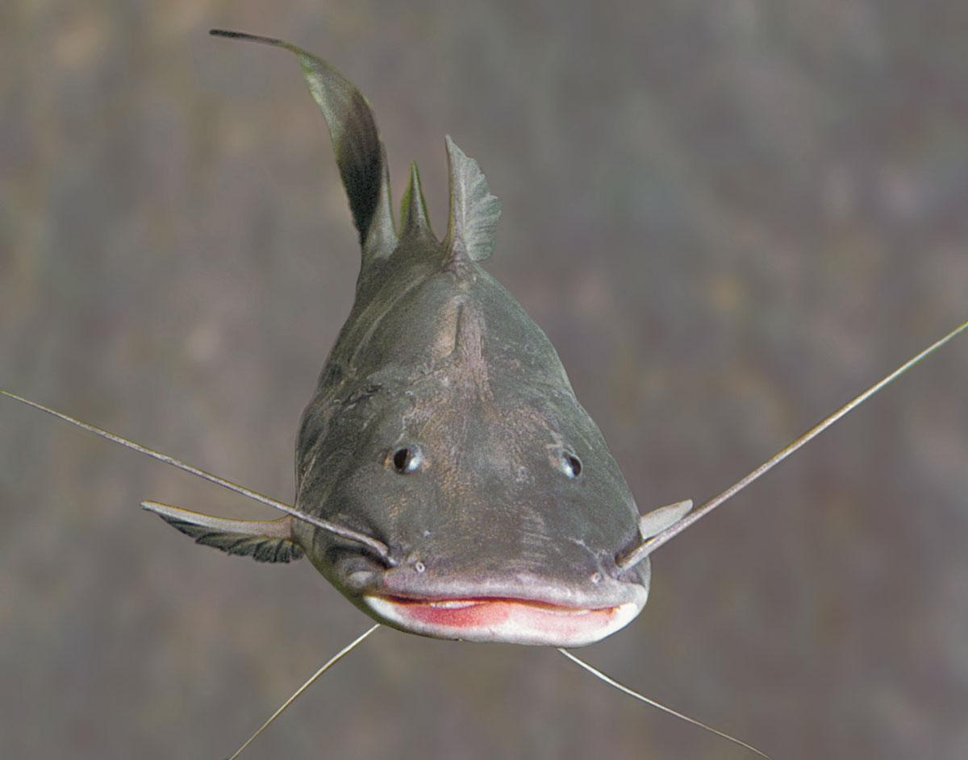
© Michael Goulding

October, 2025

MIGRATORY AMAZONIAN CATFISH ACTION PLAN

INTRODUCTION

In addition to its enormous size (6,870,000 km²) and its average annual flow of 6,742 km³, almost two and four times greater, respectively, than the second largest basin on the planet, the Congo River (1, 2), the Amazon basin is home to the most diverse ichthyofauna in the world, with 2,716 known species, of which 1,696 are endemic (3). An unidentified portion of this ichthyofauna is consumed by approximately 47 million inhabitants of the region, which has one of the highest fish consumption rates in the world (4-7). Considering only the commercial species landed in the main fishing ports, it is possible to list more than 234 species regularly caught (8). However, by including non-commercial species, such as fish less than 5 cm consumed by indigenous populations, this figure could be even more extraordinary (9).

Despite the importance of commercial fisheries in Brazil, Peru, Colombia and Bolivia, few Amazonian cities in these countries collect reliable statistical data, which makes estimates of their production inaccurate (9). Estimates obtained using different methodologies range from 173,000 to 575,000 tons per year, based on: (i) annual productivity by area estimated by gill net experiments (10); (ii) data collection from 39 publications evaluating per capita consumption in different regions (7); and (iii) maximum annual production by species recorded in 66 cities in the Amazon basin (9). In any case, most of this fishery production is caught in the extensive and continuous floodplain, periodically flooded and essential to maintain the food chain of aquatic biota (2, 11-16).

The various types of wetlands in the lowland Amazon, located at altitudes below 500 metres, occupy approximately 800,000 km² between the estuary and the foothills of the Andes, representing about 30% in the lowland area and 14% in the Amazon basin. (2, 17-19). The transient nature of this environment favours the migration of fish species, which move seasonally due to intense flooding of rivers and the flooding of large areas of the lowland of the Amazon (20-22). Migratory fish have become highly concentrated and abundant in this environment and are extremely important for regional fisheries, accounting for approximately 93% (range, 77% to 99%) of the total production of the basin and generating an estimated annual income of 436 million (9, 23).

One of the fundamental prerequisites for the management of migratory fisheries is the knowledge of their movements and spatial structure, including the return of breeders to spawning areas ("return"), the dispersal of juveniles to breeding areas and the search for feeding areas by young adults (24, 25). Although Amazonian fishermen are well aware of these movements in the regions where they fish, few studies describe them in detail. Amazonian fish exhibit a remarkable diversity of movements, synchronized by the pulse of floods and other processes that are still poorly understood. The distances covered vary widely: from a few tens to thousands of kilometres, depending on the species and the stage of the life cycle.

Species that travel shorter distances, around 50 km, can be considered resident or sedentary. Investigations using isotope analysis of otolites, capture and recapture, and radiotelemetry in peacock bass (Cichla temensis, Río Negro) and pirarucus (Arapaima gigas, Rio Amazonas) – reveal a different behaviour, with movements limited to approximately 50 km (26, 27).

The migration of small fish (adults less than 20 cm in length) is little known, as these species are rarely caught in commercial fishing. A rare and well-documented example is the migration of Trichomycterus barbouri (Trichomycteridae), a small catfish smaller than 10 cm, that is fished intensively during its migration in the Beni River near Rurrenabaque, Bolivia (28). This species covers at least 370 km, a distance that, although significant given the size of the fish, is considered short compared to the migrations of other Amazonian fish.

Species that travel at least 1000 km throughout their life (22) are the most important for commercial fishing in the Amazon. The catch of these species accounts for approximately 75% of total fisheries production and may exceed 90% in some regions (9, 23). Fishermen are well aware of their migratory routes, at least in the areas where they fish, as these species are highly appreciated by the local population and, consequently, have a good value in the local market. These species migrate between white-water (muddy) rivers, clear-water and black-water, and have in common that their spawning and dispersion movements are concentrated in white-water rivers, such as the Amazon. These rivers form floodplains, which serve as breeding and feeding areas for adults (12, 16, 20, 22, 29).

The last group of migratory species is composed of species whose breeding areas are found in the eastern Amazon and whose spawning areas are found in the western Amazon, especially near the slopes of the Andes. These are the great catfish of the genus Brachyplatystoma, known as Large Migratory Catfish (Goliath Catfishes) (30). The longest distances recorded between spawning and breeding areas for this group are 5786 km for the gilded catfish (B. rousseauxii), 4,238 km for the zebra (B. juruense) and 3129 km for the laulao (B. vaillantii). The most impressive migration is that of the gilded catfish, which can travel approximately 11,600 km to complete its life cycle (21, 31, 32).

The migration of large catfish illustrates the remarkable connectivity of Amazon rivers and highlights key challenges for ecosystem-level conservation of migratory fish. These species play a significant role in the economy and food security of the Amazon region, but are also the most susceptible to the combined impacts of overfishing, large-scale disruptions of river systems and climate change. Two of them, the gilded catfish and the laulao, are target species of the only industrial fleet that exploits Amazonian fisheries. This fleet operates with bottom trawls in the breeding areas, which increases the vulnerability of these species to overfishing (33).

Environmental changes resulting from the construction of hydroelectric dams on the Madeira River prevent catfish from migrating to spawning grounds at the headwaters of the Madeira River in Bolivia and Peru (34). This change has impacted fishing of the gilded catfish upriver (35) and its migratory pattern, resulting in partial migration and forcing individuals to remain resident in the upstream stretch (36).

ACKNOWLEDGMENTS

The development of the Regional Action Plan for Migratory Amazonian Catfish has been made possible by the joint efforts of multiple institutions, governments, civil society organizations, local and indigenous communities, and international cooperation partners.
Firstly, we would like to express our appreciation to the governments of the Amazonian countries — Bolivia, Brazil, Colombia, Ecuador, Peru and Venezuela — that actively participated in the process of dialogue, technical discussion and validation of proposals, demonstrating their commitment to the conservation of migratory catfish and to the sustainable management of fishery resources in the Amazon.

Special thanks to the Government of Brazil, through the Ministry of Environment and Climate Change (MMA) and the Ministry of Fisheries and Aquaculture (MPA), for their leadership in the inclusion of two species of migratory Amazonian catfish in Appendix II of the CMS, the organization of the regional workshop in Brasilia (September 2025), and for facilitating a meeting space for national authorities, technicians, fishermen, communities and civil society organizations.

We also acknowledge the role of the Permanent Secretariat of the Amazon Cooperation Treaty Organization (SP/ACTO), which facilitated the workshop held in Brasilia, strengthening Pan-Amazonian cooperation.

In addition, the Convention on the Conservation of Migratory Species of Wild Animals (CMS) and its General Secretariat provided technical guidance and political support, reminding countries of the importance of joint action for migratory species that transcend borders.

We express our sincere gratitude to the Amazon Waters Alliance (Alianza Aguas Amazónico, AAA), for its support and coordination, as well as the technical and scientific contribution throughout the process, including the research and dissemination work on migratory catfish, as well as the systematization of key inputs for creating this plan. Through the Alliance, we also recognize partner institutions—including Wildlife Conservation Society (WCS), The Nature Conservancy (TNC), Conservación Internacional Brasil (CI-Brazil), Amazon Sustainable Landscapes (ASL) Brazil, and the Gordon and Betty Moore Foundation—whose financial and technical support was essential.

We especially value the participation of the riparian communities, fishermen and indigenous organizations of the Amazon basin, who shared their knowledge, experiences and vision on the importance of catfish for food security and Amazonian culture.

Finally, we extend a special recognition to Dr Ronaldo Barthem and Dr Michael Goulding for contributing not only to this action plan, but also to the generation of valuable information about Amazonian catfish. We extend our gratitude to researchers, academics and professionals from Amazonian universities and institutes, as well as to the technical teams of government fisheries and environment agencies, whose fieldwork, monitoring and data generation made it possible to substantiate the decisions and measures contained herein.

INDEX

INTRODUCTION 2
ACKNOWLEDGMENTS 4
ACRONYMS 6
MIGRATORY AMAZONIAN CATFISH 7
1. BIOLOGICAL ANALYSIS 8
1.1. Taxonomy 8
1.2. Range 9
1.3. Migratory patterns 11
1.4. Population 13
2. THREATS 13
3. PREPARATION OF THE ACTION PLAN 14
3.1. Inclusion of migratory catfish in Appendix II 14
3.2. Process of creating an Action Plan 16
4. FRAMEWORK FOR ACTION 17
4.1. Overall objective 17
4.2. Matrix - Objectives, outcomes and actions 17
4.3. Governance 17
5. REFERENCES 19

ACRONYMS

AAA Alianza Aguas Amazónicas (Amazon Waters Alliance)
ASL Amazon Sustainable Landscapes
CADAP Amazon Council for the Development of Aquaculture, Fisheries and micro and small enterprises (MYPES) in Peru
CI Conservation International
CMS Convention on the Conservation of Migratory Species of Wild Animals
COP Conference of the Parties
LC Least Concern
MMA Ministry of Environment and Climate Change
MPA Ministry of Fisheries and Aquaculture
NT Near Threatened
ACTO Amazon Cooperation Treaty Organization
SERFOR National Forest and Wildlife Service
SINCHI Amazon Institute of Scientific Research
SP/ACTO Permanent Secretariat of ACTO
TNC The Nature Conservancy
VU Vulnerable
WCS Wildlife Conservation Society

MIGRATORY AMAZONIAN CATFISH

Large Amazonian catfish species, known as Goliath Catfish:

Scientific and common names (E: English; P: Portuguese; S: Spanish), Type of Fishery, Migration Area and Conservation Status: Least Concern (LC), Near Threatened (NT) and Vulnerable (VU).

Scientific name | Common name | Fishing | Scale of migration | IUCN conservation status
Brachyplatystoma juruense (Boulenger, 1898) | E: Zebra catfish; P: Zebra, Flamengo; S: Cebra, Flamengo, Alianza. | Commercial fishing | >8,000 kilometres | LC
Brachyplatystoma platynema (Boulenger, 1898) | E: Slobbering catfish; P: Babão; S: Baboso, Saliboro, Flemosa. | Commercial fishing | Unknown distance | LC
Brachyplatystoma rousseauxii (Castelnau, 1855) | E: Gilded catfish; P: Dourada; S: Dorado, Plateado. | Commercial fishing | >10,000 kilometres | VU
Brachyplatystoma vaillantii (Valenciennes, 1840) | E: Laulao catfish; P: Piramutaba; S: Pirabutón, Manitoa. | Commercial fishing | > 6,000 kilometres | LC
Brachyplatystoma capapretum (Lundberg and Akama, 2005) | E: Kumakuma; P: Piraíba, Filhote; S: Lechero, Pirahiba, Saltón. | Commercial fishing | Local migration | NT
Brachyplatystoma filamentosum (Liechtenstein, 1819) |  | Commercial fishing | Local migration | LC
Brachyplatystoma tigrinum (Britski , 1981) | E: Tigerstriped catfish; P: Tigre, Dourada-zebra; S: Zúngaro- tigrinus. | Ornamental fishing | Unknown distance | LC

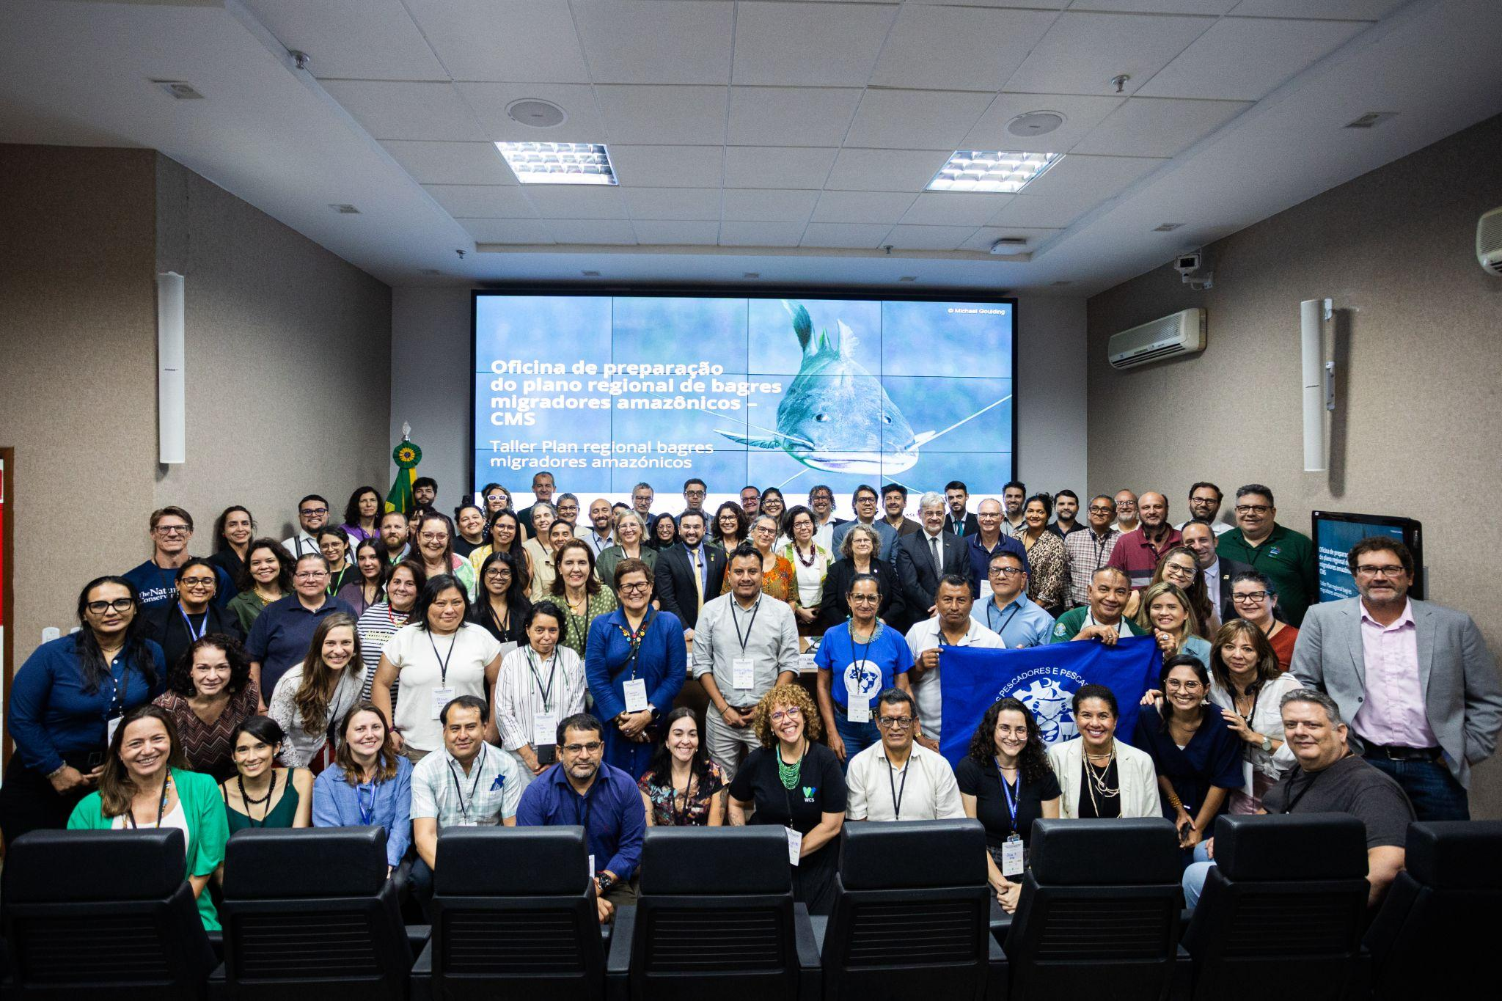
Figure 1. Regional workshop for the preparation of the Action Plan. Brasilia, 2025

BIOLOGICAL ANALYSIS

This Action Plan is relevant to all migratory Amazonian catfish. Taking into account that only two species have been added to the CMS Appendix II in 2025, we will develop the information for these two species: the Gilded catfish and the Laulao catfish. However, in the future, additional species may be added to the scope of this Action Plan, for which an amendment will be made, including their taxonomic information, distribution information, migratory patterns and population characteristics.

The gilded and laulao catfish are large migratory catfish of the Pimelodidae family, known as Goliath Catfishes. Goliath Catfish belong to a paraphyletic group of the Brachyplatystoma, with six existing species and one fossil (30).

Taxonomy

- Gilded Catfish

Class: Actinopterygii, superorder Ostariophysiology

Order: Siluriformes

Family: Pimelodidae

Genus and species: Brachyplatystoma rousseauxii (Castelnau, 1855)

Synonyms: Bagrus rousseauxii Castelnau, 1855
Bagrus goliath Kner, 1858
Brachyplatystoma paraense Steindachner, 1909

Common names: Portuguese: Dourada, Dourado
Spanish: Dorado, Plateado, Zúngaro-dorado
English: Gilded catfish

- Laulao Catfish

Class: Actinopterygii, superorder Ostariophysiology
Order: Siluriformes

Family: Pimelodidae

Genus and species: Brachyplatystoma vaillantii (Valenciennes, 1840)

Synonyms: Platystoma vaillantii Valenciennes en Cuvier & Valenciennes, 1840
Bagrus reticulatus Kner, 1858
Bagrus piramuta Kner, 1858
Brachyplatystoma parnahybae Steindachner, 1908

Common names: Portuguese: Piramutaba, Mulher-ingrata, Pira-botão
Spanish: Blanco-pobre, Pirabutón, Bagre, Manitoa
English: Laulao catfish

Range

- Gilded Catfish

The Brachyplatystoma rousseauxii is found in Brazil, Bolivia, Colombia, Ecuador, French Guiana (Fr.), Suriname, Peru and Venezuela, and its range covers the basins of the Amazon and Orinoco rivers, as well as the mouths of the main rivers that flow into the Brazil-Guyana Platform, on the border with the continent. In Brazil, the species is found in the Amazonian states of Pará, Amapá, Amazonas, Rondônia, Acre and Roraima.

Despite its wide range, there is little genetic divergence between populations of different basins (37, 38), and there is only one population in the lower Amazon basin, between the estuary and the Andean foothills (39), although there could be other populations in the headwaters of the Andes (40). The presence of a single population of gilded catfish that connects the Andes (spawning) and the estuary (breeding ground) demonstrates the hydrological connectivity of the species throughout almost its entire range in South America.

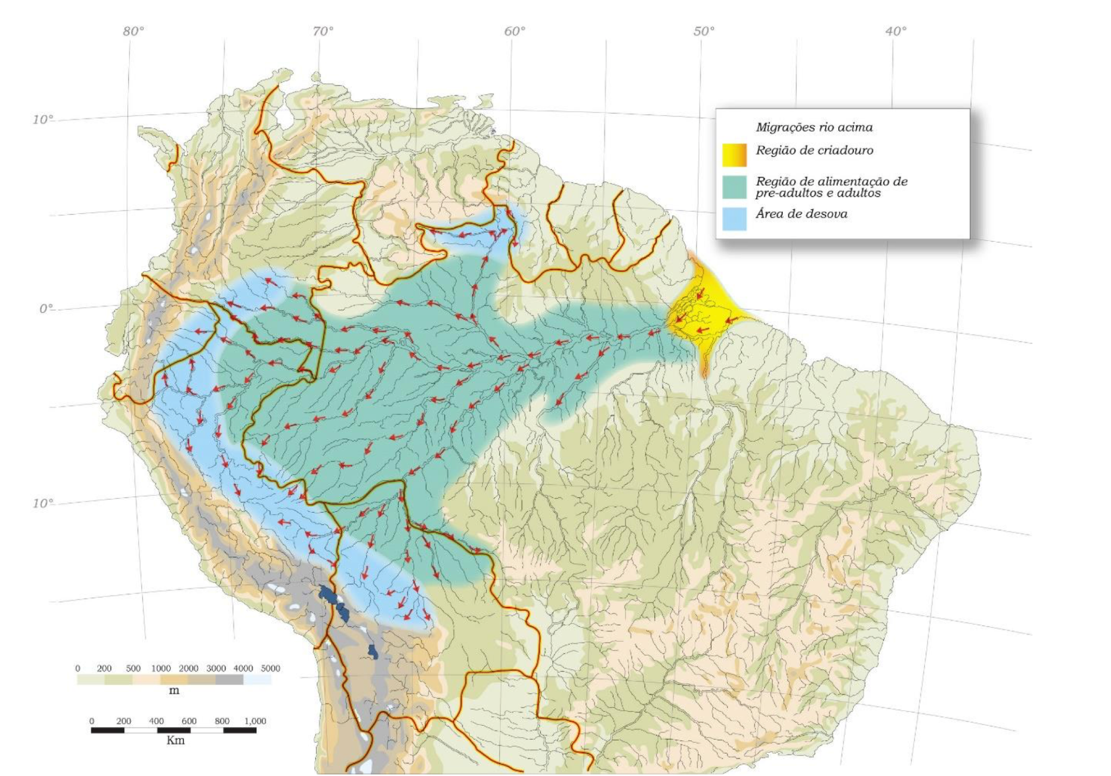
Figure 1 General migratory pattern of Brachyplatystoma rousseauxii in the Amazon basin. By Barthem and Goulding, 2007.

- Laulao Catfish

The Laulao is found in Brazil, Bolivia, Colombia, Ecuador, French Guiana (Fr.), Suriname, Peru and Venezuela, and its range covers the lowlands of the Amazon and Orinoco basins. Despite its wide range, there is little genetic divergence between populations of the different basins (37, 38). In Brazil, the species is found in the states of Pará, Amapá, Amazonas, Acre, Rondônia, Maranhão and Piauí.

The main rivers where it is located include the Lower Tocantins, the Lower Xingu, the Beni-Madre de Dios and the Middle-Lower Madeira in Brazil; the Putumayo-Içá and the Caquetá-Japurá in Brazil; the main channel of the Amazon in Brazil, Colombia and Peru; the Amazon estuary and the Parnaíba in Brazil; and the Coppename-Suriname-Saramacca, Corentyne-Demerara and Essequibo rivers in the Guianas.

The lack of spatial genetic segregation of laulao in the Amazon River, between the eastern and western Amazon, suggests the existence of a single population (60) in the Amazon basin. The presence of a single laulao population and its association with spawning in white-water rivers (turbid waters) of the western Amazon, but using the Amazon estuary as a breeding ground, demonstrates the extensive river connectivity on which its existence depends.
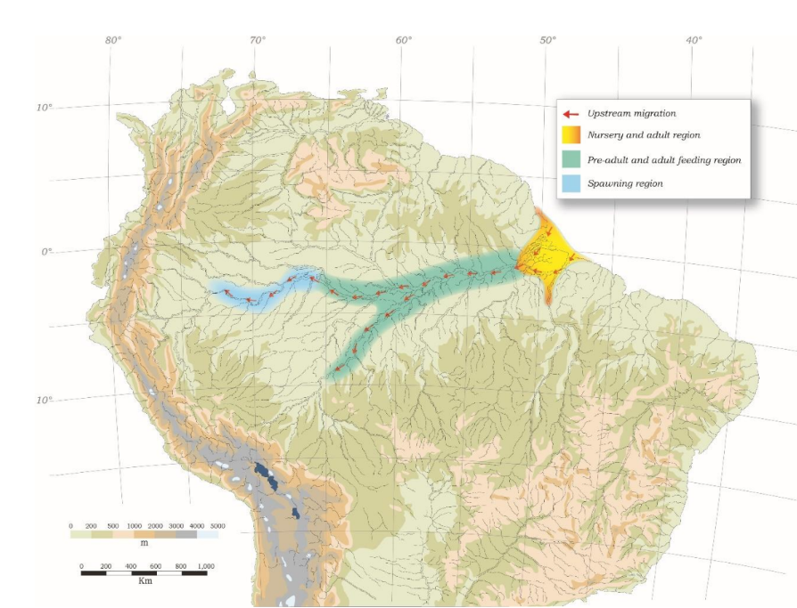
Figure 2. General migratory pattern of Brachyplatystome vaillantii in the Amazon basin. By Barthem and Goulding, 2007.

Migratory patterns

- Gilded Catfish

The gilded catfish undertakes annual migrations with different strategies for juveniles and subadults/adults. Migration begins in the spawning areas of the Andean piedmont, where eggs, larvae and juveniles move or swim downstream until they reach their breeding ground in the estuary, after a few weeks. This one-way distance of juvenile migrations downstream can reach 5,786 km (31, 41, 42).

The breeding area of the gilded catfish extends along the main headwaters of the Andes and the Amazon, and the main rivers, including several of its tributaries, such as Caquetá-Japurá and Putumayo-Içá (Colombia), Napo (Ecuador), Marañón (Peru and Ecuador), Ucayali (Peru) and Madeira (Mamoré and Beni in Bolivia, and Madre de Dios in Bolivia and Peru). In addition to the Andean rivers, the spawning area also extends to the turbid waters of Juruá and Purús, on the border between Peru, Bolivia and Brazil, in the headwaters associated with a low and mountainous region of the Fitzcarrald Arch. There is also a possible small spawning area in the headwaters of the Branco River in northern Brazil (9, 31, 43-46).

The gilded catfish in the spawning area are ready to spawn or have already done so. The exact spawning sites and habitats of the gilded catfish are unknown, but the presence of eggs or small larvae in the Andean foothills suggests that this is the spawning area (31, 46, 47).

Because the stomachs of adults in or near the Andes are empty, it is assumed that the gilded catfish do not remain in the area after spawning and probably migrate downstream to feed (31, 48). After spawning, the larvae float downstream, remaining in the deepest and fastest currents, and grow during their downstream migration to the Amazon estuary (31, 49–51).

The enormous flow of the Amazon River maintains a large expanse of freshwater at its mouth and in stretches along the coast, which recedes or expands according to the flow of the river (52). This area at the mouth of the Amazon is the gilded catfish breeding ground (21). When the individuals reach the mouth, they are already juvenile (about 7 to 8 cm) and remain in the breeding ground for about two years, until they reach about 60 cm. The gilded catfish juveniles and subadults are the target of intensive fishing by industrial and artisanal fishing fleets in the region of the mouth of the Amazon (21, 33, 53).

The gilded catfish begins its migration upstream from the estuary during the low water period of the Amazon River. The absence of adults in the estuary indicates that they do not return (21, 54). The average size of the gilded catfish caught in the Amazon River and its turbid tributaries increases with the distance to the estuary and reaches its maximum values (>1 m) in the spawning area of the Andean slopes. Spawning can occur at any time of the year but is more intense during the rainy season (16, 21, 31, 41).

- Laulao Catfish

The laulao catfish migrates annually upstream from the estuarine nursery to breeding areas in the western Amazon, for a maximum migratory distance of at least 3,129 km (31). The exact breeding areas of the laulao have not been located, although only newborn individuals and larvae have been caught in the western Amazon. Experimental fishing sites where laulao larvae have been caught include: Araracuara on the Caquetá-Japurá River in Colombia (44); the Napo River in Ecuador (61); Porto Velho on the Madeira River in Brazil (62); and near Tefé on the Solimões River in Brazil (21). After hatching, the larvae move downstream, remaining in the deepest and fastest-flowing parts of the channels of the powerful white-water rivers. Larvae and juveniles grow during their migration downstream to the Amazon estuary, feeding on phytoplankton, zooplankton, shrimp and insects (21, 31).

The enormous flow of the Amazon River maintains a large expanse of freshwater in the estuary, which recedes and expands seasonally with its flow (52) and constitutes the breeding environment of the laulao. When the young laulao reach the Amazon estuary, they are already juvenile, about 2 cm long, and immediately begin to feed on polychaetes, insects, shrimp and other small crustaceans in their breeding ground. As they grow, their diet changes and, at 20 cm in length, they feed mainly on fish of the genus Gobioides. (9, 21, 31).

As the flow of the Amazon River decreases during the low-water period, the salt wedge of the estuary approaches the coast, and the schools of laulao leave the estuary and begin their migration upstream, travelling along the Amazon River and some of its turbid water tributaries, such as the Madeira and the Purús. Not all adult and subadult laulao migrate upstream, as part of the population remains in or near the estuary during this period. Initially, it is a trophic migration, in which the laulao feed on fish from the alluvial plain while migrating to the riverbed during the low-water period. Schools of laulao leave the estuary around June and reach the city of Leticia, on the Colombian-Brazilian border, in mid-October, and local commercial fishermen report that they reach Pebas, Peru, a little further upstream. In general, schools of laulao that migrate upstream travel an average of 22 km/day. The schools of laulao return to the estuary as the river begins to rise and, concomitantly, the increased flow of the Amazon River pushes the salt wedge away from the coast, expanding again the freshwater environment at the mouth of the Amazon (21).

The average size of laulao caught in the Amazon River is similar to that of the estuary (55), suggesting that they consist of individuals of the same age range. However, there are no mature fish in migratory schools, indicating that commercial fishing in the Brazilian Amazon does not detect breeding movements (21). Even upstream, mature individuals are rarely found in the fisheries of the Caquetá-Ja River.

Population

- Gilded Catfish

The gilded catfish is one of the most important and valuable fishing resources of the Amazon basin, exploited by various groups of fishermen, from the estuary to the Andes. Fishing for gilded catfish in the estuary includes an artisanal fleet using gill nets and longlines, as well as an industrial fleet using pair trawls.

Gilded catfish fishing in inland waters is artisanal and is based mainly on drift gill nets used in river channels (9). Although there are no integrated statistics on landings of gilded catfish, regional data point to an alarming downward trend in catches in regions that monitor gilded catfish fishing, especially in the Madeira River region, which is the largest tributary of the Amazon River and its main headwaters (23, 35, 45, 55-59).

- Laulao Catfish

Bottom trawling in the Amazon estuary accounts for most of the laulao catches and overfishing of the species. Trawling takes place in the innermost part of the Amazon estuary, where the laulao is the main target species. The maximum catch of trawled laulao (22,486 t) in the Amazon estuary was recorded in 1977, but since then overfishing has led to a reduction in catches (33, 55, 63–68). Commercial laulao fishing is also carried out in the Amazon River to approximately the border between Brazil, Colombia and Peru.

THREATS

Major threats to gilded and laulao catfish migrations include the combined effects of intensive fishing and the impacts of large-scale disruptions to river systems, such as the construction of dams along migratory routes, deforestation of river headwaters and mining-related activities.

2.1 Fishing

The gilded catfish and the laulao are important commercial fishing species in the Amazon region, especially in the mouth of the Amazon and in the Amazon and Solimões rivers, as well as in their main muddy tributaries. The intensification of the exploitation of these species began in the 1970, with the introduction of bottom trawls in the Amazon estuary and the establishment of several fish processing plants along the coast and the banks of major rivers (9, 21).
Intensive exploitation of these species resulted in a significant reduction in annual catches, leading to their classification as Critically Endangered. Catches of trawled laulao in the Amazon estuary reached their highest level in 1977, five years after the introduction of trawling equipment, when 22,486 tons were reported; however, by 1992, the stock already showed clear signs of overfishing, with only 6,299 tons captured. Bottom trawling was identified as the main factor in this situation, considering that the estuarine fleet operates in areas where historically between 76% and 81% of the total laulao is caught in the Amazon basin, and where between 80% and 98% of the catches correspond to immature individuals (33, 53, 64, 65, 67-71). Gilded catfish fishing is more widespread than laulao fishing, and catches in certain regions have declined since the 1970, such as in the department of Loreto in Peru (56, 72), the department of Amazonas in Colombia (44), the Madeira River (33, 35, 73) and the lower Amazon River (58). Fishing in estuaries is the most worrying, since this region concentrates the largest catch of gilded catfish (38% of the total), consisting predominantly of immature specimens. (9, 33, 70). Although done on a significantly reduced scale, gilded catfish fishing in the Andes or nearby areas poses a threat to the species, as it exploits individuals during their breeding period (31, 48, 74). Gilded catfish fishing in springs uses small driftnets in riverbeds and is carried out from Colombia to Bolivia, where there is access to roads for the transport of the catch. Since these fisheries are carried out in different countries, the management of this resource is only possible through international cooperation.
More than a decade ago several studies were published that point to the overfishing of the gilded catfish. Despite the intensification of fishing for these species due to growing demand, no plan has yet been implemented to promote effective and integrated fisheries management measures in the Amazon countries.

2.2 Large-scale changes in river systems

Simultaneously with the fishing activity, the life cycle of the gilded catfish and the laulao is affected by large-scale changes in river systems caused by the implementation of major infrastructure projects or economic expansion, such as hydroelectric plants along the migratory routes and deforestation and mining in their breeding areas, causing water pollution and general modification of critical habitats (23, 57, 75-78).

Dams are one of the main interventions that negatively impact migratory fish by disrupting their natural flow. In the Andean-Amazon region, approximately 150 potential sites for the construction of dams for electricity generation have been identified (79). A few large dams or many small dams would cause flood pulse changes, sediment and nutrient retention, and blocking fish migrations (76).

Recent research indicates that climate change could significantly affect river hydrological regimes, with projected increases in flow and greater flooding in the Western Amazon, while a decrease in water volume is expected in the Eastern Amazon (16, 80). The implications of climate change, particularly when considered alongside infrastructure development and overfishing, remain uncertain for migratory fish stocks in the Amazon region (43).

Deforestation often has consequences for regional precipitation patterns, which can subsequently affect river flow patterns (75). In addition, deforestation and mining in the headwaters increase erosion and introduce pollutants into the water which, when transported downstream, compromise water quality and contaminate aquatic organisms (81).

International cooperation agreements are an important first step in promoting research and policy-building on the conservation of transboundary migratory fish. These agreements can also mitigate the impacts of large infrastructure development projects, particularly in the headwaters of the main Andean-Amazonian rivers, strengthening ecosystem services related to water quality, aquatic biodiversity and wetlands in general (16). Finally, large catfish conclusively demonstrate the ecological scale that needs to be addressed for the management of the Amazon ecosystem.

PREPARATION OF THE ACTION PLAN

Inclusion of migratory catfish in Appendix II

At the 14th Conference of the Parties (COP) to CMS, held in Samarkand, Uzbekistan, in February, in 2024, Brazil's proposal to include gilded catfish (Brachyplatystoma rousseauxii) and laulao (Brachyplatystoma vaillantii) in Appendix II to the Convention was approved. This decision, adopted by consensus of the Parties, marked a crucial milestone for the conservation of these two emblematic species of the Amazon, constituting a significant step toward their protection and that of their critical habitats on a regional scale.

Inclusion in CMS was driven by a coalition of regional actors led by the Brazilian government. The Brazilian MMA, through ICMBio, with the technical and scientific support of organizations such as the WCS through the AAA, and with contributions from institutions in neighbouring countries such as the Amazon Council for the Development of Aquaculture, Fisheries and MYPES in Peru (CADAP) and the National Forest and Wildlife Service (SERFOR) of Peru and the Amazon Institute of Scientific Research (SINCHI) of Colombia. These entities put forward strong scientific, conservation, political and institutional arguments to support it, highlighting the need for concerted international action and coordinated actions for the protection of these two migratory catfish and their key habitats.

Several key factors justified the inclusion of these species in CMS Appendix II, including:

- Migrations in the Amazon basin: The gilded catfish makes the longest continental aquatic migration in the world, covering more than 11,000 km on a round trip that connects the Andes with the Atlantic. The laulao also completes far-reaching displacements of approximately 6,300 km. [a] These migratory routes cross multiple Amazonian countries (Bolivia, Brazil, Colombia, Ecuador, Peru, Venezuela), evidencing their transboundary nature and the need for international cooperation for its conservation.
- Ecological importance and connectivity: As large predatory fish, gilded catfish and laulao play a fundamental ecological role in the integrity of the Amazon aquatic network. They act as indicators of the health and connectivity of the aquatic ecosystems of the basin, since their life cycle depends on the connectivity of the Amazon basin.
- Socioeconomic and cultural relevance: The migrations of these catfish support the most important commercial fisheries in the Amazon as migratory fish represent over 80% of the commercial fishing catch in the basin.
- Shared threats and worrying conservation status: Both species face severe anthropogenic pressures throughout the basin. Infrastructure fragments their migratory routes, overfishing reduces their populations, alluvial mining pollutes their habitats, and deforestation and climate change alter essential hydrological regimes. Because the conservation status of both species is considered unfavourable under these threat scenarios, experts stressed that they need coordinated international actions to avoid further declines and ensure their sustainable management in the long term.

[b] The decision to list the gilded catfish and the laulao in Appendix II fully reflects the mission and criteria of CMS. According to the Convention, “migratory species that need or would benefit significantly from international cooperation are listed in Appendix II”, encouraging Range States to establish global or regional agreements for their conservation. Listing in Appendix II acts as a catalyst for joint action – a key initial step in boosting cooperation among Amazonian countries for these species.

Following the consensus approval of the proposal at COP14, countries in the region agreed to work collectively on a conservation instrument – a Regional Action Plan – under the guidelines of the CMS. This not only fulfils the Convention’s objective of promoting regional agreements, but also establishes a specific mechanism for sustainable management and migratory Amazonian catfish throughout their range. Thus, inclusion in CMS provides an international framework of support that reinforces existing national initiatives, promotes political dialogue among coastal countries and lays the basis for concerted action essential to protect these unique migratory fish.

Proposal document for inclusion of the Gilded Catfish in Appendix II of CMS, here.

Proposal document for inclusion of the Laulao Catfish in Appendix II of CMS, here.

Process of creating an Action Plan

After the inclusion of gilded and laulao catfish in Appendix II of the CMS, the Amazon Waters Alliance defined in its 2024 planning the creation of a Motor Group with the aim of identifying mechanisms for the implementation of the CMS Resolution that included catfish species to its Appendix II. Thus, this group initiated a collaborative process to develop a regional action plan that translates international commitment into concrete conservation measures.

During 2025, the MMA, MPA and AAA, with the support of WCS and TNC, coordinated agendas with various countries from the region to begin identifying actions for the preparation of this Action Plan. During the July and August in 2025, internal meetings were organized in each country. In this way, government representatives from Amazonian countries, and also from civil society, identified some actions that they were already taking to protect migratory Amazonian catfish and their habitats. These country meetings served as a starting point for the organization of a regional face-to-face meeting in September 2025.

Delegates from Amazonian countries, fishermen, academia, cooperation agencies and civil society met in Brasilia from 17 to 19 September 2025, to review the integrated information previously identified by each country. The organization of this meeting was led by the MMA and the Brazilian MPA, in coordination with the SP/ACTO and the AAA. This event brought together government delegations from Bolivia, Colombia, Ecuador, Peru and Venezuela (in addition to Brazil as the host country). The main objective of the meeting was to agree on the guidelines of a Regional Action Plan for the conservation of large migratory catfish of the Amazon Basin – key species for river connectivity and food security for millions of people in the region.

The regional workshop held in Brasilia was developed using a multi-stakeholder and participatory methodology, structured around five previously identified strategic axes or objectives. This identification was based on the virtual country meetings held between July and August in 2025 and also the reports that countries submit to the CMS Secretariat.

Participants organized themselves into thematic working groups and discussed actions and outcomes to address each of these priority objectives:

- Conserve critical habitats
- Collaborative management
- Use of scientific and traditional knowledge
- Strengthen sustainable value chains
- Promote regional policies and regulations

The meeting concluded with support for the proposal to develop a regional plan for Amazonian catfish. The outcomes and priority actions were defined around the five objectives, integrating the contributions, visions and priorities of the six participating countries. In other words, the plan reflects a regional agreement on what to do and how to organize to do so. It was also agreed that a technical group comprising organizers and attendees of the regional meeting would make the necessary edits and prepare the appropriate formats to submit it for review by the Scientific Committee in October 2025, and for formal approval at the COP15 of the CMS, scheduled in Campo Grande, Brazil, in March 2026.

The Brasilia workshop and the preparation of the Action Plan were supported by various partners and sources of cooperation. In addition to the institutions that organized the regional workshop, the Gordon and Betty Moore Foundation provided key support throughout the process as a major donor. Other close collaborators were: WCS, TNC, ASL/Brazil, and CI-Brazil, providing financial and technical support to make this participatory process possible. This broad support reflects the shared interest of the international community in preserving the integrity of the Amazon and its migratory species.

FRAMEWORK FOR ACTION

Overall objective

Improve the conservation and sustainable use of migratory Amazonian catfish and their priority habitats, through regional coordination and collaboration.

Matrix - Objectives, outcomes and actions

In the Annex, you will find the objectives, outcomes and specific actions for each of the five identified objectives.

Governance

The following is a governance proposal for this Plan of Action, which will be discussed among the Amazonian countries. The Amazon Waters Alliance will facilitate this discussion.

- Regional Coordination Committee for migratory Amazonian catfish

The Plan will have a Regional Coordination Committee as the main governance body. This committee will comprise:
  - An official representative from each range country that is a part of CMS: Bolivia, Brazil, Ecuador and Peru, designated by the competent fisheries or environment authorities.
  - Representatives of Colombia and Venezuela will also be invited to serve on the regional committee.

- Functions:
  - Coordinate the implementation of the Plan.
  - Harmonize national policies.
  - Approve strategic guidelines and proposals for adjustments to the Plan.
  - Identify funding opportunities for the implementation of the actions contained in the Action Plan.
  - Annual meetings to review progress and identify adjustments.
  - Biennial report on the status of the species and the implementation of the plan, submitted to CMS.
B. Advisory Committee

The Plan will have an Advisory Committee, made up of one representative from each country (member and non-member of CMS). The advisory committee will be coordinated by the Amazon Waters Alliance.
- Functions:
- Provide scientific and technical input for decisions of the Regional Coordination Committee.
- Generate and update information on the biology, migration, and population status of catfish.
- Develop guidelines and recommendations for fisheries management and habitat conservation.
- Connect local and scientific knowledge (including fishermen and indigenous people) with political processes.

Technical Secretariat of Action Plan

- Responsibilities:
  - Systematize information and regional monitoring.
  - Convene and organize annual meetings of the Regional Coordination Committee.
  - Facilitate technical and scientific exchange.
  - Ensure the inclusion of civil society, communities and fishermen in the implementation processes.

C. Thematic Working Groups

To ensure effective implementation, it is recommended to establish specialized working groups, made up of government technicians, scientists, and local community representatives.

A working group will be established for each objective of the Framework for Action:
- Objective 1 - Identification and conservation of priority habitats for breeding, migration and growth of migratory Amazonian catfish.
​
- Objective 2 - Mechanisms for the generation and exchange of knowledge and the collaborative management of established migratory catfish.
- Objective 3 - The countries will use scientific and traditional knowledge to maintain connectivity and thus ensure the sustainable management of migratory catfish.
- Objective 4 - By 2036, the Amazonian catfish value chain will be strengthened, characterized by its traceability, sustainable use and social fairness, guaranteeing the conservation of the species and the well-being of fishing communities.
- Objective 5 - Amazonian countries have policies and regulations that allow for the conservation and sustainable management of migratory catfish and their habitats.

A working group for Communications and Advocacy will also be established.

REFERENCES

1.Milliman JD, Meade RH. World-wide delivery of river sediment to the oceans. Journal of Geology. 1983;91:1-21.
2.Goulding M, Barthem R, Ferreira EJG, Duenas R. The Smithsonian atlas of the Amazon: Washington London: Smithsonian Books; 2003. p. 253
3. Dagosta FCP, Pinna MD. The Fishes of the Amazon: Distribution and Biogeographical Patterns, with a Comprehensive List of Species. Bulletin of the American Museum of Natural History. 2019;431(1):1.
4.Couto TBA, Jenkins CN, Beveridge CF, Heilpern SA, Herrera‐R GA, Piland NC, et al. Translating science into actions to conserve Amazonian freshwaters. Conservation Science and Practice. 2024.
5.Heilpern SA, Sethi SA, Barthem RB, Batista VDS, Doria CRC, Duponchelle F, et al. Biodiversity underpins fisheries resilience to exploitation in the Amazon river basin. Proceedings Biological sciences / The Royal Society. 2022; 289(1976):20220726.
6.FAO. The State of World Fisheries and Aquaculture 2016. Contributing to food security and nutrition for all: Rome; 2016.
7.Isaac VJ, Almeida MCd. El consumo de pescado en la Amazonía Brasileña. COPESCAALC Documento Ocasional. 2011;13: p. 43
8.Barthem RB. Development of commercial fisheries in the Amazon basin and consequences for fish stocks and subsistence fishing. In: Clusener-Godt M, Sachs I, Uitto JI, editors. Brazilian Perspectives on Sustainable Development of the Amazon Region. Paris: The Parthenon Publishing Group; 1995. pp. 175-204.
9.Barthem RB, Goulding M. An unexpected ecosystem: The Amazon as revealed by fisheries: Missouri Botanical Garden Press; 2007. p. 241
10.Bayley PB. Aquatic productivity in the central Amazon Várzea in the context of the fishery yield. I Simpósio do Trópical Úmido. 1984;5: 325-34.
11.Welcomme RL, Hagborg D. Towards a model of a floodplain fish population and its fishery. Environmental Biology of Fishes. 1977;2: 7-24.
12.Goulding M. The fishes and the forest : Explorations in Amazonian natural history. Berkeley: University of California Press; 1980. xii, p. 280
13.Petrere Jr M. Relationships among catches, fishing effort and river morphology for eight rivers in Amazonas state (Brazil), during 1976-1978. Amazoniana. 1983;8(2):281-96.
14.Junk WJ, Bayley PB, Sparks RE. The flood pulse concept in river-floodplain systems. In: Dodge DP, editor. Proceedings of the International Large River Symposium. 106. Ontario: Canadian Special Publication of Fisheries and Aquatic Sciences; 1989. pp. 110-27.
15.Forsberg BR, Araujo-Lima CARM, MARTINELLI LA, Victoria RL, Bonassi JA. Autotrophic carbon sources for fish of the central amazon. Ecology. 1993:644-52.
16.Goulding M, Venticinque E, Ribeiro MLdB, Barthem RB, Leite RG, Forsberg B, et al. Ecosystem-based management of Amazon fisheries and wetlands. Fish and Fisheries. 2019;20(1):138-58.
17.Melack JM, Hess LL. Remote sensing of the distribution and extent of wetlands in the Amazon Basin. In: Junk WJ, Piedade MTF, Wittmann F, Schöngart J, Parolin P, editors. Amazonian Floodplain Forests: Ecophysiology, Biodiversity and Sustainable Management. 210. New York: Springer Verlag; 2010. pp. 43-59.
18.Junk WJ, Piedade MTF, Lourival R, Wittmann F, Kandus P, Lacerda LD, et al. Brazilian wetlands: Their definition, delineation, and classification for research, sustainable management, and protection. Aquatic Conservation: Marine and Freshwater Ecosystems. 2013;24(1):5-22.
19.Junk WJ, Piedade MTF, Wittmann F, Schöngart J, Parolin P. Amazonian Floodplain Forests: Ecophysiology, Biodiversity and Sustainable Management: Ecological Studies, Springer Verlag, Heidelberg; 2011.
20.Araujo-Lima C, Goulding M. So fruitful a fish: Ecology, conservation, and aquaculture of the Amazon's tambaqui. New York: Columbia University Press; 1997. xii, p. 191
21.Barthem RB, Goulding M. The catfish connection: Ecology, migration, and conservation of Amazon predators. New York: Columbia University Press; 1997. p. 144
22.Ribeiro MCLdB, Petrere Jr M. Fisheries ecology and management of the Jaraqui (Semaprochilodus Taeniurus, S. Insignis) in central Amazonia. Regulated Rivers: Research & Management. 1990;5(3):195-215.
23.Duponchelle F, Isaac VJ, Doria C, Van Damme PA, Herrera‐R GA, Anderson EP, et al. Conservation of migratory fishes in the Amazon basin. Aquatic Conservation: Marine and Freshwater Ecosystems. 2021.
24.Harden-Jones RH. Fish Migration: Edward Arnold (Publishers) Ltd., London; 1968. p. 325
25.Sólmundsson J, Jónsdóttir IG, Ragnarsson SÁ, Björnsson B. Connectivity among offshore feeding areas and nearshore spawning grounds; implications for management of migratory fish. ICES Journal of Marine Science. 2018;75(1):148-57.
26.Sousa RGC, Humston R, Freitas CEC. Movement patterns of adult peacock bass Cichla temensis between tributaries of the middle Negro River basin (Amazonas - Brazil): an otolith geochemical analysis. Fisheries Management and Ecology. 2016;23(1):76-87.
27.McGrath DG, Almeida OT, Crossa M, Cardoso A, Cunha M. Working towards community-based ecosystem management of the lower Amazon floodplain. PLEC News and Views. 2005;6:3-10.
28.Miranda-Chumacero G, Álvarez G, Luna V, Wallace RB, Painter L. First observations on annual massive upstream migration of juvenile catfish Trichomycterus in an Amazonian River. Environmental Biology of Fishes. 2015;98(8):1913-26.
29.Goulding M. Ecologia da pesca do rio Madeira. Manaus, Brazil: Conselho Nacional de Pesquisas Científicas e Tecnológicos (CNPq)/Instituto Nacional de Pesquisas da Amazônia (INPA); 1979. p. 172
30.Lundberg JG, Akama A. Brachyplatystoma capapretum: A new species of goliath catfish from the Amazon Basin, with a reclassification of allied catfishes (Siluriformes: Pimelodidae). Copeia. 2005;2005(3):492-516.
31.Barthem RB, Goulding M, Leite RG, Canas C, Forsberg B, Venticinque E, et al. Goliath catfish spawning in the far western Amazon confirmed by the distribution of mature adults, drifting larvae and migrating juveniles. Scientific reports. 2017;7: 41784.
32.Hauser M, Doria CRC, Santos RV, García-Vasquez A, Pouilly M, Pécheyran C, et al. Shedding light on the migratory patterns of the Amazonian goliath catfish, Brachyplatystoma platynemum, using otolith 87 Sr/86Sr analyses. Aquatic Conservation: Marine and Freshwater Ecosystems. 2019.
33.Prestes L, Barthem R, Mello-Filho A, Anderson E, Correa SB, Couto TBD, et al. Proactively averting the collapse of Amazon fisheries based on three migratory flagship species. PLoS One. 2022;17(3):e0264490.
34.Hahn L, Martins EG, Nunes LD, Machado LS, Lopes TM, da Câmara LF. Semi-natural fishway efficiency for goliath catfish (Brachyplatystoma spp.) in a large dam in the Amazon Basin. Hydrobiologia. 2020.
35.Damme PAV, Córdova-Clavijo L, Baigún C, Hauser M, Doria CRdC, Duponchelle F. Upstream dam impacts on gilded catfish Brachyplatystoma rousseauxii (Siluriformes: Pimelodidae) in the Bolivian Amazon. Neotropical Ichthyology. 2019;17(4).
36.Hauser M, Duponchelle F, Hermann TW, Limburg KE, Castello L, Stewart DJ, et al. Unmasking continental natal homing in goliath catfish from the upper Amazon. Freshwater Biology. 2019.
37.Reis RE, Kullander SO, Ferrari-Jr. CJ. Checklist of the Freshwater Fishes of South and Central America: Porto Alegre: EDIPUCRS, Brasil; 2003.
38.Lundberg JG, Sullivan JP, Hardman M. Phylogenetics of the South American catfish family Pimelodidae (Teleostei: Siluriformes) using nuclear and mitochondrial gene sequences. Proceedings of the Academy of Natural Sciences of Philadelphia. 2011;161(1):153-89.
39.Batista JS, Alves-Gomes JA. Phylogeography of Brachyplatystoma rousseauxii (Siluriformes—Pimelodidae) in the Amazon Basin offers preliminary evidence of the first case of “homing” for an Amazonian migratory catfish. Genetics and Molecular Research. 2006;5(4):723-40.
40.Carvajal-Vallejos FM, Duponchelle F, Desmarais E, Cerqueira F, Querouil S, Nunez J, et al. Genetic structure in the Amazonian catfish Brachyplatystoma rousseauxii: influence of life history strategies. Genetica. 2014;142(4):323-36.
41.Cañas CM, Waylen PR. Modelling production of migratory catfish larvae (pimelodidae) on the basis of regional hydro-climatology features of the madre de dios basin in southeastern Peru. Hydrological Processes. 2012;26(7):996-1007.
42.Hermann TW, Stewart DJ, Barriga Salazar RE, Coghlan SM. Spatial and Temporal Patterns of Pelagic Catfish Larvae Drifting in Lowland Rivers of Eastern Ecuador (Pisces: Siluriformes). Ichthyology & Herpetology. 2021;109(4).
43.Feng D, Raoufi R, Beighley E, Melack JM, Goulding M, Barthem RB, et al. Future climate impacts on the hydrology of headwater streams in the Amazon River Basin: Implications for migratory goliath catfishes. Hydrological Processes. 2020.
44.Agudelo-Córdoba E, Salinas-Coy Y, Sánchez-Páez CL, Muñoz-Sosa DL, Arteaga-Díaz ME, Rodríguez-Prieto OJ, et al. Bagres de la amazonia colombiana: Un recurso sin fronteras. Bogotá: SINCHI; 2000. p. 253
45.Agudelo-Córdoba E, Petrere Jr M, Joven-León ÁV, Peláez M, Bonilla-Castillo CA, Duponchelle F. Breeding, growth and exploitation of Brachyplatystoma rousseauxii Castelnau, 1855 in the Caqueta River, Colombia. Neotropical Ichthyology. 2013;11(3):637-47.
46.Hermann TW, Duponchelle F, Castello L, Limburg KE, Pereira LA, Hauser M. Harnessing the potential for otolith microchemistry to foster the conservation of Amazonian fishes. Aquatic Conservation: Marine and Freshwater Ecosystems. 2021;31(5):1206-20.
47.Miranda-Chumacero G, Mariac C, Duponchelle F, Painter L, Wallace R, Cochonneau G, et al. Threatened fish spawning area revealed by specific metabarcoding identification of eggs and larvae in the Beni River, upper Amazon. Global Ecology and Conservation. 2020;24.
48.Barthem RB, Goulding M, Forsberg BR, Cañas CM, Ortega H. Aquatic ecology of the Río Madre de Dios: Scientific bases for Andes-Amazon headwaters conservation: Asociación para la Conservación de la Cuenca Amazónica (ACCA); 2003.
49.Barthem RB, Costa MCd, Cassemiro F, Leite RG, Silva Jr. N. Diversity and abundance of fish larvae drifting in the Madeira River, Amazon Basin: sampling methods comparison. In: Grillo O, editor. Biodiversity - The Dynamic Balance of the Planet: InTech; 2014. pp. 137-58.
50.Cella-Ribeiro A, Assakawa LF, Torrente-Vilara G, Zuanon J, Leite RG, Doria C, et al. Temporal and spatial distribution of young Brachyplatystoma spp. (Siluriformes: Pimelodidae) along the rapids stretch of the Madeira River (Brazil) before the construction of two hydroelectric dams. Journal of Fish Biology. 2015.
51.Duponchelle F, Pouilly M, Pécheyran C, Hauser M, Renno J-F, Panfili J, et al. Trans-Amazonian natal homing in giant catfish. Journal of Applied Ecology. 2016;53(5):1511-20.
52.Nikiema O, Devenon J-L, Baklouti M. Numerical modeling of the Amazon River plume. Continental Shelf Research. 2007;27(7):873-99.
53.Barthem RB, Mello-Filho A, Assunção W, Gomes PFF. Estrutura de tamanho e distribuição espacial da piramutaba (Brachyplatystoma vaillantii) na foz Amazônica: implicações para o manejo da pesca. Bol Inst Pesca, São Paulo. 2015;41(2):249-60.
54.Lopes GCS, Matos OF, Freitas CEC. Spatial dynamics of Amazonian commercial fisheries: an analysis of landscape composition and fish landings. Brazilian journal of biology = Revista brasleira de biologia. 2023;83: e265791.
55.Alonso JC, Pirker LEM. Dinâmica populacional e estado atual da exploração de piramutaba e de dourada. In: Fabré NN, Barthem RB, editors. O Manejo da Pesca dos Grandes Bagres Migradores: Instituto Brasileiro do Meio Ambiente e dos Recursos Naturais Renováveis, Brasília; 2005. pp. 21-8.
56.Garcia A, Tello S, Vargas G, Duponchelle F. Patterns of commercial fish landings in the loreto region (Peruvian Amazon) between 1984 and 2006 Hemiodus. Fish physiology and biochemistry. 2009;35(1):53-67.
57.Hauser M, Doria CRC, Melo LRC, Santos AR, Ayala DM, Nogueira LD, et al. Age and growth of the Amazonian migratory catfish Brachyplatystoma rousseauxii in the Madeira River basin before the construction of dams. Neotropical Ichthyology. 2018;16(1).
58.Cruz REA, Kaplan DA, Santos PB, Ávila-da-Silva AO, Marques EE, Isaac VJ. Trends and environmental drivers of giant catfish catch in the lower Amazon River. Marine and Freshwater Research. 2020.
59.Prestes L, Salomão CB, Fortunato WCP, Oliveira NI. A atividade pesqueira na foz do amazonas, arquipélago do Bailique-Amapá, Brasil. Holos. 2021; 1:1-30.
60.Formiga KM, Batista JdS, Alves-Gomes JA. The most important fishery resource in the Amazon, the migratory catfish Brachyplatystoma vaillantii (Siluriformes: Pimelodidae), is composed of a unique and genetically diverse population in the Solimões-Amazonas River System. Neotropical Ichthyology. 2021;19(1).
61.Utreras-Bucheli VM. Caracterización de la pesca de grandes bagres en el Alto Río Napo (Ecuador), recomendaciones para su manejo y conservación. [MSc Thesis]. Seville, Spain: Universidad Internacional de Andalucía, UNIA; 2010.
62.Cella-Ribeiro A, Torrente-Vilara G, Lima-Filho JA, Doria CRdC, editors. Ecologia e biologia de peixes do Rio Madeira. Porto Velho-RO: EDUFRO; 2016.
63.Dias-Neto J. A pesca da piramutaba (Brachyplatystoma vallanti) na região norte do Brasil. Atlantica. 1991;13(1):11-9.
64.Barthem RB, Petrere Jr M. Fisheries and population dynamics of the freshwater catfish Brachyplatystoma vaillantii in the Amazon estuary. In: Armantrout NB, editor. Condition of the World's Aquatic Habitat Proceedings of the World Fisheries Congress, Theme 1 Athens, Greece. 1237: Oxford & IBH Publishing Co. Pvt. Ltd., New Delhi; 1995. pp. 43-59. . 329-50.
65.IBAMA. Reunião do grupo permanente de estudos sobre a piramutaba.: IBAMA; 1999. pp. 1-92
66.Dias-Neto J, Dias JdFO. O uso da biodiversidade aquática no Brasil: uma avaliação com foco na pesca. Brasília: Ibama; 2015.
67.Matsunaga AMF, Junior IF, Itó LS. Análise quantitativa da influência de parâmetros ambientais sobre a captura por unidade de esforço (CPUE) da piramutaba brachyplatystoma vaillantii (Valenciennes, 1840) da costa amazônica do Brasil. Boletim Técnico Cientifico do CEPNOR. 2017;17(1):9-19.
68.Mello-Filho AdS. A dinâmica da pesca e avaliação de estoques de piramutaba, Brachyplatystoma vaillantii, pela frota de arrasto, na região do estuário amazônico. Belém, PA: Universidade Federal do Pará; 2020.
69.Klautau AGCdM, Cordeiro APB, Cintra IHA, Silva LEOd, Bastos CEMC, Carvalho HRLd, et al. Analysis of the industrial fishing of piramutaba catfish, Brachyplatystoma vaillantii (Valenciennes 1840), in two estuarine areas of the Brazilian Amazon. Pan-American Journal of Aquatic Sciences. 2016;11(2):143-50.
70.Klautau AGCdM, Cordeiro APB, Cintra IHA, Silva LEOd, Carvalho HRLd, Itó LS. Impacted biodiversity by industrial piramutaba fishing in the Amazon River mouth. Bol Inst Pesca, São Paulo. 2016;42(1):102-11.
71.Jimenez EA, Asano Filho M, Frédou FL. Fish bycatch of the Laulao Catfish Brachyplatystoma vaillantii (Valenciennes, 1840) trawl fishery in the Amazon estuary. Brazilian Journal of Oceanography. 2013;61(2):129-40.
72.Garcia-Vasquez A, Alonso JC, Carvajal F, Moreau J, Nunez J, Renno JF, et al. Life-history characteristics of the large Amazonian migratory catfish Brachyplatystoma rousseauxii in the Iquitos region, Peru. Journal of Fish Biology. 2009;75(10):2527-51.
73.Santos RE, Pinto-Coelho RM, Fonseca R, Simões NR, Zanchi FB. The decline of fisheries on the Madeira River, Brazil: The high cost of the hydroelectric dams in the Amazon Basin. Fisheries Management and Ecology. 2018;25(5):380-91.
74.Cañas CM, Pine WE. Documentation of the temporal and spatial patterns of pimelodidae catfish spawning and larvae dispersion in the madre de Dios River (Peru): Insights for conservation in the Andean-Amazon headwaters. River Research and Applications. 2011;27(5):602-11.
75.Castello L, Macedo MN. Large-scale degradation of Amazonian freshwater ecosystems. Glob Chang Biol. 2015;22(3):990-1007.
76.Forsberg BR, Melack JM, Dunne T, Barthem RB, Goulding M, Paiva RCD, et al. The potential impact of new Andean dams on Amazon fluvial ecosystems. PloS one. 2017;12(8): e0182254.
77.Soares JM, Gomes JM, Anjos MR, Silveira JN, Custódio FB, Gloria MBA. Mercury in fish from the Madeira River and health risk to Amazonian and riverine populations. Food Research International. 2018; 109:537-43.
78.Alho CJ, Reis RE, Aquino PP. Amazonian freshwater habitats experiencing environmental and socioeconomic threats affecting subsistence fisheries. Ambio. 2015;44(5):412-25.
79.Finer M, Jenkins CN. Proliferation of hydroelectric dams in the Andean Amazon and implications for Andes-Amazon connectivity. PLoS One. 2012;7(4):e35126.
80.Sorribas MV, Paiva RCD, Melack JM, Bravo JM, Jones C, Carvalho L, et al. Projections of climate change effects on discharge and inundation in the Amazon basin. Climatic Change. 2016;136(3-4):555-70.
81.Finer M, Jenkins CN, Pimm SL, Keane B, Ross C. Oil and gas projects in the western Amazon: Threats to wilderness, biodiversity, and indigenous peoples. PLOS One. 2008;3(8): e2932.
[a] Un hito clave para la conservación de los peces migratorios amazónicos: El dorado y la piramutaba incluidos en el Apéndice II de CMS > WCS Ecuador
[b] Amazon catfish must be protected by the Convention on Migratory Species COP-14 (commentary)

ANNEX TO THE MIGRATORY AMAZONIAN CATFISH ACTION PLAN
Result | Action | Seasonality
Objective 1 - Priority habitats for reproduction, migration and growth of migratory Amazonian catfish identified and conserved
1.1 Priority areas and corridors identified for the conservation of critical habitats for catfish during their migration and reproduction. | 1.1.A. Form a group of experts representing several countries (including local knowledge) to develop a methodology for defining priority areas and corridors. | Short-term
 | 1.1.B. Develop a regional spatial analysis of priority areas and corridors, with available information and evidence, indicating the key areas for reproduction, migration and growth of gilded and laulao catfish and their interaction with conservation and/or management areas, fishing areas, threats and seasonality. | Short-term
 | 1.1.C. Publish and disseminate the results of the spatial analyses and the databases with priority areas for catfish. | Short and medium-term
 | 1.1.D. Update the spatial analyses with an agreed methodology using new available data | Medium-term
1.2 Priority areas and corridors identified are part of the System of Protected Natural Areas, RAMSAR sites or other conservation measures. | 1.2.A. Propose new areas in the system of protected areas and other forms of conservation such as Ramsar sites, OECMs in relation to the priority areas and corridors identified. | Short-term
 | 1.2.B. Strengthen protected areas, indigenous territories and other existing forms of conservation that overlap with priority areas to ensure that they have integrated and effective ecosystem management for gilded and laulao catfish - including local communities in their effective management. | Medium-term
 | 1.2.C. Incorporate fishing agreement areas as mechanisms to help protect priority and connectivity areas. | Medium-term
 | 1.2.D. Develop and establish regional agreements for the conservation of strategic transnational corridors, and strengthen existing agreements. | Long-term
 | 1.2.E. Implement actions to restore connectivity and mitigate other impacts to facilitate the migration of Amazonian catfish in basins with barriers. | Long-term
Objective 2 - Mechanisms for the generation and exchange of knowledge and the collaborative management of established migratory catfish
2.1 Spaces for dialogue and exchange of information and knowledge about migratory catfish created and strengthened | 2.1.A. Develop «knowledge dialogue» activities as a space for exchanging knowledge between fishermen and other traditional peoples and communities, NGOs, researchers, governments and other collaborators. | Short-term
 | 2.1.B. Bring the results of the dialogues to the discussion forums on fisheries policies and management in each country of the region, ensuring the active and democratic participation of the fishermen and women of the basin. | Short-term
 | 2.1.C. Establish spaces for exchange and connection between national/regional forums for discussion on fisheries management between different countries. | Medium-term
 | 2.1.D. Foster the creation and holding of discussion forums on fisheries management policies between fishermen and women. | Short-term
 | 2.1.E. Evaluate the creation of a specific regional commission for Amazonian fishing.
 | 2.1.F. Map existing initiatives among fishermen-communicators in order to exchange experiences and create networks of fishermen-communicators in the Amazon basin. | Short and medium-term
 | 2.1.G. Production of outreach materials developed with the fishermen themselves. | Medium-term
2.2. Instruments for the collaborative management of migratory catfish created and strengthened | 2.2.A. Map and strengthen fishing agreements and other existing local-scale fisheries management measures. | Short/medium term
 | 2.2.B. Study to evaluate the current status and efficacy of fisheries agreements and other local-scale fisheries management measures, including the identification of challenges and opportunities. | Short-term
 | 2.2.C. Promote the negotiation of regional agreements between countries in the catfish distribution area, as well as local fishing agreements with a view to achieving proper management, good practices for control and appropriate monitoring for the sustainable fishing of the species, based on a participatory process. | Medium-term
 | 2.2.D. Establish, strengthen and review agreements and other cooperation mechanisms between countries, including and highlighting fisheries management and integrated river basin management. | Medium/long-term
 | 2.2.E. Establish river basin management plans, taking into account priority actions for areas and river basins set out in Objective 1 of this action plan. | Medium-term
Objective 3 - Countries use scientific and traditional knowledge to maintain connectivity and thus ensure the sustainable management of migratory catfish
3.1 Countries have harmonized inter-and intra-country Information systems and capabilities developed for evidence-based decision-making | 3.1.A. Establish an integrated database on relevant ecological, environmental and fishing aspects for the sustainable use of migratory Amazonian catfish | Medium-term
 | 3.1.B. Form Task Groups (subnational, national and regional) to create monitoring systems. | Short-term
 | 3.1.C. Implement an environmental and fishing monitoring system based on the life cycle of catfish, including participatory monitoring. | Long-term
3.2 Migratory catfish stocks will be assessed and managed until 2036 | 3.2.A. Carry out periodic integrated stock assessment studies in the Amazon region. | Long-term
 | 3.2.B Design fisheries management proposals in a participatory way. | Long-term
3.3. Environmental changes that affect migratory catfish will be identified until 2036 | 3.3.A. Access infrastructure project monitoring data to build the integrated database, through official bodies. | Medium-term
 | 3.3.B. Conduct studies to understand how environmental changes affect migratory catfish. | Long-term
 | 3.3.C. Assess the effects of climate change on the migration and sustainable use of catfish. | Long-term
Objective 4 - By 2036, the Amazonian catfish value chain will be strengthened, characterized by its traceability, sustainable use and social fairness, guaranteeing the conservation of the species and well-being of fishing communities
4.1. Use and management of Amazonian catfish is legal, sustainable and traceable, based on good collaborative fishing practices and respect for aquatic ecosystems | 4.1.A. Foster cooperativism/associativity and community organization, promoting models of co-responsibility and shared management of resources, ensuring the transfer of knowledge and social sustainability of the activity. | Short and medium-term
 | 4.1.B. Design and implement a sustainable fishing programme that strengthens fishing activities, the use of good practices and the continuity of the activity for future generations, considering: sizes and weights, fishing gear, fishing periods and maximum sustainability limits. | Medium and long-term
 | 4.1.C. Officially recognize and identify fishing grounds, fishermen and primary processing landing sites (colonies, fairs, markets, plants, cold storage facilities), strengthening their legitimacy and information management by levels. | Short-term
 | 4.1.D. Implement certification, safety and traceability schemes at country-level that promote origin, legality and good fishing practices for access to local, national and international markets. | Medium and long-term
 | 4.1.E. Promote an environmental education programme for all actors in the chain (from capture to consumption) that is connected with traceability initiatives (documents of origin), seals, censuses and information management (monitoring), for implementation in each country. | Medium and long-term
 | 4.1.F. Promote country-level agreements that facilitate the market for Amazonian catfish products and byproducts at borders. | Short and medium-term
4.2. The Amazonian catfish value chains operate more efficiently, generating greater income for fishermen and other actors in the chain. | 4.2.A. Develop feasibility studies that allow countries to take actions to improve logistics, infrastructure and the cold chain within the framework of their development instruments, from the artisanal fisherman to the industry/market, ensuring the quality, safety and competitiveness of fishery products in local, national and international markets. | Short-term
 | 4.2.B. Promote business roundtables and trade mechanisms, guaranteeing representativeness, fair prices and equitable conditions for fishermen and local communities. | Medium-term
 | 4.2.C. Develop feasibility studies on fair minimum prices and financial and economic compensation mechanisms, that allow countries to implement measures that reduce the vulnerability of fishermen to market volatility. | Short-term
 | 4.2.D. Promote a financial and administrative culture in fishing organizations, strengthening business management, planning, and access to financial and non-financial service capacities. | Medium-term
 | 4.2.E. Strengthen the capacity of public institutions to provide support and technical assistance to fishermen's organizations. | Medium-term
 | 4.2.F. Identify public and private financing opportunities for improvements in the value chain. | Short-term
4.3. Sources of income and employment for fishermen and other actors in the chain have been diversified by adding value to Amazonian catfish products and byproducts, and by promoting the development of innovative bioproducts. | 4.3.A. Conduct studies on the potential for adding value and developing bioproducts originating from the Amazonian catfish, identifying viable applications in the food, pharmaceutical, cosmetic and other sectors, to prioritize alternatives with greater technical, economic and market feasibility. | Short-term
 | 4.3.B. Promote the comprehensive use of catfish waste and byproducts, encouraging their integration into other value chains and promoting the development of innovative local bioproducts that reduce losses and waste. | Medium-term
 | 4.3.C. Strengthen the technical capabilities of actors in the chain, mainly fishermen and local organizations, through training programmes, technical assistance and technology transfer that consolidate processes of adding value and production of innovative bioproducts in a sustainable manner. | Medium-term
Objective 5 - Amazonian countries have policies and regulations that allow the conservation and sustainable management of migratory catfish and their habitats.
5.1. Policies and regulations created, improved and/or adapted for the sustainable management of migratory catfish and their critical habitats. | 5.1.A. Conduct a comparative analysis of national legislation on fisheries in the Amazon towards the harmonization of measures for the conservation and comprehensive management of Amazonian catfish, considering the provisions of different international forums on sustainable fisheries management. | Short-term
 | 5.1.B. Adapt or develop, as appropriate, national regulations that establish management measures for artisanal fishing (closed seasons, minimum permitted sizes, mesh size, net size, area restrictions, catch quotas), taking basin and stock assessment data as a reference. | Medium-term
 | 5.1.C. Promote the incorporation of conservation and sustainable use criteria for species in planning, as well as in the regulations governing licensing for infrastructure that may affect the connectivity of river basins that are part of the catfish habitat. | Medium-term
 | 5.1.D. Review and, if appropriate, update existing binational and multinational memorandum of understanding, agreements and/or conventions, incorporating the sustainable management of catfish fishing along their migratory route, including aspects of joint action in cross-border areas. | Short-term
 | 5.1.E. Promote the interaction of the plan with other international agreements focused on fishery resources for efficient regional fisheries management. | Medium-term
 | 5.1.F. Promote public policies and mobilize international cooperation that generate incentives and facilitate the necessary regulatory frameworks for adding value and the production of bioproducts, ensuring the active participation of fishermen and other actors in the chain. | Medium-term
5.2 Effectively implemented inspection and control actions. | 5.2.A. Establish protocols and/or joint action plans for cross-border control, considering the legal instruments of inspection and control, and identifying priority areas for the inspection and control of landings and exports of large catfish. | Medium-term
5.2 Effectively implemented inspection and control actions. | 5.2.B. Incorporate into the national legislation of countries the application of local fishing agreements as a management measure to strengthen traceability and sustainable fishing practices. | Medium-term
5.2 Effectively implemented inspection and control actions. | 5.2.C Establish a single procedure for taxonomic determination of migratory catfish species, taking into account the relevant scientific and common name. | Short-term

