 | CONVENTION ON  MIGRATORY  SPECIES | UNEP/CMS/COP15/Doc.20.2  20 October 2025  Original: English

15th MEETING OF THE CONFERENCE OF THE PARTIES
Campo Grande, Brazil, 23 – 29 March 2026
Agenda Item 20.2

STATE OF THE WORLD’S MIGRATORY SPECIES: INTERIM REPORT (2026)
(Prepared by the Secretariat)

Summary:

This document contains the State of the World’s Migratory Species: Interim Report (2026), developed in implementation of Decision 14.24 d).

It complements document UNEP/CMS/COP15/Doc.20.1 Conservation Status of Migratory Species.

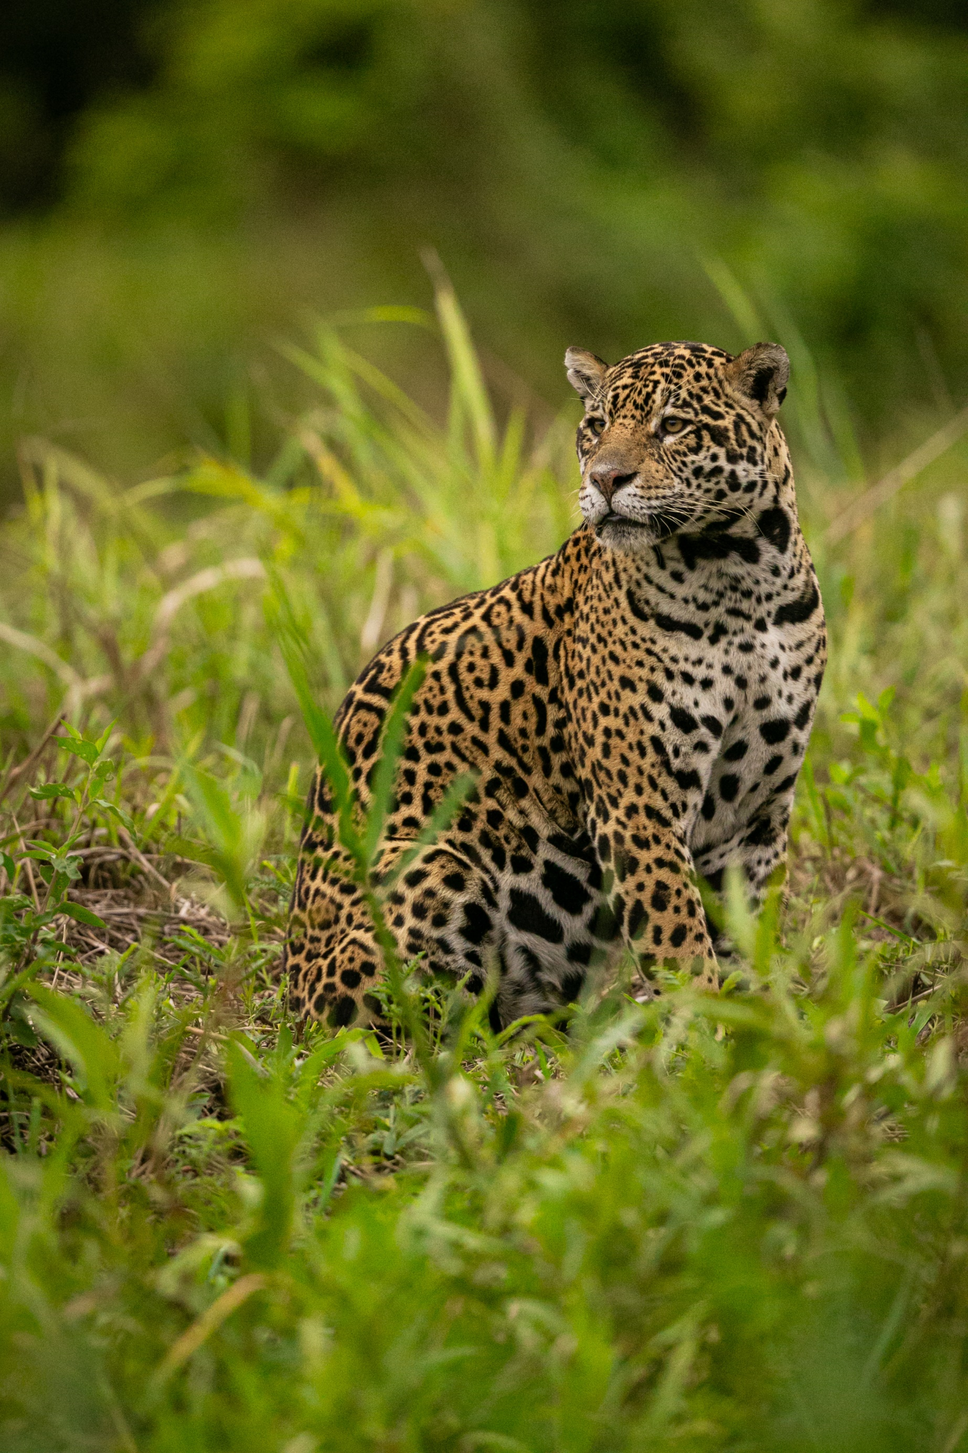
State of the World’s Migratory Species:
Interim Report (2026)




State of the World’s Migratory Species: Interim Report (2026)
Prepared for: The Secretariat of the Convention on the Conservation of Migratory Species of Wild Animals (CMS).
Copyright: © 2026 Convention on the Conservation of Migratory Species of Wild Animals.
Citation: UNEP-WCMC, 2026. State of the World’s Migratory Species: Interim Report (2026). UNEP-WCMC, Cambridge, United Kingdom.
Authors: Andrew Szopa-Comley, Frances Davis and Kelly Malsch.
Acknowledgements: This report was made possible by the generous financial contributions of the Arcadia Fund.
UNEP-WCMC would also like to express their sincere thanks to colleagues from the CMS Secretariat and members of the CMS Working Group on the State of the World’s Migratory Species for their expert input and review. UNEP-WCMC also sincerely thanks the following organisations for their valuable contributions to the report: BirdLife International for their analysis of Key Biodiversity Areas for CMS-listed species; and the Global Initiative on Ungulate Migration (GIUM), Migratory Connectivity in the Ocean (MiCO) and BirdLife International for their contributions to the section on mapping migratory pathways.
The report authors thank the following individuals for their expert contributions and/or review: Lily Bentley, Daniel Dunn and Angela Liu (University of Queensland); Janey Fugate, Grant Hopcraft, Matthew Kauffman and Thomas Mueller (GIUM); Ian Burfield, Stuart Butchart, Vicky Jones and Tom Scott (BirdLife International).
Cover photo: Jaguar (Panthera onca). Photo credit: Photocech / Adobe Stock | #526706118. Inside cover: Munk’s Devil Rays (Mobula munkiana). Photo credit: Lars von Ritter Zahony / Ocean Image Bank.

The UN Environment Programme World Conservation Monitoring Centre (UNEP-WCMC) is a global Centre of excellence on biodiversity. The Centre operates as a collaboration between the UN Environment Programme and the UK-registered charity WCMC. Together we are confronting the global crisis facing nature.
This publication may be reproduced for educational or non-profit purposes without special permission, provided acknowledgement to the source is made. Reuse of any figures is subject to permission from the original rights holders. No use of this publication may be made for resale or any other commercial purpose without permission in writing from the UN Environment Programme. Applications for permission, with a statement of purpose and extent of reproduction, should be sent to the Director, UNEP-WCMC, 219 Huntingdon Road, Cambridge, CB3 0DL, UK.
The contents of this report do not necessarily reflect the views or policies of the UN Environment Programme, contributory organisations or editors. The designations employed and the presentations of material in this report do not imply the expression of any opinion whatsoever on the part of the UN Environment Programme or contributory organisations, editors or publishers concerning the legal status of any country, territory, city area or its authorities, or concerning the delimitation of its frontiers or boundaries or the designation of its name, frontiers or boundaries. The mention of a commercial entity or product in this publication does not imply endorsement by the UN Environment Programme.
UNEP promotes environmentally sound practices globally and in its own activities. Our distribution policy aims to reduce UNEP’s carbon footprint.
United Nations Environment Programme World Conservation
Monitoring Centre (UNEP-WCMC)
219 Huntingdon Road,
Cambridge CB3 0DL, UK
Tel: +44 1223 277314 www.unep-wcmc.org
www.unep-wcmc.org

Contents
Executive Summary v
Introduction 1
1. Changes in the conservation status of CMS-listed species 2
2. Spotlight on recently reported population changes 6
3. Progress identifying and protecting important habitats for CMS-listed species 12
4. Recent progress mapping migratory pathways 17
Conclusion 21
Appendix 22
References 24

Executive Summary

The first State of the World’s Migratory Species was launched at the 14th meeting of the Conference of the Parties of the Convention on the Conservation of Migratory Species of Wild Animals (CMS COP14), in February 2024. The report revealed that the extinction risk of CMS-listed species is rising, and that the same trend is evident for migratory species as a whole (including those not listed in the CMS Appendices). This concerning trajectory is the result of intensifying pressure from human activities, with many migratory species exposed to a combination of interacting threats occurring in different locations on their migratory routes.

This interim report, produced for CMS COP15 in response to Decision 14.24 d), provides an update on major developments in the conservation status of CMS-listed species since COP14. It includes an analysis of updates to the IUCN Red List of Threatened Species TM and summarizes insights on population trends and distribution changes from recently published scientific literature. It also provides an update on the extent to which important habitats for CMS-listed species have been identified and protected. Finally, it shines a spotlight on several initiatives that are mapping the routes and pathways used by migratory species.

Updated IUCN Red List assessments have been published for approximately one third of all CMS-listed species since this dataset was analyzed in the first State of the World’s Migratory Species. Following these re-assessments, almost one in four CMS-listed species (24%) are now globally threatened, representing a marginal (2%) increase to the percentage (22%) reported at COP14. Of the species that were listed in the CMS Appendices prior to COP14, 34 have shifted to a new IUCN Red List category over the same period. Twenty-six of these species have moved to a more threatened IUCN Red List category, including 18 shorebirds. The majority of these shorebirds are confirmed as having undergone deteriorations in their conservation status that can be attributed to growing threats, as opposed to changes resulting from improvements in data indicating that the species is more threatened than originally determined. At the same time, seven CMS-listed species have shifted to a less threatened IUCN Red List category, reflecting some conservation successes.

According to data from IUCN Red List assessments, the proportion of CMS-listed species with a decreasing population trend now stands at 49%, up from the 44% reported at COP14. This change may reflect improved information on population trends, rather than sudden declines in populations since COP14, but the situation is still concerning. Recently published scientific papers and reports also highlight decreasing population trends for migratory shorebirds, raptors in the African-Eurasian flyway, freshwater fish, and sharks and rays. Many of these insights reaffirm alarming trends that were already known at COP14, including the worsening conservation status of CMS-listed fish. These negative trends contrast with a more positive picture overall for many (but not all) marine turtle populations globally.

Since COP14, progress has been made identifying areas that represent important habitats for CMS-listed species. To date, of the 16,589 Key Biodiversity Areas (KBAs) recognized globally, 9,372 KBAs have been identified as being important for CMS-listed species. A growing number of Important Marine Mammal Areas (IMMAs) and Important Shark and Ray Areas (ISRAs) – together totalling over 1,000 distinct areas globally – have also been identified. Many important areas for CMS-listed aquatic mammals and sharks have been delineated as part of the IMMA and ISRA networks. While important areas have now been identified for a broader range of CMS-listed species, more work is needed to comprehensively identify the networks of sites that individual species rely on throughout their life and annual cycles.

Significant progress has also been made since COP14 in efforts to synthesize spatial information on migratory routes, pathways and connections, by a range of different groups and initiatives. These efforts are illustrated in this report through a spotlight section highlighting the Global Initiative on Ungulate Migration (GIUM), the Migratory Connectivity in the Ocean (MiCO) system and BirdLife International’s work to identify and map six major marine flyways. Up-to-date mapping can accelerate the identification of comprehensive site networks for migratory species and help to pinpoint the human-made obstacles and anthropogenic activities that threaten to disrupt connectivity and fragment migratory routes.

Despite these advances, detailed scientific information on the most important habitats and migratory pathways is still lacking for many CMS-listed species, and substantial regional knowledge gaps still remain. Gaps also exist in efforts to safeguard important habitats; crucially, many of the important areas for CMS-listed species that have been identified to date lack adequate levels of protection. On average, just over half (52.6%) of the area of each KBA identified as being important for CMS-listed species is now covered by protected and conserved areas. These results suggest that there are potentially substantial gaps in the protection of sites that are important for the global persistence of for CMS-listed species globally; the identification of these unprotected sites also provides a useful basis for countries to plan, prioritize and make decisions on the designation of new protected and conserved areas.

Based on the findings of this report, more action will be needed to achieve Target 2.2 of the Samarkand Strategic Plan for Migratory Species, which calls for the protection, effective conservation, management and restoration of all important habitats for CMS-listed species by 2032. Accelerating efforts to identify networks of important sites, and to map the migratory pathways that link them, will be pivotal in ensuring that area-based conservation is targeted to the places where it is needed most. Ultimately, action to restore, connect and protect important habitats, and reduce the pressures facing migratory species from threats such as overexploitation, climate change and pollution, is still urgently required to secure their future. The first State of the World’s Migratory Species included a set of recommendations for priority actions, which provided the foundation for the Samarkand Strategic Plan for Migratory Species. Such recommended actions are still valid and, are more urgent than ever.

Introduction

The first State of the World’s Migratory Species was launched at CMS COP14 in Samarkand, Uzbekistan, in March 2024. The report provided a comprehensive overview of the conservation status of migratory species and the pressures that they face. It also highlighted examples of actions being taken to conserve these species and their habitats.

One of the key messages from the State of the World’s Migratory Species is that the conservation status of migratory species is deteriorating overall. Just over one in five CMS-listed species were found to be threatened with extinction, with 44% undergoing population declines. The report concluded that these trends are being driven by intense levels of anthropogenic pressure, with the main pressures across CMS-listed species as a whole identified as habitat loss, degradation and fragmentation, and overexploitation. Other key threats include pollution, climate change and invasive species.

While the main drivers of increasing extinction risk across CMS-listed species are unlikely to have changed substantially since COP14, new information relevant to the conservation status and trends in many CMS-listed and migratory species has been published during the interim period. Recognizing the need for regular reviews of information on the status of and threats to migratory species the CMS Parties adopted Resolution 14.4 to help inform conservation actions. Through this Resolution, the Parties decided that the State of the World’s Migratory Species should be produced for alternate meetings of the Conference of the Parties, with the next report to be developed for COP16. At interim meetings, starting at COP15, Parties agreed – via Decision 14.24 d) – that the Secretariat should “during the intersessional period prior to COP15, identify any major developments regarding the conservation status of migratory species, including emerging trends or threats, and prepare a summary for the 8th meeting of the Sessional Committee and for the attention of COP15”.

This short interim report, produced for CMS COP15, provides an update on recently reported changes to the conservation status, population trends and distributions of CMS-listed species (sections 1 and 2). It also summarizes recent efforts to identify and protect important habitats for migratory species (section 3), as well as recent efforts to map migratory pathways (section 4). Guidance on the content of the interim report for COP15 was provided by an Intersessional Working Group on the State of the World’s Migratory Species. As part of their work, the group reviewed and provided feedback on the approach proposed for this report by UNEP-WCMC and provided expert review of the report as it was developed.

Changes in the conservation status of CMS-listed species

The first State of the World’s Migratory Species provided an overview of the conservation status of CMS-listed species, including an analysis of data from the IUCN Red List of Threatened SpeciesTM that were available at the time of writing (September 2025). The IUCN Red List assigns species to broad categories of extinction risk, based on a standardized set of scientifically rigorous criteria.

Since the previous analysis, which used version 2022-2 of the IUCN Red List, 386 of the 1200 CMS-listed species have been re-assessed, excluding species that were listed at COP14. A closer look at the changes that have occurred within this group of re-assessed species can provide valuable insights on changes in conservation status. As global IUCN Red List assessments were used as the source of information for the majority (97%) of CMS-listed species, the IUCN Red List categories presented in this analysis mostly reflect global extinction risk.

Changes in the IUCN Red List category of CMS-listed species

Thirty-four (9%) of the 392 re-assessed CMS-listed species have been re-classified to a different IUCN Red List category since 2022. Twenty-six of these species have shifted to a more threatened category, while seven species have moved to a less threatened category (see Appendix Table 1 for further details). The total number of globally threatened CMS-listed species now stands at 284, representing 24% of all CMS-listed species (Figure 1.1a), up slightly from the 22% reported in the first State of the World’s Migratory Species.

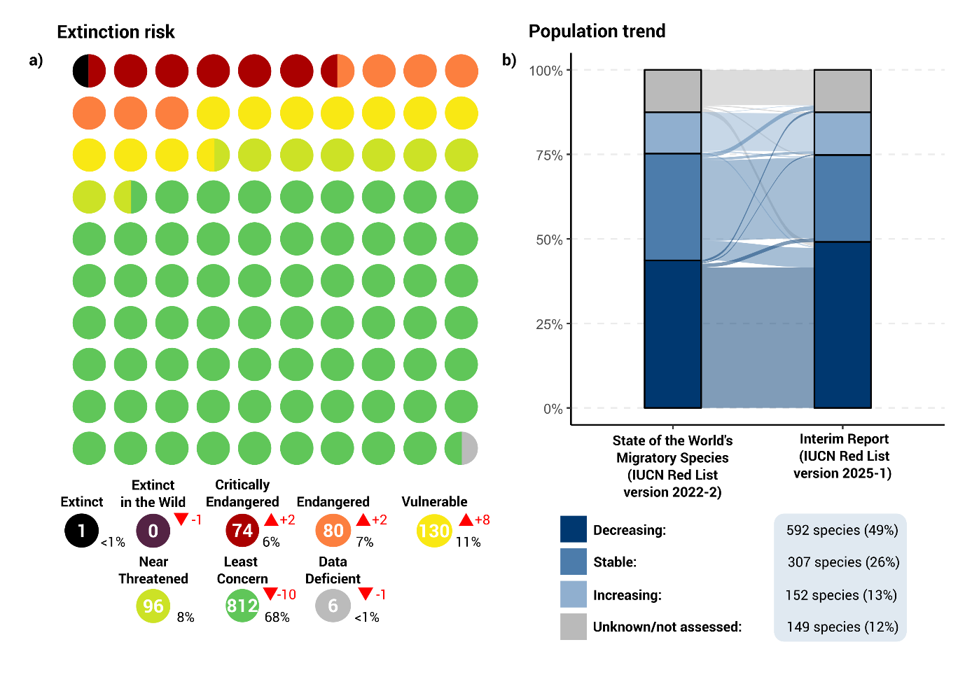
Figure 1.1: a) Proportion and number of CMS-listed species in each IUCN Red List category. In the main graphic, each circle represents 1% of the 1,200 CMS-listed species. The key below shows the total number of CMS-listed species that are currently in each category. The red numbers and arrows show the net change between the State of the World’s Migratory Species and this report*. Net changes exclude species that were listed at COP14, and species listed at the population level for which relevant regional-level assessments have become available since the State of the World’s Migratory Species. Net changes may reflect both deteriorations/improvements in conservation status due to growing/reduced threats, or changes in status due to improvements in knowledge. b) Change in the population trends of individual CMS-listed species between the State of the World’s Migratory Species and this report*. The key shows the total number of CMS-listed species in each population trend category; taxa that were added to the CMS Appendices at COP14 are excluded from the chart.

*The State of the World’s Migratory Species used data from IUCN Red List assessments published up to 2022 (IUCN Red List version 2022-2); this report uses the latest IUCN Red List data (version 2025-1, released March 2025) that was available at the time of writing (September 2025). One CMS-listed species, Gazella erlangeri, has not been assessed by the IUCN Red List.
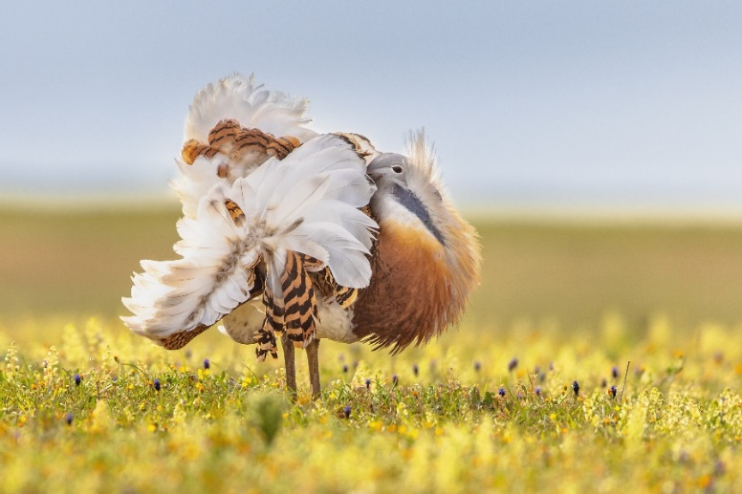
Photo caption: The CMS Appendix I-listed Great Bustard (Otis tarda), categorized as Vulnerable in 2017, was re-classified as Endangered in 2023. Great Bustards face a range of pressures, including the loss and fragmentation of habitat (caused by agricultural intensification and infrastructure development), illegal taking and disturbance¹. Photo credit: Adobe Stock | #536283277.

Species that have moved to a more threatened category

Nineteen (73%) of the 26 species that have recently moved to a more threatened category are now categorized as Vulnerable, Endangered or Critically Endangered (see Appendix Table 1). Of these 19 globally threatened species, 12 were previously categorized as Least Concern or Near Threatened in the preceding assessment. A further seven species were previously categorized as globally threatened but have shifted to an even more threatened category: four of these species are now Endangered and three are now Critically Endangered.

Eighteen (69%) of the 26 CMS-listed species that moved to a more threatened category are migratory shorebirds, of which nine are now assessed as Vulnerable. At least 14t of these species have been confirmed as undergoing a deterioration in their global conservation status since 1988 that can be attributed to increased threats, rather than improvements in information².

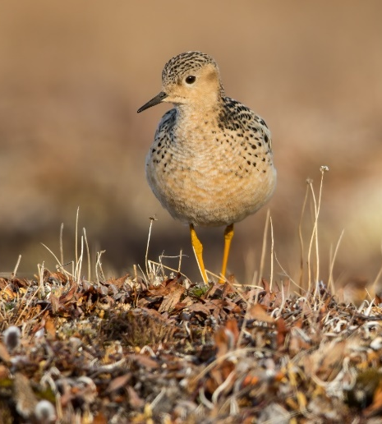
Photo caption: Like several other CMS-listed shorebirds, the CMS Appendix I-listed Buff-breasted Sandpiper (Calidris subruficollis) has recently been re-categorized from Near Threatened to Vulnerable, following the publication of an updated IUCN Red List assessment for this species in 2024. This species undertakes a 30,000 km round-trip migration from its Arctic breeding grounds to non-breeding areas in southern South America but faces an uncertain future due to habitat loss and climate change³. Photo credit: Adobe Stock | #402858055.

Species that have moved to a less threatened category

Seven CMS-listed species have an improved conservation status since 2022. These include four bird species that have moved from Near Threatened to Least Concern (see Appendix Table 1), as well as the following examples of conservation successes:
- Following a successful reintroduction project in Chad, the Scimitar-horned Oryx (Oryx dammah) has been re-categorized from Extinct in the Wild to Endangered. The reintroduction has led to the establishment of a viable wild population, which numbered approximately 575 individuals in 2022⁴.
- Recent population growth and range expansion has led to the Mediterranean Monk Seal (Monachus monachus) being re-categorized from Endangered to Vulnerable⁵. However, the global population still remains small, at under 1000 individuals, and is still subject to pressures including the loss of optimal pupping and foraging habitat and negative interactions with fisheries⁶.
- Saiga Antelope (Saiga tatarica) populations have rebounded spectacularly in parts of their range after disease outbreaks during the 2010s, moving the species from globally Endangered to Near Threatened. This recovery reflects intensified conservation efforts in Kazakhstan, including expanded anti-poaching initiatives, the protection of key habitats and engagement with local communities⁷. Saiga remain threatened in some areas and Range States, and are absent from other parts of their former range; the long-term recovery of the species depends on sustained conservation measures⁸.
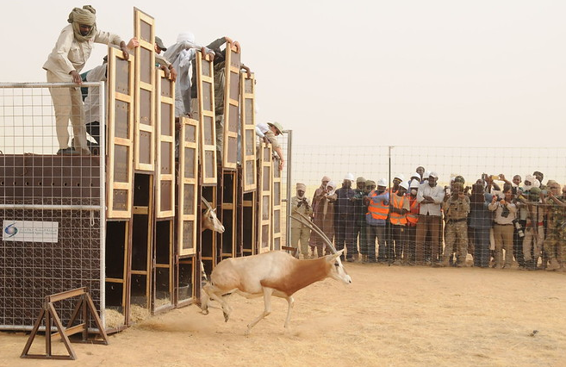
Photo caption: Scimitar-horned Oryx (Oryx dammah) being released as part of a successful reintroduction project in Chad in 2016. The species was categorized as Extinct in the Wild by the IUCN Red List in 2000 but has recently been re-categorized to Endangered following successful reintroduction efforts. Photo credit: Smithsonian’s National Zoo / Environmental Agency—Abu Dhabi (EAD), licenced under CC BY-NC-ND 2.0.

Changes in population trends

Updates to the IUCN Red List have also resulted in changes to population trends of CMS-listed species. Excluding the ten entirely new species and subspecies that were added to the CMS Appendices at COP14, the overall proportion of CMS-listed species with an increasing or stable population trend has declined from 43% (520 species) to 38% (459 species). This change has largely been driven by the 67 Appendix II birds that have been re-assigned from the “stable” to the “decreasing” category, as indicated by the transitions shown in Figure 1.1b. By contrast, in terms of positive trends, one terrestrial mammal (the Saiga Antelope, Saiga tatarica) and fourteen birds that were previously classified as “decreasing” now have either “increasing” or “stable” population trends.

The growth in the number of species with declining populations is likely to reflect the integration of additional long-term trend data within IUCN Red List assessments, rather than abrupt decreases during the time period since COP14. This update nonetheless presents a concerning picture: the total number of CMS-listed species that have decreasing population trends now stands at 592, or almost half (49%) of all CMS-listed species, up from the 44% reported in the State of the World’s Migratory Species.

Spotlight on recently reported population changes

Since CMS COP14, several scientific papers, assessments and reports have been published that provide updated information on trends in population abundance and changes in the distribution of migratory species across the globe. This section presents a brief synthesis of key findings from selected papers and assessments published between late 2023 up until the time of writing (September 2025). The aim of this section is to provide updates on key global or regional trends in some CMS-listed and non-CMS migratory species rather than to present a systematic survey or analysis of all of the relevant literature and data.

Population changes reported across multiple taxonomic groups

Impacts of avian influenza

- Since 2021, H5N1 highly pathogenic avian influenza (HPAI) has been detected in an unusually broad host range of birds and mammals and caused substantial mortality in many populations of birds and aquatic mammals across multiple continents^{1,2}. Reported mass mortality events have affected a range of avian CMS-listed species, including Critically Endangered African Penguins (Spheniscus demersus), Vulnerable Humboldt Penguins (Spheniscus humboldti) and Near Threatened Peruvian Pelicans (Pelecanus thagus) in South America, Near Threatened Dalmatian Pelicans (Pelecanus crispus) in Europe and Vulnerable Hooded (Grus monacha) and Red-crowned Cranes (Grus japonensis) in Asia³⁻⁶⁻⁴⁴. Mass mortality events have also been recorded in CMS-listed aquatic mammals, such as the South American Sea Lion (Otaria byronia) and the South American Fur Seal (Arctocephalus australis)³.
- Although the long-term impacts of HPAI are uncertain, these disease outbreaks have added to the pressures already faced by migratory species. The emergence of HPAI is especially concerning for long-lived migratory species that are sensitive to any increases in mortality¹.

Terrestrial mammals

Ungulates

- The expansion of infrastructure, such as roads, railroads, fences and pipelines, represents a significant challenge to migratory ungulates⁷. These obstacles are increasingly constraining the movements of CMS-listed ungulates, especially in regions such as Central Asia⁸ (see Section 4 – Mapping the world’s ungulate migrations for additional insights). For example, between 2002 and 2021, mobility declined significantly for the Mongolian Gazelle (Procapra gutturosa), a nomadic species that makes some of the longest distance movements ever recorded⁹. Increasing traffic volume leading to a loss of connectivity appears to be a key factor in the decline⁹.
- The rapid proliferation of fencing has had a profound impact on many ungulate species around the world. For example, the Mara-Loita Blue Wildebeest (Connochaetus taurinus) population has declined by 75% since the late 1970s after land use changes were permitted throughout their range¹⁰. The population has sustained further declines since 2021, coinciding with the rapid expansion of fencing¹¹. This contrasts with the situation in the Serengeti-Mara population, which has remained stable because its entire migratory range is under some form of protection on both sides of the Kenya-Tanzania border¹⁰.
- Across the Arctic, populations of migratory tundra Caribou (Rangifer tarandus) have declined overall by 65% over the past 20-30 years, with indications that populations are increasingly being affected by climate change and the expansion of human infrastructure such as mines and roads¹². Many Caribou and Wild Reindeer populations that occur further south are also under threat due to the loss and fragmentation of important forest habitat¹³. Although Caribou are not CMS-listed, their migrations play a central role in the tundra ecosystem and are of immense value to Arctic Indigenous cultures¹².


Photo caption: Listed in CMS Appendix II at COP14, Guanacos (Llama guanicoe) exist in isolated populations across their range, which encompasses several South American countries. Entanglement in fences is the main threat to Guanaco migrations in Patagonia, which typically involve short-distance movements between high-altitude summer and low-elevation winter ranges¹⁴. Photo credit: Adobe Stock | #83783149.

Birds

African-Eurasian raptors and other landbirds

- According to the recent Raptors MOU Conservation Status Assessment Report, the global populations of over half (53%) of the 93 species listed on Annex 1 of the Raptors MOU are declining, with a particularly high proportion of vultures and eagles showing decreasing population trends¹⁵. For example, a recent study found that African raptor species associated with savanna habitats have undergone widespread declines over the past 20-40 years, based on road transect surveys undertaken across the continent¹⁶.
- The Mid-Term Implementation Review of the Vulture Multi-species Action Plan to conserve African-Eurasian Vultures (Vulture MSAP) provides a detailed update on current situation facing vultures in this region¹⁷. Most European vulture populations are recovering or stable, and there are also signs that South Asian populations have stabilized at a low level following a historic collapse in numbers driven by unintentional poisoning^{17,18}. These trends have been attributed to improvements in legislation and active conservation management^{17,19}. However, many vulture populations are still declining rapidly, particularly in Africa¹⁷.
- The main pressures facing raptors in Africa and Eurasia are habitat loss and illegal taking, including hunting and trapping, intentional and unintentional poisoning, and taking for belief-based use, along with electrocution and collisions with energy infrastructure¹⁵. Information on mortality events derived from tracking data has confirmed that electrocution and collisions with energy infrastructure are a significant cause of human-induced mortality for migratory raptors in the African-Eurasian flyway, alongside illegal killing and poisoning²⁰.
- Looking beyond raptors, the distributions of other Palearctic migrants contracted substantially in Kenya between 1970 and 2023, according to a cross-comparison of earlier bird atlas maps with more recent citizen science data²¹. These range losses mirror general declines in the population abundance of long-distance Afro-Palearctic migrants in Europe between 1980 and 2017²². Long-distance migrants dependent on agricultural systems appear to be suffering the greatest declines, exacerbated by climate change impacts^{22,23}.

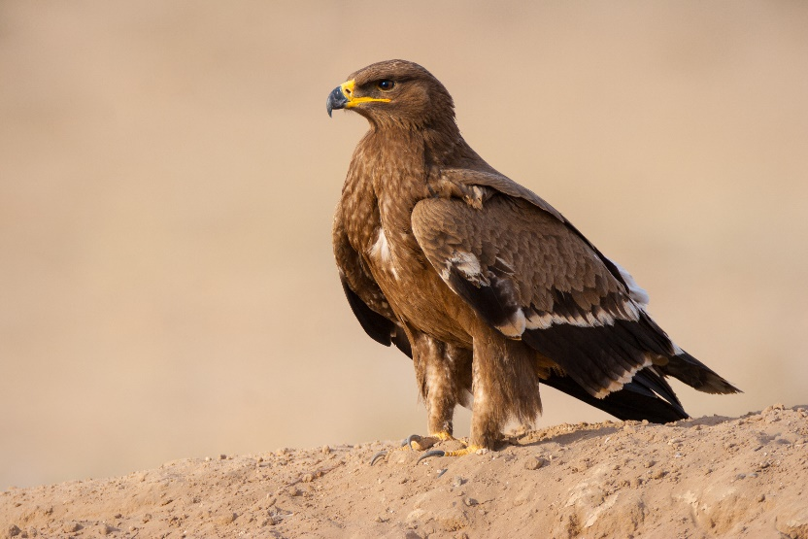
Photo caption: CMS Appendix I-listed Steppe Eagles (Aquila nipalensis) migrate thousands of kilometres from breeding areas in China, Central Asia, Mongolia and Russia to non-breeding locations in Africa, Middle East and southern Asia. Categorized as globally Endangered, populations are threatened by an array of pressures including habitat conversion, illegal killing and collisions with power lines and energy infrastructure²⁵. A Global Action Plan on Steppe Eagles is to be presented to COP15. Photo credit: Adobe Stock | #1419499617.

Shorebirds

- The probable global extinction of the Appendix I-listed Slender-billed Curlew (Numenius tenuirostris) has been reported, on the basis of an analysis incorporating data on threats to the species, historic observations and survey effort²⁶. With no confirmed sightings of the species since 1995, the pressures that triggered the loss of the Slender-billed Curlew are poorly known but are likely to have included habitat loss and hunting²⁶. The plight of this species offers the world important lessons on the need to take urgent action when substantial declines are detected.
- Large and accelerating declines have been documented for shorebirds that use the Americas flyway, stretching between the Arctic and South America²⁷. Between 1980 and 2019, 18 out of 28 shorebird species analyzed showed clear evidence of population declines, based on counts at stopover sites in the United States of America and southern Canada²⁷.
- Pronounced long-term declines in the populations of many migratory shorebirds have also occurred in the East Asian-Australasian flyway²⁸, in the East Atlantic flyway (particularly species breeding in the Arctic and boreal regions²⁹), and at coastal sites in India³⁰. The main threats affecting shorebird populations globally include the loss and deterioration of key habitats, including at stopover and non-breeding sites^{27-31,32}, unsustainable taking³³, disturbance, and climate change-driven shifts in the suitability of conditions at breeding sites³⁴.
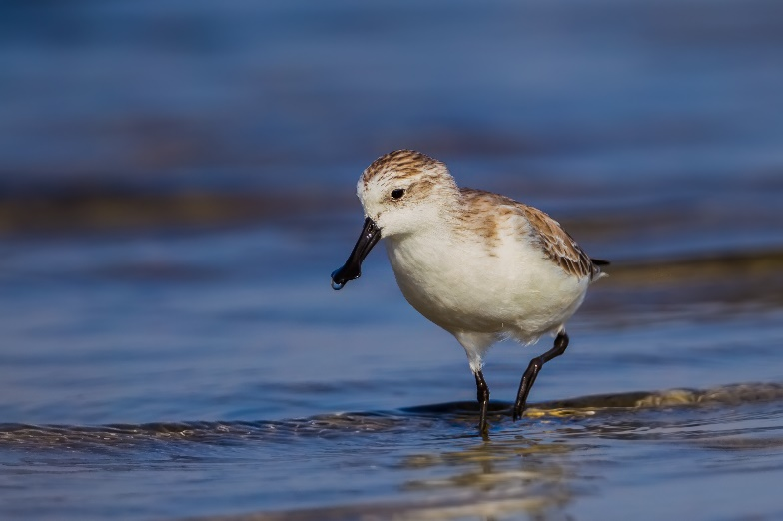
Photo caption: Coordinated conservation action along flyways is crucial for reducing the pressures on migratory shorebirds. While this report highlights new information on alarming population decreases for species in this group, many shorebirds were already known to have declined rapidly over the long-term, including the Critically Endangered Spoon-billed Sandpiper (Calidris pygmaea)³⁵. Photo credit: Adobe Stock | #98383832.

Fish

The first State of the World’s Migratory Species highlighted fish – both freshwater and marine – as a particular concern, with nearly all (97%) of CMS-listed fish threatened with extinction, and evidence for steep declines in the abundance of monitored fish populations over the last 50 years. Recent insights from the literature confirm these negative trends, underscoring the need for intensified action focussing on this group of species.

Freshwater fish

- According to the most recent update of the Living Planet Index (LPI), monitored populations of migratory freshwater fish declined by 81% on average globally between 1970 and 2020³⁶. Average population declines were particularly steep in Latin America (-91%) & the Caribbean and Europe (-75%) but were less pronounced in North America (-34%) and Asia-Oceania (-28%). There was insufficient data to produce a trend for Africa³⁶.
- Habitat loss, degradation and alterations – including the impacts of dams and other human activities that cause changes in flow regime – was the most widely reported pressure affecting the monitored populations considered in the LPI update, followed by overexploitation³⁶. Freshwater migratory species are predicted to suffer growing future impacts from dams, including in the Amazon, Congo, Niger, Mekong and Salween basins³⁷. In the Amazon basin, the number of free-flowing rivers >1,000 km in length is projected to decrease from 16 to nine if planned dams are built³⁸. These changes are expected to impact CMS-listed aquatic mammals and reptiles that are reliant on river connectivity, such as the Amazon River Dolphin (Inia geoffrensis) and the South American River Turtle (Podocnemis expansa)³⁸.

Sharks and rays

Since the publication of the first State of the World’s Migratory Species, several reports and studies have been released that provide updated information on the status of sharks and rays. This includes the recently published IUCN Species Survival Commission (SSC) Shark Specialist Group’s report on the ‘Global status of sharks, rays and chimaeras’ as well as other key papers³⁹⁻⁴¹. These studies found that:

- Sharks and rays as a whole have experienced substantial increases in extinction risk between 1970 and 2020, reaffirming their status as one of the most threatened vertebrate groups⁴⁰. Globally, populations of these species have declined in abundance by half since 1970 as a result of overfishing, based on an analysis of global trends in catch per unit effort⁴⁰. Among taxonomic groups that contain several CMS-listed species, the sawfishes (Pristidae), devil rays (Mobulidae) and hammerhead sharks (Sphyrnidae) are particularly severely threatened⁴⁰. Extinction risk has also risen steeply for the requiem sharks (Carcharhinidae), which includes strongly declining CMS-listed species such as the Critically Endangered Oceanic Whitetip (Carcharhinus longimanus)⁴³.
- Taking a regional perspective, the most pronounced increases in extinction risk for sharks and rays have occurred in the tropical Atlantic Ocean, the Northern Indian Ocean, the Indo-West Pacific Ocean and the Mediterranean and Black Sea regions⁴⁰. Regional populations of wide-ranging sharks and rays may rebound, if science-based fisheries management approaches are implemented⁴¹.
- Overfishing – including both targeted fisheries and incidental bycatch – remains the primary threat affecting sharks and rays³⁹. The loss and degradation of coastal habitats such as mangroves has also contributed to dramatic long-term declines and substantial range loss for coastal species such as sawfishes⁴², all five of which are now categorized by the IUCN Red List as Critically Endangered⁴³.
- Climate change, including the impacts of ocean warming, acidification and potentially deoxygenation, has also been identified as an additional pressure that will likely have a strong impact on coastal and pelagic species^{39,44-45}.


Photo caption: The Critically Endangered Angelshark (Squatina squatina) – listed on CMS Appendices I and II and Annex 1 of the Sharks MOU – was formerly widespread in coastal waters of the northeast Atlantic Ocean and the Mediterranean Sea, but due to overexploitation, populations are now increasingly fragmented^{39,46}. A CMS Single Species Action Plan for Angelshark in the Mediterranean Sea was adopted at COP14. Photo credit: Adobe Stock | #220283534.

Reptiles

Marine turtles

- The conservation status of marine turtles appears to be improving overall. In a recent comprehensive assessment, conducted by the IUCN SSC Marine Turtle Specialist Group (MTSG), the proportion of marine turtle regional management units (RMUs) scored as “low risk-low threat” increased from 23% in 2011 to 40% in 2024⁴⁷. Over the same period, risk-threat categories improved for 54% and deteriorated for 15% of RMUs⁴⁷.
- The results of this updated assessment – which can be viewed online via an interactive data dashboard – match the picture emerging from a recent synthesis of trends in annual nesting numbers, which shows upward or stable trends for most monitored populations⁴⁸. In some cases, positive trends have been attributed to conservation measures, including efforts to reduce take and the establishment of protected areas⁴⁹.
- Many marine turtle populations remain threatened, however⁴⁷. Viewed from a regional perspective, while improvements in conservation status were more common in Atlantic Ocean RMUs, most of the “high risk-high threat” RMUs were concentrated in the Pacific Ocean⁴⁷. Of the nine “high risk-high threat” RMUs, four were Leatherback Turtle RMUs (Dermochelys coriacea) and three were Loggerhead Turtle (Caretta caretta) RMUs⁴⁷.
- Despite the overall signs of recovery noted above, marine turtles still face severe threats⁴⁹. According to the IUCN SSC MTSG assessment, fisheries bycatch was judged to be the most severe pressure across all marine turtle RMUs, showing relatively little sign of improvement since 2011⁴⁷. Other continuing and emerging pressures facing marine turtles include coastal development, plastic pollution, climate change and direct take⁴⁹.


Photo caption: At monitored nesting beaches, population abundance trends of Green Turtles (Chelonia mydas) are generally increasing or stable⁴⁸, although dramatic declines have been reported at one of the world’s largest nesting colonies⁵⁰. Action is still needed to address persistent threats facing this species such as bycatch, pollution and the loss of seagrass meadows which provide foraging habitat⁴⁹. Photo credit: Adobe Stock | #536146467.

Progress identifying and protecting important habitats for CMS-listed species

Many migratory species rely on a network of areas and discrete sites that provide vitally important breeding, non-breeding, feeding or stopover habitat. This section provides a summary of recent progress in identifying and protecting critical sites for CMS-listed species globally, building on an analysis conducted for the first State of the World’s Migratory Species. Action to identify and protect important habitats for CMS-listed species is not just a vital component of the Samarkand Strategic Plan for Migratory Species 2024-2032, but will also contribute significantly to efforts to maintain and enhance ecological connectivity globally. Tackling the loss, degradation and fragmentation of important habitats for migratory species is also crucial for achieving multiple targets included in the Kunming-Montreal Global Biodiversity Framework.

Identifying important habitats

Multiple approaches have been developed to identify important areas for biodiversity globally¹. These include Key Biodiversity Areas (KBAs), developed as an umbrella approach for identifying important sites for all taxonomic groups, ecosystems, ecological integrity, biological processes and irreplaceability². KBAs are identified at the national level using a set of quantitative criteria². For example, sites can be identified as KBAs if they support a significant proportion of the worldwide population of a globally threatened species, or if they hold significant demographic aggregations of a species during one or more key stages of its life cycle, among other criteria.

In addition to KBAs, other taxon-specific initiatives with a global scope, such as Important Marine Mammal Areas (IMMAs), Important Shark and Ray Areas (ISRAs) and Important Marine Turtle Areas (IMTAs), are also particularly relevant to CMS (see Box 1). There are differences between the approaches used to identify important locations under these frameworks²⁻³, including differences in scale. While KBAs are defined as sites that are actually or potentially manageable as a unit¹, IMMAs and ISRAs may include larger areas, such as coastal or trans-oceanic migratory corridors³. IMMAs, ISRAs and IMTAs initiatives also use globally standardized criteria to identify discrete portions of habitat that have the potential to be managed for conservation⁴⁻⁶.

Many important habitats for CMS-listed species have been identified and recognized as KBAs, IMMAs and/or ISRAs, but considerable geographic and taxonomic gaps still remain (Figure 3.1). Of the 1,200 CMS-listed species, 782 (63%) have had at least one important site recognized through one or more of these initiatives at the time of writing (September 2025). Of the 16,589 KBAs that have been recognized globally to date, 9,372 have been identified as being important for 718 (60%) of the 1,200 CMS-listed species. This means that the site supports population sizes of one or more CMS-listed species that exceed the thresholds for at least one KBA criterion.

KBAs or IMMAs have also been identified for 57 (86%) of the 66 CMS-listed aquatic mammals (Figure 3.1). Similarly, KBAs or ISRAs have been delineated for 48 (76%) of the 63 CMS-listed fish (Figure 3.1), including 39 (98%) of the 40 CMS-listed sharks⁷. These figures reflect the considerable progress made identifying IMMAs and ISRAs by the IUCN Marine Mammal Protected Area Task Force and the IUCN SSC Shark Specialist Group in recent years (Box 1).
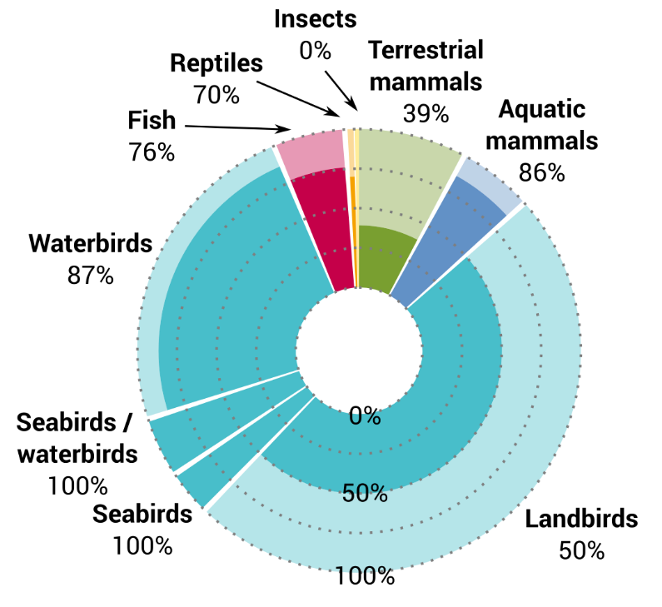
Figure 3.1: Proportion of CMS-listed species (n=1,200) for which at least one Key Biodiversity Area (KBA), Important Marine Mammal Area (IMMA) or Important Shark and Ray Area (ISRA) has been identified (n=782), by taxonomic group, as shown by the shaded areas within each segment shown in the chart. The width of the segments is proportional to the number of CMS-listed species that fall within each taxonomic group (i.e. the segment for landbirds is the widest because 49% CMS-listed species are landbirds). Data sources: World Database of Key Biodiversity Areas (2025); searchable database of Important Marine Mammal Areas (2025); IUCN SSC Shark Specialist Group (2025)⁷.
Box 1: Identifying IMMAs, ISRAs and IMTAs for CMS-listed marine migratory species

As of July 2025, 323 Important Marine Mammal Areas (IMMAs) have been identified for 100 species of aquatic mammals, including 46 CMS-listed species, as part of a process involving regional identification workshops convened by the IUCN Marine Mammal Protected Area Task Force⁸. The combined surface area of these IMMAs – viewable online through the IMMA e-Atlas – is equivalent to 17.8% of the global ocean⁸. Since March 2023, regional IMMA workshops have been held in the North East Atlantic Ocean and the North West Atlantic Ocean and Wider Caribbean regions with the aim of identifying further sites⁸. A study was also conducted to explore ways to monitor and assess the status of IMMAs, focussing on pilot sites across six different countries⁹.

The Important Shark and Ray Area (ISRA) project was established by the IUCN SSC Shark Specialist Group in 2022. The global identification of ISRAs is undertaken regionally through an expert driven process, and as of January 2025, approximately two-thirds (63.8%) of global marine waters had been surveyed for ISRAs¹⁰. It is anticipated that assessments in the remaining five regions (European Atlantic, North America and Caribbean Atlantic, African Atlantic, Australia and Southeast Indian Ocean, and North American Pacific) will be completed by 2027¹⁰.

Additionally, although the IUCN SSC Marine Turtle Specialist Group established Important Marine Turtle Area (IMTA) criteria and guidelines in 2021, to date, no IMTAs have been formally identified. To address this gap, the Blue Corridors for Turtles partnership is seeking to synthesize and assess connectivity data at a global scale and support the identification of IMTAs through regional workshops (under the auspices of the MTSG). Blue Corridors for Turtles is a global partnership, with coordination from WWF and the CMS Secretariat, the University of Queensland, the State of the World’s Sea Turtles (SWOT) programme and Collecte Localisation Satellites - Argos system (CLS-Argos) as partners.
The basic summary statistics provided above (see Figure 3.1) represent just a first step towards a more complete understanding of the progress made in identifying important areas for CMS-listed species. As migratory species under CMS are by definition found in several countries, and typically depend on multiple sites, used at different stages of their annual cycle and often scattered across multiple jurisdictions, more sophisticated analyses – taking connectivity between sites into account – will be needed to understand how serious existing knowledge gaps are. Some CMS-listed migratory species occur at low densities across large geographic areas¹¹⁻¹²; approaches that focus only on identifying discrete sites are likely to be less relevant to these species.

Identifying globally important habitats for migratory species is also an ongoing process. For example, while KBAs have been identified in 99% of countries and territories, only a small minority have comprehensively identified sites using the new Global KBA standard¹. Substantial knowledge gaps continue to exist in relation to the sites used by many migratory species over the course of their life and annual cycles.

One way to address gaps in site information is to utilize animal movement data. Recent syntheses of tracking data have facilitated the identification of important sites for highly mobile taxa that move vast distances across remote areas, such as seabirds and marine mammals¹³. Despite the technological improvements in tracking devices that have allowed growing volumes of movement data to be collected, detailed information on migratory movements are still lacking for many migratory species¹⁴⁻¹⁶. For example, avian tracking studies have been skewed towards larger-bodied species and particular geographic regions, potentially reflecting technological constraints as well as geographic disparities in funding available for research¹⁴⁻¹⁶. Initiatives designed to promote the mobilisation of animal movement data for global conservation goals, such as the recent proposal for an Animal Movement Biodiversity Observation Network (Move BON), anchored within the GEO BON framework, can potentially help to address these issues¹⁷. One of the main aims of Move BON is to improve the degree of coordination between existing tracking initiatives, in order to fill spatial and taxonomic gaps – and increase access to – movement data.

Ultimately, although progress has been made since COP14, more survey, tracking and monitoring efforts are needed to identify comprehensive networks of sites for migratory species globally.

Coverage of KBAs by protected and conserved areas

Site identification initiatives provide crucial information that can help to target area-based conservation efforts to the most important sites for the global persistence of biodiversity¹. Globally, on average, just over half (52.6%) of the area of each KBA identified as being important for CMS-listed species was covered by protected and conserved areas in 2025 (Figure 3.2). While coverage levels have risen since the 1980s, the rate of progress appears to have slowed in recent years (Figure 3.3). Europe currently has the highest percentage coverage (65.5%), followed by Africa (50.7%). Asia has the lowest percentage coverage (35.5%), just below North America (37.6%), Oceania (41.3%) and South & Central America & The Caribbean (41.7%).

Looking across different taxonomic groups of CMS-listed species, mean coverage of KBAs by protected and conserved areas was highest for certain groups of birds (seabirds/waterbirds: 61.8%; waterbirds: 58.6%; landbirds: 58.2%) and terrestrial mammals (60.6%); intermediate for aquatic mammals (43.8%); and lowest for fish and reptiles (both 36.7%). There were 26 globally threatened CMS-listed species for which the mean KBA coverage by protected and conserved areas was less than 25%, including three Critically Endangered species: the Common Guitarfish (Rhinobatos rhinobatos), the White-winged Flufftail (Sarothrura ayresi) and the Spoon-billed Sandpiper (Calidris pygmaea).
Taken together, these results suggest that there are potentially substantial gaps in the protection of important habitats for CMS-listed species globally. The identification of unprotected sites that are important for the global persistence of CMS-listed species provides a useful resource enabling countries to plan, prioritize and make decisions on these sites, whilst also taking into account (and ensuring the participation of) all relevant stakeholders in decision-making.
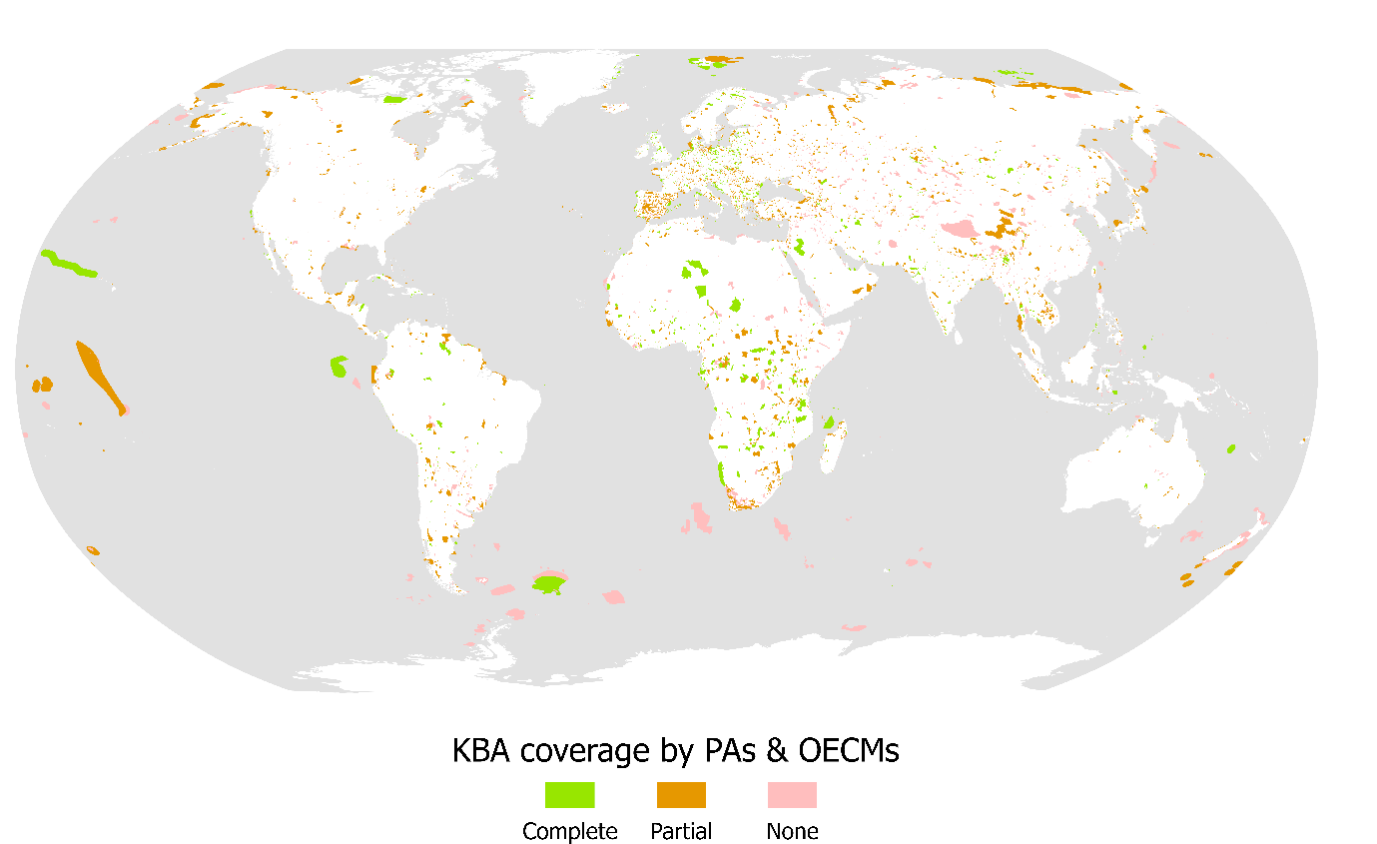
Figure 3.2: Global map indicating the extent to which Key Biodiversity Areas (KBAs) that have been identified as being important for CMS-listed species are covered by protected areas and other effective area-based conservation measures (OECMs), shown as complete (≥98%), partial (98% - 2%) and no (≤2%) coverage. Data sources: World Database on Protected Areas (WDPA) and World Database on Other Effective Area-Based Conservation Measures (WD-OECM) (2025); World Database of Key Biodiversity Areas (2025). Calculated by BirdLife International (2025).

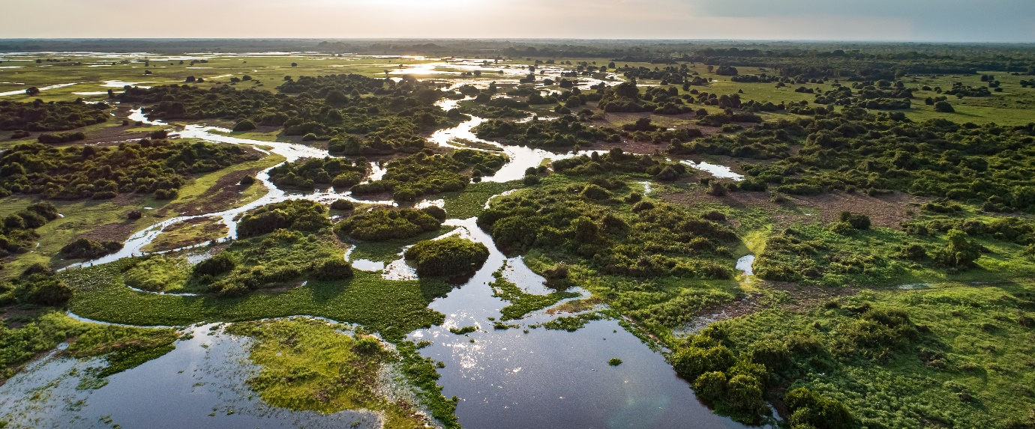
Photo caption: Wetlands, like the Pantanal in South America, provide vital habitat for a diverse range of migratory species. According to the Global Wetland Outlook 2025, around over one fifth of global wetlands are reported as being in a poor state, with an increasing number of Ramsar Parties reporting a deterioration in their condition between 2011 and 2021¹⁸. The top reported negative drivers of changes in the state of wetlands include pollution, urbanisation and industrial/infrastructure development, although drought was highlighted as a concern in Europe¹⁸. Further action is needed to effectively conserve, manage and restore the world’s remaining wetlands, to ensure their biodiversity value is not diminished. Photo credit: Adobe Stock | #301916260.

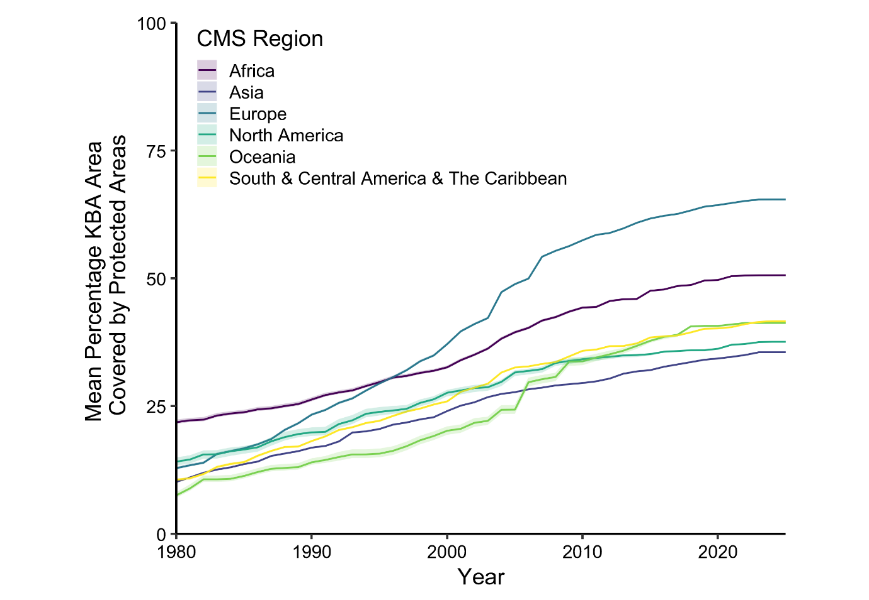
Figure 3.3: Regional trends in the mean percentage coverage of Key Biodiversity Areas identified as being important for CMS-listed species by protected areas and other effective-area based conservation measures (OECMs), between 1980 and 2025. Data sources: World Database on Protected Areas (WDPA) and World Database on Other Effective Area-Based Conservation Measures (WD-OECM) (2025); World Database of Key Biodiversity Areas (2025). Calculated by BirdLife International (2025).

Future analyses assessing the coverage of IMMAs, ISRAs and IMTAs by protected and conserved areas would also be informative. A recent large-scale analysis of global tracking data compiled by the MegaMove project found that increasing marine protected area coverage levels to 30% will still leave approximately 60% of the important areas used by highly mobile marine megafauna for breeding, feeding or migrating unprotected¹⁹. Broader forms of ocean management designed to mitigate specific pressures over large areas, such as shipping restrictions (e.g. reductions in vessel speed, or changes in shipping routes) or policies designed to reduce bycatch, will also be needed to lessen negative impacts on these species¹⁹⁻²⁰. Understanding the state of protection for marine migratory species has been identified as key research aim under the Migratory Connectivity in the Ocean (MiCO) initiative (see Section 4).

Recent progress mapping migratory pathways

Mapping the world’s migration pathways is a crucial step towards ensuring that migratory populations can continue to safely access the vital breeding, foraging and resting areas that they need to survive. Migration maps derived from empirical tracking data allow migratory animals themselves to tell us which seasonal ranges or corridors are most crucial over the course of their life cycle. The recent growth in animal tracking research has drastically improved the state of knowledge in this area, by enabling migration routes to be mapped in unprecedented detail, and by facilitating the discovery of previously unknown migratory pathways.

Improved maps of migration corridors can help to direct area-based conservation efforts towards critical areas in need of enhanced protection. However, since animal movements often span distances that are orders of magnitude larger than any protected area¹⁻², migratory species must be able to travel unimpeded through wider land-, river- or seascapes that are increasingly fragmented by a range of human infrastructure and activities³⁻⁶. Migration maps – and the tracking data that underpins them – can help to identify potential obstacles to movement, assess the degree of exposure to pressures encountered on migratory journeys, and highlight the broader regions where policy interventions are needed to sustain connectivity in the context of working land- and seascapes⁶⁻⁸. Mapping efforts can also reveal the migratory connections that link distant countries⁹⁻¹¹, providing a sound scientific basis for collaborative international conservation efforts.

This section contains an overview of the recent progress made by initiatives dedicated to mapping terrestrial and marine migratory pathways. Here, we feature two initiatives that have been at the forefront of recent efforts to map migrations: the Global Initiative on Ungulate Migration (GIUM), a module of the CMS Atlas of Migration, and the Migratory Connectivity in the Ocean (MiCO) system.

Mapping the world’s ungulate migrations

Contribution by: Thomas Mueller, Janey Fugate and Matthew Kauffman – Global Initiative on Ungulate Migration (GIUM)

The Global Initiative on Ungulate Migration (GIUM) unites an international community of conservation-focused migration researchers and conservationists to document and protect the world’s key migratory routes for hoofed mammals. By leveraging collaborations with over 80 scientists from more than 50 institutions, the initiative has developed the world’s first living Atlas of Ungulate Migration, mapping over 30 of the planet’s major ungulate migrations across 17 different ungulate species. For each migration, detailed fact sheets explain the route, summarize specific conservation challenges, and often include supplemental maps showing where these movements intersect with threats or protected areas. For example, a detailed map of the migration of the White-eared Kob (Kobus kob leucotis) and Tiang (Damaliscus lunatus tiang) in South Sudan and Ethiopia was released for the first time in April 2025. It is the world’s largest ungulate migration, involving over five million White-eared Kob, but faces pressure from unregulated hunting and imminent oil development. Mapping is ongoing in many locations around the world, and GIUM plans to significantly expand the Atlas by the end of 2026.

One of the most urgent and consistent threats highlighted by GIUM’s work is the proliferation of linear infrastructure—especially roads, railways, and fencing. Such barriers fragment habitats, impede migration, and increase risks for migratory species in multiple regions. This issue is particularly pronounced in Central Asia and Africa, where rapid infrastructure growth has created new obstacles for iconic migratory mammals like Mongolian Gazelles (Procapra gutturosa), Saiga Antelopes (Saiga tatarica) and Blue Wildebeest (Connochaetes taurinus). In these regions, rapidly expanding fence networks and newly constructed transportation corridors increasingly disrupt migratory paths, sometimes truncating entire migrations (Figure 4.1). Often, construction occurs before biologists and planners have adequate maps of the population’s migratory pathways.

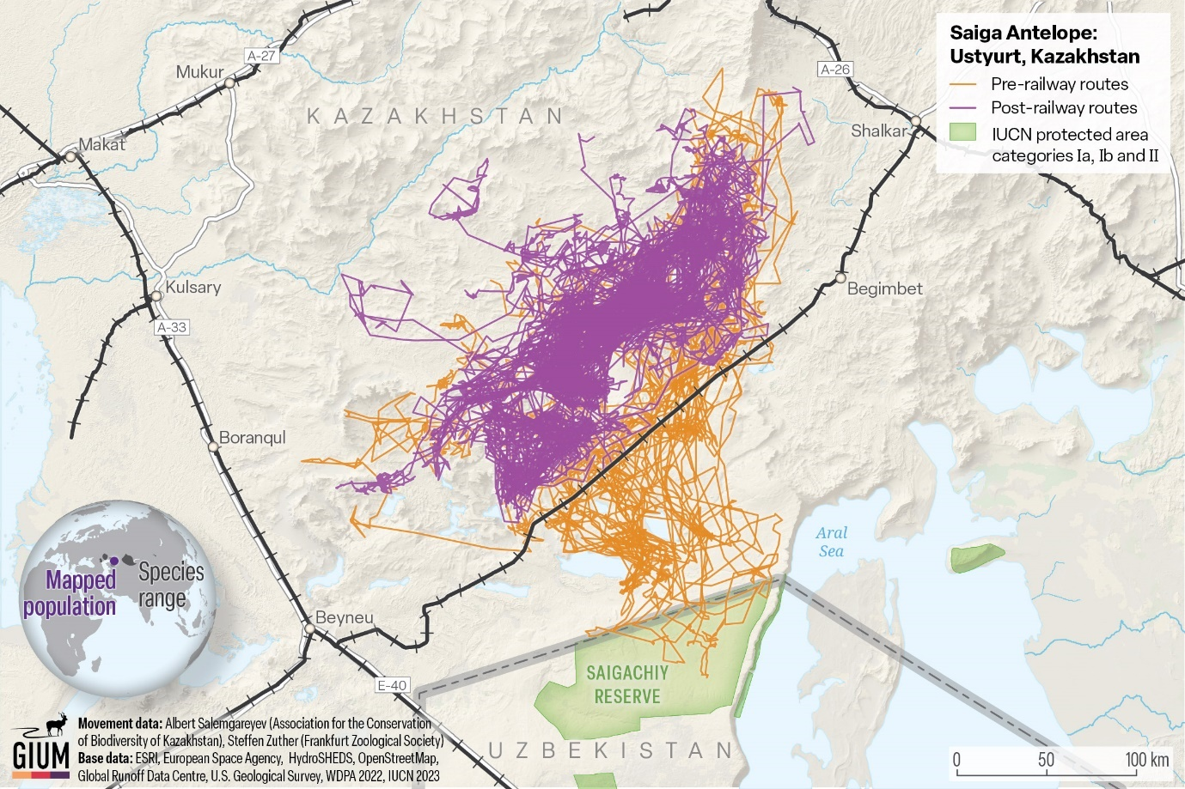

Figure 4.1: Movement data collected before and after the construction of a new railway in the Ustyurt Saiga Antelope (Saiga tatarica) population’s range shows the dramatic effect linear infrastructure can have on the CMS Appendix II-listed Saiga’s ability to move freely across the extent of their migratory range. After construction (purple tracks), saigas no longer cross the border to Uzbekistan and access the protected area to the south, which previously provided critical winter habitat (orange tracks). Map credit: Salemgareyev, A. & S. Zuther. 2024. Saiga Antelope: Ustyurt, Kazakhstan. Global Initiative on Ungulate Migration, editors. Atlas of Ungulate Migration. Convention on the Conservation of Migratory Species of Wild Animals.

The Atlas of Ungulate Migrations equips conservationists, land managers, and policymakers with the data and tools needed to prioritize landscape connectivity and plan infrastructure with migratory wildlife in mind. It provides visuals of migration routes in addition to actionable threat assessments so that future development can safeguard the hoofed migrations that underpin global biodiversity.

Advancing our understanding of marine migratory connectivity

Contribution by: Angela Liu, Lily Bentley and Daniel Dunn – University of Queensland

The Migratory Connectivity in the Ocean system (MiCO) is an open-access online system that describes information on migratory connectivity for over 100 CMS-listed marine species. It represents a critical effort to synthesize and translate the growing amounts of published marine tracking data into actionable knowledge for policymakers. Built from a systematic literature review containing over 1,200 published articles, MiCO aggregates movement data into key "metasites" that delineate breeding, foraging, nesting, or migrating areas. The connections between these metasites are represented as interactive networks in the online system (Figure 4.2), displayed alongside information on global species distribution, age, activity, and sex ratio within the metasites, and for some species, core use areas from tracking data. A recent Nature Communications article summarizing the database highlights that on average, countries were connected to around 28 other national territories or to areas beyond national jurisdiction by migratory marine species, demonstrating the extensive transboundary nature of marine migrations, and the importance of transboundary cooperation in the management of these species¹².

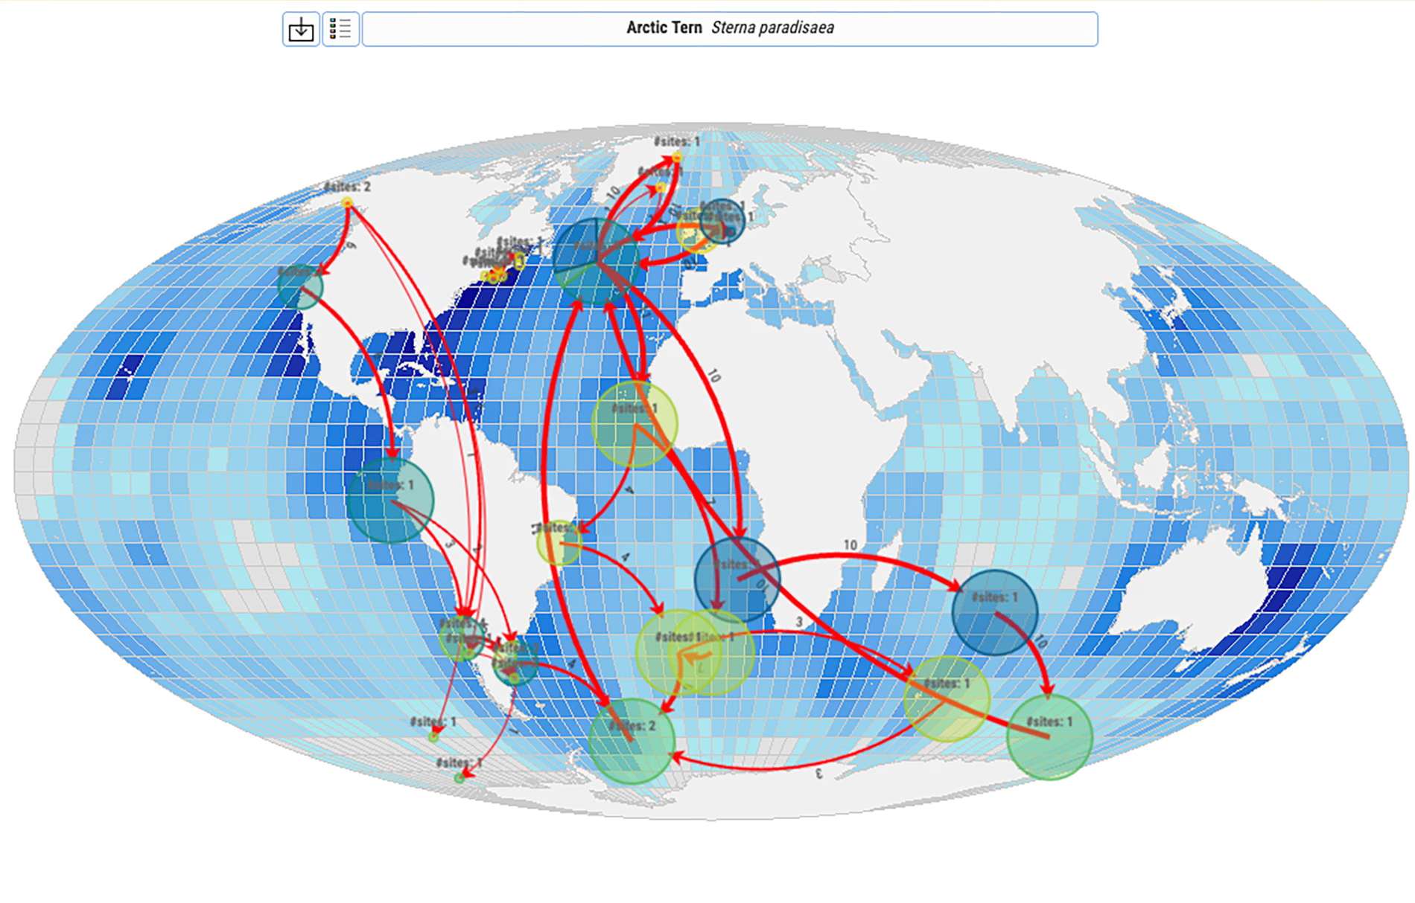
Figure 4.2: Migratory connections for the Arctic tern (Sterna paradisaea) in MiCO.

MiCO was specifically developed to help inform the delivery of a “well-connected” network of marine protected areas to meet Aichi Target 11 and now the Kunming-Montreal Global Biodiversity Framework Target 3. Previously, connectivity among protected areas was calculated as by the distance between them or via models of larval transport. This dataset opens an entirely new way to understand connectivity and calculate connectivity between MPAs – and one that is focused on the species we most frequently seek to protect. Current research aims to leverage MiCO alongside important area datasets such as the Key Biodiversity Areas (KBAs), Important Marine Mammal Areas (IMMAs), Important Shark and Ray Areas (ISRAs) and Ecologically and Biologically Significant Marine Areas (EBSAs), to better understand connectivity between these sites, and to provide a framework to understand the state of protection of marine migratory megavertebrates. Critically, MiCO also helps us identify taxonomic and geographic gaps in our knowledge of migratory species’ movements, enabling new research to focus on areas of specific need.

Mapping marine flyways for migratory seabirds

The identification of the six major Marine Flyways using tracking data collated in BirdLife International’s Seabird Tracking Database is another significant recent development relevant to migratory connectivity in the marine realm (Figure 4.3). These flyways help to illustrate the broad-scale migratory routes followed by multiple seabird species across the world’s oceans¹³. A draft Resolution on Seabirds and Marine Flyways will be discussed at CMS COP15 to formally recognize marine flyways and their contribution in strengthening international cooperation for the conservation of seabirds.

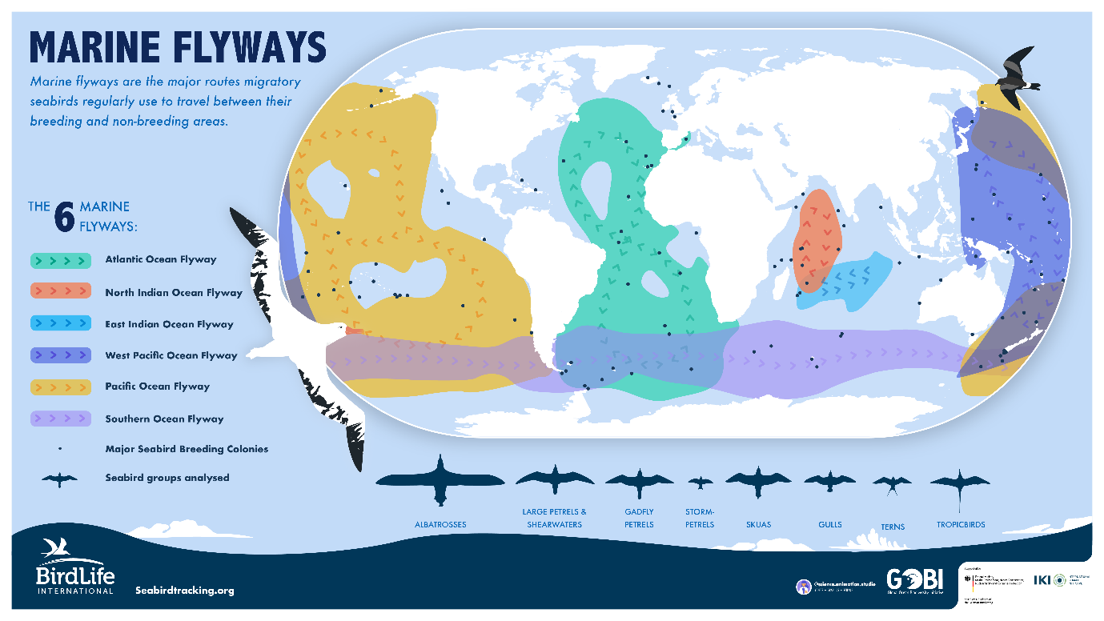
Figure 4.3: The six marine flyways across the world's oceans highlighting the repeatable migration of pelagic seabirds. Image credit: BirdLife International.

Conclusion

The first State of the World’s Migratory Species, launched at CMS COP14 in February 2024, revealed that CMS-listed species face escalating levels of extinction risk, with more species’ global populations deteriorating than improving between 1988 and 2020. Levels of extinction risk also increased among the wider group of all migratory species, which includes many globally threatened species not listed in the CMS Appendices. The first State of the World’s Migratory Species also found that 22% of CMS-listed species were globally threatened and 44% were undergoing global population declines, a greater proportion than those with stable (31%) or increasing (12%) population trends. By analysing a more recent version of the IUCN Red List, which included multiple new assessments for CMS-listed species, this interim report finds that 24% of CMS-listed species are now threatened with extinction, and 49% have decreasing population trends.

While not all CMS-listed species have been re-assessed by the IUCN Red List since the first State of the World’s Migratory Species, twenty-six species have moved to a more threatened IUCN Red List category, and only seven have transitioned to a less threatened category. These statistics underscore the need for urgent conservation action. Although this report includes some inspirational examples of successful conservation efforts, the majority of the recently reported population changes highlighted here are a cause for concern.

The first State of the World’s Migratory Species demonstrated that, although some important knowledge gaps exist, the anthropogenic pressures facing CMS-listed species are relatively well understood. These pressures include habitat loss and degradation, habitat fragmentation, overexploitation, pollution, climate change and invasive species. The first State of the World’s Migratory Species outlined a clear set of specific recommendations for priority actions that, if implemented at scale, would help to combat these pressures, and ultimately improve the conservation status of migratory species. These recommendations are unchanged and should be acted on with greater urgency.

In particular, action to protect, connect and restore habitats remains vitally important, if the integrity of the ecological networks and ecosystems that CMS-listed species rely on is to be maintained. While progress has been made in identifying important sites and migratory pathways, survey, monitoring and tracking work is still needed to identify the comprehensive networks of sites and areas used by migratory species globally. The novel insights provided by initiatives dedicated to mapping migratory pathways will play a vital role in improving the evidence base needed to support action.

Additionally, swift collaborative action is needed to tackle overexploitation, reduce the damaging impacts of environmental pollution, and address the root causes and cross-cutting impacts of climate change. Accelerating progress in all of these areas will secure a better future for CMS-listed species, in line with the vision outlined in the Samarkand Strategic Plan for Migratory Species 2024-2032.

Appendix

Table 1: Overview of the 34 CMS-listed species that have been re-categorized by the IUCN Red List, since the analysis conducted for the State of the World’s Migratory Species (incorporating data from IUCN Red List version 2022-2, released 1 April 2022): these include seven positive changes, twenty-six negative changes (orange rows) and one change from Data Deficient to Least Concern (grey row). Globally or regionally threatened species are highlighted in bold. For each species, the table provides information on the change in conservation status and a summary of the rationale for the current IUCN Red List category, as described in the species assessment. Status as of August 2025 (incorporating data from IUCN Red List version 2025-1, released 27 March 2025).

Scientific name  (Common name) | CMS App. | Change in IUCN Red List category (Popn. trend) | Summary of rationale for current IUCN Red List category and major threats  (all quantitative estimates of population change refer to the past three generations)
Terrestrial mammals
Plecotus kolombatovici (Balkan Long-eared Bat) | II | NT (↓)* → VU (↓)* | Population decline >10% suspected; habitat loss and degradation are major threats.
Oryx dammah  (Scimitar-horned Oryx) | I/II | EW → EN (↑) | Re-establishment of a viable wild population in Chad.
Saiga tatarica  (Saiga Antelope) | II | CR (↓) → NT (↑) | Population recovery following disease outbreaks; the EN, VU or LC categories are considered as plausible as NT, due to multiple unpredictable factors that may affect the population in future.
Aquatic mammals
Monachus monachus (Mediterranean Monk Seal) | I/II | EN (↑) → VU (↑) | Recent population increases and local range expansion; global population size remains small.
Birds
Anser canagicus  (Emperor Goose) | II | NT (↓) → LC (↑) | Population appears to have increased recently; population size does not meet the VU threshold.
Anser cygnoid  (Swan Goose) | I/II | VU (↓) → EN (↓) | Evidence for accelerating declines; ongoing threats from habitat loss, disturbance and climate change.
Asarcornis scutulata (White-winged Duck) | II | EN (↓) → CR (↓) | Population decline due to habitat loss, disturbance and hunting probably >80%; populations are now small and fragmented.
Mareca falcata  (Falcated Duck) | II | NT (↓) → LC (-) | Large population, population trend appears to be stable.
Hirundo atrocaerulea  (Blue Swallow) | I/II | VU (↓) → EN (↓) | Small, declining population, threatened by habitat loss and degradation.
Otis tarda  (Great Bustard) | I/II | VU (↓) → EN (↓) | Rapid population declines across most of the species’ range; threats include habitat alteration, infrastructure impacts, climate change and illegal taking.
Terpsiphone atrocaudata (Japanese Paradise-Flycatcher) | II | NT (↓) → LC (-) | Species has a large range, population trend appears to be stable.
Arenaria interpres  (Ruddy Turnstone) | II | LC (↓) → NT (↓) | Estimated population reduction of 20-29%; exact drivers of decline are unknown.
Calidris alpina  (Dunlin) | II | LC (↓) → NT (↓) | Suspected population decline of 20-29%; exact drivers of decline remain unknown.
Calidris falcinellus  (Broad-billed Sandpiper) | II | LC (↓) → VU (↓) | Estimated population declines of 30-49%; drivers poorly known, but likely to include loss/degradation of breeding habitat.
Calidris ferruginea  (Curlew Sandpiper) | II | NT (↓) → VU (↓) | Probable population decline of 30-49%; likely causes include habitat loss/degradation and climate change.
Calidris fuscicollis  (White-rumped Sandpiper) | II | LC (↓) → VU (↓) | Recent monitoring suggests a rapid population decline of 40-49%; drivers of decline are poorly understood.
Calidris himantopus  (Stilt Sandpiper) | II | LC (↑) → NT (↓) | Population estimated to be decreasing by 20-29%; causes of decline are uncertain.
Calidris minutilla  (Least Sandpiper) | II | LC (↓) → NT (↓) | Recent monitoring suggests a moderately rapid decline; drivers are very poorly known.
Calidris subruficollis  (Buff-breasted Sandpiper) | I/II | NT (↓) → VU (↓) | Evidence for a moderately rapid to rapid population decline, driven by habitat loss at non-breeding and stopover sites.
Charadrius dealbatus (White-faced Plover) | II | DD (?) → LC (?) | Previously poorly known, but recently confirmed to be fairly widespread; population size suspected to be large.
Charadrius mongolus (Siberian Sandplover) | II | LC (?) → EN (↓) | Estimated population decline of 50-62%; threatened by the loss and degradation of stopover habitat and climate change.
Charadrius vociferus (Killdeer) | II | LC (↓) → NT (↓) | Estimated population reduction of >20%; uncertain drivers of decline.
Limnodromus griseus (Short-billed Dowitcher) | II | LC (↓) → VU (↓) | Estimated population decline of 20-49%; uncertain drivers of decline.
Limnodromus scolopaceus (Long-billed Dowitcher) | II | LC (?) → NT (↓) | Suspected population decline of 20-29%; uncertain drivers of decline.
Limosa fedoa  (Marbled Godwit) | II | LC (↓) → VU (↓) | Rapid population decline noted; threatened by the loss of breeding and staging habitat.
Limosa haemastica (Hudsonian Godwit) | II | LC (↓) → VU (↓) | Suspected population decline of 20-37%; exact drivers uncertain.
Pluvialis squatarola  (Grey Plover) | II | LC (↓) → VU (↓) | Estimated population reduction of 30-49%; the precise drivers are unknown.
Pluvianellus socialis (Magellanic Plover) | I/II | NT (-) → VU (-) | Small global population size; stable population trend.
Tringa brevipes  (Grey-tailed Tattler) | II | NT (↓) → LC (-) | Species has a large range; population trend suspected to be stable.
Tringa flavipes  (Lesser Yellowlegs) | II | LC (↓) → VU (↓) | Estimated population reduction of 26-49%; drivers may include unsustainable taking.
Tringa melanoleuca (Greater Yellowlegs) | II | LC (-) → NT (↓) | Suspected population decrease of up to 29%; potential drivers include taking.
Spheniscus demersus (African Penguin) | II | EN (↓) → CR (↓) | Population decreasing extremely rapidly; likely main drivers are impacts of fisheries and climate change on prey.
Fish
Acipenser ruthenus (Sterlet) | II | VU (↓)* → EN (↓)* | Wild populations estimated to have declined by 60-70%.
Anoxypristis cuspidata (Narrow Sawfish) | I/II | EN (↓) → CR (↓) | Global population reduction suspected >80% and substantial range loss, driven by overexploitation and habitat degradation.
*Refers to the Europe assessment. The Appendix II listings of Plecotus kolombatovici and Acipenser ruthenus apply to the European and Danube populations, respectively.

References

- Changes in the conservation status of CMS-listed species

- BirdLife International. 2023. Otis tarda. The IUCN Red List of Threatened Species 2023: e.T22691900A226280431.
- BirdLife International. 2024. Press Release: New report reveals plummeting migratory shorebird populations globally. Available at: https://www.birdlife.org/news/2024/10/28/press-release-new-report-reveals-plummeting-migratory-shorebird-populations-globally [Accessed 29 August 2025]
- BirdLife International. 2024. Calidris subruficollis. The IUCN Red List of Threatened Species 2024: e.T22693447A256354281.
- IUCN SSC Antelope Specialist Group. 2023. Oryx dammah. The IUCN Red List of Threatened Species 2023: e.T15568A197393805.
- Karamanlidis, A.A., Dendrinos, P., Fernandez de Larrinoa, P., Kıraç, C.O., Nicolaou, H. & Pires, R. 2023. Monachus monachus. The IUCN Red List of Threatened Species 2023: e.T13653A238637039.
- Karamanlidis, A. A. 2024. Current status, biology, threats and conservation priorities of the Vulnerable Mediterranean monk seal. Endang. Species Res. 53, 341-361. https://doi.org/10.3354/esr01304
- IUCN SSC Antelope Specialist Group. 2023. Saiga tatarica. The IUCN Red List of Threatened Species 2023: e e.T19832A233712210.
- Milner-Gulland, E. & Mallon, D. P. 2024. Saiga tatarica (Green Status assessment). The IUCN Red List of Threatened Species 2024: eT19832A1983220251.

- Spotlight on recently reported population changes

- Lambertucci, S. A, Santangeli, A, & Plaza, P. I. 2025. The threat of avian influenza H5N1 looms over global biodiversity. Nat. Rev. Biodivers. 1, 7-9. https://doi.org/10.1038/s44358-024-00008-7
- CMS FAO Co-convened Scientific Task Force on Avian Influenza and Wild Birds. 2023. Scientific Task Force on Avian Influenza and Wild Birds: Statement on H5N1 high pathogenicity avian influenza in wild birds – Unprecedented conservation impacts and urgent needs. Available at: https://www.cms.int/sites/default/files/publication/avian_influenza_2023_aug.pdf
- Kuiken, T. et al. 2025. Emergence, spread, and impact of high-pathogenicity avian influenza H5 in wild birds and mammals of South America and Antarctica. Cons. Biol. e70052. https://doi.org/10.1111/cobi.70052
- Alexandrou, O., Malakou, M., & Catsadorakis, G. 2022 The impact of avian influenza 2022 on Dalmatian pelicans was the worst ever wildlife disaster in Greece. Oryx 56(6), 813.
- EAAFP. 2022. Updates of HPAI recorded in East Asian – Australasian Flyway. East Asian – Australasian Flyway Partnership. Available at: https://www.eaaflyway.net/updates-hpai-eaaf/
- BirdLife International. 2024. Spheniscus demersus. The IUCN Red List of Threatened Species 2024: e.T22697810A256021744.
- Kauffman, M. J. et al. 2021. Causes, consequences, and conservation of ungulate migration. Annu. Rev. Ecol. Evol. Syst. 52, 453-478. https://doi.org/10.1146/annurev-ecolsys-012021-011516
- UNEP/CMS, Eds. 2025. Central Asian Mammals Migration and Linear Infrastructure Atlas. CMS Technical Series No. 41. Bonn, Germany. Available at: https://www.cms.int/cami/es/node/26514
- Mengden, P. et al. 2023. Nomadic movements under threat: declining mobility of Mongolian gazelles in the Eastern Steppe of Mongolia. Biol. Cons. 286, 110271. https://doi.org/10.1016/j.biocon.2023.110271
- Kauffman, M., S. Albeke, M. Atallah, M. Boyers, F. Cagnacci, S. Chamaille-Jammes, J. Fugate, I. Freeman, J. Gage, M. Hebblewhite, G. Hopcraft, W. Kirkpatrick, J. Merkle, J. Merson, T. Mueller, S. Mumme, A. Mysterud, C. Nobbe, W. Peters, E. Steiner, A. Steingisser, editors. 2024. Atlas of Ungulate Migration. Convention on the Conservation of Migratory Species of Wild Animals. Available at: https://www.cms.int/gium
- Stabach, J. A. et al. 2022. Increasing anthropogenic disturbance restricts wildebeest movement across East African grazing systems. Front. Ecol. Evol. 10, 846171. https://doi.org/10.3389/fevo.2022.846171
- Gunn, A. et al.2024. Migratory tundra caribou in a warmer climate. Arctic Report Card: Update for 2024. https://doi.org/10.25923/qn4a-td90
- Gunn, A. & Russell, D. 2022. Update on the global status of wild reindeer and caribou. Available at: https://www.deerspecialistgroup.org/article/1060/
- Donadio, E. et al. 2024. Guanaco: Meseta del Lago Buenos Aires, Argentina. Global Initiative on Ungulate Migration, editors. Atlas of Ungulate Migration. Convention on the Conservation of Migratory Species of Wild Animals.
- Jones, V. R., Haskell, L. & Serratosa Lopez, J. 2023. Raptors MOU Conservation Status Assessment Report MOS3 (2023), available at: UNEP/CMS/Raptors/MOS3/Doc.12.3/Annex1.
- Shaw, P., Ogada, D., Dunn, L., Buij, R., Amar, A., Garbett, R., Herremans, M., Virani, M. Z., Kendall, C. J., Croes, B. M., Odino, M., Kapila, S., Wairasho, P., Rutz, C., Botha, A., Gallo-Orsi, U., Murn, C., Maude, G. & Thomsett, S. 2024. African savanna raptors show evidence of widespread population collapse and a growing dependence on protected areas. Nat. Ecol. Evol. 8, 45–56. https://doi.org/10.1038/s41559-023-02236-0
- Botha, A. et al. 2024. Report on the Mid-term Implementation Review of the Vulture Multi-species Action Plan to conserve African-Eurasian Vultures. Abu Dhabi: CMS Raptors MOU Secretariat.
- Prakash, V. et al. 2024. Recent trends in populations of Critically Endangered Gyps vultures in India. Bird Conserv. Int. 34(e1), 1-6. https://doi.org/10.1017/S0959270923000394
- Oppel, S. et al. 2024. Long-term conservation efforts at flyway scale can halt the population decline in a globally endangered migratory raptor. Anim. Conserv. 27(3), 374-385. https://doi.org/10.1111/acv.12917
- Serratosa, J. et al. 2024. Tracking data highlight the importance of human-induced mortality for large migratory birds at a flyway scale. Biol. Conserv. 293, 110525. https://doi.org/10.1016/j.biocon.2024.110525
- Nussbaumer, R., Nussbaumer, A., Guchu, S., Stratton Hadfield, R., Kanga, E. M., Nyakeru Kung’u, G., Kuria, A., Miller, E., Kariuki Ndang’ang’a, P., Njoroge, P., Ogada, D., Shema, S. & Jackson, C. 2024. Historical bird atlas and contemporary citizen science data reveal long-term changes in geographic range of Kenyan birds. Divers. Distrib. 31(2), e13935. https://doi.org/10.1111/ddi.13935
- Vickery, J. A., Mallord, J. W., Adams, W. M., Beresford, A. E., Both, C., Cresswell, W., Diop, N., Ewing, S. R., Gregory, R. D., Morrison, C. A., Sanderson, F. J., Thorup, K., Van Wijk, R. E. & Hewson, C. M. 2023. The conservation of Afro-Palaearctic migrants: What we are learning and what we need to know? Ibis 165, 717-738. https://doi.org/10.1111/ibi.13171
- Rigal et al. 2023. Farmland practices are driving bird population decline across Europe. Proc. Natl. Acad. Sci. 120, e2216573120. https://doi.org/10.1073/pnas.2216573120
- Howard et al. 2020. Disentangling the relative roles of climate and land cover change in driving the long-term population trends of European migratory birds. Divers. Distrib. 26, 1442-1455. https://doi.org/10.1111/ddi.13144
- BirdLife International. 2021. Aquila nipalensis. The IUCN Red List of Threatened Species 2021: e.T22696038A205452572.
- Buchanan, G. M., Chapple, B., Berryman, A. J., Crockford, N., Jansen, J. J. F. J. & Bond, A. L. 2025. Global extinction of Slender-billed Curlew (Numenius tenuirostris). Ibis 167(2), 357-370. https://doi.org/10.1111/ibi.13368
- Smith, P. A., Smith, A. C., Andres, B., Francis, C. M., Harrington, B., Friis, C., Morrison, R. I. G., Paquet, J., Winn, B. & Brown, S. 2023. Accelerating declines of North America’s shorebirds signal the need for urgent conservation action. Ornithological Applications 125(2), duad003. https://doi.org/10.1093/ornithapp/duad003
- Rogers, A., Fuller, R. A. & Amano, T. 2023. Australia’s migratory shorebirds: trends and prospects. Report to the National Environmental Science Program. University of Queensland, Brisbane. Available at: https://www.nespmarinecoastal.edu.au/wp-content/uploads/2023/10/Project-1.21_Final-report.pdf
- van Roomen, M., Reneerkens, J., Citegetse, G., Crowe, O., Gueye, K., Langendoen, T., Dodman, T., Meise, K & Schekkerman, H. 2023. East Atlantic Flyway Assessment 2023. The status of coastal waterbird populations and their sites. Available at: https://zenodo.org/records/15423626
- SoIB. 2023. State of India’s Birds, 2023: Range, trends, and conservation status. Pp. 119. The SoIB Partnership. https://doi.org/10.5281/zenodo.11124590
- Studds, C., Kendall, B., Murray, N., Wilson, H. B., Rogers, D. I., Clemens, R. S., Gosbell, K., Hassell, C. J., Jessop, R., Melville, D. S., Milton, D. A., Minton, C. D. T., Pssingham, H. P., Riegen, A. C., Straw, P., Woehler, E. J. & Fuller, R. A. 2017. Rapid population decline in migratory shorebirds relying on Yellow Sea tidal mudflats as stopover sites. Nat. Commun. 8, 14895. https://doi.org/10.1038/ncomms14895
- IUCN. 2023. The 2023 IUCN Situation analysis on ecosystems of the Yellow Sea with particular reference to intertidal and associated coastal habitats. Bangkok, Thailand: IUCN. Available at: https://iucn.org/sites/default/files/2023-04/iucn-ys-situation-analysis-2023-final_0.pdf
- Gallo-Cajiao, E., Morrison, T. H., Woodworth, B. K., Lees, A. C., Naves, L. C., Yong, D. L., Choi, C.-Y., Mundkur, T., Bird, J., Jain, A., Klokov, K., Syroechkovskiy, E., Chowdhury, S. U., Wing Kan Fu, V., Watson, J. E. M. & Fuller, R. A. 2020. Extent and potential impact of hunting on migratory shorebirds in the Asia-Pacific. Biol. Conserv. 246, 108582. https://doi.org/10.1016/j.biocon.2020.108582
- Kubelka, V., Šálek, M., Tomkovich, P., Végvári, Z., Freckleton,R. P. & Székely, T. 2018. Global pattern of nest predation is disrupted by climate change in shorebirds. Science 362, 680-683. https://doi.org/10.1126/science.aat8695
- BirdLife International. 2021. Calidris pygmaea. The IUCN Red List of Threatened Species 2021: e.T22693452A154738156.
- Deinet, S., Flint, R., Puleston, H., Baratech, A., Royte, J., Thieme, M. L., Nagy, S., Hogan, Z. S., Januchowski-Hartley, S. & Wanningen, H. 2024. The Living Planet Index (LPI) for migratory freshwater fish 2024 update - Technical Report. World Fish Migration Foundation, The Netherlands. Available at: https://worldfishmigrationfoundation.com/wp-content/uploads/2024/05/LPI_migratory-freshwater-fishes-2024_Technical-report.pdf
- Barbarossa, V., Schmitt, R.J.P., Huijbregts, M.A.J., Zarfl, C., King, H. & Schipper, A.M. 2020. Impacts of current and future large dams on the geographic range connectivity of freshwater fish worldwide. Proc. Natl. Acad. Sci. U.S.A. 117(7): 3648-3655. https://doi.org/10.1073/pnas.1912776117
- Caldas, B. et al. 2023. Identifying the current and future status of freshwater connectivity corridors in the Amazon Basin. Conserv. Sci. Pract. 5(1): e12853. https://doi.org/10.1111/csp2.1285
- Jabado, R.W., Morata, A.Z.A., Bennett, R.H., Finucci, B., Ellis, J.R., Fowler, S.L., Grant, M.I., Barbosa Martins, A.P., & Sinclair, S.L. (eds.) 2024. The global status of sharks, rays, and chimaeras. Gland, Switzerland: IUCN. Available at: https://iucn.org/resources/publication/global-status-sharks-rays-and-chimaeras
- Dulvy, N. K., Pacoureau, N., Matsushiba, J. H., Yan, H. F., VanderWright, W. J., Rigby, C. L., Finucci, B., Sherman, C. S., Jabado, R. W., Carlson, J. K., Pollom, R. A., Charvet, P., Pollock, C. M., Hilton-Taylor, C. & Simpfendorfer, C. A. 2024. Ecological erosion and expanding extinction risk of sharks and rays. Science 386, eadn1477. https://doi.org/10.1126/science.adn14777
- Pacoureau, N., Carlson, J. K., Kindsvater, H. K., Rigby, C. L., Winker, H., Simpfendorfer, C.A., Charvet, P., Pollom, R. A., Barreto, R., Sherman, C. S., Talwar, B. S., Skerritt, D. J., Sumaila, U. R., Matsushiba, J. H., VanderWright, W.J., Yan, H. F. & Dulvy, N.K. 2023. Conservation successes and challenges for wide-ranging sharks and rays. https://doi.org/10.1073/pnas.2216891120
- Yan, H. F., Kyne, P. M., Jabado, R. W., Leeney, R. H., Davidson, L. N. K., Derrick, D. H., Finucci, B., Freckleton, R. P., Fordham, S. V. & Dulvy, N. K. 2021. Overfishing and habitat loss drive range contraction of iconic marine fishes to near extinction. Sci. Adv. 7, eabb6026. https://doi.org/10.1126/sciadv.abb6026
- Harry, A. V., Carlson, J. K., Espinoza, M., Grant, M. I., Haque, A. B., Jabado, R. W. & Rigby, C. L. 2024. All sawfish now Critically Endangered but sustained conservation efforts can lead to recovery. Oryx 58(2), 146-146. https://doi.org/10.1017/S0030605323001692
- Cerutti-Pereyra, F., Drenkard, E. J., Espinoza, M., Finucci, B., Galván-Magaña, F., Hacohen-Domené, A., Hearn, A., Hoyos-Padilla, M. E., Ketchum, J. T., Mejía-Falla, P. A., Moya-Serrano, A. V., Navia, A. F., Pazmiño, D. A., Ramírez-Macías, D., Rummer, J. L., Salinas-de-León, P., Sosa-Nishizaki, O., Stock, C., & Chin, A. 2024. Vulnerability of Eastern Tropical Pacific chondrichthyan fish to climate change. Glob. Change Biol. 30, e17373. https://doi.org/10.1111/gcb.17373
- Womersley, F. C. et al. 2024. Climate-driven global redistribution of an ocean giant predicts increased threat from shipping. Nat. Clim. Chang. https://doi.org/10.1038/s41558-024-02129-5
- Morey, G., Barker, J., Hood, A., Gordon, C., Bartolí, A., Meyers, E.K.M., Ellis, J.R., Sharp, R., Jiménez-Alvarado, D. & Pollom, R. 2019. Squatina squatina. The IUCN Red List of Threatened Species 2019: e.T39332A117498371.
- Wallace, B. P. et al. 2025. Updated global conservation status and priorities for marine turtles. Endang. Species Res. 56: 247-276. https://doi.org/10.3354/esr01385
- Hays, G. C., Schofield, G., Papazekou, M., Chatzimentor, A., Katsanevakis, S. & Mazaris, A. D. 2024. A pulse check for trends in sea turtle numbers across the globe. iScience 27(3), 109071. https://doi.org/10.1016/j.isci.2024.109071
- Hays, G.C., Laloë, J.-O. & Seminoff, J.A. Status, trends and conservation of global sea turtle populations. Nat. Rev. Biodivers. 1, 119-133. https://doi.org/10.1038/s44358-024-00011-y
- Restrepo, J., Webster, E. G., Ramos, I. & Valverde, R. A. 2023. Recent decline of green turtle Chelonia mydas nesting trend at Tortuguero, Costa Rica. Endang. Species Res. 51, 59-72. https://doi.org/10.3354/esr01237

- Progress identifying and protecting important habitats for CMS-listed species

- Plumptre, A. J. et al. 2024. Targeting site conservation to increase the effectiveness of new global biodiversity targets. One Earth 7(1), 11-17. https://doi.org/10.1016/j.oneear.2023.12.007
- IUCN. 2016. A Global Standard for the Identification of Key Biodiversity Areas, Version 1.0. First edition. Gland, Switzerland: IUCN.
- Boyd, C. et al. 2025. Applying the Key Biodiversity Area Standard to Important Sites for Sharks. Cons. Lett. 18(5), e13177. https://doi.org/10.1111/conl.13117
- Hyde, C. A. et al. 2022. Putting sharks on the map: A global standard for improving shark area-based conservation. Front. Mar. Sci. 9, 968853. https://doi.org/10.3389/fmars.2022.968853
- IUCN Marine Mammals Protected Areas Task Force. 2024. The IMMA Handbook. Version: March 2024. Pp. 67. Available at: https://www.marinemammalhabitat.org/download/handbook-on-the-use-of-selection-criteria-for-the-identification-of-important-marine-mammal-areas-immas/ [Accessed 11 September 2025]
- Important Marine Turtle Area (IMTA) Working Group. 2021. Important Marine Turtle Areas Guidelines 1.0 (August 2021). Prepared for the 7th Burning Issues Workshop (BI-7), IUCN-SSC Marine Turtle Specialist Group. Available at: https://www.iucn-mtsg.org/s/IMTA-Guidelines-10.pdf [Accessed 11 September 2025]
- IUCN SSC Shark Specialist Group. 2025. Dataset of Important Shark and Ray Areas (IUCN SSC SSG-ISRA). Made available under a User Licence Agreement by the IUCN SSC Shark Specialist Group and accessible via the ISRA e-Atlas. Available at: https://sharkrayareas.org/e-atlas/ [Accessed 16 September 2025]
- IUCN Marine Mammal Protected Areas Task Force. 2025. 3rd Information Note on Activities Related to the Identification of Important Marine Mammal Areas (IMMAs). (UNEP/CMS/COP15/Inf. 25.3.1a/Annex 1).
- IUCN Marine Mammal Areas Protected Areas Task Force. 2025. Moving from Important Marine Mammal Areas (IMMA) Identification to Marine Mammal Conservation Action: Evaluation and Implementation of Conservation Action in IMMAs – Summary Report. Pp. 28. Available at: https://www.marinemammalhabitat.org/download/moving-from-important-marine-mammal-area-imma-identification-to-marine-mammal-conservation-action-evaluation-and-implementation-of-conservation-action-in-immas/ [Accessed 11 September 2025]
- Armstrong, A. O. et al. 2025. Turning the tide for sharks: Important Shark and Ray Areas. Oryx 59(1), 11-12. https://doi.org/10.1017/S0030605324001790
- Nandintsetseg, D. et al. 2019. Challenges in the conservation of wide-ranging nomadic species. J. Appl. Ecol. 56(8), 1916-1926. https://doi.org/10.1111/1365-2664.13380
- Vickery, J. A., Mallord, J. W., Adams, W. M., Beresford, A. E., Both, C., Cresswell, W., Diop, N., Ewing, S. R., Gregory, R. D., Morrison, C. A., Sanderson, F. J., Thorup, K., Van Wijk, R. E. & Hewson, C. M. 2023. The conservation of Afro-Palaearctic migrants: What we are learning and what we need to know? Ibis 165, 717-738. https://doi.org/10.1111/ibi.13171
- Becker, S. L. et al. 2025. Scaling up ocean conservation through recognition of key biodiversity areas in the Southern Ocean from multispecies tracking data. Cons. Biol. 39(1), e14345. https://doi.org/10.1111/cobi.14345
- Bernard, A. et al. 2021. Towards a global strategy for seabird tracking. Conserv. Lett. 14, e12804. https://doi.org/10.1111/cobi.14002
- Guilherme, J. L. et al. 2023. Connectivity between countries established by landbirds and raptors migrating along the African-Eurasian flyway. Cons. Biol. 37, e14002. https://doi.org/10.1111/conl.12804
- Scarpignato, A. L. et al. 2023. Shortfalls in tracking data available to inform North American migratory bird conservation. Biol. Cons. 286, 110224. https://doi.org/10.1016/j.biocon.2023.110224
- WILDLABS. 2024. Introducing the Move BON Initiative. https://wildlabs.net/article/introducing-move-bon-initiative [Accessed 9 October 2025]
- Convention on Wetlands. 2025. Global Wetland Outlook 2025: Valuing, conserving, restoring and financing wetlands. Gland, Switzerland: Secretariat of the Convention on Wetlands. https://doi.org/10.69556/GWO-2025-eng
- Sequeira, A. M. M. et al. 2025. Global tracking of marine megafauna space use reveals how to achieve conservation goals. Science 388(6751), 1086-1097. https://doi.org/10.1126/science.adl0239
- Nisi, A. C. et al. 2024. Ship collision risk threatens whales across the world’s oceans. Science 386(6724), 870-875. https://doi.org/1126/science.adp1950

- Recent progress mapping migratory pathways

- Sequeira, A. M. M. et al. 2025. Global tracking of marine megafauna space use reveals how to achieve conservation goals. Science 388(6751), 1086-1097. https://doi.org/10.1126/science.adl0239
- Nandintsetseg, D. et al. 2019. Challenges in the conservation of wide-ranging nomadic species. J. Appl. Ecol. 56(8), 1916-1926. https://doi.org/10.1111/1365-2664.13380
- Mendgen, P. et al. 2023. Nomadic ungulate movements under threat: Declining mobility of Mongolian gazelles in the Eastern Steppe of Mongolia. Biol. Cons. 286, 110271. https://doi.org/10.1016/j.biocon.2023.110271
- Nisi, A. C. et al. 2024. Ship collision risk threatens whales across the world’s oceans. Science 386(6724), 870-875. https://doi.org/1126/science.adp1950
- Sun, J. et al. 2025. Widespread and strong impacts of river fragmentation by anthropogenic barriers on fishes in the Mekong River Basin. Commun. Earth. Environ. 6, 534. https://doi.org/10.1038/s43247-025-02467-y
- UNEP/CMS, Eds. 2025. Central Asian Mammals Migration and Linear Infrastructure Atlas. CMS Technical Series No. 41. Bonn, Germany. Available at: https://www.cms.int/cami/es/node/26514
- Womersley et al. 2024. Identifying priority sites for whale shark ship collision management globally. Sci. Tot. Env. 934, 172776. https://doi.org/10.1016/j.scitotenv.2024.172776
- Clark, B. L. et al. 2023. Global assessment of marine plastic exposure risk for oceanic birds. Nat. Commun. 13, 3665. https://doi.org/10.1038/s41467-023-38900-z
- Beal, M. et al. 2021. Global political responsibility for the conservation of albatrosses and large petrels. Sci. Adv. 7(10), eabd7225. https://doi.org/10.1126/sciadv.abd7225
- Guilherme, J. L. et al. 2023. Connectivity between countries established by landbirds and raptors migrating along the African-Eurasian flyway. Cons. Biol. 37, e14002. https://doi.org/10.1111/cobi.14002
- Beal, M. et al. 2025. Site-level connectivity identified from multiple sources of movement data to inform conservation of a migratory bird. J. Appl. Ecol. 62(2), 303-316. https://doi.org/10.1111/1365-2664.14839
- Bentley, L. K. et al. 2025. Marine megavertebrate migrations connect the global ocean. Nat. Commun. 16, 4089. https://doi.org/10.1038/s41467-025-59271-7
- Morten, J. M. et al. 2025. Global marine flyways identified for long-distance migrating seabirds from tracking data. Glob. Ecol. Biogeog. 34(2), e70004. https://doi.org/10.1111/geb.70004

This report uses version 2025-1 of the IUCN Red List.
Consistent with the first State of the World’s Migratory Species, CMS-listed species where the parent species is also CMS-listed species were excluded from the analysis, to avoid double counting (five CMS-listed subspecies were excluded in this way: Calidris canutus rufa, Gypaetus barbatus meridionalis, Lynx lynx balcanicus, Tursiops truncatus gephyreus and Tursiops truncatus ponticus).
Data from subspecies, subpopulation and regional assessments were used for taxa where only a subspecies or population of a species is listed in the CMS Appendices, excluding any assessments labelled as ‘needs updating’ and where a more recent species-level assessment was available. Non-global assessments were used for thirty-seven species in total, including for twenty-eight bat species for which the CMS listing applies to European populations only. Relevant regional assessments for these species only became available after 2022.
One species (Charadrius dealbatus, White-faced Plover) moved from Data Deficient to Least Concern.
Globally threatened species are those that have been categorized as Critically Endangered, Endangered or Vulnerable.
Similar to the approach taken in the first State of the World’s Migratory Species, the number of bird species included under higher-level listings was based on a disaggregation following the CMS standard taxonomic reference. Only those birds assessed by the CMS COP-appointed co-Councillor for Birds as meeting the CMS movement criteria regardless of conservation status were included.
At COP14, fourteen proposals to amend the CMS Appendices were adopted.
Literature published after late 2023 was published too late for inclusion in the first State of the World’s Migratory Species.
Other recent literature has also been cited in order to provide additional context on the drivers of population change, where available (i.e. the reasons for recovery, or pressures that are recognized as causing declines).
A range of other regional site networks are also relevant to CMS-listed species, including information on Internationally Important Raptor Sites gathered under the Raptors MOU (see Table 3, contained in Annex 3 of the Raptors MOU text), the AEWA Critical Sites network, the IOSEA Marine Turtles Site Network, the Western Hemisphere Shorebird Reserve Network, the East Asian-Australasian Flyway Partnership network of important sites and priority transboundary conservation units identified under the Central Asian Mammals Initiative (CAMI) (see UNEP/CMS/CAMI-TW/Doc.3).
Other current modules of the CMS Atlas of Migration include the Central Asian Mammals Migration and Linear Infrastructure (CAMI) Atlas, the Eurasian African Bird Migration Atlas and the Marine Turtle Breeding and Migration Atlas (“TurtleNet”).

