Fourth Meeting of Range States for the European Eel
Malmö, Sweden, 14-15 October 2025
UNEP/CMS/Eels4/Doc.4.2

CMS SINGLE SPECIES ACTION PLAN
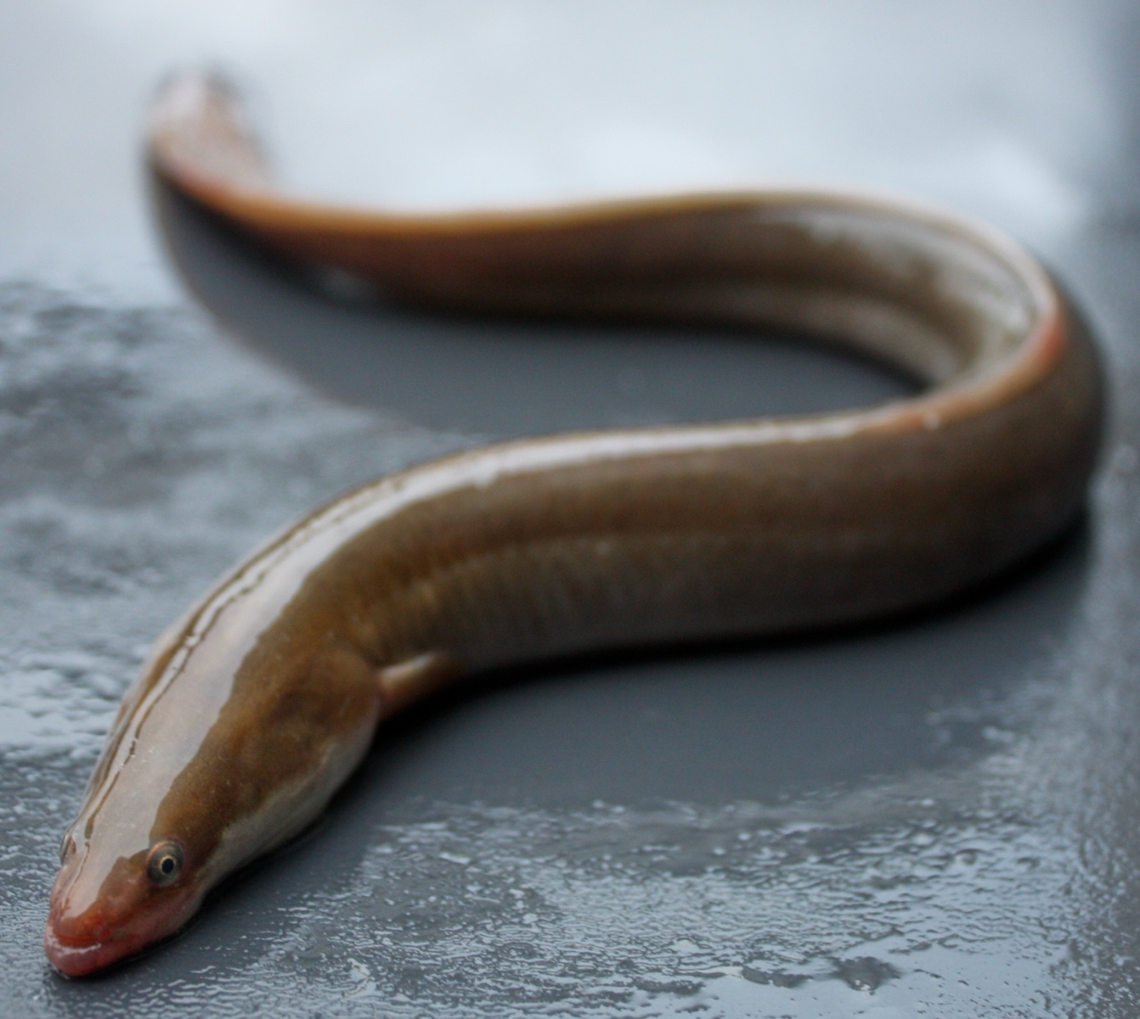
FOR THE EUROPEAN EEL (Anguilla anguilla)
Photo Credit: David Curnick, ZSL
Second draft
September, 2025

INTRODUCTION

European eel (Anguilla anguilla) was included in Appendix II of CMS at the 11th Conference of the Parties to the Convention (CMS COP11, 2014), following a proposal by the Government of Monaco, recognizing that the species would significantly benefit from international cooperation. The first meeting of Range States of the European eel took place in 2016, where options for how CMS may benefit the species were discussed. Parties approved a Concerted Action for the species at CMS CoP12 in 2017 (UNEP/CMS/Concerted Action 12.1). A second and third meeting of Range States took place in Malmö, Sweden in May 2018 and June 2019 respectively, which underlined the need for international cooperation to address the many gaps and challenges in European Eel conservation and management. The possibility of a dedicated CMS instrument was discussed, but it was agreed that a Single Species Action Plan would provide the most useful and immediate framework to advance coordinated measures for the conservation of the species. This was noted at COP13 (2020). The Fourth Meeting of Range States was held in Malmö, Sweden on 14–15 October 2025, where the draft Action Plan was finalized for submission to CMS COP15 in 2026. With the cooperation of the Sargasso Sea Commission, and on the basis of the outcomes of the Range State meetings, CMS has developed this Single Species Action Plan (SSAP) for the European Eel.

ACKNOWLEDGEMENTS

The development of the Single Species Action Plan was led by Matt Gollock, Chair of the IUCN Anguillid Eel Specialist Group, supported by the CMS Secretariat.

The Sargasso Sea Commission, the Principality of Monaco, and the Government of Sweden financed and otherwise supported the development of the Single Species Action Plan.

TABLE OF CONTENTS
INTRODUCTION 1
ACKNOWLEDGEMENTS 1
ACRONYMS AND ABBREVIATIONS 3
GLOSSARY 3
1. BIOLOGICAL ASSESSMENT 5
1.1 Taxon 5
1.2 Distribution 6
1.3 Population Productivity and Trend 7
2. THREATS 8
2.1 Barriers to migration 8
2.2 Climate change 8
2.3 Habitat loss 9
2.4 Unsustainable exploitation and trade 9
2.5 Pollution 9
2.6 Predation 10
2.7 Invasive species 10
2.8 Parasites and disease 10
2.9 Threats in the marine environment 10
2.10 Threat Prioritisation 10
3. POLICIES AND LEGISLATION RELEVANT FOR MANAGEMENT 12
3.1 Conservation and legal status 12
3.2 Range States and relevant organisations 13
3.3 International Conventions ratified by the Range States 14
3.4. National legislation and management measures specific to the European eel 15
4. Framework for Action 16
4.1 Goal 16
4.2 Objectives, Actions and Results 16
4.3 Scientific studies and data collection 16
4.4 Secure sufficient resources for ongoing conservation 16
4.5 Objectives Framework 17
4.6 National Implementation 17
4.7 Resources, guidelines, and tools available 17
4.8 Activities 18
5. REFERENCES 24
ANNEX 1 – THREAT MATRIX 28
ANNEX 2 - LEGISLATION SPECIFIC TO THE EUROPEAN EEL 30

ACRONYMS AND ABBREVIATIONS

CMS Convention on the Conservation of Migratory Species of Wild Animals
CITES Convention on the International Trade in Endangered Species of Wild Fauna and Flora

CBD Convention on Biological Diversity

EIFAAC European Inland Fisheries and Aquaculture Advisory Commission

GFCM General Fisheries Commission for the Mediterranean

HELCOM Baltic Marine Environment Protection Commission

ICES International Council for the Exploration of the Sea

OSPAR Convention for the Protection of the Marine Environment of the North-East Atlantic

GLOSSARY

Anthropogenic | Caused by humans.
Catadromous | Feeding and growing in freshwater and breeding in the marine environment.
Elver | Young eel, in its first year following recruitment from the ocean. The elver stage is sometimes considered to exclude the glass eel stage, but not by everyone. To avoid confusion, pigmented 0+cohort age eel are included in the glass eel term.
Escapement | The amount of eel that leaves (escapes) a water body, after taking account of all natural and anthropogenic losses. Most commonly used with reference to silver eel – silver eel escapement.
Glass eel | Young, unpigmented eel, recruiting from the sea into continental waters. WGEEL consider the glass eel term to include all recruits of the 0+ cohort age group, including some pigmented eel.
Leptocephalus | Flat and transparent marine larval stage of eel, on migration from spawning ground to continental waters, between pre-Leptocephalus and metamorphosis to glass eel.
Life stage | Defined stage in the lifecycle of eel, whether leptocephalus, glass eel, yellow eel, or silver eel.
Non-detriment finding (NDF) | In relation to CITES, the competent scientific authority has advised in writing that the capture or collection of the specimens in the wild or their export will not have a harmful effect on the conservation status of the species or on the extent of the territory occupied by the relevant population of the species.
Production | The amount of fish produced from a waterbody.
River Basin District (RBD) | The area of land and sea, made up of one or more neighbouring river basins together with their associated surface and groundwaters, transitional and coastal waters, which is identified under Article 3(1) of the Water Framework Directive as the main unit for management of river basins. The term is used in relation to the EU Water Framework Directive.
Restocking | The practice of adding fish [eels] to a waterbody from another source, to supplement existing populations or to create a population where none exists.
Silver eel | Migratory phase following the yellow eel phase. Eel in this phase are characterized by darkened back, silvery belly with a clearly contrasting black lateral line, enlarged eyes. Silver eel undertake downstream migration towards the sea, and subsequently westwards. This phase mainly occurs in the second half of calendar years, although some are observed throughout winter and following spring.
Trap and Transport | Capturing downstream migrating silver eel for transportation around hydropower turbines.
Yellow eel | Life-stage resident in continental waters. Often defined as a sedentary phase, but migration within and between rivers, and to and from coastal waters occurs and therefore includes young pigmented eels (‘elvers’ and bootlace).

1. BIOLOGICAL ASSESSMENT

1.1 Taxon

- The family Anguillidae consists of 16 species – the European eel (Anguilla anguilla) and American eel (A. rostrata) are the only two species to be found in the Atlantic region. Hybrids have been found as larvae in the Sargasso Sea (Pujolar et al., 2014) and as yellow eels in Iceland where pure A. rostrata and A. anguilla also exist (Albert et al. 2006). The European eel is the only anguillid eel listed on the Appendices of the Convention on the Conservation of Migratory Species (CMS) and is the subject of this Single Species Action Plan.

Table 1: Taxonomic classification of the European eel (A. anguilla) and common names in multiple languages.

1.1 Class: | Actinopterygii
1.2 Order: | Anguilliformes
1.3 Family: | Anguillidae
1.4 Genus: | Anguilla (Schrank, 1798)
1.5 Species: | Anguilla anguilla (Linnaeus, 1758)
1.6 Common Name: | Arabic: حَنْكَليس  English: European eel; Common eel; River eel; Weed eel  French: Angèle; Anguille d'Europe; Anguille européenne  Spanish: Anguila; Anguila europea; Anguilla

- The European eel has a life history best described as ‘facultatively catadromous’. Unlike true anadromy, where fish feed and grow in freshwater before migrating to the sea to breed, the European eel’s growth stage is often described as ‘continental’ as they are found in fresh, brackish and coastal waters. The species spends the majority of its life in continental waters. Breeding and spawning of the European eel takes place in the marine environment and is believed to be essential for the completion of the life cycle. While there is some understanding of the eel’s continental life history, relatively little is known about its marine phase. The eel has a number of life stages (Figure 1) that have their own terminology and regional vernacular – leptocephalus, glass eel, elver, yellow eel and silver eel.

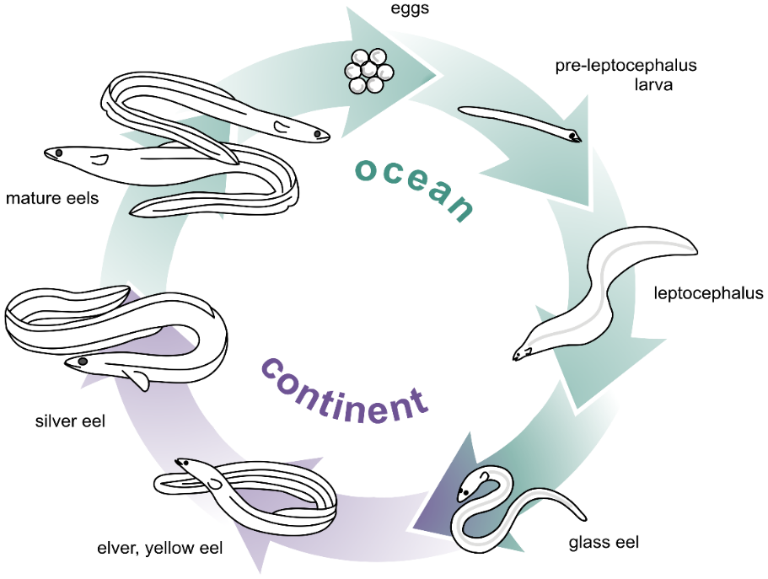

Figure 1: A schematic diagram of the life cycle of anguillid eels (Henkel et al. 2012).

- After hatching, the marine larval leptocephalus stage is leaf-shaped and very different from the elongate shape most associated with the anguillids. During the migration the leptocephali grow and elongate to become transparent glass eels upon arrival at the continental shelf. As the glass eels grow and pigment – be it in freshwater or saline waters – they become elvers and then yellow eels; these are morphologically similar, distinguished primarily on size. The final stage is the marine-migratory silver eel which is characterised by a darkened dorsum, silvery counter-shading and large eyes. A more detailed description of the life cycle can be found in science case for listing.

1.2 Distribution

- Due to the nature of this species’ life history, the distribution primarily refers to the continental growth stage – the yellow eel – which is known to occur in freshwater bodies, estuaries and coastal waters of the Range States (Moriarty and Dekker, 1997; ICES, 2009). In reality, both the adult spawning migration and the subsequent larval migration occurs in the open ocean, both in Range State’s Exclusive Economic Zones (EEZ) and the High Seas. The European eel is believed to spawn in the Sargasso Sea in the West Central Atlantic, before eggs hatch and leptocephalus larvae migrate, on oceanic currents, back across the Atlantic to begin the continental phase of their life history (Schmidt, 1922; Aarestrup et al., 2009; Wright et al., 2022). Research has indicated that the spawning migration may not be as synchronised as previously thought and that escapement cohorts could mix depending on the distance from the Sargasso (Righton et al., 2016).

- The common name of A. anguilla - the European eel – indicates the majority distribution of the species. However, its full range is described as from Iceland to the North Cape in Norway, southwards along the coast of Europe, the Mediterranean and on the North African Coast (Figure 2) (Schmidt, 1922; Dekker, 2003). It is occasionally found in the White and Barents seas, the Pechora River in northwest Russia and the Black Sea. Historically, its range may have been wider (Bevacqua et al., 2015; Kettle et al., 2011).

- The European eel has been ‘introduced’ in East Asia, either through escape or release from farms, However, due to the specific breeding location and associated migration of silver eels of this species, these are not thought to have successfully populated the region over subsequent generations.

Figure 2: Distribution of A. anguilla – points represent the occurrence of leptocephalus larvae caught during scientific surveys. The size of the points is proportional to the number of larvae. ICES (2023).

1.3 Population Productivity and Trend

- Longitude and latitude, sex and habitat quality can have an effect on generation length in the European eel. Further, there is an estimated two-year larval migration and one-year spawning migration of silver eels (Righton et al., 2016). At present the average generation length is estimated to be 12 years (Pike, Crook and Gollock, 2020).

- Assessing the population status of the European eel is challenging. The stock-recruitment relationship is not well understood, there can be tens of years between the recruitment and the subsequent escapement of silver eels, and as they are panmictic, escapement from one area does not translate directly into returning larval recruitment at the same locality (ICES, 2024a). As such, the assessment of the population requires examination of the juvenile recruitment, continental yellow eel and escaping silver eel life stages together (Jacoby et al., 2015). Data quantity and quality is highly variable - there is generally more relating to juvenile life stages, and the northern part of the species range (ICES, 2024b). It should be noted that productivity/fecundity of spawning adults is very poorly understood due to the pelagic breeding site.

- At present, the available date indicates the status of the European eel is of significant concern (ICES, 2024a). Recruitment declined dramatically in the 1980s and reached a historic low compared to the baseline in 2011 - it remains at very low at the time of writing (ICES, 2024a). The most recent assessment of these combined data sets using the IUCN Red List Categories and Criteria resulted in a Critically Endangered listing (Pike, Crook and Gollock, 2020). Key metrics to inform this listing are the Joint European Inland Fisheries and Aquaculture Advisory Commission (EIFAAC), International Council for the Exploration of the Sea (ICES) and General Fisheries Commission for the Mediterranean (GFCM) Working Group on Eel (WGEEL) stock indices (ICES, 2024b). The most recent ICES Advice in relation to the European eel stated (ICES, 2024a):

ICES advises that when the precautionary approach is applied, there should be zero catches in all habitats in 2025. This applies to both recreational and commercial catches and includes catches of glass eels for restocking and aquaculture.

Based on ecosystem-based management, ICES considers that:

- all non-fisheries related anthropogenic mortalities should be reduced to zero.
- the quantity and quality of eel habitats should be restored; this includes restoring connectivity and the physical, chemical, and biological properties of the habitats.

2. THREATS

- There is a broad suite of proposed causal factors for these declines, which can affect every life stage (ICES, 2024b). However, the significance of any single threat, and cumulative effects it may have with others, is not well understood (Jacoby et al., 2015). Therefore, the precautionary approach needs to be considered when developing and implementing conservation measures.

- Below are very brief summaries of the major threats that have been proposed as drivers of the decline in European eel abundance, as there is extensive literature that more comprehensively examines these (e.g. Righton et. al., 2021). The ICES Stock Annex for the European eel also provides a very useful background document for the species (ICES, 2023).

2.1 Barriers to migration

- Barriers to both upstream and downstream migration in continental waters present issues for the European eel. For example, with regards to juveniles populating continental waters during upstream migration, accessible habitat has been reduced by 80% compared to the 19th century, as a result of damming in the Iberian Peninsula (Clavero and Hermoso, 2015). It is estimated that there may be over 1 million barriers in Europe's rivers which could impact both upstream migration of juveniles, and downstream migration of silver eels. A comprehensive overview of available information on barriers in Europe can be consulted in the Amber Barrier Atlas. Reduced habitat availability may increase inter- and intra-specific competition and also reduce the fitness of maturing eels due to a reduction of food availability and lipid deposition. In addition to reducing available habitat, hydropower facilities and pumping stations may cause lethal or sub-lethal injuries to silver eels migrating downstream to begin their spawning migration, and in some countries, this is believed to be the major cause of anthropogenic mortality (ICES, 2019).

2.2 Climate change

- Climate change has been hypothesised to play a role in fluctuations of abundance in A. anguilla, particularly larval transport and glass eel recruitment. This is due to its impact on the suspected breeding area (Sargasso Sea) and on changing oceanic conditions that can influence the recruitment of glass eels to near shore and freshwater environments (e.g Miller et al., 2009; Durif et al., 2011; Henderson et al., 2012; Baltazar-Soares et al., 2014; Pacariz et al., 2014; Miller and Tsukamoto, 2016). However, these studies can be contradictory and our understanding of oceanic processes and their effects on juvenile eels is poor.

- In recent years, unusually warm and dry periods occurring throughout European eel Range States resulted in higher water temperatures, reduced levels of dissolved oxygen, and/or habitat loss through drought in transitional and freshwater systems (Kettle et al., 2011; ICES, 2018). Extreme weather events are a significant component of climate change. The influence of extreme cold days on eel catches highlights the potential impact of climate change on the European eel's dispersal patterns (Mestav et al., 2024).

2.3 Habitat loss

- Habitat loss, particularly in freshwater systems, is intrinsically linked with both barriers to migration and climate change. However, degradation and loss of available habitat is also exacerbated by urban and rural development, flood control, water-level management and the abstraction of surface and ground water for both domestic and commercial use (Drouineau et al., 2018; ICES, 2020b). For example, it was highlighted that siltation in marshlands reduced infiltration of larger eels to this important growth habitat (Lafaille et al. 2004). It was also shown that smaller eels preferred more in-channel cover/aquatic vegetation and this is generally less abundant in modified rivers (Domingos et al. 2006).

- Further, it has been hypothesised, that the decline in good quality habitat and associated resources may be causing a decline in body condition of escaping silver eels in parts of the range. This may have effects on the success of migration and/or spawning due this species’ reliance on fat stores for reproductive success (van Ginneken and van den Thillart, 2000).

2.4 Unsustainable exploitation and trade

- European eels are in demand in domestic and international markets for direct consumption and stocking in aquaculture. As such, all continental life stages of eels are exploited within the range of the European eel (Musing et al. 2018; CITES 2022). In 2007, the European eel was listed in Appendix II of the Convention on the International Trade in Endangered Species of Wild Fauna and Flora (CITES) to regulate international trade as a driver of unsustainable exploitation. The listing came into effect in 2009, and in 2010, the EU’s Scientific Review Group (SRG) stated it was not possible to perform a Non-Detriment Finding (NDF) for the import of A. anguilla and formed a negative opinion for all range States which was formalised in the Suspension Regulation in 2024. Thus, since December 2023, imports into the EU (including Northern Ireland) have been prohibited by law. In addition, the SRG set a zero-export policy in 2010, which has been annually renewed and is still in place at present. This does not account for domestic/intra-EU fisheries, for both consumption and restocking, as indicated by reported glass eel and yellow and silver eel landing data of EU Member States.

- Since 2010, legal trade in the European eel as reported by CITES included mainly exports by Morocco and Tunisia as Range States and to date, export quotas exist for Algeria, Morocco, Tunisia and Türkiye (Pike et al. 2020). The UK produced an NDF in 2023 to allow movement of glass eels from two rivers in England to Lough Neagh in Northern Ireland – these have since ceased due to Suspension Regulation (see above). This is the only published assessment of the sustainability of eel fisheries.

- Despite the above measures, illegal fishing and trade are believed to occur throughout the species range (Musing et al. 2018). Since 2022, the International Council for the Exploration of the Sea (ICES) has advised that, when the precautionary approach is applied, there should be zero catches in all habitats of the European eel. This applies to recreational and commercial catches and includes catches of glass eels for restocking and aquaculture.

2.5 Pollution

- Chemical pollutants can damage tissues and disrupt physiological processes in the European eel (Geeraerts and Belpaire, 2010; Belpaire et al., 2016, 2019; De Meyer et al., 2018). It is also believed that they may impact the ability of eels to migrate and/or reproduce through disruption of normal lipid metabolism (Belpaire et al., 2019). In addition to chemical pollutants, both light and sound have been shown to affect eel behaviour (Walker et al., 2014; Simpson et al., 2015).

2.6 Predation

- Predation also represents a threat to A. anguilla. While in some cases this will be a natural phenomenon, understanding how predation impacts overall population status – particularly in the marine habitat – is useful for informing management measures. Cormorants and other species have been a focus of recent research - eel consumption by these birds is believed to be of a similar quantity to that of fishery landings in both the Baltic Sea (Hansson et al. 2017) and some lakes in Sweden (Ovegård 2017). Results in the scientific literature are however not congruent, and another study of cormorant’s diet found no eel (Engström, 2001). Oceanic tagging studies found that as many as 50% of eels are consumed by apex predators (Righton et al. 2016). As silver eel escapement is the closest metric we have to a spawning stock, knowing marine mortality is extremely useful when considering the success of continental management measures.

2.7 Invasive species

- A negative relationship between invasive catfish abundance and European eel settlement in freshwater is attributed to predation and/or interspecific competition (Bevacqua et al., 2011).

2.8 Parasites and disease

- The introduced nematode (Anguillicola crassus) is thought to impact the fitness of the European eel. These include a negative effect on silver stage physiology (Fazio et al., 2012); swimbladder damage which impairs swimming performance (Palstra et al., 2007); increased susceptibility to hypoxia (Gollock et al., 2005) and a reduced ability to cope with high pressure during their reproductive migration (Vettier et al., 2003; Sjöberg et al. 2009). A recent study, where low infection intensities of A. crassus occurred, indicated that there were no major negative impacts on the investigated health indicators (Myrenås et al. 2023).

- Several viral pathogens have been identified as being potentially threatening to the European eel: Eel virus European (EVE), Eel virus European X (EVEX) and Anguillid herpesvirus‐1 (HVA). Generally, these exhibit as non-specific haemorrhagic disease with increased mortality rates (Van Beurden et al., 2012; McConville et al., 2018).

2.9 Threats in the marine environment

- While a number of the threats described above will have impacts in the marine environment, there is far less understood about these impacts, and also the biology of eels in saline waters. As such, we have created a specific objective to address this.

2.10 Threat Prioritisation

- As stated above, the significance of any single threat, and cumulative effects it may have with others, is not well understood. As such, carrying out a threat prioritisation exercise at the population level would present significant challenges. However, threats have been shown to vary across the species range and will impact continental populations to different degrees based on the water-system and associated management implemented by each State.

- As such, the threats outlined above should be assessed by each Range State using a pre-defined matrix (see Annex 1) to determine their relative impact on the European eel - in one or several life stages - to inform implementation of the SSAP in the context of other management measures. The matrix considers the likelihood of occurrence of a threat relevant to the European eel, and the consequences of that threat or impact considering existing mitigation measures. Where mitigation/management measures do exist and have been implemented the threat should be assessed assuming that these continue to be applied appropriately. Based on these factors the priority for action can be determined by relevant Range State representatives drawing on peer reviewed literature and expert opinion.

- While Range States should carry these assessments out individually, there should be co-ordination with other relevant Parties where transboundary watercourses are concerned.

3. POLICIES AND LEGISLATION RELEVANT FOR MANAGEMENT

3.1 Conservation and legal status

Table 2: Details of international conservation instruments specific to the European eel.

International legal and non-legal instruments | Protection measure / Assessment
International Union for Conservation of Nature (IUCN) Red List of Threatened Species | Critically Endangered A2bd+4bd (2018):  Population reduced an observed, estimated, inferred or suspected reduction of at least 80% over three generations, based on the following:
Convention on International Trade in Endangered Species of Wild Fauna and Flora  (CITES) | The European eel was listed in Appendix II of the Convention on International Trade in Endangered Species of Wild Fauna and Flora (CITES) in 2007, although this did not come into force until March 2009.  International trade in specimens of Appendix-II species may be authorised by the granting of an export permit or re-export certificate. This is as a result of evidence that such export will not be detrimental to the survival of that species – this is presented in the form of a Non-Detriment Finding (NDF).
European Union | Council Regulation (EC) no 1100/2007 - Establishing measures for the recovery of the stock of European eel.  The Regulation was developed to establish measures for the recovery of the stock of European eel. Eel management plans (EMPs) should be created to implement measures to recover the European eel within nationally determined Eel Management Units (EMUs).  Measures on European eel fisheries  Annual review of fishing measures in EU waters – at present there is a period of closure of six months for commercial fisheries and recreational fisheries are banned.
General Fisheries Commission for the Mediterranean (GFCM) | GFCM/46/2023/16  Proposed a 30% decrease in fishing effort relative to the reference period.  Recreational fishing of all stages of European eel life cycle (glass, yellow, silver) is prohibited in all habitats.  An extension of the temporal closures to 6 or 3+3 months.  Some measures to fight IUU fishing: catch registration, control and traceability.
The Baltic Marine Environment Protection Commission (HELCOM). | In 2021, HELCOM published an update of the action plan adopting the schedule:  By 2023 identify rivers where management measures for migratory fish species, including eel, would have the greatest positive impact.  With the aim to protect and restore eel populations, determine which measures set out in the Convention on the Conservation Migratory Species of Wild Animals (CMS), EU Eel Regulation and other relevant instruments would benefit from regional cooperation on a Baltic-wide level.
The Convention for the Protection of the Mediterranean Sea Against Pollution (Barcelona Convention) | European eel is listed in Annex III - Species whose exploitation is regulated.
The Convention for the Protection of the Marine Environment of the North-East Atlantic (OSPAR) | The European eel was included on the OSPAR List of threatened and/or declining species and habitats in 2008 (OSPAR Agreement 2008–6).  In 2014, OSPAR issued a recommendation (OSPAR Recommendation 2014/15) to strengthen the protection of the European eel at all life stages in order to recover its population.  In 2022, OSPAR updated their status assessment for the European eel as ‘poor’.

3.2 Range States and relevant organisations

Table 3: Range States and their affiliations to relevant Regional Fishery Bodies that operate in range of European eel.

Range State | EIFAAC | GFCM | HELCOM | ICES | OSPAR
Albania | Y | Y
Algeria |  | Y
Austria | Y
Belarus
Belgium | Y |  |  | Y | Y
Bosnia and Herzegovina | Y
Bulgaria | Y | Y
Croatia | Y | Y
Cyprus | Y | Y
Czechia | Y
Denmark | Y |  | Y | Y | Y
Egypt |  | Y
Estonia | Y |  | Y | Y
European Union | Y | Y | Y
Finland | Y |  | Y | Y | Y
France | Y | Y |  | Y | Y
Georgia
Germany | Y |  | Y | Y | Y
Greece | Y | Y
Hungary | Y
Iceland | Y |  |  | Y | Y
Ireland | Y |  |  | Y | Y
Israel | Y | Y
Italy | Y | Y
Latvia | Y |  | Y | Y
Lebanon |  | Y
Libya |  | Y
Lithuania | Y |  | Y | Y
Luxembourg | Y |  |  |  | Y
Malta |  | Y
Mauritania
Moldova
Monaco |  | Y
Montenegro |  | Y
Morocco |  | Y
Netherlands | Y |  |  | Y | Y
North Macedonia
Norway | Y |  |  | Y | Y
Poland | Y |  | Y | Y
Portugal | Y |  |  | Y | Y
Romania | Y | Y
Russian Federation |  |  | Y | Y
Serbia
Slovakia | Y
Slovenia |  | Y
Spain | Y | Y |  | Y | Y
Sweden | Y |  | Y | Y | Y
Switzerland | Y |  |  |  | Y
Syrian Arab Republic |  | Y
Tunisia |  | Y
Türkiye | Y | Y
Ukraine
UK (incl. Gibraltar, Guernsey, Isle of Man and Jersey) | Y |  |  | Y | Y

3.3 International Conventions ratified by the Range States

Table 4: Range States and their status as signatories to global Conventions.

Country or territory | CMS | CITES | CBD
Albania | Y | Y | Y
Algeria | Y | Y | Y
Belarus | Y | Y | Y
Bosnia and Herzegovina | Y | Y | Y
Egypt | Y | Y | Y
European Union | Y | Y | Y
Georgia | Y | Y | Y
Iceland | Y | Y | Y
Israel | Y | Y | Y
Lebanon | Y | Y | Y
Libya | Y | Y | Y
Moldova | Y | Y | Y
Monaco | Y | Y | Y
Montenegro | Y | Y | Y
Morocco | Y | Y | Y
North Macedonia | Y | Y | Y
Norway | Y | Y | Y
Russian Federation | - | Y | Y
Serbia | Y | Y | Y
Switzerland | Y | Y | Y
Syrian Arab Republic | Y | Y | Y
Tunisia | Y | Y | Y
Türkiye | - | Y | Y
Ukraine | Y | Y | Y
UK (incl. Gibraltar, Guernsey, Isle of Man and Jersey) | Y | Y | Y

3.4. National legislation and management measures specific to the European eel

- Annex 2 provides an overview of national and EU legislation, specific for the protection and conservation of the European eel.

4. Framework for Action

4.1 Goal

- To strengthen the conservation and management of the European eel across its full range by coordinating, harmonising and implementing actions that stimulate species recovery allowing it to fulfil its role in healthy ecosystems.

4.2 Objectives, Actions and Results

- The previously described threats to the species have been well characterised, but co-ordinated efforts to address these are still limited (e.g. ICES, 2025). There is need for increased co-ordination and harmonisation across the species range with regard to implementation of measures and improved monitoring of the effectiveness of interventions. Further, monitoring of effectiveness needs to include metrics that can assess change over appropriate temporal scales (ICES, 2021).

- At present, there are a number of international frameworks and associated national mechanisms that aim to work towards the recovery of the eel, but these may be challenging to assess collectively (e.g. ICES, 2025). As such, the SSAP has the potential to act as an umbrella framework with a view to capturing the full geographical range of the species and address any gaps that have been identified in conservation and management of the European eel.

- As such, the objectives, actions and results have been developed in response to the previous Range State meetings, input to several versions of the SSAP and consideration of other relevant frameworks that address European eel management and conservation.

- The objectives broadly address the following themes:

- Mitigation of identified threats to the European eel
- Monitoring of effectiveness of interventions
- Strengthening collaboration and co-ordination of Range States

The objectives and corresponding actions and results are set out in the tables below.

4.3 Scientific studies and data collection

In support of the Concerted Action, there is a rationale for national programmes to improve scientific data collection as well as strengthened liaison between stakeholders. Such initiatives could facilitate improved knowledge of the European eel’s population status and how this is impacted by the threats described above.

There is also a strong rationale for the results of scientific studies to be shared and developed collaboratively with other Parties and Range States. In particular, population genetics, tagging, and monitoring studies can provide critical insights into connectivity across the species’ panmictic stock and into the dynamics of its spawning migration. Such efforts would be in alignment with the Convention (Article II, Section 3(a)).

4.4 Secure sufficient resources for ongoing conservation

To successfully achieve the results of this Action Plan, sufficient resources need to be secured to implement actions at a national and regional scale. Parties might consider establishing national working groups that consist of local experts and stakeholders to support implementation on a national level.

4.5 Objectives Framework

- For each objective, there is an intended result that will be achieved through actions, each of which has a priority, time scale, and those responsible for delivering.

Actions should be prioritised, at the Range State scale, as:
- Essential
- High
- Medium
- Low

Timescales should be attached to each Action using the following scale:
- Immediate: completed within the next year
- Short: completed within the next 3 years
- Medium: completed within the next 5 years
- Long: completed within the next 10 years
- Ongoing: currently being implemented and should continue
- Completed: completed during preparation of Action Plan

All Range States are expected to undertake Actions 1.1-1.7.

4.6 National Implementation

This plan forms a guide for all Range States and other stakeholders and relates to the species across its entire life cycle. Not all aspects will be relevant for all countries, for example, where existing legislation and/or plans are already in place. In addition, some national governments may need additional capacity building to be able to undertake some aspects of this plan. Governments endorsing this Single Species Action Plan commit to reviewing their national implementation and developing their own workplans to organize national implementation guided by this Single Species Action Plan and agreed priorities as necessary with respect to existing national management measures.

4.7 Resources, guidelines, and tools available

In order to streamline efforts across the range, Parties and implementing partners shall strive to make use of available resources, guidance and tools already developed by bodies such as ICES and the GFCM.

4.8 Activities
Objective 1: Strengthen co-ordination of European eel conservation and management across the species range.
Result | Action | Priority | Time Scale | Responsible Range States, Organisations and Stakeholders
All Range States of the European eel are collaboratively working to conserve the species through the CMS SSAP and other relevant mechanisms. | 1.1 Identify and include Range States that are not presently engaged in the CMS SSAP and other relevant regional frameworks to ensure these are effective. | Essential
 | 1.2 Use the threat matrix (Annex 1) to prioritise implementation of actions relevant to eel populations. | Essential
 | 1.3 Harmonize data collection and analysis harmonised across the species’ range to allow comparison and use of appropriate metrics. | Essential
 | 1.4 Strengthen international relations where transboundary collaboration is required for eel management and conservation – e.g. river basin scale data collection - | Essential
 | 1.5 Ensure restocking programmes are effectively benefitting the species population and do not impact other Party’s management efforts. | Essential
 | 1.6 Establish regular cycle of meetings in order to monitor progress of SSAP. | Essential
 | 1.7 Exchange International, national and sub-national information and co-ordinate efforts to address knowledge gaps. | Essential

Objective 2: Assessment and mitigation of barriers to upstream and downstream migration
Result | Action | Priority | Time Scale | Responsible Range States Organisations and Stakeholders
Significantly reduce the impact of barriers on European eel migration and mortality. | 2.1 Carry out enumeration, location (mapping), and the type and extent of passability of upstream migration barriers. Assess the importance of the watercourse in function of potential upstream habitat.
 | 2.2 Carry out enumeration, location (mapping), type, water use, capacity of downstream migration barriers is carried out. Assess the importance and the mortality level of barriers in relation to the extent of silver eel migration.
 | 2.3 Prioritise mitigation activities and develop associated timelines.
 | 2.4 Implement relevant mitigation for upstream migration barrier removal, fish or eel passages, and adapt barrier management or other methods during the migration period, .
 | 2.5 Implement relevant mitigation for downstream migration, such as barrier removal, screening, eel bypass along barriers, assisted migration (trap and transport), fish friendly turbines or pumps, temporarily shutdown of turbines or other methods during the migration period.
 | 2.6 Implement monitoring of mitigation measures, where not present already.
 | 2.7 Co-ordinate on international, national and sub-national level and share knowledge.

Objective 3: Assess the impact of continental habitat loss on European eels and implement mitigation at relevant spatial scales.
Result | Action | Priority | Time Scale | Responsible Range States, Organisations and Stakeholders
Mitigation of habitat loss maximises both access and carrying capacity of aquatic systems within the continental range of the European eel. | 4.1 Quantify the scale of European eel habitat conversion and loss to date, and risk of future reductions, at the international, national and sub-national scale.
 | 4.2 Developed models to better understand the carrying capacity of available habitat at relevant geographical scales, such that anthropogenic impacts and associated mortality, can be better managed.
 | 4.3 Identify areas of highest risk of habitat loss due to the impacts of climate change.
 | 4.4 Identify key locations and implement relevant mitigation e.g. re-wilding/greening and monitor their effectiveness.
 | 4.5 Exchange international, national and sub-national information and co-ordinate activities relating to habitat loss, specific to eels.

Objective 4: The impact of unsustainable exploitation of European eel is reduced and range-wide management strengthened.
Result | Action | Priority | Time Scale | Responsible Range States, Organisations and Stakeholders
Fisheries, and associated trade, are legal, traceable and demonstrably sustainable, and management is strengthened through improved data collection. | 5.1 Improve fisheries data collection – including effort, harmonise across the range and use to inform management at the relevant geographical scale.
 | 5.2 Ensure that for all life-stages, that catch does not exceed sustainable supply and matches legal demand, and thereby minimising any surplus catch beyond local? demand that can be traded illegally.
 | 5.3 Implement measures at the national/sub-national level that sustainable harvest matches legal demand, minimising any surplus that can be traded illegally
 | 5.4 Strengthen traceability of fisheries and associated trade – including for those used in restocking and aquaculture facilities.
 | 5.5 Ensure restocking programmes have appropriate monitoring and can evidence a benefit to the species.
 | 5.6 Co-ordinate with relevant domestic and international CITES Authorities to ensure management of trade is informed by an understanding of demand and exploitation patterns.
 | 5.7 Coordinate data collection with relevant RFBs in relation to informing regional management, mortality indices and/or Stock Assessments – ICES/GFCM/HELCOM.

Objective 5: Understanding and mitigation of the impact of pollutants on the European eel is strengthened
Result | Action | Priority | Time Scale | Responsible Range States, Organisations and Stakeholders
Improved evidence base of the impact of pollutants on the European eel, with a view to informing management and improving the quality of migrating silver eels. | 6.1 Quantify the presence of key toxicants, determined at a relevant geographical scale, noting the persistence of many compounds.
 | 6.2 Strengthen water and sediment quality management and/or enforcement is strengthened at a relevant geographical scale such that the presence of key toxicants, and their associated impact on European eel life stages, are reduced.
 | 6.3 Co-ordinate efforts to improve water and sediment quality are co-ordinated across the species range, especially in the context of transboundary waterbodies.

Objective 6: Understanding of the impact of the parasite Anguillicola crassus and other diseases on the European eel is improved.
Result | Action | Priority | Time Scale | Responsible Range States, Organisations and Stakeholders
Improved understanding of the scale of impact of Anguillicola crassus and other diseases informs management actions. | 7.1 Quantify, in the context of other threats, the sub-lethal impact of A. crassus on key metrics – e.g. silvering, silver eel condition, swimming performance, pressure tolerance, swim bladder function, fecundity.
 | 7.2 Improve understanding of the scale of impact of viral and bacterial diseases on the European eel across its range.
 | 7.3 Improve the understanding of the role aquaculture and/or restocking activities plays in the spread of parasite and diseases, with a view to develop appropriate mitigation.

Objective 8: Knowledge the oceanic phase of the European eel life history, including the Sargasso Sea, is increased.
Result | Action | Priority | Time Scale | Responsible Range States, Organisations and Stakeholders
The impact of the threats to European eels in saline waters is better understood, such that they can inform management in Range States and ABNJ. | 8.1 Use remote sensing and monitoring, modelling and other relevant methodologies to improve understanding of oceanic changes (e.g. AMOC) on larval survival, transport and resultant recruitment.
 | 8.2 Improve understanding of the spawning migrations and biology of the eel and the importance of the Sargasso Sea.
 | 8.3 Strengthen knowledge sharing and co-ordination of activities relating to marine threats across the species range.

Objective 9: Co-ordination of engagement with relevant marine management policy mechanisms and bodies to conserve the Sargasso Sea
Result | Action | Priority | Time Scale | Responsible Range States, Organisations and Stakeholders
Actions are co-ordinated across relevant conventions, government departments and organisations. | 9.1 Engage with relevant national representatives working on the ‘Hamilton Declaration on collaboration for the conservation of the Sargasso Sea’.
 | 9.2 Engage with national representatives at UN BBNJ Agreement on relevant matters – particularly in relation to the Atlantic High Seas and the Sargasso Sea.

5. REFERENCES

Aarestrup, K., Økland, F., Hansen, M.M., Righton, D., Gargan, P., Castonguay, M., Bernatchez, L., Howey, P., Sparholt, H., Pedersen, M.I. and McKinley, R.S. (2009). Oceanic spawning migration of the European eel (Anguilla anguilla). Science 325: 1660.

Albert, V., Jónsson, B. and Bernatchez, L. (2006). Natural hybrids in Atlantic eels (Anguilla anguilla, A. rostrata): Evidence for successful reproduction and fluctuating abundance in space and time. Molecular ecology 15: 1903-16.

Baltazar-Soares, M., Biastoch, A., Harrod, C., Hanel, R., Marohn, L., Prigge, E., Evans, D., Bodles, K., Behrens, E., Boening, C. W. and Eizaguirre, C. (2014). Recruitment collapse and population structure of the European eel shaped by local ocean current dynamics. Current Biology 24: 104-108.

Belpaire, C., Pujolar, J.M., Geeraerts, C. and Maes, G.E. (2016). Contaminants in eels and their role in the collapse of the eel stocks. In “Biology and ecology of anguillid eels”, T. Arai (Ed), CRC Press, p 225-250.

Belpaire, C., Hodson, P., Pierron, F. and Freese, M. (2019). Impact of chemical pollution on Atlantic eels: facts, research needs and implications for management. Current Opinion in Environmental Science and Health 11:26-36.

Bevacqua, D., Meliá, P., Gatto, M. and De Leo, G.A. (2015). A global viability assessment of the European eel. Global Change Biology 21: 3323–3335.

CITES.(2022). Status of use and trade of anguillid eels.

Clavero, M. and Hermoso, V. (2015). Historical data to plan the recovery of the European eel. Journal of Applied Ecology 52: 960-968.

De Meyer, J., Belpaire, C., Boeckx, P., Bervoets, L., Covaci, A., Malarvannan, G., De Kegel, B. and Adriaens, D. (2018). Head shape disparity impacts pollutant accumulation in European eel. Environmental Pollution 240: 378–386.

Dekker, W. (2003). Did lack of spawners cause the collapse of the European Eel, Anguilla anguilla? Fisheries Management and Ecology 10: 365-376.

Drouineau, H., Rochard, E., Castonguay, M., Yokouchi, K., Mateo, M., Verreault, G., & Durif, C. and Lambert, P. (2018). Freshwater eels: A symbol of the effects of global change. Fish and Fisheries 19: 903-930.

Durif, C.M.F, Gjøsæter, J. and Vøllestad, L.A. (2011). Influence of oceanic factors on Anguilla anguilla (L.) over the twentieth century in coastal habitats of the Skagerrak, southern Norway. Proceeding of the Royal Society B 278: 464-473.

Engström, H. (2001). Long term effects of cormorant predation on fish communities and fishery in a freshwater lake. Ecography. 24: 127–138.

European Commission (2020). Coffey, Directorate-General for Maritime Affairs and Fisheries, Economisti Associati, EUROFISH, F&S, POSEIDON, MacNab, S., Luchetta, G., Nimmo, F., Huntington, T., Uden, R., Frederickson, M.Caillart, B., Evaluation of the Eel Regulation – Final report, Publications Office, 2020, https://data.europa.eu/doi/10.2771/679816

Geeraerts, C. and Belpaire, C. (2010). The effects of contaminants in European eel: a review. Ecotoxicology 19: 239–266.

Gollock, M.J., Kennedy C.R. and Brown, J.A. (2005). European eels, Anguilla anguilla (L.), infected with Anguillicola crassus exhibit a more pronounced stress response to severe hypoxia than uninfected eels. Journal of Fish Diseases 28: 429–436.

Hansson, S., Bergström, U., Bonsdorff, E., Härkönen, T., Jepsen, N., Kautsky, L., Lundström, K., Lunneryd, S.-G., Ovegård, M., Salmi, J., Sendek, D. and Vetemaa, M. (2017). Competition for the fish–fish extraction from the Baltic Sea by humans, aquatic mammals, and birds. ICES Journal of Marine Science 75(3): 999–1008.

Henderson, P.A., Plenty, S.J., Newton, L.C. and Bird, D.J. (2012). Evidence for a population collapse of European eel (Anguilla anguilla) in the Bristol Channel. Journal for the Marine Biological Association of the UK 92: 843-851.

Henkel, C.V., Burgerhout, E., de Wijze, D.L., Dirks, R.P., Minegishi, Y., Jansen, H.J., Spaink, H.P., Dufour, S., Weltzien, F., Tsukamoto, K. and van den Thillart G.E.E.J.M (2012) Primitive Duplicate Hox Clusters in the European Eel's Genome. PLoS ONE 7(2): e32231. https://doi.org/10.1371/journal.pone.0032231

ICES (2009). Report of the Study Group on Anguillid Eels in Saline Waters (SGAESAW).

ICES (2018). Report of the 2018 session of the Joint EIFAC/ICES Working Group on Eels.

ICES. (2019). Joint EIFAAC/ICES/GFCM Working Group on Eels (WGEEL). ICES Scientific Reports. 1:50. 177 pp. http://doi.org/10.17895/ices.pub.5545

ICES. (2020). Joint EIFAAC/ICES/GFCM Working Group on Eels (WGEEL). ICES Scientific Reports. 2:85. 223 pp. http://doi.org/10.17895/ices.pub.5982

ICES. (2021). Workshop on the future of eel advice (WKFEA). ICES Scientific Reports. 3:13. 67 pp. https://doi.org/10.17895/ices.pub.5988
ICES. (2023). Stock Annex: European eel (Anguilla anguilla) throughout its natural range. ICES Stock Annexes. https://doi.org/10.17895/ices.pub.24517486

ICES. (2024a). European eel (Anguilla anguilla) throughout its natural range. In Report of the ICES Advisory Committee, 2024. ICES Advice 2024, ele.2737.nea. https://doi.org/10.17895/ices.advice.27100516.

ICES (2024b). Joint EIFAAC/ICES/GFCM Working Group on Eels (WGEEL). ICES Scientific Reports. 6:90. 146 pp. https://doi.org/10.17895/ices.pub.27233457

ICES. (2025). Workshop for the Technical Evaluation of EU Member States’ Eel Regulation Progress Re-ports for Submission in 2024/2025 (WKEMP4). ICES Scientific Reports. 7:36. 175 pp. https://doi.org/10.17895/ices.pub.28788749

Jacoby, D.M.P., Casselman, J.M., Crook, V., DeLucia, M.B., Ahn, H., Kaifu, K., Kurwie, T., Sasal, P., Silfvergrip, A.M.C., Smith, K.G., Uchida, K., Walker, A.M. and Gollock, M. J. (2015). Synergistic patterns of threat and the challenges facing global anguillid eel conservation. Global Ecology and Conservation. 4: 321–333.

Laffaille, P., Baisez, A., Rigaud, C., and Feunteun, E. (2004). Habitat preferences of different European eel size classes in a reclaimed marsh: A contribution to species and ecosystem conservation. Wetlands 24 642–651. https://doi.org/10.1672/0277-5212(2004)024[0642:HPODEE]2.0.CO;2

Kettle, A.J., Vøllestad, L.A. and Wibig, J. (2011). Where once the eel and the elephant were together: decline of the European eel because of changing hydrology in southwest Europe and northwest Africa? Fish and Fisheries 12: 380–411.

McConville, J., Fringuelli, E., Evans, D. and Savage, P. (2017). First examination of the Lough Neagh European eel (Anguilla anguilla) population for eel virus European, eel virus European X and Anguillid Herpesvirus‐1 infection by employing novel molecular techniques. Journal of Fish Diseases. 41: 1783-1791.

Mestav, B., Özdilek, Ş.Y., Acar, Z., Gökkaya, K. and Partal, N. (2024) Climate change effects on abundance and distribution of the European eel in Türkiye. Fisheries Management and Ecology, 31, e12732. https://doi.org/10.1111/fme.12732

Miller, M. J. and Tsukamoto, K. (2016). The ecology of oceanic dispersal and survival of anguillid leptocephali. Canadian Journal of Fisheries and Aquatic Sciences 74: 958-971.

Miller, M. J., Kimura, S., Friedland, K. D., Knights, B., Kim, H., Jellyman, D. J. and Tsukamoto, K. (2009). Review of ocean-atmospheric factors in the Atlantic and Pacific oceans influencing spawning and recruitment of anguillid eels. Pages 231–249 In: Haro, A. J., Smith, K. L., Rulifson, R. A., Moffitt, C. M., Klauda, R. J., Dadswell, M. J., Cunjak, R. A., Cooper, J. E., Beal, K. L. and Avery, T. S. editors. Challenges for Diadromous Fishes in a Dynamic Global Environment. American Fisheries Society Symposium 69, Bethesda Maryland.

Moriarty, C. and Dekker, W. (1997). Management of the European Eel. Fisheries Bulletin. 15. 1-110.

Musing, L., Shiraishi, H., Crook, V., Gollock, M., Levy, E. and Kecse-Nagy, K. (2018). Implementation of the CITES Appendix II listing of European Eel Anguilla anguilla. CITES AC30 Doc. 18.1, Annex 1: 1–82.

Myrenås, E., Näslund, J., Persson, J. and Sundin, J. (2023). Effects of the invasive swim bladder parasite Anguillicola crassus on health and condition indicators in the European eel. Journal of Fish Diseases, 46, 1029–1047. https://doi.org/10.1111/jfd.13822

Ovegård, M. (2017). The interactions between cormorants and wild fish populations. Analytical methods and applications. Swedish University of Agricultural Sciences.

Pacariz, S., Westerberg, H. and Björk, G. (2014). Climate change and passive transport of European eel larvae. Ecology of Freshwater Fish 23: 86-94.

Palstra, A.P., Heppener, D.F.M., van Ginneken, V.J.T., Szekely, C. and van den Thillart, G.E.E.J.M. (2007). Swimming performance of silver eels is severely impaired by the swim-bladder parasite Anguillicola crassus. Journal of Experimental Marine Biology and Ecology 352: 244–256.

Pike, C., Crook, V. & Gollock, M. (2020). Anguilla anguilla. The IUCN Red List of Threatened Species 2020: e.T60344A152845178. https://dx.doi.org/10.2305/IUCN.UK.2020-2.RLTS.T60344A152845178.en. Accessed on 17 March 2025.

Pujolar, J.M., Jacobsen, M.W., Als, T.D., Frydenberg, J., Magnussen, E., Jónsson, B., Jiang, X., Cheng, L., Bekkevold, D., Maes, G.E., Bernatchez, L. and Hansen, M.M. (2014). Assessing patterns of hybridization between North Atlantic eels using diagnostic single-nucleotide polymorphisms. Heredity 112: 627–637.

Righton, D., Westerberg, H., Feunteun, E., Økland, F., Gargan, P., Amilhat, E., Metcalfe, J., Lobon-Cervia, J., Sjöberg, N., Simon, J., Acou, A., Vedor, M., Walker, A., Trancart, T., Brämick, U. and Aarestrup, K. (2016). Empirical observations of the spawning migration of European eels: The long and dangerous road to the Sargasso Sea. Science Advances 2: 1–14.

Righton D, Piper A, Aarestrup K, et al. (2021). Important questions to progress science and sustainable management of anguillid eels. Fish and Fisheries. 22: 762–788. https://doi.org/10.1111/faf.12549

Schmidt, J. (1922). The breeding places of the eel. Philosophical Transactions of the Royal Society of London Series B 211: 179–208.

Simpson, S.D., Purser, J. and Radford, A.N. (2015). Anthropogenic noise compromises anti-predator behaviour in European eels. Global Change Biology 21(2): 586–593.

Sjöberg, N.B., Petersson, E., Wickström, H. and Hansson, S. (2009). Effects of the swimbladder parasite Anguillicola crassus on the migration of European silver eels Anguilla anguilla in the Baltic Sea. Journal of Fish Biology 74: 2158–2170.

Van Beurden S.J., Engelsma M.Y., Roozenburg I., Voorbergen-Laarman, M.A., Van Tulden, P.W., Kerkhoff, S., Van Nieuwstadt, A.P., Davidse, A. and Haenen, O.L.M. (2012). Viral diseases of wild and farmed European eel Anguilla anguilla with particular reference to the Netherlands. Diseases of Aquatic Organisms 101(1): 69‐86.

Van Ginneken, V.J.T. and Van den Thillart, G.E.E.J.M. (2000). Eel fat stores enough to reach the Sargasso. Nature 403: 156-157.

Vettier, A., Szekely, C. and Sebert, P. (2003). Are yellow eels from Lake Balaton able to cope with high pressure encountered during migration to the Sargasso Sea? The case of energy metabolism. Animal Biology 53: 329–338.

Walker, A.M., Godard, M.J. and Davison, P. (2014). The home range and behaviour of yellow‐stage European eel Anguilla anguilla in an estuarine environment. Aquatic Conserv: Mar. Freshw. Ecosyst., 24: 155-165.

Wright, R.M., Piper, A.T., Aarestrup, K.. Azevedo, J.M.N., Cowan, G., Don, A., Gollock, M., Rodriguez Ramallo, S., Velterop, R., Walker, A., Westerberg, H. and Righton, D. (2022). First direct evidence of adult European eels migrating to their breeding place in the Sargasso Sea. Sci. Rep. 12, 15362. https://doi.org/10.1038/s41598-022-19248-8

ANNEX 1 – THREAT MATRIX

Levels of risk and the associated priority for action are defined as follows:

Very High | Immediate additional action required
High | Additional action and the precautionary approach should be applied
Moderate | Obtain additional information and develop additional action, if required
Low | Monitor the occurrence of threats and reassess level of threat if likelihood or consequences change

Likelihood of occurrence has been categorised:

i. Almost Certain
ii. Likely
iii. Possible
iv. Unlikely
v. Rare/Unknown

Consequence classifications are defined as follows:

i. Unknown/Not yet evaluated – No known impact on species status if not addressed.
ii. Minor – Possible, but not known, contribution to species decline. Should not be prioritised over other threats.
iii. Moderate – Could contribute to species decline, but not an immediate threat.
iv. Major – Could result in significant declines of species in an area if not addressed.
v. Catastrophic – Could lead to the loss of the species in an area if not addressed and contribute to extinction risk.

THREAT MATRIX

Likelihood | Consequences
Likelihood | Not significant | Minor | Moderate | Major | Catastrophic
Almost certain | Low | Moderate | Very high | Very high | Very high
Likely | Low | Moderate | High | Very high | Very high
Possible | Low | Moderate | High | Very high | Very high
Unlikely | Low | Low | Moderate | High | Very high
Rare / unknown | Low | Low | Moderate | High | Very high

It is very important to recognise that addressing individual threats in isolation – both geographically, and in the context of other impacts - is likely to have limited effects and that interventions should be co-ordinated where possible.

Below is an example taken from the Angelshark SSAP for the Mediterranean Sea.

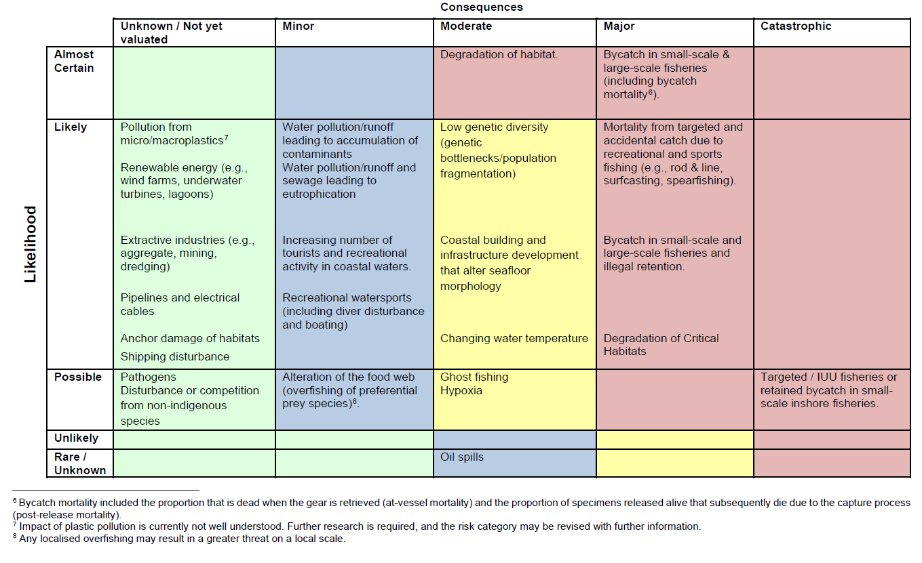

ANNEX 2 - LEGISLATION SPECIFIC TO THE EUROPEAN EEL

Range State | Legislation
European Union | Council Regulation (EC) no 1100/2007 - Establishing measures for the recovery of the stock of European eel.  The Regulation was developed to establish measures for the recovery of the stock of European eel. Eel management plans (EMPs) should be created to implement measures to recover the European eel within nationally determined Eel Management Units (EMUs).  Measures on European eel fisheries  Annual review of fishing measures in EU waters – at present there is a period of closure of six months for commercial fisheries and recreational fisheries are banned.

See Section 3 for list of Range States.
This matrix is applied across Single Species Action Plans under CMS.
The countries that make up the European Union are Austria, Belgium, Bulgaria, Croatia, Republic of Cyprus, Czech Republic, Denmark, Estonia, Finland, France, Germany, Greece, Hungary, Ireland, Italy, Latvia, Lithuania, Luxembourg, Malta, Netherlands, Poland, Portugal, Romania, Slovakia, Slovenia, Spain and Sweden.

