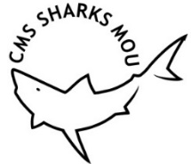 | MEMORANDUM OF UNDERSTANDING ON THE CONSERVATION OF MIGRATORY SHARKS | CMS/Sharks/MOS3/CRP9  13 December 2018

(From CMS/Sharks/MOS3/Doc.14.1/Annex)

TERMS OF REFERENCE OF THE ADVISORY COMMITTEE

Last Amended by the Meeting of Signatories at its Second Session
(San José, 15-19 February 2016)

Mandate and Tasks

- The purpose of the Advisory Committee is to serve and assist the Signatories in the implementation of the Memorandum of Understanding including the Conservation Plan.

- Members of the Advisory Committee serve in their individual capacity rather than as representatives of Governments or organizations with which they also may be affiliated.

- The Secretariat should serve as clearinghouse of requests from the Signatories for advice from the Advisory Committee.

- The main tasks of the Advisory Committee are set forth in paragraph 24 of the MOU. The Signatory States may request the Advisory Committee to give priority to certain activities and tasks, which may include, but are not limited to:
  - Provide expert advice, information and making recommendations including suggestions on new initiatives and on the implementation of this Memorandum of Understanding, to the Secretariat and the Signatories, as necessary and when appropriate;
  - Analyze, as necessary, scientific assessments and making recommendations on the conservation status of shark populations listed in Annex 1 and others which may be contemplated for inclusion;
  - Prepare a report on its activities for each advisory session of the Meeting of the Signatories to be submitted to the Secretariat in ample time before the session of the Meeting of the Signatories;
  - Recommend to the Secretariat the convening of an urgent session of the Meeting of the Signatories in view of emergencies which may arise; and
  - Carry out any other task referred to it by the Meeting of the Signatories.

- The following additional tasks were added by the Signatories at their First Meeting:

- Develop a reporting format for national reports;
- Review the need for, and develop if necessary, additional criteria for the inclusion of further species in Annex 1;
- Review proposals for the inclusion of species in Annex 1 of the MOU submitted by Signatories;
- Undertake further tasks as identified in the Conservation Plan (Annex 3 of the MOU); and
- Review priorities and timeframes and responsible entities for implementation of the Conservation Plan.

Size and Composition

- The Advisory Committee should comprise 10 persons qualified as experts in migratory shark conservation, science and management. In appointing the Advisory Committee, Signatories should strive to achieve a balance among the areas of expertise.

- The members of the Committee should be appointed as representatives of the regions by the Signatories from each region as set out in Annex 2 to the MOU and reiterated below.

Region | Number of representatives
Africa | 2
Asia | 2
Europe | 2
North America | 1
Oceania | 1
South, Central America and the Caribbean | 2

- The boundaries of the above regions are as follows: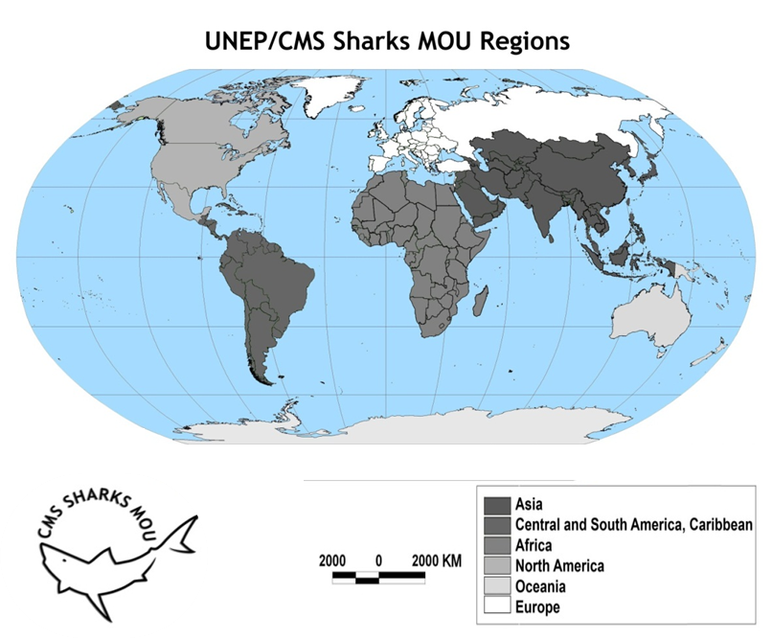

- The Advisory Committee may establish Working Groups to support the implementation of their TOR and invite additional experts to participate in the work of these groups.

- The Advisory Committee may invite specialists to attend its meetings in order to provide additional expertise.

Nomination and Appointment

- Each Signatory may nominate one or more individual, regardless of their nationality and in accordance with paragraph 7, to serve as member of the Advisory Committee.

- The Secretariat should inform the Signatories of any vacancies arising from the expiry of a term or other reason, such as voluntary resignation. Nominations for any vacancies should be provided in writing to the Secretariat at least 60 days in advance of the Meeting of the Signatories and should include detailed information on the professional background of the nominee (e.g. curriculum vitae). The Secretariat should circulate such nominations to all Signatories of the respective region.

- At their meetings, the Signatories of each region should appoint their regional representatives by consensus, from among the individuals nominated, taking into account their technical expertise relating to sharks.

14 Advisory Committee members should serve for a minimum period of two consecutive regular Meetings of the Signatories and where possible not longer than for three terms.

15. Renewal of members of the Advisory Committee should take into account consideration of the continuity of the Committee. As such, where possible, no more than three members should be replaced simultaneously, nor should two members of a region be replaced at the same time.

16 Replacement of Advisory Committee members will be tracked and managed by the Secretariat to balance stability, continuity and renewal. Regions with members who are eligible or identified for potential replacement will be notified at the time of distribution of meeting documents for the coming MOS. Regions will need to consult with their members and come to the MOS ready to advise the Secretariat whether the current member is retained, or a new member will be appointed.

17.Should a vacancy arise intersessionally, the Advisory Committee may propose a replacement for consideration by the Signatories. The proposal should be communicated to the Signatories of the region concerned via the Secretariat and should be accompanied by the same information on the professional background of the nominee as would be required for a regular nomination. In the absence of any objections from the Signatories of the region concerned, within 30 days of the communication from the Secretariat, the interim appointment may be considered as having been accepted and may become effective immediately. If an objection is raised by a Signatory, the procedure may be repeated, as appropriate, until an acceptable nominee is identified. The term of appointment of the provisional nominee shall expire at the end of the next Meeting of the Signatories.

Officers

18.The Advisory Committee should select a Chair and a Vice-Chair, both of whom should be the principal points of contact between the Advisory Committee and the Secretariat.

19.The Chair of the Advisory should participate in the Meetings of the Signatories, and may also participate, if funding permits, in the meetings of related and associated agreements and organizations that the Signatories deem relevant to the work of the MoU. The other members of the Advisory Committee may participate as observers in the Meetings of the Signatories.

20.The Chair of the Committee should provide a report of the Committee’s work to each session of the Meeting of the Signatories.

21.The Vice-Chair should assist in the execution of the Chair’s functions and should preside over meetings in the absence of the Chair.

Meetings and Modus Operandi

22.In accordance with paragraph 26 of the MoU and in order to minimize costs, the Advisory Committee should conduct its work through electronic means whenever possible. The web-based communication space and working area, such as is in use by other CMS family agreements, may facilitate this.

23.Where the need arises, meetings of the Advisory Committee should be convened by the Chair of the Committee in consultation with the Secretariat.

24.Notice of meetings, including the date and venue, should be sent to all members of the Committee by the Secretariat at least 150 days in advance.

CMS/Sharks/Outcome 2.7

