11th MEETING OF THE CONFERENCE OF THE PARTIES

## Quito, Ecuador, 4-9 November 2014

Agenda Item 17.1

|  |  |  |
| --- | --- | --- |
| **CMS** | | |
|  | CONVENTION ONMIGRATORYSPECIES | Distribution: General  UNEP/CMS/COP11/Doc..17.1  19 September 2014  Original: English |

#### OPTIONS FOR THE RESTRUCTURING OF THE SCIENTIFIC COUNCIL

Summary:

Resolution 10.9 on Future Structure and Strategies for CMS and the CMS Family recommended Activity 7 on “Restructuring of the Scientific Council to maximize expertise and knowledge capacity”. The paper included in this document as Annex I aims at providing background information and general considerations relevant to the process of revision of the form and the working practices of the Scientific Council, and offers some possible scenarios for consideration by COP11.

The document also includes a draft resolution on the composition and form of the Scientific Council, for consideration and possible adoption by COP11.

#### OPTIONS FOR THE RESTRUCTURING OF THE SCIENTIFIC COUNCIL

*(Prepared by the UNEP/CMS Secretariat)*

1. The Future Shape process undertaken during the triennium 2008-2011 identified the restructuring of the Scientific Council as one of the sixteen target activities for CMS, as outlined in Resolution 10.9 on Future Structure and Strategies for CMS and the CMS Family. Specifically, the Future Shape process recommended Activity 7 on “Restructuring of the Scientific Council to maximize expertise and knowledge capacity”, providing for short-, medium- and long-term targets.
2. Within this context, and with a view to the consideration of this important issue by the 11th meeting of the Conference of the Parties (COP11), the Secretariat has drafted a document on possible options for the restructuring of the CMS Scientific Council, attached to this cover note as Annex I. The document aims at providing background information and general considerations relevant to the process of revision of the form and the working practices of the Scientific Council, and offers some possible scenarios for a revision of the form as a basis for discussion.
3. A preliminary draft of the document was sent to CMS Parties in April 2014 for consultation. The same version was also submitted to the 18th meeting of the Scientific Council for its consideration and comments (UNEP/CMS/ScC18/Doc.4.4). Based on the feedback from Parties and the Scientific Council, the Secretariat prepared the present version for consideration by COP11.

***Action requested:***

The Conference of the Parties is invited to:

1. Consider the report on options for the restructuring of the Scientific Council attached to this note as Annex I.
2. Review and adopt with a single option the draft Resolution on the restructuring of the Scientific Council attached to this cover note as Annex II.

**ANNEX I**

**OPTIONS FOR THE RESTRUCTURING OF THE SCIENTIFIC COUNCIL**

*(Prepared by the UNEP/CMS Secretariat)*

**Introduction**

1. Pursuant to Future Shape process Activity 7 (UNEP/CMS/Res.10.9), this document discusses options for restructuring the CMS Scientific Council in order to maximize its efficiency, expertise and suitability to the evolving needs of the Convention. In the long term (2020), activity 7 of the Future Shape process recommends expanding the sharing of advice and knowledge across the CMS Family. The mandate for undertaking this work is provided in full detail in Annex 1.
2. The document has been prepared by the CMS Secretariat as part of the planning, assessment and gap analysis (PAGA) process mandated by Resolution 10.9 on the Future Structure and Strategies of CMS and the CMS Family. The document builds on earlier considerations from 2007 with regards to restructuring the Scientific Council (UNEP/CMS/ScC14/Doc.20).
3. For the preparation of this document, the Secretariat has taken into account available information, in particular the review of professional expertise of the Council members currently being undertaken. A table including the structure and modus operandi of the scientific subsidiary bodies of MEAs and CMS Family instruments has also been compiled as a basis for discussion (see Annex 2). Comments from Parties and the 18th meeting of the Scientific Council (ScC18) on an earlier version of the document have been taken into account for the preparation of this version.

**The current structure of the CMS Scientific Council**

*Composition*

1. Article VIII.2 of the Convention states that any Party can appoint a qualified expert as a member of the Scientific Council. While not all Parties have availed themselves of this prerogative, most actually have and, as a result of the steady growth of CMS membership, the Council currently counts 91 members appointed by individual Parties. In addition, the Convention foresees that the Scientific Council includes as members experts selected and appointed by the Conference of the Parties. For the triennium 2012-2014, nine of those have been appointed by COP with the title “COP-appointed Councillor”.
2. The nine COP-appointed Councillors (confirmed at COP10) cover the following taxa, geographic regions and threats: marine turtles; birds; aquatic mammals; fish; neo-tropical fauna; Asiatic fauna; African fauna; by-catch and climate change.
3. Members are appointed in their individual capacity as experts, not as representatives of their national governments.
4. A number of observers also participate in Council meetings, these being mainly NGOs, scientific institutions or representatives of MEA Secretariats.

*Meetings*

1. There is no set frequency for Meetings of the Council. Meetings can be convened by the Secretariat whenever it is considered necessary. In practice, the Council has usually met once intersessionally and once back to back with the meetings of the COP i.e., twice in each triennium. Most recently, the Standing Committee at its 40th meeting agreed to de-couple Scientific Council meetings from those of the COP, so that the Scientific Council meets between three to four months prior to the meeting of the COP. This practice took effect starting with the 18th meeting of the Scientific Council in 2014, and is confirmed in the revised Rules of Procedure for the COP submitted by the Standing Committee to COP11 for consideration.
2. To date, 18 full meetings of the Council have taken place plus one special restricted meeting that took place in 2009 in Bonn.

*Expertise*

1. An analysis of the scientific expertise of the members of the Scientific Council was presented to the Scientific Council at its 17th Meeting, held in Bergen, Norway, in November 2011 (UNEP/CMS/ScC17/Doc.6/Rev.1). The analysis was based on responses to a questionnaire by forty-five out of the total of 103 councillors (inclusive of Party-appointed and COP-appointed councillors and alternate members; status October 2011).[1]
2. Topics covered in the assessment were knowledge of languages, employment background and focus of expertise (geographic region, taxonomic group(s), habitat type, threats and human-induced impacts):
   1. **Languages:** The majority of councillors were fluent in one or two of the official UN languages. Most councillors were fluent in English (n=43), and it remains the most widely-spoken UN language. Nevertheless, all the UN languages, with the exception of Chinese (0), were spoken in the Council. However, relatively few Councillors spoke Arabic (3);
   2. **Employment background:** The majority of councillors worked within their governments (27) and within academia (19). Relatively few councillors were employed in the private sector (2), independent work (1) and non-governmental organizations (8);
   3. **Geographical regions:** The Council had considerable expertise in Europe, followed by several regions of Africa and the southern region of the Americas. Councillors had limited experience in North and Middle Africa, the Americas (excluding South America), as well as Asia in its entirety. In addition to these regions, there was a lack of expertise pertaining to Antarctica and the island states and territories, particularly the Caribbean, and Oceania;
   4. **Understanding of taxonomic groups**: Councillors possessed knowledge on all taxa listed in the CMS Appendices, albeit to varying degrees. Figure 1 shows that there is a clear bias towards birds;

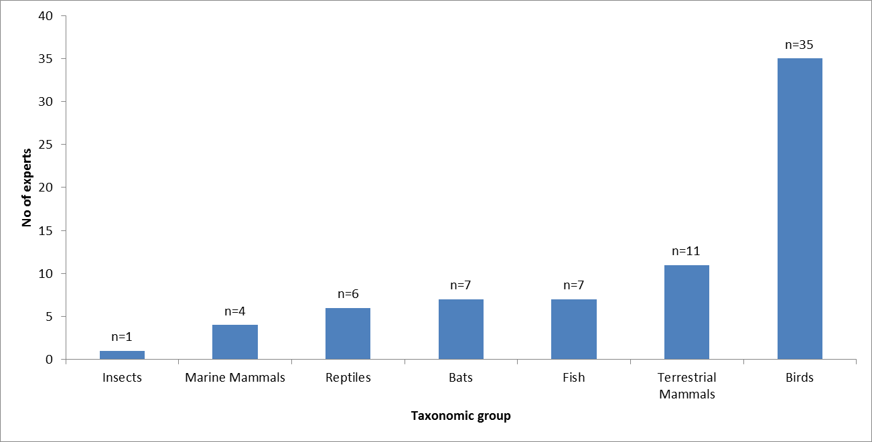

Figure 1: Experience of Councillors with the taxonomic groups listed in CMS Appendix I and II (n=45)

Source: UNEP/CMS/ScC17/Doc.6/Rev.1

1. **Habitat types:** Most councillors were experienced with forests and wetlands. The Council also had considerable experience on grassland, marine, rocky areas, savannah and desert areas. Introduced vegetation and caves and subterranean habitats (non-aquatic) were poorly-represented with only two and three councillors stating expertise for each category respectively (Figure 2); and

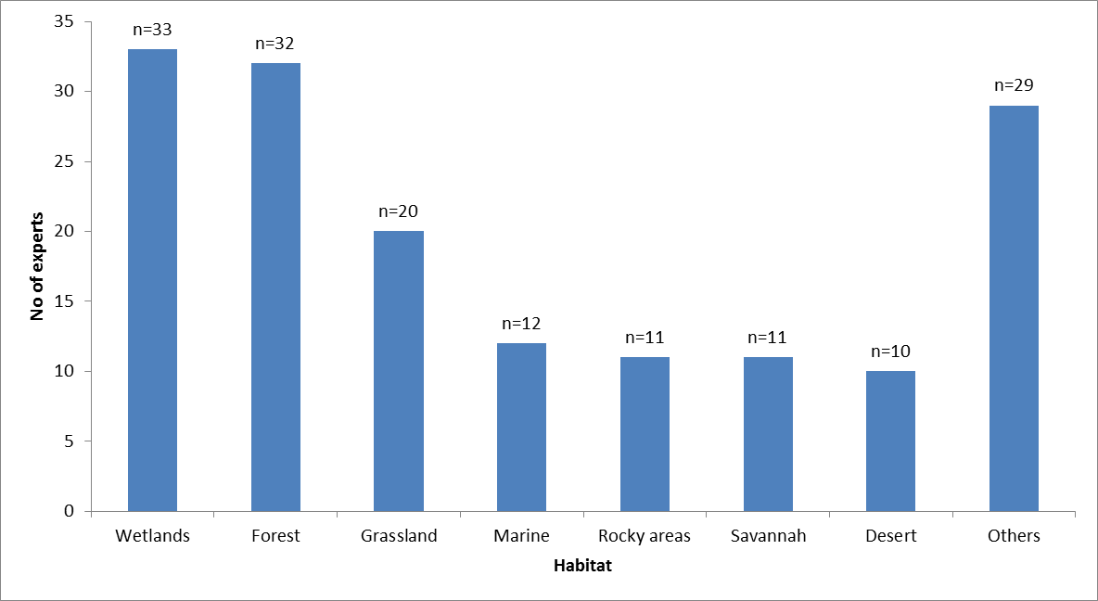

Figure 2: Experience of Councillors on different habitats important for CMS-listed species (n=45). The “Other” category included habitats which were represented by fewer than 10 experts.

Source: UNEP/CMS/ScC17/Doc.6/Rev.1

1. **Threats and human-induced impacts:** In terms of human-induced impacts, the majority of councillors participating in the survey focused on habitat destruction and climate change, with hunting and invasive species following. There was limited expertise on certain impacts such as ship collisions, oil pollution, electrocution, wind turbines, acoustic and light pollution (all <10) (Figure 3).

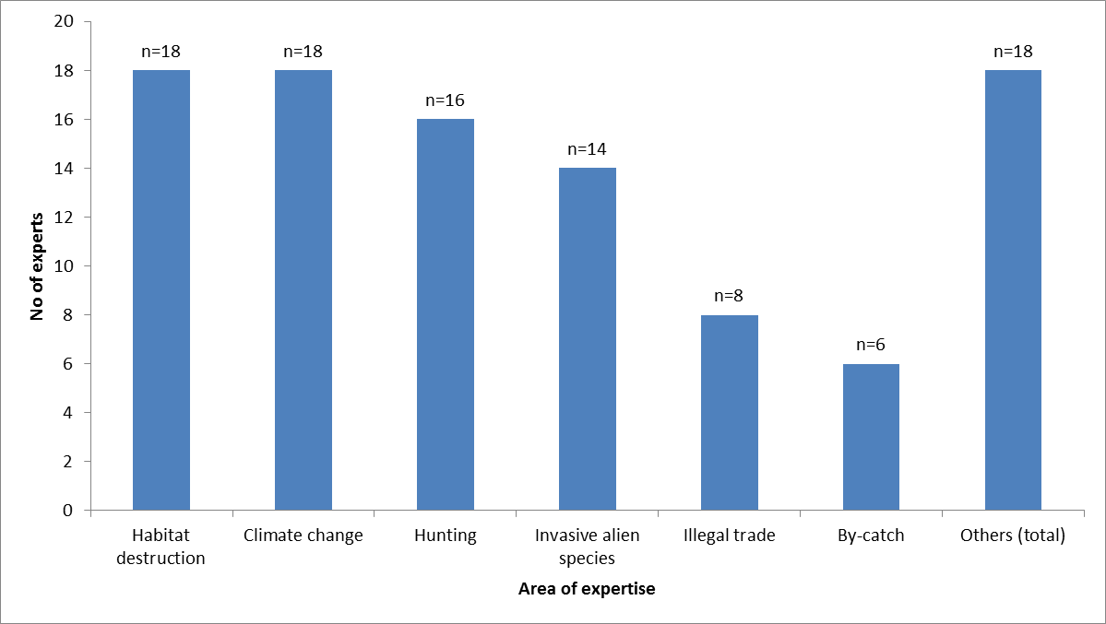

Figure 3: Recent scientific focus (Human induced impacts) of the CMS Scientific Council members (n=45). The “Other” category included areas of expertise in terms of human-induced impacts which were represented by less than 10 experts.

Source: UNEP/CMS/ScC17/Doc.6/Rev.1

1. In sum, the analysis of expertise shows a clear imbalance in the Scientific Council and points to existing gaps in expertise. There is a strong bias towards birds, whereas other areas of expertise, for example on aquatic mammals, marine fish – sharks in particular – certain habitats and issues, are underrepresented. This imbalance potentially limits the effectiveness of the Council with regards to providing advice on new and emerging issues across most taxa and biomes. Any revision of the form of the Council should make sure this imbalance is addressed and corrected.

*Working groups*

1. In general working groups deal with taxonomic groups or cross-cutting issues. The Scientific Council has established a number of working groups that normally meet during the meetings of the Council. Only some of these groups have Terms of Reference or a defined membership. The following have been created:
   1. Birds;
   2. Terrestrial mammals;
   3. Marine turtles;
   4. Fish;
   5. Aquatic mammals;
   6. Climate change;
   7. Bycatch;
   8. Underwater noise (joint working group with ACCOBAMS and ASCOBANS) [tbc];
   9. Sustainable use (this working group was closed during COP10 after having completed its mandate of analysing the relevance of the Addis Ababa Principles to CMS).
2. In addition there are other working groups that are mandated by COP resolutions and operate in the orbit of the Council. The following have been created:
   1. Flyways (created by Resolution 9.2);
   2. Minimizing Poisoning to Migratory Birds (created by Resolution 10.26); and
   3. Migratory Landbirds of the African Eurasian Region (created by Resolution 10.27).
3. Working Groups established under the Scientific Council communicate by electronic means, as e-mail or the recently created online-Workspace. However the intersessional activity of these Working Groups is generally low. In some cases, technical meetings or workshops take place for specific Working Groups, e.g., landbirds or bird poisoning, bringing together the relevant Scientific Councillors. These meetings depend entirely on voluntary contributions raised on a case-by-case basis.

*Costs*

1. The budget to service Scientific Council meetings for the triennium 2012-2014 is €95,000. The funds were entirely used to organize the 18th meeting of the CMS Scientific Council at the Secretariat’s offices in Bonn. The budget covered the travel and subsistence costs of 35 eligible members[2] for a duration of three days. The meeting benefitted from additional resources through the provision of simultaneous interpretation free of charge by the Government of Germany. Scientific Council meetings outside of Bonn are likely to be more expensive, due to the costs for venue hire, interpretation and travel of Secretariat staff.

**Constraints of the current system**

*Increase in membership and cost*

1. Since its founding, the Convention has experienced a steady increase in Parties and therefore in Party-appointed Scientific Councillors. Between 2007 and 2014 the number of Party-appointed Councillors has risen from 74 to 91. If all Parties availed themselves of their right to appoint a member of the Scientific Council, the number of this type of councillor would be at 120. The increase in the number of Scientific Councillors has been accompanied by an increase in cost for Scientific Council meetings. Meetings of the full Council are becoming increasingly expensive.

*Evolving needs of the Convention*

1. In addition to the need of reducing the costs of its meetings, the Council may also need to adjust its expertise to reflect the evolving needs of the Convention, particularly in light of the new Strategic Plan for Migratory Species which is expected to be adopted by COP11 and which draws heavily on the CBD Strategic Plan and the Aichi Targets.
2. Furthermore, pursuant to Resolution 10.09 (Annex I, Activity 5), the Secretariat is currently working on a global gap analysis at Convention level, including emerging issues and an analysis of species missing from the Appendices.
3. In the year 2013 the Intergovernmental Science-Policy Platform on Biodiversity and Ecosystem Services (IPBES) was established and the Scientific Council is requested by Resolution 10.8 to undertake a review of needs and opportunities for improving the interface between science and policy in relation to the conservation and sustainable use of migratory species.
4. To allow the expertise of the Scientific Council to adapt to the evolving needs of the Convention it may require, *inter alia*, some changes in the form and procedures of the Council, that would ensure the possibility of periodic adjustments of the councillors’ expertise, notably across taxa and thematic issues. It may also require the development of an implementation plan to reflect how the Scientific Council is going to contribute to the Strategic Plan for Migratory Species that will be adopted at COP11 in 2014 and other future COP mandates.

*Intersessional inactivity*

1. The creation of working groups has generally proved to be an effective mechanism for delivering on specific issues within the regular meetings of the Council. With a few noticeable exceptions, activity of working groups has however not continued significantly in the inter-sessional period. This contrasts with the practice in other technical advisory bodies to MEAs, including CMS Agreements and MOUs, where intersessional work by members of their technical advisory bodies is a strong feature of their programme.
2. Building on the example of other technical advisory bodies to MEAs, a revision of the practice concerning working groups, in particular the definition of Terms of Reference, membership and a work programme for each Working Group at an early stage in the intersessional period is seen to be instrumental in facilitating and promoting the activity of the working groups intersessionally.

*Summary of constraints*

1. In sum, the main constraints that are affecting the functioning of the Scientific Council can be summarized as follows:
   1. A very large membership with around 100 members;
   2. Expensive meetings with a high number of sponsored delegates;
   3. Uneven distribution of expertise across taxa and thematic issues, and limited expertise on the evolving needs of the Convention;
   4. No resources to generate intersessional work; and
   5. Relatively low intersessional participation of scientific councillors in working groups.
2. In order to overcome these constraints and maximize the scientific and technical output of the Council, an approach aiming to (i) reduce the costs of individual meetings, (ii) redirect financial resources towards intersessional work, and (iii) balance and, where appropriate, adjust the expertise across taxa and thematic issues, appears as the most logical option in the current resource-constrained environment. With a view to reducing the costs of meetings, the only option that would not appear too discriminatory - in terms of possibility of attendance - against members from developing countries seems to be a significant and geographically balanced reduction of the number of members of the Council participating in meetings. This reduction should not be to the detriment of the overall expertise of the Council, that should instead be maximized through a targeted selection of the membership, trying to incorporate where appropriate areas of expertise that are currently missing or underrepresented. In order to achieve this, an evolution towards a form based on regional representation and the targeted designation of experts in pre-identified areas of expertise according to actual needs seems to be inevitable.

**Comparison with scientific advisory bodies of other Multilateral Environmental Agreements and CMS instruments**

1. Discussions about restructuring scientific advisory bodies are not unique to CMS. A similar discussion has taken place under the Convention on Biological Diversity (CBD) in response to which the CBD COP adopted decision XI/13 on ways and means to improve the effectiveness of the Subsidiary Body on Scientific, Technical and Technological Advice and collaboration with the IPBES.
2. Across Multilateral Environmental Agreements (MEAs) and CMS Instruments there are different models of structuring scientific advisory bodies. A table comparing these models can be found in Annex 2 of this document. Key insights from the table are summarized below.

*Membership*

1. With few exceptions, the scientific advisory bodies of the instruments under analysis have on average between 15 and 20 members.
2. Only the largest MEAs such as CBD and UNFCCC, and some of the smaller agreements such as the CMS Gorilla Agreement, have one or more individuals per Party as members on their scientific advisory bodies.
3. In contrast, conventions comparable to CMS usually opted for some kind of representation mechanism. The CITES Animals Committee, Ramsar Scientific and Technical Review Panel (STRP) and others apply regional representation to their scientific advisory bodies. In addition, at least one of the members of the Ramsar STRP must have communication, education, participation and awareness (CEPA) expertise, and at least one member must have socio-economic science expertise.
4. Similarly, the Technical Committee of AEWA consists of nine experts selected from the different regions of the agreement (appointed by the Meeting of the Parties); one representative each of IUCN, Wetlands International and CIC; and one thematic expert for each of the following fields: rural economics, game management, and environmental law (appointed by the Meeting of the Parties).

*Method of appointment*

1. In most cases, the members of the scientific advisory bodies of other agreements are nominated and elected by the Parties of the agreement. In doing so, Parties often refer to a roster list, compiled by the agreement secretariats. The CMS institution of “COP-appointed Councillor” is an exception which is not found in other agreements.
2. In addition to such regular members, several agreements however have “ex-officio” members serving on the scientific advisory bodies, such as in the case of AEWA (see paragraph 31 above)

*Periodicity*

1. The scientific advisory bodies of other agreements usually have meetings that are de-coupled from the relevant decision-making meetings (COPs or MOPs). Table 1 below summarizes the timing and periodicity of meetings of the scientific subsidiary bodies of other MEAs.

|  |  |  |
| --- | --- | --- |
| **Instrument** | **De-coupled technical and decision-making meeting (Yes/No)** | **Approximate time between scientific advisory body meetings and COP** |
| ***Biodiversity related Conventions*** |  |  |
| **CBD** | Yes | 6 months |
| **CITES** | Yes | 12 months |
| **Ramsar Convention** | Yes | 17 months |
| **World Heritage Convention** | Yes | 4 months between the committee sessions and General Assemblies |
| **International Treaty on Plant Genetic Resources For Food and Agriculture** | Yes | 7 months |
| ***CMS Family Instruments*** |  |  |
| **AEWA** | Yes | 6-8 months |
| **Wadden Sea Seals** | No |  |
| **Gorilla Agreement** | Yes | 8 months |
| **ACAP** | Yes | 7 months |
| **EUROBATS** | Yes | 4 months |
| **ACCOBAMS** | Yes | 12 months |
| **ASCOBANS** | Yes | 12 months |

Table 1: Overview of the approximate timing of recent technical and decision-making meetings of the regional agreements negotiated under CMS and other biodiversity-related Multilateral Environmental Agreements.

**Discussion**

1. In light of the constraints of the current operating system, the new form of the Scientific Council should:
   1. reduce costs in a resource-constrained context;
   2. allow the Council to better adapt to the evolving needs of the Convention and ensure balanced scientific expertise across all taxa and thematic issues;
   3. ensure adequate distribution of scientific and policy expertise; and
   4. ensure more intersessional activity.

*Legal implications*

1. In considering possible changes in the operational organization of the Scientific Council, including during the consultation on the present document, the opinion has been expressed by many that the basic structure and membership of the Council cannot be changed without amending the text of the Convention. This view is reflected in this document, and all proposed changes in the form of the Council are considered to be compatible with the provisions of the Convention, in particular of its ArticleVIII.
2. Individual Parties should remain entitled to appoint a member of the Scientific Council, if they so desire. Party-appointed councillors would be listed on a roster and their expertise would be drawn upon for specific consultations or assignments, such as the chairing of a Working Group. Meetings of the Scientific Council, however, would only comprise a relatively small subset of Party-appointed members selected from the different regions and COP-appointed councillors.
3. The Scientific Council would continue its intersessional work through working groups, taking into account the suggestions for a refinement and consolidation of the working practice of groups that have been suggested in document UNEP/CMS/ScC14/Doc.20. As is currently the case, the working groups would continue to involve a large number of Party-appointed councillors.
4. Savings arising from a reduced size of the Scientific Council meetings could be redirected towards supporting intersessional work, such as convening workshops of specific working groups.
5. The adoption of a new form of the Scientific Council would require the adoption of new rules of procedure. These new rules of procedures should, *inter alia*, redefine the terms of the Councillors, e.g., setting criteria for the appointment of members and term limits, and the terms of participation in the work of the Council of observers, as appropriate.
6. Comments from Parties and ScC18 have also stressed the importance of a clearer definition of the Terms of Reference of the Scientific Council. A document defining in detail the mandate of the Scientific Council currently does not exist. The functions and tasks of the Scientific Council are defined by the text of the Convention (Article VIII) and various resolutions of the Conference of the Parties (see Annex 1 to this paper). However, the recent experience with the de-coupling of Scientific Council meetings from those of the COP, while it proved the value of this initiative in increasing the Council’s usefulness for the preparation of the meeting of the COP, it also evidenced the risk of overlap and confusion in the roles of the two bodies. In particular, the need for a clarification of the role and limits of the Scientific Council in advising on policy matters has been recognized.

**Scenarios**

1. Based on these considerations, and taking into account comments from Parties and ScC18 on an earlier version of this paper, this version describes four possible scenarios for a revised form of the Scientific Council which are elaborated below. These scenarios should be regarded as indicative, and a form based on a combination of elements would also be possible, as suggested by some of the comments from the Parties. All scenarios foresee a representative membership, composed of COP-appointed Councillors, and a subset of Party-appointed councillors, which is renewed at each ordinary meeting of the Conference of the Parties. Representative members are expected to bear the main responsibility with delivering on the mandate of the COP, they are expected to participate in meetings of the Council and consult and coordinate views within their regions or areas of expertise and appropriately take account of the full spectrum of such views to be conveyed at meetings. Party-appointed Councillors not included in the representative membership in a given period are encouraged to contribute to the work of the Council through the representative members and participation in working groups, as well as through activity at the national level (e.g. identification of projects to be submitted to the Small Grants Programme; contribution to the compilation of the national report to COP).

*Scenario A*

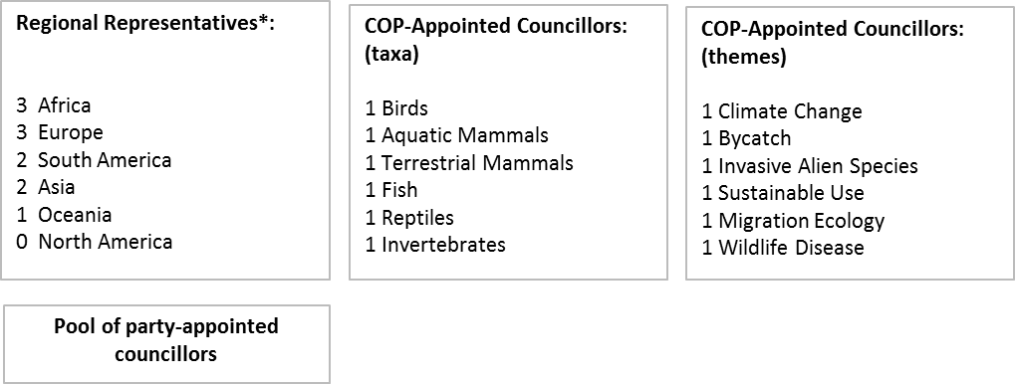

Figure 4: Scenario A

*elected from the pool of Party-appointed councillors

1. Scenario A is represented in Figure 4. The Scenario provides for 11 regional representatives, the distribution across regions following the Standing Committee membership. These representative members would be selected at each COP from the pool of Party-appointed councillors, on the basis of nominations made by the Parties and taking into account the predicted needs in expertise for the next triennium. Regional representatives should be individuals with a broad understanding of key scientific issues and concrete experience in translating science into policy in their region. While selected regionally, they would not hold any political mandate on behalf of their region.
2. Scenario A foresees COP-appointed Councillors for taxa groupings (6) and cross-cutting themes (6). These councillors would be suggested by Parties, based on strict scientific selection criteria, and appointed by COP. Taxa and themes indicated in Figure 4 should be seen as indicative, and might change depending on the evolving needs of the Convention. This is valid also for the other scenarios illustrated in this paper.
3. In total, the representative membership of the Scientific Council would count 23 members.
4. The main advantage of this Scenario compared to the current form would be the smaller size of the Council while at the same time maintaining broad and clearly defined expertise.
5. The costs of a three-day meeting under this scenario at the Secretariat’s headquarter in Bonn, can be estimated at US$71,633 ≈ €55,157[3] using as a basis the costs actually incurred for the organization of ScC18.

*Scenario B*

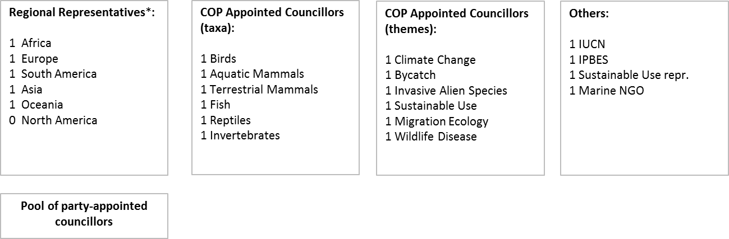

Figure 5: Scenario B

*elected from the pool of party-appointed councillors

1. Scenario B is represented in Figure 5. The Scenario provides for five regional representatives, i.e. one representative from each CMS region. As in Scenario A, regional representatives would be elected at each COP from the pool of Party-appointed Councillors and should be individuals with a broad understanding of key scientific issues and concrete experience in translating science into policy in their region.
2. Like Scenario A, Scenario B foresees councillors for taxa groupings (six) and cross-cutting themes (six). Again, these would be suggested by Parties, based on strict scientific selection criteria, and appointed by COP.
3. In addition, IUCN, IPBES, a representative of an organization focusing on sustainable use, and a representative of an organization dealing with marine issues would serve as ex-officio members in the Scientific Council with one representative each. While proposed by their respective organizations, also these members would be formally appointed by the COP.
4. In total, the representative membership of the Scientific Council would count 21 members.
5. Compared with the current operational organization of the Council, this scenario would have similar advantages to those suggested for scenario A; while the main distinctive feature of this Scenario compared to other scenarios would be a particularly strong science base of the Council due to the relative weight given to COP-appointed councillors and ex-officio members.
6. The costs of a three-day meeting under this scenario at the Secretariat’s headquarter in Bonn, can be estimated at US$70,817 ≈ €54,529 using as a basis the costs actually incurred for the organization of ScC18.

*Scenario C*



Figure 6: Scenario C

*elected from the pool of party-appointed councillors

1. Compared with scenarios A and B, regional representation would be stronger in Scenario C, where avian, marine and terrestrial experts would be selected by region. As in the previous two scenarios, all regional representatives would be elected from the pool of party-appointed councillors at each COP. They should be individuals with a broad understanding of key scientific issues and concrete experience in translating science into policy in their region.
2. In this scenario, the COP-appointed councillors would represent a number of cross-cutting themes (six). These would likely have to be individuals with a broad scientific understanding but with a firm basis in policy-making. Again, they would be suggested by Parties, based on strict scientific selection criteria, and appointed by COP.
3. The total number of representatives under this Scenario would be 21.
4. Compared with the current form of the Council, this scenario would have similar advantages to those suggested for scenarios A and B. Compared to other Scenarios, Scenario C would ensure balanced scientific expertise from each CMS region. A disadvantage, however, could be that there is a danger of creating redundancies of expertise. To avoid such redundancies it would be necessary to ensure that the whole range of species are covered (i.e. to avoid, for example, a potential situation where there are five marine mammals experts from the different regions but no expert on marine fish or reptiles).
5. The costs of a three-day meeting under this scenario at the Secretariat’s headquarter in Bonn, can be estimated at US$57,316 ≈ €44,133 using as a basis the costs actually incurred for the organization of ScC18.

*Scenario D*



Figure 7: Scenario D

*elected from the pool of Party-appointed Councillors

1. In Scenario D, the reduction in the representative membership with respect to the current operational organization would be less drastic than in scenarios A-C. However, the full representative membership would meet only once in the triennium, a few months before the meeting of the COP, with the purpose of finalizing the Council’s scientific, technical and policy input to the meeting of the COP. For the rest of the intersessional period, only a subset of the representative membership with a strong scientific focus, made up of the COP-appointed Councillors and the working group leaders (when selected from among the Party-appointed councillors), would meet and lead the implementation of the mandate of the COP to the Scientific Council.
2. As with Scenarios A and B, the COP-appointed Councillors would cover taxa and cross-cutting themes, and would be suggested by Parties, based on strict scientific selection criteria and appointed by the COP. Party-appointed members would be selected on a regional basis and should be individuals with a broad understanding of key scientific issues and concrete experience in translating science into policy.
3. Under this scenario, the costs of a three-day meeting at the Secretariat’s headquarter in Bonn of the full representative membership can be estimated at US$76,648 ≈ €59,018, while a meeting of the COP-appointed councillors and working group leaders only can be estimated at US$41,664 ≈ €32,081 using as a basis the costs actually incurred for the organization of ScC18.

**Proposed way forward**

1. The Conference of the Parties may wish to consider the scenarios outlined above as a basis for its decision on a new operational organization of the Scientific Council.
2. Should COP11 find an agreement on a new operational organization of the Scientific Council, some transitional measures would be necessary to put it in place during the subsequent intersessional period, should the Parties so wish. Such measures should concern the appointment of COP-appointed Councillors and the selection of Party-appointed Councillors to form the representative membership for the period 2015-2017, as well as the development and adoption of Terms of Reference and new Rules of Procedure for the Scientific Council.
3. The selection and appointment of the representative membership, that in the approach proposed in this paper should normally be a prerogative of the Conference of the Parties, could, in the transitional phase, be delegated by COP11 to the Standing Committee, which will select and appoint the representative members on the basis of nominations made by Parties. The Secretariat will be able to coordinate the nomination process.
4. The Secretariat could also be entrusted to develop Terms of Reference for the Scientific Council, in consultation with the Council itself, with a view to their submission to the Standing Committee for review and adoption.
5. The Scientific Council, in its new operational organization, would develop and adopt a revision of its Rules of Procedure as well as elements of its *modus operandi* functional to its new organization, to be eventually submitted to the Standing Committee or the Conference of the Parties for endorsement.
6. An alternative to the course of action outlined above would be to maintain the Scientific Council in its current operational organization for the next triennium, while working in the intersessional period towards the development of Terms of Reference and revised Rules of Procedure and *modus operandi*, to be submitted to COP12 for review and adoption, and arrange for nomination for the representative membership of the Council in time for COP12 consideration.
7. Should COP11 not be in a position to come to a definitive agreement on the new operational organization of the Council, the possibility of implementing the scenario receiving most support for a trial period of three years under the supervision of the Standing Committee could be considered, with a view to reporting the results to COP12 for its consideration and decision.

**Annex 1**

**Mandate**

**a) Convention text**

Article VIII of the Convention lays out the basic rules pertaining to the Scientific Council. The Article stipulates:

*1. At its first meeting, the Conference of the Parties shall establish a Scientific Council to provide advice on scientific matters.*

*2. Any Party may appoint a qualified expert as a member of the Scientific Council. In addition, the Scientific Council shall include as members qualified experts selected and appointed by the Conference of the Parties; the number of these experts, the criteria for their selection and the terms of their appointments shall be as determined by the Conference of the Parties.*

*3. The Scientific Council shall meet at the request of the Secretariat as required by the Conference of the Parties.*

*4. Subject to the approval of the Conference of the Parties, the Scientific Council shall establish its own rules of procedure.*

*5. The Conference of the Parties shall determine the functions of the Scientific Council, which may include:*

*a) providing scientific advice to the Conference of the Parties, to the Secretariat, and, if approved by the Conference of the Parties, to any body set up under this Convention or an AGREEMENT or to any Party;*

*b) recommending research and the co-ordination of research on migratory species, evaluating the results of such research in order to ascertain the conservation status of migratory species and reporting to the Conference of the Parties on such status and measures for its improvement;*

*c) making recommendations to the Conference of the Parties as to the migratory species to be included in Appendices I and II, together with an indication of the range of such migratory species;*

*d) making recommendations to the Conference of the Parties as to specific conservation and management measures to be included in AGREEMENTS on migratory species; and*

*e) recommending to the Conference of the Parties solutions to problems relating to the scientific aspects of the implementation of this Convention, in particular with regard to the habitats of migratory species.*

**b) COP Resolutions on the Scientific Council**

The structure and work of the Scientific Council have further been specified in a series of resolutions (see Table 1).

Most relevant of these in the context of this paper, is perhaps Resolution 1.4 on the Composition and Functions of the Scientific Council. This Resolution recommends in paragraph 3, that the special qualifications of members of the Scientific Council should initially cover the following fields of expertise: migration biology, population ecology, habitat conservation, aquatic mammals, terrestrial mammals, bats, aquatic reptiles and birds.

The same resolution, in paragraph 5 (b), also states that *for reasons of economy and efficiency, the Scientific Council should work in small groups dealing with particular problems. The full Council should normally meet only in connection with a meeting of the Conference of the Parties.*

|  |  |
| --- | --- |
| **Res. No.** | **Title** |
| 1.4 | Composition and Functions of the Scientific Council |
| 3.4 | Funding and Role of the Scientific Council |
| 4.5 | Arrangements for the Scientific Council |
| 6.7 | Institutional Arrangements: Scientific Council |
| 7.12 | Institutional Arrangements: Scientific Council |
| 8.21 | Institutional Arrangements: Standing Committee and Scientific Council |
| 10.19 | Migratory Species Conservation in the Light of Climate Change *(paragraph 17 creates the post of COP-aAppointed Sc Cllr for Climate Change)* |

Table 1: Resolutions on the Scientific Council

The rules of procedure of the Scientific Council at the time this paper is being written are laid out in document UNEP/CMS/ScC17/Inf.2.

**c) Resolution 10.9 on the Future Structure and Strategies of CMS and the CMS Family**

The Future Shape process undertaken during the triennium 2008-2011 identified the restructuring of the Scientific Council as one of the 16 target activities for CMS, as outlined in Resolution 10.9 on Future Structure and Strategies for CMS and the CMS Family, and Resolution 10.1 on Financial and Administrative Matters. Specifically, the Future Shape process has recommended Activity 7 on “Restructuring of the Scientific Council to maximize expertise and knowledge capacity”, including the following items:

* *To identify potential and relevant opportunities to maximize the expertise and knowledge of the Scientific Council to best support the CMS;*
* *To identify any gaps in knowledge and/or expertise that exists in the current membership of the Scientific Council;*
* *To expand advice and knowledge sharing across the CMS Family.*

In particular, the following activities are to be undertaken in the short, medium and long term:

1. *Planning Process, Assessment and Gap Analysis* (PAGA) (by COP11 in 2014);
2. *Implementing the review of CMS membership of the Scientific Council based on species groupings or thematic issues if appropriate* (by COP12 in 2017);
3. *To expand advice and knowledge sharing across the CMS Family* (by COP13 in 2020).

COP10 requested that the PAGA on the effectiveness of the Scientific Council be undertaken in the short-term and that results be reported to COP11 in 2014.

|  |  |  |  |  |  |  |
| --- | --- | --- | --- | --- | --- | --- |
|  | **Activity** | **OPTION** | **DESCRIPTION** | **SHORT TERM: BY COP 2014** | **MEDIUM TERM: BY COP12 -2017** | **LONG TERM: BY COP13 - 2020** |
| 7 | Restructuring of Scientific Council to maximize expertise and knowledge capacity | 2 and 3 | - To identify potential and relevant opportunities to maximize the expertise and knowledge of the Scientific Council to best support the CMS.  - To identify any gaps in knowledge and/or expertise that exists in the current membership of the Scientific Council.  - To expand advice and knowledge sharing across the CMS Family. | Planning process, assessment, Gap Analysis (7.1) | Implementing the review of CMS membership of Scientific Council based on species groupings or thematic issues if appropriate (7.2) |  |
| CMS-wide Scientific Institution if appropriate. (7.3) | |

**Annex 2**

| **Institution** | **Body** | **Membership** | **Total Number of Members** | **Observers** | **Intersessional  "Modus Operandi"** | **Text** |
| --- | --- | --- | --- | --- | --- | --- |
| **CITES** | The ANIMALS COMMITTEE | 5 CITES Regions:  AFRICA, ASIA, CENTRAL AND SOUTH AMERICA AND CARIBBEAN, EUROPE - with TWO representatives for each region and TWO alternate representatives  NORTH AMERICA and OCEANIA – ONE representative for each region and ONE alternate representative | 20 | Representatives of Parties and alternate regional representatives not replacing a regional representative, the United Nations, its Specialized Agencies, the International Atomic Energy Agency, as well as any State not a Party to the Convention. | Any member may submit a proposal to the Chairman for a decision by *postal procedure*. The Chairman shall send the proposal to the Secretariat for communication to the members, who shall comment within 40 days of the communication of the proposal | “The membership of the Committee shall consist of the *regional representatives* elected at each meeting of the Conference of the Parties and the specialist on zoological nomenclature elected by the Conference of the Parties. Each regional representative shall be entitled to represent his/her region at meetings of the Committee.” (RULES OF PROCEDURE FOR MEETINGS OF THE ANIMALS COMMITTEE (adopted at the 23rd meeting, Geneva, April 2008, effective from 25 April 2008) |
| **CBD** | Subsidiary Body on Scientific, Technical and Technological Advice (SBSTTA) | Open to participation by all Parties and shall be multidisciplinary. It shall comprise government representatives competent in the relevant field of expertise  + national focal points + Ad hoc technical expert groups (no more than 15 members per group) | ? | The United Nations, its Specialized Agencies, the International Atomic Energy Agency, as well as any State not a Party to the Convention and any other body or agency, whether governmental or nongovernmental, qualified in fields relating to conservation and sustainable use of biological diversity. | In preparing documentation for meetings, the Executive Secretary will establish work plans, timetables, resource requirements, and collaborators and contributors, and follow a transparent process for contributions, comments and feedback at various stages of document preparation | "This body shall be open to participation by all Parties and shall be multidiscipiinary. It shall comprise government representatives competent in the relevant field of expertise." (CBD Convention Text) |
| **Ramsar** | The Scientific and Technical Review Panel (STRP) | A Chairperson and 13 expert members, appointed to the Panel by the STRP Oversight Committee for the 2013-2015 triennium, taking into account the priority themes and tasks for this triennium as set out in the annexes:  - One appointed member shall have CEPA (communication, education,  participation and awareness) expertise;   - One appointed member shall have socio-economic science expertise;  - At least one member, and preferably two, shall be appointed from each of the six Ramsar regions | 14 | The work of the Panel will continue to benefit from the involvement and input of other relevant scientific and technical organizations and their networks, invited by the COP as observers to the Panel. | Electronic mail and Web-based information and communication systems. | Same as in the membership cell  (from: Resolution IX.11, as refined by X.9, and adjusted in line with Resolution XI.18) |
| **UNCCD** | The Committee on Science and Technology (CST) | Government representatives competent in the relevant fields of expertise | As many as the parties, the parties are 196 | The United Nations, its specialized agencies and any State member thereof or observers thereto not Party to the Convention, may be represented at sessions of the Conference of the Parties as observers. Anybody or agency, whether national or international, governmental or non-governmental, which is qualified in matters covered by the Convention, and which has informed the Permanent Secretariat of its wish to be represented at a session of the Conference of the Parties as an observer, may be so admitted unless at least one third of the Parties present object | Not specified | "It shall be composed of government representatives competent in the relevant fields of expertise." (UNCCD Convention Text) |
| **UNFCCC** | Subsidiary Body for Scientific and Technological Advice | Each Party participating in a session shall be represented by a delegation consisting of a head of delegation and such other accredited representatives, alternate representatives and advisers as it may require | ? | The United Nations, its specialized agencies, any international entity or entities entrusted by the Conference of the Parties pursuant to Article 11 of the Convention with the operation of the financial mechanism, and the International Atomic Energy Agency, as well as any State member thereof or observers thereto not Party to the Convention, may be represented at sessions of the Conference of the Parties as observers. | Not specified | "Each Party participating in a session shall be represented by a delegation consisting of a head of delegation and such other accredited representatives, alternate representatives and advisers as it may require." (Rules of Procedure Text - FCCC/CP/1996/2 22 May 1996) |
| **WORLD HERITAGE** | Inter-governmental Committee for the Protection of the World Cultural and Natural Heritage | There are 21 Committee members represented by 21 States Parties to the World Heritage Convention:  - Each State member of the Committee shall be represented by one delegate, who may be assisted by alternates, advisers and experts.  - States members of the Committee shall choose as their representatives persons qualified in the field of cultural or natural heritage. They are strongly encouraged to include in their delegation persons qualified in both fields | 21 | States Parties to the Convention which are not members of the Committee may attend the sessions of the Committee and its Bureau as observers  Non States Parties to the Convention who are Member States of UNESCO or of the United Nations may also be permitted by the Committee, upon written request, to attend the sessions of the Committee and its Bureau as observers  The United Nations and organizations of the United Nations system and other international governmental and nongovernmental organizations, permanent observer missions to UNESCO and non-profit-making institutions having activities in the fields covered by the Convention, | Not specified | “It shall be composed of 15 States Parties to the Convention, elected by States Parties to the Convention meeting in general assembly during the ordinary session of the General Conference of the United Nations Educational, Scientific and Cultural Organization. The number of States members of the Committee shall be increased to 21 as from the date of the ordinary session of the General Conference following the entry into force of this Convention for at least 40 States.” (Convention text) |
| **ACAP** | Advisory Committee | One member and an alternate member per party | 28  (even if the number can change depending on how many alternative representatives and advisers are appointed by the parties) | All signatories to the Agreement, other States which are not Parties, any member economy of the Asia Pacific Economic Cooperation forum in respect of Article VIII, paragraph 15 of the Agreement, the United Nations, any specialised Agency of the United Nations, any regional economic integration organisation, any secretariat of a relevant international convention, particularly regional fisheries management organisations, may send observers to Committee meetings  Any international scientific, environmental, cultural or technical body concerned with the conservation and management of marine living resources or the conservation of albatrosses and petrels may request admittance to Committee meetings. | Wherever practicable, documents will be distributed electronically | "Party to the Agreement (hereafter referred to as a "Party") shall be entitled to appoint one member to the Committee (hereafter referred to as the Committee Member) and such other Alternative Representatives and Advisers as the Party may deem necessary. Parties shall submit the names of their Committee Member and Alternate Committee Members and Advisers to the Secretariat through their coordinating authorities prior to the start of each Meeting" (RULES OF PROCEDURE FOR THE ADVISORY COMMITTEE - September 2011) |
| **ACCOBAMS** | Scientific Committee | shall consist of :  - Four experts representing each of the four geographical regions, appointed by the Meeting of the Parties;   - Three experts appointed by the Director General of CIESM; - Three experts appointed by IUCN;- One representative each from the European Cetacean Society (ECS), the Scientific Committee of the International Whaling Commission (IWC), and the CMS Scientific Council, each of them appointed by the corresponding Organization. | 12 | The Chairperson, in consultation with the Executive Secretary, may invite observers representing riparian Countries and in accordance with the agenda, may admit a limited number of observers from specialized international Inter-Governmental and Non-Governmental Organizations and, in extraordinary circumstances, may admit one or more special guests.   If the following disciplines are not already represented on the Scientific Committee, the Chairperson, in consultation with the Executive Secretary, may invite specialists in environmental law, fisheries and socio-economics, and in any other field relevant to the agenda | Proposals may be submitted in writing at any time of the year | Same as in the membership cell (From ACCOBAMS Res. 5.3 Scientific Committee) |
| **AEWA** | The Technical Committee | Shall consist of: - Nine experts representing the different regions of the Agreement Area (Northern & South-western Europe, Central Europe, Eastern Europe, South-western Asia, Northern Africa, Central Africa, Western Africa, Eastern Africa and Southern Africa) elected among all the Parties on the recommendation of the Parties of the region in question. - One representative appointed by each of the following organisations: the International Union for Conservation of Nature (IUCN), Wetlands International, the International Council for Game and Wildlife Conservation (CIC) - One thematic expert from each of the following fields: rural economics, game management, and environmental law; elected by the Parties. | 15 | The Chairman may admit a maximum of four observers from specialized international inter-governmental and non-governmental organizations. | E-mail and internet communication systems | Same as in the membership cell (From the “Modus Operandi of the Technical Committee of the Agreement on the Conservation of African-Eurasian Migratory Waterbirds”) |
| **ASCOBANS** | Advisory Committee | Each Party shall be entitled to appoint one member of the Advisory Committee and each Committee member may be accompanied by advisers, and the Committee may invite other experts to attend its meetings | 10 + Advisers | All non-Party Range States and Regional Economic Integration Organizations bordering on the waters concerned, as well as organizations listed in footnote 3 may be represented at the meeting by observers who shall have the right to participate but not to vote.  Any other body or individual qualified in cetacean conservation and management which has informed the Secretariat not less than 60 days before the meeting of its desire to be represented at the meeting by observers, shall be entitled to be present unless at least one-third of the Parties have opposed their application at least 30 days before the meeting. Once admitted, these observers shall have the right to participate but not to vote. | Online workspace be used for intersessional work of the Advisory Committee | "A Party to the Agreement (hereafter referred to as a "Party") shall be entitled to be represented at the meeting by a delegation consisting of a Committee Member and Alternate, when appropriate and such Advisers as the Party may deem necessary" (Document 1-01 rev.2 Rules of Procedure of the ASCOBANS Advisory Committee) |
| **EUROBATS** | Advisory Committee | Each party shall be entitled to appoint one member of the Advisory Committee.  Each member can be accompanied by advisors and Committee can invite other experts to attend its meetings | 35 + Advisors | The Foreign and Commonwealth Office, representing the UK in its role as the Depositary to this Agreement, the Secretariats of the Convention on the Conservation of Migratory Species of Wild Animals, the Convention on the Conservation of European Wildlife and Natural Habitats and all relevant non-Party Range States and Regional Economic Integration Organisations may be represented at the meeting by observers who shall have the right to participate but not to vote | Online workspace be used for intersessional work of the Advisory Committee | Same as in the membership cell (MOP 1995 - Annex H, Resolution on the establishment of an Advisory Committee) |
| **GORILLA Agreement** | Technical Committee | Shall consist of: - One representative of each Range State with professional capacity in wildlife conservation;         - One representative from UNEP/GRASP; - One expert from each of the following fields: forest management and conservation environmental law, wild animal health. | 9 + Alternates | The Chairman may admit observers from specialized international inter-governmental and non-governmental organizations | Work by correspondence between formal meetings | Same as in the membership cell (UNEP/CMS/GOR-MOP1/INF.1 7 november 2008) |
| **DUGONG MOU** | Dugong Technical Group (DTG) | Membership of the DTG is voluntary, they serve in their capacity as specialist individuals rather than as representatives of Governments or organizations with which they also may be affiliated. (Membership of the DTG is for three years and may be ended at any time by either party by written notice. Members may be re-appointed by mutual consent) The size of the DTG may fluctuate and the composition of the DTG will strike a balance among the areas of expertise set forth in the Memorandum of Understanding, which include dugong biology and ecology, marine resource management, fisheries bycatch mitigation, socio-economics, sustainable development and other relevant disciplines. Additional experts may be invited to participate on an ad hoc basis, at the request of the Secretariat. | Variable | Not specified | To minimise costs, the DTG will conduct as many of its activities as possible through electronic forms of communication | Same as in the membership cell (CMS/Dugong/SS2/Doc.11.4/Annex II) |
| **RAPTORS MOU** | Technical Advisory Group | Membership shall include: - Ten persons nominated by Signatories from the four main geo-political regions covered by the Raptors MOU, namely: Africa (excluding North Africa) – three representatives; Asia – two representatives; Europe – three representatives; and, the Middle East and North Africa – two representatives; - Up to five other experts;  - One person nominated by BirdLife International – the IUCN nominated authority on birds | 11 to 16 | To promote synergies and co-operation, observers from the African-Eurasian Waterbirds Technical Committee, the CMS Landbirds Action Plan and Co-operating Partners may attend at their own cost | In order to conduct its business efficiently and to minimize costs, the TAG should operate through electronic means whenever possible | Same as in the membership cell  (Terms of Reference for the Technical Advisory Group (TAG)) |
| **SHARKS MOU** | Advisory Committee | Appointed as representatives of the Regions by the Signatories from each Region | 10 | The Advisory Committee may invite other experts to attend its meetings | The Advisory Committee should conduct its work through collaboration by electronic means whenever possible, with the Chair of the Committee providing a report on the Committee’s work to each session of the Meeting of the Signatories | Same as in the membership cell (MOU on the Conservation of Migratory Sharks Text) |
| **IOSEA**  **TURTLES**  **MOU** | Advisory Committee | Each Signatory State may nominate one or more individuals from a country other than their own to serve as members of the Advisory Committee, should have up to 10 members, striving to achieve a balance among the areas of expertise set forth in the Memorandum of Understanding (marine turtle biology, marine resource management, coastal development, socio-economics, law, fisheries technology, and other relevant disciplines), as well as an equitable representation of sub-regions and gender, to the extent possible. | 8 | The Advisory Committee may benefit from additional participation in the form of observers from each of the IOSEA sub-regions. | To minimize costs, the Advisory Committee should conduct as much of its activity as possible through electronic communication | Same as in the membership cell (Terms of Reference for the Advisory Committee - Proceedings revised and adopted on 26 January 2012) |

**ANNEX II**

**DRAFT RESOLUTION**

**RESTRUCTURING OF THE SCIENTIFIC COUNCIL**

*Recalling* the establishment by Resolution 1.4 of the Scientific Council, made up of members appointed by the Conference of the Parties and members appointed by individual Contracting Parties;

*Also recalling* the provisions of Resolutions 3.4, 4.5, 6.7, 7.12 and 8.21, dealing with various aspects of the composition, functions and operation of the Scientific Council;

*Acknowledging* the fundamental contribution made by the Scientific Council since its establishment to the implementation of the Convention;

*Further recalling* that the Future Shape process undertaken during the triennium 2008-2011 identified the restructuring of the Scientific Council as one of the sixteen target activities for CMS, as outlined in Resolution 10.9 on Future Structure and Strategies for CMS and the CMS Family, and Resolution 10.1 on Financial and Administrative Matters; and

*Welcoming* the document prepared by the Secretariat on options for a revision of the operational organization of the Scientific Council (UNEP/CMS/COP11/Doc.17.1);

*The Conference of the Parties to the*

*Convention on the Conservation of Migratory Species of Wild Animals*

1. *Reaffirms* that the Scientific Council will be composed of members appointed by individual Parties (Party-appointed Councillors) and members appointed by the Conference of the Parties (COP-appointed Councillors). Any Party may appoint a qualified expert as a member of the Scientific Council. Party-appointed Councillors will contribute to the work of the Council in their expert capacity and not as representatives of the Parties that appointed them;
2. *Decides* that, for each intersessional period between two consecutive meetings of the Conference of the Parties, a representative selection of the membership of the Scientific Council should be identified, composed of COP-appointed Councillors, and a subset of Party-appointed Councillors selected regionally, to be renewed at each ordinary meeting of the Conference of the Parties. Representative members are expected to bear the main responsibility of delivering the mandate of the Conference of the Parties, to participate in meetings of the Council and to consult and coordinate views within their respective regions or area of expertise;
3. *Further decides* that, for the 2015-2017 triennium, the representative membership will be:

either

[i) Eleven Party-appointed members selected within the Standing Committee geographic regions, as follows: three from Africa; two from Asia; three from Europe; one from Oceania; two from **South & Central America & Caribbean**;

ii) Six COP-appointed members with expertise in taxa of migratory species, as follows: one for aquatic mammals; one for terrestrial mammals; one for birds; one for reptiles; one for fish; one for invertebrates;

[Option A]

iii) Six COP-appointed members with expertise in thematic issues, as follows: one for climate change; one for bycatch; one for invasive alien species; one for sustainable use; one for migration ecology; one for wildlife disease;]

or

[i) Five Party-appointed members selected within the Standing Committee geographic regions, as follows: one from Africa; one from Asia; one from Europe; one from Oceania; one from **South & Central America & Caribbean**;

ii) Six COP-appointed members with expertise in taxa of migratory species, as follows: one for aquatic mammals; one for terrestrial mammals; one for birds; one for reptiles; one for fish; one for invertebrates;

[Option B]

iii) Six COP-appointed members with expertise in thematic issues, as follows: one for climate change; one for bycatch; one for invasive alien species; one for sustainable use; one for migration ecology; one for wildlife disease;

iv) Four representatives of partner organizations, proposed by the respective organizations and appointed by the COP, as follows: one representative of IUCN; one representative of IPBES; one representative of an organization focusing on sustainable use; one representative of an organization dealing with marine conservation issues;]

or

[i) Five Party-appointed members with expertise in the science and conservation of avian migratory taxa, selected within the Standing Committee geographic regions, as follows: one from Africa; one from Asia; one from Europe; one from Oceania; one from **South & Central America & Caribbean**;

ii) Five Party-appointed members with expertise in the science and conservation of marine migratory taxa, selected within the Standing Committee geographic regions, as follows: one from Africa; one from Asia; one from Europe; one from Oceania; one from **South & Central America & Caribbean**;

[Option C]

iii) Five Party-appointed members with expertise in the science and conservation of terrestrial migratory taxa, selected within the Standing Committee geographic regions, as follows: one from Africa; one from Asia; one from Europe; one from Oceania; one0 from **South & Central America & Caribbean**;

iv) Six COP-appointed members with expertise in thematic issues, as follows: one for climate change; one for bycatch; one for invasive alien species; one for sustainable use; one for migration ecology; one for wildlife disease;]

or

[i) Fifteen Party-appointed members selected within the Standing Committee geographic regions, as follows: three from Africa; three from Asia; three from Europe; three from Oceania; three from **South & Central America & Caribbean**;

ii) Six COP-appointed members with expertise in taxa of migratory species, as follows: one for aquatic mammals; one for terrestrial mammals; one for birds; one for reptiles; one for fish; one for invertebrates;

iii) Six COP-appointed members with expertise in thematic issues, as follows: one for climate change; one for bycatch; one for invasive alien species; one for sustainable use; one for migration ecology; one1 for wildlife disease;

[Option D]

*Further decides* that the full representative membership would meet only once in the triennium, a few months before the meeting of the COP, with the purpose of finalizing the Council’s scientific, technical and policy input to the meeting of the COP. For the rest of the intersessional period, only a subset of the representative membership with a strong scientific focus, made of the COP-appointed Councillors and the working group leaders (when selected from among the Party-appointed Councillors), would meet and lead the implementation of the mandate of the COP to the Scientific Council];

1. *Encourages* Party-appointed Councillors not included in the representative membership to contribute to the work of the Council through the regional representatives and participation in working groups through the interactive tools available to the Scientific Council, as well as activities at the national level;
2. *Requests* the Standing Committee at its 44th Meeting, in order to facilitate the rapid entry into effect of the new form of the Scientific Council, to select and appoint the representative members of the Scientific Council on the basis of nominations made by Parties, and *instructs* the Secretariat to coordinate the nomination process;
3. *Further instructs* the Secretariat to develop Terms of Reference for the Scientific Council, in consultation with the Council itself, with a view to their submission to the Standing Committee at it 44th Meeting for review and provisional adoption;
4. *Requests* the Scientific Council, in its new form, to develop and adopt a revision of its Rules of Procedure as well as elements of its *modus operandi* appropriate to its new form, to be submitted to the Standing Committee for review and to 12th Meeting of the Conference of the Parties for endorsement; and
5. *Request* the Scientific Council to submit a report on the implementation of the arrangements listed above to the 12th Meeting of the Conference of the Parties.

1. The results are indicative, but cannot be seen as fully representative, of the current expertise available within the Council due to the limited number of Scientific Council members having participated in the survey.
2. Corresponding to about 50% of the members potentially eligible according to the rules established by COP10 to support the participation of delegates in official CMS meetings.
3. Exchange rate: 1 US$ = 0.77 EUR.