Memorandum of Understanding on
the Conservation of Migratory Sharks

Whale Shark Fact Sheet
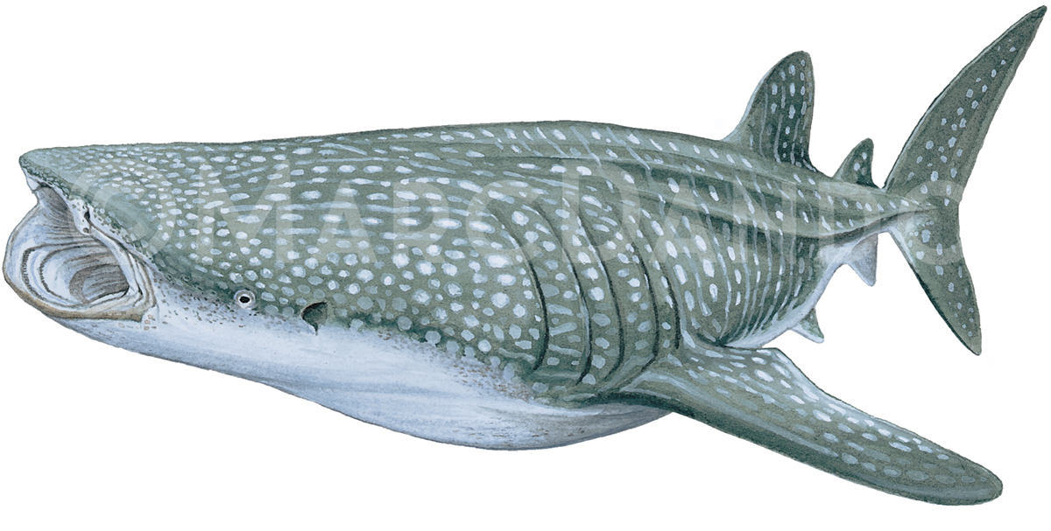

Class: | Chondrichthyes
Order: | Orectolobiformes
Family: | Rhincodontidae
Species: | Rhincodon typus
Whale shark
Requin-baleine
Tiburón ballena

Illustration: © Marc Dando

BIOLOGY
The Whale shark (Rhincodon typus) is the world’s largest living fish (<20m), found globally in tropical and warm temperate waters (Chen 2002; Rowat & Brooks 2012). Coastal feeding aggregations are known from these filter feeders, where they exploit seasonal productivity of pelagic invertebrates, fish spawning events, and small schooling fishes. Although encounters are rarely associated with surface temperatures below 21°C, whale sharks are capable of withstanding temperatures as low as 4.2°C during dives to up to 1,900 m (Colman 1997; Duffy 2002; Afonso et al. 2014; Tyminski et al. 2015). Their reproductive ecology is poorly understood but associated with slow growth and late maturity and therefore a limited reproductive capacity.

DISTRIBUTION
Whale sharks are distributed circum-tropically from approximately 30°N to 35°S with seasonal variations (Rowat & Brooks 2012; Sequeira et al. 2014). Several aggregation sites are distributed over all three ocean basins, with major subpopulations in the Atlantic Ocean and Indo-Pacific (Sequeira et al. 2013). Nonetheless, evidence of the connectivity of the Atlantic and Indo-Pacific subpopulations remains contradictory but are considered as functionally separated by the latest IUCN species assessment (Sequeira et al. 2013; Vignaud et al. 2014; Pierce & Norman 2016).

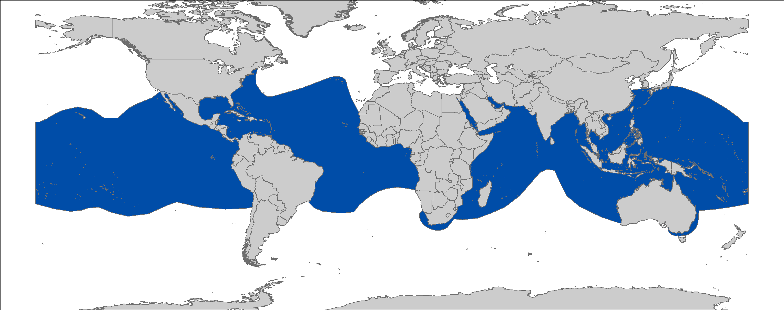
Figure 1: Distribution of Rhincodon typus, courtesy of IUCN.

CRITICAL SITES
Critical sites of whale sharks are comprised of aggregation sites, typically dominated by specific age classes (juvenile males in coastal feeding aggregations, and adult sharks at seamounts and volcanic islands) and migration corridors. Thus, they are critical for the species and urgently need to be protected from targeted and incidental fisheries. Known sites, which are important feeding, pupping or mating grounds comprise inter alia.

POPULATION STATUS AND TRENDS
Two global-scale genetic studies on whale sharks have estimated genetic effective population size. Castro et al. (2007) used mitochondrial DNA to estimate current genetic effective population size to be 119,000 – 238,000 sharks. Schmidt et al. (2009) estimated genetic effective population size to be approximately 103,000. An estimated 75% whale sharks inhabit the Indo-Pacific, while 25% occur in the Atlantic. Overall, the global population experienced an estimated decline of 50% over the last three generations (75 years). (Pierce & Norman 2016). In addition to the decline in abundance, a decline in mean total length was also reported from a number of locations. The current IUCN Red List status for the global populations for whale sharks is Endangered (Pierce & Norman 2016).
Estimated Decline | Region | Time Period | Reference
ATLANTIC
≥30% | Whole Atlantic | Last 75 years | Pierce & Norman 2016
~70% | Western Africa | 1980 - 2010 | Sequeira et al. 2014
INDO-PACIFIC
50 to 63% | Whole Indo-Pacific | Last 75 years | Pierce & Norman 2016
~66% | Western & Central  Indian Ocean | 1991- 2007 | Sequeira et al. 2013
50% | Western Central Pacific | 2003 - 2012 | Harley et al. 2013
Estimated Decline | Region | Time Period | Reference
> 79% | Tofo, Inhambane,Mozambique | 2005 - 2016 | Rohner et al. 2013; S Pierce unpubl. data.
~92% | Andaman Sea, Thailand | 1992 - 2001 | Theberge & Dearden 2006
40% (controversial) | Ningaloo Reef, Western Australia | 1995 - 2004 | Bradshaw et al. 2008
~60% | Pamilacan, Philippines | 1993 - 1997 | Alava et al. 2002
~60% | Guiwanon, Philippines | 1993 - 1997 | Alava et al. 2002
~80% | Hongchun Harbour, Taiwan, China | 1980s - 1995 | Chen & Phipps 2002
~50% | Taiwan | 1997 - 2002 | Chen & Phipps 2002

THREATS
- Fisheries: Whale sharks, incidentally captured in tuna purse seine or gillnet fisheries, are believed to have a predominant impact on a populations level than targeted fisheries (Pierce & Norman 2016). Although the current large-scale fisheries in southern China, where whale sharks are routinely captured and retained when sighted, are of major concern (Li et al. 2012).
- International trade: Recent surveys indicated that whale shark fins are demanding high prices, which could lead to increased targeted fisheries and trade (Li et al. 2012).
- Ship strikes: Whale sharks are exposed to the threat of vessel strikes due to their frequent feeding behaviour close to the surface. Propeller injuries are commonly recorded during monitoring programs (Rowat et al. 2007; Speed et al. 2008; Fox et al. 2013). However, the total scope of this issue remains largely unexplored.
- Climate change: Climate change might have adverse effects on prey availability, ocean acidification and currents. The dimension of these effects and how whale sharks will manage to cope with them remains uncertain.
- Pollution: Environmental pollution events occurring in whale shark hotspots, such as the Deepwater Horizon oil spill in the Gulf of Mexico could have population level impacts (McKinney et al. 2012). As filter feeding organisms, they are likely to be affected by high concentrations of microplastic pollution (Fossi et al. 2017).
- Tourism: Tourism activities may increase the risk of vessel strikes, local disturbance from interference, crowding or provisioning.

KEY KNOWLEDGE GAPS
The existing knowledge about basic facts concerning their life history traits, reproductive ecology or population size of the world’s largest fish is still very limited, although significant progress has been made compared to other species of sharks. Great uncertainty can be found when looking at connectivity between populations and trends. Apart from biological knowledge gaps, the impact of threats, like harvest & trade level trends, frequency of vessel strikes, or impact of climate change & pollution need more science and fisheries-based attention.

KEY MANAGEMENT AND CONSERVATION GAPS
- A number of Range States that are Signatories to the Sharks MOU and/or Parties to CMS do not provide legal protection for whale sharks or establish sufficient enforcement.
- Regional/multilateral cooperation is lacking.
- Some RFBs have not agreed on any measures for whale shark protection (International Commission for the Conservation of Atlantic Tunas).
- Existing laws & measures for whale shark protection lack enforcement.
- Support for scientific research and monitoring is sparse.
- No mitigation for gillnets fisheries has been put in place by IOTC.

RECOMMENDATIONS FOR CONSERVATION AND MANAGEMENT ACTION
A multifaceted approach is required to address the management and conservation gaps for whale sharks. Sharks MOU Signatories and other Range States are encouraged:

- Incorporate conservation measures for whale sharks into national legislation of all Parties/Signatories (in line with CMS Appendix II & the Objective of the Sharks MOU)

    - Evaluate & revise the current implementation/compliance with CITES Appendix II obligations and RFBs/RFMO measures;
- Make effective enforcement a high priority;
- Adopt the Port State Measures Agreement and Implement port-state controls;
- Conduct market surveys and patrols;
- Patrol in protected areas;
- Prosecute exporters.

- Improve the understanding of whale sharks through strategic research, monitoring and information exchange

- Investigate whale shark aggregation sites, seasonality, population connectivity & migrations to support development of spatial fisheries management;
- Assess the impacts of bycatch, climate change & pollution on whale sharks;
- Develop capacity in research, data collection & monitoring;
- Address data gaps in biological knowledge (life history parameters, reproductive ecology) of whale sharks;
- Conduct long-term monitoring of whale shark populations;
- Share research results and expertise with other stakeholders/Range States/Sharks MOU Secretariat.

- Improve multilateral cooperation among regions & RFBs
- Communicate your actions to the public and other Range States;
- Increase awareness about the CMS Sharks MOU in the South-east Asian region by highlighting the benefits whale shark conservation brings to countries and communities;
- Engage neighboring countries, including non-Signatory Range States to protect whale sharks and encourage their integration in conservation approaches (e.g. via joint workshops);
- Cooperate with RFBs and RSCs on:
  - Developing and supporting proposals for minimum on board observer coverage on commercial shipping lines & fishing vessels to gain information on vessel strikes, bycatch & fisheries interactions;
  - Collating information on bycatch & fisheries interaction to assess the level of impact;
  - Developing potential bycatch mitigation strategies;
  - Supporting the ban of setting of purse-seine nets around whale sharks by ICCAT.

- Minimize interactions between fisheries and whale sharks
- Collect information on the scale of bycatch and fisheries interaction to assess the level of impact on whale sharks & any potential mitigation strategies;
- Introduce spatio-temporal gear restrictions around whale shark aggregation sites;
- Adopt & promote safe release and handling guidelines;
- Promote data reporting, safe release & prohibition requirements;
- Encourage IOTC to devise mitigation strategies for gillnet fisheries;
- Encourage ICCAT to develop a recommendation on the use of FADs, which would include recommendations for the entanglement of whale sharks.

- Improve/implement national fisheries reporting
- Support proposals for Establish a reporting scheme for whale sharks;
- Standardize species-specific bycatch reporting scheme (national fisheries & RFMOs);
- Disseminate identification materials;
- Train observers (customs officers, scientists and NGOs).

- Support development of alternate livelihoods for communities reliant on Whale shark fisheries
- Develop & implement unified guidelines for sustainable whale shark tourism (support Philippines with Concerted Actions proposal);
- Promote non-consumptive usage, sustainable fisheries & aquaculture;
- Assist with raising capital for expenses of implementation.

- Raise awareness about the threats to whale sharks and reduce the demand for fins
- Inform the public about the need of shark conservation via educational, social media and local outreach campaigns;
- Develop science-based campaigns for demand reduction;
- Highlight the threats posed to whale sharks & health risk of the consumer (heavy metals).

- LEGAL INSTRUMENTS

Instrument | Description
Cartagena Convention  Convention for the Protection and Development of the Marine Environment of the Wider Caribbean Region | Annex III: Parties may regulate the use of these species of flora and fauna in order to ensure and maintain their populations at the highest possible levels.
CCSBT  Commission for the Conservation of Southern Bluefin Tuna | CCSBT encourages both Members and Cooperating Non-Members to comply with a variety of binding and non-binding measures in order to protect species ecologically related to Southern bluefin tuna, including sharks.
CITES  Convention on International Trade in Endangered Species of Wild Fauna and Flora | Appendix II: Species not necessarily threatened with extinction, but in which trade must be controlled in order to avoid utilization incompatible with their survival.
CMS  Convention on the Conservation of Migratory Species of Wild Animals | Appendix I: Migratory species threatened with extinction; CMS Parties strive towards strictly protecting these species, conserving or restoring the places where they live, mitigating obstacles to migration and controlling other factors that might endanger them.
 | Appendix II: Migratory species that have an unfavourable conservation status and need or would significantly benefit from international cooperation; CMS Parties shall endeavour to conclude global or regional agreements to benefit these species.
FAO  Food and Agriculture Organization | IPOA Sharks: International Plan of Action for Conservation and Management of Sharks
IATTC  Inter-American Tropical Tuna Commission | Res. C-16-01: Amendment of resolution C-15-03 on the collection and analysis of data on fish-aggregating devices  Res. C-16-04: Amendment to resolution C-05-03 on the conservation of sharks caught in association with fisheries in the eastern Pacific Ocean  Res. C-16-05: Resolution on the management of shark species
IOTC  Indian Ocean Tuna Commission | Res. 13/05: On the conservation of Whale Sharks (Rhincodon typus)  Res. 13/06: On a scientific and management framework on the conservation of sharks species caught in association with IOTC managed fisheries  Res. 15/09: On a fish aggregating devices (FADs) working group  Res. 17/05: On the conservation of sharks caught in association with fisheries managed by IOTC  Res. 17/07: On the prohibition to use large-scale driftnets in the IOTC Area  Res 17/08: Procedures on a FADs Management Plan including limitation on number of FADs, more detailed specifications of catch reporting from FAD sets, & development of improved designs to reduce incidence of entanglement of non-target species
Sharks MOU  Memorandum of Understanding on the Conservation of Migratory Sharks | Annex 1: Signatories should endeavour to achieve and maintain a favourable conservation status for these species based on the best available scientific information and taking into account their socio-economic value.
UNCLOS  United Nations Convention on the Law of the Sea | Annex I: States whose nationals fish in the region for the highly migratory species listed shall cooperate directly or through appropriate international organizations to ensure the conservation and optimum utilization of such species throughout the region, both within and beyond the exclusive economic zone.
WCPFC  Western & Central Pacific Fisheries Commission | CMM 2008-04: Conservation and management measures to prohibit the use of large sale driftnets on the high seas in the Convention Area  CMM 2009-02: Conservation and management measures on the application of high seas FAD closure and catch retention  CMM 2010-07: Conservation and management measures for sharks  CMM 2012-04: Conservation and management measure for protection of Whale Sharks from purse seine fishing operations  CMM 2014-05: Conservation and management measures for sharks

- KNOWN CRITICAL SITES
Critical sites for whale shark may include known areas of aggregation in various locations around the world (Pierce and Norman 2016). These sites function as feeding areas or areas where mating takes place. A compilation of these sites and their purpose (i.e. feeding, mating, etc.) is ongoing and being complemented by current research efforts.

REFERENCES

Acuña-Marrero D, Jiménez J, Smith F, Doherty Jr PF, Hearn A, Green JR, Paredes-Jarrín J, Salinas-de-León P 2014. Whale shark (Rhincodon typus) seasonal presence, residence time and habitat use at Darwin Island, Galapagos Marine Reserve. PLoS One 9: e115946.
Afonso P, McGinty N, Machete M 2014. Dynamics of whale shark occurrence at their fringe oceanic habitat. PLoS One 9: e102060.
Alava, M.N.R., 2002. Conservation and management of Whale Sharks in the Philippines. In Shark Conference (pp. 13-16).
Anderson R, Ahmed H 1993. The shark fisheries of the Maldives. FAO, Rome, and Ministry of Fisheries, Male, Maldives.
Araujo G, Lucey A, Labaja J, So CL, Snow S, Ponzo A 2014. Population structure and residency patterns of whale sharks, Rhincodon typus, at a provisioning site in Cebu, Philippines. PeerJ 2: e543.
Berumen ML, Braun CD, Cochran JE, Skomal GB, Thorrold SR 2014. Movement patterns of juvenile whale sharks tagged at an aggregation site in the Red Sea. PLoS One 9: e103536.
Bradshaw, C.J., Fitzpatrick, B.M., Steinberg, C.C., Brook, B.W. and Meekan, M.G., 2008. Decline in whale shark size and abundance at Ningaloo Reef over the past decade: the world’s largest fish is getting smaller. Biological Conservation, 141(7), pp.1894-1905.
Brooks K, Rowat D, Pierce SJ, Jouannet D, Vely M 2010. Seeing spots: photo-identification as a regional tool for whale shark identification. Western Indian Ocean Journal of Marine Science 9: 185-194.
Castro A, Stewart B, Wilson S, Hueter R, Meekan M, Motta P, Bowen B, Karl S 2007. Population genetic structure of Earth's largest fish, the whale shark (Rhincodon typus). Molecular ecology 16: 5183-5192.
Chen C-TL, KM; Joung, SJ; 2002. Preliminary report on Taiwan’s whale shark fishery. Elasmobranch Biodiversity, Conservation and Management: Proceedings of the International Seminar and Workshop, Sabah, Malaysia, July 1997: 162.
Chen, V.Y. and Phipps, M.J., 2002. Management and trade of whale sharks in Taiwan. TRAFFIC East Asia-Taipei.
Clark E, Nelson DR 1997. Young whale sharks, Rhincodon typus, feeding on a copepod bloom near La Paz, Mexico. Environmental Biology of Fishes 50: 63-73.
Colman J 1997. A review of the biology and ecology of the whale shark. Journal of Fish Biology 51: 1219-1234.
Duffy C 2002. Distribution, seasonality, lengths, and feeding behaviour of whale sharks (Rhincodon typus) observed in New Zealand waters.
Fossi MC, Baini M, Panti C, Galli M, Jiménez B, Muñoz-Arnanz J, Marsili L, Finoia MG, Ramírez-Macías D 2017. Are whale sharks exposed to persistent organic pollutants and plastic pollution in the Gulf of California (Mexico)? First ecotoxicological investigation using skin biopsies. Comparative Biochemistry and Physiology Part C: Toxicology & Pharmacology.
Fox S, Foisy I, De La Parra Venegas R, Galván Pastoriza B, Graham R, Hoffmayer E, Holmberg J, Pierce S 2013. Population structure and residency of whale sharks Rhincodon typus at Utila, Bay Islands, Honduras. Journal of Fish Biology 83: 574-587.
Gifford A, Compagno LJ, Levine M, Antoniou A 2007. Satellite tracking of whale sharks using tethered tags. Fisheries Research 84: 17-24.
Graham RT, Roberts CM 2007. Assessing the size, growth rate and structure of a seasonal population of whale sharks (Rhincodon typus Smith 1828) using conventional tagging and photo identification. Fisheries Research 84: 71-80.
Harley S, Williams P, Rice J 2013. Spatial and temporal distribution of whale sharks in the western and central Pacific Ocean based on observer data and other data sources.
Hearn AR, Green J, Román MH, Acuña-Marrero D, Espinoza E, Klimley AP 2016. Adult female whale sharks make long-distance movements past Darwin Island (Galapagos, Ecuador) in the Eastern Tropical Pacific. Marine Biology 163: 214.
Heyman WD, Graham RT, Kjerfve B, Johannes RE 2001. Whale sharks Rhincodon typus aggregate to feed on fish spawn in Belize. Marine Ecology Progress Series 215: 275-282.
Li W, Wang Y, Norman B 2012. A preliminary survey of whale shark Rhincodon typus catch and trade in China: an emerging crisis. Journal of Fish Biology 80: 1608-1618.
Macena BCL, Hazin FHV 2016. Whale Shark (Rhincodon typus) Seasonal Occurrence, Abundance and Demographic Structure in the Mid-Equatorial Atlantic Ocean. PLoS One 11: e0164440.
McKinney JA, Hoffmayer ER, Wu W, Fulford R, Hendon JM 2012. Feeding habitat of the whale shark Rhincodon typus in the northern Gulf of Mexico determined using species distribution modelling. Marine Ecology Progress Series 458: 199-211.
Meekan MG, Bradshaw CJ, Press M, McLean C, Richards A, Quasnichka S, Taylor JG 2006. Population size and structure of whale sharks Rhincodon typus at Ningaloo Reef, Western Australia. Marine Ecology Progress Series 319: 275-285.
Motta PJ, Maslanka M, Hueter RE, Davis RL, De la Parra R, Mulvany SL, Habegger ML, Strother JA, Mara KR, Gardiner JM 2010. Feeding anatomy, filter-feeding rate, and diet of whale sharks Rhincodon typus during surface ram filter feeding off the Yucatan Peninsula, Mexico. Zoology 113: 199-212.
Nelson JD, Eckert SA 2007. Foraging ecology of whale sharks (Rhincodon typus) within Bahía de los Angeles, Baja California Norte, México. Fisheries Research 84: 47-64.
Pacheco-Polanco JD, Herra-Miranda D, Oviedo-Correa L, Quirós-Pereira W, Figgener C Whale shark, Rhincodon typus (Orectolobifoms: Rhincodontidae) feeding aggregations in Golfo Dulce, Osa Peninsula, Costa Rica. Revista de Biología Tropical 63: 299-306.
Pierce SJ, Norman B 2016. Rhincodon typus. The IUCN Red List of Threatened Species.
Pierce SJ, Méndez‐Jiménez A, Collins K, Rosero‐Caicedo M 2010. Developing a code of conduct for whale shark interactions in Mozambique. Aquatic Conservation: Marine and Freshwater Ecosystems 20: 782-788.
Quiros AL 2007. Tourist compliance to a Code of Conduct and the resulting effects on whale shark (Rhincodon typus) behavior in Donsol, Philippines. Fisheries Research 84: 102-108.
Robinson DP, Jaidah MY, Jabado RW, Lee-Brooks K, El-Din NMN, Malki AAA, Elmeer K, McCormick PA, Henderson AC, Pierce SJ 2013. Whale sharks, Rhincodon typus, aggregate around offshore platforms in Qatari waters of the Arabian Gulf to feed on fish spawn. PLoS One 8: e58255.
Robinson DP, Jaidah MY, Bach S, Lee K, Jabado RW, Rohner CA, March A, Caprodossi S, Henderson AC, Mair JM 2016. Population Structure, Abundance and Movement of Whale Sharks in the Arabian Gulf and the Gulf of Oman. PLoS One 11: e0158593.
Rohner CA, Armstrong AJ, Pierce SJ, Prebble CE, Cagua EF, Cochran JE, Berumen ML, Richardson AJ 2015. Whale sharks target dense prey patches of sergestid shrimp off Tanzania. Journal of plankton research: fbv010.
Rowat D, Gore M 2007. Regional scale horizontal and local scale vertical movements of whale sharks in the Indian Ocean off Seychelles. Fisheries Research 84: 32-40.
Rowat D, Brooks K 2012. A review of the biology, fisheries and conservation of the whale shark Rhincodon typus. Journal of Fish Biology 80: 1019-1056.
Rowat D, Meekan M, Engelhardt U, Pardigon B, Vely M 2007. Aggregations of juvenile whale sharks (Rhincodon typus) in the Gulf of Tadjoura, Djibouti. Environmental Biology of Fishes 80: 465-472.
Rowat D, Brooks K, March A, McCarten C, Jouannet D, Riley L, Jeffreys G, Perri M, Vely M, Pardigon B 2011. Long-term membership of whale sharks (Rhincodon typus) in coastal aggregations in Seychelles and Djibouti. Marine and Freshwater Research 62: 621-627.
Rowat DR, Leblond ST, Pardigon B, Vely M, Jouannet D, Webster IA 2016. Djibouti–a kindergarten for whale sharks? QScience Proceedings: 54.
Schleimer A, Araujo G, Penketh L, Heath A, McCoy E, Labaja J, Lucey A, Ponzo A 2015. Learning from a provisioning site: code of conduct compliance and behaviour of whale sharks in Oslob, Cebu, Philippines. PeerJ 3: e1452.
Schmidt JV, Schmidt CL, Ozer F, Ernst RE, Feldheim KA, Ashley MV, Levine M 2009. Low genetic differentiation across three major ocean populations of the whale shark, Rhincodon typus. PLoS One 4: e4988.
Sequeira A, Mellin C, Meekan M, Sims D, Bradshaw C 2013. Inferred global connectivity of whale shark Rhincodon typus populations. Journal of Fish Biology 82: 367-389.
Sequeira AM, Mellin C, Floch L, Williams PG, Bradshaw CJ 2014. Inter-ocean asynchrony in whale shark occurrence patterns. Journal of Experimental Marine Biology and Ecology 450: 21-29.
Speed C, Meekan M, Rowat D, Pierce S, Marshall A, Bradshaw C 2008. Scarring patterns and relative mortality rates of Indian Ocean whale sharks. Journal of Fish Biology 72: 1488-1503.
Taylor JG 2007. Ram filter-feeding and nocturnal feeding of whale sharks (Rhincodon typus) at Ningaloo Reef, Western Australia. Fisheries Research 84: 65-70.
Theberge, M.M. and Dearden, P., 2006. Detecting a decline in whale shark Rhincodon typus sightings in the Andaman Sea, Thailand, using ecotourist operator-collected data. Oryx, 40(3), pp.337-342.
Tyminski JP, de la Parra-Venegas R, Cano JG, Hueter RE 2015. Vertical Movements and Patterns in Diving Behavior of Whale Sharks as Revealed by Pop-Up Satellite Tags in the Eastern Gulf of Mexico. PLoS One 10: e0142156.
Vignaud TM, Maynard JA, Leblois R, Meekan MG, Vázquez‐Juárez R, Ramírez‐Macías D, Pierce SJ, Rowat D, Berumen ML, Beeravolu C 2014. Genetic structure of populations of whale sharks among ocean basins and evidence for their historic rise and recent decline. Molecular ecology 23: 2590-2601.
Wilson SG, Taylor JG, Pearce AF 2001. The seasonal aggregation of whale sharks at Ningaloo Reef, Western Australia: currents, migrations and the El Nino/Southern Oscillation. Environmental Biology of Fishes 61: 1-11.

See the IUCN website for further details on the population assessment: http://www.iucnredlist.org/details/19488/0.

