Memorandum of Understanding on
the Conservation of Migratory Sharks

Thresher Sharks Fact Sheet
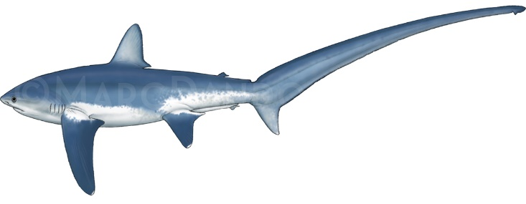
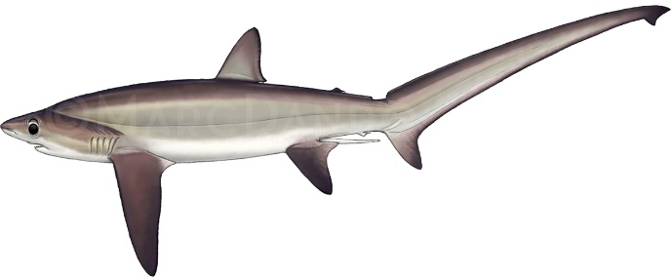
Alopias superciliosus – Bigeye Thresher Alopias vulpinus – Common Thresher

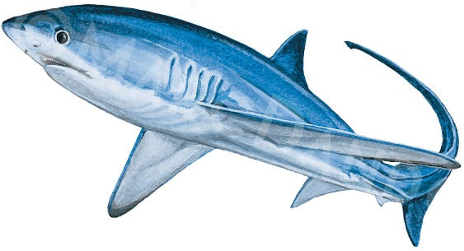

Alopias pelagicus – Pelagic Thresher

Class: | Chondrichthyes
Order: | Lamniformes
Family: | Alopiidae
Species: | Alopias superciliosus – Bigeye Thresher  Alopias vulpinus – Common Thresher  Alopias pelagicus – Pelagic Thresher

Thresher sharks
Requins-renard
Tiburón azotador

Illustration: © Marc Dando

BIOLOGY
All three species of thresher shark belong to the genus Alopias and include the Pelagic (Alopias pelagicus), Bigeye (Alopias superciliosus) and Common (Alopias vulpinus) Thresher. Whilst all three species have biological characteristics that result in very low productivity, A. superciliosus in particular is one of the less productive pelagic shark species, due to the very low fecundity (2 pups per cycle) and late maturity (12–13 years for females). Several demographic studies have ranked this species as one of the least productive elasmobranch (Cortes 2002). In contrast, A. vulpinus, which attains the largest size, is the fastest growing and earliest-maturing of the three species (Smith et al. 2008).

DISTRIBUTION
Alopias superciliosus and A. vulpinus occur circumglobally, whilst A. pelagicus is restricted to the Indian and Pacific Oceans. All three species are epipelagic, occurring in the upper parts of the water column, but their depth range can extend to deeper (500–750 m) water. Whilst often associated with oceanic habitats, both A. vulpinus and A. pelagicus are often associated with shelf sea habitats and may occur in shallower water close to land. Their latitudinal distributions are restricted mainly to tropical and warm temperate waters, with A. vulpinus also extending into higher latitudes (Compagno 2001).

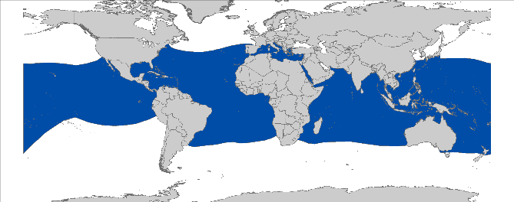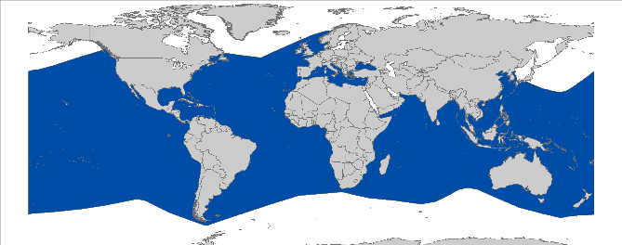

Alopias superciliosus Alopias vulpinus
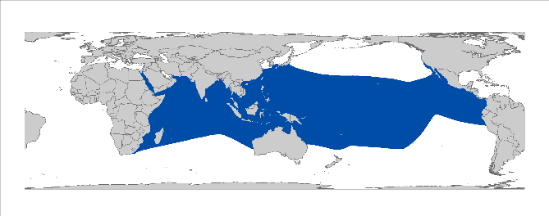
Alopias pelagicus

Figure 1: Distribution of thresher shark species, courtesy of IUCN.

CRITICAL SITES
Critical sites are those habitats that may have a key role for the conservation status of a shark population, and may include feeding, mating, pupping, overwintering grounds and other aggregation sites, as well as corridors between these sites such as migration routes. Critical sites have not been accurately defined and delineated for these species in all areas, but some potentially important grounds have been proposed, such as the Southern California Bight (Cartamil et al., 2010) and the waters south of the Iberian Peninsula (Moreno & Morón, 1992).

POPULATION STATUS AND TRENDS
Most information available on the population status and trends in thresher sharks consists of fisheries catch data which, in many cases is not species-specific. The stock structures of all thresher sharks have not been defined, due to a lack of appropriate data. Ecological Risk Assessments have been conducted by tuna-RFMOs including A. superciliosus and A. vulpinus in the ICCAT area, and all three species in the IOTC and IATTC areas. All have shown that thresher sharks are amongst the most vulnerable of the pelagic shark species. In WCPFC, Rice et al. (2015) conducted an indicator-based analysis and found that there had been a decrease in the CPUEs of the thresher shark complex over the period 1995-2014. However, the index is difficult to interpret as most catches are not reported to species level (Rice et al. 2015). A sustainability risk assessment for A. superciliosus in the Pacific Ocean reported that while fishing mortality of this species is low in Pacific longline fisheries, it has exceeded the sustainability in some years (Fu et al. 2018). Young et al. (2016) reported the standardized CPUE of bigeye thresher shark using Hawaiian longline observer data for the period between 1995 and 2014, which shows general flat trend with large increase of the nominal CPUE in most recent years. The IUCN Red List assessed the global populations of A. superciliosus (Amorim et al. 2009), A. vulpinus (Goldman et al. 2009), and A. pelagicus (Reardon et al. 2009) to be Vulnerable.

Species | Region | Trend | Time Period | Reference
ATLANTIC
A. vulpinus,  A. superciliosus | NW Atlantic Ocean | Stable | 1992-2014 |  | (Young et al. 2016)
INDO-PACIFIC
All species | Central Pacific Ocean | 83% decline | 1951-1958 and 1999-2002 |  | (Ward & Myers 2005)
All species | Central Pacific Ocean | 9.5% decline in deep sets 43% decline in shallow sets | 1995–2000 and 2004–2006 |  | (Walsh et al. 2009)
A. superciliosus | Central Pacific Ocean | Stable | 1995-2014 |  | Young et al. (2016).
A. vulpinus | Eastern Pacific Ocean | Increasing, population is at 94% of its unexploited level | 1969-2014 |  | (Teo et al. 2016)
All species | Central Pacific | No clear trend | 1995-2006 |  | (Clarke et al. 2011)
All species | Western Central Pacific | No clear trend | 1996-2010 |  | (Clarke et al. 2011)
A. pelagicus  A. superciliosus | Arabian Sea and adjacent waters | Over 50% decline | 1961-2017 |  | (Jabado et al. 2017)

THREATS
- Fisheries: Alopias spp. are commonly taken on longlines, in fixed bottom and pelagic gillnets, in midwater and pelagic trawls, and purse seine (Maguire 2006), with many coastal and oceanic pelagic fisheries supplying domestic markets with meat. Despite this, catch and effort data are incomplete, especially for those species taken in both shelf seas and oceanic habitats Thresher sharks are also taken in recreational fisheries in some areas.
- International trade: The underlying driver of the targeting, retention of bycatch, and international trade in thresher sharks consists of the demand for their fins and meat. Thresher sharks have been found to account for approximately for 2–6% of sharks in the Hong Kong market (Clarke et al. 2006a; Clarke et al. 2006b). However, the fin market has changed since then and the current situation is unclear.

KEY KNOWLEDGE GAPS
- Data on population size, distribution, connectivity and trends are widely lacking for all three species. Especially limited knowledge exists on the pelagic thresher throughout its range (Reardon et al. 2009). Reliable information about harvest and demand levels are scarce;
- Little is known about the characteristics and locations of important habitats (which may include parturition and nursery areas, overwintering grounds, feeding grounds, mating grounds and migration routes).

KEY MANAGEMENT AND CONSERVATION GAPS
- Target fisheries on Alopias spp. are prohibited in EU waters and in ICCAT and WCPFC fisheries, whereby there is no-retention agreed under ICCAT for bigeye thresher and under IOTC for all species;
- Stock assessments have been conducted only for common thresher in the East Pacific (Teo et al. 2016);
- National fishery or conservation measures are limited;
- Critical sites have not been identified and delineated;
- Fishery data (landings, discards, size frequency, catch and effort) are lacking in most areas and is rarely provided at a species-specific level.

RECOMMENDATIONS FOR CONSERVATION AND MANAGEMENT ACTION
A multifaceted approach is required to address the management and conservation gaps for white sharks. Sharks MOU Signatories and other Range States are encouraged:

- Incorporate conservation measures for thresher sharks into national legislation of all Parties/Signatories

- Implement relevant international measures (e.g. CMS and RFMOs).

- Improve the understanding of thresher sharks through strategic research, monitoring and information exchange

- Identify critical sites of thresher sharks’ abundance and seasonality;
- Address data gaps in biological knowledge (life-history parameters) of all thresher sharks;
- Further investigate post-release survivorship of threshers to inform improved handling and release protocols;
- Enhance or develop where necessary collection of fishery data (including landings, discards, size frequency, catch and effort where needed);
- Develop stock assessment in cooperation with RFMOs for all three species;
- Conduct long-term monitoring of thresher shark populations.

- Improve multilateral cooperation among regions & RFBs

- Support the introduction of appropriate management and conservation measures for thresher sharks at international and regional fora (e.g. Co-sponsor proposals / resolutions within multilateral agreements);
- Promote better regional cooperation between RFMOs and RFBs (e.g. data-sharing or involvement in the Kobe process);
- Support development and implementation of appropriate management plans for thresher sharks;
- Identify synergies with other Range States/stakeholders to support coordinated and resource-effective research & conservation programs.

- Identify the effective approaches to reduce bycatch and improve survivorship of thresher sharks

- including gear modifications e.g. hook and trace type, and fishing practices e.g. soak time and safe release handling guidelines.

- Raise awareness about the threats to thresher sharks

- Inform the public about the need of shark conservation via educational, social media and local outreach campaigns

LEGAL INSTRUMENTS

Instrument | Description | Species
Barcelona Convention  Barcelona Convention for the Protection of the Marine Environment and the Coastal Region of the Mediterranean | Annex III: Species whose exploitation is regulated; Parties shall ensure the favourable state of conservation of these species by taking all appropriate measures, in cooperation with competent international organizations. | A. vulpinus
CCSBT  Commission for the Conservation of Southern Bluefin Tuna | CCSBT encourages both Members and Cooperating Non-Members to comply with a variety of binding and non-binding measures in order to protect species ecologically related to Southern bluefin tuna, including sharks. | A. vulpinus  A. pelagicus  A. superciliosus
CITES  Convention on International Trade in Endangered Species of Wild Fauna and Flora | Appendix II: Species not necessarily threatened with extinction, but in which trade must be controlled in order to avoid utilization incompatible with their survival. | A. vulpinus  A. pelagicus  A. superciliosus
CMS  Convention on the Conservation of Migratory Species of Wild Animals | Appendix II: Migratory species that have an unfavourable conservation status and need or would significantly benefit from international cooperation; CMS Parties shall endeavour to conclude global or regional agreements to benefit these species. | A. vulpinus  A. pelagicus  A. superciliosus
EU  European Union | Council Regulation (EC) No 1185/2003: establishes a general prohibition of the practice of ‘shark finning’, whereby a shark’s fins are removed and the remainder of the shark is discarded at sea.  Council Regulation (EU) 2018/120: prohibits for Union vessels in the ICCAT region to retain on board, tranship or land any part or whole carcass of bigeye thresher sharks (Alopias superciliosus) in any fishery and to undertake a directed fishery for species of thresher sharks of the Alopias genus. | A. vulpinus  A. pelagicus  A. superciliosus
FAO  Food and Agriculture Organization | IPOA Sharks: International Plan of Action for Conservation and Management of Sharks | A. vulpinus  A. pelagicus  A. superciliosus
GFCM  General Fisheries Commission for the Mediterranean | Rec. GFCM/36/2012/3: shark species listed under Annex III of the Barcelona Convention cannot be retained on board, transshipped, landed, transferred, stored, sold or displayed or offered for sale and must be released unharmed and alive to the extent possible. | A. vulpinus
IATTC  Inter-American Tropical Tuna Commission | Res. C-16-01: Amendment of resolution C-15-03 on the collection and analysis of data on fish-aggregating devices  Res. C-16-04:Amendment to resolution C-05-03 on the conservation of sharks caught in association with fisheries in the eastern Pacific Ocean  Res. C-16-05:Resolution on the management of shark species | A. vulpinus  A. pelagicus  A. superciliosus
ICCAT  International Commission for the Conservation of Atlantic Tunas | Res. 95-02: Cooperation with FAO to study status of stocks & shark by-catches  Res. 03-10: Resolution by ICCAT on shark fishery  Rec. 04-10: Recommendation by ICCAT concerning the conservation of sharks caught in association with fisheries managed by ICCAT  Rec. 07-06: Supplemental recommendation by ICCAT concerning sharks  Rec. 09-07: Recommendation by ICCAT on the conservation of thresher sharks caught in association with fisheries in the ICCAT Convention Area  Rec. 11-10: Recommendation by ICCAT on information collection and harmonization of data on bycatch and discards in ICCAT fisheries  Rec. 13-10: Recommendation on Biological Sampling of Prohibited Sharks Species by Scientific Observers | A. vulpinus  A. pelagicus  A. superciliosus
IOTC  Indian Ocean Tuna Commission | Res. 12/09: On the conservation of Thresher Sharks (Family Alopiidae) caught in association with fisheries in the IOTC Area of Competence  Res. 13/06: On a scientific and management framework on the conservation of shark species caught in association with IOTC managed fisheries  Res. 15/09: On a fish aggregating devices (FADs) working group  Res. 17/05: On the conservation of sharks caught in association with fisheries managed by IOTC  Res. 17/07: On the prohibition to use large-scale driftnets in the IOTC Area  Res 17/08: Procedures on a FADs Management Plan including limitation on number of FADs, more detailed specifications of catch reporting from FAD sets, & development of improved designs to reduce incidence of entanglement of non-target species | A. vulpinus  A. pelagicus  A. superciliosus
Sharks MOU  Memorandum of Understanding on the Conservation of Migratory Sharks | Annex 1: Signatories should endeavour to achieve and maintain a favourable conservation status for these species based on the best available scientific information and taking into account their socio-economic value. | A. vulpinus  A. pelagicus  A. superciliosus
UNCLOS  United Nations Convention on the Law of the Sea | Annex I: States whose nationals fish in the region for the highly migratory species listed shall cooperate directly or through appropriate international organizations to ensure the conservation and optimum utilization of such species throughout the region, both within and beyond the exclusive economic zone. | A. vulpinus  A. pelagicus  A. superciliosus
WCPFC  Western & Central Pacific Fisheries Commission | CMM 2008-04: Conservation and management measures to prohibit the use of large sale driftnets on the high seas in the Convention Area  CMM 2009-02: Conservation and management measures on the application of high seas FAD closure and catch retention  CMM 2010-07: Conservation and management measures for sharks  CMM 2014-05: Conservation and management measures for sharks | A. vulpinus  A. pelagicus  A. superciliosus

- KNOWN CRITICAL SITES

Country | Location |  | Site characteristics | Species | Reference
Pelagic areas | Northeastern Atlantic |  |  | A. superciliosus, A. vulpinus | (Manday 1975; Moreno et al. 1989; Fernandez-Carvalho et al. 2015)
 | Southwest Atlantic |  |  | A. superciliosus | (Gilmore 1993; Fernandez-Carvalho et al. 2015)
 | Southern North Sea |  | Potential nursery | Alopias vulpinus | (Ellis 2004)
 | Western Mediterranean |  |  | A. vulpinus | (Moreno et al. 1989; Fernandez-Carvalho et al. 2015)
 | Adriatic Sea |  | Potential nursery | A. vulpinus | (Ferretti et al. 2008; Fernandez-Carvalho et al. 2015)
 | Alboran Sea |  |  | A. superciliosus,  A. vulpinus | (Moreno et al. 1989; Moreno & Morón 1992; Tudela et al. 2005)
 | Gibraltar Strait region |  | Potential nursery | A. vulpinus, A. vulpinus | (Ferretti et al. 2008; ICES 2009)
 | South western Iberian Peninsula |  | Potential nursery | A. superciliosus | (Moreno & Morón 1992; Tudela et al. 2005; ICES 2009)
INDIAN OCEAN
India | Andaman Sea |  | Potential Nursery | A. pelagicus,  A. superciliosus | (Benjamin et al. 2015; Das et al. 2016)
Oman | Arabian Sea |  | Aggregation site | A. pelagicus,  A. superciliosus | (Jabado et al. 2015)
PACIFIC OCEAN
Mexico | Southern California Bight |  | Potential Nursery | A. vulpinus | (Cartamil et al. 2010)
USA |  | Southern California Bight | Nursery | A. vulpinus | (Cartamil et al. 2010)
 | 10–15°N and 150–180°W |  | Potential nursery | A. superciliosus | (Cartamil et al. 2010; Matsunaga & Yokawa 2013)

REFERENCES

Amorim, A., Baum, J., Cailliet, G.M., Clò, S., Clarke, S.C., Fergusson, I., Gonzalez, M., Macias, D., Mancini, P., Mancusi, C., Myers, R., Reardon, M., Trejo, T., Vacchi, M. & Valenti, S.V. 2009. Alopias superciliosus. The IUCN Red List of Threatened Species 2009: e.T161696A5482468.
Benjamin D, Madhusoodana Kurup B, Harikrishnan M, Varghese BC 2015. First Report on Recruits of Bigeye Thresher Shark Alopias superciliosus (Lamniformes: Alopidae) with Largest Birth Size from Indian Waters. International Journal of Scientific Research in Science, Engineering and Technology 1: 216-220.
Cartamil D, Wegner N, Kacev D, Ben-Aderet N, Kohin S, Graham J 2010. Movement patterns and nursery habitat of juvenile thresher sharks Alopias vulpinus in the Southern California Bight. Marine Ecology Progress Series 404: 249-258.
Clarke S, Harley S, Hoyle S, Rice J 2011. An indicator-based analysis of key shark species based on data held by SPC-OFP. In ed., WCPFC-SC7-2011/EB-WP-01. Pp.
Clarke SC, Magnussen JE, Abercrombie DL, McAllister MK, Shivji MS 2006a. Identification of shark species composition and proportion in the Hong Kong shark fin market based on molecular genetics and trade records. Conservation Biology 20: 201-211.
Clarke SC, McAllister MK, Milner‐Gulland EJ, Kirkwood G, Michielsens CG, Agnew DJ, Pikitch EK, Nakano H, Shivji MS 2006b. Global estimates of shark catches using trade records from commercial markets. Ecology letters 9: 1115-1126.
Compagno LJ 2001. Sharks of the world: an annotated and illustrated catalogue of shark species known to date, v.2. Food & Agriculture Org. pp.
Cortes E 2002. Incorporating uncertainty into demographic modeling: application to shark populations and their conservation. Conservation Biology 16: 1048-1062.
Das P, Sinha M, Bhargava A, Singh P, Sahu K, Mali K 2016. A Report on the Recruitments of Alopias pelagicus and Alopias superciliosus in the Andaman Sea. J Aquac Mar Biol 4(6): 00099.
Ellis J 2004. The occurrence of thresher shark off the Suffolk coast. Transactions of the Suffolk Naturalists' Society 40: 73-80.
Fernandez-Carvalho J, Coelho R, Mejuto J, Cortés E, Domingo A, Yokawa K, Liu K-M, García-Cortés B, Forselledo R, Ohshimo S 2015. Pan-Atlantic distribution patterns and reproductive biology of the bigeye thresher, Alopias superciliosus. Reviews in fish biology and fisheries 25: 551.
Ferretti F, Myers RA, Serena F, Lotze HK 2008. Loss of large predatory sharks from the Mediterranean Sea. Conservation Biology 22: 952-964.
Gilmore RG 1993. Reproductive biology of lamnoid sharks. Environmental Biology of Fishes 38: 95-114.
Goldman, K.J., Baum, J., Cailliet, G.M., Cortés, E., Kohin, S., Macías, D., Megalofonou, P., Perez, M., Soldo, A. & Trejo, T. 2009. Alopias vulpinus. The IUCN Red List of Threatened Species 2009: e.T39339A10205317.
ICES 2009. Working group on elasmobranch fisheries. ICES CM 2009/ACOM:16.
Jabado RW, Al Ghais SM, Hamza W, Shivji MS, Henderson AC 2015. Shark diversity in the Arabian/Persian Gulf higher than previously thought: insights based on species composition of shark landings in the United Arab Emirates. Marine Biodiversity 45: 719-731.
Jabado RW, Kyne PM, Pollom RA, Ebert DA, Simpfendorfer CA, Ralph GM, Dulvy NK, (eds.) 2017. The Conservation Status of Sharks, Rays, and Chimaeras in the Arabian Sea and Adjacent Waters. Environment Agency – Abu Dhabi, UAE and IUCN Species Survival Commission Shark Specialist Group, Vancouver, Canada 236 pp.
Maguire J-J 2006. The state of world highly migratory, straddling and other high seas fishery resources and associated species. Food & Agriculture Org. pp.
Manday DG 1975. Las pesquerías pelágico-oceánicas de corto radio de acción en la región noroccidental de Cuba. pp.
Matsunaga H, Yokawa K 2013. Distribution and ecology of bigeye thresher Alopias superciliosus in the Pacific Ocean. Fisheries science 79: 737-748.
Moreno J, Morón J 1992. Reproductive biology of the Bigeye Thresher Shark, Alopias superciliosus (Lowe, 1939). Marine and Freshwater Research 43: 77-86.
Moreno J, Parajna J, Moron J 1989. Breeding biology and phenology of Alopias vulpinus (Bonnaterre, 1788)(Squaliformes: Alopiidae) in the North-Eastern Atlantic and Western Mediterranean. Scientia Marina (Spain).
Reardon M, Márquez F, Trejo T, Clarke SC 2009. Alopias pelagicus. The IUCN Red List of Threatened Species 2009: e.T161597A5460720.
Rice, J., Tremblay-Boyer, L., Scott, R., Hare, S. and Tidd, A., 2015. Analysis of stock status and related indicators for key shark species of the Western Central Pacific Fisheries Commission. In Western and Central Pacific Fisheries Commission 11th Regular Session (pp. 1-146).
Smith SE, Rasmussen RC, Ramon DA, Cailliet GM 2008. The biology and ecology of thresher sharks (Alopiidae). Sharks of the Open Ocean: Biology, Fisheries and Conservation: 60-68.
Teo SL, Rodriguez EG, Sosa-Nishizaki O 2016. Status of common thresher sharks, Alopias vulpinus, along the west coast of North America. US Department of Commerce, National Oceanic and Atmospheric Administration, National Marine Fisheries Service, Southwest Fisheries Science Center. pp.
Tudela S, Kai AK, Maynou F, El Andalossi M, Guglielmi P 2005. Driftnet fishing and biodiversity conservation: the case study of the large-scale Moroccan driftnet fleet operating in the Alboran Sea (SW Mediterranean). Biological Conservation 121: 65-78.
Walsh WA, Bigelow KA, Sender KL 2009. Decreases in shark catches and mortality in the Hawaii-based longline fishery as documented by fishery observers. Marine and coastal fisheries: Dynamics, management, and ecosystem science: 270-282.
Ward P, Myers RA 2005. Shifts in open-ocean fish communities coinciding with the commencement of commercial fishing. Ecology 86: 835-847.
Young C, Carlson J, Hutchinson M, Kobayashi D, McCandless C, Miller M, Teo S, Warren T 2016. Status review report: common thresher shark (Alopias vulpinus) and bigeye thresher shark (Alopias superciliosus). In ed., Final Report to National Marine Fisheries Service, Office of Protected Resources. Pp.

Map requires updating: A. vulpinus likely does not occur in the Western Indian Ocean
See the IUCN website for further details on the population assessments: http://www.iucnredlist.org/details/161696/0, http://www.iucnredlist.org/details/39339/0, and http://www.iucnredlist.org/details/161597/0.
http://www.tuna-org.org

