Memorandum of Understanding on
the Conservation of Migratory Sharks

Basking Shark Fact Sheet

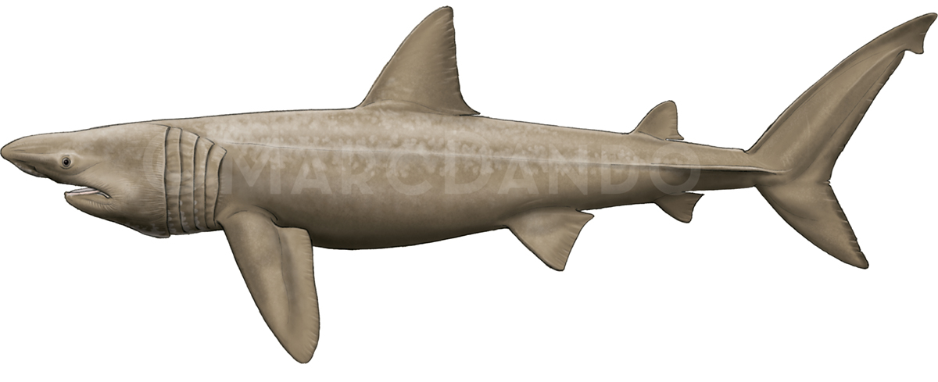

Class: | Chondrichthyes
Order: | Lamniformes
Family: | Cetorhinidae
Species: | Cetorhinus maximus
Basking Shark
Requin pèlerin
Tiburón peregrino

Illustration: © Marc Dando

BIOLOGY
The Basking Shark (Cetorhinus maximus) is a large (up to 12 m) temperate water species. It is a filter-feeder, and often forages around frontal systems and other oceanographic features with high densities of zooplankton. It can undertake considerable vertical (>1000 m) and horizontal movements (>9,000 km) (Skomal et al. 2009). Basking Shark has a low fecundity (~6 pups per litter, every 2-4 years), and females attain sexual maturity at a late age (possibly 16-20 years) and size (>8 m) (Matthews 1950; Compagno 1984; Sims 2008).

DISTRIBUTION
Basking Shark occurs in temperate and boreal waters of the northern hemisphere and is also present in both the South Atlantic, and South Pacific (Compagno 1984).

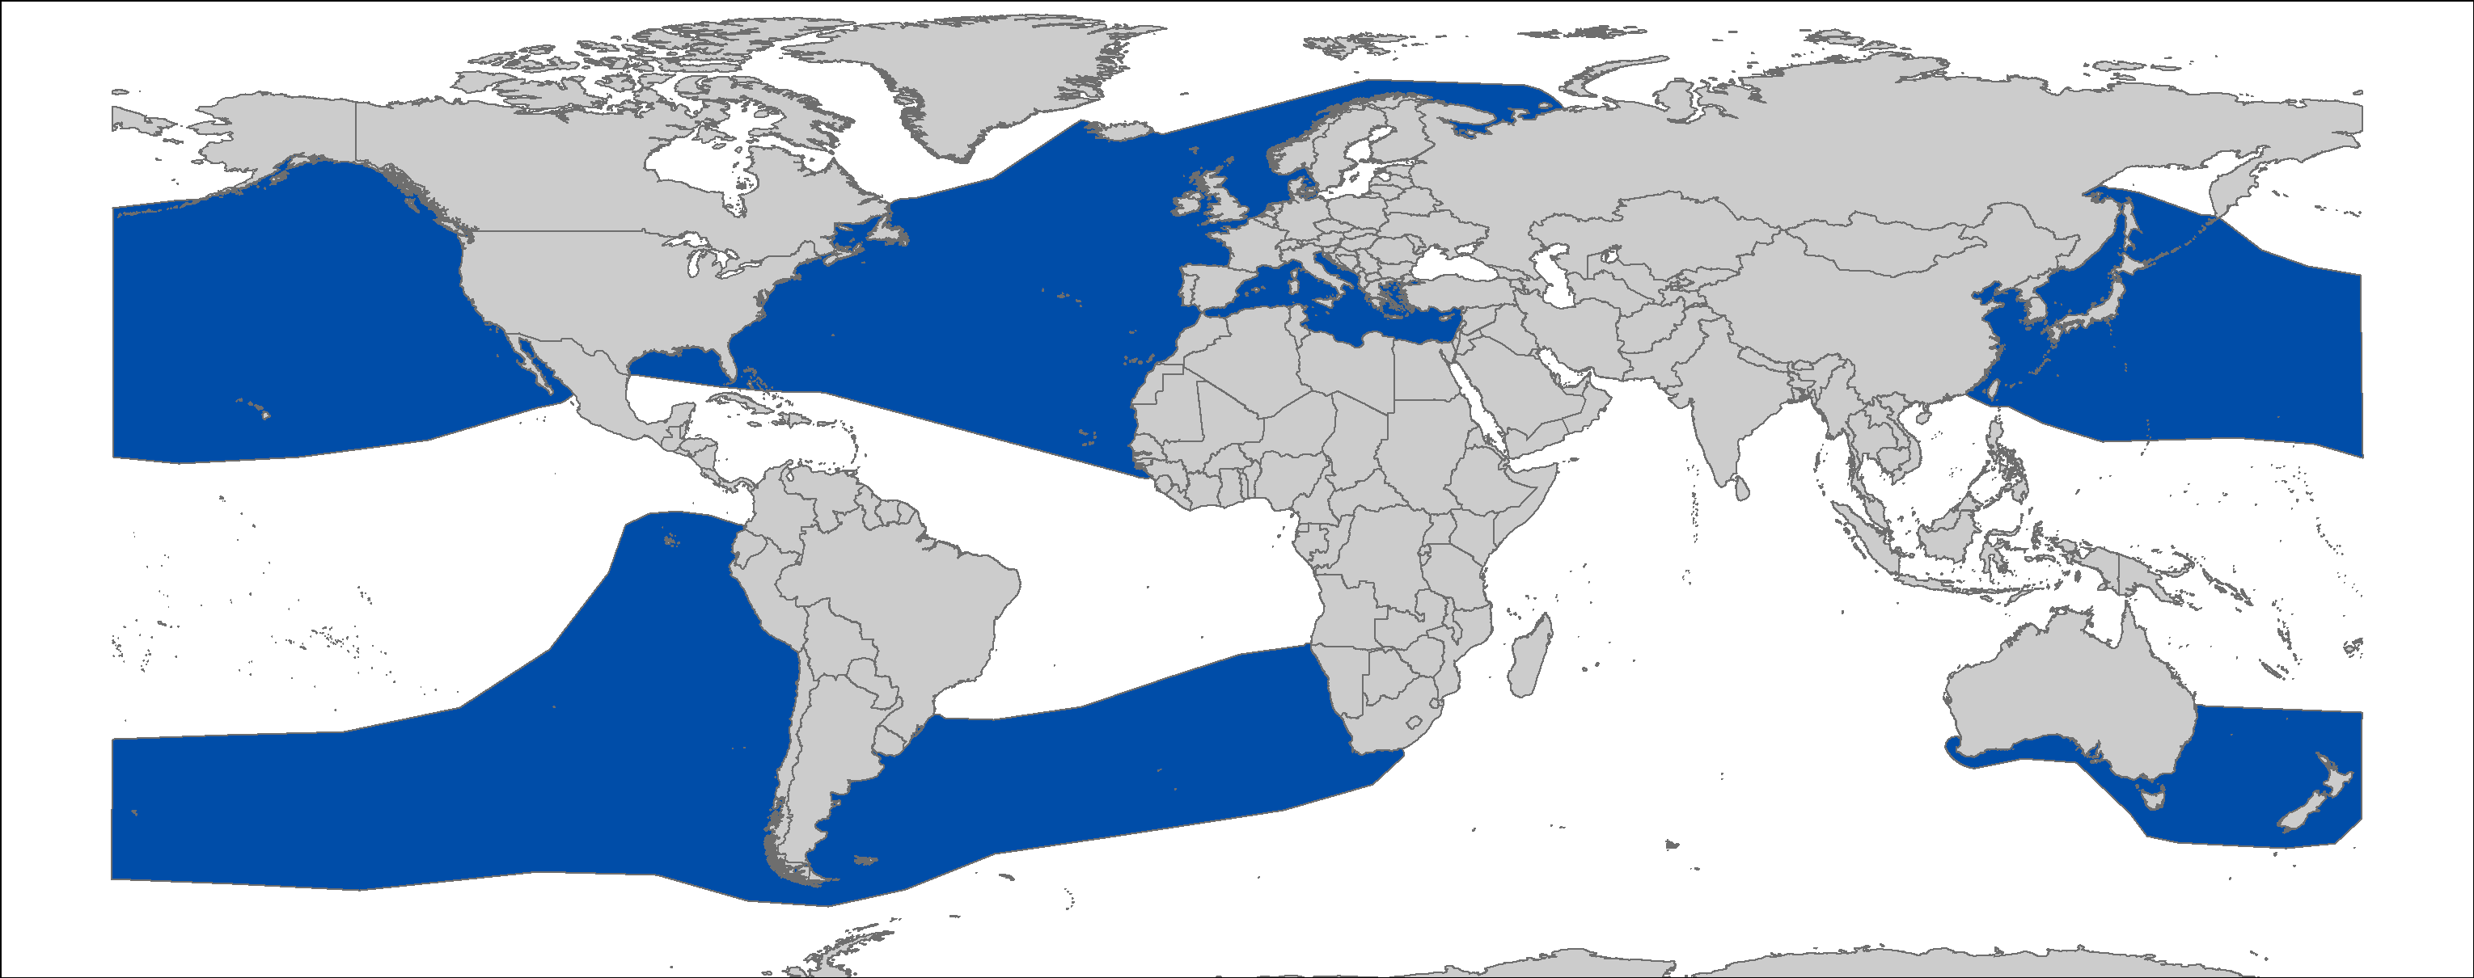
Figure 1: Distribution of Cetorhinus maximus, courtesy of IUCN.

CRITICAL SITES
Critical sites are those habitats that may have a key role for the conservation status of a shark population, and may include feeding, mating, pupping, overwintering grounds and other aggregation sites, as well as corridors between these sites such as migration routes. Whilst some aggregation sites are documented in some areas (e.g. western English Channel, North-west Scotland and Isle of Man in the North-east Atlantic; Lower Bay of Fundy and off Massachusetts in the North-west Atlantic; Kenney et al. 1985; Sims 2008; Curtis et al. 2014; Hoogenboom et al. 2015), other critical sites and migration corridors have not been accurately defined.

POPULATION STATUS AND TRENDS
Most information available on the population status and trends is based on historical landings data and sightings databases. Stock units have not been fully defined and there are no accurate assessments of population size. The current IUCN Red List status for the global populations is Vulnerable (Fowler 2009).

THREATS
- Fisheries: Basking sharks were previously taken in target fisheries using strike nets and harpoons. They remain an incidental, unquantified, bycatch in gillnet and trawl fisheries, and may get entangled in ropes deployed with static gears;
- International trade: Given the high value associated with some body parts (e.g. fins), there is the potential for illegal trade (Magnussen et al. 2007);
- Boat/Vessel strikes: As Basking sharks are large-bodied and occur in surface waters, there is the potential for vessel strike or propeller damage (Witt et al. 2012).

KEY KNOWLEDGE GAPS
- Recent and accurate estimates of population sizes and demographic structure are lacking;
- Information to better define migration routes and/or critical habitats for each life stage is incomplete;
- Information on discards and post-release survivorship is lacking;
- Life-history data are very limited.

KEY MANAGEMENT AND CONSERVATION GAPS
- Little knowledge of population size and trends is available;
- Reporting and monitoring of bycatch levels, including post-release survivorship, is incomplete;
- Critical habitats have not been fully identified and delineated.

RECOMMENDATIONS FOR CONSERVATION AND MANAGEMENT ACTION
- Incorporate conservation measures for Basking Shark into national legislation of all Parties/Signatories.

- Implement relevant international conservation and enforcement measures, as required under CMS and CITES.

- Improve the understanding of Basking Shark through strategic research, monitoring and information exchange, including distributional data and population status

- Identify critical sites for Basking Shark;
- Collate data from sightings schemes to ascertain their utility for monitoring population size, and consideration of fishery-independent monitoring if current data are uninformative;
- Enhance data collection from dead bycatch and stranded specimens and collaborative use of biological data, such as on their life-history (noting that the protected status of this species can restrict the collection of data and biological material from dead bycatch);
- Improve reporting and monitoring of bycatch levels, including post-release survivorship, and consideration of bycatch avoidance measures where relevant.

LEGAL INSTRUMENTS

Instrument | Description
Barcelona Convention  Barcelona Convention for the Protection of the Marine Environment and the Coastal Region of the Mediterranean | Annex II: Endangered or threatened species; Parties shall ensure the maximum possible protection and recovery of, while prohibiting the damage to and destruction of, these species.
Bern Convention  Convention on the Conservation of European Wildlife and Natural Habitats | Appendix II: Strictly protected fauna species; Contracting Parties shall ensure the special protection of these species through particularly prohibiting deliberate killing, taking, disturbance, trade and possession.
CCAMLR  Commission for the Conservation of Antarctic Marine Living Resources | CCAMLR implements a comprehensive set of binding ecosystem-based measures in order to support the conservation of Antarctic marine living resources and the management of fisheries in the Southern Ocean.
CCSBT  Commission for the Conservation of Southern Bluefin Tuna | CCSBT adopted WCPFC Conservation and Management Measure (CMM 2010-07)
CITES  Convention on International Trade in Endangered Species of Wild Fauna and Flora | Appendix II: fishing states are required to demonstrate that any exports were derived from a sustainably managed population, enabling exports and imports to be monitored through a permit system.
CMS  Convention on the Conservation of Migratory Species of Wild Animals | Appendix I: Migratory species threatened with extinction; CMS Parties strive towards strictly protecting these species, conserving or restoring the places where they live, mitigating obstacles to migration and controlling other factors that might endanger them.
 | Appendix II: Migratory species that have an unfavourable conservation status and need or would significantly benefit from international cooperation; CMS Parties shall endeavour to conclude global or regional agreements to benefit these species.
EU  European Union | Council Regulation (EC) No 1185/2003: establishes a general prohibition of the practice of ‘shark finning’, whereby a shark’s fins are removed and the remainder of the shark is discarded at sea.  Council Regulation (EU) 2018/120: prohibits for Union vessels to fish for, to retain on board, to transship or to land Basking Shark in all waters. The regulation also prohibits third-country vessels to fish for, to retain on board, and to tranship Basking Shark in Union waters.
FAO  Food and Agriculture Organization | - IPOA Sharks: International Plan of Action for Conservation and Management of Sharks based on which states should adopt and implement a national plan of action for conservation and management of shark stocks (NPO Sharks) if their vessels conduct directed fisheries for sharks or if their vessels regularly catch sharks in non-directed fisheries.
GFCM  General Fisheries Commission for the Mediterranean | Rec. GFCM/36/2012/3: shark species listed under Annex II of the Barcelona Convention cannot be retained on board, transshipped, landed, transferred, stored, sold or displayed or offered for sale and must be released unharmed and alive to the extent possible.
NEAFC  North East Atlantic Fisheries Commission | NEAFC considers and designs recommendations and measures to ensure the protection and conservation of shark species related to fisheries in its region.
SEAFO  South East Atlantic Fisheries Organisation | In order to ensure long-term conservation of all living marine resources in its region, SEAFO considers and adopts conservation and management measures to protect shark species in the region as necessary.
Sharks MOU  Memorandum of Understanding on the Conservation of Migratory Sharks | Annex 1: Signatories should endeavour to achieve and maintain a favourable conservation status for these species based on the best available scientific information and taking into account their socio-economic value.
SPRFMO  South Pacific Regional Fisheries Management Organisation | Considering both the precautionary approach and an ecosystem approach to fisheries management, SPRFMO adopts, as necessary, protocols and conservation measures meant to safeguard shark species related to fisheries in the area.
UNCLOS  United Nations Convention on the Law of the Sea | Annex I: States whose nationals fish in the region for the highly migratory species listed in Annex I shall cooperate directly or through appropriate international organizations to ensure the conservation and optimum utilization of such species throughout the region, both within and beyond the exclusive economic zone.

REFERENCES
CITES 2002. Convention on International Trade in Endangered Species (CITES), 2002. Inclusion of Basking Shark Cetorhinus maximus in Appendix II. Proponent: United Kingdom (on behalf of the Member States of the European Community). 12th Meeting of the Conference of Parties Proposal 36.
Compagno LJ 1984. Sharks of the world. An annotated and illustrated catalog of shark species known to date. FAO species catalog, Hexanchiformes to Lamniformes 4: 249.
Curtis TH, Zeeman SI, Summers EL, Cadrin SX, Skomal GB 2014. Eyes in the sky: linking satellite oceanography and biotelemetry to explore habitat selection by basking sharks. Animal Biotelemetry 2: 12.
Fowler, S.L. 2009. Cetorhinus maximus. The IUCN Red List of Threatened Species
2009: e.T4292A10763893.
Francis M, Duffy C 2002. Distribution, seasonal abundance and bycatch of basking sharks (Cetorhinus maximus) in New Zealand, with observations on their winter habitat. Marine Biology 140: 831-842.
Hoogenboom JL, Wong SN, Ronconi RA, Koopman HN, Murison LD, Westgate AJ 2015. Environmental predictors and temporal patterns of basking shark (Cetorhinus maximus) occurrence in the lower Bay of Fundy, Canada. Journal of Experimental Marine Biology and Ecology 465: 24-32.
Kenney RD, Owen RE, Winn HE 1985. Shark distributions off the Northeast United States from marine mammal surveys. Copeia 1985: 220-223.
Kunzlik P 1988. The basking shark. Department of Agriculture and Fisheries for Scotland. pp.
Magnussen JE, Pikitch EK, Clarke S, Nicholson C, Hoelzel AR, Shivji MS 2007. Genetic tracking of basking shark products in international trade. Animal Conservation 10: 199-207.
Matthews LH 1950. Reproduction in the basking shark, Cetorhinus maximus (Gunner). Philosophical Transactions of the Royal Society of London. Series B, Biological Sciences: 247-316.
Sims DW 2008. Sieving a Living: A Review of the Biology, Ecology and Conservation Status of the Plankton‐Feeding Basking Shark Cetorhinus maximus. Advances in marine biology 54: 171-220.
Skomal GB, Zeeman SI, Chisholm JH, Summers EL, Walsh HJ, McMahon KW, Thorrold SR 2009. Transequatorial migrations by basking sharks in the western Atlantic Ocean. Current biology 19: 1019-1022.
Southall E, Sims D, Metcalfe J, Doyle J, Fanshawe S, Lacey C, Shrimpton J, Solandt J, Speedie C 2005. Spatial distribution patterns of basking sharks on the European shelf: preliminary comparison of satellite-tag geolocation, survey and public sightings data. JMBA-Journal of the Marine Biological Association of the United Kingdom 85: 1083-1088.
Squire JJL 1990. Distribution and apparent abundance of the basking shark, Cetorhinus maximus, off the central and southern California coast, 1962-85. Marine Fisheries Review 52: 8-11.
Witt MJ, Hardy T, Johnson L, McClellan CM, Pikesley SK, Ranger S, Richardson PB, Solandt J-L, Speedie C, Williams R 2012. Basking sharks in the northeast Atlantic: spatio-temporal trends from sightings in UK waters. Marine Ecology Progress Series 459: 121-134.

See the IUCN website for further details on the population assessment: http://www.iucnredlist.org/details/4292/0.

