ANNEX 5

The Living Planet Index (LPI) for species listed on
the CMS Appendices

Technical summary submitted to UNEP-WCMC and the CMS Secretariat

Stefanie Deinet
Institute of Zoology, Zoological Society of London London, U.K.

Contents
Introduction 3
Results 3
All CMS-listed species 3
Appendix I-listed species 4
CMS-listed species by class 6
Taxonomic coverage 7
Conclusions and caveats 8
Attachments 8
Method 9
Data collection 9
Calculation of indices 9
Assessing species representation 9
Bibliography 10
Appendix 11

Introduction
The Living Planet Index (Loh et al. 2005, Collen et al. 2009, McRae et al. 2017), one in the suite of global species indicators used to track progress towards the Aichi Biodiversity Targets (SCBD 2010), monitors the average change in abundance of vertebrate species over time. The underlying database (Living Planet Database, LPD, (LPD 2019)) currently contains data on over 25,000 populations of more than 4,400 species from across the world, collected from a variety of sources. Because additional information is recorded on the ecology of each species population and the geographic location of monitoring, the data can be further divided to show trends in certain subsets of the data, for example species listed on the Convention on the Conservation of Migratory Species of Wild Animals (CMS) Appendices (Convention on the Conservation of Migratory Species of Wild Animals (CMS) 2018).

Results

All CMS-listed species
From the LPD, we collected abundance information for 3,369 populations of 583 CMS-listed species of fish, birds, mammals and reptiles. These showed an overall average increase of 8% between 1970 and 2015. Because the LPI describes average change, this means that although populations of these monitored species are, on average, 8% more abundant in 2015 compared to 1970, some species have increased more or even decreased over the same period. The index represents 50% of all CMS-listed species, with representation for different classes ranging from 48% in fish to 62% in aquatic mammals and 100% in reptiles (Table 1).
As seen in Figure 1, the index is fairly stable throughout, showing several periods of oscillating change returning to the baseline. This pattern is very similar to the trend in monitored bird species (Figure 4), which dominate the data set, especially those listed on Appendix II (not shown). While bird species make up 79% of the LPI CMS dataset, they are not significantly overrepresented as a proportion compared to the expected 82% listed on the CMS Appendices (Table 1).
The overall trend for CMS-listed species suggests that this set of species has fared better at a global level than other global biodiversity indices would suggest (e.g. Living Planet Index 2018, (WWF 2018)). However, the overall index masks differences in different subsets of the underlying data, for example different appendices and taxonomic groups, which will be shown below.

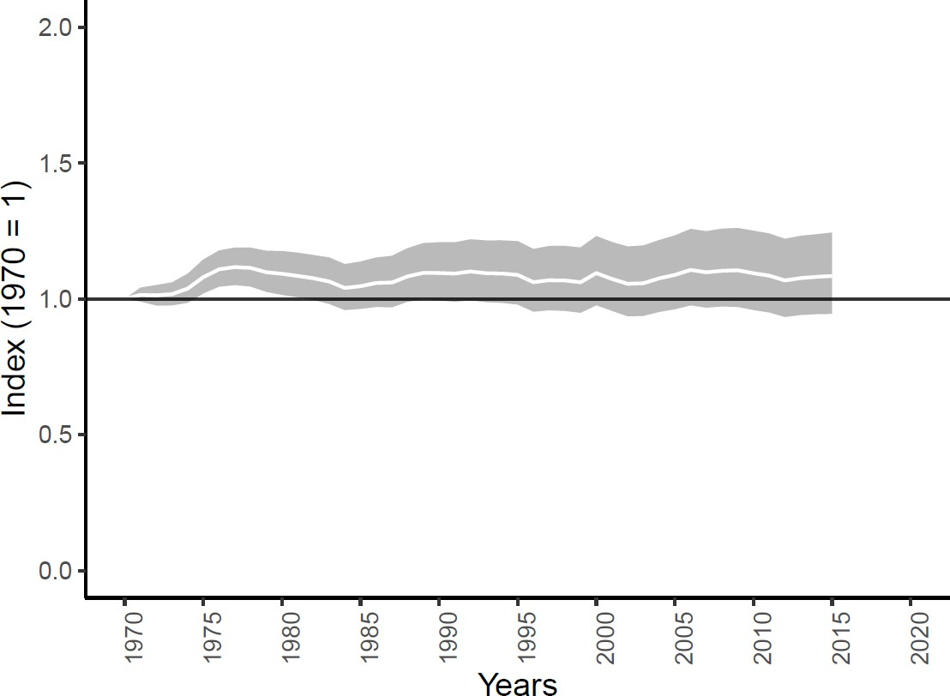

Figure 1. Average abundance change of 8% between 1970 and 2015 of 3,369 monitored populations of 583 CMS- listed species of fishes, birds, mammals, and reptiles monitored globally. The white line shows the index values and the shaded areas represent the statistical uncertainty surrounding the trend (range: -5% to 24%). Please note that there are no amphibian species listed on any CMS Appendix.

Appendix I-listed species
A look at the average trend in 111 populations of 30 species of birds, mammals and reptiles listed exclusively on CMS Appendix I reveals an initial steady increase from 1970 until the mid-2000s, followed by a steady decrease (Figure 2). This pattern of increase and decrease is reflected in both aquatic mammals and, to a lesser extent, in birds (not shown). By contrast, terrestrial mammals show a pronounced and steady decline throughout (not shown). The index returns to a value of 1.05 in 2015, meaning that abundance is on average 0.5% higher than in 1970. Representation is over 50% for mammals and all species combined, and 100% for reptiles (but this includes only 1 species). There are no data in the LPI for the single species of fish listed on CMS Appendix I (Table 1).
However, by focusing on species that are listed on Appendix I only, this excludes species that are also listed on Appendix II. Species listed on both Appendices (as “I/II”) are deemed to be endangered but also require international agreements for their conservation and management or would significantly benefit from the international cooperation that could be achieved by an international agreement. Adding these Appendix I/II-listed 634 populations of 71 species of birds (n=48), fish (n=6), mammals (n=11) and reptiles (n=6) reveals more of an oscillating pattern, which shows less of an initial increase and an overall more negative trend, with species declining by 23% in abundance on average between 1970 and 2015 (Figure 3).
Please refer to Figures S1 and S2 in the Appendix for graphs plotting the Appendix I and the Appendix I & Appendix I/II indices together with the overall CMS index.

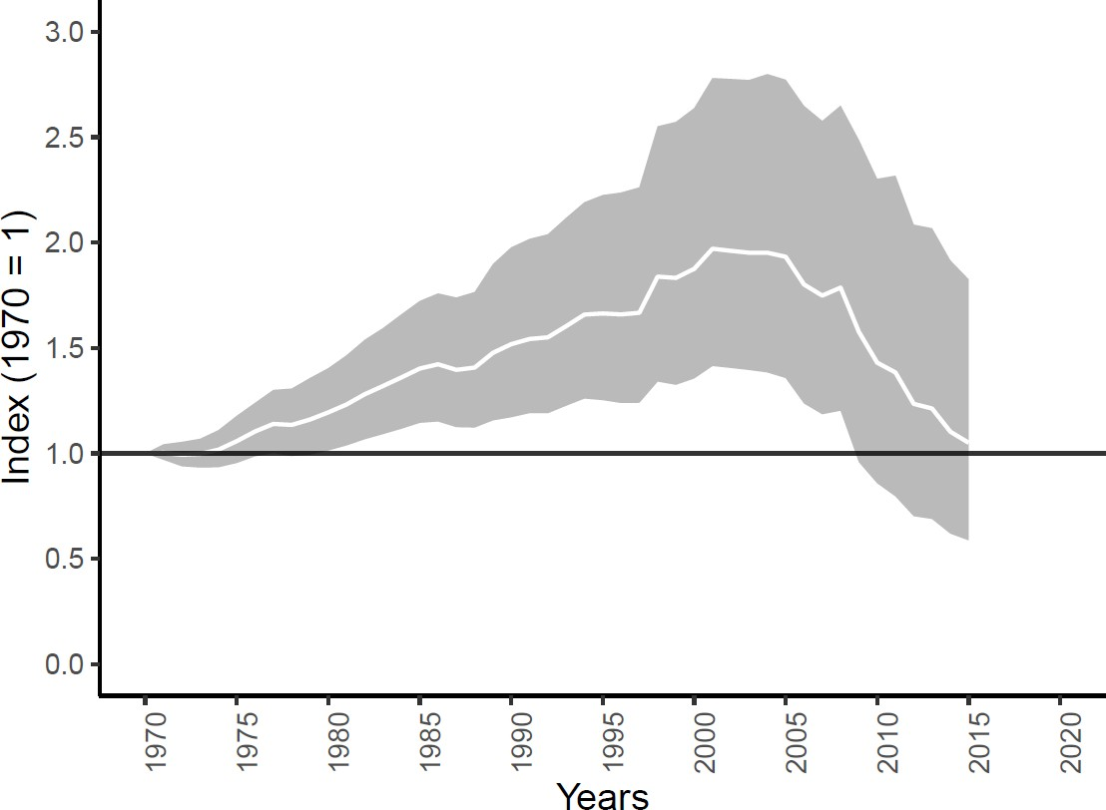

Figure 2. Average abundance change of 0.5% between 1970 and 2015 in 111 monitored populations of 30 species of birds, mammals and reptiles listed on CMS Appendix I. The white line shows the index values and the shaded areas represent the statistical uncertainty surrounding the trend (range: -41% to 83%). Please note that there was no information in the LPD for the single fish species listed on CMS Appendix I.
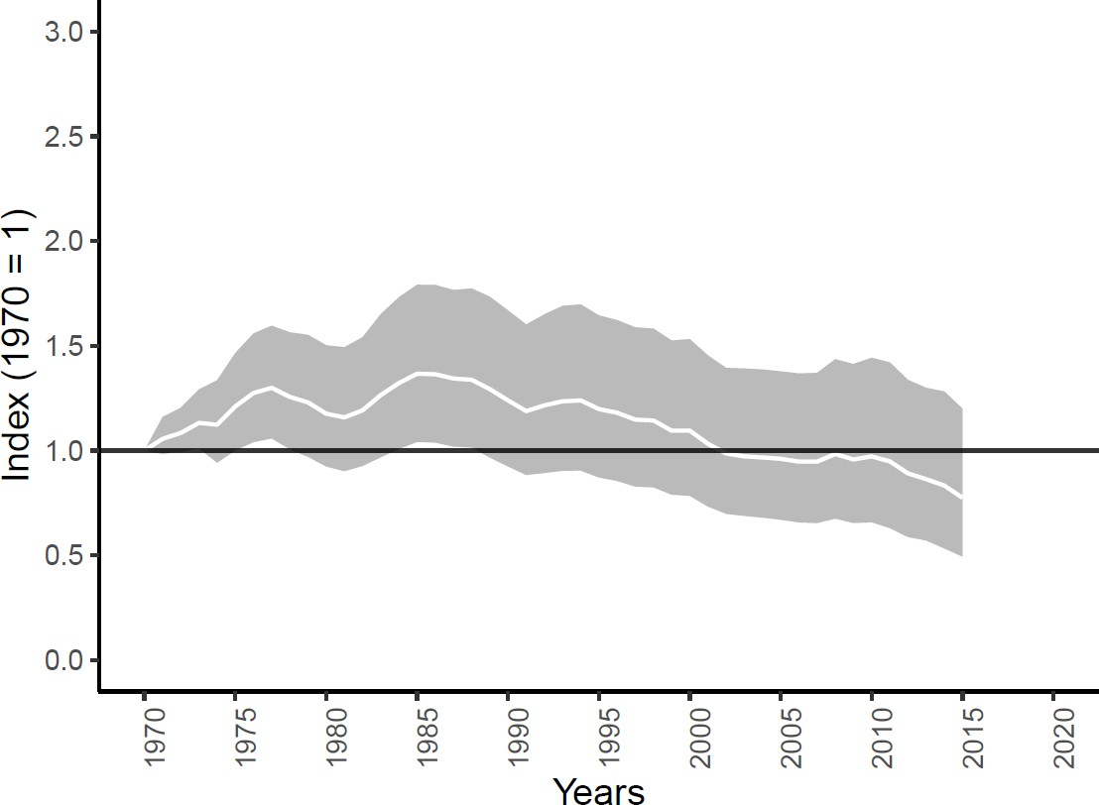

Figure 3. Average abundance change of -23% between 1970 and 2015 in 745 monitored populations of 100 species of birds, mammals, fishes and reptiles listed on CMS Appendix I or Appendix I/II. The white line shows the index values and the shaded areas represent the statistical uncertainty surrounding the trend (range: -51% to 20%). Please note that there was no information in the LPD for any of fish species listed on CMS Appendix I.

Taken together, these two indices suggest that monitored endangered CMS-listed species not deemed to be in need of international conservation have, on average, been stable since 1970 but that there has been a decline in these Appendix I-listed species since the mid-2000s. This may indeed continue beyond 2015 as more data become available. Lastly, they also suggest that the status of species listed on both Appendices is worsening. This could potentially be due to a number of different explanations, such as international agreements not yet being in place or not involving all necessary partners within the regions these species use on their migration, or established agreements not working sufficiently well to prevent declines in abundance. More detailed analysis may shed light on this but goes beyond the scope of this report.

CMS-listed species by class
As mentioned above, the overall index in Figure 1 above comprises a large number of bird species, so that it resembles the trend of this taxonomic group most closely (Figure 4). CMS-listed bird species have, on average, shown a 19% increase (range: 2% to 38%) in abundance between 1970 and 2015. By contrast, there is a marked average decline in fish (-92%; range: -96% to -85%) and terrestrial mammals (-11%; range: -49% to 50%). The index of aquatic mammals is the most inconsistent with a relatively stable trend until the early 2000s followed by a very pronounced increase until near the end of the index, leading to a 103% increase in abundance on average (range: 12% to 261%). This sudden increase is caused by a number of species – mostly cetaceans, but not exclusively – changing from a previously negative trend to a positive trend. The increasing trend is then maintained by different species showing positive trends at different points until the end of the study period. These data do not come from the same data source or the same region, and tend to be of shorter length. The trend is therefore less likely to be a genuine reflection of average trends in these species and more likely to be the result of intermittent monitoring data. In addition, a number of these time-series comprised occasional years with lower values, which could, in part be explained by the difficulty in accurately monitoring wide-ranging marine mammals in open water.
Overall, the status of CMS-listed species looks favourable because the indicator is fairly stable over time and there has been an overall increase on average. However, the taxonomic results suggest that the status of fish and terrestrial mammals is worse than that of birds and aquatic mammals (Figure 4) and also reptiles.

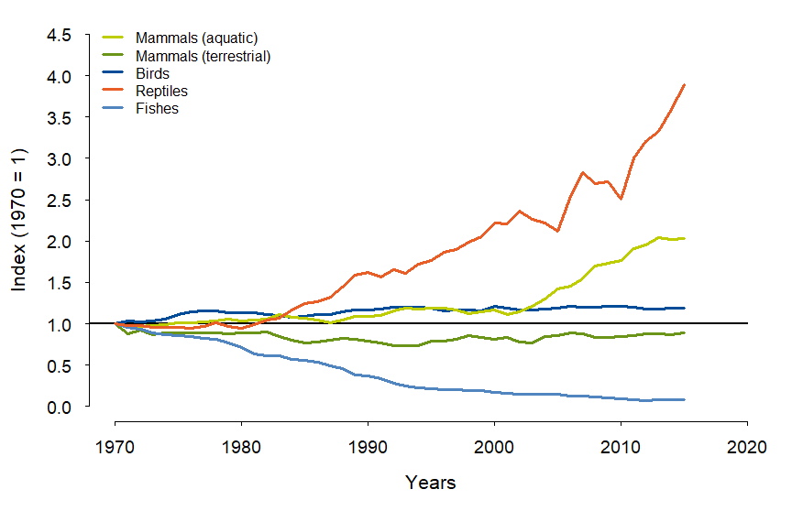

Figure 4. Average abundance change between 1970 and 2015 in different taxonomic groups of species listed on CMS Appendices (Appendix I, Appendix II or Appendix I/II). Trends are for 2,531 monitored populations of 465 bird species, 263 monitored populations of 45 terrestrial mammal species, 195 monitored populations of 37 aquatic mammal species, 232 populations of 10 reptile species, and 148 monitored populations of 26 fish species. Index end values are listed in the main text.

Taxonomic coverage
Usually, abundance data are not always available for the entire range of a species, which means that the trends shown reflect the data we have. It is also not possible to infer trends for locations or species that are not in the dataset.
Even though taxonomic coverage of the LPI dataset is not complete, it can be considered to be good, with around 50% of expected CMS-listed species represented in the overall index (Table 1). Representation is best for aquatic mammals (62%), and slightly less than 50% for birds (49%) and fish (48%). For Appendix I only, and Appendix I and Appendix I/II species combined, over half of species are represented overall, and this is also true mammals (Table 1). The very good representation for reptiles (100% and 88%) is in stark contrast with fish, which although 48% representation in the overall index, is lacking data for species considered to be endangered (Table 1). Despite these differences, none of the data cuts are significantly under-represented (not shown).
Overall, coverage for these indices is very good compared to other global indicators, with a minimum of 46% of species represented in each data cut except Appendix I and Appendix I/II fish. As an example, in the global LPI, all but one of the data cuts comprise less than 30% of expected species, with the vast majority representing less than 10% (WWF 2018).

Table 1. Representation of the LPI dataset, comparing the observed number of species listed on different CMS Appendices and in different taxonomic groups in the LPI with the expected number of species on CMS (from (UNEP 2019)). Representation values in red are less than 30%, and in purple less than 50%. Please note that indices with an * denote those including reptiles.

 |  | LPI  Populations | LPI  Species | Expected species | Represen- tation
All CMS | All species* | 3,369 | 583 | 1,158 | 50%
 | Birds | 2,531 | 465 | 944 | 49%
 | Mammals (terrestrial) | 263 | 45 | 90 | 50%
 | Mammals (aquatic) | 195 | 37 | 60 | 62%
 | Mammals (combined) | 458 | 82 | 150 | 55%
 | Fishes | 148 | 26 | 54 | 48%
 | Reptiles | 232 | 10 | 10 | 100%
Appendix I | All species* | 111 | 30 | 54 | 56%
 | Birds | 27 | 12 | 26 | 46%
 | Mammals | 82 | 17 | 26 | 65%
 | Fishes | 0 | 0 | 1 | 0%
 | Reptiles | 2 | 1 | 1 | 100%
App I and App I/II | All species* | 745 | 100 | 166 | 60%
 | Birds | 374 | 60 | 95 | 63%
 | Mammals | 135 | 27 | 40 | 68%
 | Fishes | 40 | 6 | 23 | 26%
 | Reptiles | 196 | 7 | 8 | 88%

Conclusions and caveats
In summary, monitored species listed on the CMS Appendices have slightly increased on average between 1970 and 2015. Aquatic mammals and birds have gained in abundance, and by contrast terrestrial mammals and fish in particular have decreased. Species only listed on Appendix I are also stable, but when combined with those listed on Appendix I/II, their average trend also shows a decline.
While coverage for the indicators presented are generally good, data is not available for all species for all years, so trends may not always be representative of all CMS-listed species. To achieve at least 50% representation in all data cuts, more information is needed on birds and fish, and especially those fish listed on Appendix I or Appendix I/II. These species are considered to be endangered according to CMS (Convention on the Conservation of Migratory Species of Wild Animals (CMS) 2018), and tracking their change in abundance is vital to prevent future declines or extinctions.

Attachments
CMS_species_list.xlsx List of species included in the indices by taxonomic group and their
CMS listing, and the number of populations of these species
CMS_results.xlsx Index values for all indices included in the report: Global CMS,
Appendix I, Appendix I & Appendix I/II, Birds, Mammals_aquatic, Mammals_terrestrial, Fishes, Reptiles

Method

Data collection
To evaluate trends in CMS-listed species, we created indices using data from the Living Planet Database (LPD) (LPD 2019)). The LPD currently contains over 25,000 populations of more than 4,000 species and is one of the largest repositories of time-series data of population size, density, abundance or a proxy of abundance. These are gathered from a variety of sources including published scientific literature, online databases and grey literature. Data are only included if a measure of population size is available for at least two years, and information available on how the data were collected, the units of measurement, and the geographic location of the population. The data must be collected using the same method on the same population throughout the time-series and the data source referenced and traceable (see (Collen et al. 2009) for further details). Because the Living Planet Index is based on species populations as the unit of analysis, one species may be represented by multiple population records.
For this analysis we included data on all populations of birds, mammals, fish and reptiles contained within the LPD with an Appendix I, Appendix II, or Appendix I/II CMS listing, coded based on the CMS Appendices (Convention on the Conservation of Migratory Species of Wild Animals (CMS) 2018). We distinguished between terrestrial and aquatic mammals using the ecological affiliation of each population to one of three different systems as coded in the LPI, categorising freshwater and marine populations as ‘aquatic’, and terrestrial populations as ‘terrestrial’.
The period covered by the index is from 1970 to 2015. The year 2015 was chosen as the cut-off point for the index because at present there are insufficient data to calculate a robust index after this point due to publication time-lag.

Calculation of indices
We calculated average trends for each species within a Generalised Additive Modelling (GAM) framework, following (Collen et al. 2009), whereby each population time-series with six or more data points was modelled using a GAM. Population time-series with fewer than six data points or that resulted in poor GAM fit were modelled using the chain method (Loh et al. 2005). Where we had more than one population time-series for a species, the modelled annual trends for each population were averaged to provide a single set of annual trends for each species. These were then averaged across species and converted to index values with a baseline year of 1970. For each index, we generated 95% confidence intervals using a bootstrap resampling technique for 10,000 iterations (as (Collen et al. 2009). These confidence intervals demonstrate the uncertainty in the index values inherited from the baseline in 1970 and propagated through the time-series. An R package, rlpi, for calculating these index values is available at https://github.com/Zoological-Society-of-London/rlpi. All indices were unweighted.

Assessing species representation
Numbers of species in the dataset were compared with estimates of the number of species listed on different CMS appendices and in different taxonomic groups. These expected values were downloaded as a spreadsheet from Species+ (UNEP 2019) and then filtered accordingly.

Bibliography
Collen, B., J. Loh, S. Whitmee, L. McRae, R. Amin, and J. E. Baillie. 2009. Monitoring change in vertebrate abundance: the Living Planet Index. Conservation Biology 23:317-327.
Convention on the Conservation of Migratory Species of Wild Animals (CMS). 2018. Appendices I and II of the Convention on the Conservation of Migratory Species of Wild Animals (CMS). https://www.cms.int/en/page/appendix-i-ii-cms. Downloaded 19 September 2019.
Loh, J., R. E. Green, T. Ricketts, J. Lamoreux, M. Jenkins, V. Kapos, and J. Randers. 2005. The Living Planet Index: using species population time series to track trends in biodiversity. Philosophical Transactions of the Royal Society B 360:289-295.
LPD. 2019. Living Planet Index Database. www.livingplanetindex.org. Downloaded on 19 September 2019.
McRae, L., S. Deinet, and R. Freeman. 2017. The Diversity-Weighted Living Planet Index: Controlling for Taxonomic Bias in a Global Biodiversity Indicator. PLoS One 12:e0169156.
SCBD. 2010. COP-10 Decision X/2. The Strategic Plan for Biodiversity 2011-2020 and the Aichi Biodiversity Targets. Secretariat of the Convention on Biological Diversity.
UNEP. 2019. The Species+ Website. Nairobi, Kenya. Compiled by UNEP-WCMC, Cambridge, UK. Available at: www.speciesplus.net. [Accessed (25/09/2019)].
WWF. 2018. Living Planet Report - 2018: Aiming Higher. M. Grooten and R. E. A. Almond (Eds). WWF, Gland, Switzerland.

Appendix
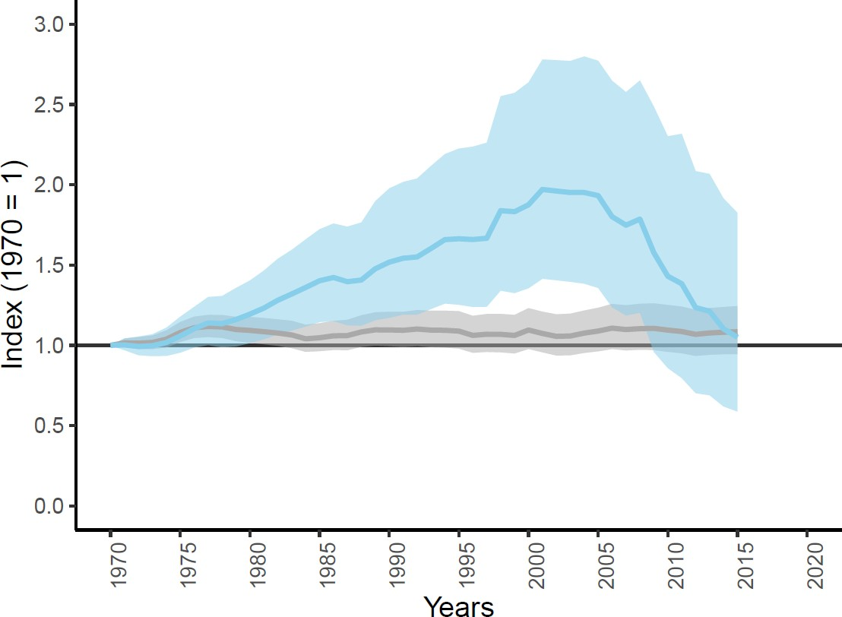
Figure S1. Average abundance change of 3,369 populations of 583 CMS-listed species of fishes, birds, mammals, and reptiles monitored globally (grey line) and 111 populations of 30 species of birds, mammals and reptiles listed on CMS Appendix I (blue line). The white line shows the index values and the shaded areas represent the statistical uncertainty surrounding the trend.
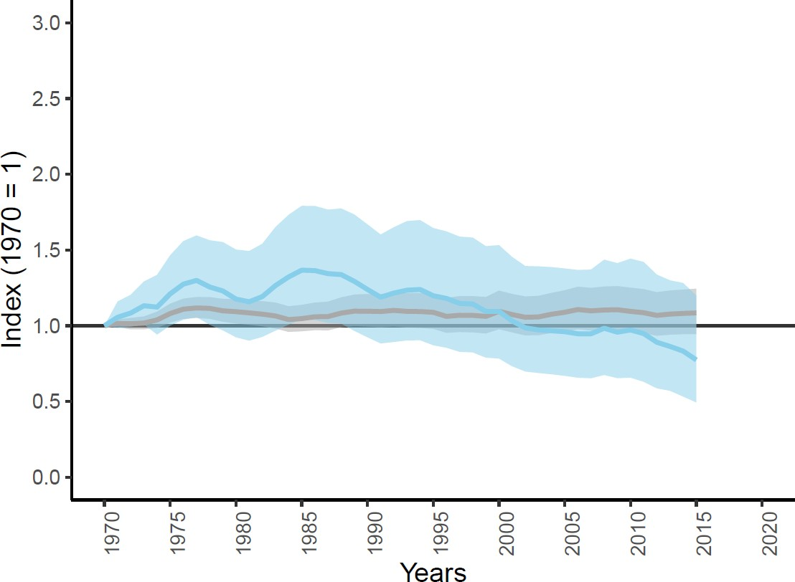

Figure S2. Average abundance change of 3,369 populations of 583 CMS-listed species of fishes, birds, mammals, and reptiles monitored globally (grey line) and 745 populations of 100 species of birds, mammals and reptiles listed on CMS Appendix I or Appendix I/II (blue line). The white line shows the index values and the shaded areas represent the statistical uncertainty surrounding the trend. Please note that there was no information in the LPD for any of fish species listed on CMS Appendix I.

