Memorandum of Understanding on
the Conservation of Migratory Sharks

Sawfishes Fact Sheet

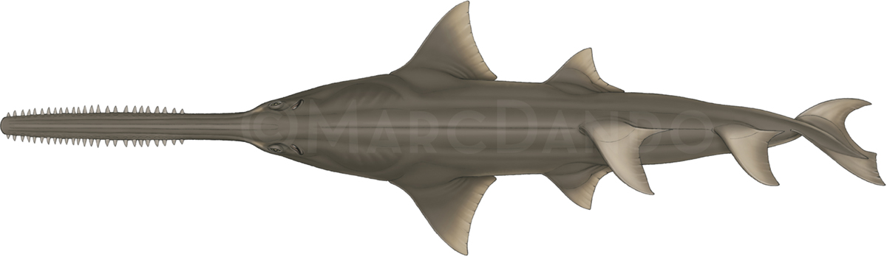 | 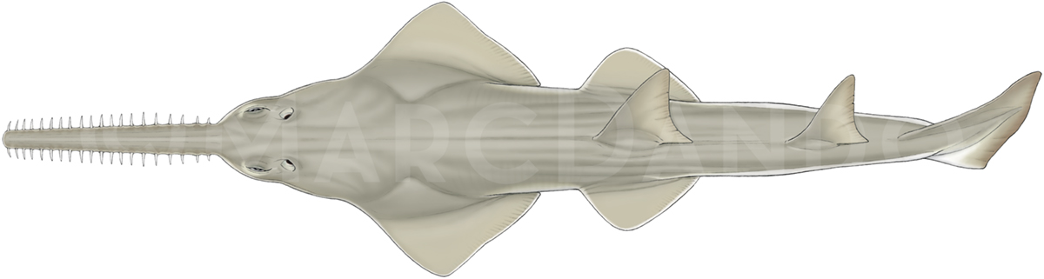
Anoxypristis cuspidata | Pristis clavata
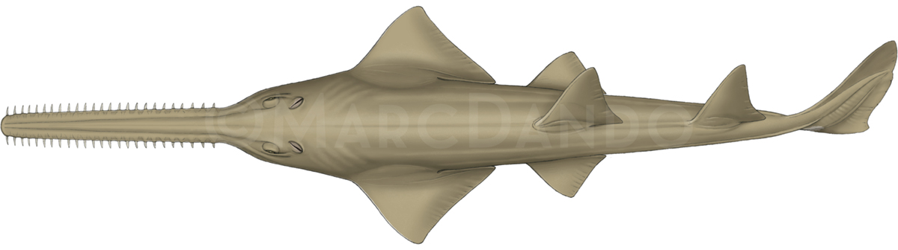 | 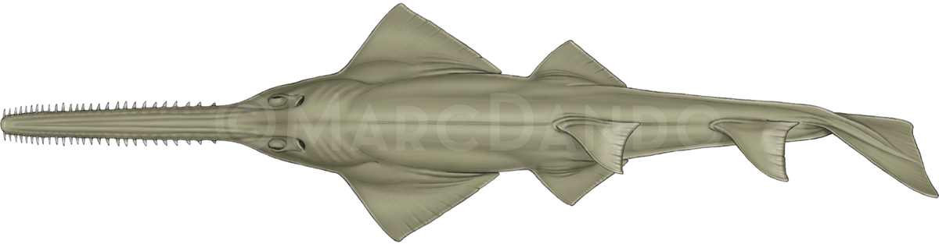
Pristis pectinata | Pristis zijsron
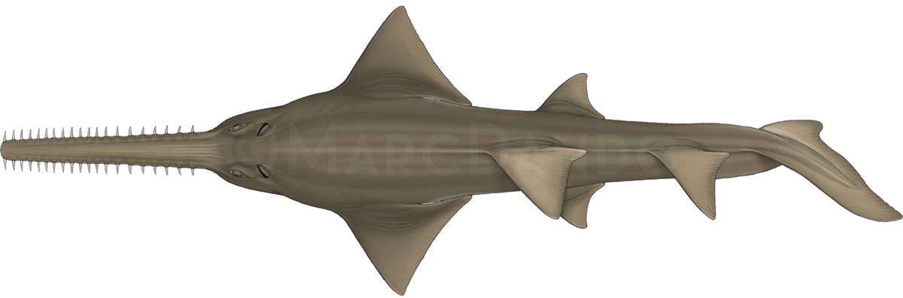
Pristis pristis

Class: | Chondrichthyes
Order: | Rhinopristiformes
Family: | Pristidae
Species: | Anoxypristis cuspidata - Narrow sawfish  Pristis clavata - Dwarf sawfish  Pristis pectinata - Smalltooth sawfish  Pristis zijsron - Green sawfish  Pristis pristis – Largetooth sawfish

Sawfishes
Poissons-scies
Peces sierra

Illustration: © Marc Dando

BIOLOGY
The family Pristidae consists of five sawfish species (Anoxypristis cuspidata, Pristis clavata, Pristis pectinata, Pristis zijsron, Pristis pristis). They range in maximum length from 3m to over 7m and some species can weigh up to one metric tonne. The most obvious characteristic is a distinctive elongated toothed rostrum, which they use for feeding. All sawfishes are ovoviviparous, giving birth to (1-20) well developed young. Although a variety of habitats may be preferred by different life stages, they spend much of their life in shallow (often <10m) marine and estuarine waters, usually associated with mangroves or seagrasses (Simpfendorfer 2007; Carlson et al. 2014; Moore 2015). However, some species are known to seasonally inhabit deep parts of the continental shelf, to depths of >80 m.

DISTRIBUTION
Sawfish occur in circum-tropical and warm temperate waters. In some regions, sawfishes are known to inhabit freshwater lakes and river systems. While their historical range comprised about 90 tropical countries, 43 countries are believed to have lost at least one species in their waters, while presumably 20 Range States lost all species (Dulvy et al. 2016; Ferretti et al. 2016).

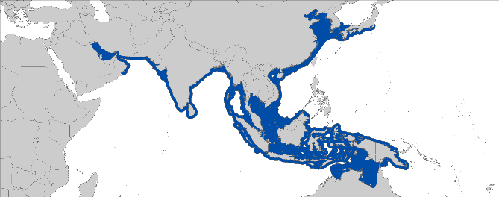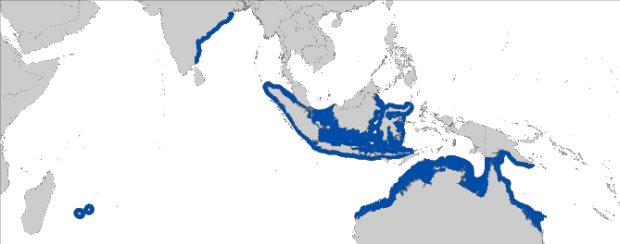

Anoxypristis cuspidata Pristis clavata

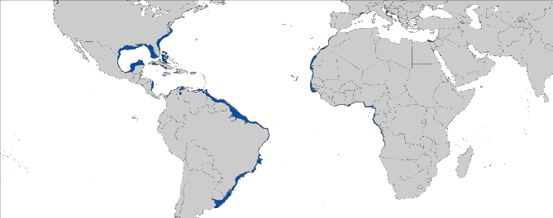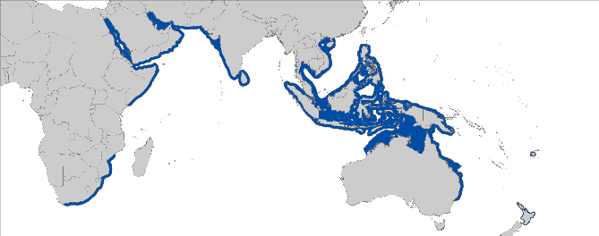

Pristis pectinata Pristis zijsron

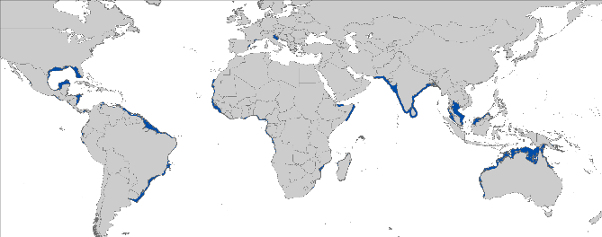

Pristis pristis

Figure 1: Distribution of sawfish species, courtesy of IUCN

- CRITICAL SITES
The present extent of the different sawfish distributions represents just a small fraction of historic ranges. Therefore, the remaining refuges play a critical role in the protection of the Pristidae family. However, due to their rarity and lack of capacity for research in many Range States, the determination of these refuges is difficult. To date, only a limited number of these critical sites has been examined in scientific investigations.

POPULATION STATUS AND TRENDS
There are no stock assessments for sawfish, however, information on population trends are available for some species and areas. All sawfish species have undergone significant, albeit largely unquantified, declines with only patchy remnant populations in their once more wide-ranging historical distributions. Considering the trends of the different threats to sawfishes and the range contractions of up to 81% from original, populations in most areas may continue to decrease (Dulvy et al. 2016). The current IUCN Red List status for the global narrow sawfish populations is Endangered (D’Anastasi et al. 2013), Endangered for the dwarf sawfish populations (Kyne et al. 2013b), Critically Endangered for the smalltooth sawfish populations (Carlson et al. 2013), Critically Endangered for the green sawfish populations (Simpfendorfer 2013), Critically Endangered for the largetooth sawfish (Kyne et al. 2013a).

Species | Region | Population trend | Time Period | Reference
Pristis zijsron | Global population | >80% decline | 44 years | (Simpfendorfer 2013)
Anoxypristis cuspidata | Global population | Declines of between 50 and 70% are suspected | ~18 years | (D’Anastasi et al. 2013)
Pristis pectinata | USA | 95-99% decline | Since early 1900s | (Simpfendorfer 2000; NMFS 2009)
 |  | ~5% increase per year | Since 1989 | (Carlson et al. 2007)
Pristis pectinata | Global | Decline >80% of its former range. |  | Dulvy et al (2016)
Pristis pristis | Indo-West Pacific | >80% decline | Three generations (1969-2013) | (Kyne et al. 2013a)
Pristis clavata | Northern Australia | 50-80% decline | Three generation lengths (~49 years) | (Kyne et al. 2013b)

THREATS
- Fisheries: The greatest threat is fisheries where sawfish are commonly caught as bycatch. Because of their rostra, sawfish are particularly susceptible to gillnets, driftnets, trammel nets, and trawls (Simpfendorfer 2000; Brewer et al. 2006; NMFS 2010). Fishing using longlines and handlines was also reported to capture sawfish, but with much lower impact than net entanglement (NMFS 2009).
- Habitat degradation: Sawfishes rely on several habitat types, which exposes them to a variety of anthropogenic threats (e.g. agriculture, mining operations, pollution, dam and canal building and land reclamation) (Harrison and Dulvy 2014).
- International trade: Bycatch is often retained because of the economic value of sawfish fins and rostra.
- Marine debris: Entanglement in marine debris and abandoned fishing gear poses a threat to sawfishes (Seitz & Poulakis 2006).

KEY KNOWLEDGE GAPS
- Recent and accurate estimates of distribution, critical sites, population sizes and life history are lacking;
- Knowledge about effective bycatch mitigation measures is lacking.

KEY MANAGEMENT AND CONSERVATION GAPS
- Only few Range States provide specific protections to sawfish, and enforcement of these laws is poor;
- Bycatch mitigation measures are limited.

RECOMMENDATIONS FOR CONSERVATION AND MANAGEMENT ACTION
- Incorporate conservation measures for sawfishes into national legislation of all Parties/Signatories.

- Implement and enforce relevant international measures (e.g. CMS and CITES), that prohibit targeting, retaining, landing, transshipping, and selling of sawfish parts;
- Incorporate sawfish & habitat protection into national legislation of all Parties to CMS / Range States;
- Assist in drafting, enhancing & promoting new legislation for Range States that do not yet provide legal protection.

- Conserve and restore suitable habitats
- Focus on key habitats and migration corridors for future research to support development of spatial fisheries management
- Conserve mangroves and other suitable habitats, and stop land reclamation in key habitats
- Reduce anthropogenic activities (e.g. pollution) in sawfish habitats

- Improve the understanding of sawfish populations through strategic research, monitoring and information exchange
- Survey current and historic distributions and abundance along key river systems and coastal areas
- Identify critical sites of sawfish species and seasonality
- Conduct long-term monitoring of sawfish populations
- Address data gaps in biological knowledge (life history parameters) of sawfish

- Improve multilateral cooperation among regions
- Collaboratively draft & support proposal for sawfish Concerted Actions at the next CMS CoP
- Engage neighboring countries/non-Signatories to protect sawfishes & foster their integration in conservation planning and implementation workshops
- Identify synergies with other Range States/stakeholders to support coordinated and resource-effective research & conservation programs

- Enforce compliance with fisheries management regulations, landing & trade bans.
- Prioritize enforcement, including to conduct market surveys and patrols, protected area patrols and the prosecution of exporters
- Improve capacity in species identification through trainings and the dissemination of available ID guides

- Identify the effective approaches to reduce bycatch and improve survivorship of sawfishes
- Identify gear modifications and fishing practices e.g. soak time and safe release handling guidelines;
- Explore options for spatial management;
- Investigate post-release survivorship of sawfishes to inform improved handling and release protocols.

- Engage local communities in the conservation of sawfishes
- Provide training to fishing communities on species identification and safe release guidelines;
- Involve local communities in the development of regional management.

- Enhance or develop where necessary collection of fishery data (including landings, discards, size frequency, catch and effort where needed)
- Collect data on bycatch;
- Develop capacity in research & monitoring in all regions.

- Raise awareness about the threats to sawfishes
- Inform the public about the need of sawfish conservation and status (illegal trade) and encourage the public to report encounters with sawfishes.

LEGAL INSTRUMENTS

Instrument | Description | Species
Barcelona Convention  Barcelona Convention for the Protection of the Marine Environment and the Coastal Region of the Mediterranean | Annex II: Endangered or threatened species; Parties shall ensure the maximum possible protection and recovery of, while prohibiting the damage to and destruction of, these species. | P. pectinate  P. pristis
Cartagena Convention  Convention for the Protection and Development of the Marine Environment of the Wider Caribbean Region | Annex II: Parties shall ensure total protection and recovery to these species of fauna by prohibiting the taking, possession, killing or commercial trade and, to the extent possible, disturbance. | P. pectinata
CITES  Convention on International Trade in Endangered Species of Wild Fauna and Flora | Appendix I: Species threatened with extinction; trade in specimens of these species is permitted only in exceptional circumstances. | all species
CMS  Convention on the Conservation of Migratory Species of Wild Animals | Appendix I: Migratory species threatened with extinction; CMS Parties strive towards strictly protecting these species, conserving or restoring the places where they live, mitigating obstacles to migration and controlling other factors that might endanger them. | all species
 | Appendix II: Migratory species that have an unfavourable conservation status and need or would significantly benefit from international cooperation; CMS Parties shall endeavour to conclude global or regional agreements to benefit these species. | all species
FAO  Food and Agriculture Organization | IPOA Sharks: International Plan of Action for Conservation and Management of Sharks based on which states should adopt and implement a national plan of action for conservation and management of shark stocks (NPO Sharks) if their vessels conduct directed fisheries for sharks or if their vessels regularly catch sharks in non-directed fisheries. | all species
Sharks MOU  Memorandum of Understanding on the Conservation of Migratory Sharks | Annex 1: Signatories should endeavour to achieve and maintain a favourable conservation status for these species based on the best available scientific information and taking into account their socio-economic value. | all species

KNOWN CRITICAL SITES

Information on critical sites are limited. There are, however, two regions that potentially represent ‘lifeboat’ areas (Dulvy et al. 2016) for sawfish species. Southwest Florida, USA and northern Australia have reproducing populations (Peverell, 2005; National Marine Fisheries Service, 2009; Norton et al., 2012). Local sawfish status surveys are ongoing in Africa and Asia using fisher knowledge surveys (e.g. Leeney and Poncelet 2013; Jabado et al. 2015) and environmental DNA (eDNA; Colin Simpfendorfer pers. comm.) to further identify critical sites.

REFERENCES

Brewer D, Heales D, Milton D, Dell Q, Fry G, Venables B, Jones P 2006. The impact of turtle excluder devices and bycatch reduction devices on diverse tropical marine communities in Australia's northern prawn trawl fishery. Fisheries Research 81: 176-188.
Carlson J, Gulak S, Simpfendorfer C, Grubbs R, Romine J, Burgess G 2014. Movement patterns and habitat use of smalltooth sawfish, Pristis pectinata, determined using pop‐up satellite archival tags. Aquatic Conservation: Marine and Freshwater Ecosystems 24: 104-117.
Carlson JK, Osborne J, Schmidt TW 2007. Monitoring the recovery of smalltooth sawfish, Pristis pectinata, using standardized relative indices of abundance. Biological Conservation 136: 195-202.
Carlson, J., Wiley, T. & Smith, K. 2013. Pristis pectinata. The IUCN Red List of Threatened Species 2013: e.T18175A43398238.
Charvet-Almeida P 1999. Informações gerais sobre o Pristis no ará. In ed. Boletim SBEEL Pp.
Charvet-Almeida P 2002. Sawfish trade in the North of Brazil. Shark News 14.
D'Anastasi B, Simpfendorfer C, van Herwerden L 2013. Anoxypristis cuspidata. The IUCN Red List of Threatened Species 2013: e.T39389A18620409. In ed. Pp.
Dulvy NK, Davidson LN, Kyne PM, Simpfendorfer CA, Harrison LR, Carlson JK, Fordham SV 2016. Ghosts of the coast: global extinction risk and conservation of sawfishes. Aquatic Conservation: Marine and Freshwater Ecosystems 26: 134-153.
Feitosa LM, Martins APB, Nunes JLS 2017. Sawfish (Pristidae) records along the Eastern Amazon coast. Endangered Species Research 34: 229-234.
Ferretti F, Morey GV, Seret B, Šprem JF, Micheli F, 2016. Falling through the cracks: the fading history of a large iconic predator. Fish and Fisheries 17 (3): 875-889
Guttridge T, Gulak S, Franks B, Carlson J, Gruber S, Gledhill K, Bond M, Johnson G, Grubbs R 2015. Occurrence and habitat use of the critically endangered smalltooth sawfish Pristis pectinata in the Bahamas. Journal of Fish Biology 87: 1322-1341.
Harrison LR, Dulvy NKe 2014. Sawfish: A Global Strategy for Conservation. In ed. Vancouver, Canada, IUCN Species Survival Commission’s Shark Specialist Group. Pp.
Jabado RW, Al Ghais SM, Hamza W, Henderson AC 2015. The shark fishery in the United Arab Emirates: an interview based approach to assess the status of sharks. Aquatic Conservation: Marine and Freshwater Ecosystems 25: 800-816.
Jabado RW, Al Baharna RA, Al Ali SR, Al Suwaidi KO, Al Blooshi AY, Al Dhaheri SS 2017. Is this the last stand of the Critically Endangered green sawfish Pristis zijsron in the Arabian Gulf? Endangered Species Research 32: 265-275.
Kyne PM, Carlson J, Smith K 2013a. Pristis pristis. The IUCN Red List of Threatened Species 2013: e.T18584848A18620395. In ed. Pp.
Kyne PM, Rigby C, Simpfendorfer C 2013b. Pristis clavata. The IUCN Red List of Threatened Species 2013: e.T39390A18620389. In ed. Pp.
Leeney RH, Poncelet P. 2013. Using fishers’ ecological knowledge to assess the status and cultural importance of sawfish in Guinea-Bissau. Aquatic Conservation: Marine and
Freshwater Ecosystems DOI: 10.1002/aqc.2419.
Moore A 2015. A review of sawfishes (Pristidae) in the Arabian region: diversity, distribution, and functional extinction of large and historically abundant marine vertebrates. Aquatic Conservation: Marine and Freshwater Ecosystems 25: 656-677.
Morgan DL, Allen MG, Ebner BC, Whitty JM, Beatty SJ 2015. Discovery of a pupping site and nursery for critically endangered green sawfish Pristis zijsron. Journal of Fish Biology 86: 1658-1663.
NMFS NMFS 2010. Smalltooth Sawfish (Pristis pectinata Latham) 5-Year Review: Summary and Evaluation. In ed. National Oceanic and Atmospheric Administration. Pp.
NMFS NMFS 2009. Recovery Plan for Smalltooth Sawfish (Pristis pectinata). In ed. Prepared by the Smalltooth Sawfish Recovery Team for the National Marine Fisheries Service. Silver Spring, Maryland, National Oceanic and Atmospheric Administration. Pp.
Norton SL, Wiley TR, Carlson JK, Frick AL, Poulakis GR, Simpfendorfer CA 2012. Designating critical habitat for juvenile endangered smalltooth sawfish in the United States. Marine and Coastal Fisheries 4: 473-480.
Poulakis GR, Stevens PW, Timmers AA, Wiley TR, Simpfendorfer CA 2011. Abiotic affinities and spatiotemporal distribution of the endangered smalltooth sawfish, Pristis pectinata, in a south-western Florida nursery. Marine and Freshwater Research 62: 1165-1177.
Seitz JC, Poulakis GR 2002. Recent occurrence of sawfishes (Elasmobranchiomorphi: Pristidae) along the southwest coast of Florida (USA). Florida Scientist: 256-266.
Seitz JC, Poulakis GR 2006. Anthropogenic effects on the smalltooth sawfish (Pristis pectinata) in the United States. Marine Pollution Bulletin 52: 1533-1540.
Simpfendorfer CA 2000. Predicting population recovery rates for endangered western Atlantic sawfishes using demographic analysis. Environmental Biology of Fishes 58: 371-377.
Simpfendorfer CA 2007. The importance of mangroves as nursery habitat for smalltooth sawfish (Pristis pectinata) in South Florida. Bulletin of Marine Science 80: 933-934.
Simpfendorfer CA 2013. Pristis zijsron. The IUCN Red List of Threatened Species 2013: e.T39393A18620401. In ed. Pp.
Simpfendorfer CA, Wiley TR, Yeiser BG 2010. Improving conservation planning for an endangered sawfish using data from acoustic telemetry. Biological Conservation 143: 1460-1469.
Taniuchi T, Ishihara H, Tanaka S, Hyodo S, Murakami M, Seret B 2003. Occurrence of two species of elasmobranchs, Carcharhinus leucas and Pristis microdon, in Betsiboka River, West Madagascar. Cybium 27: 237-241.
White WT, Appleyard SA, Kyne PM, Mana RR 2017. Sawfishes in Papua New Guinea: a preliminary investigation into their status and level of exploitation. Endangered Species Research 32: 277-291.
Wiley TR, Simpfendorfer CA 2010. Using public encounter data to direct recovery efforts for the endangered smalltooth sawfish Pristis pectinata. Endangered Species Research 12: 179-191.

See IUCN website for further details on the population assessments: http://www.iucnredlist.org/details/39389/0, http://www.iucnredlist.org/details/39390/0, http://www.iucnredlist.org/details/18175/0, http://www.iucnredlist.org/details/39393/0, and http://www.iucnredlist.org/details/18584848/0.

