Memorandum of Understanding on
the Conservation of Migratory Sharks

Great and Scalloped Hammerhead Sharks Fact Sheet

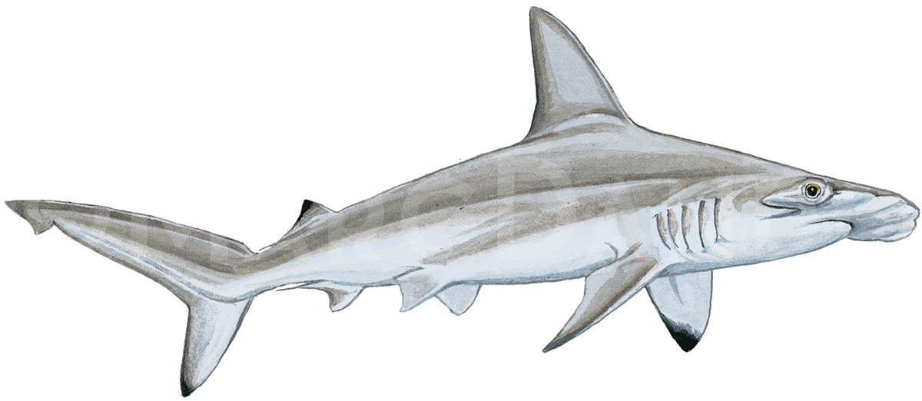
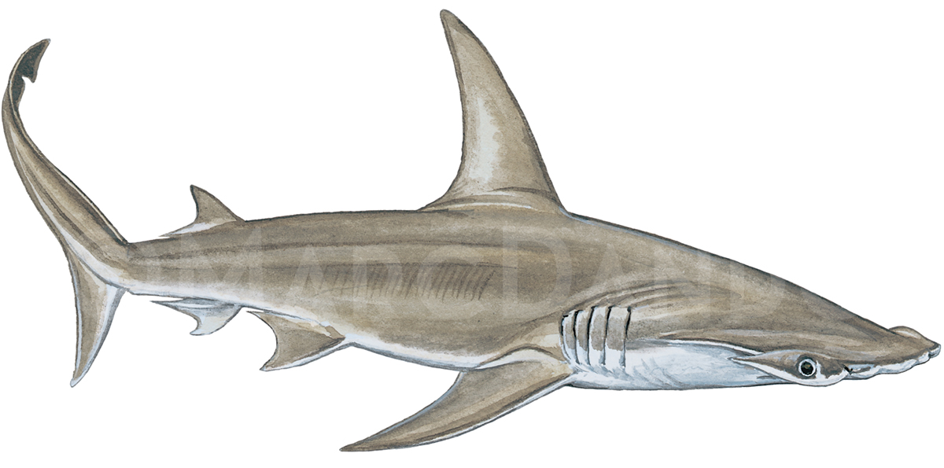

Sphyrna mokarran Sphyrna lewini

Class: | Chondrichthyes
Order: | Carcharhiniformes
Family: | Sphyrnidae
Species: | Sphyrna mokarran - Great Hammerhead  Sphyrna lewini - Scalloped Hammerhead
Hammerhead sharks
Requins-marteaux
Tiburones martillo

Illustration: © Marc Dando

BIOLOGY
Great hammerhead (Sphyrna mokarran) and Scalloped hammerhead (Sphyrna lewini) sharks are long lived, late maturing, and relatively slow growing. Great hammerhead sharks can live to up to 44 years and have a gestation period of 11 months producing 6-33 pups biennially (Stevens and Lyle 1989, Piercy et al. 2010). Scalloped hammerhead sharks cam live to up to 35 years and have a gestation period of 8-12 months producing 15-31 pups biennially (Branstetter 1987, Castro 2011).

DISTRIBUTION
Sphyrna mokarran and Sphyrna lewini are globally distributed species, but usually inhabit coastal waters and continental shelves in warm temperate and tropical seas (Compagno 1984).

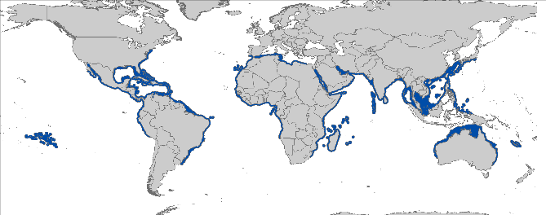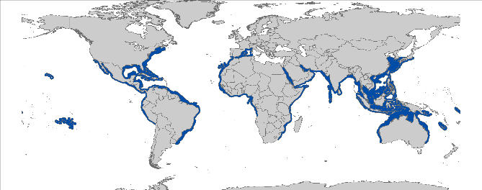Sphyrna mokarran Sphyrna lewini

Figure 1: Distribution of hammerhead shark species courtesy of IUCN.

CRITICAL SITES
Critical sites are those habitats that may have a key role for the conservation status of a shark population, and may include feeding, mating, pupping, overwintering grounds and other aggregation sites, as well as corridors between these sites such as migration routes. While a number of aggregation sites can be highlighted for Sphyrna lewini, basic knowledge about important habitats acting as nursery grounds or for other important life history stages is lacking. Knowledge about S. mokarran is limited. Critical sites have not been accurately defined in all areas, but some potentially important grounds may exist (especially for the eastern Pacific for S. lewini).

POPULATION STATUS AND TRENDS
Most information available on the status and trends consists of fisheries catch data for these species. However, catch data are often aggregated due to species identification issues. Data on the status of hammerhead shark species come from multiple sources including stock assessments, analysis of fishery landings data and bycatch in shark control programs. Stock units have not been defined. The current IUCN status for both species is Endangered globally (Baum et al. 2009, Denham et al. 2007).

Species | Population trend | Region | Time period | Reference
ATLANTIC
Sphyrna mokarran | 3% decrease | NW Atlantic | 1995-2012 | (Miller et al. 2014)
Sphyrna spp. | 50% decline | NE Atlantic | 2000-2010 | (Diop & Dossa 2011)
Sphyrna lewini | 83% decline | NW Atlantic | 1981-2005 | (Hayes et al. 2009)
Sphyrna spp. | 72% decline | NW Atlantic | 1981-2005 | (Jiao et al. 2008)
Sphyrna mokarran | 57% decline | NW Atlantic | 1981-2005 | (Jiao et al. 2008)
INDO-PACIFIC
Sphyrna lewini | 64% decline | Western Indian Ocean | 1978-2003 | (Dudley & Simpfendorfer 2006; Brown et al. 2016)
Sphyrna lewini | 50-75% decline | Eastern Indian Ocean | 1997-1998 / 2004-2005 | (Heupel & McAuley 2007)
Sphyrna lewini | 60-90% decline | South West Pacific | 1993-2001 | (Vooren & Klippel 2005)
Sphyrna lewini | 71% decline | Eastern Pacific | 1992-2004 | (Myers et al. 2007)
Sphyrna spp. | 85% decline | Western Pacific | 1963-2007 | (De Jong & Simpfendorfer 2009)
Sphyrna spp. | 51% decline | Eastern Pacific | 2004-2006 | (Martínez-Ortíz et al. 2007)

THREATS
- Fisheries: Hammerhead sharks are taken both as target and bycatch in longline (surface and bottom), gill net and purse-seine, where they exhibit very low at-vessel and post release survival (Morgan & Burgess 2007; Ellis et al. 2017). Recreational fishing can also be a significant threat especially in the United States and Australia (Miller et al. 2014).

- International trade: Hammerhead shark products (e.g. meat) appear on domestic markets and contribute to subsistence needs in some coastal communities. However, the predominant demand is rooted in the international shark fin trade, where their fins are some of the highest value of all sharks (Denham et al. 2007). Other products such as Head cartilage, including rostral and jaws structures, coming from Asian countries are marketed as naturalistic curiosities (Vacchi, unpublished data, 2016).
- Habitat degradation: Hammerheads rely on coastal habitats for several years, particularly as nursery areas for juveniles (e.g. mangrove habitat use by S. lewini). This reliance on coastal habitats exposes them to a variety of anthropogenic threats (e.g. mining operations, pollution and land reclamation).
- Shark Control Programmes: Scalloped hammerhead and great hammerhead sharks have experienced decreases in population size off south Africa and Australia from beach protection programs (Miller et al. 2013; Miller et al. 2014).

KEY KNOWLEDGE GAPS
- Accurate estimates of species-specific population sizes and trends, stock structure and critical sites are lacking for many parts of the range;
- Data on Sphyrna mokarran, including life history and ecological data, are particularly scarce;
- Bycatch mitigation measures are lacking, which is critical due to high at-vessel mortality of hammerhead sharks.

KEY MANAGEMENT AND CONSERVATION GAPS
- Limited actions for hammerheads are present in RFMOs, although hammerheads are no retention species in ICCAT (noting high at-vessel mortality);
- National fishery or conservation measures are limited;
- Full stock assessments have only been conducted in the NW Atlantic (e.g. Jiao et al. 2008)
- Bycatch mitigation measures are limited;
- Hammerhead catches are largely underreported compared to trade statistics, based in part on take of these species in artisanal fisheries and associated lack of data;
- Critical habitats have not been delineated for S. mokarran.

RECOMMENDATIONS FOR CONSERVATION AND MANAGEMENT ACTION
- Incorporate conservation measures for hammerhead sharks into national legislation of all Parties/Signatories (in line with CMS Appendix II & the Objective of the Sharks MOU)

- Evaluate and implement relevant international measures (e.g. CITES, CMS and RFMOs);
- Consider adopting fins attached measures to effectively prohibit finning.

- Conserve and restore suitable habitats

- Focus on key habitats and connectivity via migration corridors for future research to support the development of spatial fisheries management;
- Conserve mangroves and other suitable habitats (e.g. coral reefs).

- Improve the understanding of hammerhead sharks through strategic research, monitoring and information exchange

- Identify critical sites (especially for S. mokarran);
- Prioritize research on the population structure of hammerheads;
- Address data gaps in ecological and biological knowledge (life history parameters) of hammerhead sharks;
- Investigate post-release survivorship of hammerhead sharks to improve handling and release protocols;
- Collect species-specific data on catch and bycatch especially in coastal and artisanal fisheries;
- Develop stock assessments in cooperation with RFMOs for both species.

- Improve multilateral cooperation among regions & RFBs

- Support the development and implementation of appropriate management plans for hammerhead sharks;
- Support proposals for "look-alike provisions" or "head-attached policy" (or to develop carcass ID guides) to close loop-holes and improve species-specific data collection;
- Engage neighboring countries, including non-Signatory Range States to protect and foster their integration in conservation planning and implementation workshops;
- Promote better regional cooperation between RFMOs, RFBs (e.g. data-sharing or involvement in the Kobe process);
- Identify synergies with other Range States/stakeholders to support coordinated and resource-effective research and conservation programs.

- Enhance or develop where necessary collection of fishery data (including landings, discards, size frequency, catch and effort)

- Identify effective approaches to reduce bycatch and improve survivorship of hammerheads

- Identify gear modifications and fishing practices (e.g. soak time and safe release handling guidelines) to reduce interactions and increase survival;
- Encourage the development and application of sustainable fishing techniques (e.g. exploration of fishing depth as a means of avoiding capture);
- Reduce the soaking time of pelagic longlines or gillnets to increase survivorship.

LEGAL INSTRUMENTS

Instrument | Description | Species
Barcelona Convention  Barcelona Convention for the Protection of the Marine Environment and the Coastal Region of the Mediterranean | Annex II: Endangered or threatened species; Parties shall ensure the maximum possible protection and recovery of, while prohibiting the damage to and destruction of, these species. | S. mokarran  S. lewini
Cartagena Convention  Convention for the Protection and Development of the Marine Environment of the Wider Caribbean Region | Annex III: Parties may regulate the use of these species of flora and fauna in order to ensure and maintain their populations at the highest possible levels. | S. mokarran  S. lewini
CCSBT  Commission for the Conservation of Southern Bluefin Tuna | CCSBT encourages both Members and Cooperating Non-Members to comply with a variety of binding and non-binding measures in order to protect species ecologically related to Southern bluefin tuna, including sharks. | S. mokarran  S. lewini
CITES  Convention on International Trade in Endangered Species of Wild Fauna and Flora | Appendix II: Species not necessarily threatened with extinction, but in which trade must be controlled in order to avoid utilization incompatible with their survival. | S. mokarran  S. lewini
CMS  Convention on the Conservation of Migratory Species of Wild Animals | Appendix II: Migratory species that have an unfavourable conservation status and need or would significantly benefit from international cooperation; CMS Parties shall endeavour to conclude global or regional agreements to benefit these species. | S. mokarran  S. lewini
EU  European Union | Council Regulation (EU) 2017/127: prohibits to fish for, to retain on board, to transship or to land both hammerhead species for Union vessels in the ICCAT Convention Area. | S. mokarran  S. lewini
FAO  Food and Agriculture Organization | IPOA Sharks: International Plan of Action for Conservation and Management of Sharks based on which states should adopt and implement a national plan of action for conservation and management of shark stocks (NPO Sharks) if their vessels conduct directed fisheries for sharks or if their vessels regularly catch sharks in non-directed fisheries. | S. mokarran  S. lewini
GFCM  General Fisheries Commission for the Mediterranean | Rec. GFCM/36/2012/3: shark species listed under Annex II of the Barcelona Convention cannot be retained on board, transshipped, landed, transferred, stored, sold or displayed or offered for sale and must be released unharmed and alive to the extent possible. | S. mokarran  S. lewini
IATTC  Inter-American Tropical Tuna Commission | Res. C-16-01: Amendment of resolution C-15-03 on the collection and analysis of data on fish-aggregating devices  Res. C-16-04:Amendment to resolution C-05-03 on the conservation of sharks caught in association with fisheries in the eastern Pacific Ocean  Res. C-16-05:Resolution on the management of shark species | S. mokarran  S. lewini
ICCAT  International Commission for the Conservation of Atlantic Tunas | Res. 95-02: Cooperation with FAO to study status of stocks & shark by-catches  Res. 03-10: Resolution by ICCAT on the sharks fishery  Rec. 04-10: Recommendation by ICCAT concerning the conservation of sharks caught in association with fisheries managed by ICCAT  Rec. 07-06: Supplemental recommendation by ICCAT concerning sharks  Rec. 10-08: Recommendation by ICCAT on Hammerhead Sharks (Family Sphyrnidae) caught in association with fisheries managed by ICCAT  Rec. 11-10: Recommendation by ICCAT on information collection and harmonization of data on bycatch and discards in ICCAT fisheries  Rec. 13-10: Recommendation on Biological Sampling of Prohibited Sharks Species by Scientific Observers | S. mokarran  S. lewini
IOTC  Indian Ocean Tuna Commission | Res. 13/06: On a scientific and management framework on the conservation of sharks species caught in association with IOTC managed fisheries  Res. 15/09: On a fish aggregating devices (FADs) working group  Res. 17/05: On the conservation of sharks caught in association with fisheries managed by IOTC  Res. 17/07: On the prohibition to use large-scale driftnets in the IOTC Area  Res 17/08:Procedures on a FADs Management Plan including limitation on number of FADs, more detailed specifications of catch reporting from FAD sets, & development of improved designs to reduce incidence of entanglement of non-target species | S. mokarran  S. lewini
NAFO  Northwest Atlantic Fisheries Organization | In order to safeguard the marine ecosystems in which the Convention Area’s fisheries resources are found, NAFO develops and adopts conservation and enforcement measures to protect shark species in its region. | S. mokarran  S. lewini
Sharks MOU  Memorandum of Understanding on the Conservation of Migratory Sharks | Annex 1: Signatories should endeavour to achieve and maintain a favourable conservation status for these species based on the best available scientific information and taking into account their socio-economic value. | S. mokarran  S. lewini
UNCLOS  United Nations Convention on the Law of the Sea | Annex I: States whose nationals fish in the region for the highly migratory species listed in Annex I shall cooperate directly or through appropriate international organizations to ensure the conservation and optimum utilization of such species throughout the region, both within and beyond the exclusive economic zone. | S. mokarran  S. lewini
WCPFC  Western & Central Pacific Fisheries Commission | CMM 2008-04: Conservation and management measures to prohibit the use of large sale driftnets on the high seas in the Convention Area  CMM 2009-02: Conservation and management measures on the application of high seas FAD closure and catch retention  CMM 2010-07: Conservation and management measures for sharks  CMM 2014-05: Conservation and management measures for sharks | S. mokarran  S. lewini

KNOWN CRITICAL SITES

Information on critical sites is limited. There are potential areas in the eastern Pacific Ocean in and around the Galapagos Islands (e.g. Hearn et al. 2010; Ketchum et al. 2014) and Central America (e.g. Bessudo et al. 2011; López-Garro & Zanella 2015). Ongoing and future research will help to further identify these areas.

REFERENCES

Baum, J., Clarke, S., Domingo, A., Ducrocq, M., Lamónaca, A.F., Gaibor, N., Graham, R., Jorgensen, S., Kotas, J.E., Medina, E., Martinez-Ortiz, J., Monzini Taccone di Sitizano, J., Morales, M.R., Navarro, S.S., Pérez-Jiménez, J.C., Ruiz, C., Smith, W., Valenti, S.V. & Vooren, C.M. 2009. Sphyrna lewini. The IUCN Red List of Threatened Species 2009: e.T39385A10190088.
Bejarano-Álvarez M, Galván-Magaña F, Ochoa-Báez RI 2011. Reproductive biology of the scalloped hammerhead shark Sphyrna lewini (Chondrichthyes: Sphyrnidae) off southwest Mexico. Aqua International Journal of Ichthyology 17: 11-22.
Bessudo S, Soler GA, Klimley AP, Ketchum JT, Hearn A, Arauz R 2011. Residency of the scalloped hammerhead shark (Sphyrna lewini) at Malpelo Island and evidence of migration to other islands in the Eastern Tropical Pacific. Environmental Biology of Fishes 91: 165-176.
Bonfil R 2003. Consultancy on elasmobranch identificationand stock assessment in the Red Sea and Gulf of Aden. FinalReport presented to the Regional Organization for theConservation of the Environment of the Red Sea and Gulfof Aden, Jeddah, Saudi Arabia.
Branstetter S (1987) Age, growth and reproductive biology of the silky shark, Carcharhinus falciformis, and the scalloped hammerhead, Sphyrna lewini, from the northwestern Gulf of Mexico. Environ Biol Fishes 19:161–173
Brown KT, Seeto J, Lal MM, Miller CE 2016. Discovery of an important aggregation area for endangered scalloped hammerhead sharks, Sphyrna lewini, in the Rewa River estuary, Fiji Islands. Pacific Conservation Biology 22: 242-248.
Chin A, Simpfendorfer C, White W, Johnson G, McAuley R, Heupel M 2017. Crossing lines: a multidisciplinary framework for assessing connectivity of hammerhead sharks across jurisdictional boundaries. Scientific Reports 7.
Compagno LJ 1984. Sharks of the world. An annotated and illustrated catalog of shark species known to date. FAO species catalog, Hexanchiformes to Lamniformes 4: 249.
De Jong S, Simpfendorfer C 2009. The Queensland Shark Control Program: a fisheries-independent assessment of shark stocks at two far north Queensland locations. thesis, Honours Thesis, School of Earth & Environmental Sciences, James Cook University, Townsville, Australia. p.
Denham J, Stevens JD, Simpfendorfer C, Heupel MR, Cliff G, Morgan A, Graham R, Ducrocq M, Dulvy NK, Seisay M, Asber M, Valenti SV, Litvinov F, Martins P, Lemine Ould Sidi M, Tous P, Bucal D 2007. Sphyrna mokarran. In ed., The IUCN Red List of Threatened Species 2007: e.T39386A10191938. Pp.
Diemer K, Mann B, Hussey N 2011. Distribution and movement of scalloped hammerhead Sphryna lewini and smooth hammerhead Sphyrna zygaena sharks along the east coast of southern Africa. African Journal of Marine Science 33: 229-238.
Diop MS, Dossa J 2011. 30 Years of Shark Fishing in West Africa: Development of Fisheries, Catch Trends, and Their Conservation Status in Sub-regional Fishing Commission Member Countries. FIBA. pp.
Dudley SF, Simpfendorfer CA 2006. Population status of 14 shark species caught in the protective gillnets off KwaZulu–Natal beaches, South Africa, 1978–2003. Marine and Freshwater Research 57: 225-240.
Duncan KM, Holland KN 2006. Habitat use, growth rates and dispersal patterns of juvenile scalloped hammerhead sharks Sphyrna lewini in a nursery habitat. Marine Ecology Progress Series 312: 211-221.
Ellis J, McCully Phillips S, Poisson F 2017. A review of capture and post‐release mortality of elasmobranchs. Journal of Fish Biology 90: 653-722.
Hayes CG, Jiao Y, Cortés E 2009. Stock assessment of scalloped hammerheads in the western North Atlantic Ocean and Gulf of Mexico. North American Journal of Fisheries Management 29: 1406-1417.
Hearn A, Ketchum J, Klimley AP, Espinoza E, Penaherrera C 2010. Hotspots within hotspots? hammerhead shark movements around wolf island, galapagos marine reserve. Marine Biology 157: 1899-1915.
Heupel M, McAuley R 2007. Sharks and Rays (Chondrichthyans) in the North-west Marine Region. Report to Department of the Environment and Water Resources, National Oceans Office Branch. Hobart, Tasmania.
Hoyos-Padilla EM, Ketchum JT, Klimley AP, Galván-Magaña F 2014. Ontogenetic migration of a female scalloped hammerhead shark Sphyrna lewini in the Gulf of California. Animal Biotelemetry 2: 17.
Jabado RW, Al Ghais SM, Hamza W, Shivji MS, Henderson AC 2015. Shark diversity in the Arabian/Persian Gulf higher than previously thought: insights based on species composition of shark landings in the United Arab Emirates. Marine Biodiversity 45: 719-731.
Jiao Y, Hayes C, Cortés E 2008. Hierarchical Bayesian approach for population dynamics modelling of fish complexes without species-specific data. ICES Journal of Marine Science 66: 367-377.
Ketchum JT, Hearn A, Klimley AP, Peñaherrera C, Espinoza E, Bessudo S, Soler G, Arauz R 2014. Inter-island movements of scalloped hammerhead sharks (Sphyrna lewini) and seasonal connectivity in a marine protected area of the eastern tropical Pacific. Marine Biology 161: 939-951.
Klimley A 1981. Schooling of the scalloped hammerhead shark, Sphyrna lewini, in the Gulf of California. Fish. Bull. 79: 356-360.
López-Garro A, Zanella I 2015. Tiburones y rayas capturados por pesquerías artesanales con línea de fondo en el Golfo Dulce, Costa Rica. Rev Biol Trop 63: 183–198.
López-Garro A, Arauz Vargas R, Zanella I, Foulgo LL 2009. Análisis de las capturas de tiburones y rayas en las pesquerías artesanales de Tárcoles, Pacífico Central de Costa Rica. Rev Ciencias Mar y Costeras 1: 145–157.
Martínez-Ortíz J, Galván-Magaña F, Carrera-Fernández M, Mendoza-Intriago D, Estupiñán-Montaño C, Cedeño-Figueroa L 2007. Abundancia estacional de tiburones desembarcados en Manta–Ecuador. Tiburones en el Ecuador: Casos de Estudio. Manta: EPESPO-PMRC: 9-27.
Miller MH, Carlson J, Hogan L, Kobayashi D 2014. Status review report: great hammerhead shark (Sphyrna mokarran). Finar Report to National Marine Fisheries Service. . In ed., Office of Protected Resources. Pp.
Miller MH, Carlson J, Cooper P, Kobayashi D, Nammack M, Wilson J 2013. Status review report: scalloped hammerhead shark (Sphyrna lewini). National Marine Fisheries Service, National Oceanic and Atmospheric Admnistration, 125p.
Morgan A, Burgess GH 2007. At-vessel fishing mortality for six species of sharks caught in the Northwest Atlantic and Gulf of Mexico. Gulf and Caribbean Research 19: 123-129.
Myers RA, Baum JK, Shepherd TD, Powers SP, Peterson CH 2007. Cascading effects of the loss of apex predatory sharks from a coastal ocean. Science 315: 1846-1850.
Piercy AN, Carlson JK, Passerotti MS 2010. Age and growth of the great hammerhead shark, Sphyrna mokarran, in the north-western Atlantic Ocean and Gulf of Mexico. Marine and Freshwater Research 61: 992-998.
Spaet JLY, Jabado RW, Henderson AC, Moore ABM, Berumen ML 2015. Population genetics of four heavily exploited shark species around the Arabian Peninsula. Ecology and evolution 5: 2317–2332.
Stevens, J.D. and J.M. Lyle. 1989. Biology of three hammerhead sharks (Eusphyra blochii, Sphyrna mokarran and S. lewini) from northern Australia. Aust. J. Mar. Freshwater Res. 40: 129–146.
Vooren CM, Klippel S 2005. Ações para a conservação de tubarões e raias no sul do Brasil. Sandro Klippel. pp.
Zanella I, López-Garro A 2015. Abundancia, reproducción y tallas del tiburón martillo Sphyrna lewini Carcharhiniformes: Sphyrnidae) en la pesca artesanal de Golfo Dulce, Pacífico de Costa Rica. Rev Biol Trop 63: 307-317.
Zanella I, López A, Arauz R 2009. Caracterización de la pesca del tiburón martillo, en la parte externa del Golfo de Nicoya, Costa Rica. Rev Ciencias Mar y Costeras 1: 175-195.

See the IUCN website for further details of the population assessments: http://www.iucnredlist.org/details/39386/0, and http://www.iucnredlist.org/details/39385/0.
http://www.tuna-org.org

