|  |  |  |
| --- | --- | --- |
|  | **CONVENTION ON**  **MIGRATORY**  **SPECIES** | UNEP/CMS/COP13/Doc.28.2.7/Rev.1  20 February 2020  Original: English |

13th MEETING OF THE CONFERENCE OF THE PARTIES

Gandhinagar, India, 17 - 22 February 2020

Agenda Item 28.2

**PROPOSAL FOR A CONCERTED ACTION FOR**

**THE HARBOUR PORPOISE (*Phocoena phocoena*) ALREADY LISTED**

**ON APPENDIX II OF THE CONVENTION**\*

Summary:

The following non-governmental organisations submit the attached proposal for a Concerted Action for the populations of Harbour Porpoises (*Phocoena phocoena*) in the Baltic Sea and Iberian Peninsula, in accordance with the process elaborated in Resolution 12.28.

* Coalition Clean Baltic
* Whale and Dolphin Conservation
* Humane Society International
* ORCA

Please also see note on development of this action under (xv) below.

Revision 1 reflects a small amendment requested by Parties.

\*The geographical designations employed in this document do not imply the expression of any opinion whatsoever on the part of the CMS Secretariat (or the United Nations Environment Programme) concerning the legal status of any country, territory, or area, or concerning the delimitation of its frontiers or boundaries. The responsibility for the contents of the document rests exclusively with its author

**PROPOSAL FOR A CONCERTED ACTION FOR**

**THE HARBOUR PORPOISE (*Phocoena phocoena*)**

1. **Proponent:**

The proponents: Coalition Clean Baltic, Whale and Dolphin Conservation, Humane Society International and ORCA.

The proponents making this proposal all have considerable experience in cetacean biology and conservation and in the development of marine conservation policy. Additionally, all four organizations contribute to the work of ASCOBANS, the regional agreement covering these populations.

**Coalition Clean Baltic**

Coalition Clean Baltic (CCB) has been active in the conservation of the Baltic Sea harbour porpoises for well over a decade. CCB currently coordinates of all three of the ASCOBANS harbour porpoise conservation plans, and also works in other projects to improve the awareness and conservation status for the Baltic Sea harbour porpoise.

**Whale and Dolphin Conservation**

Whale and Dolphin Conservation (WDC) has been working for over thirty years protecting whales and dolphins around the globe from the challenges they face every day. With extensive experience funding vital conservation, education and research projects, WDC is a global authority on whale and dolphin issues.

**Humane Society International**

Humane Society International (HSI) is one of the largest and most effective animal protection organisations in the world, with offices in a number of European countries and elsewhere. It has a long history of working on marine wildlife issues including within the context of CMS, ASCOBANS and ACCOBAMS.

**ORCA**

ORCA is a UK-based whale and dolphin conservation charity, dedicated to the long-term protection of whales, dolphins and porpoises throughout UK, European and global waters. ORCA has been collecting scientific data on the density, distribution and range of cetacean species within European waters since 1995, specializing in dedicated distance sampling survey effort, utilizing citizen science and platforms of opportunity.

1. **Target species, lower taxon or population, or group of taxa with needs in common:**

Class: Mammalia

Order: Artiodactyla

Infraorder: Cetacea

Family: Phocoenidae

Species: *Phocoena phocoena* - Harbour porpoise: Baltic and Iberian populations.

1. **Geographical range:**

**The Baltic Sea harbour porpoise population**

*Historic distribution*

The historic distribution range of porpoises within the Baltic Sea Region included all of the Kattegat, Skagerrak and the Baltic Sea Proper, and continued northwards to the Gulf of Riga, Gulf of Finland and Kemi in the north-east part of the Gulf of Bothnia (Koschinski, 2001; HELCOM, 2013; Benke *et al.,* 2014; Loisa, 2016). Sightings were known from Estonia and Latvia during summer and autumn, and some individuals even entered the river Neva at St Petersburg in the innermost Gulf of Finland (Koschinski, 2001). However, during the latter half of the 1900s, porpoise numbers in the Baltic Sea declined and their range contracted southwards and westwards; sightings in the eastern and northern most Baltic are now rare (Koschinski, 2001).

*Current distribution*

Most available information for the Baltic Proper subpopulation originates from opportunistic bycatch, stranding and sighting records along the Baltic Sea coasts (HELCOM, 2016). Observations are rare, and the species is considered to be virtually absent in the north-eastern Baltic (Koschinski, 2001). Until recently, it was considered that the spatial boundaries between the Belt Sea and Baltic Proper subpopulations were the Drogden and Darss Sills (e.g. Berggren *et al.,* 2002; Huggenberger *et al.,* 2002; Gallus *et al.,* 2012; Benke *et al.,* 2014). However, a comprehensive assessment of the spatio-temporal distribution of the Baltic Proper subpopulation was carried out between May 2011 and May 2013 by the Static Acoustic Monitoring of the Baltic Sea Harbour Porpoise project (SAMBAH, 2016; Carlén *et al.,* 2018), which deployed 304 acoustic devices across Baltic Sea waters from the east end of the Belt Seas north to the Åland Islands (entrance to the Gulf of Bothnia). The Baltic Proper subpopulation was found to be spatially-distinct from the Belt Sea subpopulation during the reproductive period in the summer months (May to October), but with probable mixing of the two subpopulations in the south-west Baltic Sea during the winter (Carlén *et al.,* 2018). This was consistent with earlier acoustic work in the German Baltic (Gallus *et al.,* 2012; Benke *et al.,* 2014), which indicated that the German waters north and east of the island of Rügen (Pomeranian Bay) were occupied by Belt Sea porpoises over the summer (June to August), but that during the winter both the Belt Sea and Baltic Proper subpopulations shifted westwards so that Pomeranian Bay was occupied by Baltic Proper porpoises in winter (January to March). The waters along the south coast of Sweden and around the Danish island of Bornholm, are also likely to be used seasonally by porpoises from both subpopulations. Consequently, the winter distributional limits of Baltic Proper porpoises remain unclear and are complicated by apparent mixing of two subpopulations in the same areas.

Based on the SAMBAH results, Carlén *et al.* (2018) proposed a summer south-west management border for the Baltic Proper subpopulation, in a diagonal line extending approximately between Hanö in Sweden to Słupsk in Poland (Figures 1 and 2). This proposed management border was located slightly further east than a previously-proposed eastern most summer management border for the Belt Sea subpopulation (13.5°E longitude: Sveegaard *et al.,* 2015), highlighting an area of low porpoise occurrence between the two subpopulations during summer. Within their summer range, Baltic Proper porpoises were concentrated over the Hoburgs and Midsjöbankarna offshore banks in Swedish and Polish waters, in an area considered to be an essential core breeding area for the subpopulation (Figure 2; Evans and Similä, 2018). In winter, the Baltic Proper subpopulation was more widespread, with acoustic detections recorded from the south-west Baltic to the Åland Islands at the entrance to the Gulf of Bothnia, and low densities along Lithuania, Latvia, and along the east coast of Sweden (Carlén *et al.,* 2018).

No detections were recorded in the Gulf of Riga of the Gulf of Finland by the SAMBAH project, indicating porpoises in those regions are very scarce (Carlén *et al.,* 2018). However, a sighting campaign launched by the Ministry of the Environment in Finland in 2001 resulted in 63 sightings of 113 individuals in Finnish waters between 2000 and 2015, and included a number of sightings from the Gulf of Finland and further north from the Gulf of Bothnia (Loisa, 2016). Records from Polish waters are rare and predominantly comprise fisheries bycatch, with an average of 4.5 animals captured annually between 1990 and 1999, mainly in Puck Bay in the western part of Gdansk Bay (Koschinski, 2001; Skóra and Kuklik, 2003).

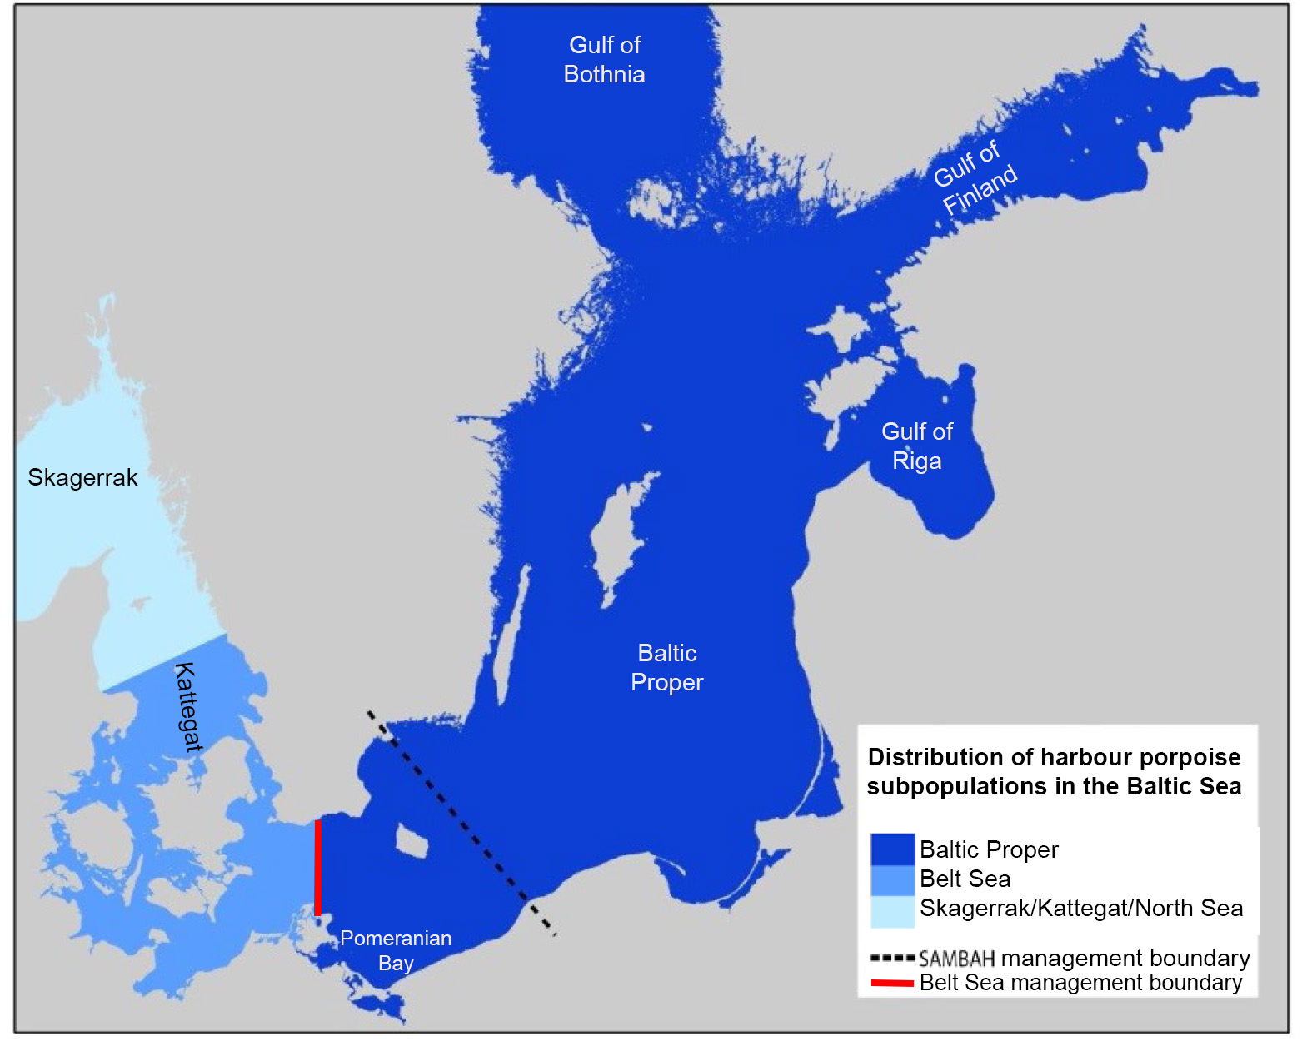**Figure 1.** Distribution ranges of harbour porpoise subpopulations in the Baltic Sea (adapted from Loisa, 2016), and the proposed summer management boundaries for the Belt Sea (13.5°E: Sveegaard *et al.,* 2015) and Baltic Proper (Carlén *et al.,* 2018) subpopulations.

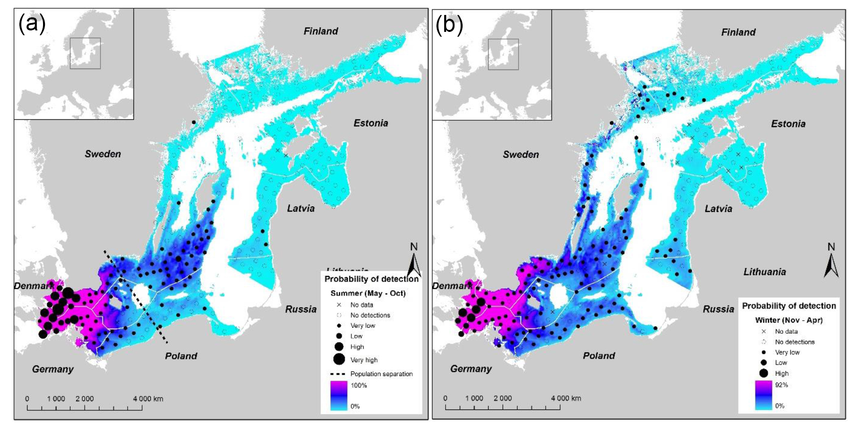

**Figure 2.** Predicted seasonal probability of detection of harbour porpoises in the SAMBAH project area during: (a) May–Oct; and (b) Nov–Apr (SAMBAH, 2016). The dashed line indicates the spatial separation between the Belt Sea and Baltic harbour porpoise populations during May–October.

**The Iberian harbour porpoise population**

*Overview*

The Iberian harbour porpoise population inhabits the cold-water upwelling zone along the Atlantic coasts of Spain and Portugal (Figures 3 and 4: Donovan and Bjørge, 1995; Sequeira, 1996; Read, 2016; Fontaine, 2016; Hammond *et al.,* 2017).

|  |  |
| --- | --- |
| Fontaine 2016_2.jpg  **Figure 3.** North-east Atlantic distribution of three harbour porpoise subspecies (from Fontaine, 2016). Blue=North Atlantic (*P. p. phocoena*; Yellow=Iberian (*P. p. meridionalis*); orange=North-west African (*P. p. meridionalis*); red=Black Sea (*P. p. relicta*); graded blue to yellow=contact zone between Iberian and North Atlantic porpoises. | Hammond et al (2017)_3.jpg  **Figure 4.** Sightings of harbour porpoises during the SCANS III survey in 2016. From Hammond *et al*. (2017). |

*Historical distribution*

Historically, the Iberian population probably occurred in a continuous distribution with the wider European North Atlantic population that is currently found from the French Bay of Biscay coast northwards to Iceland (Fontaine *et al.,* 2007, 2010). Genetic studies revealed shallow genetic divergence between Iberian porpoises and those occurring north of the Bay of Biscay (Tolley and Rosel, 2006; Fontaine *et al.,* 2007). This was initially considered to be the result of habitat fragmentation induced by climate warming after the Little Ice Age (LIA; Fontaine *et al.,* 2007, 2010). However, subsequent work by Fontaine *et al.* (2014) found deep mtDNA divergence between porpoises from the European North Atlantic, the Iberian/North-west African upwelling regions, and the Black Sea, indicating that they evolved independently from each other for a substantial amount of time. The latter two populations appear to have shared a common ancestor prior to splitting from the European North Atlantic population. Fontaine *et al.* (2014) proposed that this common ancestor arose from a movement of porpoises into the Mediterranean Sea from the Atlantic during colder climatic conditions associated with the last glacial maximum. Subsequent warming caused porpoises from the western Mediterranean to move back out into Atlantic waters, leading to the relictual Iberian and North-west African populations using habitats where sufficient productive upwelling occurs to support their energetic requirements. Consequently, the current Iberian population arose due to the contraction of suitable cold-water productive habitat during postglacial warming, leaving fragmented porpoise populations from a much wider historical distribution.

*Spain*

The vast majority (86%) of porpoise strandings reported in Spain between 1978 and 1994 occurred along the western Galician coast (Lens, 1997), and comparatively few occurred along the Biscay coast (López *et al.,* 2002). This distribution is supported by recent sightings data. Boat transect surveys along the entire northern Spanish coast in 2006/07 did not record any porpoises, and only two sightings were recorded during shore monitoring (López *et al.,* 2013). During five years of shore-based monitoring in Galicia, Pierce *et al.* (2010) found that porpoises were recorded in 1.6% of coastal observation periods and were widely-distributed, with the highest sighting frequencies recorded off Faro Punta Roncadoira on the north coast of Galicia, Faro Cabo Vilán near Cabo Fisterra (the westernmost point of Galicia), and La Guardia located close to the border with Portugal. Although clearly widespread in Galician coastal waters, boat surveys indicate that the south-west Galician coast is of particular importance for porpoises (Spyrakos *et al.,* 2011; Fernández *et al.,* 2013; Llavona Vallina, 2018). Despite a wide distribution of multi-faceted survey effort off Galicia between 1998 and 2009, porpoise sightings (n=35) were recorded only between Cabo Fisterra and the Portuguese border (Fernández *et al.,* 2013). Surveys in this region (Ría of Arousa) between 2014 and 2017 recorded 70 porpoise encounters (338 animals), with sightings distributed throughout the study area (Díaz López and Methion, 2018). Porpoises appear to be rare off southern Spain in the Gulf of Cádiz (Sociedad Española de Cetáceos, 2006), and are generally absent from the Strait of Gibraltar and the western Mediterranean Sea (Frantzis *et al.,* 2001). A small number of porpoise sightings in the northern Aegean are thought to originate from the isolated Black Sea population (Frantzis *et al.,* 2001; Fontaine, 2016).

*Portugal*

Initial information on porpoise distribution in Portugal originated from strandings, with over 86% of porpoise strandings occurring in the upwelling regions along the northern and central Portuguese coasts; most (67%) around Aveiro and Figueira da Foz (Sequeira, 1996). Since then, a more expansive dataset has shown that strandings occur all along the Portuguese coastline, particularly between Viana do Castelo in the north and Nazaré in central Portugal (Ferreira *et al.,* 2017). Between 1978 and 2015, 347 porpoise strandings were reported in central and northern Portugal, with 43 in 2014 alone (Ferreira *et al.,* In Prep.). The SCANS survey in 2016 recorded porpoise sightings from the border with Galicia south to Peniche, but had no sightings south of that region (Figure 4; Hammond *et al.,* 2017). However, sightings recorded from a variety of platforms since 2008 support an occurrence all along the Portuguese coast, with a main area of concentration located between Porto and Nazaré, and a second hotspot occurring between Vila do Conde and Caminha near the border with Galicia (Figure 5; Vingada *et al.,* 2011; Araújo *et al.,* 2015; Vingada and Eira, 2017a). Aerial surveys along the Portuguese coastline produced predicted occurrence maps that suggest annual fluctuations in porpoise occurrence, particularly in southern Portugal (Araújo *et al.,* 2015). Shore-based surveys at the Douro River mouth (near Porto) in northern Portugal during 2017 included repeated sightings of a leucistic animal, that suggests some site-fidelity at that location (Gil *et al.,* In Press). Porpoises are scarcer in southern Portugal (Araújo *et al.,* 2015; Vingada and Eira, 2017a), but survey work has revealed regular sightings off Costa de Setubal and Costa Sudoeste, which may be important in maintaining connectivity between regions (Araújo *et al.,* 2015; Vingada and Eira, 2017a). Few records exist from the Gulf of Cádiz coast. However, during 2009, 22 porpoise sightings were recorded along the western Algarve coast of southern Portugal (Cape São Vicente to Lagos), indicating that Iberian porpoises do also inhabit that region (Castro, 2010).

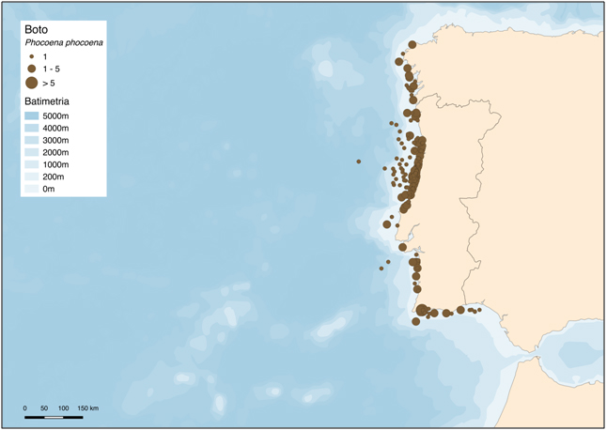

**Figure 5.** Sightings of harbour porpoises from aerial census, platforms of opportunity and coastal surveys in Portuguese waters, 2010–2015. Adapted from Vingada and Eira (2017a).

*Distribution limit*s

An area of very low density occurs along the southern Bay of Biscay coast that may represent the northern limit of distribution of the Iberian population. In that region, warmer oligotrophic waters are considered to represent an ecological barrier to porpoise movements, and result in the current separation of the Iberian population from the rest of the eastern North Atlantic population (Fontaine *et al.,* 2007, 2010, 2014). Fontaine *et al.* (2017) suggests a genetic contact zone between North Sea and Iberian ecotypes occurring in the region between the northern Bay of Biscay and south-west England, but any gene flow is likely to be one-directional (northwards). The southern distribution of Iberian porpoises extends to at least the Algarve coast of Portugal (Sequeira, 1996; Castro, 2010; Araújo *et al.,* 2015; Vingada and Eira, 2017a) and the Spanish coast in the Gulf of Cádiz (Sociedad Española de Cetáceos, 2006), although the scarcity of sightings in this region suggests low densities. Porpoises are currently absent from the Strait of Gibraltar and the Mediterranean Sea, with the exception of occasional vagrants (Frantzis *et al.,* 2001; Fontaine, 2016). A survey of the waters between the Gulf of Cádiz and Mauritania did not record any porpoises north of Agadir in Morocco (30°N; Boisseau *et al.,* 2007), although three strandings were reported between Agadir and the Straits of Gibraltar over a 29 year monitoring period between 1980 and 2009 (Masski and De Stéphanis, 2015). Harbour porpoise do occur in the upwelling system off the north-west coast of Africa between (at least) latitudes 14° and 30°N (Senegal, Mauritania, Western Sahara and Morocco: Cadenat, 1949; Fraser, 1958; Bayed and Beaubrun, 1987; Smeenk *et al.,* 1992; Donovan and Bjørge, 1995; Robineau and Vely, 1998; Boisseau *et al.,* 2007). The lack of intensive survey effort in the region between the Iberian Peninsula (Strait of Gibraltar) and Agadir (Morocco) limits understanding of the potential connectivity between African and Iberian porpoises. Until further evidence, the continental divide at the Strait of Gibraltar is taken to represent the southern distributional limit of the Iberian population (Donovan and Bjørge, 1995).

*Seasonality*

Strandings and sightings of harbour porpoise occur year-round in Spain and Portugal (Sequeira, 1996; Lens, 1997; López *et al.,* 2002; Pierce *et al.,* 2010; Vingada and Eira, 2017a; Díaz López and Methion, 2018; Ferreira *et al.,* In Prep.). However, in Galicia strandings were more common in winter (peaking March and April), while in Portugal a peak was detected in May, and with similar values in June–August (Llavona Vallina, 2018; Ferreira *et al.,* In Prep.). Sightings from a shore vantage point in central Portugal also varied seasonally, with highest sighting rates recorded between October and March, and very few sightings between July and September (Pereira, 2015).

1. **Summary of Activities:**

The Baltic Sea and Iberian Peninsula populations of harbor porpoise are considered critically endangered and a critically isolated population respectively and have been recognized as high priority for conservation by numerous scientific fora. The need for these populations to be listed CMS Appendix I was recognised at the 24th ASCOBANS Advisory Committee meeting in 2018. Despite this, the nomination failed to take place. Noting this and for the reasons detailed in this document, the activities in this proposal are of paramount importance for the protection of both harbor porpoise populations.

Activities and actions proposed support the work of ASCOBANS and the Baltic Porpoise Action Plan and this concerted action will also strengthen the collaborative effort by all CMS Parties bordering the Baltic Proper.

The Iberian population will similarly benefit from the actions recommended, here and particularly with regard to reducing unintentional mortality from fisheries bycatch.

1. **Activities and expected outcomes:**

The proponents will contribute to the following actions for the benefit of the Baltic Sea and Iberian harbour porpoise populations:

* Participate in developing an action plan for the Iberian harbour porpoise population. Timeline: Before COP 14
* Work to support the ASCOBANS Recovery Plan for the Baltic Sea harbour porpoise (the Jastarnia Plan). Timeline: Ongoing with progress reported annually to Jastarnia and ASCOBANS advisory committee meetings
* Work to assist governments in the collection of relevant data on fishing effort within the range of both populations, including *inter alia* 
  + gear type
  + soak time x net length
  + vessels of all sizes
  + bycatch data

Timeline: Open-ended

* Encourage, and where appropriate assist in, large-scale surveys and national monitoring of the respective populations. This should be coordinated between countries and support and increase the knowledge-base required for effective management. Timeline: As proves appropriate
* Assist governments in developing management and mitigation measures within both the designated marine protected area and wider population range of the Baltic Sea population. Timeline: As proves appropriate
* Support governments in the creation of an appropriate network of marine protected areas for the Iberian harbour porpoise population, and assist with the development of management and mitigation measures within this area and the populations’ entire range. Timeline: Development of a proposal before COP 14
* Contribute to the development of conservation goals relevant to EU regulations, such as Favorable Conservation Values for the Habitats Directive and threshold values for GES for MSFD indicators D1C2 on population abundance and D1C4 on distributional range, for both populations. Timeline: As per reporting cycles
* Work to raise awareness of the Baltic Sea and Iberian population of harbour porpoise for the general public, managers and decision-makers in all range states. Timeline: Open-ended and ongoing
* Encourage and support the listing of both populations appropriately in the Appendices of CMS COP 14 in 2023. Given that the Baltic porpoise is already covered by CMS Appendix II, this means inclusion in on Appendix I and add the Iberian population to both appendices. Timeline: Before COP 14

It is proposed that Parties:

* As soon as possible, implement a coherent system for data collection on fishing effort and bycatch of protected, endangered and threatened species, including harbour porpoise, for vessels of all sizes;
* Take immediate management actions and measures, including fisheries regulations to protect porpoises within and outside marine protected areas such as Natura 2000 sites;
* Actively participate in the development of an Action Plan for the Iberian harbour porpoise population with immediate effect; and
* List the two harbour porpoise populations on CMS Appendix I at the earliest opportunity and also add the Iberian porpoise population to Appendix II.

1. **Associated benefits:**

Harbour porpoises have the potential to act as both flagship- and indicator-species and as such can help to catalyze conservation actions to benefit entire ecosystems.

Therefore, a number of associated benefits exist with this proposal:

* It will support existing harbour porpoise initiatives within the Baltic Sea, e.g. HELCOM recommendation 17/2;
* Provide improved conservation benefits for a wider range of taxa throughout the relevant regions; and

Within the Baltic Sea region, other species such as seals and seabirds will also benefit from improved monitoring and mitigation measures. Similarly, for the Iberian harbour porpoise population, a number of species will benefit from improved monitoring and mitigation measures, including turtles, elasmobranchs, seals and seabirds (some of which are protected species).

1. **Timeframe:**

Please see section iv above for indicative timings.

1. **Relationship to other CMS actions:**

The implementation of the actions relates to the following CMS activity areas:

* ASCOBANS, including:
  + The ASCOBANS Recovery Plan for Baltic Harbour Porpoises;
  + The ASCOBANS Conservation Plan for the Harbour Porpoise Population in the Western Baltic, the Belt Sea and the Kattegat;
  + The ASCOBANS Conservation Plan for Harbour Porpoises in the North Sea;
* ACCOBAMS, as may prove appropriate;
* CMS Resolution 12.22 on ‘Bycatch’; and
* CMS Global Programme of Work for Cetaceans – specifically in relation to 7.2 and 9.2

1. **Conservation priority:**

**The Baltic Sea harbour porpoise population**

In the Baltic Sea, several strands of evidence including genetics, distributional data, skull morphometrics and contaminant work, support the existence of a distinct population of the harbour porpoise. The Baltic Sea population inhabits the eastern portion of the Baltic Sea, with a south-western summer management border extending in a diagonal line between Hanö in Sweden and Słupsk in Poland (SAMBAH, 2016; Carlén *et al.,* 2018), and appears to be concentrated over a relatively small spatial area in summer, incorporating the Hoburgs and Midsjöbankarna offshore banks in Swedish and Polish waters.

The Baltic Sea population has long been of conservation concern, with marked declines noted anecdotally over the last century by many observers, and a Critically Endangered status on both the IUCN Red List (Hammond *et al.,* 2008) and the Baltic Marine Environment Protection Commission Red List (HELCOM, 2013). The first, and only, abundance estimate available for the subpopulation was of only 497 individuals in 2011–2013, and had wide confidence limits (95% CI 80–1,091; SAMBAH, 2016). Life-history information indicates that female porpoises in Baltic Sea have a shorter lifespan than elsewhere (3.7 years), with only ~27% of females living long enough to produce a calf (Kesselring *et al.,* 2017, 2018). High anthropogenic-related mortality due to bycatch in fisheries (especially static gear such as gillnets) appears to be the major threat to the Baltic Proper subpopulation, and is considered unsustainably high. Environmental contaminants may also have contributed to the decline in, and lack of recovery of, Baltic porpoise abundance. Underwater noise from sources including shipping and offshore wind farm construction, may cause displacement and behavioural impacts. The low numbers in combination with the numerous threats to the population means that Range States should provide strict protection by prohibiting takes, conserving habitats, limiting obstacles to migration and controlling other factors that might endanger them. Concerted action with therefore strengthen the collaborative effort by all CMS Parties bordering the Baltic Proper.

**The Iberian harbour porpoise population**

The Iberian harbour porpoise inhabits a region of seasonal upwelling along the Atlantic coasts of Spain and Portugal. Distribution appears to be concentrated around Galicia in north-west Spain, and along the central and northern coasts of Portugal (a geographic region referred to hereon as the north-west Iberian Peninsula, NWIP). The Iberian porpoise is not currently recognised by the IUCN Red List. However, a significant amount of information on Iberian porpoises has emerged within the last decade, and since the last 2008 Red List assessment was produced. In 2009, the ICES WGMME recognised Iberian porpoises as a critical, isolated, population that represented a demographically significant unit and a unique management unit inhabiting ICES areas 8c and 9a. The Iberian population is genetically-distinct, exhibits low and asymmetric gene flow and, together with animals off north-west Africa, appears to comprise a unique porpoise ecotype (Fontaine *et al.,* 2007, 2010; Llavona Vallina, 2018). Recently, harbour porpoises off Iberia and North-west Africa were proposed as a fourth recognised subspecies in the wider north-east Atlantic region, *Phocoena phocoena meridionalis* (Fontaine *et al.,* 2014). No genetic differentiation is apparent between porpoises from Spain and Portugal, indicating that they comprise a single, widely-distributed population. Regular movements between the two countries are unproven but highly likely, based on genetic data and inferences from typical porpoise home ranges in other regions. The population size of Iberian porpoises is low (<3,000 animals), and estimated annual mortality rates are high (18%). An estimated 11% of annual porpoise mortality in the NWIP was deemed directly attributed to fisheries interactions (Read *et al.,* 2013). However, more recent estimates from Portuguese fisheries suggests a fisheries bycatch of 30.32% of the estimated national population size of 1,531 animals. These values greatly exceed the ASCOBANS recommendation of 1.7% of a population annually and are unsustainably high. The Iberian population would therefore greatly benefit from the action plan recommended, particularly with regard to reducing unintentional mortality from fisheries bycatch.

1. **Relevance:**

Regular transboundary movements by harbour porpoise from the Baltic Proper subpopulation are evidenced by spatio-temporal variation in distribution, the spanning of the core summer high density areas across Swedish-Polish borders, and the high mobility of the species in general. Regular movements between Spain and Portugal are unproven but highly likely, based on genetic data and inferences from typical porpoise home ranges in other regions.

By listing certain harbour porpoise populations in Appendix II already, CMS Parties have highlighted their unfavorable conservation status and that they would benefit from international cooperation. However, the degree of action for the conservation of the critically endangered Baltic Sea population, as well as the Iberian population, is extremely low. We therefore argue that Parties need to work together in applying urgently needed conservation actions for these populations.

1. **Absence of better remedies:**

The CMS Network is the ideal platform for improving awareness and focusing attention on these threatened populations in all Range States, driving implementation of key management and mitigation measures under this Concerted Action. A strategic and collaborative approach is required to take forward the urgently needed steps for conserving these populations, and for this purpose it is essential that Parties work together on developing and implementing activities.

1. **Readiness and feasibility:**

The NGOs concerned with this proposal have existing work streams and public outreach campaigns within this area and are already fully engaged, therefore this will be a continuation and extension of existing programmes.

1. **Likelihood of success:**

Given the commitment of the four proponents, as underlined by their previous activities, it is believed this proposal has a high chance of success.

However, some variables are outside of the proponents’ control, as indicated in the notes on timing above and as with any project there is a risk of effects caused by unforeseen changes in staff and funding.

1. **Magnitude of likely impact:**

See section V notes on associated benefits.

1. **Cost-effectiveness:**

Contribution from the proponent NGOs is voluntary and therefore cost-neutral to others.

1. **Consultations-Planned/Undertaken:**

This proposal has been significantly informed by numerous expert discussions that the proponents have been involved in over a number of years and predominantly within the context of ASCOBANS, including its Jastarnia Plan.

Specifically, the document as provided here was developed after the 25th meeting of the ASCOBANS Advisory Committee in September 2019 where the Advisory Committee’s clear support for the listings described and the associated conservation actions for both harbour porpoise populations was apparent. This meeting concluded on the same day as the deadline for the proposals to the CMS CoP.

**References**

***Baltic Harbour Porpoise***

ASCOBANS (2009). Recovery Plan for Baltic Harbour Porpoises. Jastarnia Plan (2009 revision). 48pp.

ASCOBANS (2016). Recovery Plan for Baltic Harbour Porpoises. Jastarnia Plan (2016 revision). ASCOBANS Resolution 8.3. Annex I, 8th Meeting of the Parties to ASCOBANS, Helsinki, Finland, 30 August - 1 September 2016. 94pp.

Benke, H., Bräger, S., Dähne, M., Gallus, A., Hansen, S., Honnef, C.G., Jabbusch, M., Koblitz, J.C., Krügel, K., Liebschner, A., Narberhaus, I. and Verfuß, U.K. (2014). Baltic Sea harbour porpoise populations: status and conservation needs derived from recent survey results. Marine Ecology Progress Series, 495: 275-290.

Berggren, P., Wade, P.R., Carlström J, and Read AJ. (2002). Potential limits to anthropogenic mortality for harbour porpoises in the Baltic region. Biological Conservation, 103: 313–322.

Carlén, I., Thomas, L., Carlström, J., Amundin, M., Teilmann, J., Tregenza, N., Tougaard, J., Jens C. Koblitz, J.C., Sveegaard, S., Wennerberg, D., Loisa, O., Dähne, M., Brundiers, K. Kosecka, M., Kyhn, L.A., Ljungqvist, C.T., Pawliczkai, I., Kozai, R., Arciszewskii, B., Galatius, A., Jabbusch, M., Laaksonlaita, J., Niemi, J., Lyytinen, S., Gallus, A., Benke, H., Blankett, P., Skórai, K.E. and Acevedo-Gutiérrezk, A. (2018). Basin-scale distribution of harbour porpoises in the Baltic Sea provides basis for effective conservation actions. Biological Conservation, 226: 42-53.

Evans, P.G.H. and Similä, T. (2018). Progress report on the Jastarnia Plan: The recovery plan for the harbour porpoise in the Baltic proper. 24th ASCOBANS Advisory Committee Meeting AC24/Doc.3.1.b. Vilnius, 25 -27 September 2018.

Fontaine, M.C., Roland, K., Calves, I., Austerlitz, F., Palstra, F.P., Tolley, K.A., Ryan, S., Ferreira, M., Jauniaux, T., Llavona, A., Öztürk, B., Öztürk, A.A., Ridoux, V., Rogan, E., Sequeira, M., Siebert, U., Vikingsson, G.A., Borrell, A., Michaux, J.R. and Aguilar, A. (2014). Postglacial climate changes and rise of three ecotypes of harbour porpoises, *Phocoena phocoena*, in western Palearctic waters. Molecular Ecology, 23: 3306–3321.

Gallus, A., Dähne, M., Verfuß, U.K., Bräger, S., Adler, S., Siebert, U. and Benke, H. (2012). Use of passive acoustic monitoring to assess the status of the ‘Critically Endangered’ Baltic harbour porpoise in German Waters. Endangered Species Research, 18: 265−278.

Hammond, P.S., Bearzi, G., Bjørge, A., Forney, K.A., Karczmarski, L., Kasuya, T., Perrin, W., Scott, M.D., Wang, J.Y. , Wells, R.S. and Wilson, B. (2008). *Phocoena phocoena* (Baltic Sea subpopulation). The IUCN Red List of Threatened Species 2008: e.T17031A98831650. http://dx.doi.org/10.2305/IUCN.UK.2008.RLTS.T17031A6739565.en

Hammond P.S., Lacey C., Gilles A., Viquerat S., Börjesson P., Herr H., Macleod K., Ridoux V., Santos M.B., Scheidat M., Teilmann J., Vingada J. and Øien N. (2017). Estimates of cetacean abundance in European Atlantic waters in summer 2016 from the SCANS-III aerial and shipboard surveys. Available at https://synergy.st-andrews.ac.uk/scans3/files/2017/04/SCANS-III-design-based-estimates-2017-04-28-final.pdf

HELCOM (2013). Species Information Sheet: *Phocoena phocoena*. Available at: http://www.helcom.fi/Red%20List%20Species%20Information%20Sheet/HELCOM%20Red%20List%20Phocoena%20phocoena.pdf#search=porpoise

HELCOM (2018). State of the Baltic Sea – Second HELCOM holistic assessment 2011-2016. Baltic Sea Environment Proceedings. 155pp. Baltic Marine Environment Protection Commission – HELCOM. Available at www.helcom.fi/baltic-sea-trends/holistic-assessments/state-of-the-baltic-sea-2018/reports-and-materials/.

Huggenberger, S., Benke, H. and Kinze, C.C. (2002). Geographical variation in harbour porpoise (*Phocoena phocoena*) skulls: support for a separate non-migratory population in the Baltic proper. Ophelia 56, 1–12. https://doi.org/10.1080/00785236.2002.10409484.

Koschinski, S. (2001). Current knowledge on harbour porpoises (Phocoena phocoena) in the Baltic Sea. Ophelia, 55: 167–197.

Loisa, O. (2016). Pyöriäinen Suomessa - Päivitetty ehdotus toimenpiteistä pyöriäisen suojelemiseksi Suomessa (Harbour porpoise – updated proposal on measures for the conservation of harbour porpoise in Finland). The Finnish Environment 5/2016. Ministry of the Environment. 56 pp. http://urn.fi/URN:ISBN:978-952-11-4619-0 [In Finnish, with English summary].

SAMBAH (2016). Final report for LIFE Project Number LIFE08 NAT/S/000261 covering the project activities from 01/01/2010 to 30/09/2015. Reporting date 29/02/2016, 80pp.

Skòra, K.E. and Kuklik, I. (2003). Bycatch as a potential threat to harbour porpoises (*Phocoena phocoena*) in Polish Baltic waters. NAMMCO Scientific Publications, 5: 303-315.

Sveegaard, S., Teilmann, J., Tougaard, J., Dietz, R., Mouritsen, K.N., Desportes, G. and Siebert, U. (2011). High-density areas for harbor porpoises (*Phocoena phocoena*) identified by satellite tracking. Marine Mammal Science, 27: 230-246.

Sveegaard, S., Galatius, A., Dietz, R., Kyhn, L., Koblitz, J.C., Amundin, M., Nabe-Nielsen, J., Sinding, M.-H.S., Andersen, L.W. and Teilmann, J. (2015). Defining management units for cetaceans by combining genetics, morphology, acoustics and satellite tracking. Global Ecology and Conservation, 3: 839–850.

***Iberian Harbour Porpoise***

Araújo , H., Santos, J. Rodrigues, P., Vingada, J., Eira, C., Raínho, A., Arriegas, I., Leonardo, T., Nunes, M. e Sequeira, M. (2015). Proposta técnica de novos Sítios de Interesse Comunitário para a conservação de cetáceos em Portugal Continental para inclusão na Lista Nacional de Sítios. Anexo do Relatório de Progresso do LIFE+MarPro PT/NAT/00038, pp. 182.

Bayed, A. and Beaubrun, P.C. (1987). Les mammiferes marins du Maroc: Inventaire preliminaire. Mammalia, 51(3): 437–446.

Boisseau, O., Matthews, J., Gillespie, D., Lacey, C., Moscrop, A., ad Ouamari, N. El. (2007). A visual and acoustic survey for harbour porpoises off North-West Africa: further evidence of a discrete population. African Journal of Marine Science, 29: 403–410.

Cadenat, J. (1949). Notes sur les cétacés observés sur les côtes du Sénégal de 1941 à 1948. Bulletin de l'Institut Français d'Afrique Noire, 11: 1–15.

Castro, J.M. (2010). Characterization of cetaceans in the South coast of Portugal between Lagos and Cape São Vicente. MSc Thesis, Faculty of Sciences, University of Lisbon.

Díaz López, B. and Methion, S. (2018). Does interspecific competition drive patterns of habitat use and relative density in harbour porpoises? Marine Biology, 165: 92.

Donovan, G.P. and Bjørge, A. (1995) Harbour porpoises in the North Atlantic. In: Bjørge, A. and Donovan, G.P. (eds), Reports of the International Whaling Commission, Special Issue 16: 3–25.

Fernández, R., MacLeod, C.D., Pierce, G.J., Covelo, P., López, A., Torres-Palenzuela, J., Valavanis, V. and Santos, M.B. (2013). Inter-specific and seasonal comparison of the niches occupied by small cetaceans off north-west Iberia. Continental Shelf Research, 64: 88–98.

Ferreira, M., Marçalo, A., Nicolau, L., Pereira, A., Braga, E., Araújo, H., Santos, J., Vaqueiro, J., Bento, M.C., Gomes, T., Eira, C. and Vingada, J. (2017). Redes de arrojamentos e reabilitação: 2013-2016. Anexo do Relatório final do projeto LIFE MarPro PT/NAT/00038.

Ferreira, M., Pereira, A., Costa, E., Bastos-Santos, J. Araújo, H., Vaqueiro, J., Oliveira, I. Nicolau, L., Gomes, T., Sá, S., Bento, C., Sequeira, M., Vingada, J., López, A. and Eira, C. In Prep. Strandings of harbour porpoise *Phocoena phocoena* in the northern Portugal.

Fontaine, M.C. (2016). Harbour porpoises, *Phocoena phocoena*, in the Mediterranean Sea and adjacent regions: biogeographic relicts of the Last Glacial Period. Advances in Marine Biology, 75: 333–358.

Fontaine, M.C., Baird, S.J.E., Piry, S., Ray, N., Tolley, K.A. Duke, S., Birkun, A. Jr., Ferreira, M., Jauniaux, T., Llavona Vallina, A., Öztürk, B., Öztürk, A.A., Ridoux, V., Rogan, E., Sequeira, M., Siebert, U., Vikingsson, G.A., Bouquegneau, J-M. and Michaux, J.R. (2007). Rise of oceanographic barriers in continuous populations of a cetacean: the genetic structure of harbour porpoises in Old World waters. BMC Biology 2007, 5:30 doi:10.1186/1741-7007-5-30.

Fontaine, M.C., Tolley, K.A., Michaux, J.R., Birkun, A. Jr., Ferreira, M., Jauniaux, T., Llavona Vallina, A., Öztürk, B., Öztürk, A.A., Ridoux, V., Rogan, E., Sequeira, M., Bouquegneau, J-M. and Baird, S.J.E. (2010). Genetic and historic evidence for climate-driven population fragmentation in a top cetacean predator: the harbour porpoises in European water. Proceedings of the Royal Society B, 277: 2829–2837.

Fontaine, M.C., Roland, K., Calves, I., Austerlitz, F., Palstra, F.P., Tolley, K.A., Ryan, S., Ferreira, M., Jauniaux, T., Llavona Vallina, A., Öztürk, B., Öztürk, A.A., Ridoux, V., Rogan, E., Sequeira, M., Siebert, U., Vikingsson, G.A., Borrell, A., Michaux, J.R. and Aguilar, A. (2014). Postglacial climate changes and rise of three ecotypes of harbour porpoises, *Phocoena phocoena*, in western Palearctic waters. Molecular Ecology, 23: 3306–3321.

Fontaine, M.C., Thatcher, O., Ray, N., Piry, S., Brownlow, A., Davinson, N.J., Jepson, P.D., Deaville, R., Goodman, S.J. (2017). Mixing of porpoise ecotypes in South Western UK waters revealed by genetic profiling. Royal Society of Open Science, 4: 160992.

Frantzis, A., Gordon, J., Hassidis, G. and Komnenou, A. (2001). The enigma of harbor porpoise presence in the Mediterranean Sea. Marine Mammal Science, 17: 937–944.

Fraser, F.C. (1958). Common or harbour porpoises from French West Africa. Bulletin de l'Institut Français d'Afrique Noire, 20: 276–285.

Gil, A., Correia, A.M. and Sousa-Pinto, I. Records of harbour porpoise (*Phocoena phocoena*) in the mouth of the Douro River (Northern Portugal) with presence of an anomalous white individual. In Press, Marine Biodiversity Records.

Hammond P.S., Lacey C., Gilles A., Viquerat S., Börjesson P., Herr H., Macleod K., Ridoux V., Santos M.B., Scheidat M., Teilmann J., Vingada J. and Øien N. (2017). Estimates of cetacean abundance in European Atlantic waters in summer 2016 from the SCANS-III aerial and shipboard surveys. Available at https://synergy.st-andrews.ac.uk/scans3/files/2017/04/SCANS-III-design-based-estimates-2017-04-28-final.pdf

ICES (2009). ICES Working Group on Marine Mammal Ecology (WGMME) Report 2009. February 2–6 2009, Vigo, Spain. ICES CM 2009/ACOM:21.

Lens, S. (1997). A note on the harbour porpoise (*Phocoena phocoena*) in the coastal waters of Spain. Reports of the International Whaling Commission, 47: 841–847.

Llavona Vallina, A. (2018). Population parameters and genetic structure of the harbour porpoise (*Phocoena phocoena*, L. 1758) in the Northwest Iberian Peninsula. Universidade de Aveiro. PhD Thesis.

López, A., Santos, M.B., Pierce, G.J., González, AF, Valeiras, X. and Guerra, A. (2002). Trends in strandings and by-catch of marine mammals in northwest Spain during the 1990s. Journal of the Marine Biological Association of the United Kingdom, 82: 513–521.

López, A., Vázquez, J.A., Martínez Cedeira, J.A., Cañadas, A., Marcos, E., Maestre, I., Ruano, A., Larias, L., Llavona, A., MacLeod, K. and Evans, P. (2013). Abundance estimates for harbour porpoise (*Phocoena phocoena*) in the Spanish area of the Iberian Peninsula Management Unit. 4 - 15 June 2013, Jeju Island, Republic of Korea. SC/65a/SM20. 4pp.

Masski, H. and De Stéphanis, R. (2015). Cetaceans of the Moroccan coast: information from a reconstructed strandings database. Journal of the Marine Biological Association of the United Kingdom. 9pp. http://dx.doi.org/10.1017/S0025315415001563.

Pereira, A.T. (2015). Monitorização do uso costeiro por pequenos cetáceos e avaliação do uso de pingers para mitigação de capturas acidentais na região norte de Portugal. Mestrado Recursos Biológicos Aquáticos, Departamento de Biologia, Universidade do Porto.

Pierce, G.J., Caldas, M., Cedeira, J., Santos, M.B., Llavona, A., Covelo, P., Martinez, G., Torres, J., Sacau, M. and López, A. (2010). Trends in cetacean sightings along the Galician coast, north-west Spain, 2003–2007, and inferences about cetacean habitat preferences. Journal of the Marine Biological Association of the United Kingdom, 90: 1547–1560.

Read, F.L. (2016). Understanding cetacean and fisheries interactions in the north-west Iberian Peninsula. PhD Thesis. University de Vigo, Spain.

Read, F.L., Santos, M.B., González, A.F., López, A., Ferreira, M., Vingada, J. and Pierce, G.J. (2013). Understanding harbour porpoise (*Phocoena phocoena*) and fishery interactions in the north-west Iberian Peninsula. Final report to ASCOBANS (SSFA/ASCOBANS/2010/4). www.ascobans.org/pdf/ac19/AC19\_6-06\_PreliminaryProjectReport\_IberianPorpoises.pdf. 40 pp.

Robineau, D. and Vely, M. (1998). Les cétacés de Mauritanie (Afrique du nord-ouest). Particularités et variations spatio-temporelles de répartition: rôle des facteurs océanographiques. Revue d'Ecologie (la Terre et la Vie), 53: 123–152.

Sequeira, M. (1996). Harbour porpoises *Phocoena phocoena* in Portuguese waters. Reports of the International Whaling Commission, 46: 583–586.

Smeenk, C., Leopold, M.F. and Addink, M.J. (1992). Note on the harbour porpoise *Phocoena phocoena* in Mauritania, West Africa. Lutra, 35: 98–104.

Sociedad Española de Cetáceos (2006). Plan de monitorización de la marsopa (*Phocoena phocoena*) en Andalucía. Primera fase 2007 - 2010. LIFE02NAT/E/8610. 17 pp.

Spyrakos, E., Santos-Diniz, T.C., Martinez-Iglesias, G., Torres-Palenzuela, J.M. and Pierce, G.J. (2011). Spatiotemporal patterns of marine mammal distribution in coastal waters of Galicia, NW Spain. Hydrobiologia, 670: 87–109.

Tolley, K. and Rosel, P.E. (2006). Population structure and historical demography of eastern North Atlantic harbour porpoises inferred through mtDNA sequences. Marine Ecology Progress Series, 327: 297–308.

Vingada, J. and Eira, C. (2017a). Conservation of Cetaceans and Seabirds in Continental Portugal The LIFE + MarPro project. Edições Afrontamento. 219 pp.

Vingada, J., Ferreira, M., Marçalo, A., Santos, J., Araújo, H., Oliveira, I., Monteiro, S., Nicolau, L., Gomes, P., Tavares, C. and Eira, C. (2011). SAFESEA - Manual de Apoio para a Promoção de uma Pesca Mais Sustentável e de um Mar Seguro para Cetáceos. Programa EEAGrants - EEA Financial Mechanism 2004-2009 (Projecto 0039), Braga. 114 pp. In Portuguese.

**Annex 1. Glossary of Terms**

ACCOBAMS = Agreement on the Conservation of Cetaceans of the Black Sea, Mediterranean Sea and contiguous Atlantic Area

ASCOBANS = Agreement on the Conservation of Small Cetaceans of the Baltic, North East Atlantic, Irish and North Seas

CCB = Coalition Clean Baltic

CFP = Common Fisheries Policy

CMS = Convention on the Conservation of Migratory Species of Wild Animals

COP = Convention of Parties

EC = European Committee

HELCOM = Baltic Marine Environment Protection Commission - Helsinki Commission

HSI = Humane Society International

ICES = The International Council for the Exploration of the Sea

IUCN = The International Union for Conservation of Nature

NGOs = Non-governmental organisation

NWIP = North West Iberian Peninsula

PET = Protected, Endangered or Threatened Species

SAMBAH = Static Acoustic Monitoring of the Baltic Sea Harbour Porpoise

SCANS = Small Cetaceans in European Atlantic waters and the North Sea

WBBK = Western Baltic, the Belt Sea and the Kattegat

WGMME = Working Group on Marine Mammal Ecology

WDC = Whale and Dolphin Conservation