 | CONVENTION ON  MIGRATORY  SPECIES | UNEP/CMS/COP14/Doc.27.7.3  14 November 2023  Original: English

14th MEETING OF THE CONFERENCE OF THE PARTIES
Samarkand, Uzbekistan, 12 - 17 February 2024
Agenda Item 27.7

IMPLEMENTATION OF THE CMS APPENDIX I-LISTING FOR
THE OCEANIC WHITETIP SHARK (Carcharhinus longimanus)
(Prepared by the Maldives)

Summary:

The Government of the Maldives has prepared a set of draft decisions to improve the implementation of the Oceanic Whitetip shark (Carcharhinus longimanus) CMS Appendix I listing.

IMPLEMENTATION OF THE CMS APPENDIX I-LISTING FOR
THE OCEANIC WHITETIP SHARK (Carcharhinus longimanus)

Summary

- The Maldives submitted a proposal for Concerted Action for CMS COP (UNEP/CMS/COP14/Doc.32.3.6) and as per UNEP/CMS/COP14/Doc.32.3.6/Add.1 it was noted by the Scientific Council that the action would be better framed as Draft Decisions to CMS COP14.

- By way of this document the Government of the Maldives sets forward a set of draft decisions as recommended by the Scientific Council for the adoption of Draft Decisions to improve the implementation of the CMS Appendix I listing for the Oceanic Whitetip shark.

Background

- Formerly one of the world’s most abundant pelagic sharks, oceanic whitetip sharks have a circumglobal distribution stretching from tropical to warm-temperate oceanic waters where, irrespective of location, they commonly encounter fleets regulated by the major tuna Regional Fisheries Management Organizations (tRFMOs; Quieroz et al. 2019).

- In a similar timeframe to that when CITES Parties decided to include the OWT in CITES Appendix II (2013), the species had become the only shark species protected by all tRFMOs, which in large part prohibited its retention, transshipment, and landing in the fisheries covered by these bodies. These measures reflect global understanding of its dire conservation status and the urgent need for management action. Subsequently (CoP 13, 2020) the species was listed on CMS Appendix I.

- In this document, we present evidence of the continued presence of Critically Endangered oceanic whitetip sharks in international trade, with that trade taking place at significantly higher volumes, and from a wider range of Parties, than reported to CITES. The analysis within this paper indicates that as many as 36,216 individual oceanic whitetip sharks were traded illegally through Hong Kong SAR during the three years from 2015-2017, compared with only ~11,815 individuals accounted for in the CITES trade database over this period.

- Oceanic whitetip sharks (OWT) are a highly vulnerable species, taken as “incidental” catch in global pelagic fisheries. Prior to its CITES listing, concerns over the species’ continued declining populations (now listed as ‘Critically Endangered’ globally on the IUCN Red List of Threatened Species) had already resulted in stronger protection for OWT via a range of fisheries management, biodiversity conservation (CMS), and trade regulation measures, at national, regional, and global scales.

- Data on the international catch and trade of OWT from the available online statistics of the Food and Agricultural Organization Of the United Nations (FAO), tuna Regional Fisheries Management Organizations (tRFMOs; International Commission for the Conservation of Atlantic Tunas (ICCAT), Indian Ocean Tuna Commission (IOTC), Inter-American Tropical Tuna Commission (IATTC), and Western and Central Pacific Fisheries Commission (WCPFC)), the CITES trade database, Hong Kong SAR Customs data, and the Agriculture Fisheries Conservation Department of Hong Kong SAR confiscation records, compared with research analyzing the global species composition of the international fin trade, were used to evaluate recent levels of international OWT trade.

- Official government landings data reported to the tRFMOs show reduced catches since the species was prohibited in all four bodies. Low volumes of trade have been registered in the CITES trade database since the CITES Appendix II listing entered into force, indicating good compliance with these measures based on this database only. However, seizures of the easily identifiable unprocessed OWT fins being illegally traded and research conducted in the retail markets of the global shark fin trade hub indicate that official data mask substantial under-reporting by Parties to the FAO, RFMOs and CITES and a likely lack of compliance with these bodies, and CMS measures for the species.

- Hong Kong SAR is estimated to represent 50% of the global fin trade. During the initial preparation of fins for processing, when first imported into Hong Kong SAR, excess meat, skin, and cartilage are removed. These trimmings are sold for consumption as an inexpensive shark fin byproduct. Long-term genetic analyses of these trimmings, representing the entire shark fin trade (Fields et al. 2018, Cardeñosa et al. 2022), indicate that OWT fins have remained in the Hong Kong SAR and mainland China fin markets at comparable levels to those before the CITES Appendix II listing entered into force in 2014.

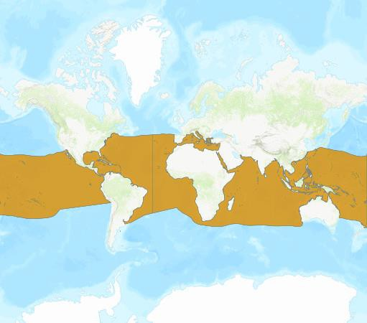
- Overall, there are clear discrepancies between the volumes of OWT recorded in the CITES trade database and those found in the global fin trade. Additionally, as explored in this document, there are further discrepancies between the OWT landings data reported to the tRFMOs, reported to the FAO, and trade documented in the CITES trade database. It appears from this analysis that large volumes of OWT products are being traded without adequate CITES documentation, and are non- compliant with CITES. This is of concern in terms of CMS compliance, as it indicates that the CMS Appendix I listing is, along with the CITES and RFMO measures being poorly or partially implemented.
Figure 1: Global distribution of the oceanic whitetip shark (©IUCN Red List)

Recommended actions:

- The Conference of the Parties is recommended to:

a) adopt the draft Decisions contained in the Annex.

ANNEX

DRAFT DECISIONS

IMPLEMENTATION OF THE CMS APPENDIX I-LISTING
FOR THE OCEANIC WHITETIP SHARK (Carcharhinus longimanus)

Directed to Parties

14.AA Parties are requested to provide to the CMS Secretariat information on their domestic and regional management measures for the oceanic whitetip shark – clarifying how they meet the objectives of the CMS Appendix I listing

Directed to the Secretariat

14.BB The Secretariat is requested to

- issue a notification to seek information from Parties in fulfilment of Decision 14.AA;

- collate the information provided by the Parties in response to Decision 14.AA, and to transmit this information in sufficient time to allow submission to the Standing Committee for review at its 55th meeting.

Directed to the Standing Committee

14.CC The Standing Committee is requested to review the compilation of information provided by the Secretariat in fulfilment of Decision 14.BB, and to both report progress, and make recommendations for further action, to the Convention of the Parties at its 15th meeting.

