ANNEX 3

PRELIMINARY ANALYSIS OF IUCN RED DATA LIST INFORMATION ON SPECIES LISTED ON, AND COVERED BY CMS APPENDICES

Contents
APPENDIX I 2
Conservation status 2
Main threats affecting species listed on Appendix I 4
APPENDIX II 14
Appendix II-listed species by taxonomic group 14
Conservation status 14
Population Trends. 15
Main threats affecting species listed on Appendix II 16
Species listed and covered on Appendix II 26
Conservation status 26
Population Trends. 27
Main threats affecting species listed and covered on Appendix II 28

APPENDIX I

Appendix I-listed species by taxonomic group

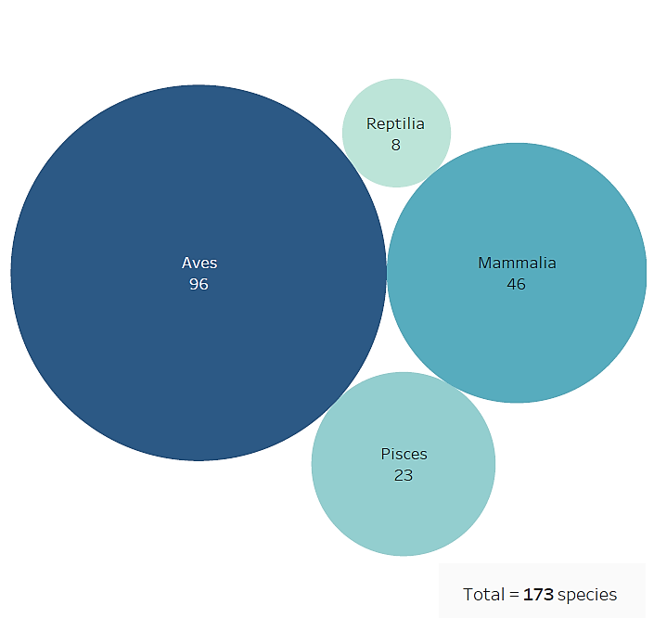
CMS Appendix I includes 173 taxa at the species or sub-species levels, of which 46 mammals, 96 birds, 8 reptiles and 23 fishes. (Fig. 1)

Fig. 1 Species and subspecies listed on Appendix I by broad taxonomic category

Conservation status
IUCN Red List categories have been selected from the assessments of the global population of listed taxa, they do not consider the level of geographic population as indicated in Appendix I for some species. Of the species listed in Appendix I (Fig. 2), one (<1%) is assessed as ‘Extinct in the wild’; 38 (22%) are assessed as ‘Critically Endangered’; 47 (27%) as ‘Endangered’; 51 (29%) as ‘Vulnerable’; 13 (8%) as ‘Near Threatened’. Hence a total of 150 species, i.e. ca. 87% of all migratory species in Appendix I, can be considered as being of signiﬁcant global concern. Of the remaining 22 species, 15 (9%) are assessed as ‘Least Concern’ and 2 (1%) as ‘Data Deficient’. For 5 species (3%) no assessment is available in the Red List database and are classified in this analysis as ‘Species not assessed’.
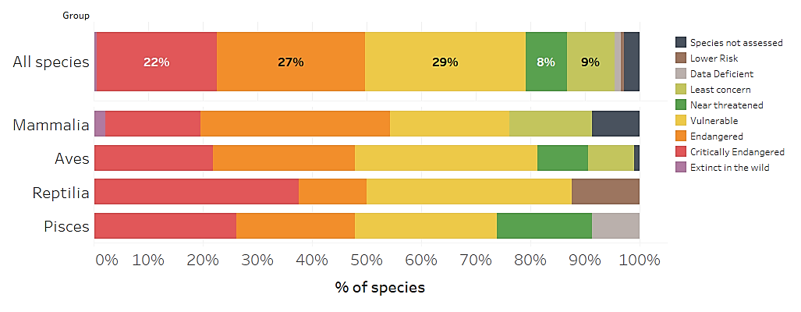
Fig. 2 Percentage of Appendix I-listed species in IUCN Red List Categories

According to the CMS Guidelines for assessment of Appendix I and II listing proposals, a taxon assessed as ‘Extinct in the Wild’, ‘Critically Endangered’, or ‘Endangered’ using the IUCN Red List criteria is eligible for consideration for listing in Appendix I, recognizing that CMS Appendix I species are broadly defined as ‘endangered’ (Fig. 3). Of the species currently listed on Appendix I, 86 (50%) meet the current criteria for listing on the Appendix.
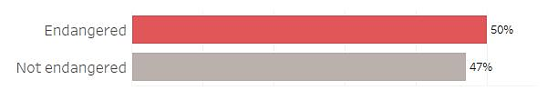
Fig. 3 Percentage of Appendix I-listed species meeting the criteria for listing defined in Res.11.33 (Rev.COP12) as regards conservation status

Population Trends

Population trends categories have been selected from the assessments of the global population of listed taxa, they do not consider the level of geographic population as indicated in Appendix I for some species. The current population trend for 127 species (73%) listed on Appendix I is ‘Decreasing’ (Fig. 4); for 14 species (8%) is ‘Increasing’; for 9 species (5%) is ‘Stable’; for 15 species (9%) is ‘Unknown’, for 2 species (1%) is ‘Unspecified’. For 5 species (3%) no information on population trends were found in the Red List database and are classified in this analysis as ‘Species not assessed’.
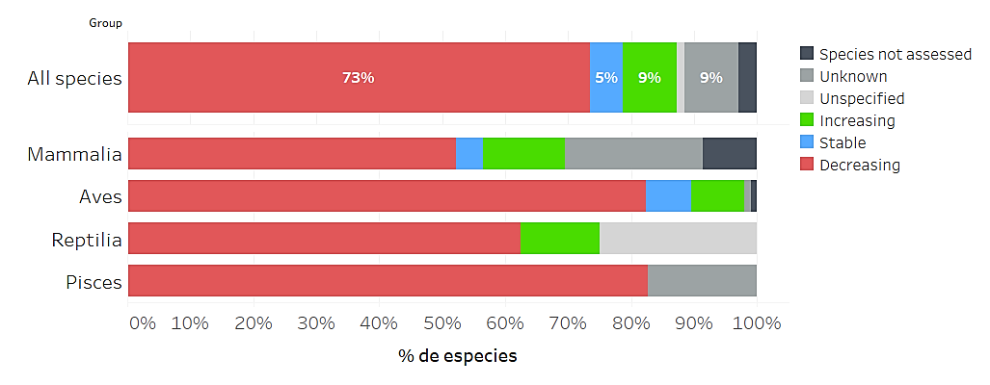
Fig. 4 Population trends for species listed on Appendix I

Main threats affecting species listed on Appendix I

Threats as categorized and defined by the IUCN – CMP Unified Classification of Direct Threats have been extracted from Red List Assessments for Appendix I-listed species whenever available. All three levels defined by the IUCN hierarchical classification scheme have been considered. A total of 166 species had information about threats available. Threat categories have been extracted from the assessments of the global population of listed taxa, they do not consider the level of geographic population as indicated in Appendix I for some species. The percentage of the main threats does not reflect the sum of the subcategories’ values because one species can be assessed for more than one threat category.

Fig. 5 shows the percentage of species impacted by kind of threat. Biological resource use impacts 159 species (96%); agriculture and aquaculture affect 97 species (58%); pollution 94 species (57%); invasive and other problematic species, genes and diseases 80 species (48%); climate change and severe weather 74 species (45%).

Fig. 6 shows the percentage of species in the four main taxonomic groups, impacted by main categories of threat. Specific threats by taxonomic group are shown in table 1.

Fig 5. Percentage of species listed on Appendix I impacted, by kind of threat
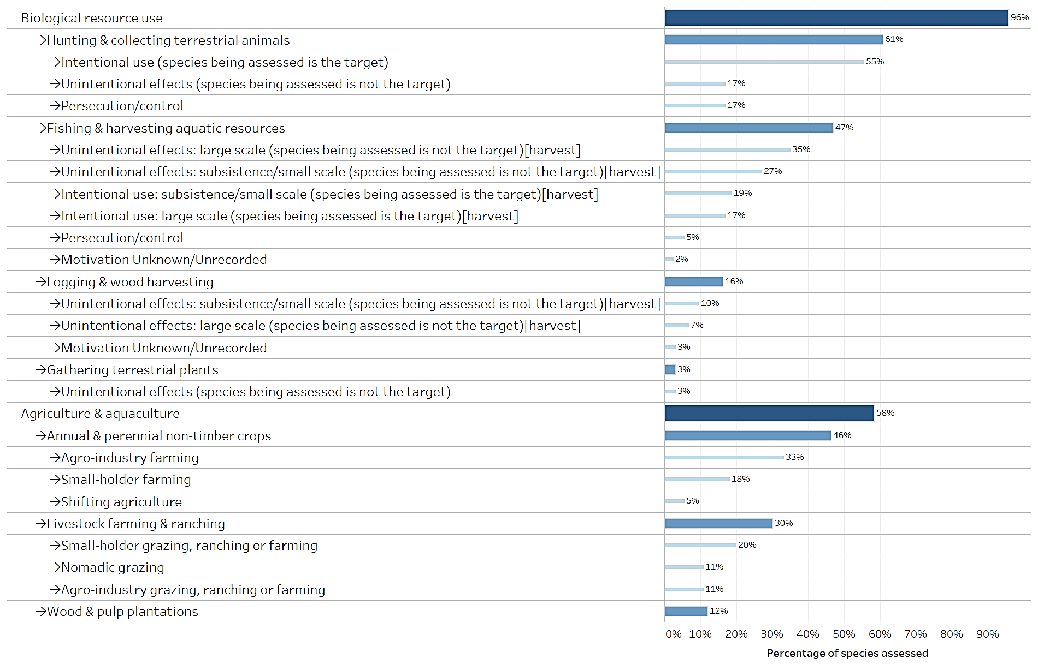
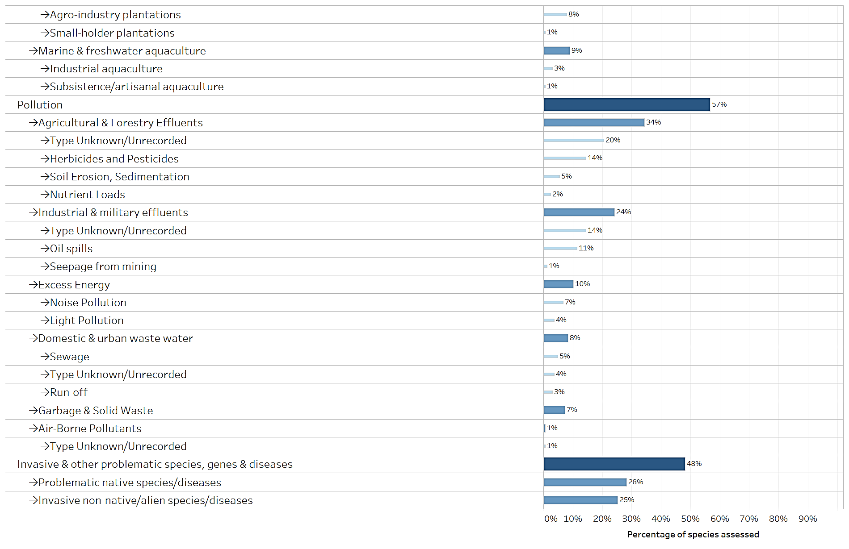
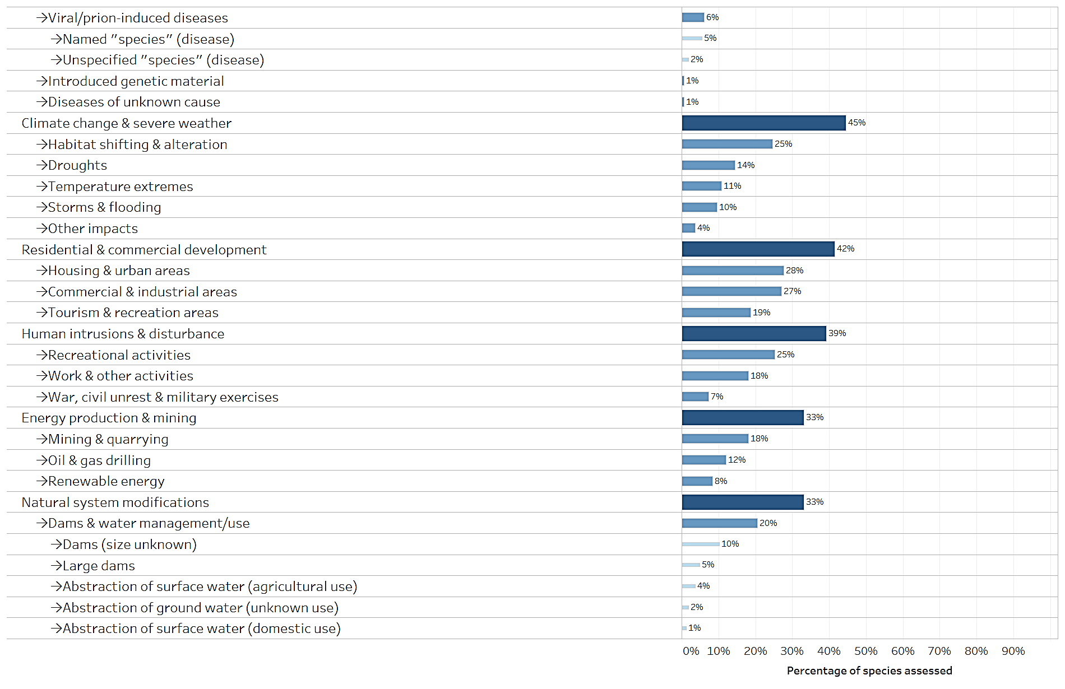
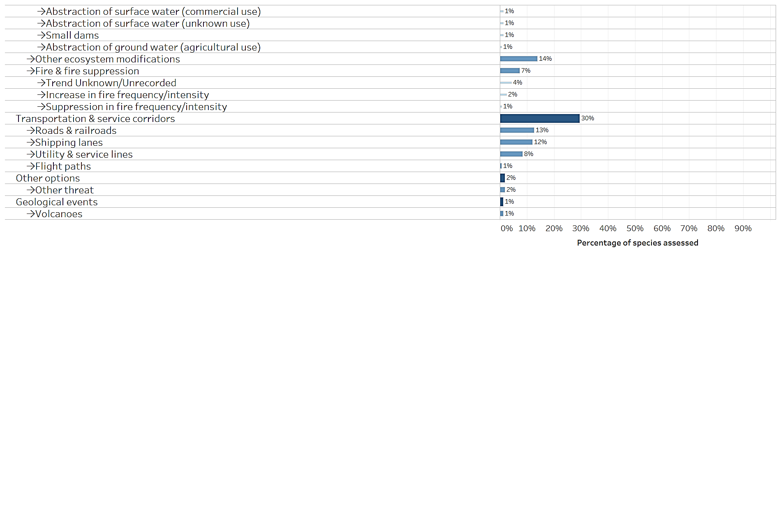

Fig. 6 Percentage of Appendix I-listed species in each taxonomic group impacted, by main categories of threat
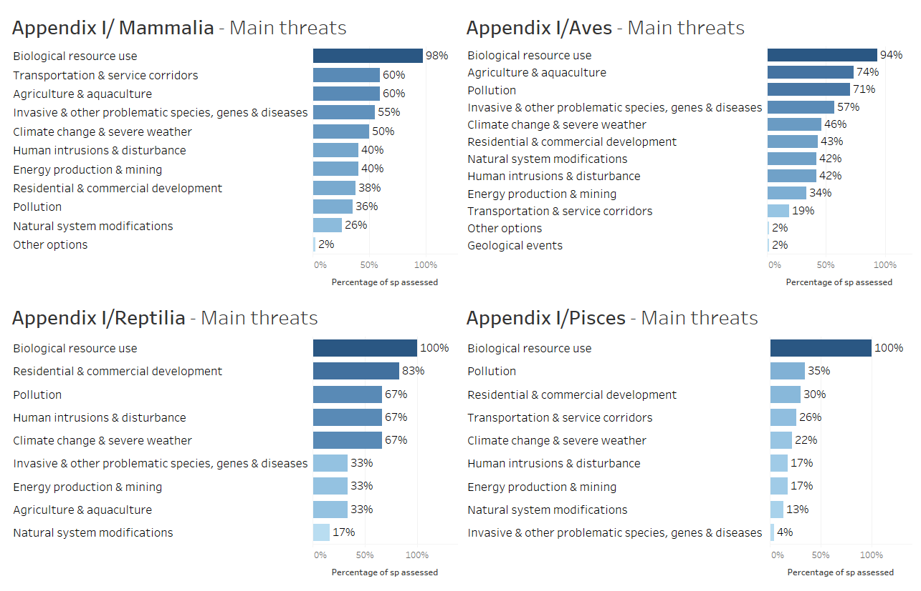

Table 1. Percentage of Appendix I-listed species in each taxonomic group impacted, by kind of threat.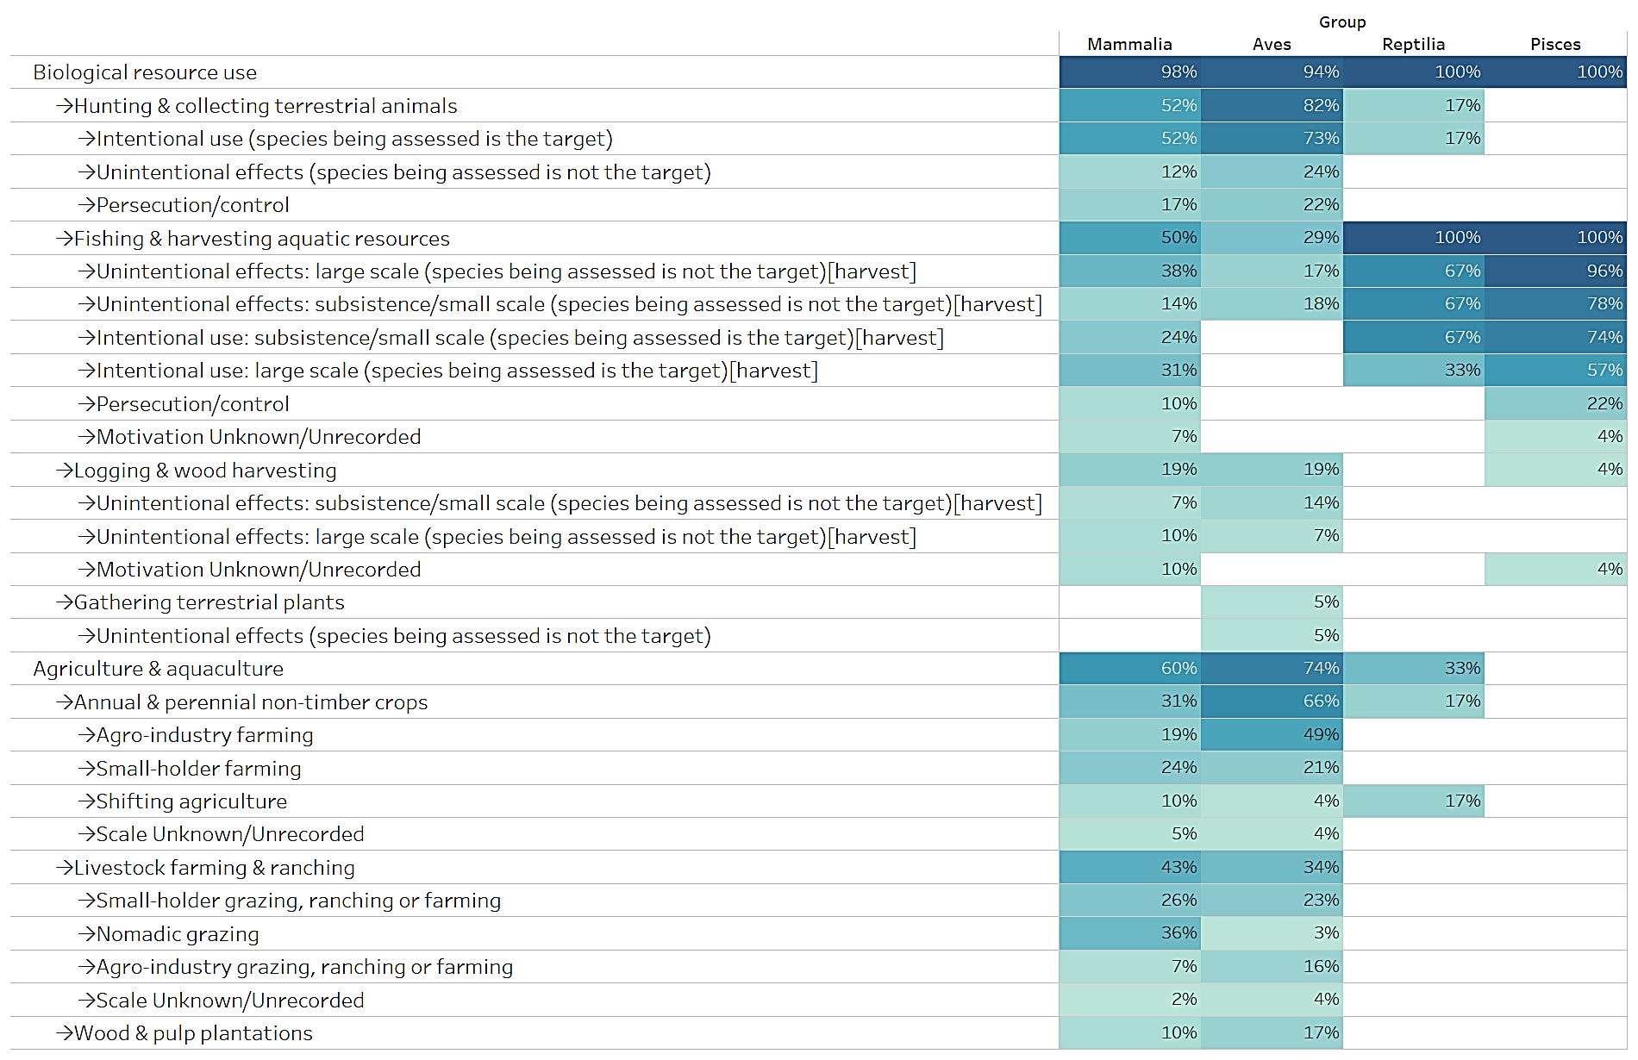
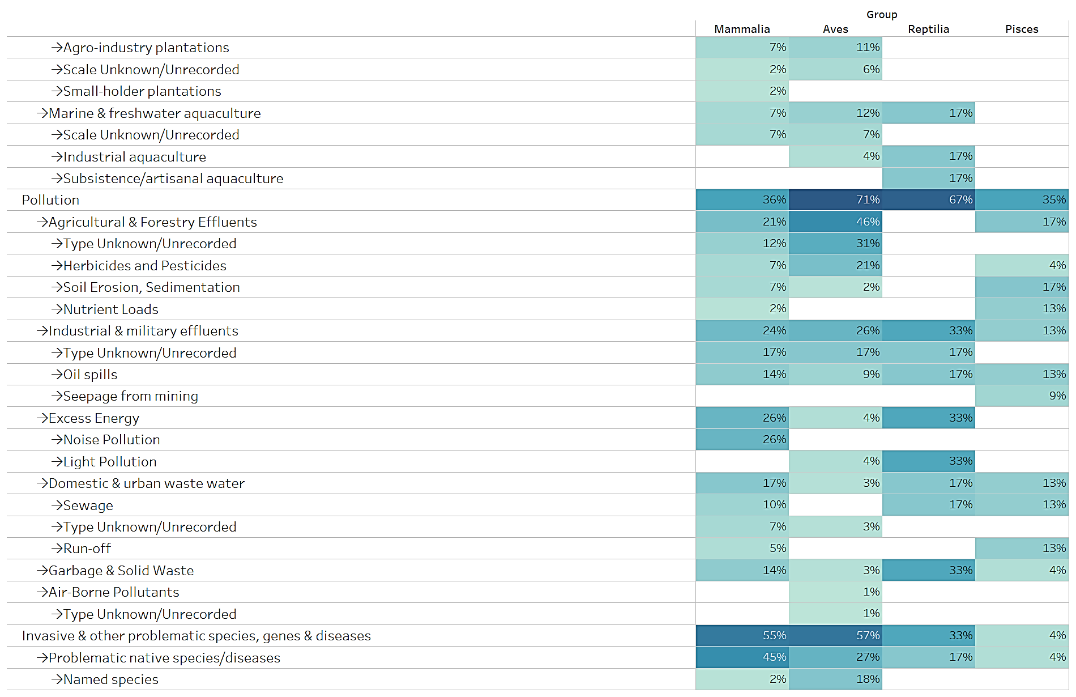
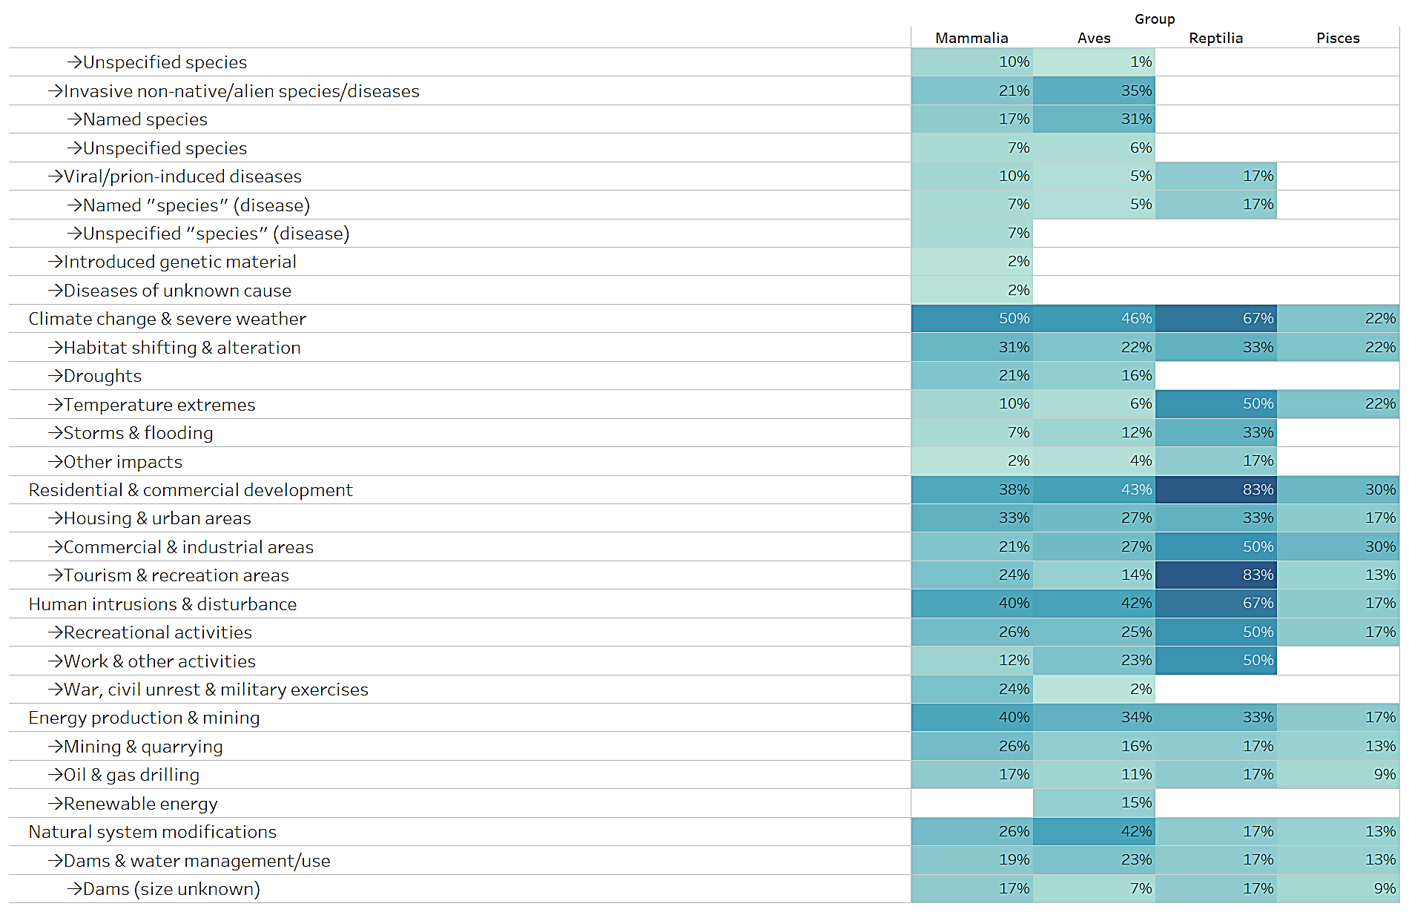
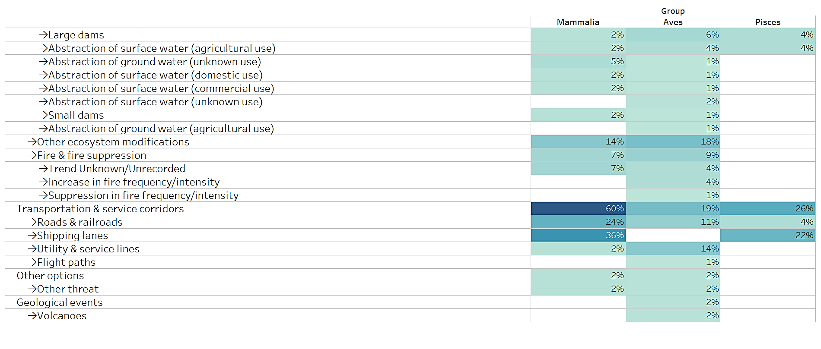

APPENDIX II

Appendix II-listed species by taxonomic group

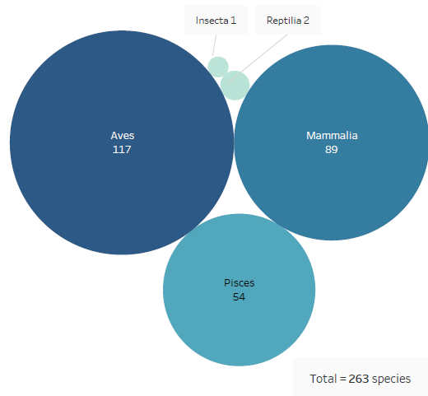
CMS Appendix II includes 263 taxa at the species or sub-species levels, of which 89 mammals, 117 birds, 2 reptiles, 54 fish and 1 insect. (Fig.7)

Fig 7. Species and subspecies listed on Appendix II by broad taxonomic category

Conservation status
IUCN Red List categories have been selected from the assessments of the global population of listed taxa, they do not consider the level of geographic population as indicated on Appendix II for some species. Of the species listed on Appendix II (Fig. 8), one (<1%) is assessed as ‘Extinct in the Wild’; 26 (10%) are assessed as ‘Critically Endangered’; 28 (11%) as ‘Endangered’; 57 (22%) as ‘Vulnerable’; 31 (12%) as ‘Near Threatened’. Hence a total of 143 species, i.e. ca. 54% of all migratory species listed on Appendix II, can be considered as being of signiﬁcant global concern. Of the remaining 120 species, 85 (32%) are assessed as ‘Least Concern’; 12 (5%) as ‘Data Deficient’ and 1 species (insect) was considered ‘Not Applicable’ to the assessment process. For 22 species (8%) no assessment is available in the Red List database and are classified in this analysis as ‘Species not assessed’.
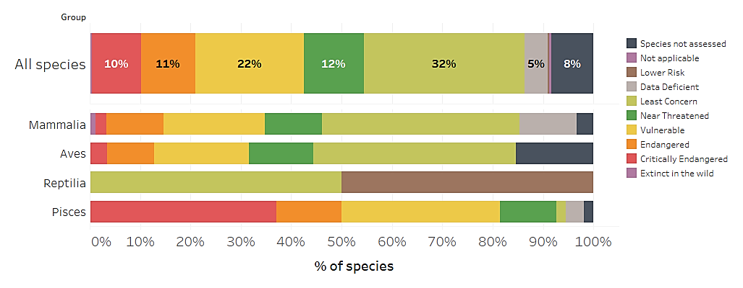
Fig. 8 Percentage of Appendix-II listed species in IUCN Red List Categories

According to the CMS Guidelines for assessment of Appendix I and II listing proposals, a taxon assessed as ‘Extinct in the Wild’, ‘Critically Endangered’, ‘Endangered’, ‘Vulnerable’ or ‘Near Threatened’ using the IUCN Red List criteria is eligible for consideration for listing on Appendix II, recognizing that such taxa meet the definition of ‘unfavourable conservation status’ under the Convention. A taxon assessed as ‘Data Deficient’ should be evaluated in terms of the merit of any individual Appendix II proposal.

Of the species currently listed on Appendix II, 155 (59%) can meet the criteria for listing on the Appendix (Fig. 9)

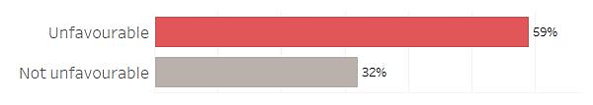

Fig.9 Percentage of Appendix II-listed species meeting the criteria for listing on Appendix II defined in Res.11.33 (Rev.COP12) as regards conservation status

Population Trends.

Population trends categories have been selected from the assessments of the global population of listed taxa, they do not consider the level of geographic population as indicated in Appendix I for some species. The current population trend for 126 species (48%) listed on Appendix II is ‘Decreasing’ (Fig. 10); for 27 species (10%) is ‘Stable’; for 20 species (8%) is ‘Increasing’; for 64 species (24%) is ‘Unknown’; for 3 species (1%) is ‘Unspecified’. For 22 species (8%) no information on population trends were found in the Red List database and are classified in this analysis as ‘Species not assessed’.
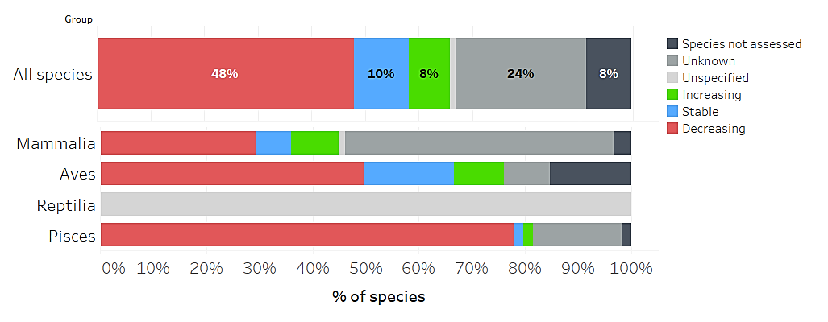
Fig 10. Population trends for species listed on Appendix II

Main threats affecting species listed on Appendix II

Threats as categorized and defined by the IUCN – CMP Unified Classification of Direct Threats have been extracted from Red List Assessments for Appendix II listed species whenever available. All three levels defined by the IUCN hierarchical classification scheme have been considered. A total of 214 species had information about threats available. Threat categories have been extracted from the assessments of the global population of listed taxa, they do not consider the level of geographic population as indicated on Appendix II for some species.

Figure 11 shows the percentage of species impacted by kind of threat. Biological resource use impacts 200 species (93%); pollution is affecting 98 species (46%); invasive & other problematic species, genes and diseases 82 species (38%); climate change & severe weather 81 species (38%); the modification of natural systems, which is, the changes to natural processes such as fire, hydrology and sedimentation affects 69 species (32%).

Fig. 12 show the percentage of the main four taxonomic groups, impacted by the main kind of threat. This information is not presented for reptiles because there is no information on the threats of the two species listed in Appendix II. Specific threats by taxonomic group are shown in table 2.

Fig. 11 Percentage of species listed on Appendix II impacted, by kind of threat
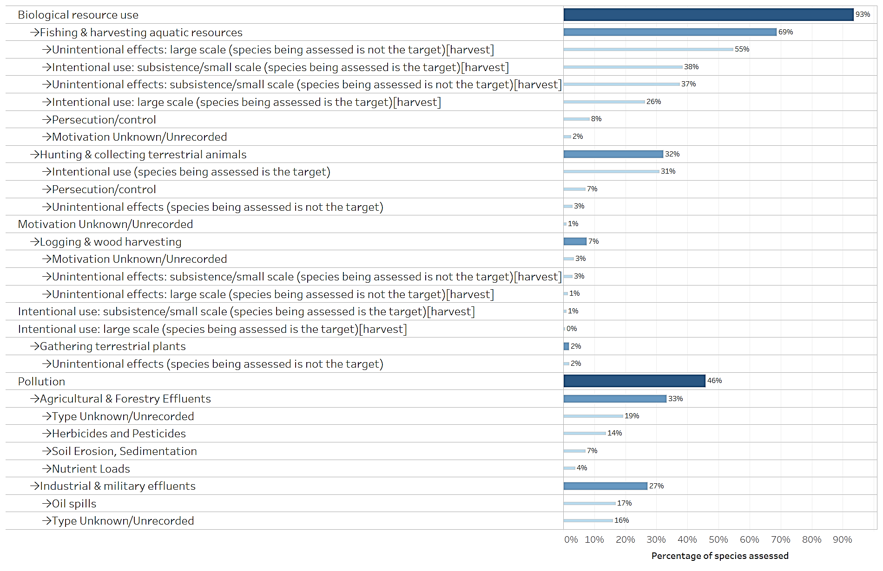
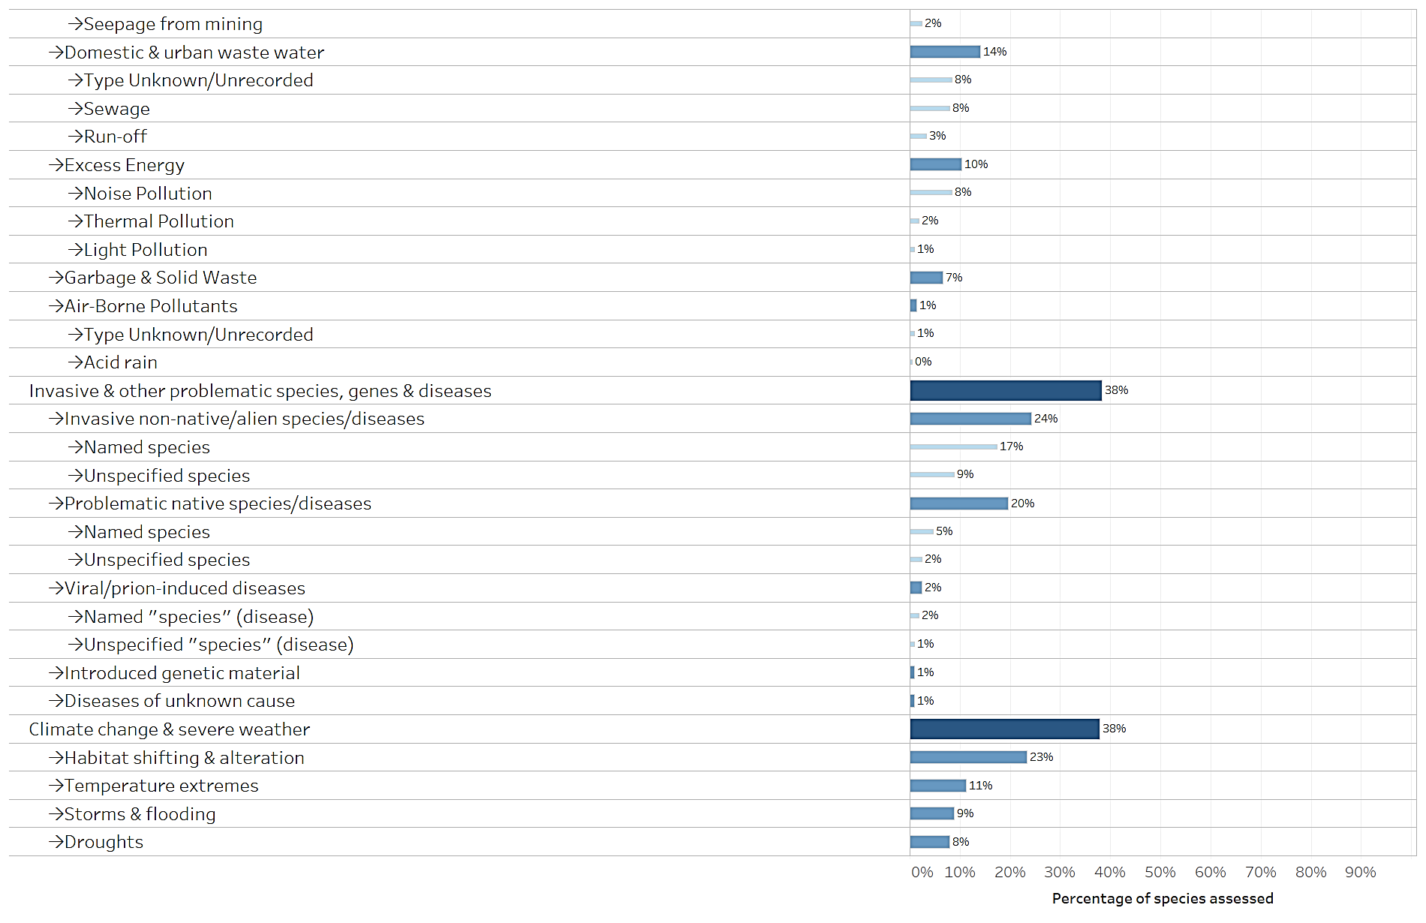
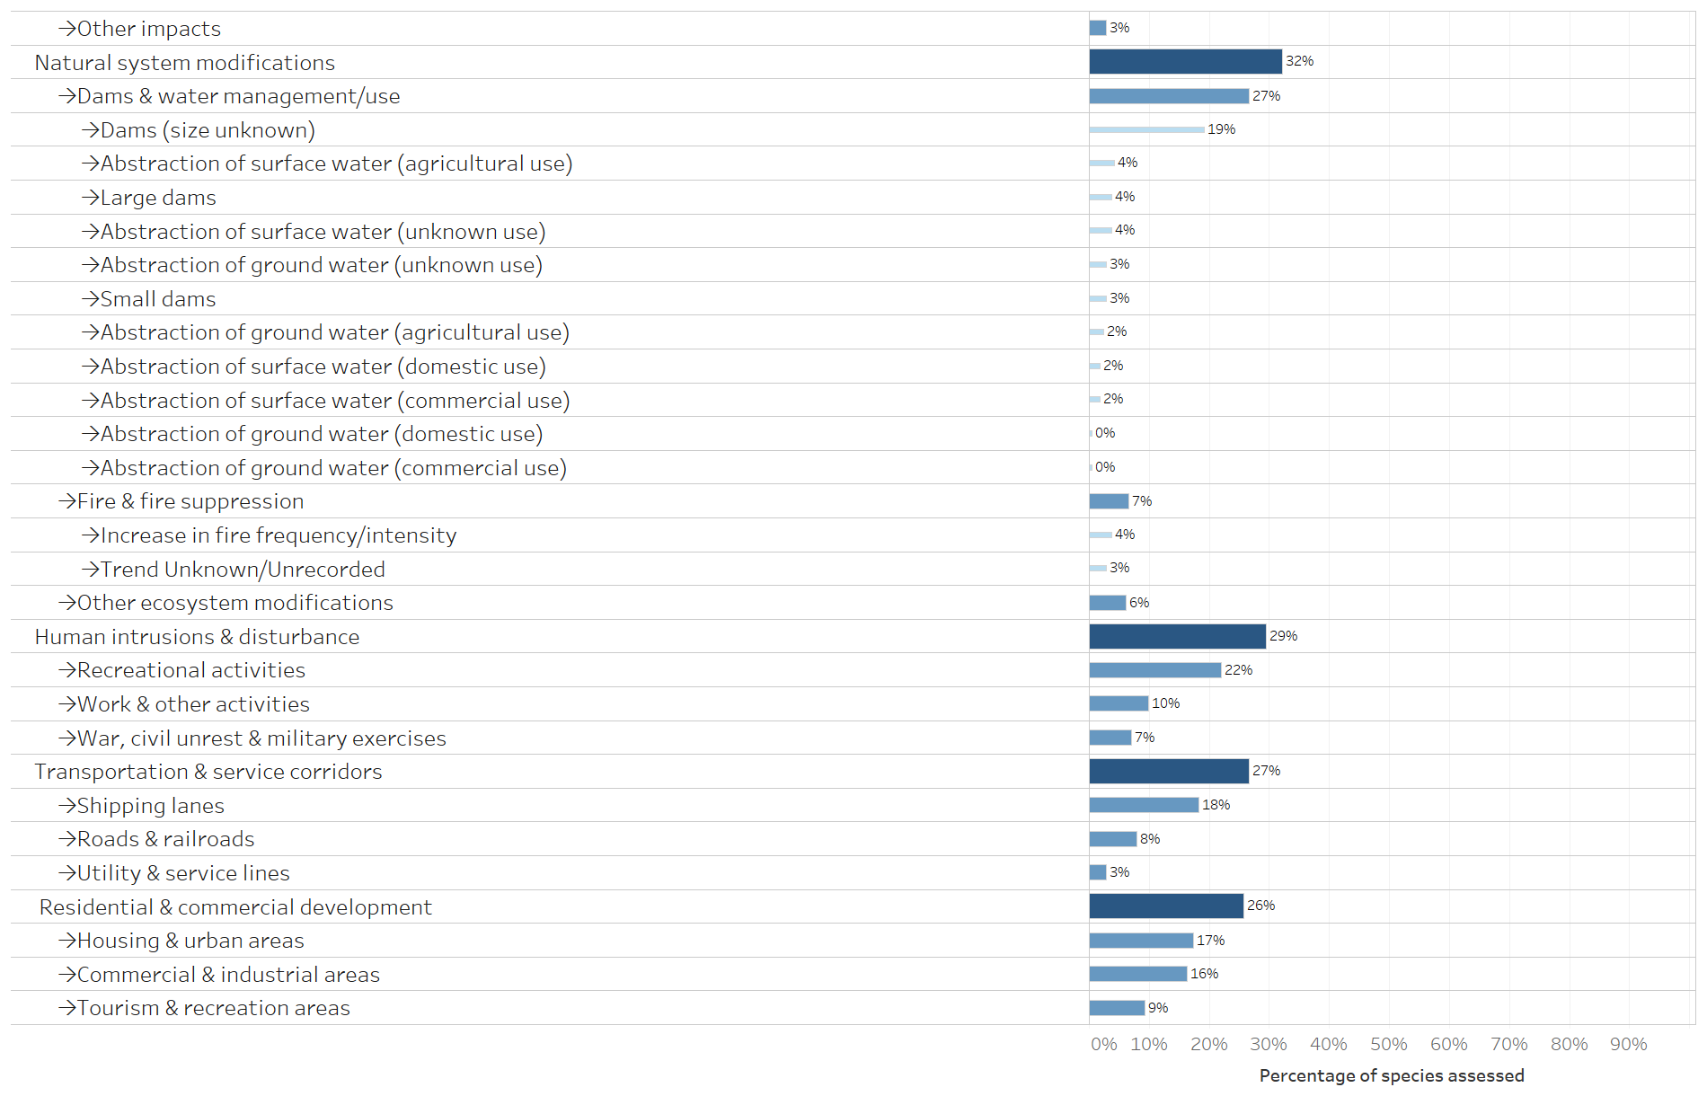
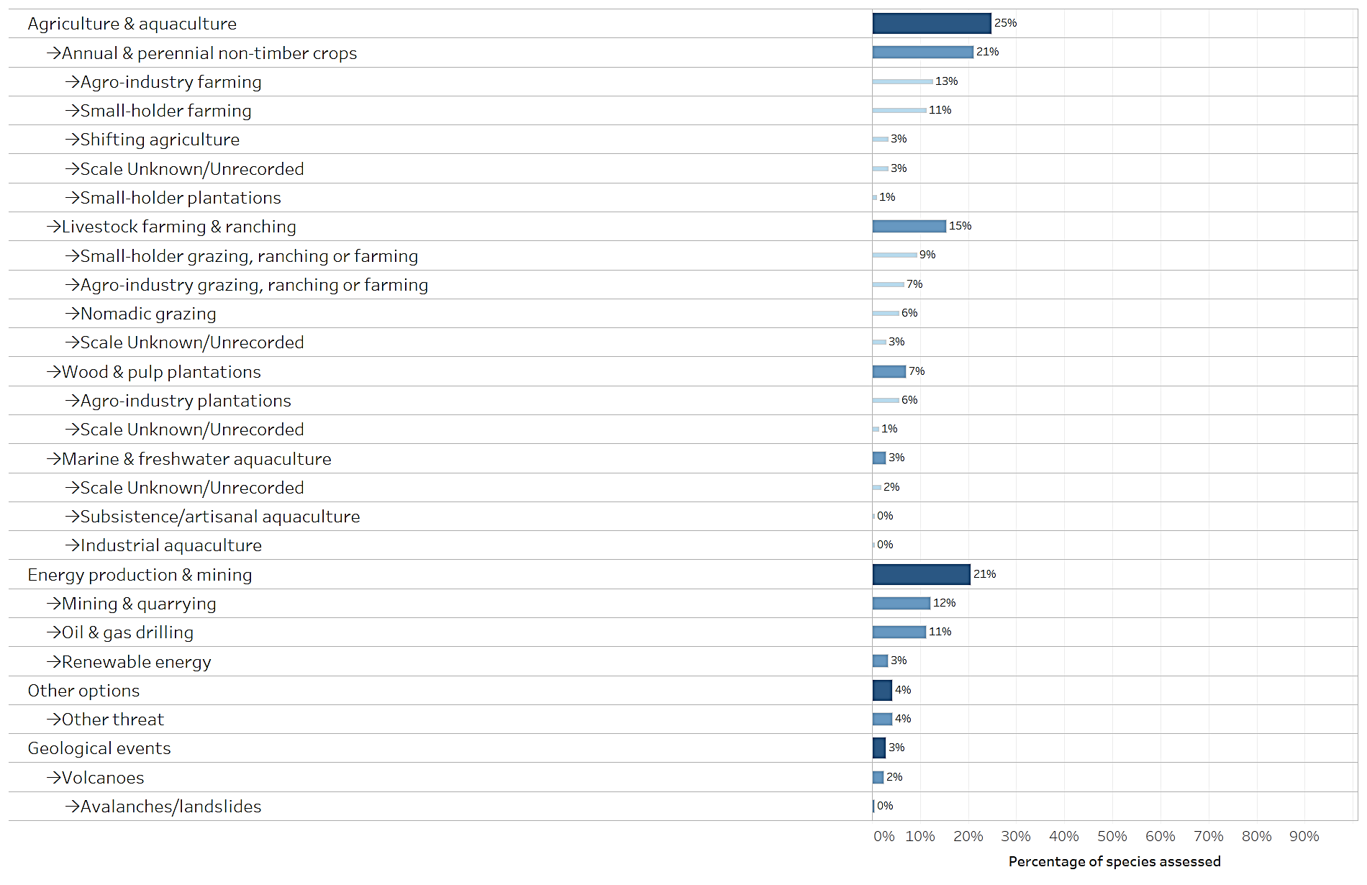

Fig. 12 Percentage of species listed on Appendix II in each taxonomic group impacted, by main kind of threat
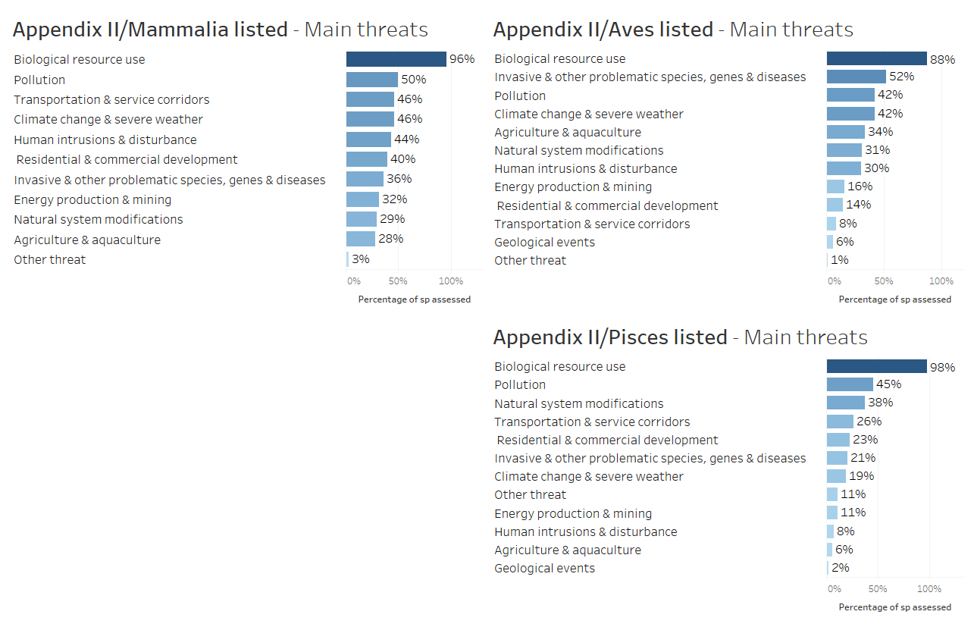
Table 2. Percentage of species listed in each taxonomic group on Appendix II impacted, by kind of threat.
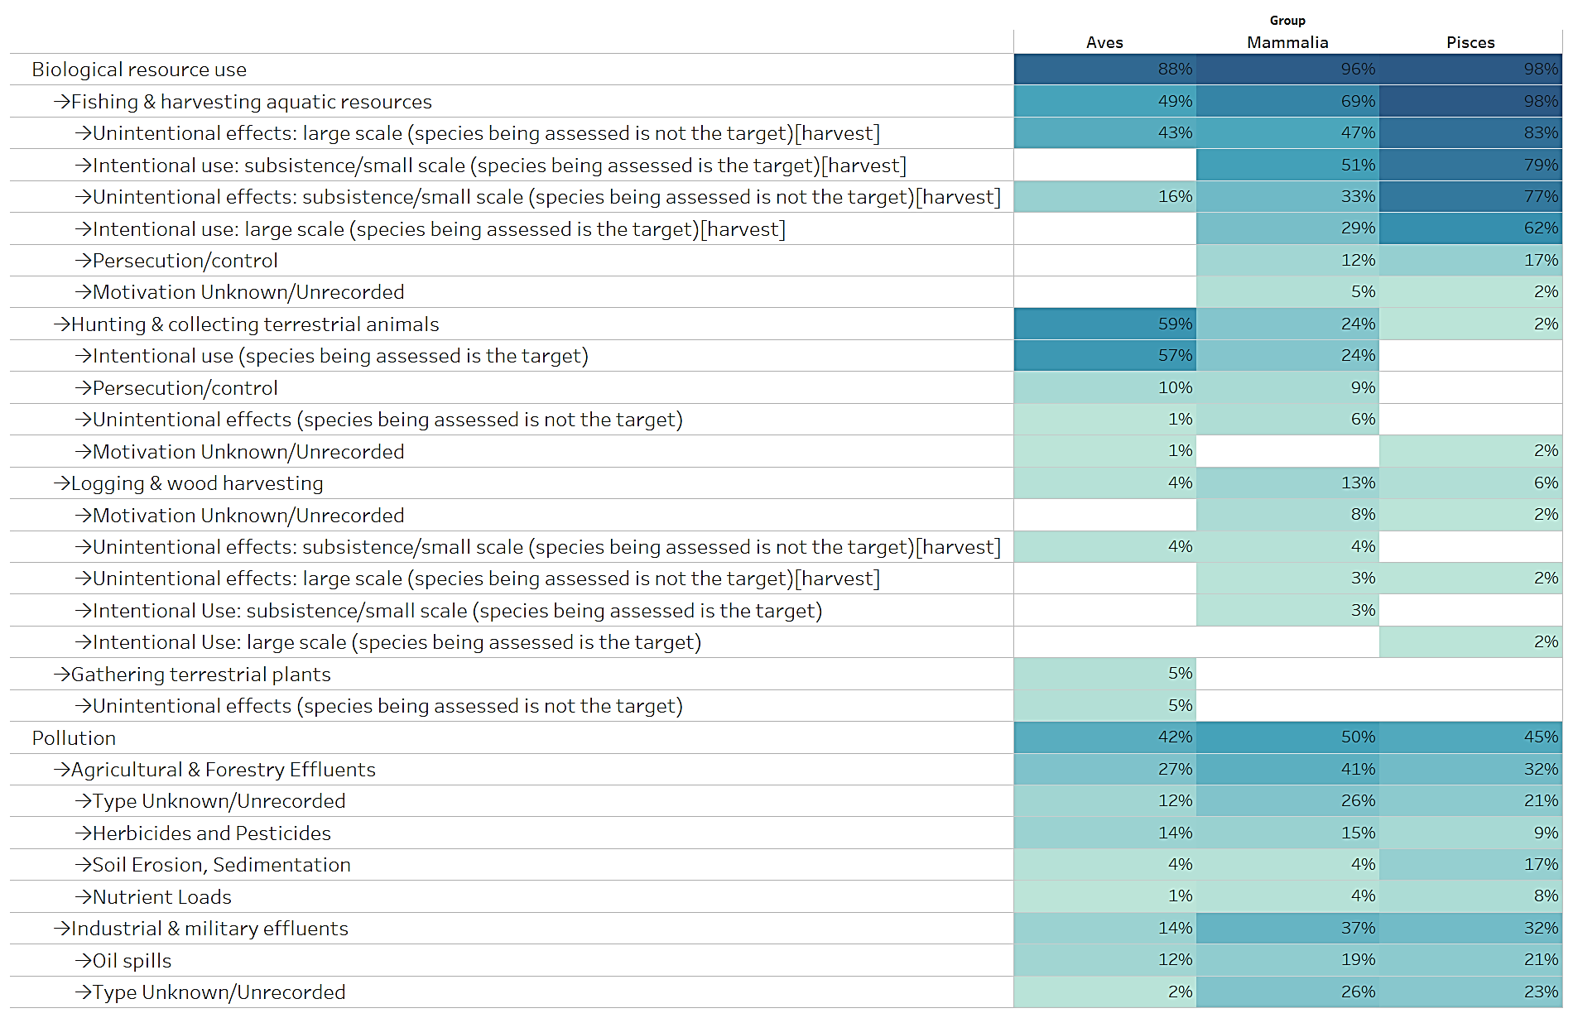
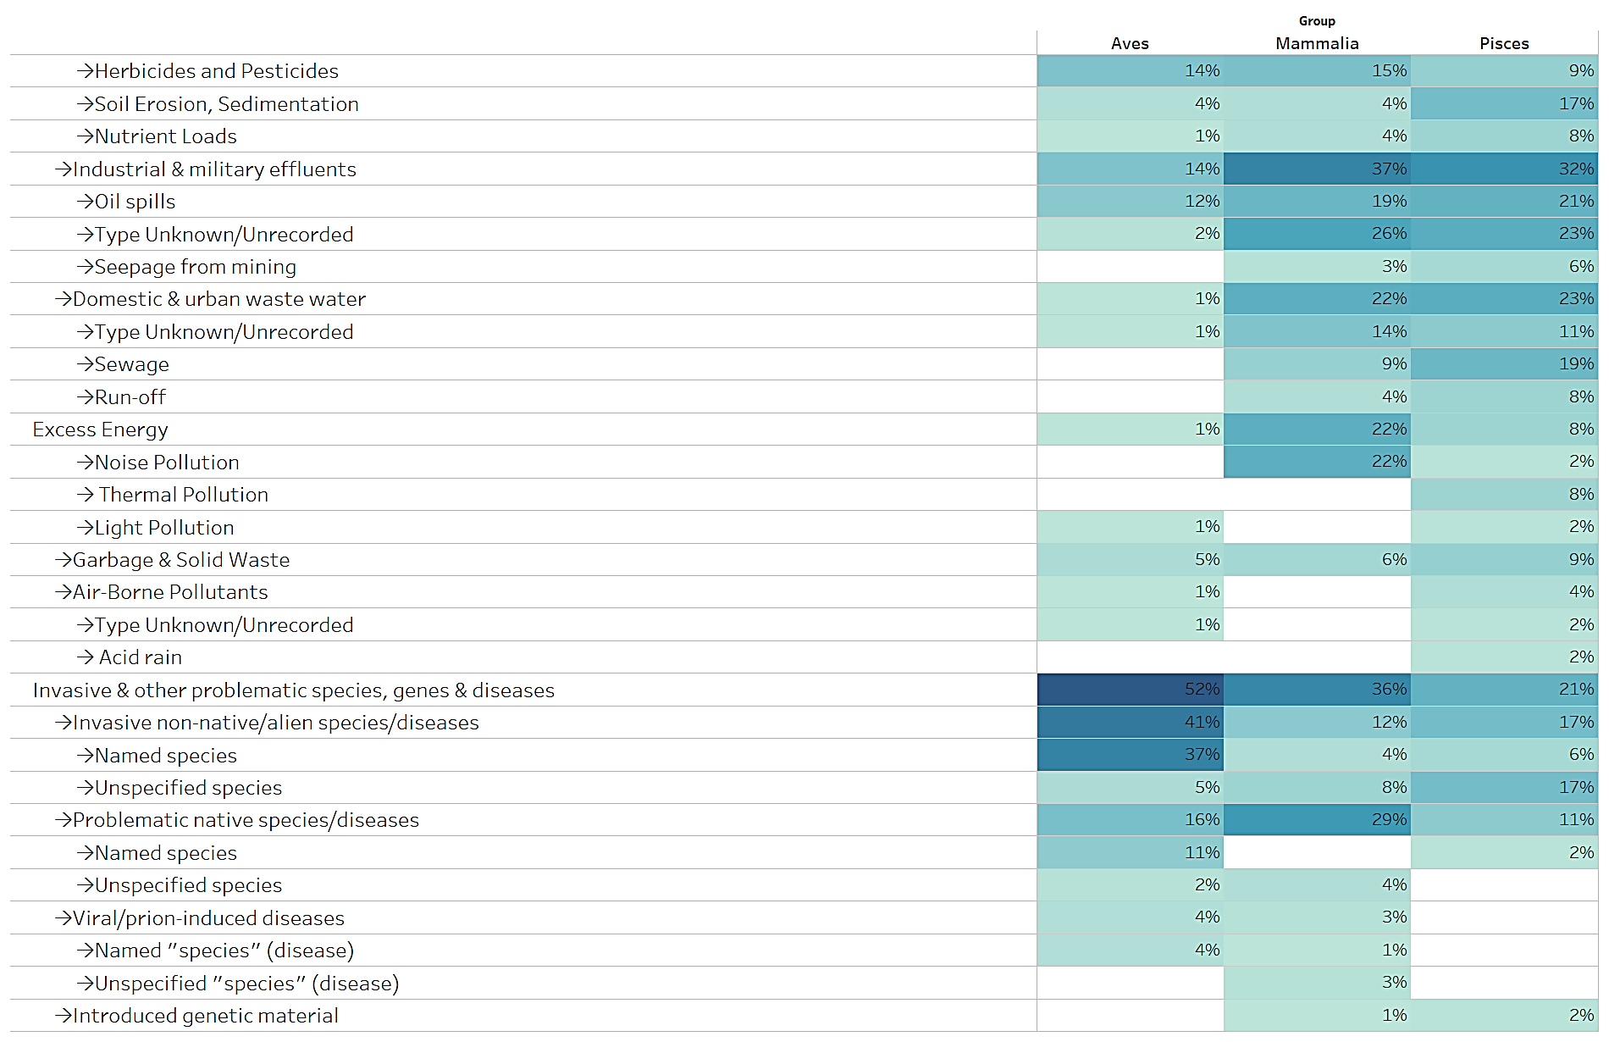
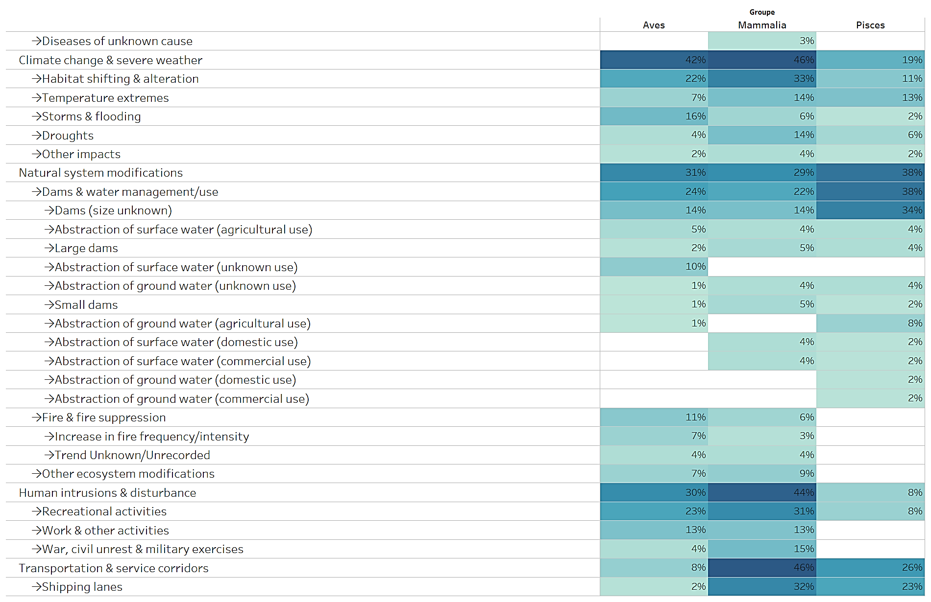
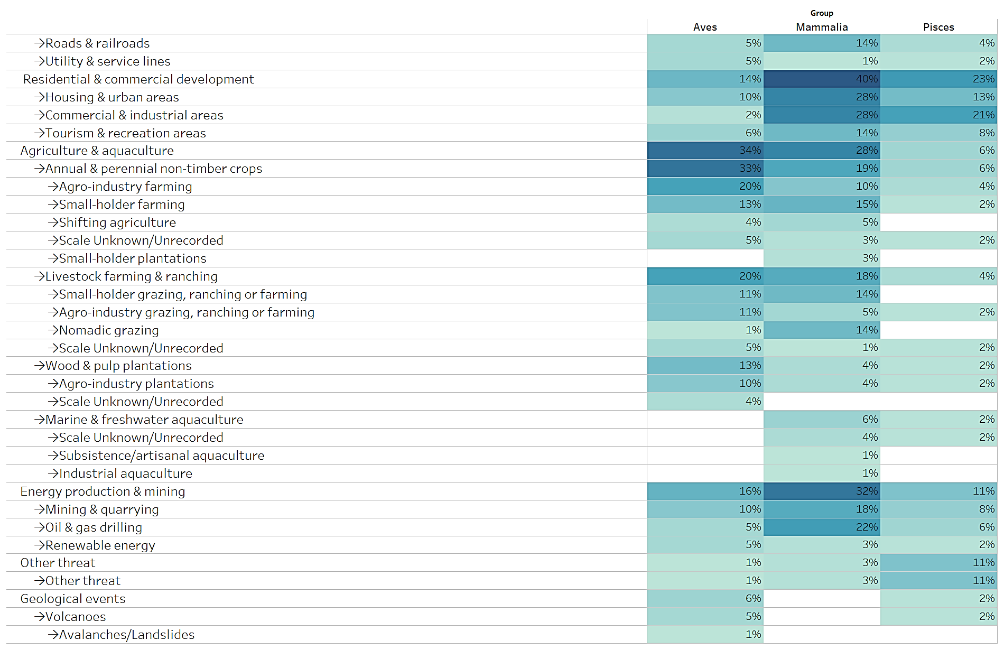

Species listed and covered on Appendix II

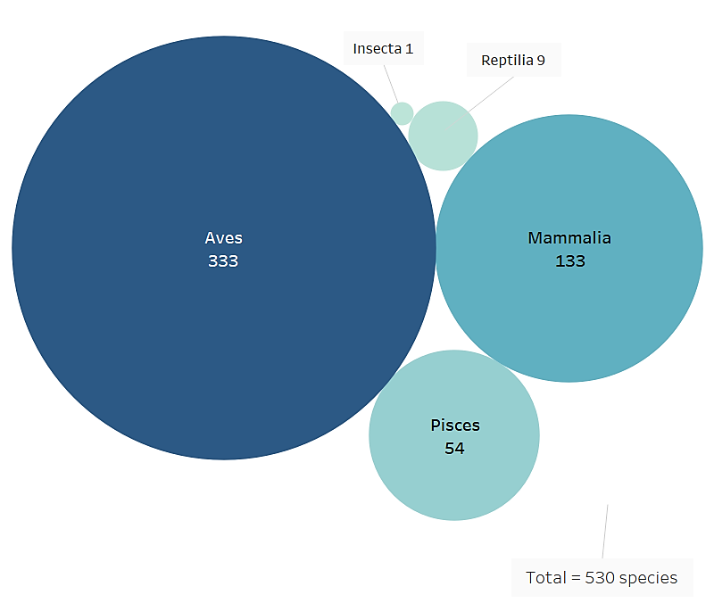
In addition to taxa at the species and subspecies levels, Appendix II lists 2 mammal families, 63 bird families, 3 bird genera and 2 reptile families. A conservative selection of the species covered under the families and genera listed was made, considering covered those species included in a CMS Art. IV Agreement and/or included also on Appendix I.

The two families of mammals contained on Appendix II are bats of the order Chiroptera. Species covered by the EUROBATS Agreement were considered covered by the families, with the exclusion of those species endemic to a single country.
Fig. 13 Species listed and covered on Appendix II by broad taxonomic category

The disaggregation of the bird families and genera used data from the Handbook of the Birds of the World.
A total of 267 species were selected, of which 115 are included in AEWA, 79 in the Raptors MOU, 44 in the EUROBATS Agreement, 27 in CMS Appendix I, 1 in the IOSEA MOU and 1 in the Aquatic Warbler MOU
In total, 530 species are listed and covered on Appendix II, of which 133 mammals, 333 birds, 9 reptiles, 54 fish and 1 insect (Fig. 13)

Conservation status

IUCN Red List categories have been selected from the assessments of the global population of listed taxa, they do not consider the level of geographic population as indicated on Appendix II for some species. Of the species listed and covered on Appendix II (Fig. 14), one (<1%) is assessed as ‘Extinct in the Wild’; 41 (8%) are assessed as ‘Critically Endangered’; 44 (8%) as ‘Endangered’; 86 (16%) as ‘Vulnerable’; 56 (11%) as ‘Near Threatened’. Hence a total of 228 species, i.e. ca.43% of all species listed or covered under Appendix II can be considered as being of signiﬁcant global concern. Of the remaining 302 species, 259 (49%) are assessed as ‘Least Concern’; 17 (3%) as ‘Data Deficient’; 1 species (insect) was considered ‘Not Applicable’ to the assessment process. For 25 species (5%) no assessment is available in the Red List database and are classified in this analysis as ‘Species not assessed’.

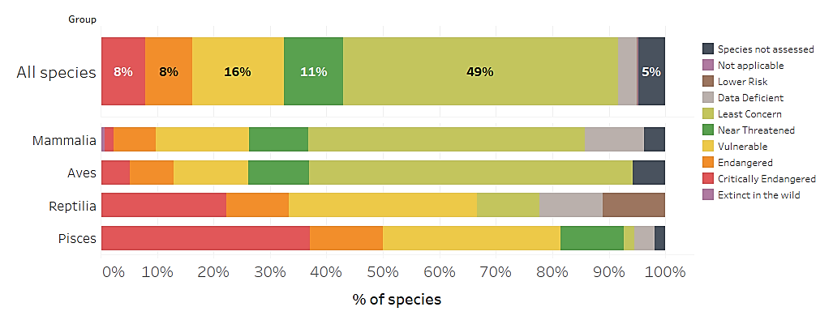
Fig. 14 Percentage of species in IUCN Red List Categories listed and covered on Appendix II

Of the 530 species listed and covered on Appendix II, 245 species (46%) can meet the definition of ‘unfavourable conservation status’ (Fig. 15).

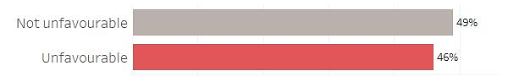

Fig. 15 Percentage of species listed and covered on Appendix II meeting the criteria for listing on Appendix II defined in Res.11.33 (Rev.COP12)

Population Trends.

Population trends categories have been selected from the assessments of the global population of listed taxa, they do not consider the level of geographic population as indicated in Appendix I for some species. The current population trend for 261 species (49%) listed and covered on Appendix II is ‘Decreasing’ (Fig. 14); for 75 species (14%) is ‘Stable’; for 52 species (10%) is ‘Increasing’; for 111 species (21%) is ‘Unknown’; for 5 species (1%) is ‘Unspecified’. For 25 species (5%) no information on population trends were found in the Red List database and are classified in this analysis as ‘Species not assessed’.

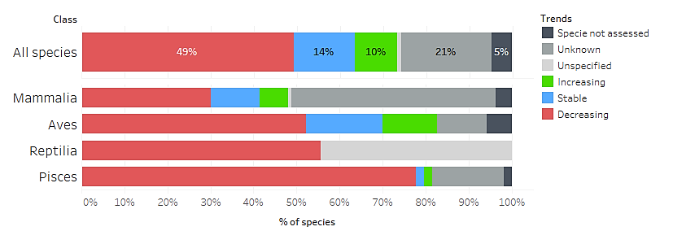
Fig. 16 Population trend of species listed and covered on Appendix II

Main threats affecting species listed and covered on Appendix II

Threats as categorized and defined by the IUCN – CMP Unified Classification of Direct Threats have been extracted from Red List Assessments for Appendix II listed species whenever available. All three levels defined by the IUCN hierarchical classification scheme have been considered. A total of 425 species had information about threats available. Threat categories have been extracted from the assessments of the global population of listed taxa, they do not consider the level of geographic population as indicated on Appendix II for some species.

Figure 17 shows the percentage of species impacted by kind of threat. Biological resource use impacts 348 species (82%); pollution is affecting 214 species (50%); climate change 168 (40%); Agriculture & aquaculture 166 species (39%); and the modification of natural systems, which is, the changes to natural processes such as fire, hydrology and sedimentation affects 149 species (35%).

Fig. 18 show the percentage of the main four taxonomic groups, impacted by the main kind of threat. Specific threats by taxonomic group are shown in table 3.
Fig. 17 Percentage of species listed and covered on Appendix II impacted, by kind of threat

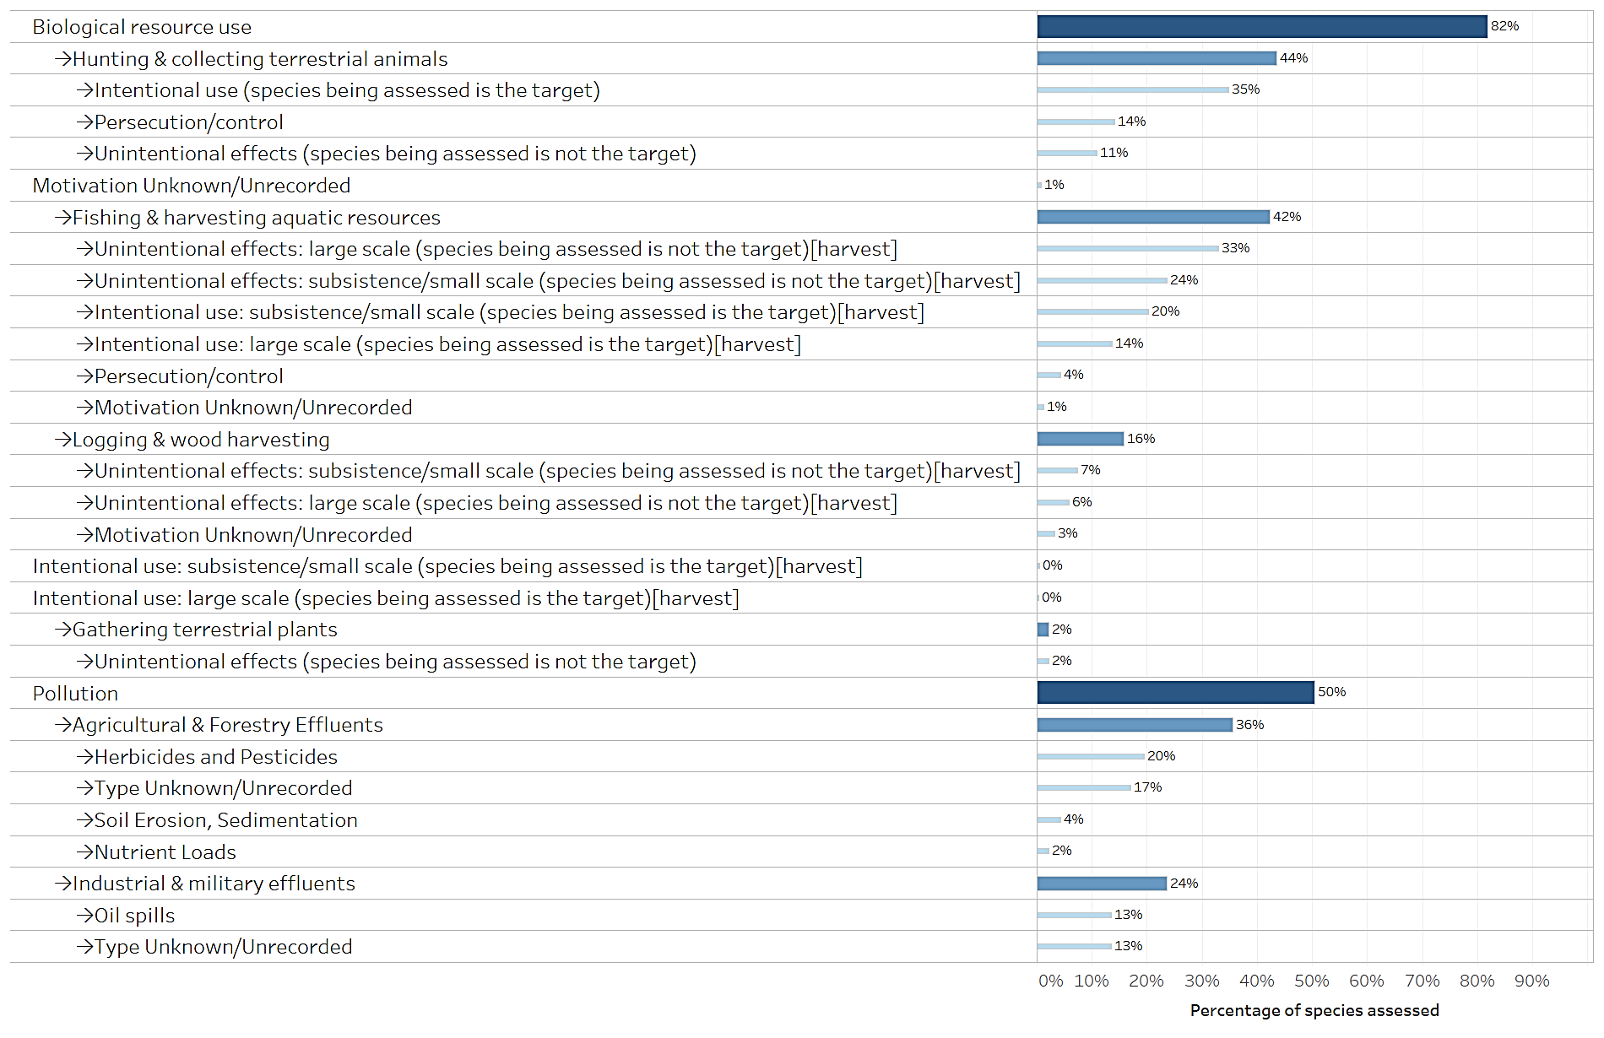
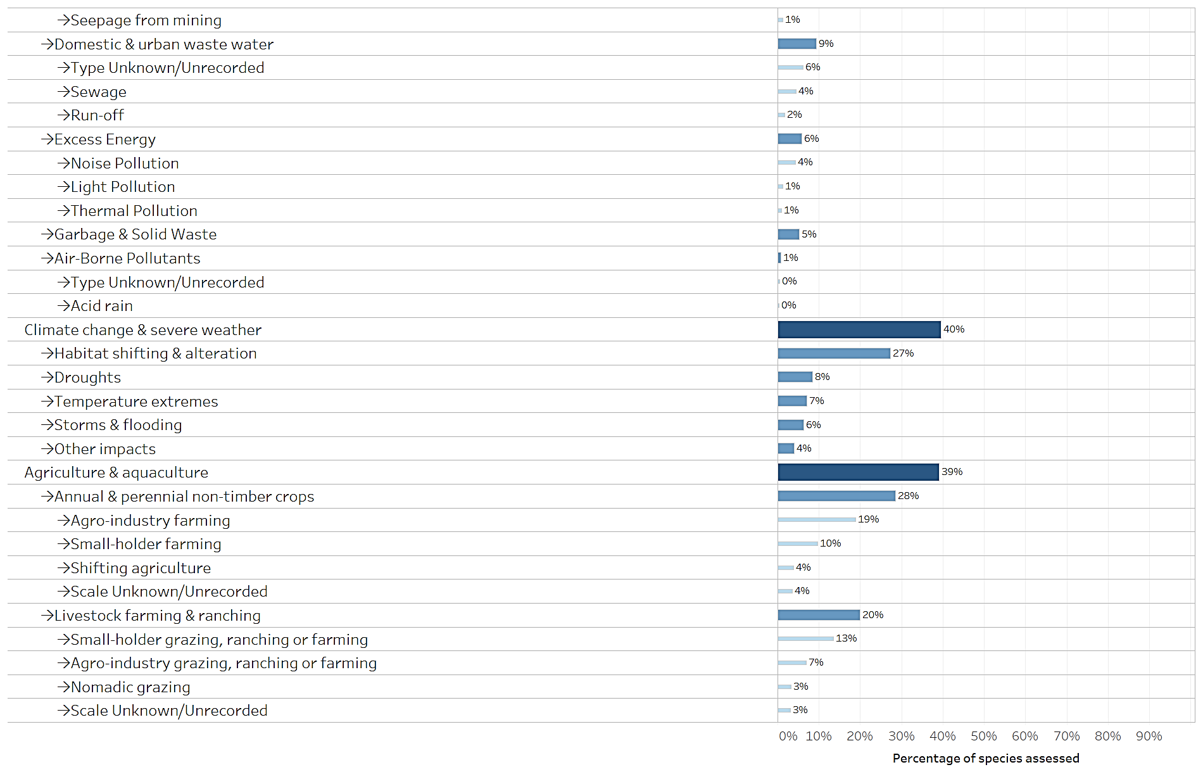
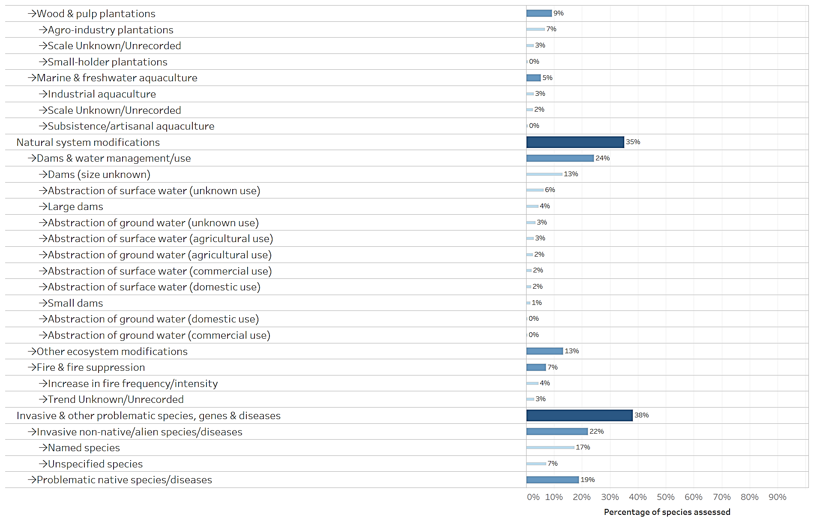
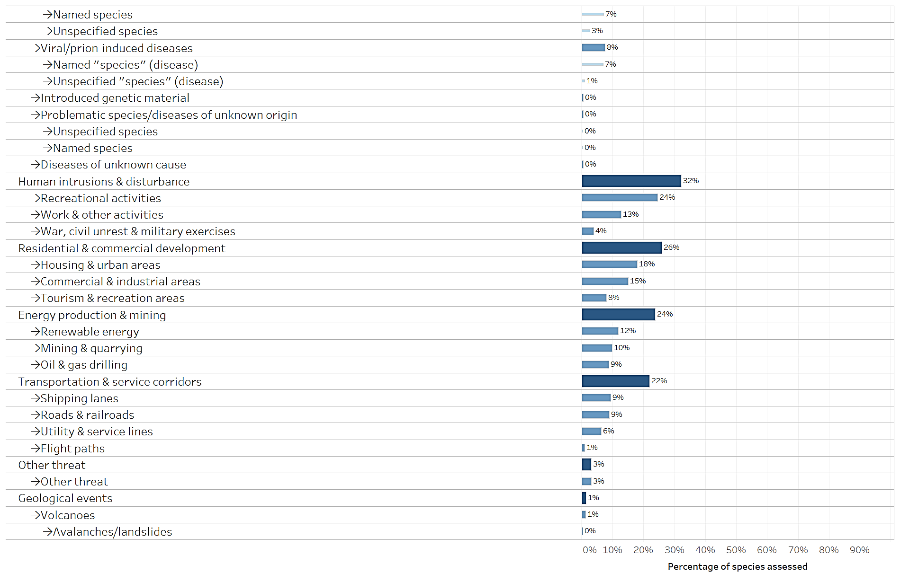
Fig. 18 Percentage of species listed and covered on Appendix II in each taxonomic group impacted, by main kind of threat

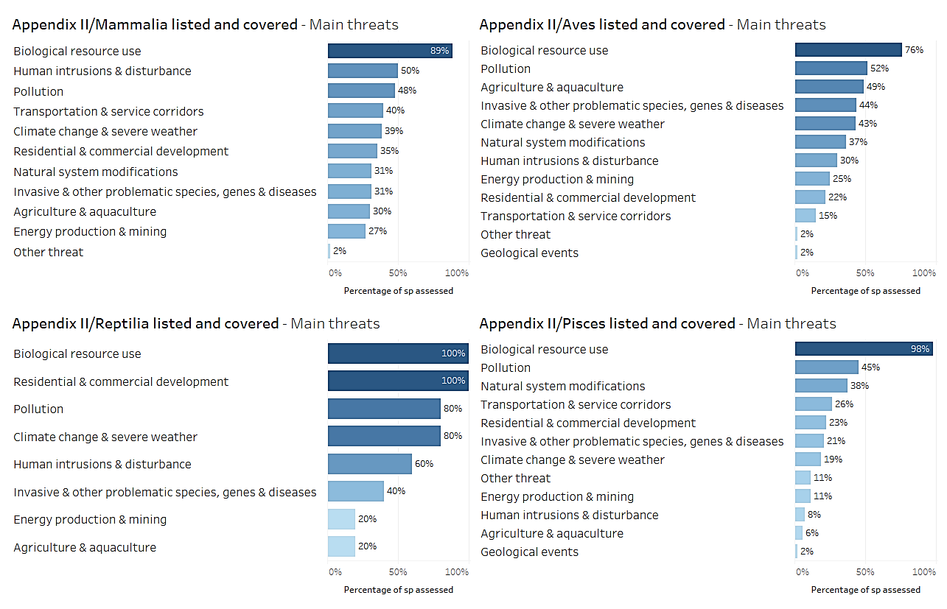

Table 3. Percentage of species listed and covered in each taxonomic group on Appendix II impacted, by kind of threat.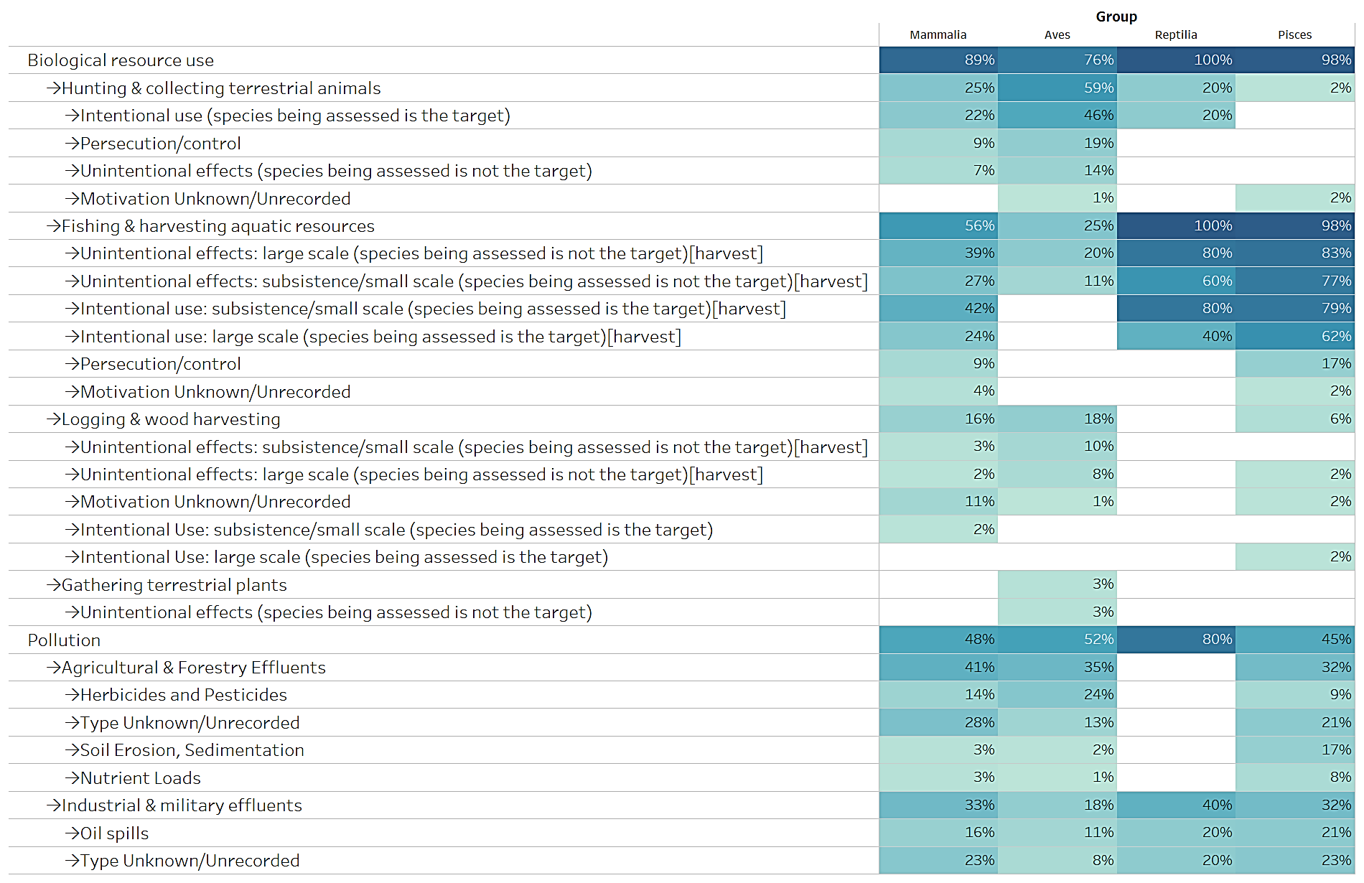
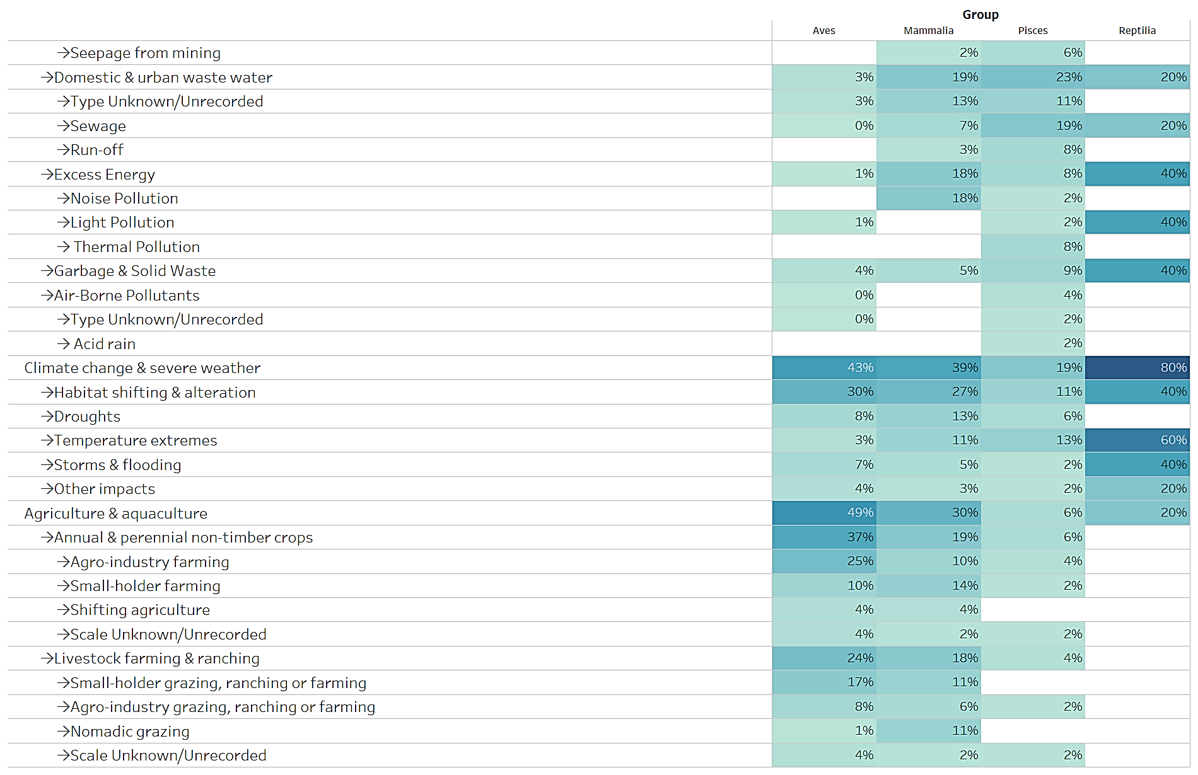
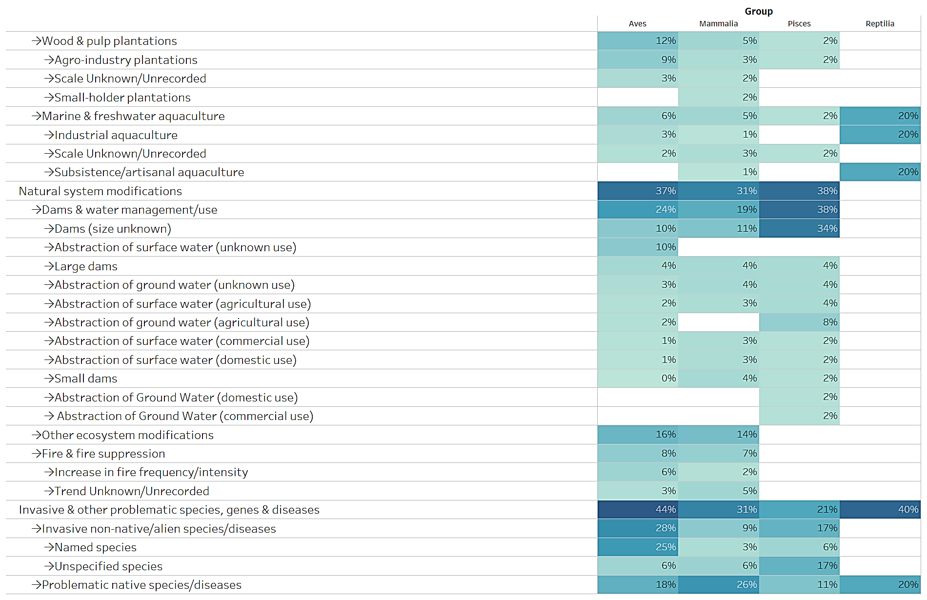

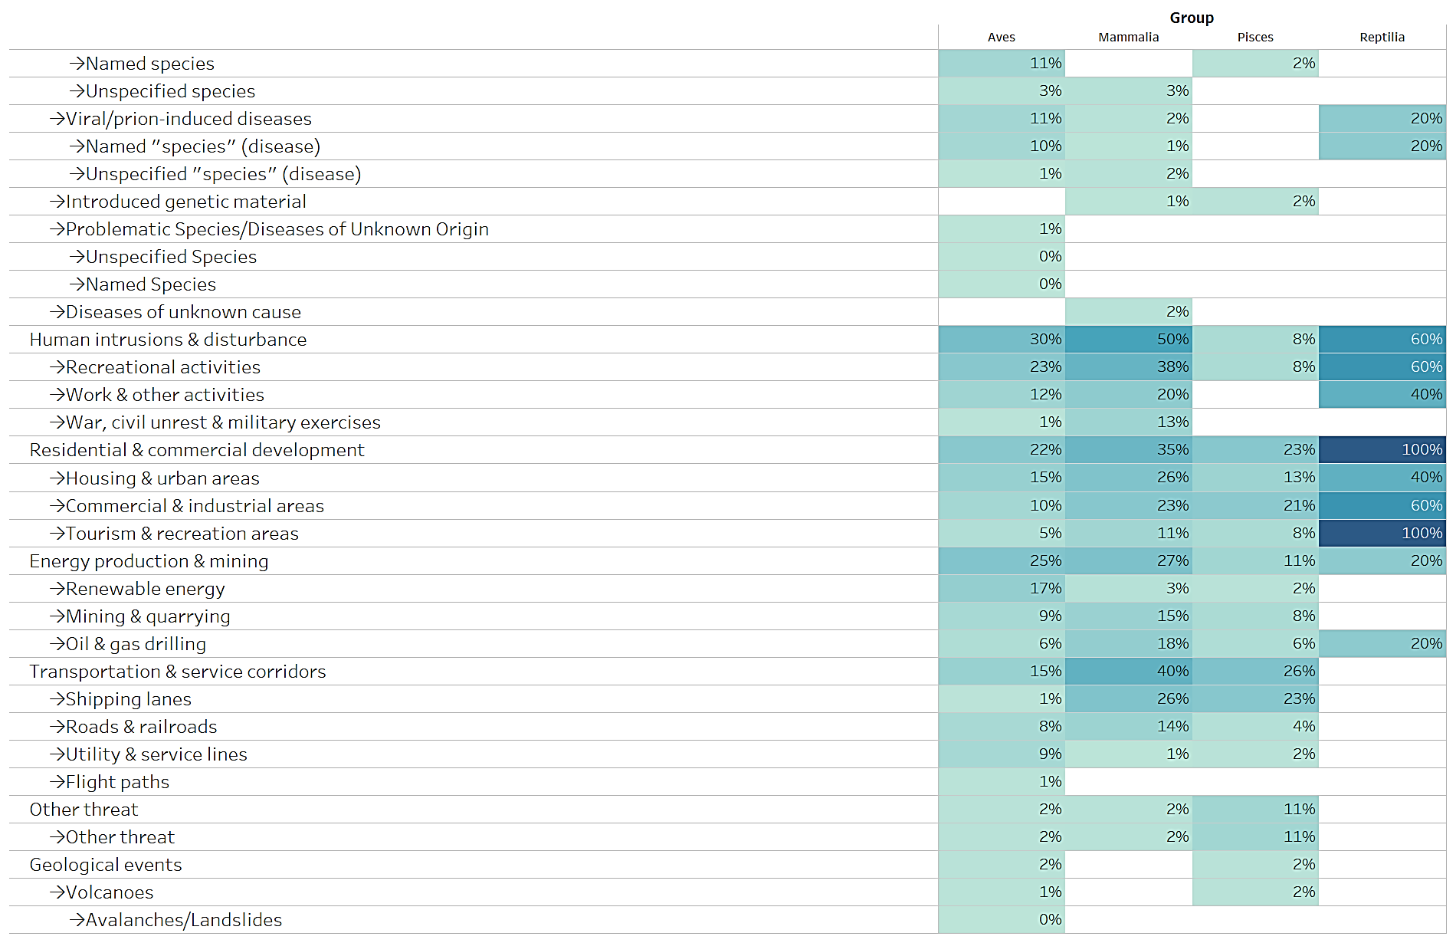

According to the Rules of Procedure for IUCN Red List Assessments 2017–2020, codification for threats is not a required supporting information for all assessments, it is required only for taxa assessed as Extinct, Extinct in the Wild, Critically Endangered, Endangered, Vulnerable, and Near Threatened.
According to the Rules of Procedure for IUCN Red List Assessments 2017–2020, codification for threats is not a required supporting information for all assessments, it is required only for taxa assessed as Extinct, Extinct in the Wild, Critically Endangered, Endangered, Vulnerable, and Near Threatened.
According to the Rules of Procedure for IUCN Red List Assessments 2017–2020, codification for threats is not a required supporting information for all assessments, it is required only for taxa assessed as Extinct, Extinct in the Wild, Critically Endangered, Endangered, Vulnerable, and Near Threatened.

