Memorandum of Understanding on
the Conservation of Migratory Sharks

Devil and Manta Ray Fact Sheet

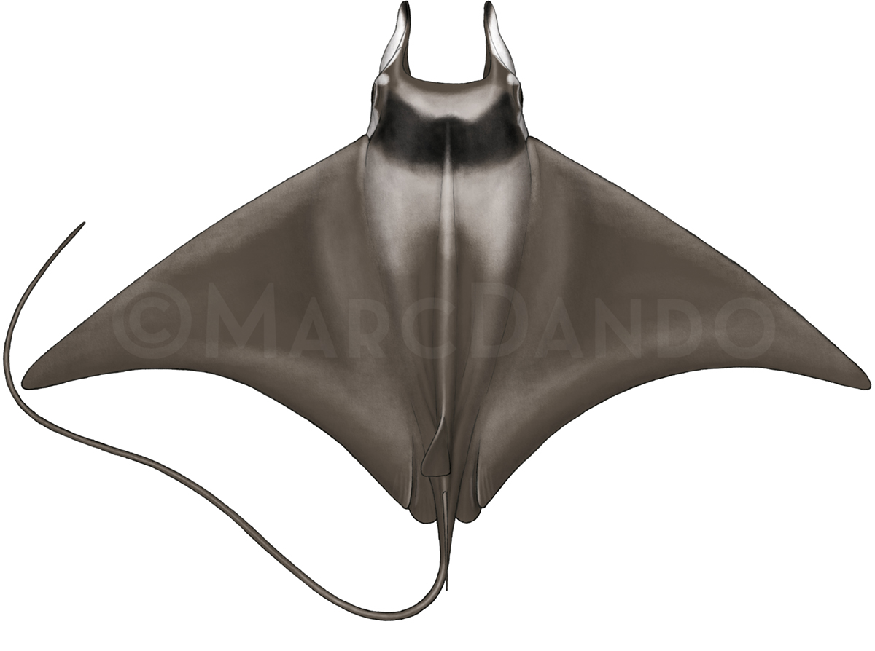
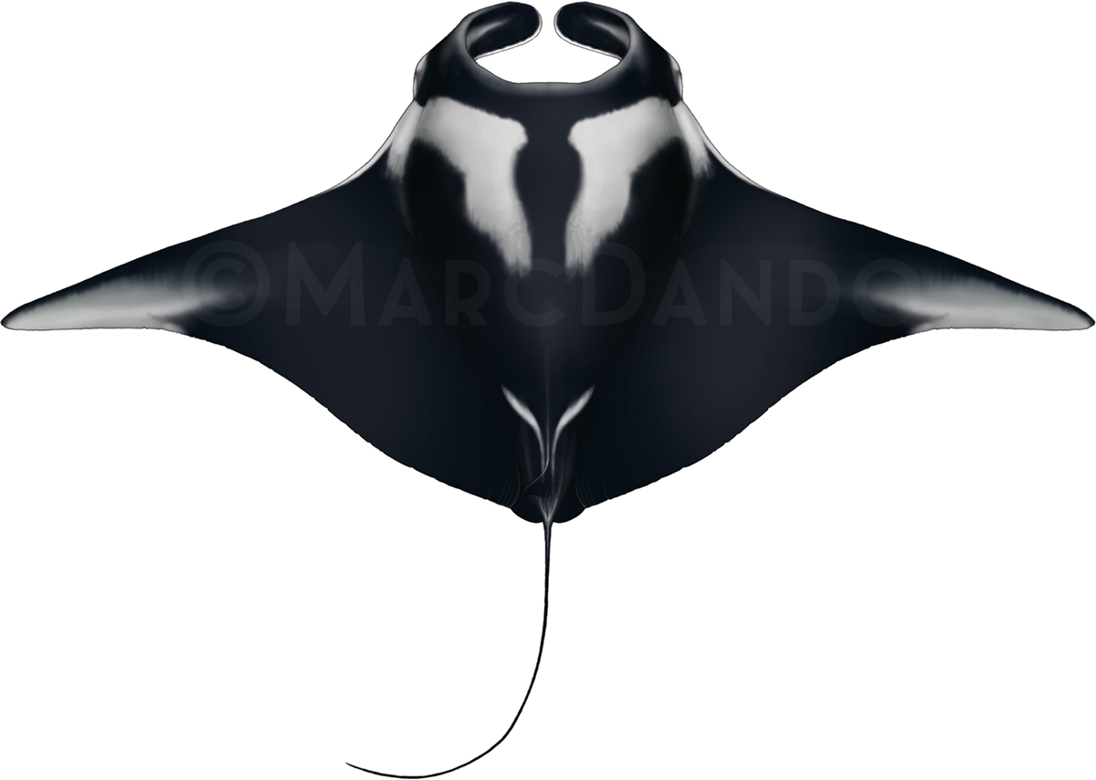
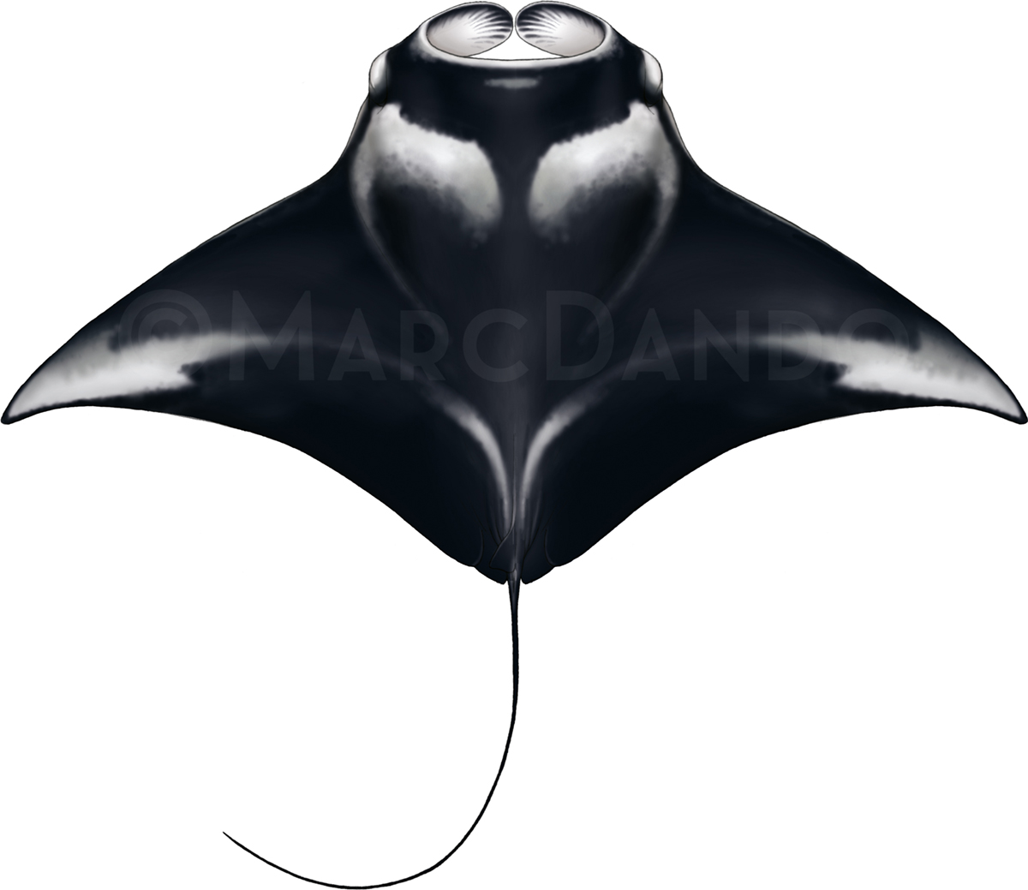
Manta birostris Manta alfredi Mobula mobular
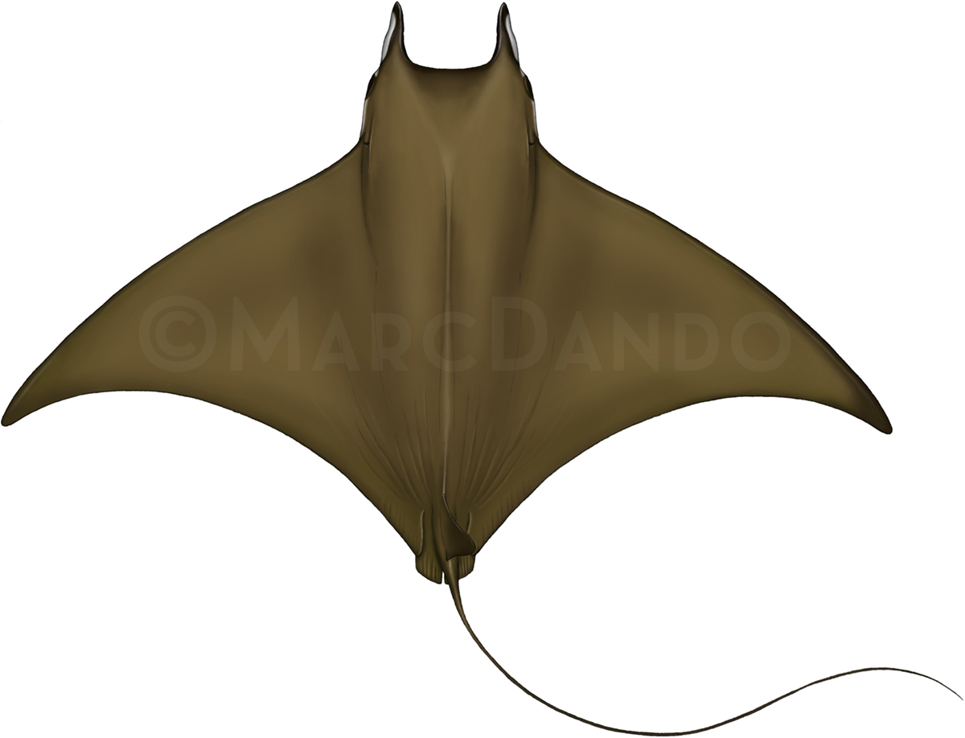
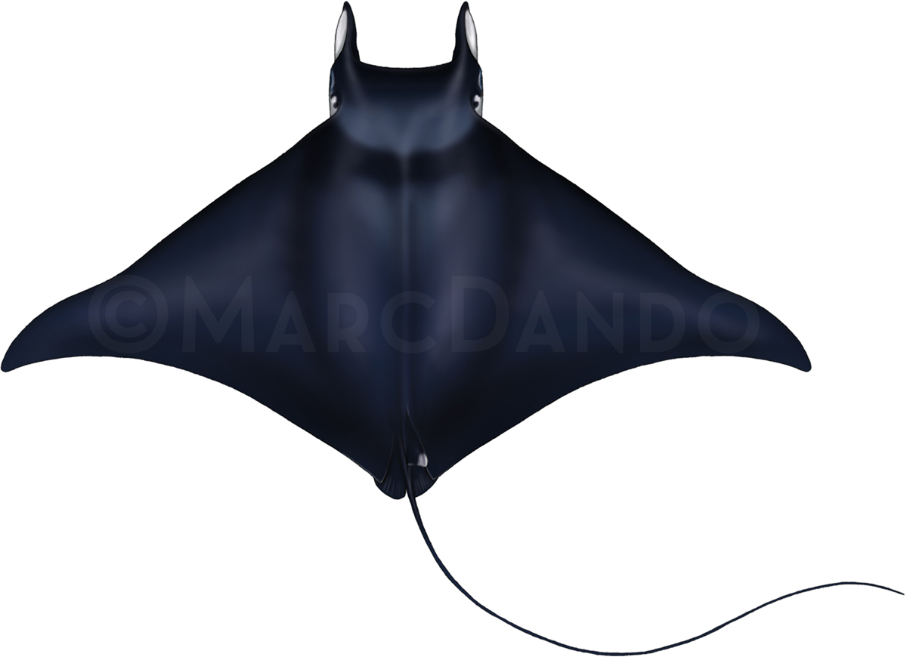
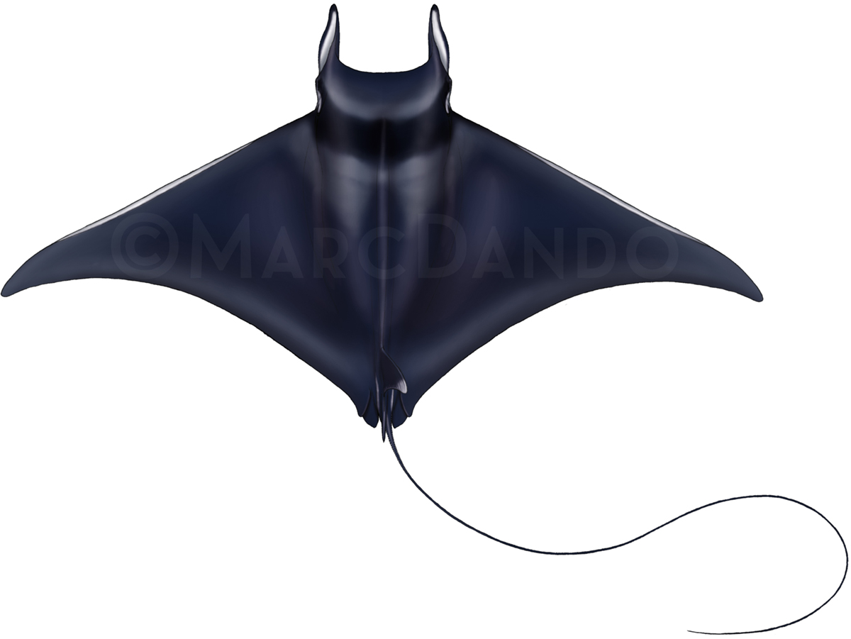

Mobula japanica Mobula thurstoni Mobula tarapacana
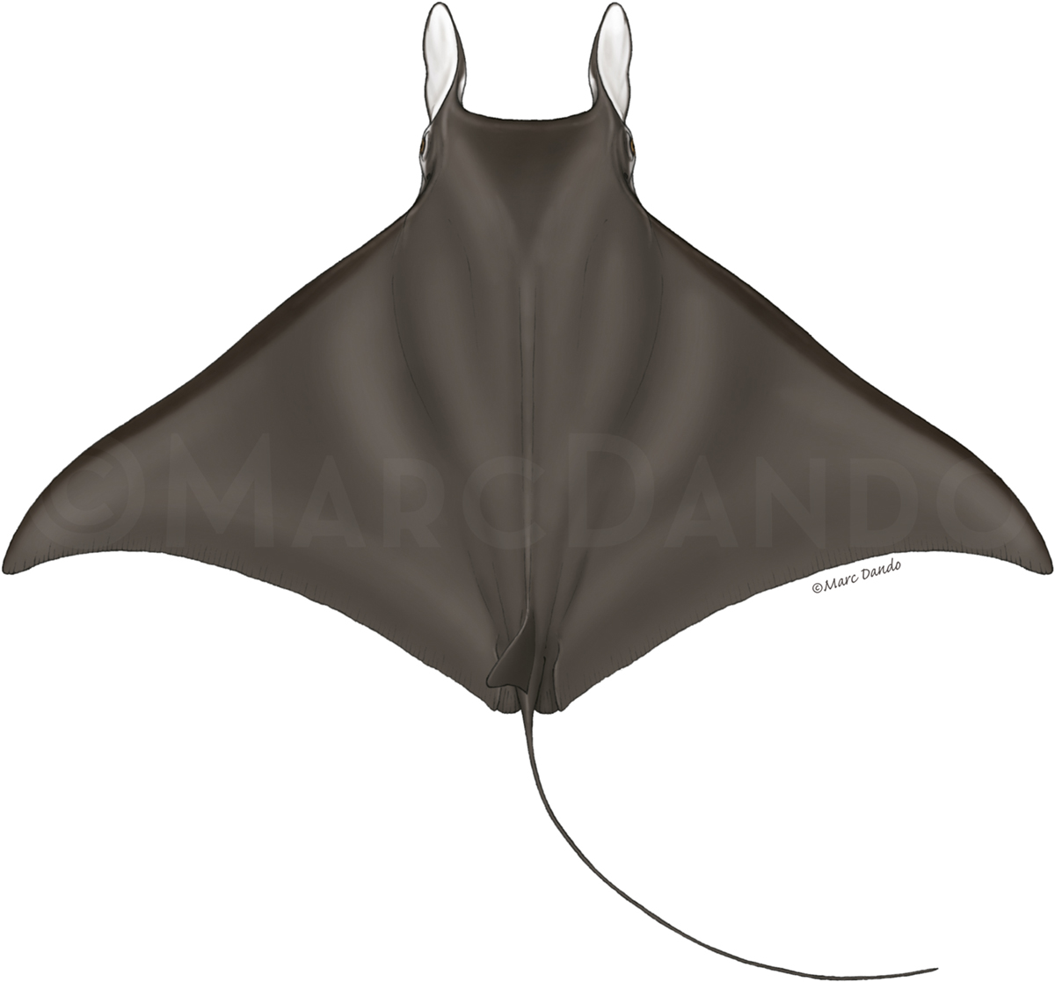
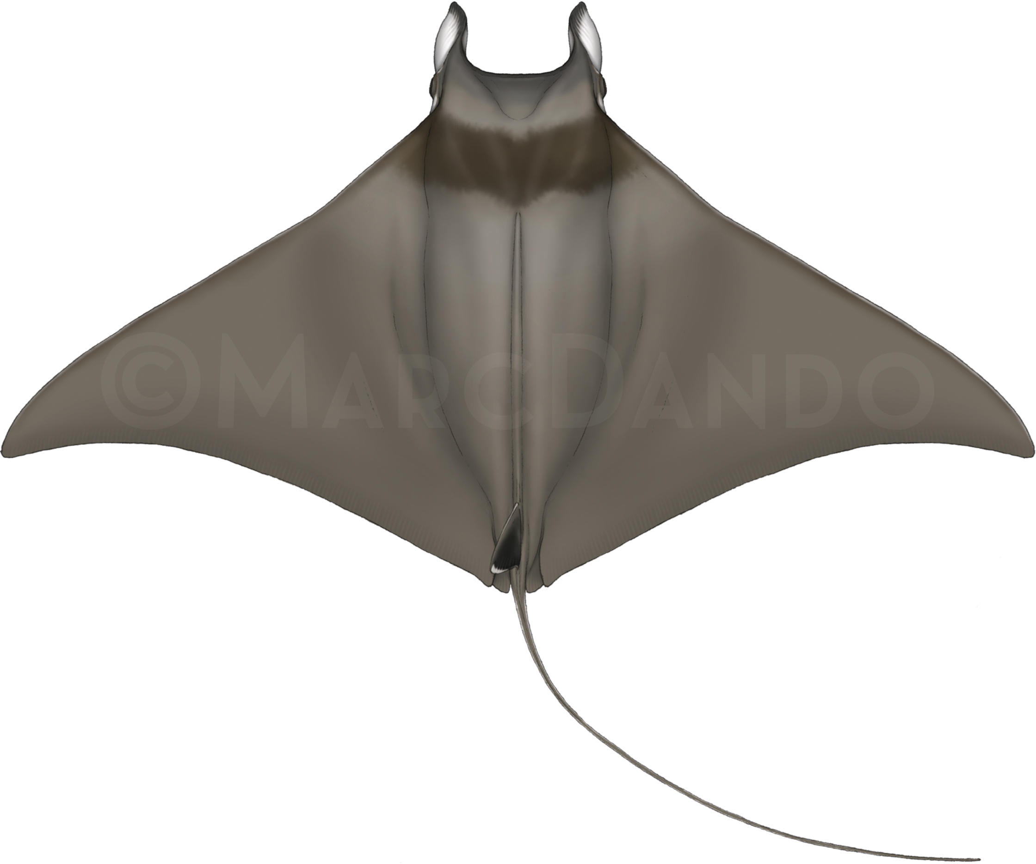
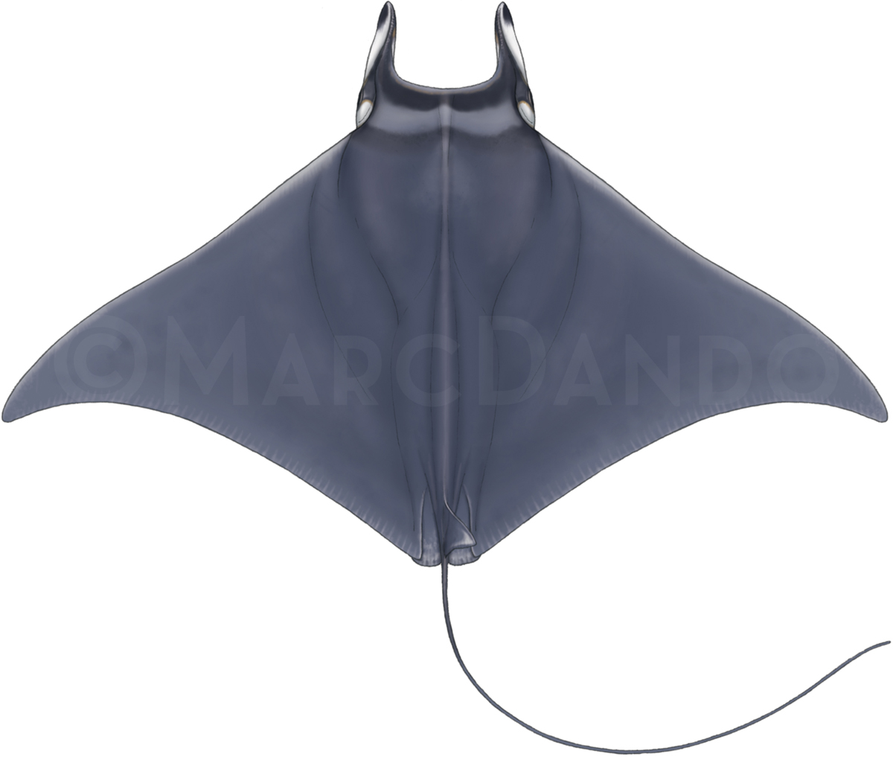

Mobula eregoodootenkee Mobula kuhlii Mobula hypostoma
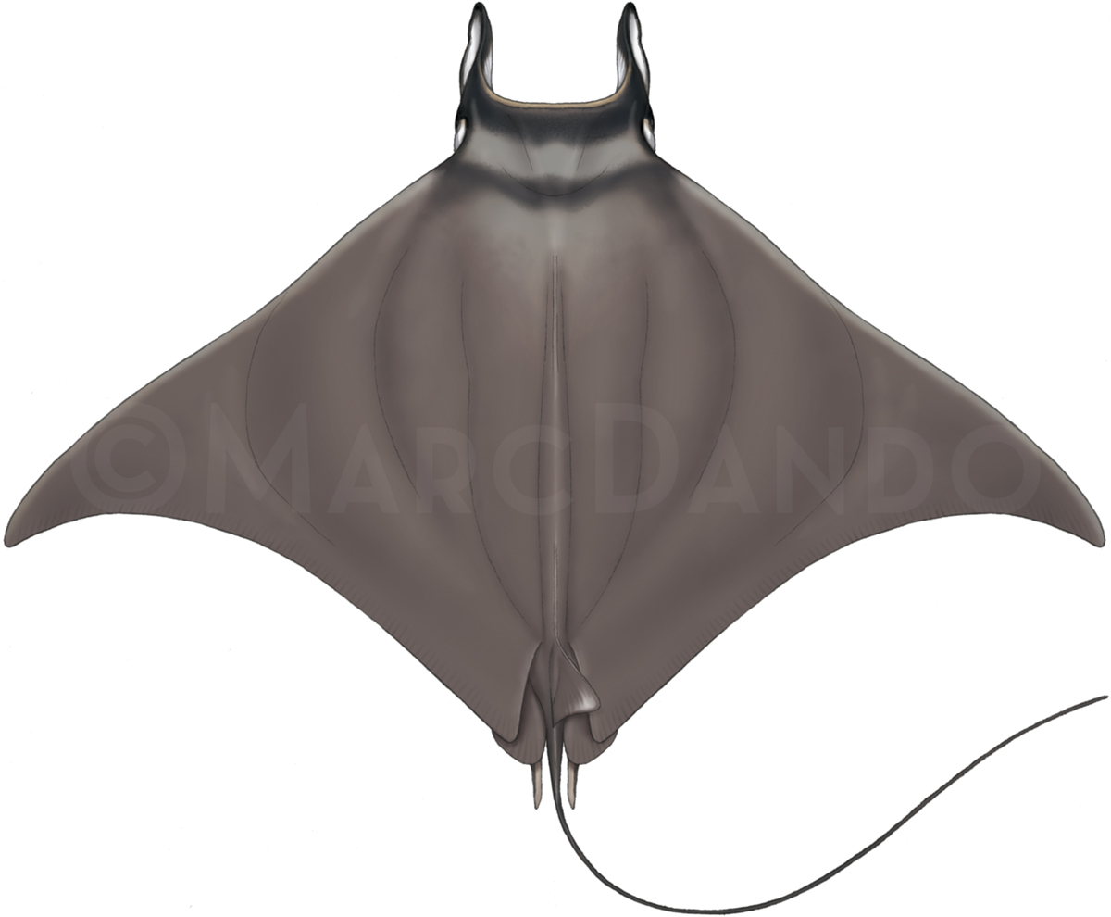
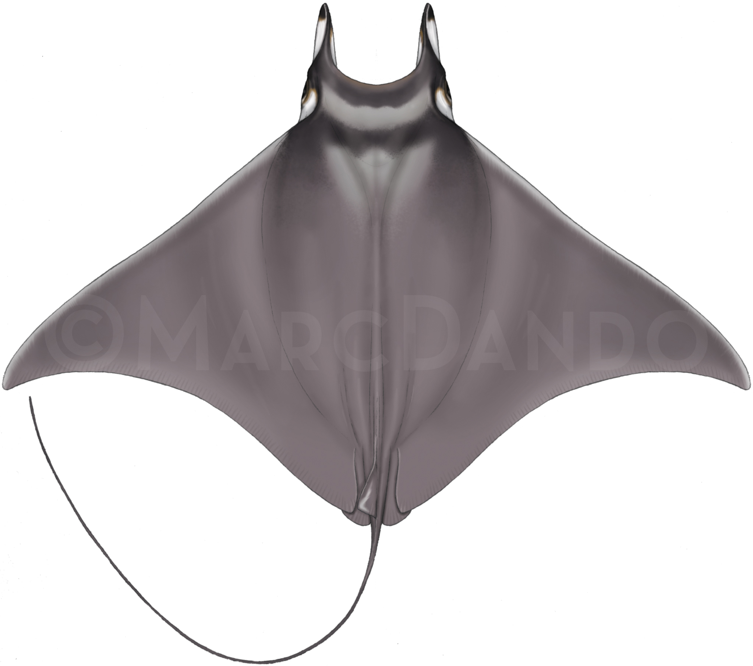

Mobula rochebrunei Mobula munkiana

Class: | Chondrichthyes
Order: | Rajiformes
Family: | Rajiformes
Species: | Manta alfredi – Reef Manta Ray  Mobula mobular – Giant Devil Ray  Mobula japanica – Spinetail Devil Ray  Mobula thurstoni – Bentfin Devil Ray  Mobula tarapacana – Sicklefin Devil Ray  Mobula eregoodootenkee – Longhorned Pygmy Devil Ray  Mobula hypostoma – Atlantic Pygmy Devil Ray  Mobula rochebrunei – Guinean Pygmy Devil Ray  Mobula munkiana – Munk’s Pygmy Devil Ray  Mobula kuhlii – Shortfin Devil Ray

Devil and Manta Rays
Raie manta & Raies Mobula
Mantas & Rayas Mobula

Illustration: © Marc Dando

BIOLOGY
Devil and manta rays (family Mobulidae, the mobulid rays) are slow-growing, large-bodied animals with some species occurring in small, highly fragmented populations. Mobulid rays are pelagic, filter-feeders, with populations sparsely distributed across tropical and warm temperate oceans. Currently, nine species of devil ray (genus Mobula) and two species of manta ray (genus Manta) are recognized by CMS. Mobulid rays have among the lowest fecundity of all elasmobranchs (1 young every 2-3 years), and a late age of maturity (up to 8 years), resulting in population growth rates among the lowest for elasmobranchs (Dulvy et al. 2014; Pardo et al 2016).

- DISTRIBUTION
The three largest-bodied species of Mobula (M. japanica, M. tarapacana, and M. thurstoni), and the oceanic manta (M. birostris) have circumglobal tropical and subtropical geographic ranges. The overlapping range distributions of mobulids, difficulty in differentiating between species, and lack of standardized reporting of fisheries data make it difficult to determine each species’ geographical extent.

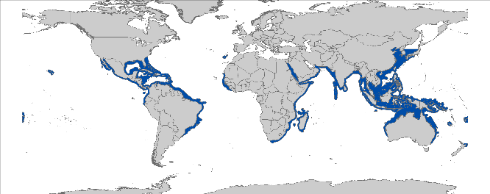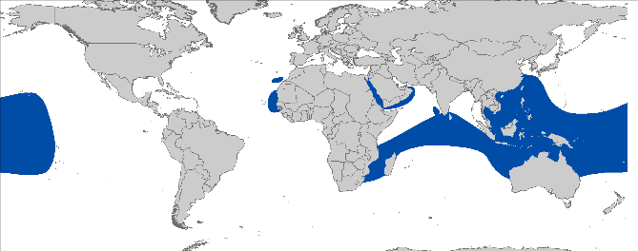
Manta (Mobula) birostris Manta (Mobula) alfredi
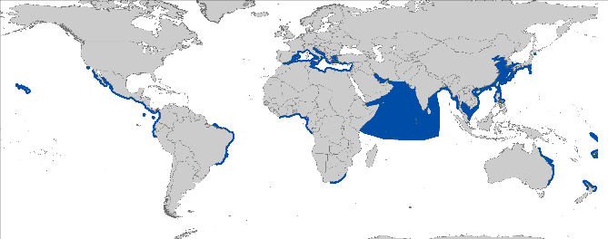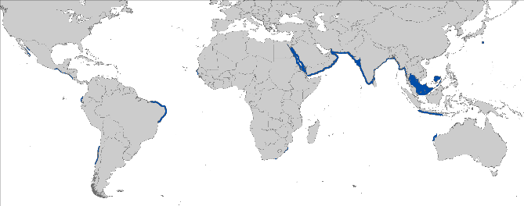

Mobula mobular (and M. japonica) Mobula thurstoni

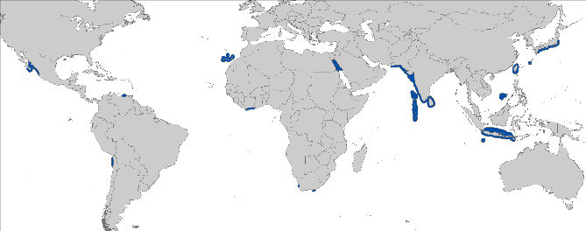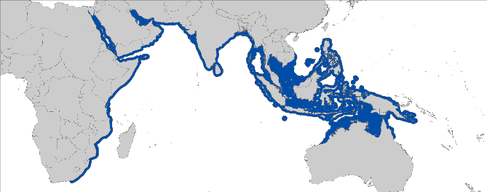
Mobula taracapana Mobula eregoodootenkee

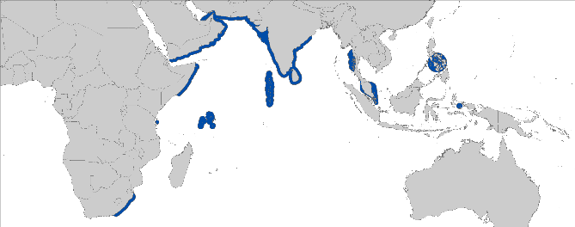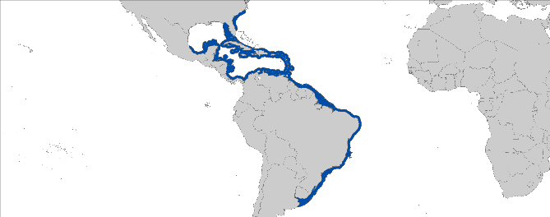
Mobula kuhlii Mobula hypostoma

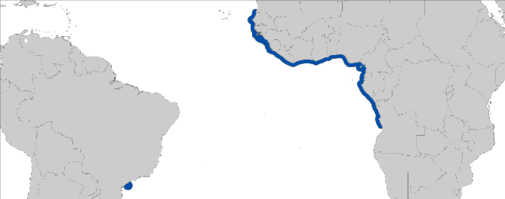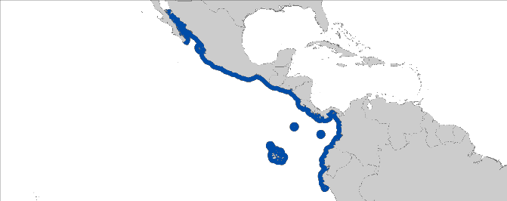Mobula rochebrunei Mobula munkiana

Figure 1: Distribution of mobulid species, courtesy of IUCN.

- CRITICAL SITES
Critical sites are those habitats that may have a key role for the conservation status of a shark population, and may include feeding, mating, pupping, overwintering grounds and other aggregation sites, as well as corridors between these sites such as migration routes. Mobulids depend on habitats at specific sites for several different components of their life cycle including pupping areas and areas where they aggregate to feed (see Appendix).

POPULATION STATUS AND TRENDS
There are no stock assessments for mobulids, however, information on population trends are available for some species and areas. Whilst global population numbers of mobulids are unknown, records exist that show local, genus-wide declines in localities around the world (Couturier et al. 2012; Lewis et al. 2015; Ward-Paige et al. 2013). The current IUCN Red List status for the global populations for mobulids are Vulnerable for M. birostris (Marshall et al. 2018), Vulnerable for M. alfredi (Marshall et al. 2018), Endangered for M. mobular (Notarbartolo di Sciara et al. 2015), Near Threatened for M. japonica (White et al. 2006), Near Threatened for M. thurstoni (Walls et al. 2016), Vulnerable for M. tarapacana (Pardo et al. 2016), Near Threatened for M. eregoodootenkee (Pierce et al. 2003), Data Deficient for M. kuhlii (Bizzarro et al. 2009), Data Deficient for M. hypostoma (Bizzarro et al. 2009), Vulnerable for M. rochebrunei (Valenti et al. 2009), and Near Threatened for M. munkiana (Bizzarro et al. 2006).

Species | Region | Estimated Decline | Time Period | References
ATLANTIC
Mobula spp. | Guinea | 61% | 4 years (2004 to 2008) | (Doumbouya 2009)
INDO-PACIFIC
M. japanica | Tanjung Luar, Indonesia | 96% | 7-13 years (2001-5 to 2013-14) | (White et al. 2006; Lewis et al. 2015)
M. japanica | Cilacap, Indonesia | 50% | 8-13 years (2001-5 to 2014) | (White et al. 2006; Dharmadi 2014)
M. japanica, M. munkiana, M. thurstoni and M. tarapacana | Tumbes, Peru | 89% | 14 years (1999 to 2013) | (Llanos et al. 2010; IMARPE 2014)
M. japanica, M. tarapacana, and other Mobula spp. | Lamaker, Indonesia | 86% | 12 years (2002 to 2014) | (Dewar 2002; Lewis et al. 2015)
M. japanica, M. tarapacana, and other Mobula spp. | India | > 50% | 10 years (1993-5 to 2012-13) | (Raje et al. 2007; Mohanraj unpublished data)
M. tarapacana | Tanjung Luar, Indonesia | 99% | 7-13 years (2001-5 to 2013-14) | (White et al. 2006; Lewis et al. 2015)
M. tarapacana | Cilacap, Indonesia | 77% | 8-13 years (2001-5 to 2014) | (White et al. 2006) Dharmadi & Fahmi, unpublished
M. tarapacana and other Mobula spp. | Cocos Islands, Costa Rica | 78% | 21 years (Jan 1993-Dec 2013) | (White et al. 2015)
Mobula spp. | Senegal | 82% | 5 years (2005 to 2014)

THREATS

- Fisheries: Targeted and incidental fisheries pose a major threat to mobulids on a global scale. Mobulid rays are caught by a variety of gears including harpoon, longline, purse seine, gillnet and trawl (White 2006; Lewis et al. 2015) and retained for their meat and gill plates. Targeted fishing in critical habitats and aggregation sites raises concern as a large number of individuals can be captured in a short period. There can also be low post-release survivorship in some fisheries. Mobulid meat is an important protein source in some developing countries particularly in South and Central America and Asia (Fernando & Stevens 2011; Lewis et al. 2015).
- International trade: Recent market surveys documented an alarming increase in the demand for mobulid gill plates, with the estimated number of individuals increasing almost threefold from early 2011 to late 2013 (O’Malley 2013). The high and increasing value of gill plates drives increased target fishing pressure for all mobulids in key Range States, with many former bycatch fisheries now targeting mobulids (Fahmi 2014; Lewis et al. 2015).
- Other actual or potential threats: Due of their surface-water habitat, manta rays are exposed to collisions with vessels causing serious injuries, sometimes death. Tourism interactions, as well as protective shark nets (Australia and South Africa) and abandoned fishing gears (lines in particular) may cause local disturbance and result in some disturbance or mortality. However, whether these factors have population-level impacts is uncertain. As filter-feeding organisms, mobulids are likely to be affected by the presence of plastic debris in the sea water column.

KEY KNOWLEDGE GAPS

A comprehensive knowledge gap analysis with recommendations for actions is described by Lawson et al. (2017). Closing these gaps will enable the prioritization of conservation and management actions.

KEY MANAGEMENT AND CONSERVATION GAPS

- Few Range States provide specific protections to mobulids, and enforcement of these laws can be poor;
- Regional/multilateral cooperation among and between countries and RFMOs is lacking;
- A limited number of RFBs have agreed on fishery or conservation measures for mobulids;
- Not all RFBs have adopted technical (bycatch mitigation? Standardized bycatch reporting scheme?) or handling guidelines.

RECOMMENDATIONS FOR CONSERVATION AND MANAGEMENT ACTION

A multifaceted approach is required to address management and conservation gaps for mobulid rays. CMS Sharks MOU Signatories and other Range States are encouraged as follows:

- Incorporate mobulid protection into national legislation of all parties to CMS / Range states

- Implement relevant international measures (e.g. CMS, CITES and RFMOs) that prohibit targeting, retaining, landing, transshipping, and selling of mobulid parts;
- Consider the Concerted action plan for mobulids (REF).

- Improve the understanding of migratory shark populations through research, monitoring and information exchange,

- Identify critical sites of mobulid abundance and seasonality;
- Address data gaps in biological knowledge (life history parameters) of mobulid rays;
- Support research to define management units within the Mobulidae family;
- Conduct long-term monitoring of mobulid populations;
- Develop capacity in research, data collection & monitoring;
- Establish conservation time-bound targets and indicators to assess progress toward objectives as outlined in Lawson et al. 2017.

- Improve multilateral cooperation among regions & RFBs

- Support the introduction of appropriate management and conservation measures for mobulids at international and regional fora, including relevant RFMOs (e.g. Co-sponsor proposals / resolutions within multilateral agreements);
- Improve the effectiveness of the 2015 IATTC mobulid ray protection measure (i.e. by ending the exceptions for small scale fisheries);
- Promote standardized data reporting and safe release techniques.

- Enforce landing and trade bans

- Prioritize enforcement, including to conduct market surveys and patrols, protected area patrols;
- Adopt the Port State Measures Agreement and Implement port-state controls;
- Improve capacity in species identification through trainings and the dissemination of available ID guides.

- Identify the effective approaches to reduce bycatch and improve survivorship of mobulids.

- Identify gear modifications and best fishing practices e.g. gear restrictions, pole and line, safe release handling guidelines (Poisson et al. 2014);
- Explore options for spatial management;
- Investigate post-release survivorship of mobulids to inform improved handling and release protocols;
- encourage ICCAT, IOTC, and WCPFC to develop recommendations, Resolutions, and CMM, respectively, for the safe release of all Mobulid rays incidentally caught.

- Enhance or develop where necessary collection of fishery data (including landings, discards, size frequency, catch and effort where needed)
- Collection of bycatch data;
- Develop capacity in research & monitoring in all regions;
- Report national species-specific landings of devil and manta rays to FAO & RFMOs.

- Engage local communities in the conservation of mobulids
- Provide training to fishing communities on species identification and safe release guidelines;
- Involve local communities in the development of regional management (i.e. eco-tourism, sustainable fisheries and aquaculture).

- Reduce gill plate demand
- Increase awareness of human health risk of consuming gill plates and conservation threat to mobulids through science-based campaigns

The global strategy and action plan ““Sympathy for the devil: a conservation strategy for devil and manta rays” by (Lawson et al. 2017) is a useful reference comprising a series of goals, objectives and actions required to ensure a thriving future for these animals, their ocean habitats, and the communities that rely upon them.

LEGAL INSTRUMENTS

Instrument | Description | Species
Barcelona Convention  Barcelona Convention for the Protection of the Marine Environment and the Coastal Region of the Mediterranean | Annex II: Endangered or threatened species; Parties shall ensure the maximum possible protection and recovery of, while prohibiting the damage to and destruction of, these species. | M. mobular
Bern Convention  Convention on the Conservation of European Wildlife and Natural Habitats | Appendix II: Strictly protected fauna species; Contracting Parties shall ensure the special protection of these species through particularly prohibiting deliberate killing, taking, disturbance, trade and possession. | M. mobular
Cartagena Convention  Convention for the Protection and Development of the Marine Environment of the Wider Caribbean Region | Annex III: Parties may regulate the use of these species of flora and fauna in order to ensure and maintain their populations at the highest possible levels. | M. alfredi  M. birostris
CITES  Convention on International Trade in Endangered Species of Wild Fauna and Flora | Appendix II: Species not necessarily threatened with extinction, but in which trade must be controlled in order to avoid utilization incompatible with their survival. | M. alfredi  M. birostris  M. mobular  M. japanica  M. thurstoni  M. tarapacana  M. eregoodootenkee  M. kuhlii  M. hypostoma  M. rochebrunei  M. munkiana
CMS  Convention on the Conservation of Migratory Species of Wild Animals | Appendix I: Migratory species threatened with extinction; CMS Parties strive towards strictly protecting these species, conserving or restoring the places where they live, mitigating obstacles to migration and controlling other factors that might endanger them. | M. alfredi  M. birostris  M. mobular  M. japanica  M. thurstoni  M. tarapacana  M. eregoodootenkee  M. kuhlii  M. hypostoma  M. rochebrunei  M. munkiana
 | Appendix II: Migratory species that have an unfavourable conservation status and need or would significantly benefit from international cooperation; CMS Parties shall endeavour to conclude global or regional agreements to benefit these species. | M. alfredi  M. birostris  M. mobular  M. japanica  M. thurstoni  M. tarapacana  M. eregoodootenkee  M. kuhlii  M. hypostoma  M. rochebrunei  M. munkiana
FAO  Food and Agriculture Organization | IPOA Sharks: International Plan of Action for Conservation and Management of Sharks based on which states should adopt and implement a national plan of action for conservation and management of shark stocks (NPO Sharks) if their vessels conduct directed fisheries for sharks or if their vessels regularly catch sharks in non-directed fisheries. | M. alfredi  M. birostris  M. mobular  M. japanica  M. thurstoni  M. tarapacana  M. eregoodootenkee  M. kuhlii  M. hypostoma  M. rochebrunei  M. munkiana
GFCM  General Fisheries Commission for the Mediterranean | Rec. GFCM/36/2012/3: shark species listed under Annex II of the Barcelona Convention cannot be retained on board, transshipped, landed, transferred, stored, sold or displayed or offered for sale and must be released unharmed and alive to the extent possible. | M. mobular
IATTC  Inter-American Tropical Tuna Commission | Res. C-15-04: Resolution on the conservation of Mobulid rays caught in association with fisheries in the IATTC Convention Area | M. alfredi  M. birostris  M. mobular  M. japanica  M. thurstoni  M. tarapacana  M. eregoodootenkee  M. kuhlii  M. hypostoma  M. rochebrunei  M. munkiana
Sharks MOU  Memorandum of Understanding on the Conservation of Migratory Sharks | Annex 1: Signatories should endeavour to achieve and maintain a favourable conservation status for these species based on the best available scientific information and taking into account their socio-economic value. | M. alfredi  M. birostris  M. mobular  M. japanica  M. thurstoni  M. tarapacana  M. eregoodootenkee  M. kuhlii  M. hypostoma  M. rochebrunei  M. munkiana
SPRFMO  South Pacific Regional Fisheries Management Organisation | Considering both the precautionary approach and an ecosystem approach to fisheries management, SPRFMO adopts, as necessary, protocols and conservation measures meant to safeguard shark species related to fisheries in the area. | M. alfredi  M. birostris  M. mobular  M. japanica  M. thurstoni  M. tarapacana  M. eregoodootenkee  M. kuhlii  M. hypostoma  M. rochebrunei  M. munkiana
WCMC  Western and Central Pacific Fisheries Commission | WCPFC considers mobulids as key shark species for assessment and safe release guidelines shall be developed with a view to their adoption by WCPFC14 | M. alfredi  M. birostris  M. mobular  M. japanica  M. thurstoni  M. tarapacana  M. eregoodootenkee  M. kuhlii  M. hypostoma  M. rochebrunei  M. munkiana

- KNOWN CRITICAL SITES

Critical sites for mobulids may include known areas of aggregation in various locations around the world (Notarbartolo-di- Sciara and Hillyer 1989; Graham et al. 2012; Venables 2013). These sites function as feeding areas, cleaning stations, or sites where mating takes place (e.g. Heinrichs et al. 2011; Marshal et al. 2011; Graham et al. 2012; Venables 2013). A compilation of these sites and there purpose (i.e. feeding, mating, etc.) is ongoing and being complemented by current research efforts.

REFERENCES

Acebes JM 2013. Hunting “Big Fish”: A marine environmental history of a contested fishery in the Bohol Sea. thesis, Murdoch University. p.
Alava ED, ER; Yaptinchay, Arnel Andrew; Trono, Romeo B 1997. Fishery and trade of whale sharks and manta rays in the Bohol Sea, Philippines. Elasmobranch biodiversity, conservation and management: Proceedings of the international seminar and workshop. Sabah, Malaysia: 132-148.
Alfaro-Shigueto J, Mangel JC, Pajuelo M, Dutton PH, Seminoff JA, Godley BJ 2010. Where small can have a large impact: structure and characterization of small-scale fisheries in Peru. Fisheries Research 106: 8-17.
Bizzarro, J., Smith, W., Baum, J., Domingo, A. & Menni, R. 2009. Mobula hypostoma. The IUCN Red List of Threatened Species 2009: e.T161737A5492018.
Bizzarro, J.J., Smith, W.D. & Clark, T.B. 2006. Mobula munkiana. The IUCN Red List of Threatened Species 2006: e.T60198A12309375.
Bizzarro JJ, Smith WD, Hueter RE, Tyminski JP, Marquez-Farias JF, Castillo-Geniz JL, Cailliet GM, Villavicencio-Garayzar CJ 2007. The status of shark and ray fishery resources in the Gulf of California: applied research to improve management and conservation. In ed., Moss Landing Marine Laboratories. Pp.
Bizzarro, J., Smith, W., White, W.T. & Valenti, S.V. 2009. Mobula kuhlii. The IUCN Red List of Threatened Species 2009: e.T161439A5424139.
Chong-Robles J 2006. Análisis de la captura incidental de elasmobranquios en la pesquería mexicana de atún con red de cerco en el Océano Pacífico Oriental. thesis, Tesis de Maestría. CICESE. México. p.
Couturier L, Marshall A, Jaine F, Kashiwagi T, Pierce S, Townsend K, Weeks S, Bennett M, Richardson A 2012. Biology, ecology and conservation of the Mobulidae. Journal of Fish Biology 80: 1075-1119.
Dewar H 2002. Preliminary report: Manta harvest in Lamakera. p. Oceanside, USA: Report from the PflegerInstitue of Environmental Research and the Nature Conservancy: 3.
Dharmadi F 2014. Biological Aspects, Stock and Conservation Status of Giant Oceanic Manta Ray, Manta birostris in the Indian Ocean. Proceedings of the Design Symposium on Conservation of Ecosystem (The 13th SEASTAR 2000 workshop) 2: 1-8.
DIOP, Mika. 2016, Résumé des missions de sensibilisation dans les Etats Membres CSRP et aux Secrétariats Exécutifs de la COREP (Gabon) et du CPCO (Ghana) Période : 13 juillet au 16 août 2016.
DIOP, Mika. 2016. Statut de conservation en Afrique de l’Ouest des espèces proposées à l’Annexe II de la CITES, CoP 17.Note Technique. Octobre, 2016.
Doumbouya F 2009. Rapport sur l’actualisation des etudes sure les raies mantas en Guinee. Centre National des Sciences Halieutiques de Boussoura. Ministère de la Pêche et de l’Aquaculture. Republique de Guinee.
DPM., 2017 – Statistiques de pêche du Sénégal 2016
Duffy C, Abbott D 2003. Sightings of mobulid rays from northern New Zealand, with confirmation of the occurrence of Manta birostris in New Zealand waters.
Fahmi D 2014. Biological Aspects, Stock and Conservation Status of Giant Oceanic Manta Ray, Manta birostris in the Indian Ocean. Proceedings of the Design Symposium on Conservation of Ecosystem (The 13th SEASTAR 2000 workshop) 2: 1-8.
Fernando D, Stevens G 2011. A study of Sri Lanka’s manta and mobula ray fishery. The Manta Trust 29.
Henderson A, Reeve A 2011. Noteworthy elasmobranch records from Oman. African Journal of Marine Science 33: 171-175.
Howard R, Ahmad A 2015. U Saw Han Shein (2015). Shark and Ray Fisheries of Myanmar–status and socio-economic importance. In ed., Report. Pp.
IMARPE 2014. Boletin Informativo Pesquero Abril 2014 No. 9, Instituto del Mar del Peru Laboratorio Costero de Tumbes.
Kizhakudan SJ, Zacharia P, Thomas S, Vivekanandan E, Muktha M 2015. Guidance on national plan of action for sharks in India. Central Marine Fisheries Research Institute. pp.
Lawson JM, Fordham SV, O’Malley MP, Davidson LNK, Walls RHL, Heupel MR, Stevens G, Fernando D, Budziak A, Simpfendorfer CA, Ender I, Francis MP, Notarbartolo di Sciara G, Dulvy NK 2017. Sympathy for the devil: a conservation strategy for devil and manta rays. PeerJ 5: e3027.
Lewis SA, Setiasih N, O'Malley MP, Campbell SJ, Yusuf M, Sianipar AB 2015. Assessing Indonesian manta and devil ray populations through historical landings and fishing community interviews. In ed., PeerJ PrePrints. Pp.
Llanos J, Inga C, Ordinola E, Rujel J 2010. Investigaciones biológico pesqueras en la región Tumbes, Perú. 1996–2005.
Luiz OJ, Balboni AP, Kodja G, Andrade M, Marum H 2009. Seasonal occurrences of Manta birostris (Chondrichthyes: Mobulidae) in southeastern Brazil. Ichthyological Research 56: 96-99.
Marshall, A., Bennett, M.B., Kodja, G., Hinojosa-Alvarez, S., Galvan-Magana, F., Harding, M., Stevens, G. & Kashiwagi, T. 2018. Mobula birostris (amended version of 2011 assessment). The IUCN Red List of Threatened Species 2018: e.T198921A126669349.
Marshall, A., Kashiwagi, T., Bennett, M.B., Deakos, M., Stevens, G., McGregor, F., Clark, T., Ishihara, H. & Sato, K. 2018. Mobula alfredi (amended version of 2011 assessment). The IUCN Red List of Threatened Species 2018: e.T195459A126665723.
Marshall, A.D., Dudgeon, C.L. and Bennett, M.B., 2011. Size and structure of a photographically identified population of manta rays Manta alfredi in southern Mozambique. Marine Biology, 158(5), pp.1111-1124.
Mohanraj G, Rajapackiam S, Mohan S, Batcha H, Gomathy S 2009. Status of elasmobranchs fishery in Chennai, India. Asian Fisheries Science 22: 607-615.
Nair RJ, Venugopal K 2003. Targeted shark fishery in Kerala. Marine Fisheries Information
Service, Technical and Extension Series 176: 8-9.
Notarbartolo di Sciara, G., Serena, F. & Mancusi, C. 2015. Mobula mobular. The IUCN Red List
of Threatened Species 2015: e.T39418A48942228.
O’Malley MPL-B, Katie; Medd, Hannah B; 2013. The global economic impact of manta ray watching tourism. PLoS One 8: e65051.
Pardo, S.A., Walls, R.H.L. & Bigman, J.S. 2016. Mobula tarapacana (errata version published in 2017). The IUCN Red List of Threatened Species 2016: e.T60199A121705844.
Paulin C, Habib G, Carey C, Swanson P, Voss G 1982. New records of Mobula japanica and Masturus lanceolatus, and further records of Luvarus imperialis (Pisces: Mobulidae, Molidae, Luvaridae) from New Zealand. New Zealand Journal of Marine and Freshwater Research 16: 11-17.
Pierce, S.J. & Bennett, M.B. (SSG Australia & Oceania Regional Workshop, March 2003). 2003. Mobula eregoodootenkee. The IUCN Red List of Threatened Species 2003: e.T41832A10575938.
Poisson F, Séret B, Vernet A-L, Goujon M, Dagorn L 2014. Collaborative research: Development of a manual on elasmobranch handling and release best practices in tropical tuna purse-seine fisheries. Marine Policy 44: 312-320.
Rajapackiam S, Mohan S, Rudramurthy N 2007. Utilization of gill rakers of lesser devil ray Mobula diabolus-a new fish byproduct. Marine Fisheries Information Service, Technical and Extension Series 191: 22-23.
Raje S, Sivakami S, Mohanraj G, Manojkumar P, Raju A, Joshi K 2007. Atlas on the Elasmobranch fishery resources of India. CMFRI Special Publication 95: 1-253.
Reeve A, Henderson A 2012. Short Communication New mobulid records from Oman. J. Appl. Ichthyol 1: 2.
Sampson L, Galván-Magaña F, De Silva-Dávila R, Aguíñiga-García S, O'Sullivan JB 2010. Diet and trophic position of the devil rays Mobula thurstoni and Mobula japanica as inferred from stable isotope analysis. Journal of the Marine Biological Association of the United Kingdom 90: 969-976.
Sobral A, Afonso P 2014. Occurrence of mobulids in the Azores, central North Atlantic. Journal of the Marine Biological Association of the United Kingdom 94: 1671-1675.
Villavicencio-Garayzar C 1991. Observations on Mobula munkiana (Chondrichtyes: Mobulidae) in the bahia de La Paz, BCS, Mexico.
Valenti, S.V. & Kyne, P.M. 2009. Mobula rochebrunei. The IUCN Red List of Threatened Species 2009: e.T161510A5439639.
Walls, R.H.L., Pardo, S.A., Bigman, J.S., Clark, T.B., Smith, W.D. & Bizzarro, J.J. 2016. Mobula thurstoni (errata version published in 2016). The IUCN Red List of Threatened Species 2016: e.T60200A100016879.
Ward-Paige CA, Davis B, Worm B 2013. Global population trends and human use patterns of Manta and Mobula rays. PLoS One 8: e74835.
White ER, Myers MC, Flemming JM, Baum JK 2015. Shifting elasmobranch community assemblage at Cocos Island—an isolated marine protected area. Conservation Biology 29: 1186-1197.
White WT, Cavanagh RD 2007. Whale shark landings in Indonesian artisanal shark and ray fisheries. Fisheries Research 84: 128-131.
White, W.T., Clark, T.B., Smith, W.D. & Bizzarro, J.J. 2006. Mobula japanica. The IUCN Red List of Threatened Species 2006: e.T41833A10576180.
White WT, Last P, Stevens J, Yearsley G 2006. Economically important sharks & rays of Indonesia. Australian Centre for International Agricultural Research (ACIAR). pp.
White WT, Corrigan S, Yang L, Henderson AC, Bazinet AL, Swofford DL, Naylor GJ 2017. Phylogeny of the manta and devilrays (Chondrichthyes: mobulidae), with an updated taxonomic arrangement for the family. Zoological Journal of the Linnean Society.
White WTG, Jenny; Potter, Ian C 2006. Data on the bycatch fishery and reproductive biology of mobulid rays (Myliobatiformes) in Indonesia. Fisheries Research 82: 65-73.
Zacharia P, Kanthan K 2010. Unusual heavy landing of rays and skates at Tuticorin Fisheries Harbour. Marine Fisheries Information Service; Technical and Extension Series 205: 13-15.

In accordance with White et al. 2017 the taxonomy of Mobulidae has changed but has not yet been adopted by the Signatories.
See IUCN http://www.iucnredlist.org/search website for further details on population assessments.
[delete this footnote]

