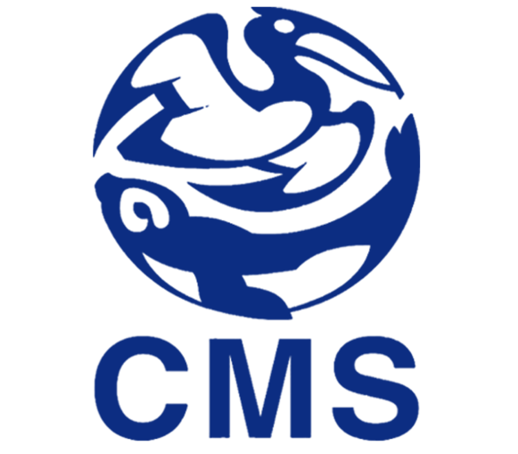

SMALL GRANTS PROGRAMME

PART a - Application Form -

Please send the completed form to the Secretariat (secretariat@cms.int) as a Pdf or MS Word file, together with the duly signed Endorsement Form(s) and the project budget by 30 November 2013 at the latest. Submission via email is preferred, stating “Small Grants Programme application”, as well as the name of the implementing agency in the subject line. Submissions sent via post have to reach the Secretariat by the same date and should be sent to: UNEP/CMS Secretariat, UN Campus, Platz der Vereinten Nationen 1, 53113 Bonn, Germany.

The Revised Guidelines for the Operation of the Small Grants Programme are available in the document UNEP/CMS/Conf.10.43 , on the CMS website: www.cms.int.

For any queries please do not hesitate to contact Johannes Stahl (jstahl@cms.int) or Laura Aguado (laguado@cms.int) at the UNEP/CMS Secretariat.

- Please use the grey fields for answers and comments. –
1. Implementing agency

Agency/organization name

Project leader

Position

Address

E-mail

Telephone

Optional: attach CVs of key personnel.

2. Collaborating agencies (if applicable)

List of collaborating agencies (including contact person, email, telephone):

Involvement of collaborating agencies to date (Max 100 words per agency):

3. Project title, duration and host country/ies

Project title (not exceeding 10 words)

Proposed start date (month/year)

Proposed end date (month/year)

(please note that SGP projects are limited to two years’ duration)

Host country/ies

Key migratory species targeted by project

4. Topics relevant for the project

You need to choose the topics under which you intend to submit your proposal. You can choose up to three topics, in the order of importance.
Threats to migratory species (by-catch, invasive alien species, barriers to migration…)
Capacity building (training programmes…)
Research (tagging, monitoring…)
Conservation and restoration (species recovery programmes, restorations of rivers, reforestations…)
Building regional and national cooperation/dialogue (workshops, lectures…)
Awareness-raising (publications, campaigns…)
OTHERS:

4. Overall amount requested and other support from CMS (in EURO)

Total amount requested (limited to € 15,000) €

Have the implementing agency or the collaborating agency/ies received funding from CMS in the past?

No Yes

If “yes”, please provide details of the project, implementing agency, year and total amount (Max 200 words):

Has this proposal also been submitted to other funding programmes, including those of the CMS Family?

No Yes

If “yes”, please state to which programmes you have applied (Max 200 words):

5. Other financial/in-kind contributions related to the project (Max 200 words)

Projects submitted to the SGP should not depend on co-funding. However, co-funding for related activities is a strong element in favour of support. State what additional funds or in-kind contributions are available, which organizations/individuals have provided these and include them in the project budget (10.) under “other sources”. Indicate which source of funding is confirmed and which unconfirmed.

6. Executive summary (Max 1,000 words)

This section must be provided in English (in addition to the primary language of the application, if the application is submitted in French or Spanish).

Describe the problem to be addressed, explain why it is a priority for the host country/ies and for the implementation of the Convention on Migratory Species (CMS) and its instruments. Highlight which clearly identifiable need and specific CMS mandate (e.g. Action Plan, Resolution) the project addresses. Outline the proposed strategy and actions, as well as intended outcomes. Briefly state who is implementing the project. Please note that this summary will be made available to the CMS Scientific Council and may be used for fundraising purposes. If successful, the project summary will be published on the CMS website.

7. Background information (Max 1,500 words)

Provide any additional background information which is not included in the executive summary and which is relevant to the project and the targeted need. Include scientific information, as well as relevant legal, policy and historical information. Include a justification of the implementing and potential collaborating agencies. If a needs assessment has been conducted, outline the results here. If the project will build upon or contribute to other initiatives, explain how these will integrate.

8. Conservation and other impacts (Max 500 words)

Outline what impact the project is likely to have, how migratory species are going to benefit, explain what steps are being taken to ensure the outputs are sustainable and illustrate how local communities are involved, if at all.

9. Project workplan (fill only as many as required)

Objectives  (refer to overall CMS mandate and project objectives; note that several activities can fall under the same objective) | Activities  (these are concrete actions, such as “hold workshop”, “ranger training”; include specific method for technical matters, such as monitoring) | Responsibility & timing of activities  (add organization/person responsible for each activity, as well as a start and end date of each activity) | Outputs  (products or services resulting from individual activities, such as “species action plan”, “population estimate for year x” or “rangers trained in skill x”; interim products such as progress reports should be included)

The country/ies in which activities are planned as part of the project. For a full list of countries which are eligible for the CMS Small Grants Programme, see the document Country Eligibility in the application package or consult the CMS SGP Guide for Applicants 2013.
The CMS Family includes 7 regional agreements and 19 Memoranda of Understanding. For a full list and links, see http://www.cms.int/species/index.htm

