Memorandum of Understanding on
the Conservation of Migratory Sharks

Silky Shark Fact Sheet
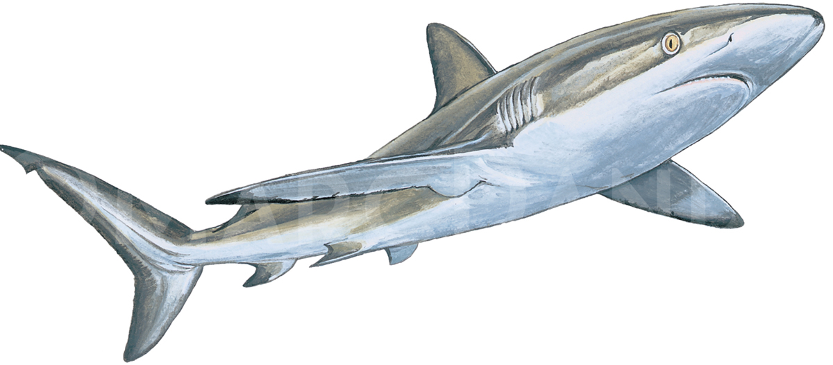

Class: | Chondrichthyes
Order: | Charcharhiniformes
Family: | Charcharhinidae
Species: | Carcharhinus falciformis

Silky shark
Requin soyeux
Tiburon sedoso

Illustration: © Marc Dando

BIOLOGY
The silky shark Carcharhinus falciformis is an abundant, oceanic and epipelagic carcharhinid shark (Compagno et al., 2005). The silky shark can be characterized as a long lived (up to 30 years) species, relatively slow growing, and maturing at between 5-10 years of age. Depending on the study, litter size ranges from 2-25 individuals.

DISTRIBUTION
Silky shark is an oceanic and coastal species with circumtropical distribution found along continental shelves and slopes from the surface to 500 m of depth, with adults tending to occupy deeper waters than its juveniles. Silky shark are often associated with seamounts, and juveniles with floating objects (Ebert et al. 2016).

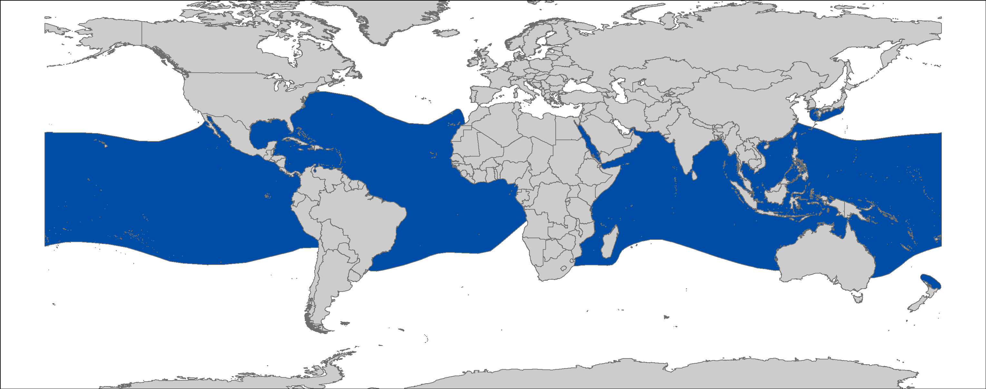
Figure 1: Distribution of Carcharhinus falciformis, courtesy of IUCN.

CRITICAL SITES
Critical sites are those habitats that may have a key role for the conservation status of a shark population, and may include feeding, mating, pupping, overwintering grounds and other aggregation sites, as well as corridors between these sites such as migration routes. Critical sites have not been accurately defined for these species in all areas, but some potentially important grounds have been proposed REFS.

- POPULATION STATUS AND TRENDS
Information available on the population status and trends in this taxon consists of fisheries catch data analyzed in a generalized linear modeling approach and stock assessments. RFMOs assessing silky shark are examining stocks in the Pacific and Indian Ocean IOTC to be undertaken in 2019. Stock units have not been defined in the Pacific Ocean. The current IUCN Red List status for the global populations of silky shark is Vulnerable (Rigby et al. 2017).

Region | Population trend | Time Period | Reference
ATLANTIC
Western North Atlantic (Gulf of Mexico and Caribbean Sea) | 46% (observer) to 50% (logbook) Decline | 1992-2005 | (Cortés et al. 2007)
INDO-PACIFIC
Western Indo-Pacific | 30% decline | 1995-2009 | Rice and Harley (2013)
Western Indo-Pacific | No trend | 1995–2014 | Rice (2015)
EASTERN PACIFIC
Eastern Pacific Ocean | 60-80% Decline | 1994-2004 | (Minami et al. 2007)
USA/Mexico (Northern EPO) | 37% Decline | 1994-2015 | (FAO 2016; Lennert-Cody et al. 2016)
Columbia/Ecuador (Southern EPO) | 77% Decline | 1994-2013 | (FAO 2016; Lennert-Cody et al. 2016)
Columbia/Ecuador (Southern EPO) | 65% Decline | 1994-2015 | (FAO 2016; Lennert-Cody et al. 2016)

THREATS
- Fisheries: The silky shark are caught as bycatch in longline and purse-seine fisheries (Clarke et al. 2013b; Oliver et al. 2015). Silky sharks are under both high fishing and bycatch pressures in the Gulf of Mexico, which has caused a large decline in their population (Hoyos-Padilla et al. 2012). Entanglement of silky sharks in Fish Aggregating Devices is also a large source of mortality, with one study estimating it to be 5-6 times larger than bycatch in the Indian Ocean (Filmalter et al. 2013).
- International trade: Silky shark meat is used for human consumption where permitted. Its fins are also commonly taken for international trade, representing 3-4% of the fin trade in the Hong Kong markets (Clarke et al. 2006).

KEY KNOWLEDGE GAPS
- Recent and accurate estimates of population sizes and demographic structure with regard to sustainable levels of fishing pressure are urgently needed;
- Further, the distribution, life-history, and ecological parameters of both species are lacking. Especially, data relative to critical habitats beyond seamounts.

KEY MANAGEMENT AND CONSERVATION GAPS
- High mortality associated with fish aggregation devices (FADs);
- National fishery or conservation measures are limited;
- Full stock assessments have only been conducted in the Pacific Ocean;
- Critical habitats have not been identified and delineated;
- Fishery data (landings, discards, size frequency, catch and effort) are lacking in some areas.

RECOMMENDATIONS FOR CONSERVATION AND MANAGEMENT ACTION
A multifaceted approach is required to address the management and conservation gaps for white sharks. Sharks MOU Signatories and other Range States are encouraged:

- Incorporate conservation measures for silky sharks into national legislation of all Parties/Signatories.

- Implement relevant international measures (e.g. CMS, CITES and RFMOs).

- Improve the understanding of silky shark through strategic research, monitoring and information exchange, including data collection of biological and distributional data and population status.

- Identify critical sites of silky shark abundance and seasonality;
- Further investigate post-release survivorship of silky sharks to inform improved handling and release protocols especially associated with purse seine fisheries;
- Address data gaps in biological knowledge (life-history and ecological parameters) of silky sharks;
- Conduct long-term monitoring of silky shark populations;
- Enhance or develop where necessary collection of fishery data (including landings, discards, size frequency, catch and effort where needed);
- Develop stock assessment in cooperation with RFMOs for silky sharks.

- Improve multilateral cooperation among regions & RFBs

- Support the introduction of appropriate management and conservation measures for silky sharks at international and regional fora (e.g. Co-sponsor proposals / resolutions within multilateral agreements);
- Promote better regional cooperation between RFMOs and RFBs (e.g. data-sharing or involvement in the Kobe process);
- Support development and implementation of appropriate management plans for silky sharks;
- Identify synergies with other Range States/stakeholders to support coordinated and resource-effective research & conservation programs.

- Identify the effective approaches to reduce bycatch and improve survivorship of silky sharks.

- Including gear modifications e.g. hook and trace type and fishing practices and safe release handling guidelines.

- Raise awareness about the threats to silky sharks

- Inform the public about the need of shark conservation via educational, social media and local outreach campaigns.

LEGAL INSTRUMENTS

Instrument | Description
CITES  Convention on International Trade in Endangered Species of Wild Fauna and Flora | Appendix II: Species not necessarily threatened with extinction, but in which trade must be controlled in order to avoid utilization incompatible with their survival.
CMS  Convention on the Conservation of Migratory Species of Wild Animals | Appendix II: Migratory species that have an unfavourable conservation status and need or would significantly benefit from international cooperation; CMS Parties shall endeavour to conclude global or regional agreements to benefit these species.
EU  European Union | Council Regulation (EU) 2017/127 prohibits to fish for, to retain on board, to tranship or to land silky sharks for Union vessels in the ICCAT and WCPFC Convention Areas. When accidentally caught, the specimens shall not be harmed and promptly be released
FAO  Food and Agriculture Organization | IPOA Sharks: International Plan of Action for Conservation and Management of Sharks based on which states should adopt and implement a national plan of action for conservation and management of shark stocks (NPO Sharks) if their vessels conduct directed fisheries for sharks or if their vessels regularly catch sharks in non-directed fisheries.
IATTC  Inter-American Tropical Tuna Commission | Res. C-16-01: Amendment of resolution C-15-03 on the collection and analysis of data on fish-aggregating devices  Res. C-16-04:Amendment to resolution C-05-03 on the conservation of sharks caught in association with fisheries in the eastern Pacific Ocean  Res. C-16-05:Resolution on the management of shark species  Res. C-16-06: Conservation measures for shark species, with special emphasis on the Silky Shark (Charcharhinus falciformis), for the years 2017, 2018, and 2019
ICCAT  International Commission for the Conservation of Atlantic Tunas | Res. 95-02: Cooperation with FAO to study status of stocks & shark by-catches  Res. 03-10: Resolution by ICCAT on the sharks fishery  Rec. 04-10: Recommendation by ICCAT concerning the conservation of sharks caught in association with fisheries managed by ICCAT  Rec. 07-06: Supplemental recommendation by ICCAT concerning sharks  Rec. 11-08: Recommendation by ICCAT on the conservation of Silky Sharks caught in association with ICCAT Fisheries  Rec. 11-10: Recommendation by ICCAT on information collection and harmonization of data on bycatch and discards in ICCAT fisheries  Rec. 13-10: Recommendation on Biological Sampling of Prohibited Sharks Species by Scientific Observers
Sharks MOU  Memorandum of Understanding on the Conservation of Migratory Sharks | Annex 1: Signatories should endeavour to achieve and maintain a favourable conservation status for these species based on the best available scientific information and taking into account their socio-economic value.
UNCLOS  United Nations Convention on the Law of the Sea | Annex I: States whose nationals fish in the region for the highly migratory species listed shall cooperate directly or through appropriate international organizations to ensure the conservation and optimum utilization of such species throughout the region, both within and beyond the exclusive economic zone.
WCPFC  Western & Central Pacific Fisheries Commission | CMM 2008-04: Conservation and management measures to prohibit the use of large sale driftnets on the high seas in the Convention Area  CMM 2009-02: Conservation and management measures on the application of high seas FAD closure and catch retention  CMM 2010-07: Conservation and management measures for sharks  CMM 2013-08: Conservation and management measure for Silky Sharks  CMM 2014-05: Conservation and management measures for sharks

10. KNOWN CRITICAL SITE

Information on critical sites is limited. Some studies suggest potential areas are around seamount in the eastern Pacific. Ongoing and future research using pop-off archival satellite tags will help to further identify these areas.

REFERENCES
Amandé JM, Ariz J, Chassot E, Chavance P, Delgado de Molina A, Gaertner D, Murua H, Pianet R, Ruiz J 2008. By-catch and discards of the European purse seine tuna fishery in the Indian Ocean. Estimation and characteristics for the 2003-2007 period. Indian Ocean Tuna Commission.
Amandè M, Bez N, Konan N, Murua H, Delgado De Molina A, Chavance P, Dagorn L 2011. Areas with high bycatch of silky sharks (Carcharhinus falciformis) in the Western Indian Ocean purse seine fishery. Working document for IOTC. Indian Ocean Tuna Commission.
Blaber S, Dichmont C, White W, Buckworth R, Sadiyah L, Iskandar B, Nurhakim S, Pillans R, Andamari R 2009. Elasmobranchs in southern Indonesian fisheries: the fisheries, the status of the stocks and management options. Reviews in fish biology and fisheries 19: 367-391.
Clarke C, Lea J, Ormond R 2013a. Changing relative abundance and behaviour of silky and grey reef sharks baited over 12 years on a Red Sea reef. Marine and Freshwater Research 64: 909-919.
Clarke SC, Harley SJ, Hoyle SD, Rice JS 2013b. Population trends in Pacific Oceanic sharks and the utility of regulations on shark finning. Conservation Biology 27: 197-209.
Clarke SC, Magnussen JE, Abercrombie DL, McAllister MK, Shivji MS 2006. Identification of shark species composition and proportion in the Hong Kong shark fin market based on molecular genetics and trade records. Conservation Biology 20: 201-211.
Compagno, L.J.V., Last, P.R., Stevens, J.D. and Alava, M.N.R., 2005. Checklist of Philippine chondrichthyes. CSIRO Marine Laboratories Report, 243, pp.1-103.
Cortés E, Brown CA, Beerhircher L 2007. Relative abundance of pelagic sharks in the western north Atlantic Ocean, including the Gulf of Mexico and Caribbean Sea. Gulf and Caribbean Research 19: 37-52.
Ebert DA, Fowler SL, Compagno LJ 2016. Sharks of the world: a fully illustrated guide. Wild Nature Press. pp.
FAO 2016. Report of the fifth FAO Expert Advisory Panel for the Assessment of Proposals to Amend Appendices I and II of CITES Concerning Commercially-exploited Aquatic Species, Rome, 6–10 June 2016. FAO Fisheries and Aquaculture Report No. R1163. Rome, FAO. 121 pp
Filmalter JD, Capello M, Deneubourg J-L, Cowley PD, Dagorn L 2013. Looking behind the curtain: quantifying massive shark mortality in fish aggregating devices. Frontiers in Ecology and the Environment 11: 291-296.
Hall N, Bartron C, White W, Potter I 2012. Biology of the silky shark Carcharhinus falciformis (Carcharhinidae) in the eastern Indian Ocean, including an approach to estimating age when timing of parturition is not well defined. Journal of Fish Biology 80: 1320-1341.
Hazin FH, Oliveira PG, Macena BC 2007. Aspects of the reproductive biology of the silky shark, Carcharhinus falciformis (Nardo, 1827), in the vicinity of Archipelago of Saint Peter and Saint Paul, in the equatorial Atlantic Ocean. Collective Volume of Scientific Papers: ICCAT 60: 648-651.
Hoyos-Padilla EM, Ceballos-Vázquez BP, Galván-Magaña F 2012. Reproductive biology of the silky shark Carcharhinus falciformis (Chondrichthyes: Carcharhinidae) off the west coast of Baja California Sur, Mexico. Aqua, International Journal of Ichthyology 18: 15-24.
Joung S-J, Chen C-T, Lee H-H, Liu K-M 2008. Age, growth, and reproduction of silky sharks, Carcharhinus falciformis, in northeastern Taiwan waters. Fisheries Research 90: 78-85.
Lennert-Cody C, Aires-da-Silva A, Maunder M, Román M 2016. Updated stock status indicators for silky sharks in the Eastern Pacific Ocean (1994-2015). IATTC, Document SAC- 07-06b.i.
Minami M, Lennert-Cody CE, Gao W, Roman-Verdesoto M 2007. Modeling shark bycatch: the zero-inflated negative binomial regression model with smoothing. Fisheries Research 84: 210-221.
Oliver S, Braccini M, Newman SJ, Harvey ES 2015. Global patterns in the bycatch of sharks and rays. Marine Policy 54: 86-97.
Rice, J., Tremblay-Boyer, L., Scott, R., Hare, S. and Tidd, A., 2015. Analysis of stock status and related indicators for key shark species of the Western Central Pacific Fisheries Commission. In Western and Central Pacific Fisheries Commission 11th Regular Session (pp. 1-146).
Rice, J. and Harley, S., 2013. Updated stock assessment of silky sharks in the western and central Pacific Ocean. Scientific Committee Ninth Regular Session, pp.6-14.
Rigby, C.L., Sherman, C.S., Chin, A. & Simpfendorfer, C. 2017. Carcharhinus falciformis. The IUCN Red List of Threatened Species 2017: e.T39370A117721799.
Yokota L, Lessa RP 2006. A nursery area for sharks and rays in Northeastern Brazil. Environmental Biology of Fishes 75: 349-360.

See the IUCN website for further details on the population assessment: http://www.iucnredlist.org/details/39370/0.
http://www.tuna-org.org

