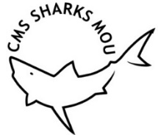 | MEMORANDUM OF UNDERSTANDING  ON THE CONSERVATION OF  MIGRATORY SHARKS | CMS/Sharks/MOS4/Doc.10.6  22 December 2022  Original: English

4th Meeting of the Signatories (Sharks MOS4)

Bonn, 28 February – 2 March 2023
Agenda Item 10

IMPROVING REPORTING OF LANDINGS DATA

FOR SPECIES LISTED IN ANNEX 1 OF THE SHARKS MOU
(Prepared by the Advisory Committee)

- Annex 1 of this document includes an analysis of data reported to the United Nations Food and Agriculture Organization (FAO) on nominal landings of shark and ray species listed in Appendix I of CMS and Annex 1 of the Sharks MOU. An “Executive Summary of main results and recommendations” is provided in Annex 1, section 1.

- Based on the findings of the analysis, Annex 2 includes “Recommendations to Signatories to improve reporting of landings data for species listed in Annex 1 of the Sharks MOU”. Signatories are invited to review and adopt final recommendations as “Outcome 4.x” from this Meeting

- Annex 3 includes draft decisions from this meeting and Annex 4 draft activities that Signatories may consider including in the Programme of Work (2023-2025) also discussed under agenda item 12.

- Landings data used for this analysis can be visualized interactively accessing the Supplementary Information files of Annex I. Signatories are encouraged to consult these files and consider referring to them to inform future activities of the Sharks MOU when needed.

Background

MOU Mandates

- In accordance with the Programme of Work (2019-2021), the Sharks MOU Advisory Committee (AC) was tasked to:

  - Further develop and prioritize areas of action as contained in Outcome 3.12 with options by taxa, region, and other relevant factors (activity 3);

  - Set up a repository for relevant information to assist managers, including species identification, bycatch mitigation and safe handling, discard survival, and other relevant fisheries management information (activity 8);

  - Implement the Capacity-building Programme for the MOU as adopted in Outcome 3.6 to assist Signatories with the implementation of the Conservation Plan (activity 10);

  - Strengthen synergies and collaborate, where relevant, with the Convention on International Trade in Endangered Species of Wild Fauna and Flora (CITES) and the Food and Agriculture Organization of the United Nations (FAO) (activity 12);

  - Prepare publications as required (e.g., domestic legislation, species priorities) (activity 20);

  - Compile information, review data, liaise with stakeholders, and provide information to Signatories on the implementation and functioning of the MOU (activity 21).

Analysis of landings data

- Whereas the Conservation Plan of the Sharks MOU states the need to create and maintain species-specific national records of shark catches, this task has been hampered by the lack of data reporting and standardization within the national reports produced by Signatories for each MOS. Furthermore, the new national report format updated after MOS3 excluded the reporting of quantitative catch data (noting that these data are reported to FAO and other relevant bodies as required) in favour of prioritizing reporting of actions undertaken towards implementing the Conservation Plan. Still, given fisheries are the main threat for all listed sharks and rays, analyses of accurate species-specific catch data remain a critical endeavor to identify the conservation needs and impact of the Sharks MOU.

- Therefore, landings data collated by the FAO global capture production database have the potential to become an important tool to inform the Sharks MOU by evaluating the level of exploitation of CMS and Sharks MOU-listed species as most Signatories are already reporting annual landings data, including for those shark and ray species listed in Annex 1 of the MOU. Furthermore, the FAO dataset also collates landings data from the other Range States which could assist identifying new potential collaborations and additional Signatories. Finally, reported data is maintained and curated for consistency, making this dataset a global standard for researchers and stakeholders.

- To this end, the AC has analyzed recent FAO landings data of CMS Appendix I and Sharks MOU Annex 1-listed species as a case study. The study, as presented in
Annex 1 of this document, involved the analysis of the average annual landings reported globally between 2015–2019 of:

  - CMS Appendix I-listed shark and ray species (Annex 1, section 3);

  - Sharks MOU Annex 1-listed species (Annex 1, section 4);

  - Shark and ray landings reported using generic and aggregated species codes (e.g., “sharks nei”) that may or may not relate to listed species (Annex 1, section 5).

- Based on the results of the analysis, the AC prepared recommendations to Signatories:

  - to promote prohibition of landings of CMS Appendix I-listed species;

  - to highlight the need to share regional research and conservation measures between all fishing nations in FAO Major Fishing Areas (henceforth FAO Areas), given the significant level of exploitation of long-distance fleets from some Signatories and Range States (instead of relying solely on the Signatories with territorial waters in the region);

  - to improve the completeness and quality of data reported to FAO for enhancing the accuracy and value of this powerful resource. Specific recommendations have been collated within Draft Outcome 4.x, Annex 2 for discussion and agreement.

- Supplementary Information (SI) files generated for this analysis have been further designed to be used as a tool to inform future activities of the Sharks MOU. Each of the files provides the landings between 2015-2019 by Signatories and Range States for each FAO Area of:

  - CMS Appendix I-listed species (SI-1);

  - species-specific Sharks MOU Annex-1 landings (SI-2);

  - total Sharks MOU and uncertain landings in relation to all shark and ray species reported to FAO (SI-3).

- Potential examples of usage of this tool include the identification of:

  - Signatories and Range States whose collaboration may be critical through Concerted Action or adhesion of the Sharks MOU given the level of exploitation of specific listed species of conservation or research focus.

  - Regions and Signatories where capacity-building is needed most to improve species-specific data reporting.

Action requested:

- The meeting is requested to:

- Take note of the analysis provided in Annex 1 and provide comments;

- Review and discuss draft “Outcome 4.x” (Annex 2) and agree on final “Recommendations to Signatories to improve reporting of landings data for species listed in Annex 1 of the Sharks MOU ” from this meeting;

- Review and agree on a final version of draft decisions of the meeting in Annex 3 of this document;

- Review and agree on activities as suggested in Annex 4 to this document and consider including those in the Programme of Work (2023-2025).

ANNEX 1

IMPROVING REPORTING OF LANDINGS DATA FOR SPECIES LISTED IN ANNEX 1 “ANALYSIS OF NOMINAL LANDINGS AS REPORTED TO FAO (2015-2019)”

Authors: Maria Pozo-Montoro, Mario Espinoza, Rima W. Jabado, John K. Carlson, James R. Ellis

Supplementary Information: https://github.com/mpozo-montoro/MOS4-Doc.10.6

Executive summary of main results and recommendations

The main insights of the analyses and respective recommendations are:

  - CMS Appendix I-listed species are still being reported in FAO statistics by several CMS Parties. Further efforts should be made to enforce the required prohibition on the taking of such species (which may include fishing for, retaining, transshipping, landing or selling), and encourage safe live release of Appendix I-listed species when caught accidentally. See Section 3 for more specific recommendations and information.

  - Large quantities of Sharks MOU Annex 1-listed species are landed by Signatories with long-distance fishing fleets that operate beyond the FAO Major Fishing Area(s) corresponding to their national waters. It is encouraged that research and conservation measures towards regional priorities identified by the AC are shared and coordinated not only by those Signatories found within the region but also by those Signatories with long-distance fleets operating in international waters and the waters of other Range States. See Section 4 for more specific recommendations and information.

  - The magnitude of CMS Appendix I-listed species and the degree of generic and aggregated landings was lower for Signatories compared to Non-Signatory Range States. At the same time, the reported landings of Sharks MOU Annex 1-listed species were slightly higher by Signatories. Signatories should continue encouraging Non-Signatory Range States to sign the Sharks MOU for improved coordination of conservation and management efforts for listed species. Signatories are also encouraged to keep working and collaborating with Range States, such as through bilateral agreements, concerted actions, and relevant Regional Fisheries Bodies (RFBs), given they share half of the reported landings. See Sections 3 – 5 for more information.

  - Results and recommendations relating to data reporting of listed species to FAO. For FAO data to be used effectively for monitoring global trends of reported landings of listed species, improved data quality is required relating (i) taxonomic resolution, (ii) completeness of data, and (iii) quality control.

    - Taxonomic Resolution. The level of uncertainty in the reported landings that may include Sharks MOU Annex 1-listed species is quite high in some regions. Signatories are encouraged to report landings to species level (or genus when more appropriate). Collaborative efforts to improve the taxonomic resolution of shark landings should be encouraged between Signatories and other relevant Range States that report a high proportion of national catch statistics for sharks and rays under more generic landing categories. See Section 5 for more specific recommendations and information.

    - Completeness of data. Data reported to FAO were considered incomplete due to missing and inconsistent data for several species and nations, and more standardized data reporting is required. Signatories are encouraged to compare national landings data with those data that have been collated by FAO (and other regional databases) and revise and harmonize sources to provide more accurate spatial and temporal data. Signatories not currently reporting data to FAO are encouraged to submit their data. Signatories are encouraged to report landings of all Annex I-listed species to FAO. Further efforts should be made to increase reporting of catches from artisanal, subsistence, and recreational fisheries. See Section 6 for more specific recommendations and information.

    - Quality control: Potential input errors were also identified, indicating that more robust quality control of landings data is required before data submission. Signatories are encouraged to review and undertake more detailed quality control of the national landings data, including those that are reported to FAO (and other regional databases). Categories to submit species landings data should be reexamined to avoid perpetuating taxonomic errors. See Section 6 for more specific recommendations and information.

  - Despite being a powerful tool, the FAO database lacks information regarding discarded catches, which need to be complemented with other sources of data collection. There is still a critical need to collect at regional and global scale information regarding levels of discarded catch and its fate (proportion of dead and alive discards and level of post-release mortality for each listed species). Please also refer to CMS/Sharks/MOS4/Doc.10.7.

- Methodology

  - Data extraction

Data were extracted from the FAO global capture production dataset released on March 2021 for each of the 19 marine FAO Major Fishing Areas (henceforth FAO Areas) for the last five available years (2015–2019). Given the limited extent and landings of listed sharks and rays in the three Antarctic areas (FAO Areas 48, 58, and 88), these were combined into one area for the Southern Ocean.

Data were obtained for the ISSCAAP group 38 “Sharks, rays, chimaeras”. Categories referring to Chimaeriform species were removed from the dataset (i.e., twelve categories referring to chimaeras, such as: “Chimaeras, etc. nei” - Chimaeriformes, “Ratfishes nei” – Hydrolagus spp., or “Rabbit fish” – Chimaera monstrosa). An overview of the species taxonomic codes, scientific names, and common names in English, French, and Spanish used to identify CMS Appendix I and/or Sharks MOU Annex I-listed species at FAO is given in Table 1.

Table 1. Taxonomic codes available to record landings of CMS Appendix I and Sharks MOU Annex 1-listed species to FAO. These codes are as available on FAO’s ASFIS List of Species for Fishery Statistics Purposes published in 2021. Some of the names provided here may not currently be valid scientific names. The ASFIS codes available have changed over time, and some of these codes may not have been available for longer-term analyses.

Type of Category | Taxonomic code | 3-alpha code | Scientific name | English name | French name | Spanish name
Aggregated uncertain | 199XXXXXXX054 | SKX | Elasmobranchii | Sharks, rays, skates, etc. nei | Requins, raies, etc. nca | Tiburones, rayas, etc. nep
Aggregated uncertain | 199XXXXXXX053 | SKH | Selachimorpha (Pleurotremata) | Various sharks nei | Requins divers nca | Escualos diversos nep
No data | 108XXXXXXX | CVX | Carcharhiniformes | Ground sharks | - | -
Aggregated uncertain | 10802XXXXX | RSK | Carcharhinidae | Requiem sharks nei | Requins nca | Cazones picudos, tintoreras nep
Aggregated uncertain | 10802010XX | CWZ | Carcharhinus spp. | Carcharhinus sharks nei | Requins Carcharhinus nca | Cazones Carcharhinus nep
Species-specific | 1080201017 | FAL | Carcharhinus falciformis | Silky shark | Requin soyeux | Tiburón jaquetón
Species-specific | 1080201011 | OCS | Carcharhinus longimanus | Oceanic whitetip shark | Requin océanique | Tiburón oceánico
Species-specific | 1080201016 | DUS | Carcharhinus obscurus | Dusky shark | Requin de sable | Tiburón arenero
Aggregated uncertain | 10803XXXXX | SPY | Sphyrnidae | Hammerhead sharks, etc. nei | Requins marteau, etc. nca | Cornudas, cachudas etc. nep
Aggregated uncertain | 10803005XX | SPN | Sphyrna spp. | Hammerhead sharks nei | Requins marteau nca | Cornudas, cachudas (=Peces martillo) nep
Species-specific | 1080300506 | SPL | Sphyrna lewini | Scalloped hammerhead | Requin-marteau halicorne | Cornuda común
Species-specific | 1080300510 | SPK | Sphyrna mokarran | Great hammerhead | Grand requin marteau | Cornuda gigante
Species-specific | 1080300501 | SPZ | Sphyrna zygaena | Smooth hammerhead | Requin-marteau commun | Cornuda cruz(=Pez martillo)
No data | 106XXXXXXX | LMZ | Lamniformes | Mackerel sharks | - | -
Aggregated all listed | 10606006XX | THR | Alopias spp. | Thresher sharks nei | Renards de mer nca | Zorros nep
Species-specific | 1060600602 | PTH | Alopias pelagicus | Pelagic thresher | Renard pélagique | Zorro pelágico
Species-specific | 1060600603 | BTH | Alopias superciliosus | Bigeye thresher | Renard à gros yeux | Zorro ojón
Species-specific | 1060600601 | ALV | Alopias vulpinus | Thresher | Renard | Zorro
Species-specific | 1060100301 | BSK | Cetorhinus maximus | Basking shark | Pèlerin | Peregrino
Aggregated all listed / Aggregated uncertain | 10608XXXXX | MSK | Lamnidae | Mackerel sharks,porbeagles nei | Requins taupe nca | Jaquetones, marrajos nep
Species-specific | 1060800701 | WSH | Carcharodon carcharias | Great white shark | Grand requin blanc | Jaquetón blanco
Aggregated all listed | 10608002XX | MAK | Isurus spp. | Mako sharks | Taupes | Marrajos
Species-specific | 1060800201 | SMA | Isurus oxyrinchus | Shortfin mako | Taupe bleue | Marrajo dientuso
Species-specific | 1060800203 | LMA | Isurus paucus | Longfin mako | Petite taupe | Marrajo carite
Species-specific | 1060800301 | POR | Lamna nasus | Porbeagle | Requin-taupe commun | Marrajo sardinero
No data | 107XXXXXXX | OCX | Orectolobiformes | Carpet sharks | - | -
No data | 1070500401 | RHN | Rhincodon typus | Whale shark | Requin baleine | Tiburón ballena
Aggregated uncertain | 10901XXXXX | DGX | Squalidae | Dogfish sharks nei | Squales nca | Galludos y tollos nep
Aggregated uncertain | 109XXXXXXX | SHX | Squaliformes | Dogfish sharks, etc. nei | Squaliformes nca | Squaliformes nep
Aggregated uncertain | 10901XXXXX040 | DGH | Squalidae, Scyliorhinidae | Dogfishes and hounds nei | Squales et émissoles nca | Galludos, tollos y musolas nep
Aggregated uncertain | 10901007XX | DGZ | Squalus spp. | Dogfishes nei | Aiguillats nca | Mielgas nep
Species-specific | 1090100704 | DGS | Squalus acanthias | Picked dogfish | Aiguillat commun | Mielga
Aggregated uncertain / Aggregated all listed | 10903XXXXX | ASK | Squatinidae | Angelsharks, sand devils nei | Anges de mer nca | Angelotes, peces ángel nep
Species-specific | 1090300401 | AGN | Squatina squatina | Angelshark | Ange de mer commun | Angelote
Aggregated uncertain | 110XXXXXXX | SRX | Rajiformes | Rays, stingrays, mantas nei | Raies, pastenagues, mantes nca | Rayas, pastinacas, mantas nep
Aggregated all listed | 11008XXXXX | MAN | Mobulinae | Mantas, devil rays nei | Mantes, diables de mer nca | Mantas, diablos nep
Aggregated all listed | 11008010XX | RMV | Mobula spp. | Mobula nei | - | -
No data | 1100801014 | RMA | Mobula alfredi | - | - | -
Species-specific | 1100801013 | RMB | Mobula birostris | Giant manta | Mante géante | Manta gigante
No data | 1100801003 | RME | Mobula eregoodootenkee | Longhorned mobula | - | -
No data | 1100801004 | RMH | Mobula hypostoma | Lesser devil ray | Mante diable | Manta del Golfo
Species-specific | 1100801005 | RMJ | Mobula japanica | Spinetail mobula | Mante aiguillat | -
No data | 1100801006 | RMK | Mobula kuhlii | Shortfin Devil Ray | Petit diable | -
Species-specific | 1100801007 | RMM | Mobula mobular | Devil fish | - | Manta mobula
No data | 1100801008 | RMU | Mobula munkiana | Munk’s Devil Ray | - | -
No data | 1100801010 | RMN | Mobula rochebrunei | Lesser Guinean devil ray | Petit diable de Guinée | Diablito de Guinea
No data | 1100801011 | RMT | Mobula tarapacana | Chilean devil ray | - | -
No data | 1100801012 | RMO | Mobula thurstoni | Smoothtail mobula | Mante vampire | -
Aggregated all listed | 11002XXXXX | SAW | Pristidae | Sawfishes | Poissons-scies | Peces sierra
No data | 1100200301 | RPA | Anoxypristis cuspidata | Pointed sawfish | - | -
No data | 1100200401 | RPC | Pristis clavata | Dwarf Sawfish | - | -
No data | 1100200403 | RPP | Pristis pectinata | Smalltooth Sawfish | Poisson-scie trident | -
No data | 1100200404 | RPR | Pristis pristis | Common sawfish | Poisson-scie commun | -
No data | 1100200402 | RPM | Pristis microdon | Largetooth sawfish | Poisson-scie grandent
No data | 1100200405 | RPZ | Pristis zijsron | Longcomb sawfish | - | Guitarras, etc. nep
Aggregated uncertain | 11001XXXXX | GTF | Rhinobatidae | Guitarfishes, etc. nei | Guitares, etc. nca | -
Species-specific | 1100100401 | RCA | Rhynchobatus australiae | Whitespotted wedgefish | - | Pez cuna manchado
Species-specific | 1100100402 | RCD | Rhynchobatus djiddensis | Giant guitarfish | Poisson paille à pois | -
Non-existing | NA | NA | Rhynchobatus laevis | Smoothnose Wedgefish | NA

  - Data considerations

Certain species categories were either excluded or considered as a “generic and aggregated” category depending on the FAO Area. For instance, landings of “Picked dogfish” - Squalus acanthias - were excluded from FAO Areas 41, 81, and 87 because only northern hemisphere populations have been listed in Annex 1 on the Sharks MOU. Similarly, aggregated categories that may contain Squalus acanthias (i.e., “Dogfish sharks nei, “Dogfishes and hounds”, “Dogfish sharks, etc. nei”, “Dogfishes nei”) were considered uncertain for the northern hemisphere, whereas they were considered non-Sharks MOU listed species for FAO Areas at the southern hemisphere. Landings of “Mackerel sharks, porbeagles nei” were considered as a “generic and aggregated landing category” for FAO Areas 61 and 67 (North Pacific), given the presence of Salmon Shark (Lamna ditropis), which is not listed on the Sharks MOU. Landings of “Angelshark, sand devils nei” were considered to contain only Sharks MOU and CMS-listed species in the Northeast Atlantic (FAO Area 27), given Squatina squatina is the only angel shark species in that area.

For the analysis of CMS Appendix I-listed species, reported landings from those years prior to the year of listing were excluded. Specifically, Oceanic Whitetip Shark was not included because it was listed in 2020, whereas the latest year data available for these analyses was 2019. Similarly, landings of Angel shark and Common Guitarfish from the Mediterranean were only included from 2017 onwards.

The reported landings data for Angel shark in the Northeast Atlantic (FAO Area 27) in 2018 were of a magnitude that was not considered plausible (5,792 tonnes), and these data were therefore excluded from analyses [See Section 6.b for detailed discussion].

For the purposes of the present study, landings of overseas territories were generally included within the total figures of their mainland (e.g., New Caledonian landings were included within France), whilst non-member states of the UN and some territories whose jurisdiction is questioned were excluded (e.g., Palestine, Falkland Islands). Landings from China included those from Hong Kong and Taiwan. The description and use of boundaries, geographic names, and related data shown in this document do not necessarily imply official endorsement or acceptance by the United Nations.

- Reported landings of shark and ray species listed on CMS Appendix I

  - Background

Species listed under Appendix I of the Convention of Migratory Species (CMS) must be strictly protected by Parties to CMS and Signatories of the Sharks MOU. Among other conservation measures, this obligation includes strictly prohibiting the taking of Appendix I-listed species with a very restricted scope for exemptions.
There are 20 valid species of sharks and rays currently listed under Appendix I of CMS due to their high risk of extinction in the wild in the near future. These species include all five species of sawfishes (family Pristidae), mobulids (11 species of manta and devil rays, nine of which are currently considered valid), Oceanic Whitetip Shark (Carcharhinus longimanus), Angel shark (Squatina squatina), Whale Shark (Rhincodon typus), Basking Shark (Cetorhinus maximus), White Shark (Carcharodon carcharias), and, for the Mediterranean Sea, Common Guitarfish (Rhinobatos rhinobatos).
In accordance, as taking is prohibited 90 days after a species is listed, landings of these species to this date should be strictly banned by CMS Parties, and Parties should promote and enforce the immediate release of these species when captured accidentally.

  - Results

From 2015 to 2019, an average of 7,901 tonnes of Appendix-I listed sharks and rays have been reportedly landed worldwide annually (excluding reported landings of Oceanic Whitetip Shark prior to its listing in 2020, Angel shark, and Common Guitarfish before they were listed in 2017, and Angel shark landings reported by France in 2018 due to the high likelihood of this being an input error). A total of nine CMS Parties and one Non-Party contributed to the reported landings (Figure 1, Supplementary Information 1). Despite the widespread reported landings of Appendix I-listed species by several CMS Parties, landings reported from CMS Parties contributed only 21% of the total. This was due to the substantial record of landings of CMS Appendix I-listed species reported by Non-Parties.

The greatest proportion of landings of Appendix I-listed species were Mantas and Devil Rays (95%; 7,478 tonnes/year), followed by Sawfishes (3%; 259 tonnes/year) and Angelshark (2%; 162 tonnes/year) (Figure 1). There were no reported landings of either Whale Shark, Basking Shark, or White Shark. Similarly, no landings of Common Guitarfish were reported in the Mediterranean since the year the species was listed.

The FAO Areas reporting the highest magnitude of Appendix I-listed species were: the Western Central Pacific (FAO Area 71; 66%), Eastern Indian Ocean (FAO Area 57; 24%), and Western Indian Ocean (FAO Area 51; 5%). The remaining reported landings were from Southeast Pacific (FAO Area 87; 2%), Mediterranean and Black Sea (FAO Area 37; 2%), and Northeast Atlantic (FAO Area 51; <1%). For more details, please refer to Supplementary Information 1.

Figure 1: Global annual average landings of CMS Appendix I-listed species, as reported to FAO (2015-2019; tonnes of live weight). Nations labels colour coded as: (Dark blue) Sharks MOU Signatory and CMS Party; (green) only CMS Party; (grey) Range state.

  - Remarks and specific recommendations

Landing CMS Appendix I-listed species can undermine global conservation efforts for these migratory species given their conservation status. Therefore, CMS Parties and Sharks MOU Signatories should prioritize and work together to monitor reported landings (which should be near zero). The specific actions required to attain this objective may vary from nation to nation and require case-specific studies. The main recommendations following this initial analysis are:

    - CMS Parties should review their national legislation, and promote revisions where relevant, to ensure that Appendix I-listed species cannot be legally taken nor landed by any of their fishing fleets and should be released immediately when caught incidentally. Fisheries interacting with Appendix I-listed species may include commercial, artisanal, subsistence, and recreational fisheries, and so the relevant regulations for each sector may need to be evaluated.
    - Training and outreach programmes should be developed to make all relevant fishing sectors aware of the protected status of CMS Appendix I-listed species and the importance of these measures.
    - Implementation and monitoring of compliance should be strengthened.
    - Training in safe release handling techniques of Appendix I-listed species is required.
    - National fisheries with significant interactions with Appendix I-listed species should be identified and options for modifying fishing practices to reduce incidental catches, such as gear modifications, time-area closures, and changes in fishing deployments, should be identified and encouraged. Released Appendix I-listed species and their state (live/dead release) should be recorded within national records (despite not being reported to FAO). Research gaps on post-release survival should be identified and addressed.
    - Sharks MOU Signatories and CMS Parties already complying with the protection of CMS Appendix-I species should prioritize collaborative efforts with Non-Parties to reduce, if not eliminate, landings of CMS Appendix I-listed species.

- Reported landings of Sharks MOU Annex 1-listed species

  - Background

Species listed under Annex 1 of the Sharks MOU need to be managed sustainably through conservation and management based on the best available science following the measures outlined in the Sharks MOU Conservation Plan.

There are currently 35 valid species of migratory sharks and rays listed under Annex 1 of the Sharks MOU due to their need for international collaboration to improve their conservation status. These include all species listed in Appendix I of CMS. Species listed in Appendix II of CMS that are also included on the Sharks MOU are Whitespotted Wedgefish (Rhynchobatus australiae), Giant Guitarfish (Rhynchobatus djiddensis), all three species of Thresher shark (Alopias pelagicus, A. vulpinus, A. superciliosus), both species of Mako Shark (Isurus oxyrinchus and I. paucus), Porbeagle Shark (Lamna nasus), Silky Shark (Carcharhinus falciformis), Dusky Shark (Carcharhinus obscurus), Oceanic Whitetip Shark (Carcharhinus longimanus), Picked Dogfish (Squalus acanthias, northern hemisphere), Angelshark (Squatina squatina), and three species of Hammerhead Sharks (Sphyrna lewini, S. mokarran, and S. zygaena).

The Advisory Committee is also developing methods to prioritize species for further scientific research through collaborative and regionally coordinated studies by FAO Areas. Such regional prioritization can be informed by the species’ conservation status, available population data, susceptibility to fisheries and habitat destruction, ongoing conservation measures, and regional importance. For more information, please consult CMS/Sharks/MOS4/Doc.10.5.

The long-distance fleets of several nations land shark and ray species caught from FAO Areas outside their national borders (Sala et al. 2018). Therefore, there is a rationale to identify Signatories and Range States exploiting listed sharks and rays that have been identified as regional research priorities and to work collaboratively rather than this being the responsibility of just those nations with jurisdiction in the area.

  - Results

From 2015 to 2019, an average of 48,632 tonnes/year of Sharks MOU-listed species (7% of all shark and ray landings) have been reported as landed globally. A total of 35 Signatories and 37 Range States reported landings of Sharks MOU Annex 1-listed species. Signatories accounted for 4%, whereas Range States reported the remaining 3%.

The most commonly landed Sharks MOU species included: Shortfin Mako (25%; 12,093 tonnes/year), Picked Dogfish (20%; 9,825 tonnes/year), Manta and Devil Rays (14%; 6,900 tonnes/year), Silky Shark (12%; 5,988 tonnes/year), Thresher Sharks reported under the genus category (10%; 4,722 tonnes/year), Pelagic Thresher (9%; 4,292 tonnes/year), Whitespotted Wedgefish (3%; 1,505 tonnes/year) and the broad category of Mackerel Sharks (1%). The remaining percentage (16%) included other species ranging from 0.022 tonnes/year of Devil Fish (Mobula mobular) to 335 tonnes/year of Oceanic Whitetip Shark. No landings data were reported for Dusky Shark, the Smoothnose Wedgefish, White Shark, Basking Shark, Whale Shark, nor any species-specific landings of some species of mobulid and sawfish.

The FAO Areas with the highest proportion of reported landings included the Northwest Atlantic (FAO Area 21; 20%), Western Central Pacific (FAO Area 71; 19%), Eastern Indian Ocean (FAO Area 57; 16%), Southeast Pacific (FAO Area 87; 14%), and the Western Indian Ocean (FAO Area 51; 11%). Areas that accounted for <1% of global reported landings included the Mediterranean and Black Sea (FAO Area 37), Western Central Atlantic (FAO Area 31), Northwest Pacific (FAO Area 61), and those areas surrounding Antarctica.

Landings of Sharks MOU Annex 1-listed species within most FAO Areas were often reported from Signatories and Range states without national waters in the region. The only FAO Areas with reported landings exclusively from nations with territories within the region included the Mediterranean Sea and Black Sea (FAO Area 37), Northwest Pacific (FAO Area 61), and Pacific Northeast (FAO Area 67). In almost half of the FAO Areas, the highest number of landings of Sharks MOU Annex 1-listed species came from Signatories without national waters in the area (FAO Areas 21, 31, 41, 47, 81, and 87). This may have been partially due to Signatories from the EU reporting a lower proportion of their landings in generic and aggregated landings categories, which allows for a more precise, species-specific identification of landings (for more information, see Section 5).

The species composition of the landings reported within each FAO Area varied substantially, with some areas having one species dominating the landings and others having a higher diversity of listed species being reported. The distribution and magnitude of Signatories and Range States landing Sharks MOU-listed species from the different FAO Areas are summarized in Figure 2 and displayed in detail in Supplementary Information 2.

  - Remarks and specific recommendations

Landings of Sharks MOU listed species are not distributed evenly between nations with national waters in each FAO Area. Indeed, long-distance fishing fleets of foreign nations may often report the highest quantity of landings. Therefore, Signatories landing Sharks MOU listed species from a given FAO Area should work collaboratively to address identified regional research priorities, even if they don’t have national waters in that region. Recommendations for further steps considering the outcomes of the analysis are:
    - Consider including all Signatories with long-distance fleets in an FAO Area as identified in Supplementary Information 2 when designing and implementing regionally coordinated research plans to address regional research priorities.
    - Signatories with the highest quantities of landings in each FAO Area for a given species, as outlined in Supplementary Information 2, should become key players to improve knowledge if the species is identified as a regional research priority given the high degree of interaction of their fisheries relevant to improve understanding of their biology and population status.
    - Non-Signatories report a significant proportion of the official landings in certain FAO Areas. Collaborative efforts in fisheries management, conservation, and scientific research should be encouraged through bilateral and regional agreements, concerted actions, and relevant Regional Fisheries Management Organizations (RFMOs) and Regional Fisheries Bodies (RFBs).

Signatories should encourage relevant non-Signatory Range States to join the Sharks MOU, for improved coordination of research plans and conservation actions and sustainability of relevant fisheries.

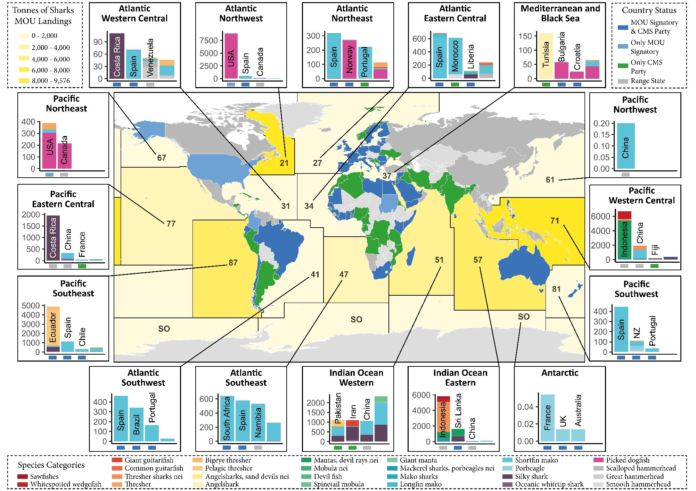
Figure 2: Global annual average Sharks MOU Annex I-listed landings, as reported to FAO (2015-2019; tonnes of live weight). Total magnitude of reported landings for each FAO Area is indicated by colour intensity (Legend at top left). Plots for each FAO Area represent the top three nations with the highest magnitude of reported landings and the total for the remaining nations. Each species’ landings are represented with a different colour (Legend at bottom). The status of each nation regarding CMS and Sharks MOU adhesion is represented with a coloured square at the x axis of each plot (Legend at top right). EU Member States are all highlighted as an MOU Signatory & CMS Party (blue) regardless of whether the individual Country has signed the Sharks MOU. Refer to Supplementary Information 2 to consult reporting nations and species landed in each FAO Area.
- Shark and ray landings reported using generic and aggregated species codes that may or may not relate to Sharks MOU Annex 1-listed species

  - Background

Landings reported to FAO are classified into standardized species categories recognized by the ASFIS list of species. When this document was prepared, the ASFIS list of species included 13,060 taxonomic categories relevant to the fisheries and aquaculture sectors of the world (2021 data release).

There were 59 categories that could be used to identify landings of shark and ray species listed under Sharks MOU Annex 1. These species categories ranged from the species (e.g. “Silky shark”), genus (e.g. “Carcharhinus sharks nei”) or family level (e.g. “Requiem sharks nei”) up to higher taxonomic levels such as orders (e.g., “Rays, stingrays, mantas nei”), superorders (e.g., “Various sharks nei”), subclasses (e.g. “Sharks, rays, skates, etc. nei”) or even classes (e.g., “Cartilaginous fishes nei” – which includes sharks, rays and chimaeras).

Ideally, landings for each species should be identified to species or genus level if identification between close species is challenging (e.g., Mobula species). This species-specific reporting system ensures that there is sufficient resolution in landings to provide more accurate assessments of landings, and to inform stock assessments, fisheries management, and conservation.

Due to issues such as a lack of reporting requirements or training for fishers and fisheries observers, landings are also reported under broader category levels (Cashion et al. 2019). These are particularly problematic for listed species when the categories encompass other species that are not protected, as it becomes uncertain whether the landings reported under broader categories consist of listed species and the relative proportion. For example, landings reported under the category “Hammerhead sharks, etc. nei” may include any of the three species of hammerhead sharks that are listed in Annex 1 of Sharks MOU and/or any of the other extant species. Therefore, there is a critical need to identify for which species and where further efforts should be made to improve the resolution of reported landings.

  - Results

From 2015 to 2019, 399,642 tonnes/year of the total annual reported landings of sharks and rays were at a taxonomic level that makes it uncertain to determine whether they comprised species listed in the Sharks MOU, being equivalent to 57% (Sharks MOU Signatories accounting for 11% of these generic and aggregated landings, whereas non-Parties reported the remaining 46%).
The most common broad taxonomic species categories that hampered species-specific identification of Sharks MOU Annex 1-listed species included: “Sharks, rays, skates, etc. nei” (54%; 214,213 tonnes/year), “Rays, stingrays, mantas nei” (35%; 140,315 tonnes/year), “Requiem sharks nei” (6%; 23,317 tonnes/year), “Hammerhead sharks, etc. nei” (2%; 8,331 tonnes/year) and “Dogfish sharks nei” (2%; 7,962 tonnes/year). The remaining categories contributing to less than 1% each included: “Guitarfishes, etc. nei” (3,221 tonnes/year), “Various sharks nei” (1,719 tonnes/year), “Angelsharks, sand devils nei” (345 tonnes/year), “Dogfishes and hounds nei” (213 tonnes/year), “Dogfishes nei” (4 tonnes/year), “Carcharhinus sharks nei” (2 tonnes/year), “Hammerhead sharks nei” (0.66 tonnes/year) and “Dogfish sharks, etc. nei” (0.03 tonnes/year). Interestingly, some of the latter mentioned and lesser used categories were used by few nations, in contrast to the first mentioned, most used categories, which were reported by up to 91 nations.

The contribution of each FAO Area to the total report of generic and aggregated landings ranged from 16% to 0.09%. The areas with the highest quantities of generic and aggregated landings reported were the Western Indian Ocean (FAO Area 51; 16%), Western Central Pacific (FAO Area 71; 16%), Eastern Indian Ocean (FAO Area 57; 13%), Eastern Central Pacific (FAO Area 77; 12%) and Eastern Central Atlantic (FAO Area 34; 11%). The areas contributing less than 1% to the global quantity of generic and aggregated landings included FAO Areas 81, 27, 21, and the Southern Ocean. However, the proportion of generic and aggregated landings within each area varied substantially, from all to almost all landings being in such aggregated and unspecific categories in the Northwest Pacific (FAO Area 61), Northeast Pacific (FAO Area 67), Eastern Central Pacific (FAO Area 77) and Eastern Indian Ocean (FAO Area 51), to only 1% in the Northeast Atlantic (FAO Area 27) and Northwest Atlantic (FAO Area 21). Similarly, the proportion of generic and aggregated landings varied substantially between nations within an area. For more information, see Figure 3 and Supplementary Information 3.

  - Remarks and specific recommendations

The lack of species-specific information of reported landings can significantly reduce the accuracy of evaluating population trends and statuses, which may undermine the efforts of both fisheries management and conservation actions. Accordingly, Signatories should prioritize improving the taxonomic resolution of reported landings. Recommendations to improve species-specific reporting of landings of Sharks MOU-listed species include:
    - Signatories should evaluate their national data collection and reporting systems and ensure that all landings are reported to species level (or genus when more appropriate).
    - Signatories should provide training, where necessary, to allow fishers, port staff, and observers to consistently identify Sharks MOU-listed species to species-level through time.
    - Signatories should strengthen monitoring procedures at landing sites to ensure compliance, and to improve monitoring, education, and enforcement where necessary.
    - Collaborative efforts to improve taxonomic resolution of shark and ray landings should be encouraged between Signatories and other relevant non-Signatory Range States for which a high proportion of landings are reported under aggregated and generic categories. The technical expertise and capacity of Signatories reporting higher proportions of landings to species-specific level (including funding of fisheries observer programmes and training) is critical to improve global reporting.
    - If possible, when improvements in reporting occur, reconstruct historical landings (catches), to minimize disruptions with time series.

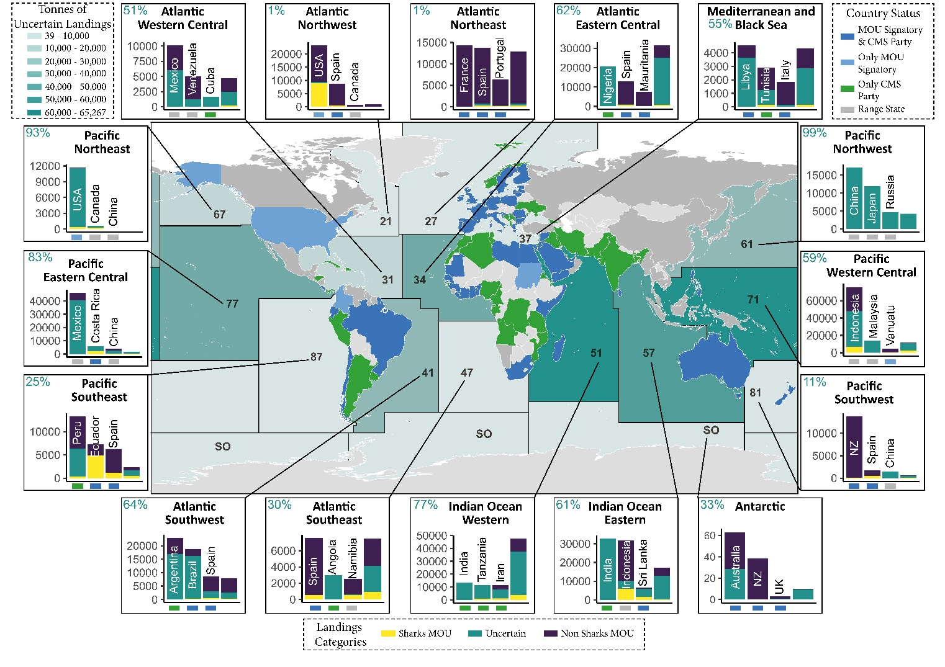
Figure 3. Global annual average landings of all elasmobranch species, as reported to FAO (2015-2019; tonnes of live weight). Total magnitude of uncertain Sharks MOU landings for each FAO Area is indicated by colour intensity (Legend at top left). Plots for each FAO Area represent the top three nations with the highest magnitude of landings and the total of the remaining nations in the region. Percentage of landings for Sharks MOU, non-Sharks MOU, and Uncertain categories are represented with different colours (Legend at bottom). Nation status regarding CMS and Sharks MOU adhesion is represented with a coloured square under its bar (Legend at top right). EU Member States are all highlighted as an MOU Signatory & CMS Party (blue) regardless of whether the individual Country has signed the Sharks MOU. Blue percentage at each plot represents the total fraction of uncertain Sharks MOU landings within the FAO Area. Refer to Supplementary Information 3 for consulting reporting nations and categories in each FAO fishing area.

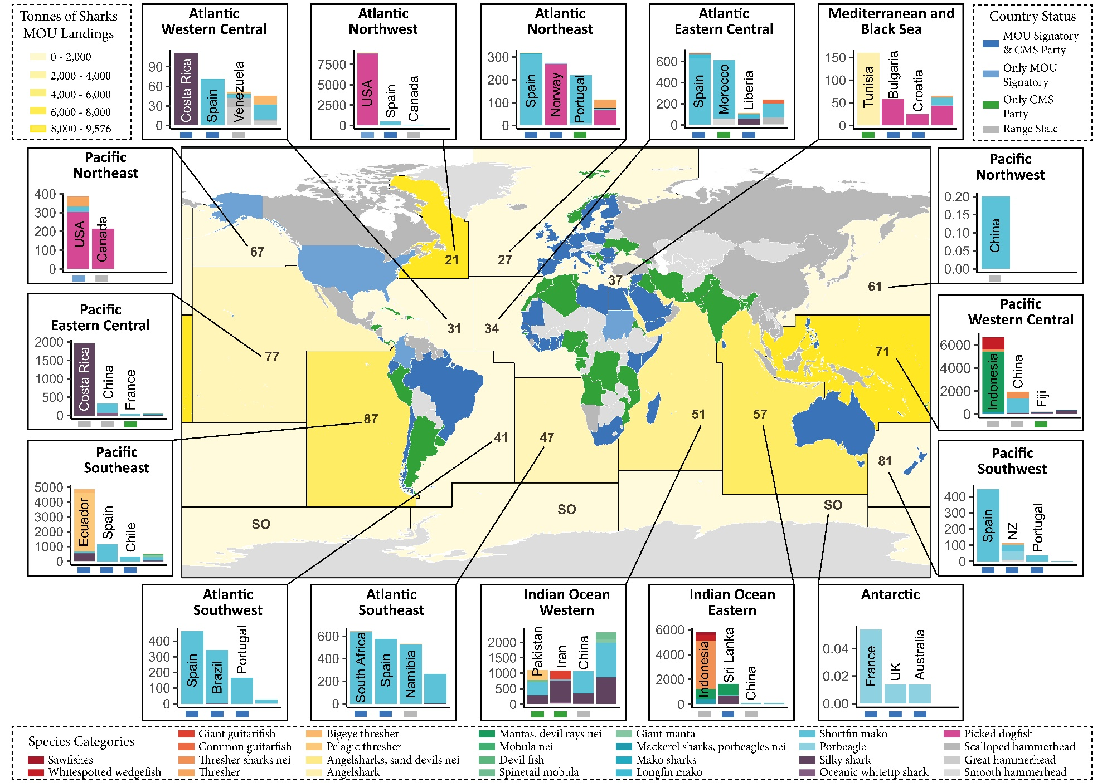
- Data limitations: Data gaps and data quality

  - Background

The landings data collated by FAO of the United Nations is an expansive resource to provide information on the levels of exploitation of CMS and Sharks MOU-listed species worldwide (Garibaldi 2012). Such an approach is crucial to identify pressing conservation issues to globally coordinate and monitor conservation measures given fisheries are usually considered the main threat to shark and ray species listed within CMS and Sharks MOU (Dulvy et al. 2021).

The accuracy and value of the outcomes from analyses of FAO landings data are highly dependent on the completeness and quality of the data submitted by nations (Garibaldi 2012). Ideally, all Signatories should report all their commercial (including long-distance fleets), artisanal, and recreational landings regarding listed shark and ray species to the highest taxonomic resolution possible (i.e., species-specific, or to genus level for taxa with taxonomic problems).

Unfortunately, several issues regarding data completeness and quality are known to affect data reported to FAO. Here, we aimed to highlight issues identified in our analyses regarding reporting of Sharks MOU-listed species to FAO to improve available data for monitoring the trends of the reported landings of these species.

  - Results

During our analyses, we identified several cases where there were data gaps at a national level. Within the period of 2015 to 2019, eight Signatories (Finland, Jordan, Latvia, Lithuania, Monaco, Poland, Somalia, and Sudan) did not report any landings of sharks and rays to FAO despite evidence that landings of listed shark and ray species may be occurring in some of them (Al-Zibdah et al. 2006; Glaser et al. 2015; Elhassan 2018). Still, the number of nations not reporting to FAO was lower for Signatories than for Range states (17 nations: Bahamas, Bosnia and Herzegovina, Cambodia, North Korea, Dominica, Haiti, Honduras, Iraq, Israel, Jamaica, Kuwait, Myanmar, Niue, Saint Kitts and Nevis, Serbia, Timor-Leste, and Vietnam).

At a global level, no species-specific landings data were reported (2015-2019) for Dusky Shark, Smoothnose Wedgefish, White Shark, Basking Shark, Whale Shark, any Sawfish, and seven species of Manta and Devil Rays. Still, there is evidence showing that some of these species are being landed in several areas but they are not being reported (King et al. 2017; Kabasakal et al. 2018; Pajuelo et al. 2018; Wainwright et al. 2018; ICES 2019; Sathiyaselvam et al. 2019; Purushottama et al. 2020; Irsan et al. 2021). For the Smoothnose Wedgefish, there was no species-level taxonomic category to report landings data to FAO. Standardized approaches of how nations should report landings of protected and prohibited species could usefully be developed, as such data may simply be omitted from submissions of national data.

On the other hand, some of the categories recognized by the ASFIS list of species to report landings to FAO may perpetuate mistakes in the taxonomy of species. For instance, the Lesser Guinean Devil Ray (Mobula rochebrunei) and the Largetooth Sawfish (Pristis microdon) are not considered valid species anymore and are now considered synonyms of the Lesser Devil Ray (Mobula hypostoma) and the Common Sawfish (Pristis pristis), respectively. Nonetheless, no data has been reported under these outdated categories. In other instances, inaccurate taxonomic categories have been used during the study period. For instance, landings of Spinetail Mobula (Mobula japanica) should be analysed as Devil Fish (Mobular mobular) according to recent changes in the taxonomy (White et al. 2018). Additionally, the scientific name for Mantas, devil rays nei (Mobulinae) and Longhorned Mobula (Mobula eregoodootenkee) should be corrected to Mobulidae and Mobula eregoodoo, respectively.

Despite FAO evaluating data submitted by countries, consulting nations when data are questionable and replacing submitted data to those validated by RFBs, if available, input mistakes were still identified in our analysis. For example, between 2015-2019, 5,792 tonnes of Angelshark were reported from the Northeast Atlantic (FAO Area 27). Given the scale of this value in relation to the Critically Endangered status of the species in the region (Ellis et al. 2021) and the fact this amount was an outlier in the time series (a total of 1 tonne was reported in the time series when this record was excluded), this quantity appears to be an input error. This issue may have either occurred as a consequence of a typographic error when inputting the catch quantity in 2018 or the 3-alpha identifying code of the species (i.e., the value may be correct but should refer to a species with a similar 3-alpha identifying code). Similar inconsistencies may undermine the accuracy of fisheries analyses bringing potentially dangerously biases for conservation planning, if unnoticed.

Underreporting and overestimating landings data may further compromise data quality. For example, under-reporting of fisheries landings is a widespread issue that may vary over time as well as between regions and nations, depending on international regulations, national data collection procedures, availability of resources for training, monitoring and enforcement, and extent of any illegal, unreported, and unregulated (IUU) fishing (Garibaldi 2012; Pauly and Zeller 2016; Selig et al. 2022). It is outside the scope of this study to determine the potential degree of underreporting of sharks and ray species listed under CMS and Sharks MOU; however, it should be expected that the level of underreporting could be quite high in some areas (Clarke et al. 2006; Pauly and Zeller 2016; Selig et al. 2022). Similarly, issues estimating total data when nations do not report in a particular year or when raising sample data may bias landings figures (Garibaldi 2012).

  - Remarks and specific recommendations

The completeness and accuracy of data reported has a critical impact on the outcomes and conclusions derived from analyses of landings data (whether FAO or other sources of collated landings data). All Signatories should aim to report their national landings of Sharks MOU Annex 1-listed species as accurately and consistently as possible. Recommendations to improve data reporting of Sharks MOU-listed species to FAO (and other relevant bodies) include:

    - Signatories not reporting landings data to FAO are strongly encouraged to do so, and to inform relevant bodies if there are specific issues that limit or prevent such reporting.
    - Signatories should report their landings of all listed Sharks MOU species. National reporting systems should be evaluated and strengthened to facilitate recording of landings, especially in relation to fisheries operating in remote areas, artisanal and subsistence fisheries, and recreational fisheries.
    - Given the complete absence of species-specific reported landings for 17 out of 35 Sharks MOU Annex 1-listed listed species at a global level, including some for which landings are suspected to occur occasionally, Signatories should ensure appropriate reporting of landings data of all listed species to the species level (or genus level where appropriate).
    - There are currently no ASFIS codes for Smoothnose Wedgefish. In the absence of such codes, nations should report to the most appropriate taxonomic level. FAO could usefully consider the merits of introducing ASFIS codes for all CMS-listed and Sharks MOU-listed shark and ray species.
    - There are currently some ASFIS categories that may perpetuate taxonomic issues in the reporting of landings data (Mobula japanica, M. rochebrunei, M. eregoodootenkee and Pristis microdon). FAO could consider how to manage these reporting categories and, where appropriate, update previously reported landings to the most updated taxonomy. Signatories should not report their landings using outdated species categories (but noting there have been instances where some recent taxonomic changes have been reversed subsequently).
    - Signatories are encouraged to timely reply to FAO consultations regarding reported data to facilitate data correction and clarification of questionable data points.
    - Signatories are encouraged to review and undertake more detailed quality control of their national landings before data are submitted to FAO or any other fisheries body.
    - Non-Signatory Range States should be encouraged to start reporting data to FAO for relevant Sharks MOU Annex 1-listed species at a suitable taxonomic level.

- Final remarks

The type of analysis performed in this study provides valuable information to inform future programmes of work and conservation activities for Sharks MOU Signatories. Further steps involving in-depth analyses of FAO landings over the years in relation to the existing national legislation of Signatories would be a powerful tool to determine the effectiveness of conservation measures and identify further efforts.

Still, in many parts of the world, national statistics on landings of sharks and rays may be incomplete or unavailable, especially if monitoring of landings in remote areas and/or by artisanal and subsistence fisheries is limited. There is also likely to be mortality and retention of listed shark and ray species in recreational fisheries. Nations should consider how to develop effective programmes to collect such landings (and catch) data.

Furthermore, FAO capture production statistics relate to reported landings data and so may overlook those specimens accidentally captured and released (discarded), which may suffer varying levels of at-vessel or post-release mortality. Therefore, research at a regional and global scale regarding the total amount of shark and ray species that are captured while identifying the fate of specimens is critical to complete the shark and ray conservation roadmap and inform the next steps.

References

Al-Zibdah, M. Khalaf, M. Odat N (2006) The Fishery Status in Jordan’ s Gulf of Aqaba, Red Sea. Pure Sci 33:127–142

Cashion MS, Bailly N, Pauly D (2019) Official catch data underrepresent shark and ray taxa caught in Mediterranean and Black Sea fisheries. Mar Policy 105:1–9. https://doi.org/10.1016/j.marpol.2019.02.041

Clarke SC, McAllister MK, Milner-Gulland EJ, et al (2006) Global estimates of shark catches using trade records from commercial markets. Ecol Lett 9:1115–1126. https://doi.org/10.1111/j.1461-0248.2006.00968.x

Dulvy NK, Pacoureau N, Rigby CL, et al (2021) Overfishing drives over one-third of all sharks and rays toward a global extinction crisis. Curr Biol. https://doi.org/10.1016/j.cub.2021.08.062

Elhassan IS (2018) Occurrence of the green sawfish Pristis zijsron in the Sudanese Red Sea with observations on reproduction. Endanger Species Res 36:41–47. https://doi.org/10.3354/esr00873

Ellis JR, Barker J, McCully Phillips SR, et al (2021) Angel sharks (Squatinidae): A review of biological knowledge and exploitation. J Fish Biol 98:592–621. https://doi.org/10.1111/JFB.14613

Garibaldi L (2012) The FAO global capture production database: A six-decade effort to catch the trend. Mar Policy 36:760–768. https://doi.org/10.1016/j.marpol.2011.10.024

Glaser S, Roberts P, Mazurek R, et al (2015) Securing Somali Fisheries. Denver, CO

ICES (2019) Basking shark (Cetorhinus maximus) in subareas 1–10, 12, and 14 (Northeast Atlantic and adjacent waters).

Irsan A, Wijayanti F, Assuyuti YM, Yuneri R (2021) Fisheries and Biological Aspect of Dusky Whaler Shark (Carcharhinus obscurus, Lesueur 1818) in Muncar Fishing Port, Banyuwangi, Indonesia. Acta Aquat Turc 17:463–473. https://doi.org/10.22392/actaquatr.812389

Kabasakal H, Bayri E, Ataç E (2018) Recent records of the great white shark, Carcharodon carcharias (Linnaeus, 1758) (chondrichthyes: Lamnidae), in Turkish waters (eastern mediterranean). Ann Ser Hist Nat 28:93–98. https://doi.org/10.19233/ASHN.2018.10

King J, McFarlane GA, Gertseva V, et al (2017) Shark Interactions With Directed and Incidental Fisheries in the Northeast Pacific Ocean: Historic and Current Encounters, and Challenges for Shark Conservation. In: Advances in Marine Biology. Academic Press, pp 9–44

Pajuelo M, Alfaro-Shigueto J, Romero M, et al (2018) Occurrence and Bycatch of Juvenile and Neonate Whale Sharks (Rhincodon typus) in Peruvian Waters. Pacific Sci 72:463–473. https://doi.org/10.2984/72.4.6

Pauly D, Zeller D (2016) Catch reconstructions reveal that global marine fisheries catches are higher than reported and declining. Nat Commun 2016 71 7:1–9. https://doi.org/10.1038/ncomms10244

Purushottama GB, Raje SG, Thakurdas, et al (2020) Reproductive biology and diet composition of Rhynchobatus laevis (Bloch and schneider, 1801) (rhinopristiformes:Rhinidae) from the northern Indian ocean. Indian J Fish 67:13–23. https://doi.org/10.21077/ijf.2020.67.4.95636-02

Sala E, Mayorga J, Costello C, et al (2018) The economics of fishing the high seas. Sci Adv 4:. https://doi.org/10.1126/sciadv.aat2504

Sathiyaselvam P, Prashanthi P, Kathula T, et al (2019) Increasing numbers of whale sharks along the Andhra Pradesh coast, India – the conservation and management initiatives taken by EGREE Foundation. In: QScience Proceedings, The 4th International Whale Shark Conference. Hamad bin Khalifa University Press (HBKU Press), p 55

Selig ER, Nakayama S, Wabnitz CCC, et al (2022) Revealing global risks of labor abuse and illegal, unreported, and unregulated fishing. Nat Commun 2022 131 13:1–11. https://doi.org/10.1038/s41467-022-28916-2

Wainwright BJ, Ip YCA, Neo ML, et al (2018) DNA barcoding of traded shark fins, meat and mobulid gill plates in Singapore uncovers numerous threatened species. Conserv Genet 19:1393–1399. https://doi.org/10.1007/s10592-018-1108-1
White WT, Corrigan S, Yang L, et al (2018) Phylogeny of the manta and devilrays (Chondrichthyes: Mobulidae), with an updated taxonomic arrangement for the family. Zool J Linn Soc 182:50–75. https://doi.org/10.1093/zoolinnean/zlx018.

ANNEX 2

RECOMMENDATIONS TO SIGNATORIES
TO IMPROVE REPORTING OF LANDINGS DATA
FOR SPECIES LISTED IN ANNEX 1 OF THE SHARKS MOU

For FAO data to be used effectively for monitoring global trends of reported landings of listed species, improved data quality is required relating to (1) taxonomic resolution, (2) completeness of data, and (3) quality control.

- Taxonomic Resolution:

The level of uncertainty in the reported landings that may include Sharks MOU Annex 1-listed species is quite high in some regions.

  - Signatories should evaluate their national data collection and reporting systems and ensure that all landings are reported to species level (or genus when more appropriate);

  - Signatories should provide training, where necessary, to allow fishers, port staff and observers to consistently identify Sharks MOU-listed species to species-level through time;

  - Signatories should strengthen monitoring procedures at landing sites to ensure compliance, and to improve monitoring, education, and enforcement where necessary;

  - Collaborative efforts to improve taxonomic resolution of shark and ray landings should be encouraged between Signatories and other relevant non-Signatory Range States for which a high proportion of landings are reported under aggregated and generic categories. The technical expertise and capacity of Signatories reporting higher proportions of landings to species-specific level (including funding of fisheries observer programmes and training) are critical to improve global reporting;

  - The merits of introducing ASFIS codes to FAO for all Sharks MOU-listed species should be considered. Specifically, no ASFIS codes for Smoothnose Wedgefish currently exist;

  - If possible, when improvements in reporting occur, reconstruct historical landings (catches) to minimize disruptions with time series.

- Completeness of data:

Data reported to FAO were considered incomplete due to missing and inconsistent data for several species and nations, and more standardized data reporting is required.

- Signatories are encouraged to compare national landings data with those data that have been collated by FAO (and other regional databases) and revise and harmonize sources to provide more accurate spatial and temporal data;

- Signatories not currently reporting data to FAO are encouraged to submit their data, and to inform relevant bodies if there are specific issues that limit or prevent such reporting;

- Signatories are encouraged to report landings of all Annex I-listed species to FAO. Specifically, given the complete absence of species-specific reported landings for 17 out of 35 Sharks MOU Annex 1-listed listed species at a global level, including some for which landings are suspected to occur occasionally;

- National reporting systems should be evaluated and strengthened to facilitate recording of landings, especially in relation to fisheries operating in remote areas, artisanal and subsistence fisheries, and recreational fisheries;

- Relevant Non-Signatory Range States should be encouraged to start reporting data to FAO for all Annex I-listed species.

- Quality control:

Potential input errors were also identified, indicating that more robust quality control of landings data is required before data submission.

- Signatories are encouraged to review and undertake more detailed quality control of the national landings data, including those that are reported to FAO (and other regional databases);

- Signatories are encouraged to timely reply to FAO consultations regarding reported data to facilitate data correction and clarification of questionable data points;

- Categories to submit species landings data should be reexamined to avoid perpetuating taxonomic errors. Signatories should not report their landings using outdated species categories and consider amending previously reported landings to the most updated taxonomy. Specifically, current ASFIS categories that may perpetuate taxonomic issues include: Mobula japanica, M. rochebrunei, M. eregoodootenkee, and Pristis microdon.

ANNEX 3

DRAFT DECISIONS OF THE MEETING

Signatories

- Acknowledged the result of the study undertaken as outlined in CMS/Sharks/MOS4/Doc.10.6.

- Agreed to implement final “Recommendations to Signatories to improve reporting of landings data for species listed in Annex 1 of the Sharks MOU” as adopted and as provided Outcome 4.x from this meeting.

- Requested the Advisory Committee, in collaboration with Cooperating Partners and the Conservation Working Group, to update the analysis of landings data, to undertake additional analyses, and to develop guidelines for how nations could appraise their national landings data to improve quality control of data being submitted. These activities were included in the Programme of Work (2023-2025).

ANNEX 4

DRAFT ACTIVITIES FOR INCLUSION IN THE PROGRAMME OF WORK (2023-2025)

No. | Activities | Mandate | Priority  ranking | Time frame | Responsible entity | Funding needs for implementation | Secretariat staff required for implementation (working days
Species Conservation/Habitat Conservation
X. Improving reporting of landings data for species listed in Annex 1 of the Sharks MOU
x.1 | Update the analyses provided in CMS/Sharks/MOS4/Doc.10.6 to include the most up to date data and publish the findings in a peer reviewed scientific journal in collaboration with specialists at the FAO (and other relevant specialists). | MOS4 decisions | tbd | 2023 | AC  Coop  CWG | €16,000  (Consultancy and open access publication fees) | P staff: 5  G staff: 0.5  (recruiting and guiding consultant, managing donor agreement)
x.2 | Undertake analyses of those landings data of Annex 1-listed sharks, as reported to relevant RFMOs (e.g., ICCAT), including comparison with comparable data held by FAO in collaboration with specialists, including at RFMO working group meetings. | MOS4 decisions | tbd | 2023-2025 | AC  Coop  CWG | €10,000 (travel support to present working documents at relevant RFMO working group meetings; 3 missions) | P staff: 0.5  G staff: 1  (managing travel)
x.3 | Identify the types of error, or potential error, that have been observed in analyses of landings data, and develop guidelines for how nations could usefully appraise their national landings data to improve quality control of data being submitted. | MOS4 decisions | tbd | 2023-2025 | AC  Coop  CWG | €10,000 (travel support for additional expert and 2 -day workshop back-to-back with AC4) | P staff: 3  G staff: 0.5  (managing travel and meeting logistics, including procurement as required, participate)

Nominal catch (also referred to as nominal landings): Landed weight converted to a live weight basis often by use of a conversion factor. Nominal catch is often referred to as the live weight equivalent of the landed weight or shortened to the live weight, and in some national publications it is also referred to as landings on a round, fresh basis, whole basis or landings on an ex-water basis. Care should be taken when referring to the nominal catch as the catch since in many situations the catch includes discarded components which are not landed (refer catch concept diagram). Often, in further processing the data, conversion factors are applied to the individual products (i.e. landed weight) which express the weight in a more homogenous way. Once verified, nominal catch is also in many cases the definitive declaration of what was caught and the amount which is applied against quotas or reported by a country. (source: https://www.fao.org/cwp-on-fishery-statistics/handbook/capture-fisheries-statistics/catch-and-landings)
‘"nei" is an FAO term meaning “not elsewhere included”; when is not possible to identify to the species and more than one species is included in the same group.
Noting the exemptions permissible under Art III (5) of the CMS Convention
Whilst nominal landings of Squalus acanthias in FAO Areas 61, 67, and 77 were included in the current study, these are now considered to represent a different species, Squalus suckleyi.
Listed on FAO ASFIS as Mobilinae instead of Mobulidae.
Listed on FAO ASFIS as Mobula eregoodootenkee instead of Mobula eregoodoo.
Listed on FAO ASFIS but not considered a valid species and it should now be aggregated with Mobula mobular.
Listed on FAO ASFIS but not considered a valid species and it should now be aggregated with Mobula hypostoma.
Listed on FAO ASFIS but not considered a valid species, it should now be aggregated with Pristis pristis.
Conservation Plan (CP), Terms of Reference of the Advisory Committee (AC TOR), Terms of Reference of the Secretariat (SEC TOR)
Core Secretariat activities and suggested priorities (High, Medium)
Year(s) during which activity should be implemented
Signatories (SIG), Advisory Committee (AC), Secretariat (SEC), Conservation Working Group (CWS), Consultants, Cooperating Partners (CooP)

