|  |  |  |
| --- | --- | --- |
|  | **CONVENTION ON**  **MIGRATORY**  **SPECIES** | UNEP/CMS/COP14/Doc.32.3.3  25 May 2023  Original: English |

14th MEETING OF THE CONFERENCE OF THE PARTIES

Samarkand, Uzbekistan, 12 – 17 February 2024

Agenda Item 32.3

**PROPOSAL FOR A CONCERTED ACTION FOR**

**THE PALLAS’S CAT (*Felis manul*)**

**PROPOSED FOR LISTING ON APPENDIX II OF THE CONVENTION**\*

Summary:

The IUCN SSC Cat Specialist Group, the Manul Working Group, and the Pallas’s Cat International Conservation Alliance have submitted the attached proposal* for a Concerted Action for the Pallas’s Cat *Felis (Otocolobus) manul* in accordance with the process elaborated in Resolution 12.28 (Rev.COP13).

*The geographical designations employed in this document do not imply the expression of any opinion whatsoever on the part of the CMS Secretariat (or the United Nations Environment Programme) concerning the legal status of any country, territory, or area, or concerning the delimitation of its frontiers or boundaries. The responsibility for the contents of the document rests exclusively with its author

**PROPOSAL FOR A CONCERTED ACTION FOR**

**THE PALLAS’S CAT (*Felis manul*)**

**PROPOSED FOR LISTING ON APPENDIX II OF THE CONVENTION**

1. **Proponent**

The IUCN SSC Cat Specialist Group, the Manul Working Group, and Pallas’s Cat International Conservation Alliance

1. **Target species, lower taxon or population, or group of taxa with needs in common**

Pallas’s Cat (*Felis manul*).

1. **Geographical range**

Pallas’s Cat, or Manul, *Felis manul* has an extensive but fragmented range from the South Caucasus through south-west Asia, Central Asia, Mongolia, the Russian Federation, and western China.

Distribution map:

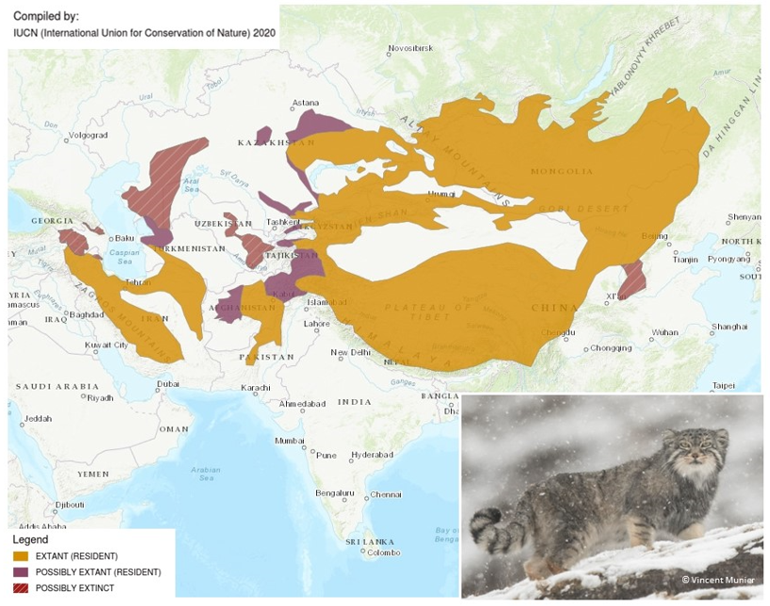

1. **Summary of Activities**

The proposed activities cover the addition of the Pallas’s Cat to the Central Asian Mammals Initiative (CAMI), the development of an associated Programme of Work aligned with the Pallas’s Cat Strategy and Action Plan 2018-2028, and effective implementation of the Concerted Action and Programme of Work to enhance the conservation status of the species.

1. **Activities and expected outcomes**

1. Include Pallas’s Cat in the CMS Central Asian Mammals Initiative (CAMI): this will raise the profile of the species among national governments and other stakeholders. 2. Develop an associated set of objectives and actions for Pallas’s Cat under all four parts of the existing CAMI Programme of Work (POW): (a) Part I (Cross-cutting) and Part IV (Implementation Support) both contain elements highly relevant to Pallas’s Cat; (b) Part III (Landscape Level) contains actions for the Gobi-Steppe and Qinghai-Tibet Plateau regions, both of which harbour important Pallas’s Cat populations; (c) Under Part II (Species-specific Measures), six Objectives for a Pallas’s Cat PoW under CAMI are proposed, derived from the Pallas’s Cat Conservation Strategy (Annex). A full Table of objectives and actions can be found in the strategy. Development of such a Programme of Work will provide the main framework for conservation action under the Central Asian Mammals Initiative. 3. Implement the PoW: Effective implementation of the concerted action and Programme of Work will enhance the conservation status of Pallas’s Cat across its range, especially for populations in south-west Asia and the Himalayan region which are small, fragmented, and declining, and fill knowledge gaps.

1. **Associated benefits**

The inclusion of this charismatic carnivore will complement the current CAMI programme and further extend its scope to the small/medium carnivore guild, their small mammal prey, and conservation of the steppe and mountain-steppe ecosystem. Asia’s rangelands are under threat from overgrazing, conversion to agriculture, and climate change. Conservation of Pallas’s Cat requires planning at landscape level, sustainable management and restoration of rangeland, comprehensive and well-managed protected area networks and ecosystem connectivity, activities which are covered by Targets 1, 2, 3, respectively in the Kunming-Montreal Global Biodiversity Framework.

1. **Timeframe**

The initial duration of the proposed Concerted Action is 7 years (2024-2030) aligned with the current CAMI POW. Renewal will be sought, in line with continuation of the whole CAMI programme.

1. **Relationship to other CMS actions**

This proposed Concerted Action is linked directly to the proposed addition of Pallas’s Cat to Appendix II of CMS, led by the Government of Kazakhstan and supported by the Government of Uzbekistan. This listing proposal envisages the inclusion of Pallas’s Cat in the Central Asian Mammals Initiative, which has already proved to be a highly successful instrument in advancing biodiversity conservation within the region. Pallas’s Cat occurs within all the CAMI range states.

1. **Conservation priority**

Pallas’s Cat has an extensive but fragmented range in the mountain steppe ecosystems of South-west and Central Asia. Populations in several parts of the range appear to be small and isolated and the species has declined or disappeared in several western parts of the distribution. Pallas’s Cat is a habitat and prey specialist, has a patchy distribution, and it remains vulnerable to several threats including rangeland degradation and climate change. To date, it has received very little conservation attention and the proposed listing on the Convention, and the Concerted Action, are intended to redress this.

1. **Relevance**

Almost all the populations in Russia lie along the border with Mongolia, and all the key populations in Bhutan, India, Nepal, Pakistan, and Turkmenistan lie close (<50 km) to international borders and have a transboundary character. Several known populations in the deserts and mountains of Central and South-west Asia are also considered to be transboundary. Pallas’s Cats commonly undertake large movements. Individuals may migrate distances up to 52 km, and longer movements up to 170 km over two months have been recorded. These migrations often involve crossing habitats that are not normally used, including swimming across large rivers. The high incidence of home range abandonment (50% of 29 adults studied) suggests that such behaviour is an integral part of their ecology, most likely linked to localised prey depletion, disturbance, or competition with other carnivores, resulting in emigration and colonisation of a new area. Cyclic fluctuations in rodent numbers oblige Pallas’s Cats to move long distances to find areas with adequate prey. The number and extent of transboundary populations necessitates cooperative conservation action at bilateral and multilateral levels.

1. **Absence of better remedies**

Pallas’s Cat, as well as many other small-medium carnivores, has received far less attention than several larger species and their conservation has been relatively neglected. The proposed listing on Appendix II of the Convention and development of the Concerted Action, will significantly increase the profile of the species among policymakers, formally require range state governments to consider Pallas’s Cat conservation, provide a robust international conservation framework for action, and facilitate the raising of funds: taken together, these measures will mark a step-change in the conservation of Pallas’s Cat. Conservation efforts for the species by NGOs and research institutes would continue without a CMS listing or Concerted Action, but in the current rather fragmentary way, and without formal support from governments or integration into their National Biodiversity Strategy and Action Plan. Maintaining the status quo is not considered likely to produce meaningful improvements to the status of the species.

1. **Readiness and feasibility**

The Manul Working Group (MWG) coordinates research and conservation activities among all specialists working across the species range and collates information (<https://savemanul.org/>). Working closely with the MWG, the Pallas’s Cat International Conservation Alliance (PICA) operates a small grant scheme to support the research and conservation across the range of Pallas’s Cat and delivers capacity building and training (<https://pallascats.org/>). The Manul Working Group is formally affiliated to the IUCN SSC Cat Specialist Group. These organisations are well-placed to lead and coordinate implementation of the Concerted Action and Programme of Work. and they have contacts to a wide range of regional and international researchers and field workers.

1. **Likelihood of success**

The CMS Central Asian Mammals Initiative has been very successful in raising awareness and catalysing conservation action for the species within its remit. This Concerted Action, together with the proposed objectives and actions under the CAMI Programme of Work, and the listing on Appendix II of the Convention, are expected to produce similarly positive outcomes for Pallas’s Cat. All key stakeholders have been consulted on the listing proposal and the concerted action and are ready to support implementation. A variety of educational materials and guidance has also been prepared in range state country languages, which will facilitate implementation.

1. **Magnitude of likely impact**

Over 90% of Pallas’s Cat range lies within the region covered by the CMS Central Asian Mammals Initiative (CAMI) and the species occurs in all CAMI countries. The Concerted Action and inclusion of Pallas’s Cat in CAMI will raise awareness of the species among policymakers and the public. Implementation of the associated Programme of Work will improve the conservation status of the species throughout its range. The inclusion of this charismatic carnivore in CAMI will complement the existing programme and extend its scope to the small/medium carnivore guild, their prey, and ultimately the conservation of the steppe ecosystem.

1. **Cost-effectiveness**

The Pallas’s Cat International Conservation Alliance and the Manul Working Group have supported projects in ten range countries, in support of objectives in the Pallas’s Cat Strategy and Action Plan since 2016. Additional funding has been obtained by other organisations. Much of this funding has been assembled from donations from the international zoo community which have been matched by international grant funding (Fondation Segré). The cost effectiveness of this coordinated approach to directing small grant funding towards mutually agreed conservation priorities has therefore been demonstrated. The costs of Activities 1 and 2 are low and already covered by MWG and PICA. Detailed funding needs for Activity 3 (Implementation of the CA/POW) will be estimated on approval of the proposed Concerted Action. Some of the proposed activities are covered or partly covered by existing projects, including the continuation of the PICA small grant programme (due to be rolled out annually from 2023 onwards), and in-kind contributions by partner organisations. Funding for the remaining actions will need to be obtained, and the addition of Pallas’s Cat to Appendix II of the Convention, adoption of the Concerted Action under the CAMI framework, will enhance fundraising opportunities and extend the options to larger regional and international donors.

**Consultations-Planned/Undertaken**

The CA proposal has been developed by PICA, IUCN Cat SG and MWG, which collectively include a comprehensive network of conservationists, researchers, and others involved in conservation of Pallas’s Cat. The associated Proposal to list Pallas’s Cat on Appendix II of the Convention has been developed by PICA, MWG, and the IUCN Cat SG in close cooperation with range states and other stakeholders. The Government of Kazakhstan, a key range state, has agreed to act as lead proponent, supported by the Government of Uzbekistan. All CMS Parties where Pallas’s Cat occurs have been invited to comment on the draft listing proposal. The objectives and activities in the proposed Concerted Action / Programme of Work are all designed to be implemented within the range states, except for some of the *ex situ* component and global awareness raising. The Pallas’s Cat *ex situ* community is fully integrated into the Manul Working Group and the Pallas’s Cat International Conservation Alliance and have also been involved throughout in consultations on the proposals.

**ANNEX.**

**PROPOSED OBJECTIVES FOR PALLAS’S CAT UNDER THE CAMI PROGRAMME OF WORK, ALIGNED WITH THE PALLAS’S CAT CONSERVATION STRATEGY1**

|  |  |  |
| --- | --- | --- |
| **Pallas’s Cat (*Felis* *manul*2)** | **Responsible** | **Priority** |
| 1 Prevent habitat destruction and fragmentation and mitigate negative impact of infrastructure and agriculture development | Government agencies, NGOs | High |
| 2 Make legal hunting sustainable (Mongolia only) and stop illegal killing and illegal trade | Government agencies, NGOs | High |
| 3 Understand and reduce human-caused mortality of Pallas’s Cat (free-ranging dogs, poisoning, etc.) | Government agencies, NGOs, MWG, PICA | High |
| 4 Increase scientific research and understanding of the basic ecology and population dynamics of the species | Government agencies, NGOs, MWG, PICA, IUCN CatSG | High |
| 5 Develop science and conservation capacity in field ecology and conservation in Pallas’s Cat range countries | Government agencies, NGOs, MWG, PICA, IUCN CatSG | High |
| 6 Develop the global network (Manul Working Group) and participation of Pallas’s Cat specialists to increase knowledge and conservation of the species | Government agencies, NGOs, MWG, PICA, IUCN CatSG | High |

1 Pallas's Cat Global Action Planning Group. 2019. Conservation strategy for *Otocolobus manul*. *Cat News Special Issue* 13: 55-62.

2 *Otocolobus manul* on the IUCN Red List